

Description of 3B18 Message

PIP® 3B18
Validated 11.01.00

Specification Information
Name | Description of 3B18 Message
PIP | Notify Of Shipping Documentation
Cluster | Order Management
Segment | Transportation and Distribution
Publication Date | 08 October 2007
Version Identifier | V11.01

Table of Content

1. Document Management 8
1.1 Legal Disclaimer 8
1.2 Copyright 8
1.3 Trademarks 8
1.4 Acknowledgments 8
1.5 Related Documents 9
1.6 Document Version History 9
1.7 Document Purpose 9
2. Interchange Model 10
2.1 ShippingDocumentationNotification 10
2.1.1 Interchange Diagram 10
2.1.2 Dependency Diagram 11
2.1.3 AmendmentInformation 11
2.1.4 DateInformation 12
2.1.5 DeclarationInformation 13
2.1.6 HeaderInformation 15
2.1.7 PartnerProductIdentification 16
2.1.8 PricingInformation 16
2.1.9 PricingPaymentInformation 17
2.1.10 ProductIdentificationInformation 17
2.1.11 RequestingOrderInformation 18
2.1.12 RoutingInformation 19
2.1.13 ShipmentInformation 20
2.1.14 ShipmentLineItem 23
2.1.15 ShipmentReturnInformation 25
2.1.16 ShippingBusinessDocument 25
2.1.17 ShippingContainer 26
2.1.18 ShippingContainerItem 27
2.1.19 ShippingDocumentationNotification 28
2.1.20 ShippingOrderInformation 28
2.1.21 SubContainer 29
2.2 CodeList 29
2.2.1 DeliveryType 29
3. Domain Model 30
3.1 Procurement 30
3.1.1 Procurement 30
3.1.1.1 Dependency Diagram 30
3.1.1.2 CurrencyConversion 30
3.1.1.3 PaymentOrder 31
3.1.1.4 RequestingOrderLineItemReference 31
3.1.1.5 SpecialHandlingInstruction 32
3.1.1.6 TaxExemption 32
3.1.1.7 TaxExemptStatus 33
3.1.2 CodeList 33
3.1.2.1 TaxExemptionCode 33
3.1.2.2 SpecialHandling 35
3.1.2.3 PaymentTerms 43
3.1.2.4 OrderAdmin 45
3.2 Logistics 46
3.2.1 Logistics 46
3.2.1.1 Dependency Diagram 46
3.2.1.2 BillOfLading 46
3.2.1.3 Customs 46
3.2.1.4 CustomsInformation 47
3.2.1.5 CustomsPermittedInformation 48
3.2.1.6 DateInformation 48
3.2.1.7 ExportLicense 49
3.2.1.8 ForeignCurrencyControl 49
3.2.1.9 FreeOnBoardTerms 50
3.2.1.10 FreightValuation 50
3.2.1.11 Handbook 50
3.2.1.12 HarmonizedTariffScheduleInformation 51
3.2.1.13 HazardousMaterialDescription 51
3.2.1.14 Instructions 52
3.2.1.15 IsHazardousMaterial 52
3.2.1.16 LinearWithMeasureType 53
3.2.1.17 LotReference 53
3.2.1.18 ManufacturerProfile 54
3.2.1.19 MassPhysicalDimension 54
3.2.1.20 MeasureWithType 54
3.2.1.21 OrderInformation 55
3.2.1.22 PhysicalDimension 56
3.2.1.23 PortIdentification 56
3.2.1.24 PortIdentificationChoice 57
3.2.1.25 PortInformation 57
3.2.1.26 ShipmentDate 58
3.2.1.27 ShippingDocumentReference 58
3.2.1.28 ShippingInstructionsCode 59
3.2.1.29 TrackingReference 59
3.2.2 CodeList 59
3.2.2.1 TrackingReferenceType 59
3.2.2.2 Incoterms 60
3.2.2.3 ShipmentMode 60
3.2.2.4 NationalExportControlClassification 61
3.2.2.5 PortType 62
3.2.2.6 PortIdentifierAuthorityCode 62
3.2.2.7 CustomsType 62
3.2.2.8 ShipDateCode 63
3.2.2.9 FreightPaymentTerms 65
3.2.2.10 LotDiscrepancyReason 66
3.2.2.11 RouteLocation 66
3.2.2.12 ContainerSpecification 67
3.2.2.13 ShippingDocument 68
3.3 Shared 69
3.3.1 Shared 69
3.3.1.1 Dependency Diagram 69
3.3.1.2 MonetaryAmount 69
3.3.1.3 ProductQuantity 70
3.3.1.4 QuantityInformation 70
3.3.1.5 Rate 71
3.3.2 CodeList 71
3.3.2.1 FreeOnBoard 71
3.3.2.2 InvoiceChargeType 71
3.3.2.3 MonetaryAmountType 72
3.3.2.4 PackageType 72
3.3.2.5 ShippingServiceLevel 72
3.3.2.6 PaymentMethod 74
3.3.2.7 AmountType 76
3.3.2.8 RateType 77
4. Universal Structure 78
4.1 ContactInformation 78
4.1.1 ContactInformation 78
4.2 DataType 78
4.2.1 Contact 78
4.2.2 DUNS 79
4.2.3 DUNSPlus4 79
4.2.4 GLN 80
4.2.5 GTIN 80
4.2.6 PercentAmount 81
4.3 Dates 81
4.3.1 StartAndEndDate 81
4.4 Document 81
4.4.1 BusinessDocumentReference 81
4.5 Locations 82
4.5.1 AlternativeIdentifier 82
4.5.2 Location 83
4.5.3 LocationChoice 83
4.5.4 PhysicalAddress 84
4.6 MonetaryExpression 85
4.6.1 FinancialAmount 85
4.7 PartnerIdentification 86
4.7.1 FullPartner 86
4.7.2 IntermittentPartner 86
4.7.3 KnownPartner 87
4.7.4 KnownPartnerContact 87
4.7.5 NewPartner 88
4.7.6 PartnerDescription 89
4.7.7 PartnerDescriptionChoice 89
4.7.8 PartnerIdentification 90
4.7.9 PartnerIdentificationChoice 90
4.7.10 SpecifiedFullPartner 91
4.7.11 SpecifiedIntermittentPartner 92
4.7.12 SpecifiedKnownPartner 92
4.7.13 SpecifiedKnownPartnerContact 92
4.7.14 SpecifiedNewPartner 93
4.7.15 SpecifiedPartnerDescription 94
4.7.16 SpecifiedPartnerDescriptionChoice 94
4.8 PhysicalDimension 95
4.8.1 Measure 95
4.8.2 Volume 95
4.8.3 Weight 96
4.9 ProductIdentification 96
4.9.1 ProductIdentification 96
4.9.2 ProductIdentificationChoice 97
4.9.3 TextualDescription 97
4.10 CodeList 97
4.10.1 Country 97
4.10.2 CountrySubdivision 97
4.10.3 Currency 98
4.10.4 Language 98
4.10.5 DocumentType 98
4.10.6 MimeTypeQualifier 100
4.10.7 UnitOfMeasure 110
4.10.8 ProcessRoleIdentifier 118
4.10.9 WeightType 120
5. System Structure 122
5.1 BusinessProcessIdentifier 122
5.2 BusinessServiceInformation 122
5.3 ContractInformation 123
5.4 CorrelationInformation 123
5.5 DocumentHeader 124
5.6 DocumentIdentification 125
5.7 DocumentIdentificationChoice 125
5.8 DocumentInformation 126
5.9 DocumentManifest 126
5.10 DocumentSecurity 127
5.11 ManifestItem 127
5.12 PipIdentifier 128
5.13 PipVersion 129
5.14 Receiver 129
5.15 RequestingDocumentInformation 130
5.16 Sender 130
5.17 StandardDocumentIdentification 131
5.18 TpirPipIdentification 131
5.19 VersionIdentifier 132
5.20 CodeList 133
5.20.1 TPIRFileType 133
6. XML Data Type 134
6.1 anyURI 134
6.2 boolean 134
6.3 date 134
6.4 dateTime 134
6.5 decimal 134
6.6 float 134
6.7 integer 134
6.8 positiveInteger 134
6.9 string 135

Table of Figures

Figure 2-1 Interchange 10
Figure 2-2 Dependency 11
Figure 2-3 AmendmentInformation 11
Figure 2-4 DateInformation 12
Figure 2-5 DeclarationInformation 13
Figure 2-6 HeaderInformation 15
Figure 2-7 PartnerProductIdentification 16
Figure 2-8 PricingInformation 16
Figure 2-9 PricingPaymentInformation 17
Figure 2-10 ProductIdentificationInformation 17
Figure 2-11 RequestingOrderInformation 18
Figure 2-12 RoutingInformation 19
Figure 2-13 ShipmentInformation 20
Figure 2-14 ShipmentLineItem 23
Figure 2-15 ShipmentReturnInformation 25
Figure 2-16 ShippingBusinessDocument 25
Figure 2-17 ShippingContainer 26
Figure 2-18 ShippingContainerItem 27
Figure 2-19 ShippingDocumentationNotification 28
Figure 2-20 ShippingOrderInformation 28
Figure 2-21 SubContainer 29
Figure 3-1 Dependency 30
Figure 3-2 CurrencyConversion 30
Figure 3-3 PaymentOrder 31
Figure 3-4 RequestingOrderLineItemReference 31
Figure 3-5 SpecialHandlingInstruction 32
Figure 3-6 TaxExemption 32
Figure 3-7 TaxExemptStatus 33
Figure 3-8 Dependency 46
Figure 3-9 BillOfLading 46
Figure 3-10 Customs 46
Figure 3-11 CustomsInformation 47
Figure 3-12 CustomsPermittedInformation 48
Figure 3-13 DateInformation 48
Figure 3-14 ExportLicense 49
Figure 3-15 ForeignCurrencyControl 49
Figure 3-16 FreeOnBoardTerms 50
Figure 3-17 FreightValuation 50
Figure 3-18 Handbook 50
Figure 3-19 HarmonizedTariffScheduleInformation 51
Figure 3-20 HazardousMaterialDescription 51
Figure 3-21 Instructions 52
Figure 3-22 IsHazardousMaterial 52
Figure 3-23 LinearWithMeasureType 53
Figure 3-24 LotReference 53
Figure 3-25 ManufacturerProfile 54
Figure 3-26 MassPhysicalDimension 54
Figure 3-27 MeasureWithType 54
Figure 3-28 OrderInformation 55
Figure 3-29 PhysicalDimension 56
Figure 3-30 PortIdentification 56
Figure 3-31 PortInformation 57
Figure 3-32 ShipmentDate 58
Figure 3-33 ShippingDocumentReference 58
Figure 3-34 ShippingInstructionsCode 59
Figure 3-35 TrackingReference 59
Figure 3-36 Dependency 69
Figure 3-37 MonetaryAmount 69
Figure 3-38 ProductQuantity 70
Figure 3-39 QuantityInformation 70
Figure 3-40 Rate 71
Figure 4-1 ContactInformation 78
Figure 4-2 Contact 78
Figure 4-3 DUNS 79
Figure 4-4 DUNSPlus4 79
Figure 4-5 GLN 80
Figure 4-6 GTIN 80
Figure 4-7 PercentAmount 81
Figure 4-8 StartAndEndDate 81
Figure 4-9 BusinessDocumentReference 81
Figure 4-10 AlternativeIdentifier 82
Figure 4-11 Location 83
Figure 4-12 PhysicalAddress 84
Figure 4-13 FinancialAmount 85
Figure 4-14 FullPartner 86
Figure 4-15 IntermittentPartner 86
Figure 4-16 KnownPartner 87
Figure 4-17 KnownPartnerContact 87
Figure 4-18 NewPartner 88
Figure 4-19 PartnerDescription 89
Figure 4-20 PartnerIdentification 90
Figure 4-21 SpecifiedFullPartner 91
Figure 4-22 SpecifiedIntermittentPartner 92
Figure 4-23 SpecifiedKnownPartner 92
Figure 4-24 SpecifiedKnownPartnerContact 92
Figure 4-25 SpecifiedNewPartner 93
Figure 4-26 SpecifiedPartnerDescription 94
Figure 4-27 Measure 95
Figure 4-28 Volume 95
Figure 4-29 Weight 96
Figure 4-30 ProductIdentification 96
Figure 4-31 TextualDescription 97
Figure 5-1 BusinessProcessIdentifier 122
Figure 5-2 BusinessServiceInformation 122
Figure 5-3 ContractInformation 123
Figure 5-4 CorrelationInformation 123
Figure 5-5 DocumentHeader 124
Figure 5-6 DocumentIdentification 125
Figure 5-7 DocumentInformation 126
Figure 5-8 DocumentManifest 126
Figure 5-9 DocumentSecurity 127
Figure 5-10 ManifestItem 127
Figure 5-11 PipIdentifier 128
Figure 5-12 PipVersion 129
Figure 5-13 Receiver 129
Figure 5-14 RequestingDocumentInformation 130
Figure 5-15 Sender 130
Figure 5-16 StandardDocumentIdentification 131
Figure 5-17 TpirPipIdentification 131
Figure 5-18 VersionIdentifier 132

Document Management

Legal Disclaimer
RosettaNet, its members, officers, directors, employees, or agents shall not be liable for any injury, loss, damages, financial or otherwise, arising from, related to, or caused by the use of this document or the specifications herein, as well as associated guidelines and schemas. The use of said specifications shall constitute your express consent to the foregoing exculpation.

Copyright
©2007 RosettaNet. All rights reserved. No part of this publication may be reproduced, stored in a retrieval system, or transmitted, in any form or by any means, electronic, mechanical, photocopying, recording, or otherwise, without the inclusion of this copyright notice. Any derivative works must cite the copyright notice. Any public redistribution or sale of this publication or derivative works requires prior written permission of the publisher.

Trademarks
RosettaNet, Partner Interface Process, PIP and the RosettaNet logo are trademarks or registered trademarks of "RosettaNet," a non-profit organization. All other product names and company logos mentioned herein are the trademarks of their respective owners. In the best effort, all terms mentioned in this document that are known to be trademarks or registered trademarks have been appropriately recognized in the first occurrence of the term.

Acknowledgments
This document has been prepared by RosettaNet (http://www.rosettanet.org/) from requirements gathered during the Milestone Program and in conformance with the methodology. Listed below are the legal entities that contributed to the design and development of this PIP.
BAX Global | Cisco Systems, Inc.
Dagang Net Technologies SDN BHD | Danzas
Danzas AEI Intercontinental, Inc. | DHL Danzas Air & Ocean
GridNode, Inc. | GridNode Pte. Ltd.
Intel Corporation | Intel Corporations
Menlo Worldwide | MITAC International Corp.
Sterling Commerce | MIMOS Berhad
Shanghai Easipass International, Inc.

Related Documents
- Associated PIP Message Schemas (included with PIP Specification only)
- Description of Partner Interface Process for 3B18
- Message Structure

Document Version History
Version | Date | Description
Validated 11.00.00 | 11 July 2006 | Validated Version  Milestone Program: e-Customs
Validated 11.01.00 | 08 October 2007 | Validated Version  Milestone Program: Schema2Market

Document Purpose
The purpose of the document is to explain the structure, the association between objects, the content of objects and the definition for single elements to a non-technical audience.

Interchange Model

ShippingDocumentationNotification

Interchange Diagram
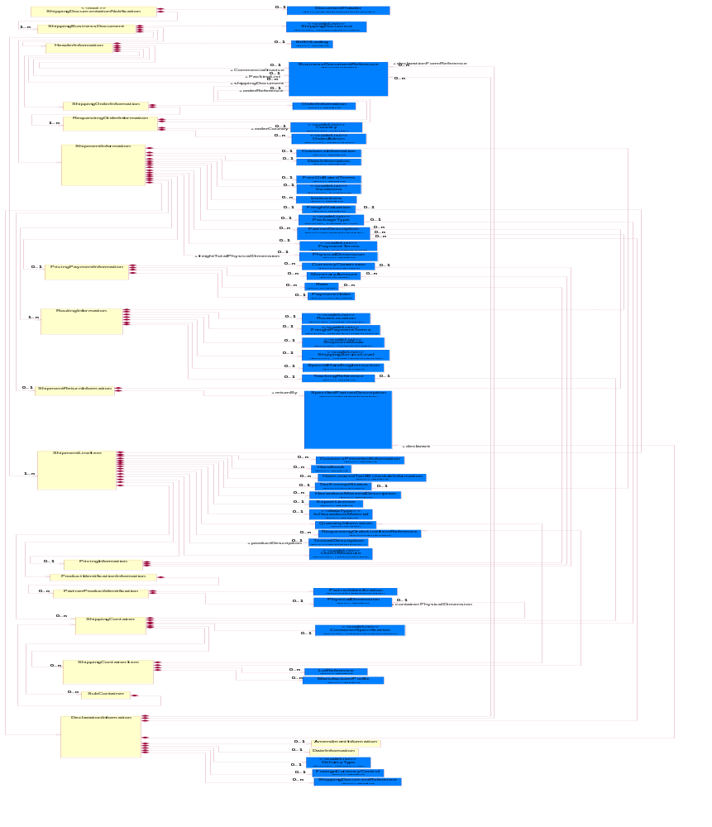
Figure 2-1 Interchange

Dependency Diagram
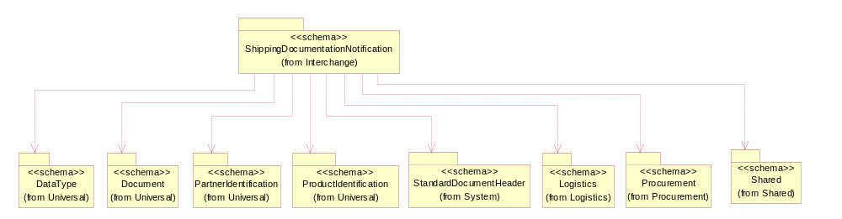
Figure 2-2 Dependency

AmendmentInformation
This object represents a collection of information regarding the amendment needed on an approved customs declaration.
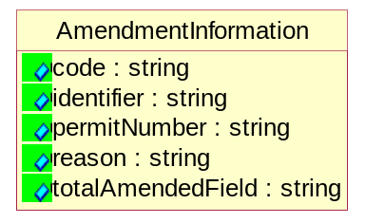
Figure 2-3 AmendmentInformation
Attribute | Type | Documentation
code | string | This object represents the type of changes made.
identifier | string | This object represents a sequencial number to identify the amendment made.
permitNumber | string | This object represents the permit number of the permit that is being amended.
reason | string | This object represents a textual description of the reason for the amendment made.
totalAmendedField | string | This object represents the count for the number of fields amended.

DateInformation
The collection of business properties that identifies a set of dates associated with this transaction.
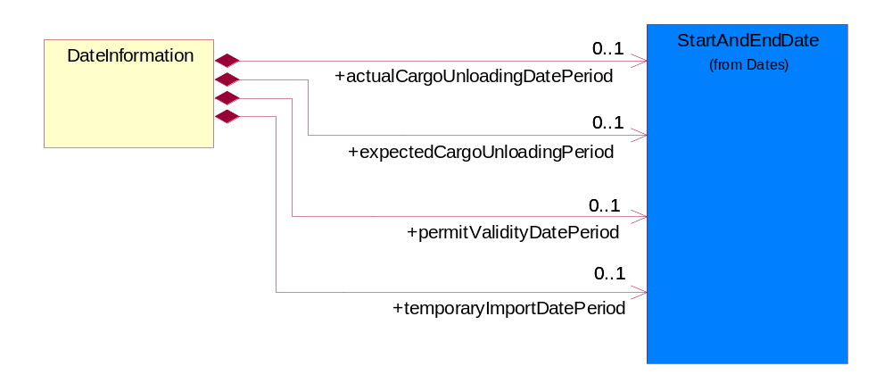
Figure 2-4 DateInformation

Composition | Cardinality | Type | Documentation
actualCargoUnloadingDatePeriod | 0..1 | StartAndEndDate | This object represents the actual start and end date for the period that cargo will be removed from the warehouse.
expectedCargoUnloadingPeriod | 0..1 | StartAndEndDate | This object represents the estimated start and end date for the period that cargo will be removed from the warehouse.
permitValidityDatePeriod | 0..1 | StartAndEndDate | This object represents the start and end date for the validity of the permit.
temporaryImportDatePeriod | 0..1 | StartAndEndDate | This object represents the start and end date for goods under Temporary Import Scheme (TIS).

DeclarationInformation
The collection of business properties that describes the information about import or export declaration of a shipment.
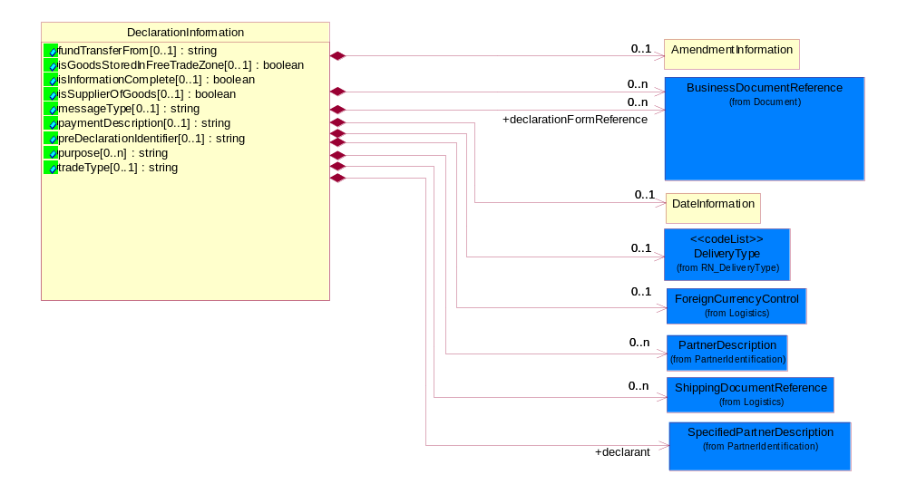
Figure 2-5 DeclarationInformation

Attribute | Type | Documentation
fundTransferFrom[0..1] | string | This object represents the party where the fund transfers from.
isGoodsStoredInFreeTradeZone[0..1] | boolean | This object represents an indicator whether if the good stored in Free Trade Zone (FTZ).
isInformationComplete[0..1] | boolean | This object represents an indicator to determine if the information complete and ready for customs declaration.
isSupplierOfGoods[0..1] | boolean | This object represents an indicator if the declarant is the supplier of goods.
messageType[0..1] | string | This object representing the type of customs declaration being submitted. This is usually required during routing process for system to identify where to route the message to.
paymentDescription[0..1] | string | This object represents a description for the payment type used for this customs declaration.
preDeclarationIdentifier[0..1] | string | A unique serial number that a declaring company needs to purchase from Customs prior to shipment declaration.
purpose[0..n] | string | This object represents a description of the purpose of customs declaration.
tradeType[0..1] | string | This object describes a method that a company used for conducting business activities.

Composition | Cardinality | Type | Documentation
declarationFormReference | 0..n | BusinessDocumentReference | This object represents the declaration form number which related to this customs declaration.
BusinessDocumentReference | 0..n | BusinessDocumentReference | The business document reference object allows for the indirect referencing of a relationship to other business related documents.
ForeignCurrencyControl | 0..1 | ForeignCurrencyControl | This object represents the currency control information.
PartnerDescription | 0..n | PartnerDescription | The collection of business properties that describe a business partners' identity, their contact information, where they are physically located and their function in a supply chain.
declarant | 1 | SpecifiedPartnerDescription | This object represents the party that declare the shipment.
DateInformation | 0..1 | DateInformation | The collection of business properties that identifies a set of dates associated with this transaction.
DeliveryType | 0..1 | DeliveryType | This object represents a code which indicates the location of removal of dutiable goods.
AmendmentInformation | 0..1 | AmendmentInformation | This object represents a collection of information regarding the amendment needed on an approved customs declaration.
ShippingDocumentReference | 0..n | ShippingDocumentReference | The shipping document reference object allows for the indirect referencing of a relationship to other shipping related business documents.

HeaderInformation
The collection of business properties that describes header information for documents associated with a shipment.
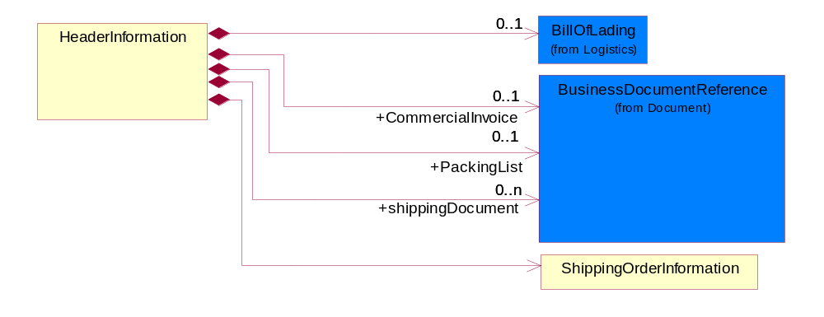
Figure 2-6 HeaderInformation

Composition | Cardinality | Type | Documentation
ShippingOrderInformation | 1 | ShippingOrderInformation | The collection of business properties that identifies a shipping order with which the shipping documentation is associated.
CommercialInvoice | 0..1 | BusinessDocumentReference | The business document reference object allows for the indirect referencing of a relationship to other business related documents.
PackingList | 0..1 | BusinessDocumentReference | The collection of business properties that describes header information to appear on a Packing List.
BillOfLading | 0..1 | BillOfLading | The collection of business properties that describes header information to appear on a Bill of Lading.
shippingDocument | 0..n | BusinessDocumentReference | The collection of business properties that identifies unique references number to identify the set of shipping documents associated with a shipment.

PartnerProductIdentification
The collection of business properties that describe proprietary part information.
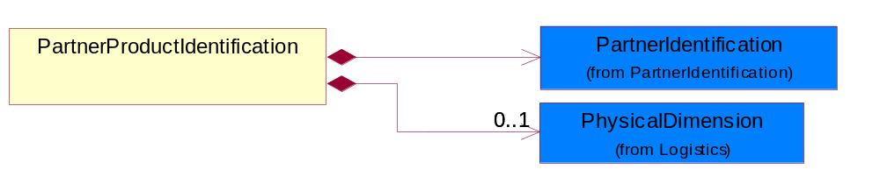
Figure 2-7 PartnerProductIdentification
Composition | Cardinality | Type | Documentation
PartnerIdentification | 1 | PartnerIdentification | The business document must allow for the identity of one or more parties to the transaction.
PhysicalDimension | 0..1 | PhysicalDimension | The physical dimension of a quantity such as length, time, mass.

PricingInformation
The collection of business properties that describes pricing information for a product or a total shipment.
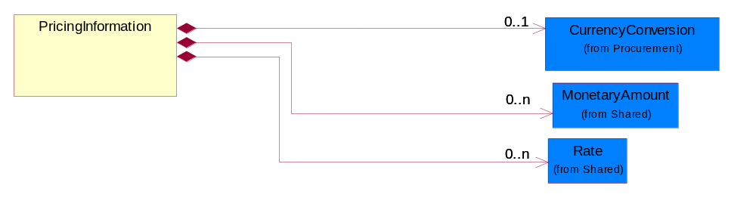
Figure 2-8 PricingInformation

Composition | Cardinality | Type | Documentation
CurrencyConversion | 0..1 | CurrencyConversion | The collection of business properties that describe the exchange of money in circulation.
MonetaryAmount | 0..n | MonetaryAmount | The collection of business properties that describe the monetary amount defined by a specified currency.
Rate | 0..n | Rate | The percentage of an amount.

PricingPaymentInformation
The collection of business properties that describes pricing information for a product or a total shipment.
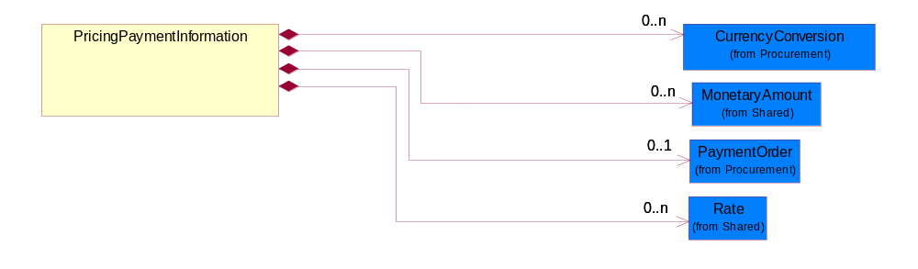
Figure 2-9 PricingPaymentInformation

Composition | Cardinality | Type | Documentation
CurrencyConversion | 0..n | CurrencyConversion | The collection of business properties that describe the exchange of money in circulation.
PaymentOrder | 0..1 | PaymentOrder | The collection of business properties that describe a payment order.
MonetaryAmount | 0..n | MonetaryAmount | The collection of business properties that describe the monetary amount defined by a specified currency.
Rate | 0..n | Rate | The percentage of an amount.

ProductIdentificationInformation
The collection of business properties that describe proprietary and global identifier information regarding a product.
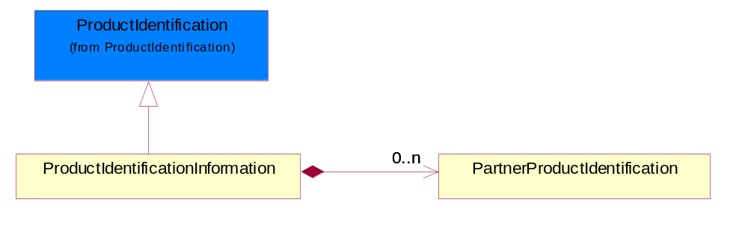
Figure 2-10 ProductIdentificationInformation
Composition | Cardinality | Type | Documentation
PartnerProductIdentification | 0..n | PartnerProductIdentification | The collection of business properties that describe proprietary part information.

RequestingOrderInformation
The collection of business properties that identifies an order of another type that caused this shipping order to be created.
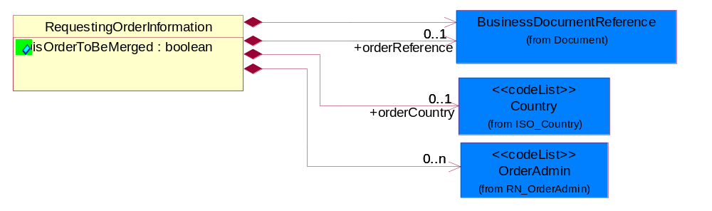
Figure 2-11 RequestingOrderInformation
Attribute | Type | Documentation
isOrderToBeMerged | boolean | Indicates whether multiple shipping orders from the same requesting order must be merged into a single delivery.

Composition | Cardinality | Type | Documentation
BusinessDocumentReference | 1 | BusinessDocumentReference | The business document reference object allows for the indirect referencing of a relationship to other business related documents.
orderCountry | 0..1 | Country | The country where the office which accepted the order is located.
orderReference | 0..1 | BusinessDocumentReference | An additional reference number to identify a single shipment when there are multiple shipments resulting from a single requesting order.
OrderAdmin | 0..n | OrderAdmin | Additional administrative code identifying the reason the shipping order is being sent, possibly indicating a predefined workflow.

RoutingInformation
The collection of business properties that describes a leg used in the routing of a shipment.
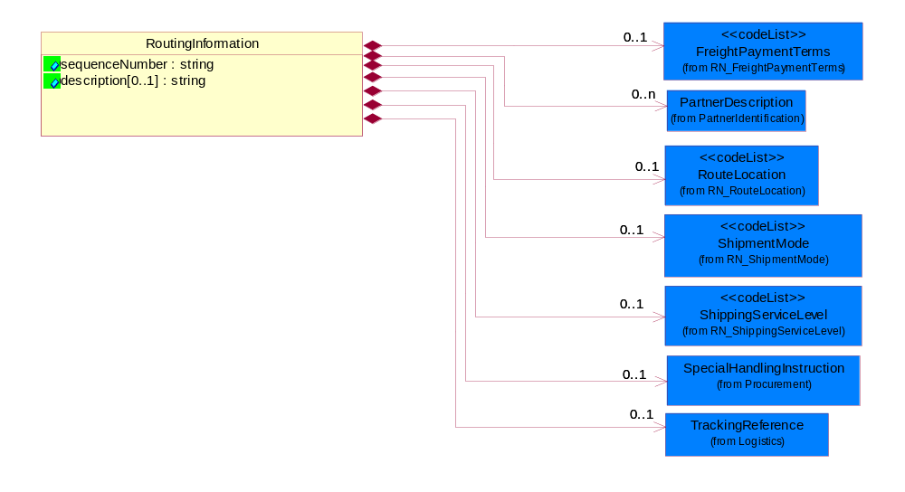
Figure 2-12 RoutingInformation

Attribute | Type | Documentation
sequenceNumber | string | A positive integer which identifies the order of a designated element within a specified set.
description[0..1] | string | Textual description about routing information eg. description of transportation type.

Composition | Cardinality | Type | Documentation
ShipmentMode | 0..1 | ShipmentMode | The method of transport used for the conveyance of goods.
TrackingReference | 0..1 | TrackingReference | Proprietary unique identifier for tracking product shipments.
FreightPaymentTerms | 0..1 | FreightPaymentTerms | Code identifying responsibility for payment of shipping charges.
SpecialHandlingInstruction | 0..1 | SpecialHandlingInstruction | The collection of business properties that describe product packaging or shipping handling instructions.
RouteLocation | 0..1 | RouteLocation | Code identifying the route location of some point after a shipment is created within a carrier's system.
PartnerDescription | 0..n | PartnerDescription | The collection of business properties that describe a business partners' identity, their contact information, where they are physically located and their function in a supply chain.
ShippingServiceLevel | 0..1 | ShippingServiceLevel | Code identifying the shipping service level, e.g., overnight, same day.

ShipmentInformation
The collection of business properties that identifies how a shipment is to be made.
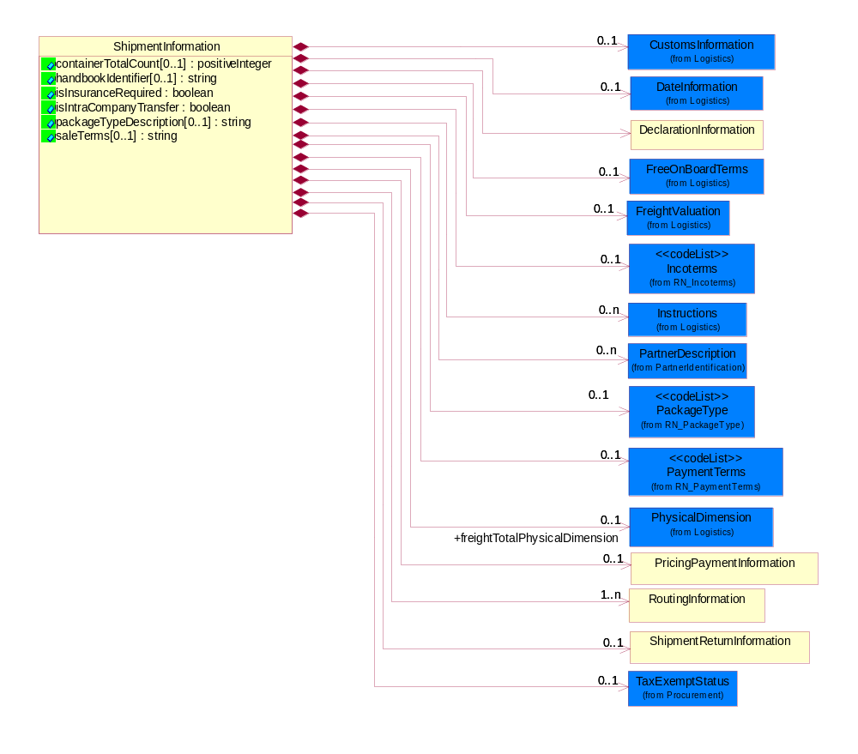
Figure 2-13 ShipmentInformation
Attribute | Type | Documentation
containerTotalCount[0..1] | positiveInteger | Indicates the total number of containers in the shipment that belong to this shipping order. This is usually the total number of packed cartons.
handbookIdentifier[0..1] | string | This object represents the handbook identifier.
isInsuranceRequired | boolean | Indicates whether insurance is required for the shipment.
isIntraCompanyTransfer | boolean | Indicates whether the shipment represents a transfer within the same company or group of related companies.
packageTypeDescription[0..1] | string | This object represents the description for the type of packaging for a product.
saleTerms[0..1] | string | A textual description of terms of sale which clarify the responsibilities of parties to the sale with respect to : transportation from seller to buyer; export clearance; import clearance. This is an extension to Incoterms which allow user to fill in additional values which is out of list of values of incoterms eg. Shipper only need to pay for dunnage fee or According to market price.

Composition | Cardinality | Type | Documentation
Incoterms | 0..1 | Incoterms | Code identifying incoterms.
PaymentTerms | 0..1 | PaymentTerms | Code identifying the terms that govern the payment for goods and services.
PricingPaymentInformation | 0..1 | PricingPaymentInformation | The collection of business properties that describes pricing information for a product or a total shipment.
RoutingInformation | 1..n | RoutingInformation | The collection of business properties that describes a leg used in the routing of a shipment.
ShipmentReturnInformation | 0..1 | ShipmentReturnInformation | The collection of business properties that describes how a shipment should be returned to the sender.
DateInformation | 0..1 | DateInformation | The collection of business properties that identifies a set of dates associated with this transaction.
FreeOnBoardTerms | 0..1 | FreeOnBoardTerms | The collection of business properties that identifies the Free On Board terms.
freightTotalPhysicalDimension | 0..1 | PhysicalDimension | The total volume and/or weight of the complete shipment.
Instructions | 0..n | Instructions | The collection of business properties that identifies shipping instruction notes and their location on shipping documents or labels.
CustomsInformation | 0..1 | CustomsInformation | The collection of business properties that describe a information necessary to comply with local Customs regulations during international transportation.
TaxExemptStatus | 0..1 | TaxExemptStatus | The collection of business properties that describe tax exemption conditions.
DeclarationInformation | 1 | DeclarationInformation | The collection of business properties that describes the information about import or export declaration of a shipment.
FreightValuation | 0..1 | FreightValuation | The valuation of the product or products for purposes such as insurance and customs declarations.
PartnerDescription | 0..n | PartnerDescription | The collection of business properties that describe a business partners' identity, their contact information, where they are physically located and their function in a supply chain.
PackageType | 0..1 | PackageType | Code specifying the type of packaging for a product.

ShipmentLineItem
The collection of business properties that describes the shipping details for a product line item on the shipping order.
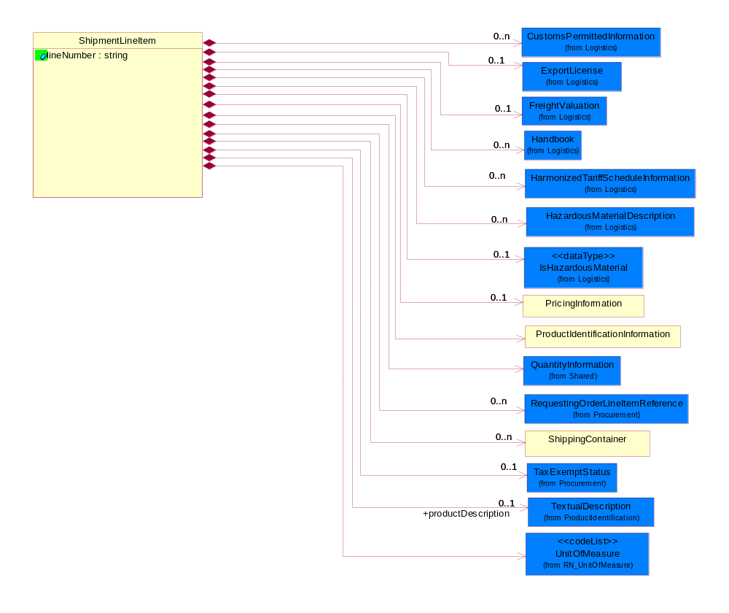
Figure 2-14 ShipmentLineItem
Attribute | Type | Documentation
lineNumber | string | Number of the line in the document.

Composition | Cardinality | Type | Documentation
UnitOfMeasure | 1 | UnitOfMeasure | Code identifying a product unit of measure.
HazardousMaterialDescription | 0..n | HazardousMaterialDescription | The collection of business properties that describe the nature of dangerous goods tendered for transportation.
PricingInformation | 0..1 | PricingInformation | The collection of business properties that describes pricing information for a product or a total shipment.
productDescription | 0..1 | TextualDescription | A textual description of the product.
ShippingContainer | 0..n | ShippingContainer | The collection of business properties that describe the nature and contents of a shipping unit.
ExportLicense | 0..1 | ExportLicense | The collection of business properties that describe an export license number.
ProductIdentificationInformation | 1 | ProductIdentificationInformation | The collection of business properties that describe proprietary and global identifier information regarding a product.
IsHazardousMaterial | 0..1 | IsHazardousMaterial | Indicates whether the product contains hazardous material.
TaxExemptStatus | 0..1 | TaxExemptStatus | The collection of business properties that describe tax exemption conditions.
CustomsPermittedInformation | 0..n | CustomsPermittedInformation | The collection of business properties describes the information permitted by Customs.
FreightValuation | 0..1 | FreightValuation | The valuation of the product or products for purposes such as insurance and customs declarations.
Handbook | 0..n | Handbook | The collection of business properties that describe a handbook published by Customs which is used to control the permitted values of goods being declared by goods category. This is to prevent under or over declaration of values of good.
HarmonizedTariffScheduleInformation | 0..n | HarmonizedTariffScheduleInformation | The collection of business properties that describes a harmonized tariff schedule for a particular country.
QuantityInformation | 1 | QuantityInformation | The collection of business properties that describes information regarding the quantity of the product shipped.
RequestingOrderLineItemReference | 0..n | RequestingOrderLineItemReference | The collection of business properties that references a line item on a requesting document.

ShipmentReturnInformation
The collection of business properties that describes how a shipment should be returned to the sender.
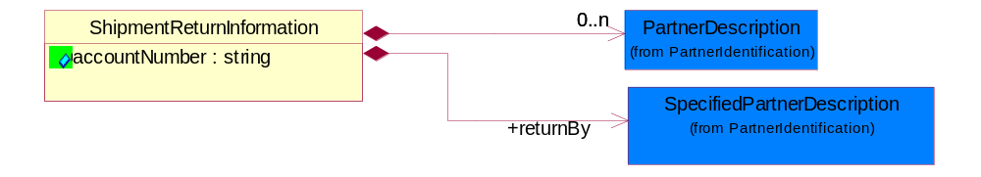
Figure 2-15 ShipmentReturnInformation

Attribute | Type | Documentation
accountNumber | string | Identification number of an account.

Composition | Cardinality | Type | Documentation
returnBy | 1 | SpecifiedPartnerDescription | The party responsible for either carrying or forwarding the returned product.
PartnerDescription | 0..n | PartnerDescription | The collection of business properties that describe a business partners' identity, their contact information, where they are physically located and their function in a supply chain.

ShippingBusinessDocument
The collection of business properties that describes one or more business documents associated with a shipment.
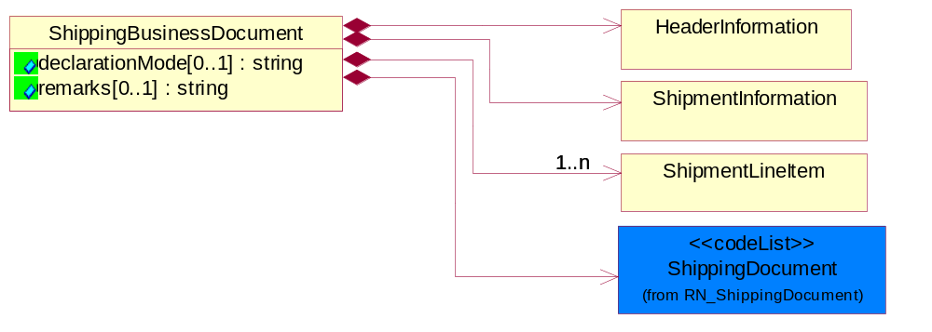
Figure 2-16 ShippingBusinessDocument
Attribute | Type | Documentation
declarationMode[0..1] | string | To identify the mode of processing of the declaration, which triggers specific procedure(s) in the processing of the declaration.
remarks[0..1] | string | Free form text field for additional information needed.

Composition | Cardinality | Type | Documentation
HeaderInformation | 1 | HeaderInformation | The collection of business properties that describes header information for documents associated with a shipment.
ShipmentInformation | 1 | ShipmentInformation | The collection of business properties that identifies how a shipment is to be made.
ShipmentLineItem | 1..n | ShipmentLineItem | The collection of business properties that describes the shipping details for a product line item on the shipping order.
ShippingDocument | 1 | ShippingDocument | Code identifying a type of shipping document.

ShippingContainer
The collection of business properties that describe the nature and contents of a shipping unit.
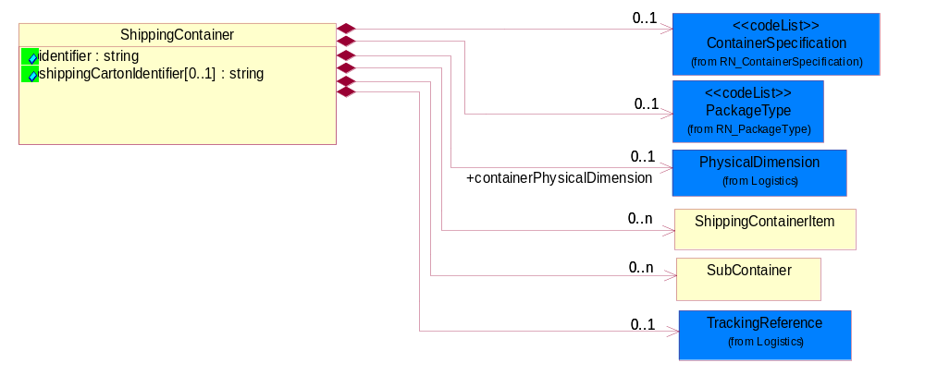
Figure 2-17 ShippingContainer
Attribute | Type | Documentation
identifier | string | Unique identifier that represents a shipping container. Normally a UCC structured identifier. Also known as a "license plate".
shippingCartonIdentifier[0..1] | string | An additional unique identifier that represents a shipping carton.

Composition | Cardinality | Type | Documentation
ShippingContainerItem | 0..n | ShippingContainerItem | The collection of business properties that describe the nature and contents of the good contained within shipping unit.
SubContainer | 0..n | SubContainer | The collection of business properties that describe the nature and contents of inner containers (packages) contained within an outer shipping unit.
TrackingReference | 0..1 | TrackingReference | Proprietary unique identifier for tracking product shipments.
containerPhysicalDimension | 0..1 | PhysicalDimension | Describes the size, weight and volume of a shipping container.
ContainerSpecification | 0..1 | ContainerSpecification | This object represents the specification of a shipping container.
PackageType | 0..1 | PackageType | Code specifying the type of packaging for a product.

ShippingContainerItem
The collection of business properties that describe the nature and contents of the good contained within shipping unit.
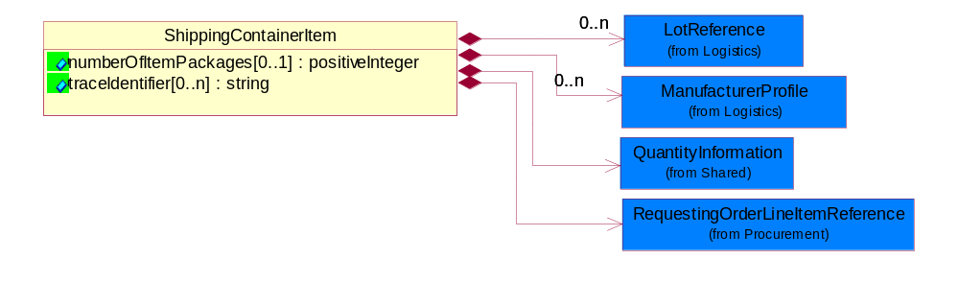
Figure 2-18 ShippingContainerItem

Attribute | Type | Documentation
numberOfItemPackages[0..1] | positiveInteger | A numeric expression of the number of item packages within a container.
traceIdentifier[0..n] | string | Free form text for a non-serial lot identifier.

Composition | Cardinality | Type | Documentation
ManufacturerProfile | 0..n | ManufacturerProfile | The collection of business properties that describe a manufacturer's product.
LotReference | 0..n | LotReference | The collection of business properties that describe a manufacturing lot tendered for shipping.
QuantityInformation | 1 | QuantityInformation | The collection of business properties that describes information regarding the quantity of the product shipped.
RequestingOrderLineItemReference | 1 | RequestingOrderLineItemReference | The collection of business properties that references a line item on a requesting document.

ShippingDocumentationNotification
The root element for PIP3B18.
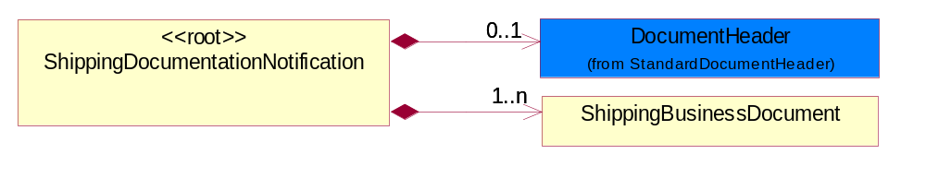
Figure 2-19 ShippingDocumentationNotification
Composition | Cardinality | Type | Documentation
DocumentHeader | 0..1 | DocumentHeader | The object allows for the identification of the sender and receiver of the business document.
ShippingBusinessDocument | 1..n | ShippingBusinessDocument | The collection of business properties that describes one or more business documents associated with a shipment.

ShippingOrderInformation
The collection of business properties that identifies a shipping order with which the shipping documentation is associated.
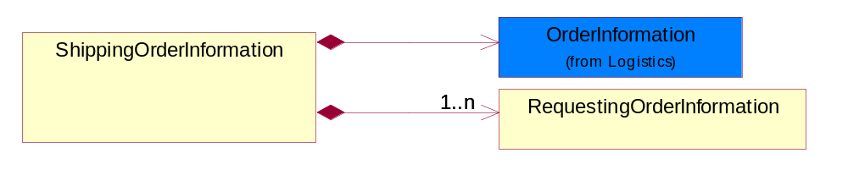
Figure 2-20 ShippingOrderInformation
Composition | Cardinality | Type | Documentation
RequestingOrderInformation | 1..n | RequestingOrderInformation | The collection of business properties that identifies an order of another type that caused this shipping order to be created.
OrderInformation | 1 | OrderInformation | The collection of business properties that identifies a shipping order, including its identity, type and purpose.

SubContainer
The collection of business properties that describe the nature and contents of inner containers (packages) contained within an outer shipping unit.
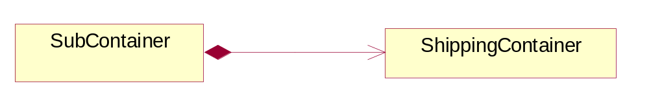
Figure 2-21 SubContainer
Composition | Cardinality | Type | Documentation
ShippingContainer | 1 | ShippingContainer | The collection of business properties that describe the nature and contents of a shipping unit.

CodeList

DeliveryType
This object represents a code which indicates the location of removal of dutiable goods.

Name | Documentation
EXT | External - Removal of dutiable good from one FTZ to another.
INT | Internal - Removal of dutiable goods is within an FTZ.

Domain Model

Procurement

Procurement

Dependency Diagram
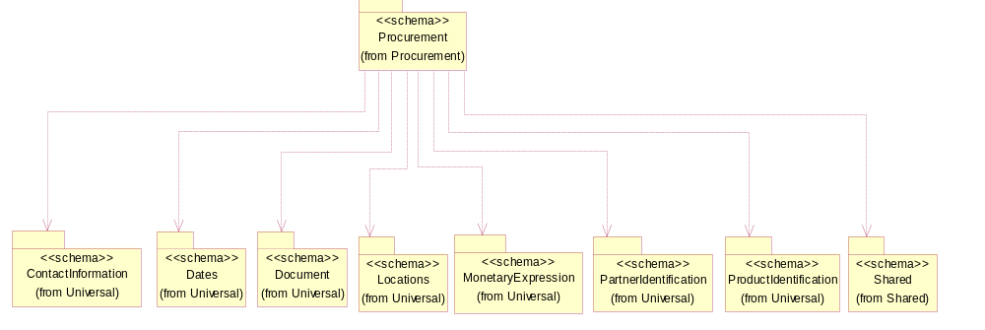
Figure 3-22 Dependency

CurrencyConversion
The collection of business properties that describe the exchange of money in circulation.
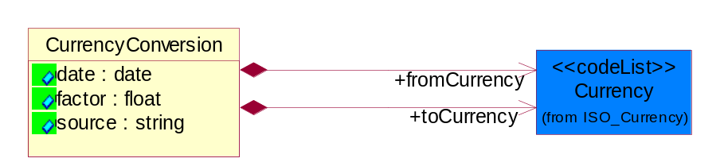
Figure 3-23 CurrencyConversion
Attribute | Type | Documentation
date | date | The date of the exchange rate used to convert between currencies.
factor | float | The conversion factor to apply to convert from the currency of the freight charges to the currency used for payment.
source | string | The source of the exchange rate used to convert between currencies.

Composition | Cardinality | Type | Documentation
toCurrency | 1 | Currency | The currency of the receiving partner in a business transaction.
fromCurrency | 1 | Currency | The currency of the initiating partner in a business transaction.

PaymentOrder
The collection of business properties that describe a payment order.
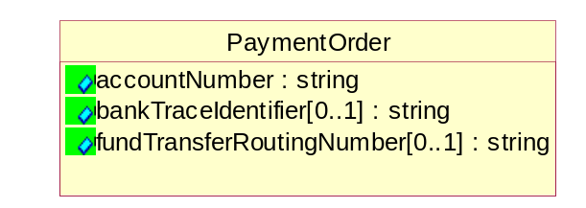
Figure 3-24 PaymentOrder
Attribute | Type | Documentation
accountNumber | string | Identification number of an account.
bankTraceIdentifier[0..1] | string | The unique number assigned by a bank for auditing purposes.
fundTransferRoutingNumber[0..1] | string | Bank routing number used for electronic fund transfers.

RequestingOrderLineItemReference
The collection of business properties that references a line item on a requesting document.
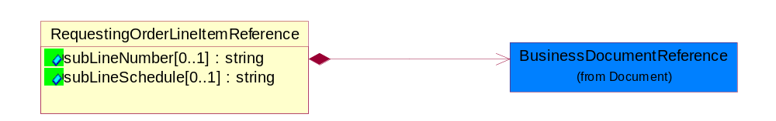
Figure 3-25 RequestingOrderLineItemReference
Attribute | Type | Documentation
subLineNumber[0..1] | string | Number of the subline in the document, associated with a given line number.
subLineSchedule[0..1] | string | Number of the schedule within the subline in the document, associated with a given line number.

Composition | Cardinality | Type | Documentation
BusinessDocumentReference | 1 | BusinessDocumentReference | The business document reference object allows for the indirect referencing of a relationship to other business related documents.

SpecialHandlingInstruction
The collection of business properties that describe product packaging or shipping handling instructions.
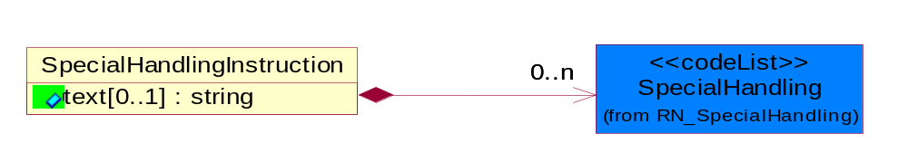
Figure 3-26 SpecialHandlingInstruction
Attribute | Type | Documentation
text[0..1] | string | Free form textual description for how specified goods, packages or containers should be handled.

Composition | Cardinality | Type | Documentation
SpecialHandling | 0..n | SpecialHandling | Code identifying special handling or packaging requirements for the product.

TaxExemption
The collection of business properties that describe tax exemption type and identification information.
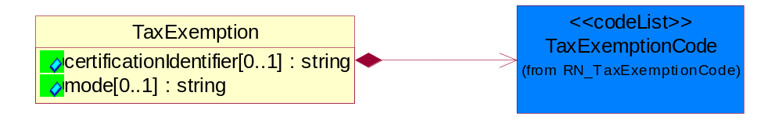
Figure 3-27 TaxExemption
Attribute | Type | Documentation
certificationIdentifier[0..1] | string | The unique identifier that represents the authorization for a product or service's tax exempt status.
mode[0..1] | string | This object refering to the tax exemption mode by Customs against goods declared eg. duty free, partial tax exemption or full tax exemption.

Composition | Cardinality | Type | Documentation
TaxExemptionCode | 1 | TaxExemptionCode | Code identifying the type of tax exemption for a product or service.

TaxExemptStatus
The collection of business properties that describe tax exemption conditions.

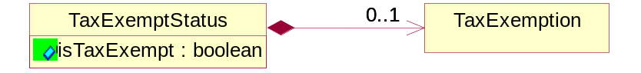
Figure 3-28 TaxExemptStatus
Attribute | Type | Documentation
isTaxExempt | boolean | Indicates whether a product is exempt from taxation.

Composition | Cardinality | Type | Documentation
TaxExemption | 0..1 | TaxExemption | The collection of business properties that describe tax exemption type and identification information.

CodeList

TaxExemptionCode
Code identifying the type of tax exemption for a product or service.

Name | Documentation
AGR | Agriculture.
AQT | Tax exemption for aquatic product for open-sea fishery.
BTL | Tax exemption for border trade with low value - import/export of goods with low value at border.
CPT | Exempt - From County Property Tax.
CRT | Tax exemption for charity - levy free import of commodity for helping the poor charity from beyond the border non-refundable donation to within-border.
CSM | Tax exemption for consignment of assembly and replenishment material and export of finished product.
DIS | Disabled.
DIV | Disabled Veteran.
DPI | Direct Pay ID.
DRD | Tax exemption for disaster relief donation - import goods using disaster relief donation.
EFE | Exempt - For export.
EFR | Exempt - For resale.
EVD | Tax exemption for entire vehicle duty - Levy payment for automobile spare part under the entire vehicle special characterization.
EVI | Tax exemption for entire vehicle special levy - import of automobile spare part under the entire vehicle special characterization.
EXC | Tax exemption for exceptional case - import/export of goods under exceptional levy exemption.
FAD | Tax exemption for free aid - import/export cargo for free aid.
FFE | Tax exemption for import/export of goods by sole foreign capital funded enterprise.
FTZ | Tax exemption for free tax zone - tax free zone for import of self consumption commodity.
GND | Tax exemption for general duty or general levy for import/export goods.
GST | Exempt - Goods and Services Tax.
HOM | Homestead.
ICT | Tax exemption for incentive program - import of equipment under national/foreign capital national development incentive program.
IET | Tax exemption for internally set rule - import/export of goods enjoying temporarily set levy rate.
IFS | Tax exemption for public infrastructure eg. Import of equipment for correspondence, harbor, railroad, road, airport construction.
IGC | Tax exemption for integrated circuit - import of goods for integrated circuit manufacturing companies.
IMM | Tax exemption for import for manufacturing - import of manufacturing material and export of finished product.
ITA | Tax exemption for ITA products - IT product without full levy number.
ITS | Tax exemption for internal sale equipment - equipment and key components of open-sea ships for internal sales.
LAE | Material taxable - labor exempt.
LFC | Tax exemption for local-foreign cooperation - import/export of goods of local-foreign cooperation company.
LFV | Tax exemption for local-foreign joint venture - import/export of goods of local-foreign joint venture company.
LOF | Exempt - Letter on File.
LON | Tax exemption for loan project - import of goods using loan.
LOS | Exempt - Local service.
LOS | Tax exemption for international financial institution loan and foreign government loan, specified electromechanical device spare parts.
LPT | Tax exemption for land petroleum - import of equipment for exploration, extraction of land petroleum.
LPT | Exempt - From Local Property Tax.
MAE | Labor taxable - Material exempt.
MFE | Tax exemption for manufacturing equipment - import of un-priced equipment by foreign company conducting manufacturing trade.
MNE | Tax exemption for import cargo for major national event.
MPT | Tax exemption for marine petroleum - import of equipment for exploration, extraction of marine petroleum.
NDF | Tax exemption for nationally approved duty free - import/export goods which have been approved duty-free by state council.
NE1 | Not exempt - For resale.
NE2 | Not exempt - Not for resale.
NFR | Exempt - Not For Resale.
NOH | Non-homestead.
NOT | Not taxable.
NTL | Tax exemption for nationalization - Import of parts for nationally specified small vehicle and video camera production.
O65 | Over 65.
OLR | Tax exemption because of other legal regulation - Other legal regulation which reduce/eliminate import and export cargo levy.
OPA | Tax exemption for Hong Kong/Macau OPA - HongKong/Macao textile that went through manufacturing in China that has obtaining export permit.
OPS | Open space.
OPT | Other Property Tax exemption.
OSV | Tax exemption for open sea vessels - Open sea ships and equipment component.
OTZ | Tax exemption for other zone that uses special policy to export cargo.
PSL | Exempt - Per State Law.
PST | Exempt - Provincial Sales Tax.
REE | Recurring exempt.
SEG | Tax exemption for scientific education goods - universities and scientific research institution importing scientific educational goods.
SFD | Tax exemption for self funding - import of equipment, spare parts, and fittings, using own funding on top of foreign company investment amount.
SPD | Tax exemption for spare part duty - Levy payment for automobile spare part under the non-entire vehicle special characterization.
SPT | Exempt - From School Property Tax.
SRG | Tax exemption for specific zone for import of self consumption commodity or export cargo.
TNT | Tax exemption for enterprises who import cargo for technological transformations.
TOE | Totally exempt.
TOS | Exempt - Toll service.
TPT | Exempt - From state property tax.
USE | Usage exempt.
USG | Exempt - Sale to U.S. government.
WOF | Working farm.

SpecialHandling
Code identifying special handling or packaging requirements for the product.

Name | Documentation
15M | 15 Minute Window.
24H | 24 Hour Availability.
AAO | Attachments - Advance Only Waybill.
ACC | Accepted by Carrier at Owner's Risk of Freezing.
ACD | Air Conditioning Disconnect and Connect.
ACU | Attachment - Customer's Document.
ADC | Additional Copy of Shipping Papers for Proof of Delivery.
ADF | Advanced Fee.
ADL | Advance Loading.
AGS | Armed Guard Service.
AHM | Accessible Hazardous Material.
AMD | A.M. Delivery Requirement.
ANU | Anchoring and Unanchoring.
ANV | Annual Volume.
APW | Attachment - Prepaid Waybill.
ART | Air Ride Truck Service.
ASE | Attachment - Shipper's Export Document.
ASM | Attachment - Shipper's Manifest.
ASP | Attachment - Shipper's Packing Instructions.
ASR | Assembly Service Requested.
ATD | Aggregate Tender Discount.
ATT | Air Ride Tractor Service.
AUS | Auxiliary Service.
BA1 | Bunker Adjustment - 20 Foot Container.
BA2 | Bunker Adjustment - 40 Foot Container.
BCC | Bill Consignee for Weigh Charges.
BCP | Bypass Consolidation Point.
BFS | Barge Freight All Kinds Service.
BKA | Bunker Adjustment.
BKS | Block Stowage.
BLB | Blocking and Bracing.
BLS | Blind Shipment.
BNS | If Bad Ordered Notify Shipper.
BOL | Bolster Load, Do Not Switch.
BSA | Bunker Surcharge Authorized.
BSC | Bill Shipper for Weigh Charge.
BUA | Bulky Article.
CA1 | Currency Adjustment - 20 Foot Container.
CA2 | Currency Adjustment - 40 Foot Container.
CAA | Cargo Aboard.
CAB | Chain and Binders.
CAC | Carrier Caboose.
CAR | Carrier.
CAT | Cargo Taxes.
CBC | Cargo on Board Certification Required.
CCB | Convert Commercial Bill of Lading (BOL) to Government BOL.
CCE | Certification that the Containers Being Returned Empty Were Received Filled by Rail Freight Service.
CCL | Container, Consolidator Load.
CER | Certification.
CFB | Cleared for Border Crossing.
CFC | Customs Fees - Container Level.
CFE | Cleared for Export.
CFI | Customs Fees - Lift Level.
CFL | Container, Factory Load.
CGC | Carrier Guard Car Service.
CHB | Clearinghouse Balance.
CIP | Commercial Invoice Preparation.
CIR | Circuitous Routing.
CLC | Carrier Load and Consignee Unload.
CLE | Cleaning.
CLH | Consolidation and Line Haul.
CLL | Commodity Loaded Less Than or Equal To the Car Ordered.
CLU | Carrier Load and Carrier Unload.
CNE | Certification That the Newsprint Winding Cores Being Returned Empty Were Received Filled by Rail Freight Service.
COA | Controlled Atmosphere.
COD | Container Diversion.
COL | Container Lease.
COM | Container Mounting.
CON | Conductivity/Anti-static Additive.
COO | Certificate of Origin.
COS | Completing Shipment.
COU | Consignee Unload.
COV | Courier, Overnight.
CPM | Customs Papers Mailed.
CPN | Customer Required PRO Number.
CRA | Class Rates Applied.
CRD | Comb. Rates over Detroit.
CRL | Customer Required Packing List.
CRN | Customer Required Appointment Number.
CRP | Contract Rates Apply.
CRT | Cross Town.
CSD | Courier, Same Day.
CSL | Consolidation.
CSR | Certification that this Shipment is for Recycling as Defined in Applicable Tariffs Containing Such Provisions.
CSU | Constant Surveillance.
CUI | Customs Inspection.
DAN | Dangerous.
DAR | Drop and Run.
DCE | Detention of Conveying Equipment and the Power Unit.
DEM | Demurrage.
DEP | Detention of Conveying Equipment Excluding the Power Unit.
DES | Delivery Service.
DEV | Detention (Vehicle).
DHI | Do not Hump or Hump into.
DID | Direct Delivery.
DNC | Do Not Couple to Double Shelf Couples.
DND | Do Not Divert.
DNF | Do Not Freeze.
DNH | Do Not Hump.
DNP | Do Not Pool.
DNT | Do Not Transfer Contents.
DNU | Do Not Uncouple.
DOD | DOD Constant Surveillance Service.
DOM | Domestic.
DOS | Documentation - Special.
DP1 | Detention With Power Units (30 minute periods).
DP2 | Detention With Power Units (60 minute periods).
DPD | Drayage at Port of Debarkation (Rate Zone).
DPE | Drayage at Port of Embarkation (Rate Zone).
DRO | Drop-Off Delivery.
DSR | Distribution Service Requested.
DSW | Delivery Only on Surrender of Written Order.
DVN | Delivery Verification Not Required.
DWA | Destination Weights Apply.
ECS | Escort/Courier Service.
EET | Electronic Equipment Transfer.
EHM | Endorsed as Hazardous Material.
ELB | Extra Labor.
EMM | Empty Movement.
EMR | Empty Return.
EMS | Emergency Service.
END | Endorsement.
EOS | Escort Service with Overnight Subsistence.
EPP | Export Preparation.
EPT | Export.
EQU | Equipment..
ERA | Expedited Rates Applied.
ERI | Expand Remove and Install.
ESC | Escort.
EST | Escort Services (Telephone).
EUV | Exclusive Use of Vehicle.
EVA | Excessive Valuation Authorized.
EXC | Exempt Commodity.
EXD | Extra Driver.
EXL | Extra Lights.
EXP | Expedite.
EXS | Expedited Service.
EXU | Exclusive Use.
EXW | Excessive Weight.
FIS | Filtration Service.
FLS | Flatrack Surcharge.
FOD | FOD, FOB - Destination.
FOS | FOS, FOB Shipping Point.
FPT | For Processing in Transit.
FRA | Fragile - Handle with Care.
FST | For Storage in Transit.
FUS | Full Service.
GGC | Government Guard Car.
GOC | Government-Owned Containers.
GSS | Greater Security Service.
GVC | Government Caboose.
HAL | Hold at Location.
HAN | Handling.
HAR | Harmless.
HCD | Hazardous Cargo On Deck.
HCT | High Cube Trailer Rates.
HEA | Heat.
HES | Heat - Special.
HFO | Hold for Orders.
HFR | Home for Repair.
HIT | Heat in Transit.
HMS | Hazardous Materials Surcharge.
HOR | Heater or Refrigeration.
HVL | High Value Load.
IHM | Inaccessible Hazardous Material.
IMP | Impactographs.
IMS | Import Shipment.
INB | In-bond.
IND | Inside Delivery.
INH | Inspect Hourly if Car Stopped.
INP | Inside Pickup.
INS | Insulated.
IPM | Intra-Plant Move.
ISS | Intermodal Shipment Service.
ITS | Interline Transfer Service.
JIT | Just-In-Time (JIT).
JLE | Joint Line Exception.
KFF | Keep From Freezing Percent Differential.
KMD | Keep Material Dry.
LAA | Labor Associated with Detention of Conveying Equipment.
LAB | Land Bridge (Import/Export).
LAD | Labor Disturbance.
LAO | Layover.
LAS | Layover Service.
LBD | Labor Disturbance.
LBS | Light Bar Service.
LBT | Low Boy Trailer/Flat Bed.
LC1 | Land Currency Adjustment - 40 Foot Container.
LC2 | Land Currency Adjustment Factor - 20 Foot Container.
LCA | Land Currency Adjustment - 40 Foot Container.
LCF | Land Currency Adjustment Factor - 20 Foot Container.
LDE | Labor Associated with Detention of Conveying Equipment.
LDP | Linehaul from Port of Debarkation.
LEP | Linehaul To Port of Embarkation.
LFC | Less Than Full Carload.
LFL | Less Than Container, Factory Load.
LFV | Loaded to Full Visible Capacity.
LIS | Linehaul Service.
LIU | Live Unload.
LOC | Liability of Carrier.
LOD | Loading Devices.
LPD | Linehaul Percent Differential.
LSO | Local Service Only.
LTC | Less Than Container.
LTD | Liner Terms at Port of Debarkation.
LTE | Liner Terms at Port of Embarkation.
LTL | Less Than Container, Consolidator Load.
LTT | Less Than Truckload.
MAW | Manifest Must Accompany Waybill.
MER | Mechanical Refrigeration.
MFI | Moving Under "For Furtherance Instructions" and May Be Delivered.
MOA | Modified Atmosphere.
MSS | Motor Surveillance Service.
MTS | Multi-Tank Surveillance Service.
MUP | Multiple Pickup.
NCB | Notify Consignee Before Delivery.
NEF | New Equipment First Transborder Movement.
NFE | Not for Export.
NFS | Nontransit Flat Shipment.
NMR | No Marshalling Required for Hazardous Materials.
NPR | No Placards Required.
NRC | Not Restricted Cargo.
NSB | Notify Shipper Before Reconsignment.
NSE | No Special Entrainment Required.
NSI | Notify Shipper Immediately if Shipment is Delayed en Route.
NUW | In Case of Fire Do Not Use Water.
OAH | Offshore - Alaska/Hawaii Service.
ODS | On Deck Stowage.
OHC | Over Height Container.
OTH | Other.
OVF | Overflow.
OVP | Oversized Premium.
OVW | Overweight.
OWR | One Way Rates Applied.
PAD | Pickup and Delivery.
PAS | Partial Shipment.
PAU | Pack and Unpack.
PAW | Preparation of Air Waybill - Origin.
PCC | Preparation of Canadian Customs Invoice.
PDB | Pickup and Delivery Beyond Service Area.
PDL | Percent Differential - Less Than Container.
PDS | Pickup and Delivery From Storage in Transit.
PEE | Preparation of Export Entry.
PFH | Protect From Heat.
PHR | Per Hour Rates Applied.
PIC | Preparation of Insurance Certificate.
PIT | Pier Time.
PIU | Pickup.
PLR | Protect Lowest Through Rate.
PMD | P.M. Delivery Requirement.
PMR | Per Mile Rates Apply.
POC | Port Changes.
PPC | PPC, FOB -Destination charge to customer.
PPD | PPD, Prepay+I35/Add Freight to Invoice.
PPS | Product Protection Service.
PRS | Priority Service.
PSC | Protective Security Service.
PSN | Pickup of Shipments on Saturday, Sunday, and/or Holidays Requiring Absolute Next Day Delivery.
PSP | Pallets/Skids/Platforms.
PSS | Pickup of Shipments Requiring Same Day Delivery Service.
PST | Pickup of Shipments Requiring Same Day Delivery Service and/or Delivery at a Specified Time.
PUE | Preparation of U.S. Export Documentation.
PUP | PUP Trailer Rates Apply.
RAH | Railhead Handling.
RAM | Radioactive Material.
RBC | Render Bill for Charges.
RCD | Reefer Cargo Percent Differential.
RCG | Return Carrier Guard Car Service.
RCP | Railroad Controlled Private Equipment Subject to Demurrage.
RCS | Reconsignment.
REA | Return Authorization.
REC | Return of Empty Container.
RED | Redelivery.
REF | Refrigerated.
REM | Reefer Maintenance.
RER | Reweight Requested.
RES | Reservations.
RFT | Record for Transit.
RMP | Return Movement of Pallet.
ROE | ROEE Van Type Truck.
ROS | Roadrailer Service.
RSC | Requires Shelf Couplers.
RSD | Residential Delivery.
RSM | Reshipment.
RST | Respotting.
RTS | Round Trip Service.
RUO | Rush Order.
RVC | Released Value Charge in Excess of Carrier Maximum Liability.
RWE | Roadway Easy Rates Applied.
SAD | Saturday Delivery.
SAH | Stow Away from Heat.
SAR | Shipper Authorization Required for Diversion or Consignment.
SCA | Service Charge Applies.
SCC | Shipper Load/Carrier Count.
SCG | Shipper Certifies Gross Weight under 240,000 pounds.
SCL | Apply a Uniform Code Council/International Article Numbering Association (UCC/EAN) Serial Shipping Container Label to the Shipping Containers.
SCW | Stretch Wrap.
SDS | Special Dromedary Service.
SEC | Special Equipment Charge.
SED | Shipper Export Declaration Required.
SEE | Stairs, Elevator, Excess Carry.
SES | Security Signature Service.
SFD | Single Factor Origination/Port of Debarkation.
SFO | Single Factor Origination/Destination.
SFP | Single Factor Port of Embarkation/Destination.
SFS | Satisfactory Service Standards.
SGD | Single Driver.
SHH | Shipment Holdover for Holidays.
SHL | Shiftable Load.
SHP | Sunday or Holiday Pickup or Delivery.
SHW | Shipment Holdover for Weekends.
SID | Shipment to be Inspected at Destination and Disposition Instructions will be Furnished.
SIR | Signature Required.
SIS | Single Shipment.
SLC | Shipper Load and Carrier Unload.
SLD | Split Delivery.
SLO | Shipper Load and Count.
SLP | Split Pickup.
SLS | Shipper Load and Consignee Unload.
SMP | Small Package.
SMS | Special Motor Surveillance.
SNT | Shipment from Non-Temp Storage.
SOD | Stop-off at Destination.
SOE | Shipment Holdover on Weekends.
SOH | Shipment Holdover on Holidays.
SOO | Stop-off at Origination.
SOW | Shipment Holdover on Weekdays.
SPC | Special Containers.
SPD | Saturday Pickup or Delivery.
SPL | Shipper Load.
SPP | Special Permit.
SPR | Speed Restricted.
SPS | Special Permits.
SPU | Saturday Pick-Up.
SR1 | Speed Restricted to 15 Miles per Hour.
SR2 | Speed Restricted to 25 Miles per Hour.
SR3 | Speed Restricted to 35 Miles per Hour.
SR4 | Speed Restricted to 45 Miles per Hour.
SRC | Shove to Rest and Cover.
SRG | Storage.
SSC | Stripping, Sorting and Consolidation.
SSD | Subject to Special Detention Rules/Charges.
SSN | Substitute Service Not to be Used.
SSS | Satellite Surveillance Service.
SST | Spot for Storage - No Shipment.
STM | Special Train Movement.
STO | Stop-off.
STR | Signature and Tally Record.
STT | Stack Train.
STW | Stowage.
SUR | Supervisor Requested.
SVR | Surveying Routes.
TAT | Tendered as Truckload (Truckload Service Requested).
TCL | Trailer, Consolidator Load.
TDS | Time of Delivery and Signature Required.
TEC | Temperature Control.
TER | Termination.
TFL | Trailer, Factory Load.
TFP | Transfer Product.
THC | Terminal Handling Charges.
TLO | Top Load Only.
TMV | Tendering of Multiple Vehicles.
TOC | Truckload-Double Operator-Common Carrier.
TOP | Truckload-Double Operator-Padded Van.
TOS | Total Shipment.
TPS | Third Party Service.
TRA | Truck Rates Applicable.
TRP | Trailer Preparation - Special.
TRS | Trade Show.
TSN | Transmit a Ship Notice/Manifest Transaction Set.
TSS | Transit Shipment.
TTD | Team Track Delivery.
TTR | Tentative Release - Tentatively releasing the shipment either for import or export and subject to compliance to additional conditions which could be executed later.
TVR | Time Volume Rates Only.
UAP | Unload as Placarded.
UAT | Use of Alternate Terminal.
ULS | Unload from Left Side of Car.
UNH | Use No Hooks.
UNI | Unitized.
UNP | Unpacking.
UOR | Unloading or Reloading.
UPP | Unprotected Perishable.
URS | Unload from Right Side of Car.
VEI | Ventilation Instructions.
VEW | Verification Weigh.
WAI | Waive Inspection.
WCO | Weigh to Check for Overload.
WEE | Weigh Empty.
WEV | Weight Verification.
WID | Waived Inspection - Set Direct.
WPD | Written Proof of Delivery.
WTA | Waiting Time Authorized.

PaymentTerms
Code identifying the terms that govern the payment for goods and services.

Name | Documentation
180 | Net 180 days.
197 | Net 197 dsays.
562 | Net 562 days.
ACA | Available Credit Applied.
BDE | Bad Debt.
CAC | COD Cashier's Check.
CCC | COD Company Check.
CCD | COD Cashier's Check Deduction.
COD | COD cash.
CPD | COD Company check Deduction.
DSC | Discover Card.
EFT | EFT.
IMC | International Master Card.
IVC | International Visa Card.
L30 | Letter of Credit-30 days after shipment.
L45 | Letter of Credit-45 days after shipment.
LOC | Letter of Credit-at site.
MAC | Master Card.
N01 | Net 1 day.
N05 | Net 5 days.
N10 | Net 10 days.
N15 | Net 15 days.
N20 | Net 20 days.
N2A | Net 20 10.
N2B | Net 20 15.
N30 | Net 30 days.
N35 | Net 35 days.
N3A | Net 30 10.
N3B | Net 30 15.
N45 | Net 45 days.
N4A | Net 45 10.
N4B | Net 45 15.
N60 | Net 60 days.
N90 | Net 90 days.
NOT | No terms.
P30 | Net 30 plus.
PCC | Prepay Credit Card.
PNA | 0.4% net 10.
PNB | 1% 10 days net 10.
PNC | 1% 10 days net 45.
PND | 1% 10th/25th net 30.
PNE | 1% 15 days net 30.
PNF | 1% 30 days net 30.
PNG | 1% net 45.
PNH | 2% 10 days net 30.
PNI | 2% 15 days net 30.
PPC | Prepay check.
PPD | Prepaid.
PPW | Prepay wire.
PWT | 1% Wire transfer prepay.
S60 | Net 60 spare parts.
VDT | Vendor Terms.
VIS | Visa.
WTR | Wire transfer.

OrderAdmin
Additional administrative code identifying the reason the shipping order is being sent, possibly indicating a predefined workflow.

Name | Documentation
DDE | Demo Depot.
DOA | DOA.
ERA | E-Rate.
GRA | Government Rated.
INT | Internal/Demo/Evaluation/Sample.
MUL | Multinational.
PRE | Premium.
REP | Replacement.
RZC | Replacement - Zero Cost.
SAM | Sample.
SPR | Special Promotions.
STA | Standard.
TIO | Trade-in Order.
TIR | Trade-in Return.
UPG | Upgrade.
UZC | Upgrade - Zero Cost.

Logistics

Logistics

Dependency Diagram
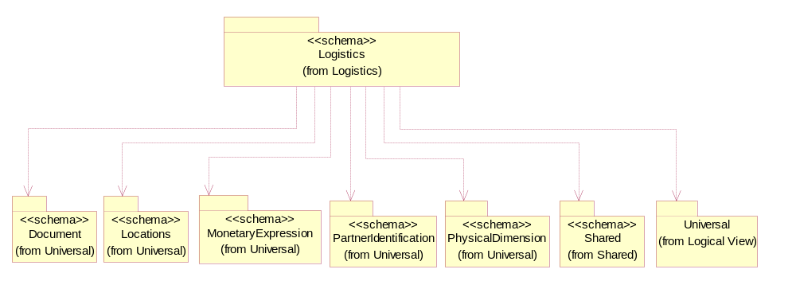
Figure 3-29 Dependency

BillOfLading
The collection of business properties that describes header information to appear on a Bill of Lading.
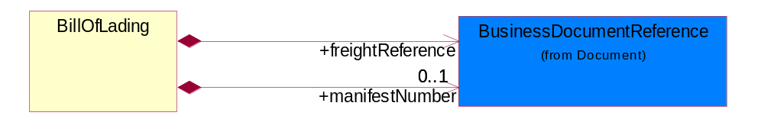
Figure 3-30 BillOfLading
Composition | Cardinality | Type | Documentation
freightReference | 1 | BusinessDocumentReference | A reference identifier for the shipment.
manifestNumber | 0..1 | BusinessDocumentReference | The manifest number for the shipment.

Customs
The collection of business properties that describes an information necessary to comply with Customs regulations during international transportations.
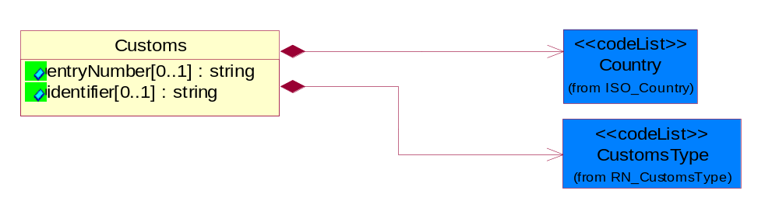
Figure 3-31 Customs

Attribute | Type | Documentation
entryNumber[0..1] | string | Unique tracking identification number that identifies a shipment routed through customs.
identifier[0..1] | string | Unique identification number assigned by a local customs authority.

Composition | Cardinality | Type | Documentation
Country | 1 | Country | For representation of Country name RosettaNet has adopted ISO 3166-3; 1999. Refer to the following web page to get the latest version of the standard:  http://www.iso.ch/iso/en/prods-services/iso3166ma/02iso-3166-code-lists/index.html  If you need more information about the ISO standard please contact ISO for more details.
CustomsType | 1 | CustomsType | The type of customs.

CustomsInformation
The collection of business properties that describe a information necessary to comply with local Customs regulations during international transportation.
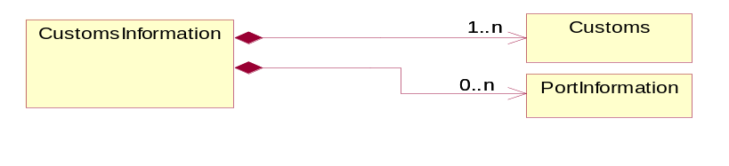
Figure 3-32 CustomsInformation

Composition | Cardinality | Type | Documentation
Customs | 1..n | Customs | The collection of business properties that describes an information necessary to comply with Customs regulations during international transportations.
PortInformation | 0..n | PortInformation | The collection of business properties that describes the harbor or haven where ships/aircrafts may anchor and discharge or receive cargo.

CustomsPermittedInformation
The collection of business properties describes the information permitted by Customs.
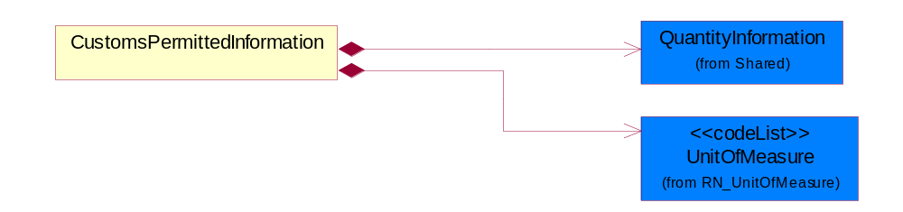
Figure 3-33 CustomsPermittedInformation
Composition | Cardinality | Type | Documentation
QuantityInformation | 1 | QuantityInformation | The collection of business properties that describes information regarding the quantity of the product shipped.
UnitOfMeasure | 1 | UnitOfMeasure | Code identifying a product unit of measure.

DateInformation
The collection of business properties that identifies a set of dates associated with this transaction.
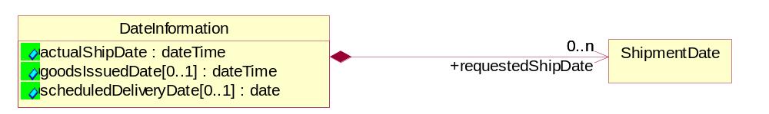
Figure 3-34 DateInformation

Attribute | Type | Documentation
actualShipDate | dateTime | The actual date a shipment was sent.
goodsIssuedDate[0..1] | dateTime | The date the goods were issued, i.e. usually when they were picked and packed.
scheduledDeliveryDate[0..1] | date | The (GMT) local date the product is scheduled for delivery.

Composition | Cardinality | Type | Documentation
requestedShipDate | 0..n | ShipmentDate | Date the shipper would like to make shipment or in a response referes to the original date a shipper proposed to ship.

ExportLicense
The collection of business properties that describe an export license number.
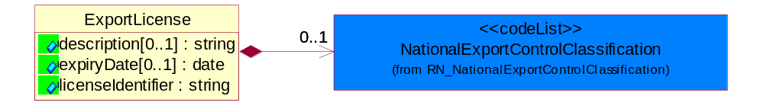
Figure 3-35 ExportLicense
Attribute | Type | Documentation
description[0..1] | string | The description of inventory item to appear on the commercial invoice.
expiryDate[0..1] | date | The date that a contractual agreement expires.
licenseIdentifier | string | The unique identifier representing a license.

Composition | Cardinality | Type | Documentation
NationalExportControlClassification | 0..1 | NationalExportControlClassification | Code identifying product classification for export regulation.

ForeignCurrencyControl
This object represents the currency control information.
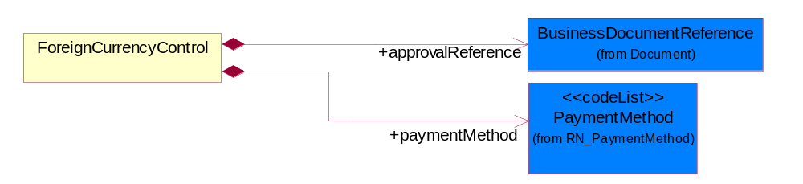
Figure 3-36 ForeignCurrencyControl
Composition | Cardinality | Type | Documentation
approvalReference | 1 | BusinessDocumentReference | This object represents the currency control approval reference which is assigned by foreign currency control board.
paymentMethod | 1 | PaymentMethod | This object represents the method used by exporter or agent to settle foreign currency through bank.

FreeOnBoardTerms
The collection of business properties that identifies the Free On Board terms.
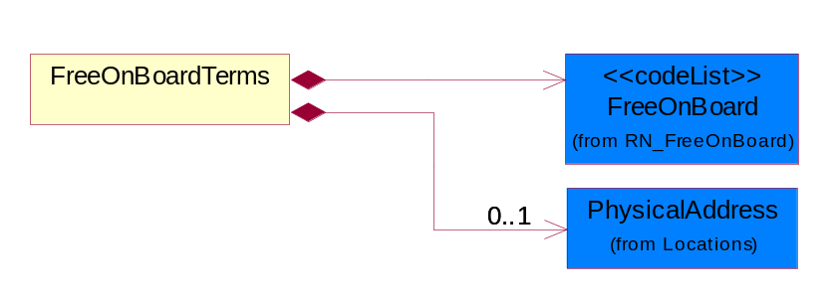
Figure 3-37 FreeOnBoardTerms
Composition | Cardinality | Type | Documentation
PhysicalAddress | 0..1 | PhysicalAddress | The business document must provide a physical address for a party to the business transaction.
FreeOnBoard | 1 | FreeOnBoard | Code identifying a specified point where a product is delivered or placed on board a carrier without charge.

FreightValuation
The valuation of the product or products for purposes such as insurance and customs declarations.
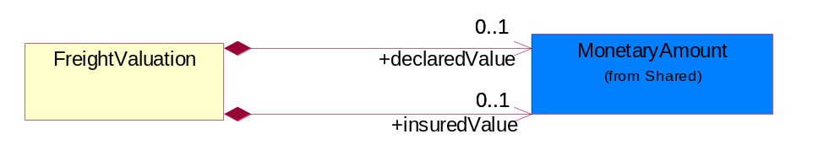
Figure 3-38 FreightValuation
Composition | Cardinality | Type | Documentation
declaredValue | 0..1 | MonetaryAmount | The invoice value of the product(s) sold to a customer.
insuredValue | 0..1 | MonetaryAmount | The amount or value declared for insurance purposes.

Handbook
The collection of business properties that describe a handbook published by Customs which is used to control the permitted values of goods being declared by goods category. This is to prevent under or over declaration of values of good.
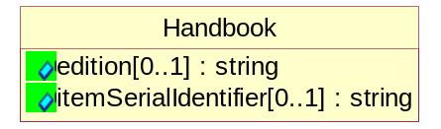
Figure 3-39 Handbook
Attribute | Type | Documentation
edition[0..1] | string | This object represents the handbook edition.
itemSerialIdentifier[0..1] | string | This object represents the item identifier in the handbook.

HarmonizedTariffScheduleInformation
The collection of business properties that describes a harmonized tariff schedule for a particular country.
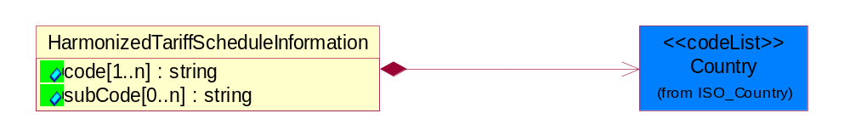
Figure 3-40 HarmonizedTariffScheduleInformation
Attribute | Type | Documentation
code[1..n] | string | Code identifying product classification or procedure classification for international shipping.
subCode[0..n] | string | Code identifying an extension of national harmonized tariff schedule code which is used for product classification or procedure classification for international shipping.

Composition | Cardinality | Type | Documentation
Country | 1 | Country | For representation of Country name RosettaNet has adopted ISO 3166-3; 1999. Refer to the following web page to get the latest version of the standard:  http://www.iso.ch/iso/en/prods-services/iso3166ma/02iso-3166-code-lists/index.html  If you need more information about the ISO standard please contact ISO for more details.

HazardousMaterialDescription
The collection of business properties that describe the nature of dangerous goods tendered for transportation.
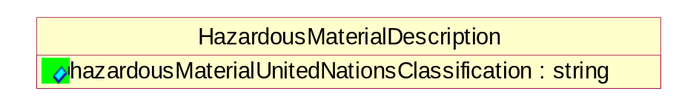
Figure 3-41 HazardousMaterialDescription

Attribute | Type | Documentation
hazardousMaterialUnitedNationsClassification | string | Code classifying hazardous material products.

Instructions
The collection of business properties that identifies shipping instruction notes and their location on shipping documents or labels.
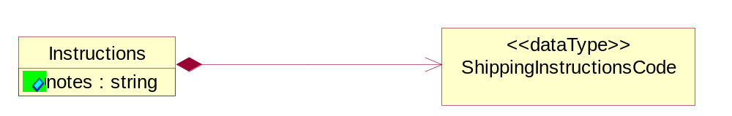
Figure 3-42 Instructions

Attribute | Type | Documentation
notes | string | Shipping instruction notes to appear on shipping documents or labels.

Composition | Cardinality | Type | Documentation
ShippingInstructionsCode | 1 | ShippingInstructionsCode | An internal identifier used to specify the location of a shipping instruction note on a shipping document or label.

IsHazardousMaterial
Indicates whether the product contains hazardous material.
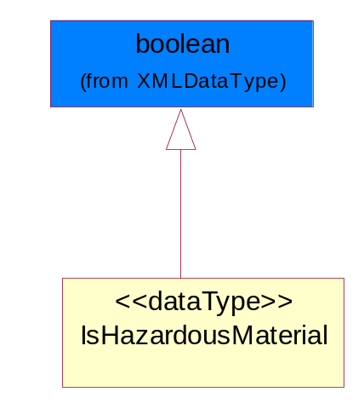
Figure 3-43 IsHazardousMaterial

LinearWithMeasureType
The business document must be able to express the linear dimensions of an object.
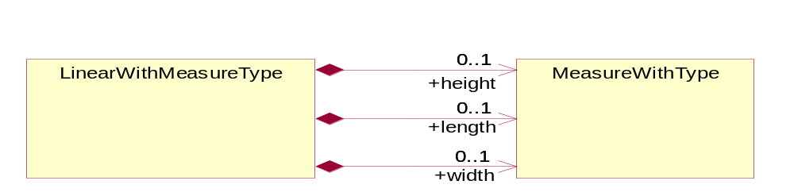
Figure 3-44 LinearWithMeasureType
Composition | Cardinality | Type | Documentation
length | 0..1 | MeasureWithType | To express the length of an object.
width | 0..1 | MeasureWithType | To express the weight of an object.
height | 0..1 | MeasureWithType | To express the height of an object.

LotReference
The collection of business properties that describe a manufacturing lot tendered for shipping.
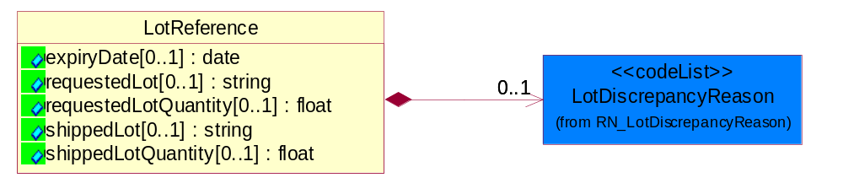
Figure 3-45 LotReference
Attribute | Type | Documentation
expiryDate[0..1] | date | The date that a contractual agreement expires.
requestedLot[0..1] | string | The identifier of a manufacturing lot from which a quantity of product was requested.
requestedLotQuantity[0..1] | float | The quantity of product requested from a specific manufacturing lot.
shippedLot[0..1] | string | The identifier of a manufacturing lot from which a quantity of product was shipped.
shippedLotQuantity[0..1] | float | A quantity of product shipped of a specific manufacturing lot within a shipping container.

Composition | Cardinality | Type | Documentation
LotDiscrepancyReason | 0..1 | LotDiscrepancyReason | Code identifying the reason for a discrepency in the lot composition of the shipment.

ManufacturerProfile
The collection of business properties that describe a manufacturer's product.
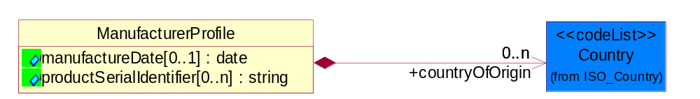
Figure 3-46 ManufacturerProfile

Attribute | Type | Documentation
manufactureDate[0..1] | date | The date the product was manufactured.
productSerialIdentifier[0..n] | string | Serial number(s) of a product.

Composition | Cardinality | Type | Documentation
countryOfOrigin | 0..n | Country | Country where product originates.

MassPhysicalDimension
The physical dimension of unit of mass used for measuring the masses of weights, volumes etc.
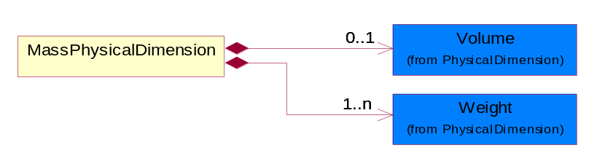
Figure 3-47 MassPhysicalDimension
Composition | Cardinality | Type | Documentation
Volume | 0..1 | Volume | The business document must be able to express the volume of an object.
Weight | 1..n | Weight | The business document must be able to express the weight of an object.

MeasureWithType
The business document must describe measurement information.
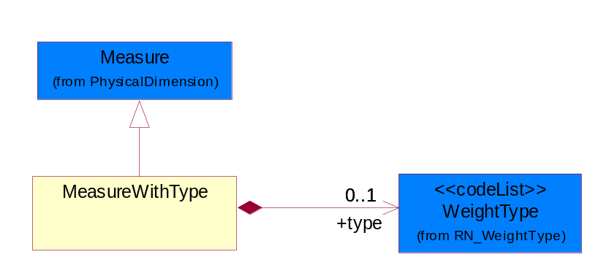
Figure 3-48 MeasureWithType

Composition | Cardinality | Type | Documentation
type | 0..1 | WeightType | A code identifying the type of measure.

OrderInformation
The collection of business properties that identifies a shipping order, including its identity, type and purpose.
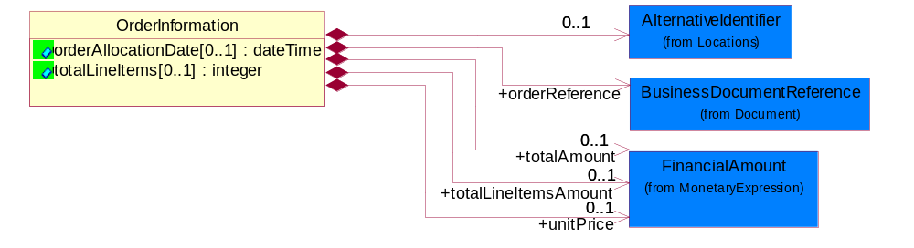
Figure 3-49 OrderInformation
Attribute | Type | Documentation
orderAllocationDate[0..1] | dateTime | Specifies an instance in time for the part was allocated.
totalLineItems[0..1] | integer | Total number of line items in an entire business document.

Composition | Cardinality | Type | Documentation
orderReference | 1 | BusinessDocumentReference | An additional reference number to identify a single shipment when there are multiple shipments resulting from a single requesting order.
AlternativeIdentifier | 0..1 | AlternativeIdentifier | Identifies the specified code and the name of the organization that a code is utilized from.
unitPrice | 0..1 | FinancialAmount | Agreed upon Export/Import invoice unit price.
totalAmount | 0..1 | FinancialAmount | Total price for an entire business document.
totalLineItemsAmount | 0..1 | FinancialAmount | Total price for all shipping order line items.

PhysicalDimension
The physical dimension of a quantity such as length, time, mass.
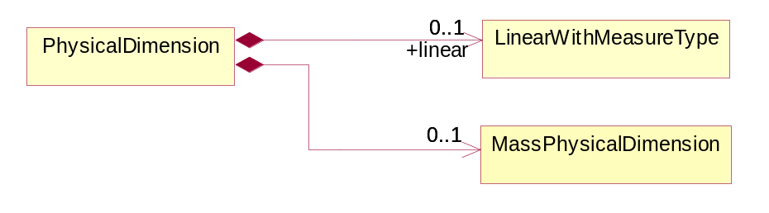
Figure 3-50 PhysicalDimension
Composition | Cardinality | Type | Documentation
MassPhysicalDimension | 0..1 | MassPhysicalDimension | The physical dimension of unit of mass used for measuring the masses of weights, volumes etc.
linear | 0..1 | LinearWithMeasureType | The business document must be able to express the linear dimensions of an object.

PortIdentification
The collection of business properties that defines types of ports as specified per IATA and IMO Codes and in ISO 3166-1 for country code and ISO 3166-2 for location code.
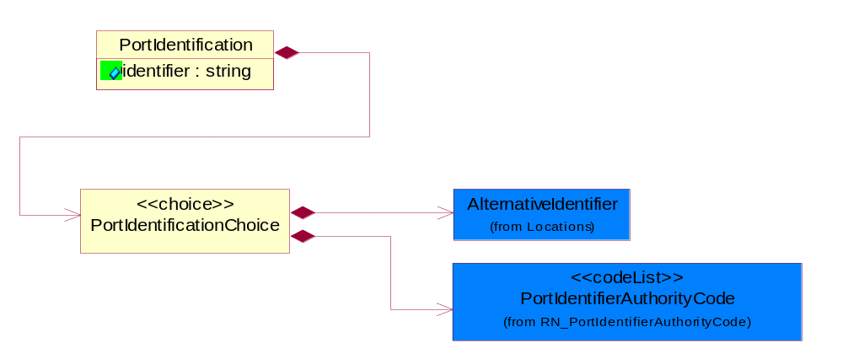
Figure 3-51 PortIdentification
Attribute | Type | Documentation
identifier | string | Code identifying Port as specified by the referenced Port Identifier Authority.

Composition | Cardinality | Type | Documentation
PortIdentificationChoice | 1 | PortIdentificationChoice | Choices of business properties that defines types of ports as specified per IATA and IMO Codes and in ISO 3166-1 for country code and ISO 3166-2 for location code.

PortIdentificationChoice
Choices of business properties that defines types of ports as specified per IATA and IMO Codes and in ISO 3166-1 for country code and ISO 3166-2 for location code.

Composition | Cardinality | Type | Documentation
AlternativeIdentifier | 1 | AlternativeIdentifier | Identifies the specified code and the name of the organization that a code is utilized from.
PortIdentifierAuthorityCode | 1 | PortIdentifierAuthorityCode | Code identifying the Authority maintaining the Port Identifier.

PortInformation
The collection of business properties that describes the harbor or haven where ships/aircrafts may anchor and discharge or receive cargo.
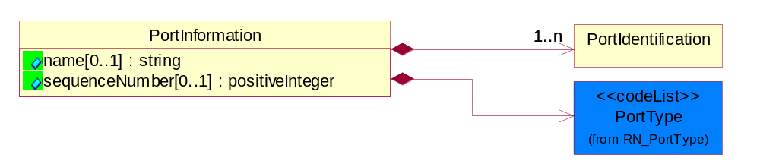
Figure 3-52 PortInformation
Attribute | Type | Documentation
name[0..1] | string | Additional code used locally (within each country/local leigslation) to further identify Port Codes as specified per IATA and IMO Codes and in ISO 3166-1 for country code and ISO 3166-2 for location code.
sequenceNumber[0..1] | positiveInteger | A positive integer which identifies the order of a designated element within a specified set.

Composition | Cardinality | Type | Documentation
PortType | 1 | PortType | Code identifying the type of ports used during a shipment.
PortIdentification | 1..n | PortIdentification | The collection of business properties that defines types of ports as specified per IATA and IMO Codes and in ISO 3166-1 for country code and ISO 3166-2 for location code.

ShipmentDate
The collection of business properties that identifies a constraint on when the products may be shipped.
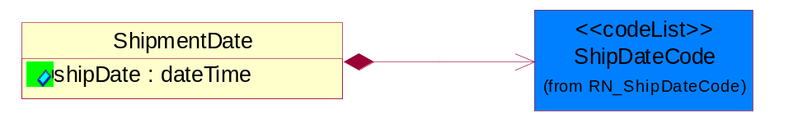
Figure 3-53 ShipmentDate
Attribute | Type | Documentation
shipDate | dateTime | The date when the shipment maybe shipped.

Composition | Cardinality | Type | Documentation
ShipDateCode | 1 | ShipDateCode | Code identifying a type of ship date.

ShippingDocumentReference
The shipping document reference object allows for the indirect referencing of a relationship to other shipping related business documents.
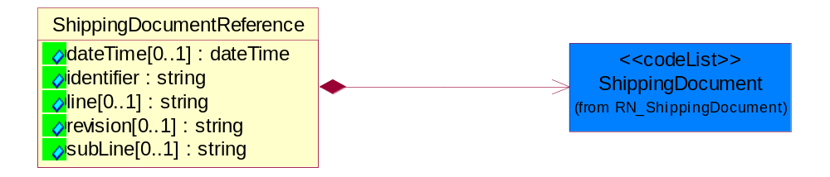
Figure 3-54 ShippingDocumentReference
Attribute | Type | Documentation
dateTime[0..1] | dateTime | The date-time stamp indicating on the referenced business document.
identifier | string | Unique identification of the referenced business document.
line[0..1] | string | References the specific line number of the specified business document.
revision[0..1] | string | Referenced the revision of the specified business document.
subLine[0..1] | string | References the specific subline number of the specified business document.

Composition | Cardinality | Type | Documentation
ShippingDocument | 1 | ShippingDocument | Code identifying a type of shipping document.

ShippingInstructionsCode
An internal identifier used to specify the location of a shipping instruction note on a shipping document or label.
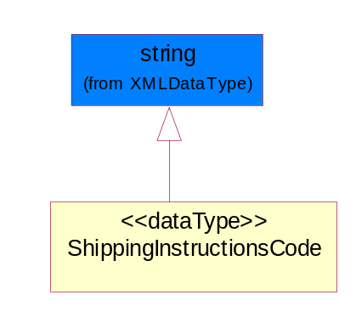
Figure 3-55 ShippingInstructionsCode

TrackingReference
Proprietary unique identifier for tracking product shipments.
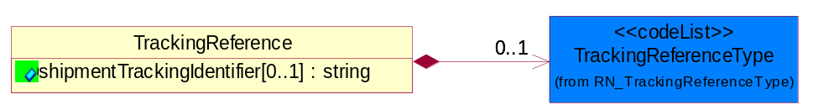
Figure 3-56 TrackingReference
Attribute | Type | Documentation
shipmentTrackingIdentifier[0..1] | string | Proprietary unique identifier for tracking product shipments.

Composition | Cardinality | Type | Documentation
TrackingReferenceType | 0..1 | TrackingReferenceType | Code identifying the type of document reference being used to track a shipment.

CodeList

TrackingReferenceType
Code identifying the type of document reference being used to track a shipment.

Name | Documentation
BKN | Booking Number - Shipment identification number assigned by shipper when booking freight shipment with carrier.
BOL | Bill of Lading Number - Shipment identification number on bill of lading issued by shipper, forwarder or carrier.
CIN | Commercial Invoice - An invoice for customs purposes to allow the determination of the proper import/export duty/taxes.
CRN | Carrier Reference Number - Carrier assigned shipment identification number on bill of lading.
FTR | Freight Tracking Reference - Reference number that describes information about tracing shipments during the transportation process.
HAN | House Airwaybill Number - Forwarder assigned shipment identification number on bill of lading issued by forwarder.
MAB | Master Airwaybill Number - Carrier assigned shipment identification number on bill of lading issued by carrier.
OBL | Ocean Bill of Lading Number - Carrier assigned shipment identification number on bill of lading issued by carrier.
PON | Purchase Order Number.
PRO | Pro Number - Carrier assigned shipment identification number on bill of lading.
PSN | Packing Slip Number - Shipment identification number on shipment contents packing list attached to shipment.
RFI | Radio Frequency Identification (RFID).
RRN | Route Reference Number.
SID | Seal Identifier - Trailer or container seal number assigned by party closing doors on trailer or container.
SON | Seller Sales Order Number.
SRN | Shipper Reference Number - Shipper assigned shipment identification number on bill of lading issued by shipper or forwarder.
TRN | Trailer Number - Owner assigned equipment identification number on trailer.

Incoterms
Code identifying incoterms.

Name | Documentation
CFR | Cost and Freight (named port of destination).
CIF | Cost, Insurance and Freight (named port of destination).
CIP | Carriage and insurance paid to (named place of destination).
CPT | Carriage Paid To (named place of destination).
DAF | Delivered at Frontier (named place).
DDP | Delivered Duty Paid (named place of destination).
DDU | Delivered Duty Unpaid (named place of destination).
DEQ | Delivered Ex Quay (duty paid) (named port of destination).
DES | Delivered Ex Ship (named port of destination).
EXW | Ex Works (named place).
FAS | Free Along Ship (named port of shipment).
FCA | Free Carrier (named place).
FOB | Free on Board (named port of shipment).

ShipmentMode
The method of transport used for the conveyance of goods.

Name | Documentation
AIE | Air Express.
AIF | Air Freight.
AIR | Air.
COC | Contract Carrier.
COO | Containerized Ocean.
CPI | Customer Pickup.
EXT | Expedited Truck.
INM | Intermodal.
MAT | Mail Transport.
MOT | Motor.
OCE | Ocean.
OTH | Others.
PRC | Private Carrier.
RAI | Rail.
TRK | Truck.

NationalExportControlClassification
Code identifying product classification for export regulation.

Name | Documentation
CLE | Clearance - The cargo will be or has been cleared.
CUC | Already customs cleared in the importing country, arrangement for inspection are not necessary because they were cleared before.
DET | Detention - The cargo has been or will be detained.
DOR | Documents Required - Pertinent documents are required.
DRC | Documents Requirements Completed - All requirements for documents have been completed.
FUM | Fumigation - The cargo has been or will be fumigated.
IAC | Inspection Arrangements Completed - Arrangements for inspection of the cargo have been completed.
IAR | Inspection Arrangements Required - Arrangements for inspection of the cargo are required.
INS | Inspection - The cargo has been or will be inspected.
LWI | Lowest Importance.
NCP | No Customs Procedure - Customs clearance not required.
SAC | Safety Arrangements Completed - Arrangements for safeguarding the cargo have been completed.
SAR | Safety Arrangements Required - Arrangements for safeguarding the cargo are required.
SCR | Security - The cargo has been or will be secured.
SEC | Security Arrangements Completed - Arrangements for storing the cargo have been completed.
SER | Security Arrangements Required - Arrangements for the security of the cargo are required.
STR | Storage arrangements required - Arrangements for storing the cargo are required.
TAC | Transport Arrangements Completed - All arrangements for transport have been completed.
TAR | Transport Arrangements Required - Transport has to be arranged.

PortType
Code identifying the type of ports used during a shipment.

Name | Documentation
POC | Port of Discharge - The location (port, or airport) at which shipment is off-loaded by a transportation line, not to be confused with destination which may be a point further inland. Port where cargo is discharged from conveyance.
POE | Port of Export - Location (port, airport, or Customs point) from which an export shipment leaves a country for a voyage to a foreign country (this location can be the same or different from port of loading). This is the port of exit from exporting country.
POH | Port of Transhipment - Location (port, or airport) where cargo changes conveyance (off-loaded from 1st coveyance & loaded onto 2nd conveyance). There could be multiple occurence of Ports of Transhipment.
POI | Port of Import - Location (port, airport, or Customs point) from which an imported shipment enters/admitted into the receiving/importing country. Ports of Import are officially designated by the importing country's government and as such Customs formalities would be required at this port.
POL | Port of Loading - Location at where goods are loaded into Containers (or prepared for exports).
PON | Port of Destination - The location at which the shipment is destined to be sent.
POO | Port of Origin - The location at which the shipment originates from.

PortIdentifierAuthorityCode
Code identifying the Authority maintaining the Port Identifier.

Name | Documentation
IATA | International Air Transport Association.
ICAO | International Civil Aviation Organization.
IMO | International Maritime Organization.
ISO | International Organization for Standardization.
NVOCC | Non Vessel Operating Common Carrier.
VOCC | Vessel Operating Common Carrier.

CustomsType
The type of customs.

Name | Documentation
EXP | Export.
IMP | Import.

ShipDateCode
Code identifying a type of ship date.

Name | Documentation
ACP | Acceptance.
ACT | Action.
ADY | Arrival at Destination Yard.
AED | Accrual End Date.
AFT | Actual Free Time Expiration Date.
APD | Actual Pickup Date.
APL | Actual Placement.
ASD | Accrual Start Date.
BDO | Beginning Date of Customer Plant Shutdown.
BOI | Bill of Lading Initiated Date.
BOL | Bill of Lading.
BPE | Buy Period Date (End).
BPS | Buy Period Date (Start).
BRD | Backorder Release Date.
CAD | Cancel After This Date.
CBD | Charge Back Date.
CCL | Contract Closed.
CDA | Check Date.
CFP | Contract Final Payment.
CFR | Charged From.
COD | Cutoff Date.
CPC | Contract Physically Completed.
CRE | Customs Release.
CTO | Charged To.
DAG | Delivery Appointment Granted Date.
DAR | Date Available/Constructive Replacement.
DAS | Delivery Appointment Scheduled Date.
DBT | Delivered By This Date.
DDC | Date Delivery Commenced.
DIC | Date Invoice Created.
DIS | Date Issued.
DLC | Date Loading Commenced.
DLD | Date Loading Completed.
DNB | Deliver Not Before Date.
DNL | Deliver No Later Than Date.
DOT | Delivered on This Date.
DPA | Duty Paid.
DRD | Demand Receipt Date.
DRS | Delivery Requested Scheduled Date.
DRT | Delivery Requested on This Date.
DSP | Date Shipped to Port of Embarkation (POE).
DUL | Date Unloaded.
DWO | Deliver Week Of.
ECC | Estimated Contract Completion.
ECL | Extended Closeout.
EDA | Effective Date.
EDB | Expiration Date.
EDD | Estimated Delivery Date.
EDO | Ending Date of Customer Plant Shutdown.
EES | Est. Next Promo, Ship Date End.
EFD | Equipment Furnished Date.
EPD | Earliest Pickup Date.
EPE | Est. Next Promo (Date end).
EPS | Est. Next Promo (Date start).
ERE | Expected Reply.
ESE | Est. Next Promo, Ship Date Start.
FBD | Freight Bill Date.
FOD | First Order Date.
FSD | First Ship Date.
GED | Guarantee Expiration Date.
INS | Inspection.
IVD | Invoice Date.
LAC | Last Acquisition.
LDE | Last Demand.
LPD | Latest Pickup Date.
MNF | Manufacture.
MRB | Must Respond By.
NTF | Notified.
OFD | Offered for Delivery.
OPO | Original Purchase Order Date.
ORD | Ordered.
OTR | Original Transaction.
PAG | Pickup Appointment Granted Date.
PAS | Pickup Appointment Scheduled Date.
PBD | Publication Date.
PCE | Price Change Effective Date.
PCL | Price Change Last Arrival Date.
PCM | Price Change Last Order Date.
PCO | Purchase Order Date.
PCR | Purchase Order Received.
PCS | Price Change Last Ship Date.
PDA | Pack Date.
PDE | Promotion Order Date (End).
PDS | Promotion Order Date (Start).
PFE | Promotion Floor Stock Protect (End).
PFS | Promotion Floor Stock Protect (Start).
PME | Promotion Ship Date (End).
PMO | Promotion End.
PMS | Promotion Ship Date (Start).
PMT | Promotion Start.
PPD | Preferred Payment Date.
PPE | Promotion Performance Date (End).
PPS | Promotion Performance Date (Start).
PRD | Product Receipt Date.
PRE | Period End.
PRQ | Promotion Requested Delivery Date (End).
PRS | Promotion Requested Delivery Date (Start).
PSD | Process Date.
PSH | Pickup Requested Scheduled Date.
PVE | Promotion Invoice Protection Date (End).
PVS | Promotion Invoice Protection Date (Start).
RDD | Requested Delivery Date.
REC | Recorded.
REJ | Rejection.
REL | Released.
REQ | Required By.
RPD | Requested Pack Date.
RSD | Requested Ship Date/Pick-up Date.
SDA | Scheduled Delivery Date - Appointment confirmed.
SDC | Scheduled Delivery Date - Needs confirmation.
SDD | Scheduled Delivery Date.
SHB | Ship Not Before Date.
SHL | Ship Not Later Than Date.
SHO | Shipped on This Date.
SIG | Signature.
SIS | Store Inventory Stock.
SLD | Sold Date.
SLE | Shelf-Life Expiration.
SLG | Sailing Date.
SPA | Scheduled Pick-up Date - Appointment confirmed.
SPE | Spot for Load Exchange Date (Export).
SPL | Spot for Load Date.
SPN | Scheduled Pick-up Date - Needs confirmation.
SPP | Scheduled Pick - Up Date.
SPS | Spot for Storage Date (No shipment).
SPU | Spot for Unload Date.
SSC | Scheduled Service Completion.
SUD | Superseded Date.
SWO | Ship Week Of Date.
TDD | Terms Discount Due Date.
TND | Terms Net Due Date.
TRA | Transfer.
TRS | Transaction Control Date.
VAL | Validated.
WIS | Warehouse Inventory Stock.
WRT | Warranty Expiration.

FreightPaymentTerms
Code identifying responsibility for payment of shipping charges.

Name | Documentation
ADC | Advance Collect.
ADP | Advance Prepaid.
COD | Collect on Delivery.
COF | Collect, freight credited back to customer.
COL | Collect.
CPI | Customer Pick-up/backhaul.
DBS | Defined by buyer and seller.
FOB | FOB Port of Call.
HPR | Half Prepaid.
MIX | Mixed.
NRE | Non Revenue.
PBB | Paid by Buyer.
PBS | Paid by Seller.
PCO | Per Contract.
PIC | Pickup.
PPC | Prepaid but charged to customer.
PPL | Prepaid local, collect outstate.
PPO | Prepaid Only.
PPP | Prepaid by Processor.
PPS | Prepaid (by seller).
PPY | Prepaid and summary bill.
RCF | Return Container Freight Free.
RCG | Return container freight paid by customer.
RCH | Return container freight paid by supplier.
RUL | Rule 11 Shipment.
SFN | Service freight, no charge.
TPP | Third Party Pay.
WCO | Weight Condition.

LotDiscrepancyReason
Code identifying the reason for a discrepency in the lot composition of the shipment.

Name | Documentation
DLO | Damaged Lot - Lot was found to be damaged.
WLO | Wrong Lot - Expecting different lot.
WLQ | Wrong Lot Quantity - Expecting different lot quantity.

RouteLocation
Code identifying the route location of some point after a shipment is created within a carrier's system.

Name | Documentation
ACL | Activity Location - Generally used to signify an activity has happened at a location that is not on the shipment routing, or the shipment routing could not be determined by the party sending the event. Rails use this all the time, because they can report hundreds of activities for a cross-country move.
BLO | Bill Of Lading Origin Of Goods - Contractual. Origin of goods can differ from origin of shipment. Ocean carrier can take posession of goods at a load port, but the BL must state a different location. Factory door.
BWH | Bonded Warehouse.
COM | Customs Office Of Manifest Destination - Sending the customs manifest location to customer, especially for inland clearance points, since it may not be defined on the route any other way.
COO | Customs Office Of Manifest Origin.
COP | Consolidation Point.
DCP | De-Consolidation Point.
DFW | Duty Free Warehouse.
DFZ | Duty Free Zone.
EXM | Export Manufacturing.
FID | Final Destination.
FPD | Final Port of Discharge.
INP | Interim Point - Rails differentiate between transit and interim. An interim point is a passing point. A transit point is where the train is passing through a major rail facility but the train does not change in makeup - no railcars added or removed.
LGC | Logistics Center.
NDF | Non Duty Free Zone.
PDC | Place of Delivery - Contractual.
PDE | Place of Delivery.
POC | Port of Discharge - The location (port, or airport) at which shipment is off-loaded by a transportation line, not to be confused with destination which may be a point further inland. Port where cargo is discharged from conveyance.
POE | Port of Export - Location (port, airport, or Customs point) from which an export shipment leaves a country for a voyage to a foreign country (this location can be the same or different from port of loading). This is the port of exit from exporting country.
POH | Port of Transhipment - Location (port, or airport) where cargo changes conveyance (off-loaded from 1st coveyance & loaded onto 2nd conveyance). There could be multiple occurence of Ports of Transhipment.
POI | Port of Import - Location (port, airport, or Customs point) from which an imported shipment enters/admitted into the receiving/importing country. Ports of Import are officially designated by the importing country's government and as such Customs formalities would be required at this port.
POL | Port of Loading - Location at where goods are loaded into Containers (or prepared for exports).
PON | Port of Destination - The location at which the shipment is destined to be sent.
POO | Port of Origin - The location at which the shipment originates from.
POR | Place Of Receipt - Contractual. The place of receipt contractual is where the ocean carrier takes possession of the cargo.
RCP | Reconsolidation Point.

ContainerSpecification
This object represents the specification of a shipping container.

Name | Documentation
LNG | 40 footer and longer or equivalent container.
SHT | 20 footer and equivalent container.

ShippingDocument
Code identifying a type of shipping document.

Name | Documentation
BDE | Bonded Declaration - A bonded declaration is used to move cargo from bond to bond, (i.e. between bonded areas) without payment of duties/taxes. Bonded area in this context means area that deemed or licensed by Customs, e.g. Free Trade Zone, Free Industrial Zone or Bonded Warehouse.
BOL | Bill of Lading.
CIN | Commercial Invoice.
COO | Certificate of Origin.
EDE | Export Declaration.
EXC | Exception.
IDE | Import Declaration - To identify the type of shipping document as an import declaration for explicitly going through Import proceedings.
LCS | License.
PFI | Pro Forma Invoice.
PLI | Packing List.
SIN | Sales Invoice - An invoice containing sales information.
SIS | Sales Invoice Summary - A summary of sales invoice data.
SLO | Shippers Letter of Instruction.

Shared

Shared

Dependency Diagram
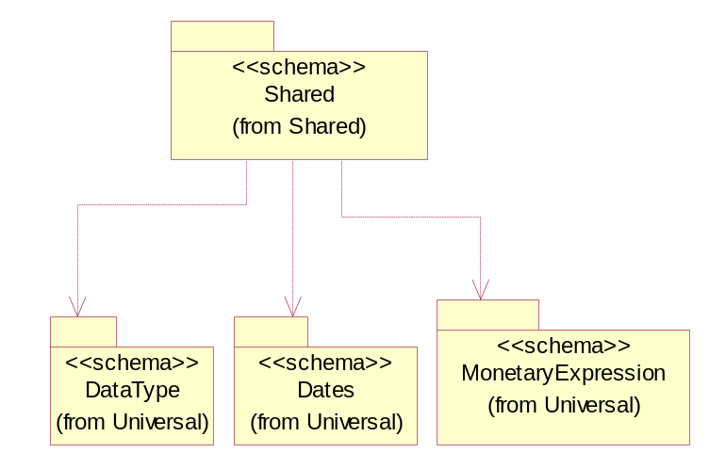
Figure 3-57 Dependency

MonetaryAmount
The collection of business properties that describe the monetary amount defined by a specified currency.
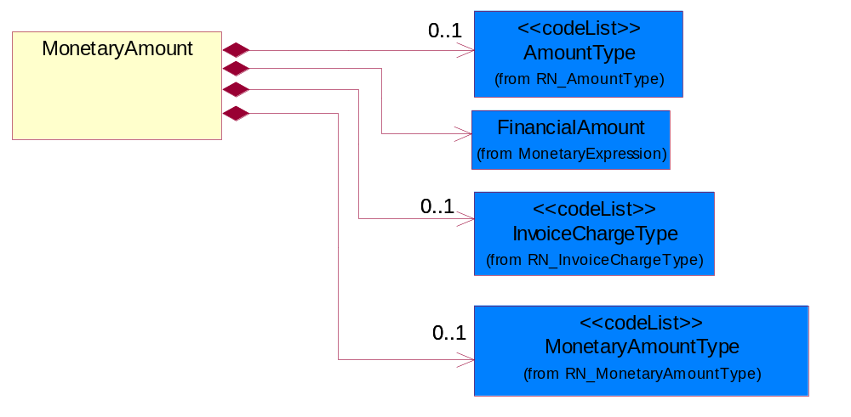
Figure 3-58 MonetaryAmount
Composition | Cardinality | Type | Documentation
FinancialAmount | 1 | FinancialAmount | The business document must express financial amounts.
InvoiceChargeType | 0..1 | InvoiceChargeType | Code identifying the values for the types of charges contained in an invoice.
MonetaryAmountType | 0..1 | MonetaryAmountType | Code identifying whether the monetary amount is a debit or credit.
AmountType | 0..1 | AmountType | Code identifying the type of monetary amount.

ProductQuantity
A quantity specifying the number of product units.
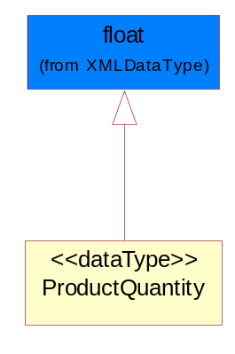
Figure 3-59 ProductQuantity

QuantityInformation
The collection of business properties that describes information regarding the quantity of the product shipped.
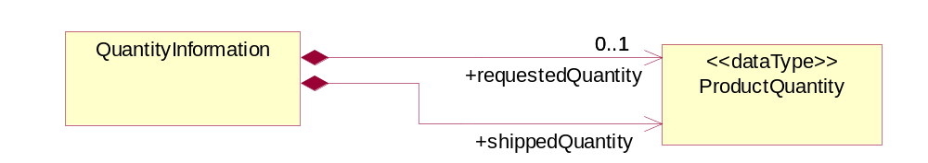
Figure 3-60 QuantityInformation
Composition | Cardinality | Type | Documentation
requestedQuantity | 0..1 | ProductQuantity | The quantity of product requested.
shippedQuantity | 1 | ProductQuantity | Quantity of product shipped.

Rate
The percentage of an amount.
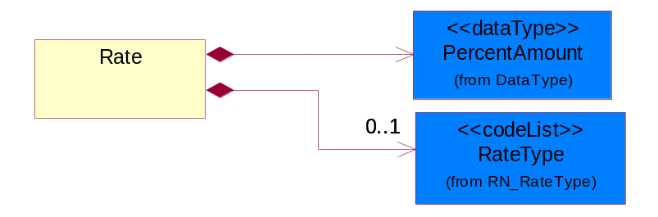
Figure 3-61 Rate
Composition | Cardinality | Type | Documentation
PercentAmount | 1 | PercentAmount | A number representing a percentage value, e.g. 75.125 represents 75 1/8 percent.
RateType | 0..1 | RateType | The type of a rate.

CodeList

FreeOnBoard
Code identifying a specified point where a product is delivered or placed on board a carrier without charge.

Name | Documentation
DES | Destination.
NMA | Name Address.
ORG | Origin.

InvoiceChargeType
Code identifying the values for the types of charges contained in an invoice.

Name | Documentation
ALC | Allowances and Charges.
CUC | Custom Charges.
DEA | Deposit Amount.
ESC | Expedited Shipping Charge - Charge for accelerating the delivery of a product.
FRC | Freight Charges.
HAC | Handling Charges.
LEC | Lease Charge - Charge for the use of a product in which the purchaser assumes certain responsibilities of ownership.
LIC | License Charge - Charge for the use of a product (usually software) in which the manufacturer maintains ownership of the product.
MAC | Maintenance Charge - Charge (usually periodic) for providing maintenance support for a product.
PUC | Purchase Charge - Charge for a product in which the buyer takes all responsibilities of ownership.
QUD | Quantity Discount.
REC | Rental Charge - Charge for the use of a product (usually hardware) in which the manufacturer maintains ownership of the product.

MonetaryAmountType
Code identifying whether the monetary amount is a debit or credit.

Name | Documentation
CRE | Credit.
DEB | Debit.
ZER | Zero remit.

PackageType
Code specifying the type of packaging for a product.

Name | Documentation
BOX | Box.
BRL | Barrel.
CRT | Carton.
LPK | Loose Package.
MHC | Material/Method of holding a string of computer chips.
MIX | Mixed Package.
OTH | Others.
PAC | Parcel.
PBG | Plastic Ball Grind Array.
PBX | Paper Box.
PCC | Plastic Chip Carrier.
PLT | Pallet.
REE | Reel.
TQF | Thin Quad Flat Package.
TRA | Tray.
TUB | Plastic tube to hold computer chips.
WDC | Wooden Crate.

ShippingServiceLevel
Code identifying the shipping service level, e.g., overnight, same day.

Name | Documentation
1BD | 1BD, Same Business Day - 4 hour Response Time.
5BD | 5 Business Days.
9AM | 9 A.M.
ACH | Air Charter.
AEC | Air Economy.
AIC | Air Cargo.
AM | A.M.
ARS | Authorized Return Service.
ATA | Airport to Airport.
ATD | Airport to Door.
BCT | Bulk Commodity Train.
BUC | Business Class.
CBS | Consignee Billing Service.
COE | Courier Express.
DCR | Delivery Confirmation Return.
DEC | Delivery Confirmation.
DES | Deferred Service.
DNO | Delivery Notification Only.
DOS | Door Service.
DSN | Delivery scheduled next day by cartage agent.
DSS | Delivery scheduled second day by cartage agent.
DST | Delivery scheduled third day by cartage agent.
DTA | Door to Airport.
DTD | Door to Door.
DTP | Door to Port (Ocean).
ESP | Express Service Plus.
ESV | Expedited Service.
ESW | Expedited Service Worldwide.
EXS | Express Service.
EXW | Express Service - Worldwide.
FIC | First Class.
GEN | General.
GRO | Ground.
ISS | Other intermodal and stack service.
MAF | Manifest freight.
MET | Metro.
MUW | Multiweight.
NBD | Next Business Day.
NDA | Next Day Air.
NEM | Next Morning.
NFO | Next Flight Out.
NHW | Next day Hundred Weight.
NOR | NORMAL - Normal delivery.
NOS | Not served.
OIS | Other Intermodal and Stack service
OTH | Other.
OVN | Overnight.
PAS | Passenger service.
PIU | Pickup.
PM | PM.
PMI | Priority Mail Insured.
POB | P.O. Box/Zip code.
POD | Proof of Delivery (POD) with Signature.
PRM | Priority Mail.
PRS | Premium Surface.
PS1 | Primary Service Area - Next Day by 10:30 A.M.
PS2 | Primary Service Area - Next Day by 5:00 P.M.
PS3 | Primary Service Area - Next Day By 9:30 A.M.
PS4 | Primary Service Area - Next Day by Noon.
PS5 | Primary Service Area - Second Day by Noon.
PTD | Port to Door (Ocean).
PTP | Port to Port (Ocean).
REG | Regular.
SAD | Same day.
SAP | Saturday Pickup.
SAT | Saturday.
SBD | SBD, Second Business Day.
SCH | Scheduled.
SDA | Second Day Air.
SDW | Second Day Hundred Weight.
SED | Second Day.
SEM | Second Morning.
SGW | Standard Ground Hundred Weight.
STC | Standard Class.
STG | Standard Ground.
STO | Standard Ocean.
STS | Standard Service.
SUH | Sunday and Holidays.
TDS | Three Day Service.
TIC | Time Critical.
TRG | Tracking - Ground.

PaymentMethod
Code identifying how the trading partner paid the seller for the product.

Name | Documentation
ACH | Automated Clearing House (ACH).
ACR | ACH Reversal.
BAD | Batched Delivery.
BIA | Billing Account.
BND | Bank Draft.
BOE | Book Entry.
CAC | Cashier's Check.
CAS | Cash.
CBB | Compensation by Balance.
CCP | ACH Savings Cash Concentration/Disbursement Plus (CCD+) Credit.
CCR | CCD+(NACHA Cash Concentration/Disbursement - Funds Transacted Plus an 80 Record Remittance Detail).
CCW | CCD (NACHA Cash Concentration/Disbursement - Funds Transacted without Remittance Information).
CDA | Credit/Debit Account.
CDD | Pre-Arranged Payment or Deposit (PPD) Credit to a Demand Deposit Account.
CDP | ACH Savings Cash Concentration/Disbursement Plus (CCD+) Debit.
CDS | Pre-Arranged Payment or Deposit (PPD) Credit to Savings.
CHE | Check.
CHIPS | Clearing House Interbank Payment System (CHIPS)Funds/Wire Transfer.
CLH | Clearinghouse.
CPC | Collect Payment by Company Check.
CPF | Collect Payment by Certified Funds.
CPP | Pre-Arranged Payment or Deposit Plus Addendum (PPD+) Credit to a Demand Deposit Account.
CRA | Credit Account.
CRC | Credit Card.
CRE | Credit.
CTC | ACH Savings Corporate Trade Exchange (CTX) Credit.
CTD | ACH Savings Corporate Trade Exchange (CTX) Debit.
CTP | CTP (NACHA Corporate Trade Payment - Transaction Plus Remittance Detail in Fixed Format).
CTX | CTX (NACHA Corporate Trade Exchange - Transaction Plus Remittance Detail in ANSI Standard Flexible Format).
CXC | ACH Demand Corporate Trade Exchange (CTX) Credit.
CXD | ACH Demand Corporate Trade Exchange (CTX) Debit.
DBT | Defined by TPA.
DCC | ACH Demand Cash Concentration/Disbursement (CCD) Credit.
DCD | ACH Demand Cash Concentration/Disbursement (CCD) Debit.
DCP | ACH Demand Cash Concentration/Disbursement Plus (CCD+) Credit.
DDA | Pre-Arranged Payment or Deposit (PPD) Debit to a Demand Deposit Account.
DDP | ACH Demand Cash Concentration/Disbursement Plus (CCD+) Debit.
DEB | Debit.
DEC | Debit Card.
DEM | Debit Memo.
DID | Direct Deposit.
DPP | Pre-Arranged Payment or Deposit Plus Addendum (PPD+) Debit to a Demand Deposit Account.
DRA | Draft.
DWO | Discount was Offered.
ECN | EDIBANX Clearing Network.
EFT | EFT.
EPS | Electronic Payment System.
EXC | 1035 Exchange.
FIN | Financed.
FIO | Financial Institution Option.
FPB | Freight Payment Bank.
FRN | Federal Reserve Funds/Wire Transfer - Nonrepetitive.
FRR | Federal Reserve Funds/Wire Transfer - Repetitive.
GRA | Graduated.
INS | Invoiced Separately.
JPO | Joint Purchase Option.
LAP | Lease Agreement is in Place.
LEV | Level (Sum Constant).
LOB | Lock Box.
LOC | Letter of Credit has been provided.
MOD | Money order.
MOO | Money Order.
MOR | Mail order.
NPD | Non-Payment Data.
NPR | No Payment is Required.
OTH | Other.
PAM | Payment has Already been Made.
PAN | Payment is Net.
PAS | Payment after shipment.
PBC | Payment is made by Check.
PBS | Payment before shipment.
PCC | Payment is pre-paid with Credit Card.
PCP | ACH Savings Cash Concentration/Disbursement (PPD+) Credit.
PDD | ACH Savings Cash Concentration/Disbursement (PDD) Debit.
PDP | ACH Savings Cash Concentration/Disbursement (PPD+) Debit.
PIK | Payment was made in Kind.
PME | Payment was Made Electronically.
PMI | Payment will be made the Month after the Invoice.
PMN | Promissory note.
PNA | Private Netting Agreement, Pay by Wire Transfer.
PPC | Payment is made by Pre-paid Check.
PPD | ACH Savings Cash Concentration/Disbursement (PPD) Credit.
PPW | Payment is Pre-paid by Wire.
PRC | Preauthorized Check (Draft).
PRN | Proprietary Network.
PVC | Previously Charged.
PVN | Private Netting, Pay by Check.
PWT | Payment is made via Wire Transfer.
PYN | Payment note.
RDA | Related Detail Account.
SCC | ACH Savings Cash Concentration/Disbursement (CCD) Credit.
SCD | ACH Savings Cash Concentration/Disbursement (CCD) Debit.
SPA | Special Account.
SUA | Summary Account.
SWIFT | Society for Worldwide Interbank Financial Telecommunications (S.W.I.F.T.).
TGT | Telegraphic transfer.
TOF | Transfer of Funds by the banking institution.
TRC | Traveler's Check.
VIS | VISA Special Electronic Funds Transfer Network.
WAI | Waived.
WIT | Wire Transfer.

AmountType
Code identifying the type of monetary amount.

Name | Documentation
DIS | Discount Value - The monetary amount of the discount on the price applied to a customer order.
FRE | Freight Charges - The monetary amount to be paid for freight transportation.
INS | InsuranceCharges - The monetary amount to be paid for freight insurance.
MAT | Material Cost - This object represents the material cost for the product.
MIS | Miscellaneous Charges - The monetary amount to be paid for miscellaneous charges.
PRC | Processing Charges - The monetary amount to be paid by consignee for consignment manufacturer.
TOD | Total Amount Due - Total amount due upon receipt of statement.
TOT | Total Amount - Total price for an entire business document.
TOV | Total Value Added Amount - The total amount of the shipment including any value added tax.
UNI | Unit Price - Agreed upon sale price for each unit ordered.
VAD | Value Added Unit Price - The price of a unit including any value added tax.

RateType
The type of a rate.

Name | Documentation
ANC | Ancillary Rate - Adjustment rate applied to unit shipment. For instance, those duties and/or taxes subject to a bond taken as security if goods are not re-exported within a given period. In those circumstances where security required equates to 150% of the duty and/or taxes, the adjustment to be entered here is 1.5. The system will automatically calculate the 1.5 uplift.
DIS | Discount Rate - The percentage discount on the price applied to a customer order.
FRE | Freight Charges Rate - The rate for the charges to be paid for freight transportation.
INS | Insurance Charges Rate - The rate for the insurance charges.
MIS | Miscellaneous Charges Rate - The rate of miscellaneous charges.
TAX | Taxation Rate - The rate for the taxation for the items being declared.

Universal Structure

ContactInformation

ContactInformation
The business document must allow for the identification of the name of the department, service or individual to be contacted regarding the context of the business document.
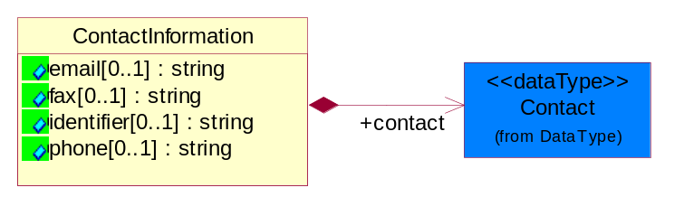
Figure 4-62 ContactInformation
Attribute | Type | Documentation
email[0..1] | string | The electronic mail for the specified contact.
fax[0..1] | string | The fax number for the specified contact.
identifier[0..1] | string | Identifies the role of the contact (i.e. Service Technician, Account Manager) in the Business Process.
phone[0..1] | string | The telephone number for the specified contact.

Composition | Cardinality | Type | Documentation
contact | 1 | Contact | The name of the department, service or individual to be contacted within the organization.

DataType

Contact
The name of the department, service or individual to be contacted within the organization.
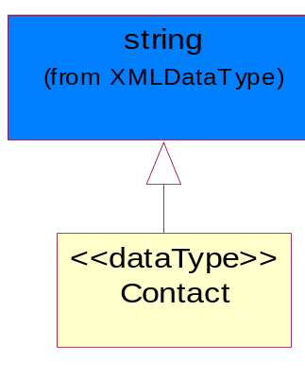
Figure 4-63 Contact

DUNS
A number assigned by Dun and Bradstreet to identify a business location.
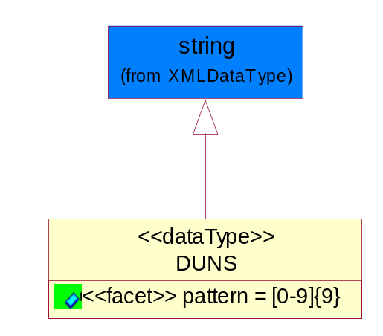
Figure 4-64 DUNS
Attribute | Type | Documentation
pattern |  | [0-9]{9}

DUNSPlus4
A identifier to specify a specific location within a business location.
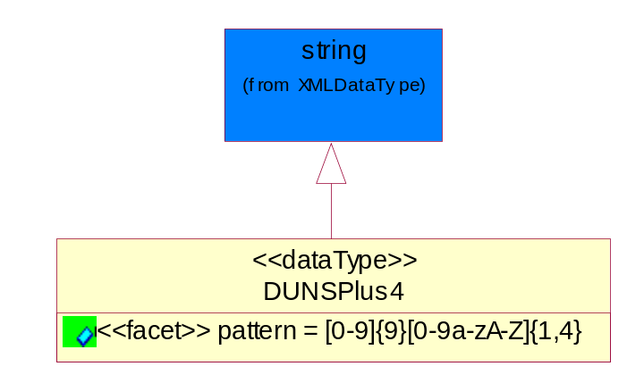
Figure 4-65 DUNSPlus4
Attribute | Type | Documentation
pattern |  | Data Universal Numbering System +4 (DUNS+4) number means the DUNS number assigned by Dun and Bradstreet, Inc. (D&B) plus an alphanumeric of length 4 suffix that may be assigned by a business concern.

GLN
Global Location Number (GLN) - A identifier to identify legal entities, trading parties and location.
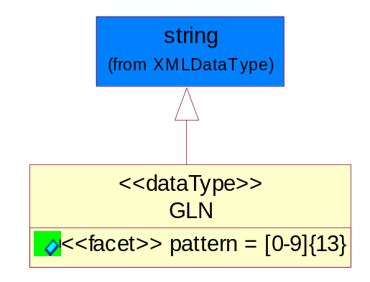
Figure 4-66 GLN

Attribute | Type | Documentation
pattern |  | [0-9]{13}

GTIN
Global Trade Identification Number (GTIN).
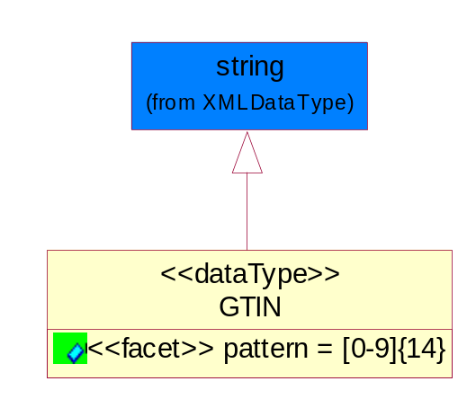
Figure 4-67 GTIN
Attribute | Type | Documentation
pattern |  | [0-9]{14}

PercentAmount
A number representing a percentage value, e.g. 75.125 represents 75 1/8 percent.
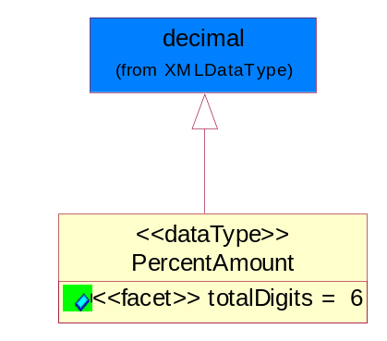
Figure 4-68 PercentAmount
Attribute | Type | Documentation
totalDigits |  | 6

Dates

StartAndEndDate
The start and end date of a certain period.
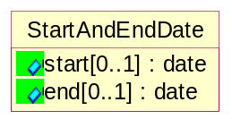
Figure 4-69 StartAndEndDate
Attribute | Type | Documentation
start[0..1] | date | The start date of a period.
end[0..1] | date | The endt date of a period.

Document

BusinessDocumentReference
The business document reference object allows for the indirect referencing of a relationship to other business related documents.
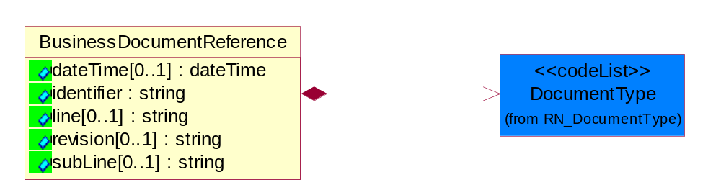
Figure 4-70 BusinessDocumentReference

Attribute | Type | Documentation
dateTime[0..1] | dateTime | The date-time stamp indicating on the referenced business document.
identifier | string | Unique identification of the referenced business document.
line[0..1] | string | References the specific line number of the specified business document.
revision[0..1] | string | Referenced the revision of the specified business document.
subLine[0..1] | string | References the specific subline number of the specified business document.

Composition | Cardinality | Type | Documentation
DocumentType | 1 | DocumentType | A code identifying the business context of a document.

Locations

AlternativeIdentifier
Identifies the specified code and the name of the organization that a code is utilized from.
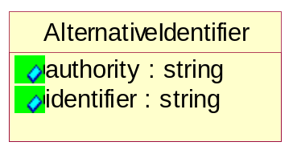
Figure 4-71 AlternativeIdentifier

Attribute | Type | Documentation
authority | string | The name of the organization that a code is utilized from.
identifier | string | The specified code to represent an entity (e.g. product, location, partner, etc.).

Location
The business document must specify a location.
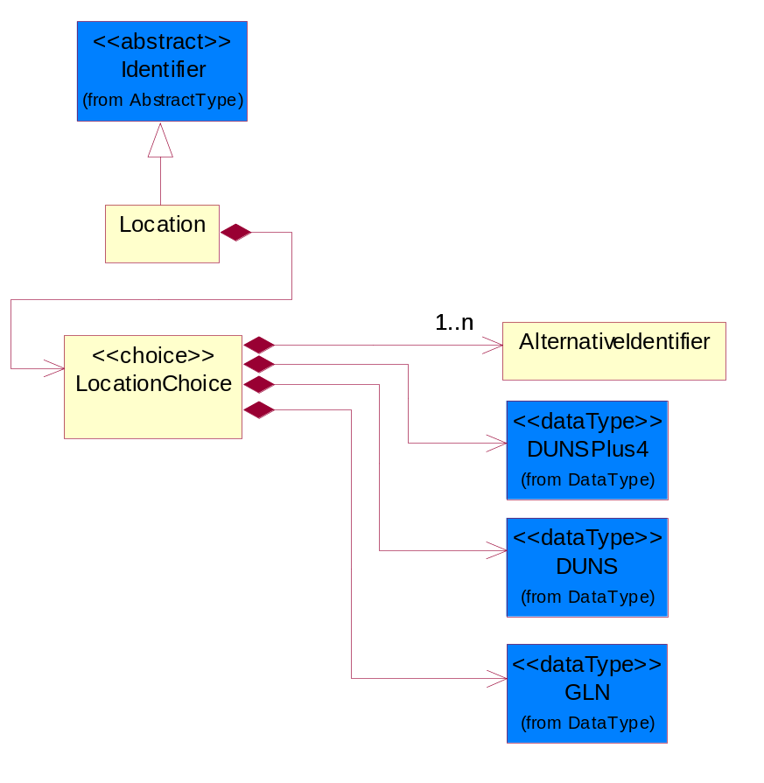
Figure 4-72 Location
Composition | Cardinality | Type | Documentation
LocationChoice | 1 | LocationChoice

LocationChoice
Composition | Cardinality | Type | Documentation
DUNSPlus4 | 1 | DUNSPlus4 | A identifier to specify a specific location within a business location.
DUNS | 1 | DUNS | A number assigned by Dun and Bradstreet to identify a business location.
AlternativeIdentifier | 1..n | AlternativeIdentifier | Identifies the specified code and the name of the organization that a code is utilized from.
GLN | 1 | GLN | Global Location Number (GLN) - A identifier to identify legal entities, trading parties and location.

PhysicalAddress
The business document must provide a physical address for a party to the business transaction.
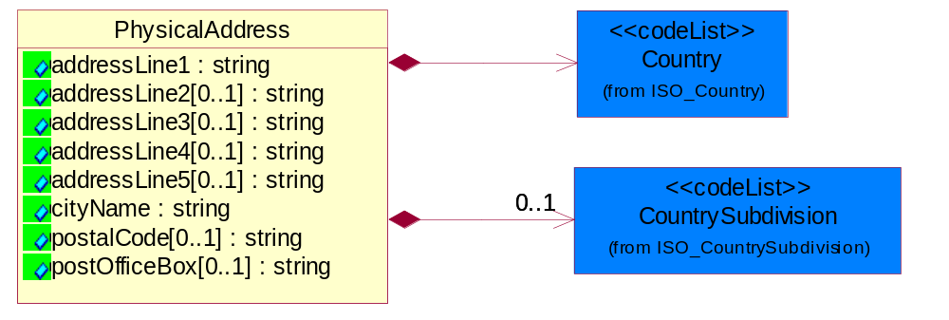
Figure 4-73 PhysicalAddress

Attribute | Type | Documentation
addressLine1 | string | The first line of a physical address.
addressLine2[0..1] | string | The second line of a physical address.
addressLine3[0..1] | string | The third line of a physical address.
addressLine4[0..1] | string | The fourth line of a physical address.
addressLine5[0..1] | string | The fifth line of a physical address.
cityName | string | The name of a city.
postalCode[0..1] | string | Identifying geographic location as specified by a national postal code.
postOfficeBox[0..1] | string | The Post Office Box identifier used to identify a party's post office box.

Composition | Cardinality | Type | Documentation
Country | 1 | Country | For representation of Country name RosettaNet has adopted ISO 3166-3; 1999. Refer to the following web page to get the latest version of the standard:  http://www.iso.ch/iso/en/prods-services/iso3166ma/02iso-3166-code-lists/index.html  If you need more information about the ISO standard please contact ISO for more details.
CountrySubdivision | 0..1 | CountrySubdivision | For representation of a Countries subdivisions RosettaNet has adopted ISO 3166-3; 1999. Refer to the following web page to get the latest version of the standard:  http://www.iso.ch/iso/en/prods-services/iso3166ma/02iso-3166-code-lists/index.html  If you need more information about the ISO standard please contact ISO for more details.

MonetaryExpression

FinancialAmount
The business document must express financial amounts.
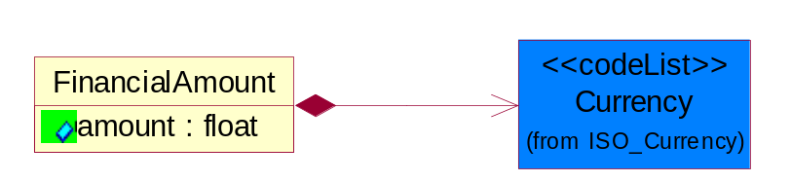
Figure 4-74 FinancialAmount

Attribute | Type | Documentation
amount | float | Specifies the monetary amount.

Composition | Cardinality | Type | Documentation
Currency | 1 | Currency | For representation of Currency codes RosettaNet has adopted ISO 4217; 1995. The British Standards Institution (BSI) is the ISO 4217 Maintenance Agency. Refer to the following web page to get the latest version of the standard:  http://www.bsi-global.com/Technical+Information/Publications/_Publications/tig90.xalter  If you need more information about the ISO standard please contact ISO for more details.

PartnerIdentification

FullPartner
The business document must describe the trading partners in the business transaction. This data structure provide the flexibility to describe a partner in all possible methods as for new, existing or known partner.
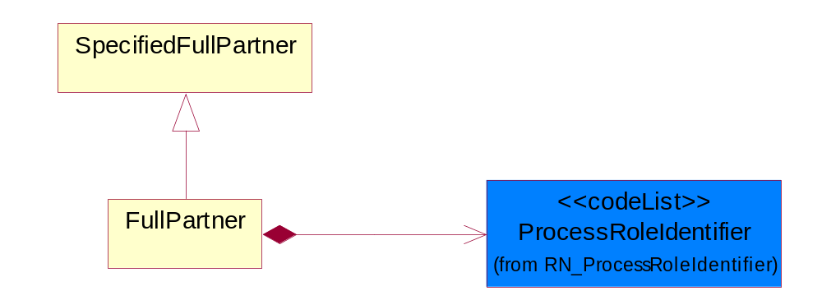
Figure 4-75 FullPartner

Composition | Cardinality | Type | Documentation
ProcessRoleIdentifier | 1 | ProcessRoleIdentifier | Describes the role of the partner in the business process. A partner will fulfill at least one or more roles during the business process.

IntermittentPartner
The business document must describe a physical address for a delivery.
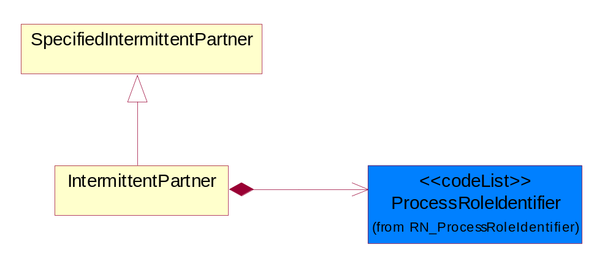
Figure 4-76 IntermittentPartner

Composition | Cardinality | Type | Documentation
ProcessRoleIdentifier | 1 | ProcessRoleIdentifier | Describes the role of the partner in the business process. A partner will fulfill at least one or more roles during the business process.

KnownPartner
The business document must describe the trading partners in the business transaction.
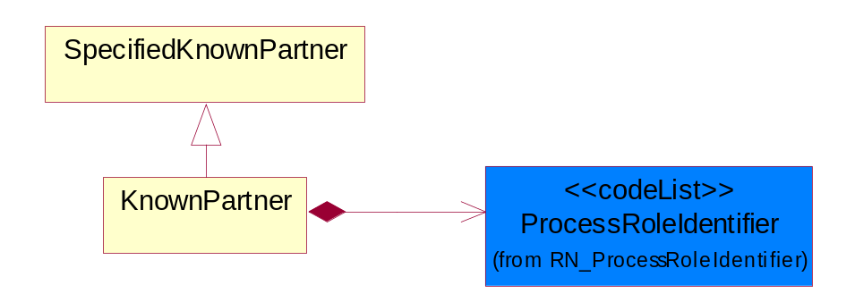
Figure 4-77 KnownPartner

Composition | Cardinality | Type | Documentation
ProcessRoleIdentifier | 1 | ProcessRoleIdentifier | Describes the role of the partner in the business process. A partner will fulfill at least one or more roles during the business process.

KnownPartnerContact
The business document must describe the trading partners in the business transaction.
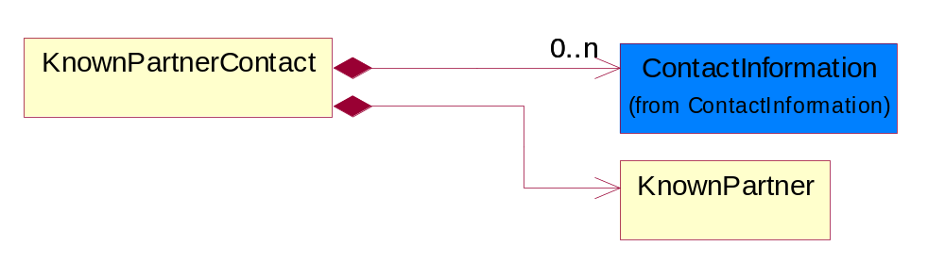
Figure 4-78 KnownPartnerContact

Composition | Cardinality | Type | Documentation
KnownPartner | 1 | KnownPartner | The business document must describe the trading partners in the business transaction.
ContactInformation | 0..n | ContactInformation | The business document must allow for the identification of the name of the department, service or individual to be contacted regarding the context of the business document.

NewPartner
The business document must describe a new, existing (but known to only one of the parties to the transaction) or an unknown party to the business transaction.
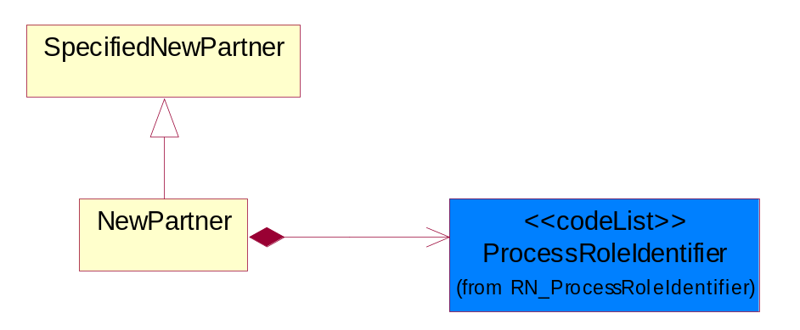
Figure 4-79 NewPartner

Composition | Cardinality | Type | Documentation
ProcessRoleIdentifier | 1 | ProcessRoleIdentifier | Describes the role of the partner in the business process. A partner will fulfill at least one or more roles during the business process.

PartnerDescription
The collection of business properties that describe a business partners' identity, their contact information, where they are physically located and their function in a supply chain.
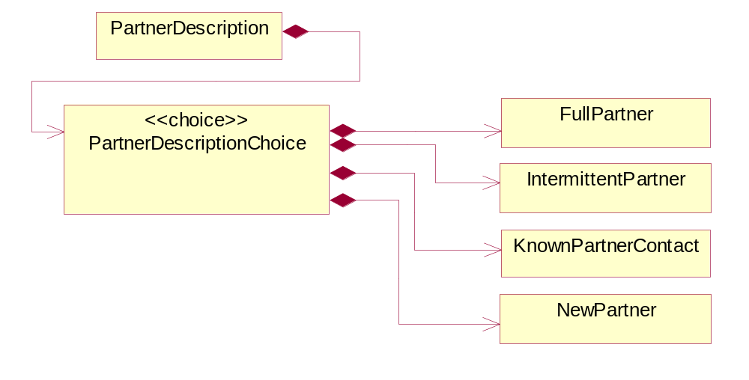
Figure 4-80 PartnerDescription
Composition | Cardinality | Type | Documentation
PartnerDescriptionChoice | 1 | PartnerDescriptionChoice

PartnerDescriptionChoice

Composition | Cardinality | Type | Documentation
KnownPartnerContact | 1 | KnownPartnerContact | The business document must describe the trading partners in the business transaction.
IntermittentPartner | 1 | IntermittentPartner | The business document must describe a physical address for a delivery.
NewPartner | 1 | NewPartner | The business document must describe a new, existing (but known to only one of the parties to the transaction) or an unknown party to the business transaction.
FullPartner | 1 | FullPartner | The business document must describe the trading partners in the business transaction. This data structure provide the flexibility to describe a partner in all possible methods as for new, existing or known partner.

PartnerIdentification
The business document must allow for the identity of one or more parties to the transaction.
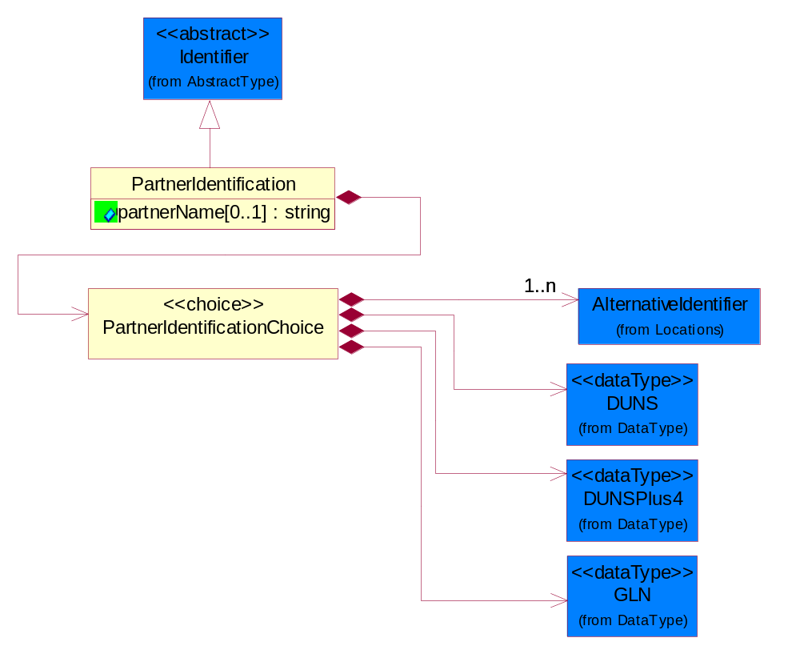
Figure 4-81 PartnerIdentification
Attribute | Type | Documentation
partnerName[0..1] | string | The name of the partner’s company/business.

Composition | Cardinality | Type | Documentation
PartnerIdentificationChoice | 1 | PartnerIdentificationChoice

PartnerIdentificationChoice
Composition | Cardinality | Type | Documentation
DUNS | 1 | DUNS | A number assigned by Dun and Bradstreet to identify a business location.
DUNSPlus4 | 1 | DUNSPlus4 | A identifier to specify a specific location within a business location.
AlternativeIdentifier | 1..n | AlternativeIdentifier | Identifies the specified code and the name of the organization that a code is utilized from.
GLN | 1 | GLN | Global Location Number (GLN) - A identifier to identify legal entities, trading parties and location.

SpecifiedFullPartner
The business document must describe the trading partners in the business transaction. This data structure provide the flexibility to describe a partner in all possible methods as for new, existing or known partner. This is specifically for partner who role has been specified.
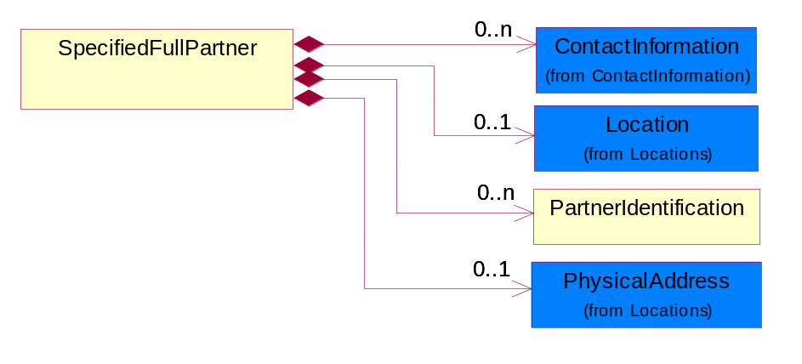
Figure 4-82 SpecifiedFullPartner
Composition | Cardinality | Type | Documentation
ContactInformation | 0..n | ContactInformation | The business document must allow for the identification of the name of the department, service or individual to be contacted regarding the context of the business document.
Location | 0..1 | Location | The business document must specify a location.
PartnerIdentification | 0..n | PartnerIdentification | The business document must allow for the identity of one or more parties to the transaction.
PhysicalAddress | 0..1 | PhysicalAddress | The business document must provide a physical address for a party to the business transaction.

SpecifiedIntermittentPartner
The business document must describe a physical address for a delivery.
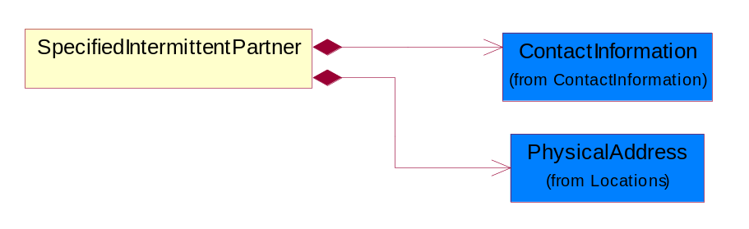
Figure 4-83 SpecifiedIntermittentPartner
Composition | Cardinality | Type | Documentation
ContactInformation | 1 | ContactInformation | The business document must allow for the identification of the name of the department, service or individual to be contacted regarding the context of the business document.
PhysicalAddress | 1 | PhysicalAddress | The business document must provide a physical address for a party to the business transaction.

SpecifiedKnownPartner
The business document must describe the trading partners in the business transaction.
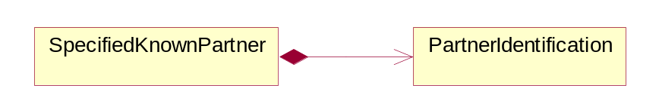
Figure 4-84 SpecifiedKnownPartner
Composition | Cardinality | Type | Documentation
PartnerIdentification | 1 | PartnerIdentification | The business document must allow for the identity of one or more parties to the transaction.

SpecifiedKnownPartnerContact
The business document must describe the trading partners in the business transaction and allow for a identification of an individual of the trading partner.
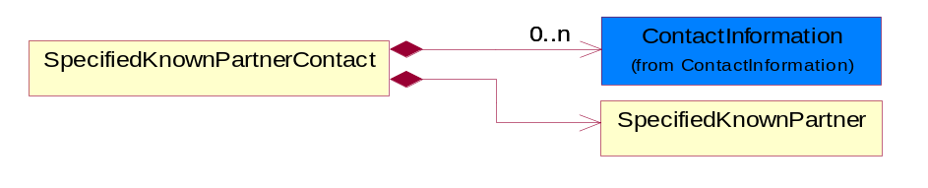
Figure 4-85 SpecifiedKnownPartnerContact

Composition | Cardinality | Type | Documentation
SpecifiedKnownPartner | 1 | SpecifiedKnownPartner | The business document must describe the trading partners in the business transaction.
ContactInformation | 0..n | ContactInformation | The business document must allow for the identification of the name of the department, service or individual to be contacted regarding the context of the business document.

SpecifiedNewPartner
The business document must describe a new, existing (but known to only one of the parties to the transaction) or an unknown party to the business transaction.
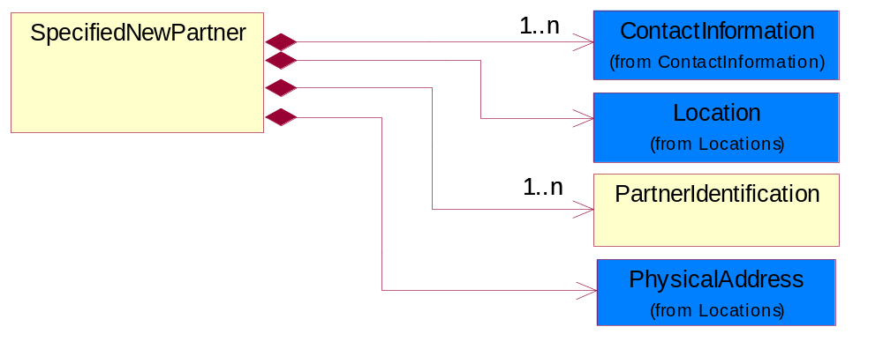
Figure 4-86 SpecifiedNewPartner
Composition | Cardinality | Type | Documentation
ContactInformation | 1..n | ContactInformation | The business document must allow for the identification of the name of the department, service or individual to be contacted regarding the context of the business document.
Location | 1 | Location | The business document must specify a location.
PhysicalAddress | 1 | PhysicalAddress | The business document must provide a physical address for a party to the business transaction.
PartnerIdentification | 1..n | PartnerIdentification | The business document must allow for the identity of one or more parties to the transaction.

SpecifiedPartnerDescription
The collection of business properties that describe a business partners' identity, their contact information, where they are physically located and their function in a supply chain.
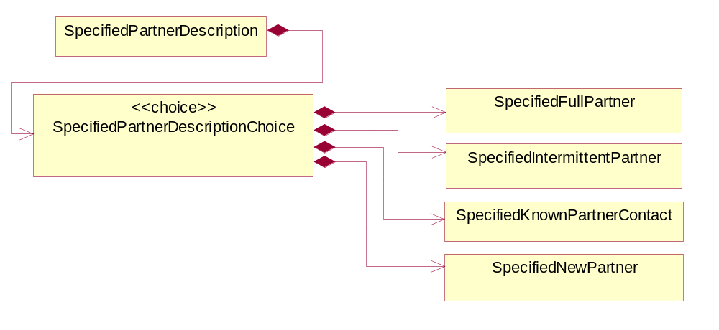
Figure 4-87 SpecifiedPartnerDescription

Composition | Cardinality | Type | Documentation
SpecifiedPartnerDescriptionChoice | 1 | SpecifiedPartnerDescriptionChoice

SpecifiedPartnerDescriptionChoice

Composition | Cardinality | Type | Documentation
SpecifiedKnownPartnerContact | 1 | SpecifiedKnownPartnerContact | The business document must describe the trading partners in the business transaction and allow for a identification of an individual of the trading partner.
SpecifiedIntermittentPartner | 1 | SpecifiedIntermittentPartner | The business document must describe a physical address for a delivery.
SpecifiedNewPartner | 1 | SpecifiedNewPartner | The business document must describe a new, existing (but known to only one of the parties to the transaction) or an unknown party to the business transaction.
SpecifiedFullPartner | 1 | SpecifiedFullPartner | The business document must describe the trading partners in the business transaction. This data structure provide the flexibility to describe a partner in all possible methods as for new, existing or known partner. This is specifically for partner who role has been specified.

PhysicalDimension

Measure
The business document must describe measurement information.
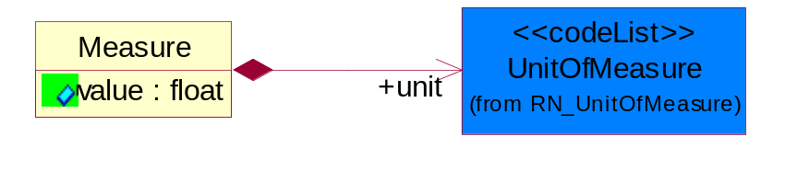
Figure 4-88 Measure
Attribute | Type | Documentation
value | float | The worth of an object in the specified unit of measure.

Composition | Cardinality | Type | Documentation
unit | 1 | UnitOfMeasure | To express the unit type of measurement.

Volume
The business document must be able to express the volume of an object.
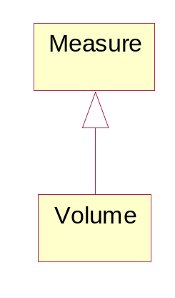
Figure 4-89 Volume

Weight
The business document must be able to express the weight of an object.
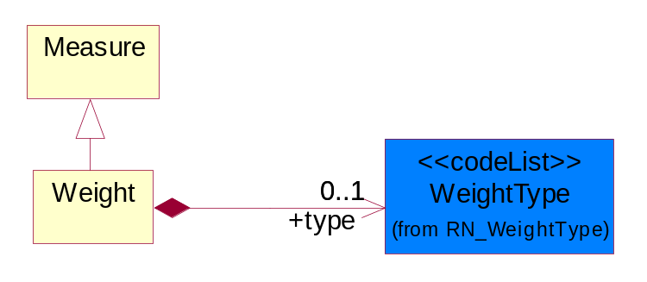
Figure 4-90 Weight
Composition | Cardinality | Type | Documentation
type | 0..1 | WeightType | A code identifying the type of weight.

ProductIdentification

ProductIdentification
The object provides the identifier(s) of a product.
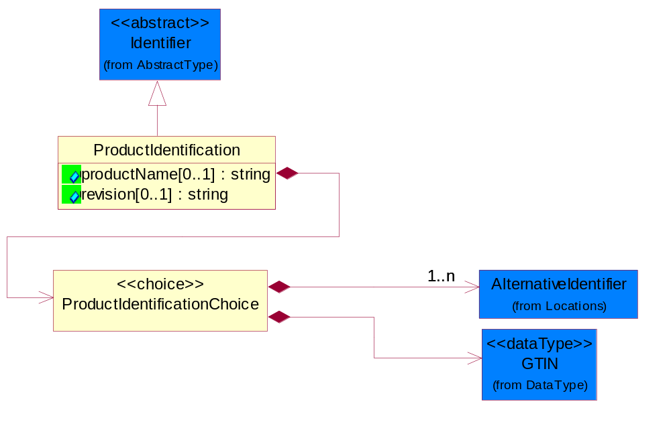
Figure 4-91 ProductIdentification
Attribute | Type | Documentation
productName[0..1] | string | The name of the product.
revision[0..1] | string | Referenced the specified product revision.

Composition | Cardinality | Type | Documentation
ProductIdentificationChoice | 1 | ProductIdentificationChoice

ProductIdentificationChoice

Composition | Cardinality | Type | Documentation
AlternativeIdentifier | 1..n | AlternativeIdentifier | Identifies the specified code and the name of the organization that a code is utilized from.
GTIN | 1 | GTIN | Global Trade Identification Number (GTIN).

TextualDescription
The business document must allow for multiple levels of textual description of an event or object.
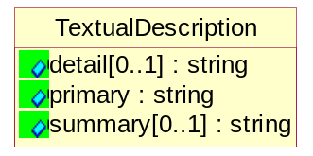
Figure 4-92 TextualDescription

Attribute | Type | Documentation
detail[0..1] | string | A detail description of an event or object.
primary | string | A phrase or single word description of an event or object.
summary[0..1] | string | A condensed description of an event or object.

CodeList

Country
For representation of Country name RosettaNet has adopted ISO 3166-3; 1999. Refer to the following web page to get the latest version of the standard:
http://www.iso.ch/iso/en/prods-services/iso3166ma/02iso-3166-code-lists/index.html

If you need more information about the ISO standard please contact ISO for more details.

CountrySubdivision
For representation of a Countries subdivisions RosettaNet has adopted ISO 3166-3; 1999. Refer to the following web page to get the latest version of the standard:
http://www.iso.ch/iso/en/prods-services/iso3166ma/02iso-3166-code-lists/index.html

If you need more information about the ISO standard please contact ISO for more details.

Currency
For representation of Currency codes RosettaNet has adopted ISO 4217; 1995. The British Standards Institution (BSI) is the ISO 4217 Maintenance Agency. Refer to the following web page to get the latest version of the standard:
http://www.bsi-global.com/Technical+Information/Publications/_Publications/tig90.xalter

If you need more information about the ISO standard please contact ISO for more details.

Language
For representation of Language name RosettaNet has adopted ISO 639-2; 1998. Refer to the following web page to get the latest version of the standard:

http://www.loc.gov/standards/iso639-2/iso639jac.html

If you need more information about the ISO standard please contact ISO for more details.

DocumentType
A code identifying the business context of a document.

Instance | Documentation
ARA | Authorization Request Approval.
CBN | Product batch number of customer.
CCN | Customs clearance number.
CFA | Failure Analysis - Request document that will accompany the product providing characteristics of the component failure.
CIN | Commercial Invoice.
CNM | Traditional credit note or memo.
CON | In a virtual sourcing relationship, a third party trading partner is supplying a part to a customer on behalf of another company that has taken the order for the customer. In this case a Customer Order Number is associated to the request for material that is sent to the virtual trading partners.
COS | Consumption Notice.
COT | Contract.
CRN | Unique consumption reference number identifying the product consumption issue i.e. one-to-one relationship with physical flow.
DEM | Traditional debit note or memo.
DEN | Delivery Note.
DIN | Discontinuation Notice.
DOR | Delivery Order.
DRN | Drawing Number.
DRR | Design Registration Request.
ECO | Engineering Change Order - The proprietary unique identification number that represents an engineering change order.
EIR | Engineering Information Request.
EOL | End of Life.
FUO | Sales order or transfer order fulfilling demand out of a facility (outbound shipment).
INV | Invoice.
LID | Location Identifier. Data for on-site work that have to be done on the machine (associated with preventive maintenance order).
MEN | Master Event Number.
MID | Machine Identifier. Data for on-site work that have to be done on the machine (associated with preventive maintenance order).
MON | Model Number.
OCL | The unique identifier assigned by the OEM for a warranty claim.
OGA | Other governmental agency issued document.
OPO | The unique identifier assigned by the OEM for a part order.
OPR | The unique identifier assigned by the OEM for a part return.
PCN | Product/Process Change.
PFA | Failure Analysis - Request document that will accompany the product providing characteristics of the product failure.
PII | Refers to previously issued invoice.
PLS | Unique number that identifies packing form prior to shipment.
POI | Purchase Order IN.
PON | Production order number for material release.
POO | Purchase Order OUT.
PRC | Product Catalog.
PSI | Refers to previously issued self-billing invoice.
PUO | Purchase Order.
QUO | Quote.
REC | Document identifying the receipt of materials or products into a facility against a purchase order or transfer order (inbound shipment).
REO | Purchase order or transfer order replenishing inventory into a facility (inbound shipment).
REQ | Requisition.
RMA | Returned Material Authorization.
RPO | Purchase order for materials or product returned to and reworked by a supplier.
RTA | Remittance Advice - Remittance details.
SAO | Sales Order.
SBC | Credit Memo used in self-billing scenario.
SBD | Debit Memo used in self-billing scenario.
SBI | Invoice in self billing scenario.
SBN | Product batch number of supplier.
SCA | Similar to contracts - Contains the quantity of an article that is to be ordered from a vendor and the price for article or service that is to be procured.
SEN | Serial Number.
SEO | A document that gives a repair provider the necessary authorization to repair or upgrade a product either at the customer site or at the repair provider’s site.
SHD | Shipping Document.
SNC | Shipset Number on Code List.
SPC | The unique identifier assigned by the ASP for a warranty claim.
SPN | Spec Number.
SPO | The unique identifier assigned by the ASP for a part order.
SPR | The unique identifier assigned by the ASP for a part return.
SPW | The unique identifier assigned by the ASP to reference a work order.
SRI | A document that contains the shipping reference number which allows the product to be tracked within the outsourced logistic providers network.
TRO | Order which results in materials or products being moved from one facility to another (outbound shipment and inbound shipment).
WAB | Waybill.
WAC | Denotes a warranty claim.
WOO | Work Order.

MimeTypeQualifier
The MIME type as defined by IANA.

Please refer to http://www.iana.org/assignments/media-types/ for a list of types.

Instance | Documentation
application/activemessage | [Shapiro]
application/andrew-inset | [Borenstein]
application/applefile | [Faltstrom]
application/atomicmail | [Borenstein]
application/batch-SMTP | [RFC2442]
application/beep+xml | [RFC3080]
application/cals-1840 | [RFC1895]
application/cnrp+xml | [RFCCNRP]
application/commonground | [Glazer]
application/cpl+xml
application/cybercash | [Eastlake]
application/dca-rft | [Campbell]
application/dec-dx | [Campbell]
application/dicom | [RFC3240]
application/dvcs | [RFC3029]
application/EDI-Consent | [RFC1767]
application/EDIFACT | [RFC1767]
application/EDI-X12 | [RFC1767]
application/eshop | [Katz]
application/font-tdpfr | [RFC3073]
application/http | [RFC2616]
application/hyperstudio | [Domino]
application/iges | [Parks]
application/index | [RFC2652]
application/index.cmd | [RFC2652]
application/index.obj | [RFC2652]
application/index.response | [RFC2652]
application/index.vnd | [RFC2652]
application/iotp | [RFC2935]
application/ipp | [RFC2910]
application/isup | [RFC3204]
application/mac-binhex40 | [Faltstrom]
application/macwriteii | [Lindner]
application/marc | [RFC2220]
application/mathematica | [Van Nostern]
application/msword | [Lindner]
application/news-message-id | [RFC1036,Spencer]
application/news-transmission | [RFC1036, Spencer]
application/ocsp-request | [RFC2560]
application/ocsp-response | [RFC2560]
application/octet-stream | [RFC2045,RFC2046]
application/oda | [RFC2045,RFC2046]
application/ogg | [RFC-walleij-ogg-mediatype-08.txt]
application/parityfec | [RFC3009]
application/pdf | [Lindner]
application/pgp-encrypted | [RFC3156]
application/pgp-keys | [RFC3156]
application/pgp-signature | [RFC3156]
application/pkcs10 | [RFC2311]
application/pkcs7-mime | [RFC2311]
application/pkcs7-signature | [RFC2311]
application/pkix-cert | [RFC2585]
application/pkixcmp | [RFC2510]
application/pkix-crl | [RFC2585]
application/postscript | [RFC2045,RFC2046]
application/prs.alvestrand.titrax-sheet | [Alvestrand]
application/prs.cww | [Rungchavalnont]
application/prs.nprend | [Doggett]
application/prs.plucker | [Janssen]
application/qsig | [RFC3204]
application/reginfo+xml | [RFC-ietf-sipping-reg-event-00.txt]
application/remote-printing | [RFC1486,Rose]
application/riscos | [Smith]
application/rtf | [Lindner]
application/sdp | [RFC2327]
application/set-payment | [Korver]
application/set-payment-initiation | [Korver]
application/set-registration | [Korver]
application/set-registration-initiation | [Korver]
application/sgml | [RFC1874]
application/sgml-open-catalog | [Grosso]
application/sieve | [RFC3028]
application/slate | [Crowley]
application/timestamp-query | [RFC3161]
application/timestamp-reply | [RFC3161]
application/tve-trigger | [Welsh]
application/vemmi | [RFC2122]
application/vnd.3gpp.pic-bw-large | [Meredith]
application/vnd.3gpp.pic-bw-small | [Meredith]
application/vnd.3gpp.pic-bw-var | [Meredith]
application/vnd.3gpp.sms | [Meredith]
application/vnd.3M.Post-it-Notes | [O'Brien]
application/vnd.accpac.simply.aso | [Leow]
application/vnd.accpac.simply.imp | [Leow]
application/vnd.acucobol | [Lubin]
application/vnd.acucorp | [Lubin]
application/vnd.adobe.xfdf | [Perelman]
application/vnd.aether.imp | [Moskowitz]
application/vnd.amiga.ami | [Blumberg]
application/vnd.anser-web-certificate-issue-initiation | [Mori]
application/vnd.anser-web-funds-transfer-initiation | [Mori]
application/vnd.audiograph | [Slusanschi]
application/vnd.blueice.multipass | [Holmstrom]
application/vnd.bmi | [Gotoh]
application/vnd.businessobjects | [Imoucha]
application/vnd.canon-cpdl | [Muto]
application/vnd.canon-lips | [Muto]
application/vnd.cinderella | [Kortenkamp]
application/vnd.claymore | [Simpson]
application/vnd.commerce-battelle | [Applebaum]
application/vnd.commonspace | [Chandhok]
application/vnd.contact.cmsg | [Patz]
application/vnd.cosmocaller | [Dellutri]
application/vnd.ctc-posml | [Kohlhepp]
application/vnd.cups-postscript | [Sweet]
application/vnd.cups-raster | [Sweet]
application/vnd.cups-raw | [Sweet]
application/vnd.curl | [Byrnes]
application/vnd.cybank | [Helmee]
application/vnd.data-vision.rdz | [Fields]
application/vnd.dna | [Searcy]
application/vnd.dpgraph | [Parker]
application/vnd.dreamfactory | [Appleton]
application/vnd.dxr | [Duffy]
application/vnd.ecdis-update | [Buettgenbach]
application/vnd.ecowin.chart | [Olsson]
application/vnd.ecowin.filerequest | [Olsson]
application/vnd.ecowin.fileupdate | [Olsson]
application/vnd.ecowin.series | [Olsson]
application/vnd.ecowin.seriesrequest | [Olsson]
application/vnd.ecowin.seriesupdate | [Olsson]
application/vnd.enliven | [Santinelli]
application/vnd.epson.esf | [Hoshina]
application/vnd.epson.msf | [Hoshina]
application/vnd.epson.quickanime | [Gu]
application/vnd.epson.salt | [Nagatomo]
application/vnd.epson.ssf | [Hoshina]
application/vnd.ericsson.quickcall | [Tidwell]
application/vnd.eudora.data | [Resnick]
application/vnd.fdf | [Zilles]
application/vnd.ffsns | [Holstage]
application/vnd.FloGraphIt | [Floersch]
application/vnd.framemaker | [Wexler]
application/vnd.fsc.weblaunch | [D.Smith]
application/vnd.fujitsu.oasys | [Togashi]
application/vnd.fujitsu.oasys2 | [Togashi]
application/vnd.fujitsu.oasys3 | [Okudaira]
application/vnd.fujitsu.oasysgp | [Sugimoto]
application/vnd.fujitsu.oasysprs | [Ogita]
application/vnd.fujixerox.ddd | [Onda]
application/vnd.fujixerox.docuworks | [Taguchi]
application/vnd.fujixerox.docuworks.binder | [Matsumoto]
application/vnd.fut-misnet | [Pruulmann]
application/vnd.grafeq | [Tupper]
application/vnd.groove-account | [Joseph]
application/vnd.groove-help | [Joseph]
application/vnd.groove-identity-message | [Joseph]
application/vnd.groove-injector | [Joseph]
application/vnd.groove-tool-message | [Joseph]
application/vnd.groove-tool-template | [Joseph]
application/vnd.groove-vcard | [Joseph]
application/vnd.hbci | [Hammann]
application/vnd.hhe.lesson-player | [Jones]
application/vnd.hp-HPGL | [Pentecost]
application/vnd.hp-hpid | [Gupta]
application/vnd.hp-hps | [Aubrey]
application/vnd.hp-PCL | [Pentecost]
application/vnd.hp-PCLXL | [Pentecost]
application/vnd.httphone | [Lefevre]
application/vnd.hzn-3d-crossword | [Minnis]
application/vnd.ibm.afplinedata | [Buis]
application/vnd.ibm.electronic-media | [Tantlinger]
application/vnd.ibm.MiniPay | [Herzberg]
application/vnd.ibm.modcap | [Hohensee]
application/vnd.ibm.secure-container | [Tantlinger]
application/vnd.informix-visionary | [Gales]
application/vnd.intercon.formnet | [Gurak]
application/vnd.intertrust.digibox | [Tomasello]
application/vnd.intertrust.nncp | [Tomasello]
application/vnd.intu.qbo | [Scratchley]
application/vnd.intu.qfx | [Scratchley]
application/vnd.irepository.package+xml | [Knowles]
application/vnd.is-xpr | [Natarajan]
application/vnd.japannet-directory-service | [Fujii]
application/vnd.japannet-jpnstore-wakeup | [Yoshitake]
application/vnd.japannet-payment-wakeup | [Fujii]
application/vnd.japannet-registration | [Yoshitake]
application/vnd.japannet-registration-wakeup | [Fujii]
application/vnd.japannet-setstore-wakeup | [Yoshitake]
application/vnd.japannet-verification | [Yoshitake]
application/vnd.japannet-verification-wakeup | [Fujii]
application/vnd.jisp | [Deckers]
application/vnd.kde.karbon | [Faure]
application/vnd.kde.kchart | [Faure]
application/vnd.kde.kformula | [Faure]
application/vnd.kde.kivio | [Faure]
application/vnd.kde.kontour | [Faure]
application/vnd.kde.kpresenter | [Faure]
application/vnd.kde.kspread | [Faure]
application/vnd.kde.kword | [Faure]
application/vnd.kenameaapp | [DiGiorgio-Haag]
application/vnd.koan | [Cole]
application/vnd.liberty-request+xml | [McDowell]
application/vnd.llamagraphics.life-balance.desktop | [White]
application/vnd.lotus-1-2-3 | [Wattenberger]
application/vnd.lotus-approach | [Wattenberger]
application/vnd.lotus-freelance | [Wattenberger]
application/vnd.lotus-notes | [Laramie]
application/vnd.lotus-organizer | [Wattenberger]
application/vnd.lotus-screencam | [Wattenberger]
application/vnd.lotus-wordpro | [Wattenberger]
application/vnd.mcd | [Gotoh]
application/vnd.mediastation.cdkey | [Flurry]
application/vnd.meridian-slingshot | [Wedel]
application/vnd.micrografx.flo | [Prevo]
application/vnd.micrografx.igx | [Prevo]
application/vnd.mif | [Wexler]
application/vnd.minisoft-hp3000-save | [Bartram]
application/vnd.mitsubishi.misty-guard.trustweb | [Tanaka]
application/vnd.Mobius.DAF | [Kabayama]
application/vnd.Mobius.DIS | [Kabayama]
application/vnd.Mobius.MBK | [Devasia]
application/vnd.Mobius.MQY | [Devasia]
application/vnd.Mobius.MSL | [Kabayama]
application/vnd.Mobius.PLC | [Kabayama]
application/vnd.Mobius.TXF | [Kabayama]
application/vnd.mophun.application | [Wennerstrom]
application/vnd.mophun.certificate | [Wennerstrom]
application/vnd.motorola.flexsuite | [Patton]
application/vnd.motorola.flexsuite.adsi | [Patton]
application/vnd.motorola.flexsuite.fis | [Patton]
application/vnd.motorola.flexsuite.gotap | [Patton]
application/vnd.motorola.flexsuite.kmr | [Patton]
application/vnd.motorola.flexsuite.ttc | [Patton]
application/vnd.motorola.flexsuite.wem | [Patton]
application/vnd.mozilla.xul+xml | [McDaniel]
application/vnd.ms-artgalry | [Slawson]
application/vnd.ms-asf | [Fleischman]
application/vnd.mseq | [Le Bodic]
application/vnd.ms-excel | [Gill]
application/vnd.msign | [Borcherding]
application/vnd.ms-lrm | [Ledoux]
application/vnd.ms-powerpoint | [Gill]
application/vnd.ms-project | [Gill]
application/vnd.ms-tnef | [Gill]
application/vnd.ms-works | [Gill]
application/vnd.ms-wpl | [Plastina]
application/vnd.musician | [Adams]
application/vnd.music-niff | [Butler]
application/vnd.netfpx | [Mutz]
application/vnd.noblenet-directory | [Solomon]
application/vnd.noblenet-sealer | [Solomon]
application/vnd.noblenet-web | [Solomon]
application/vnd.novadigm.EDM | [Swenson]
application/vnd.novadigm.EDX | [Swenson]
application/vnd.novadigm.EXT | [Swenson]
application/vnd.obn | [Hessling]
application/vnd.osa.netdeploy | [Klos]
application/vnd.palm | [Peacock]
application/vnd.pg.format | [Gandert]
application/vnd.pg.osasli | [Gandert]
application/vnd.powerbuilder6 | [Guy]
application/vnd.powerbuilder6-s | [Guy]
application/vnd.powerbuilder7 | [Shilts]
application/vnd.powerbuilder75 | [Shilts]
application/vnd.powerbuilder75-s | [Shilts]
application/vnd.powerbuilder7-s | [Shilts]
application/vnd.previewsystems.box | [Smolgovsky]
application/vnd.publishare-delta-tree | [Ben-Kiki]
application/vnd.pvi.ptid1 | [Lamb]
application/vnd.pwg-multiplexed | [RFC3391]
application/vnd.pwg-xhtml-print+xml | [Wright]
application/vnd.Quark.QuarkXPress | [Scheidler]
application/vnd.rapid | [Szekely]
application/vnd.s3sms | [Tarkkala]
application/vnd.sealed.net | [Lambert]
application/vnd.seemail | [Webb]
application/vnd.shana.informed.formdata | [Selzler]
application/vnd.shana.informed.formtemplate | [Selzler]
application/vnd.shana.informed.interchange | [Selzler]
application/vnd.shana.informed.package | [Selzler]
application/vnd.smaf | [Takahashi]
application/vnd.sss-cod | [Dani]
application/vnd.sss-dtf | [Bruno]
application/vnd.sss-ntf | [Bruno]
application/vnd.street-stream | [Levitt]
application/vnd.svd | [Becker]
application/vnd.swiftview-ics | [Widener]
application/vnd.triscape.mxs | [Simonoff]
application/vnd.trueapp | [Hepler]
application/vnd.truedoc | [Chase]
application/vnd.ufdl | [Manning]
application/vnd.uplanet.alert | [Martin]
application/vnd.uplanet.alert-wbxml | [Martin]
application/vnd.uplanet.bearer-choice | [Martin]
application/vnd.uplanet.bearer-choice-wbxml | [Martin]
application/vnd.uplanet.cacheop | [Martin]
application/vnd.uplanet.cacheop-wbxml | [Martin]
application/vnd.uplanet.channel | [Martin]
application/vnd.uplanet.channel-wbxml | [Martin]
application/vnd.uplanet.list | [Martin]
application/vnd.uplanet.listcmd | [Martin]
application/vnd.uplanet.listcmd-wbxml | [Martin]
application/vnd.uplanet.list-wbxml | [Martin]
application/vnd.uplanet.signal | [Martin]
application/vnd.vcx | [T.Sugimoto]
application/vnd.vectorworks | [Pharr]
application/vnd.vidsoft.vidconference | [Hess]
application/vnd.visio | [Sandal]
application/vnd.visionary | [Aravindakumar]
application/vnd.vividence.scriptfile | [Risher]
application/vnd.vsf | [Rowe]
application/vnd.wap.sic | [WAP-Forum]
application/vnd.wap.slc | [WAP-Forum]
application/vnd.wap.wbxml | [Stark]
application/vnd.wap.wmlc | [Stark]
application/vnd.wap.wmlscriptc | [Stark]
application/vnd.webturbo | [Rehem]
application/vnd.wrq-hp3000-labelled | [Bartram]
application/vnd.wt.stf | [Wohler]
application/vnd.wv.csp+wbxml | [Salmi]
application/vnd.xara | [Matthewman]
application/vnd.xfdl | [Manning]
application/vnd.yellowriver-custom-menu | [Yellow]
application/whoispp-query | [RFC2957]
application/whoispp-response | [RFC2958]
application/wita | [Campbell]
application/wordperfect5.1 | [Lindner]
application/x400-bp | [RFC1494]
application/xhtml+xml | [RFC3236]
application/xml | [RFC3023]
application/xml-dtd | [RFC3023]
application/xml-external-parsed-entity | [RFC3023]
application/zip | [Lindner]
audio/32kadpcm | [RFC2421,RFC2422]
audio/AMR | [RFC3267]
audio/AMR-WB | [RFC3267]
audio/basic | [RFC2045,RFC2046]
audio/CN | [RFC3389]
audio/DAT12 | [RFC3190]
audio/DVI4
audio/EVRC | [RFC-ietf-avt-evrc-smv-03.txt]
audio/EVRC0 | [RFC-ietf-avt-evrc-smv-03.txt]
audio/G.722.1 | [RFC3047]
audio/G722
audio/G723
audio/G726-16
audio/G726-24
audio/G726-32
audio/G726-40
audio/G728
audio/G729
audio/G729D
audio/G729E
audio/GSM
audio/GSM-EFR
audio/L16 | [RFC2586]
audio/L20 | [RFC3190]
audio/L24 | [RFC3190]
audio/L8
audio/LPC
audio/MP4A-LATM | [RFC3016]
audio/MPA
audio/mpa-robust | [RFC3119]
audio/mpeg | [RFC3003]
audio/parityfec | [RFC3009]
audio/PCMA
audio/PCMU
audio/prs.sid | [Walleij]
audio/QCELP
audio/RED
audio/SMV | [RFC-ietf-avt-evrc-smv-03.txt]
audio/SMV0 | [RFC-ietf-avt-evrc-smv-03.txt]
audio/telephone-event | [RFC2833]
audio/tone | [RFC2833]
audio/VDVI
audio/vnd.3gpp.iufp | [Belling]
audio/vnd.cisco.nse | [Kumar]
audio/vnd.cns.anp1 | [McLaughlin]
audio/vnd.cns.inf1 | [McLaughlin]
audio/vnd.digital-winds | [Strazds]
audio/vnd.everad.plj | [Cicelsky]
audio/vnd.lucent.voice | [Vaudreuil]
audio/vnd.nortel.vbk | [Parsons]
audio/vnd.nuera.ecelp4800 | [Fox]
audio/vnd.nuera.ecelp7470 | [Fox]
audio/vnd.nuera.ecelp9600 | [Fox]
audio/vnd.octel.sbc | [Vaudreuil]
audio/vnd.qcelp | [Lundblade]
audio/vnd.rhetorex.32kadpcm | [Vaudreuil]
audio/vnd.vmx.cvsd | [Vaudreuil]
image/cgm | Computer Graphics Metafile
image/g3fax | [RFC1494]
image/gif | [RFC2045,RFC2046]
image/ief | [RFC1314] Image Exchange Format
image/jpeg | [RFC2045,RFC2046]
image/naplps | [Ferber]
image/png | [Randers-Pehrson]
image/prs.btif | [Simon]
image/prs.pti | [Laun]
image/t38 | [RFC3362]
image/tiff | [RFC3302] Tag Image File Format
image/tiff-fx | [RFC3250] Tag Image File Format Fax eXtended
image/vnd.cns.inf2 | [McLaughlin]
image/vnd.djvu | [Bottou]
image/vnd.dwg | [Moline]
image/vnd.dxf | [Moline]
image/vnd.fastbidsheet | [Becker]
image/vnd.fpx | [Spencer]
image/vnd.fst | [Fuldseth]
image/vnd.fujixerox.edmics-mmr | [Onda]
image/vnd.fujixerox.edmics-rlc | [Onda]
image/vnd.globalgraphics.pgb | [Bailey]
image/vnd.mix | [Reddy]
image/vnd.ms-modi | [Vaughan]
image/vnd.net-fpx | [Spencer]
image/vnd.svf | [Moline]
image/vnd.wap.wbmp | [Stark]
image/vnd.xiff | [S.Martin]
message/delivery-status | [RFC1894]
message/disposition-notification | [RFC2298]
message/external-body | [RFC2045,RFC2046]
message/http | [RFC2616]
message/news | [RFC 1036, H.Spencer]
message/partial | [RFC2045,RFC2046]
message/rfc822 | [RFC2045,RFC2046]
message/s-http | [RFC2660]
message/sip | [RFC3261]
message/sipfrag | [RFC3420]
model/iges | [Parks]
model/mesh | [RFC2077]
model/vnd.dwf | [Pratt]
model/vnd.flatland.3dml | [Powers]
model/vnd.gdl | [Babits]
model/vnd.gs-gdl | [Babits]
model/vnd.gtw | [Ozaki]
model/vnd.mts | [Rabinovitch]
model/vnd.parasolid.transmit.binary | [Parasolid]
model/vnd.parasolid.transmit.text | [Parasolid]
model/vnd.vtu | [Rabinovitch]
model/vrml | [RFC2077]
multipart/alternative | [RFC2045,RFC2046]
multipart/appledouble | [Faltstrom]
multipart/byteranges | [RFC2068]
multipart/digest | [RFC2045,RFC2046]
multipart/encrypted | [RFC1847]
multipart/form-data | [RFC2388]
multipart/header-set | [Crocker]
multipart/mixed | [RFC2045,RFC2046]
multipart/parallel | [RFC2045,RFC2046]
multipart/related | [RFC2387]
multipart/report | [RFC1892]
multipart/signed | [RFC1847]
multipart/voice-message | [RFC2421,RFC2423]
text/calendar | [RFC2445]
text/css | [RFC2318]
text/directory | [RFC2425]
text/enriched | [RFC1896]
text/html | [RFC2854]
text/parityfec | [RFC3009]
text/plain | [RFC2646,RFC2046]
text/prs.lines.tag | [Lines]
text/rfc822-headers | [RFC1892]
text/richtext | [RFC2045,RFC2046]
text/rtf | [Lindner]
text/sgml | [RFC1874]
text/t140 | [RFC2793]
text/tab-separated-values | [Lindner]
text/uri-list | [RFC2483]
text/vnd.abc | [Allen]
text/vnd.curl | [Byrnes]
text/vnd.DMClientScript | [Bradley]
text/vnd.fly | [Gurney]
text/vnd.fmi.flexstor | [Hurtta]
text/vnd.in3d.3dml | [Powers]
text/vnd.in3d.spot | [Powers]
text/vnd.IPTC.NewsML | [IPTC]
text/vnd.IPTC.NITF | [IPTC]
text/vnd.latex-z | [Lubos]
text/vnd.motorola.reflex | [Patton]
text/vnd.ms-mediapackage | [Nelson]
text/vnd.net2phone.commcenter.command | [Xie]
text/vnd.sun.j2me.app-descriptor | [G.Adams]
text/vnd.wap.si | [WAP-Forum]
text/vnd.wap.sl | [WAP-Forum]
text/vnd.wap.wml | [Stark]
text/vnd.wap.wmlscript | [Stark]
text/xml | [RFC3023]
text/xml-external-parsed-entity | [RFC3023]
video/BMPEG
video/BT656
video/CelB
video/DV | [RFC3189]
video/H261
video/H263
video/H263-1998
video/H263-2000
video/JPEG
video/MP1S
video/MP2P
video/MP2T
video/MP4V-ES | [RFC3016]
video/mpeg | [RFC2045,RFC2046]
video/MPV
video/nv
video/parityfec | [RFC3009]
video/pointer | [RFC2862]
video/quicktime | [Lindner]
video/SMPTE292M | [RFC-avt-smpte292-video-08.txt]
video/vnd.fvt | [Fuldseth]
video/vnd.motorola.video | [McGinty]
video/vnd.motorola.videop | [McGinty]
video/vnd.mpegurl | [Recktenwald]
video/vnd.nokia.interleaved-multimedia | [Kangaslampi]
video/vnd.objectvideo | [Clark]
video/vnd.vivo | [Wolfe]

UnitOfMeasure
Code identifying a product unit of measure.

Instance | Documentation
10P | 10-pack.
1BF | 100 Board Feet.
1FC | 20 Foot Container.
1GR | Gram/Cubic Centimeter.
1GT | 10,000 Gallon Tankcar.
1KB | 25 Kilogram Bulk Bag.
1KD | 10 Kilogram Drum.
1KP | 1000-pack.
1PA | 20-Pack.
1PB | 50 Pound Bag.
1PD | 100 Pound Drum.
2FC | 40 Foot Container.
2GR | Gram/square meter.
2GT | 20,000 Gallon Tankcar.
2KB | 300 Kilogram Bulk Bag.
2KD | 15 Kilogram Drum.
2PA | 100-Pack.
3GR | Grams Per 100 Centimeters.
3KB | 500 Kilogram Bulk Bag.
3KD | 55 Gallon Drum.
4GR | Grams Per 100 Grams.
4KD | 115 Kilogram Drum.
50P | 50-pack.
5GR | Grams Per Cubic Centimeter.
6GR | Grams Per Square Centimeter.
7GR | Grams Per Square Meter.
ACR | Acre.
ACT | Actual Pounds.
ALU | Aluminum Pounds Only.
AMP | Ampere.
ASM | Angstrom.
BAB | Base Box.
BAC | Batch.
BAE | Bale.
BAG | Bag.
BAL | Ball.
BAN | Band.
BAP | Batting Pound.
BAR | Bar.
BAS | Basket.
BAT | Batt.
BAW | Base Weight.
BEA | Beam.
BEC | Becquerel/kilogram.
BEL | Belt.
BIL | Billet.
BIN | Bin.
BIT | Bit.
BKC | Bulk Car Load.
BLO | Block.
BOA | Board.
BOF | Board Feet.
BOL | Bolt.
BOT | Bottle.
BOX | Box.
BRD | Barrels Per Day.
BRE | Barrel.
BRI | Barrel (Imperial).
BRM | Barrels Per Minute.
BTF | British Thermal Units (BTUs) Per Cubic Foot.
BTP | British Thermal Units (BTUs) Per Pound.
BTU | British Thermal Unit (BTU).
BUC | Bucket.
BUD | Bushel, Dry Imperial.
BUK | Bunks.
BUL | Bulk.
BUN | Bundle.
BUP | Bulk Pack.
BUS | Bushel.
BYT | Bytes.
CAA | Carat.
CAB | Carboy.
CAC | Card.
CAD | Candela.
CAG | Cartridge.
CAK | Cask.
CAL | Calorie.
CAN | Can.
CAO | Carload.
CAR | Car.
CAS | Case.
CAT | Canister.
CAW | Catchweight.
CEL | Cell.
CEM | Centimeter.
CEP | Centipoise (CPS).
CET | Centiliter.
CGM | Centigram.
CHA | Chains (Land Survey).
CHE | Chest.
CNN | Connector.
COG | Coil Group.
COI | Coil.
COL | Coulomb.
COM | Composite Product Pounds (Total Weight).
CON | Cone.
COT | Container.
COV | Cover.
CRA | Crate.
CRT | Carton.
CSE | Cassette.
CUB | Cubic centimeter.
CUC | Cubic centimeter/second.
CUF | Cubic Foot.
CUI | Cubic inch.
CUM | Cubicmeter.
CUP | Cup.
CUY | Cubic yard.
CYC | Cycles.
CYL | Cylinder.
DAY | Day.
DCB | Decibels.
DCG | Decagram.
DCL | Deciliter.
DEA | Deal.
DEC | Decimeter.
DEF | Degree Fahrenheit.
DEG | Degree Celsius.
DEP | Dep. Factor.
DGM | Decigram.
DIE | Die.
DIL | Display.
DIP | Dispenser.
DOZ | Dozen.
DRA | Dram.
DRU | Drum.
DRY | Dry Pounds.
EAC | Each.
ELE | Electrical Capacitance.
FAR | Farads.
FFA | Femtofarad.
FLO | Fluid Ounce.
FOI | Fluid Ounce (Imperial).
FOO | Foot.
FOU | Fluid Ounce US.
FUU | Fuel Usage (Gallons).
GAL | Gallon.
GAS | Gage Systems.
GIH | Gigahertz.
GIJ | Gigajoules.
GIL | Gill (Imperial).
GOB | Gross Barrels.
GOG | Gross Gallons.
GOK | Gross Kilogram.
GOT | Gross Ton.
GOY | Gross Yard.
GRA | Gram.
GRG | Great Gross (Dozen Gross).
GRK | Grams Per Kilogram.
GRL | Grams Per Liter.
GRM | Grams Per Milliliter.
GRN | Grain.
GRO | Gross.
GRP | Group.
HAG | Half Gallon.
HAH | Half Hour.
HAL | Half Liter.
HAN | Hank.
HEA | Heat lots.
HEC | Hectare.
HEL | Hectoliter.
HEP | Hectopascal.
HER | Hertz.
HNY | Henry.
HOS | Hours.
HOU | Hour.
HUA | Hundredth of a Carat.
HUB | Hundred Boxes.
HUC | Hundred Count.
HUS | Hundred Sheets.
IMG | Imperial Gallons.
INC | Inch.
JAR | Jar.
JOI | Joint.
JOU | Joule.
KBY | Kilobyte.
KEG | Keg.
KEL | Kelvin.
KHO | Kilometer/hour.
KIC | Kilogram per cubic meter.
KIE | Kilometer.
KIG | Kilogram.
KIH | Kilohertz.
KIK | Kilobecquerel/Kilogram.
KIL | Kiloampere.
KIM | Kilogram/square meter.
KIO | Kiloohm.
KIS | Kilogramm pro Sekunde.
KIT | Kit.
KIV | Kilovolt.
KIW | Kilowatt.
KJL | Kilojoule.
KKG | Kilogram/Kilogram.
KUD | Kubikdezimeter.
KUM | Kubikmeter pro Sekunde.
KWH | Kilowatt-hour.
LIF | Lifts.
LIM | Link.
LIQ | Liquid Pounds.
LIT | Liter.
LOA | Load.
LOT | Lot.
LUG | Lug.
MAM | Milliamps/mm.
MAT | Mat.
MBY | Megabyte.
MCG | Microgram.
MCM | Milligrams Per Cubic Meter.
MCR | Micron.
MEG | Megagram.
MEH | Megahertz.
MEP | Megapascal.
MET | Meter.
MEW | Megawatt.
MGM | Milligram.
MIB | Million BTU's.
MIC | Mikrogram/cubic meter.
MIG | Micrograms Per Cubic Meter.
MIL | Mile.
MIM | Micrometer.
MIN | Minute.
MIP | Millipascal seconds.
MIS | Microsecond.
MIT | Miter.
MIV | Millivolt.
MIW | Milliwatt.
MJO | Millijoule.
MLA | Milliampere.
MLB | Millibar.
MLC | Milligram/cubic meter.
MLI | Milliliter.
MLK | Milligram/kilogram.
MLL | Milligram/Liter.
MLS | Miles.
MME | Millimeter.
MMH | Millimeter H20.
MMK | Millimol/kilogram.
MMO | Millimol.
MOK | Mol/kilogram.
MOL | Mol.
MON | Month.
MPH | Megagrams Per Hour.
MSC | Millisecond.
MSM | Milligrams Per Square Meter.
MTA | Millitesla.
MTQ | Meter pro Quadratsekunde.
MTS | Meters per second.
MUL | Multichip - When 2 or more dies (chips) are merged into one package.
MVS | Millivolts.
MVT | Millivolt.
NAA | Nanoamps.
NAM | Nanometer.
NAS | Nanosecond.
NEB | Net Barrels.
NEG | Net Gallons.
NEI | Net Imperial Gallons.
NEL | Net Liters.
NEW | Newton.
OCT | Ohm/ct.
OHM | Ohm.
OMM | Ohm/mm.
ONE | One.
OSQ | Ohm/sq.
OTP | One Thousand Pieces.
OUN | Ounce.
OVI | Ohm/via.
PAC | Parcel.
PAD | Pad.
PAG | Package.
PAI | Pail.
PAK | Pack (PAK).
PAL | Pallet.
PAN | Panel.
PAR | Pair.
PAS | Pascal.
PAT | Packet.
PEC | Percent.
PEG | Percentage.
PEH | Percent Per 1000 Hours.
PEN | Pennyweight.
PER | Per Hundred Pieces.
PEW | Percent Weight.
PFR | Picofarad.
PID | Pint U.S. Dry.
PIE | Piece.
PIL | Pint - US liquid.
PLA | Plate.
PLL | Pallet (Lift).
PLT | Pallete.
PLU | Pallet/Unit Load.
POF | Pounds Per Foot.
POG | Pounds Per Gallon.
PON | Pound.
POP | Pounds Per Piece of Product.
POS | Pounds Per 1000 Square Feet.
POT | Pounds Per Thousand.
PPB | Parts per billion (US).
PPM | Parts per million.
PPP | Pounds Per Pound of Product.
PSC | Picosecond.
PSS | Pascal second.
QUA | Quart - US liquid.
RAC | Rack.
REA | Ream of 500 Sheets.
REE | Reel.
RIN | Ring.
ROD | Rod.
ROL | Roll.
SAC | Sack.
SBB | Super Bulk Bag.
SEC | Second.
SET | Set.
SHE | Sheet.
SHI | Shipment.
SHM | Sheet - Metric measure.
SHO | Shot.
SID | Disk (Disc).
SKE | Skein.
SKI | Skid.
SLE | Sleeve.
SLI | Slip Sheet.
SMI | Square mile.
SMM | Square millimeter.
SPO | Spool.
SQF | Square foot.
SQI | Square inch.
SQK | Square kilometer.
SQM | Square meter.
SQS | Square meter/second.
SQU | Square.
SQY | Square Yard.
STI | Stick.
STM | Statute Mile.
STR | Strip.
TAB | Tablet.
TAN | Tank.
TAT | Tank Truck.
TES | Tesla.
THO | Thousand.
TNN | Tonne.
TON | Ton.
TOR | Torr.
TOT | Tote.
TRA | Train.
TRF | Track Foot.
TRL | Trailer.
TRO | Troy.
TRU | Truckload.
TRY | Tray.
TRZ | Troy OZ.
TUB | Tube.
ULU | Unitless Unit of Measure.
UNT | Unit.
USG | US gallon.
USP | US pound.
UST | US ton.
VIA | Vial.
VOL | Volt.
VTA | Volts (Alternating Current).
VTD | Volts (Direct Current).
VTM | Volts Per Meter.
WAF | Wafer.
WAR | Watt.
WEE | Week.
WRA | Wrap.
YAR | Yard.
YEA | Year.

ProcessRoleIdentifier
Describes the role of the partner in the business process. A partner will fulfill at least one or more roles during the business process.

Instance | Documentation
ADM | Administered by - The party who is the administrative authority of an account.
ALT | Alternate approval by - The party who has approved a request in the event the approver is not able to respond.
APP | Approval by - The party who has approved a request.
BIF | Bill from - The party that will issue the invoice.
BIT | Bill to - The party that will pay the invoice.
CBK | Customs Broker - CustomsBroker  This object represents the party that declare the shipment on behalf of declarant.
CLF | Collect From - To enable the buyer to specify the location of where products not supplied directly by the seller/installer may be collected.
CLM | Claimed By - This object represents the claimant.
CNC | Cancellation party - The party who is cancelling the shipping order.
COR | Change originated by - The party who originates a proposed change.
COW | Change owned by - The party who owns or who is assigned responsibility for a proposed change.
CRA | Credit applicant - The party who is applying for credit.
CRE | Created by - The party responsible for creating a process or task.
CSP | Contract Service Provider.
CWN | contractOwner - The party who is the owner of the contract. For example, in the direct business, the buyer is the contract owner. In the distribution business, the buyer is the distributor and the contract owner is the reseller.
DCE | DesignCustomerApplicationEngineer. The demand customer's Field Application Engineer.
DCT | Declared To - This object represents the party that the declaration goes to.
DCU | DesignCustomer. The owner of the product for which the design has been created.
DIS | Distributed by - The party who supplies products to retailers.
DST | Distributed To - This object represents the party to send information to.
FCP | Forecast Partner - The collection of business properties that describes the partner types for a forecast.
FIA | From Install At - The collection of sender business properties that describes a business partners' identity, their contact information, where they are physically located and their function in a supply chain.
FIN | Financed by - The party who is the financier.
FNB | Founded by - The party who performs the act, process, or art of casting metals.
FOR | Forwarded to - The party to whom a business document has been forwarded.
IMB | Imported By - The party responsible for importing the product.
INL | Inventory location - The party where the inventory product entry is located.
INO | Inventory owner - The party that owns the inventory product entry.
ITF | In transit from - The party sending the product quantity in a product location transfer.
ITL | installAt - The partner and/or location to which the product must be set up for use or service.
ITT | In transit to - The party receiving the product quantity in a product location transfer.
LGP | Logistics Provided By - The party who handles the details of an operation.
MFG | Manufactured by - The party who creates, processes or produces goods especially in large quantities and by means of industrial machines.
OWN | Owned by - The party who owns a process.
PAE | ProductProviderFieldApplicationEngineer. The product provider Field Application Engineer.
PCW | Primary Contract With - The primary party with whom a contract is formed.
PNB | Planning By - The party who establishes goals, policies or procedures.
PSR | ProductProviderSalesRepresentative. The product provider sales representative.
PUR | Purchased by - The party who is a purchaser of a product.
REA | Requested approval by - The party who has been selected to approve a request.
REC | Received by - The party who has received a product shipment.
REQ | Requested by - The party who has initiated a request.
RES | Respond to - The party to whom a responding business document must be sent when it is not equal to the partner specified in the document header.
RET | Return by - The party responsible for either carrying or forwarding the returned product.
REV | Reviewed by - The party responsible for reviewing a business document.
RFR | receivedFrom - The partner and/or location from where the product was shipped.
RLS | Released By - This object represents the party that releases the goods.
RMT | remitTo - The partner to which payment for a business document is sent.
RPB | Repaired By - The collection of business properties used to identify the business partner responsible for the repair or  rework of a product.
RQT | Refer Quote To - The partner to whom a quote request is being referred.
RSF | Requested Ship From - The party where the product is requested to be shipped from.
RTT | ReturnTo - The partner and/or location to which the returned product must be delivered.
SBF | Self-billing from - The party who initiates the billing in self-billing scenario.
SBT | Self-billing to - The party whom the invoice is addressed to.
SCB | Subcontracted By - The party who is contracted to perform part or all of another party's contract.
SCP | Shipping charges paid by - The party responsible for administering payment of the shipping charges.
SCW | Secondary Contract With - The subsequent party(ies) with whom a contract is formed.
SHF | Ship From - The collection of business properties used to identify the business partner initiating a shipment or transaction.
SHT | Ship To - The partner and/or location to which the product must be delivered.
SLD | Sold to - The party to whom a product has been sold.
SOB | Sold By - The seller involved in a business transaction.
SPL | Supplied by - The party who supplies an item, part or assembly.
SPS | Service Provider Site - Identification for the location of the ASP site that is ordering the replacement parts and/or performing the repair.
SRT | Submit returns to - The party to whom product returns are to be submitted.
STR | Stored By - This object represents the party that stores the goods.
SVA | ShipVia - The partner and/or location through which the product must be shipped, such as the "cross dock" at a shipping hub.  It must not be specified for the last leg, since this would be the same as the final destination specified in the ShipmentInformation/shipTo.
TFR | Transfer From - The party responsible for making the payment (Payer).
TIA | To lnstall At - The collection of receiver business properties that describes business partners' identity, their contact information, where they are physically located and their function in a supply chain.
TMT | Transfer Manufacturing To - The movement of the manufacturing process to another site.
TRA | Transported by - The party responsible for either carrying or forwarding the product.
TSB | Tested By - The collection of business properties used to identify the specific location and resources used to conduct a defined cycle or steps or measurements required to confirm a result or event.
TTR | Transfer To - The party who is receiving the payment (payee).
ULR | Ultimate recipient - The party who ultimately receives the shipment, when an intermediate party takes responsibility for payment and final delivery.
USE | Used by - The party who is the end user of the product.
UST | Unstuffed By - This object represents the party that unstuffs the goods.
WHB | Warehoused By - The party who stocks or stores products.

WeightType
A code identifying the type of weight.

Instance | Documentation
CHR | Chargeable.
DMN | Dimensional.
GNR | General.
GRS | Gross.
NET | Net.

System Structure

BusinessProcessIdentifier
A Business Process Identifier to uniquely define the TPIR-PIP 'role' within a Business Scenario at a company or MNC level. The identifier MUST be composed of alphanumeric characters only and its length MUST be between one and twelve characters.
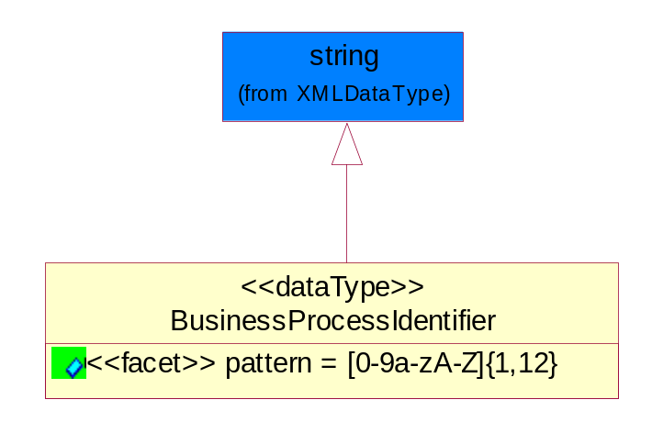
Figure 5-93 BusinessProcessIdentifier

Attribute | Type | Documentation
pattern |  | [0-9a-zA-Z]{1,12}

BusinessServiceInformation
The object allows the specification of the business service utilized within the partner company. This may or may not be the same as the information sent by the RNIF.
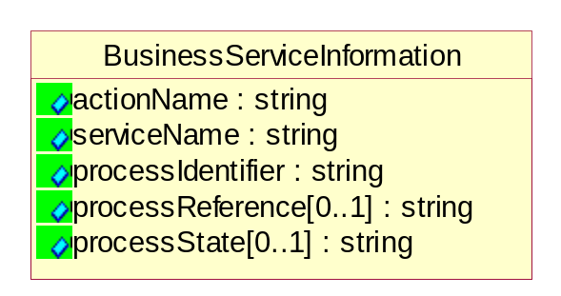
Figure 5-94 BusinessServiceInformation

Attribute | Type | Documentation
actionName | string | The name of Action. For RosettaNet usually any of Request/Confirm/Notify/Query/Response.
serviceName | string | The name of the Business Activity with the "Request/Confirm" part removed. E.g., for the Activity "Request Purchase Order"==> "Purchase Order".
processIdentifier | string | The name of the PIP e.g. Notify of Forecast Reply.
processReference[0..1] | string | The URN for the PIP that includes Cluster/Segment/Process pattern used to identify the interface process (such as PIP3A4)
processState[0..1] | string | The business process (or service) state of the sender of a document. When a service receives this document, the receiver may use the state as a precondition.

ContractInformation
A block of information used to correlate a contract in an executing choreography.

Figure 5-95 ContractInformation

Attribute | Type | Documentation
contractIdentifier[0..1] | string | Unique identification of a contract between the Sender and the Receiver
contractType[0..1] | string | The type of the contract: an attribute describing the type of the ContractIndentification. Valid values are URI, URN,ebXMLCPA, or other values defined by partners.

CorrelationInformation
A block of information used to correlate a requesting document to a responding document and to the contract in an executing choreography.
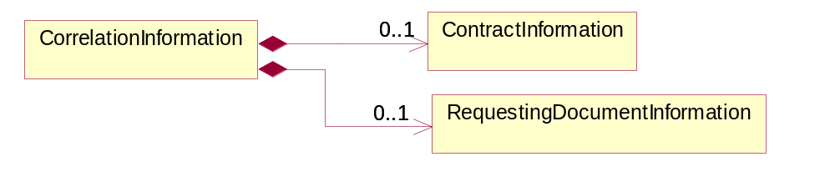
Figure 5-96 CorrelationInformation

Composition | Cardinality | Type | Documentation
ContractInformation | 0..1 | ContractInformation | A block of information used to correlate a contract in an executing choreography.
RequestingDocumentInformation | 0..1 | RequestingDocumentInformation | A block of information used to correlate a requesting document to a responding document in an executing choreography.

DocumentHeader
The object allows for the identification of the sender and receiver of the business document.
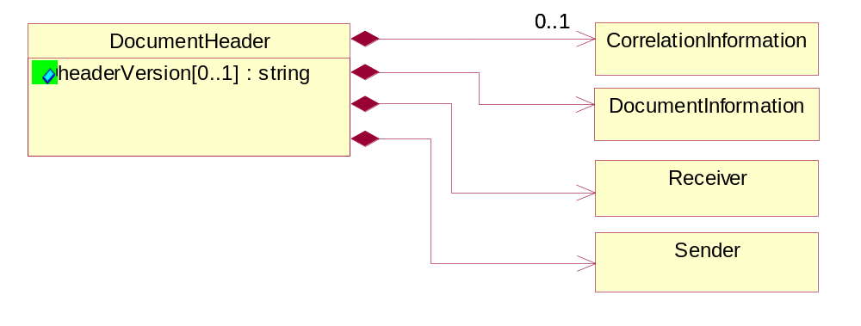
Figure 5-97 DocumentHeader

Attribute | Type | Documentation
headerVersion[0..1] | string | The UN/CEFACT version of the document header.

Composition | Cardinality | Type | Documentation
Sender | 1 | Sender | The object allows the identification of the initiating party of the business message.
CorrelationInformation | 0..1 | CorrelationInformation | A block of information used to correlate a requesting document to a responding document and to the contract in an executing choreography.
DocumentInformation | 1 | DocumentInformation | The object specifies information to identify the business document, a summary of attachments, and information about the business document security.
Receiver | 1 | Receiver | The object allows the identification of the receiving party of the business message.

DocumentIdentification
The object specifies all information necessary to identify the business document.
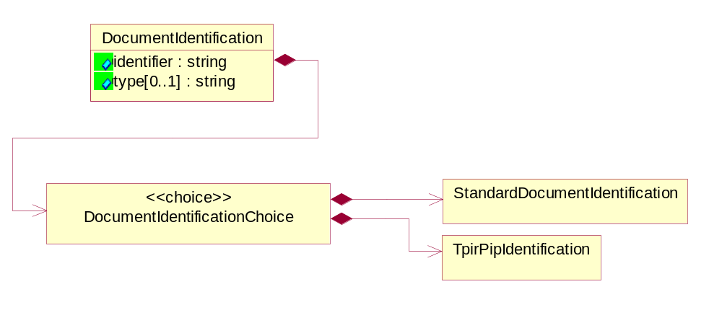
Figure 5-98 DocumentIdentification

Attribute | Type | Documentation
identifier | string | The unique identifier for the document being sent.
type[0..1] | string | Name of the Action Message

Composition | Cardinality | Type | Documentation
DocumentIdentificationChoice | 1 | DocumentIdentificationChoice

DocumentIdentificationChoice

Composition | Cardinality | Type | Documentation
StandardDocumentIdentification | 1 | StandardDocumentIdentification | The object specifies additional information necessary to identify the standard business document.
TpirPipIdentification | 1 | TpirPipIdentification | The object specifies all information necessary to uniquely identify a TPIR-PIP within a Registry or trading partner repository.

DocumentInformation
The object specifies information to identify the business document, a summary of attachments, and information about the business document security.
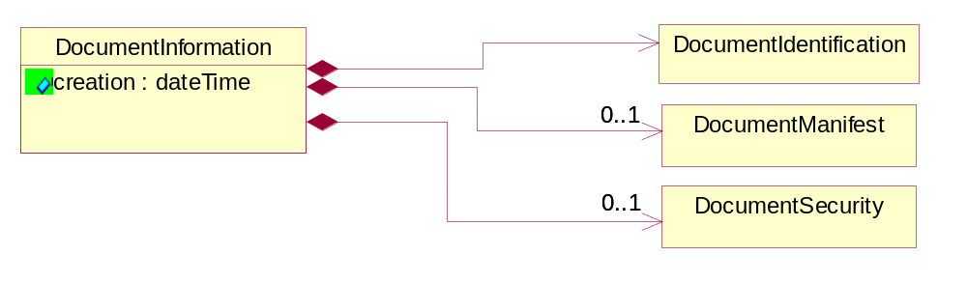
Figure 5-99 DocumentInformation

Attribute | Type | Documentation
creation | dateTime | The creation date and time of the specified Business Document (i.e. the Purchase Order date).

Composition | Cardinality | Type | Documentation
DocumentIdentification | 1 | DocumentIdentification | The object specifies all information necessary to identify the business document.
DocumentSecurity | 0..1 | DocumentSecurity | The object provides additional granularity in specifying business document security (this is in addition to the specified PIP security).
DocumentManifest | 0..1 | DocumentManifest | The block provides a brief summary of attachments and Service Content.

DocumentManifest
The block provides a brief summary of attachments and Service Content.
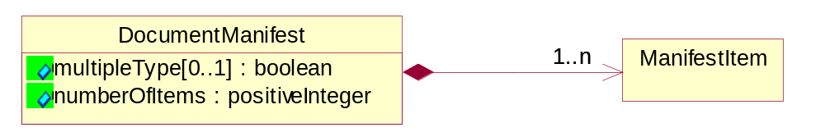
Figure 5-100 DocumentManifest

Attribute | Type | Documentation
multipleType[0..1] | boolean | Indicates whether the manifest contains documents of multiple types. True if yes, and False if no.
numberOfItems | positiveInteger | Total number of documents in the message. The physical count of the attachments in the payload plus the RosettaNet Business Message (for Service Content). The value of this field will be at least 1.

Composition | Cardinality | Type | Documentation
ManifestItem | 1..n | ManifestItem | The object provides details about the specific attachment(s).

DocumentSecurity
The object provides additional granularity in specifying business document security (this is in addition to the specified PIP security).

Figure 5-101 DocumentSecurity

Attribute | Type | Documentation
nonRepudiableReceipt | boolean | The value "true" will indicate that a signed acknowledgement for the business document is necessary.
persistentEncryption | boolean | The value "true" will indicate that the Business Document (including the header) needs to be encrypted when stored or transported.
persistentSignature | boolean | The value "true" will indicate that a signature is required to be stored with the document while stored or transported.

ManifestItem
The object provides details about the specific attachment(s).

Figure 5-102 ManifestItem

Attribute | Type | Documentation
description[0..1] | string | A description of the attachment.
length[0..1] | positiveInteger | The size of the attachment in bytes (i.e. 1 000 000 bytes)
universalResourceIdentifier | string | The generic set of all names/addresses that are short strings that refer to resources.

Composition | Cardinality | Type | Documentation
mimeTypeQualifier | 1 | MimeTypeQualifier | The MIME type as defined by IANA.  Please refer to http://www.iana.org/assignments/media-types/ for a list of types.
language | 0..1 | Language | For representation of Language name RosettaNet has adopted ISO 639-2; 1998. Refer to the following web page to get the latest version of the standard:  http://www.loc.gov/standards/iso639-2/iso639jac.html  If you need more information about the ISO standard please contact ISO for more details.

PipIdentifier
PIP Identification.[ i.e. PIP3A4]
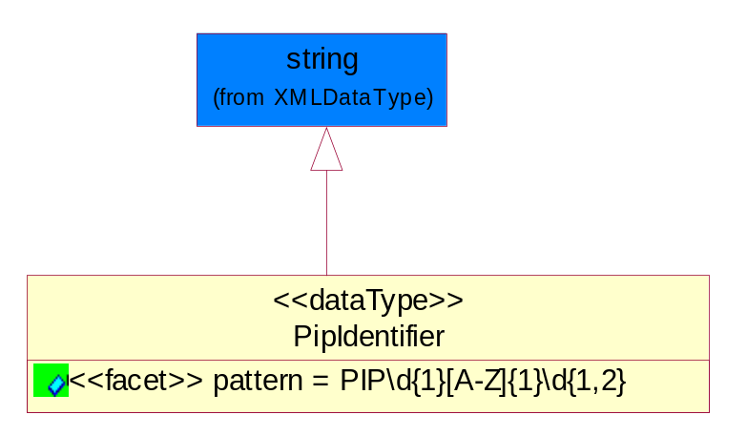
Figure 5-103 PipIdentifier
Attribute | Type | Documentation
pattern |  | PIP\d{1}[A-Z]{1}\d{1,2}

PipVersion
PIP version number (i.e. 02.02.00).
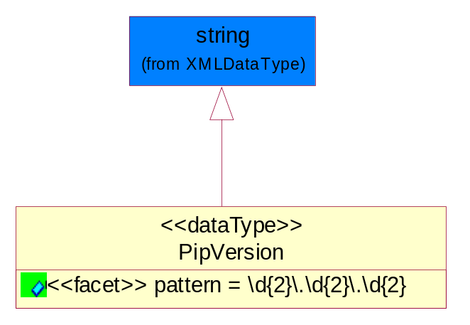
Figure 5-104 PipVersion

Attribute | Type | Documentation
pattern |  | \d{2}\.\d{2}\.\d{2}

Receiver
The object allows the identification of the receiving party of the business message.
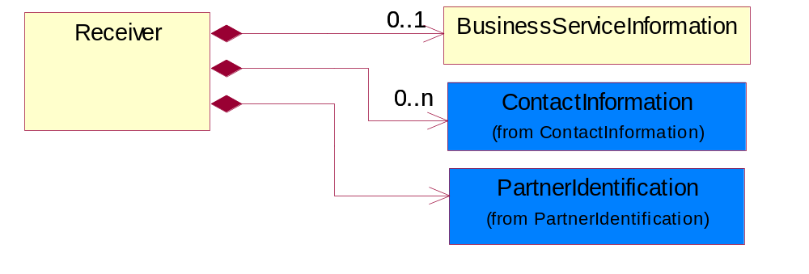
Figure 5-105 Receiver

Composition | Cardinality | Type | Documentation
BusinessServiceInformation | 0..1 | BusinessServiceInformation | The object allows the specification of the business service utilized within the partner company. This may or may not be the same as the information sent by the RNIF.
PartnerIdentification | 1 | PartnerIdentification | The business document must allow for the identity of one or more parties to the transaction.
ContactInformation | 0..n | ContactInformation | The business document must allow for the identification of the name of the department, service or individual to be contacted regarding the context of the business document.

RequestingDocumentInformation
A block of information used to correlate a requesting document to a responding document in an executing choreography.

Figure 5-106 RequestingDocumentInformation

Attribute | Type | Documentation
businessProcessInstanceIdentifier[0..1] | string | The identifier for the public business process instance being sent that both the sender and receiver can identify.
responseDateTime[0..1] | dateTime | The expected time to receive the response. This can not be greater than the PIP TimeToPerform.
requestingDocumentCreationDateTime[0..1] | dateTime | The date-time of the requesting business document.
requestingDocumentInstanceIdentifier | string | The Business Document identification number that identifies the requesting Business Document.

Sender
The object allows the identification of the initiating party of the business message.
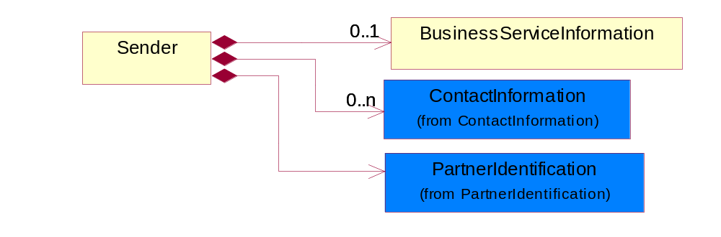
Figure 5-107 Sender

Composition | Cardinality | Type | Documentation
PartnerIdentification | 1 | PartnerIdentification | The business document must allow for the identity of one or more parties to the transaction.
BusinessServiceInformation | 0..1 | BusinessServiceInformation | The object allows the specification of the business service utilized within the partner company. This may or may not be the same as the information sent by the RNIF.
ContactInformation | 0..n | ContactInformation | The business document must allow for the identification of the name of the department, service or individual to be contacted regarding the context of the business document.

StandardDocumentIdentification
The object specifies additional information necessary to identify the standard business document.
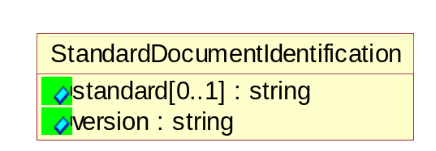
Figure 5-108 StandardDocumentIdentification

Attribute | Type | Documentation
standard[0..1] | string | Identifies the standard used to submit the business document. (e.g. RosettaNet).
version | string | PIP3A4v01.00

TpirPipIdentification
The object specifies all information necessary to uniquely identify a TPIR-PIP within a Registry or trading partner repository.

Figure 5-109 TpirPipIdentification

Attribute | Type | Documentation
partnerId | DUNSPlus4 | The Trading Partner Identification of MNC that is creating this TPIR PIP.
pipIdentifier | PipIdentifier | A TPIR PIP Identification [i.e., 3A4 ).
pipVersion | PipVersion | A TPIR PIP version number (i.e., 02.02.00)
tpirPipVersion | VersionIdentifier | A TPIR-PIP Version Number (i.e., major and minor version number as XX.XX).
tpirBusinessProcessIdentifier[0..1] | BusinessProcessIdentifier | A Business Process Identifier to uniquely define the TPIR-PIP 'role' within a Business Scenario at a company or MNC level. The identifier MUST be composed of alphanumeric characters only and its length MUST be between one and twelve characters.
uri[0..1] | anyURI | Describes the destination uri for the TPIR form.

Composition | Cardinality | Type | Documentation
fileType | 0..1 | TPIRFileType | Describes the file type of the TPIR form (PDF, XDP or XML).

VersionIdentifier
Version Number (i.e., major and minor version number as XX.XX).
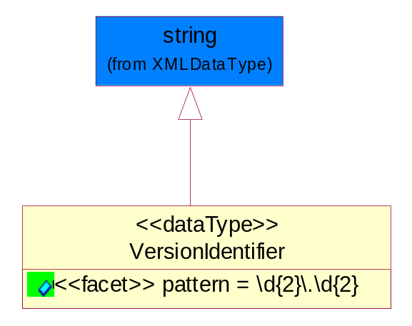
Figure 5-110 VersionIdentifier

Attribute | Type | Documentation
pattern |  | \d{2}\.\d{2}

CodeList

TPIRFileType
A code identifying the file type of TPIR form.

Name | Documentation
PDF | Portable Document Format.
XDP | XML Data Package.
XML | eXtensible Markup Language.

XML Data Type

anyURI
Represents a URI as defined by RFC 2396. An anyURI value can be absolute or relative, and may have an optional fragment identifier.

boolean
Represents Boolean values, which are either "true" or "false".

date
For the represents a calendar date.
The pattern for a date is CCYY-MM-DD where CC represents the century, YY the year, MM the month, and DD the day, with an optional time zone indicator as allowed for dateTime.

dateTime
Represents a specific instance of time.
The pattern for dateTime is CCYY-MM-DDThh:mm:ss where CC represents the century, YY the year, MM the month, and DD the day, preceded by an optional leading negative (-) character to indicate a negative number. If the negative character is omitted, positive (+) is assumed. The T is the date/time separator and hh, mm, and ss represent hour, minute, and second respectively. Additional digits can be used to increase the precision of fractional seconds if desired. For example, the format ss.ss... with any number of digits after the decimal point is supported. The fractional seconds part is optional.
This representation may be immediately followed by a "Z" to indicate Coordinated Universal Time (UTC) or to indicate the time zone. For example, the difference between the local time and Coordinated Universal Time, immediately followed by a sign, + or -, followed by the difference from UTC represented as hh:mm (minutes is required). If the time zone is included, both hours and minutes must be present.

decimal
A data type that contains decimal numbers scaled by a power of 10.

float
Represents single-precision 32-bit floating-point numbers.

integer
Represents a sequence of decimal digits with an optional leading sign (+ or -). This data type is derived from decimal.

positiveInteger
Represents an integer that is greater than zero. This data type is derived from nonNegativeInteger.

string
Represents character string.

