

Description of
Partner Interface Process® for 3B18

Validated 11.01.00

Specification Information
Name | Notify Of Shipping Documentation
Cluster | Order Management
Segment | Transportation and Distribution
Publication Date | 08 October 2007
Version Identifier | V11.01

Table of Contents
1 Document Management 4
1.1 Legal Disclaimer 4
1.2 Copyright 4
1.3 Trademarks 4
1.4 Acknowledgments 4
1.5 Related Documents 5
1.6 Document Version History 5
1.7 Document Structure 5
2 Business Process 6
2.1 Business Process Definition 6
2.1.1 Executive Summary 6
2.1.2 Business Process Description 7
2.2 PIP Scope Description 9
2.3 PIP Business Document 10
2.4 PIP Business Process Flow Diagram 10
2.5 PIP Start State 11
2.6 PIP End States 12
2.7 Partner Role Descriptions 13
2.8 Business Process Activity Controls 13
3 Network and Implementation Specification 15
3.1 Business Action and Business Signal Specifications 15
3.2 Business Transaction Dialog Specification 15
3.2.1 Message Exchange Controls 16
3.2.2 Communications Specification 16

List of Figures:
Figure 1: Activity Diagram of Notify Of Shipping Documentation 11
Figure 2: Sequence Diagram of Notify Of Shipping Documentation 16

List of Tables:
Table 1: PIP Business Document 10
Table 2: PIP Start State 11
Table 3: PIP End State 12
Table 4: PIP Failure State 12
Table 5: Partner Role Description 13
Table 6: Business Activity Description 13
Table 7: Business Activity Performance Control 14
Table 8: Network Component Specification 15
Table 9: Business Action – Business Document Mapping 15
Table 10: Message Exchange Control 16
Table 11: Dialog: Service-Service 16

Document Management

Legal Disclaimer
RosettaNet™, its members, officers, directors, employees, or agents shall not be liable for any injury, loss, damages, financial or otherwise, arising from, related to, or caused by the use of this document or the specifications herein, as well as associated guidelines and schemas. The use of said specifications shall constitute your express consent to the foregoing exculpation.

Copyright
©2007 RosettaNet. All rights reserved. No part of this publication may be reproduced, stored in a retrieval system, or transmitted, in any form or by any means, electronic, mechanical, photocopying, recording, or otherwise, without the prior written permission of the publisher. Printed in the United States of America.

Trademarks
RosettaNet, Partner Interface Process, PIP and the RosettaNet logo are trademarks or registered trademarks of "RosettaNet," a non-profit organization. All other product names and company logos mentioned herein are the trademarks of their respective owners. In the best effort, all terms mentioned in this document that are known to be trademarks or registered trademarks have been appropriately recognized in the first occurrence of the term.

Acknowledgments
This document has been prepared by RosettaNet (http://www.rosettanet.org/) from requirements gathered during the Milestone Program and in conformance with the methodology. Listed below are the legal entities that contributed to the design and development of this PIP.
BAX Global | Cisco Systems, Inc.
Dagang Net Technologies SDN BHD | Danzas
Danzas AEI Intercontinental, Inc. | DHL Danzas Air & Ocean
GridNode, Inc. | GridNode Pte. Ltd.
Intel Corporation | Intel Corporations
Menlo Worldwide | MITAC International Corp.
Sterling Commerce | MIMOS Berhad
Shanghai Easipass International, Inc.

Related Documents
- Associated PIP Message Schemas (included within the PIP Specification package only)
- Description of 3B18 Message
- Messages Structure
- XML instance of ebXML BPSS for PIP 3B18

Document Version History
Version | Date | Description
Validated 11.00.00 | 11 July 2006 | Validated Version  Milestone Program: e-Customs
Validated 11.01.00 | 08 October 2007 | Validated Version  Milestone Program: Schema2Market

Document Structure
A Partner Interface Process (PIP) Specification is comprised of the following two parts:
- Business Process. Captures the semantics of the business process and the flow of the message exchange between roles as they perform business activities.
- Network and Implementation Specification. Specifies the network protocol message formats and communications requirements between peer-protocols supported by network components in the RosettaNet Implementation Framework.

Business Process

Business Process Definition
Enable the communication of shipping documentation information from a manufacturer or distributor with outsourced logistics operations to its third-party logistics provider.

Executive Summary
All businesses that sell products existing as physical goods, such as raw materials, components and finished goods, must deliver them from their manufacturing or storage location to the customer’s location. This physical movement of products may involve several parties. The first party to the shipment is usually the seller, which initiates the shipping of the products. The second party is usually the buyer, as the consignee to which the products are shipped. Additionally, there may be third-party logistics (3PL) and even fourth-party logistics (4PL) providers, offering services to the shipper such as outsourced manufacturing, product warehousing, routing and tracking, in addition to physically transporting the products.
When products are shipped, they will often need to be accompanied by various shipping documents. These documents may include:
- Bill of Lading, a document issued by a carrier to a Shipper, signed by the captain agent or owner of the carrier, furnishing written evidence regarding receipt of goods, the conditions on which transport is made (contract of carriage) and the engagement to deliver the goods at the prescribed point of destination to the lawful holder of the bill of lading. Receipt for merchandise and a contract to deliver it as freight.
- Certificate of Origin, a document attesting to the country of origin of goods. Such certificates (or the format for them) are usually obtained through an official or quasi-official organization in the country of origin, such as a consular office or local chamber of commerce. A Certificate of Origin may be required even though the Commercial Invoice contains similar information. A Certificate of Origin is used by customs authorities to prove country of origin of goods. Country of origin can determine different import statuses, eligibility for quota programs, distinguish between different rates of duty or prove eligibility for preferential import programs.
- Commercial Invoice, a document identifying the seller and buyer of the goods or services, identifying numbers such as invoice number, date, shipping date, mode of transport, delivery and payment terms, and a complete listing and description of the goods being sold, including prices, discounts and quantities. A Commercial Invoice is used by governments to determine the true transaction value of the goods for assessment of customs duties and also to prepare consular documents.
- Export Declaration, a form required for all US Export shipments (with some exceptions) prepared by the Shipper indicating the value, weight, destination and other basic information about the shipment, including ECCN number, Schedule B number and license type information. The document is used to report and compile export statistics to the Department of Census as well as to control exports of certain types of materials and technology.
- Packing List, a document prepared by the Shipper listing the kinds and quantities of merchandise in a particular shipment. A copy is usually sent to the consignee and affixed to the packages to assist in checking the shipment contents when received. Packing lists contain similar information to the Commercial Invoice with the exclusion of prices and payment terms.
- Pro Forma Invoice, an invoice provided by the Shipper for customs purposes in lieu of a commercial invoice when a commercial invoice is not available at the time of merchandise entry or customs entry.
- Shippers Letter of Instruction, a form used by a Shipper to authorize a carrier, freight forwarder or third party agent to issue a Bill of Lading or air waybill on the Shipper's behalf. The form contains all details of shipment and authorizes the carrier to sign the Bill of Lading in the name of the Shipper.
- Sales Invoice, a form of invoice containing sales information.
- Sales Invoice Summary, a form used by a Shipper to summarize sales invoice data.
- Bonded Declaration: A bonded declaration is used to move cargo from bond to bond (i.e. between bonded areas) without payment of duties/taxes. Bonded area in this context means any area that deemed or licensed by Customs, eg. Free Trade Zones (FTZ), Free Commercial Zones, Free Industrial Zones, Bonded Warehouses (both Public & Private), Duty Free Areas (eg Duty Free Shops). Cargo in these areas are subject to duty & taxes (where applicable) if moved to Principal Customs Areas (PCA).

Business Process Description
The "Description of Partner Interface Process for 3B18" Partner Interface Process™ (PIP) supports a process in which a Shipper communicates information that a Shipping Provider must incorporate in the documentation to accompany a shipment. The Shipper is the organization responsible for the supply of products to its customers, i.e. the first party described above. The Shipping Provider is a third-party that performs the shipping logistics on behalf of the Shipper.
Usually the Shipper will already have sent the Shipping Provider a shipping order to specify which products to ship, how to ship them, the origin and destination locations, and other related information. PIP 3B11 Notify of Shipping Order or PIP 3B12 Request Shipping Order will have been used for this purpose.
Sometimes the shipping documentation information is sent to a different Shipping Provider than the Shipping Provider to which the shipping order is sent. An example of this is where another party provides shipping services for the same shipment, such as where the Shipping Provider is a third-party export administrator.
PIP 3B18 Description of Partner Interface Process for 3B18 is also designed to support the Shipper’s labeling requirements, sufficient for the Shipping Provider to create a shipping label for the shipment. This is an adhesive label containing information such as consignee name, address, shipment identification numbers and carton count information.
The Shipper may ask for additional, proprietary, documents to be generated by a Shipping Provider from the information passed in PIP 3B18 Description of Partner Interface Process for 3B18, which will be specified in the Trading Partner Agreement.
While a shipment is authorized by only a single instance of either PIP 3B11 Notify of Shipping Order or PIP 3B12 Request Shipping Order, each shipment may have multiple occurrences of PIP 3B18 Description of Partner Interface Process for 3B18. For the shipping documents required to support a given shipment, the following scenarios are possible:
- The Shipper may transmit a single 3B18 for all the shipping documents to a single Shipping Provider.
- The Shipper may transmit a separate 3B18 for each shipping document to a single Shipping Provider.
- The Shipper may transmit a separate 3B18 to several different Shipping Providers, each of which has been contracted by the Shipper to manage a specific set of shipping documents.
PIP 3B18 Description of Partner Interface Process for 3B18 is usually transmitted after the applicable PIP 3B11 Notify of Shipping Order or PIP 3B12 Request Shipping Order that authorizes the shipment. However, it is possible to send 3B18 before 3B11 or 3B12, so the Shipping Provider can prepare the shipping documentation in advance.
For simple domestic shipments, PIPs 3B11 and 3B12 may contain sufficient information for the Shipping Provider to generate all necessary shipping documentation without the use of PIP 3B18. However, the documentation for international shipments will require the use of PIP 3B18.
Should the Description of Partner Interface Process for 3B18 transaction not complete successfully, the requesting partner executes PIP0A1, “Notification of Failure”.

PIP Scope Description
This PIP is designed to enable the communication of shipping documentation information from a manufacturer or distributor with outsourced logistics operations to its third-party logistics provider.
For example, a manufacturer of semiconductor components may store completed products at a warehouse operated by another company and need to request a third-party to ship the components to its customer whenever a sales order is received. Documentation to accompany the shipment is required.

PIP Business Document
Business Document are generated and exchanged by roles performing activities in this PIP. Business Document is listed and defined in Table 1.
Table 1: PIP Business Document
Business Document | Description
Shipping Documentation Notification | Contains information requesting shipping documents to accompany a shipment.

PIP Business Process Flow Diagram
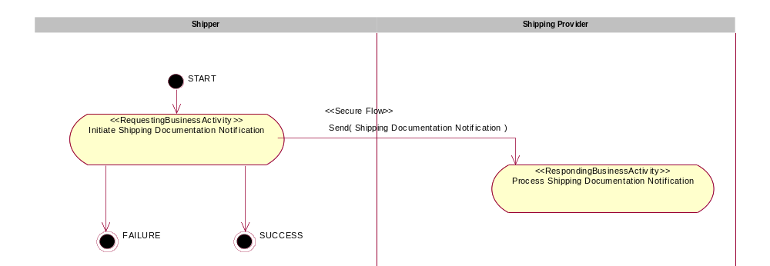
Figure 1: Activity Diagram of Notify Of Shipping Documentation

PIP Start State
The start state is comprised of the following conditions:
Table 2: PIP Start State
 | Approved | Exist |  | Valid | Non-Repudiated | Retry Count | Authorized
 | Approved | Party | In Backend System
TPA |  |  | 
Sending Partner |  |  |  | 
Receiving Partner |  | 
Business Document |  |  |  |  |  |  | 

PIP End States
The end state is comprised of the following conditions:
Table 3: PIP End State
 | Approved | Exist |  | Valid | Non-Repudiated | Retry Count | Authorized
 | Approved | Party | In Backend system
Acknowledgment of Receipt |  |  |  |  | 
Receiving Partner |  |  |  |  |  |  | 
The PIP failure state is comprised of one or more of the following conditions:
Table 4: PIP Failure State
 | NO | Exceeded
Success | 
Retry Count |  | 

Partner Role Descriptions
Table 5 describes the partner roles in this PIP.
Table 5: Partner Role Description
Role Name | Role Description
Shipper | The department or organization responsible for authorizing a Shipping Provider to ship products from one location to another. The Shipper sends shipping documentation information to incorporate into the documents that must accompany the shipment.
Shipping Provider | The department or organization responsible for performing shipping logistics on behalf of the Shipper. The Shipping Provider completes shipping documents that must accompany a shipment.

Business Process Activity Controls
Table 6 describes the interaction between roles performing business activity in this PIP.
Table 6: Business Activity Description
Role  Name | Activity Name | Activity Description
Shipper | Initiate Shipping Documentation Notification | A Shipper sends a Shipping Documentation Notification business document to a Shipping Provider.

Table 7 details the security, audit and process controls relating to activity performed in the PIP.
Table 7: Business Activity Performance Control
Role  Name | Activity  Name | Acknowledgment  of Receipt |  | Time to Perform | Retry Count | Is Authorization Required? | Non-Repudiation of Origin and Content?
Role  Name | Activity  Name | Non-Repudiation Required? | Time to Acknowledge
Shipper | Description of Partner Interface Process for 3B18 Notification | Y | 2hrs | N/A | 3 | Y | Y

Network and Implementation Specification
Each network component maps into a role of the PIP model. Table 8 specifies the mapping between roles and network components.
Table 8: Network Component Specification
Network Component | Classification | Maps to Role in Business Process
Shipper Service | Business Service | Shipper
Shipping Provider Service | Business Service | Shipping Provider

Business Action and Business Signal Specifications
Each business action maps to a Business Document of the PIP model. Table 9 specifies the mapping between Business Documents and business actions.
Table 9: Business Action – Business Document Mapping
Business Action | Business Document | Document Function
Shipping Documentation Notification Action | Shipping Documentation Notification | Request

Business Transaction Dialog Specification
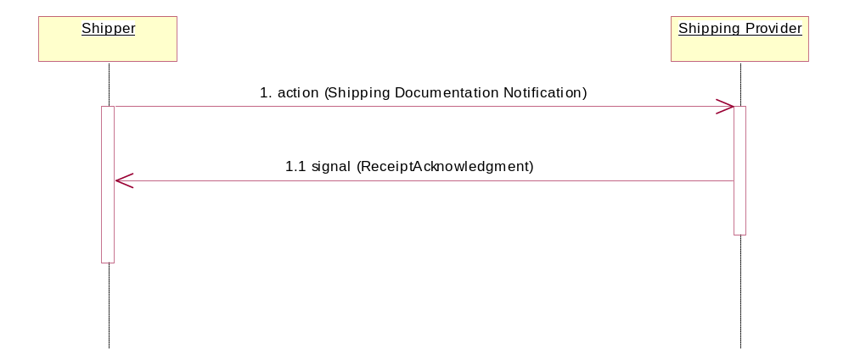
Figure 2: Sequence Diagram of Notify Of Shipping Documentation

Message Exchange Controls
Table 10: Message Exchange Control
# | Name |  | Time to Acknowledge Receipt Signal |  | Time to Respond to Action |  | Included in Time to Perform |  | Is Authorization Required? |  | Is Non-Repudiation Required? |  | Is Secure Transport Required?
1. |  | Shipping Documentation Notification Action |  | 2hrs |  | N/A |  | N/A |  | Y |  | Y |  | Y
1.1. |  | Receipt Acknowledgment |  | N/A |  | N/A |  | N/A |  | Y |  | Y |  | Y

Communications Specification
Table 11: Dialog: Service-Service
# | Business Message | Digital Signature Required? | SSL Required?
1. | Shipment Documentation Notification | Y | Y
1.1. | Receipt Acknowledgment | Y | Y

