

Description of 3B20 Message

PIP® 3B20
Validated 11.00.00

Specification Information
Name | Description of 3B20 Message
PIP | Notify of Shipping Order Confirmation
Cluster | Order Management
Segment | Transportation and Distribution
Publication Date | 8 February 2010
Version Identifier | V11.00

Table of Content

1. Document Management 7
1.1 Legal Disclaimer 7
1.2 Copyright 7
1.3 Trademarks 7
1.4 Acknowledgments 7
1.5 Related Documents 7
1.6 Document Version History 7
1.7 Document Purpose 7
2. Interchange Model 8
2.1 ShippingOrderConfirmationNotification 8
2.1.1 Interchange Diagram 8
2.1.2 Dependency Diagram 9
2.1.3 DateInformation 9
2.1.4 OrderConfirmation 9
2.1.5 QuantityInformation 10
2.1.6 RequestingOrderInformation 10
2.1.7 RequestingOrderLineItemReference 11
2.1.8 RoutingInformation 12
2.1.9 ShipmentInformation 13
2.1.10 ShipmentLineItem 16
2.1.11 ShippingContainer 19
2.1.12 ShippingContainerItem 21
2.1.13 ShippingOrder 22
2.1.14 ShippingOrderConfirmation 23
2.1.15 SubContainer 23
3. Domain Model 24
3.1 Procurement 24
3.1.1 Dependency Diagram 24
3.1.2 CurrencyConversion 24
3.1.3 SpecialHandlingInstruction 25
3.1.4 WarehouseLocation 26
3.1.5 WarehouseLocationChoice 26
3.1.6 CodeList 27
3.1.6.1 SpecialHandling 27
3.1.6.2 OrderAdmin 35
3.2 Logistics 36
3.2.1 Dependency Diagram 36
3.2.2 ExportDeclaration 36
3.2.3 ExportLicense 37
3.2.4 FreeOnBoardTerms 37
3.2.5 FreightPaymentInformation 38
3.2.6 HazardousMaterialDescription 38
3.2.7 IsDeliveryRequired 39
3.2.8 IsHazardousMaterial 39
3.2.9 IsPartialShipment 40
3.2.10 LabelInstruction 40
3.2.11 LabelServiceContent 41
3.2.12 LinearWithMeasureType 41
3.2.13 LotReference 42
3.2.14 ManufacturerProfile 43
3.2.15 MassPhysicalDimension 43
3.2.16 MeasureWithType 44
3.2.17 OrderInformation 45
3.2.18 PhysicalDimension 46
3.2.19 ReturnInstructions 46
3.2.20 ReturnLabel 47
3.2.21 ShipmentDate 48
3.2.22 ShipmentInstructions 48
3.2.23 ShippingLabel 49
3.2.24 TrackingReference 50
3.2.25 CodeList 51
3.2.25.1 TrackingReferenceType 51
3.2.25.2 Incoterms 52
3.2.25.3 ShipmentMode 52
3.2.25.4 NationalExportControlClassification 53
3.2.25.5 ShipDateCode 54
3.2.25.6 FreightPaymentTerms 57
3.2.25.7 ReturnLabelCode 57
3.2.25.8 LotDiscrepancyReason 58
3.2.25.9 ShipmentType 58
3.2.25.10 InventoryOwnership 58
3.2.25.11 ShippingOrderStatus 58
3.2.25.12 ShippingOrderRejectReason 59
3.2.25.13 InstructionType 59
3.3 Shared 60
3.3.1 Dependency Diagram 60
3.3.2 ProductQuantity 60
3.3.3 CodeList 61
3.3.3.1 FreeOnBoard 61
3.3.3.2 PackageType 61
3.3.3.3 ShippingServiceLevel 62
4. Universal Structure 64
4.1 ContactInformation 64
4.1.1 ContactInformation 64
4.2 DataType 65
4.2.1 Contact 65
4.2.2 DUNS 65
4.2.3 DUNSPlus4 66
4.2.4 GLN 66
4.2.5 GTIN 67
4.3 Document 68
4.3.1 BusinessDocumentReference 68
4.4 Locations 69
4.4.1 AlternativeIdentifier 69
4.4.2 Location 70
4.4.3 LocationChoice 71
4.4.4 PhysicalAddress 72
4.5 MonetaryExpression 74
4.5.1 FinancialAmount 74
4.6 PartnerIdentification 75
4.6.1 FullPartner 75
4.6.2 IntermittentPartner 76
4.6.3 KnownPartner 77
4.6.4 KnownPartnerContact 78
4.6.5 NewPartner 79
4.6.6 PartnerDescription 80
4.6.7 PartnerDescriptionChoice 81
4.6.8 PartnerIdentification 82
4.6.9 PartnerIdentificationChoice 83
4.6.10 SpecifiedFullPartner 84
4.6.11 SpecifiedIntermittentPartner 85
4.6.12 SpecifiedKnownPartner 86
4.6.13 SpecifiedNewPartner 87
4.7 CodeList 88
4.7.1 Country 88
4.7.2 CountrySubdivision 88
4.7.3 Currency 88
4.7.4 Language 88
4.7.5 DocumentType 89
4.7.6 MimeTypeQualifier 91
4.7.7 ProcessRoleIdentifier 102
5. System Structure 105
5.1 BusinessProcessIdentifier 105
5.2 BusinessServiceInformation 106
5.3 ContractInformation 107
5.4 CorrelationInformation 107
5.5 DocumentHeader 108
5.6 DocumentIdentification 109
5.7 DocumentIdentificationChoice 109
5.8 DocumentInformation 110
5.9 DocumentManifest 111
5.10 DocumentSecurity 111
5.11 ManifestItem 112
5.12 PipIdentifier 113
5.13 PipVersion 113
5.14 Receiver 114
5.15 RequestingDocumentInformation 115
5.16 Sender 116
5.17 StandardDocumentIdentification 117
5.18 TpirPipIdentification 118
5.19 VersionIdentifier 119
5.20 CodeList 120
5.20.1 TPIRFileType 120
6. XML Data Type 121
6.1 anyURI 121
6.2 boolean 121
6.3 date 121
6.4 dateTime 121
6.5 float 121
6.6 integer 121
6.7 positiveInteger 121
6.8 string 121

Table of Figures

Figure ‎2-1 Interchange 8
Figure ‎2-2 Dependency 9
Figure ‎2-3 DateInformation 9
Figure ‎2-4 OrderConfirmation 9
Figure ‎2-5 QuantityInformation 10
Figure ‎2-6 RequestingOrderInformation 10
Figure ‎2-7 RequestingOrderLineItemReference 11
Figure ‎2-8 RoutingInformation 12
Figure ‎2-9 ShipmentInformation 13
Figure ‎2-10 ShipmentLineItem 16
Figure ‎2-11 ShippingContainer 19
Figure ‎2-12 ShippingContainerItem 21
Figure ‎2-13 ShippingOrder 22
Figure ‎2-14 ShippingOrderConfirmation 23
Figure ‎2-15 SubContainer 23
Figure ‎3-1 Dependency 24
Figure ‎3-2 CurrencyConversion 24
Figure ‎3-3 SpecialHandlingInstruction 25
Figure ‎3-4 WarehouseLocation 26
Figure ‎3-5 Dependency 36
Figure ‎3-6 ExportDeclaration 36
Figure ‎3-7 ExportLicense 37
Figure ‎3-8 FreeOnBoardTerms 37
Figure ‎3-9 FreightPaymentInformation 38
Figure ‎3-10 HazardousMaterialDescription 38
Figure ‎3-11 IsDeliveryRequired 39
Figure ‎3-12 IsHazardousMaterial 39
Figure ‎3-13 IsPartialShipment 40
Figure ‎3-14 LabelInstruction 40
Figure ‎3-15 LabelServiceContent 41
Figure ‎3-16 LinearWithMeasureType 41
Figure ‎3-17 LotReference 42
Figure ‎3-18 ManufacturerProfile 43
Figure ‎3-19 MassPhysicalDimension 43
Figure ‎3-20 MeasureWithType 44
Figure ‎3-21 OrderInformation 45
Figure ‎3-22 PhysicalDimension 46
Figure ‎3-23 ReturnInstructions 46
Figure ‎3-24 ReturnLabel 47
Figure ‎3-25 ShipmentDate 48
Figure ‎3-26 ShippingLabel 49
Figure ‎3-27 TrackingReference 50
Figure ‎3-28 Dependency 60
Figure ‎3-29 ProductQuantity 60
Figure ‎4-1 ContactInformation 64
Figure ‎4-2 Contact 65
Figure ‎4-3 DUNS 65
Figure ‎4-4 DUNSPlus4 66
Figure ‎4-5 GLN 66
Figure ‎4-6 GTIN 67
Figure ‎4-7 BusinessDocumentReference 68
Figure ‎4-8 AlternativeIdentifier 69
Figure ‎4-9 Location 70
Figure ‎4-10 PhysicalAddress 72
Figure ‎4-11 FinancialAmount 74
Figure ‎4-12 FullPartner 75
Figure ‎4-13 IntermittentPartner 76
Figure ‎4-14 KnownPartner 77
Figure ‎4-15 KnownPartnerContact 78
Figure ‎4-15 NewPartner 79
Figure ‎4-16 PartnerDescription 80
Figure ‎4-17 PartnerIdentification 82
Figure ‎4-18 SpecifiedFullPartner 84
Figure ‎4-19 SpecifiedIntermittentPartner 85
Figure ‎4-20 SpecifiedKnownPartner 86
Figure ‎4-21 SpecifiedNewPartner 87
Figure ‎5-1 BusinessProcessIdentifier 105
Figure ‎5-2 BusinessServiceInformation 106
Figure ‎5-3 ContractInformation 107
Figure ‎5-4 CorrelationInformation 107
Figure ‎5-5 DocumentHeader 108
Figure ‎5-6 DocumentIdentification 109
Figure ‎5-7 DocumentInformation 110
Figure ‎5-8 DocumentManifest 111
Figure ‎5-9 DocumentSecurity 111
Figure ‎5-10 ManifestItem 112
Figure ‎5-11 PipIdentifier 113
Figure ‎5-12 PipVersion 113
Figure ‎5-13 Receiver 114
Figure ‎5-14 RequestingDocumentInformation 115
Figure ‎5-15 Sender 116
Figure ‎5-16 StandardDocumentIdentification 117
Figure ‎5-17 TpirPipIdentification 118
Figure ‎5-18 VersionIdentifier 119

Document Management

Legal Disclaimer
RosettaNet, its members, officers, directors, employees, or agents shall not be liable for any injury, loss, damages, financial or otherwise, arising from, related to, or caused by the use of this document or the specifications herein, as well as associated guidelines and schemas. The use of said specifications shall constitute your express consent to the foregoing exculpation.

Copyright
©2010 RosettaNet. All rights reserved. No part of this publication may be reproduced, stored in a retrieval system, or transmitted, in any form or by any means, electronic, mechanical, photocopying, recording, or otherwise, without the inclusion of this copyright notice. Any derivative works must cite the copyright notice. Any public redistribution or sale of this publication or derivative works requires prior written permission of the publisher.

Trademarks
RosettaNet, Partner Interface Process, PIP and the RosettaNet logo are trademarks or registered trademarks of "RosettaNet," a non-profit organization. All other product names and company logos mentioned herein are the trademarks of their respective owners. In the best effort, all terms mentioned in this document that are known to be trademarks or registered trademarks have been appropriately recognized in the first occurrence of the term.

Acknowledgments
This document has been prepared by RosettaNet (http://www.rosettanet.org/) from requirements gathered during the Milestone Program and in conformance with the methodology. Listed below are the legal entities that contributed to the design and development of this PIP.

Related Documents
- Associated PIP Message Schemas (included with PIP Specification only)
- Description of Partner Interface Process for 3B20
- Message Structure

Document Version History
Version | Date | Description
Validated 11.00.00 | 8 February 2010 | Validated Version

Document Purpose
The purpose of the document is to explain the structure, the association between objects, the content of objects and the definition for single elements to a non-technical audience.

Interchange Model

ShippingOrderConfirmationNotification

Interchange Diagram
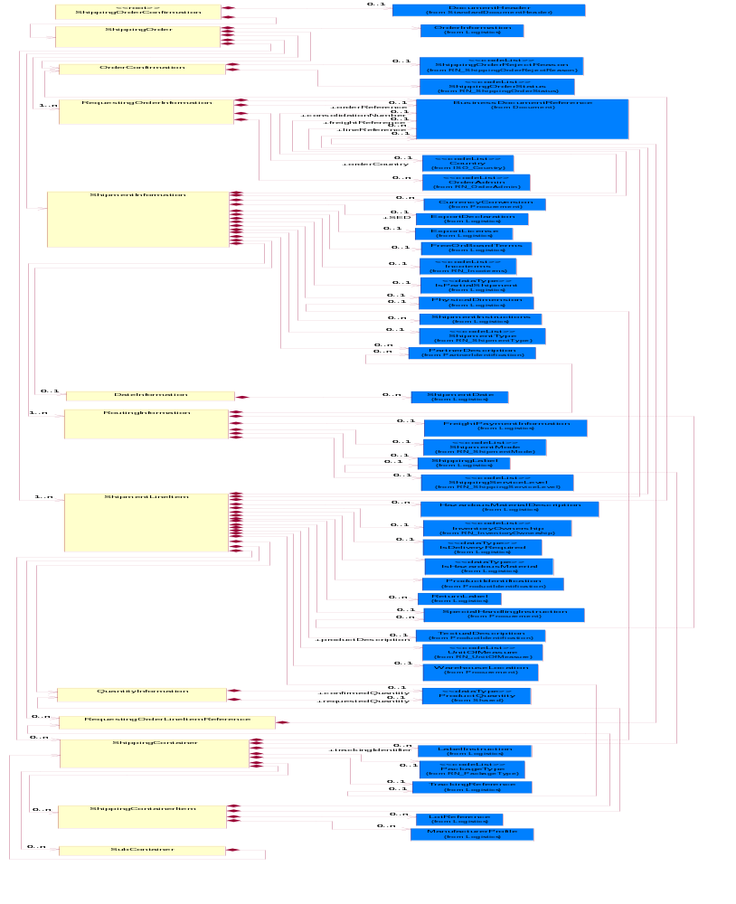
Figure ‎2-1 Interchange

Dependency Diagram
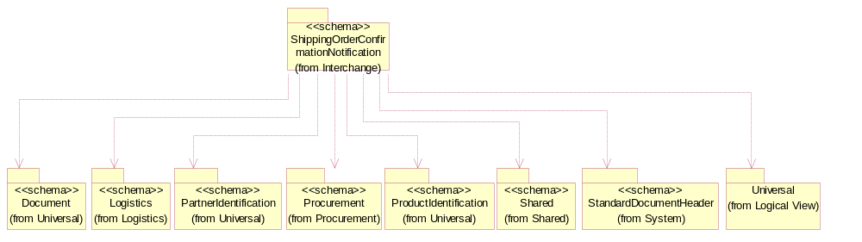
Figure ‎2-2 Dependency

DateInformation
The collection of business properties that identifies a set of dates associated with this transaction.
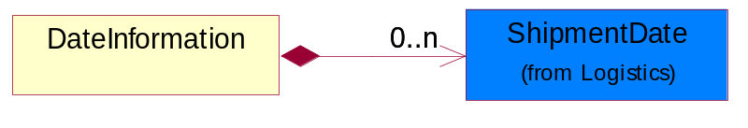
Figure ‎2-3 DateInformation

Composition | Cardinality | Type | Documentation
ShipmentDate | 0..n | ShipmentDate | The collection of business properties that identifies a constraint on when the products may be shipped.

OrderConfirmation
The collection of business properties that describes the confirmation or rejection of a shipping order.
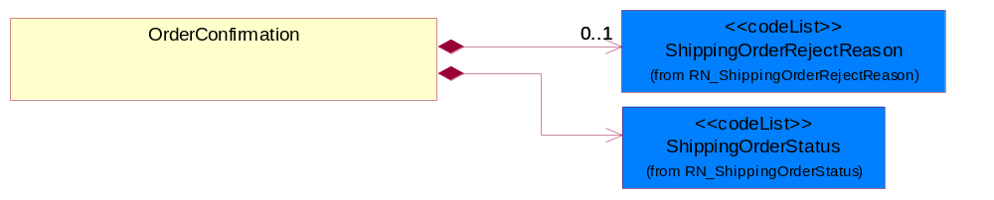
Figure ‎2-4 OrderConfirmation

Composition | Cardinality | Type | Documentation
ShippingOrderStatus | 1 | ShippingOrderStatus | Code identifying the confirmation status of a shipping order.
ShippingOrderRejectReason | 0..1 | ShippingOrderRejectReason | Code identifying the reason for the rejection of a shipping order.

QuantityInformation
The collection of business properties that describes information regarding the quantity of the product shipped.
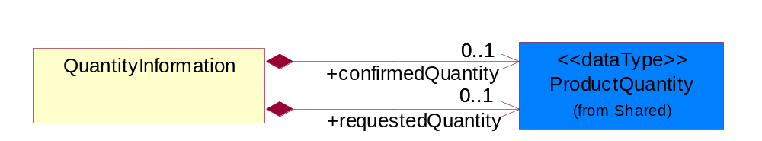
Figure ‎2-5 QuantityInformation

Composition | Cardinality | Type | Documentation
confirmedQuantity | 0..1 | ProductQuantity | The quantity confirmed for delivery.
requestedQuantity | 0..1 | ProductQuantity | The quantity of product requested.

RequestingOrderInformation
The collection of business properties that identifies an order of another type that caused this shipping order to be created.
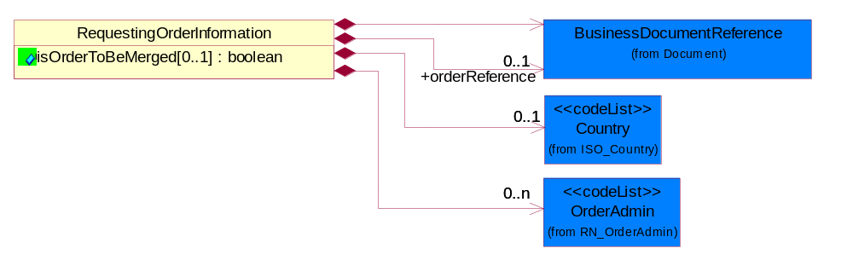
Figure ‎2-6 RequestingOrderInformation

Attribute | Type | Documentation
isOrderToBeMerged[0..1] | boolean | Indicates whether multiple shipping orders from the same requesting order must be merged into a single delivery.

Composition | Cardinality | Type | Documentation
BusinessDocumentReference | 1 | BusinessDocumentReference | The business document reference object allows for the indirect referencing of a relationship to other business related documents.
orderCountry | 0..1 | Country | The country where the office which accepted the order is located.
orderReference | 0..1 | BusinessDocumentReference | An additional reference number to identify a single shipment when there are multiple shipments resulting from a single requesting order.
OrderAdmin | 0..n | OrderAdmin | Additional administrative code identifying the reason the shipping order is being sent, possibly indicating a predefined workflow.

RequestingOrderLineItemReference
The collection of business properties that references a line item on a requesting document.
RequestingOrderLineItemReference
subLineSchedule[0..1] : string
BusinessDocumentReference
(from Document)
Figure ‎2-7 RequestingOrderLineItemReference

Attribute | Type | Documentation
subLineSchedule[0..1] | string | Number of the schedule within the subline in the document, associated with a given line number.

Composition | Cardinality | Type | Documentation
BusinessDocumentReference | 1 | BusinessDocumentReference | The business document reference object allows for the indirect referencing of a relationship to other business related documents.

RoutingInformation
The collection of business properties that describes a leg used in the routing of a shipment. ProcessRoleIdenfier usage suggested: SVA - Ship Via, and TRA - Transported By.
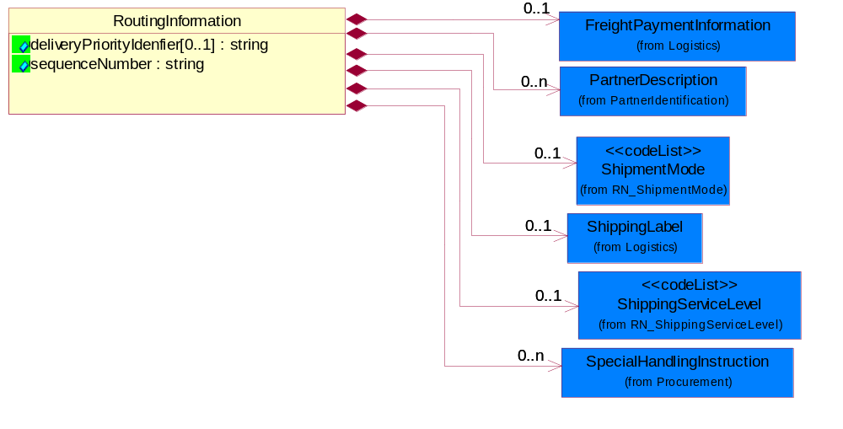
Figure ‎2-8 RoutingInformation

Attribute | Type | Documentation
deliveryPriorityIdenfier[0..1] | string | A numeric data item in the sales order that is used in sequencing how sales order lines are evaluated for shipping.
sequenceNumber | string | A positive integer which identifies the order of a designated element within a specified set.

Composition | Cardinality | Type | Documentation
ShipmentMode | 0..1 | ShipmentMode | The method of transport used for the conveyance of goods.
FreightPaymentInformation | 0..1 | FreightPaymentInformation | The collection of business properties that describes payments required for a shipment.
SpecialHandlingInstruction | 0..n | SpecialHandlingInstruction | The collection of business properties that describe product packaging or shipping handling instructions.
ShippingServiceLevel | 0..1 | ShippingServiceLevel | Code identifying the shipping service level, e.g., overnight, same day.
ShippingLabel | 0..1 | ShippingLabel | The collection of business properties that describe Shipping label and shipment information.
PartnerDescription | 0..n | PartnerDescription | The collection of business properties that describe a business partners' identity, their contact information, where they are physically located and their function in a supply chain.

ShipmentInformation
The collection of business properties that identifies how a shipment is to be made. ProcessRoleIdenfier usage suggested: IMB - Imported By, SHF - Ship From and SHT - Ship To.
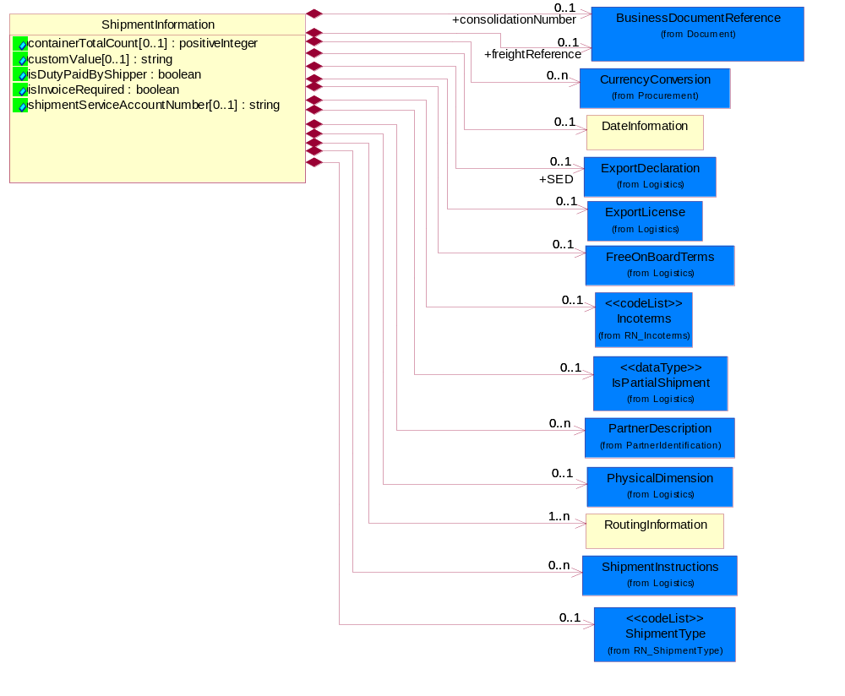
Figure ‎2-9 ShipmentInformation

Attribute | Type | Documentation
containerTotalCount[0..1] | positiveInteger | Indicates the total number of containers in the shipment that belong to this shipping order. This is usually the total number of packed cartons.
customValue[0..1] | string | Declared value for International Shipment to be displayed on label.
isDutyPaidByShipper | boolean | Indicates whether any applicable customs duty is paid by the Shipper or the consignee.
isInvoiceRequired | boolean | Indicates whether the commercial invoice is required.
shipmentServiceAccountNumber[0..1] | string | To display carriers service for Shipment Delivery on the label.

Composition | Cardinality | Type | Documentation
consolidationNumber | 0..1 | BusinessDocumentReference | A number that identifies other shipping orders that must be delivered to the same location at the same time.
DateInformation | 0..1 | DateInformation | The collection of business properties that identifies a set of dates associated with this transaction.
freightReference | 0..1 | BusinessDocumentReference | A reference identifier for the shipment, such as the Bill Of Lading.
Incoterms | 0..1 | Incoterms | Code identifying incoterms.
RoutingInformation | 1..n | RoutingInformation | The collection of business properties that describes a leg used in the routing of a shipment. ProcessRoleIdenfier usage suggested: SVA - Ship Via, and TRA - Transported By.
FreeOnBoardTerms | 0..1 | FreeOnBoardTerms | The collection of business properties that identifies the Free On Board terms.
CurrencyConversion | 0..n | CurrencyConversion | The collection of business properties that describe the exchange of money in circulation.
PhysicalDimension | 0..1 | PhysicalDimension | The physical dimension of a quantity such as length, time, mass.
ShipmentInstructions | 0..n | ShipmentInstructions | The collection of business properties that identifies shipping instruction notes and their location on shipping documents or labels.
IsPartialShipment | 0..1 | IsPartialShipment | The collection of business properties that identifies how a shipment is to be made.
ShipmentType | 0..1 | ShipmentType | Code that indicates the type of shipment being sent.
SED | 0..1 | ExportDeclaration | A reference identifier for the export shipment, Shipper Export Declaration information.
ExportLicense | 0..1 | ExportLicense | The collection of business properties that describe an export license number.
PartnerDescription | 0..n | PartnerDescription | The collection of business properties that describe a business partners' identity, their contact information, where they are physically located and their function in a supply chain.

ShipmentLineItem
The collection of business properties that describes the shipping details for a product line item on the shipping order.
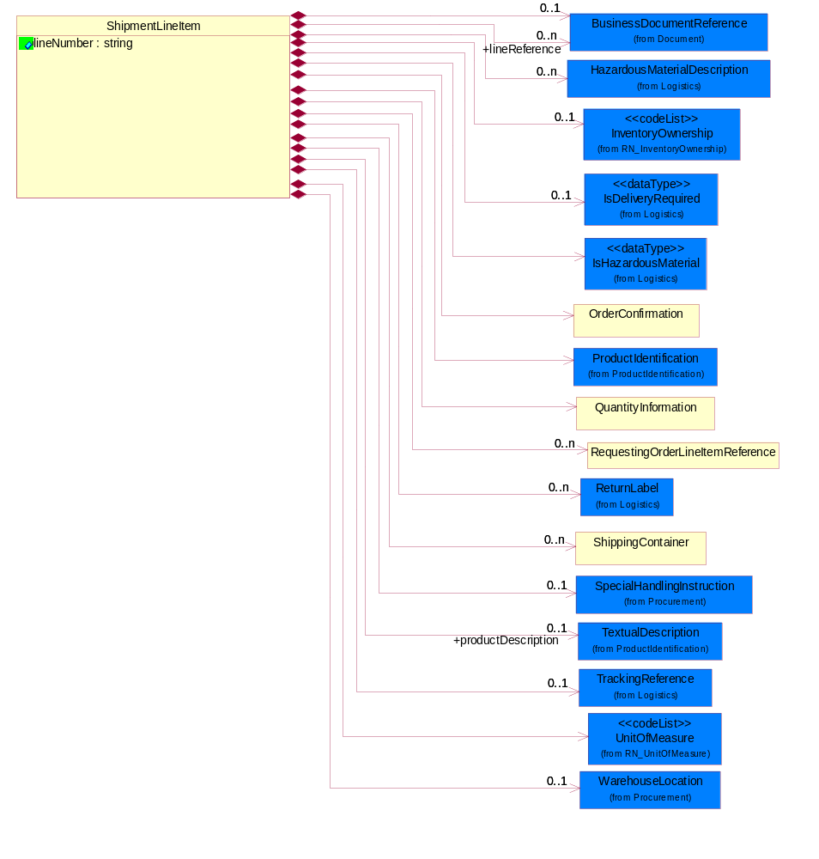
Figure ‎2-10 ShipmentLineItem

Attribute | Type | Documentation
lineNumber | string | Number of the line in the document.

Composition | Cardinality | Type | Documentation
UnitOfMeasure | 1 | UnitOfMeasure | Code identifying a product unit of measure.
HazardousMaterialDescription | 0..n | HazardousMaterialDescription | The collection of business properties that describe the nature of dangerous goods tendered for transportation.
productDescription | 0..1 | TextualDescription | A textual description of the product.
ProductIdentification | 1 | ProductIdentification | The object provides the identifier(s) of a product.
QuantityInformation | 1 | QuantityInformation | The collection of business properties that describes information regarding the quantity of the product shipped.
RequestingOrderLineItemReference | 0..n | RequestingOrderLineItemReference | The collection of business properties that references a line item on a requesting document.
ShippingContainer | 0..n | ShippingContainer | The collection of business properties that describe the nature and contents of a shipping unit.
OrderConfirmation | 1 | OrderConfirmation | The collection of business properties that describes the confirmation or rejection of a shipping order.
ReturnLabel | 0..n | ReturnLabel | The collection of business properties that identifies a return label included in the shipment to facilitate return shipment of products.
IsHazardousMaterial | 1 | IsHazardousMaterial | Indicates whether the product contains hazardous material.
WarehouseLocation | 0..1 | WarehouseLocation | The physical address or location identification for a warehouse.
lineReference | 0..n | BusinessDocumentReference | An additional reference identifier at the line level.
IsDeliveryRequired | 0..1 | IsDeliveryRequired | Indicates whether actual physical product is required to be picked or delivered.
InventoryOwnership | 0..1 | InventoryOwnership | Code that indicates the ownership of the inventory.
BusinessDocumentReference | 0..1 | BusinessDocumentReference | The business document reference object allows for the indirect referencing of a relationship to other business related documents.
SpecialHandlingInstruction | 0..1 | SpecialHandlingInstruction | The collection of business properties that describe product packaging or shipping handling instructions.
TrackingReference | 0..1 | TrackingReference | Proprietary unique identifier for tracking product shipments.

ShippingContainer
The collection of business properties that describe the nature and contents of a shipping unit.
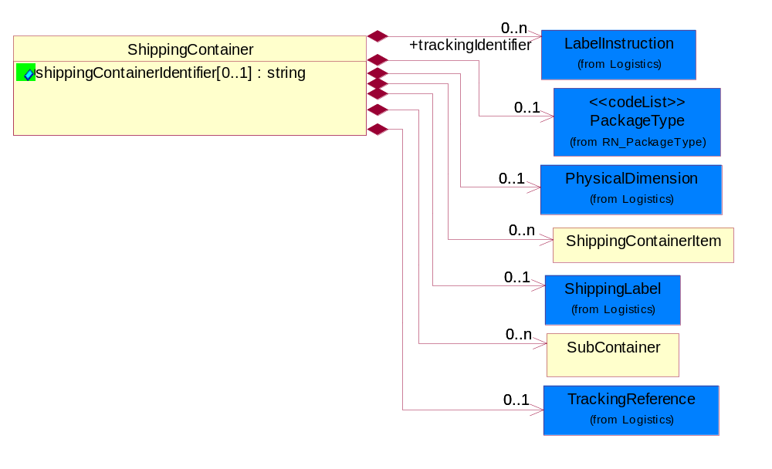
Figure ‎2-11 ShippingContainer

Attribute | Type | Documentation
shippingContainerIdentifier[0..1] | string | Unique identifier that represents a shipping container. Normally a UCC structured identifier. Also known as a "license plate".

Composition | Cardinality | Type | Documentation
ShippingContainerItem | 0..n | ShippingContainerItem | The collection of business properties that describe the nature and contents of the good contained within shipping unit.
SubContainer | 0..n | SubContainer | The collection of business properties that describe the nature and contents of inner containers (packages) contained within an outer shipping unit.
PhysicalDimension | 0..1 | PhysicalDimension | The physical dimension of a quantity such as length, time, mass.
ShippingLabel | 0..1 | ShippingLabel | The collection of business properties that describe Shipping label and shipment information.
trackingIdentifier | 0..n | LabelInstruction | Used for Waybill data specific instructions.
PackageType | 0..1 | PackageType | Code specifying the type of packaging for a product.
TrackingReference | 0..1 | TrackingReference | Proprietary unique identifier for tracking product shipments.

ShippingContainerItem
The collection of business properties that describe the nature and contents of the good contained within shipping unit.
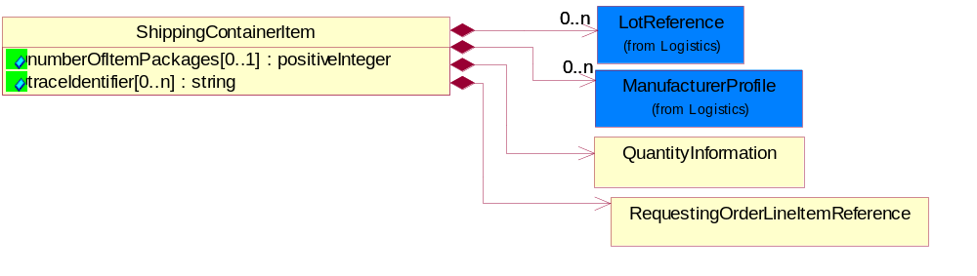
Figure ‎2-12 ShippingContainerItem

Attribute | Type | Documentation
numberOfItemPackages[0..1] | positiveInteger | A numeric expression of the number of item packages within a container.
traceIdentifier[0..n] | string | Free form text for a non-serial lot identifier.

Composition | Cardinality | Type | Documentation
ManufacturerProfile | 0..n | ManufacturerProfile | The collection of business properties that describe a manufacturer's product.
LotReference | 0..n | LotReference | The collection of business properties that describe a manufacturing lot tendered for shipping.
QuantityInformation | 1 | QuantityInformation | The collection of business properties that describes information regarding the quantity of the product shipped.
RequestingOrderLineItemReference | 1 | RequestingOrderLineItemReference | The collection of business properties that references a line item on a requesting document.

ShippingOrder
The collection of business properties that describes an order to ship products from one location to another.
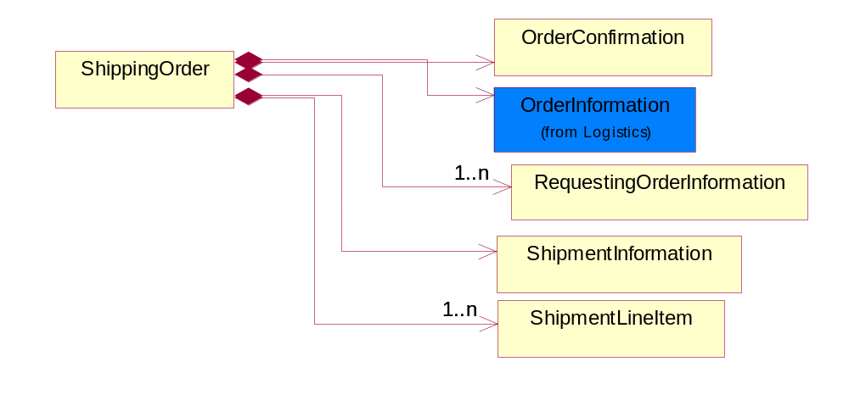
Figure ‎2-13 ShippingOrder

Composition | Cardinality | Type | Documentation
OrderConfirmation | 1 | OrderConfirmation | The collection of business properties that describes the confirmation or rejection of a shipping order.
RequestingOrderInformation | 1..n | RequestingOrderInformation | The collection of business properties that identifies an order of another type that caused this shipping order to be created.
ShipmentInformation | 1 | ShipmentInformation | The collection of business properties that identifies how a shipment is to be made. ProcessRoleIdenfier usage suggested: IMB - Imported By, SHF - Ship From and SHT - Ship To.
ShipmentLineItem | 1..n | ShipmentLineItem | The collection of business properties that describes the shipping details for a product line item on the shipping order.
OrderInformation | 1 | OrderInformation | The collection of business properties that identifies a shipping order, including its identity, type and purpose.

ShippingOrderConfirmation
Top level object for a Shipping Order Confirmation document.
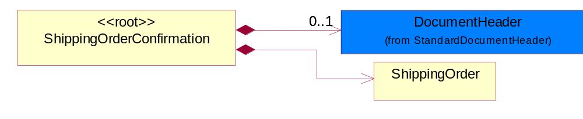
Figure ‎2-14 ShippingOrderConfirmation

Composition | Cardinality | Type | Documentation
DocumentHeader | 0..1 | DocumentHeader | The object allows for the identification of the sender and receiver of the business document.
ShippingOrder | 1 | ShippingOrder | The collection of business properties that describes an order to ship products from one location to another.

SubContainer
The collection of business properties that describe the nature and contents of inner containers (packages) contained within an outer shipping unit.
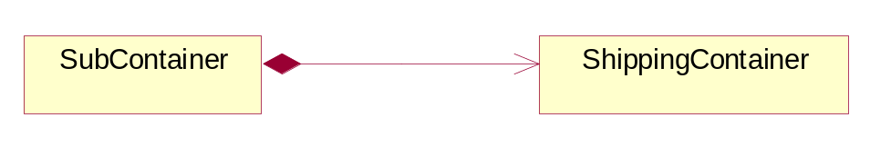
Figure ‎2-15 SubContainer

Composition | Cardinality | Type | Documentation
ShippingContainer | 1 | ShippingContainer | The collection of business properties that describe the nature and contents of a shipping unit.

Domain Model

Procurement

Dependency Diagram
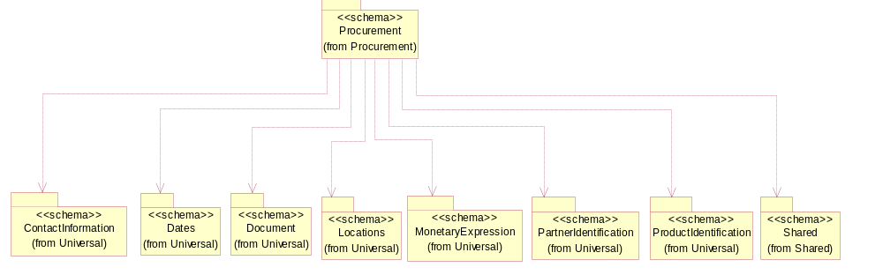
Figure ‎3-16 Dependency

CurrencyConversion
The collection of business properties that describe the exchange of money in circulation.
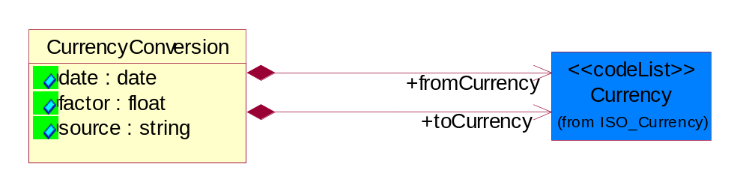
Figure ‎3-17 CurrencyConversion

Attribute | Type | Documentation
date | date | The date of the exchange rate used to convert between currencies.
factor | float | The conversion factor to apply to convert from the currency of the freight charges to the currency used for payment.
source | string | The source of the exchange rate used to convert between currencies.

Composition | Cardinality | Type | Documentation
toCurrency | 1 | Currency | The currency of the receiving partner in a business transaction.
fromCurrency | 1 | Currency | The currency of the initiating partner in a business transaction.

SpecialHandlingInstruction
The collection of business properties that describe product packaging or shipping handling instructions.
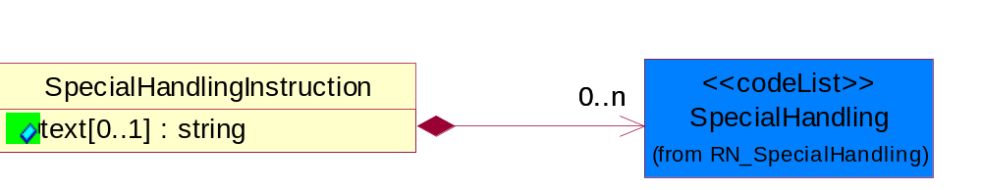
Figure ‎3-18 SpecialHandlingInstruction

Attribute | Type | Documentation
text[0..1] | string | Free form textual description for how specified goods, packages or containers should be handled.

Composition | Cardinality | Type | Documentation
SpecialHandling | 0..n | SpecialHandling | Code identifying special handling or packaging requirements for the product.

WarehouseLocation
The physical address or location identification for a warehouse.
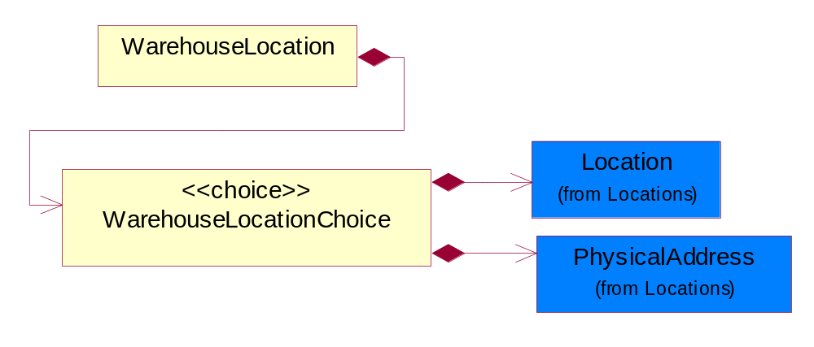
Figure ‎3-19 WarehouseLocation

Composition | Cardinality | Type | Documentation
WarehouseLocationChoice | 1 | WarehouseLocationChoice | Choices of the physical address or location identification for a warehouse.

WarehouseLocationChoice
Choices of the physical address or location identification for a warehouse.

Composition | Cardinality | Type | Documentation
PhysicalAddress | 1 | PhysicalAddress | The business document must provide a physical address for a party to the business transaction.
Location | 1 | Location | The business document must specify a location.

CodeList

SpecialHandling
Code identifying special handling or packaging requirements for the product.

Name | Documentation
15M | 15 Minute Window.
24H | 24 Hour Availability.
AAO | Attachments - Advance Only Waybill.
ACC | Accepted by Carrier at Owner's Risk of Freezing.
ACD | Air Conditioning Disconnect and Connect.
ACU | Attachment - Customer's Document.
ADC | Additional Copy of Shipping Papers for Proof of Delivery.
ADF | Advanced Fee.
ADL | Advance Loading.
AGS | Armed Guard Service.
AHM | Accessible Hazardous Material.
AMD | A.M. Delivery Requirement.
ANU | Anchoring and Unanchoring.
ANV | Annual Volume.
APW | Attachment - Prepaid Waybill.
ART | Air Ride Truck Service.
ASE | Attachment - Shipper's Export Document.
ASM | Attachment - Shipper's Manifest.
ASP | Attachment - Shipper's Packing Instructions.
ASR | Assembly Service Requested.
ATD | Aggregate Tender Discount.
ATT | Air Ride Tractor Service.
AUS | Auxiliary Service.
BA1 | Bunker Adjustment - 20 Foot Container.
BA2 | Bunker Adjustment - 40 Foot Container.
BCC | Bill Consignee for Weigh Charges.
BCP | Bypass Consolidation Point.
BFS | Barge Freight All Kinds Service.
BKA | Bunker Adjustment.
BKS | Block Stowage.
BLB | Blocking and Bracing.
BLS | Blind Shipment.
BNS | If Bad Ordered Notify Shipper.
BOL | Bolster Load, Do Not Switch.
BSA | Bunker Surcharge Authorized.
BSC | Bill Shipper for Weigh Charge.
BUA | Bulky Article.
CA1 | Currency Adjustment - 20 Foot Container.
CA2 | Currency Adjustment - 40 Foot Container.
CAA | Cargo Aboard.
CAB | Chain and Binders.
CAC | Carrier Caboose.
CAR | Carrier.
CAT | Cargo Taxes.
CBC | Cargo on Board Certification Required.
CCB | Convert Commercial Bill of Lading (BOL) to Government BOL.
CCE | Certification that the Containers Being Returned Empty Were Received Filled by Rail Freight Service.
CCL | Container, Consolidator Load.
CER | Certification.
CFB | Cleared for Border Crossing.
CFC | Customs Fees - Container Level.
CFE | Cleared for Export.
CFI | Customs Fees - Lift Level.
CFL | Container, Factory Load.
CGC | Carrier Guard Car Service.
CHB | Clearinghouse Balance.
CIP | Commercial Invoice Preparation.
CIR | Circuitous Routing.
CLC | Carrier Load and Consignee Unload.
CLE | Cleaning.
CLH | Consolidation and Line Haul.
CLL | Commodity Loaded Less Than or Equal To the Car Ordered.
CLU | Carrier Load and Carrier Unload.
CNE | Certification That the Newsprint Winding Cores Being Returned Empty Were Received Filled by Rail Freight Service.
COA | Controlled Atmosphere.
COD | Container Diversion.
COL | Container Lease.
COM | Container Mounting.
CON | Conductivity/Anti-static Additive.
COO | Certificate of Origin.
COS | Completing Shipment.
COU | Consignee Unload.
COV | Courier, Overnight.
CPM | Customs Papers Mailed.
CPN | Customer Required PRO Number.
CRA | Class Rates Applied.
CRD | Comb. Rates over Detroit.
CRL | Customer Required Packing List.
CRN | Customer Required Appointment Number.
CRP | Contract Rates Apply.
CRT | Cross Town.
CSD | Courier, Same Day.
CSL | Consolidation.
CSR | Certification that this Shipment is for Recycling as Defined in Applicable Tariffs Containing Such Provisions.
CSU | Constant Surveillance.
CUI | Customs Inspection.
DAN | Dangerous.
DAR | Drop and Run.
DCE | Detention of Conveying Equipment and the Power Unit.
DEM | Demurrage.
DEP | Detention of Conveying Equipment Excluding the Power Unit.
DES | Delivery Service.
DEV | Detention (Vehicle).
DHI | Do not Hump or Hump into.
DID | Direct Delivery.
DNC | Do Not Couple to Double Shelf Couples.
DND | Do Not Divert.
DNF | Do Not Freeze.
DNH | Do Not Hump.
DNP | Do Not Pool.
DNT | Do Not Transfer Contents.
DNU | Do Not Uncouple.
DOD | DOD Constant Surveillance Service.
DOM | Domestic.
DOS | Documentation - Special.
DP1 | Detention With Power Units (30 minute periods).
DP2 | Detention With Power Units (60 minute periods).
DPD | Drayage at Port of Debarkation (Rate Zone).
DPE | Drayage at Port of Embarkation (Rate Zone).
DRO | Drop-Off Delivery.
DSR | Distribution Service Requested.
DSW | Delivery Only on Surrender of Written Order.
DVN | Delivery Verification Not Required.
DWA | Destination Weights Apply.
ECS | Escort/Courier Service.
EET | Electronic Equipment Transfer.
EHM | Endorsed as Hazardous Material.
ELB | Extra Labor.
EMM | Empty Movement.
EMR | Empty Return.
EMS | Emergency Service.
END | Endorsement.
EOS | Escort Service with Overnight Subsistence.
EPP | Export Preparation.
EPT | Export.
EQU | Equipment..
ERA | Expedited Rates Applied.
ERI | Expand Remove and Install.
ESC | Escort.
EST | Escort Services (Telephone).
EUV | Exclusive Use of Vehicle.
EVA | Excessive Valuation Authorized.
EXC | Exempt Commodity.
EXD | Extra Driver.
EXL | Extra Lights.
EXP | Expedite.
EXS | Expedited Service.
EXU | Exclusive Use.
EXW | Excessive Weight.
FIS | Filtration Service.
FLS | Flatrack Surcharge.
FOD | FOD, FOB - Destination.
FOS | FOS, FOB Shipping Point.
FPT | For Processing in Transit.
FRA | Fragile - Handle with Care.
FST | For Storage in Transit.
FUS | Full Service.
GGC | Government Guard Car.
GOC | Government-Owned Containers.
GSS | Greater Security Service.
GVC | Government Caboose.
HAL | Hold at Location.
HAN | Handling.
HAR | Harmless.
HCD | Hazardous Cargo On Deck.
HCT | High Cube Trailer Rates.
HEA | Heat.
HES | Heat - Special.
HFO | Hold for Orders.
HFR | Home for Repair.
HIT | Heat in Transit.
HMS | Hazardous Materials Surcharge.
HOR | Heater or Refrigeration.
HVL | High Value Load.
IHM | Inaccessible Hazardous Material.
IMP | Impactographs.
IMS | Import Shipment.
INB | In-bond.
IND | Inside Delivery.
INH | Inspect Hourly if Car Stopped.
INP | Inside Pickup.
INS | Insulated.
IPM | Intra-Plant Move.
ISS | Intermodal Shipment Service.
ITS | Interline Transfer Service.
JIT | Just-In-Time (JIT).
JLE | Joint Line Exception.
KFF | Keep From Freezing Percent Differential.
KMD | Keep Material Dry.
LAA | Labor Associated with Detention of Conveying Equipment.
LAB | Land Bridge (Import/Export).
LAD | Labor Disturbance.
LAO | Layover.
LAS | Layover Service.
LBD | Labor Disturbance.
LBS | Light Bar Service.
LBT | Low Boy Trailer/Flat Bed.
LC1 | Land Currency Adjustment - 40 Foot Container.
LC2 | Land Currency Adjustment Factor - 20 Foot Container.
LCA | Land Currency Adjustment - 40 Foot Container.
LCF | Land Currency Adjustment Factor - 20 Foot Container.
LDE | Labor Associated with Detention of Conveying Equipment.
LDP | Linehaul from Port of Debarkation.
LEP | Linehaul To Port of Embarkation.
LFC | Less Than Full Carload.
LFL | Less Than Container, Factory Load.
LFV | Loaded to Full Visible Capacity.
LIS | Linehaul Service.
LIU | Live Unload.
LOC | Liability of Carrier.
LOD | Loading Devices.
LPD | Linehaul Percent Differential.
LSO | Local Service Only.
LTC | Less Than Container.
LTD | Liner Terms at Port of Debarkation.
LTE | Liner Terms at Port of Embarkation.
LTL | Less Than Container, Consolidator Load.
LTT | Less Than Truckload.
MAW | Manifest Must Accompany Waybill.
MER | Mechanical Refrigeration.
MFI | Moving Under "For Furtherance Instructions" and May Be Delivered.
MOA | Modified Atmosphere.
MSS | Motor Surveillance Service.
MTS | Multi-Tank Surveillance Service.
MUP | Multiple Pickup.
NCB | Notify Consignee Before Delivery.
NEF | New Equipment First Transborder Movement.
NFE | Not for Export.
NFS | Nontransit Flat Shipment.
NMR | No Marshalling Required for Hazardous Materials.
NPR | No Placards Required.
NRC | Not Restricted Cargo.
NSB | Notify Shipper Before Reconsignment.
NSE | No Special Entrainment Required.
NSI | Notify Shipper Immediately if Shipment is Delayed en Route.
NUW | In Case of Fire Do Not Use Water.
OAH | Offshore - Alaska/Hawaii Service.
ODS | On Deck Stowage.
OHC | Over Height Container.
OTH | Other.
OVF | Overflow.
OVP | Oversized Premium.
OVW | Overweight.
OWR | One Way Rates Applied.
PAD | Pickup and Delivery.
PAS | Partial Shipment.
PAU | Pack and Unpack.
PAW | Preparation of Air Waybill - Origin.
PCC | Preparation of Canadian Customs Invoice.
PDB | Pickup and Delivery Beyond Service Area.
PDL | Percent Differential - Less Than Container.
PDS | Pickup and Delivery From Storage in Transit.
PEE | Preparation of Export Entry.
PFH | Protect From Heat.
PHR | Per Hour Rates Applied.
PIC | Preparation of Insurance Certificate.
PIT | Pier Time.
PIU | Pickup.
PLR | Protect Lowest Through Rate.
PMD | P.M. Delivery Requirement.
PMR | Per Mile Rates Apply.
POC | Port Changes.
PPC | PPC, FOB -Destination charge to customer.
PPD | PPD, Prepay+I35/Add Freight to Invoice.
PPS | Product Protection Service.
PRS | Priority Service.
PSC | Protective Security Service.
PSN | Pickup of Shipments on Saturday, Sunday, and/or Holidays Requiring Absolute Next Day Delivery.
PSP | Pallets/Skids/Platforms.
PSS | Pickup of Shipments Requiring Same Day Delivery Service.
PST | Pickup of Shipments Requiring Same Day Delivery Service and/or Delivery at a Specified Time.
PUE | Preparation of U.S. Export Documentation.
PUP | PUP Trailer Rates Apply.
RAH | Railhead Handling.
RAM | Radioactive Material.
RBC | Render Bill for Charges.
RCD | Reefer Cargo Percent Differential.
RCG | Return Carrier Guard Car Service.
RCP | Railroad Controlled Private Equipment Subject to Demurrage.
RCS | Reconsignment.
REA | Return Authorization.
REC | Return of Empty Container.
RED | Redelivery.
REF | Refrigerated.
REM | Reefer Maintenance.
RER | Reweight Requested.
RES | Reservations.
RFT | Record for Transit.
RMP | Return Movement of Pallet.
ROE | ROEE Van Type Truck.
ROS | Roadrailer Service.
RSC | Requires Shelf Couplers.
RSD | Residential Delivery.
RSM | Reshipment.
RST | Respotting.
RTS | Round Trip Service.
RUO | Rush Order.
RVC | Released Value Charge in Excess of Carrier Maximum Liability.
RWE | Roadway Easy Rates Applied.
SAD | Saturday Delivery.
SAH | Stow Away from Heat.
SAR | Shipper Authorization Required for Diversion or Consignment.
SCA | Service Charge Applies.
SCC | Shipper Load/Carrier Count.
SCG | Shipper Certifies Gross Weight under 240,000 pounds.
SCL | Apply a Uniform Code Council/International Article Numbering Association (UCC/EAN) Serial Shipping Container Label to the Shipping Containers.
SCW | Stretch Wrap.
SDS | Special Dromedary Service.
SEC | Special Equipment Charge.
SED | Shipper Export Declaration Required.
SEE | Stairs, Elevator, Excess Carry.
SES | Security Signature Service.
SFD | Single Factor Origination/Port of Debarkation.
SFO | Single Factor Origination/Destination.
SFP | Single Factor Port of Embarkation/Destination.
SFS | Satisfactory Service Standards.
SGD | Single Driver.
SHH | Shipment Holdover for Holidays.
SHL | Shiftable Load.
SHP | Sunday or Holiday Pickup or Delivery.
SHW | Shipment Holdover for Weekends.
SID | Shipment to be Inspected at Destination and Disposition Instructions will be Furnished.
SIR | Signature Required.
SIS | Single Shipment.
SLC | Shipper Load and Carrier Unload.
SLD | Split Delivery.
SLO | Shipper Load and Count.
SLP | Split Pickup.
SLS | Shipper Load and Consignee Unload.
SMP | Small Package.
SMS | Special Motor Surveillance.
SNT | Shipment from Non-Temp Storage.
SOD | Stop-off at Destination.
SOE | Shipment Holdover on Weekends.
SOH | Shipment Holdover on Holidays.
SOO | Stop-off at Origination.
SOW | Shipment Holdover on Weekdays.
SPC | Special Containers.
SPD | Saturday Pickup or Delivery.
SPL | Shipper Load.
SPP | Special Permit.
SPR | Speed Restricted.
SPS | Special Permits.
SPU | Saturday Pick-Up.
SR1 | Speed Restricted to 15 Miles per Hour.
SR2 | Speed Restricted to 25 Miles per Hour.
SR3 | Speed Restricted to 35 Miles per Hour.
SR4 | Speed Restricted to 45 Miles per Hour.
SRC | Shove to Rest and Cover.
SRG | Storage.
SSC | Stripping, Sorting and Consolidation.
SSD | Subject to Special Detention Rules/Charges.
SSN | Substitute Service Not to be Used.
SSS | Satellite Surveillance Service.
SST | Spot for Storage - No Shipment.
STM | Special Train Movement.
STO | Stop-off.
STR | Signature and Tally Record.
STT | Stack Train.
STW | Stowage.
SUR | Supervisor Requested.
SVR | Surveying Routes.
TAT | Tendered as Truckload (Truckload Service Requested).
TCL | Trailer, Consolidator Load.
TDS | Time of Delivery and Signature Required.
TEC | Temperature Control.
TER | Termination.
TFL | Trailer, Factory Load.
TFP | Transfer Product.
THC | Terminal Handling Charges.
TLO | Top Load Only.
TMV | Tendering of Multiple Vehicles.
TOC | Truckload-Double Operator-Common Carrier.
TOP | Truckload-Double Operator-Padded Van.
TOS | Total Shipment.
TPS | Third Party Service.
TRA | Truck Rates Applicable.
TRP | Trailer Preparation - Special.
TRS | Trade Show.
TSN | Transmit a Ship Notice/Manifest Transaction Set.
TSS | Transit Shipment.
TTD | Team Track Delivery.
TTR | Tentative Release - Tentatively releasing the shipment either for import or export and subject to compliance to additional conditions which could be executed later.
TVR | Time Volume Rates Only.
UAP | Unload as Placarded.
UAT | Use of Alternate Terminal.
ULS | Unload from Left Side of Car.
UNH | Use No Hooks.
UNI | Unitized.
UNP | Unpacking.
UOR | Unloading or Reloading.
UPP | Unprotected Perishable.
URS | Unload from Right Side of Car.
VEI | Ventilation Instructions.
VEW | Verification Weigh.
WAI | Waive Inspection.
WCO | Weigh to Check for Overload.
WEE | Weigh Empty.
WEV | Weight Verification.
WID | Waived Inspection - Set Direct.
WPD | Written Proof of Delivery.
WTA | Waiting Time Authorized.

OrderAdmin
Additional administrative code identifying the reason the shipping order is being sent, possibly indicating a predefined workflow.

Name | Documentation
DDE | Demo Depot.
DOA | DOA.
ERA | E-Rate.
GRA | Government Rated.
INT | Internal/Demo/Evaluation/Sample.
MUL | Multinational.
PRE | Premium.
REP | Replacement.
RZC | Replacement - Zero Cost.
SAM | Sample.
SPR | Special Promotions.
STA | Standard.
TIO | Trade-in Order.
TIR | Trade-in Return.
UPG | Upgrade.
UZC | Upgrade - Zero Cost.

Logistics

Dependency Diagram
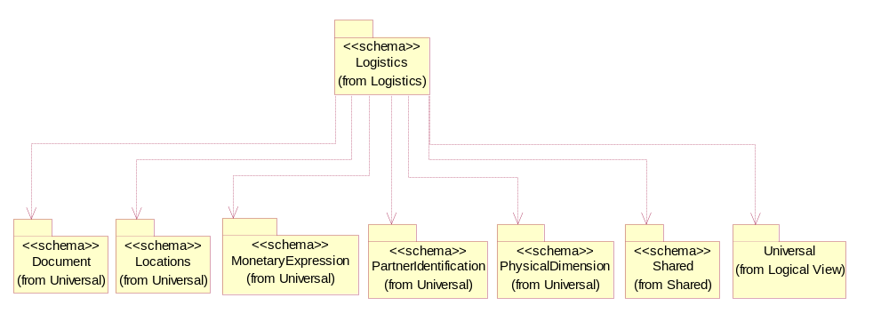
Figure ‎3-20 Dependency

ExportDeclaration
The collection of business properties that describe an export declarations.
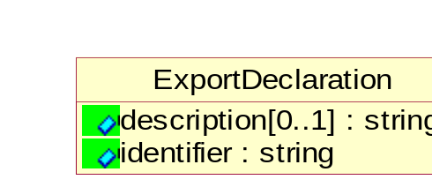
Figure ‎3-21 ExportDeclaration

Attribute | Type | Documentation
description[0..1] | String | Information related to International service - Information related SED (Shipper Export Declarations).
Identifier | String | To identify unique reference for Shipper Export Declaration.

ExportLicense
The collection of business properties that describe an export license number.
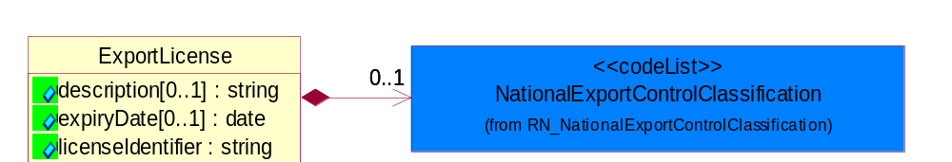
Figure ‎3-22 ExportLicense

Attribute | Type | Documentation
description[0..1] | string | The description of inventory item to appear on the commercial invoice.
expiryDate[0..1] | date | The date that a contractual agreement expires.
licenseIdentifier | string | The unique identifier representing a license.

Composition | Cardinality | Type | Documentation
NationalExportControlClassification | 0..1 | NationalExportControlClassification | Code identifying product classification for export regulation.

FreeOnBoardTerms
The collection of business properties that identifies the Free On Board terms.
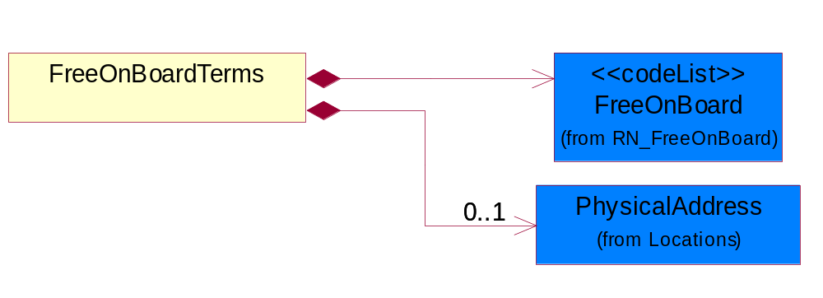
Figure ‎3-23 FreeOnBoardTerms

Composition | Cardinality | Type | Documentation
PhysicalAddress | 0..1 | PhysicalAddress | The business document must provide a physical address for a party to the business transaction.
FreeOnBoard | 1 | FreeOnBoard | Code identifying a specified point where a product is delivered or placed on board a carrier without charge.

FreightPaymentInformation
The collection of business properties that describes payments required for a shipment.
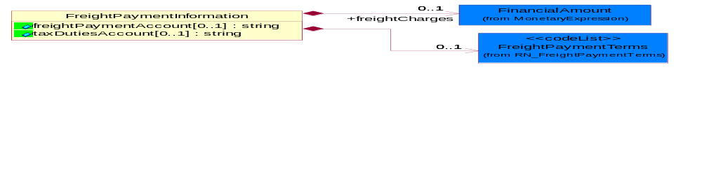
Figure ‎3-24 FreightPaymentInformation

Attribute | Type | Documentation
freightPaymentAccount[0..1] | String | The account number with the shipping carrier of the party paying the carrier fees for the shipment.
taxDutiesAccount[0..1] | String | Identification number of taxes/duties account.

Composition | Cardinality | Type | Documentation
FreightPaymentTerms | 0..1 | FreightPaymentTerms | Code identifying responsibility for payment of shipping charges.
freightCharges | 0..1 | FinancialAmount | The monetary amount to be paid for freight transportation.

HazardousMaterialDescription
The collection of business properties that describe the nature of dangerous goods tendered for transportation.
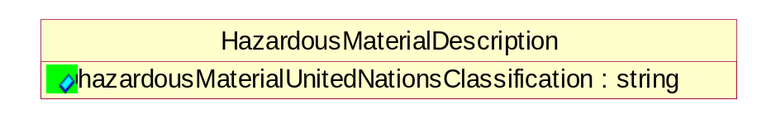
Figure ‎3-25 HazardousMaterialDescription

Attribute | Type | Documentation
hazardousMaterialUnitedNationsClassification | String | Code classifying hazardous material products.

IsDeliveryRequired
Indicates whether actual physical product is required to be picked or delivered.
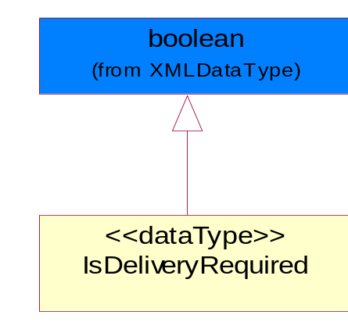
Figure ‎3-26 IsDeliveryRequired

IsHazardousMaterial
Indicates whether the product contains hazardous material.
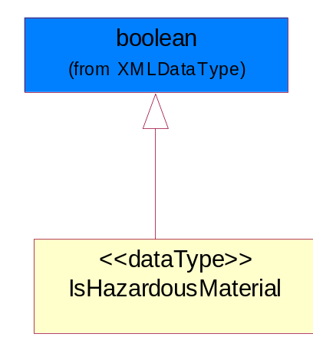
Figure ‎3-27 IsHazardousMaterial

IsPartialShipment
The collection of business properties that identifies how a shipment is to be made.
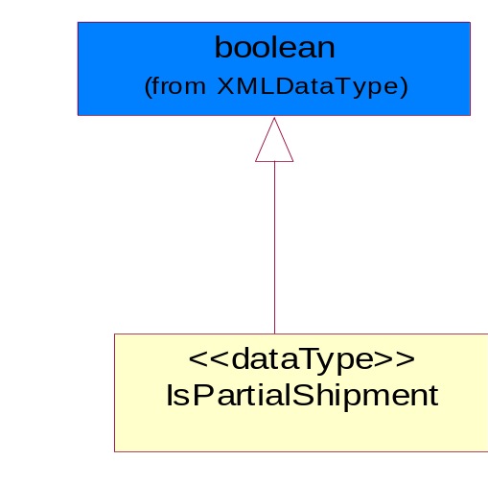
Figure ‎3-28 IsPartialShipment

LabelInstruction
The collection of business properties that identifies shipping instruction types code to be displayed or imbedded on labels.
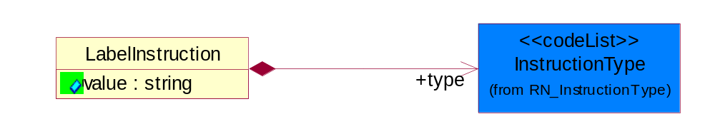
Figure ‎3-29 LabelInstruction

Attribute | Type | Documentation
value | string | Free Form Text, String to be displayed for Label Instruction.

Composition | Cardinality | Type | Documentation
type | 1 | InstructionType | To express type of instructions.

LabelServiceContent
The collection of business properties that identifies label service code and format to be displayed on labels.
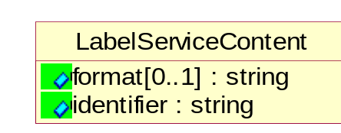
Figure ‎3-30 LabelServiceContent

Attribute | Type | Documentation
format[0..1] | string | To display Service code on the label.
Identifier | string | To communicate format of the text for the shipping label.

LinearWithMeasureType
The business document must be able to express the linear dimensions of an object.
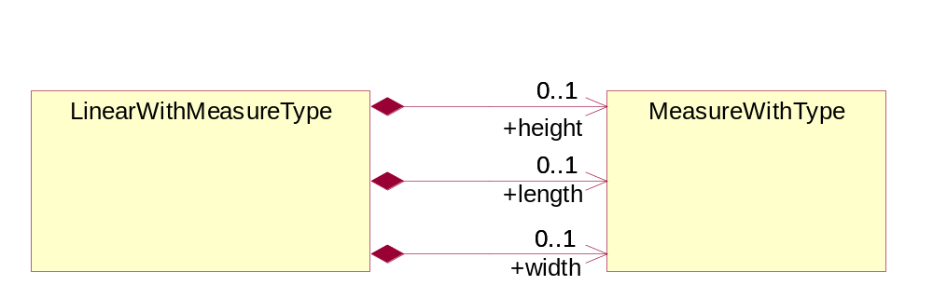
Figure ‎3-31 LinearWithMeasureType

Composition | Cardinality | Type | Documentation
length | 0..1 | MeasureWithType | To express the length of an object.
width | 0..1 | MeasureWithType | To express the weight of an object.
height | 0..1 | MeasureWithType | To express the height of an object.

LotReference
The collection of business properties that describe a manufacturing lot tendered for shipping.
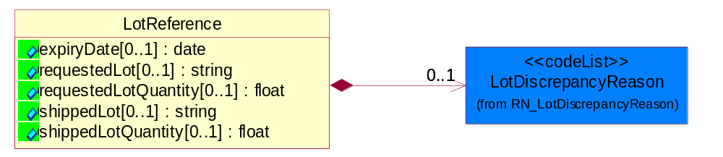
Figure ‎3-32 LotReference

Attribute | Type | Documentation
expiryDate[0..1] | date | The date that a contractual agreement expires.
requestedLot[0..1] | string | The identifier of a manufacturing lot from which a quantity of product was requested.
requestedLotQuantity[0..1] | float | The quantity of product requested from a specific manufacturing lot.
shippedLot[0..1] | string | The identifier of a manufacturing lot from which a quantity of product was shipped.
shippedLotQuantity[0..1] | float | A quantity of product shipped of a specific manufacturing lot within a shipping container.

Composition | Cardinality | Type | Documentation
LotDiscrepancyReason | 0..1 | LotDiscrepancyReason | Code identifying the reason for a discrepency in the lot composition of the shipment.

ManufacturerProfile
The collection of business properties that describe a manufacturer's product.
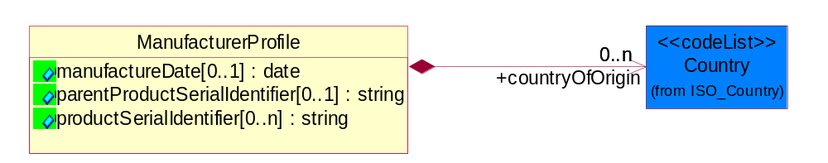
Figure ‎3-33 ManufacturerProfile

Attribute | Type | Documentation
manufactureDate[0..1] | date | The date the product was manufactured.
parentProductSerialIdentifier[0..1] | string | The unique Parent Product Serial Identifier of a product.
productSerialIdentifier[0..n] | string | Serial number(s) of a product.

Composition | Cardinality | Type | Documentation
countryOfOrigin | 0..n | Country | Country where product originates.

MassPhysicalDimension
The physical dimension of unit of mass used for measuring the masses of weights, volumes etc.
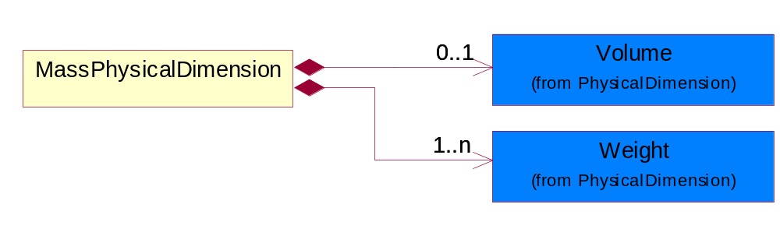
Figure ‎3-34 MassPhysicalDimension

Composition | Cardinality | Type | Documentation
Volume | 0..1 | Volume | The business document must be able to express the volume of an object.
Weight | 1..n | Weight | The business document must be able to express the weight of an object.

MeasureWithType
The business document must describe measurement information.
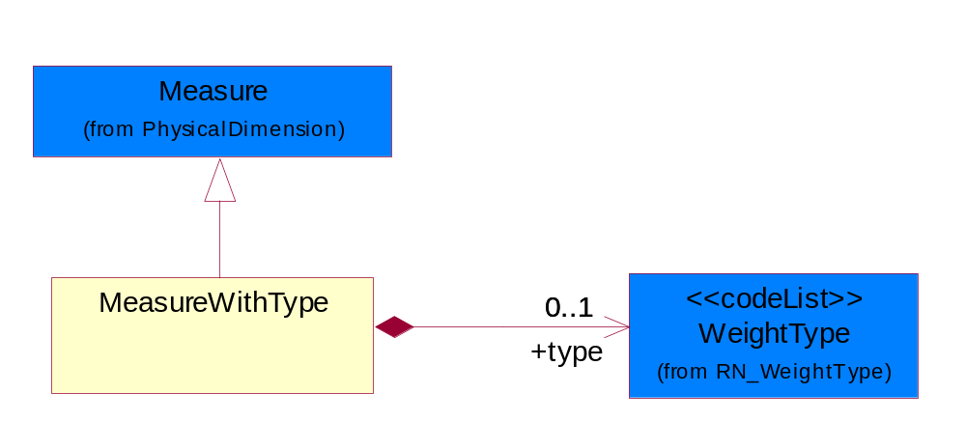
Figure ‎3-35 MeasureWithType

Composition | Cardinality | Type | Documentation
type | 0..1 | WeightType | A code identifying the type of measure.

OrderInformation
The collection of business properties that identifies a shipping order, including its identity, type and purpose.
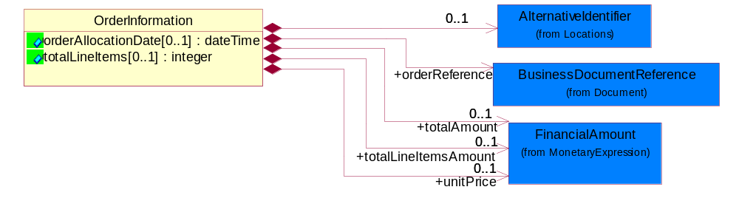
Figure ‎3-36 OrderInformation

Attribute | Type | Documentation
orderAllocationDate[0..1] | dateTime | Specifies an instance in time for the part was allocated.
totalLineItems[0..1] | integer | Total number of line items in an entire business document.

Composition | Cardinality | Type | Documentation
orderReference | 1 | BusinessDocumentReference | An additional reference number to identify a single shipment when there are multiple shipments resulting from a single requesting order.
AlternativeIdentifier | 0..1 | AlternativeIdentifier | Identifies the specified code and the name of the organization that a code is utilized from.
unitPrice | 0..1 | FinancialAmount | Agreed upon Export/Import invoice unit price.
totalAmount | 0..1 | FinancialAmount | Total price for an entire business document.
totalLineItemsAmount | 0..1 | FinancialAmount | Total price for all shipping order line items.

PhysicalDimension
The physical dimension of a quantity such as length, time, mass.
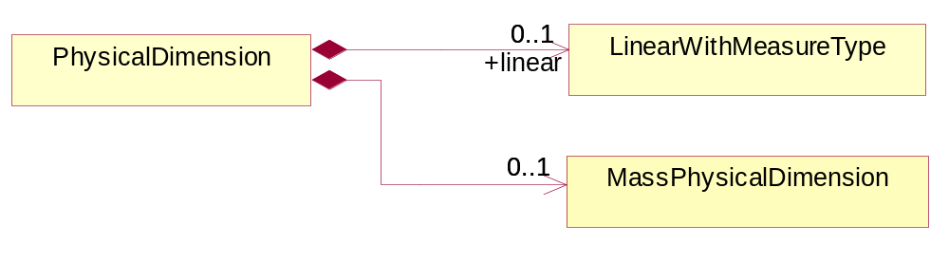
Figure ‎3-37 PhysicalDimension

Composition | Cardinality | Type | Documentation
MassPhysicalDimension | 0..1 | MassPhysicalDimension | The physical dimension of unit of mass used for measuring the masses of weights, volumes etc.
linear | 0..1 | LinearWithMeasureType | The business document must be able to express the linear dimensions of an object.

ReturnInstructions
The collection of business properties that identifies return instructions that should be printed in the native language of the outbound order's receiver country code.
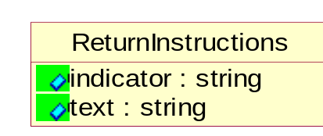
Figure ‎3-38 ReturnInstructions

Attribute | Type | Documentation
indicator | string | An identifier used to specify the lines of the return instructions should be printed.
text | string | Return instructions that should be printed in the native language of the outbound order's receiver country code.

ReturnLabel
The collection of business properties that identifies a return label included in the shipment to facilitate return shipment of products.
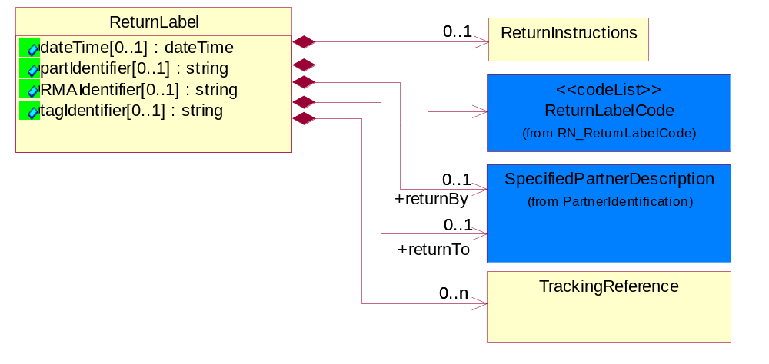
Figure ‎3-39 ReturnLabel

Attribute | Type | Documentation
dateTime[0..1] | dateTime | The expected return date for the part.
partIdentifier[0..1] | string | The unique identifier representing a Return Part number that prints on the return label.
RMAIdentifier[0..1] | string | The unique identifier representing a Return material authorization number.
tagIdentifier[0..1] | string | The unique identifier representing a return tag number.

Composition | Cardinality | Type | Documentation
TrackingReference | 0..n | TrackingReference | Proprietary unique identifier for tracking product shipments.
ReturnLabelCode | 1 | ReturnLabelCode | Code specifying the type of return label, e.g. for returning unused or defective parts.
returnBy | 0..1 | SpecifiedPartnerDescription | The party responsible for either carrying or forwarding the returned product.
returnTo | 0..1 | SpecifiedPartnerDescription | The partner and/or location to which the returned product must be delivered.
ReturnInstructions | 0..1 | ReturnInstructions | The collection of business properties that identifies return instructions that should be printed in the native language of the outbound order's receiver country code.

ShipmentDate
The collection of business properties that identifies a constraint on when the products may be shipped.
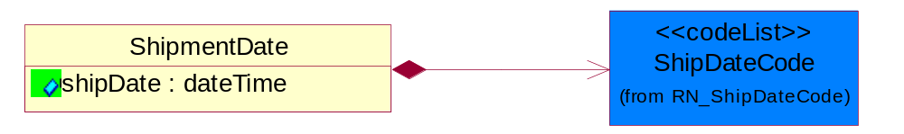
Figure ‎3-40 ShipmentDate

Attribute | Type | Documentation
shipDate | dateTime | The date when the shipment maybe shipped.

Composition | Cardinality | Type | Documentation
ShipDateCode | 1 | ShipDateCode | Code identifying a type of ship date.

ShipmentInstructions
The collection of business properties that identifies shipping instruction notes and their location on shipping documents or labels.

Attribute | Type | Documentation
comment | string | Shipping instruction notes to appear on shipping documents or labels.
identifier | string | An internal identifier used to specify the location of a shipping instruction note on a shipping document or label.

ShippingLabel
The collection of business properties that describe Shipping label and shipment information.
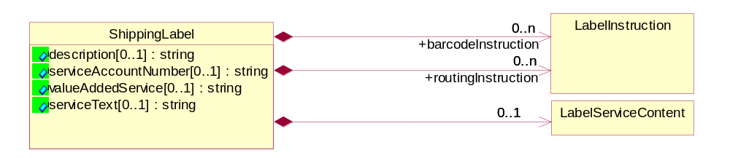
Figure ‎3-41 ShippingLabel

Attribute | Type | Documentation
description[0..1] | string | Free Form Text to identify International Shipment on label.
serviceAccountNumber[0..1] | string | The unique identifier representing a transport collect label.
valueAddedService[0..1] | string | VAS display line for the label.
serviceText[0..1] | string | Indicates carrier/shipment service label as it is printed on the label.

Composition | Cardinality | Type | Documentation
barcodeInstruction | 0..n | LabelInstruction | Used for Carrier specific instructions.
routingInstruction | 0..n | LabelInstruction | Used for Route date specific instructions.
LabelServiceContent | 0..1 | LabelServiceContent | The collection of business properties that identifies label service code and format to be displayed on labels.

TrackingReference
Proprietary unique identifier for tracking product shipments.
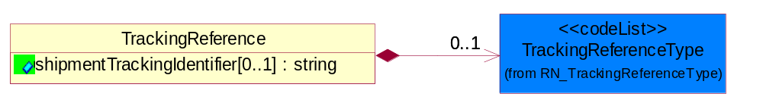
Figure ‎3-42 TrackingReference

Attribute | Type | Documentation
shipmentTrackingIdentifier[0..1] | string | Proprietary unique identifier for tracking product shipments.

Composition | Cardinality | Type | Documentation
TrackingReferenceType | 0..1 | TrackingReferenceType | Code identifying the type of document reference being used to track a shipment.

CodeList

TrackingReferenceType
Code identifying the type of document reference being used to track a shipment.

Name | Documentation
BKN | Booking Number - Shipment identification number assigned by shipper when booking freight shipment with carrier.
BOL | Bill of Lading Number - Shipment identification number on bill of lading issued by shipper, forwarder or carrier.
CIN | Commercial Invoice - An invoice for customs purposes to allow the determination of the proper import/export duty/taxes.
CRN | Carrier Reference Number - Carrier assigned shipment identification number on bill of lading.
FTR | Freight Tracking Reference - Reference number that describes information about tracing shipments during the transportation process.
HAN | House Airwaybill Number - Forwarder assigned shipment identification number on bill of lading issued by forwarder.
MAB | Master Airwaybill Number - Carrier assigned shipment identification number on bill of lading issued by carrier.
OBL | Ocean Bill of Lading Number - Carrier assigned shipment identification number on bill of lading issued by carrier.
PON | Purchase Order Number.
PRO | Pro Number - Carrier assigned shipment identification number on bill of lading.
PSN | Packing Slip Number - Shipment identification number on shipment contents packing list attached to shipment.
RFI | Radio Frequency Identification (RFID).
RRN | Route Reference Number.
SID | Seal Identifier - Trailer or container seal number assigned by party closing doors on trailer or container.
SON | Seller Sales Order Number.
SRN | Shipper Reference Number - Shipper assigned shipment identification number on bill of lading issued by shipper or forwarder.
TRN | Trailer Number - Owner assigned equipment identification number on trailer.

Incoterms
Code identifying incoterms.

Name | Documentation
CFR | Cost and Freight (named port of destination).
CIF | Cost, Insurance and Freight (named port of destination).
CIP | Carriage and insurance paid to (named place of destination).
CPT | Carriage Paid To (named place of destination).
DAF | Delivered at Frontier (named place).
DDP | Delivered Duty Paid (named place of destination).
DDU | Delivered Duty Unpaid (named place of destination).
DEQ | Delivered Ex Quay (duty paid) (named port of destination).
DES | Delivered Ex Ship (named port of destination).
EXW | Ex Works (named place).
FAS | Free Along Ship (named port of shipment).
FCA | Free Carrier (named place).
FOB | Free on Board (named port of shipment).

ShipmentMode
The method of transport used for the conveyance of goods.

Name | Documentation
AIE | Air Express.
AIF | Air Freight.
AIR | Air.
COC | Contract Carrier.
COO | Containerized Ocean.
CPI | Customer Pickup.
EXT | Expedited Truck.
INM | Intermodal.
MAT | Mail Transport.
MOT | Motor.
OCE | Ocean.
OTH | Others.
PRC | Private Carrier.
RAI | Rail.
TRK | Truck.

NationalExportControlClassification
Code identifying product classification for export regulation.

Name | Documentation
CLE | Clearance - The cargo will be or has been cleared.
CUC | Already customs cleared in the importing country, arrangement for inspection are not necessary because they were cleared before.
DET | Detention - The cargo has been or will be detained.
DOR | Documents Required - Pertinent documents are required.
DRC | Documents Requirements Completed - All requirements for documents have been completed.
FUM | Fumigation - The cargo has been or will be fumigated.
IAC | Inspection Arrangements Completed - Arrangements for inspection of the cargo have been completed.
IAR | Inspection Arrangements Required - Arrangements for inspection of the cargo are required.
INS | Inspection - The cargo has been or will be inspected.
LWI | Lowest Importance.
NCP | No Customs Procedure - Customs clearance not required.
SAC | Safety Arrangements Completed - Arrangements for safeguarding the cargo have been completed.
SAR | Safety Arrangements Required - Arrangements for safeguarding the cargo are required.
SCR | Security - The cargo has been or will be secured.
SEC | Security Arrangements Completed - Arrangements for storing the cargo have been completed.
SER | Security Arrangements Required - Arrangements for the security of the cargo are required.
STR | Storage arrangements required - Arrangements for storing the cargo are required.
TAC | Transport Arrangements Completed - All arrangements for transport have been completed.
TAR | Transport Arrangements Required - Transport has to be arranged.

ShipDateCode
Code identifying a type of ship date.

Name | Documentation
ACP | Acceptance.
ACT | Action.
ADY | Arrival at Destination Yard.
AED | Accrual End Date.
AFT | Actual Free Time Expiration Date.
APD | Actual Pickup Date.
APL | Actual Placement.
ASD | Accrual Start Date.
BDO | Beginning Date of Customer Plant Shutdown.
BOI | Bill of Lading Initiated Date.
BOL | Bill of Lading.
BPE | Buy Period Date (End).
BPS | Buy Period Date (Start).
BRD | Backorder Release Date.
CAD | Cancel After This Date.
CBD | Charge Back Date.
CCL | Contract Closed.
CDA | Check Date.
CFP | Contract Final Payment.
CFR | Charged From.
COD | Cutoff Date.
CPC | Contract Physically Completed.
CRE | Customs Release.
CTO | Charged To.
DAG | Delivery Appointment Granted Date.
DAR | Date Available/Constructive Replacement.
DAS | Delivery Appointment Scheduled Date.
DBT | Delivered By This Date.
DDC | Date Delivery Commenced.
DIC | Date Invoice Created.
DIS | Date Issued.
DLC | Date Loading Commenced.
DLD | Date Loading Completed.
DNB | Deliver Not Before Date.
DNL | Deliver No Later Than Date.
DOT | Delivered on This Date.
DPA | Duty Paid.
DRD | Demand Receipt Date.
DRS | Delivery Requested Scheduled Date.
DRT | Delivery Requested on This Date.
DSP | Date Shipped to Port of Embarkation (POE).
DUL | Date Unloaded.
DWO | Deliver Week Of.
ECC | Estimated Contract Completion.
ECL | Extended Closeout.
EDA | Effective Date.
EDB | Expiration Date.
EDD | Estimated Delivery Date.
EDO | Ending Date of Customer Plant Shutdown.
EES | Est. Next Promo, Ship Date End.
EFD | Equipment Furnished Date.
EPD | Earliest Pickup Date.
EPE | Est. Next Promo (Date end).
EPS | Est. Next Promo (Date start).
ERE | Expected Reply.
ESE | Est. Next Promo, Ship Date Start.
FBD | Freight Bill Date.
FOD | First Order Date.
FSD | First Ship Date.
GED | Guarantee Expiration Date.
INS | Inspection.
IVD | Invoice Date.
LAC | Last Acquisition.
LDE | Last Demand.
LPD | Latest Pickup Date.
MNF | Manufacture.
MRB | Must Respond By.
NTF | Notified.
OFD | Offered for Delivery.
OPO | Original Purchase Order Date.
ORD | Ordered.
OTR | Original Transaction.
PAG | Pickup Appointment Granted Date.
PAS | Pickup Appointment Scheduled Date.
PBD | Publication Date.
PCE | Price Change Effective Date.
PCL | Price Change Last Arrival Date.
PCM | Price Change Last Order Date.
PCO | Purchase Order Date.
PCR | Purchase Order Received.
PCS | Price Change Last Ship Date.
PDA | Pack Date.
PDE | Promotion Order Date (End).
PDS | Promotion Order Date (Start).
PFE | Promotion Floor Stock Protect (End).
PFS | Promotion Floor Stock Protect (Start).
PME | Promotion Ship Date (End).
PMO | Promotion End.
PMS | Promotion Ship Date (Start).
PMT | Promotion Start.
PPD | Preferred Payment Date.
PPE | Promotion Performance Date (End).
PPS | Promotion Performance Date (Start).
PRD | Product Receipt Date.
PRE | Period End.
PRQ | Promotion Requested Delivery Date (End).
PRS | Promotion Requested Delivery Date (Start).
PSD | Process Date.
PSH | Pickup Requested Scheduled Date.
PVE | Promotion Invoice Protection Date (End).
PVS | Promotion Invoice Protection Date (Start).
RDD | Requested Delivery Date.
REC | Recorded.
REJ | Rejection.
REL | Released.
REQ | Required By.
RPD | Requested Pack Date.
RSD | Requested Ship Date/Pick-up Date.
SDA | Scheduled Delivery Date - Appointment confirmed.
SDC | Scheduled Delivery Date - Needs confirmation.
SDD | Scheduled Delivery Date.
SHB | Ship Not Before Date.
SHL | Ship Not Later Than Date.
SHO | Shipped on This Date.
SIG | Signature.
SIS | Store Inventory Stock.
SLD | Sold Date.
SLE | Shelf-Life Expiration.
SLG | Sailing Date.
SPA | Scheduled Pick-up Date - Appointment confirmed.
SPE | Spot for Load Exchange Date (Export).
SPL | Spot for Load Date.
SPN | Scheduled Pick-up Date - Needs confirmation.
SPP | Scheduled Pick - Up Date.
SPS | Spot for Storage Date (No shipment).
SPU | Spot for Unload Date.
SSC | Scheduled Service Completion.
SUD | Superseded Date.
SWO | Ship Week Of Date.
TDD | Terms Discount Due Date.
TND | Terms Net Due Date.
TRA | Transfer.
TRS | Transaction Control Date.
VAL | Validated.
WIS | Warehouse Inventory Stock.
WRT | Warranty Expiration.

FreightPaymentTerms
Code identifying responsibility for payment of shipping charges.

Name | Documentation
ADC | Advance Collect.
ADP | Advance Prepaid.
COD | Collect on Delivery.
COF | Collect, freight credited back to customer.
COL | Collect.
CPI | Customer Pick-up/backhaul.
DBS | Defined by buyer and seller.
FOB | FOB Port of Call.
HPR | Half Prepaid.
MIX | Mixed.
NRE | Non Revenue.
PBB | Paid by Buyer.
PBS | Paid by Seller.
PCO | Per Contract.
PIC | Pickup.
PPC | Prepaid but charged to customer.
PPL | Prepaid local, collect outstate.
PPO | Prepaid Only.
PPP | Prepaid by Processor.
PPS | Prepaid (by seller).
PPY | Prepaid and summary bill.
RCF | Return Container Freight Free.
RCG | Return container freight paid by customer.
RCH | Return container freight paid by supplier.
RUL | Rule 11 Shipment.
SFN | Service freight, no charge.
TPP | Third Party Pay.
WCO | Weight Condition.

ReturnLabelCode
Code specifying the type of return label, e.g. for returning unused or defective parts.

Name | Documentation
DFR | Defective - No Return Required.
DFT | Defective.
UNR | Unused - No Return Required.
UNU | Unused.

LotDiscrepancyReason
Code identifying the reason for a discrepency in the lot composition of the shipment.

Name | Documentation
DLO | Damaged Lot - Lot was found to be damaged.
WLO | Wrong Lot - Expecting different lot.
WLQ | Wrong Lot Quantity - Expecting different lot quantity.

ShipmentType
Code that indicates the type of shipment being sent.

Name | Documentation
DYM | Dynamic Merge.
MTL | Multi Leg.
OCD | Outbound cross-dock merge.
OTH | Other.
RVS | Reverse.

InventoryOwnership
Code that indicates the ownership of the inventory.

Name | Documentation
CSS | Consignment Stock.
OTH | Other.
PJS | Project Stock.
RPS | Returnable Packaging Stock with customer.
RTP | Returnable Transport Package.
SMV | Stock of Material provided to vendor.
SOS | Sales Order Stock.
VCS | Vendor Consignment Stock.

ShippingOrderStatus
Code identifying the confirmation status of a shipping order.

Name | Documentation
ACC | Accepted.
REJ | Rejected.

ShippingOrderRejectReason
Code identifying the reason for the rejection of a shipping order.

Name | Documentation
ADP | Administrative Problem.
CNA | Carrier Not Available.
DSO | Duplicate Shipping Order - The same shipping order received more than once.
EPR | Export Restriction.
HMR | Hazardous Material Restriction.
ICD | Invalid Cross Dock.
ICL | Invalid Consolidation.
IDA | Invalid Address.
IDI | Insufficient Delivery Information.
IEL | Invalid Export License.
INA | Inventory Not Available - Insufficient or no inventory in 3PL warehouse even though SAP has the inventory (Out of sync).
INC | Invalid Carrier.
ISD | Invalid Ship Date.
ISO | Invalid Shipping Order.
IVM | Inventory Missing - Inventory shows up in SAP, but physically materials could be missing or misplace.
IVQ | Invalid Quantity.
SSL | Shipping Service Level Not Available.

InstructionType
Code specifying the type of method for labeling instruction.

Name | Documentation
REA | Readable Instructions.
SCA | Scanable Instructions.

Shared

Dependency Diagram
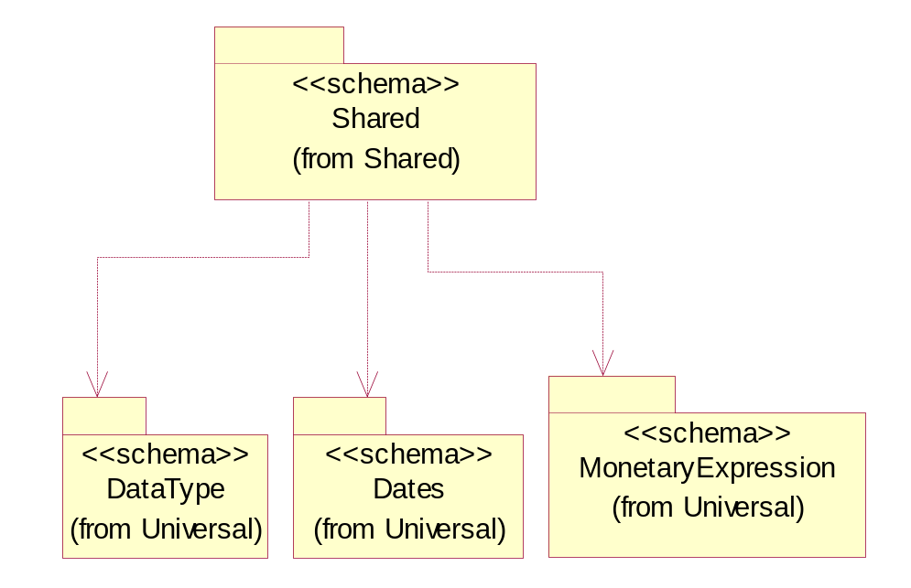
Figure ‎3-43 Dependency

ProductQuantity
A quantity specifying the number of product units.
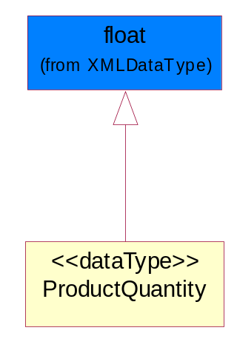
Figure ‎3-44 ProductQuantity

CodeList

FreeOnBoard
Code identifying a specified point where a product is delivered or placed on board a carrier without charge.

Name | Documentation
DES | Destination.
NMA | Name Address.
ORG | Origin.

PackageType
Code specifying the type of packaging for a product.

Name | Documentation
BOX | Box.
BRL | Barrel.
CRT | Carton.
LPK | Loose Package.
MHC | Material/Method of holding a string of computer chips.
MIX | Mixed Package.
OTH | Others.
PAC | Parcel.
PBG | Plastic Ball Grind Array.
PBX | Paper Box.
PCC | Plastic Chip Carrier.
PLT | Pallet.
REE | Reel.
TQF | Thin Quad Flat Package.
TRA | Tray.
TUB | Plastic tube to hold computer chips.
WDC | Wooden Crate.

ShippingServiceLevel
Code identifying the shipping service level, e.g., overnight, same day.

Name | Documentation
1BD | 1BD, Same Business Day - 4 hour Response Time.
5BD | 5 Business Days.
9AM | 9 A.M.
ACH | Air Charter.
AEC | Air Economy.
AIC | Air Cargo.
AM | A.M.
ARS | Authorized Return Service.
ATA | Airport to Airport.
ATD | Airport to Door.
BCT | Bulk Commodity Train.
BUC | Business Class.
CBS | Consignee Billing Service.
COE | Courier Express.
DCR | Delivery Confirmation Return.
DEC | Delivery Confirmation.
DES | Deferred Service.
DNO | Delivery Notification Only.
DOS | Door Service.
DSN | Delivery scheduled next day by cartage agent.
DSS | Delivery scheduled second day by cartage agent.
DST | Delivery scheduled third day by cartage agent.
DTA | Door to Airport.
DTD | Door to Door.
DTP | Door to Port (Ocean).
ESP | Express Service Plus.
ESV | Expedited Service.
ESW | Expedited Service Worldwide.
EXS | Express Service.
EXW | Express Service - Worldwide.
FIC | First Class.
GEN | General.
GRO | Ground.
ISS | Other intermodal and stack service.
MAF | Manifest freight.
MET | Metro.
MUW | Multiweight.
NBD | Next Business Day.
NDA | Next Day Air.
NEM | Next Morning.
NFO | Next Flight Out.
NHW | Next day Hundred Weight.
NOR | NORMAL - Normal delivery.
NOS | Not served.
OIS | Other Intermodal and Stack service
OTH | Other.
OVN | Overnight.
PAS | Passenger service.
PIU | Pickup.
PM | PM.
PMI | Priority Mail Insured.
POB | P.O. Box/Zip code.
POD | Proof of Delivery (POD) with Signature.
PRM | Priority Mail.
PRS | Premium Surface.
PS1 | Primary Service Area - Next Day by 10:30 A.M.
PS2 | Primary Service Area - Next Day by 5:00 P.M.
PS3 | Primary Service Area - Next Day By 9:30 A.M.
PS4 | Primary Service Area - Next Day by Noon.
PS5 | Primary Service Area - Second Day by Noon.
PTD | Port to Door (Ocean).
PTP | Port to Port (Ocean).
REG | Regular.
SAD | Same day.
SAP | Saturday Pickup.
SAT | Saturday.
SBD | SBD, Second Business Day.
SCH | Scheduled.
SDA | Second Day Air.
SDW | Second Day Hundred Weight.
SED | Second Day.
SEM | Second Morning.
SGW | Standard Ground Hundred Weight.
STC | Standard Class.
STG | Standard Ground.
STO | Standard Ocean.
STS | Standard Service.
SUH | Sunday and Holidays.
TDS | Three Day Service.
TIC | Time Critical.
TRG | Tracking - Ground.

Universal Structure

ContactInformation

ContactInformation
The business document must allow for the identification of the name of the department, service or individual to be contacted regarding the context of the business document.
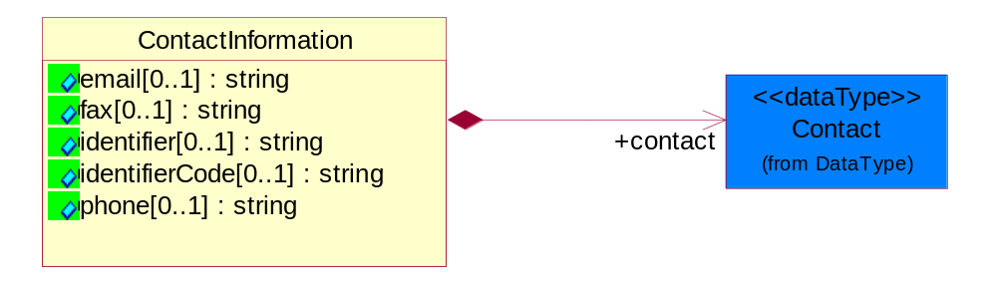
Figure ‎4-45 ContactInformation

Attribute | Type | Documentation
email[0..1] | string | The electronic mail for the specified contact.
fax[0..1] | string | The fax number for the specified contact.
identifier[0..1] | string | Identifies the role of the contact (i.e. Service Technician, Account Manager) in the Business Process.
identifierCode[0..1] | string | IdentifierCode is a unique security authorization code to identify the contact- ie. badge ID.
phone[0..1] | string | The telephone number for the specified contact.

Composition | Cardinality | Type | Documentation
contact | 1 | Contact | The name of the department, service or individual to be contacted within the organization.

DataType

Contact
The name of the department, service or individual to be contacted within the organization.
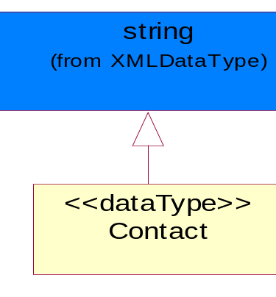
Figure ‎4-46 Contact

DUNS
A number assigned by Dun and Bradstreet to identify a business location.
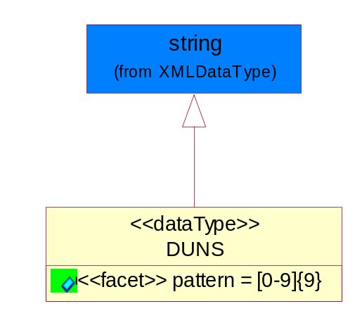
Figure ‎4-47 DUNS

Attribute | Type | Documentation
pattern |  | [0-9]{9}

DUNSPlus4
A identifier to specify a specific location within a business location.
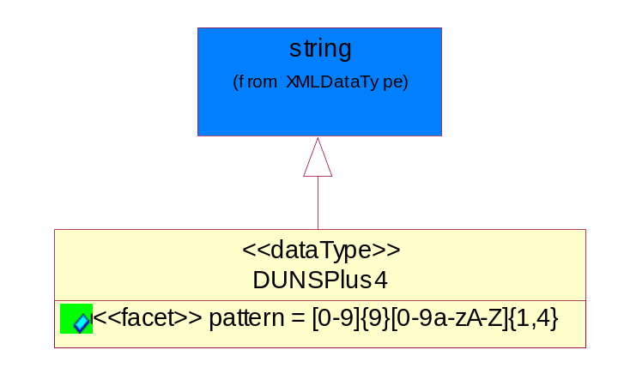
Figure ‎4-48 DUNSPlus4

Attribute | Type | Documentation
Pattern |  | Data Universal Numbering System +4 (DUNS+4) number means the DUNS number assigned by Dun and Bradstreet, Inc. (D&B) plus an alphanumeric of length 4 suffix that may be assigned by a business concern.

GLN
Global Location Number (GLN) - A identifier to identify legal entities, trading parties and location.
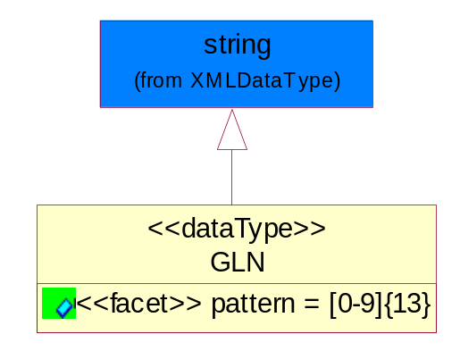
Figure ‎4-49 GLN

Attribute | Type | Documentation
Pattern |  | [0-9]{13}

GTIN
Global Trade Identification Number (GTIN).
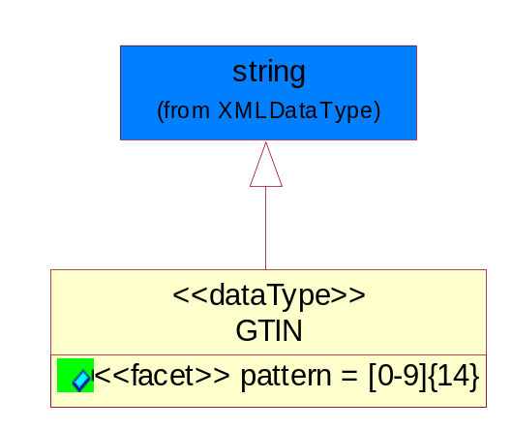
Figure ‎4-50 GTIN

Attribute | Type | Documentation
Pattern |  | [0-9]{14}

Document

BusinessDocumentReference
The business document reference object allows for the indirect referencing of a relationship to other business related documents.
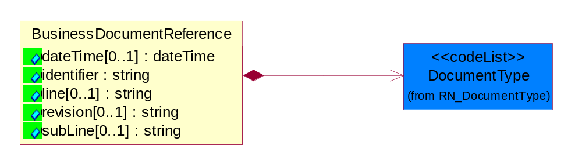
Figure ‎4-51 BusinessDocumentReference

Attribute | Type | Documentation
dateTime[0..1] | dateTime | The date-time stamp indicating on the referenced business document.
identifier | string | Unique identification of the referenced business document.
line[0..1] | string | References the specific line number of the specified business document.
revision[0..1] | string | Referenced the revision of the specified business document.
subLine[0..1] | string | References the specific subline number of the specified business document.

Composition | Cardinality | Type | Documentation
DocumentType | 1 | DocumentType | A code identifying the business context of a document.

Locations

AlternativeIdentifier
Identifies the specified code and the name of the organization that a code is utilized from.
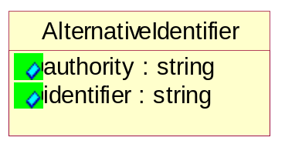
Figure ‎4-52 AlternativeIdentifier

Attribute | Type | Documentation
authority | string | The name of the organization that a code is utilized from.
identifier | string | The specified code to represent an entity (e.g. product, location, partner, etc.).

Location
The business document must specify a location.
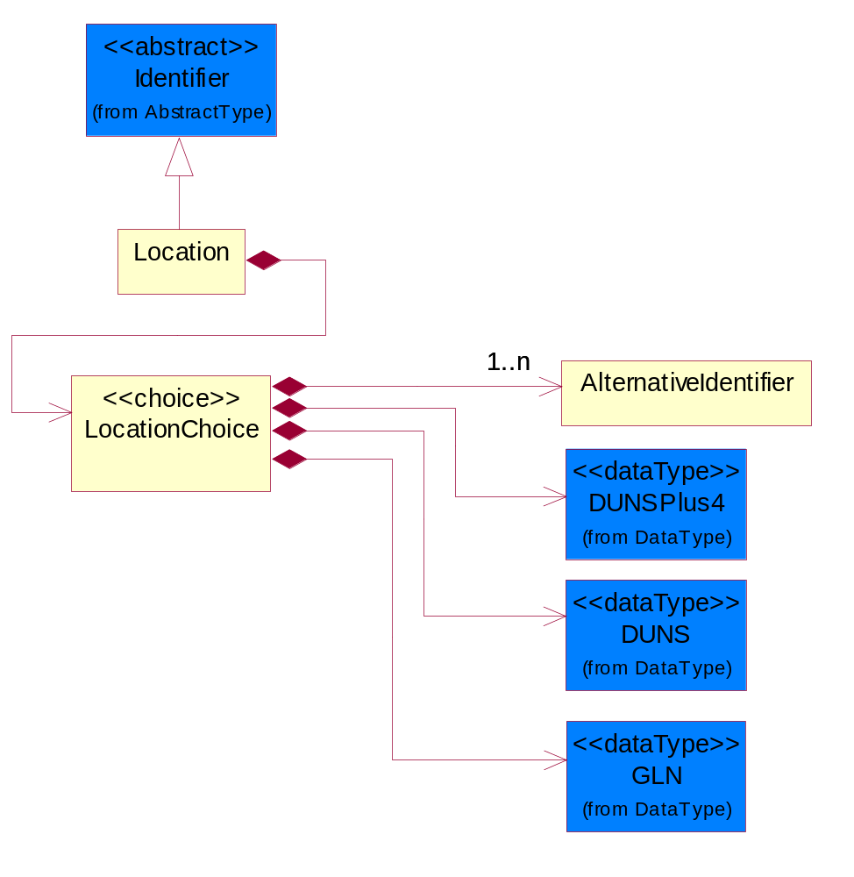
Figure ‎4-53 Location

Composition | Cardinality | Type | Documentation
LocationChoice | 1 | LocationChoice

LocationChoice

Composition | Cardinality | Type | Documentation
DUNSPlus4 | 1 | DUNSPlus4 | A identifier to specify a specific location within a business location.
DUNS | 1 | DUNS | A number assigned by Dun and Bradstreet to identify a business location.
AlternativeIdentifier | 1..n | AlternativeIdentifier | Identifies the specified code and the name of the organization that a code is utilized from.
GLN | 1 | GLN | Global Location Number (GLN) - A identifier to identify legal entities, trading parties and location.

PhysicalAddress
The business document must provide a physical address for a party to the business transaction.
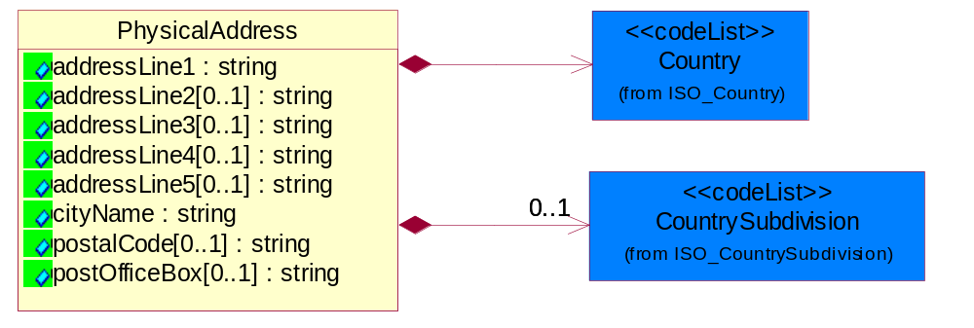
Figure ‎4-54 PhysicalAddress

Attribute | Type | Documentation
addressLine1 | string | The first line of a physical address.
addressLine2[0..1] | string | The second line of a physical address.
addressLine3[0..1] | string | The third line of a physical address.
addressLine4[0..1] | string | The fourth line of a physical address.
addressLine5[0..1] | string | The fifth line of a physical address.
cityName | string | The name of a city.
postalCode[0..1] | string | Identifying geographic location as specified by a national postal code.
postOfficeBox[0..1] | string | The Post Office Box identifier used to identify a party's post office box.

Composition | Cardinality | Type | Documentation
Country | 1 | Country | For representation of Country name RosettaNet has adopted ISO 3166-3; 1999. Refer to the following web page to get the latest version of the standard:  http://www.iso.ch/iso/en/prods-services/iso3166ma/02iso-3166-code-lists/index.html  If you need more information about the ISO standard please contact ISO for more details.
CountrySubdivision | 0..1 | CountrySubdivision | For representation of a Countries subdivisions RosettaNet has adopted ISO 3166-3; 1999. Refer to the following web page to get the latest version of the standard:  http://www.iso.ch/iso/en/prods-services/iso3166ma/02iso-3166-code-lists/index.html  If you need more information about the ISO standard please contact ISO for more details.

MonetaryExpression

FinancialAmount
The business document must express financial amounts.
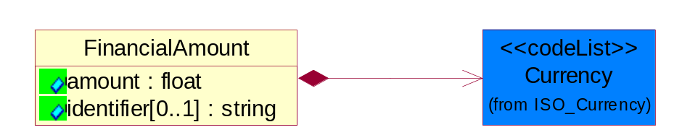
Figure ‎4-55 FinancialAmount

Attribute | Type | Documentation
amount | float | Specifies the monetary amount.
identifier[0..1] | string | Identifier is a unique identifier to which the specific price is tied - ie. promotion name/ program.

Composition | Cardinality | Type | Documentation
Currency | 1 | Currency | For representation of Currency codes RosettaNet has adopted ISO 4217; 1995. The British Standards Institution (BSI) is the ISO 4217 Maintenance Agency. Refer to the following web page to get the latest version of the standard:  http://www.bsi-global.com/Technical+Information/Publications/_Publications/tig90.xalter  If you need more information about the ISO standard please contact ISO for more details.

PartnerIdentification

FullPartner
The business document must describe the trading partners in the business transaction. This data structure provide the flexibility to describe a partner in all possible methods as for new, existing or known partner.
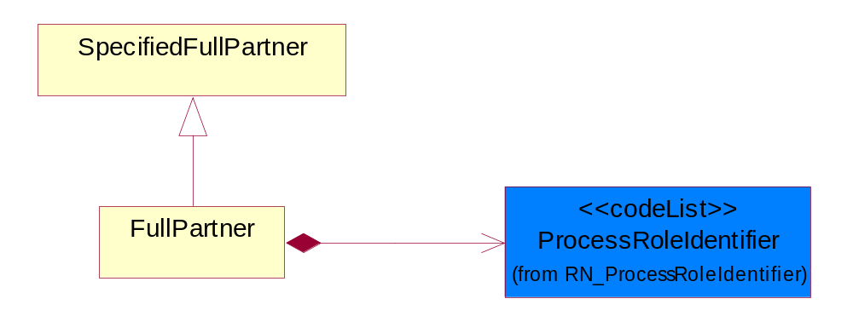
Figure ‎4-56 FullPartner

Composition | Cardinality | Type | Documentation
ProcessRoleIdentifier | 1 | ProcessRoleIdentifier | Describes the role of the partner in the business process. A partner will fulfill at least one or more roles during the business process.

IntermittentPartner
The business document must describe a physical address for a delivery.
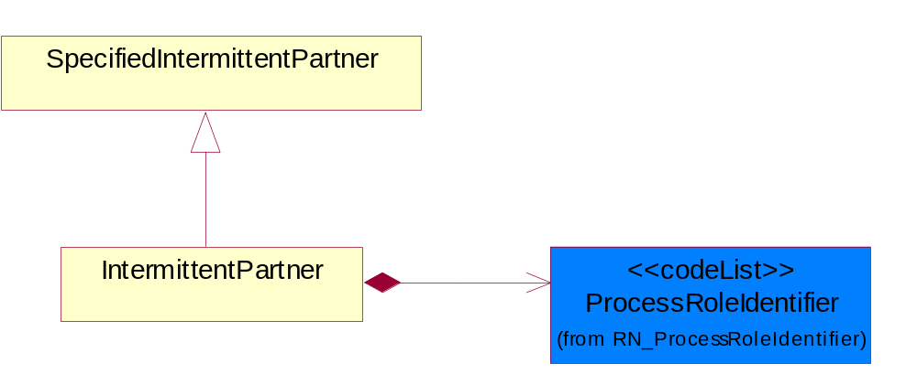
Figure ‎4-57 IntermittentPartner

Composition | Cardinality | Type | Documentation
ProcessRoleIdentifier | 1 | ProcessRoleIdentifier | Describes the role of the partner in the business process. A partner will fulfill at least one or more roles during the business process.

KnownPartner
The business document must describe the trading partners in the business transaction.
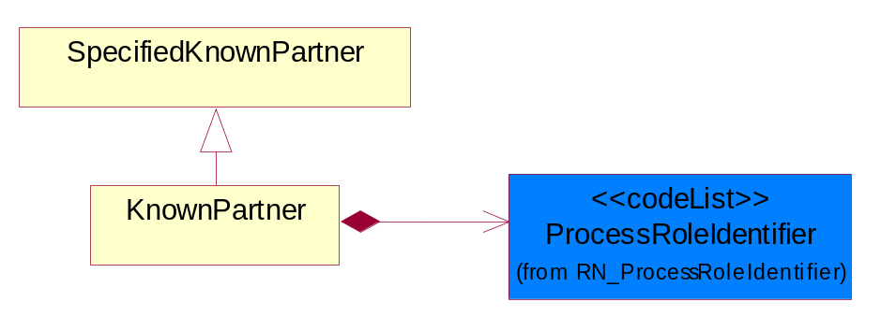
Figure ‎4-58 KnownPartner

Composition | Cardinality | Type | Documentation
ProcessRoleIdentifier | 1 | ProcessRoleIdentifier | Describes the role of the partner in the business process. A partner will fulfill at least one or more roles during the business process.

KnownPartnerContact
The business document must describe the trading partners in the business transaction.
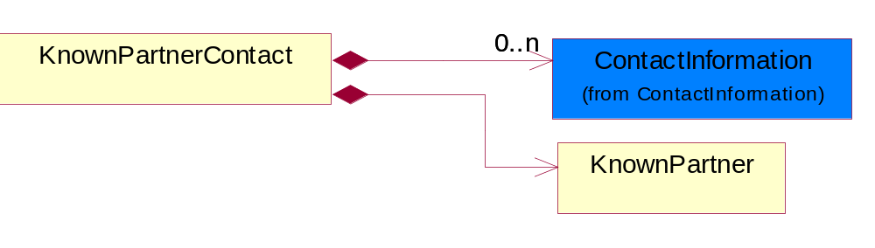
Figure ‎4-59 KnownPartnerContact

Composition | Cardinality | Type | Documentation
KnownPartner | 1 | KnownPartner | The business document must describe the trading partners in the business transaction.
ContactInformation | 0..n | ContactInformation | The business document must allow for the identification of the name of the department, service or individual to be contacted regarding the context of the business document.

NewPartner
The business document must describe a new, existing (but known to only one of the parties to the transaction) or an unknown party to the business transaction.
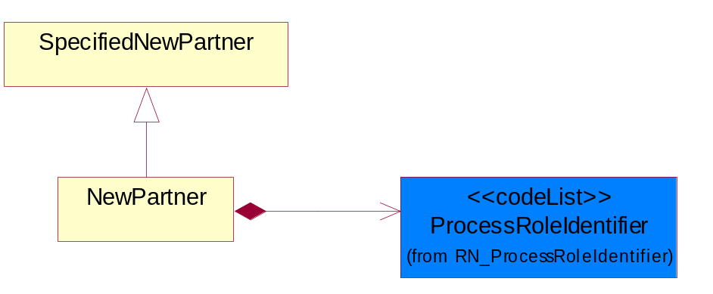
Figure ‎4-60 NewPartner

Composition | Cardinality | Type | Documentation
ProcessRoleIdentifier | 1 | ProcessRoleIdentifier | Describes the role of the partner in the business process. A partner will fulfill at least one or more roles during the business process.

PartnerDescription
The collection of business properties that describe a business partners' identity, their contact information, where they are physically located and their function in a supply chain.
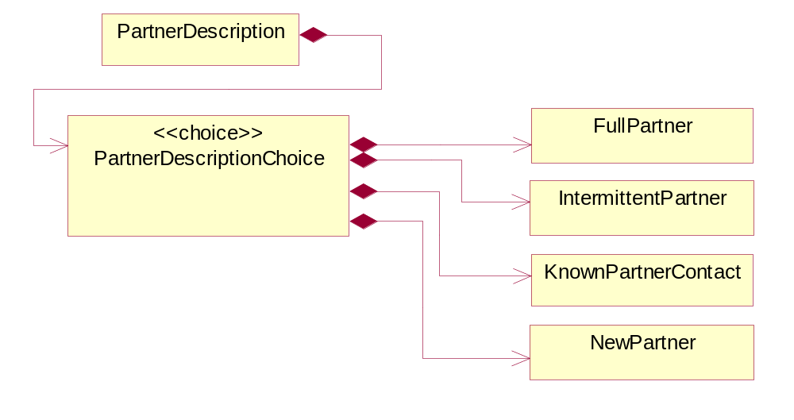
Figure ‎4-61 PartnerDescription

Composition | Cardinality | Type | Documentation
PartnerDescriptionChoice | 1 | PartnerDescriptionChoice

PartnerDescriptionChoice

Composition | Cardinality | Type | Documentation
KnownPartnerContact | 1 | KnownPartnerContact | The business document must describe the trading partners in the business transaction.
IntermittentPartner | 1 | IntermittentPartner | The business document must describe a physical address for a delivery.
NewPartner | 1 | NewPartner | The business document must describe a new, existing (but known to only one of the parties to the transaction) or an unknown party to the business transaction.
FullPartner | 1 | FullPartner | The business document must describe the trading partners in the business transaction. This data structure provide the flexibility to describe a partner in all possible methods as for new, existing or known partner.

PartnerIdentification
The business document must allow for the identity of one or more parties to the transaction.
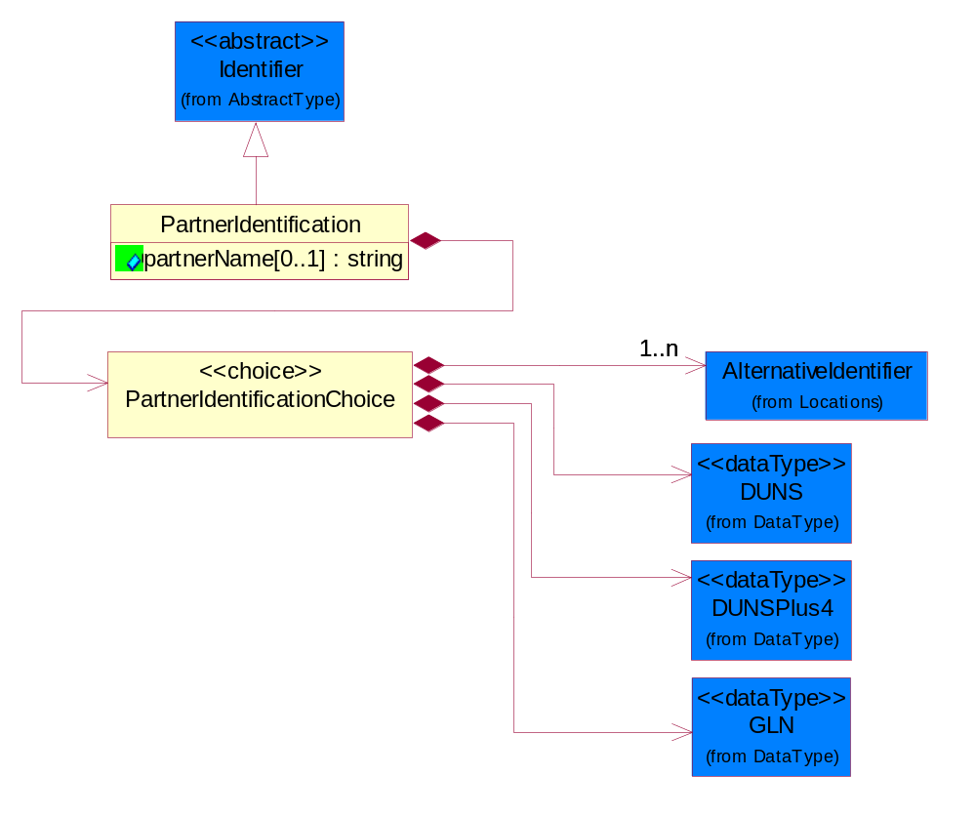
Figure ‎4-62 PartnerIdentification

Attribute | Type | Documentation
partnerName[0..1] | string | The name of the partner’s company/business.

Composition | Cardinality | Type | Documentation
PartnerIdentificationChoice | 1 | PartnerIdentificationChoice

PartnerIdentificationChoice

Composition | Cardinality | Type | Documentation
DUNS | 1 | DUNS | A number assigned by Dun and Bradstreet to identify a business location.
DUNSPlus4 | 1 | DUNSPlus4 | A identifier to specify a specific location within a business location.
AlternativeIdentifier | 1..n | AlternativeIdentifier | Identifies the specified code and the name of the organization that a code is utilized from.
GLN | 1 | GLN | Global Location Number (GLN) - A identifier to identify legal entities, trading parties and location.

SpecifiedFullPartner
The business document must describe the trading partners in the business transaction. This data structure provide the flexibility to describe a partner in all possible methods as for new, existing or known partner. This is specifically for partner who role has been specified.
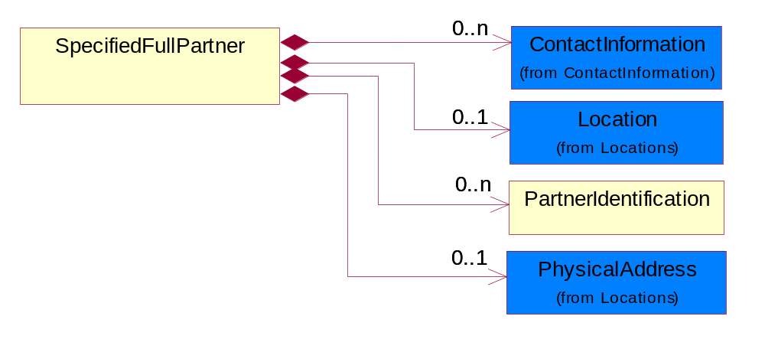
Figure ‎4-63 SpecifiedFullPartner

Composition | Cardinality | Type | Documentation
ContactInformation | 0..n | ContactInformation | The business document must allow for the identification of the name of the department, service or individual to be contacted regarding the context of the business document.
Location | 0..1 | Location | The business document must specify a location.
PartnerIdentification | 0..n | PartnerIdentification | The business document must allow for the identity of one or more parties to the transaction.
PhysicalAddress | 0..1 | PhysicalAddress | The business document must provide a physical address for a party to the business transaction.

SpecifiedIntermittentPartner
The business document must describe a physical address for a delivery.
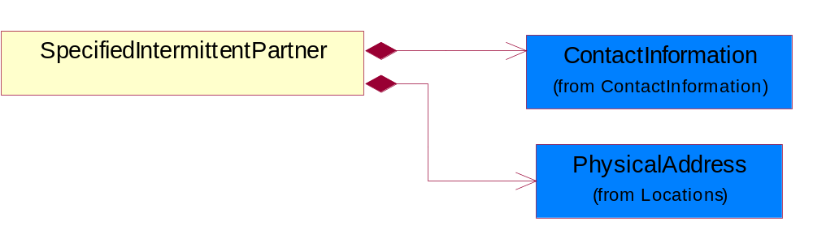
Figure ‎4-64 SpecifiedIntermittentPartner

Composition | Cardinality | Type | Documentation
ContactInformation | 1 | ContactInformation | The business document must allow for the identification of the name of the department, service or individual to be contacted regarding the context of the business document.
PhysicalAddress | 1 | PhysicalAddress | The business document must provide a physical address for a party to the business transaction.

SpecifiedKnownPartner
The business document must describe the trading partners in the business transaction.
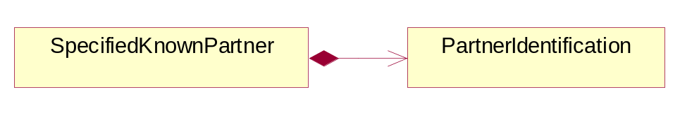
Figure ‎4-65 SpecifiedKnownPartner

Composition | Cardinality | Type | Documentation
PartnerIdentification | 1 | PartnerIdentification | The business document must allow for the identity of one or more parties to the transaction.

SpecifiedNewPartner
The business document must describe a new, existing (but known to only one of the parties to the transaction) or an unknown party to the business transaction.
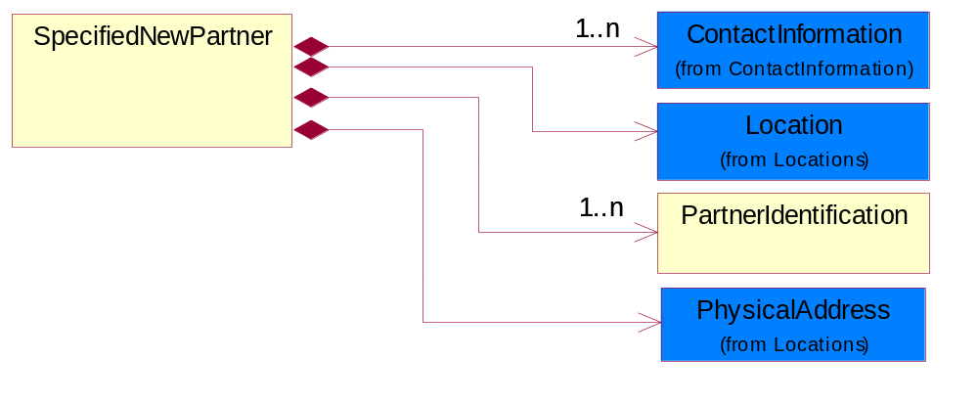
Figure ‎4-66 SpecifiedNewPartner

Composition | Cardinality | Type | Documentation
ContactInformation | 1..n | ContactInformation | The business document must allow for the identification of the name of the department, service or individual to be contacted regarding the context of the business document.
Location | 1 | Location | The business document must specify a location.
PhysicalAddress | 1 | PhysicalAddress | The business document must provide a physical address for a party to the business transaction.
PartnerIdentification | 1..n | PartnerIdentification | The business document must allow for the identity of one or more parties to the transaction.

CodeList

Country
For representation of Country name RosettaNet has adopted ISO 3166-3; 1999. Refer to the following web page to get the latest version of the standard:
http://www.iso.ch/iso/en/prods-services/iso3166ma/02iso-3166-code-lists/index.html

If you need more information about the ISO standard please contact ISO for more details.

CountrySubdivision
For representation of a Countries subdivisions RosettaNet has adopted ISO 3166-3; 1999. Refer to the following web page to get the latest version of the standard:
http://www.iso.ch/iso/en/prods-services/iso3166ma/02iso-3166-code-lists/index.html

If you need more information about the ISO standard please contact ISO for more details.

Currency
For representation of Currency codes RosettaNet has adopted ISO 4217; 1995. The British Standards Institution (BSI) is the ISO 4217 Maintenance Agency. Refer to the following web page to get the latest version of the standard:
http://www.bsi-global.com/Technical+Information/Publications/_Publications/tig90.xalter

If you need more information about the ISO standard please contact ISO for more details.

Language
For representation of Language name RosettaNet has adopted ISO 639-2; 1998. Refer to the following web page to get the latest version of the standard:

http://www.loc.gov/standards/iso639-2/iso639jac.html

If you need more information about the ISO standard please contact ISO for more details.

DocumentType
A code identifying the business context of a document.

Instance | Documentation
APM | Applied Promotions.
ARA | Authorization Request Approval.
CAR | Certificate of Analysis Response.
CBN | Product batch number of customer.
CCN | Customs clearance number.
CFA | Failure Analysis - Request document that will accompany the product providing characteristics of the component failure.
CIN | Commercial Invoice.
CNM | Traditional credit note or memo.
COA | Certificate of Analysis.
CON | In a virtual sourcing relationship, a third party trading partner is supplying a part to a customer on behalf of another company that has taken the order for the customer. In this case a Customer Order Number is associated to the request for material that is sent to the virtual trading partners.
COS | Consumption Notice.
COT | Contract.
CRN | Unique consumption reference number identifying the product consumption issue i.e. one-to-one relationship with physical flow.
DEM | Traditional debit note or memo.
DEN | Delivery Note.
DIN | Discontinuation Notice.
DOR | Delivery Order.
DRN | Drawing Number.
DRR | Design Registration Request.
ECO | Engineering Change Order - The proprietary unique identification number that represents an engineering change order.
EDD | Export Declaration Document.
EIR | Engineering Information Request.
EOL | End of Life.
FUO | Sales order or transfer order fulfilling demand out of a facility (outbound shipment).
IDD | Import Declaration Document.
INV | Invoice.
LID | Location Identifier. Data for on-site work that have to be done on the machine (associated with preventive maintenance order).
MEN | Master Event Number.
MID | Machine Identifier. Data for on-site work that have to be done on the machine (associated with preventive maintenance order).
MON | Model Number.
NTS | Notes.
OCL | The unique identifier assigned by the OEM for a warranty claim.
OGA | Other governmental agency issued document.
OPO | The unique identifier assigned by the OEM for a part order.
OPR | The unique identifier assigned by the OEM for a part return.
PCN | Product/Process Change.
PFA | Failure Analysis - Request document that will accompany the product providing characteristics of the product failure.
PII | Refers to previously issued invoice.
PLS | Unique number that identifies packing form prior to shipment.
POI | Purchase Order IN.
PON | Production order number for material release.
POO | Purchase Order OUT.
PRC | Product Catalog.
PSI | Refers to previously issued self-billing invoice.
PUO | Purchase Order.
QUO | Quote.
REC | Document identifying the receipt of materials or products into a facility against a purchase order or transfer order (inbound shipment).
REN | Release Number.
REO | Purchase order or transfer order replenishing inventory into a facility (inbound shipment).
REQ | Requisition.
RMA | Returned Material Authorization.
RPO | Purchase order for materials or product returned to and reworked by a supplier.
RTA | Remittance Advice - Remittance details.
SAO | Sales Order.
SBC | Credit Memo used in self-billing scenario.
SBD | Debit Memo used in self-billing scenario.
SBI | Invoice in self billing scenario.
SBN | Product batch number of supplier.
SCA | Similar to contracts - Contains the quantity of an article that is to be ordered from a vendor and the price for article or service that is to be procured.
SEN | Serial Number.
SEO | A document that gives a repair provider the necessary authorization to repair or upgrade a product either at the customer site or at the repair provider’s site.
SHD | Shipping Document.
SNC | Shipset Number on Code List.
SPC | The unique identifier assigned by the ASP for a warranty claim.
SPN | Spec Number.
SPO | The unique identifier assigned by the ASP for a part order.
SPR | The unique identifier assigned by the ASP for a part return.
SPW | The unique identifier assigned by the ASP to reference a work order.
SRI | A document that contains the shipping reference number which allows the product to be tracked within the outsourced logistic providers network.
SWT | Switch Authorization.
TCS | Terms and Conditions.
TRO | Order which results in materials or products being moved from one facility to another (outbound shipment and inbound shipment).
WAB | Waybill.
WAC | Denotes a warranty claim.
WOO | Work Order.

MimeTypeQualifier
The MIME type as defined by IANA.

Please refer to http://www.iana.org/assignments/media-types/ for a list of types.

Instance | Documentation
application/activemessage | [Shapiro]
application/andrew-inset | [Borenstein]
application/applefile | [Faltstrom]
application/atomicmail | [Borenstein]
application/batch-SMTP | [RFC2442]
application/beep+xml | [RFC3080]
application/cals-1840 | [RFC1895]
application/cnrp+xml | [RFCCNRP]
application/commonground | [Glazer]
application/cpl+xml
application/cybercash | [Eastlake]
application/dca-rft | [Campbell]
application/dec-dx | [Campbell]
application/dicom | [RFC3240]
application/dvcs | [RFC3029]
application/EDI-Consent | [RFC1767]
application/EDIFACT | [RFC1767]
application/EDI-X12 | [RFC1767]
application/eshop | [Katz]
application/font-tdpfr | [RFC3073]
application/http | [RFC2616]
application/hyperstudio | [Domino]
application/iges | [Parks]
application/index | [RFC2652]
application/index.cmd | [RFC2652]
application/index.obj | [RFC2652]
application/index.response | [RFC2652]
application/index.vnd | [RFC2652]
application/iotp | [RFC2935]
application/ipp | [RFC2910]
application/isup | [RFC3204]
application/mac-binhex40 | [Faltstrom]
application/macwriteii | [Lindner]
application/marc | [RFC2220]
application/mathematica | [Van Nostern]
application/msword | [Lindner]
application/news-message-id | [RFC1036,Spencer]
application/news-transmission | [RFC1036, Spencer]
application/ocsp-request | [RFC2560]
application/ocsp-response | [RFC2560]
application/octet-stream | [RFC2045,RFC2046]
application/oda | [RFC2045,RFC2046]
application/ogg | [RFC-walleij-ogg-mediatype-08.txt]
application/parityfec | [RFC3009]
application/pdf | [Lindner]
application/pgp-encrypted | [RFC3156]
application/pgp-keys | [RFC3156]
application/pgp-signature | [RFC3156]
application/pkcs10 | [RFC2311]
application/pkcs7-mime | [RFC2311]
application/pkcs7-signature | [RFC2311]
application/pkix-cert | [RFC2585]
application/pkixcmp | [RFC2510]
application/pkix-crl | [RFC2585]
application/postscript | [RFC2045,RFC2046]
application/prs.alvestrand.titrax-sheet | [Alvestrand]
application/prs.cww | [Rungchavalnont]
application/prs.nprend | [Doggett]
application/prs.plucker | [Janssen]
application/qsig | [RFC3204]
application/reginfo+xml | [RFC-ietf-sipping-reg-event-00.txt]
application/remote-printing | [RFC1486,Rose]
application/riscos | [Smith]
application/rtf | [Lindner]
application/sdp | [RFC2327]
application/set-payment | [Korver]
application/set-payment-initiation | [Korver]
application/set-registration | [Korver]
application/set-registration-initiation | [Korver]
application/sgml | [RFC1874]
application/sgml-open-catalog | [Grosso]
application/sieve | [RFC3028]
application/slate | [Crowley]
application/timestamp-query | [RFC3161]
application/timestamp-reply | [RFC3161]
application/tve-trigger | [Welsh]
application/vemmi | [RFC2122]
application/vnd.3gpp.pic-bw-large | [Meredith]
application/vnd.3gpp.pic-bw-small | [Meredith]
application/vnd.3gpp.pic-bw-var | [Meredith]
application/vnd.3gpp.sms | [Meredith]
application/vnd.3M.Post-it-Notes | [O'Brien]
application/vnd.accpac.simply.aso | [Leow]
application/vnd.accpac.simply.imp | [Leow]
application/vnd.acucobol | [Lubin]
application/vnd.acucorp | [Lubin]
application/vnd.adobe.xfdf | [Perelman]
application/vnd.aether.imp | [Moskowitz]
application/vnd.amiga.ami | [Blumberg]
application/vnd.anser-web-certificate-issue-initiation | [Mori]
application/vnd.anser-web-funds-transfer-initiation | [Mori]
application/vnd.audiograph | [Slusanschi]
application/vnd.blueice.multipass | [Holmstrom]
application/vnd.bmi | [Gotoh]
application/vnd.businessobjects | [Imoucha]
application/vnd.canon-cpdl | [Muto]
application/vnd.canon-lips | [Muto]
application/vnd.cinderella | [Kortenkamp]
application/vnd.claymore | [Simpson]
application/vnd.commerce-battelle | [Applebaum]
application/vnd.commonspace | [Chandhok]
application/vnd.contact.cmsg | [Patz]
application/vnd.cosmocaller | [Dellutri]
application/vnd.ctc-posml | [Kohlhepp]
application/vnd.cups-postscript | [Sweet]
application/vnd.cups-raster | [Sweet]
application/vnd.cups-raw | [Sweet]
application/vnd.curl | [Byrnes]
application/vnd.cybank | [Helmee]
application/vnd.data-vision.rdz | [Fields]
application/vnd.dna | [Searcy]
application/vnd.dpgraph | [Parker]
application/vnd.dreamfactory | [Appleton]
application/vnd.dxr | [Duffy]
application/vnd.ecdis-update | [Buettgenbach]
application/vnd.ecowin.chart | [Olsson]
application/vnd.ecowin.filerequest | [Olsson]
application/vnd.ecowin.fileupdate | [Olsson]
application/vnd.ecowin.series | [Olsson]
application/vnd.ecowin.seriesrequest | [Olsson]
application/vnd.ecowin.seriesupdate | [Olsson]
application/vnd.enliven | [Santinelli]
application/vnd.epson.esf | [Hoshina]
application/vnd.epson.msf | [Hoshina]
application/vnd.epson.quickanime | [Gu]
application/vnd.epson.salt | [Nagatomo]
application/vnd.epson.ssf | [Hoshina]
application/vnd.ericsson.quickcall | [Tidwell]
application/vnd.eudora.data | [Resnick]
application/vnd.fdf | [Zilles]
application/vnd.ffsns | [Holstage]
application/vnd.FloGraphIt | [Floersch]
application/vnd.framemaker | [Wexler]
application/vnd.fsc.weblaunch | [D.Smith]
application/vnd.fujitsu.oasys | [Togashi]
application/vnd.fujitsu.oasys2 | [Togashi]
application/vnd.fujitsu.oasys3 | [Okudaira]
application/vnd.fujitsu.oasysgp | [Sugimoto]
application/vnd.fujitsu.oasysprs | [Ogita]
application/vnd.fujixerox.ddd | [Onda]
application/vnd.fujixerox.docuworks | [Taguchi]
application/vnd.fujixerox.docuworks.binder | [Matsumoto]
application/vnd.fut-misnet | [Pruulmann]
application/vnd.grafeq | [Tupper]
application/vnd.groove-account | [Joseph]
application/vnd.groove-help | [Joseph]
application/vnd.groove-identity-message | [Joseph]
application/vnd.groove-injector | [Joseph]
application/vnd.groove-tool-message | [Joseph]
application/vnd.groove-tool-template | [Joseph]
application/vnd.groove-vcard | [Joseph]
application/vnd.hbci | [Hammann]
application/vnd.hhe.lesson-player | [Jones]
application/vnd.hp-HPGL | [Pentecost]
application/vnd.hp-hpid | [Gupta]
application/vnd.hp-hps | [Aubrey]
application/vnd.hp-PCL | [Pentecost]
application/vnd.hp-PCLXL | [Pentecost]
application/vnd.httphone | [Lefevre]
application/vnd.hzn-3d-crossword | [Minnis]
application/vnd.ibm.afplinedata | [Buis]
application/vnd.ibm.electronic-media | [Tantlinger]
application/vnd.ibm.MiniPay | [Herzberg]
application/vnd.ibm.modcap | [Hohensee]
application/vnd.ibm.secure-container | [Tantlinger]
application/vnd.informix-visionary | [Gales]
application/vnd.intercon.formnet | [Gurak]
application/vnd.intertrust.digibox | [Tomasello]
application/vnd.intertrust.nncp | [Tomasello]
application/vnd.intu.qbo | [Scratchley]
application/vnd.intu.qfx | [Scratchley]
application/vnd.irepository.package+xml | [Knowles]
application/vnd.is-xpr | [Natarajan]
application/vnd.japannet-directory-service | [Fujii]
application/vnd.japannet-jpnstore-wakeup | [Yoshitake]
application/vnd.japannet-payment-wakeup | [Fujii]
application/vnd.japannet-registration | [Yoshitake]
application/vnd.japannet-registration-wakeup | [Fujii]
application/vnd.japannet-setstore-wakeup | [Yoshitake]
application/vnd.japannet-verification | [Yoshitake]
application/vnd.japannet-verification-wakeup | [Fujii]
application/vnd.jisp | [Deckers]
application/vnd.kde.karbon | [Faure]
application/vnd.kde.kchart | [Faure]
application/vnd.kde.kformula | [Faure]
application/vnd.kde.kivio | [Faure]
application/vnd.kde.kontour | [Faure]
application/vnd.kde.kpresenter | [Faure]
application/vnd.kde.kspread | [Faure]
application/vnd.kde.kword | [Faure]
application/vnd.kenameaapp | [DiGiorgio-Haag]
application/vnd.koan | [Cole]
application/vnd.liberty-request+xml | [McDowell]
application/vnd.llamagraphics.life-balance.desktop | [White]
application/vnd.lotus-1-2-3 | [Wattenberger]
application/vnd.lotus-approach | [Wattenberger]
application/vnd.lotus-freelance | [Wattenberger]
application/vnd.lotus-notes | [Laramie]
application/vnd.lotus-organizer | [Wattenberger]
application/vnd.lotus-screencam | [Wattenberger]
application/vnd.lotus-wordpro | [Wattenberger]
application/vnd.mcd | [Gotoh]
application/vnd.mediastation.cdkey | [Flurry]
application/vnd.meridian-slingshot | [Wedel]
application/vnd.micrografx.flo | [Prevo]
application/vnd.micrografx.igx | [Prevo]
application/vnd.mif | [Wexler]
application/vnd.minisoft-hp3000-save | [Bartram]
application/vnd.mitsubishi.misty-guard.trustweb | [Tanaka]
application/vnd.Mobius.DAF | [Kabayama]
application/vnd.Mobius.DIS | [Kabayama]
application/vnd.Mobius.MBK | [Devasia]
application/vnd.Mobius.MQY | [Devasia]
application/vnd.Mobius.MSL | [Kabayama]
application/vnd.Mobius.PLC | [Kabayama]
application/vnd.Mobius.TXF | [Kabayama]
application/vnd.mophun.application | [Wennerstrom]
application/vnd.mophun.certificate | [Wennerstrom]
application/vnd.motorola.flexsuite | [Patton]
application/vnd.motorola.flexsuite.adsi | [Patton]
application/vnd.motorola.flexsuite.fis | [Patton]
application/vnd.motorola.flexsuite.gotap | [Patton]
application/vnd.motorola.flexsuite.kmr | [Patton]
application/vnd.motorola.flexsuite.ttc | [Patton]
application/vnd.motorola.flexsuite.wem | [Patton]
application/vnd.mozilla.xul+xml | [McDaniel]
application/vnd.ms-artgalry | [Slawson]
application/vnd.ms-asf | [Fleischman]
application/vnd.mseq | [Le Bodic]
application/vnd.ms-excel | [Gill]
application/vnd.msign | [Borcherding]
application/vnd.ms-lrm | [Ledoux]
application/vnd.ms-powerpoint | [Gill]
application/vnd.ms-project | [Gill]
application/vnd.ms-tnef | [Gill]
application/vnd.ms-works | [Gill]
application/vnd.ms-wpl | [Plastina]
application/vnd.musician | [Adams]
application/vnd.music-niff | [Butler]
application/vnd.netfpx | [Mutz]
application/vnd.noblenet-directory | [Solomon]
application/vnd.noblenet-sealer | [Solomon]
application/vnd.noblenet-web | [Solomon]
application/vnd.novadigm.EDM | [Swenson]
application/vnd.novadigm.EDX | [Swenson]
application/vnd.novadigm.EXT | [Swenson]
application/vnd.obn | [Hessling]
application/vnd.osa.netdeploy | [Klos]
application/vnd.palm | [Peacock]
application/vnd.pg.format | [Gandert]
application/vnd.pg.osasli | [Gandert]
application/vnd.powerbuilder6 | [Guy]
application/vnd.powerbuilder6-s | [Guy]
application/vnd.powerbuilder7 | [Shilts]
application/vnd.powerbuilder75 | [Shilts]
application/vnd.powerbuilder75-s | [Shilts]
application/vnd.powerbuilder7-s | [Shilts]
application/vnd.previewsystems.box | [Smolgovsky]
application/vnd.publishare-delta-tree | [Ben-Kiki]
application/vnd.pvi.ptid1 | [Lamb]
application/vnd.pwg-multiplexed | [RFC3391]
application/vnd.pwg-xhtml-print+xml | [Wright]
application/vnd.Quark.QuarkXPress | [Scheidler]
application/vnd.rapid | [Szekely]
application/vnd.s3sms | [Tarkkala]
application/vnd.sealed.net | [Lambert]
application/vnd.seemail | [Webb]
application/vnd.shana.informed.formdata | [Selzler]
application/vnd.shana.informed.formtemplate | [Selzler]
application/vnd.shana.informed.interchange | [Selzler]
application/vnd.shana.informed.package | [Selzler]
application/vnd.smaf | [Takahashi]
application/vnd.sss-cod | [Dani]
application/vnd.sss-dtf | [Bruno]
application/vnd.sss-ntf | [Bruno]
application/vnd.street-stream | [Levitt]
application/vnd.svd | [Becker]
application/vnd.swiftview-ics | [Widener]
application/vnd.triscape.mxs | [Simonoff]
application/vnd.trueapp | [Hepler]
application/vnd.truedoc | [Chase]
application/vnd.ufdl | [Manning]
application/vnd.uplanet.alert | [Martin]
application/vnd.uplanet.alert-wbxml | [Martin]
application/vnd.uplanet.bearer-choice | [Martin]
application/vnd.uplanet.bearer-choice-wbxml | [Martin]
application/vnd.uplanet.cacheop | [Martin]
application/vnd.uplanet.cacheop-wbxml | [Martin]
application/vnd.uplanet.channel | [Martin]
application/vnd.uplanet.channel-wbxml | [Martin]
application/vnd.uplanet.list | [Martin]
application/vnd.uplanet.listcmd | [Martin]
application/vnd.uplanet.listcmd-wbxml | [Martin]
application/vnd.uplanet.list-wbxml | [Martin]
application/vnd.uplanet.signal | [Martin]
application/vnd.vcx | [T.Sugimoto]
application/vnd.vectorworks | [Pharr]
application/vnd.vidsoft.vidconference | [Hess]
application/vnd.visio | [Sandal]
application/vnd.visionary | [Aravindakumar]
application/vnd.vividence.scriptfile | [Risher]
application/vnd.vsf | [Rowe]
application/vnd.wap.sic | [WAP-Forum]
application/vnd.wap.slc | [WAP-Forum]
application/vnd.wap.wbxml | [Stark]
application/vnd.wap.wmlc | [Stark]
application/vnd.wap.wmlscriptc | [Stark]
application/vnd.webturbo | [Rehem]
application/vnd.wrq-hp3000-labelled | [Bartram]
application/vnd.wt.stf | [Wohler]
application/vnd.wv.csp+wbxml | [Salmi]
application/vnd.xara | [Matthewman]
application/vnd.xfdl | [Manning]
application/vnd.yellowriver-custom-menu | [Yellow]
application/whoispp-query | [RFC2957]
application/whoispp-response | [RFC2958]
application/wita | [Campbell]
application/wordperfect5.1 | [Lindner]
application/x400-bp | [RFC1494]
application/xhtml+xml | [RFC3236]
application/xml | [RFC3023]
application/xml-dtd | [RFC3023]
application/xml-external-parsed-entity | [RFC3023]
application/zip | [Lindner]
audio/32kadpcm | [RFC2421,RFC2422]
audio/AMR | [RFC3267]
audio/AMR-WB | [RFC3267]
audio/basic | [RFC2045,RFC2046]
audio/CN | [RFC3389]
audio/DAT12 | [RFC3190]
audio/DVI4
audio/EVRC | [RFC-ietf-avt-evrc-smv-03.txt]
audio/EVRC0 | [RFC-ietf-avt-evrc-smv-03.txt]
audio/G.722.1 | [RFC3047]
audio/G722
audio/G723
audio/G726-16
audio/G726-24
audio/G726-32
audio/G726-40
audio/G728
audio/G729
audio/G729D
audio/G729E
audio/GSM
audio/GSM-EFR
audio/L16 | [RFC2586]
audio/L20 | [RFC3190]
audio/L24 | [RFC3190]
audio/L8
audio/LPC
audio/MP4A-LATM | [RFC3016]
audio/MPA
audio/mpa-robust | [RFC3119]
audio/mpeg | [RFC3003]
audio/parityfec | [RFC3009]
audio/PCMA
audio/PCMU
audio/prs.sid | [Walleij]
audio/QCELP
audio/RED
audio/SMV | [RFC-ietf-avt-evrc-smv-03.txt]
audio/SMV0 | [RFC-ietf-avt-evrc-smv-03.txt]
audio/telephone-event | [RFC2833]
audio/tone | [RFC2833]
audio/VDVI
audio/vnd.3gpp.iufp | [Belling]
audio/vnd.cisco.nse | [Kumar]
audio/vnd.cns.anp1 | [McLaughlin]
audio/vnd.cns.inf1 | [McLaughlin]
audio/vnd.digital-winds | [Strazds]
audio/vnd.everad.plj | [Cicelsky]
audio/vnd.lucent.voice | [Vaudreuil]
audio/vnd.nortel.vbk | [Parsons]
audio/vnd.nuera.ecelp4800 | [Fox]
audio/vnd.nuera.ecelp7470 | [Fox]
audio/vnd.nuera.ecelp9600 | [Fox]
audio/vnd.octel.sbc | [Vaudreuil]
audio/vnd.qcelp | [Lundblade]
audio/vnd.rhetorex.32kadpcm | [Vaudreuil]
audio/vnd.vmx.cvsd | [Vaudreuil]
image/cgm | Computer Graphics Metafile
image/g3fax | [RFC1494]
image/gif | [RFC2045,RFC2046]
image/ief | [RFC1314] Image Exchange Format
image/jpeg | [RFC2045,RFC2046]
image/naplps | [Ferber]
image/png | [Randers-Pehrson]
image/prs.btif | [Simon]
image/prs.pti | [Laun]
image/t38 | [RFC3362]
image/tiff | [RFC3302] Tag Image File Format
image/tiff-fx | [RFC3250] Tag Image File Format Fax eXtended
image/vnd.cns.inf2 | [McLaughlin]
image/vnd.djvu | [Bottou]
image/vnd.dwg | [Moline]
image/vnd.dxf | [Moline]
image/vnd.fastbidsheet | [Becker]
image/vnd.fpx | [Spencer]
image/vnd.fst | [Fuldseth]
image/vnd.fujixerox.edmics-mmr | [Onda]
image/vnd.fujixerox.edmics-rlc | [Onda]
image/vnd.globalgraphics.pgb | [Bailey]
image/vnd.mix | [Reddy]
image/vnd.ms-modi | [Vaughan]
image/vnd.net-fpx | [Spencer]
image/vnd.svf | [Moline]
image/vnd.wap.wbmp | [Stark]
image/vnd.xiff | [S.Martin]
message/delivery-status | [RFC1894]
message/disposition-notification | [RFC2298]
message/external-body | [RFC2045,RFC2046]
message/http | [RFC2616]
message/news | [RFC 1036, H.Spencer]
message/partial | [RFC2045,RFC2046]
message/rfc822 | [RFC2045,RFC2046]
message/s-http | [RFC2660]
message/sip | [RFC3261]
message/sipfrag | [RFC3420]
model/iges | [Parks]
model/mesh | [RFC2077]
model/vnd.dwf | [Pratt]
model/vnd.flatland.3dml | [Powers]
model/vnd.gdl | [Babits]
model/vnd.gs-gdl | [Babits]
model/vnd.gtw | [Ozaki]
model/vnd.mts | [Rabinovitch]
model/vnd.parasolid.transmit.binary | [Parasolid]
model/vnd.parasolid.transmit.text | [Parasolid]
model/vnd.vtu | [Rabinovitch]
model/vrml | [RFC2077]
multipart/alternative | [RFC2045,RFC2046]
multipart/appledouble | [Faltstrom]
multipart/byteranges | [RFC2068]
multipart/digest | [RFC2045,RFC2046]
multipart/encrypted | [RFC1847]
multipart/form-data | [RFC2388]
multipart/header-set | [Crocker]
multipart/mixed | [RFC2045,RFC2046]
multipart/parallel | [RFC2045,RFC2046]
multipart/related | [RFC2387]
multipart/report | [RFC1892]
multipart/signed | [RFC1847]
multipart/voice-message | [RFC2421,RFC2423]
text/calendar | [RFC2445]
text/css | [RFC2318]
text/directory | [RFC2425]
text/enriched | [RFC1896]
text/html | [RFC2854]
text/parityfec | [RFC3009]
text/plain | [RFC2646,RFC2046]
text/prs.lines.tag | [Lines]
text/rfc822-headers | [RFC1892]
text/richtext | [RFC2045,RFC2046]
text/rtf | [Lindner]
text/sgml | [RFC1874]
text/t140 | [RFC2793]
text/tab-separated-values | [Lindner]
text/uri-list | [RFC2483]
text/vnd.abc | [Allen]
text/vnd.curl | [Byrnes]
text/vnd.DMClientScript | [Bradley]
text/vnd.fly | [Gurney]
text/vnd.fmi.flexstor | [Hurtta]
text/vnd.in3d.3dml | [Powers]
text/vnd.in3d.spot | [Powers]
text/vnd.IPTC.NewsML | [IPTC]
text/vnd.IPTC.NITF | [IPTC]
text/vnd.latex-z | [Lubos]
text/vnd.motorola.reflex | [Patton]
text/vnd.ms-mediapackage | [Nelson]
text/vnd.net2phone.commcenter.command | [Xie]
text/vnd.sun.j2me.app-descriptor | [G.Adams]
text/vnd.wap.si | [WAP-Forum]
text/vnd.wap.sl | [WAP-Forum]
text/vnd.wap.wml | [Stark]
text/vnd.wap.wmlscript | [Stark]
text/xml | [RFC3023]
text/xml-external-parsed-entity | [RFC3023]
video/BMPEG
video/BT656
video/CelB
video/DV | [RFC3189]
video/H261
video/H263
video/H263-1998
video/H263-2000
video/JPEG
video/MP1S
video/MP2P
video/MP2T
video/MP4V-ES | [RFC3016]
video/mpeg | [RFC2045,RFC2046]
video/MPV
video/nv
video/parityfec | [RFC3009]
video/pointer | [RFC2862]
video/quicktime | [Lindner]
video/SMPTE292M | [RFC-avt-smpte292-video-08.txt]
video/vnd.fvt | [Fuldseth]
video/vnd.motorola.video | [McGinty]
video/vnd.motorola.videop | [McGinty]
video/vnd.mpegurl | [Recktenwald]
video/vnd.nokia.interleaved-multimedia | [Kangaslampi]
video/vnd.objectvideo | [Clark]
video/vnd.vivo | [Wolfe]

ProcessRoleIdentifier
Describes the role of the partner in the business process. A partner will fulfill at least one or more roles during the business process.

Instance | Documentation
ADM | Administered by - The party who is the administrative authority of an account.
ALT | Alternate approval by - The party who has approved a request in the event the approver is not able to respond.
APP | Approval by - The party who has approved a request.
AUT | Authorized By - The party who has authorized a request.
BIF | Bill from - The party that will issue the invoice.
BIT | Bill to - The party that will pay the invoice.
CBK | Customs Broker - CustomsBroker  This object represents the party that declare the shipment on behalf of declarant.
CLF | Collect From - To enable the buyer to specify the location of where products not supplied directly by the seller/installer may be collected.
CLM | Claimed By - This object represents the claimant.
CNC | Cancellation party - The party who is cancelling the shipping order.
COR | Change originated by - The party who originates a proposed change.
COW | Change owned by - The party who owns or who is assigned responsibility for a proposed change.
CRA | Credit applicant - The party who is applying for credit.
CRE | Created by - The party responsible for creating a process or task.
CSP | Contract Service Provider.
CWN | contractOwner - The party who is the owner of the contract. For example, in the direct business, the buyer is the contract owner. In the distribution business, the buyer is the distributor and the contract owner is the reseller.
DCE | DesignCustomerApplicationEngineer. The demand customer's Field Application Engineer.
DCT | Declared To - This object represents the party that the declaration goes to.
DCU | DesignCustomer. The owner of the product for which the design has been created.
DIS | Distributed by - The party who supplies products to retailers.
DLR | Declared By - This object represents the party that declare the shipment.
DST | Distributed To - This object represents the party to send information to.
FCP | Forecast Partner - The collection of business properties that describes the partner types for a forecast.
FIA | From Install At - The collection of sender business properties that describes a business partners' identity, their contact information, where they are physically located and their function in a supply chain.
FIN | Financed by - The party who is the financier.
FNB | Founded by - The party who performs the act, process, or art of casting metals.
FOR | Forwarded to - The party to whom a business document has been forwarded.
IMB | Imported By - The party responsible for importing the product.
INL | Inventory location - The party where the inventory product entry is located.
INO | Inventory owner - The party that owns the inventory product entry.
ITF | In transit from - The party sending the product quantity in a product location transfer.
ITL | installAt - The partner and/or location to which the product must be set up for use or service.
ITT | In transit to - The party receiving the product quantity in a product location transfer.
LGP | Logistics Provided By - The party who handles the details of an operation.
MFG | Manufactured by - The party who creates, processes or produces goods especially in large quantities and by means of industrial machines.
OWN | Owned by - The party who owns a process.
PAE | ProductProviderFieldApplicationEngineer. The product provider Field Application Engineer.
PCW | Primary Contract With - The primary party with whom a contract is formed.
PNB | Planning By - The party who establishes goals, policies or procedures.
PSR | ProductProviderSalesRepresentative. The product provider sales representative.
PUR | Purchased by - The party who is a purchaser of a product.
REA | Requested approval by - The party who has been selected to approve a request.
REC | Received by - The party who has received a product shipment.
REQ | Requested by - The party who has initiated a request.
RES | Respond to - The party to whom a responding business document must be sent when it is not equal to the partner specified in the document header.
RET | Return by - The party responsible for either carrying or forwarding the returned product.
REV | Reviewed by - The party responsible for reviewing a business document.
RFR | receivedFrom - The partner and/or location from where the product was shipped.
RLS | Released By - This object represents the party that releases the goods.
RMT | remitTo - The partner to which payment for a business document is sent.
RPB | Repaired By - The collection of business properties used to identify the business partner responsible for the repair or  rework of a product.
RQT | Refer Quote To - The partner to whom a quote request is being referred.
RSF | Requested Ship From - The party where the product is requested to be shipped from.
RTT | ReturnTo - The partner and/or location to which the returned product must be delivered.
SBF | Self-billing from - The party who initiates the billing in self-billing scenario.
SBT | Self-billing to - The party whom the invoice is addressed to.
SCB | Subcontracted By - The party who is contracted to perform part or all of another party's contract.
SCP | Shipping charges paid by - The party responsible for administering payment of the shipping charges.
SCW | Secondary Contract With - The subsequent party(ies) with whom a contract is formed.
SHF | Ship From - The collection of business properties used to identify the business partner initiating a shipment or transaction.
SHT | Ship To - The partner and/or location to which the product must be delivered.
SLD | Sold to - The party to whom a product has been sold.
SOB | Sold By - The seller involved in a business transaction.
SPL | Supplied by - The party who supplies an item, part or assembly.
SPS | Service Provider Site - Identification for the location of the ASP site that is ordering the replacement parts and/or performing the repair.
SRT | Submit returns to - The party to whom product returns are to be submitted.
STR | Stored By - This object represents the party that stores the goods.
SVA | ShipVia - The partner and/or location through which the product must be shipped, such as the "cross dock" at a shipping hub.  It must not be specified for the last leg, since this would be the same as the final destination specified in the ShipmentInformation/shipTo.
TFR | Transfer From - The party responsible for making the payment (Payer).
TIA | To lnstall At - The collection of receiver business properties that describes business partners' identity, their contact information, where they are physically located and their function in a supply chain.
TMT | Transfer Manufacturing To - The movement of the manufacturing process to another site.
TRA | Transported by - The party responsible for either carrying or forwarding the product.
TSB | Tested By - The collection of business properties used to identify the specific location and resources used to conduct a defined cycle or steps or measurements required to confirm a result or event.
TTR | Transfer To - The party who is receiving the payment (payee).
ULR | Ultimate recipient - The party who ultimately receives the shipment, when an intermediate party takes responsibility for payment and final delivery.
USE | Used by - The party who is the end user of the product.
UST | Unstuffed By - This object represents the party that unstuffs the goods.
WHB | Warehoused By - The party who stocks or stores products.

System Structure

BusinessProcessIdentifier
A Business Process Identifier to uniquely define the TPIR-PIP 'role' within a Business Scenario at a company or MNC level. The identifier MUST be composed of alphanumeric characters only and its length MUST be between one and twelve characters.
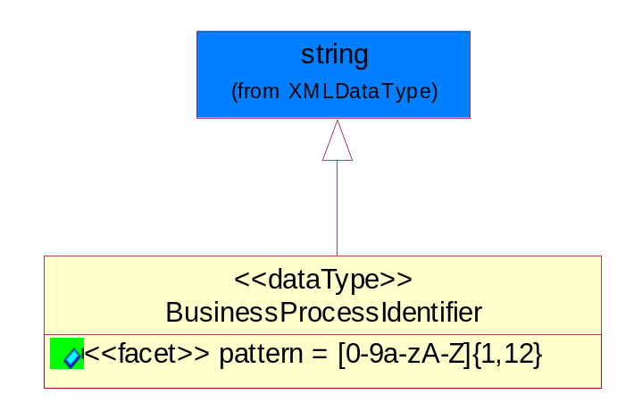
Figure ‎5-67 BusinessProcessIdentifier

Attribute | Type | Documentation
pattern |  | [0-9a-zA-Z]{1,12}

BusinessServiceInformation
The object allows the specification of the business service utilized within the partner company. This may or may not be the same as the information sent by the RNIF.
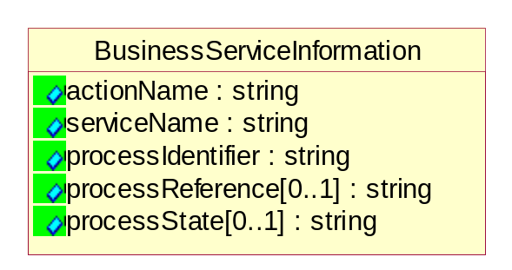
Figure ‎5-68 BusinessServiceInformation

Attribute | Type | Documentation
actionName | string | The name of Action. For RosettaNet usually any of Request/Confirm/Notify/Query/Response.
serviceName | string | The name of the Business Activity with the "Request/Confirm" part removed. E.g., for the Activity "Request Purchase Order"==> "Purchase Order".
processIdentifier | string | The name of the PIP e.g. Notify of Forecast Reply.
processReference[0..1] | string | The URN for the PIP that includes Cluster/Segment/Process pattern used to identify the interface process (such as PIP3A4)
processState[0..1] | string | The business process (or service) state of the sender of a document. When a service receives this document, the receiver may use the state as a precondition.

ContractInformation
A block of information used to correlate a contract in an executing choreography.

Figure ‎5-69 ContractInformation

Attribute | Type | Documentation
contractIdentifier[0..1] | string | Unique identification of a contract between the Sender and the Receiver
contractType[0..1] | string | The type of the contract: an attribute describing the type of the ContractIndentification. Valid values are URI, URN,ebXMLCPA, or other values defined by partners.

CorrelationInformation
A block of information used to correlate a requesting document to a responding document and to the contract in an executing choreography.
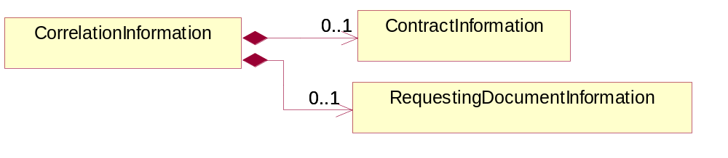
Figure ‎5-70 CorrelationInformation

Composition | Cardinality | Type | Documentation
ContractInformation | 0..1 | ContractInformation | A block of information used to correlate a contract in an executing choreography.
RequestingDocumentInformation | 0..1 | RequestingDocumentInformation | A block of information used to correlate a requesting document to a responding document in an executing choreography.

DocumentHeader
The object allows for the identification of the sender and receiver of the business document.
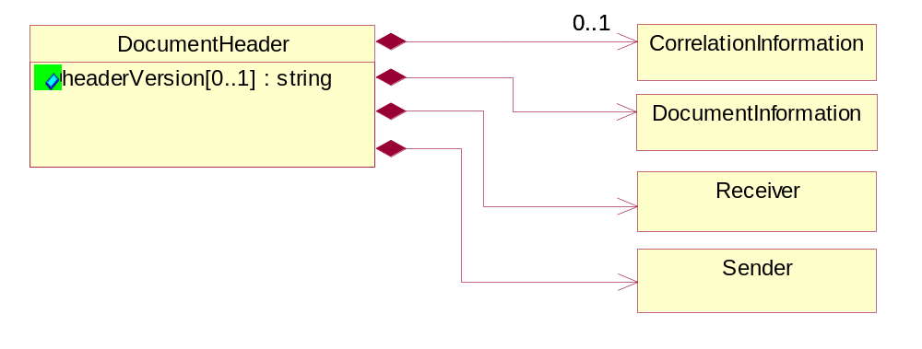
Figure ‎5-71 DocumentHeader

Attribute | Type | Documentation
headerVersion[0..1] | string | The UN/CEFACT version of the document header.

Composition | Cardinality | Type | Documentation
Sender | 1 | Sender | The object allows the identification of the initiating party of the business message.
CorrelationInformation | 0..1 | CorrelationInformation | A block of information used to correlate a requesting document to a responding document and to the contract in an executing choreography.
DocumentInformation | 1 | DocumentInformation | The object specifies information to identify the business document, a summary of attachments, and information about the business document security.
Receiver | 1 | Receiver | The object allows the identification of the receiving party of the business message.

DocumentIdentification
The object specifies all information necessary to identify the business document.
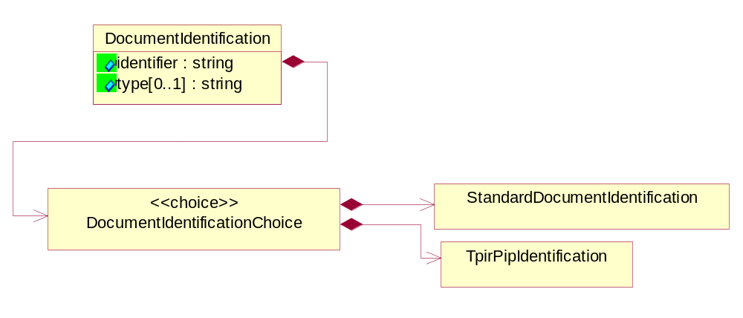
Figure ‎5-72 DocumentIdentification

Attribute | Type | Documentation
identifier | string | The unique identifier for the document being sent.
type[0..1] | string | Name of the Action Message

Composition | Cardinality | Type | Documentation
DocumentIdentificationChoice | 1 | DocumentIdentificationChoice

DocumentIdentificationChoice

Composition | Cardinality | Type | Documentation
StandardDocumentIdentification | 1 | StandardDocumentIdentification | The object specifies additional information necessary to identify the standard business document.
TpirPipIdentification | 1 | TpirPipIdentification | The object specifies all information necessary to uniquely identify a TPIR-PIP within a Registry or trading partner repository.

DocumentInformation
The object specifies information to identify the business document, a summary of attachments, and information about the business document security.
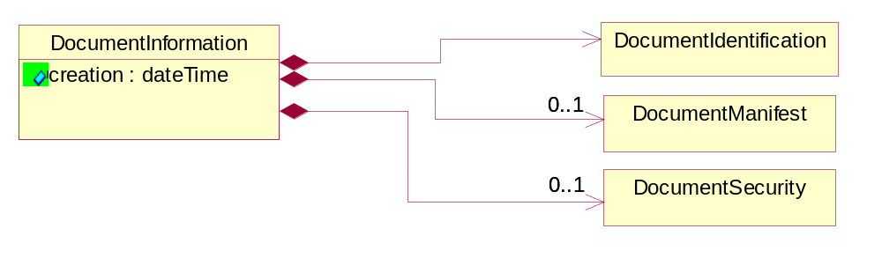
Figure ‎5-73 DocumentInformation

Attribute | Type | Documentation
creation | dateTime | The creation date and time of the specified Business Document (i.e. the Purchase Order date).

Composition | Cardinality | Type | Documentation
DocumentIdentification | 1 | DocumentIdentification | The object specifies all information necessary to identify the business document.
DocumentSecurity | 0..1 | DocumentSecurity | The object provides additional granularity in specifying business document security (this is in addition to the specified PIP security).
DocumentManifest | 0..1 | DocumentManifest | The block provides a brief summary of attachments and Service Content.

DocumentManifest
The block provides a brief summary of attachments and Service Content.
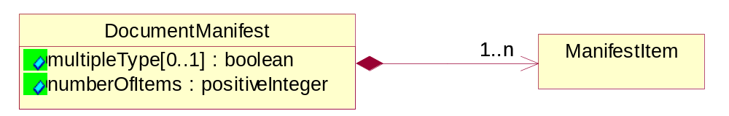
Figure ‎5-74 DocumentManifest

Attribute | Type | Documentation
multipleType[0..1] | boolean | Indicates whether the manifest contains documents of multiple types. True if yes, and False if no.
numberOfItems | positiveInteger | Total number of documents in the message. The physical count of the attachments in the payload plus the RosettaNet Business Message (for Service Content). The value of this field will be at least 1.

Composition | Cardinality | Type | Documentation
ManifestItem | 1..n | ManifestItem | The object provides details about the specific attachment(s).

DocumentSecurity
The object provides additional granularity in specifying business document security (this is in addition to the specified PIP security).

Figure ‎5-75 DocumentSecurity

Attribute | Type | Documentation
nonRepudiableReceipt | boolean | The value "true" will indicate that a signed acknowledgement for the business document is necessary.
persistentEncryption | boolean | The value "true" will indicate that the Business Document (including the header) needs to be encrypted when stored or transported.
persistentSignature | boolean | The value "true" will indicate that a signature is required to be stored with the document while stored or transported.

ManifestItem
The object provides details about the specific attachment(s).

Figure ‎5-76 ManifestItem

Attribute | Type | Documentation
description[0..1] | string | A description of the attachment.
length[0..1] | positiveInteger | The size of the attachment in bytes (i.e. 1 000 000 bytes)
universalResourceIdentifier | string | The generic set of all names/addresses that are short strings that refer to resources.

Composition | Cardinality | Type | Documentation
mimeTypeQualifier | 1 | MimeTypeQualifier | The MIME type as defined by IANA.  Please refer to http://www.iana.org/assignments/media-types/ for a list of types.
language | 0..1 | Language | For representation of Language name RosettaNet has adopted ISO 639-2; 1998. Refer to the following web page to get the latest version of the standard:  http://www.loc.gov/standards/iso639-2/iso639jac.html  If you need more information about the ISO standard please contact ISO for more details.

PipIdentifier
PIP Identification.[ i.e. PIP3A4]
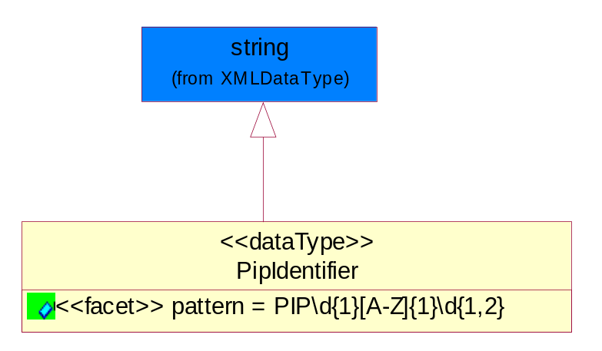
Figure ‎5-77 PipIdentifier

Attribute | Type | Documentation
pattern |  | PIP\d{1}[A-Z]{1}\d{1,2}

PipVersion
PIP version number (i.e. 02.02.00).
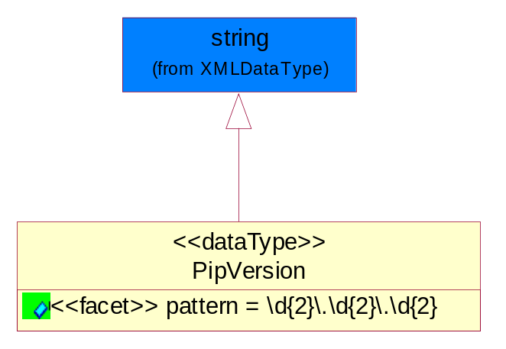
Figure ‎5-78 PipVersion

Attribute | Type | Documentation
pattern |  | \d{2}\.\d{2}\.\d{2}

Receiver
The object allows the identification of the receiving party of the business message.
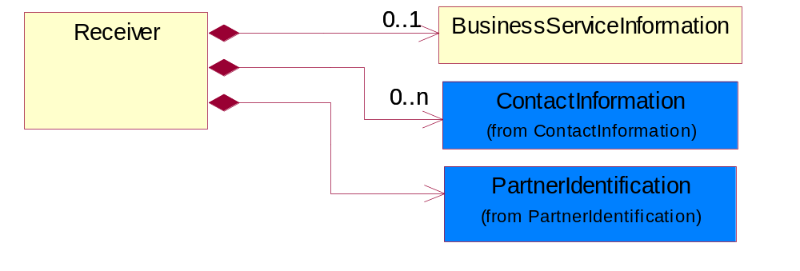
Figure ‎5-79 Receiver

Composition | Cardinality | Type | Documentation
BusinessServiceInformation | 0..1 | BusinessServiceInformation | The object allows the specification of the business service utilized within the partner company. This may or may not be the same as the information sent by the RNIF.
PartnerIdentification | 1 | PartnerIdentification | The business document must allow for the identity of one or more parties to the transaction.
ContactInformation | 0..n | ContactInformation | The business document must allow for the identification of the name of the department, service or individual to be contacted regarding the context of the business document.

RequestingDocumentInformation
A block of information used to correlate a requesting document to a responding document in an executing choreography.

Figure ‎5-80 RequestingDocumentInformation

Attribute | Type | Documentation
businessProcessInstanceIdentifier[0..1] | string | The identifier for the public business process instance being sent that both the sender and receiver can identify.
responseDateTime[0..1] | dateTime | The expected time to receive the response. This can not be greater than the PIP TimeToPerform.
requestingDocumentCreationDateTime[0..1] | dateTime | The date-time of the requesting business document.
requestingDocumentInstanceIdentifier | string | The Business Document identification number that identifies the requesting Business Document.

Sender
The object allows the identification of the initiating party of the business message.
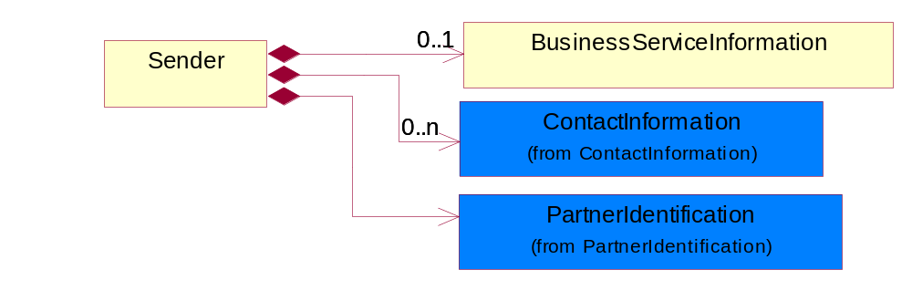
Figure ‎5-81 Sender

Composition | Cardinality | Type | Documentation
PartnerIdentification | 1 | PartnerIdentification | The business document must allow for the identity of one or more parties to the transaction.
BusinessServiceInformation | 0..1 | BusinessServiceInformation | The object allows the specification of the business service utilized within the partner company. This may or may not be the same as the information sent by the RNIF.
ContactInformation | 0..n | ContactInformation | The business document must allow for the identification of the name of the department, service or individual to be contacted regarding the context of the business document.

StandardDocumentIdentification
The object specifies additional information necessary to identify the standard business document.
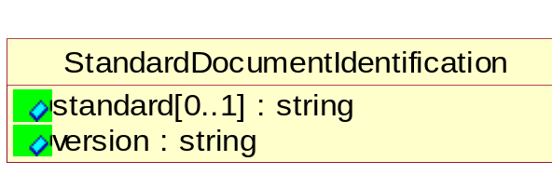
Figure ‎5-82 StandardDocumentIdentification

Attribute | Type | Documentation
standard[0..1] | string | Identifies the standard used to submit the business document. (e.g. RosettaNet).
version | string | PIP3A4v01.00

TpirPipIdentification
The object specifies all information necessary to uniquely identify a TPIR-PIP within a Registry or trading partner repository.

Figure ‎5-83 TpirPipIdentification

Attribute | Type | Documentation
partnerId | DUNSPlus4 | The Trading Partner Identification of MNC that is creating this TPIR PIP.
pipIdentifier | PipIdentifier | A TPIR PIP Identification [i.e., 3A4 ).
pipVersion | PipVersion | A TPIR PIP version number (i.e., 02.02.00)
tpirPipVersion | VersionIdentifier | A TPIR-PIP Version Number (i.e., major and minor version number as XX.XX).
tpirBusinessProcessIdentifier[0..1] | BusinessProcessIdentifier | A Business Process Identifier to uniquely define the TPIR-PIP 'role' within a Business Scenario at a company or MNC level. The identifier MUST be composed of alphanumeric characters only and its length MUST be between one and twelve characters.
uri[0..1] | anyURI | Describes the destination uri for the TPIR form.

Composition | Cardinality | Type | Documentation
fileType | 0..1 | TPIRFileType | Describes the file type of the TPIR form (PDF, XDP or XML).

VersionIdentifier
Version Number (i.e., major and minor version number as XX.XX).
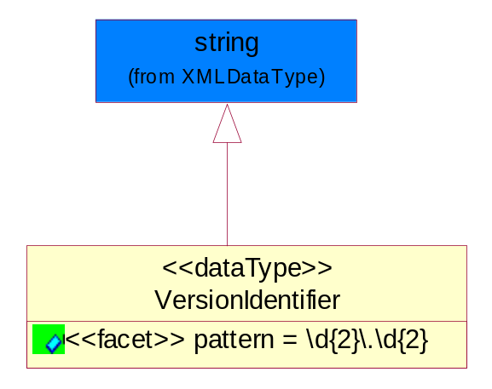
Figure ‎5-84 VersionIdentifier

Attribute | Type | Documentation
pattern |  | \d{2}\.\d{2}

CodeList

TPIRFileType
A code identifying the file type of TPIR form.

Name | Documentation
PDF | Portable Document Format.
XDP | XML Data Package.
XML | eXtensible Markup Language.

XML Data Type

anyURI
Represents a URI as defined by RFC 2396. An anyURI value can be absolute or relative, and may have an optional fragment identifier.

boolean
Represents Boolean values, which are either "true" or "false".

date
For the represents a calendar date.
The pattern for a date is CCYY-MM-DD where CC represents the century, YY the year, MM the month, and DD the day, with an optional time zone indicator as allowed for dateTime.

dateTime
Represents a specific instance of time.
The pattern for dateTime is CCYY-MM-DDThh:mm:ss where CC represents the century, YY the year, MM the month, and DD the day, preceded by an optional leading negative (-) character to indicate a negative number. If the negative character is omitted, positive (+) is assumed. The T is the date/time separator and hh, mm, and ss represent hour, minute, and second respectively. Additional digits can be used to increase the precision of fractional seconds if desired. For example, the format ss.ss... with any number of digits after the decimal point is supported. The fractional seconds part is optional.

This representation may be immediately followed by a "Z" to indicate Coordinated Universal Time (UTC) or to indicate the time zone. For example, the difference between the local time and Coordinated Universal Time, immediately followed by a sign, + or -, followed by the difference from UTC represented as hh:mm (minutes is required). If the time zone is included, both hours and minutes must be present.

float
Represents single-precision 32-bit floating-point numbers.

integer
Represents a sequence of decimal digits with an optional leading sign (+ or -). This data type is derived from decimal.

positiveInteger
Represents an integer that is greater than zero. This data type is derived from nonNegativeInteger.

string
Represents character string.

