

Description of 3B2 Message

PIP® 3B2
Validated 11.00.00

Specification Information
Name | Description Of 3B2 Message
PIP | Notify of Advance Shipment
Cluster | Order Management
Segment | Transportation And Distribution
Publication Date | 27 July 2006
Version Identifier | V11.00

Table of Content

1. Document Management 6
1.1 Legal Disclaimer 6
1.2 Copyright 6
1.3 Trademarks 6
1.4 Acknowledgments 6
1.5 Related Documents 7
1.6 Document Version History 7
1.7 Document Purpose 7
2. Interchange Model 8
2.1 AdvanceShipmentNotification 8
2.1.1 Interchange Diagram 8
2.1.2 Dependency Diagram 9
2.1.3 AdvanceShipment 9
2.1.4 AdvanceShipmentNotification 10
2.1.5 DeviceActivationInformation 10
2.1.6 DeviceActivationNumber 11
2.1.7 DocumentSubLineLotShipReference 11
2.1.8 LotShipReference 12
2.1.9 Shipment 13
2.1.10 ShippingContainer 15
2.1.11 ShippingContainerItem 16
2.1.12 SubContainer 17
3. Domain Model 18
3.1 Procurement 18
3.1.1 Procurement 18
3.1.1.1 Dependency Diagram 18
3.1.1.2 LotIdentification 18
3.1.1.3 SpecialHandlingInstruction 18
3.1.2 CodeList 19
3.1.2.1 SpecialHandling 19
3.2 Logistics 28
3.2.1 Logistics 28
3.2.1.1 Dependency Diagram 28
3.2.1.2 HazardousMaterialDescription 28
3.2.1.3 ManufacturerProfile 28
3.2.1.4 MassPhysicalDimension 29
3.2.1.5 ShipmentDate 29
3.2.1.6 TrackingReference 30
3.2.2 CodeList 30
3.2.2.1 TrackingReferenceType 30
3.2.2.2 Incoterms 31
3.2.2.3 ShipmentChangeDisposition 31
3.2.2.4 ShipmentMode 32
3.2.2.5 NationalExportControlClassification 32
3.2.2.6 ShipDateCode 34
3.3 Manufacturing 37
3.3.1 Manufacturing 37
3.3.1.1 Dependency Diagram 37
3.3.1.2 LotQuantity 37
3.3.2 CodeList 38
3.3.2.1 LotQuantityClassification 38
3.4 Shared 39
3.4.1 Shared 39
3.4.1.1 Dependency Diagram 39
3.4.1.2 SCAC 39
3.4.2 CodeList 40
3.4.2.1 PackageType 40
3.4.2.2 ShippingServiceLevel 40
4. Universal Structure 43
4.1 ContactInformation 43
4.1.1 ContactInformation 43
4.2 DataType 44
4.2.1 Contact 44
4.2.2 DUNS 44
4.2.3 DUNSPlus4 45
4.2.4 GLN 45
4.2.5 GTIN 46
4.3 Document 47
4.3.1 BusinessDocumentReference 47
4.4 Locations 48
4.4.1 AlternativeIdentifier 48
4.4.2 Location 48
4.4.3 LocationChoice 49
4.4.4 PhysicalAddress 49
4.5 MonetaryExpression 51
4.5.1 FinancialAmount 51
4.6 PartnerIdentification 52
4.6.1 PartnerIdentification 52
4.6.2 PartnerIdentificationChoice 52
4.6.3 SpecifiedFullPartner 53
4.6.4 SpecifiedIntermittentPartner 54
4.6.5 SpecifiedKnownPartner 54
4.6.6 SpecifiedKnownPartnerContact 55
4.6.7 SpecifiedNewPartner 55
4.6.8 SpecifiedPartnerDescription 56
4.6.9 SpecifiedPartnerDescriptionChoice 57
4.7 PhysicalDimension 58
4.7.1 Linear 58
4.7.2 Measure 58
4.7.3 Volume 59
4.7.4 Weight 59
4.8 ProductIdentification 60
4.8.1 ProductIdentification 60
4.8.2 ProductIdentificationChoice 60
4.9 CodeList 61
4.9.1 Country 61
4.9.2 CountrySubdivision 61
4.9.3 Currency 61
4.9.4 Language 61
4.9.5 DocumentType 62
4.9.6 MimeTypeQualifier 63
4.9.7 UnitOfMeasure 74
4.9.8 WeightType 81
5. System Structure 82
5.1 BusinessProcessIdentifier 82
5.2 BusinessServiceInformation 82
5.3 ContractInformation 83
5.4 CorrelationInformation 83
5.5 DocumentHeader 84
5.6 DocumentIdentification 85
5.7 DocumentIdentificationChoice 85
5.8 DocumentInformation 86
5.9 DocumentManifest 86
5.10 DocumentSecurity 87
5.11 ManifestItem 88
5.12 PipIdentifier 89
5.13 PipVersion 89
5.14 Receiver 90
5.15 RequestingDocumentInformation 90
5.16 Sender 91
5.17 StandardDocumentIdentification 92
5.18 TpirPipIdentification 92
5.19 VersionIdentifier 93
5.20 CodeList 94
5.20.1 TPIRFileType 94
6. XML Data Type 95
6.1 anyURI 95
6.2 boolean 95
6.3 date 95
6.4 dateTime 95
6.5 float 95
6.6 positiveInteger 95
6.7 string 95

Table of Figures

Figure ‎2-1 Interchange 8
Figure ‎2-2 Dependency 9
Figure ‎2-3 AdvanceShipment 9
Figure ‎2-4 AdvanceShipmentNotification 10
Figure ‎2-5 DeviceActivationInformation 10
Figure ‎2-6 DeviceActivationNumber 11
Figure ‎2-7 DocumentSubLineLotShipReference 11
Figure ‎2-8 LotShipReference 12
Figure ‎2-9 Shipment 13
Figure ‎2-10 ShippingContainer 15
Figure ‎2-11 ShippingContainerItem 16
Figure ‎2-12 SubContainer 17
Figure ‎3-1 Dependency 18
Figure ‎3-2 LotIdentification 18
Figure ‎3-3 SpecialHandlingInstruction 18
Figure ‎3-4 Dependency 28
Figure ‎3-5 HazardousMaterialDescription 28
Figure ‎3-6 ManufacturerProfile 28
Figure ‎3-7 MassPhysicalDimension 29
Figure ‎3-8 ShipmentDate 29
Figure ‎3-9 TrackingReference 30
Figure ‎3-10 Dependency 37
Figure ‎3-11 LotQuantity 37
Figure ‎3-12 Dependency 39
Figure ‎3-13 SCAC 39
Figure ‎4-1 ContactInformation 43
Figure ‎4-2 Contact 44
Figure ‎4-3 DUNS 44
Figure ‎4-4 DUNSPlus4 45
Figure ‎4-5 GLN 45
Figure ‎4-6 GTIN 46
Figure ‎4-7 BusinessDocumentReference 47
Figure ‎4-8 AlternativeIdentifier 48
Figure ‎4-9 Location 48
Figure ‎4-10 PhysicalAddress 49
Figure ‎4-11 FinancialAmount 51
Figure ‎4-12 PartnerIdentification 52
Figure ‎4-13 SpecifiedFullPartner 53
Figure ‎4-14 SpecifiedIntermittentPartner 54
Figure ‎4-15 SpecifiedKnownPartner 54
Figure ‎4-16 SpecifiedKnownPartnerContact 55
Figure ‎4-17 SpecifiedNewPartner 55
Figure ‎4-18 SpecifiedPartnerDescription 56
Figure ‎4-19 Linear 58
Figure ‎4-20 Measure 58
Figure ‎4-21 Volume 59
Figure ‎4-22 Weight 59
Figure ‎4-23 ProductIdentification 60
Figure ‎5-1 BusinessProcessIdentifier 82
Figure ‎5-2 BusinessServiceInformation 82
Figure ‎5-3 ContractInformation 83
Figure ‎5-4 CorrelationInformation 83
Figure ‎5-5 DocumentHeader 84
Figure ‎5-6 DocumentIdentification 85
Figure ‎5-7 DocumentInformation 86
Figure ‎5-8 DocumentManifest 86
Figure ‎5-9 DocumentSecurity 87
Figure ‎5-10 ManifestItem 88
Figure ‎5-11 PipIdentifier 89
Figure ‎5-12 PipVersion 89
Figure ‎5-13 Receiver 90
Figure ‎5-14 RequestingDocumentInformation 90
Figure ‎5-15 Sender 91
Figure ‎5-16 StandardDocumentIdentification 92
Figure ‎5-17 TpirPipIdentification 92
Figure ‎5-18 VersionIdentifier 93

Document Management

Legal Disclaimer
RosettaNet, its members, officers, directors, employees, or agents shall not be liable for any injury, loss, damages, financial or otherwise, arising from, related to, or caused by the use of this document or the specifications herein, as well as associated guidelines and schemas. The use of said specifications shall constitute your express consent to the foregoing exculpation.

Copyright
©2006 RosettaNet. All rights reserved. No part of this publication may be reproduced, stored in a retrieval system, or transmitted, in any form or by any means, electronic, mechanical, photocopying, recording, or otherwise, without the inclusion of this copyright notice. Any derivative works must cite the copyright notice. Any public redistribution or sale of this publication or derivative works requires prior written permission of the publisher.

Trademarks
RosettaNet, Partner Interface Process, PIP and the RosettaNet logo are trademarks or registered trademarks of "RosettaNet," a non-profit organization. All other product names and company logos mentioned herein are the trademarks of their respective owners. In the best effort, all terms mentioned in this document that are known to be trademarks or registered trademarks have been appropriately recognized in the first occurrence of the term.

Acknowledgments
This document has been prepared by RosettaNet (http://www.rosettanet.org/) from requirements gathered during the Milestone Program and in conformance with the methodology. Listed below are the legal entities that contributed to the design and development of this PIP.
Amkor Technology, Inc. | Sterling Commerce
BCM Electronics | STMicroelectronics
Globetronics SDH. BHD | Sumitomo Bakelite Co., Ltd.
Intel Corporation | Tokyo Electron
Menlo Worldwide | Tokyo Electron Americe
Motorola Semiconductor Products Sector, Motorola SPS, Motorola | Tokyo Electron Limited
MIMOS Berhad | UMC
Shinko Electric Industries Co., Ltd. | United Microelectronics Corp.
SMSC | UPS Supply Chain Solutions
Standard Microsystems Corporation

Related Documents
- Associated PIP Message Schemas (included with PIP Specification only)
- Description of Partner Interface Process for 3B2
- Message Structure

Document Version History
Version | Date | Description
Validated 11.00.00 | 27 July 2006 | Validated Version

Document Purpose
The purpose of the document is to explain the structure, the association between objects, the content of objects and the definition for single elements to a non-technical audience.

Interchange Model

AdvanceShipmentNotification

Interchange Diagram
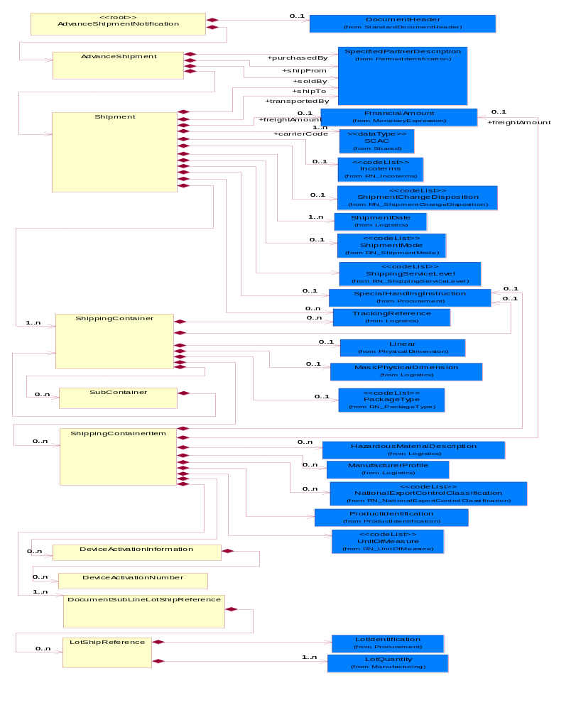
Figure ‎2-1 Interchange

Dependency Diagram
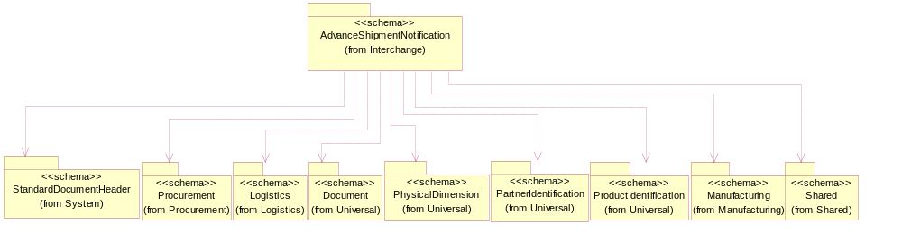
Figure ‎2-2 Dependency

AdvanceShipment
The Advance Shipment Notification contains detailed information on when product shipped and expected date of arrival, how product shipped, and detail on what the shipment contains.
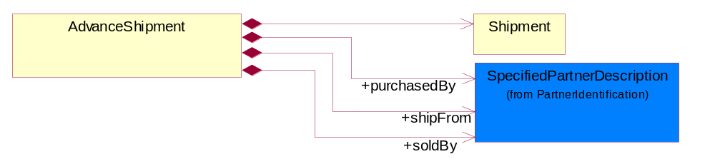
Figure ‎2-3 AdvanceShipment

Composition | Cardinality | Type | Documentation
Shipment | 1 | Shipment | The collection of business properties that describe a consignment tendered for transportation from one point to another.
purchasedBy | 1 | SpecifiedPartnerDescription | The party who is a purchaser of a product.
soldBy | 1 | SpecifiedPartnerDescription | The party who is a seller of a product.
shipFrom | 1 | SpecifiedPartnerDescription | The DUNS or DUNS + 4 number of the location of the originating party initiating a shipment or transaction.

AdvanceShipmentNotification
A message wrapper for the PIP3B2
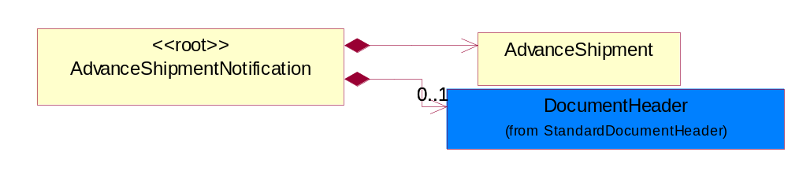
Figure ‎2-4 AdvanceShipmentNotification

Composition | Cardinality | Type | Documentation
DocumentHeader | 0..1 | DocumentHeader | The object allows for the identification of the sender and receiver of the business document.
AdvanceShipment | 1 | AdvanceShipment | The Advance Shipment Notification contains detailed information on when product shipped and expected date of arrival, how product shipped, and detail on what the shipment contains.

DeviceActivationInformation
Information to activate for a serialized product (i.e. handsets or other wireless devices).
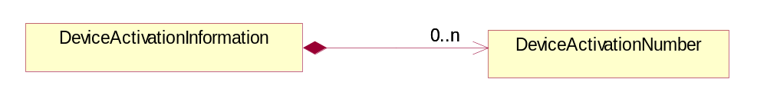
Figure ‎2-5 DeviceActivationInformation

Composition | Cardinality | Type | Documentation
DeviceActivationNumber | 0..n | DeviceActivationNumber | Number used to activate the serialized product.

DeviceActivationNumber
Number used to activate the serialized product.
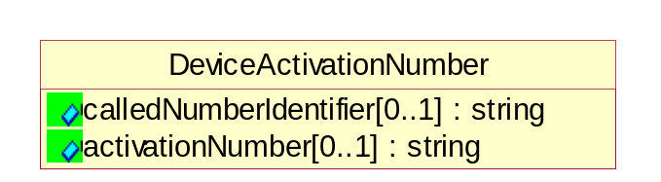
Figure ‎2-6 DeviceActivationNumber

Attribute | Type | Documentation
calledNumberIdentifier[0..1] | string | The actual value of the identifier type specified by 'ActivationNumberType'.
activationNumber[0..1] | string | Text to describe the serialization identifier

DocumentSubLineLotShipReference
Reference to document(s) this shipment is being sent against (i.e. Purchase Order)
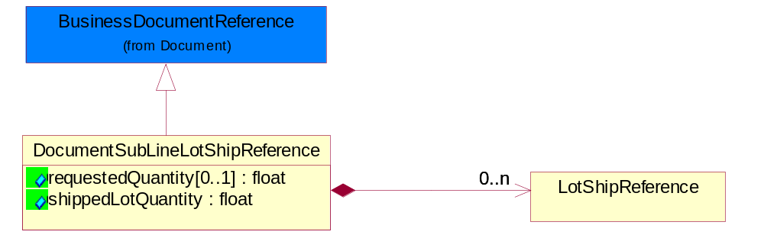
Figure ‎2-7 DocumentSubLineLotShipReference

Attribute | Type | Documentation
requestedQuantity[0..1] | float | The quantity of product requested.
shippedLotQuantity | float | A quantity of product shipped of a specific manufacturing lot within a shipping container.

Composition | Cardinality | Type | Documentation
LotShipReference | 0..n | LotShipReference | Reference to specific lot information (i.e. quantity, lot identifiers) contained in this shipment.

LotShipReference
Reference to specific lot information (i.e. quantity, lot identifiers) contained in this shipment.
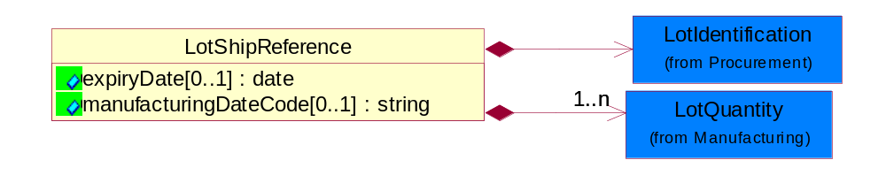
Figure ‎2-8 LotShipReference

Attribute | Type | Documentation
expiryDate[0..1] | date | The date that a contractual agreement expires.
manufacturingDateCode[0..1] | string | The unique identifier assigned to a product by a manufacturer to distinguish individual manufacturing periods.

Composition | Cardinality | Type | Documentation
LotIdentification | 1 | LotIdentification | This object identifies a lot which associates the product with a specific group of products with some similar attributes.
LotQuantity | 1..n | LotQuantity | The collection of business properties that describe the quantity of items in a lot.

Shipment
The collection of business properties that describe a consignment tendered for transportation from one point to another.
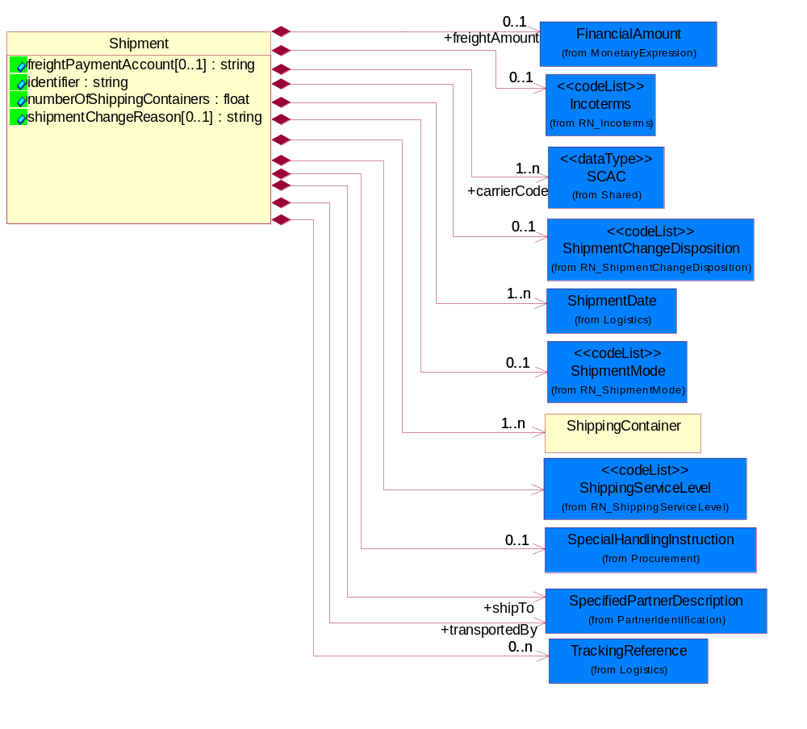
Figure ‎2-9 Shipment

Attribute | Type | Documentation
freightPaymentAccount[0..1] | string | Identification number of an account.
identifier | string | Reference identifier assigned by the partner originating a shipment to uniquely identify the shipment.
numberOfShippingContainers | float | A numeric expression of the number of outer containers for product shipping.
shipmentChangeReason[0..1] | string | Team must provide valid definition. Should be changed from Free Form Text to a code list.

Composition | Cardinality | Type | Documentation
Incoterms | 0..1 | Incoterms | Code identifying incoterms.
ShipmentChangeDisposition | 0..1 | ShipmentChangeDisposition | Code identifying the additional reasons for a change to a product shipment.
ShipmentMode | 0..1 | ShipmentMode | The method of transport used for the conveyance of goods.
ShippingContainer | 1..n | ShippingContainer | The collection of business properties that describe the nature and contents of a shipping unit.
TrackingReference | 0..n | TrackingReference | Proprietary unique identifier for tracking product shipments.
shipTo | 1 | SpecifiedPartnerDescription | The partner and/or location to which the product must be delivered.
transportedBy | 1 | SpecifiedPartnerDescription | The party responsible for either carrying or forwarding the product.
SpecialHandlingInstruction | 0..1 | SpecialHandlingInstruction | The collection of business properties that describe product packaging or shipping handling instructions.
freightAmount | 0..1 | FinancialAmount | The freight amount charge that should be paid for this container.
ShipmentDate | 1..n | ShipmentDate | The collection of business properties that identifies a constraint on when the products may be shipped.
carrierCode | 1..n | SCAC | A unique carrier identification code, based on Standard Carrier Alpha Code(s)
ShippingServiceLevel | 1 | ShippingServiceLevel | Code identifying the shipping service level, e.g., overnight, same day.

ShippingContainer
The collection of business properties that describe the nature and contents of a shipping unit.
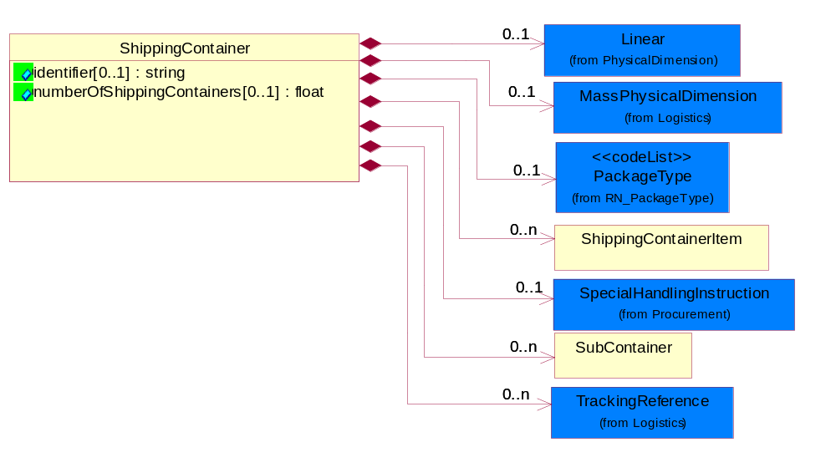
Figure ‎2-10 ShippingContainer

Attribute | Type | Documentation
identifier[0..1] | string | Unique identifier that represents a shipping container. Normally a UCC structured identifier. Also known as a "license plate".
numberOfShippingContainers[0..1] | float | A numeric expression of the number of outer containers for product shipping.

Composition | Cardinality | Type | Documentation
Linear | 0..1 | Linear | The business document must be able to express the linear dimensions of an object.
MassPhysicalDimension | 0..1 | MassPhysicalDimension | The physical dimension of unit of mass used for measuring the masses of weights, volumes etc.
ShippingContainerItem | 0..n | ShippingContainerItem | The collection of business properties that describe the nature and contents of the good contained within shipping unit.
TrackingReference | 0..n | TrackingReference | Proprietary unique identifier for tracking product shipments.
SubContainer | 0..n | SubContainer | The collection of business properties that describe the nature and contents of inner containers (packages) contained within an outer shipping unit.
SpecialHandlingInstruction | 0..1 | SpecialHandlingInstruction | The collection of business properties that describe product packaging or shipping handling instructions.
PackageType | 0..1 | PackageType | Code specifying the type of packaging for a product.

ShippingContainerItem
The collection of business properties that describe the nature and contents of the good contained within shipping unit.
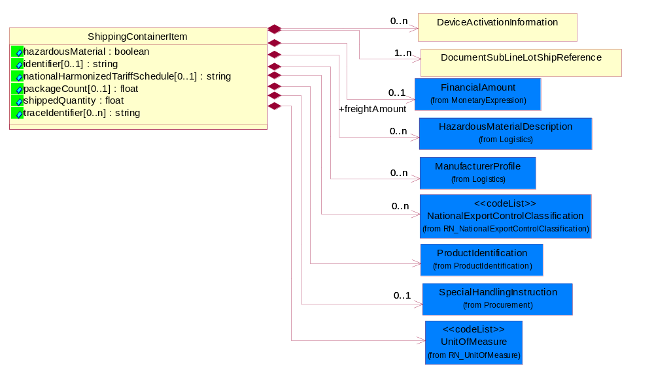
Figure ‎2-11 ShippingContainerItem

Attribute | Type | Documentation
hazardousMaterial | boolean | Indicates whether the product contains hazardous material.
identifier[0..1] | string | The identifier used to denote the lowest unit in a shipment, i.e., a package within a box.
nationalHarmonizedTariffSchedule[0..1] | string | Code identifying product classification for international shipping.
packageCount[0..1] | float | A numeric expression of the number of item packages within a container.
shippedQuantity | float | Quantity of product shipped.
traceIdentifier[0..n] | string | Free form text for a non-serial lot identifier.

Composition | Cardinality | Type | Documentation
DocumentSubLineLotShipReference | 1..n | DocumentSubLineLotShipReference | Reference to document(s) this shipment is being sent against (i.e. Purchase Order)
HazardousMaterialDescription | 0..n | HazardousMaterialDescription | The collection of business properties that describe the nature of dangerous goods tendered for transportation.
ManufacturerProfile | 0..n | ManufacturerProfile | The collection of business properties that describe a manufacturer's product.
ProductIdentification | 1 | ProductIdentification | The object provides the identifier(s) of a product.
NationalExportControlClassification | 0..n | NationalExportControlClassification | Code identifying product classification for export regulation.
UnitOfMeasure | 1 | UnitOfMeasure | Code identifying a product unit of measure.
SpecialHandlingInstruction | 0..1 | SpecialHandlingInstruction | The collection of business properties that describe product packaging or shipping handling instructions.
freightAmount | 0..1 | FinancialAmount | The business document must express financial amounts.
DeviceActivationInformation | 0..n | DeviceActivationInformation | Information to activate for a serialized product (i.e. handsets or other wireless devices).

SubContainer
The collection of business properties that describe the nature and contents of inner containers (packages) contained within an outer shipping unit.
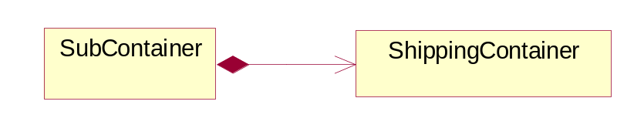
Figure ‎2-12 SubContainer

Composition | Cardinality | Type | Documentation
ShippingContainer | 1 | ShippingContainer | The collection of business properties that describe the nature and contents of a shipping unit.

Domain Model

Procurement

Procurement

Dependency Diagram
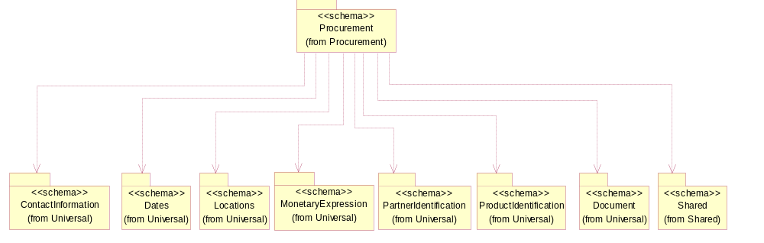
Figure ‎3-13 Dependency

LotIdentification
This object identifies a lot which associates the product with a specific group of products with some similar attributes.
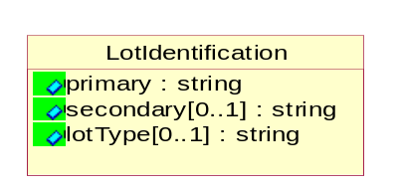
Figure ‎3-14 LotIdentification

Attribute | Type | Documentation
primary | string | The primary lot identifier
secondary[0..1] | string | The secondary lot identifier
lotType[0..1] | string | Identify the type of the lot whether it's for Production or Engineering.

SpecialHandlingInstruction
The collection of business properties that describe product packaging or shipping handling instructions.
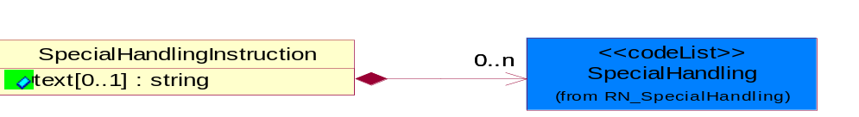
Figure ‎3-15 SpecialHandlingInstruction

Attribute | Type | Documentation
text[0..1] | string | Free form textual description for how specified goods, packages or containers should be handled.

Composition | Cardinality | Type | Documentation
SpecialHandling | 0..n | SpecialHandling | Code identifying special handling or packaging requirements for the product.

CodeList

SpecialHandling
Code identifying special handling or packaging requirements for the product.

Name | Documentation
15M | 15 Minute Window.
24H | 24 Hour Availability.
AAO | Attachments - Advance Only Waybill.
ACC | Accepted by Carrier at Owner's Risk of Freezing.
ACD | Air Conditioning Disconnect and Connect.
ACU | Attachment - Customer's Document.
ADC | Additional Copy of Shipping Papers for Proof of Delivery.
ADF | Advanced Fee.
ADL | Advance Loading.
AGS | Armed Guard Service.
AHM | Accessible Hazardous Material.
AMD | A.M. Delivery Requirement.
ANU | Anchoring and Unanchoring.
ANV | Annual Volume.
APW | Attachment - Prepaid Waybill.
ART | Air Ride Truck Service.
ASE | Attachment - Shipper's Export Document.
ASM | Attachment - Shipper's Manifest.
ASP | Attachment - Shipper's Packing Instructions.
ASR | Assembly Service Requested.
ATD | Aggregate Tender Discount.
ATT | Air Ride Tractor Service.
AUS | Auxiliary Service.
BA1 | Bunker Adjustment - 20 Foot Container.
BA2 | Bunker Adjustment - 40 Foot Container.
BCC | Bill Consignee for Weigh Charges.
BCP | Bypass Consolidation Point.
BFS | Barge Freight All Kinds Service.
BKA | Bunker Adjustment.
BKS | Block Stowage.
BLB | Blocking and Bracing.
BLS | Blind Shipment.
BNS | If Bad Ordered Notify Shipper.
BOL | Bolster Load, Do Not Switch.
BSA | Bunker Surcharge Authorized.
BSC | Bill Shipper for Weigh Charge.
BUA | Bulky Article.
CA1 | Currency Adjustment - 20 Foot Container.
CA2 | Currency Adjustment - 40 Foot Container.
CAA | Cargo Aboard.
CAB | Chain and Binders.
CAC | Carrier Caboose.
CAR | Carrier.
CAT | Cargo Taxes.
CBC | Cargo on Board Certification Required.
CCB | Convert Commercial Bill of Lading (BOL) to Government BOL.
CCE | Certification that the Containers Being Returned Empty Were Received Filled by Rail Freight Service.
CCL | Container, Consolidator Load.
CER | Certification.
CFB | Cleared for Border Crossing.
CFC | Customs Fees - Container Level.
CFE | Cleared for Export.
CFI | Customs Fees - Lift Level.
CFL | Container, Factory Load.
CGC | Carrier Guard Car Service.
CHB | Clearinghouse Balance.
CIP | Commercial Invoice Preparation.
CIR | Circuitous Routing.
CLC | Carrier Load and Consignee Unload.
CLE | Cleaning.
CLH | Consolidation and Line Haul.
CLL | Commodity Loaded Less Than or Equal To the Car Ordered.
CLU | Carrier Load and Carrier Unload.
CNE | Certification That the Newsprint Winding Cores Being Returned Empty Were Received Filled by Rail Freight Service.
COA | Controlled Atmosphere.
COD | Container Diversion.
COL | Container Lease.
COM | Container Mounting.
CON | Conductivity/Anti-static Additive.
COO | Certificate of Origin.
COS | Completing Shipment.
COU | Consignee Unload.
COV | Courier, Overnight.
CPM | Customs Papers Mailed.
CPN | Customer Required PRO Number.
CRA | Class Rates Applied.
CRD | Comb. Rates over Detroit.
CRL | Customer Required Packing List.
CRN | Customer Required Appointment Number.
CRP | Contract Rates Apply.
CRT | Cross Town.
CSD | Courier, Same Day.
CSL | Consolidation.
CSR | Certification that this Shipment is for Recycling as Defined in Applicable Tariffs Containing Such Provisions.
CSU | Constant Surveillance.
CUI | Customs Inspection.
DAN | Dangerous.
DAR | Drop and Run.
DCE | Detention of Conveying Equipment and the Power Unit.
DEM | Demurrage.
DEP | Detention of Conveying Equipment Excluding the Power Unit.
DES | Delivery Service.
DEV | Detention (Vehicle).
DHI | Do not Hump or Hump into.
DID | Direct Delivery.
DNC | Do Not Couple to Double Shelf Couples.
DND | Do Not Divert.
DNF | Do Not Freeze.
DNH | Do Not Hump.
DNP | Do Not Pool.
DNT | Do Not Transfer Contents.
DNU | Do Not Uncouple.
DOD | DOD Constant Surveillance Service.
DOM | Domestic.
DOS | Documentation - Special.
DP1 | Detention With Power Units (30 minute periods).
DP2 | Detention With Power Units (60 minute periods).
DPD | Drayage at Port of Debarkation (Rate Zone).
DPE | Drayage at Port of Embarkation (Rate Zone).
DRO | Drop-Off Delivery.
DSR | Distribution Service Requested.
DSW | Delivery Only on Surrender of Written Order.
DVN | Delivery Verification Not Required.
DWA | Destination Weights Apply.
ECS | Escort/Courier Service.
EET | Electronic Equipment Transfer.
EHM | Endorsed as Hazardous Material.
ELB | Extra Labor.
EMM | Empty Movement.
EMR | Empty Return.
EMS | Emergency Service.
END | Endorsement.
EOS | Escort Service with Overnight Subsistence.
EPP | Export Preparation.
EPT | Export.
EQU | Equipment..
ERA | Expedited Rates Applied.
ERI | Expand Remove and Install.
ESC | Escort.
EST | Escort Services (Telephone).
EUV | Exclusive Use of Vehicle.
EVA | Excessive Valuation Authorized.
EXC | Exempt Commodity.
EXD | Extra Driver.
EXL | Extra Lights.
EXP | Expedite.
EXS | Expedited Service.
EXU | Exclusive Use.
EXW | Excessive Weight.
FIS | Filtration Service.
FLS | Flatrack Surcharge.
FOD | FOD, FOB - Destination.
FOS | FOS, FOB Shipping Point.
FPT | For Processing in Transit.
FRA | Fragile - Handle with Care.
FST | For Storage in Transit.
FUS | Full Service.
GGC | Government Guard Car.
GOC | Government-Owned Containers.
GSS | Greater Security Service.
GVC | Government Caboose.
HAL | Hold at Location.
HAN | Handling.
HAR | Harmless.
HCD | Hazardous Cargo On Deck.
HCT | High Cube Trailer Rates.
HEA | Heat.
HES | Heat - Special.
HFO | Hold for Orders.
HFR | Home for Repair.
HIT | Heat in Transit.
HMS | Hazardous Materials Surcharge.
HOR | Heater or Refrigeration.
HVL | High Value Load.
IHM | Inaccessible Hazardous Material.
IMP | Impactographs.
IMS | Import Shipment.
INB | In-bond.
IND | Inside Delivery.
INH | Inspect Hourly if Car Stopped.
INP | Inside Pickup.
INS | Insulated
IPM | Intra-Plant Move.
ISS | Intermodal Shipment Service.
ITS | Interline Transfer Service.
JIT | Just-In-Time (JIT).
JLE | Joint Line Exception.
KFF | Keep From Freezing Percent Differential.
KMD | Keep Material Dry.
LAA | Labor Associated with Detention of Conveying Equipment.
LAB | Land Bridge (Import/Export).
LAD | Labor Disturbance.
LAO | Layover.
LAS | Layover Service.
LBD | Labor Disturbance.
LBS | Light Bar Service.
LBT | Low Boy Trailer/Flat Bed.
LC1 | Land Currency Adjustment - 40 Foot Container.
LC2 | Land Currency Adjustment Factor - 20 Foot Container.
LCA | Land Currency Adjustment - 40 Foot Container.
LCF | Land Currency Adjustment Factor - 20 Foot Container.
LDE | Labor Associated with Detention of Conveying Equipment.
LDP | Linehaul from Port of Debarkation.
LEP | Linehaul To Port of Embarkation.
LFC | Less Than Full Carload.
LFL | Less Than Container, Factory Load.
LFV | Loaded to Full Visible Capacity.
LIS | Linehaul Service.
LIU | Live Unload.
LOC | Liability of Carrier.
LOD | Loading Devices.
LPD | Linehaul Percent Differential
LSO | Local Service Only.
LTC | Less Than Container.
LTD | Liner Terms at Port of Debarkation.
LTE | Liner Terms at Port of Embarkation.
LTL | Less Than Container, Consolidator Load.
LTT | Less Than Truckload.
MAW | Manifest Must Accompany Waybill.
MER | Mechanical Refrigeration.
MFI | Moving Under "For Furtherance Instructions" and May Be Delivered.
MOA | Modified Atmosphere.
MSS | Motor Surveillance Service.
MTS | Multi-Tank Surveillance Service.
MUP | Multiple Pickup.
NCB | Notify Consignee Before Delivery.
NEF | New Equipment First Transborder Movement.
NFE | Not for Export.
NFS | Nontransit Flat Shipment.
NMR | No Marshalling Required for Hazardous Materials.
NPR | No Placards Required.
NRC | Not Restricted Cargo.
NSB | Notify Shipper Before Reconsignment.
NSE | No Special Entrainment Required.
NSI | Notify Shipper Immediately if Shipment is Delayed en Route.
NUW | In Case of Fire Do Not Use Water.
OAH | Offshore - Alaska/Hawaii Service.
ODS | On Deck Stowage.
OHC | Over Height Container.
OTH | Other.
OVF | Overflow.
OVP | Oversized Premium.
OVW | Overweight.
OWR | One Way Rates Applied.
PAD | Pickup and Delivery.
PAS | Partial Shipment.
PAU | Pack and Unpack.
PAW | Preparation of Air Waybill - Origin.
PCC | Preparation of Canadian Customs Invoice.
PDB | Pickup and Delivery Beyond Service Area.
PDL | Percent Differential - Less Than Container.
PDS | Pickup and Delivery From Storage in Transit.
PEE | Preparation of Export Entry.
PFH | Protect From Heat.
PHR | Per Hour Rates Applied.
PIC | Preparation of Insurance Certificate.
PIT | Pier Time.
PIU | Pickup.
PLR | Protect Lowest Through Rate.
PMD | P.M. Delivery Requirement.
PMR | Per Mile Rates Apply.
POC | Port Changes.
PPC | PPC, FOB -Destination charge to customer.
PPD | PPD, Prepay+I35/Add Freight to Invoice.
PPS | Product Protection Service.
PRS | Priority Service.
PSC | Protective Security Service.
PSN | Pickup of Shipments on Saturday, Sunday, and/or Holidays Requiring Absolute Next Day Delivery.
PSP | Pallets/Skids/Platforms.
PSS | Pickup of Shipments Requiring Same Day Delivery Service.
PST | Pickup of Shipments Requiring Same Day Delivery Service and/or Delivery at a Specified Time.
PUE | Preparation of U.S. Export Documentation.
PUP | PUP Trailer Rates Apply.
RAH | Railhead Handling.
RAM | Radioactive Material.
RBC | Render Bill for Charges.
RCD | Reefer Cargo Percent Differential.
RCG | Return Carrier Guard Car Service.
RCP | Railroad Controlled Private Equipment Subject to Demurrage.
RCS | Reconsignment.
REA | Return Authorization.
REC | Return of Empty Container.
RED | Redelivery.
REF | Refrigerated.
REM | Reefer Maintenance.
RER | Reweight Requested.
RES | Reservations.
RFT | Record for Transit.
RMP | Return Movement of Pallet.
ROE | ROEE Van Type Truck.
ROS | Roadrailer Service.
RSC | Requires Shelf Couplers.
RSD | Residential Delivery.
RSM | Reshipment.
RST | Respotting.
RTS | Round Trip Service.
RUO | Rush Order.
RVC | Released Value Charge in Excess of Carrier Maximum Liability.
RWE | Roadway Easy Rates Applied.
SAD | Saturday Delivery.
SAH | Stow Away from Heat.
SAR | Shipper Authorization Required for Diversion or Consignment.
SCA | Service Charge Applies.
SCC | Shipper Load/Carrier Count.
SCG | Shipper Certifies Gross Weight under 240,000 pounds.
SCL | Apply a Uniform Code Council/International Article Numbering Association (UCC/EAN) Serial Shipping Container Label to the Shipping Containers.
SCW | Stretch Wrap.
SDS | Special Dromedary Service.
SEC | Special Equipment Charge.
SED | Shipper Export Declaration Required.
SEE | Stairs, Elevator, Excess Carry.
SES | Security Signature Service.
SFD | Single Factor Origination/Port of Debarkation.
SFO | Single Factor Origination/Destination.
SFP | Single Factor Port of Embarkation/Destination.
SFS | Satisfactory Service Standards.
SGD | Single Driver.
SHH | Shipment Holdover for Holidays.
SHL | Shiftable Load.
SHP | Sunday or Holiday Pickup or Delivery.
SHW | Shipment Holdover for Weekends.
SID | Shipment to be Inspected at Destination and Disposition Instructions will be Furnished.
SIR | Signature Required.
SIS | Single Shipment.
SLC | Shipper Load and Carrier Unload.
SLD | Split Delivery.
SLO | Shipper Load and Count.
SLP | Split Pickup.
SLS | Shipper Load and Consignee Unload.
SMP | Small Package.
SMS | Special Motor Surveillance.
SNT | Shipment from Non-Temp Storage.
SOD | Stop-off at Destination.
SOE | Shipment Holdover on Weekends.
SOH | Shipment Holdover on Holidays.
SOO | Stop-off at Origination.
SOW | Shipment Holdover on Weekdays.
SPC | Special Containers.
SPD | Saturday Pickup or Delivery.
SPL | Shipper Load.
SPP | Special Permit.
SPR | Speed Restricted.
SPS | Special Permits.
SPU | Saturday Pick-Up.
SR1 | Speed Restricted to 15 Miles per Hour.
SR2 | Speed Restricted to 25 Miles per Hour.
SR3 | Speed Restricted to 35 Miles per Hour.
SR4 | Speed Restricted to 45 Miles per Hour.
SRC | Shove to Rest and Cover.
SRG | Storage.
SSC | Stripping, Sorting and Consolidation.
SSD | Subject to Special Detention Rules/Charges.
SSN | Substitute Service Not to be Used.
SSS | Satellite Surveillance Service.
SST | Spot for Storage - No Shipment.
STM | Special Train Movement.
STO | Stop-off.
STR | Signature and Tally Record.
STT | Stack Train.
STW | Stowage.
SUR | Supervisor Requested.
SVR | Surveying Routes.
TAT | Tendered as Truckload (Truckload Service Requested).
TCL | Trailer, Consolidator Load.
TDS | Time of Delivery and Signature Required.
TEC | Temperature Control.
TER | Termination.
TFL | Trailer, Factory Load.
TFP | Transfer Product.
THC | Terminal Handling Charges.
TLO | Top Load Only.
TMV | Tendering of Multiple Vehicles.
TOC | Truckload-Double Operator-Common Carrier.
TOP | Truckload-Double Operator-Padded Van.
TOS | Total Shipment.
TPS | Third Party Service.
TRA | Truck Rates Applicable.
TRP | Trailer Preparation - Special.
TRS | Trade Show.
TSN | Transmit a Ship Notice/Manifest Transaction Set.
TSS | Transit Shipment.
TTD | Team Track Delivery.
TTR | Tentative Release - Tentatively releasing the shipment either for import or export and subject to compliance to additional conditions which could be executed later.
TVR | Time Volume Rates Only.
UAP | Unload as Placarded.
UAT | Use of Alternate Terminal.
ULS | Unload from Left Side of Car.
UNH | Use No Hooks.
UNI | Unitized.
UNP | Unpacking.
UOR | Unloading or Reloading.
UPP | Unprotected Perishable.
URS | Unload from Right Side of Car.
VEI | Ventilation Instructions.
VEW | Verification Weigh.
WAI | Waive Inspection.
WCO | Weigh to Check for Overload.
WEE | Weigh Empty.
WEV | Weight Verification.
WID | Waived Inspection - Set Direct.
WPD | Written Proof of Delivery.
WTA | Waiting Time Authorized.

Logistics

Logistics

Dependency Diagram
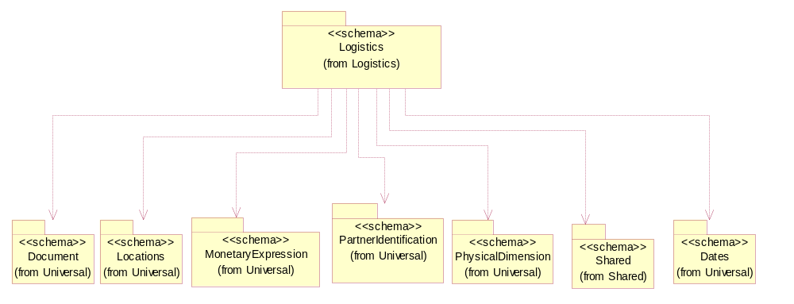
Figure ‎3-16 Dependency

HazardousMaterialDescription
The collection of business properties that describe the nature of dangerous goods tendered for transportation.
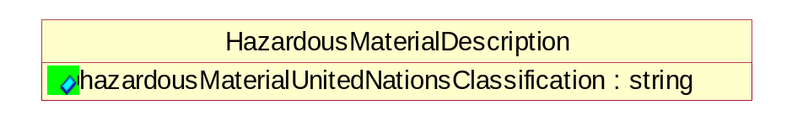
Figure ‎3-17 HazardousMaterialDescription

Attribute | Type | Documentation
hazardousMaterialUnitedNationsClassification | string | Code classifying hazardous material products.

ManufacturerProfile
The collection of business properties that describe a manufacturer's product.
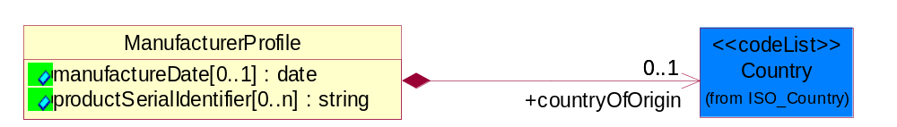
Figure ‎3-18 ManufacturerProfile

Attribute | Type | Documentation
manufactureDate[0..1] | date | The date the product was manufactured.
productSerialIdentifier[0..n] | string | Serial number(s) of a product.

Composition | Cardinality | Type | Documentation
countryOfOrigin | 0..1 | Country | Country where product originates.

MassPhysicalDimension
The physical dimension of unit of mass used for measuring the masses of weights, volumes etc.
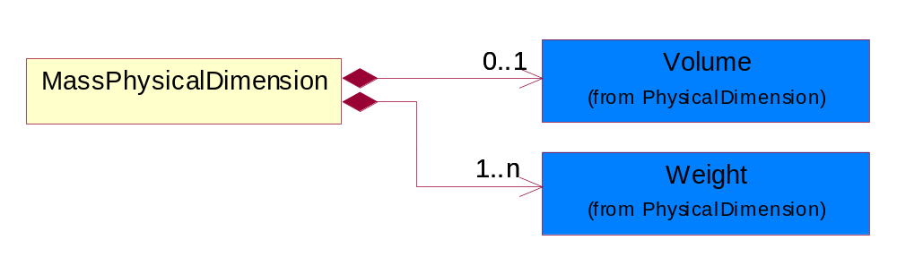
Figure ‎3-19 MassPhysicalDimension

Composition | Cardinality | Type | Documentation
Volume | 0..1 | Volume | The business document must be able to express the volume of an object.
Weight | 1..n | Weight | The business document must be able to express the weight of an object.

ShipmentDate
The collection of business properties that identifies a constraint on when the products may be shipped.
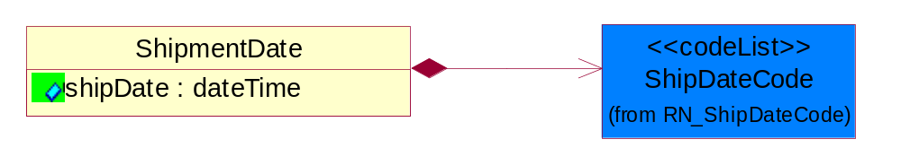
Figure ‎3-20 ShipmentDate

Attribute | Type | Documentation
shipDate | dateTime | The date when the shipment maybe shipped.

Composition | Cardinality | Type | Documentation
ShipDateCode | 1 | ShipDateCode | Code identifying a type of ship date.

TrackingReference
Proprietary unique identifier for tracking product shipments.
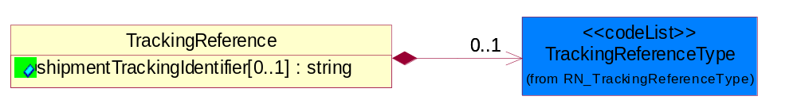
Figure ‎3-21 TrackingReference

Attribute | Type | Documentation
shipmentTrackingIdentifier[0..1] | string | Proprietary unique identifier for tracking product shipments.

Composition | Cardinality | Type | Documentation
TrackingReferenceType | 0..1 | TrackingReferenceType | Code identifying the type of document reference being used to track a shipment.

CodeList

TrackingReferenceType
Code identifying the type of document reference being used to track a shipment.

Name | Documentation
BKN | Booking Number - Shipment identification number assigned by shipper when booking freight shipment with carrier.
BOL | Bill of Lading Number - Shipment identification number on bill of lading issued by shipper, forwarder or carrier.
CIN | Commercial Invoice - An invoice for customs purposes to allow the determination of the proper import/export duty/taxes.
CRN | Carrier Reference Number - Carrier assigned shipment identification number on bill of lading.
FTR | Freight Tracking Reference - Reference number that describes information about tracing shipments during the transportation process.
HAN | House Airwaybill Number - Forwarder assigned shipment identification number on bill of lading issued by forwarder.
MAB | Master Airwaybill Number - Carrier assigned shipment identification number on bill of lading issued by carrier.
OBL | Ocean Bill of Lading Number - Carrier assigned shipment identification number on bill of lading issued by carrier.
PON | Purchase Order Number.
PRO | Pro Number - Carrier assigned shipment identification number on bill of lading.
PSN | Packing Slip Number - Shipment identification number on shipment contents packing list attached to shipment.
RFI | Radio Frequency Identification (RFID).
RRN | Route Reference Number.
SID | Seal Identifier - Trailer or container seal number assigned by party closing doors on trailer or container.
SON | Seller Sales Order Number.
SRN | Shipper Reference Number - Shipper assigned shipment identification number on bill of lading issued by shipper or forwarder.
TRN | Trailer Number - Owner assigned equipment identification number on trailer.

Incoterms
Code identifying incoterms.

Name | Documentation
CFR | Cost and Freight (named port of destination).
CIF | Cost, Insurance and Freight (named port of destination).
CIP | Carriage and insurance paid to (named place of destination).
CPT | Carriage Paid To (named place of destination).
DAF | Delivered at Frontier (named place).
DDP | Delivered Duty Paid (named place of destination).
DDU | Delivered Duty Unpaid (named place of destination).
DEQ | Delivered Ex Quay (duty paid) (named port of destination).
DES | Delivered Ex Ship (named port of destination).
EXW | Ex Works (named place).
FAS | Free Along Ship (named port of shipment).
FCA | Free Carrier (named place).
FOB | Free on Board (named port of shipment).

ShipmentChangeDisposition
Code identifying the additional reasons for a change to a product shipment.

Name | Documentation
ABS | Abandon shipment.
CAS | Cancel shipment.
DES | Destroy shipment.
RES | Release shipment.
ROC | Reassignment of carrier.
RTS | Return Shipment.
SFN | Stop shipment until further notice.

ShipmentMode
The method of transport used for the conveyance of goods.

Name | Documentation
AIE | Air Express.
AIF | Air Freight.
AIR | Air.
COC | Contract Carrier.
COO | Containerized Ocean.
CPI | Customer Pickup.
EXT | Expedited Truck.
INM | Intermodal.
MAT | Mail Transport.
MOT | Motor.
OCE | Ocean.
OTH | Others.
PRC | Private Carrier.
RAI | Rail.
TRK | Truck.

NationalExportControlClassification
Code identifying product classification for export regulation.

Name | Documentation
CLE | Clearance - The cargo will be or has been cleared.
CUC | Already customs cleared in the importing country, arrangement for inspection are not necessary because they were cleared before.
DET | Detention - The cargo has been or will be detained.
DOR | Documents Required - Pertinent documents are required.
DRC | Documents Requirements Completed - All requirements for documents have been completed.
FUM | Fumigation - The cargo has been or will be fumigated.
IAC | Inspection Arrangements Completed - Arrangements for inspection of the cargo have been completed.
IAR | Inspection Arrangements Required - Arrangements for inspection of the cargo are required.
INS | Inspection - The cargo has been or will be inspected.
LWI | Lowest Importance.
NCP | No Customs Procedure - Customs clearance not required.
SAC | Safety Arrangements Completed - Arrangements for safeguarding the cargo have been completed.
SAR | Safety Arrangements Required - Arrangements for safeguarding the cargo are required.
SCR | Security - The cargo has been or will be secured.
SEC | Security Arrangements Completed - Arrangements for storing the cargo have been completed.
SER | Security Arrangements Required - Arrangements for the security of the cargo are required.
STR | Storage arrangements required - Arrangements for storing the cargo are required.
TAC | Transport Arrangements Completed - All arrangements for transport have been completed.
TAR | Transport Arrangements Required - Transport has to be arranged.

ShipDateCode
Code identifying a type of ship date.

Name | Documentation
ACP | Acceptance.
ACT | Action.
ADY | Arrival at Destination Yard.
AED | Accrual End Date.
AFT | Actual Free Time Expiration Date.
APD | Actual Pickup Date.
APL | Actual Placement.
ASD | Accrual Start Date.
BDO | Beginning Date of Customer Plant Shutdown.
BOI | Bill of Lading Initiated Date.
BOL | Bill of Lading.
BPE | Buy Period Date (End).
BPS | Buy Period Date (Start).
BRD | Backorder Release Date.
CAD | Cancel After This Date.
CBD | Charge Back Date.
CCL | Contract Closed.
CDA | Check Date.
CFP | Contract Final Payment.
CFR | Charged From.
COD | Cutoff Date.
CPC | Contract Physically Completed.
CRE | Customs Release.
CTO | Charged To.
DAG | Delivery Appointment Granted Date.
DAR | Date Available/Constructive Replacement.
DAS | Delivery Appointment Scheduled Date.
DBT | Delivered By This Date.
DDC | Date Delivery Commenced.
DIC | Date Invoice Created.
DIS | Date Issued.
DLC | Date Loading Commenced.
DLD | Date Loading Completed.
DNB | Deliver Not Before Date.
DNL | Deliver No Later Than Date.
DOT | Delivered on This Date.
DPA | Duty Paid.
DRD | Demand Receipt Date.
DRS | Delivery Requested Scheduled Date.
DRT | Delivery Requested on This Date.
DSP | Date Shipped to Port of Embarkation (POE).
DUL | Date Unloaded.
DWO | Deliver Week Of.
ECC | Estimated Contract Completion.
ECL | Extended Closeout.
EDA | Effective Date.
EDB | Expiration Date.
EDD | Estimated Delivery Date.
EDO | Ending Date of Customer Plant Shutdown.
EES | Est. Next Promo, Ship Date End.
EFD | Equipment Furnished Date.
EPD | Earliest Pickup Date.
EPE | Est. Next Promo (Date end).
EPS | Est. Next Promo (Date start).
ERE | Expected Reply.
ESE | Est. Next Promo, Ship Date Start.
FBD | Freight Bill Date.
FOD | First Order Date.
FSD | First Ship Date.
GED | Guarantee Expiration Date.
INS | Inspection.
IVD | Invoice Date.
LAC | Last Acquisition.
LDE | Last Demand.
LPD | Latest Pickup Date.
MNF | Manufacture.
MRB | Must Respond By.
NTF | Notified.
OFD | Offered for Delivery.
OPO | Original Purchase Order Date.
ORD | Ordered.
OTR | Original Transaction.
PAG | Pickup Appointment Granted Date.
PAS | Pickup Appointment Scheduled Date.
PBD | Publication Date.
PCE | Price Change Effective Date.
PCL | Price Change Last Arrival Date.
PCM | Price Change Last Order Date.
PCO | Purchase Order Date.
PCR | Purchase Order Received.
PCS | Price Change Last Ship Date.
PDA | Pack Date.
PDE | Promotion Order Date (End).
PDS | Promotion Order Date (Start).
PFE | Promotion Floor Stock Protect (End).
PFS | Promotion Floor Stock Protect (Start).
PME | Promotion Ship Date (End).
PMO | Promotion End.
PMS | Promotion Ship Date (Start).
PMT | Promotion Start.
PPD | Preferred Payment Date.
PPE | Promotion Performance Date (End).
PPS | Promotion Performance Date (Start).
PRD | Product Receipt Date.
PRE | Period End.
PRQ | Promotion Requested Delivery Date (End).
PRS | Promotion Requested Delivery Date (Start).
PSD | Process Date.
PSH | Pickup Requested Scheduled Date.
PVE | Promotion Invoice Protection Date (End).
PVS | Promotion Invoice Protection Date (Start).
RDD | Requested Delivery Date.
REC | Recorded.
REJ | Rejection.
REL | Released.
REQ | Required By.
RPD | Requested Pack Date.
RSD | Requested Ship Date/Pick-up Date.
SDA | Scheduled Delivery Date - Appointment confirmed.
SDC | Scheduled Delivery Date - Needs confirmation.
SDD | Scheduled Delivery Date.
SHB | Ship Not Before Date.
SHL | Ship Not Later Than Date.
SHO | Shipped on This Date.
SIG | Signature.
SIS | Store Inventory Stock.
SLD | Sold Date.
SLE | Shelf-Life Expiration.
SLG | Sailing Date.
SPA | Scheduled Pick-up Date - Appointment confirmed.
SPE | Spot for Load Exchange Date (Export).
SPL | Spot for Load Date.
SPN | Scheduled Pick-up Date - Needs confirmation.
SPP | Scheduled Pick - Up Date.
SPS | Spot for Storage Date (No shipment).
SPU | Spot for Unload Date.
SSC | Scheduled Service Completion.
SUD | Superseded Date.
SWO | Ship Week Of Date.
TDD | Terms Discount Due Date.
TND | Terms Net Due Date.
TRA | Transfer.
TRS | Transaction Control Date.
VAL | Validated.
WIS | Warehouse Inventory Stock.
WRT | Warranty Expiration.

Manufacturing

Manufacturing

Dependency Diagram
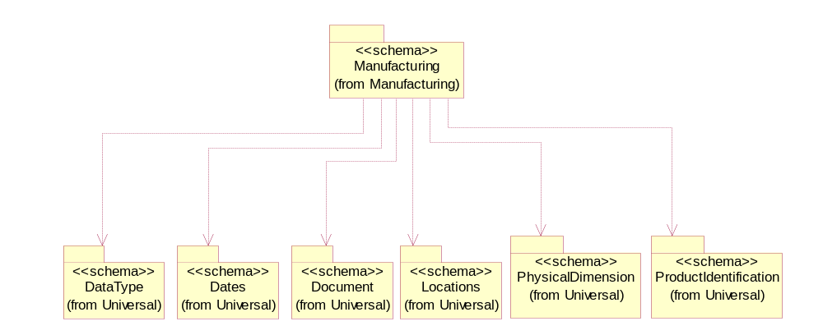
Figure ‎3-22 Dependency

LotQuantity
The collection of business properties that describe the quantity of items in a lot.
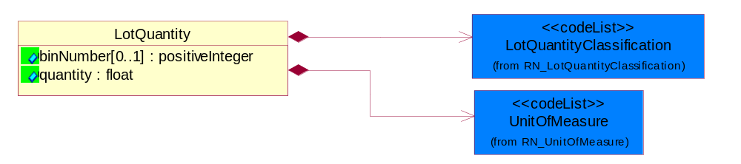
Figure ‎3-23 LotQuantity

Attribute | Type | Documentation
binNumber[0..1] | positiveInteger | Code number used to segregate lot quantities by performance after final testing.
quantity | float | A quantity specifying the number of product units.

Composition | Cardinality | Type | Documentation
UnitOfMeasure | 1 | UnitOfMeasure | Code identifying a product unit of measure.
LotQuantityClassification | 1 | LotQuantityClassification | Code identifying the classification of a manufacturing lot quantity.

CodeList

LotQuantityClassification
Code identifying the classification of a manufacturing lot quantity.

Name | Documentation
ACC | Acceptable. The lot quantity meets the minimum requirements.
BON | Bonus. A positive variance in the lot quantity.
BTE | Bin Test. Bin Test Quantity.
CQU | Change Quantity. The change quantity event and quantity is intended to be used when the quantity of a lot changes for a reason other then those we have defined events for (scrap, reject, and bonus).
CUR | Current. Current Quantity.
GRO | Gross. The initial quantity of the lot.
LPR | Lot probe.
MER | Merge. Merge Quantity.
NET | Net. The final quantity of the lot.
PFI | Projected final. The estimated final quantity of the lot.
PLO | Previous lot. The quantity of the preceding lot.
REC | Receipt. Receipt Quantity.
REJ | Reject. Reject/Loss Quantity.
SCH | Schedule. A lot is still physically in the Die Bank (before being started) but has been allocated to start and as a result, is not available for being considered for planning purposes as it is already committed to.
SCR | Scrap. The quantity of products which is disposed of.
SHI | Ship. Actual Ship Quantity.
SPL | Split. Split Quantity.
STA | Start. Start Quantity.

Shared

Shared

Dependency Diagram
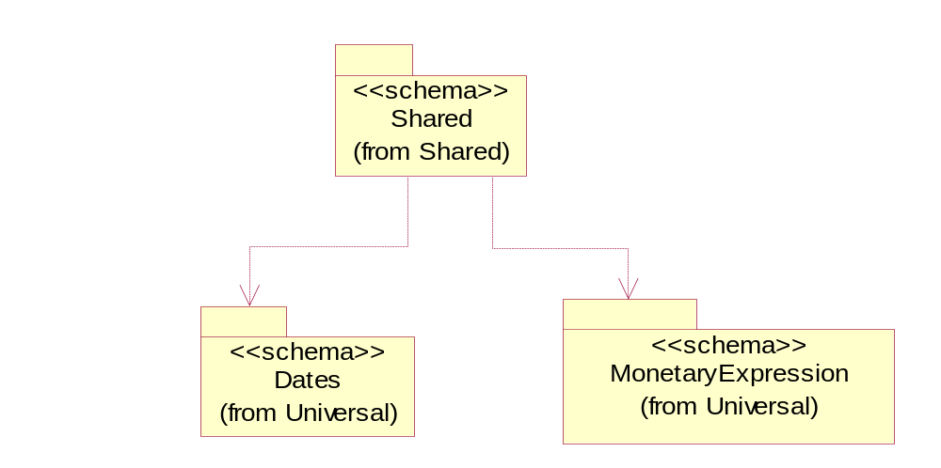
Figure ‎3-24 Dependency

SCAC
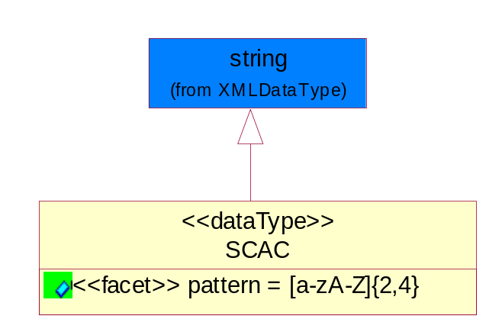
Figure ‎3-25 SCAC

Attribute | Type | Documentation
pattern

CodeList

PackageType
Code specifying the type of packaging for a product.

Name | Documentation
BOX | Box.
BRL | Barrel.
CRT | Carton.
LPK | Loose Package.
MHC | Material/Method of holding a string of computer chips.
MIX | Mixed Package.
OTH | Others.
PAC | Parcel.
PBG | Plastic Ball Grind Array.
PBX | Paper Box.
PCC | Plastic Chip Carrier.
PLT | Pallet.
REE | Reel.
TQF | Thin Quad Flat Package.
TRA | Tray.
TUB | Plastic tube to hold computer chips.
WDC | Wooden Crate.

ShippingServiceLevel
Code identifying the shipping service level, e.g., overnight, same day.

Name | Documentation
1BD | 1BD, Same Business Day - 4 hour Response Time.
5BD | 5 Business Days.
9AM | 9 A.M.
ACH | Air Charter.
AEC | Air Economy.
AIC | Air Cargo.
AM | A.M.
ARS | Authorized Return Service.
ATA | Airport to Airport.
ATD | Airport to Door.
BCT | Bulk Commodity Train.
BUC | Business Class.
CBS | Consignee Billing Service.
COE | Courier Express.
DCR | Delivery Confirmation Return.
DEC | Delivery Confirmation.
DES | Deferred Service.
DNO | Delivery Notification Only.
DOS | Door Service.
DSN | Delivery scheduled next day by cartage agent.
DSS | Delivery scheduled second day by cartage agent.
DST | Delivery scheduled third day by cartage agent.
DTA | Door to Airport.
DTD | Door to Door.
DTP | Door to Port (Ocean).
ESP | Express Service Plus.
ESV | Expedited Service.
ESW | Expedited Service Worldwide.
EXS | Express Service.
EXW | Express Service - Worldwide.
FIC | First Class.
GEN | General.
GRO | Ground.
ISS | Other intermodal and stack service.
MAF | Manifest freight.
MET | Metro.
MUW | Multiweight.
NBD | Next Business Day.
NDA | Next Day Air.
NEM | Next Morning.
NFO | Next Flight Out.
NHW | Next day Hundred Weight.
NOR | NORMAL - Normal delivery.
NOS | Not served.
OIS | Other Intermodal and Stack service
OTH | Other.
OVN | Overnight.
PAS | Passenger service.
PIU | Pickup.
PM | PM.
PMI | Priority Mail Insured.
POB | P.O. Box/Zip code.
POD | Proof of Delivery (POD) with Signature.
PRM | Priority Mail.
PRS | Premium Surface.
PS1 | Primary Service Area - Next Day by 10:30 A.M.
PS2 | Primary Service Area - Next Day by 5:00 P.M.
PS3 | Primary Service Area - Next Day By 9:30 A.M.
PS4 | Primary Service Area - Next Day by Noon.
PS5 | Primary Service Area - Second Day by Noon.
PTD | Port to Door (Ocean).
PTP | Port to Port (Ocean).
REG | Regular.
SAD | Same day.
SAP | Saturday Pickup.
SAT | Saturday.
SBD | SBD, Second Business Day.
SCH | Scheduled.
SDA | Second Day Air.
SDW | Second Day Hundred Weight.
SED | Second Day.
SEM | Second Morning.
SGW | Standard Ground Hundred Weight.
STC | Standard Class.
STG | Standard Ground.
STO | Standard Ocean.
STS | Standard Service.
SUH | Sunday and Holidays.
TDS | Three Day Service.
TIC | Time Critical.
TRG | Tracking - Ground.

Universal Structure

ContactInformation

ContactInformation
The business document must allow for the identification of the name of the department, service or individual to be contacted regarding the context of the business document.
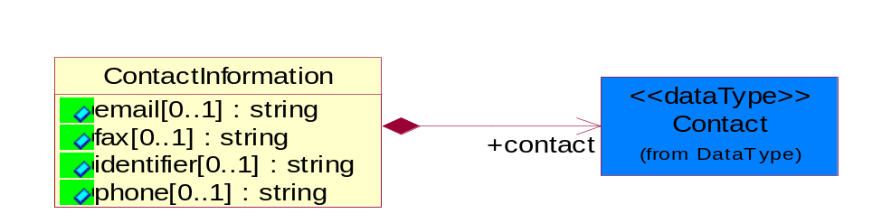
Figure ‎4-26 ContactInformation

Attribute | Type | Documentation
email[0..1] | string | The electronic mail for the specified contact.
fax[0..1] | string | The fax number for the specified contact.
identifier[0..1] | string | Identifies the role of the contact (i.e. Service Technician, Account Manager) in the Business Process.
phone[0..1] | string | The telephone number for the specified contact.

Composition | Cardinality | Type | Documentation
contact | 1 | Contact | The name of the department, service or individual to be contacted within the organization.

DataType

Contact
The name of the department, service or individual to be contacted within the organization.
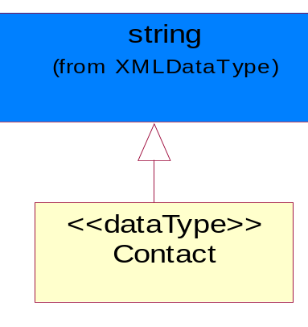
Figure ‎4-27 Contact

DUNS
A number assigned by Dun and Bradstreet to identify a business location.
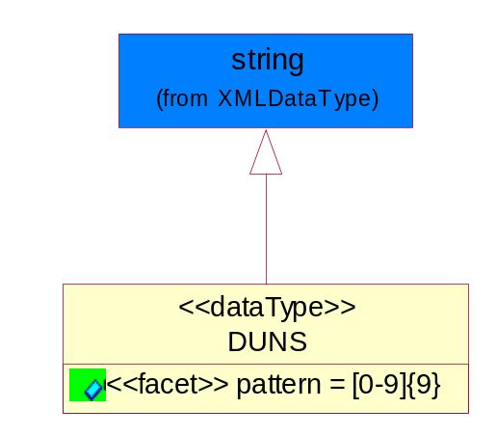
Figure ‎4-28 DUNS

Attribute | Type | Documentation
pattern |  | [0-9]{9}

DUNSPlus4
A identifier to specify a specific location within a business location.
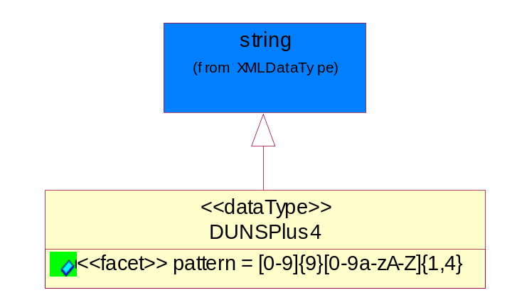
Figure ‎4-29 DUNSPlus4

Attribute | Type | Documentation
pattern |  | Data Universal Numbering System +4 (DUNS+4) number means the DUNS number assigned by Dun and Bradstreet, Inc. (D&B) plus an alphanumeric of length 4 suffix that may be assigned by a business concern.

GLN
Global Location Number (GLN) - A identifier to identify legal entities, trading parties and location.
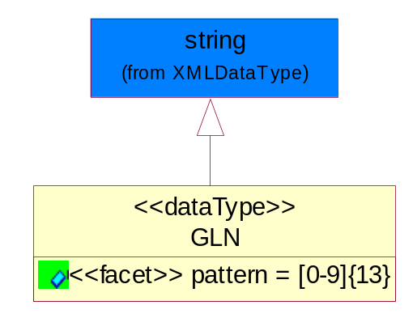
Figure ‎4-30 GLN

Attribute | Type | Documentation
pattern |  | [0-9]{13}

GTIN
Global Trade Identification Number (GTIN).
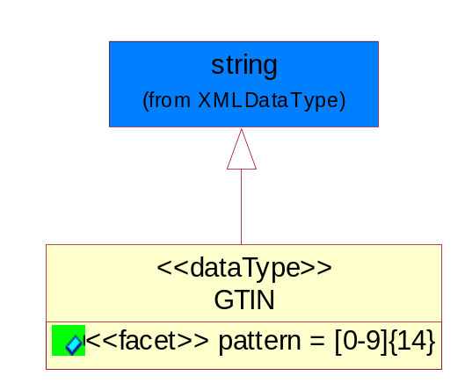
Figure ‎4-31 GTIN

Attribute | Type | Documentation
pattern |  | [0-9]{14}

Document

BusinessDocumentReference
The business document reference object allows for the indirect referencing of a relationship to other business related documents.
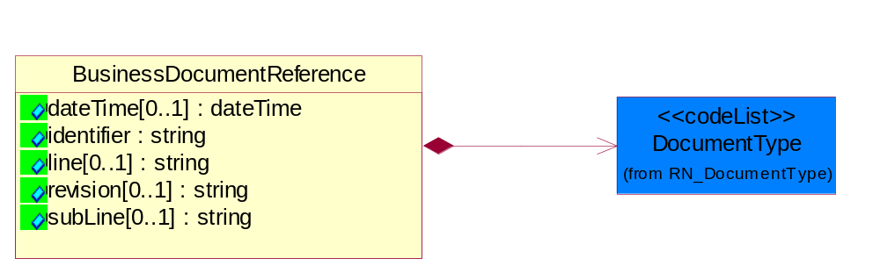
Figure ‎4-32 BusinessDocumentReference

Attribute | Type | Documentation
dateTime[0..1] | dateTime | The date-time stamp indicating on the referenced business document.
identifier | string | Unique identification of the referenced business document.
line[0..1] | string | References the specific line number of the specified business document.
revision[0..1] | string | Referenced the revision of the specified business document.
subLine[0..1] | string | References the specific subline number of the specified business document.

Composition | Cardinality | Type | Documentation
DocumentType | 1 | DocumentType | A code identifying the business context of a document.

Locations

AlternativeIdentifier
Identifies the specified code and the name of the organization that a code is utilized from.
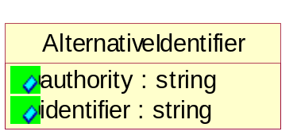
Figure ‎4-33 AlternativeIdentifier

Attribute | Type | Documentation
authority | string | The name of the organization that a code is utilized from.
identifier | string | The specified code to represent an entity (e.g. product, location, partner, etc.)

Location
The business document must specify a location.
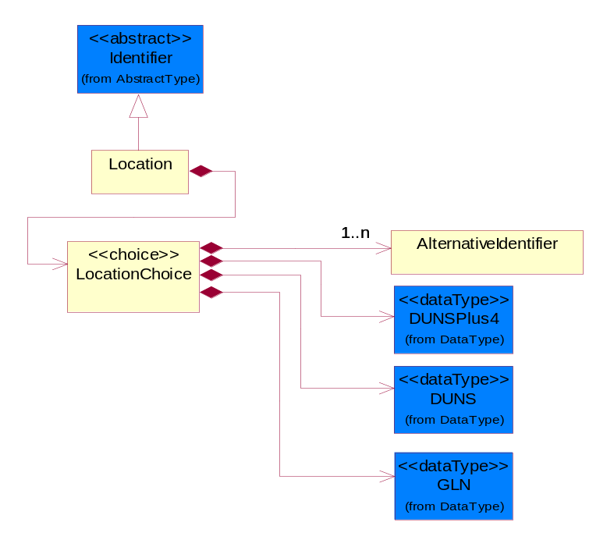
Figure ‎4-34 Location

Composition | Cardinality | Type | Documentation
LocationChoice | 1 | LocationChoice

LocationChoice

Composition | Cardinality | Type | Documentation
DUNSPlus4 | 1 | DUNSPlus4 | A identifier to specify a specific location within a business location.
DUNS | 1 | DUNS | A number assigned by Dun and Bradstreet to identify a business location.
AlternativeIdentifier | 1..n | AlternativeIdentifier | Identifies the specified code and the name of the organization that a code is utilized from.
GLN | 1 | GLN | Global Location Number (GLN) - A identifier to identify legal entities, trading parties and location.

PhysicalAddress
The business document must provide a physical address for a party to the business transaction.
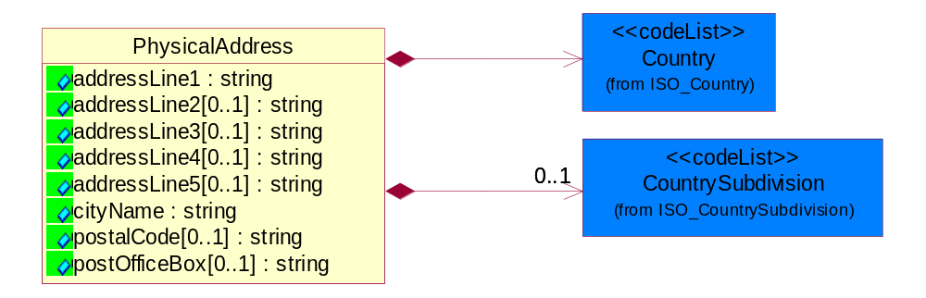
Figure ‎4-35 PhysicalAddress

Attribute | Type | Documentation
addressLine1 | string | The first line of a physical address.
addressLine2[0..1] | string | The second line of a physical address.
addressLine3[0..1] | string | The third line of a physical address.
addressLine4[0..1] | string | The fourth line of a physical address.
addressLine5[0..1] | string | The fifth line of a physical address.
cityName | string | The name of a city.
postalCode[0..1] | string | Identifying geographic location as specified by a national postal code.
postOfficeBox[0..1] | string | The Post Office Box identifier used to identify a party's post office box.

Composition | Cardinality | Type | Documentation
Country | 1 | Country | For representation of Country name RosettaNet has adopted ISO 3166-3; 1999. Refer to the following web page to get the latest version of the standard:  http://www.iso.ch/iso/en/prods-services/iso3166ma/02iso-3166-code-lists/index.html  If you need more information about the ISO standard please contact ISO for more details.
CountrySubdivision | 0..1 | CountrySubdivision | For representation of a Countries subdivisions RosettaNet has adopted ISO 3166-3; 1999. Refer to the following web page to get the latest version of the standard:  http://www.iso.ch/iso/en/prods-services/iso3166ma/02iso-3166-code-lists/index.html  If you need more information about the ISO standard please contact ISO for more details.

MonetaryExpression

FinancialAmount
The business document must express financial amounts.
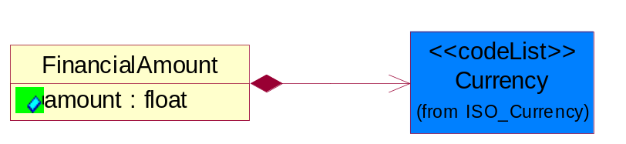
Figure ‎4-36 FinancialAmount

Attribute | Type | Documentation
amount | float | Specifies the monetary amount.

Composition | Cardinality | Type | Documentation
Currency | 1 | Currency | For representation of Currency codes RosettaNet has adopted ISO 4217; 1995. The British Standards Institution (BSI) is the ISO 4217 Maintenance Agency. Refer to the following web page to get the latest version of the standard:  http://www.bsi-global.com/Technical+Information/Publications/_Publications/tig90.xalter  If you need more information about the ISO standard please contact ISO for more details.

PartnerIdentification

PartnerIdentification
The business document must allow for the identity of one or more parties to the transaction.
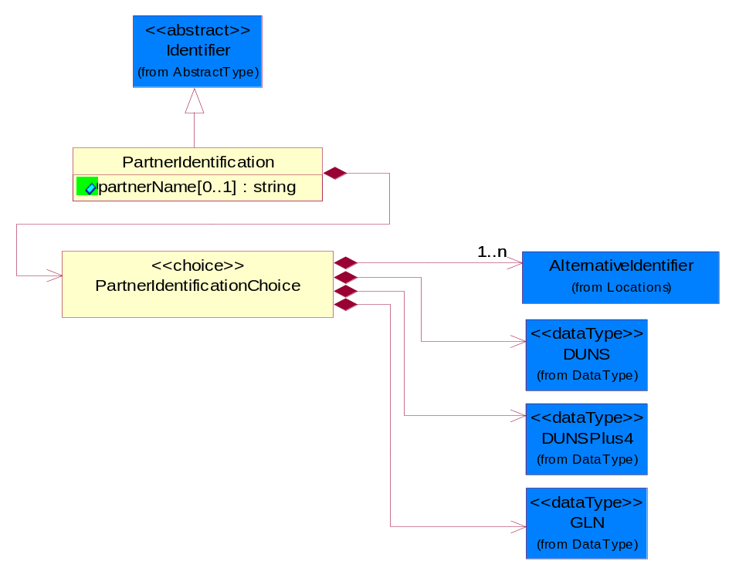
Figure ‎4-37 PartnerIdentification

Attribute | Type | Documentation
partnerName[0..1] | string | The name of the partner’s company/business.

Composition | Cardinality | Type | Documentation
PartnerIdentificationChoice | 1 | PartnerIdentificationChoice

PartnerIdentificationChoice

Composition | Cardinality | Type | Documentation
DUNS | 1 | DUNS | A number assigned by Dun and Bradstreet to identify a business location.
DUNSPlus4 | 1 | DUNSPlus4 | A identifier to specify a specific location within a business location.
AlternativeIdentifier | 1..n | AlternativeIdentifier | Identifies the specified code and the name of the organization that a code is utilized from.
GLN | 1 | GLN | Global Location Number (GLN) - A identifier to identify legal entities, trading parties and location.

SpecifiedFullPartner
The business document must describe the trading partners in the business transaction. This data structure provide the flexibility to describe a partner in all possible methods as for new, existing or known partner. This is specifically for partner who role has been specified.
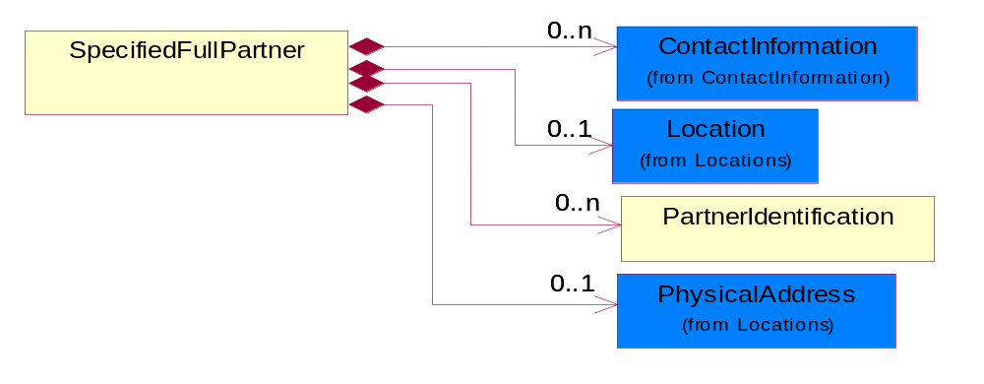
Figure ‎4-38 SpecifiedFullPartner

Composition | Cardinality | Type | Documentation
ContactInformation | 0..n | ContactInformation | The business document must allow for the identification of the name of the department, service or individual to be contacted regarding the context of the business document.
Location | 0..1 | Location | The business document must specify a location.
PartnerIdentification | 0..n | PartnerIdentification | The business document must allow for the identity of one or more parties to the transaction.
PhysicalAddress | 0..1 | PhysicalAddress | The business document must provide a physical address for a party to the business transaction.

SpecifiedIntermittentPartner
The business document must describe a physical address for a delivery.
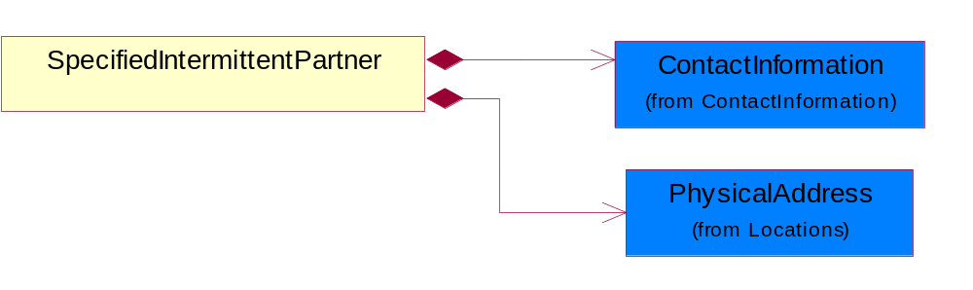
Figure ‎4-39 SpecifiedIntermittentPartner

Composition | Cardinality | Type | Documentation
ContactInformation | 1 | ContactInformation | The business document must allow for the identification of the name of the department, service or individual to be contacted regarding the context of the business document.
PhysicalAddress | 1 | PhysicalAddress | The business document must provide a physical address for a party to the business transaction.

SpecifiedKnownPartner
The business document must describe the trading partners in the business transaction.
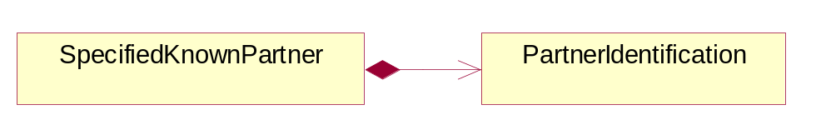
Figure ‎4-40 SpecifiedKnownPartner

Composition | Cardinality | Type | Documentation
PartnerIdentification | 1 | PartnerIdentification | The business document must allow for the identity of one or more parties to the transaction.

SpecifiedKnownPartnerContact
The business document must describe the trading partners in the business transaction and allow for a identification of an individual of the trading partner.
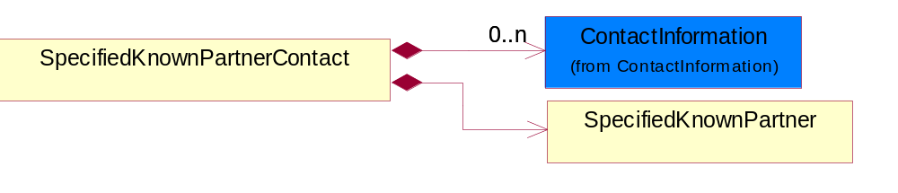
Figure ‎4-41 SpecifiedKnownPartnerContact

Composition | Cardinality | Type | Documentation
SpecifiedKnownPartner | 1 | SpecifiedKnownPartner | The business document must describe the trading partners in the business transaction.
ContactInformation | 0..n | ContactInformation | The business document must allow for the identification of the name of the department, service or individual to be contacted regarding the context of the business document.

SpecifiedNewPartner
The business document must describe a new, existing (but known to only one of the parties to the transaction) or an unknown party to the business transaction.
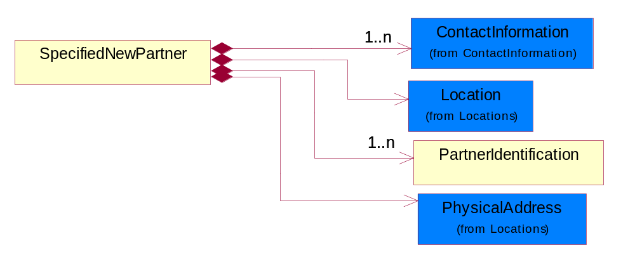
Figure ‎4-42 SpecifiedNewPartner

Composition | Cardinality | Type | Documentation
ContactInformation | 1..n | ContactInformation | The business document must allow for the identification of the name of the department, service or individual to be contacted regarding the context of the business document.
Location | 1 | Location | The business document must specify a location.
PhysicalAddress | 1 | PhysicalAddress | The business document must provide a physical address for a party to the business transaction.
PartnerIdentification | 1..n | PartnerIdentification | The business document must allow for the identity of one or more parties to the transaction.

SpecifiedPartnerDescription
The collection of business properties that describe a business partners' identity, their contact information, where they are physically located and their function in a supply chain.
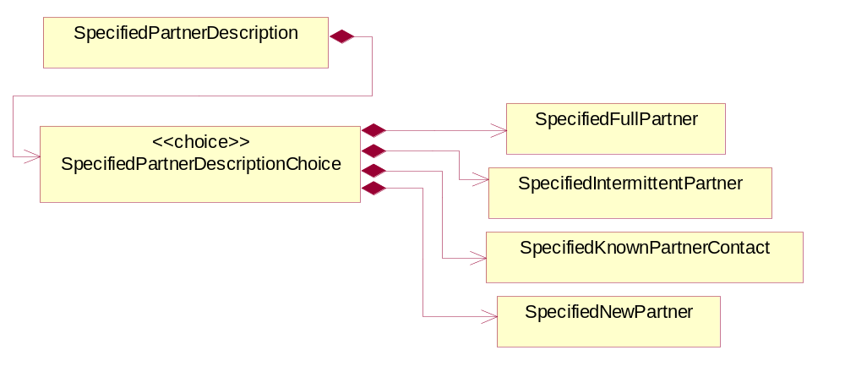
Figure ‎4-43 SpecifiedPartnerDescription

Composition | Cardinality | Type | Documentation
SpecifiedPartnerDescriptionChoice | 1 | SpecifiedPartnerDescriptionChoice

SpecifiedPartnerDescriptionChoice

Composition | Cardinality | Type | Documentation
SpecifiedKnownPartnerContact | 1 | SpecifiedKnownPartnerContact | The business document must describe the trading partners in the business transaction and allow for a identification of an individual of the trading partner.
SpecifiedIntermittentPartner | 1 | SpecifiedIntermittentPartner | The business document must describe a physical address for a delivery.
SpecifiedNewPartner | 1 | SpecifiedNewPartner | The business document must describe a new, existing (but known to only one of the parties to the transaction) or an unknown party to the business transaction.
SpecifiedFullPartner | 1 | SpecifiedFullPartner | The business document must describe the trading partners in the business transaction. This data structure provide the flexibility to describe a partner in all possible methods as for new, existing or known partner. This is specifically for partner who role has been specified.

PhysicalDimension

Linear
The business document must be able to express the linear dimensions of an object.
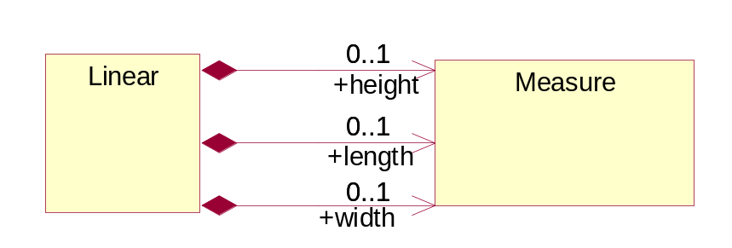
Figure ‎4-44 Linear

Composition | Cardinality | Type | Documentation
height | 0..1 | Measure | To express the height of an object.
length | 0..1 | Measure | To express the length of an object.
width | 0..1 | Measure | To express the weight of an object.

Measure
The business document must describe measurement information.
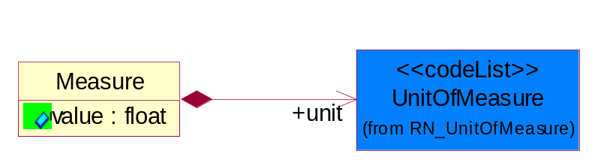
Figure ‎4-45 Measure

Attribute | Type | Documentation
value | float | The worth of an object in the specified unit of measure.

Composition | Cardinality | Type | Documentation
unit | 1 | UnitOfMeasure | To express the unit type of measurement.

Volume
The business document must be able to express the volume of an object.
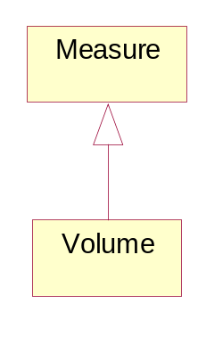
Figure ‎4-46 Volume

Weight
The business document must be able to express the weight of an object.
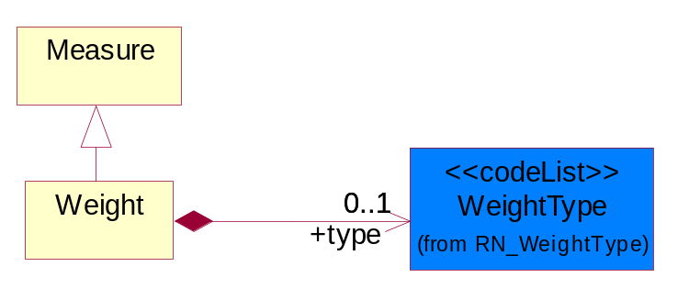
Figure ‎4-47 Weight

Composition | Cardinality | Type | Documentation
type | 0..1 | WeightType | A code identifying the type of weight.

ProductIdentification

ProductIdentification
The object provides the identifier(s) of a product.
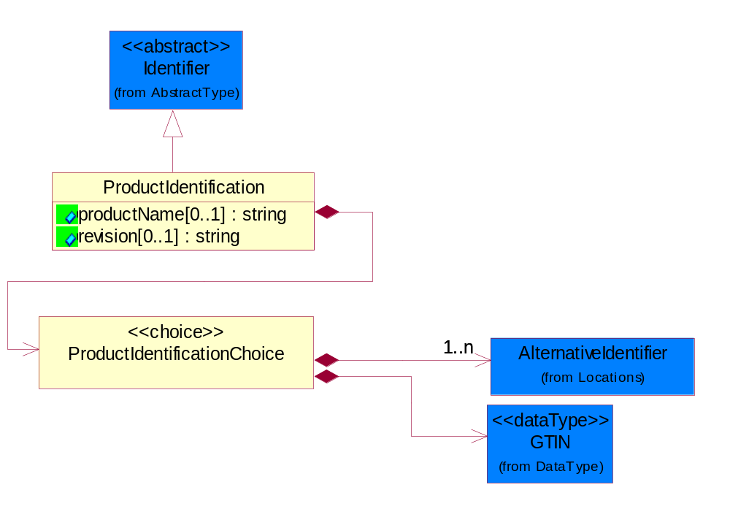
Figure ‎4-48 ProductIdentification

Attribute | Type | Documentation
productName[0..1] | string | The name of the product.
revision[0..1] | string | Referenced the specified product revision.

Composition | Cardinality | Type | Documentation
ProductIdentificationChoice | 1 | ProductIdentificationChoice

ProductIdentificationChoice

Composition | Cardinality | Type | Documentation
AlternativeIdentifier | 1..n | AlternativeIdentifier | Identifies the specified code and the name of the organization that a code is utilized from.
GTIN | 1 | GTIN | Global Trade Identification Number (GTIN).

CodeList

Country
For representation of Country name RosettaNet has adopted ISO 3166-3; 1999. Refer to the following web page to get the latest version of the standard:
http://www.iso.ch/iso/en/prods-services/iso3166ma/02iso-3166-code-lists/index.html

If you need more information about the ISO standard please contact ISO for more details.

CountrySubdivision
For representation of a Countries subdivisions RosettaNet has adopted ISO 3166-3; 1999. Refer to the following web page to get the latest version of the standard:
http://www.iso.ch/iso/en/prods-services/iso3166ma/02iso-3166-code-lists/index.html

If you need more information about the ISO standard please contact ISO for more details.

Currency
For representation of Currency codes RosettaNet has adopted ISO 4217; 1995. The British Standards Institution (BSI) is the ISO 4217 Maintenance Agency. Refer to the following web page to get the latest version of the standard:
http://www.bsi-global.com/Technical+Information/Publications/_Publications/tig90.xalter

If you need more information about the ISO standard please contact ISO for more details.

Language
For representation of Language name RosettaNet has adopted ISO 639-2; 1998. Refer to the following web page to get the latest version of the standard:

http://www.loc.gov/standards/iso639-2/iso639jac.html

If you need more information about the ISO standard please contact ISO for more details.

DocumentType
A code identifying the business context of a document.

Instance | Documentation
CBN | Product batch number of customer.
CCN | Customs clearance number.
CFA | Failure Analysis - Request document that will accompany the product providing characteristics of the component failure.
CIN | Commercial Invoice.
CNM | Traditional credit note or memo.
CON | In a virtual sourcing relationship, a third party trading partner is supplying a part to a customer on behalf of another company that has taken the order for the customer. In this case a Customer Order Number is associated to the request for material that is sent to the virtual trading partners.
COT | Contract.
CRN | Unique consumption reference number identifying the product consumption issue i.e. one-to-one relationship with physical flow.
DEM | Traditional debit note or memo.
DEN | Delivery Note.
DIN | Discontinuation Notice.
DRN | Drawing Number.
FUO | Sales order or transfer order fulfilling demand out of a facility (outbound shipment).
INV | Invoice.
LID | Location Identifier. Data for on-site work that have to be done on the machine (associated with preventive maintenance order)
MEN | Master Event Number.
MID | Machine Identifier. Data for on-site work that have to be done on the machine (associated with preventive maintenance order)
MON | Model Number.
OCL | The unique identifier assigned by the OEM for a warranty claim.
OGA | Other governmental agency issued document.
OPO | The unique identifier assigned by the OEM for a part order.
OPR | The unique identifier assigned by the OEM for a part return.
PFA | Failure Analysis - Request document that will accompany the product providing characteristics of the product failure.
PII | Refers to previously issued invoice.
PLS | Unique number that identifies packing form prior to shipment.
POI | Purchase Order IN.
PON | Production order number for material release.
POO | Purchase Order OUT
PRC | Product Catalog.
PSI | Refers to previously issued self-billing invoice.
PUO | Purchase Order.
QUO | Quote.
REC | Document identifying the receipt of materials or products into a facility against a purchase order or transfer order (inbound shipment).
REO | Purchase order or transfer order replenishing inventory into a facility (inbound shipment).
REQ | Requisition.
RMA | Returned Material Authorization.
RPO | Purchase order for materials or product returned to and reworked by a supplier.
RTA | Remittance Advice - Remittance details.
SAO | Sales Order.
SBC | Credit Memo used in self-billing scenario.
SBD | Debit Memo used in self-billing scenario.
SBI | Invoice in self billing scenario.
SBN | Product batch number of supplier.
SCA | Similar to contracts - Contains the quantity of an article that is to be ordered from a vendor and the price for article or service that is to be procured.
SEN | Serial Number.
SEO | A document that gives a repair provider the necessary authorization to repair or upgrade a product either at the customer site or at the repair provider’s site.
SHD | Shipping Document.
SNC | Shipset Number on Code List.
SPC | The unique identifier assigned by the ASP for a warranty claim.
SPN | Spec Number.
SPO | The unique identifier assigned by the ASP for a part order.
SPR | The unique identifier assigned by the ASP for a part return.
SPW | The unique identifier assigned by the ASP to reference a work order.
SRI | A document that contains the shipping reference number which allows the product to be tracked within the outsourced logistic providers network.
TRO | Order which results in materials or products being moved from one facility to another (outbound shipment and inbound shipment).
WAB | Waybill.
WAC | Denotes a warranty claim.
WOO | Work Order.

MimeTypeQualifier
The MIME type as defined by IANA.

Please refer to http://www.iana.org/assignments/media-types/ for a list of types.

Instance | Documentation
application/activemessage | [Shapiro]
application/andrew-inset | [Borenstein]
application/applefile | [Faltstrom]
application/atomicmail | [Borenstein]
application/batch-SMTP | [RFC2442]
application/beep+xml | [RFC3080]
application/cals-1840 | [RFC1895]
application/cnrp+xml | [RFCCNRP]
application/commonground | [Glazer]
application/cpl+xml
application/cybercash | [Eastlake]
application/dca-rft | [Campbell]
application/dec-dx | [Campbell]
application/dicom | [RFC3240]
application/dvcs | [RFC3029]
application/EDI-Consent | [RFC1767]
application/EDIFACT | [RFC1767]
application/EDI-X12 | [RFC1767]
application/eshop | [Katz]
application/font-tdpfr | [RFC3073]
application/http | [RFC2616]
application/hyperstudio | [Domino]
application/iges | [Parks]
application/index | [RFC2652]
application/index.cmd | [RFC2652]
application/index.obj | [RFC2652]
application/index.response | [RFC2652]
application/index.vnd | [RFC2652]
application/iotp | [RFC2935]
application/ipp | [RFC2910]
application/isup | [RFC3204]
application/mac-binhex40 | [Faltstrom]
application/macwriteii | [Lindner]
application/marc | [RFC2220]
application/mathematica | [Van Nostern]
application/msword | [Lindner]
application/news-message-id | [RFC1036,Spencer]
application/news-transmission | [RFC1036, Spencer]
application/ocsp-request | [RFC2560]
application/ocsp-response | [RFC2560]
application/octet-stream | [RFC2045,RFC2046]
application/oda | [RFC2045,RFC2046]
application/ogg | [RFC-walleij-ogg-mediatype-08.txt]
application/parityfec | [RFC3009]
application/pdf | [Lindner]
application/pgp-encrypted | [RFC3156]
application/pgp-keys | [RFC3156]
application/pgp-signature | [RFC3156]
application/pkcs10 | [RFC2311]
application/pkcs7-mime | [RFC2311]
application/pkcs7-signature | [RFC2311]
application/pkix-cert | [RFC2585]
application/pkixcmp | [RFC2510]
application/pkix-crl | [RFC2585]
application/postscript | [RFC2045,RFC2046]
application/prs.alvestrand.titrax-sheet | [Alvestrand]
application/prs.cww | [Rungchavalnont]
application/prs.nprend | [Doggett]
application/prs.plucker | [Janssen]
application/qsig | [RFC3204]
application/reginfo+xml | [RFC-ietf-sipping-reg-event-00.txt]
application/remote-printing | [RFC1486,Rose]
application/riscos | [Smith]
application/rtf | [Lindner]
application/sdp | [RFC2327]
application/set-payment | [Korver]
application/set-payment-initiation | [Korver]
application/set-registration | [Korver]
application/set-registration-initiation | [Korver]
application/sgml | [RFC1874]
application/sgml-open-catalog | [Grosso]
application/sieve | [RFC3028]
application/slate | [Crowley]
application/timestamp-query | [RFC3161]
application/timestamp-reply | [RFC3161]
application/tve-trigger | [Welsh]
application/vemmi | [RFC2122]
application/vnd.3gpp.pic-bw-large | [Meredith]
application/vnd.3gpp.pic-bw-small | [Meredith]
application/vnd.3gpp.pic-bw-var | [Meredith]
application/vnd.3gpp.sms | [Meredith]
application/vnd.3M.Post-it-Notes | [O'Brien]
application/vnd.accpac.simply.aso | [Leow]
application/vnd.accpac.simply.imp | [Leow]
application/vnd.acucobol | [Lubin]
application/vnd.acucorp | [Lubin]
application/vnd.adobe.xfdf | [Perelman]
application/vnd.aether.imp | [Moskowitz]
application/vnd.amiga.ami | [Blumberg]
application/vnd.anser-web-certificate-issue-initiation | [Mori]
application/vnd.anser-web-funds-transfer-initiation | [Mori]
application/vnd.audiograph | [Slusanschi]
application/vnd.blueice.multipass | [Holmstrom]
application/vnd.bmi | [Gotoh]
application/vnd.businessobjects | [Imoucha]
application/vnd.canon-cpdl | [Muto]
application/vnd.canon-lips | [Muto]
application/vnd.cinderella | [Kortenkamp]
application/vnd.claymore | [Simpson]
application/vnd.commerce-battelle | [Applebaum]
application/vnd.commonspace | [Chandhok]
application/vnd.contact.cmsg | [Patz]
application/vnd.cosmocaller | [Dellutri]
application/vnd.ctc-posml | [Kohlhepp]
application/vnd.cups-postscript | [Sweet]
application/vnd.cups-raster | [Sweet]
application/vnd.cups-raw | [Sweet]
application/vnd.curl | [Byrnes]
application/vnd.cybank | [Helmee]
application/vnd.data-vision.rdz | [Fields]
application/vnd.dna | [Searcy]
application/vnd.dpgraph | [Parker]
application/vnd.dreamfactory | [Appleton]
application/vnd.dxr | [Duffy]
application/vnd.ecdis-update | [Buettgenbach]
application/vnd.ecowin.chart | [Olsson]
application/vnd.ecowin.filerequest | [Olsson]
application/vnd.ecowin.fileupdate | [Olsson]
application/vnd.ecowin.series | [Olsson]
application/vnd.ecowin.seriesrequest | [Olsson]
application/vnd.ecowin.seriesupdate | [Olsson]
application/vnd.enliven | [Santinelli]
application/vnd.epson.esf | [Hoshina]
application/vnd.epson.msf | [Hoshina]
application/vnd.epson.quickanime | [Gu]
application/vnd.epson.salt | [Nagatomo]
application/vnd.epson.ssf | [Hoshina]
application/vnd.ericsson.quickcall | [Tidwell]
application/vnd.eudora.data | [Resnick]
application/vnd.fdf | [Zilles]
application/vnd.ffsns | [Holstage]
application/vnd.FloGraphIt | [Floersch]
application/vnd.framemaker | [Wexler]
application/vnd.fsc.weblaunch | [D.Smith]
application/vnd.fujitsu.oasys | [Togashi]
application/vnd.fujitsu.oasys2 | [Togashi]
application/vnd.fujitsu.oasys3 | [Okudaira]
application/vnd.fujitsu.oasysgp | [Sugimoto]
application/vnd.fujitsu.oasysprs | [Ogita]
application/vnd.fujixerox.ddd | [Onda]
application/vnd.fujixerox.docuworks | [Taguchi]
application/vnd.fujixerox.docuworks.binder | [Matsumoto]
application/vnd.fut-misnet | [Pruulmann]
application/vnd.grafeq | [Tupper]
application/vnd.groove-account | [Joseph]
application/vnd.groove-help | [Joseph]
application/vnd.groove-identity-message | [Joseph]
application/vnd.groove-injector | [Joseph]
application/vnd.groove-tool-message | [Joseph]
application/vnd.groove-tool-template | [Joseph]
application/vnd.groove-vcard | [Joseph]
application/vnd.hbci | [Hammann]
application/vnd.hhe.lesson-player | [Jones]
application/vnd.hp-HPGL | [Pentecost]
application/vnd.hp-hpid | [Gupta]
application/vnd.hp-hps | [Aubrey]
application/vnd.hp-PCL | [Pentecost]
application/vnd.hp-PCLXL | [Pentecost]
application/vnd.httphone | [Lefevre]
application/vnd.hzn-3d-crossword | [Minnis]
application/vnd.ibm.afplinedata | [Buis]
application/vnd.ibm.electronic-media | [Tantlinger]
application/vnd.ibm.MiniPay | [Herzberg]
application/vnd.ibm.modcap | [Hohensee]
application/vnd.ibm.secure-container | [Tantlinger]
application/vnd.informix-visionary | [Gales]
application/vnd.intercon.formnet | [Gurak]
application/vnd.intertrust.digibox | [Tomasello]
application/vnd.intertrust.nncp | [Tomasello]
application/vnd.intu.qbo | [Scratchley]
application/vnd.intu.qfx | [Scratchley]
application/vnd.irepository.package+xml | [Knowles]
application/vnd.is-xpr | [Natarajan]
application/vnd.japannet-directory-service | [Fujii]
application/vnd.japannet-jpnstore-wakeup | [Yoshitake]
application/vnd.japannet-payment-wakeup | [Fujii]
application/vnd.japannet-registration | [Yoshitake]
application/vnd.japannet-registration-wakeup | [Fujii]
application/vnd.japannet-setstore-wakeup | [Yoshitake]
application/vnd.japannet-verification | [Yoshitake]
application/vnd.japannet-verification-wakeup | [Fujii]
application/vnd.jisp | [Deckers]
application/vnd.kde.karbon | [Faure]
application/vnd.kde.kchart | [Faure]
application/vnd.kde.kformula | [Faure]
application/vnd.kde.kivio | [Faure]
application/vnd.kde.kontour | [Faure]
application/vnd.kde.kpresenter | [Faure]
application/vnd.kde.kspread | [Faure]
application/vnd.kde.kword | [Faure]
application/vnd.kenameaapp | [DiGiorgio-Haag]
application/vnd.koan | [Cole]
application/vnd.liberty-request+xml | [McDowell]
application/vnd.llamagraphics.life-balance.desktop | [White]
application/vnd.lotus-1-2-3 | [Wattenberger]
application/vnd.lotus-approach | [Wattenberger]
application/vnd.lotus-freelance | [Wattenberger]
application/vnd.lotus-notes | [Laramie]
application/vnd.lotus-organizer | [Wattenberger]
application/vnd.lotus-screencam | [Wattenberger]
application/vnd.lotus-wordpro | [Wattenberger]
application/vnd.mcd | [Gotoh]
application/vnd.mediastation.cdkey | [Flurry]
application/vnd.meridian-slingshot | [Wedel]
application/vnd.micrografx.flo | [Prevo]
application/vnd.micrografx.igx | [Prevo]
application/vnd.mif | [Wexler]
application/vnd.minisoft-hp3000-save | [Bartram]
application/vnd.mitsubishi.misty-guard.trustweb | [Tanaka]
application/vnd.Mobius.DAF | [Kabayama]
application/vnd.Mobius.DIS | [Kabayama]
application/vnd.Mobius.MBK | [Devasia]
application/vnd.Mobius.MQY | [Devasia]
application/vnd.Mobius.MSL | [Kabayama]
application/vnd.Mobius.PLC | [Kabayama]
application/vnd.Mobius.TXF | [Kabayama]
application/vnd.mophun.application | [Wennerstrom]
application/vnd.mophun.certificate | [Wennerstrom]
application/vnd.motorola.flexsuite | [Patton]
application/vnd.motorola.flexsuite.adsi | [Patton]
application/vnd.motorola.flexsuite.fis | [Patton]
application/vnd.motorola.flexsuite.gotap | [Patton]
application/vnd.motorola.flexsuite.kmr | [Patton]
application/vnd.motorola.flexsuite.ttc | [Patton]
application/vnd.motorola.flexsuite.wem | [Patton]
application/vnd.mozilla.xul+xml | [McDaniel]
application/vnd.ms-artgalry | [Slawson]
application/vnd.ms-asf | [Fleischman]
application/vnd.mseq | [Le Bodic]
application/vnd.ms-excel | [Gill]
application/vnd.msign | [Borcherding]
application/vnd.ms-lrm | [Ledoux]
application/vnd.ms-powerpoint | [Gill]
application/vnd.ms-project | [Gill]
application/vnd.ms-tnef | [Gill]
application/vnd.ms-works | [Gill]
application/vnd.ms-wpl | [Plastina]
application/vnd.musician | [Adams]
application/vnd.music-niff | [Butler]
application/vnd.netfpx | [Mutz]
application/vnd.noblenet-directory | [Solomon]
application/vnd.noblenet-sealer | [Solomon]
application/vnd.noblenet-web | [Solomon]
application/vnd.novadigm.EDM | [Swenson]
application/vnd.novadigm.EDX | [Swenson]
application/vnd.novadigm.EXT | [Swenson]
application/vnd.obn | [Hessling]
application/vnd.osa.netdeploy | [Klos]
application/vnd.palm | [Peacock]
application/vnd.pg.format | [Gandert]
application/vnd.pg.osasli | [Gandert]
application/vnd.powerbuilder6 | [Guy]
application/vnd.powerbuilder6-s | [Guy]
application/vnd.powerbuilder7 | [Shilts]
application/vnd.powerbuilder75 | [Shilts]
application/vnd.powerbuilder75-s | [Shilts]
application/vnd.powerbuilder7-s | [Shilts]
application/vnd.previewsystems.box | [Smolgovsky]
application/vnd.publishare-delta-tree | [Ben-Kiki]
application/vnd.pvi.ptid1 | [Lamb]
application/vnd.pwg-multiplexed | [RFC3391]
application/vnd.pwg-xhtml-print+xml | [Wright]
application/vnd.Quark.QuarkXPress | [Scheidler]
application/vnd.rapid | [Szekely]
application/vnd.s3sms | [Tarkkala]
application/vnd.sealed.net | [Lambert]
application/vnd.seemail | [Webb]
application/vnd.shana.informed.formdata | [Selzler]
application/vnd.shana.informed.formtemplate | [Selzler]
application/vnd.shana.informed.interchange | [Selzler]
application/vnd.shana.informed.package | [Selzler]
application/vnd.smaf | [Takahashi]
application/vnd.sss-cod | [Dani]
application/vnd.sss-dtf | [Bruno]
application/vnd.sss-ntf | [Bruno]
application/vnd.street-stream | [Levitt]
application/vnd.svd | [Becker]
application/vnd.swiftview-ics | [Widener]
application/vnd.triscape.mxs | [Simonoff]
application/vnd.trueapp | [Hepler]
application/vnd.truedoc | [Chase]
application/vnd.ufdl | [Manning]
application/vnd.uplanet.alert | [Martin]
application/vnd.uplanet.alert-wbxml | [Martin]
application/vnd.uplanet.bearer-choice | [Martin]
application/vnd.uplanet.bearer-choice-wbxml | [Martin]
application/vnd.uplanet.cacheop | [Martin]
application/vnd.uplanet.cacheop-wbxml | [Martin]
application/vnd.uplanet.channel | [Martin]
application/vnd.uplanet.channel-wbxml | [Martin]
application/vnd.uplanet.list | [Martin]
application/vnd.uplanet.listcmd | [Martin]
application/vnd.uplanet.listcmd-wbxml | [Martin]
application/vnd.uplanet.list-wbxml | [Martin]
application/vnd.uplanet.signal | [Martin]
application/vnd.vcx | [T.Sugimoto]
application/vnd.vectorworks | [Pharr]
application/vnd.vidsoft.vidconference | [Hess]
application/vnd.visio | [Sandal]
application/vnd.visionary | [Aravindakumar]
application/vnd.vividence.scriptfile | [Risher]
application/vnd.vsf | [Rowe]
application/vnd.wap.sic | [WAP-Forum]
application/vnd.wap.slc | [WAP-Forum]
application/vnd.wap.wbxml | [Stark]
application/vnd.wap.wmlc | [Stark]
application/vnd.wap.wmlscriptc | [Stark]
application/vnd.webturbo | [Rehem]
application/vnd.wrq-hp3000-labelled | [Bartram]
application/vnd.wt.stf | [Wohler]
application/vnd.wv.csp+wbxml | [Salmi]
application/vnd.xara | [Matthewman]
application/vnd.xfdl | [Manning]
application/vnd.yellowriver-custom-menu | [Yellow]
application/whoispp-query | [RFC2957]
application/whoispp-response | [RFC2958]
application/wita | [Campbell]
application/wordperfect5.1 | [Lindner]
application/x400-bp | [RFC1494]
application/xhtml+xml | [RFC3236]
application/xml | [RFC3023]
application/xml-dtd | [RFC3023]
application/xml-external-parsed-entity | [RFC3023]
application/zip | [Lindner]
audio/32kadpcm | [RFC2421,RFC2422]
audio/AMR | [RFC3267]
audio/AMR-WB | [RFC3267]
audio/basic | [RFC2045,RFC2046]
audio/CN | [RFC3389]
audio/DAT12 | [RFC3190]
audio/DVI4
audio/EVRC | [RFC-ietf-avt-evrc-smv-03.txt]
audio/EVRC0 | [RFC-ietf-avt-evrc-smv-03.txt]
audio/G.722.1 | [RFC3047]
audio/G722
audio/G723
audio/G726-16
audio/G726-24
audio/G726-32
audio/G726-40
audio/G728
audio/G729
audio/G729D
audio/G729E
audio/GSM
audio/GSM-EFR
audio/L16 | [RFC2586]
audio/L20 | [RFC3190]
audio/L24 | [RFC3190]
audio/L8
audio/LPC
audio/MP4A-LATM | [RFC3016]
audio/MPA
audio/mpa-robust | [RFC3119]
audio/mpeg | [RFC3003]
audio/parityfec | [RFC3009]
audio/PCMA
audio/PCMU
audio/prs.sid | [Walleij]
audio/QCELP
audio/RED
audio/SMV | [RFC-ietf-avt-evrc-smv-03.txt]
audio/SMV0 | [RFC-ietf-avt-evrc-smv-03.txt]
audio/telephone-event | [RFC2833]
audio/tone | [RFC2833]
audio/VDVI
audio/vnd.3gpp.iufp | [Belling]
audio/vnd.cisco.nse | [Kumar]
audio/vnd.cns.anp1 | [McLaughlin]
audio/vnd.cns.inf1 | [McLaughlin]
audio/vnd.digital-winds | [Strazds]
audio/vnd.everad.plj | [Cicelsky]
audio/vnd.lucent.voice | [Vaudreuil]
audio/vnd.nortel.vbk | [Parsons]
audio/vnd.nuera.ecelp4800 | [Fox]
audio/vnd.nuera.ecelp7470 | [Fox]
audio/vnd.nuera.ecelp9600 | [Fox]
audio/vnd.octel.sbc | [Vaudreuil]
audio/vnd.qcelp | [Lundblade]
audio/vnd.rhetorex.32kadpcm | [Vaudreuil]
audio/vnd.vmx.cvsd | [Vaudreuil]
image/cgm | Computer Graphics Metafile
image/g3fax | [RFC1494]
image/gif | [RFC2045,RFC2046]
image/ief | [RFC1314] Image Exchange Format
image/jpeg | [RFC2045,RFC2046]
image/naplps | [Ferber]
image/png | [Randers-Pehrson]
image/prs.btif | [Simon]
image/prs.pti | [Laun]
image/t38 | [RFC3362]
image/tiff | [RFC3302] Tag Image File Format
image/tiff-fx | [RFC3250] Tag Image File Format Fax eXtended
image/vnd.cns.inf2 | [McLaughlin]
image/vnd.djvu | [Bottou]
image/vnd.dwg | [Moline]
image/vnd.dxf | [Moline]
image/vnd.fastbidsheet | [Becker]
image/vnd.fpx | [Spencer]
image/vnd.fst | [Fuldseth]
image/vnd.fujixerox.edmics-mmr | [Onda]
image/vnd.fujixerox.edmics-rlc | [Onda]
image/vnd.globalgraphics.pgb | [Bailey]
image/vnd.mix | [Reddy]
image/vnd.ms-modi | [Vaughan]
image/vnd.net-fpx | [Spencer]
image/vnd.svf | [Moline]
image/vnd.wap.wbmp | [Stark]
image/vnd.xiff | [S.Martin]
message/delivery-status | [RFC1894]
message/disposition-notification | [RFC2298]
message/external-body | [RFC2045,RFC2046]
message/http | [RFC2616]
message/news | [RFC 1036, H.Spencer]
message/partial | [RFC2045,RFC2046]
message/rfc822 | [RFC2045,RFC2046]
message/s-http | [RFC2660]
message/sip | [RFC3261]
message/sipfrag | [RFC3420]
model/iges | [Parks]
model/mesh | [RFC2077]
model/vnd.dwf | [Pratt]
model/vnd.flatland.3dml | [Powers]
model/vnd.gdl | [Babits]
model/vnd.gs-gdl | [Babits]
model/vnd.gtw | [Ozaki]
model/vnd.mts | [Rabinovitch]
model/vnd.parasolid.transmit.binary | [Parasolid]
model/vnd.parasolid.transmit.text | [Parasolid]
model/vnd.vtu | [Rabinovitch]
model/vrml | [RFC2077]
multipart/alternative | [RFC2045,RFC2046]
multipart/appledouble | [Faltstrom]
multipart/byteranges | [RFC2068]
multipart/digest | [RFC2045,RFC2046]
multipart/encrypted | [RFC1847]
multipart/form-data | [RFC2388]
multipart/header-set | [Crocker]
multipart/mixed | [RFC2045,RFC2046]
multipart/parallel | [RFC2045,RFC2046]
multipart/related | [RFC2387]
multipart/report | [RFC1892]
multipart/signed | [RFC1847]
multipart/voice-message | [RFC2421,RFC2423]
text/calendar | [RFC2445]
text/css | [RFC2318]
text/directory | [RFC2425]
text/enriched | [RFC1896]
text/html | [RFC2854]
text/parityfec | [RFC3009]
text/plain | [RFC2646,RFC2046]
text/prs.lines.tag | [Lines]
text/rfc822-headers | [RFC1892]
text/richtext | [RFC2045,RFC2046]
text/rtf | [Lindner]
text/sgml | [RFC1874]
text/t140 | [RFC2793]
text/tab-separated-values | [Lindner]
text/uri-list | [RFC2483]
text/vnd.abc | [Allen]
text/vnd.curl | [Byrnes]
text/vnd.DMClientScript | [Bradley]
text/vnd.fly | [Gurney]
text/vnd.fmi.flexstor | [Hurtta]
text/vnd.in3d.3dml | [Powers]
text/vnd.in3d.spot | [Powers]
text/vnd.IPTC.NewsML | [IPTC]
text/vnd.IPTC.NITF | [IPTC]
text/vnd.latex-z | [Lubos]
text/vnd.motorola.reflex | [Patton]
text/vnd.ms-mediapackage | [Nelson]
text/vnd.net2phone.commcenter.command | [Xie]
text/vnd.sun.j2me.app-descriptor | [G.Adams]
text/vnd.wap.si | [WAP-Forum]
text/vnd.wap.sl | [WAP-Forum]
text/vnd.wap.wml | [Stark]
text/vnd.wap.wmlscript | [Stark]
text/xml | [RFC3023]
text/xml-external-parsed-entity | [RFC3023]
video/BMPEG
video/BT656
video/CelB
video/DV | [RFC3189]
video/H261
video/H263
video/H263-1998
video/H263-2000
video/JPEG
video/MP1S
video/MP2P
video/MP2T
video/MP4V-ES | [RFC3016]
video/mpeg | [RFC2045,RFC2046]
video/MPV
video/nv
video/parityfec | [RFC3009]
video/pointer | [RFC2862]
video/quicktime | [Lindner]
video/SMPTE292M | [RFC-avt-smpte292-video-08.txt]
video/vnd.fvt | [Fuldseth]
video/vnd.motorola.video | [McGinty]
video/vnd.motorola.videop | [McGinty]
video/vnd.mpegurl | [Recktenwald]
video/vnd.nokia.interleaved-multimedia | [Kangaslampi]
video/vnd.objectvideo | [Clark]
video/vnd.vivo | [Wolfe]

UnitOfMeasure
Code identifying a product unit of measure.

Instance | Documentation
10P | 10-pack.
1BF | 100 Board Feet.
1FC | 20 Foot Container.
1GR | Gram/Cubic Centimeter.
1GT | 10,000 Gallon Tankcar.
1KB | 25 Kilogram Bulk Bag.
1KD | 10 Kilogram Drum.
1KP | 1000-pack.
1PA | 20-Pack.
1PB | 50 Pound Bag.
1PD | 100 Pound Drum.
2FC | 40 Foot Container.
2GR | Gram/square meter.
2GT | 20,000 Gallon Tankcar.
2KB | 300 Kilogram Bulk Bag.
2KD | 15 Kilogram Drum.
2PA | 100-Pack.
3GR | Grams Per 100 Centimeters.
3KB | 500 Kilogram Bulk Bag.
3KD | 55 Gallon Drum.
4GR | Grams Per 100 Grams.
4KD | 115 Kilogram Drum.
50P | 50-pack.
5GR | Grams Per Cubic Centimeter.
6GR | Grams Per Square Centimeter.
7GR | Grams Per Square Meter.
ACR | Acre.
ACT | Actual Pounds.
ALU | Aluminum Pounds Only.
AMP | Ampere.
ASM | Angstrom.
BAB | Base Box.
BAC | Batch.
BAE | Bale.
BAG | Bag.
BAL | Ball.
BAN | Band.
BAP | Batting Pound.
BAR | Bar.
BAS | Basket.
BAT | Batt.
BAW | Base Weight.
BEA | Beam.
BEC | Becquerel/kilogram.
BEL | Belt.
BIL | Billet.
BIN | Bin.
BIT | Bit.
BKC | Bulk Car Load.
BLO | Block.
BOA | Board.
BOF | Board Feet.
BOL | Bolt.
BOT | Bottle.
BOX | Box.
BRD | Barrels Per Day.
BRE | Barrel.
BRI | Barrel (Imperial).
BRM | Barrels Per Minute.
BTF | British Thermal Units (BTUs) Per Cubic Foot.
BTP | British Thermal Units (BTUs) Per Pound.
BTU | British Thermal Unit (BTU).
BUC | Bucket.
BUD | Bushel, Dry Imperial.
BUK | Bunks.
BUL | Bulk.
BUN | Bundle.
BUP | Bulk Pack.
BUS | Bushel.
BYT | Bytes.
CAA | Carat.
CAB | Carboy.
CAC | Card.
CAD | Candela.
CAG | Cartridge.
CAK | Cask.
CAL | Calorie.
CAN | Can.
CAO | Carload.
CAR | Car.
CAS | Case.
CAT | Canister.
CAW | Catchweight.
CEL | Cell.
CEM | Centimeter.
CEP | Centipoise (CPS).
CET | Centiliter.
CGM | Centigram.
CHA | Chains (Land Survey).
CHE | Chest.
CNN | Connector.
COG | Coil Group.
COI | Coil.
COL | Coulomb.
COM | Composite Product Pounds (Total Weight).
CON | Cone.
COT | Container.
COV | Cover.
CRA | Crate.
CRT | Carton.
CSE | Cassette.
CUB | Cubic centimeter.
CUC | Cubic centimeter/second.
CUF | Cubic Foot.
CUI | Cubic inch.
CUM | Cubicmeter.
CUP | Cup.
CUY | Cubic yard.
CYC | Cycles.
CYL | Cylinder.
DAY | Day.
DCB | Decibels.
DCG | Decagram.
DCL | Deciliter.
DEA | Deal.
DEC | Decimeter.
DEF | Degree Fahrenheit.
DEG | Degree Celsius.
DEP | Dep. Factor.
DGM | Decigram.
DIE | Die.
DIL | Display.
DIP | Dispenser.
DOZ | Dozen.
DRA | Dram.
DRU | Drum.
DRY | Dry Pounds.
EAC | Each.
ELE | Electrical Capacitance.
FAR | Farads.
FFA | Femtofarad.
FLO | Fluid Ounce.
FOI | Fluid Ounce (Imperial).
FOO | Foot.
FOU | Fluid Ounce US.
FUU | Fuel Usage (Gallons).
GAL | Gallon.
GAS | Gage Systems.
GIH | Gigahertz.
GIJ | Gigajoules.
GIL | Gill (Imperial).
GOB | Gross Barrels.
GOG | Gross Gallons.
GOK | Gross Kilogram.
GOT | Gross Ton.
GOY | Gross Yard.
GRA | Gram.
GRG | Great Gross (Dozen Gross).
GRK | Grams Per Kilogram.
GRL | Grams Per Liter.
GRM | Grams Per Milliliter.
GRN | Grain.
GRO | Gross.
GRP | Group.
HAG | Half Gallon.
HAH | Half Hour.
HAL | Half Liter.
HAN | Hank.
HEA | Heat lots.
HEC | Hectare.
HEL | Hectoliter.
HEP | Hectopascal.
HER | Hertz.
HNY | Henry.
HOS | Hours.
HOU | Hour.
HUA | Hundredth of a Carat.
HUB | Hundred Boxes.
HUC | Hundred Count.
HUS | Hundred Sheets.
IMG | Imperial Gallons.
INC | Inch.
JAR | Jar.
JOI | Joint.
JOU | Joule.
KBY | Kilobyte.
KEG | Keg.
KEL | Kelvin.
KHO | Kilometer/hour.
KIC | Kilogram per cubic meter.
KIE | Kilometer.
KIG | Kilogram.
KIH | Kilohertz.
KIK | Kilobecquerel/Kilogram.
KIL | Kiloampere.
KIM | Kilogram/square meter.
KIO | Kiloohm.
KIS | Kilogramm pro Sekunde.
KIT | Kit.
KIV | Kilovolt.
KIW | Kilowatt.
KJL | Kilojoule.
KKG | Kilogram/Kilogram.
KUD | Kubikdezimeter.
KUM | Kubikmeter pro Sekunde.
KWH | Kilowatt-hour.
LIF | Lifts.
LIM | Link.
LIQ | Liquid Pounds.
LIT | Liter.
LOA | Load.
LOT | Lot.
LUG | Lug.
MAM | Milliamps/mm.
MAT | Mat.
MBY | Megabyte.
MCG | Microgram.
MCM | Milligrams Per Cubic Meter.
MCR | Micron.
MEG | Megagram.
MEH | Megahertz.
MEP | Megapascal.
MET | Meter.
MEW | Megawatt.
MGM | Milligram.
MIB | Million BTU's.
MIC | Mikrogram/cubic meter.
MIG | Micrograms Per Cubic Meter.
MIL | Mile.
MIM | Micrometer.
MIN | Minute.
MIP | Millipascal seconds.
MIS | Microsecond.
MIT | Miter.
MIV | Millivolt.
MIW | Milliwatt.
MJO | Millijoule.
MLA | Milliampere.
MLB | Millibar.
MLC | Milligram/cubic meter.
MLI | Milliliter.
MLK | Milligram/kilogram.
MLL | Milligram/Liter.
MLS | Miles.
MME | Millimeter.
MMH | Millimeter H20.
MMK | Millimol/kilogram.
MMO | Millimol.
MOK | Mol/kilogram.
MOL | Mol.
MON | Month.
MPH | Megagrams Per Hour.
MSC | Millisecond.
MSM | Milligrams Per Square Meter.
MTA | Millitesla.
MTQ | Meter pro Quadratsekunde.
MTS | Meters per second.
MUL | Multichip - When 2 or more dies (chips) are merged into one package.
MVS | Millivolts.
MVT | Millivolt.
NAA | Nanoamps.
NAM | Nanometer.
NAS | Nanosecond.
NEB | Net Barrels.
NEG | Net Gallons.
NEI | Net Imperial Gallons.
NEL | Net Liters.
NEW | Newton.
OCT | Ohm/ct.
OHM | Ohm.
OMM | Ohm/mm.
ONE | One.
OSQ | Ohm/sq.
OTP | One Thousand Pieces.
OUN | Ounce.
OVI | Ohm/via.
PAC | Parcel.
PAD | Pad.
PAG | Package.
PAI | Pail.
PAK | Pack (PAK).
PAL | Pallet.
PAN | Panel.
PAR | Pair.
PAS | Pascal.
PAT | Packet.
PEC | Percent.
PEG | Percentage.
PEH | Percent Per 1000 Hours.
PEN | Pennyweight.
PER | Per Hundred Pieces.
PEW | Percent Weight.
PFR | Picofarad.
PID | Pint U.S. Dry.
PIE | Piece.
PIL | Pint - US liquid.
PLA | Plate.
PLL | Pallet (Lift).
PLT | Pallete.
PLU | Pallet/Unit Load.
POF | Pounds Per Foot.
POG | Pounds Per Gallon.
PON | Pound.
POP | Pounds Per Piece of Product.
POS | Pounds Per 1000 Square Feet.
POT | Pounds Per Thousand.
PPB | Parts per billion (US).
PPM | Parts per million.
PPP | Pounds Per Pound of Product.
PSC | Picosecond.
PSS | Pascal second.
QUA | Quart - US liquid.
RAC | Rack.
REA | Ream of 500 Sheets.
REE | Reel.
RIN | Ring.
ROD | Rod.
ROL | Roll.
SAC | Sack.
SBB | Super Bulk Bag.
SEC | Second.
SET | Set.
SHE | Sheet.
SHI | Shipment.
SHM | Sheet - Metric measure.
SHO | Shot.
SID | Disk (Disc).
SKE | Skein.
SKI | Skid.
SLE | Sleeve.
SLI | Slip Sheet.
SMI | Square mile.
SMM | Square millimeter.
SPO | Spool.
SQF | Square foot.
SQI | Square inch.
SQK | Square kilometer.
SQM | Square meter.
SQS | Square meter/second.
SQU | Square.
SQY | Square Yard.
STI | Stick.
STM | Statute Mile.
STR | Strip.
TAB | Tablet.
TAN | Tank.
TAT | Tank Truck.
TES | Tesla.
THO | Thousand.
TNN | Tonne.
TON | Ton.
TOR | Torr.
TOT | Tote.
TRA | Train.
TRF | Track Foot.
TRL | Trailer.
TRO | Troy.
TRU | Truckload.
TRY | Tray.
TRZ | Troy OZ.
TUB | Tube.
ULU | Unitless Unit of Measure.
UNT | Unit.
USG | US gallon.
USP | US pound.
UST | US ton.
VIA | Vial.
VOL | Volt.
VTA | Volts (Alternating Current).
VTD | Volts (Direct Current).
VTM | Volts Per Meter.
WAF | Wafer.
WAR | Watt.
WEE | Week.
WRA | Wrap.
YAR | Yard.
YEA | Year.

WeightType
A code identifying the type of weight.

Instance | Documentation
CHR | Chargeable.
DMN | Dimensional.
GNR | General.
GRS | Gross.
NET | Net.

System Structure

BusinessProcessIdentifier
A Business Process Identifier to uniquely define the TPIR-PIP 'role' within a Business Scenario at a company or MNC level. The identifier MUST be composed of alphanumeric characters only and its length MUST be between one and twelve characters.
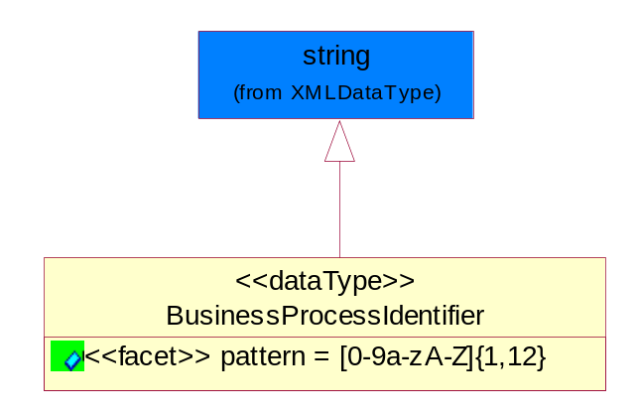
Figure ‎5-49 BusinessProcessIdentifier

Attribute | Type | Documentation
pattern |  | [0-9a-zA-Z]{1,12}

BusinessServiceInformation
The object allows the specification of the business service utilized within the partner company. This may or may not be the same as the information sent by the RNIF.
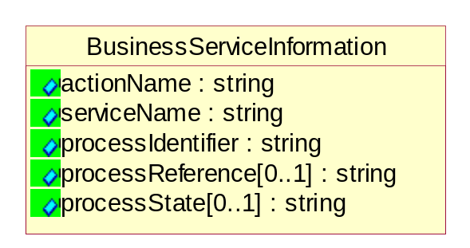
Figure ‎5-50 BusinessServiceInformation

Attribute | Type | Documentation
actionName | string | The name of Action. For RosettaNet usually any of Request/Confirm/Notify/Query/Response.
serviceName | string | The name of the Business Activity with the "Request/Confirm" part removed. E.g., for the Activity "Request Purchase Order"==> "Purchase Order".
processIdentifier | string | The name of the PIP e.g. Notify of Forecast Reply.
processReference[0..1] | string | The URN for the PIP that includes Cluster/Segment/Process pattern used to identify the interface process (such as PIP3A4)
processState[0..1] | string | The business process (or service) state of the sender of a document. When a service receives this document, the receiver may use the state as a precondition.

ContractInformation
A block of information used to correlate a contract in an executing choreography.

Figure ‎5-51 ContractInformation

Attribute | Type | Documentation
contractIdentifier[0..1] | string | Unique identification of a contract between the Sender and the Receiver
contractType[0..1] | string | The type of the contract: an attribute describing the type of the ContractIndentification. Valid values are URI, URN,ebXMLCPA, or other values defined by partners.

CorrelationInformation
A block of information used to correlate a requesting document to a responding document and to the contract in an executing choreography.
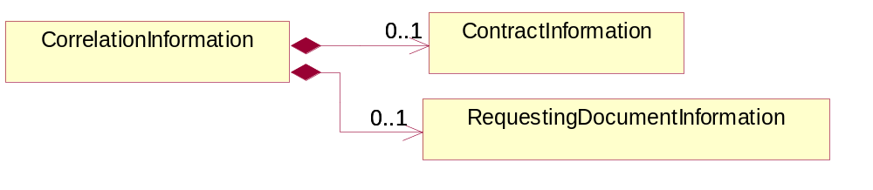
Figure ‎5-52 CorrelationInformation

Composition | Cardinality | Type | Documentation
ContractInformation | 0..1 | ContractInformation | A block of information used to correlate a contract in an executing choreography.
RequestingDocumentInformation | 0..1 | RequestingDocumentInformation | A block of information used to correlate a requesting document to a responding document in an executing choreography.

DocumentHeader
The object allows for the identification of the sender and receiver of the business document.
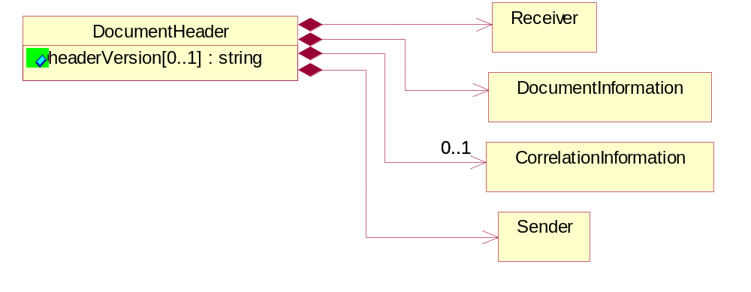
Figure ‎5-53 DocumentHeader

Attribute | Type | Documentation
headerVersion[0..1] | string | The UN/CEFACT version of the document header.

Composition | Cardinality | Type | Documentation
Sender | 1 | Sender | The object allows the identification of the initiating party of the business message.
CorrelationInformation | 0..1 | CorrelationInformation | A block of information used to correlate a requesting document to a responding document and to the contract in an executing choreography.
DocumentInformation | 1 | DocumentInformation | The object specifies information to identify the business document, a summary of attachments, and information about the business document security.
Receiver | 1 | Receiver | The object allows the identification of the receiving party of the business message.

DocumentIdentification
The object specifies all information necessary to identify the business document.
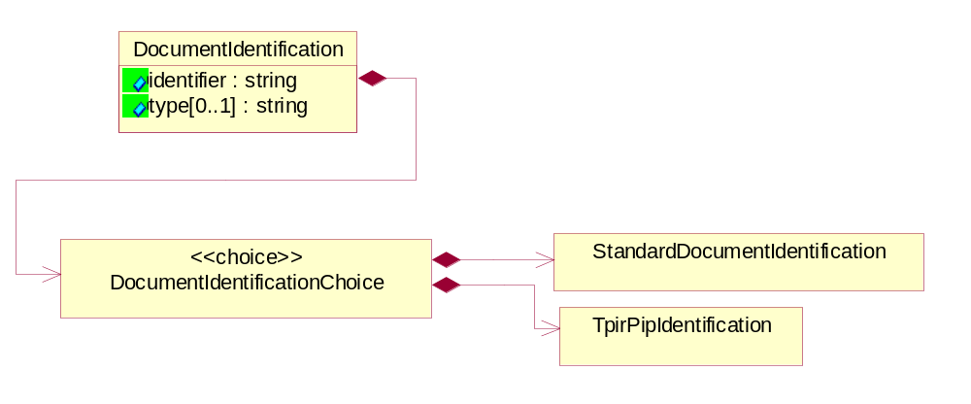
Figure ‎5-54 DocumentIdentification

Attribute | Type | Documentation
identifier | string | The unique identifier for the document being sent.
type[0..1] | string | Name of the Action Message

Composition | Cardinality | Type | Documentation
DocumentIdentificationChoice | 1 | DocumentIdentificationChoice

DocumentIdentificationChoice

Composition | Cardinality | Type | Documentation
StandardDocumentIdentification | 1 | StandardDocumentIdentification | The object specifies additional information necessary to identify the standard business document.
TpirPipIdentification | 1 | TpirPipIdentification | The object specifies all information necessary to uniquely identify a TPIR-PIP within a Registry or trading partner repository.

DocumentInformation
The object specifies information to identify the business document, a summary of attachments, and information about the business document security.
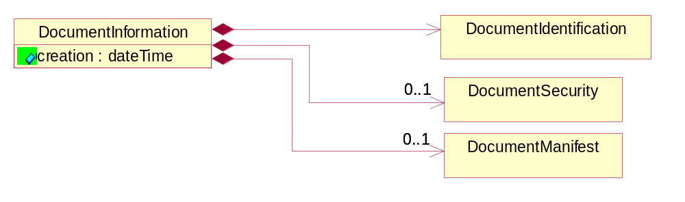
Figure ‎5-55 DocumentInformation

Attribute | Type | Documentation
creation | dateTime | The creation date and time of the specified Business Document (i.e. the Purchase Order date).

Composition | Cardinality | Type | Documentation
DocumentIdentification | 1 | DocumentIdentification | The object specifies all information necessary to identify the business document.
DocumentSecurity | 0..1 | DocumentSecurity | The object provides additional granularity in specifying business document security (this is in addition to the specified PIP security).
DocumentManifest | 0..1 | DocumentManifest | The block provides a brief summary of attachments and Service Content.

DocumentManifest
The block provides a brief summary of attachments and Service Content.
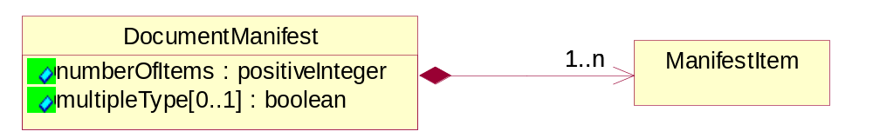
Figure ‎5-56 DocumentManifest

Attribute | Type | Documentation
numberOfItems | positiveInteger | Total number of documents in the message. The physical count of the attachments in the payload plus the RosettaNet Business Message (for Service Content). The value of this field will be at least 1.
multipleType[0..1] | boolean | Indicates whether the manifest contains documents of multiple types. True if yes, and False if no.

Composition | Cardinality | Type | Documentation
ManifestItem | 1..n | ManifestItem | The object provides details about the specific attachment(s).

DocumentSecurity
The object provides additional granularity in specifying business document security (this is in addition to the specified PIP security).

Figure ‎5-57 DocumentSecurity

Attribute | Type | Documentation
nonRepudiableReceipt | boolean | The value "true" will indicate that a signed acknowledgement for the business document is necessary.
persistentEncryption | boolean | The value "true" will indicate that the Business Document (including the header) needs to be encrypted when stored or transported.
persistentSignature | boolean | The value "true" will indicate that a signature is required to be stored with the document while stored or transported.

ManifestItem
The object provides details about the specific attachment(s).
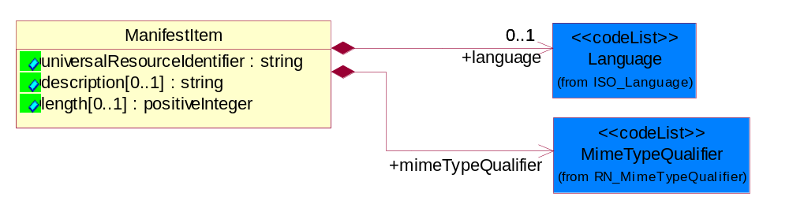
Figure ‎5-58 ManifestItem

Attribute | Type | Documentation
universalResourceIdentifier | string | The generic set of all names/addresses that are short strings that refer to resources.
description[0..1] | string | A description of the attachment.
length[0..1] | positiveInteger | The size of the attachment in bytes (i.e. 1 000 000 bytes)

Composition | Cardinality | Type | Documentation
mimeTypeQualifier | 1 | MimeTypeQualifier | The MIME type as defined by IANA.  Please refer to http://www.iana.org/assignments/media-types/ for a list of types.
language | 0..1 | Language | For representation of Language name RosettaNet has adopted ISO 639-2; 1998. Refer to the following web page to get the latest version of the standard:  http://www.loc.gov/standards/iso639-2/iso639jac.html  If you need more information about the ISO standard please contact ISO for more details.

PipIdentifier
PIP Identification.[ i.e. PIP3A4]
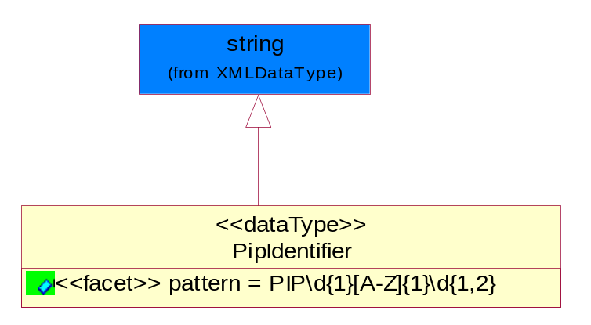
Figure ‎5-59 PipIdentifier

Attribute | Type | Documentation
pattern |  | PIP\d{1}[A-Z]{1}\d{1,2}

PipVersion
PIP version number (i.e. 02.02.00).
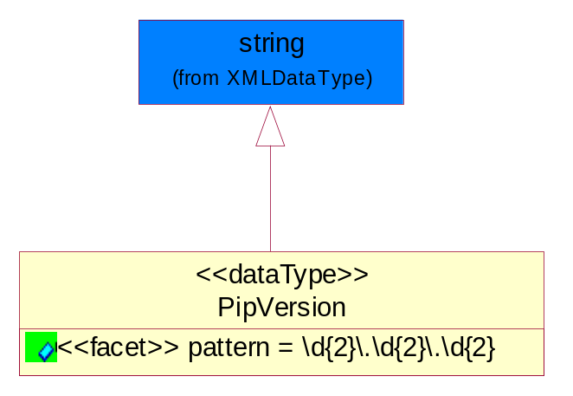
Figure ‎5-60 PipVersion

Attribute | Type | Documentation
pattern |  | \d{2}\.\d{2}\.\d{2}

Receiver
The object allows the identification of the receiving party of the business message.
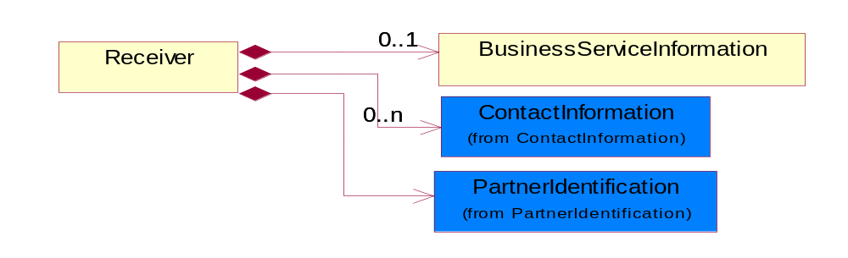
Figure ‎5-61 Receiver

Composition | Cardinality | Type | Documentation
BusinessServiceInformation | 0..1 | BusinessServiceInformation | The object allows the specification of the business service utilized within the partner company. This may or may not be the same as the information sent by the RNIF.
PartnerIdentification | 1 | PartnerIdentification | The business document must allow for the identity of one or more parties to the transaction.
ContactInformation | 0..n | ContactInformation | The business document must allow for the identification of the name of the department, service or individual to be contacted regarding the context of the business document.

RequestingDocumentInformation
A block of information used to correlate a requesting document to a responding document in an executing choreography.

Figure ‎5-62 RequestingDocumentInformation

Attribute | Type | Documentation
businessProcessInstanceIdentifier[0..1] | string | The identifier for the public business process instance being sent that both the sender and receiver can identify.
responseDateTime[0..1] | dateTime | The expected time to receive the response. This can not be greater than the PIP TimeToPerform.
requestingDocumentCreationDateTime[0..1] | dateTime | The date-time of the requesting business document.
requestingDocumentInstanceIdentifier | string | The Business Document identification number that identifies the requesting Business Document.

Sender
The object allows the identification of the initiating party of the business message.
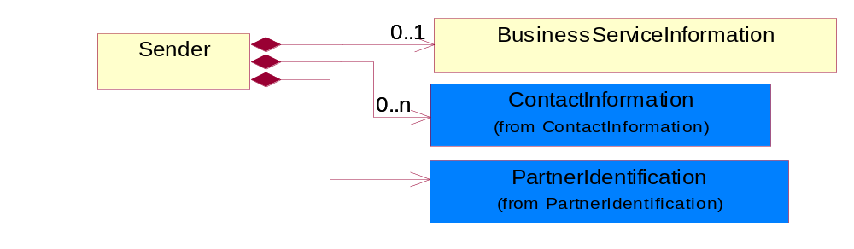
Figure ‎5-63 Sender

Composition | Cardinality | Type | Documentation
PartnerIdentification | 1 | PartnerIdentification | The business document must allow for the identity of one or more parties to the transaction.
BusinessServiceInformation | 0..1 | BusinessServiceInformation | The object allows the specification of the business service utilized within the partner company. This may or may not be the same as the information sent by the RNIF.
ContactInformation | 0..n | ContactInformation | The business document must allow for the identification of the name of the department, service or individual to be contacted regarding the context of the business document.

StandardDocumentIdentification
The object specifies additional information necessary to identify the standard business document.
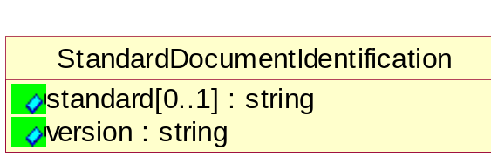
Figure ‎5-64 StandardDocumentIdentification

Attribute | Type | Documentation
standard[0..1] | string | Identifies the standard used to submit the business document. (e.g. RosettaNet).
version | string | PIP3A4v01.00

TpirPipIdentification
The object specifies all information necessary to uniquely identify a TPIR-PIP within a Registry or trading partner repository.

Figure ‎5-65 TpirPipIdentification

Attribute | Type | Documentation
partnerId | DUNSPlus4 | The Trading Partner Identification of MNC that is creating this TPIR PIP.
pipIdentifier | PipIdentifier | A TPIR PIP Identification [i.e., 3A4 ).
pipVersion | PipVersion | A TPIR PIP version number (i.e., 02.02.00)
tpirPipVersion | VersionIdentifier | A TPIR-PIP Version Number (i.e., major and minor version number as XX.XX).
tpirBusinessProcessIdentifier[0..1] | BusinessProcessIdentifier | A Business Process Identifier to uniquely define the TPIR-PIP 'role' within a Business Scenario at a company or MNC level. The identifier MUST be composed of alphanumeric characters only and its length MUST be between one and twelve characters.
uri[0..1] | anyURI | Describes the destination uri for the TPIR form.

Composition | Cardinality | Type | Documentation
fileType | 0..1 | TPIRFileType | Describes the file type of the TPIR form (PDF, XDP or XML).

VersionIdentifier
Version Number (i.e., major and minor version number as XX.XX).
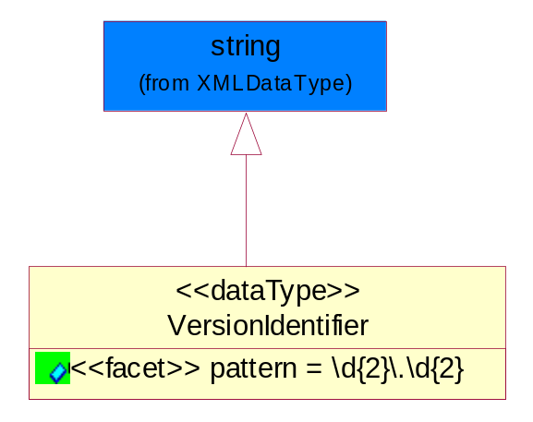
Figure ‎5-66 VersionIdentifier

Attribute | Type | Documentation
pattern |  | \d{2}\.\d{2}

CodeList

TPIRFileType
A code identifying the file type of TPIR form.

Name | Documentation
PDF | Portable Document Format.
XDP | XML Data Package.
XML | eXtensible Markup Language.

XML Data Type

anyURI
Represents a URI as defined by RFC 2396. An anyURI value can be absolute or relative, and may have an optional fragment identifier.

boolean
Represents Boolean values, which are either "true" or "false".

date
For the represents a calendar date.
The pattern for a date is CCYY-MM-DD where CC represents the century, YY the year, MM the month, and DD the day, with an optional time zone indicator as allowed for dateTime.

dateTime
Represents a specific instance of time.
The pattern for dateTime is CCYY-MM-DDThh:mm:ss where CC represents the century, YY the year, MM the month, and DD the day, preceded by an optional leading negative (-) character to indicate a negative number. If the negative character is omitted, positive (+) is assumed. The T is the date/time separator and hh, mm, and ss represent hour, minute, and second respectively. Additional digits can be used to increase the precision of fractional seconds if desired. For example, the format ss.ss... with any number of digits after the decimal point is supported. The fractional seconds part is optional.

This representation may be immediately followed by a "Z" to indicate Coordinated Universal Time (UTC) or to indicate the time zone. For example, the difference between the local time and Coordinated Universal Time, immediately followed by a sign, + or -, followed by the difference from UTC represented as hh:mm (minutes is required). If the time zone is included, both hours and minutes must be present.

float
Represents single-precision 32-bit floating-point numbers.

positiveInteger
Represents an integer that is greater than zero. This data type is derived from nonNegativeInteger.

string
Represents character string.

