

Description of
Partner Interface Process® for 3B2

Validated 11.00.00

Specification Information
Name | Notify of Advance Shipment
Cluster | Order Management
Segment | Transportation and Distribution
Publication Date | 27 July 2006
Version Identifier | V11.00
Table of Contents
1 Document Management 4
1.1 Legal Disclaimer 4
1.2 Copyright 4
1.3 Trademarks 4
1.4 Acknowledgments 4
1.5 Related Documents 5
1.6 Document Version History 5
1.7 Document Structure 5
2 Business Process 6
2.1 Business Process Definition 6
2.1.1 Business Process Description 6
2.2 PIP Business Document 7
2.3 PIP Business Process Flow Diagram 7
2.4 PIP Start State 8
2.5 PIP End States 8
2.6 Partner Role Descriptions 9
2.7 Business Process Activity Controls 9
3 Network and Implementation Specification 10
3.1 Business Action and Business Signal Specifications 10
3.2 Business Transaction Dialog Specification 10
3.2.1 Message Exchange Controls 11
3.2.2 Communications Specification 11

List of Figures:
Figure 1: Activity Diagram of Notify of Advance Shipment 7
Figure 2: Sequence Diagram of Notify of Advance Shipment 10

List of Tables:
Table 1: PIP Business Document 7
Table 2: PIP Start State 8
Table 3: PIP End State 8
Table 4: PIP Failure State 8
Table 5: Partner Role Description 9
Table 6: Business Activity Description 9
Table 7: Business Activity Performance Control 9
Table 8: Network Component Specification 10
Table 9: Business Action – Business Document Mapping 10
Table 10: Message Exchange Control 11
Table 11: Dialog: Service-Service 11

Document Management

Legal Disclaimer
RosettaNet™, its members, officers, directors, employees, or agents shall not be liable for any injury, loss, damages, financial or otherwise, arising from, related to, or caused by the use of this document or the specifications herein, as well as associated guidelines and schemas. The use of said specifications shall constitute your express consent to the foregoing exculpation.

Copyright
©2006 RosettaNet. All rights reserved. No part of this publication may be reproduced, stored in a retrieval system, or transmitted, in any form or by any means, electronic, mechanical, photocopying, recording, or otherwise, without the prior written permission of the publisher. Printed in the United States of America.

Trademarks
RosettaNet, Partner Interface Process, PIP and the RosettaNet logo are trademarks or registered trademarks of "RosettaNet," a non-profit organization. All other product names and company logos mentioned herein are the trademarks of their respective owners. In the best effort, all terms mentioned in this document that are known to be trademarks or registered trademarks have been appropriately recognized in the first occurrence of the term.

Acknowledgments
This document has been prepared by RosettaNet (http://www.rosettanet.org/) from requirements gathered during the Milestone Program and in conformance with the methodology. Listed below are the legal entities that contributed to the design and development of this PIP.
Amkor Technology, Inc. | Sterling Commerce
BCM Electronics | STMicroelectronics
Globetronics SDH. BHD | Sumitomo Bakelite Co., Ltd.
Intel Corporation | Tokyo Electron
Menlo Worldwide | Tokyo Electron Americe
Motorola Semiconductor Products Sector, Motorola SPS, Motorola | Tokyo Electron Limited
MIMOS Berhad | UMC
Shinko Electric Industries Co., Ltd. | United Microelectronics Corp.
SMSC | UPS Supply Chain Solutions
Standard Microsystems Corporation

Related Documents
- Associated PIP Message Schemas (included within the PIP Specification package only)
- Description of Advance Shipment Notification Message
- Advance Shipment Notification Messages Structure
- XML instance of ebXML BPSS for PIP 3B2

Document Version History
Version | Date | Description
Validated 11.00.00 | 27 July 2006 | Validated Version

Document Structure
A Partner Interface Process (PIP) Specification is comprised of the following two parts:
- Business Process. Captures the semantics of the business process and the flow of the message exchange between roles as they perform business activities.
- Network and Implementation Specification. Specifies the network protocol message formats and communications requirements between peer-protocols supported by network components in the RosettaNet Implementation Framework.

Business Process

Business Process Definition
The “Notify of Advance Shipment” Partner Interface Process™ (PIP) allows a Shipper to notify a Receiver that a shipment has been assigned. The purpose of the Advance Shipment Notification is to communicate at the detailed product level the contents of a shipment, when the shipment is expected to arrive, and other shipment information.
This Notification is often a part of the shipment process. In a shipping scenario, the shipment can be split once it reaches the destination, causing a need to issue a new Advance Shipment Notification.
This Notification is intended to satisfy shipment data needs of shippers and receivers.
Should this transaction not complete successfully, the requesting partner executes PIP0A1, "Notification of Failure."

Business Process Description
The primary purpose of this PIP is to
• facilitate receiving product shipments
• provide information unique for a shipment
• provide information needed for further transportation and distribution.
The primary information users are
• logistical service providers
• consignees (ultimate receiver)
Other purposes for this PIP include
• materials management
• facilitating paperless invoicing (aka pay upon receipt or pay upon shipment)
Other information users include
• material managers (buyer/planners and people responsible for materials movement)
• product end users
• accounts payable personnel
• transportation service providers (carriers)

PIP Business Document
Business Document are generated and exchanged by roles performing activities in this PIP. Business Document is listed and defined in Table 1.
Table 1: PIP Business Document
Business Document | Description
Advance Shipment Notification | The Advance Shipment Notification contains detailed information on when product shipped, expected date of arrival, how product shipped, and detail of the shipment contents.

PIP Business Process Flow Diagram
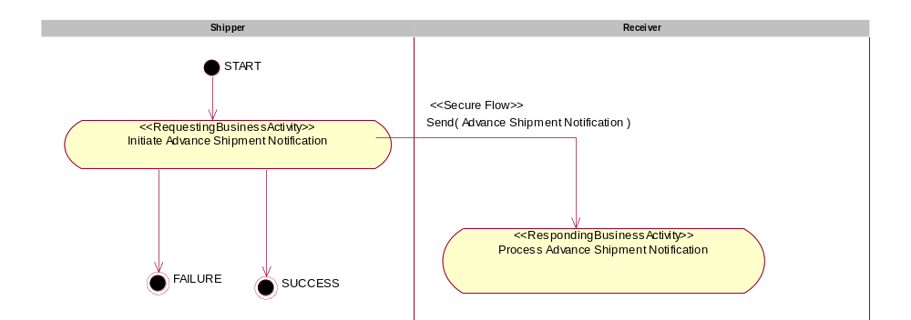

Figure 1: Activity Diagram of Notify of Advance Shipment

PIP Start State
The start state is comprised of the following conditions:
Table 2: PIP Start State
 | Approved | Exist |  | Valid | Non-Repudiated | Retry Count | Authorized
 | Approved | Party | In Backend System
TPA |  |  | 
Sending Partner |  |  |  | 
Receiving Partner |  | 
Business Document |  |  |  |  |  |  | 

PIP End States
The end state is comprised of the following conditions:
Table 3: PIP End State
 | Approved | Exist |  | Valid | Non-Repudiated | Retry Count | Authorized
 | Approved | Party | In Backend system
Acknowledgment of Receipt |  |  |  |  | 
Receiving Partner |  |  |  |  |  |  | 

The PIP failure state is comprised of one or more of the following conditions:
Table 4: PIP Failure State
 | NO | Exceeded
Success | 
Retry Count |  | 

Partner Role Descriptions
Table 5 describes the partner roles in this PIP.
Table 5: Partner Role Description
Role Name | Role Description
Shipper | The party who relinquishes (assigns) a shipment to a transport service provider.
Receiver | The Receiver is the intended recipient of products or business information. The Receiver may verify receipt if prescribed.

Business Process Activity Controls
Table 6 describes the interaction between roles performing business activity in this PIP.
Table 6: Business Activity Description
Role  Name | Activity Name | Activity Description
Shipper | Initiate Advance Shipment Notification | A Shipper issues an Advance Shipment Notification to a Receiver.

Table 7 details the security, audit and process controls relating to activity performed in the PIP.
Table 7: Business Activity Performance Control
Role  Name | Activity  Name | Acknowledgment  of Receipt |  | Time to Perform | Retry Count | Is Authorization Required? | Non-Repudiation of Origin and Content?
Role  Name | Activity  Name | Non-Repudiation Required? | Time to Acknowledge
Shipper | Initiate Advance Shipment Notification | Y | 30mins | N/A | 3 | Y | Y

Network and Implementation Specification
Each network component maps into a role of the PIP model. Table 8 specifies the mapping between roles and network components.
Table 8: Network Component Specification
Network Component | Classification | Maps to Role in Business Process
Shipper Service | Business Service | Shipper
Receiver Service | Business Service | Receiver

Business Action and Business Signal Specifications
Each business action maps to a Business Document of the PIP model. Table 9 specifies the mapping between Business Documents and business actions.
Table 9: Business Action – Business Document Mapping
Business Action | Business Document | Document Function
Advance Shipment Notification Action | Advance Shipment Notification | Request

Business Transaction Dialog Specification
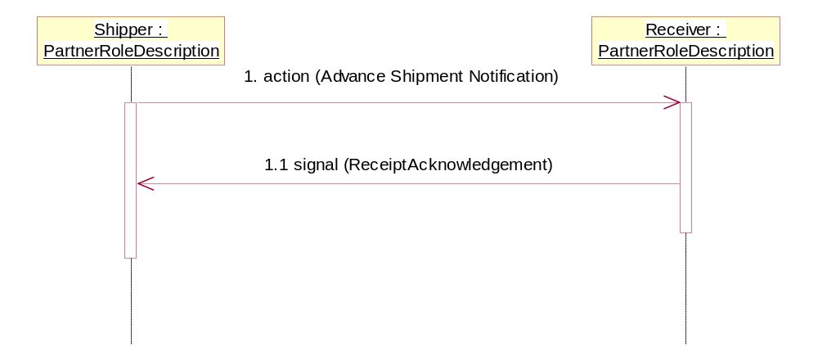
Figure 2: Sequence Diagram of Notify of Advance Shipment

Message Exchange Controls
Table 10: Message Exchange Control
# | Name |  | Time to Acknowledge Receipt Signal |  | Time to Respond to Action |  | Included in Time to Perform |  | Is Authorization Required? |  | Is Non-Repudiation Required? |  | Is Secure Transport Required?
1. |  | Advance Shipment Notification Action |  | 30mins |  | N/A |  | N/A |  | Y |  | Y |  | Y
1.1. |  | Receipt Acknowledgment |  | N/A |  | N/A |  | N/A |  | Y |  | Y |  | Y

Communications Specification
Table 11: Dialog: Service-Service
# | Business Message | Digital Signature Required? | SSL Required?
1. | Advance Shipment Notification | Y | Y
1.1. | Receipt Acknowledgment | Y | Y

