

Description of
Partner Interface Process® for 3B3

Validated 11.00.00

Specification Information
Name | Distribute Shipment Status
Cluster | Order Management
Segment | Transportation and Distribution
Publication Date | 13 July 2005
Version Identifier | V11.00
Table of Contents
1 Document Management 4
1.1 Legal Disclaimer 4
1.2 Copyright 4
1.3 Trademarks 4
1.4 Acknowledgments 4
1.5 Related Documents 4
1.6 Document Version History 5
1.7 Document Structure 5
2 Business Process 6
2.1 Business Process Definition 6
2.1.1 Business Process Description 6
2.2 PIP Business Document 6
2.3 PIP Business Process Flow Diagram 7
2.4 PIP Start State 8
2.5 PIP End States 8
2.6 Partner Role Descriptions 9
2.7 Business Process Activity Controls 9
3 Network and Implementation Specification 10
3.1 Business Action and Business Signal Specifications 10
3.2 Business Transaction Dialog Specification 10
3.2.1 Message Exchange Controls 11
3.2.2 Communications Specification 11

List of Figures:
Figure 1: Activity Diagram of Distribute Shipment Status 7
Figure 2: Sequence Diagram of Distribute Shipment Status 10

List of Tables:
Table 1: PIP Business Document 6
Table 2: PIP Start State 8
Table 3: PIP End State 8
Table 4: PIP Failure State 8
Table 5: Partner Role Description 9
Table 6: Business Activity Description 9
Table 7: Business Activity Performance Control 9
Table 8: Network Component Specification 10
Table 9: Business Action – Business Document Mapping 10
Table 10: Message Exchange Control 11
Table 11: Dialog: Service-Service 11

Document Management

Legal Disclaimer
RosettaNet™, its members, officers, directors, employees, or agents shall not be liable for any injury, loss, damages, financial or otherwise, arising from, related to, or caused by the use of this document or the specifications herein, as well as associated guidelines and schemas. The use of said specifications shall constitute your express consent to the foregoing exculpation.

Copyright
©2005 RosettaNet. All rights reserved. No part of this publication may be reproduced, stored in a retrieval system, or transmitted, in any form or by any means, electronic, mechanical, photocopying, recording, or otherwise, without the prior written permission of the publisher. Printed in the United States of America.

Trademarks
RosettaNet, Partner Interface Process, PIP and the RosettaNet logo are trademarks or registered trademarks of "RosettaNet," a non-profit organization. All other product names and company logos mentioned herein are the trademarks of their respective owners. In the best effort, all terms mentioned in this document that are known to be trademarks or registered trademarks have been appropriately recognized in the first occurrence of the term.

Acknowledgments
This document has been prepared by RosettaNet (http://www.rosettanet.org/) from requirements gathered during the Milestone Program and in conformance with the methodology. Listed below are the legal entities that contributed to the design and development of this PIP.
APL Logistics | DHL US
Ericsson | HP
Intel

Related Documents
- Associated PIP Message Schemas (included within the PIP Specification package only)
- Description of Shipment Status Distribution Message
- Shipment Status Distribution Messages Structure
- XML instance of ebXML BPSS for PIP 3B3

Document Version History
Version | Date | Description
Validated 11.00.00 | 13 July 2005 | Validated Version

Document Structure
A Partner Interface Process (PIP) Specification is comprised of the following two parts:
- Business Process. Captures the semantics of the business process and the flow of the message exchange between roles as they perform business activities.
- Network and Implementation Specification. Specifies the network protocol message formats and communications requirements between peer-protocols supported by network components in the RosettaNet Implementation Framework.

Business Process

Business Process Definition
Enables a transport service provider to report the status of a shipment while it is in transit to an end consignee or a gateway.

Business Process Description
The "Distribute Shipment Status" Partner Interface Process™ (PIP) enables a transport service provider to distribute shipment status information to another party, such as a consignee, a third-party logistics firm, a shipper, or another transport service provider.
A transport service provider is a party that adds value to the process of moving goods from one place to another. For example: Consolidators, warehousing entities, freight forwarders, documentation personnel, carrier, or custom clearing personnel.
Shipment status can be distributed:
• Any time after a shipment has been tendered (accepted and placed in transit) by a transport service provider.
• As specified in a trading partner agreement.
• As a follow-up to the execution of PIP3B4, "Query Shipment Status.”
• After a shipment reaches a consignee to notify other parties of shipment delivery expectations.
• To notify a partner of delivery exceptions (e.g., shipment lost, delivery address not found, store not open).
Shipment status information monitors the progress of a shipment. It is a “snapshot” of the status of goods in transit to an end consignee or a gateway (a point at which freight moving from one territory to another is interchanged between transportation lines).
Should this transaction not complete successfully, the requesting partner executes PIP0A1, "Notification of Failure."

PIP Business Document
Business Document are generated and exchanged by roles performing activities in this PIP. Business Document is listed and defined in Table 1.
Table 1: PIP Business Document
Business Document | Description
Shipment Status Distribution | Communicates the status of a shipment.

PIP Business Process Flow Diagram
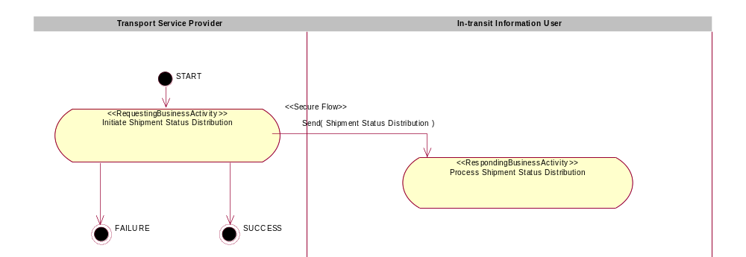
Figure 1: Activity Diagram of Distribute Shipment Status

PIP Start State
The start state is comprised of the following conditions:
Table 2: PIP Start State
 | Approved | Exist |  | Valid | Non-Repudiated | Retry Count | Authorized
 | Approved | Party | In Backend System
TPA |  |  | 
Sending Partner |  |  |  | 
Receiving Partner |  | 
Business Document |  |  |  | 

PIP End States
The end state is comprised of the following conditions:
Table 3: PIP End State
 | Approved | Exist |  | Valid | Non-Repudiated | Retry Count | Authorized
 | Approved | Party | In Backend system
Acknowledgment of Receipt |  |  |  | 
Receiving Partner |  |  |  |  |  |  | 

The PIP failure state is comprised of one or more of the following conditions:
Table 4: PIP Failure State
 | NO | Exceeded
Success | 
Retry Count |  | 

Partner Role Descriptions
Table 5 describes the partner roles in this PIP.
Table 5: Partner Role Description
Role Name | Role Description
Transport Service Provider | The party that provides transportation services for a Shipment Requester.
In-transit Information User | The party who receives shipment status information.

Business Process Activity Controls
Table 6 describes the interaction between roles performing business activity in this PIP.
Table 6: Business Activity Description
Role  Name | Activity Name | Activity Description
Transport Service Provider | Initiate Shipment Status Distribution | A Transport Service Provider sends a Shipment Status Notification to an In-transit Information User.

Table 7 details the security, audit and process controls relating to activity performed in the PIP.
Table 7: Business Activity Performance Control
Role  Name | Activity  Name | Acknowledgment  of Receipt |  | Time to Perform | Retry Count | Is Authorization Required? | Non-Repudiation of Origin and Content?
Role  Name | Activity  Name | Non-Repudiation Required? | Time to Acknowledge
Transport Service Provider | Initiate Shipment Status Distribution | N | 2hrs | N/A | 3 | N | N

Network and Implementation Specification
Each network component maps into a role of the PIP model. Table 8 specifies the mapping between roles and network components.
Table 8: Network Component Specification
Network Component | Classification | Maps to Role in Business Process
Transport Service Provider Service | Business Service | Transport Service Provider
In-transit Information User Service | Business Service | In-transit Information User

Business Action and Business Signal Specifications
Each business action maps to a Business Document of the PIP model. Table 9 specifies the mapping between Business Documents and business actions.
Table 9: Business Action – Business Document Mapping
Business Action | Business Document | Document Function
Shipment Status Distribution Action | Shipment Status Distribution | Request

Business Transaction Dialog Specification
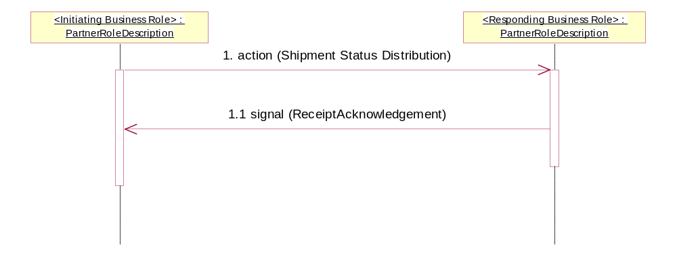
Figure 2: Sequence Diagram of Distribute Shipment Status

Message Exchange Controls
Table 10: Message Exchange Control
# | Name |  | Time to Acknowledge Receipt Signal |  | Time to Respond to Action |  | Included in Time to Perform |  | Is Authorization Required? |  | Is Non-Repudiation Required? |  | Is Secure Transport Required?
1. |  | Shipment Status Distribution Action |  | 2hrs |  | N/A |  | N/A |  | N |  | N |  | Y
1.1. |  | Receipt Acknowledgment |  | N/A |  | N/A |  | N/A |  | N |  | N |  | Y

Communications Specification
Table 11: Dialog: Service-Service
# | Business Message | Digital Signature Required? | SSL Required?
1. | Shipment Status Distribution | N | Y
1.1. | Receipt Acknowledgment | N | Y

