

Description of 3B3 Message

PIP® 3B3
Validated 11.11.00

Specification Information
Name | Description of 3B3 Message
PIP | Distribute Shipment Status
Cluster | Order Management
Segment | Transportation and Distribution
Publication Date | 05 October 2007
Version Identifier | V11.11

Table of Content

1. Document Management 7
1.1 Legal Disclaimer 7
1.2 Copyright 7
1.3 Trademarks 7
1.4 Acknowledgments 7
1.5 Related Documents 8
1.6 Document Version History 8
1.7 Document Purpose 8
2. ShipmentStatusDistribution 9
2.1.1 Interchange Diagram 9
2.1.2 Dependency Diagram 10
2.1.3 RoutingInformation 10
2.1.4 ShipmentInformation 12
2.1.5 ShipmentLineItem 13
2.1.6 ShipmentStatus 14
2.1.7 ShipmentStatusDistribution 14
2.1.8 ShipmentStatusEvent 15
2.1.9 ShipmentTransportationEvent 15
2.1.10 ShippingContainer 16
2.1.11 ShippingContainerItem 17
2.1.12 SubContainer 17
2.2 CodeList 18
2.2.1 ShipmentStatusReportingLevel 18
2.2.2 ShipmentStatus 18
3. Domain Model 27
3.1 Logistics 27
3.1.1 Logistics 27
3.1.1.1 Dependency Diagram 27
3.1.1.2 Customs 27
3.1.1.3 CustomsInformation 28
3.1.1.4 LinearWithMeasureType 28
3.1.1.5 MassPhysicalDimension 29
3.1.1.6 MeasureWithType 29
3.1.1.7 PhysicalDimension 30
3.1.1.8 PortAddress 30
3.1.1.9 PortIdentification 31
3.1.1.10 PortIdentificationChoice 31
3.1.1.11 PortInformation 32
3.1.1.12 ProofOfDeliveryInformation 32
3.1.1.13 ShipmentChangeReason 33
3.1.1.14 ShipmentDate 33
3.1.1.15 ShipmentServiceLevel 33
3.1.1.16 ShippingRoutingPoint 34
3.1.1.17 ShippingRoutingPointChoice 34
3.1.1.18 TrackingReference 35
3.1.1.19 TransportInformation 35
3.1.2 CodeList 36
3.1.2.1 TrackingReferenceType 36
3.1.2.2 ShipmentChangeDisposition 36
3.1.2.3 ShipmentMode 37
3.1.2.4 PortType 37
3.1.2.5 PortIdentifierAuthorityCode 38
3.1.2.6 CustomsType 38
3.1.2.7 ShipDateCode 38
3.1.2.8 RouteLocation 41
3.1.2.9 ContainerType 42
3.2 Procurement 43
3.2.1 Procurement 43
3.2.1.1 Dependency Diagram 43
3.2.2 RequestingOrderLineItemReference 43
3.2.2.1 SpecialHandlingInstruction 44
3.2.2.2 TransportationEvent 44
3.2.3 CodeList 45
3.2.3.1 TransportEvent 45
3.2.3.2 SpecialHandling 45
3.3 Shared 54
3.3.1 Shared 54
3.3.1.1 Dependency Diagram 54
3.3.1.2 ProductQuantity 54
3.3.1.3 QuantityInformation 54
3.3.1.4 SCAC 55
3.3.2 CodeList 55
3.3.2.1 ShippingServiceLevel 55
4. Universal Structure 58
4.1 ContactInformation 58
4.1.1 ContactInformation 58
4.2 DataType 58
4.2.1 Contact 58
4.2.2 DUNS 59
4.2.3 DUNSPlus4 59
4.2.4 GLN 59
4.3 Dates 60
4.3.1 DateTimePeriod 60
4.4 Document 60
4.4.1 BusinessDocumentReference 60
4.5 Locations 61
4.5.1 AlternativeIdentifier 61
4.5.2 Location 61
4.5.3 LocationChoice 62
4.5.4 PhysicalAddress 62
4.6 PartnerIdentification 64
4.6.1 FullPartner 64
4.6.2 IntermittentPartner 64
4.6.3 KnownPartner 65
4.6.4 KnownPartnerContact 65
4.6.5 NewPartner 66
4.6.6 PartnerDescription 66
4.6.7 PartnerDescriptionChoice 67
4.6.8 PartnerIdentification 68
4.6.9 PartnerIdentificationChoice 68
4.6.10 SpecifiedFullPartner 69
4.6.11 SpecifiedIntermittentPartner 70
4.6.12 SpecifiedKnownPartner 70
4.6.13 SpecifiedKnownPartnerContact 71
4.6.14 SpecifiedNewPartner 71
4.6.15 SpecifiedPartnerDescription 72
4.6.16 SpecifiedPartnerDescriptionChoice 72
4.7 PhysicalDimension 73
4.7.1 Measure 73
4.7.2 Volume 73
4.7.3 Weight 74
4.8 CodeList 74
4.8.1 Country 74
4.8.2 CountrySubdivision 74
4.8.3 Language 74
4.8.4 DocumentType 75
4.8.5 MimeTypeQualifier 76
4.8.6 UnitOfMeasure 87
4.8.7 ProcessRoleIdentifier 94
4.8.8 WeightType 97
5. System Structure 98
5.1 BusinessProcessIdentifier 98
5.2 BusinessServiceInformation 98
5.3 ContractInformation 99
5.4 CorrelationInformation 99
5.5 DocumentHeader 100
5.6 DocumentIdentification 101
5.7 DocumentIdentificationChoice 101
5.8 DocumentInformation 102
5.9 DocumentManifest 102
5.10 DocumentSecurity 103
5.11 ManifestItem 103
5.12 PipIdentifier 104
5.13 PipVersion 105
5.14 Receiver 105
5.15 RequestingDocumentInformation 106
5.16 Sender 106
5.17 StandardDocumentIdentification 107
5.18 TpirPipIdentification 107
5.19 VersionIdentifier 108
5.20 CodeList 108
5.20.1 TPIRFileType 108
6. XML Data Type 109
6.1 anyURI 109
6.2 boolean 109
6.3 dateTime 109
6.4 float 109
6.5 integer 109
6.6 positiveInteger 109
6.7 string 109

Table of Figures

Figure ‎2-1 Interchange 9
Figure ‎2-2 Dependency 10
Figure ‎2-3 RoutingInformation 10
Figure ‎2-4 ShipmentInformation 12
Figure ‎2-5 ShipmentLineItem 12
Figure ‎2-6 ShipmentStatus 14
Figure ‎2-7 ShipmentStatusDistribution 14
Figure ‎2-8 ShipmentStatusEvent 15
Figure ‎2-9 ShipmentTransportationEvent 15
Figure ‎2-10 ShippingContainer 16
Figure ‎2-11 ShippingContainerItem 16
Figure ‎2-12 SubContainer 16
Figure ‎3-1 Dependency 27
Figure ‎3-2 Customs 27
Figure ‎3-3 CustomsInformation 28
Figure ‎3-4 LinearWithMeasureType 28
Figure ‎3-5 MassPhysicalDimension 29
Figure ‎3-6 MeasureWithType 29
Figure ‎3-7 PhysicalDimension 30
Figure ‎3-8 PortAddress 30
Figure ‎3-9 PortIdentification 31
Figure ‎3-10 PortInformation 32
Figure ‎3-11 ProofOfDeliveryInformation 32
Figure ‎3-12 ShipmentChangeReason 33
Figure ‎3-13 ShipmentDate 33
Figure ‎3-14 ShipmentServiceLevel 33
Figure ‎3-15 ShippingRoutingPoint 34
Figure ‎3-16 TrackingReference 35
Figure ‎3-17 TransportInformation 35
Figure ‎3-18 Dependency 43
Figure ‎3-19 RequestingOrderLineItemReference 43
Figure ‎3-20 SpecialHandlingInstruction 44
Figure ‎3-21 TransportationEvent 44
Figure ‎3-21 Dependency 54
Figure ‎3-22 ProductQuantity 54
Figure ‎3-23 QuantityInformation 54
Figure ‎3-24 SCAC 55
Figure ‎4-1 ContactInformation 58
Figure ‎4-2 Contact 58
Figure ‎4-3 DUNS 59
Figure ‎4-4 DUNSPlus4 59
Figure ‎4-5 GLN 59
Figure ‎4-6 DateTimePeriod 60
Figure ‎4-7 BusinessDocumentReference 60
Figure ‎4-8 AlternativeIdentifier 61
Figure ‎4-9 Location 61
Figure ‎4-10 PhysicalAddress 62
Figure ‎4-11 FullPartner 64
Figure ‎4-12 IntermittentPartner 64
Figure ‎4-13 KnownPartner 65
Figure ‎4-14 KnownPartnerContact 65
Figure ‎4-15 NewPartner 66
Figure ‎4-16 PartnerDescription 66
Figure ‎4-17 PartnerIdentification 68
Figure ‎4-18 SpecifiedFullPartner 69
Figure ‎4-19 SpecifiedIntermittentPartner 70
Figure ‎4-20 SpecifiedKnownPartner 70
Figure ‎4-21 SpecifiedKnownPartnerContact 71
Figure ‎4-22 SpecifiedNewPartner 71
Figure ‎4-23 SpecifiedPartnerDescription 72
Figure ‎4-24 Measure 73
Figure ‎4-25 Volume 73
Figure ‎4-26 Weight 74
Figure ‎5-1 BusinessProcessIdentifier 98
Figure ‎5-2 BusinessServiceInformation 98
Figure ‎5-3 ContractInformation 99
Figure ‎5-4 CorrelationInformation 99
Figure ‎5-5 DocumentHeader 100
Figure ‎5-6 DocumentIdentification 101
Figure ‎5-7 DocumentInformation 102
Figure ‎5-8 DocumentManifest 102
Figure ‎5-9 DocumentSecurity 103
Figure ‎5-10 ManifestItem 103
Figure ‎5-11 PipIdentifier 104
Figure ‎5-12 PipVersion 105
Figure ‎5-13 Receiver 105
Figure ‎5-14 RequestingDocumentInformation 106
Figure ‎5-15 Sender 106
Figure ‎5-16 StandardDocumentIdentification 107
Figure ‎5-17 TpirPipIdentification 107
Figure ‎5-18 VersionIdentifier 108

Document Management

Legal Disclaimer
RosettaNet, its members, officers, directors, employees, or agents shall not be liable for any injury, loss, damages, financial or otherwise, arising from, related to, or caused by the use of this document or the specifications herein, as well as associated guidelines and schemas. The use of said specifications shall constitute your express consent to the foregoing exculpation.

Copyright
©2007 RosettaNet. All rights reserved. No part of this publication may be reproduced, stored in a retrieval system, or transmitted, in any form or by any means, electronic, mechanical, photocopying, recording, or otherwise, without the inclusion of this copyright notice. Any derivative works must cite the copyright notice. Any public redistribution or sale of this publication or derivative works requires prior written permission of the publisher.

Trademarks
RosettaNet, Partner Interface Process, PIP and the RosettaNet logo are trademarks or registered trademarks of "RosettaNet," a non-profit organization. All other product names and company logos mentioned herein are the trademarks of their respective owners. In the best effort, all terms mentioned in this document that are known to be trademarks or registered trademarks have been appropriately recognized in the first occurrence of the term.

Acknowledgments
This document has been prepared by RosettaNet (http://www.rosettanet.org/) from requirements gathered during the Milestone Program and in conformance with the methodology. Listed below are the legal entities that contributed to the design and development of this PIP.
APL Logistics | DHL US
Ericsson | HP
Intel

Related Documents
- Associated PIP Message Schemas (included with PIP Specification only)
- Description of Partner Interface Process for 3B3
- Message Structure

Document Version History
Version | Date | Description
Validated 11.00.00 | 13 Jul 2005 | Validated Version
Validated 11.01.00 | 17 Feb 2006 | Validated Version
Validated 11.10.00 | 20 Oct 2006 | Validated Version
Validated 11.11.00 | 05 Oct 2007 | Validated Version – Schema to Market 2007

Document Purpose
The purpose of the document is to explain the structure, the association between objects, the content of objects and the definition for single elements to a non-technical audience.

ShipmentStatusDistribution

Interchange Diagram
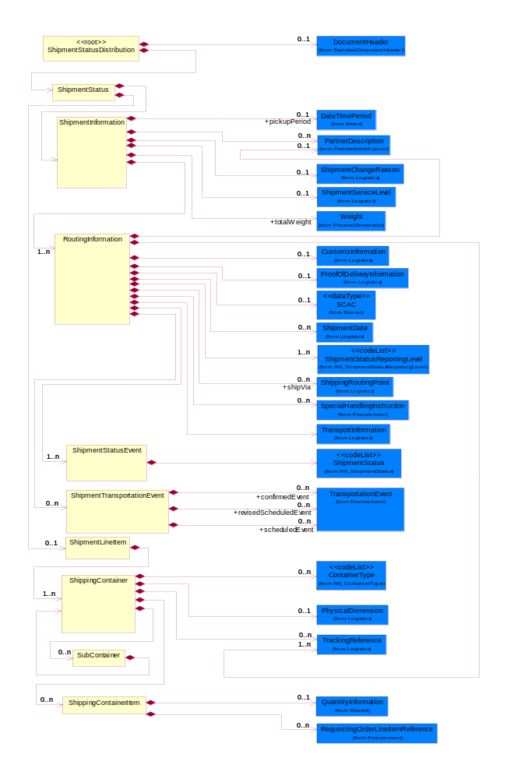
Figure ‎2-1 Interchange

Dependency Diagram
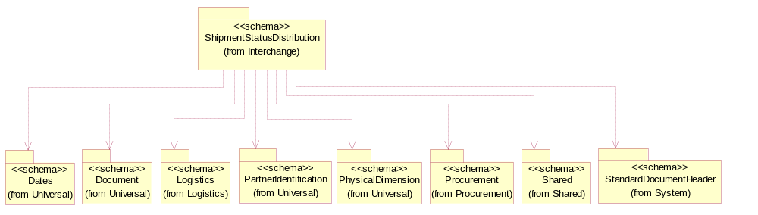
Figure ‎2-2 Dependency

RoutingInformation
The collection of business properties that describes a leg used in the routing of a shipment. The Recommended ProcessRoleIdentifier for PartnerDescription is TRA - Transported By.
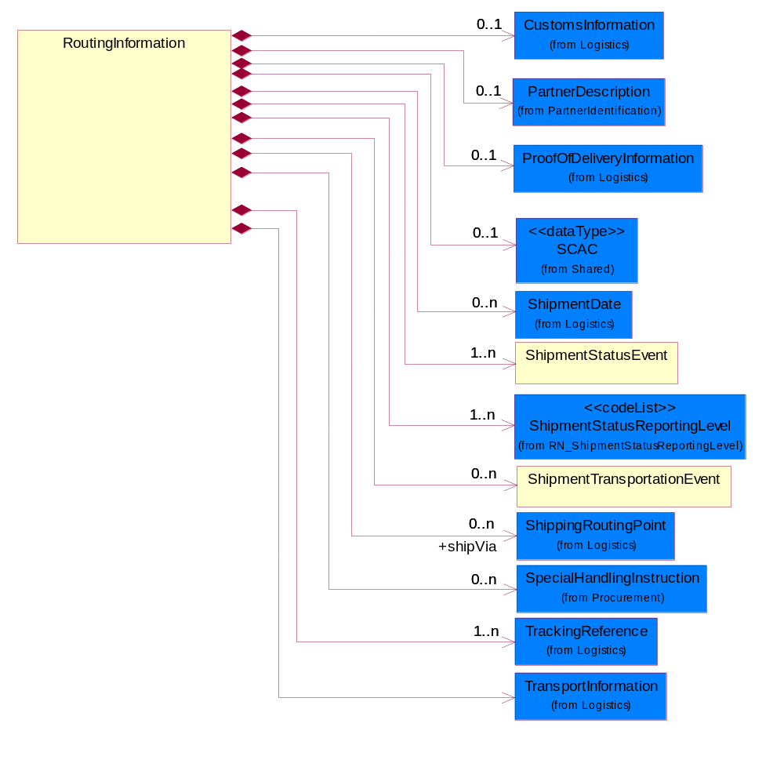
Figure ‎2-3 RoutingInformation

Composition | Cardinality | Type | Documentation
ShipmentTransportationEvent | 0..n | ShipmentTransportationEvent | The collection of business properties that describe the occurrence of the public conveyance of a shipment of goods.
TrackingReference | 1..n | TrackingReference | Proprietary unique identifier for tracking product shipments.
ShipmentStatusEvent | 1..n | ShipmentStatusEvent | The collection of business properties that describe the status of a shipment in the transportation process at a defined period of time.
ShipmentDate | 0..n | ShipmentDate | The collection of business properties that identifies a constraint on when the products may be shipped.
ProofOfDeliveryInformation | 0..1 | ProofOfDeliveryInformation | The collection of business properties that describe proof of delivery information.
SpecialHandlingInstruction | 0..n | SpecialHandlingInstruction | The collection of business properties that describe product packaging or shipping handling instructions.
ShipmentStatusReportingLevel | 1..n | ShipmentStatusReportingLevel | Code identifying the level of reporting for shipment delivery statuses.
CustomsInformation | 0..1 | CustomsInformation | The collection of business properties that describe a information necessary to comply with local Customs regulations during international transportation.
TransportInformation | 1 | TransportInformation | The collection of business properties that describe the Transport Information to the Receiving party to identify the event to a particular leg of shipment and to know the actual mode of transport that was used.
shipVia | 0..n | ShippingRoutingPoint | A partner and/or location through which the product must be shipped.
SCAC | 0..1 | SCAC | The Standard Carrier Alpha Code (SCAC) is a unique two-to-four-letter code used to identify transportation companies. NMFTA developed the SCAC identification codes in the mid 1960's to facilitate computerization in the transportation industry.  Refer http://www.nmfta.org for more detail.
PartnerDescription | 0..1 | PartnerDescription | The collection of business properties that describe a business partners' identity, their contact information, where they are physically located and their function in a supply chain.

ShipmentInformation
The collection of business properties that describe a consignment tendered for transportation from one point to another. The Recommended ProcessRoleIdentifier for PartnerDescription are SHT - Ship To, SHF - Ship From.
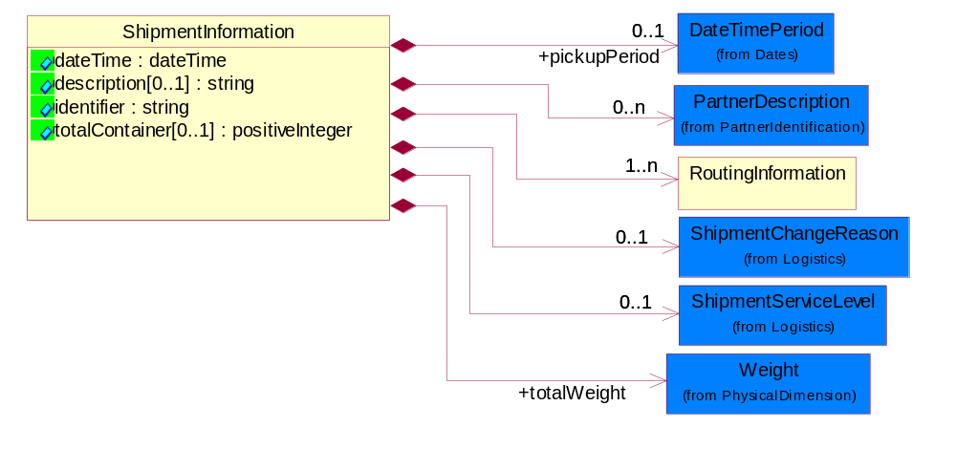
Figure ‎2-4 ShipmentInformation

Attribute | Type | Documentation
dateTime | dateTime | The date-time when the shipment status was generated.
description[0..1] | string | Free form text description regarding the detail of a shipment status.
identifier | string | Reference identifier assigned by the partner originating a shipment to uniquely identify the shipment.
totalContainer[0..1] | positiveInteger | A numeric expression of the number of outer containers for product shipping.

Composition | Cardinality | Type | Documentation
RoutingInformation | 1..n | RoutingInformation | The collection of business properties that describes a leg used in the routing of a shipment. The Recommended ProcessRoleIdentifier for PartnerDescription is TRA - Transported By.
pickupPeriod | 0..1 | DateTimePeriod | Date time for pickup to materialize.
totalWeight | 1 | Weight | Shipment weight as provided by carrier. Can be different from weight information available in Shipment notification in case of partial delivery (box lost or damaged).
ShipmentChangeReason | 0..1 | ShipmentChangeReason | The collection of business properties that describe change reason of shipment information.
ShipmentServiceLevel | 0..1 | ShipmentServiceLevel | The collection of business properties that describe service level of shipment information.
PartnerDescription | 0..n | PartnerDescription | The collection of business properties that describe a business partners' identity, their contact information, where they are physically located and their function in a supply chain.

ShipmentLineItem
The collection of business properties that describes the shipping details for a product line item on the shipping order.
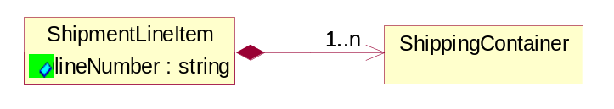
Figure ‎2-5 ShipmentLineItem

Attribute | Type | Documentation
lineNumber | string | Number of the line in the document, associated with a given unique line number.

Composition | Cardinality | Type | Documentation
ShippingContainer | 1..n | ShippingContainer | The collection of business properties that describe the nature and contents of a shipping unit.

ShipmentStatus
A container element that carries collection of multiple shipment status information in ShipmentStatusInformation which describes the shipping status of ordered products.
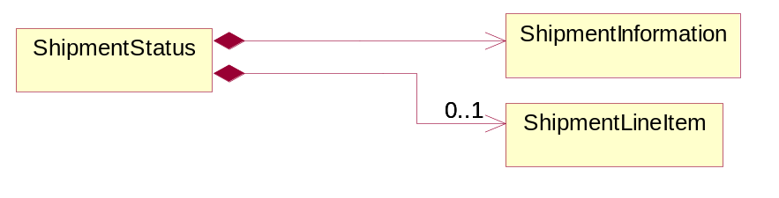
Figure ‎2-6 ShipmentStatus

Composition | Cardinality | Type | Documentation
ShipmentLineItem | 0..1 | ShipmentLineItem | The collection of business properties that describes the shipping details for a product line item on the shipping order.
ShipmentInformation | 1 | ShipmentInformation | The collection of business properties that describe a consignment tendered for transportation from one point to another. The Recommended ProcessRoleIdentifier for PartnerDescription are SHT - Ship To, SHF - Ship From.

ShipmentStatusDistribution
A message wrapper for the PIP3B3.
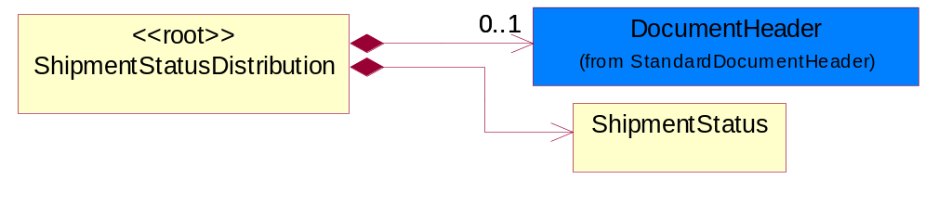
Figure ‎2-7 ShipmentStatusDistribution

Composition | Cardinality | Type | Documentation
DocumentHeader | 0..1 | DocumentHeader | The object allows for the identification of the sender and receiver of the business document.
ShipmentStatus | 1 | ShipmentStatus | A container element that carries collection of multiple shipment status information in ShipmentStatusInformation which describes the shipping status of ordered products.

ShipmentStatusEvent
The collection of business properties that describe the status of a shipment in the transportation process at a defined period of time.
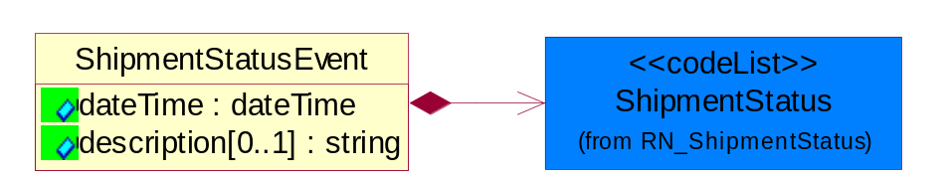
Figure ‎2-8 ShipmentStatusEvent

Attribute | Type | Documentation
dateTime | dateTime | The date-time when the shipment status was generated.
description[0..1] | string | Free form text description regarding the status of a shipment.

Composition | Cardinality | Type | Documentation
ShipmentStatus | 1 | ShipmentStatus | Code identifying the delivery status for a shipment.

ShipmentTransportationEvent
The collection of business properties that describe the occurrence of the public conveyance of a shipment of goods.
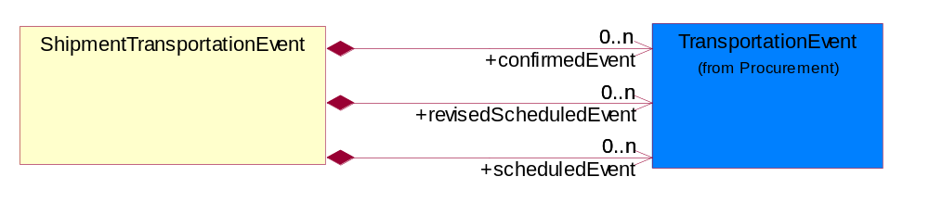
Figure ‎2-9 ShipmentTransportationEvent

Composition | Cardinality | Type | Documentation
revisedScheduledEvent | 0..n | TransportationEvent | The revised date a transportation event is scheduled to occur.
scheduledEvent | 0..n | TransportationEvent | The date a transportation event is scheduled to occur.
confirmedEvent | 0..n | TransportationEvent | The date a transportation event is confirmed to occur.

ShippingContainer
The collection of business properties that describe the nature and contents of a shipping unit.
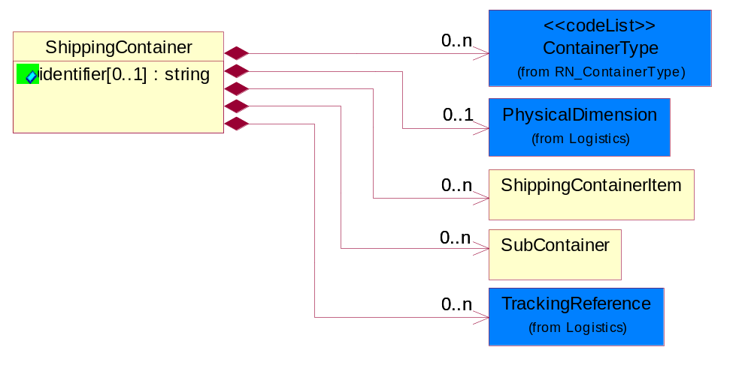
Figure ‎2-10 ShippingContainer

Attribute | Type | Documentation
identifier[0..1] | string | Unique identifier that represents a shipping container. Normally a UCC structured identifier. Also known as a "license plate".

Composition | Cardinality | Type | Documentation
ShippingContainerItem | 0..n | ShippingContainerItem | The collection of business properties that describe the nature and contents of the good contained within shipping unit.
TrackingReference | 0..n | TrackingReference | Proprietary unique identifier for tracking product shipments.
PhysicalDimension | 0..1 | PhysicalDimension | The physical dimension of a quantity such as length, time, mass.
SubContainer | 0..n | SubContainer | The collection of business properties that describe the nature and contents of inner containers (packages) contained within an outer shipping unit.
ContainerType | 0..n | ContainerType | Code identifying ithe type of container.

ShippingContainerItem
The collection of business properties that describe the nature and contents of the good contained within shipping unit.
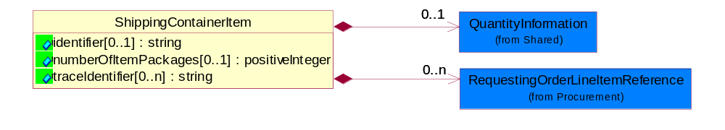
Figure ‎2-11 ShippingContainerItem

Attribute | Type | Documentation
identifier[0..1] | string | Unique identifier that represents a shipping container. Normally a UCC structured identifier. Also known as a "license plate".
numberOfItemPackages[0..1] | positiveInteger | A numeric expression of the number of item packages within a container.
traceIdentifier[0..n] | string | Free form text for a non-serial lot identifier.

Composition | Cardinality | Type | Documentation
RequestingOrderLineItemReference | 0..n | RequestingOrderLineItemReference | The collection of business properties that references a line item on a requesting document.
QuantityInformation | 0..1 | QuantityInformation | The collection of business properties that describes information regarding the quantity of the product shipped.

SubContainer
The collection of business properties that describe the nature and contents of inner containers (packages) contained within an outer shipping unit.
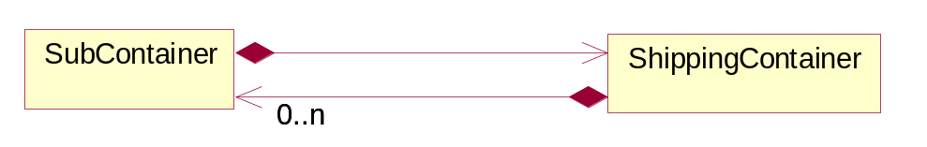
Figure ‎2-12 SubContainer

Composition | Cardinality | Type | Documentation
ShippingContainer | 1 | ShippingContainer | The collection of business properties that describe the nature and contents of a shipping unit.

CodeList

ShipmentStatusReportingLevel
Code identifying the level of reporting for shipment delivery statuses.

Name | Documentation
ALL | All. Entire history of shipment status.
CUR | Current. Current status of shipment only (no history).

ShipmentStatus
Code identifying the delivery status for a shipment.

Name | Documentation
AAA | Arrival/Arrival at airport.
AAD | Arrival/Available for delivery.
AAF | Arrival/Arrival at freight forwarder's terminal.
AAP | Arrival/Arrival at port.
AAR | Arrival/ Arrival at routing point.
AAS | Arrival/Train arrival.
AAT | Arrival/Arrival at terminal location.
AAU | Arrival/Vessel arrival.
AAV | Arrival/Aircraft arrival.
ABC | Appointment/Booking Confirmed.
ACL | Arrival/Spotted At Consignee's Location.
ADA | Appointment/Early Delivery Appointment Date And Or Time.
ADC | Appointment/Delivery Not Confirmed.
ADD | Appointment/Delivery Appointment Date And Time.
ADL | Arrival/Arrived At Delivery Location.
ADR | Appointment/Delivery Appointment Requested.
ADS | Appointment/Delivery Appointment Secured.
AEA | Appointment/Estimate Approved.
AEC | Appointment/Empty Committed.
AED | Appointment/Estimated Delivery.
AEE | Appointment/Estimated To Arrive (En Route).
AEL | Appointment/Estimated Time Of Arrival At Consignee Location.
AEP | Appointment/Early Pickup Appointment Date And Or Time.
AER | Appointment/Estimate Received.
AET | Appointment/Estimated Time Of Arrival At Scheduled Pick-Up Location.
AGO | Appointment/General Order.
AIT | Arrival/At Terminal; Intra-Terminal Movement.
ALA | Appointment/Late Delivery Appointment Date And/Or Time.
ALD | Arrival/Arrived At Pick-Up Location Loading Dock.
ALL | Arrival/Arrived At Delivery Location Loading Dock.
ALP | Appointment/Late Pickup Appointment Date And/Or Time.
APD | Appointment/Pick-Up Appointment Date And Time.
APL | Arrival/Arrived At Pick-Up Location.
APR | Appointment/Pickup Appointment Requested.
APS | Appointment/Pick-Up Appointment Secured.
ARA | Arrival/Rail Arrival At Destination Intermodal Ramp.
ARD | Appointment/Recommitted Delivery Date.
ARR | Arrival/Arrived.
ATA | Arrival/Truck arrival.
ATL | Appointment/Estimated To Depart Terminal Location.
AVF | Arrival/Vessel arrival at final discharge port.
AVR | Arrival/Vessel arrival at relay port.
CAC | Customs/Arrival at customs.
CBA | Customs/Broker assigned.
CBH | Customs/Brokerage hold .
CBN | Customs/Broker notified.
CBR | Customs/Brokerage released, waiting for customs.
CCA | Shipment Stopped / Contact Carrier - Need to contact carrier.
CCC | Customs/Customs clearance completed.
CCD | Customs/Customs delay.
CCH | Customs/Customs hold.
CCI | Customs/Customs physical inspection.
CCP | Customs/Customs pass through.
CCR | Customs/Commodity restricted .
CCS | Customs/Completion of customs clearance for documents only.
CDI | Customs/Customs document inspection.
CEF | Customs/Export declaration finalized.
CIM | Customs/Invoice missing or incorrect.
CIS | Customs/Customs Inspection Scheduled.
CMA | Customs/In-Bond Movement Authorized.
CNF | Customs/No funds in importers customs account.
CPC | Customs/Pick up by carrier from customs.
CRB | Customs/Receiver assigned new broker.
CRC | Customs/Customs reject.
CRF | Customs/Released from customs.
CRN | Customs/Released by customs, carrier notified.
CRP | Customs/Release paperwork made available to carrier.
CSC | Customs/Submitted to customs.
CSD | Customs/Shipment destroyed by customs.
CSI | Customs/Shipment inspection.
CSO | Customs/Shipment inspection – opened by customs.
CSS | Customs/Shipment seized by customs.
CST | Customs/Sample taken.
DAA | Delayed/Never arrived at destination.
DAB | Delivery attempted/Receiver refused.
DAC | Delayed/Transportation accident.
DAD | Delivery attempted/Address corrected, delivery attempted.
DAE | Delivery attempted/Business closed.
DAF | Delivery attempted/Missed delivery slot.
DAG | Delivery attempted/No funds available.
DAH | Delivery attempted/Receiver refused shipment.
DAI | Delivery attempted/Unable to locate consignee.
DAL | Delivery attempted/Improper loading facility or equipment at consignee.
DAM | Delivery attempted/Receiver's location vacant.
DAN | Delivery attempted/Consignee not available.
DAO | Delivery attempted/Company or person unknown, not delivered.
DAP | Delivery attempted/Receiver not available.
DAQ | Delivery attempted/Receiver on holiday.
DAR | Delivered/Left at receiver's location.
DAS | Delivered/Receiver acknowledges receipt.
DAT | Delivered/Sender acknowledges receipt.
DAU | Delivery attempted/Consignee refused.
DAV | Delivery attempted/Customer requested future delivery .
DAW | Delivery attempted/Delivery refused from other than receiver.
DAX | Delivery attempted/No response.
DAY | Delivery attempted/Receiver on strike.
DAZ | Delivery attempted/Receiver on vacation.
DBO | Damaged/Bad Order (Inoperative Or Damaged).
DCA | Delayed/Flight canceled.
DCB | Delayed/Intercept cancelled.
DCC | Delayed/Beyond carrier control.
DCD | Delayed/Address corrected, delivery rescheduled.
DCP | Damaged/Damage Survey Completed.
DCR | Delayed/Country localization requirements .
DCT | Delayed/Missed cut-off time.
DCU | Delivered/Met customer.
DDA | Damaged/Packaged damaged.
DDB | Damaged/Shipment damaged.
DDC | Delayed/Aircraft delayed by customs.
DDD | Delayed/No delivery attempt on scheduled day.
DDE | Delayed/Carrier delay.
DDF | Damaged/Received damaged from shipping point.
DDG | Delayed/Forwarder delay.
DDH | Delivered/Late delivery.
DDI | Delivered/Paper delivery.
DDJ | Delivered/Shipment delivered.
DDK | Departed/Truck departure.
DDL | Delivery attempted/Attempted Delivery.
DDO | Departed/Departed from Origin location.
DDP | Departed/Aircraft departure.
DDS | Delayed/Delivery rescheduled .
DDT | Departed/Departed from Terminal location.
DEF | Delayed/Weather .
DEL | Delayed/Inspection.
DEM | Delayed/Lost.
DEN | Delayed/Mis-route.
DEO | Delayed/Mis-sort.
DEP | Delayed/Overweight.
DEQ | Delayed/Stolen.
DER | Delayed/Pickup error.
DES | Delivered/Cod.
DFA | Delayed/Intercept failed.
DFB | Delayed/Special flight arranged.
DFC | Delayed/Waiting for customer specified carrier.
DFD | Departed/Departed from airport.
DFE | Departed/Departed from dynamic merge location.
DFF | Departed/Departed from fixed consolidation hub.
DFR | Departed/Departed from routing point.
DFS | Delayed/Waiting for shipping instructions.
DFV | Departed/Departed from vessel port.
DHI | Damaged/Held Pending Instructions.
DHM | Delayed/Hazardous material.
DIB | Damaged/Damage is being held at transit hub.
DIT | Damaged/Damaged in transit.
DKD | Delivered/Receiver kept damaged package.
DLA | Delayed/Late airplane.
DLB | Delivered/Package left at address other than receiver's.
DLD | Delayed/Arrived late at destination.
DLT | Delayed/Late trailer.
DMB | Delivered/Merchandise missing, balance delivered.
DMP | Delayed/Carrier missed pickup.
DMR | Damaged/Damaged merchandise returned balance delete.
DND | Delayed/International non-carrier delay.
DNR | Delayed/Package not received.
DOC | Delayed/Value of commodity exceeds limits.
DOD | Delayed/Origin delay - special flight arranged.
DOM | Delivered/End of message.
DOO | Delayed/Certificate of origin required.
DOP | Delayed/Airline off-loaded packages.
DOS | Delayed/Oversized.
DOT | Delayed/Mechanical or technical reason.
DPD | Delivered/Proof of delivery.
DPI | Damaged/Damaged package is being held by carrier.
DPL | Departed/Departed Pickup Location.
DRB | Delayed/Documentation received but not physical shipment.
DRD | Damaged/Receiver refused damaged package.
DRE | Delayed/Documentation related delay.
DRF | Delayed/Not ready for pickup, 1st attempt.
DRG | Delayed/Not ready for pickup, 2nd attempt.
DRH | Delayed/Not ready for pickup, 3rd attempt.
DRI | Damaged/Damaged, re-wrapped in hub.
DRJ | Delivered/Authorization received from the customer.
DRO | Departed/Rail Departure From Origin Intermodal Ramp.
DRQ | Damaged/Damage Survey Requested.
DSC | Delayed/Missed scheduled connection.
DSD | Delayed/Freight shipment delayed.
DSE | Delayed/Shipper error.
DSP | Delayed/Shipment Delayed.
DSU | Delayed/Intercept successful.
DTA | Delivered/Delivered To Air Carrier.
DTC | Delayed/Unable to contact receiver.
DTD | Departed/Train departure.
DTE | Delayed/Catastrophic transportation event.
DTF | Delayed/Required transport equipment not available.
DTG | Delivered/Delivered to freight forwarder's terminal.
DTL | Delivered/Delivered To Connecting Line.
DTO | Departed/Train departure from origin.
DTR | Departed/Train departure from routing points.
DTU | Delayed/Late train.
DVD | Departed/Vessel departure.
DVL | Departed/Vessel departure from load port.
DVR | Departed/Vessel departure from relay port.
HAN | Handover/Received.
HAO | Handover/Relinquished.
HFC | Handover/Waiting for customer specified carrier.
HTB | Handover/Tendered to broker.
HTS | Handover/Assigned to subagent for delivery.
IDA | In transit/Delivery Appointment requested.
IIT | In transit/Intra-Terminal Movement.
ITA | In transit/Broker assigned, released for delivery.
ITB | In transit/Cleared border.
ITC | In transit/Address corrected - in transit.
ITD | In transit/Aircraft departed, freight on board.
ITE | In transit/Next day air letter sent.
ITF | In transit/Out for delivery.
ITG | In transit/Partial discard/balance sent to receiver.
ITH | In transit/Previous exception resolved.
ITI | In transit/Processed at carrier facility.
ITJ | In transit/Released by customs. Now in-transit.
ITK | In transit/Special flight arranged.
ITL | In transit/Completed loading at pickup location.
ITM | In transit/Not late (clears late designation).
ITN | In transit/Other - released.
ITO | In transit/Airline offloaded packages.
ITR | In transit/Redispatched.
ITS | In transit/Delivery scheduled.
ITT | In transit/Airport truck run.
ITU | In transit/Forwarded to destination.
ITV | In transit/In transit with courier.
ITW | In transit/Rerouted.
LET | Load/Load equipment to vessel.
LLD | Load/Loading.
LLF | Load/Loaded On Feeder Vessel.
LLL | Load/Load equipment to vessel at load port.
LLT | Load/Load equipment to vessel at transshipment port.
LOA | Load/Load on aircraft.
LOB | Load/Load on barge.
LOR | Load/Load on rail.
LOT | Load/Load on truck.
OAC | On hold/Awaiting Clearance.
OAH | On hold/Agriculture Hold.
OAP | Other/Actually Placed.
OAR | On hold/Agriculture Refused Entry.
OAS | On hold/Held-Awaiting Shipper's Export Document.
OBN | On hold/Held-No Booking Number.
OCI | On hold/Custom Hold/Intensive Examination.
OCP | Other/Constructively Placed.
OCR | Other/Container Rehandled.
OCS | Other/Container Sealed.
OCT | Other/Chassis Tie.
OCU | Other/Chassis Un-Tie.
ODL | Other/En Route To Delivery Location.
OES | Other/Equipment Shopped For Heavy Repair.
OFE | Other/Free Time To Expire.
OFP | Other/Freight Paid.
OFT | Other/Free Time Expired.
OHA | On hold/Delivery appointment requested.
OHB | On hold/Government agency hold.
OHC | On hold/Border clearance.
OHD | On hold/Export documentation required .
OHE | On hold/Awaiting export.
OHF | On hold/Held by origin location-in-transit delay.
OHG | On hold/Held for full carrier load.
OHH | On hold/Brokerage hold.
OHI | On hold/Customs hold.
OHJ | On hold/Held for future delivery.
OHK | On hold/Hold for customer pickup.
OHL | On hold/Other government hold.
OHM | On hold/Prearranged appointment with customer.
OHN | On hold/Prohibited article.
OHO | On hold/Shipment contains restricted commodities.
OHP | On hold/Awaiting payment authorization.
OHQ | On hold/Hold per customer's request.
OHR | On hold/Sender requested a hold for pu.
OHS | On hold/Multiple shipment-awaiting all packages.
OHT | On hold/Sender requested delivery delay.
OHU | On hold/Shipment held for incorrect tariff code.
OHV | On hold/Shipment held to verify value/wght ratio.
OHW | On hold/Storage in transit - warehoused.
OHX | On hold/Stored per customer request.
OHY | On hold/Waiting for consignee pickup.
OHZ | On hold/Waiting for delivery appointment.
OIF | Other/In Flight.
OIG | Other/In-Gate.
OMD | On hold/No Hazardous Material Document Received.
OND | Shipment Stopped / Other Non-Deliverable Reason - for all other reasons.
ONS | Other/No Seal On Load.
OOC | Other/Off-Hire Container.
OOG | Other/Out-Gate.
OOH | Other/On Hand.
OOO | On hold/Held On Ground.
OOP | Other/Ocean Charges Paid.
OOR | Other/On-Hire Container.
OPL | Other/En Route To Pick-Up Location.
OPR | On hold/No Paperwork Received With Shipment Or Equipment.
OPS | On hold/Held - Protective Service.
ORC | Other/Reserve Container Against Booking.
ORW | On hold/Held-Awaiting Recount or Weight or Description.
OSA | Other/Seals Altered.
OSC | Other/Shipment Consolidation.
OSI | On hold/Shipment Information Not Received.
OSK | Other/Shipment Acknowledged.
OSN | Other/Shipment Not Authorized.
OSO | Other/Set Off At Agent.
OSR | Other/Shipment Has Been Reconsigned.
OSS | Other/Passing.
OTC | On hold/Held-Title Clearance.
OTD | Other/Technical Charges Due.
OTH | Other.
OTI | On hold/Terminal Gate Inspection.
OTP | Other/Terminal Charges Paid.
OUC | Other/Unit Cleaned.
OUP | Other/Unit Pre-Tripped.
OVR | Other/Vessel Rehandle.
OWI | On hold/Waiting inspection.
OWL | On hold/Worldwide logistics hold.
OWP | On hold/Warehoused, pending release by customs.
PPC | Partial shipment/Partial delivery, Carrier related.
PPD | Partial shipment/ Partial Delivery, Customs related.
PPH | Partial shipment/Partial delivery, Damaged, re-wrapped at hub.
PPM | Partial shipment/Partial Delivery, Shipping Depot mis-sorted.
PPS | Partial shipment/Partial delivery, Shipper related.
PSC | Partial shipment/Shipment could not be completely delivered to customer.
PSO | Partial shipment/Balance of partial shipment delivered.
PSP | Partial shipment/Balance of partial shipment returned.
PSS | Partial shipment/Shipment Split.
PUP | Picked up/Receiver picked up.
PUU | Picked up/Pick up from shipper location other than when originally tendered.
RAC | Released/Agriculture Conditional Released.
RAR | Released/Agriculture Released.
RBO | Released/Repaired And/Or Released From Bad Order.
RCR | Received/Cargo Received At Contractual Place Of Receipt.
REC | Returned/Returned empty container.
REP | Returned/Empty Equipment Dispatched.
RGR | Returned/Repair goods return.
RHR | Released/Hold Released.
RMB | Returned/All merchandise being returned.
RMC | Returned/Merchandise missing, balance returned.
RNP | Returned/Returned not picked up.
ROC | Received/Receipt of cargo.
RRC | Released/Released By Customer.
RRE | Released/Carrier released.
RRO | Received/Received At Origin.
RRP | Received/Received From Prior Carrier.
RRR | Returned/Shipper requested return.
RRT | Returned/Returned To Carrier's Terminal.
RTS | Returned/Returned to shipper.
RWB | In Transit / Replace Waybill - for any changes to the waybill.
SDA | Shipping Document/Repair Authorization Received.
SDB | Shipping Document/Bill Of Lading Released.
SDC | Shipping Document/Confirmation Of Notification.
SDF | Shipping Document/Renotification.
SDI | Shipping Document/Interchange Information Received.
SDM | Shipping Document/Notification.
SDN | Shipping Document/Notification Refused.
SDO | Shipping Document/Original Bill Of Lading Received.
SDP | Shipping Document/Paperwork Received- Did Not Receive Shipment Or Equipment.
SDQ | Shipping Document/Repair Authorization Requested.
SDR | Shipment instruction change/Documentation not received.
SDS | Shipping Document/Receipt Of Shipping Instructions.
SIB | Shipment instruction change/Movement Type Changed From In-Bond To Not In-Bond.
SIC | Shipment instruction change/Assigned to sub-agent for delivery.
SID | Shipment instruction change/Delivery change request received and pending.
SIE | Shipment instruction change/Package will be rerouted to destination.
SIF | Shipment instruction change/Receiver change request.
SIG | Shipment instruction change/Receiver requested an intercept.
SIH | Shipment instruction change/Receiver requested future delivery.
SII | Shipment instruction change/Reconsigned.
SIJ | Shipment instruction change/Service level change request received and pending.
SIK | Shipment instruction change/Service level modification.
SIL | Shipment instruction change/Shipment cancelled.
SIM | Shipment instruction change/Temporary change of address.
SIR | Shipment Instruction Request / Document Received - Request for shipper accepting order to ship.
SIT | Shipment instruction change/Movement Type Changed From Not In-Bond To In-Bond.
SSC | Shipment stopped/Shipment cancelled by carrier.
SSD | Shipment stopped/Shipment cancelled by freight payee.
SSE | Shipment stopped/Shipment cancelled by receiver.
SSF | Shipment stopped/Cancellation failed .
SSG | Shipment stopped/Shipment cancelled by shipper.
SSL | Shipment stopped/Shipment Cancelled.
SSO | Shipment stopped/Incomplete or missing documentation.
SSP | Shipment stopped/Shipment prohibited.
SSR | Shipment stopped/Customs reject/confiscate.
SSS | Shipment stopped/Cancellation successful.
SST | Shipment stopped/Expired.
SSU | Shipment stopped/Unable to resolve incorrect address.
SSV | Shipment stopped/Courier van stolen.
STT | Shipment tendered/Shipment tendered to carrier.
UAI | Undeliverable/Service area inaccessible - special event.
UAW | Undeliverable/Sold-to address was not keyed.
UBN | Undeliverable/P.O. box, not delivered.
UCU | Unload/Completed Unloading At Delivery Location.
UFA | Unload/Unload from aircraft.
UFB | Unload/Unloaded from barge.
UFT | Unload/Unloaded from train.
UFU | Unload/Unloaded from truck.
UFV | Unload/Unloaded from vessel.
UII | Undeliverable/Delivery information incomplete.
UIN | Undeliverable/Address incorrect.
ULE | Undeliverable/Address label errors.
UNA | Undeliverable/Service not available to this address.
UNE | Undeliverable/Directions needed.
UNO | Undeliverable/Receiver name or phone # was not keyed.
UNS | Undeliverable/Destination not served by carrier.
UOA | Undeliverable/Illegible or altered C.O.D. tag.
USH | Undeliverable/Carnet shipments.
USI | Undeliverable/Incomplete sender information.
USL | Undeliverable/Exceeds service limitation.
UTU | Undeliverable/Second tracer unanswered-cancel search.
UUD | Unload/Unloaded from vessel at discharge port.
UUT | Unload/Unloaded from vessel at transshipment port.

Domain Model

Logistics

Logistics

Dependency Diagram
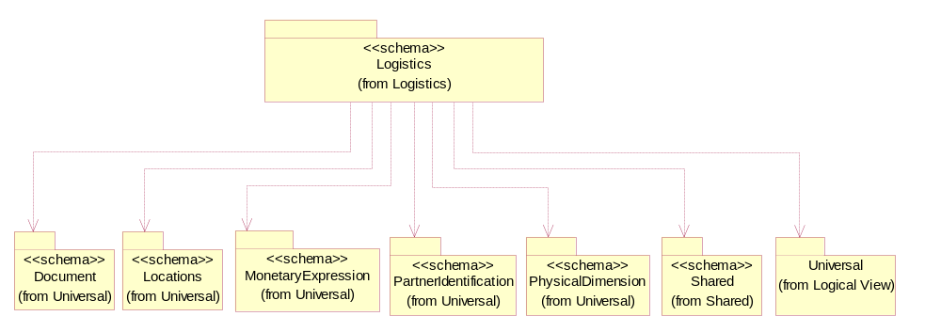
Figure ‎3-13 Dependency

Customs
The collection of business properties that describes an information necessary to comply with Customs regulations during international transportations.
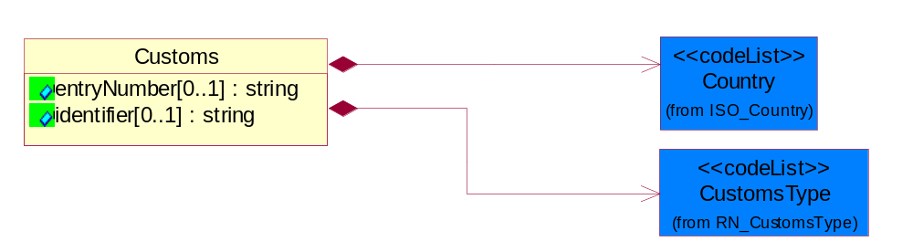
Figure ‎3-14 Customs

Attribute | Type | Documentation
entryNumber[0..1] | string | Unique tracking identification number that identifies a shipment routed through customs.
identifier[0..1] | string | Unique identification number assigned by a local customs authority.

Composition | Cardinality | Type | Documentation
Country | 1 | Country | For representation of Country name RosettaNet has adopted ISO 3166-3; 1999. Refer to the following web page to get the latest version of the standard:  http://www.iso.ch/iso/en/prods-services/iso3166ma/02iso-3166-code-lists/index.html  If you need more information about the ISO standard please contact ISO for more details.
CustomsType | 1 | CustomsType | The type of customs.

CustomsInformation
The collection of business properties that describe a information necessary to comply with local Customs regulations during international transportation.
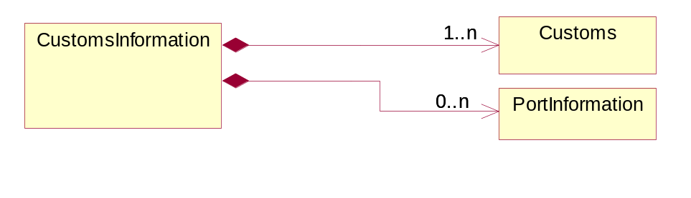
Figure ‎3-15 CustomsInformation

Composition | Cardinality | Type | Documentation
Customs | 1..n | Customs | The collection of business properties that describes an information necessary to comply with Customs regulations during international transportations.
PortInformation | 0..n | PortInformation | The collection of business properties that describes the harbor or haven where ships/aircrafts may anchor and discharge or receive cargo.

LinearWithMeasureType
The business document must be able to express the linear dimensions of an object.
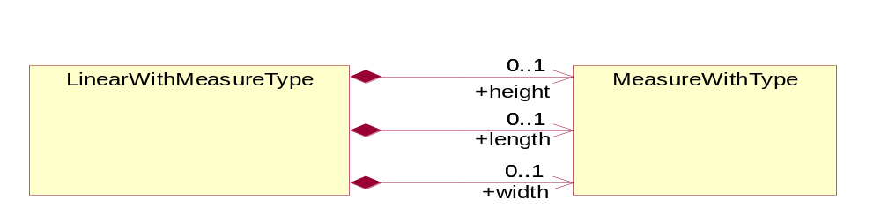
Figure ‎3-16 LinearWithMeasureType

Composition | Cardinality | Type | Documentation
length | 0..1 | MeasureWithType | To express the length of an object.
width | 0..1 | MeasureWithType | To express the weight of an object.
height | 0..1 | MeasureWithType | To express the height of an object.

MassPhysicalDimension
The physical dimension of unit of mass used for measuring the masses of weights, volumes etc.
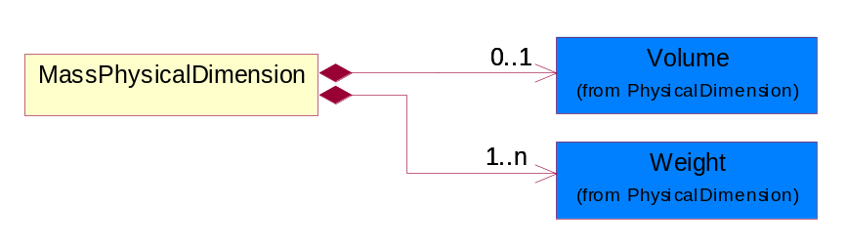
Figure ‎3-17 MassPhysicalDimension

Composition | Cardinality | Type | Documentation
Volume | 0..1 | Volume | The business document must be able to express the volume of an object.
Weight | 1..n | Weight | The business document must be able to express the weight of an object.

MeasureWithType
The business document must describe measurement information.
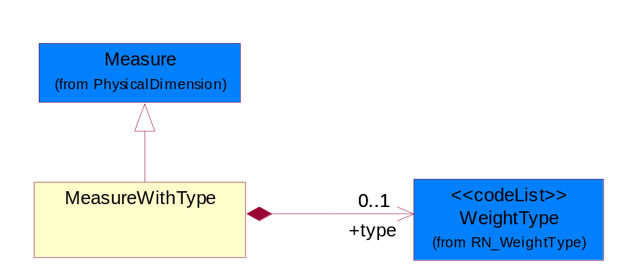
Figure ‎3-18 MeasureWithType

Composition | Cardinality | Type | Documentation
type | 0..1 | WeightType | A code identifying the type of measure.

PhysicalDimension
The physical dimension of a quantity such as length, time, mass.
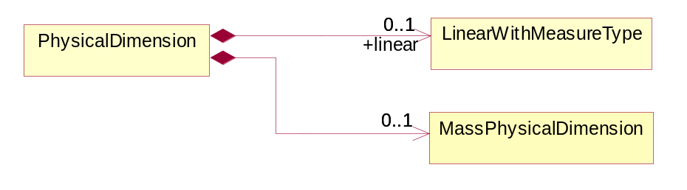
Figure ‎3-19 PhysicalDimension

Composition | Cardinality | Type | Documentation
MassPhysicalDimension | 0..1 | MassPhysicalDimension | The physical dimension of unit of mass used for measuring the masses of weights, volumes etc.
linear | 0..1 | LinearWithMeasureType | The business document must be able to express the linear dimensions of an object.

PortAddress
The collection of business properties that describe the routing point address.
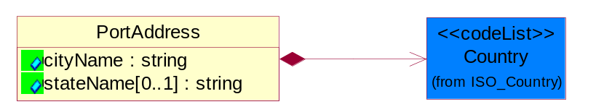
Figure ‎3-20 PortAddress

Attribute | Type | Documentation
cityName | string | The name of a city.
stateName[0..1] | string | The name of a state/province.

Composition | Cardinality | Type | Documentation
Country | 1 | Country | For representation of Country name RosettaNet has adopted ISO 3166-3; 1999. Refer to the following web page to get the latest version of the standard:  http://www.iso.ch/iso/en/prods-services/iso3166ma/02iso-3166-code-lists/index.html  If you need more information about the ISO standard please contact ISO for more details.

PortIdentification
The collection of business properties that defines types of ports as specified per IATA and IMO Codes and in ISO 3166-1 for country code and ISO 3166-2 for location code.
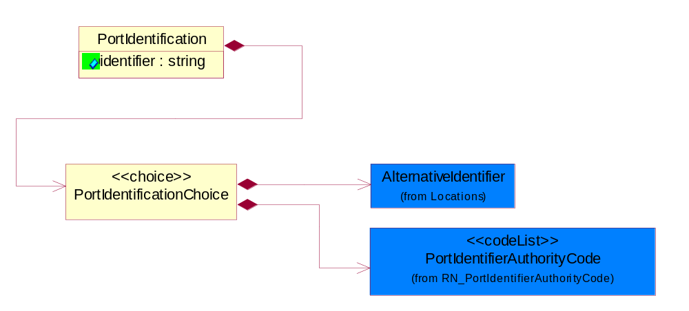
Figure ‎3-21 PortIdentification

Attribute | Type | Documentation
identifier | string | Code identifying Port as specified by the referenced Port Identifier Authority.

Composition | Cardinality | Type | Documentation
PortIdentificationChoice | 1 | PortIdentificationChoice | Choices of business properties that defines types of ports as specified per IATA and IMO Codes and in ISO 3166-1 for country code and ISO 3166-2 for location code.

PortIdentificationChoice
Choices of business properties that defines types of ports as specified per IATA and IMO Codes and in ISO 3166-1 for country code and ISO 3166-2 for location code.
Composition | Cardinality | Type | Documentation
AlternativeIdentifier | 1 | AlternativeIdentifier | Identifies the specified code and the name of the organization that a code is utilized from.
PortIdentifierAuthorityCode | 1 | PortIdentifierAuthorityCode | Code identifying the Authority maintaining the Port Identifier.

PortInformation
The collection of business properties that describes the harbor or haven where ships/aircrafts may anchor and discharge or receive cargo.
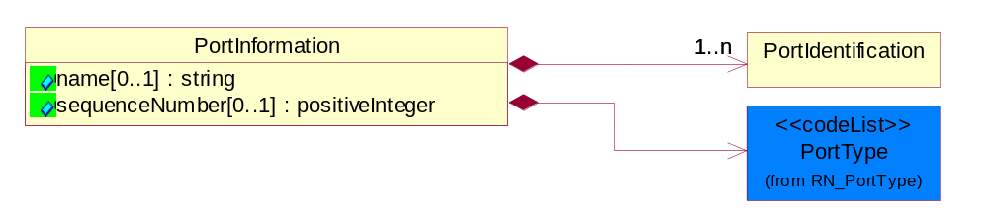
Figure ‎3-22 PortInformation

Attribute | Type | Documentation
name[0..1] | string | Additional code used locally (within each country/local leigslation) to further identify Port Codes as specified per IATA and IMO Codes and in ISO 3166-1 for country code and ISO 3166-2 for location code.
sequenceNumber[0..1] | positiveInteger | A positive integer which identifies the order of a designated element within a specified set.

Composition | Cardinality | Type | Documentation
PortType | 1 | PortType | Code identifying the type of ports used during a shipment.
PortIdentification | 1..n | PortIdentification | The collection of business properties that defines types of ports as specified per IATA and IMO Codes and in ISO 3166-1 for country code and ISO 3166-2 for location code.

ProofOfDeliveryInformation
The collection of business properties that describe proof of delivery information.
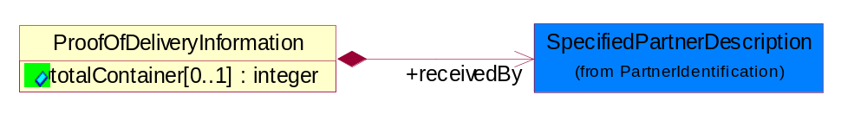
Figure ‎3-23 ProofOfDeliveryInformation

Attribute | Type | Documentation
totalContainer[0..1] | integer | An expression of the number of outer containers for product shipping.

Composition | Cardinality | Type | Documentation
receivedBy | 1 | SpecifiedPartnerDescription | The party receiving the delivered items.

ShipmentChangeReason
The collection of business properties that describe change reason of shipment information.
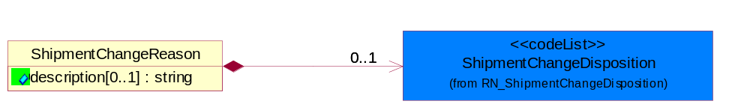
Figure ‎3-24 ShipmentChangeReason

Attribute | Type | Documentation
description[0..1] | string | Free form text description regarding the change of a shipment.

Composition | Cardinality | Type | Documentation
ShipmentChangeDisposition | 0..1 | ShipmentChangeDisposition | Code identifying the additional reasons for a change to a product shipment.

ShipmentDate
The collection of business properties that identifies a constraint on when the products may be shipped.
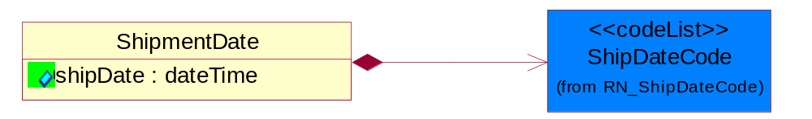
Figure ‎3-25 ShipmentDate

Attribute | Type | Documentation
shipDate | dateTime | The date when the shipment maybe shipped.

Composition | Cardinality | Type | Documentation
ShipDateCode | 1 | ShipDateCode | Code identifying a type of ship date.

ShipmentServiceLevel
The collection of business properties that describe service level of shipment information.
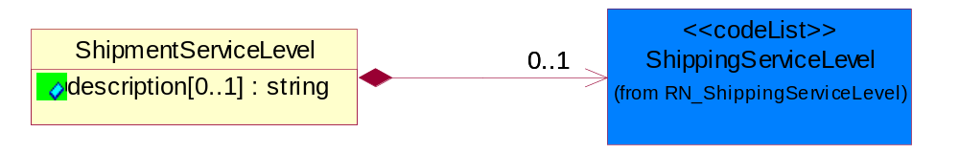
Figure ‎3-26 ShipmentServiceLevel

Attribute | Type | Documentation
description[0..1] | string | Free form textual description regarding the service level of a shipment.

Composition | Cardinality | Type | Documentation
ShippingServiceLevel | 0..1 | ShippingServiceLevel | Code identifying the shipping service level, e.g., overnight, same day.

ShippingRoutingPoint
The collection of business properties that describe the routing information of a shipment.
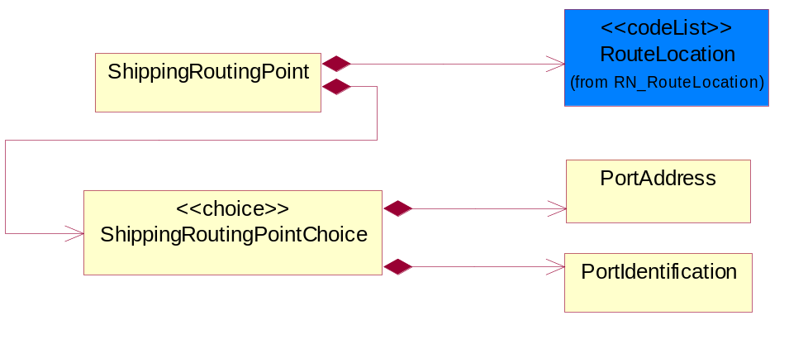
Figure ‎3-27 ShippingRoutingPoint

Composition | Cardinality | Type | Documentation
RouteLocation | 1 | RouteLocation | Code identifying the route location of some point after a shipment is created within a carrier's system.
ShippingRoutingPointChoice | 1 | ShippingRoutingPointChoice | Choices of business properties that describe the routing information of a shipment.

ShippingRoutingPointChoice
Choices of business properties that describe the routing information of a shipment.
Composition | Cardinality | Type | Documentation
PortAddress | 1 | PortAddress | The collection of business properties that describe the routing point address.
PortIdentification | 1 | PortIdentification | The collection of business properties that defines types of ports as specified per IATA and IMO Codes and in ISO 3166-1 for country code and ISO 3166-2 for location code.

TrackingReference
Proprietary unique identifier for tracking product shipments.
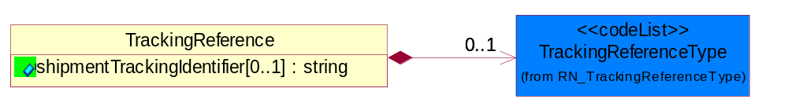
Figure ‎3-28 TrackingReference

Attribute | Type | Documentation
shipmentTrackingIdentifier[0..1] | string | Proprietary unique identifier for tracking product shipments.

Composition | Cardinality | Type | Documentation
TrackingReferenceType | 0..1 | TrackingReferenceType | Code identifying the type of document reference being used to track a shipment.

TransportInformation
The collection of business properties that describe the Transport Information to the Receiving party to identify the event to a particular leg of shipment and to know the actual mode of transport that was used.
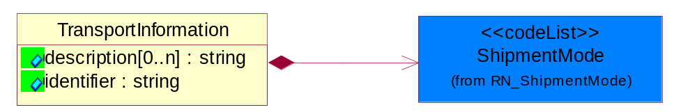
Figure ‎3-29 TransportInformation

Attribute | Type | Documentation
description[0..n] | string | Free form text description regarding the detail of a transport information.
identifier | string | Unique identifier to represent the transport information within shipment mode.

Composition | Cardinality | Type | Documentation
ShipmentMode | 1 | ShipmentMode | The method of transport used for the conveyance of goods.

CodeList

TrackingReferenceType
Code identifying the type of document reference being used to track a shipment.
Name | Documentation
BKN | Booking Number - Shipment identification number assigned by shipper when booking freight shipment with carrier.
BOL | Bill of Lading Number - Shipment identification number on bill of lading issued by shipper, forwarder or carrier.
CIN | Commercial Invoice - An invoice for customs purposes to allow the determination of the proper import/export duty/taxes.
CRN | Carrier Reference Number - Carrier assigned shipment identification number on bill of lading.
FTR | Freight Tracking Reference - Reference number that describes information about tracing shipments during the transportation process.
HAN | House Airwaybill Number - Forwarder assigned shipment identification number on bill of lading issued by forwarder.
MAB | Master Airwaybill Number - Carrier assigned shipment identification number on bill of lading issued by carrier.
OBL | Ocean Bill of Lading Number - Carrier assigned shipment identification number on bill of lading issued by carrier.
PON | Purchase Order Number.
PRO | Pro Number - Carrier assigned shipment identification number on bill of lading.
PSN | Packing Slip Number - Shipment identification number on shipment contents packing list attached to shipment.
RFI | Radio Frequency Identification (RFID).
RRN | Route Reference Number.
SID | Seal Identifier - Trailer or container seal number assigned by party closing doors on trailer or container.
SON | Seller Sales Order Number.
SRN | Shipper Reference Number - Shipper assigned shipment identification number on bill of lading issued by shipper or forwarder.
TRN | Trailer Number - Owner assigned equipment identification number on trailer.

ShipmentChangeDisposition
Code identifying the additional reasons for a change to a product shipment.
Name | Documentation
ABS | Abandon shipment.
CAS | Cancel shipment.
DES | Destroy shipment.
RES | Release shipment.
ROC | Reassignment of carrier.
RTS | Return Shipment.
SFN | Stop shipment until further notice.

ShipmentMode
The method of transport used for the conveyance of goods.
Name | Documentation
AIE | Air Express.
AIF | Air Freight.
AIR | Air.
COC | Contract Carrier.
COO | Containerized Ocean.
CPI | Customer Pickup.
EXT | Expedited Truck.
INM | Intermodal.
MAT | Mail Transport.
MOT | Motor.
OCE | Ocean.
OTH | Others.
PRC | Private Carrier.
RAI | Rail.
TRK | Truck.

PortType
Code identifying the type of ports used during a shipment.
Name | Documentation
POC | Port of Discharge - The location (port, or airport) at which shipment is off-loaded by a transportation line, not to be confused with destination which may be a point further inland. Port where cargo is discharged from conveyance.
POE | Port of Export - Location (port, airport, or Customs point) from which an export shipment leaves a country for a voyage to a foreign country (this location can be the same or different from port of loading). This is the port of exit from exporting country.
POH | Port of Transhipment - Location (port, or airport) where cargo changes conveyance (off-loaded from 1st coveyance & loaded onto 2nd conveyance). There could be multiple occurence of Ports of Transhipment.
POI | Port of Import - Location (port, airport, or Customs point) from which an imported shipment enters/admitted into the receiving/importing country. Ports of Import are officially designated by the importing country's government and as such Customs formalities would be required at this port.
POL | Port of Loading - Location at where goods are loaded into Containers (or prepared for exports).
PON | Port of Destination - The location at which the shipment is destined to be sent.
POO | Port of Origin - The location at which the shipment originates from.

PortIdentifierAuthorityCode
Code identifying the Authority maintaining the Port Identifier.
Name | Documentation
IATA | International Air Transport Association.
ICAO | International Civil Aviation Organization.
IMO | International Maritime Organization.
ISO | International Organization for Standardization.
NVOCC | Non Vessel Operating Common Carrier.
VOCC | Vessel Operating Common Carrier.

CustomsType
The type of customs.
Name | Documentation
EXP | Export.
IMP | Import.

ShipDateCode
Code identifying a type of ship date.
Name | Documentation
ACP | Acceptance.
ACT | Action.
ADY | Arrival at Destination Yard.
AED | Accrual End Date.
AFT | Actual Free Time Expiration Date.
APD | Actual Pickup Date.
APL | Actual Placement.
ASD | Accrual Start Date.
BDO | Beginning Date of Customer Plant Shutdown.
BOI | Bill of Lading Initiated Date.
BOL | Bill of Lading.
BPE | Buy Period Date (End).
BPS | Buy Period Date (Start).
BRD | Backorder Release Date.
CAD | Cancel After This Date.
CBD | Charge Back Date.
CCL | Contract Closed.
CDA | Check Date.
CFP | Contract Final Payment.
CFR | Charged From.
COD | Cutoff Date.
CPC | Contract Physically Completed.
CRE | Customs Release.
CTO | Charged To.
DAG | Delivery Appointment Granted Date.
DAR | Date Available/Constructive Replacement.
DAS | Delivery Appointment Scheduled Date.
DBT | Delivered By This Date.
DDC | Date Delivery Commenced.
DIC | Date Invoice Created.
DIS | Date Issued.
DLC | Date Loading Commenced.
DLD | Date Loading Completed.
DNB | Deliver Not Before Date.
DNL | Deliver No Later Than Date.
DOT | Delivered on This Date.
DPA | Duty Paid.
DRD | Demand Receipt Date.
DRS | Delivery Requested Scheduled Date.
DRT | Delivery Requested on This Date.
DSP | Date Shipped to Port of Embarkation (POE).
DUL | Date Unloaded.
DWO | Deliver Week Of.
ECC | Estimated Contract Completion.
ECL | Extended Closeout.
EDA | Effective Date.
EDB | Expiration Date.
EDD | Estimated Delivery Date.
EDO | Ending Date of Customer Plant Shutdown.
EES | Est. Next Promo, Ship Date End.
EFD | Equipment Furnished Date.
EPD | Earliest Pickup Date.
EPE | Est. Next Promo (Date end).
EPS | Est. Next Promo (Date start).
ERE | Expected Reply.
ESE | Est. Next Promo, Ship Date Start.
FBD | Freight Bill Date.
FOD | First Order Date.
FSD | First Ship Date.
GED | Guarantee Expiration Date.
INS | Inspection.
IVD | Invoice Date.
LAC | Last Acquisition.
LDE | Last Demand.
LPD | Latest Pickup Date.
MNF | Manufacture.
MRB | Must Respond By.
NTF | Notified.
OFD | Offered for Delivery.
OPO | Original Purchase Order Date.
ORD | Ordered.
OTR | Original Transaction.
PAG | Pickup Appointment Granted Date.
PAS | Pickup Appointment Scheduled Date.
PBD | Publication Date.
PCE | Price Change Effective Date.
PCL | Price Change Last Arrival Date.
PCM | Price Change Last Order Date.
PCO | Purchase Order Date.
PCR | Purchase Order Received.
PCS | Price Change Last Ship Date.
PDA | Pack Date.
PDE | Promotion Order Date (End).
PDS | Promotion Order Date (Start).
PFE | Promotion Floor Stock Protect (End).
PFS | Promotion Floor Stock Protect (Start).
PME | Promotion Ship Date (End).
PMO | Promotion End.
PMS | Promotion Ship Date (Start).
PMT | Promotion Start.
PPD | Preferred Payment Date.
PPE | Promotion Performance Date (End).
PPS | Promotion Performance Date (Start).
PRD | Product Receipt Date.
PRE | Period End.
PRQ | Promotion Requested Delivery Date (End).
PRS | Promotion Requested Delivery Date (Start).
PSD | Process Date.
PSH | Pickup Requested Scheduled Date.
PVE | Promotion Invoice Protection Date (End).
PVS | Promotion Invoice Protection Date (Start).
RDD | Requested Delivery Date.
REC | Recorded.
REJ | Rejection.
REL | Released.
REQ | Required By.
RPD | Requested Pack Date.
RSD | Requested Ship Date/Pick-up Date.
SDA | Scheduled Delivery Date - Appointment confirmed.
SDC | Scheduled Delivery Date - Needs confirmation.
SDD | Scheduled Delivery Date.
SHB | Ship Not Before Date.
SHL | Ship Not Later Than Date.
SHO | Shipped on This Date.
SIG | Signature.
SIS | Store Inventory Stock.
SLD | Sold Date.
SLE | Shelf-Life Expiration.
SLG | Sailing Date.
SPA | Scheduled Pick-up Date - Appointment confirmed.
SPE | Spot for Load Exchange Date (Export).
SPL | Spot for Load Date.
SPN | Scheduled Pick-up Date - Needs confirmation.
SPP | Scheduled Pick - Up Date.
SPS | Spot for Storage Date (No shipment).
SPU | Spot for Unload Date.
SSC | Scheduled Service Completion.
SUD | Superseded Date.
SWO | Ship Week Of Date.
TDD | Terms Discount Due Date.
TND | Terms Net Due Date.
TRA | Transfer.
TRS | Transaction Control Date.
VAL | Validated.
WIS | Warehouse Inventory Stock.
WRT | Warranty Expiration.

RouteLocation
Code identifying the route location of some point after a shipment is created within a carrier's system.
Name | Documentation
ACL | Activity Location - Generally used to signify an activity has happened at a location that is not on the shipment routing, or the shipment routing could not be determined by the party sending the event. Rails use this all the time, because they can report hundreds of activities for a cross-country move.
BLO | Bill Of Lading Origin Of Goods - Contractual. Origin of goods can differ from origin of shipment. Ocean carrier can take posession of goods at a load port, but the BL must state a different location. Factory door.
BWH | Bonded Warehouse.
COM | Customs Office Of Manifest Destination - Sending the customs manifest location to customer, especially for inland clearance points, since it may not be defined on the route any other way.
COO | Customs Office Of Manifest Origin.
COP | Consolidation Point.
DCP | De-Consolidation Point.
DFW | Duty Free Warehouse.
DFZ | Duty Free Zone.
EXM | Export Manufacturing.
FID | Final Destination.
FPD | Final Port of Discharge.
INP | Interim Point - Rails differentiate between transit and interim. An interim point is a passing point. A transit point is where the train is passing through a major rail facility but the train does not change in makeup - no railcars added or removed.
LGC | Logistics Center.
NDF | Non Duty Free Zone.
PDC | Place of Delivery - Contractual.
PDE | Place of Delivery.
POC | Port of Discharge - The location (port, or airport) at which shipment is off-loaded by a transportation line, not to be confused with destination which may be a point further inland. Port where cargo is discharged from conveyance.
POE | Port of Export - Location (port, airport, or Customs point) from which an export shipment leaves a country for a voyage to a foreign country (this location can be the same or different from port of loading). This is the port of exit from exporting country.
POH | Port of Transhipment - Location (port, or airport) where cargo changes conveyance (off-loaded from 1st coveyance & loaded onto 2nd conveyance). There could be multiple occurence of Ports of Transhipment.
POI | Port of Import - Location (port, airport, or Customs point) from which an imported shipment enters/admitted into the receiving/importing country. Ports of Import are officially designated by the importing country's government and as such Customs formalities would be required at this port.
POL | Port of Loading - Location at where goods are loaded into Containers (or prepared for exports).
PON | Port of Destination - The location at which the shipment is destined to be sent.
POO | Port of Origin - The location at which the shipment originates from.
POR | Place Of Receipt - Contractual. The place of receipt contractual is where the ocean carrier takes possession of the cargo.
RCP | Reconsolidation Point.

ContainerType
Code identifying ithe type of container.
Name | Documentation
BOX | Box.
CRT | Carton.
CSP | Customer Specific.
DCB | Dry/Cube.
ENV | Envelope.
ITM | Insulated/Thermal.
OTP | Open Top.
PLT | Pallet.
RFG | Refrigerated.
TNK | Tank.

Procurement

Procurement

Dependency Diagram
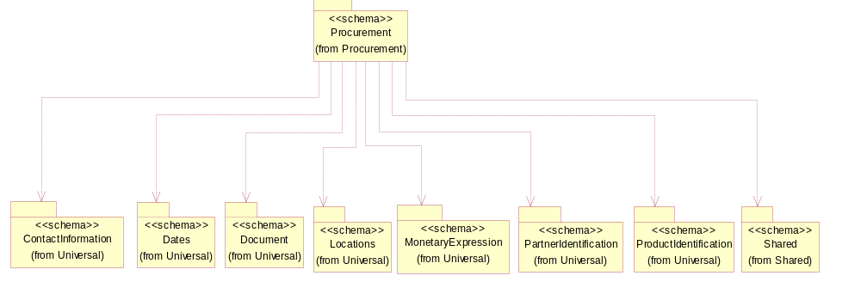
Figure ‎3-30 Dependency

RequestingOrderLineItemReference
The collection of business properties that references a line item on a requesting document.

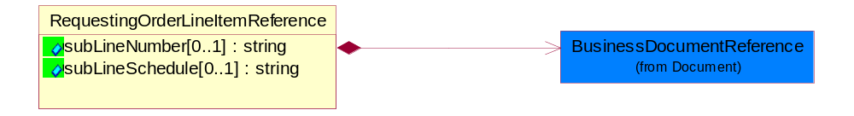
Figure ‎3-31 RequestingOrderLineItemReference
Attribute | Type | Documentation
subLineNumber[0..1] | string | Number of the subline in the document, associated with a given line number.
subLineSchedule[0..1] | string | Number of the schedule within the subline in the document, associated with a given line number.

Composition | Cardinality | Type | Documentation
BusinessDocumentReference | 1 | BusinessDocumentReference | The business document reference object allows for the indirect referencing of a relationship to other business related documents.

SpecialHandlingInstruction
The collection of business properties that describe product packaging or shipping handling instructions.
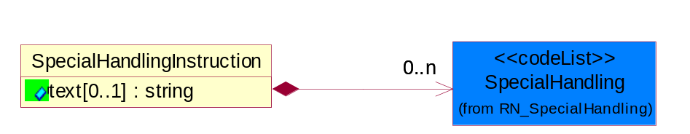
Figure ‎3-32 SpecialHandlingInstruction

Attribute | Type | Documentation
text[0..1] | string | Free form textual description for how specified goods, packages or containers should be handled.

Composition | Cardinality | Type | Documentation
SpecialHandling | 0..n | SpecialHandling | Code identifying special handling or packaging requirements for the product.

TransportationEvent
The collection of business properties that describe the occurrence of the public conveyance of goods as a commercial enterprise.
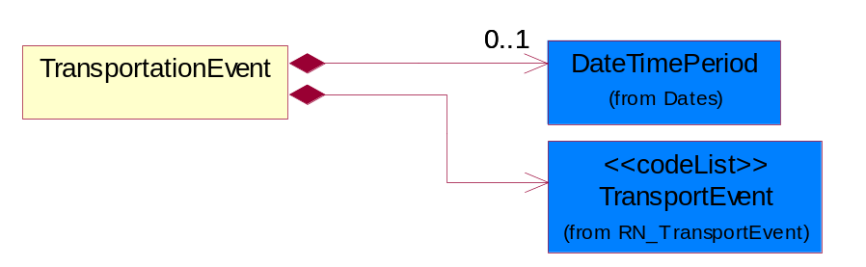
Figure ‎3-33 TransportationEvent

Composition | Cardinality | Type | Documentation
TransportEvent | 1 | TransportEvent | Code identifying an event during the transportation of a shipment.
DateTimePeriod | 0..1 | DateTimePeriod | The business document must allow for the computation or statement of a period of time based upon date and time.

CodeList

TransportEvent
Code identifying an event during the transportation of a shipment.
Name | Documentation
DOC | Dock.
PIC | Pickup.
SHP | Ship.

SpecialHandling
Code identifying special handling or packaging requirements for the product.
Name | Documentation
15M | 15 Minute Window.
24H | 24 Hour Availability.
AAO | Attachments - Advance Only Waybill.
ACC | Accepted by Carrier at Owner's Risk of Freezing.
ACD | Air Conditioning Disconnect and Connect.
ACU | Attachment - Customer's Document.
ADC | Additional Copy of Shipping Papers for Proof of Delivery.
ADF | Advanced Fee.
ADL | Advance Loading.
AGS | Armed Guard Service.
AHM | Accessible Hazardous Material.
AMD | A.M. Delivery Requirement.
ANU | Anchoring and Unanchoring.
ANV | Annual Volume.
APW | Attachment - Prepaid Waybill.
ART | Air Ride Truck Service.
ASE | Attachment - Shipper's Export Document.
ASM | Attachment - Shipper's Manifest.
ASP | Attachment - Shipper's Packing Instructions.
ASR | Assembly Service Requested.
ATD | Aggregate Tender Discount.
ATT | Air Ride Tractor Service.
AUS | Auxiliary Service.
BA1 | Bunker Adjustment - 20 Foot Container.
BA2 | Bunker Adjustment - 40 Foot Container.
BCC | Bill Consignee for Weigh Charges.
BCP | Bypass Consolidation Point.
BFS | Barge Freight All Kinds Service.
BKA | Bunker Adjustment.
BKS | Block Stowage.
BLB | Blocking and Bracing.
BLS | Blind Shipment.
BNS | If Bad Ordered Notify Shipper.
BOL | Bolster Load, Do Not Switch.
BSA | Bunker Surcharge Authorized.
BSC | Bill Shipper for Weigh Charge.
BUA | Bulky Article.
CA1 | Currency Adjustment - 20 Foot Container.
CA2 | Currency Adjustment - 40 Foot Container.
CAA | Cargo Aboard.
CAB | Chain and Binders.
CAC | Carrier Caboose.
CAR | Carrier.
CAT | Cargo Taxes.
CBC | Cargo on Board Certification Required.
CCB | Convert Commercial Bill of Lading (BOL) to Government BOL.
CCE | Certification that the Containers Being Returned Empty Were Received Filled by Rail Freight Service.
CCL | Container, Consolidator Load.
CER | Certification.
CFB | Cleared for Border Crossing.
CFC | Customs Fees - Container Level.
CFE | Cleared for Export.
CFI | Customs Fees - Lift Level.
CFL | Container, Factory Load.
CGC | Carrier Guard Car Service.
CHB | Clearinghouse Balance.
CIP | Commercial Invoice Preparation.
CIR | Circuitous Routing.
CLC | Carrier Load and Consignee Unload.
CLE | Cleaning.
CLH | Consolidation and Line Haul.
CLL | Commodity Loaded Less Than or Equal To the Car Ordered.
CLU | Carrier Load and Carrier Unload.
CNE | Certification That the Newsprint Winding Cores Being Returned Empty Were Received Filled by Rail Freight Service.
COA | Controlled Atmosphere.
COD | Container Diversion.
COL | Container Lease.
COM | Container Mounting.
CON | Conductivity/Anti-static Additive.
COO | Certificate of Origin.
COS | Completing Shipment.
COU | Consignee Unload.
COV | Courier, Overnight.
CPM | Customs Papers Mailed.
CPN | Customer Required PRO Number.
CRA | Class Rates Applied.
CRD | Comb. Rates over Detroit.
CRL | Customer Required Packing List.
CRN | Customer Required Appointment Number.
CRP | Contract Rates Apply.
CRT | Cross Town.
CSD | Courier, Same Day.
CSL | Consolidation.
CSR | Certification that this Shipment is for Recycling as Defined in Applicable Tariffs Containing Such Provisions.
CSU | Constant Surveillance.
CUI | Customs Inspection.
DAN | Dangerous.
DAR | Drop and Run.
DCE | Detention of Conveying Equipment and the Power Unit.
DEM | Demurrage.
DEP | Detention of Conveying Equipment Excluding the Power Unit.
DES | Delivery Service.
DEV | Detention (Vehicle).
DHI | Do not Hump or Hump into.
DID | Direct Delivery.
DNC | Do Not Couple to Double Shelf Couples.
DND | Do Not Divert.
DNF | Do Not Freeze.
DNH | Do Not Hump.
DNP | Do Not Pool.
DNT | Do Not Transfer Contents.
DNU | Do Not Uncouple.
DOD | DOD Constant Surveillance Service.
DOM | Domestic.
DOS | Documentation - Special.
DP1 | Detention With Power Units (30 minute periods).
DP2 | Detention With Power Units (60 minute periods).
DPD | Drayage at Port of Debarkation (Rate Zone).
DPE | Drayage at Port of Embarkation (Rate Zone).
DRO | Drop-Off Delivery.
DSR | Distribution Service Requested.
DSW | Delivery Only on Surrender of Written Order.
DVN | Delivery Verification Not Required.
DWA | Destination Weights Apply.
ECS | Escort/Courier Service.
EET | Electronic Equipment Transfer.
EHM | Endorsed as Hazardous Material.
ELB | Extra Labor.
EMM | Empty Movement.
EMR | Empty Return.
EMS | Emergency Service.
END | Endorsement.
EOS | Escort Service with Overnight Subsistence.
EPP | Export Preparation.
EPT | Export.
EQU | Equipment..
ERA | Expedited Rates Applied.
ERI | Expand Remove and Install.
ESC | Escort.
EST | Escort Services (Telephone).
EUV | Exclusive Use of Vehicle.
EVA | Excessive Valuation Authorized.
EXC | Exempt Commodity.
EXD | Extra Driver.
EXL | Extra Lights.
EXP | Expedite.
EXS | Expedited Service.
EXU | Exclusive Use.
EXW | Excessive Weight.
FIS | Filtration Service.
FLS | Flatrack Surcharge.
FOD | FOD, FOB - Destination.
FOS | FOS, FOB Shipping Point.
FPT | For Processing in Transit.
FRA | Fragile - Handle with Care.
FST | For Storage in Transit.
FUS | Full Service.
GGC | Government Guard Car.
GOC | Government-Owned Containers.
GSS | Greater Security Service.
GVC | Government Caboose.
HAL | Hold at Location.
HAN | Handling.
HAR | Harmless.
HCD | Hazardous Cargo On Deck.
HCT | High Cube Trailer Rates.
HEA | Heat.
HES | Heat - Special.
HFO | Hold for Orders.
HFR | Home for Repair.
HIT | Heat in Transit.
HMS | Hazardous Materials Surcharge.
HOR | Heater or Refrigeration.
HVL | High Value Load.
IHM | Inaccessible Hazardous Material.
IMP | Impactographs.
IMS | Import Shipment.
INB | In-bond.
IND | Inside Delivery.
INH | Inspect Hourly if Car Stopped.
INP | Inside Pickup.
INS | Insulated.
IPM | Intra-Plant Move.
ISS | Intermodal Shipment Service.
ITS | Interline Transfer Service.
JIT | Just-In-Time (JIT).
JLE | Joint Line Exception.
KFF | Keep From Freezing Percent Differential.
KMD | Keep Material Dry.
LAA | Labor Associated with Detention of Conveying Equipment.
LAB | Land Bridge (Import/Export).
LAD | Labor Disturbance.
LAO | Layover.
LAS | Layover Service.
LBD | Labor Disturbance.
LBS | Light Bar Service.
LBT | Low Boy Trailer/Flat Bed.
LC1 | Land Currency Adjustment - 40 Foot Container.
LC2 | Land Currency Adjustment Factor - 20 Foot Container.
LCA | Land Currency Adjustment - 40 Foot Container.
LCF | Land Currency Adjustment Factor - 20 Foot Container.
LDE | Labor Associated with Detention of Conveying Equipment.
LDP | Linehaul from Port of Debarkation.
LEP | Linehaul To Port of Embarkation.
LFC | Less Than Full Carload.
LFL | Less Than Container, Factory Load.
LFV | Loaded to Full Visible Capacity.
LIS | Linehaul Service.
LIU | Live Unload.
LOC | Liability of Carrier.
LOD | Loading Devices.
LPD | Linehaul Percent Differential.
LSO | Local Service Only.
LTC | Less Than Container.
LTD | Liner Terms at Port of Debarkation.
LTE | Liner Terms at Port of Embarkation.
LTL | Less Than Container, Consolidator Load.
LTT | Less Than Truckload.
MAW | Manifest Must Accompany Waybill.
MER | Mechanical Refrigeration.
MFI | Moving Under "For Furtherance Instructions" and May Be Delivered.
MOA | Modified Atmosphere.
MSS | Motor Surveillance Service.
MTS | Multi-Tank Surveillance Service.
MUP | Multiple Pickup.
NCB | Notify Consignee Before Delivery.
NEF | New Equipment First Transborder Movement.
NFE | Not for Export.
NFS | Nontransit Flat Shipment.
NMR | No Marshalling Required for Hazardous Materials.
NPR | No Placards Required.
NRC | Not Restricted Cargo.
NSB | Notify Shipper Before Reconsignment.
NSE | No Special Entrainment Required.
NSI | Notify Shipper Immediately if Shipment is Delayed en Route.
NUW | In Case of Fire Do Not Use Water.
OAH | Offshore - Alaska/Hawaii Service.
ODS | On Deck Stowage.
OHC | Over Height Container.
OTH | Other.
OVF | Overflow.
OVP | Oversized Premium.
OVW | Overweight.
OWR | One Way Rates Applied.
PAD | Pickup and Delivery.
PAS | Partial Shipment.
PAU | Pack and Unpack.
PAW | Preparation of Air Waybill - Origin.
PCC | Preparation of Canadian Customs Invoice.
PDB | Pickup and Delivery Beyond Service Area.
PDL | Percent Differential - Less Than Container.
PDS | Pickup and Delivery From Storage in Transit.
PEE | Preparation of Export Entry.
PFH | Protect From Heat.
PHR | Per Hour Rates Applied.
PIC | Preparation of Insurance Certificate.
PIT | Pier Time.
PIU | Pickup.
PLR | Protect Lowest Through Rate.
PMD | P.M. Delivery Requirement.
PMR | Per Mile Rates Apply.
POC | Port Changes.
PPC | PPC, FOB -Destination charge to customer.
PPD | PPD, Prepay+I35/Add Freight to Invoice.
PPS | Product Protection Service.
PRS | Priority Service.
PSC | Protective Security Service.
PSN | Pickup of Shipments on Saturday, Sunday, and/or Holidays Requiring Absolute Next Day Delivery.
PSP | Pallets/Skids/Platforms.
PSS | Pickup of Shipments Requiring Same Day Delivery Service.
PST | Pickup of Shipments Requiring Same Day Delivery Service and/or Delivery at a Specified Time.
PUE | Preparation of U.S. Export Documentation.
PUP | PUP Trailer Rates Apply.
RAH | Railhead Handling.
RAM | Radioactive Material.
RBC | Render Bill for Charges.
RCD | Reefer Cargo Percent Differential.
RCG | Return Carrier Guard Car Service.
RCP | Railroad Controlled Private Equipment Subject to Demurrage.
RCS | Reconsignment.
REA | Return Authorization.
REC | Return of Empty Container.
RED | Redelivery.
REF | Refrigerated.
REM | Reefer Maintenance.
RER | Reweight Requested.
RES | Reservations.
RFT | Record for Transit.
RMP | Return Movement of Pallet.
ROE | ROEE Van Type Truck.
ROS | Roadrailer Service.
RSC | Requires Shelf Couplers.
RSD | Residential Delivery.
RSM | Reshipment.
RST | Respotting.
RTS | Round Trip Service.
RUO | Rush Order.
RVC | Released Value Charge in Excess of Carrier Maximum Liability.
RWE | Roadway Easy Rates Applied.
SAD | Saturday Delivery.
SAH | Stow Away from Heat.
SAR | Shipper Authorization Required for Diversion or Consignment.
SCA | Service Charge Applies.
SCC | Shipper Load/Carrier Count.
SCG | Shipper Certifies Gross Weight under 240,000 pounds.
SCL | Apply a Uniform Code Council/International Article Numbering Association (UCC/EAN) Serial Shipping Container Label to the Shipping Containers.
SCW | Stretch Wrap.
SDS | Special Dromedary Service.
SEC | Special Equipment Charge.
SED | Shipper Export Declaration Required.
SEE | Stairs, Elevator, Excess Carry.
SES | Security Signature Service.
SFD | Single Factor Origination/Port of Debarkation.
SFO | Single Factor Origination/Destination.
SFP | Single Factor Port of Embarkation/Destination.
SFS | Satisfactory Service Standards.
SGD | Single Driver.
SHH | Shipment Holdover for Holidays.
SHL | Shiftable Load.
SHP | Sunday or Holiday Pickup or Delivery.
SHW | Shipment Holdover for Weekends.
SID | Shipment to be Inspected at Destination and Disposition Instructions will be Furnished.
SIR | Signature Required.
SIS | Single Shipment.
SLC | Shipper Load and Carrier Unload.
SLD | Split Delivery.
SLO | Shipper Load and Count.
SLP | Split Pickup.
SLS | Shipper Load and Consignee Unload.
SMP | Small Package.
SMS | Special Motor Surveillance.
SNT | Shipment from Non-Temp Storage.
SOD | Stop-off at Destination.
SOE | Shipment Holdover on Weekends.
SOH | Shipment Holdover on Holidays.
SOO | Stop-off at Origination.
SOW | Shipment Holdover on Weekdays.
SPC | Special Containers.
SPD | Saturday Pickup or Delivery.
SPL | Shipper Load.
SPP | Special Permit.
SPR | Speed Restricted.
SPS | Special Permits.
SPU | Saturday Pick-Up.
SR1 | Speed Restricted to 15 Miles per Hour.
SR2 | Speed Restricted to 25 Miles per Hour.
SR3 | Speed Restricted to 35 Miles per Hour.
SR4 | Speed Restricted to 45 Miles per Hour.
SRC | Shove to Rest and Cover.
SRG | Storage.
SSC | Stripping, Sorting and Consolidation.
SSD | Subject to Special Detention Rules/Charges.
SSN | Substitute Service Not to be Used.
SSS | Satellite Surveillance Service.
SST | Spot for Storage - No Shipment.
STM | Special Train Movement.
STO | Stop-off.
STR | Signature and Tally Record.
STT | Stack Train.
STW | Stowage.
SUR | Supervisor Requested.
SVR | Surveying Routes.
TAT | Tendered as Truckload (Truckload Service Requested).
TCL | Trailer, Consolidator Load.
TDS | Time of Delivery and Signature Required.
TEC | Temperature Control.
TER | Termination.
TFL | Trailer, Factory Load.
TFP | Transfer Product.
THC | Terminal Handling Charges.
TLO | Top Load Only.
TMV | Tendering of Multiple Vehicles.
TOC | Truckload-Double Operator-Common Carrier.
TOP | Truckload-Double Operator-Padded Van.
TOS | Total Shipment.
TPS | Third Party Service.
TRA | Truck Rates Applicable.
TRP | Trailer Preparation - Special.
TRS | Trade Show.
TSN | Transmit a Ship Notice/Manifest Transaction Set.
TSS | Transit Shipment.
TTD | Team Track Delivery.
TTR | Tentative Release - Tentatively releasing the shipment either for import or export and subject to compliance to additional conditions which could be executed later.
TVR | Time Volume Rates Only.
UAP | Unload as Placarded.
UAT | Use of Alternate Terminal.
ULS | Unload from Left Side of Car.
UNH | Use No Hooks.
UNI | Unitized.
UNP | Unpacking.
UOR | Unloading or Reloading.
UPP | Unprotected Perishable.
URS | Unload from Right Side of Car.
VEI | Ventilation Instructions.
VEW | Verification Weigh.
WAI | Waive Inspection.
WCO | Weigh to Check for Overload.
WEE | Weigh Empty.
WEV | Weight Verification.
WID | Waived Inspection - Set Direct.
WPD | Written Proof of Delivery.
WTA | Waiting Time Authorized.

Shared

Shared

Dependency Diagram
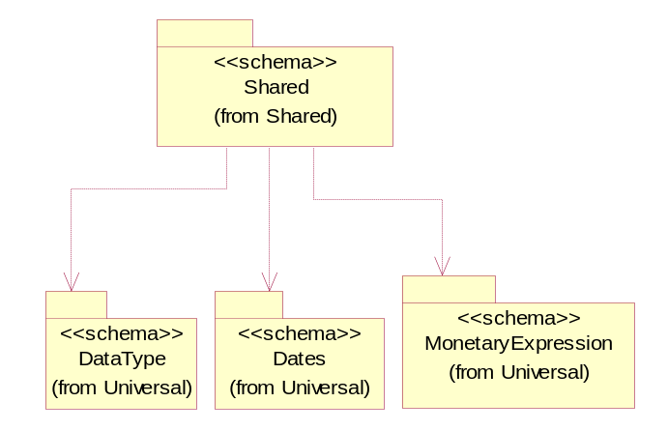
Figure ‎3-34 Dependency

ProductQuantity
A quantity specifying the number of product units.
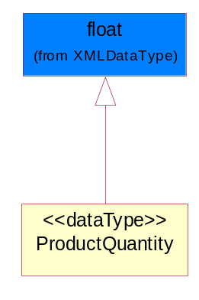
Figure ‎3-35 ProductQuantity

QuantityInformation
The collection of business properties that describes information regarding the quantity of the product shipped.
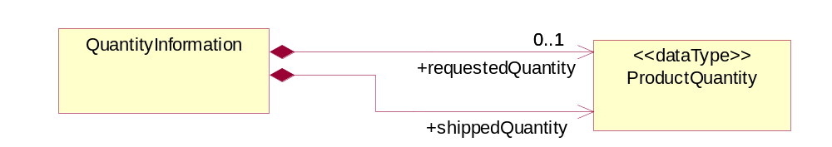
Figure ‎3-36 QuantityInformation

Composition | Cardinality | Type | Documentation
requestedQuantity | 0..1 | ProductQuantity | The quantity of product requested.
shippedQuantity | 1 | ProductQuantity | Quantity of product shipped.

SCAC
The Standard Carrier Alpha Code (SCAC) is a unique two-to-four-letter code used to identify transportation companies. NMFTA developed the SCAC identification codes in the mid 1960's to facilitate computerization in the transportation industry.

Refer http://www.nmfta.org for more detail.
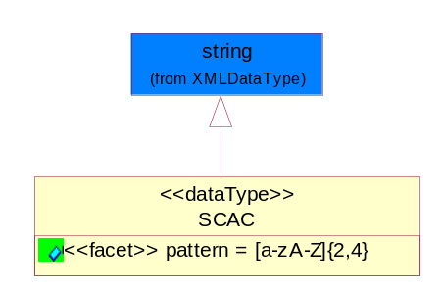
Figure ‎3-37 SCAC

Attribute | Type | Documentation
pattern |  | [a-zA-Z]{2,4}

CodeList

ShippingServiceLevel
Code identifying the shipping service level, e.g., overnight, same day.

Name | Documentation
1BD | 1BD, Same Business Day - 4 hour Response Time.
5BD | 5 Business Days.
9AM | 9 A.M.
ACH | Air Charter.
AEC | Air Economy.
AIC | Air Cargo.
AM | A.M.
ARS | Authorized Return Service.
ATA | Airport to Airport.
ATD | Airport to Door.
BCT | Bulk Commodity Train.
BUC | Business Class.
CBS | Consignee Billing Service.
COE | Courier Express.
DCR | Delivery Confirmation Return.
DEC | Delivery Confirmation.
DES | Deferred Service.
DNO | Delivery Notification Only.
DOS | Door Service.
DSN | Delivery scheduled next day by cartage agent.
DSS | Delivery scheduled second day by cartage agent.
DST | Delivery scheduled third day by cartage agent.
DTA | Door to Airport.
DTD | Door to Door.
DTP | Door to Port (Ocean).
ESP | Express Service Plus.
ESV | Expedited Service.
ESW | Expedited Service Worldwide.
EXS | Express Service.
EXW | Express Service - Worldwide.
FIC | First Class.
GEN | General.
GRO | Ground.
ISS | Other intermodal and stack service.
MAF | Manifest freight.
MET | Metro.
MUW | Multiweight.
NBD | Next Business Day.
NDA | Next Day Air.
NEM | Next Morning.
NFO | Next Flight Out.
NHW | Next day Hundred Weight.
NOR | NORMAL - Normal delivery.
NOS | Not served.
OIS | Other Intermodal and Stack service
OTH | Other.
OVN | Overnight.
PAS | Passenger service.
PIU | Pickup.
PM | PM.
PMI | Priority Mail Insured.
POB | P.O. Box/Zip code.
POD | Proof of Delivery (POD) with Signature.
PRM | Priority Mail.
PRS | Premium Surface.
PS1 | Primary Service Area - Next Day by 10:30 A.M.
PS2 | Primary Service Area - Next Day by 5:00 P.M.
PS3 | Primary Service Area - Next Day By 9:30 A.M.
PS4 | Primary Service Area - Next Day by Noon.
PS5 | Primary Service Area - Second Day by Noon.
PTD | Port to Door (Ocean).
PTP | Port to Port (Ocean).
REG | Regular.
SAD | Same day.
SAP | Saturday Pickup.
SAT | Saturday.
SBD | SBD, Second Business Day.
SCH | Scheduled.
SDA | Second Day Air.
SDW | Second Day Hundred Weight.
SED | Second Day.
SEM | Second Morning.
SGW | Standard Ground Hundred Weight.
STC | Standard Class.
STG | Standard Ground.
STO | Standard Ocean.
STS | Standard Service.
SUH | Sunday and Holidays.
TDS | Three Day Service.
TIC | Time Critical.
TRG | Tracking - Ground.

Universal Structure

ContactInformation

ContactInformation
The business document must allow for the identification of the name of the department, service or individual to be contacted regarding the context of the business document.
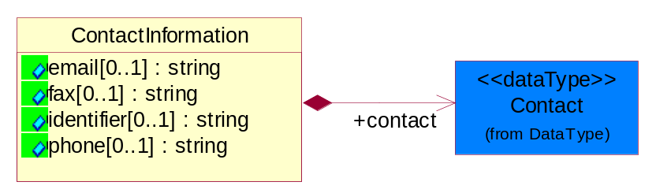
Figure ‎4-38 ContactInformation

Attribute | Type | Documentation
email[0..1] | string | The electronic mail for the specified contact.
fax[0..1] | string | The fax number for the specified contact.
identifier[0..1] | string | Identifies the role of the contact (i.e. Service Technician, Account Manager) in the Business Process.
phone[0..1] | string | The telephone number for the specified contact.

Composition | Cardinality | Type | Documentation
contact | 1 | Contact | The name of the department, service or individual to be contacted within the organization.

DataType

Contact
The name of the department, service or individual to be contacted within the organization.
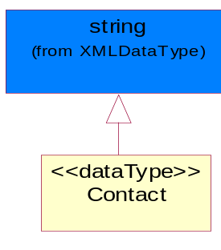
Figure ‎4-39 Contact

DUNS
A number assigned by Dun and Bradstreet to identify a business location.
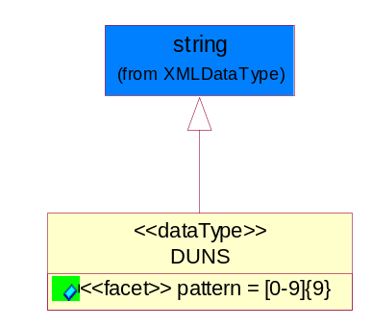
Figure ‎4-40 DUNS

Attribute | Type | Documentation
pattern |  | [0-9]{9}

DUNSPlus4
A identifier to specify a specific location within a business location.
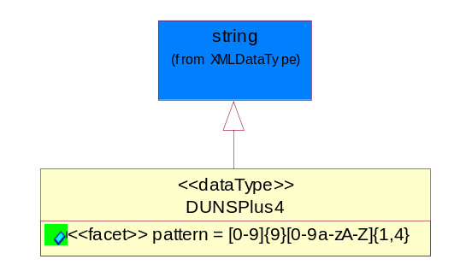
Figure ‎4-41 DUNSPlus4

Attribute | Type | Documentation
pattern |  | Data Universal Numbering System +4 (DUNS+4) number means the DUNS number assigned by Dun and Bradstreet, Inc. (D&B) plus an alphanumeric of length 4 suffix that may be assigned by a business concern.

GLN
Global Location Number (GLN) - A identifier to identify legal entities, trading parties and location.
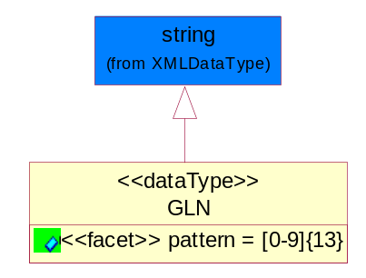
Figure ‎4-42 GLN

Attribute | Type | Documentation
pattern |  | [0-9]{13}

Dates

DateTimePeriod
The business document must allow for the computation or statement of a period of time based upon date and time.
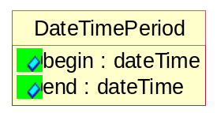
Figure ‎4-43 DateTimePeriod

Attribute | Type | Documentation
begin | dateTime | The date and time indicating the beginning of the date time period.
end | dateTime | The date and time indicating the ending of the date time period.

Document

BusinessDocumentReference
The business document reference object allows for the indirect referencing of a relationship to other business related documents.
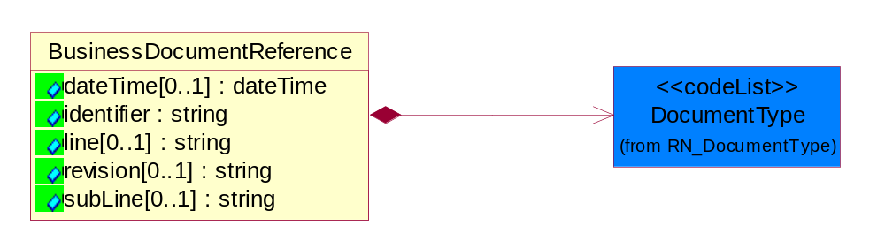
Figure ‎4-44 BusinessDocumentReference

Attribute | Type | Documentation
dateTime[0..1] | dateTime | The date-time stamp indicating on the referenced business document.
identifier | string | Unique identification of the referenced business document.
line[0..1] | string | References the specific line number of the specified business document.
revision[0..1] | string | Referenced the revision of the specified business document.
subLine[0..1] | string | References the specific subline number of the specified business document.

Composition | Cardinality | Type | Documentation
DocumentType | 1 | DocumentType | A code identifying the business context of a document.

Locations

AlternativeIdentifier
Identifies the specified code and the name of the organization that a code is utilized from.
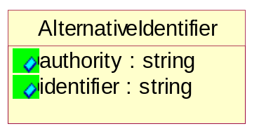
Figure ‎4-45 AlternativeIdentifier

Attribute | Type | Documentation
authority | string | The name of the organization that a code is utilized from.
identifier | string | The specified code to represent an entity (e.g. product, location, partner, etc.).

Location
The business document must specify a location.
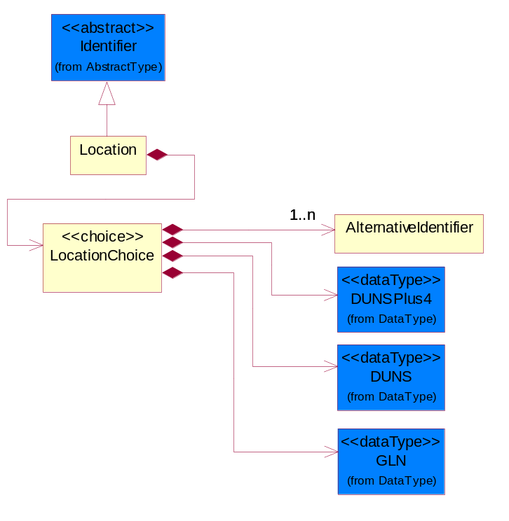
Figure ‎4-46 Location

Composition | Cardinality | Type | Documentation
LocationChoice | 1 | LocationChoice

LocationChoice
Composition | Cardinality | Type | Documentation
DUNSPlus4 | 1 | DUNSPlus4 | A identifier to specify a specific location within a business location.
DUNS | 1 | DUNS | A number assigned by Dun and Bradstreet to identify a business location.
AlternativeIdentifier | 1..n | AlternativeIdentifier | Identifies the specified code and the name of the organization that a code is utilized from.
GLN | 1 | GLN | Global Location Number (GLN) - A identifier to identify legal entities, trading parties and location.

PhysicalAddress
The business document must provide a physical address for a party to the business transaction.
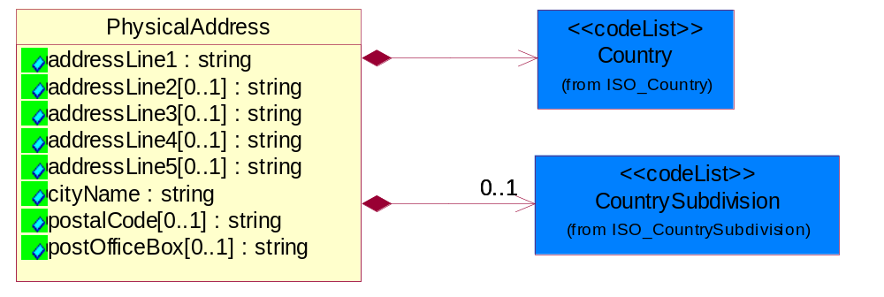
Figure ‎4-47 PhysicalAddress

Attribute | Type | Documentation
addressLine1 | string | The first line of a physical address.
addressLine2[0..1] | string | The second line of a physical address.
addressLine3[0..1] | string | The third line of a physical address.
addressLine4[0..1] | string | The fourth line of a physical address.
addressLine5[0..1] | string | The fifth line of a physical address.
cityName | string | The name of a city.
postalCode[0..1] | string | Identifying geographic location as specified by a national postal code.
postOfficeBox[0..1] | string | The Post Office Box identifier used to identify a party's post office box.

Composition | Cardinality | Type | Documentation
Country | 1 | Country | For representation of Country name RosettaNet has adopted ISO 3166-3; 1999. Refer to the following web page to get the latest version of the standard:  http://www.iso.ch/iso/en/prods-services/iso3166ma/02iso-3166-code-lists/index.html  If you need more information about the ISO standard please contact ISO for more details.
CountrySubdivision | 0..1 | CountrySubdivision | For representation of a Countries subdivisions RosettaNet has adopted ISO 3166-3; 1999. Refer to the following web page to get the latest version of the standard:  http://www.iso.ch/iso/en/prods-services/iso3166ma/02iso-3166-code-lists/index.html  If you need more information about the ISO standard please contact ISO for more details.

PartnerIdentification

FullPartner
The business document must describe the trading partners in the business transaction. This data structure provide the flexibility to describe a partner in all possible methods as for new, existing or known partner.
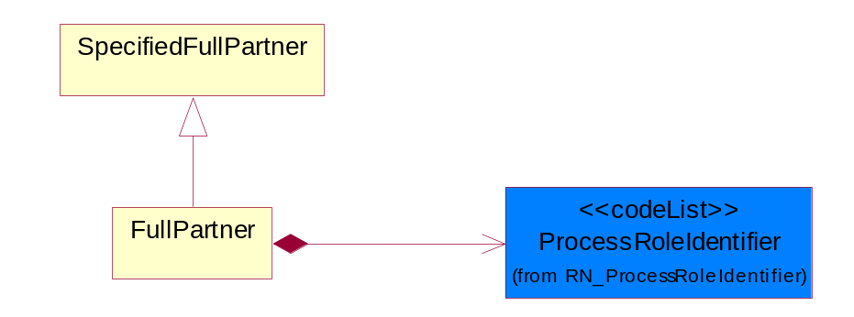
Figure ‎4-48 FullPartner

Composition | Cardinality | Type | Documentation
ProcessRoleIdentifier | 1 | ProcessRoleIdentifier | Describes the role of the partner in the business process. A partner will fulfill at least one or more roles during the business process.

IntermittentPartner
The business document must describe a physical address for a delivery.
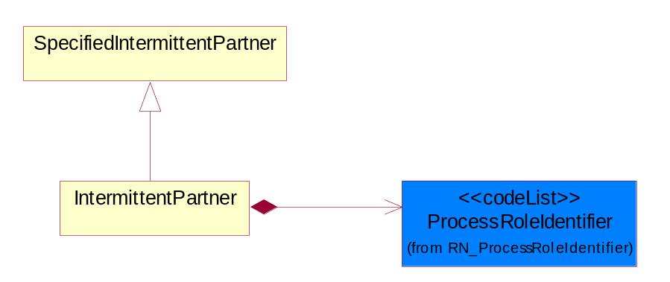
Figure ‎4-49 IntermittentPartner

Composition | Cardinality | Type | Documentation
ProcessRoleIdentifier | 1 | ProcessRoleIdentifier | Describes the role of the partner in the business process. A partner will fulfill at least one or more roles during the business process.

KnownPartner
The business document must describe the trading partners in the business transaction.
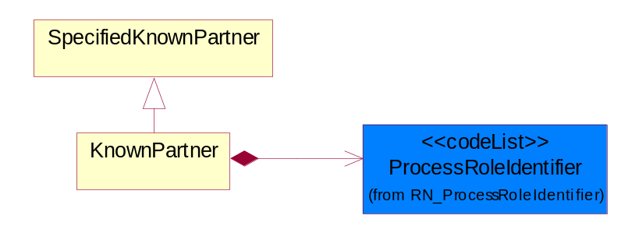
Figure ‎4-50 KnownPartner

Composition | Cardinality | Type | Documentation
ProcessRoleIdentifier | 1 | ProcessRoleIdentifier | Describes the role of the partner in the business process. A partner will fulfill at least one or more roles during the business process.

KnownPartnerContact
The business document must describe the trading partners in the business transaction.
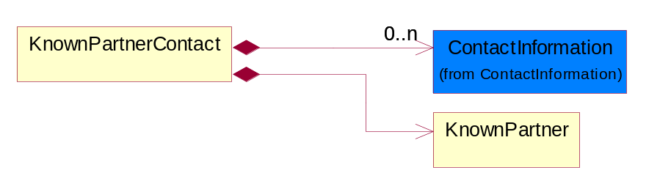
Figure ‎4-51 KnownPartnerContact

Composition | Cardinality | Type | Documentation
KnownPartner | 1 | KnownPartner | The business document must describe the trading partners in the business transaction.
ContactInformation | 0..n | ContactInformation | The business document must allow for the identification of the name of the department, service or individual to be contacted regarding the context of the business document.

NewPartner
The business document must describe a new, existing (but known to only one of the parties to the transaction) or an unknown party to the business transaction.
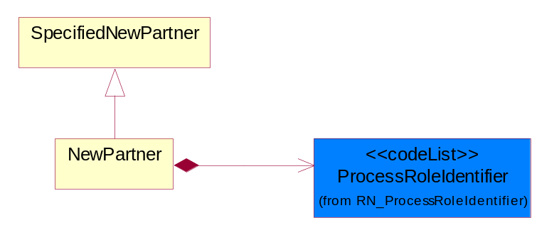
Figure ‎4-52 NewPartner

Composition | Cardinality | Type | Documentation
ProcessRoleIdentifier | 1 | ProcessRoleIdentifier | Describes the role of the partner in the business process. A partner will fulfill at least one or more roles during the business process.

PartnerDescription
The collection of business properties that describe a business partners' identity, their contact information, where they are physically located and their function in a supply chain.
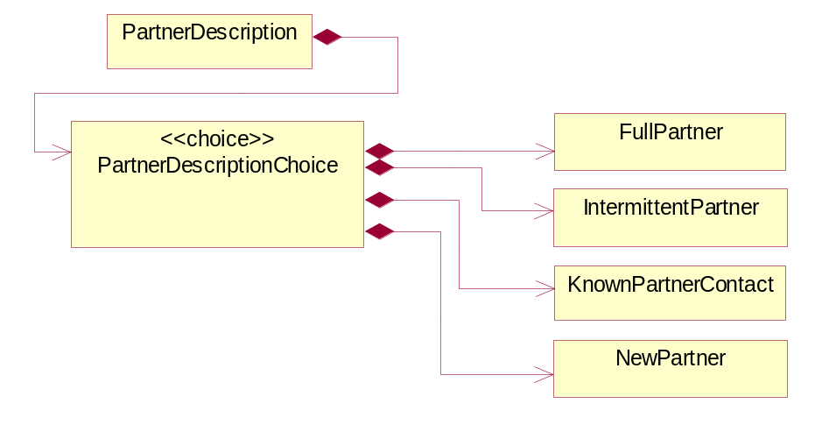
Figure ‎4-53 PartnerDescription

Composition | Cardinality | Type | Documentation
PartnerDescriptionChoice | 1 | PartnerDescriptionChoice

PartnerDescriptionChoice
Composition | Cardinality | Type | Documentation
KnownPartnerContact | 1 | KnownPartnerContact | The business document must describe the trading partners in the business transaction.
IntermittentPartner | 1 | IntermittentPartner | The business document must describe a physical address for a delivery.
NewPartner | 1 | NewPartner | The business document must describe a new, existing (but known to only one of the parties to the transaction) or an unknown party to the business transaction.
FullPartner | 1 | FullPartner | The business document must describe the trading partners in the business transaction. This data structure provide the flexibility to describe a partner in all possible methods as for new, existing or known partner.

PartnerIdentification
The business document must allow for the identity of one or more parties to the transaction.
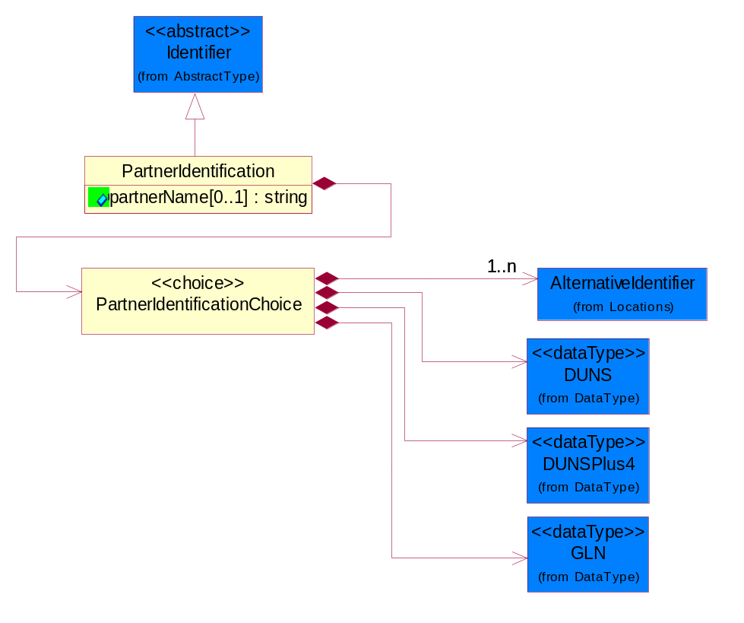
Figure ‎4-54 PartnerIdentification

Attribute | Type | Documentation
partnerName[0..1] | string | The name of the partner’s company/business.

Composition | Cardinality | Type | Documentation
PartnerIdentificationChoice | 1 | PartnerIdentificationChoice

PartnerIdentificationChoice
Composition | Cardinality | Type | Documentation
DUNS | 1 | DUNS | A number assigned by Dun and Bradstreet to identify a business location.
DUNSPlus4 | 1 | DUNSPlus4 | A identifier to specify a specific location within a business location.
AlternativeIdentifier | 1..n | AlternativeIdentifier | Identifies the specified code and the name of the organization that a code is utilized from.
GLN | 1 | GLN | Global Location Number (GLN) - A identifier to identify legal entities, trading parties and location.

SpecifiedFullPartner
The business document must describe the trading partners in the business transaction. This data structure provide the flexibility to describe a partner in all possible methods as for new, existing or known partner. This is specifically for partner who role has been specified.
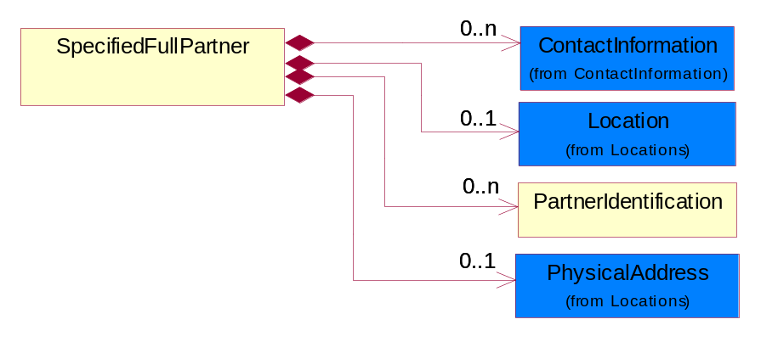
Figure ‎4-55 SpecifiedFullPartner

Composition | Cardinality | Type | Documentation
ContactInformation | 0..n | ContactInformation | The business document must allow for the identification of the name of the department, service or individual to be contacted regarding the context of the business document.
Location | 0..1 | Location | The business document must specify a location.
PartnerIdentification | 0..n | PartnerIdentification | The business document must allow for the identity of one or more parties to the transaction.
PhysicalAddress | 0..1 | PhysicalAddress | The business document must provide a physical address for a party to the business transaction.

SpecifiedIntermittentPartner
The business document must describe a physical address for a delivery.
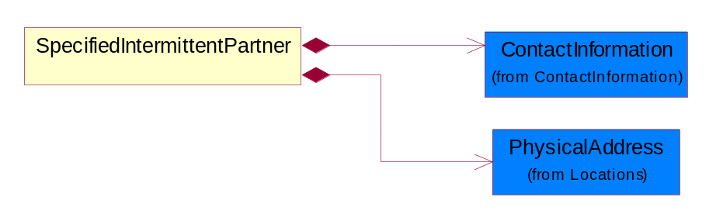
Figure ‎4-56 SpecifiedIntermittentPartner

Composition | Cardinality | Type | Documentation
ContactInformation | 1 | ContactInformation | The business document must allow for the identification of the name of the department, service or individual to be contacted regarding the context of the business document.
PhysicalAddress | 1 | PhysicalAddress | The business document must provide a physical address for a party to the business transaction.

SpecifiedKnownPartner
The business document must describe the trading partners in the business transaction.
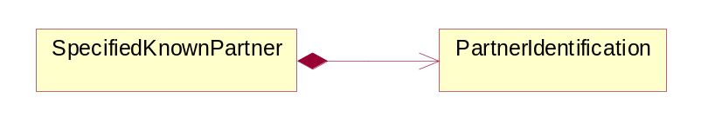
Figure ‎4-57 SpecifiedKnownPartner

Composition | Cardinality | Type | Documentation
PartnerIdentification | 1 | PartnerIdentification | The business document must allow for the identity of one or more parties to the transaction.

SpecifiedKnownPartnerContact
The business document must describe the trading partners in the business transaction and allow for a identification of an individual of the trading partner.
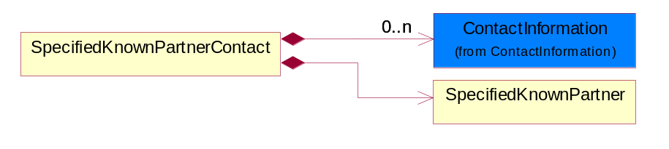
Figure ‎4-58 SpecifiedKnownPartnerContact

Composition | Cardinality | Type | Documentation
SpecifiedKnownPartner | 1 | SpecifiedKnownPartner | The business document must describe the trading partners in the business transaction.
ContactInformation | 0..n | ContactInformation | The business document must allow for the identification of the name of the department, service or individual to be contacted regarding the context of the business document.

SpecifiedNewPartner
The business document must describe a new, existing (but known to only one of the parties to the transaction) or an unknown party to the business transaction.
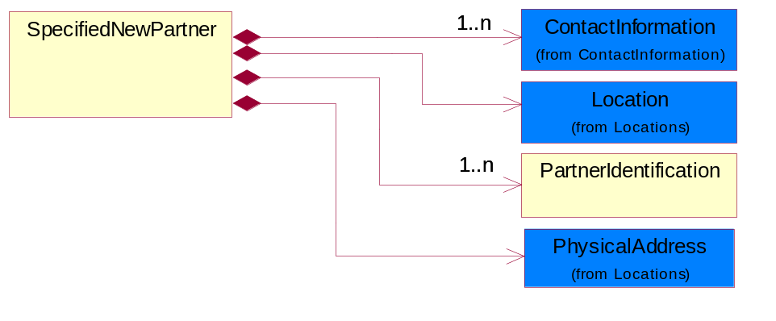
Figure ‎4-59 SpecifiedNewPartner

Composition | Cardinality | Type | Documentation
ContactInformation | 1..n | ContactInformation | The business document must allow for the identification of the name of the department, service or individual to be contacted regarding the context of the business document.
Location | 1 | Location | The business document must specify a location.
PhysicalAddress | 1 | PhysicalAddress | The business document must provide a physical address for a party to the business transaction.
PartnerIdentification | 1..n | PartnerIdentification | The business document must allow for the identity of one or more parties to the transaction.

SpecifiedPartnerDescription
The collection of business properties that describe a business partners' identity, their contact information, where they are physically located and their function in a supply chain.
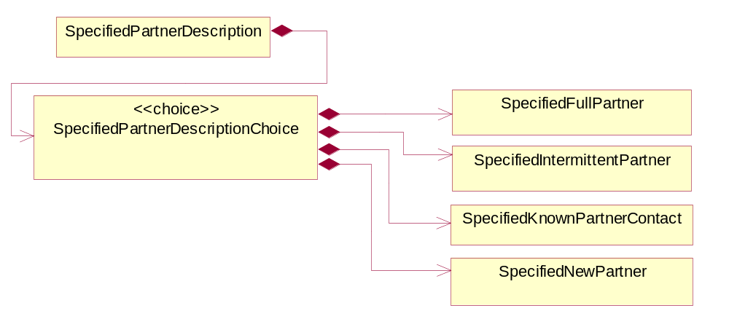
Figure ‎4-60 SpecifiedPartnerDescription

Composition | Cardinality | Type | Documentation
SpecifiedPartnerDescriptionChoice | 1 | SpecifiedPartnerDescriptionChoice

SpecifiedPartnerDescriptionChoice
Composition | Cardinality | Type | Documentation
SpecifiedKnownPartnerContact | 1 | SpecifiedKnownPartnerContact | The business document must describe the trading partners in the business transaction and allow for a identification of an individual of the trading partner.
SpecifiedIntermittentPartner | 1 | SpecifiedIntermittentPartner | The business document must describe a physical address for a delivery.
SpecifiedNewPartner | 1 | SpecifiedNewPartner | The business document must describe a new, existing (but known to only one of the parties to the transaction) or an unknown party to the business transaction.
SpecifiedFullPartner | 1 | SpecifiedFullPartner | The business document must describe the trading partners in the business transaction. This data structure provide the flexibility to describe a partner in all possible methods as for new, existing or known partner. This is specifically for partner who role has been specified.

PhysicalDimension

Measure
The business document must describe measurement information.
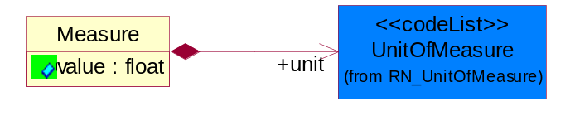
Figure ‎4-61 Measure

Attribute | Type | Documentation
value | float | The worth of an object in the specified unit of measure.

Composition | Cardinality | Type | Documentation
unit | 1 | UnitOfMeasure | To express the unit type of measurement.

Volume
The business document must be able to express the volume of an object.
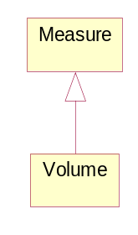
Figure ‎4-62 Volume

Weight
The business document must be able to express the weight of an object.
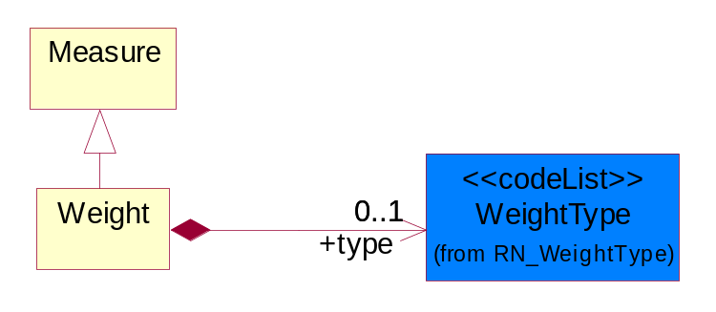
Figure ‎4-63 Weight

Composition | Cardinality | Type | Documentation
type | 0..1 | WeightType | A code identifying the type of weight.

CodeList

Country
For representation of Country name RosettaNet has adopted ISO 3166-3; 1999. Refer to the following web page to get the latest version of the standard:
http://www.iso.ch/iso/en/prods-services/iso3166ma/02iso-3166-code-lists/index.html

If you need more information about the ISO standard please contact ISO for more details.

CountrySubdivision
For representation of a Countries subdivisions RosettaNet has adopted ISO 3166-3; 1999. Refer to the following web page to get the latest version of the standard:
http://www.iso.ch/iso/en/prods-services/iso3166ma/02iso-3166-code-lists/index.html

If you need more information about the ISO standard please contact ISO for more details.

Language
For representation of Language name RosettaNet has adopted ISO 639-2; 1998. Refer to the following web page to get the latest version of the standard:

http://www.loc.gov/standards/iso639-2/iso639jac.html

If you need more information about the ISO standard please contact ISO for more details.

DocumentType
A code identifying the business context of a document.
Instance | Documentation
ARA | Authorization Request Approval.
CBN | Product batch number of customer.
CCN | Customs clearance number.
CFA | Failure Analysis - Request document that will accompany the product providing characteristics of the component failure.
CIN | Commercial Invoice.
CNM | Traditional credit note or memo.
CON | In a virtual sourcing relationship, a third party trading partner is supplying a part to a customer on behalf of another company that has taken the order for the customer. In this case a Customer Order Number is associated to the request for material that is sent to the virtual trading partners.
COS | Consumption Notice.
COT | Contract.
CRN | Unique consumption reference number identifying the product consumption issue i.e. one-to-one relationship with physical flow.
DEM | Traditional debit note or memo.
DEN | Delivery Note.
DIN | Discontinuation Notice.
DOR | Delivery Order.
DRN | Drawing Number.
DRR | Design Registration Request.
ECO | Engineering Change Order - The proprietary unique identification number that represents an engineering change order.
EIR | Engineering Information Request.
EOL | End of Life.
FUO | Sales order or transfer order fulfilling demand out of a facility (outbound shipment).
INV | Invoice.
LID | Location Identifier. Data for on-site work that have to be done on the machine (associated with preventive maintenance order).
MEN | Master Event Number.
MID | Machine Identifier. Data for on-site work that have to be done on the machine (associated with preventive maintenance order).
MON | Model Number.
OCL | The unique identifier assigned by the OEM for a warranty claim.
OGA | Other governmental agency issued document.
OPO | The unique identifier assigned by the OEM for a part order.
OPR | The unique identifier assigned by the OEM for a part return.
PCN | Product/Process Change.
PFA | Failure Analysis - Request document that will accompany the product providing characteristics of the product failure.
PII | Refers to previously issued invoice.
PLS | Unique number that identifies packing form prior to shipment.
POI | Purchase Order IN.
PON | Production order number for material release.
POO | Purchase Order OUT.
PRC | Product Catalog.
PSI | Refers to previously issued self-billing invoice.
PUO | Purchase Order.
QUO | Quote.
REC | Document identifying the receipt of materials or products into a facility against a purchase order or transfer order (inbound shipment).
REO | Purchase order or transfer order replenishing inventory into a facility (inbound shipment).
REQ | Requisition.
RMA | Returned Material Authorization.
RPO | Purchase order for materials or product returned to and reworked by a supplier.
RTA | Remittance Advice - Remittance details.
SAO | Sales Order.
SBC | Credit Memo used in self-billing scenario.
SBD | Debit Memo used in self-billing scenario.
SBI | Invoice in self billing scenario.
SBN | Product batch number of supplier.
SCA | Similar to contracts - Contains the quantity of an article that is to be ordered from a vendor and the price for article or service that is to be procured.
SEN | Serial Number.
SEO | A document that gives a repair provider the necessary authorization to repair or upgrade a product either at the customer site or at the repair provider’s site.
SHD | Shipping Document.
SNC | Shipset Number on Code List.
SPC | The unique identifier assigned by the ASP for a warranty claim.
SPN | Spec Number.
SPO | The unique identifier assigned by the ASP for a part order.
SPR | The unique identifier assigned by the ASP for a part return.
SPW | The unique identifier assigned by the ASP to reference a work order.
SRI | A document that contains the shipping reference number which allows the product to be tracked within the outsourced logistic providers network.
TRO | Order which results in materials or products being moved from one facility to another (outbound shipment and inbound shipment).
WAB | Waybill.
WAC | Denotes a warranty claim.
WOO | Work Order.

MimeTypeQualifier
The MIME type as defined by IANA.

Please refer to http://www.iana.org/assignments/media-types/ for a list of types.

Instance | Documentation
application/activemessage | [Shapiro]
application/andrew-inset | [Borenstein]
application/applefile | [Faltstrom]
application/atomicmail | [Borenstein]
application/batch-SMTP | [RFC2442]
application/beep+xml | [RFC3080]
application/cals-1840 | [RFC1895]
application/cnrp+xml | [RFCCNRP]
application/commonground | [Glazer]
application/cpl+xml
application/cybercash | [Eastlake]
application/dca-rft | [Campbell]
application/dec-dx | [Campbell]
application/dicom | [RFC3240]
application/dvcs | [RFC3029]
application/EDI-Consent | [RFC1767]
application/EDIFACT | [RFC1767]
application/EDI-X12 | [RFC1767]
application/eshop | [Katz]
application/font-tdpfr | [RFC3073]
application/http | [RFC2616]
application/hyperstudio | [Domino]
application/iges | [Parks]
application/index | [RFC2652]
application/index.cmd | [RFC2652]
application/index.obj | [RFC2652]
application/index.response | [RFC2652]
application/index.vnd | [RFC2652]
application/iotp | [RFC2935]
application/ipp | [RFC2910]
application/isup | [RFC3204]
application/mac-binhex40 | [Faltstrom]
application/macwriteii | [Lindner]
application/marc | [RFC2220]
application/mathematica | [Van Nostern]
application/msword | [Lindner]
application/news-message-id | [RFC1036,Spencer]
application/news-transmission | [RFC1036, Spencer]
application/ocsp-request | [RFC2560]
application/ocsp-response | [RFC2560]
application/octet-stream | [RFC2045,RFC2046]
application/oda | [RFC2045,RFC2046]
application/ogg | [RFC-walleij-ogg-mediatype-08.txt]
application/parityfec | [RFC3009]
application/pdf | [Lindner]
application/pgp-encrypted | [RFC3156]
application/pgp-keys | [RFC3156]
application/pgp-signature | [RFC3156]
application/pkcs10 | [RFC2311]
application/pkcs7-mime | [RFC2311]
application/pkcs7-signature | [RFC2311]
application/pkix-cert | [RFC2585]
application/pkixcmp | [RFC2510]
application/pkix-crl | [RFC2585]
application/postscript | [RFC2045,RFC2046]
application/prs.alvestrand.titrax-sheet | [Alvestrand]
application/prs.cww | [Rungchavalnont]
application/prs.nprend | [Doggett]
application/prs.plucker | [Janssen]
application/qsig | [RFC3204]
application/reginfo+xml | [RFC-ietf-sipping-reg-event-00.txt]
application/remote-printing | [RFC1486,Rose]
application/riscos | [Smith]
application/rtf | [Lindner]
application/sdp | [RFC2327]
application/set-payment | [Korver]
application/set-payment-initiation | [Korver]
application/set-registration | [Korver]
application/set-registration-initiation | [Korver]
application/sgml | [RFC1874]
application/sgml-open-catalog | [Grosso]
application/sieve | [RFC3028]
application/slate | [Crowley]
application/timestamp-query | [RFC3161]
application/timestamp-reply | [RFC3161]
application/tve-trigger | [Welsh]
application/vemmi | [RFC2122]
application/vnd.3gpp.pic-bw-large | [Meredith]
application/vnd.3gpp.pic-bw-small | [Meredith]
application/vnd.3gpp.pic-bw-var | [Meredith]
application/vnd.3gpp.sms | [Meredith]
application/vnd.3M.Post-it-Notes | [O'Brien]
application/vnd.accpac.simply.aso | [Leow]
application/vnd.accpac.simply.imp | [Leow]
application/vnd.acucobol | [Lubin]
application/vnd.acucorp | [Lubin]
application/vnd.adobe.xfdf | [Perelman]
application/vnd.aether.imp | [Moskowitz]
application/vnd.amiga.ami | [Blumberg]
application/vnd.anser-web-certificate-issue-initiation | [Mori]
application/vnd.anser-web-funds-transfer-initiation | [Mori]
application/vnd.audiograph | [Slusanschi]
application/vnd.blueice.multipass | [Holmstrom]
application/vnd.bmi | [Gotoh]
application/vnd.businessobjects | [Imoucha]
application/vnd.canon-cpdl | [Muto]
application/vnd.canon-lips | [Muto]
application/vnd.cinderella | [Kortenkamp]
application/vnd.claymore | [Simpson]
application/vnd.commerce-battelle | [Applebaum]
application/vnd.commonspace | [Chandhok]
application/vnd.contact.cmsg | [Patz]
application/vnd.cosmocaller | [Dellutri]
application/vnd.ctc-posml | [Kohlhepp]
application/vnd.cups-postscript | [Sweet]
application/vnd.cups-raster | [Sweet]
application/vnd.cups-raw | [Sweet]
application/vnd.curl | [Byrnes]
application/vnd.cybank | [Helmee]
application/vnd.data-vision.rdz | [Fields]
application/vnd.dna | [Searcy]
application/vnd.dpgraph | [Parker]
application/vnd.dreamfactory | [Appleton]
application/vnd.dxr | [Duffy]
application/vnd.ecdis-update | [Buettgenbach]
application/vnd.ecowin.chart | [Olsson]
application/vnd.ecowin.filerequest | [Olsson]
application/vnd.ecowin.fileupdate | [Olsson]
application/vnd.ecowin.series | [Olsson]
application/vnd.ecowin.seriesrequest | [Olsson]
application/vnd.ecowin.seriesupdate | [Olsson]
application/vnd.enliven | [Santinelli]
application/vnd.epson.esf | [Hoshina]
application/vnd.epson.msf | [Hoshina]
application/vnd.epson.quickanime | [Gu]
application/vnd.epson.salt | [Nagatomo]
application/vnd.epson.ssf | [Hoshina]
application/vnd.ericsson.quickcall | [Tidwell]
application/vnd.eudora.data | [Resnick]
application/vnd.fdf | [Zilles]
application/vnd.ffsns | [Holstage]
application/vnd.FloGraphIt | [Floersch]
application/vnd.framemaker | [Wexler]
application/vnd.fsc.weblaunch | [D.Smith]
application/vnd.fujitsu.oasys | [Togashi]
application/vnd.fujitsu.oasys2 | [Togashi]
application/vnd.fujitsu.oasys3 | [Okudaira]
application/vnd.fujitsu.oasysgp | [Sugimoto]
application/vnd.fujitsu.oasysprs | [Ogita]
application/vnd.fujixerox.ddd | [Onda]
application/vnd.fujixerox.docuworks | [Taguchi]
application/vnd.fujixerox.docuworks.binder | [Matsumoto]
application/vnd.fut-misnet | [Pruulmann]
application/vnd.grafeq | [Tupper]
application/vnd.groove-account | [Joseph]
application/vnd.groove-help | [Joseph]
application/vnd.groove-identity-message | [Joseph]
application/vnd.groove-injector | [Joseph]
application/vnd.groove-tool-message | [Joseph]
application/vnd.groove-tool-template | [Joseph]
application/vnd.groove-vcard | [Joseph]
application/vnd.hbci | [Hammann]
application/vnd.hhe.lesson-player | [Jones]
application/vnd.hp-HPGL | [Pentecost]
application/vnd.hp-hpid | [Gupta]
application/vnd.hp-hps | [Aubrey]
application/vnd.hp-PCL | [Pentecost]
application/vnd.hp-PCLXL | [Pentecost]
application/vnd.httphone | [Lefevre]
application/vnd.hzn-3d-crossword | [Minnis]
application/vnd.ibm.afplinedata | [Buis]
application/vnd.ibm.electronic-media | [Tantlinger]
application/vnd.ibm.MiniPay | [Herzberg]
application/vnd.ibm.modcap | [Hohensee]
application/vnd.ibm.secure-container | [Tantlinger]
application/vnd.informix-visionary | [Gales]
application/vnd.intercon.formnet | [Gurak]
application/vnd.intertrust.digibox | [Tomasello]
application/vnd.intertrust.nncp | [Tomasello]
application/vnd.intu.qbo | [Scratchley]
application/vnd.intu.qfx | [Scratchley]
application/vnd.irepository.package+xml | [Knowles]
application/vnd.is-xpr | [Natarajan]
application/vnd.japannet-directory-service | [Fujii]
application/vnd.japannet-jpnstore-wakeup | [Yoshitake]
application/vnd.japannet-payment-wakeup | [Fujii]
application/vnd.japannet-registration | [Yoshitake]
application/vnd.japannet-registration-wakeup | [Fujii]
application/vnd.japannet-setstore-wakeup | [Yoshitake]
application/vnd.japannet-verification | [Yoshitake]
application/vnd.japannet-verification-wakeup | [Fujii]
application/vnd.jisp | [Deckers]
application/vnd.kde.karbon | [Faure]
application/vnd.kde.kchart | [Faure]
application/vnd.kde.kformula | [Faure]
application/vnd.kde.kivio | [Faure]
application/vnd.kde.kontour | [Faure]
application/vnd.kde.kpresenter | [Faure]
application/vnd.kde.kspread | [Faure]
application/vnd.kde.kword | [Faure]
application/vnd.kenameaapp | [DiGiorgio-Haag]
application/vnd.koan | [Cole]
application/vnd.liberty-request+xml | [McDowell]
application/vnd.llamagraphics.life-balance.desktop | [White]
application/vnd.lotus-1-2-3 | [Wattenberger]
application/vnd.lotus-approach | [Wattenberger]
application/vnd.lotus-freelance | [Wattenberger]
application/vnd.lotus-notes | [Laramie]
application/vnd.lotus-organizer | [Wattenberger]
application/vnd.lotus-screencam | [Wattenberger]
application/vnd.lotus-wordpro | [Wattenberger]
application/vnd.mcd | [Gotoh]
application/vnd.mediastation.cdkey | [Flurry]
application/vnd.meridian-slingshot | [Wedel]
application/vnd.micrografx.flo | [Prevo]
application/vnd.micrografx.igx | [Prevo]
application/vnd.mif | [Wexler]
application/vnd.minisoft-hp3000-save | [Bartram]
application/vnd.mitsubishi.misty-guard.trustweb | [Tanaka]
application/vnd.Mobius.DAF | [Kabayama]
application/vnd.Mobius.DIS | [Kabayama]
application/vnd.Mobius.MBK | [Devasia]
application/vnd.Mobius.MQY | [Devasia]
application/vnd.Mobius.MSL | [Kabayama]
application/vnd.Mobius.PLC | [Kabayama]
application/vnd.Mobius.TXF | [Kabayama]
application/vnd.mophun.application | [Wennerstrom]
application/vnd.mophun.certificate | [Wennerstrom]
application/vnd.motorola.flexsuite | [Patton]
application/vnd.motorola.flexsuite.adsi | [Patton]
application/vnd.motorola.flexsuite.fis | [Patton]
application/vnd.motorola.flexsuite.gotap | [Patton]
application/vnd.motorola.flexsuite.kmr | [Patton]
application/vnd.motorola.flexsuite.ttc | [Patton]
application/vnd.motorola.flexsuite.wem | [Patton]
application/vnd.mozilla.xul+xml | [McDaniel]
application/vnd.ms-artgalry | [Slawson]
application/vnd.ms-asf | [Fleischman]
application/vnd.mseq | [Le Bodic]
application/vnd.ms-excel | [Gill]
application/vnd.msign | [Borcherding]
application/vnd.ms-lrm | [Ledoux]
application/vnd.ms-powerpoint | [Gill]
application/vnd.ms-project | [Gill]
application/vnd.ms-tnef | [Gill]
application/vnd.ms-works | [Gill]
application/vnd.ms-wpl | [Plastina]
application/vnd.musician | [Adams]
application/vnd.music-niff | [Butler]
application/vnd.netfpx | [Mutz]
application/vnd.noblenet-directory | [Solomon]
application/vnd.noblenet-sealer | [Solomon]
application/vnd.noblenet-web | [Solomon]
application/vnd.novadigm.EDM | [Swenson]
application/vnd.novadigm.EDX | [Swenson]
application/vnd.novadigm.EXT | [Swenson]
application/vnd.obn | [Hessling]
application/vnd.osa.netdeploy | [Klos]
application/vnd.palm | [Peacock]
application/vnd.pg.format | [Gandert]
application/vnd.pg.osasli | [Gandert]
application/vnd.powerbuilder6 | [Guy]
application/vnd.powerbuilder6-s | [Guy]
application/vnd.powerbuilder7 | [Shilts]
application/vnd.powerbuilder75 | [Shilts]
application/vnd.powerbuilder75-s | [Shilts]
application/vnd.powerbuilder7-s | [Shilts]
application/vnd.previewsystems.box | [Smolgovsky]
application/vnd.publishare-delta-tree | [Ben-Kiki]
application/vnd.pvi.ptid1 | [Lamb]
application/vnd.pwg-multiplexed | [RFC3391]
application/vnd.pwg-xhtml-print+xml | [Wright]
application/vnd.Quark.QuarkXPress | [Scheidler]
application/vnd.rapid | [Szekely]
application/vnd.s3sms | [Tarkkala]
application/vnd.sealed.net | [Lambert]
application/vnd.seemail | [Webb]
application/vnd.shana.informed.formdata | [Selzler]
application/vnd.shana.informed.formtemplate | [Selzler]
application/vnd.shana.informed.interchange | [Selzler]
application/vnd.shana.informed.package | [Selzler]
application/vnd.smaf | [Takahashi]
application/vnd.sss-cod | [Dani]
application/vnd.sss-dtf | [Bruno]
application/vnd.sss-ntf | [Bruno]
application/vnd.street-stream | [Levitt]
application/vnd.svd | [Becker]
application/vnd.swiftview-ics | [Widener]
application/vnd.triscape.mxs | [Simonoff]
application/vnd.trueapp | [Hepler]
application/vnd.truedoc | [Chase]
application/vnd.ufdl | [Manning]
application/vnd.uplanet.alert | [Martin]
application/vnd.uplanet.alert-wbxml | [Martin]
application/vnd.uplanet.bearer-choice | [Martin]
application/vnd.uplanet.bearer-choice-wbxml | [Martin]
application/vnd.uplanet.cacheop | [Martin]
application/vnd.uplanet.cacheop-wbxml | [Martin]
application/vnd.uplanet.channel | [Martin]
application/vnd.uplanet.channel-wbxml | [Martin]
application/vnd.uplanet.list | [Martin]
application/vnd.uplanet.listcmd | [Martin]
application/vnd.uplanet.listcmd-wbxml | [Martin]
application/vnd.uplanet.list-wbxml | [Martin]
application/vnd.uplanet.signal | [Martin]
application/vnd.vcx | [T.Sugimoto]
application/vnd.vectorworks | [Pharr]
application/vnd.vidsoft.vidconference | [Hess]
application/vnd.visio | [Sandal]
application/vnd.visionary | [Aravindakumar]
application/vnd.vividence.scriptfile | [Risher]
application/vnd.vsf | [Rowe]
application/vnd.wap.sic | [WAP-Forum]
application/vnd.wap.slc | [WAP-Forum]
application/vnd.wap.wbxml | [Stark]
application/vnd.wap.wmlc | [Stark]
application/vnd.wap.wmlscriptc | [Stark]
application/vnd.webturbo | [Rehem]
application/vnd.wrq-hp3000-labelled | [Bartram]
application/vnd.wt.stf | [Wohler]
application/vnd.wv.csp+wbxml | [Salmi]
application/vnd.xara | [Matthewman]
application/vnd.xfdl | [Manning]
application/vnd.yellowriver-custom-menu | [Yellow]
application/whoispp-query | [RFC2957]
application/whoispp-response | [RFC2958]
application/wita | [Campbell]
application/wordperfect5.1 | [Lindner]
application/x400-bp | [RFC1494]
application/xhtml+xml | [RFC3236]
application/xml | [RFC3023]
application/xml-dtd | [RFC3023]
application/xml-external-parsed-entity | [RFC3023]
application/zip | [Lindner]
audio/32kadpcm | [RFC2421,RFC2422]
audio/AMR | [RFC3267]
audio/AMR-WB | [RFC3267]
audio/basic | [RFC2045,RFC2046]
audio/CN | [RFC3389]
audio/DAT12 | [RFC3190]
audio/DVI4
audio/EVRC | [RFC-ietf-avt-evrc-smv-03.txt]
audio/EVRC0 | [RFC-ietf-avt-evrc-smv-03.txt]
audio/G.722.1 | [RFC3047]
audio/G722
audio/G723
audio/G726-16
audio/G726-24
audio/G726-32
audio/G726-40
audio/G728
audio/G729
audio/G729D
audio/G729E
audio/GSM
audio/GSM-EFR
audio/L16 | [RFC2586]
audio/L20 | [RFC3190]
audio/L24 | [RFC3190]
audio/L8
audio/LPC
audio/MP4A-LATM | [RFC3016]
audio/MPA
audio/mpa-robust | [RFC3119]
audio/mpeg | [RFC3003]
audio/parityfec | [RFC3009]
audio/PCMA
audio/PCMU
audio/prs.sid | [Walleij]
audio/QCELP
audio/RED
audio/SMV | [RFC-ietf-avt-evrc-smv-03.txt]
audio/SMV0 | [RFC-ietf-avt-evrc-smv-03.txt]
audio/telephone-event | [RFC2833]
audio/tone | [RFC2833]
audio/VDVI
audio/vnd.3gpp.iufp | [Belling]
audio/vnd.cisco.nse | [Kumar]
audio/vnd.cns.anp1 | [McLaughlin]
audio/vnd.cns.inf1 | [McLaughlin]
audio/vnd.digital-winds | [Strazds]
audio/vnd.everad.plj | [Cicelsky]
audio/vnd.lucent.voice | [Vaudreuil]
audio/vnd.nortel.vbk | [Parsons]
audio/vnd.nuera.ecelp4800 | [Fox]
audio/vnd.nuera.ecelp7470 | [Fox]
audio/vnd.nuera.ecelp9600 | [Fox]
audio/vnd.octel.sbc | [Vaudreuil]
audio/vnd.qcelp | [Lundblade]
audio/vnd.rhetorex.32kadpcm | [Vaudreuil]
audio/vnd.vmx.cvsd | [Vaudreuil]
image/cgm | Computer Graphics Metafile
image/g3fax | [RFC1494]
image/gif | [RFC2045,RFC2046]
image/ief | [RFC1314] Image Exchange Format
image/jpeg | [RFC2045,RFC2046]
image/naplps | [Ferber]
image/png | [Randers-Pehrson]
image/prs.btif | [Simon]
image/prs.pti | [Laun]
image/t38 | [RFC3362]
image/tiff | [RFC3302] Tag Image File Format
image/tiff-fx | [RFC3250] Tag Image File Format Fax eXtended
image/vnd.cns.inf2 | [McLaughlin]
image/vnd.djvu | [Bottou]
image/vnd.dwg | [Moline]
image/vnd.dxf | [Moline]
image/vnd.fastbidsheet | [Becker]
image/vnd.fpx | [Spencer]
image/vnd.fst | [Fuldseth]
image/vnd.fujixerox.edmics-mmr | [Onda]
image/vnd.fujixerox.edmics-rlc | [Onda]
image/vnd.globalgraphics.pgb | [Bailey]
image/vnd.mix | [Reddy]
image/vnd.ms-modi | [Vaughan]
image/vnd.net-fpx | [Spencer]
image/vnd.svf | [Moline]
image/vnd.wap.wbmp | [Stark]
image/vnd.xiff | [S.Martin]
message/delivery-status | [RFC1894]
message/disposition-notification | [RFC2298]
message/external-body | [RFC2045,RFC2046]
message/http | [RFC2616]
message/news | [RFC 1036, H.Spencer]
message/partial | [RFC2045,RFC2046]
message/rfc822 | [RFC2045,RFC2046]
message/s-http | [RFC2660]
message/sip | [RFC3261]
message/sipfrag | [RFC3420]
model/iges | [Parks]
model/mesh | [RFC2077]
model/vnd.dwf | [Pratt]
model/vnd.flatland.3dml | [Powers]
model/vnd.gdl | [Babits]
model/vnd.gs-gdl | [Babits]
model/vnd.gtw | [Ozaki]
model/vnd.mts | [Rabinovitch]
model/vnd.parasolid.transmit.binary | [Parasolid]
model/vnd.parasolid.transmit.text | [Parasolid]
model/vnd.vtu | [Rabinovitch]
model/vrml | [RFC2077]
multipart/alternative | [RFC2045,RFC2046]
multipart/appledouble | [Faltstrom]
multipart/byteranges | [RFC2068]
multipart/digest | [RFC2045,RFC2046]
multipart/encrypted | [RFC1847]
multipart/form-data | [RFC2388]
multipart/header-set | [Crocker]
multipart/mixed | [RFC2045,RFC2046]
multipart/parallel | [RFC2045,RFC2046]
multipart/related | [RFC2387]
multipart/report | [RFC1892]
multipart/signed | [RFC1847]
multipart/voice-message | [RFC2421,RFC2423]
text/calendar | [RFC2445]
text/css | [RFC2318]
text/directory | [RFC2425]
text/enriched | [RFC1896]
text/html | [RFC2854]
text/parityfec | [RFC3009]
text/plain | [RFC2646,RFC2046]
text/prs.lines.tag | [Lines]
text/rfc822-headers | [RFC1892]
text/richtext | [RFC2045,RFC2046]
text/rtf | [Lindner]
text/sgml | [RFC1874]
text/t140 | [RFC2793]
text/tab-separated-values | [Lindner]
text/uri-list | [RFC2483]
text/vnd.abc | [Allen]
text/vnd.curl | [Byrnes]
text/vnd.DMClientScript | [Bradley]
text/vnd.fly | [Gurney]
text/vnd.fmi.flexstor | [Hurtta]
text/vnd.in3d.3dml | [Powers]
text/vnd.in3d.spot | [Powers]
text/vnd.IPTC.NewsML | [IPTC]
text/vnd.IPTC.NITF | [IPTC]
text/vnd.latex-z | [Lubos]
text/vnd.motorola.reflex | [Patton]
text/vnd.ms-mediapackage | [Nelson]
text/vnd.net2phone.commcenter.command | [Xie]
text/vnd.sun.j2me.app-descriptor | [G.Adams]
text/vnd.wap.si | [WAP-Forum]
text/vnd.wap.sl | [WAP-Forum]
text/vnd.wap.wml | [Stark]
text/vnd.wap.wmlscript | [Stark]
text/xml | [RFC3023]
text/xml-external-parsed-entity | [RFC3023]
video/BMPEG
video/BT656
video/CelB
video/DV | [RFC3189]
video/H261
video/H263
video/H263-1998
video/H263-2000
video/JPEG
video/MP1S
video/MP2P
video/MP2T
video/MP4V-ES | [RFC3016]
video/mpeg | [RFC2045,RFC2046]
video/MPV
video/nv
video/parityfec | [RFC3009]
video/pointer | [RFC2862]
video/quicktime | [Lindner]
video/SMPTE292M | [RFC-avt-smpte292-video-08.txt]
video/vnd.fvt | [Fuldseth]
video/vnd.motorola.video | [McGinty]
video/vnd.motorola.videop | [McGinty]
video/vnd.mpegurl | [Recktenwald]
video/vnd.nokia.interleaved-multimedia | [Kangaslampi]
video/vnd.objectvideo | [Clark]
video/vnd.vivo | [Wolfe]

UnitOfMeasure
Code identifying a product unit of measure.
Instance | Documentation
10P | 10-pack.
1BF | 100 Board Feet.
1FC | 20 Foot Container.
1GR | Gram/Cubic Centimeter.
1GT | 10,000 Gallon Tankcar.
1KB | 25 Kilogram Bulk Bag.
1KD | 10 Kilogram Drum.
1KP | 1000-pack.
1PA | 20-Pack.
1PB | 50 Pound Bag.
1PD | 100 Pound Drum.
2FC | 40 Foot Container.
2GR | Gram/square meter.
2GT | 20,000 Gallon Tankcar.
2KB | 300 Kilogram Bulk Bag.
2KD | 15 Kilogram Drum.
2PA | 100-Pack.
3GR | Grams Per 100 Centimeters.
3KB | 500 Kilogram Bulk Bag.
3KD | 55 Gallon Drum.
4GR | Grams Per 100 Grams.
4KD | 115 Kilogram Drum.
50P | 50-pack.
5GR | Grams Per Cubic Centimeter.
6GR | Grams Per Square Centimeter.
7GR | Grams Per Square Meter.
ACR | Acre.
ACT | Actual Pounds.
ALU | Aluminum Pounds Only.
AMP | Ampere.
ASM | Angstrom.
BAB | Base Box.
BAC | Batch.
BAE | Bale.
BAG | Bag.
BAL | Ball.
BAN | Band.
BAP | Batting Pound.
BAR | Bar.
BAS | Basket.
BAT | Batt.
BAW | Base Weight.
BEA | Beam.
BEC | Becquerel/kilogram.
BEL | Belt.
BIL | Billet.
BIN | Bin.
BIT | Bit.
BKC | Bulk Car Load.
BLO | Block.
BOA | Board.
BOF | Board Feet.
BOL | Bolt.
BOT | Bottle.
BOX | Box.
BRD | Barrels Per Day.
BRE | Barrel.
BRI | Barrel (Imperial).
BRM | Barrels Per Minute.
BTF | British Thermal Units (BTUs) Per Cubic Foot.
BTP | British Thermal Units (BTUs) Per Pound.
BTU | British Thermal Unit (BTU).
BUC | Bucket.
BUD | Bushel, Dry Imperial.
BUK | Bunks.
BUL | Bulk.
BUN | Bundle.
BUP | Bulk Pack.
BUS | Bushel.
BYT | Bytes.
CAA | Carat.
CAB | Carboy.
CAC | Card.
CAD | Candela.
CAG | Cartridge.
CAK | Cask.
CAL | Calorie.
CAN | Can.
CAO | Carload.
CAR | Car.
CAS | Case.
CAT | Canister.
CAW | Catchweight.
CEL | Cell.
CEM | Centimeter.
CEP | Centipoise (CPS).
CET | Centiliter.
CGM | Centigram.
CHA | Chains (Land Survey).
CHE | Chest.
CNN | Connector.
COG | Coil Group.
COI | Coil.
COL | Coulomb.
COM | Composite Product Pounds (Total Weight).
CON | Cone.
COT | Container.
COV | Cover.
CRA | Crate.
CRT | Carton.
CSE | Cassette.
CUB | Cubic centimeter.
CUC | Cubic centimeter/second.
CUF | Cubic Foot.
CUI | Cubic inch.
CUM | Cubicmeter.
CUP | Cup.
CUY | Cubic yard.
CYC | Cycles.
CYL | Cylinder.
DAY | Day.
DCB | Decibels.
DCG | Decagram.
DCL | Deciliter.
DEA | Deal.
DEC | Decimeter.
DEF | Degree Fahrenheit.
DEG | Degree Celsius.
DEP | Dep. Factor.
DGM | Decigram.
DIE | Die.
DIL | Display.
DIP | Dispenser.
DOZ | Dozen.
DRA | Dram.
DRU | Drum.
DRY | Dry Pounds.
EAC | Each.
ELE | Electrical Capacitance.
FAR | Farads.
FFA | Femtofarad.
FLO | Fluid Ounce.
FOI | Fluid Ounce (Imperial).
FOO | Foot.
FOU | Fluid Ounce US.
FUU | Fuel Usage (Gallons).
GAL | Gallon.
GAS | Gage Systems.
GIH | Gigahertz.
GIJ | Gigajoules.
GIL | Gill (Imperial).
GOB | Gross Barrels.
GOG | Gross Gallons.
GOK | Gross Kilogram.
GOT | Gross Ton.
GOY | Gross Yard.
GRA | Gram.
GRG | Great Gross (Dozen Gross).
GRK | Grams Per Kilogram.
GRL | Grams Per Liter.
GRM | Grams Per Milliliter.
GRN | Grain.
GRO | Gross.
GRP | Group.
HAG | Half Gallon.
HAH | Half Hour.
HAL | Half Liter.
HAN | Hank.
HEA | Heat lots.
HEC | Hectare.
HEL | Hectoliter.
HEP | Hectopascal.
HER | Hertz.
HNY | Henry.
HOS | Hours.
HOU | Hour.
HUA | Hundredth of a Carat.
HUB | Hundred Boxes.
HUC | Hundred Count.
HUS | Hundred Sheets.
IMG | Imperial Gallons.
INC | Inch.
JAR | Jar.
JOI | Joint.
JOU | Joule.
KBY | Kilobyte.
KEG | Keg.
KEL | Kelvin.
KHO | Kilometer/hour.
KIC | Kilogram per cubic meter.
KIE | Kilometer.
KIG | Kilogram.
KIH | Kilohertz.
KIK | Kilobecquerel/Kilogram.
KIL | Kiloampere.
KIM | Kilogram/square meter.
KIO | Kiloohm.
KIS | Kilogramm pro Sekunde.
KIT | Kit.
KIV | Kilovolt.
KIW | Kilowatt.
KJL | Kilojoule.
KKG | Kilogram/Kilogram.
KUD | Kubikdezimeter.
KUM | Kubikmeter pro Sekunde.
KWH | Kilowatt-hour.
LIF | Lifts.
LIM | Link.
LIQ | Liquid Pounds.
LIT | Liter.
LOA | Load.
LOT | Lot.
LUG | Lug.
MAM | Milliamps/mm.
MAT | Mat.
MBY | Megabyte.
MCG | Microgram.
MCM | Milligrams Per Cubic Meter.
MCR | Micron.
MEG | Megagram.
MEH | Megahertz.
MEP | Megapascal.
MET | Meter.
MEW | Megawatt.
MGM | Milligram.
MIB | Million BTU's.
MIC | Mikrogram/cubic meter.
MIG | Micrograms Per Cubic Meter.
MIL | Mile.
MIM | Micrometer.
MIN | Minute.
MIP | Millipascal seconds.
MIS | Microsecond.
MIT | Miter.
MIV | Millivolt.
MIW | Milliwatt.
MJO | Millijoule.
MLA | Milliampere.
MLB | Millibar.
MLC | Milligram/cubic meter.
MLI | Milliliter.
MLK | Milligram/kilogram.
MLL | Milligram/Liter.
MLS | Miles.
MME | Millimeter.
MMH | Millimeter H20.
MMK | Millimol/kilogram.
MMO | Millimol.
MOK | Mol/kilogram.
MOL | Mol.
MON | Month.
MPH | Megagrams Per Hour.
MSC | Millisecond.
MSM | Milligrams Per Square Meter.
MTA | Millitesla.
MTQ | Meter pro Quadratsekunde.
MTS | Meters per second.
MUL | Multichip - When 2 or more dies (chips) are merged into one package.
MVS | Millivolts.
MVT | Millivolt.
NAA | Nanoamps.
NAM | Nanometer.
NAS | Nanosecond.
NEB | Net Barrels.
NEG | Net Gallons.
NEI | Net Imperial Gallons.
NEL | Net Liters.
NEW | Newton.
OCT | Ohm/ct.
OHM | Ohm.
OMM | Ohm/mm.
ONE | One.
OSQ | Ohm/sq.
OTP | One Thousand Pieces.
OUN | Ounce.
OVI | Ohm/via.
PAC | Parcel.
PAD | Pad.
PAG | Package.
PAI | Pail.
PAK | Pack (PAK).
PAL | Pallet.
PAN | Panel.
PAR | Pair.
PAS | Pascal.
PAT | Packet.
PEC | Percent.
PEG | Percentage.
PEH | Percent Per 1000 Hours.
PEN | Pennyweight.
PER | Per Hundred Pieces.
PEW | Percent Weight.
PFR | Picofarad.
PID | Pint U.S. Dry.
PIE | Piece.
PIL | Pint - US liquid.
PLA | Plate.
PLL | Pallet (Lift).
PLT | Pallete.
PLU | Pallet/Unit Load.
POF | Pounds Per Foot.
POG | Pounds Per Gallon.
PON | Pound.
POP | Pounds Per Piece of Product.
POS | Pounds Per 1000 Square Feet.
POT | Pounds Per Thousand.
PPB | Parts per billion (US).
PPM | Parts per million.
PPP | Pounds Per Pound of Product.
PSC | Picosecond.
PSS | Pascal second.
QUA | Quart - US liquid.
RAC | Rack.
REA | Ream of 500 Sheets.
REE | Reel.
RIN | Ring.
ROD | Rod.
ROL | Roll.
SAC | Sack.
SBB | Super Bulk Bag.
SEC | Second.
SET | Set.
SHE | Sheet.
SHI | Shipment.
SHM | Sheet - Metric measure.
SHO | Shot.
SID | Disk (Disc).
SKE | Skein.
SKI | Skid.
SLE | Sleeve.
SLI | Slip Sheet.
SMI | Square mile.
SMM | Square millimeter.
SPO | Spool.
SQF | Square foot.
SQI | Square inch.
SQK | Square kilometer.
SQM | Square meter.
SQS | Square meter/second.
SQU | Square.
SQY | Square Yard.
STI | Stick.
STM | Statute Mile.
STR | Strip.
TAB | Tablet.
TAN | Tank.
TAT | Tank Truck.
TES | Tesla.
THO | Thousand.
TNN | Tonne.
TON | Ton.
TOR | Torr.
TOT | Tote.
TRA | Train.
TRF | Track Foot.
TRL | Trailer.
TRO | Troy.
TRU | Truckload.
TRY | Tray.
TRZ | Troy OZ.
TUB | Tube.
ULU | Unitless Unit of Measure.
UNT | Unit.
USG | US gallon.
USP | US pound.
UST | US ton.
VIA | Vial.
VOL | Volt.
VTA | Volts (Alternating Current).
VTD | Volts (Direct Current).
VTM | Volts Per Meter.
WAF | Wafer.
WAR | Watt.
WEE | Week.
WRA | Wrap.
YAR | Yard.
YEA | Year.

ProcessRoleIdentifier
Describes the role of the partner in the business process. A partner will fulfill at least one or more roles during the business process.
Instance | Documentation
ADM | Administered by - The party who is the administrative authority of an account.
ALT | Alternate approval by - The party who has approved a request in the event the approver is not able to respond.
APP | Approval by - The party who has approved a request.
BIF | Bill from - The party that will issue the invoice.
BIT | Bill to - The party that will pay the invoice.
CBK | Customs Broker - CustomsBroker  This object represents the party that declare the shipment on behalf of declarant.
CLF | Collect From - To enable the buyer to specify the location of where products not supplied directly by the seller/installer may be collected.
CLM | Claimed By - This object represents the claimant.
CNC | Cancellation party - The party who is cancelling the shipping order.
COR | Change originated by - The party who originates a proposed change.
COW | Change owned by - The party who owns or who is assigned responsibility for a proposed change.
CRA | Credit applicant - The party who is applying for credit.
CRE | Created by - The party responsible for creating a process or task.
CSP | Contract Service Provider.
CWN | contractOwner - The party who is the owner of the contract. For example, in the direct business, the buyer is the contract owner. In the distribution business, the buyer is the distributor and the contract owner is the reseller.
DCE | DesignCustomerApplicationEngineer. The demand customer's Field Application Engineer.
DCT | Declared To - This object represents the party that the declaration goes to.
DCU | DesignCustomer. The owner of the product for which the design has been created.
DIS | Distributed by - The party who supplies products to retailers.
DST | Distributed To - This object represents the party to send information to.
FCP | Forecast Partner - The collection of business properties that describes the partner types for a forecast.
FIA | From Install At - The collection of sender business properties that describes a business partners' identity, their contact information, where they are physically located and their function in a supply chain.
FIN | Financed by - The party who is the financier.
FNB | Founded by - The party who performs the act, process, or art of casting metals.
FOR | Forwarded to - The party to whom a business document has been forwarded.
IMB | Imported By - The party responsible for importing the product.
INL | Inventory location - The party where the inventory product entry is located.
INO | Inventory owner - The party that owns the inventory product entry.
ITF | In transit from - The party sending the product quantity in a product location transfer.
ITL | installAt - The partner and/or location to which the product must be set up for use or service.
ITT | In transit to - The party receiving the product quantity in a product location transfer.
LGP | Logistics Provided By - The party who handles the details of an operation.
MFG | Manufactured by - The party who creates, processes or produces goods especially in large quantities and by means of industrial machines.
OWN | Owned by - The party who owns a process.
PAE | ProductProviderFieldApplicationEngineer. The product provider Field Application Engineer.
PCW | Primary Contract With - The primary party with whom a contract is formed.
PNB | Planning By - The party who establishes goals, policies or procedures.
PSR | ProductProviderSalesRepresentative. The product provider sales representative.
PUR | Purchased by - The party who is a purchaser of a product.
REA | Requested approval by - The party who has been selected to approve a request.
REC | Received by - The party who has received a product shipment.
REQ | Requested by - The party who has initiated a request.
RES | Respond to - The party to whom a responding business document must be sent when it is not equal to the partner specified in the document header.
RET | Return by - The party responsible for either carrying or forwarding the returned product.
REV | Reviewed by - The party responsible for reviewing a business document.
RFR | receivedFrom - The partner and/or location from where the product was shipped.
RLS | Released By - This object represents the party that releases the goods.
RMT | remitTo - The partner to which payment for a business document is sent.
RPB | Repaired By - The collection of business properties used to identify the business partner responsible for the repair or  rework of a product.
RQT | Refer Quote To - The partner to whom a quote request is being referred.
RSF | Requested Ship From - The party where the product is requested to be shipped from.
RTT | ReturnTo - The partner and/or location to which the returned product must be delivered.
SBF | Self-billing from - The party who initiates the billing in self-billing scenario.
SBT | Self-billing to - The party whom the invoice is addressed to.
SCB | Subcontracted By - The party who is contracted to perform part or all of another party's contract.
SCP | Shipping charges paid by - The party responsible for administering payment of the shipping charges.
SCW | Secondary Contract With - The subsequent party(ies) with whom a contract is formed.
SHF | Ship From - The collection of business properties used to identify the business partner initiating a shipment or transaction.
SHT | Ship To - The partner and/or location to which the product must be delivered.
SLD | Sold to - The party to whom a product has been sold.
SOB | Sold By - The seller involved in a business transaction.
SPL | Supplied by - The party who supplies an item, part or assembly.
SPS | Service Provider Site - Identification for the location of the ASP site that is ordering the replacement parts and/or performing the repair.
SRT | Submit returns to - The party to whom product returns are to be submitted.
STR | Stored By - This object represents the party that stores the goods.
SVA | ShipVia - The partner and/or location through which the product must be shipped, such as the "cross dock" at a shipping hub.  It must not be specified for the last leg, since this would be the same as the final destination specified in the ShipmentInformation/shipTo.
TFR | Transfer From - The party responsible for making the payment (Payer).
TIA | To lnstall At - The collection of receiver business properties that describes business partners' identity, their contact information, where they are physically located and their function in a supply chain.
TMT | Transfer Manufacturing To - The movement of the manufacturing process to another site.
TRA | Transported by - The party responsible for either carrying or forwarding the product.
TSB | Tested By - The collection of business properties used to identify the specific location and resources used to conduct a defined cycle or steps or measurements required to confirm a result or event.
TTR | Transfer To - The party who is receiving the payment (payee).
ULR | Ultimate recipient - The party who ultimately receives the shipment, when an intermediate party takes responsibility for payment and final delivery.
USE | Used by - The party who is the end user of the product.
UST | Unstuffed By - This object represents the party that unstuffs the goods.
WHB | Warehoused By - The party who stocks or stores products.

WeightType
A code identifying the type of weight.
Instance | Documentation
CHR | Chargeable.
DMN | Dimensional.
GNR | General.
GRS | Gross.
NET | Net.

System Structure

BusinessProcessIdentifier
A Business Process Identifier to uniquely define the TPIR-PIP 'role' within a Business Scenario at a company or MNC level. The identifier MUST be composed of alphanumeric characters only and its length MUST be between one and twelve characters.
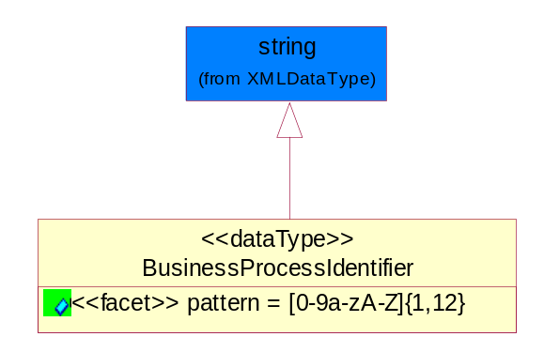
Figure ‎5-64 BusinessProcessIdentifier

Attribute | Type | Documentation
pattern |  | [0-9a-zA-Z]{1,12}

BusinessServiceInformation
The object allows the specification of the business service utilized within the partner company. This may or may not be the same as the information sent by the RNIF.
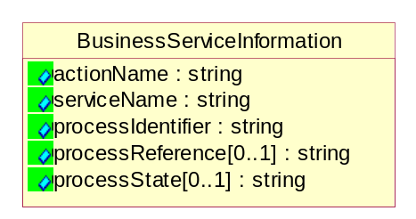
Figure ‎5-65 BusinessServiceInformation

Attribute | Type | Documentation
actionName | string | The name of Action. For RosettaNet usually any of Request/Confirm/Notify/Query/Response.
serviceName | string | The name of the Business Activity with the "Request/Confirm" part removed. E.g., for the Activity "Request Purchase Order"==> "Purchase Order".
processIdentifier | string | The name of the PIP e.g. Notify of Forecast Reply.
processReference[0..1] | string | The URN for the PIP that includes Cluster/Segment/Process pattern used to identify the interface process (such as PIP3A4)
processState[0..1] | string | The business process (or service) state of the sender of a document. When a service receives this document, the receiver may use the state as a precondition.

ContractInformation
A block of information used to correlate a contract in an executing choreography.

Figure ‎5-66 ContractInformation

Attribute | Type | Documentation
contractIdentifier[0..1] | string | Unique identification of a contract between the Sender and the Receiver
contractType[0..1] | string | The type of the contract: an attribute describing the type of the ContractIndentification. Valid values are URI, URN,ebXMLCPA, or other values defined by partners.

CorrelationInformation
A block of information used to correlate a requesting document to a responding document and to the contract in an executing choreography.
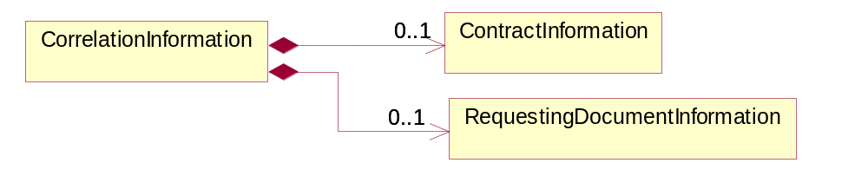
Figure ‎5-67 CorrelationInformation

Composition | Cardinality | Type | Documentation
ContractInformation | 0..1 | ContractInformation | A block of information used to correlate a contract in an executing choreography.
RequestingDocumentInformation | 0..1 | RequestingDocumentInformation | A block of information used to correlate a requesting document to a responding document in an executing choreography.

DocumentHeader
The object allows for the identification of the sender and receiver of the business document.
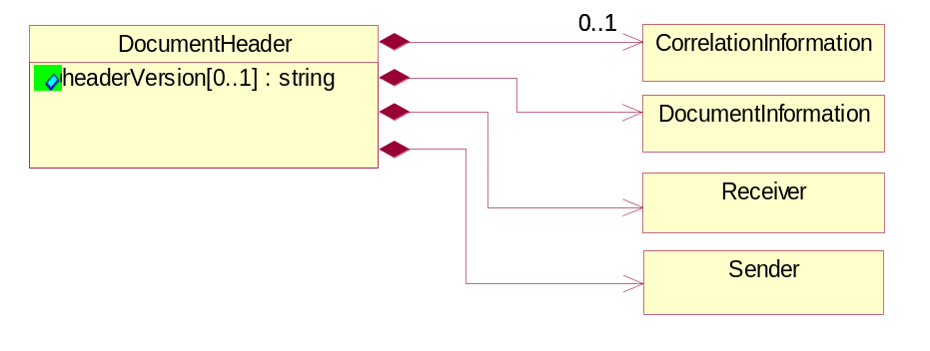
Figure ‎5-68 DocumentHeader

Attribute | Type | Documentation
headerVersion[0..1] | string | The UN/CEFACT version of the document header.

Composition | Cardinality | Type | Documentation
Sender | 1 | Sender | The object allows the identification of the initiating party of the business message.
CorrelationInformation | 0..1 | CorrelationInformation | A block of information used to correlate a requesting document to a responding document and to the contract in an executing choreography.
DocumentInformation | 1 | DocumentInformation | The object specifies information to identify the business document, a summary of attachments, and information about the business document security.
Receiver | 1 | Receiver | The object allows the identification of the receiving party of the business message.

DocumentIdentification
The object specifies all information necessary to identify the business document.
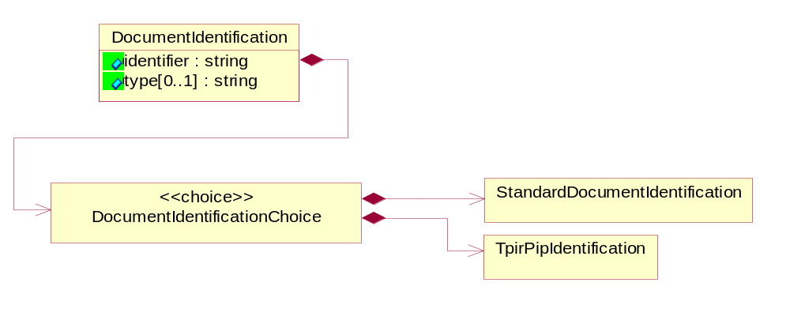
Figure ‎5-69 DocumentIdentification

Attribute | Type | Documentation
identifier | string | The unique identifier for the document being sent.
type[0..1] | string | Name of the Action Message

Composition | Cardinality | Type | Documentation
DocumentIdentificationChoice | 1 | DocumentIdentificationChoice

DocumentIdentificationChoice
Composition | Cardinality | Type | Documentation
StandardDocumentIdentification | 1 | StandardDocumentIdentification | The object specifies additional information necessary to identify the standard business document.
TpirPipIdentification | 1 | TpirPipIdentification | The object specifies all information necessary to uniquely identify a TPIR-PIP within a Registry or trading partner repository.

DocumentInformation
The object specifies information to identify the business document, a summary of attachments, and information about the business document security.
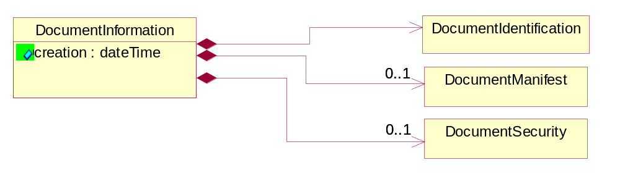
Figure ‎5-70 DocumentInformation

Attribute | Type | Documentation
creation | dateTime | The creation date and time of the specified Business Document (i.e. the Purchase Order date).

Composition | Cardinality | Type | Documentation
DocumentIdentification | 1 | DocumentIdentification | The object specifies all information necessary to identify the business document.
DocumentSecurity | 0..1 | DocumentSecurity | The object provides additional granularity in specifying business document security (this is in addition to the specified PIP security).
DocumentManifest | 0..1 | DocumentManifest | The block provides a brief summary of attachments and Service Content.

DocumentManifest
The block provides a brief summary of attachments and Service Content.
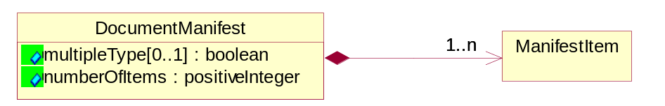
Figure ‎5-71 DocumentManifest

Attribute | Type | Documentation
multipleType[0..1] | boolean | Indicates whether the manifest contains documents of multiple types. True if yes, and False if no.
numberOfItems | positiveInteger | Total number of documents in the message. The physical count of the attachments in the payload plus the RosettaNet Business Message (for Service Content). The value of this field will be at least 1.

Composition | Cardinality | Type | Documentation
ManifestItem | 1..n | ManifestItem | The object provides details about the specific attachment(s).

DocumentSecurity
The object provides additional granularity in specifying business document security (this is in addition to the specified PIP security).

Figure ‎5-72 DocumentSecurity

Attribute | Type | Documentation
nonRepudiableReceipt | boolean | The value "true" will indicate that a signed acknowledgement for the business document is necessary.
persistentEncryption | boolean | The value "true" will indicate that the Business Document (including the header) needs to be encrypted when stored or transported.
persistentSignature | boolean | The value "true" will indicate that a signature is required to be stored with the document while stored or transported.

ManifestItem
The object provides details about the specific attachment(s).

Figure ‎5-73 ManifestItem

Attribute | Type | Documentation
description[0..1] | string | A description of the attachment.
length[0..1] | positiveInteger | The size of the attachment in bytes (i.e. 1 000 000 bytes)
universalResourceIdentifier | string | The generic set of all names/addresses that are short strings that refer to resources.

Composition | Cardinality | Type | Documentation
mimeTypeQualifier | 1 | MimeTypeQualifier | The MIME type as defined by IANA.  Please refer to http://www.iana.org/assignments/media-types/ for a list of types.
language | 0..1 | Language | For representation of Language name RosettaNet has adopted ISO 639-2; 1998. Refer to the following web page to get the latest version of the standard:  http://www.loc.gov/standards/iso639-2/iso639jac.html  If you need more information about the ISO standard please contact ISO for more details.

PipIdentifier
PIP Identification.[ i.e. PIP3A4]
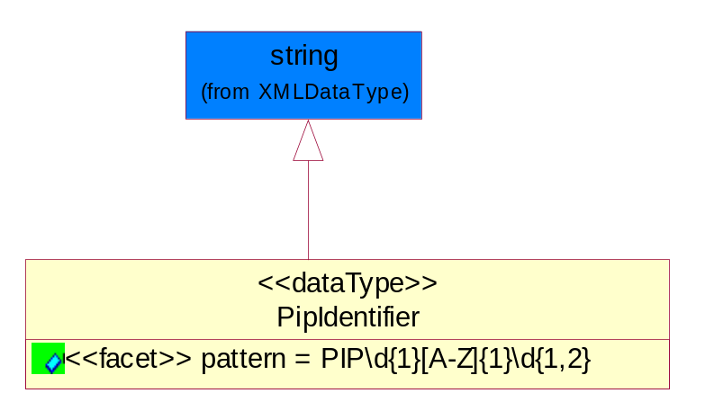
Figure ‎5-74 PipIdentifier

Attribute | Type | Documentation
pattern |  | PIP\d{1}[A-Z]{1}\d{1,2}

PipVersion
PIP version number (i.e. 02.02.00).
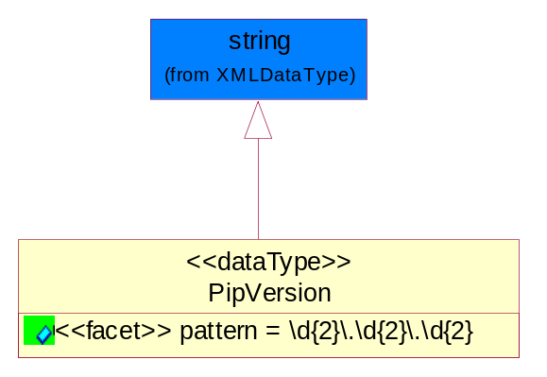
Figure ‎5-75 PipVersion

Attribute | Type | Documentation
pattern |  | \d{2}\.\d{2}\.\d{2}

Receiver
The object allows the identification of the receiving party of the business message.
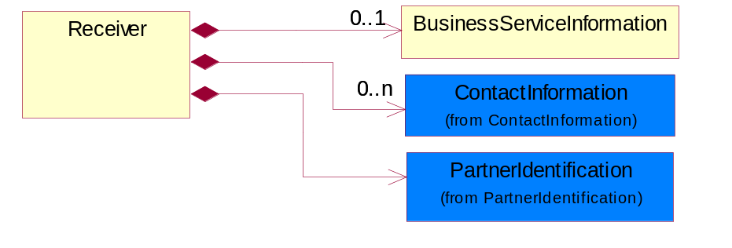
Figure ‎5-76 Receiver

Composition | Cardinality | Type | Documentation
BusinessServiceInformation | 0..1 | BusinessServiceInformation | The object allows the specification of the business service utilized within the partner company. This may or may not be the same as the information sent by the RNIF.
PartnerIdentification | 1 | PartnerIdentification | The business document must allow for the identity of one or more parties to the transaction.
ContactInformation | 0..n | ContactInformation | The business document must allow for the identification of the name of the department, service or individual to be contacted regarding the context of the business document.

RequestingDocumentInformation
A block of information used to correlate a requesting document to a responding document in an executing choreography.
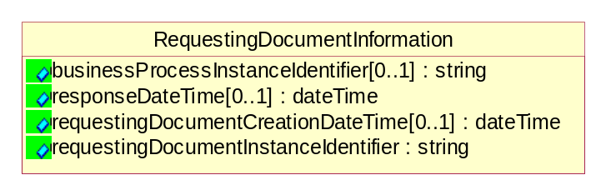
Figure ‎5-77 RequestingDocumentInformation

Attribute | Type | Documentation
businessProcessInstanceIdentifier[0..1] | string | The identifier for the public business process instance being sent that both the sender and receiver can identify.
responseDateTime[0..1] | dateTime | The expected time to receive the response. This can not be greater than the PIP TimeToPerform.
requestingDocumentCreationDateTime[0..1] | dateTime | The date-time of the requesting business document.
requestingDocumentInstanceIdentifier | string | The Business Document identification number that identifies the requesting Business Document.

Sender
The object allows the identification of the initiating party of the business message.
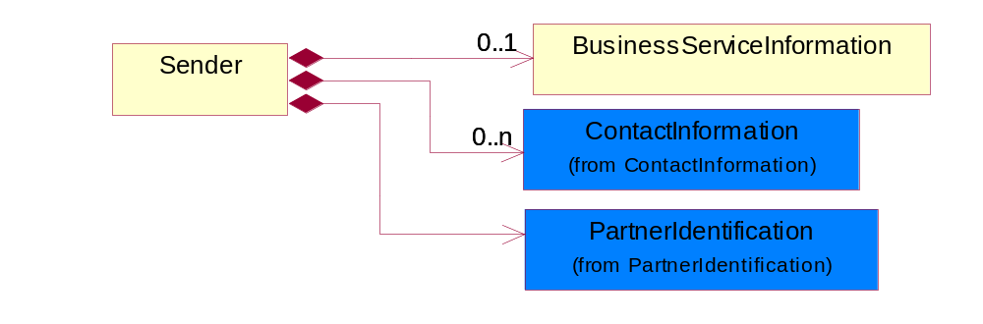
Figure ‎5-78 Sender

Composition | Cardinality | Type | Documentation
PartnerIdentification | 1 | PartnerIdentification | The business document must allow for the identity of one or more parties to the transaction.
BusinessServiceInformation | 0..1 | BusinessServiceInformation | The object allows the specification of the business service utilized within the partner company. This may or may not be the same as the information sent by the RNIF.
ContactInformation | 0..n | ContactInformation | The business document must allow for the identification of the name of the department, service or individual to be contacted regarding the context of the business document.

StandardDocumentIdentification
The object specifies additional information necessary to identify the standard business document.
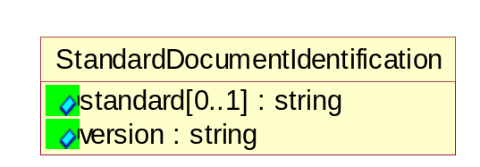
Figure ‎5-79 StandardDocumentIdentification

Attribute | Type | Documentation
standard[0..1] | string | Identifies the standard used to submit the business document. (e.g. RosettaNet).
version | string | PIP3A4v01.00

TpirPipIdentification
The object specifies all information necessary to uniquely identify a TPIR-PIP within a Registry or trading partner repository.

Figure ‎5-80 TpirPipIdentification

Attribute | Type | Documentation
partnerId | DUNSPlus4 | The Trading Partner Identification of MNC that is creating this TPIR PIP.
pipIdentifier | PipIdentifier | A TPIR PIP Identification [i.e., 3A4 ).
pipVersion | PipVersion | A TPIR PIP version number (i.e., 02.02.00)
tpirPipVersion | VersionIdentifier | A TPIR-PIP Version Number (i.e., major and minor version number as XX.XX).
tpirBusinessProcessIdentifier[0..1] | BusinessProcessIdentifier | A Business Process Identifier to uniquely define the TPIR-PIP 'role' within a Business Scenario at a company or MNC level. The identifier MUST be composed of alphanumeric characters only and its length MUST be between one and twelve characters.
uri[0..1] | anyURI | Describes the destination uri for the TPIR form.

Composition | Cardinality | Type | Documentation
fileType | 0..1 | TPIRFileType | Describes the file type of the TPIR form (PDF, XDP or XML).

VersionIdentifier
Version Number (i.e., major and minor version number as XX.XX).
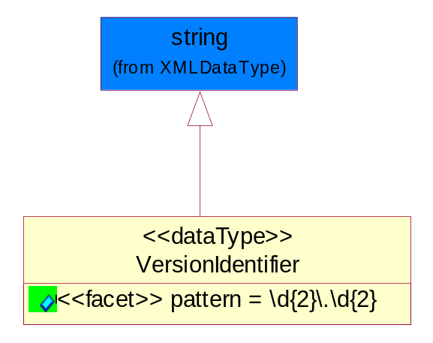
Figure ‎5-81 VersionIdentifier

Attribute | Type | Documentation
pattern |  | \d{2}\.\d{2}

CodeList

TPIRFileType
A code identifying the file type of TPIR form.
Name | Documentation
PDF | Portable Document Format.
XDP | XML Data Package.
XML | eXtensible Markup Language.

XML Data Type

anyURI
Represents a URI as defined by RFC 2396. An anyURI value can be absolute or relative, and may have an optional fragment identifier.

boolean
Represents Boolean values, which are either "true" or "false".

dateTime
Represents a specific instance of time.
The pattern for dateTime is CCYY-MM-DDThh:mm:ss where CC represents the century, YY the year, MM the month, and DD the day, preceded by an optional leading negative (-) character to indicate a negative number. If the negative character is omitted, positive (+) is assumed. The T is the date/time separator and hh, mm, and ss represent hour, minute, and second respectively. Additional digits can be used to increase the precision of fractional seconds if desired. For example, the format ss.ss... with any number of digits after the decimal point is supported. The fractional seconds part is optional.
This representation may be immediately followed by a "Z" to indicate Coordinated Universal Time (UTC) or to indicate the time zone. For example, the difference between the local time and Coordinated Universal Time, immediately followed by a sign, + or -, followed by the difference from UTC represented as hh:mm (minutes is required). If the time zone is included, both hours and minutes must be present.

float
Represents single-precision 32-bit floating-point numbers.

integer
Represents a sequence of decimal digits with an optional leading sign (+ or -). This data type is derived from decimal.

positiveInteger
Represents an integer that is greater than zero. This data type is derived from nonNegativeInteger.

string
Represents character string.

