

Description of 3C1 Message

PIP® 3C1
Validated 11.00.00

Specification Information
Name | Description of 3C1 Message
PIP | Request Return Product
Cluster | Order Management
Segment | Returns And Finance
Publication Date | 30 June 2008
Version Identifier | V11.00

Table of Content

1. Document Management 6
1.1 Legal Disclaimer 6
1.2 Copyright 6
1.3 Trademarks 6
1.4 Acknowledgments 6
1.5 Related Documents 7
1.6 Document Version History 7
1.7 Document Purpose 7
2. Interchange Model 8
2.1 ReturnProductRequest 8
2.1.1 Interchange Diagram 8
2.1.2 Dependency Diagram 8
2.1.3 ProductLineItem 9
2.1.4 Resource 10
2.1.5 ReturnProductRequest 11
2.2 ReturnProductConfirmation 12
2.2.1 Interchange Diagram 12
2.2.2 Dependency Diagram 12
2.2.3 ProductLineItem 13
2.2.4 Resource 14
2.2.5 ReturnProductConfirmation 15
2.2.6 StatusInformation 16
3. Domain Model 17
3.1 Service 17
3.1.1 Service 17
3.1.1.1 Dependency Diagram 17
3.1.1.2 FailureAnalysis 17
3.1.1.3 FailureInformation 18
3.1.2 CodeList 19
3.1.2.1 FailureAction 19
3.1.2.2 FailureModifier 19
3.1.2.3 FailureObservedCondition 19
3.1.2.4 NotificationCode 21
3.1.2.5 OperatingSystem 21
3.1.2.6 ReturnProductInstruction 22
3.1.2.7 ProductReturnReason 22
3.2 Shared 23
3.2.1 Shared 23
3.2.1.1 Dependency Diagram 23
3.2.1.2 ProductQuantity 23
3.2.2 CodeList 24
3.2.2.1 ShippingServiceLevel 24
4. Universal Structure 26
4.1 ContactInformation 26
4.1.1 ContactInformation 26
4.2 DataType 27
4.2.1 Contact 27
4.2.2 DUNS 27
4.2.3 DUNSPlus4 28
4.2.4 GLN 28
4.2.5 GTIN 29
4.3 Document 30
4.3.1 BusinessDocumentReference 30
4.4 Locations 31
4.4.1 AlternativeIdentifier 31
4.4.2 Location 31
4.4.3 LocationChoice 32
4.4.4 PhysicalAddress 32
4.5 MonetaryExpression 34
4.5.1 FinancialAmount 34
4.6 PartnerIdentification 35
4.6.1 FullPartner 35
4.6.2 IntermittentPartner 35
4.6.3 KnownPartner 36
4.6.4 KnownPartnerContact 36
4.6.5 NewPartner 37
4.6.6 PartnerDescription 38
4.6.7 PartnerDescriptionChoice 38
4.6.8 PartnerIdentification 39
4.6.9 PartnerIdentificationChoice 40
4.6.10 SpecifiedFullPartner 40
4.6.11 SpecifiedIntermittentPartner 41
4.6.12 SpecifiedKnownPartner 42
4.6.13 SpecifiedNewPartner 42
4.7 ProductIdentification 43
4.7.1 ProductIdentification 43
4.7.2 ProductIdentificationChoice 44
4.8 CodeList 44
4.8.1 Country 44
4.8.2 CountrySubdivision 44
4.8.3 Currency 44
4.8.4 Language 44
4.8.5 DocumentType 45
4.8.6 MimeTypeQualifier 46
4.8.7 UnitOfMeasure 57
4.8.8 ProcessRoleIdentifier 65
5. System Structure 68
5.1 BusinessProcessIdentifier 68
5.2 BusinessServiceInformation 68
5.3 ContractInformation 69
5.4 CorrelationInformation 70
5.5 DocumentHeader 70
5.6 DocumentIdentification 71
5.7 DocumentIdentificationChoice 72
5.8 DocumentInformation 72
5.9 DocumentManifest 73
5.10 DocumentSecurity 73
5.11 ManifestItem 74
5.12 PipIdentifier 75
5.13 PipVersion 75
5.14 Receiver 76
5.15 RequestingDocumentInformation 76
5.16 Sender 77
5.17 StandardDocumentIdentification 78
5.18 TpirPipIdentification 78
5.19 VersionIdentifier 79
5.20 CodeList 79
5.20.1 TPIRFileType 79
6. XML Data Type 80
6.1 anyURI 80
6.2 boolean 80
6.3 date 80
6.4 dateTime 80
6.5 float 80
6.6 positiveInteger 80
6.7 string 80

Table of Figures

Figure 2-1 Interchange 8
Figure 2-2 Dependency 8
Figure 2-3 ProductLineItem 9
Figure 2-4 Resource 10
Figure 2-5 ReturnProductRequest 11
Figure 2-6 Interchange 12
Figure 2-7 Dependency 12
Figure 2-8 ProductLineItem 13
Figure 2-9 Resource 14
Figure 2-10 ReturnProductConfirmation 15
Figure 2-11 StatusInformation 16
Figure 3-1 Dependency 17
Figure 3-2 FailureAnalysis 17
Figure 3-3 FailureInformation 18
Figure 3-4 Dependency 23
Figure 3-5 ProductQuantity 23
Figure 4-1 ContactInformation 26
Figure 4-2 Contact 27
Figure 4-3 DUNS 27
Figure 4-4 DUNSPlus4 28
Figure 4-5 GLN 28
Figure 4-6 GTIN 29
Figure 4-7 BusinessDocumentReference 30
Figure 4-8 AlternativeIdentifier 31
Figure 4-9 Location 31
Figure 4-10 PhysicalAddress 32
Figure 4-11 FinancialAmount 34
Figure 4-12 FullPartner 35
Figure 4-13 IntermittentPartner 35
Figure 4-14 KnownPartner 36
Figure 4-15 KnownPartnerContact 36
Figure 4-16 NewPartner 37
Figure 4-17 PartnerDescription 38
Figure 4-18 PartnerIdentification 39
Figure 4-19 SpecifiedFullPartner 40
Figure 4-20 SpecifiedIntermittentPartner 41
Figure 4-21 SpecifiedKnownPartner 42
Figure 4-22 SpecifiedNewPartner 42
Figure 4-23 ProductIdentification 43
Figure 5-1 BusinessProcessIdentifier 68
Figure 5-2 BusinessServiceInformation 68
Figure 5-3 ContractInformation 69
Figure 5-4 CorrelationInformation 70
Figure 5-5 DocumentHeader 70
Figure 5-6 DocumentIdentification 71
Figure 5-7 DocumentInformation 72
Figure 5-8 DocumentManifest 73
Figure 5-9 DocumentSecurity 73
Figure 5-10 ManifestItem 74
Figure 5-11 PipIdentifier 75
Figure 5-12 PipVersion 75
Figure 5-13 Receiver 76
Figure 5-14 RequestingDocumentInformation 76
Figure 5-15 Sender 77
Figure 5-16 StandardDocumentIdentification 78
Figure 5-17 TpirPipIdentification 78
Figure 5-18 VersionIdentifier 79

Document Management

Legal Disclaimer
RosettaNet, its members, officers, directors, employees, or agents shall not be liable for any injury, loss, damages, financial or otherwise, arising from, related to, or caused by the use of this document or the specifications herein, as well as associated guidelines and schemas. The use of said specifications shall constitute your express consent to the foregoing exculpation.

Copyright
©2008 RosettaNet. All rights reserved. No part of this publication may be reproduced, stored in a retrieval system, or transmitted, in any form or by any means, electronic, mechanical, photocopying, recording, or otherwise, without the inclusion of this copyright notice. Any derivative works must cite the copyright notice. Any public redistribution or sale of this publication or derivative works requires prior written permission of the publisher.

Trademarks
RosettaNet, Partner Interface Process, PIP and the RosettaNet logo are trademarks or registered trademarks of "RosettaNet," a non-profit organization. All other product names and company logos mentioned herein are the trademarks of their respective owners. In the best effort, all terms mentioned in this document that are known to be trademarks or registered trademarks have been appropriately recognized in the first occurrence of the term.

Acknowledgments
This document has been prepared by RosettaNet (http://www.rosettanet.org/) from requirements gathered during the Milestone Program and in conformance with the methodology. Listed below are the legal entities that contributed to the design and development of this PIP.
BCM Electronics | HP Canada
CompTIA | Intel Corporation
CompuCom Systems | MIMOS Berhad
Globetronics SDH. BHD | NexInnovations
Hewlett Packard | Sterling Commerce
Hewlett-Packard Company | Unisys
HP

Related Documents
- Associated PIP Message Schemas (included with PIP Specification only)
- Description of Partner Interface Process for 3C1
- Message Structure

Document Version History
Version | Date | Description
Validated 11.00.00 | 30 June 2008 | Validated Version: RosettaNet Schema to Market to Validation 2008

Document Purpose
The purpose of the document is to explain the structure, the association between objects, the content of objects and the definition for single elements to a non-technical audience.

Interchange Model

ReturnProductRequest

Interchange Diagram
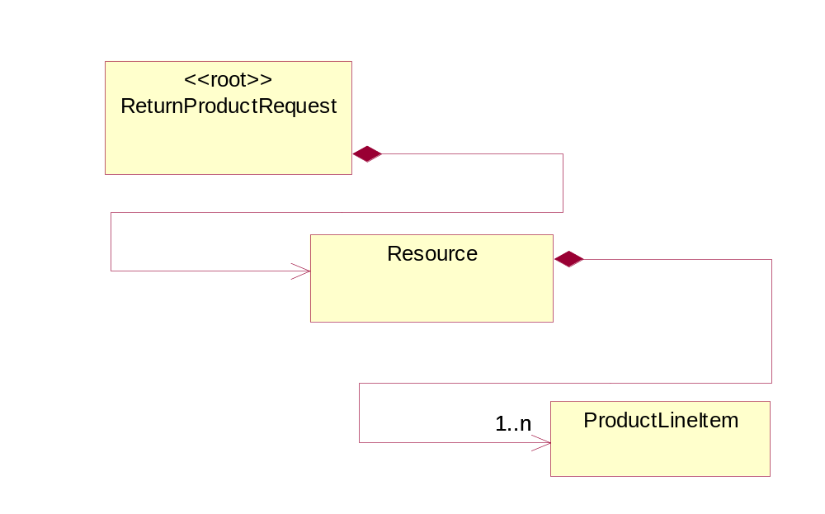
Figure 2-1 Interchange

Dependency Diagram
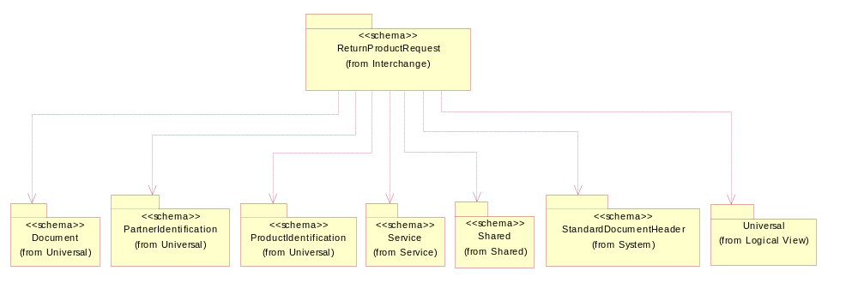
Figure 2-2 Dependency

ProductLineItem
The collection of business properties that describe a business document entry for a product.
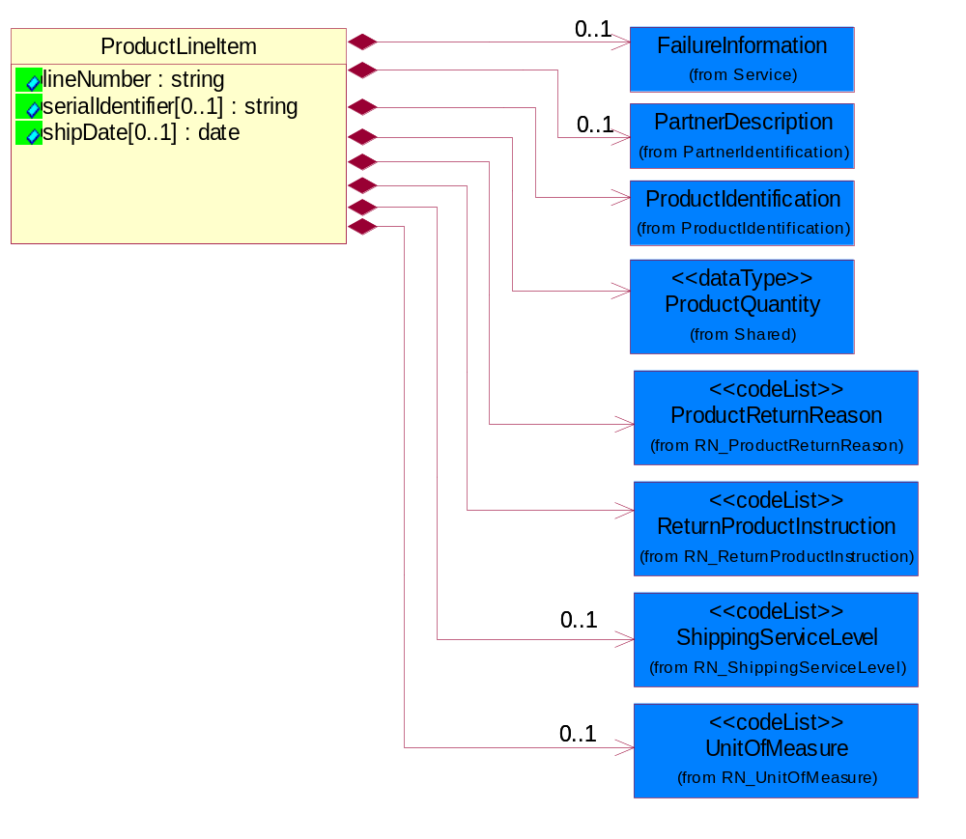
Figure 2-3 ProductLineItem

Attribute | Type | Documentation
lineNumber | string | Number of the line in the document.
serialIdentifier[0..1] | string | Unique serial identifier assigned to the product.
shipDate[0..1] | date | The (GMT) local date the product is shipped.

Composition | Cardinality | Type | Documentation
UnitOfMeasure | 0..1 | UnitOfMeasure | Code identifying a product unit of measure.
ProductIdentification | 1 | ProductIdentification | The object provides the identifier(s) of a product.
FailureInformation | 0..1 | FailureInformation | The collection of data entities that comprise information regarding the failure of a product being returned to a provider or supplier.
ProductReturnReason | 1 | ProductReturnReason | Code identifying the reason that a product is returned.
ReturnProductInstruction | 1 | ReturnProductInstruction | Code identifying the special instruction of the part that shows the part can be cancelled after order or returned to the manufacturer.
ShippingServiceLevel | 0..1 | ShippingServiceLevel | Code identifying the shipping service level, e.g., overnight, same day.
ProductQuantity | 1 | ProductQuantity | A quantity specifying the number of product units.
PartnerDescription | 0..1 | PartnerDescription | The collection of business properties that describe a business partners' identity, their contact information, where they are physically located and their function in a supply chain.

Resource
The collection of data entities that describe the references to product, product, quanity and cost of the product being returned.
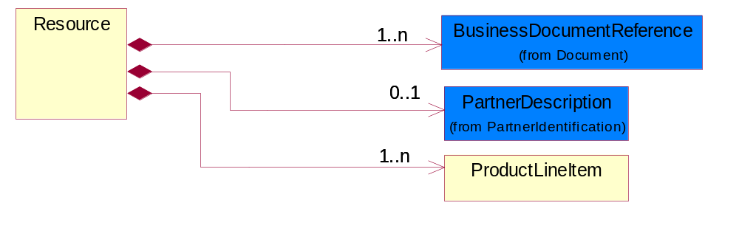
Figure 2-4 Resource

Composition | Cardinality | Type | Documentation
BusinessDocumentReference | 1..n | BusinessDocumentReference | The business document reference object allows for the indirect referencing of a relationship to other business related documents.
ProductLineItem | 1..n | ProductLineItem | The collection of business properties that describe a business document entry for a product.
PartnerDescription | 0..1 | PartnerDescription | The collection of business properties that describe a business partners' identity, their contact information, where they are physically located and their function in a supply chain.

ReturnProductRequest
A message wrapper for the PIP3C1.
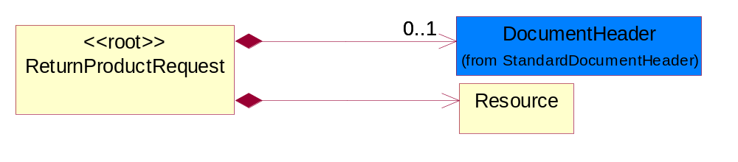
Figure 2-5 ReturnProductRequest

Composition | Cardinality | Type | Documentation
DocumentHeader | 0..1 | DocumentHeader | The object allows for the identification of the sender and receiver of the business document.
Resource | 1 | Resource | The collection of data entities that describe the references to product, product, quanity and cost of the product being returned.

ReturnProductConfirmation

Interchange Diagram
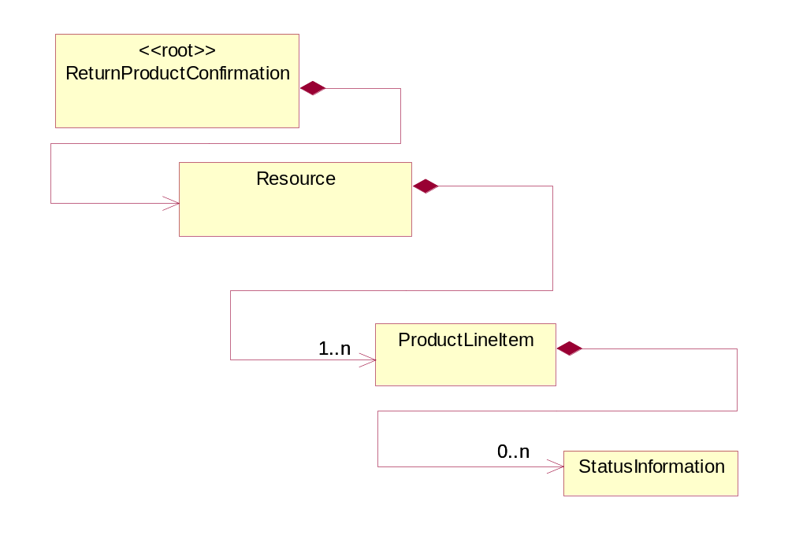
Figure 2-6 Interchange

Dependency Diagram
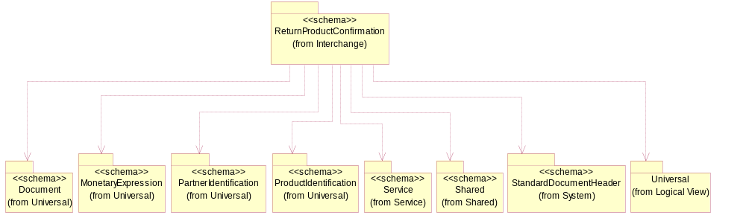
Figure 2-7 Dependency

ProductLineItem
The collection of business properties that describe a business document entry for a product.
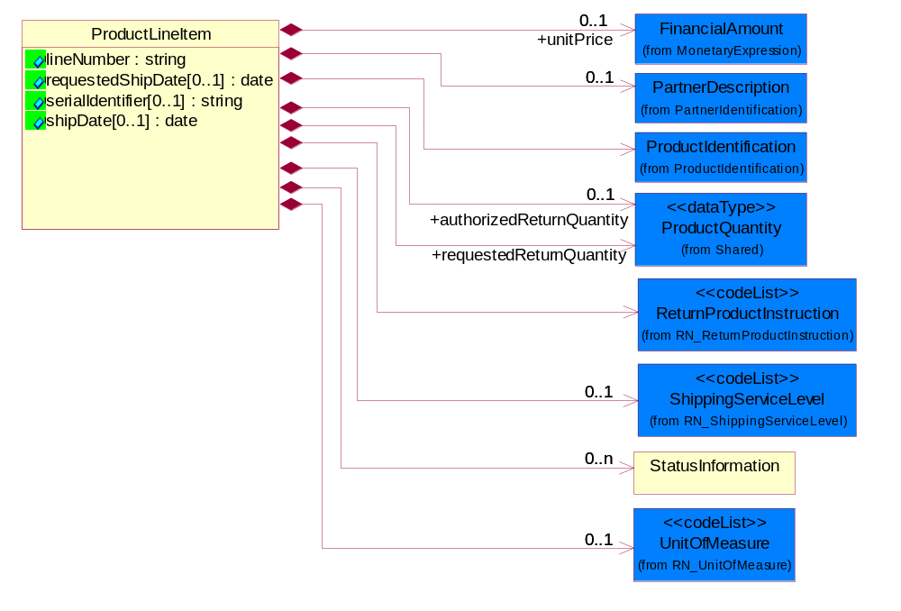
Figure 2-8 ProductLineItem

Attribute | Type | Documentation
lineNumber | string | Number of the line in the document.
requestedShipDate[0..1] | date | Date the shipper would like to make shipment or in a response refers to the original date a shipper proposed to ship.
serialIdentifier[0..1] | string | Unique serial identifier assigned to the product.
shipDate[0..1] | date | The (GMT) local date the product is shipped.

Composition | Cardinality | Type | Documentation
UnitOfMeasure | 0..1 | UnitOfMeasure | Code identifying a product unit of measure.
ProductIdentification | 1 | ProductIdentification | The object provides the identifier(s) of a product.
StatusInformation | 0..n | StatusInformation | Data entities that provide additional information on a warranty item.
unitPrice | 0..1 | FinancialAmount | Agreed upon sale price for each unit ordered.
ReturnProductInstruction | 1 | ReturnProductInstruction | Code identifying the special instruction of the part that shows the part can be cancelled after order or returned to the manufacturer.
ShippingServiceLevel | 0..1 | ShippingServiceLevel | Code identifying the shipping service level, e.g., overnight, same day.
authorizedReturnQuantity | 0..1 | ProductQuantity | The number of units of product authorized to be returned to the Original Equipment Manufacturer or Seller.
requestedReturnQuantity | 1 | ProductQuantity | The product quantity requested to be returned.
PartnerDescription | 0..1 | PartnerDescription | The collection of business properties that describe a business partners' identity, their contact information, where they are physically located and their function in a supply chain.

Resource
The collection of data entities that describe the references to product, product, quanity and cost of the product being returned.
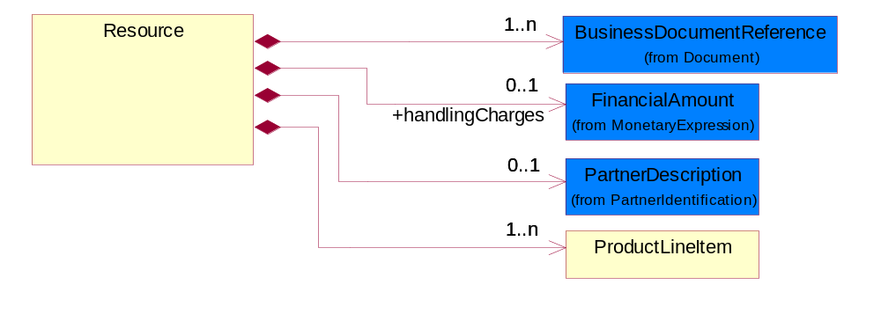
Figure 2-9 Resource

Composition | Cardinality | Type | Documentation
BusinessDocumentReference | 1..n | BusinessDocumentReference | The business document reference object allows for the indirect referencing of a relationship to other business related documents.
handlingCharges | 0..1 | FinancialAmount | The monetary amount to be paid for product handling for pre-, during and post-transportation.
ProductLineItem | 1..n | ProductLineItem | The collection of business properties that describe a business document entry for a product.
PartnerDescription | 0..1 | PartnerDescription | The collection of business properties that describe a business partners' identity, their contact information, where they are physically located and their function in a supply chain.

ReturnProductConfirmation
A message wrapper for the PIP3C1.
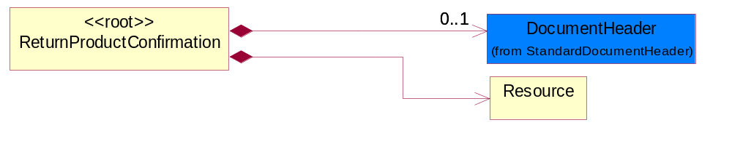
Figure 2-10 ReturnProductConfirmation

Composition | Cardinality | Type | Documentation
DocumentHeader | 0..1 | DocumentHeader | The object allows for the identification of the sender and receiver of the business document.
Resource | 1 | Resource | The collection of data entities that describe the references to product, product, quanity and cost of the product being returned.

StatusInformation
Data entities that provide additional information on a warranty item.
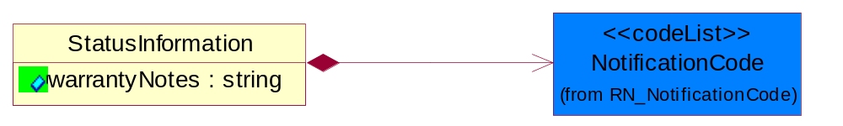
Figure 2-11 StatusInformation

Attribute | Type | Documentation
warrantyNotes | string | Text that contains information on the status of a unit under warranty.

Composition | Cardinality | Type | Documentation
NotificationCode | 1 | NotificationCode | Code identifying the purpose of a notification document.

Domain Model

Service

Service

Dependency Diagram
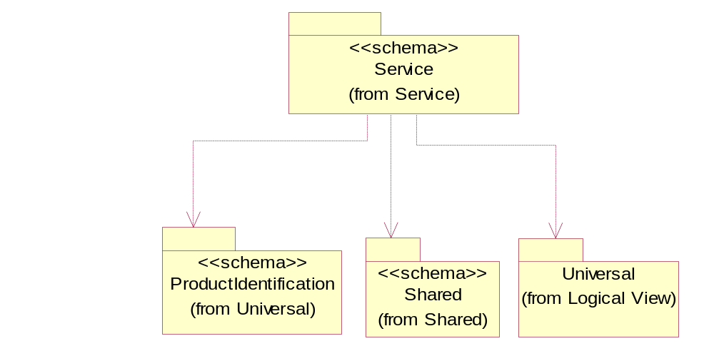
Figure 3-12 Dependency

FailureAnalysis
The collection of codes that describe a product failure.

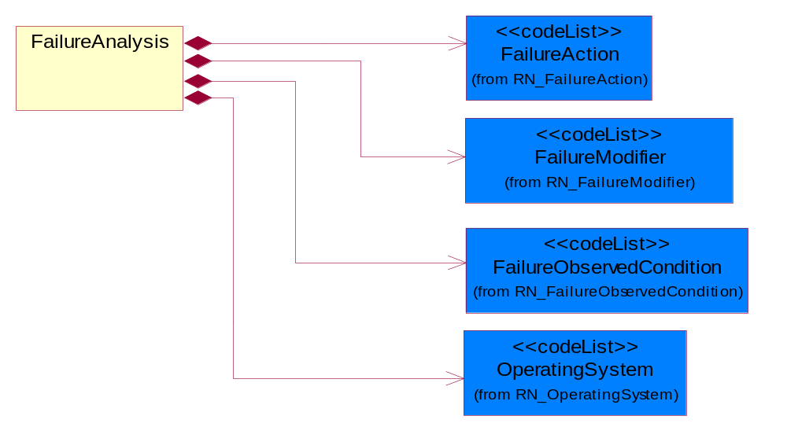
Figure 3-13 FailureAnalysis

Composition | Cardinality | Type | Documentation
FailureModifier | 1 | FailureModifier | The code used to describe the frequency or source of an operating system error.
FailureAction | 1 | FailureAction | The code used to describe the action taken to resolve an operating system error.
OperatingSystem | 1 | OperatingSystem | Used to define the computer operating system.
FailureObservedCondition | 1 | FailureObservedCondition | The code used to describe the nature of a system error.

FailureInformation
The collection of data entities that comprise information regarding the failure of a product being returned to a provider or supplier.

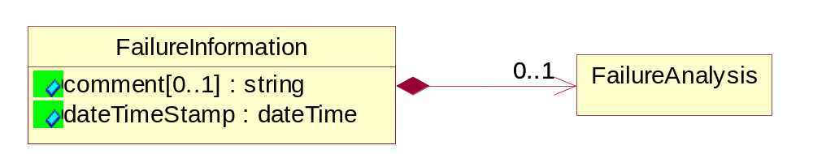
Figure 3-14 FailureInformation

Attribute | Type | Documentation
comment[0..1] | string | Text field used to further describe the suspected or observed conditions that caused a failure in a returned product.
dateTimeStamp | dateTime | Captures the date of failure of a product.

Composition | Cardinality | Type | Documentation
FailureAnalysis | 0..1 | FailureAnalysis | The collection of codes that describe a product failure.

CodeList

FailureAction
The code used to describe the action taken to resolve an operating system error.

Name | Documentation
CON | Configure - CompTIA code f.
NAC | No Action - CompTIA code d.
REA | Readjust - CompTIA code b.
REL | Reload - CompTIA code e.
RES | Reseat - CompTIA code c.
RET | Return - CompTIA code a.

FailureModifier
The code used to describe the frequency or source of an operating system error.

Name | Documentation
CON | Configuration - CompTIA code f.
COO | Continuous - CompTIA code b.
DAM | Damaged - CompTIA code g.
ENV | Environmental - CompTIA code e.
FAW | Fails After Warmup - CompTIA code d.
INT | Intermittent - CompTIA code c.
NAP | Not Applicable - CompTIA code a.

FailureObservedCondition
The code used to describe the nature of a system error.

Name | Documentation
BNR | Boards - Will Not Run Off AC Power. See also CompTIA Code: 525
BSU | Boards - Set Up. See also CompTIA Code: 512
BTD | Boards - Tape Drive Error. See also CompTIA Code: 506
BVE | Boards - Video Error. See also CompTIA Code: 505
BWB | Boards - Wrong Beeps/Startup Tone. See also CompTIA Code: 513
DAC | Display - Cannot Adjust Contrast. See also CompTIA Code: 213
DAD | Drives - Disks Do not Work in Another Drive. See also CompTIA Code: 311
DBR | Drives - Will Not Boot,Read & Writes OK. See also CompTIA Code: 312
DBS | Drives - Bad Sectors. See also CompTIA Code: 307
DCM | Display - Color(s) Missing. See also CompTIA Code: 206
DDS | Display - Diagonal Stripe. See also CompTIA Code: 210
DFC | Display - Focus/Converge. See also CompTIA Code: 203
DFE | Drives - Format Error. See also CompTIA Code: 304
DFS | Display - Fan Not Spinning. See also CompTIA Code: 211
DHB | Display - Horizontal/Vertical Bright Lines. See also CompTIA Code: 208
DID | Drives - I.D. Error. See also CompTIA Code: 305
DIP | Display - Incorrect Picture Size/Alignment. See also CompTIA Code: 216
DIS | Drives - Internal Or Will Not Spin. See also CompTIA Code: 302
DLI | Display - Dim or Low Intensity. See also CompTIA Code: 215
DLR | Drives - Lost Records. See also CompTIA Code: 306
DNA | Drives - Will Not Accept Disk. See also CompTIA Code: 310
DNB | Display - No Back Light. See alsoCompTIA Code: 205
DNM | Drives - Drive Will Not Mount. See also CompTIA Code: 308
DNR | Drives - Not Recognized w/Utility or Formatter. See also CompTIA Code: 309
DNS | Display - Would Not Show 2nd Monitor. See also CompTIA Code: 217
DNV | Display - Display-No Video. See also CompTIA Code: 201
DNY | Drives - Noisy. See also CompTIA Code: 301
DPC | Display - Pin Cushioning. See also CompTIA Code: 207
DPR | Display - Poor Resolution. See alsoCompTIA Code: 204
DRC | Display - Random Characters on Display. See also CompTIA Code: 214
DRV | Display - Rolls Vertically. See also CompTIA Code: 209
DRW | Drives - Read/Write Error. See also CompTIA Code: 303
DTS | Display - Distorted Sound. See also CompTIA Code: 212
DUV | Display - Unstable Video(Jitter/Flicker). See also CompTIA Code: 202
IDC | Input Devices - Bad Cord/Cable. See also CompTIA Code: 409
IDF | Input Devices - Foreign Substance Spilled on Unit. See also CompTIA Code: 405
IDI | Input Devices - Inoperative Key. See also CompTIA Code: 403
IDJ | Input Devices - Jittery/Intermittent. See also CompTIA Code: 407
IDK | Input Devices - Incorrect Key Code. See also CompTIA Code: 404
IDL | Input Devices - Locks Up. See also CompTIA Code: 401
IDM | Input Devices - Mechanical Failure. See also CompTIA Code: 408
IDR | Input Devices - No Response - Logic Board OK. See also CompTIA Code: 411
IDS | Input Devices - Sticky Key. See also CompTIA Code: 402
IDT | Input Devices - Not Tracking Properly. See also CompTIA Code: 406
IDU | Input Devices - Locks Up System. See also CompTIA Code: 410
MCF | Modems - Communication Failures. See also CompTIA Code: 902
MDA | Multi-Function Devices - Accessories. See also CompTIA Code: 801
MDC | Multi-Function Devices - Configuration. See also CompTIA Code: 802
MSB | Miscellaneous - Will Not Boot From HDD. See also CompTIA Code: 103
MSC | Miscellaneous - Cosmetic. See also CompTIA Code: 108
MSD | Miscellaneous - Damaged. See also CompTIA Code: 105
MSG | Miscellaneous - Good Part. CompTIA Code 101.
MSH | Miscellaneous - Hibernation / Sleep Problem. See also CompTIA Code: 111
MSI | Miscellaneous - Intermittent. See also CompTIA Code: 107
MSM | Miscellaneous - Mechanical. See also CompTIA Code: 104
MSP | Miscellaneous - No Power/No Light. See also CompTIA Code: 102
MSR | Miscellaneous - Reset Problem. See also CompTIA Code: 110
MSS | Miscellaneous - Screen Bright, No MAC Face. See also CompTIA Code: 109
MST | Modems - Self-Test Fails. See also CompTIA Code: 901
MSU | Miscellaneous - System Hangs Up. See also CompTIA Code: 106
PFA | Printer/Fax - Accesories. See also CompTIA Code: 703
PFB | Printer/Fax - Select Button Inoperable. See also CompTIA Code: 711
PFC | Printer/Fax - Communications. See also CompTIA Code: 707
PFE | Printer/Fax - Scanner. See also CompTIA Code: 706
PFF | Printer/Fax - Fails Self Test. See also CompTIA Code: 712
PFH | Printer/Fax - Paper Handling. See also CompTIA Code: 702
PFI | Printer/Fax - Indicator Lights Suggest Fault. See also CompTIA Code: 713
PFL | Printer/Fax - No Power Light. See also CompTIA Code: 709
PFM | Printer/Fax - Improper Print Head Movement. See also CompTIA Code: 710
PFN | Printer/Fax - Printer Not Seen By CPU. See also CompTIA Code: 714
PFO | Printer/Fax - Overheating. See also CompTIA Code: 704
PFP | Printer/Fax - PCB. See also CompTIA Code: 705
PFQ | Printer/Fax - Print Quality(include sample). See also CompTIA Code: 701
PFS | Printer/Fax - Software. See also CompTIA Code: 708
PSB | Power Supply - Blows Fuses. See also CompTIA Code: 606
PSC | Power Supply - Crowbar/Chirping. See also CompTIA Code: 605
PSF | Power Supply - Causes System Failures. See also CompTIA Code: 607
PSN | Power Supply - Noise/Hum. See also CompTIA Code: 604
PSO | Power Supply - Overheat(Fan Problem). See also CompTIA Code: 601
PSP | Power Supply - UPS Power - On Indicator Not Lit. See also CompTIA Code: 609
PSR | Power Supply - Random Reset. See also CompTIA Code: 602
PSU | Power Supply - UPS Battery Replacement Indicated. See also CompTIA Code: 608
PSV | Power Supply - Voltage Missing. See also CompTIA Code: 603

NotificationCode
Code identifying the purpose of a notification document.

Name | Documentation
AME | Amendment.
CAN | Cancellation.
ERR | Error.
FIN | Final.
INF | Informational.
INI | Initial.
UPD | Update.
WAR | Warning.

OperatingSystem
Used to define the computer operating system.

Name | Documentation
BAN | Banyan - Banyan NetworkOperating System - any version - CompTIA Code H.
DOS | Disk Operating System - CompTIA Code B.
NAP | Not Applicable - CompTIA Code A.
NOV | Novell Network Operating system - any version - CompTIA Code G.
OS2 | OS2. IBM Desktop PC Operating System - any version - CompTIA Code E.
UNI | UNIX Operating system - any manufacturer's version - CompTIA Code F.
WIN | MicroSoft Windows Operating System - Any version - CompTIA Code C.
WNT | Windows NT - MicroSoft Windows Network Operating System - Any version - CompTIA Code D.

ReturnProductInstruction
Code identifying the special instruction of the part that shows the part can be cancelled after order or returned to the manufacturer.

Name | Documentation
NAV | Not available - Return Product Instruction status is not available.
NCA | Non cancelable - Cancellation is not acceptable once order is placed for a part.
NCN | Non cancelable Non returnable - Both cancellation and return are not acceptable. Almost all specialty parts that are ordered for a particular project and do not have any other commercial value fall in this category.
NON | None - No special instruction. A part can be cancelled after order and can be returned to manufacturer for credit.
NRE | Non returnable - Return is not acceptable after the part is shipped.
RET | Return - Return product regardless of condition.
SAL | Salvage - Strip product of commercial valuable parts and scrap residual or recycle product in accordance with local rules and regulations covering the specific type of product.
SCR | Scrap - Dispose of product in accordance with local rules and regulations covering the specific type of product.

ProductReturnReason
Code identifying the reason that a product is returned.

Name | Documentation
CCO | Customer convenience.
DPA | DOA Part. Part defective on arrival.
DPR | Damaged product.
DPS | Defective product.
IPO | Invalid purchase order.
NIO | Not in original package.
OSH | Over shipment.
SAE | Sales administrative error.
SNT | Shipment not to schedule.
SWP | Shipped wrong product.
TPR | Tampered product.
UPA | Unused Part.
WPR | Wrong product.

Shared

Shared

Dependency Diagram
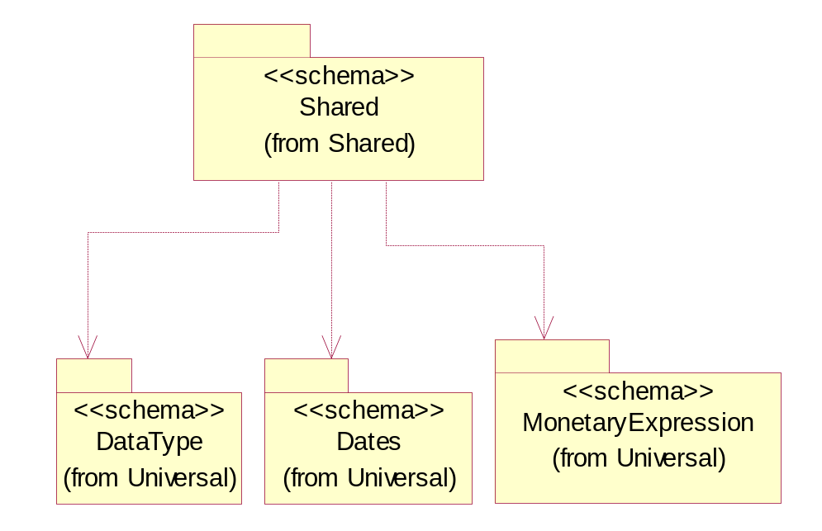
Figure 3-15 Dependency

ProductQuantity
A quantity specifying the number of product units.
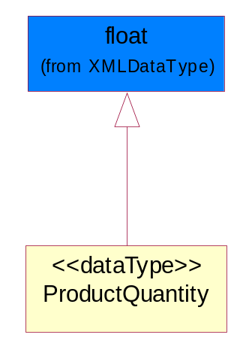
Figure 3-16 ProductQuantity

CodeList

ShippingServiceLevel
Code identifying the shipping service level, e.g., overnight, same day.

Name | Documentation
1BD | 1BD, Same Business Day - 4 hour Response Time.
5BD | 5 Business Days.
9AM | 9 A.M.
ACH | Air Charter.
AEC | Air Economy.
AIC | Air Cargo.
AM | A.M.
ARS | Authorized Return Service.
ATA | Airport to Airport.
ATD | Airport to Door.
BCT | Bulk Commodity Train.
BUC | Business Class.
CBS | Consignee Billing Service.
COE | Courier Express.
DCR | Delivery Confirmation Return.
DEC | Delivery Confirmation.
DES | Deferred Service.
DNO | Delivery Notification Only.
DOS | Door Service.
DSN | Delivery scheduled next day by cartage agent.
DSS | Delivery scheduled second day by cartage agent.
DST | Delivery scheduled third day by cartage agent.
DTA | Door to Airport.
DTD | Door to Door.
DTP | Door to Port (Ocean).
ESP | Express Service Plus.
ESV | Expedited Service.
ESW | Expedited Service Worldwide.
EXS | Express Service.
EXW | Express Service - Worldwide.
FIC | First Class.
GEN | General.
GRO | Ground.
ISS | Other intermodal and stack service.
MAF | Manifest freight.
MET | Metro.
MUW | Multiweight.
NBD | Next Business Day.
NDA | Next Day Air.
NEM | Next Morning.
NFO | Next Flight Out.
NHW | Next day Hundred Weight.
NOR | NORMAL - Normal delivery.
NOS | Not served.
OIS | Other Intermodal and Stack service
OTH | Other.
OVN | Overnight.
PAS | Passenger service.
PIU | Pickup.
PM | PM.
PMI | Priority Mail Insured.
POB | P.O. Box/Zip code.
POD | Proof of Delivery (POD) with Signature.
PRM | Priority Mail.
PRS | Premium Surface.
PS1 | Primary Service Area - Next Day by 10:30 A.M.
PS2 | Primary Service Area - Next Day by 5:00 P.M.
PS3 | Primary Service Area - Next Day By 9:30 A.M.
PS4 | Primary Service Area - Next Day by Noon.
PS5 | Primary Service Area - Second Day by Noon.
PTD | Port to Door (Ocean).
PTP | Port to Port (Ocean).
REG | Regular.
SAD | Same day.
SAP | Saturday Pickup.
SAT | Saturday.
SBD | SBD, Second Business Day.
SCH | Scheduled.
SDA | Second Day Air.
SDW | Second Day Hundred Weight.
SED | Second Day.
SEM | Second Morning.
SGW | Standard Ground Hundred Weight.
STC | Standard Class.
STG | Standard Ground.
STO | Standard Ocean.
STS | Standard Service.
SUH | Sunday and Holidays.
TDS | Three Day Service.
TIC | Time Critical.
TRG | Tracking - Ground.

Universal Structure

ContactInformation

ContactInformation
The business document must allow for the identification of the name of the department, service or individual to be contacted regarding the context of the business document.
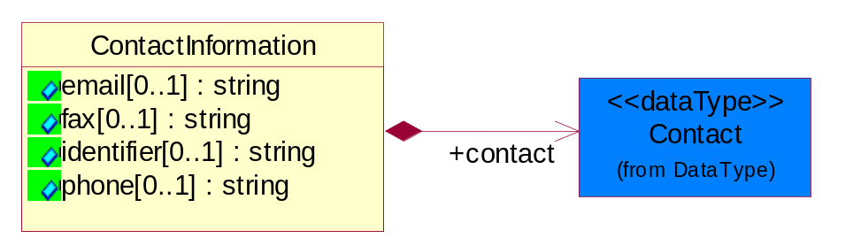
Figure 4-17 ContactInformation

Attribute | Type | Documentation
email[0..1] | string | The electronic mail for the specified contact.
fax[0..1] | string | The fax number for the specified contact.
identifier[0..1] | string | Identifies the role of the contact (i.e. Service Technician, Account Manager) in the Business Process.
phone[0..1] | string | The telephone number for the specified contact.

Composition | Cardinality | Type | Documentation
contact | 1 | Contact | The name of the department, service or individual to be contacted within the organization.

DataType

Contact
The name of the department, service or individual to be contacted within the organization.
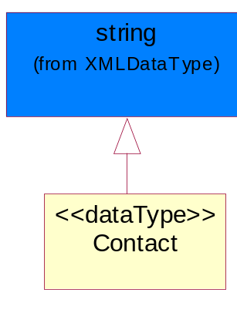
Figure 4-18 Contact

DUNS
A number assigned by Dun and Bradstreet to identify a business location.
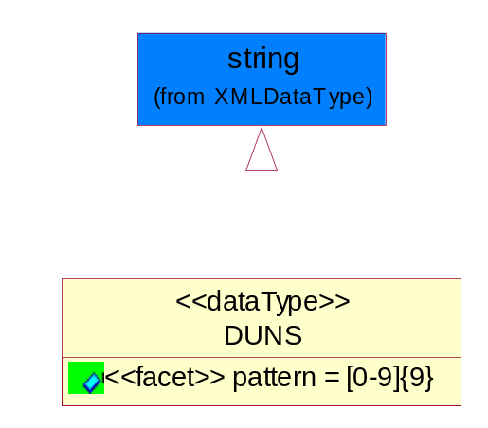
Figure 4-19 DUNS

Attribute | Type | Documentation
pattern |  | [0-9]{9}

DUNSPlus4
A identifier to specify a specific location within a business location.
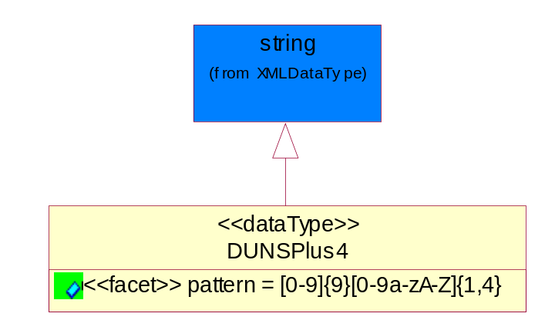
Figure 4-20 DUNSPlus4

Attribute | Type | Documentation
pattern |  | Data Universal Numbering System +4 (DUNS+4) number means the DUNS number assigned by Dun and Bradstreet, Inc. (D&B) plus an alphanumeric of length 4 suffix that may be assigned by a business concern.

GLN
Global Location Number (GLN) - A identifier to identify legal entities, trading parties and location.
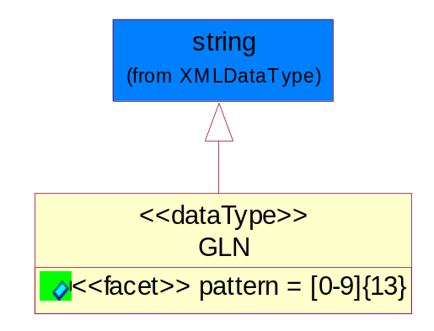
Figure 4-21 GLN

Attribute | Type | Documentation
pattern |  | [0-9]{13}

GTIN
Global Trade Identification Number (GTIN).
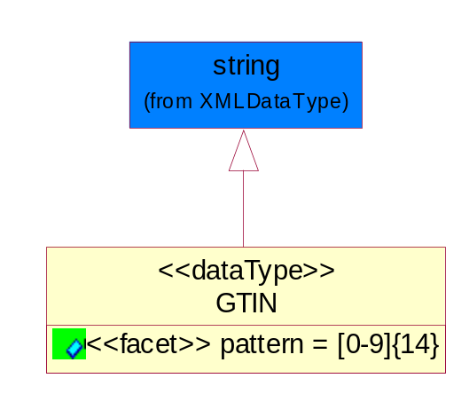
Figure 4-22 GTIN

Attribute | Type | Documentation
pattern |  | [0-9]{14}

Document

BusinessDocumentReference
The business document reference object allows for the indirect referencing of a relationship to other business related documents.
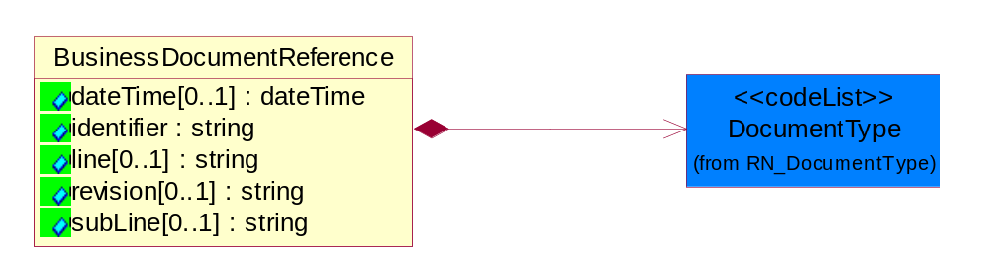
Figure 4-23 BusinessDocumentReference

Attribute | Type | Documentation
dateTime[0..1] | dateTime | The date-time stamp indicating on the referenced business document.
identifier | string | Unique identification of the referenced business document.
line[0..1] | string | References the specific line number of the specified business document.
revision[0..1] | string | Referenced the revision of the specified business document.
subLine[0..1] | string | References the specific subline number of the specified business document.

Composition | Cardinality | Type | Documentation
DocumentType | 1 | DocumentType | A code identifying the business context of a document.

Locations

AlternativeIdentifier
Identifies the specified code and the name of the organization that a code is utilized from.
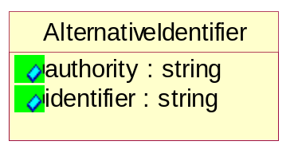
Figure 4-24 AlternativeIdentifier

Attribute | Type | Documentation
authority | string | The name of the organization that a code is utilized from.
identifier | string | The specified code to represent an entity (e.g. product, location, partner, etc.).

Location
The business document must specify a location.
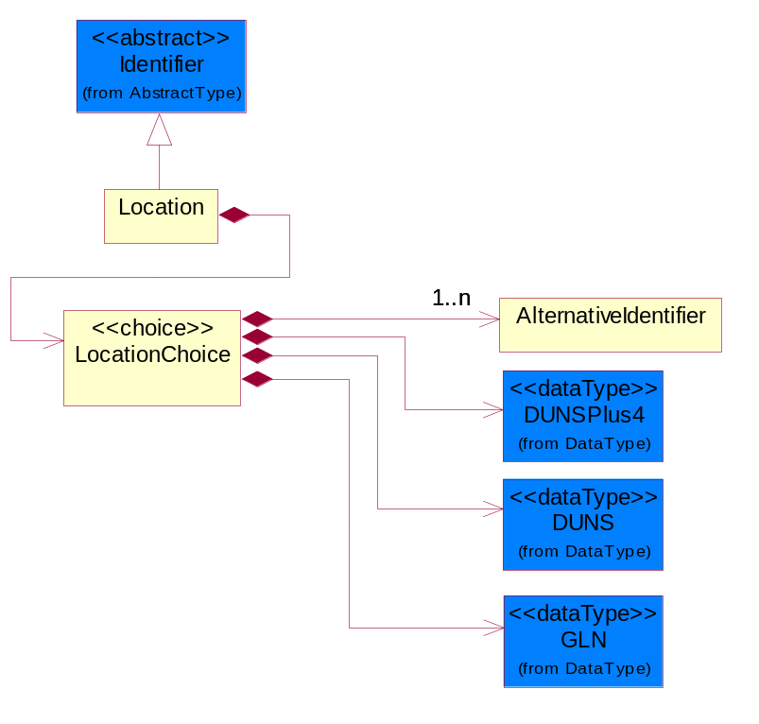
Figure 4-25 Location

Composition | Cardinality | Type | Documentation
LocationChoice | 1 | LocationChoice

LocationChoice

Composition | Cardinality | Type | Documentation
DUNSPlus4 | 1 | DUNSPlus4 | A identifier to specify a specific location within a business location.
DUNS | 1 | DUNS | A number assigned by Dun and Bradstreet to identify a business location.
AlternativeIdentifier | 1..n | AlternativeIdentifier | Identifies the specified code and the name of the organization that a code is utilized from.
GLN | 1 | GLN | Global Location Number (GLN) - A identifier to identify legal entities, trading parties and location.

PhysicalAddress
The business document must provide a physical address for a party to the business transaction.
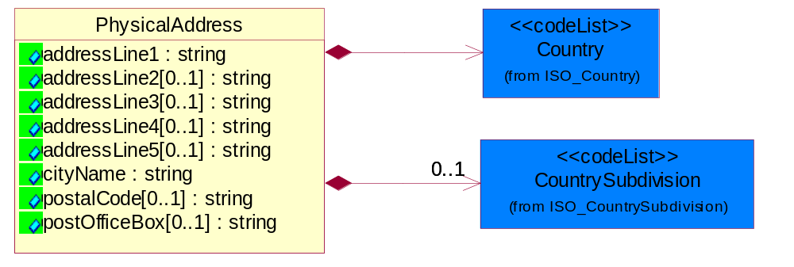
Figure 4-26 PhysicalAddress

Attribute | Type | Documentation
addressLine1 | string | The first line of a physical address.
addressLine2[0..1] | string | The second line of a physical address.
addressLine3[0..1] | string | The third line of a physical address.
addressLine4[0..1] | string | The fourth line of a physical address.
addressLine5[0..1] | string | The fifth line of a physical address.
cityName | string | The name of a city.
postalCode[0..1] | string | Identifying geographic location as specified by a national postal code.
postOfficeBox[0..1] | string | The Post Office Box identifier used to identify a party's post office box.

Composition | Cardinality | Type | Documentation
Country | 1 | Country | For representation of Country name RosettaNet has adopted ISO 3166-3; 1999. Refer to the following web page to get the latest version of the standard:  http://www.iso.ch/iso/en/prods-services/iso3166ma/02iso-3166-code-lists/index.html  If you need more information about the ISO standard please contact ISO for more details.
CountrySubdivision | 0..1 | CountrySubdivision | For representation of a Countries subdivisions RosettaNet has adopted ISO 3166-3; 1999. Refer to the following web page to get the latest version of the standard:  http://www.iso.ch/iso/en/prods-services/iso3166ma/02iso-3166-code-lists/index.html  If you need more information about the ISO standard please contact ISO for more details.

MonetaryExpression

FinancialAmount
The business document must express financial amounts.
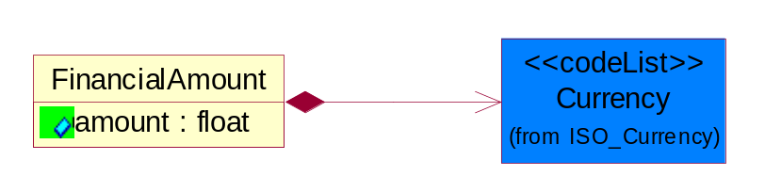
Figure 4-27 FinancialAmount

Attribute | Type | Documentation
amount | float | Specifies the monetary amount.

Composition | Cardinality | Type | Documentation
Currency | 1 | Currency | For representation of Currency codes RosettaNet has adopted ISO 4217; 1995. The British Standards Institution (BSI) is the ISO 4217 Maintenance Agency. Refer to the following web page to get the latest version of the standard:  http://www.bsi-global.com/Technical+Information/Publications/_Publications/tig90.xalter  If you need more information about the ISO standard please contact ISO for more details.

PartnerIdentification

FullPartner
The business document must describe the trading partners in the business transaction. This data structure provide the flexibility to describe a partner in all possible methods as for new, existing or known partner.
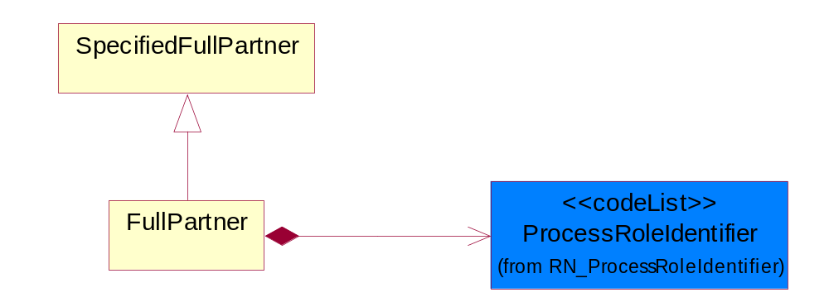
Figure 4-28 FullPartner

Composition | Cardinality | Type | Documentation
ProcessRoleIdentifier | 1 | ProcessRoleIdentifier | Describes the role of the partner in the business process. A partner will fulfill at least one or more roles during the business process.

IntermittentPartner
The business document must describe a physical address for a delivery.
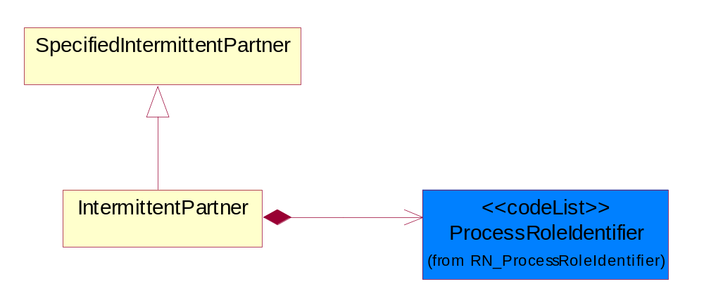
Figure 4-29 IntermittentPartner

Composition | Cardinality | Type | Documentation
ProcessRoleIdentifier | 1 | ProcessRoleIdentifier | Describes the role of the partner in the business process. A partner will fulfill at least one or more roles during the business process.

KnownPartner
The business document must describe the trading partners in the business transaction.
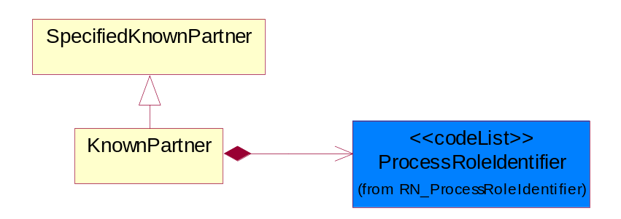
Figure 4-30 KnownPartner

Composition | Cardinality | Type | Documentation
ProcessRoleIdentifier | 1 | ProcessRoleIdentifier | Describes the role of the partner in the business process. A partner will fulfill at least one or more roles during the business process.

KnownPartnerContact
The business document must describe the trading partners in the business transaction.
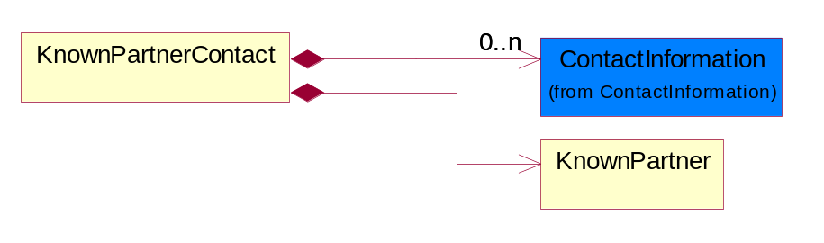
Figure 4-31 KnownPartnerContact

Composition | Cardinality | Type | Documentation
KnownPartner | 1 | KnownPartner | The business document must describe the trading partners in the business transaction.
ContactInformation | 0..n | ContactInformation | The business document must allow for the identification of the name of the department, service or individual to be contacted regarding the context of the business document.

NewPartner
The business document must describe a new, existing (but known to only one of the parties to the transaction) or an unknown party to the business transaction.
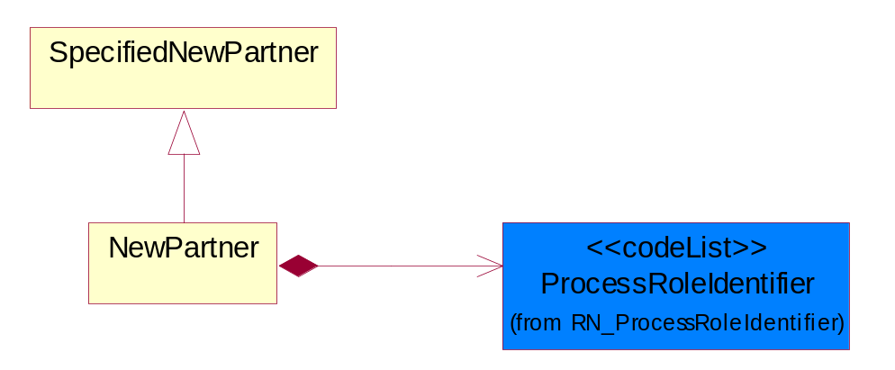
Figure 4-32 NewPartner

Composition | Cardinality | Type | Documentation
ProcessRoleIdentifier | 1 | ProcessRoleIdentifier | Describes the role of the partner in the business process. A partner will fulfill at least one or more roles during the business process.

PartnerDescription
The collection of business properties that describe a business partners' identity, their contact information, where they are physically located and their function in a supply chain.
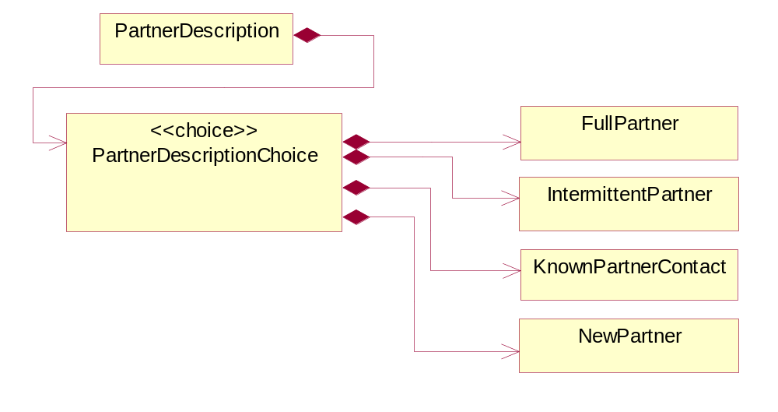
Figure 4-33 PartnerDescription

Composition | Cardinality | Type | Documentation
PartnerDescriptionChoice | 1 | PartnerDescriptionChoice

PartnerDescriptionChoice

Composition | Cardinality | Type | Documentation
KnownPartnerContact | 1 | KnownPartnerContact | The business document must describe the trading partners in the business transaction.
IntermittentPartner | 1 | IntermittentPartner | The business document must describe a physical address for a delivery.
NewPartner | 1 | NewPartner | The business document must describe a new, existing (but known to only one of the parties to the transaction) or an unknown party to the business transaction.
FullPartner | 1 | FullPartner | The business document must describe the trading partners in the business transaction. This data structure provide the flexibility to describe a partner in all possible methods as for new, existing or known partner.

PartnerIdentification
The business document must allow for the identity of one or more parties to the transaction.
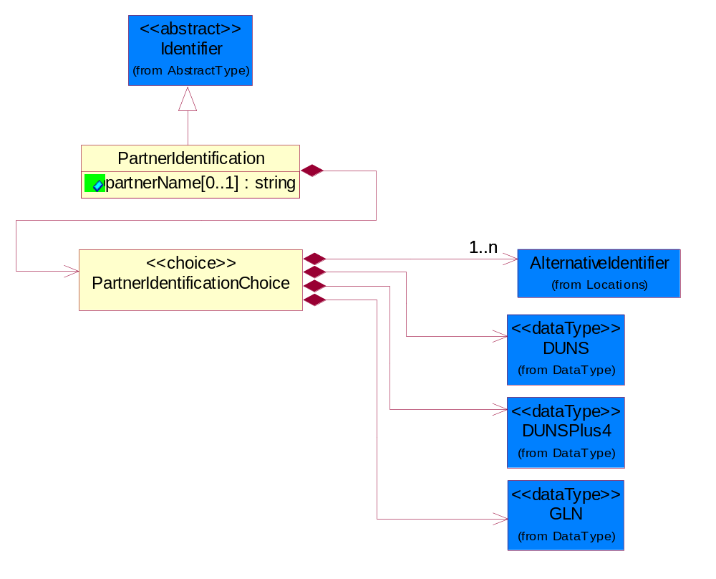
Figure 4-34 PartnerIdentification

Attribute | Type | Documentation
partnerName[0..1] | string | The name of the partner’s company/business.

Composition | Cardinality | Type | Documentation
PartnerIdentificationChoice | 1 | PartnerIdentificationChoice

PartnerIdentificationChoice

Composition | Cardinality | Type | Documentation
DUNS | 1 | DUNS | A number assigned by Dun and Bradstreet to identify a business location.
DUNSPlus4 | 1 | DUNSPlus4 | A identifier to specify a specific location within a business location.
AlternativeIdentifier | 1..n | AlternativeIdentifier | Identifies the specified code and the name of the organization that a code is utilized from.
GLN | 1 | GLN | Global Location Number (GLN) - A identifier to identify legal entities, trading parties and location.

SpecifiedFullPartner
The business document must describe the trading partners in the business transaction. This data structure provide the flexibility to describe a partner in all possible methods as for new, existing or known partner. This is specifically for partner who role has been specified.
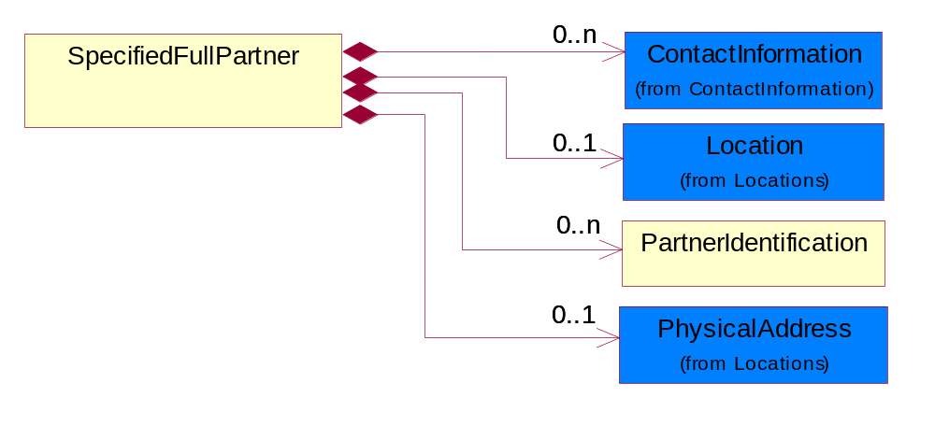
Figure 4-35 SpecifiedFullPartner

Composition | Cardinality | Type | Documentation
ContactInformation | 0..n | ContactInformation | The business document must allow for the identification of the name of the department, service or individual to be contacted regarding the context of the business document.
Location | 0..1 | Location | The business document must specify a location.
PartnerIdentification | 0..n | PartnerIdentification | The business document must allow for the identity of one or more parties to the transaction.
PhysicalAddress | 0..1 | PhysicalAddress | The business document must provide a physical address for a party to the business transaction.

SpecifiedIntermittentPartner
The business document must describe a physical address for a delivery.
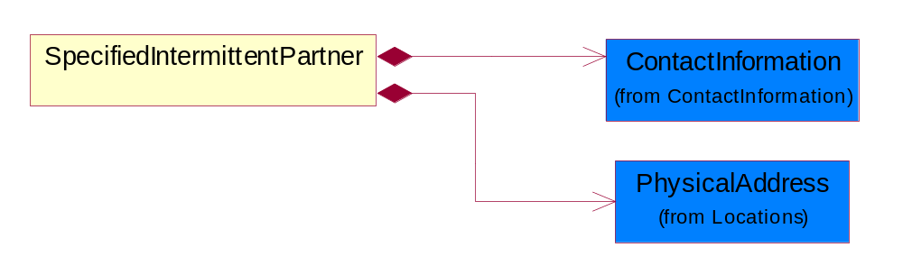
Figure 4-36 SpecifiedIntermittentPartner

Composition | Cardinality | Type | Documentation
ContactInformation | 1 | ContactInformation | The business document must allow for the identification of the name of the department, service or individual to be contacted regarding the context of the business document.
PhysicalAddress | 1 | PhysicalAddress | The business document must provide a physical address for a party to the business transaction.

SpecifiedKnownPartner
The business document must describe the trading partners in the business transaction.
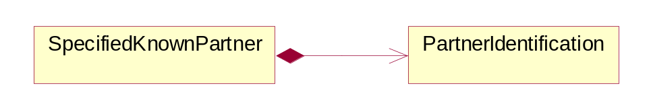
Figure 4-37 SpecifiedKnownPartner

Composition | Cardinality | Type | Documentation
PartnerIdentification | 1 | PartnerIdentification | The business document must allow for the identity of one or more parties to the transaction.

SpecifiedNewPartner
The business document must describe a new, existing (but known to only one of the parties to the transaction) or an unknown party to the business transaction.
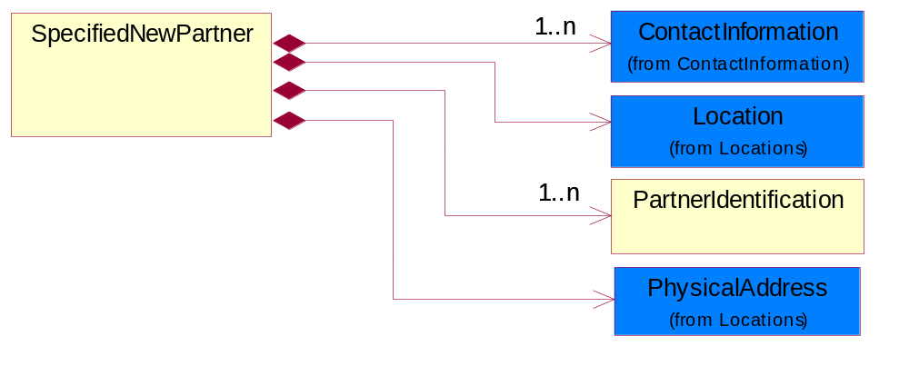
Figure 4-38 SpecifiedNewPartner

Composition | Cardinality | Type | Documentation
ContactInformation | 1..n | ContactInformation | The business document must allow for the identification of the name of the department, service or individual to be contacted regarding the context of the business document.
Location | 1 | Location | The business document must specify a location.
PhysicalAddress | 1 | PhysicalAddress | The business document must provide a physical address for a party to the business transaction.
PartnerIdentification | 1..n | PartnerIdentification | The business document must allow for the identity of one or more parties to the transaction.

ProductIdentification

ProductIdentification
The object provides the identifier(s) of a product.
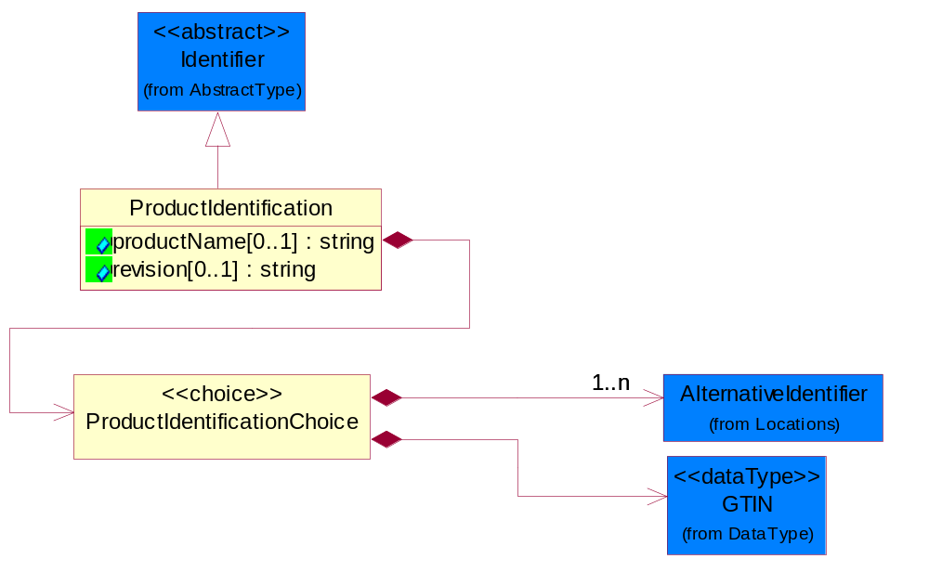
Figure 4-39 ProductIdentification

Attribute | Type | Documentation
productName[0..1] | string | The name of the product.
revision[0..1] | string | Referenced the specified product revision.

Composition | Cardinality | Type | Documentation
ProductIdentificationChoice | 1 | ProductIdentificationChoice

ProductIdentificationChoice

Composition | Cardinality | Type | Documentation
AlternativeIdentifier | 1..n | AlternativeIdentifier | Identifies the specified code and the name of the organization that a code is utilized from.
GTIN | 1 | GTIN | Global Trade Identification Number (GTIN).

CodeList

Country
For representation of Country name RosettaNet has adopted ISO 3166-3; 1999. Refer to the following web page to get the latest version of the standard:
http://www.iso.ch/iso/en/prods-services/iso3166ma/02iso-3166-code-lists/index.html

If you need more information about the ISO standard please contact ISO for more details.

CountrySubdivision
For representation of a Countries subdivisions RosettaNet has adopted ISO 3166-3; 1999. Refer to the following web page to get the latest version of the standard:
http://www.iso.ch/iso/en/prods-services/iso3166ma/02iso-3166-code-lists/index.html

If you need more information about the ISO standard please contact ISO for more details.

Currency
For representation of Currency codes RosettaNet has adopted ISO 4217; 1995. The British Standards Institution (BSI) is the ISO 4217 Maintenance Agency. Refer to the following web page to get the latest version of the standard:
http://www.bsi-global.com/Technical+Information/Publications/_Publications/tig90.xalter

If you need more information about the ISO standard please contact ISO for more details.

Language
For representation of Language name RosettaNet has adopted ISO 639-2; 1998. Refer to the following web page to get the latest version of the standard:

http://www.loc.gov/standards/iso639-2/iso639jac.html

If you need more information about the ISO standard please contact ISO for more details.

DocumentType
A code identifying the business context of a document.

Instance | Documentation
ARA | Authorization Request Approval.
CBN | Product batch number of customer.
CCN | Customs clearance number.
CFA | Failure Analysis - Request document that will accompany the product providing characteristics of the component failure.
CIN | Commercial Invoice.
CNM | Traditional credit note or memo.
CON | In a virtual sourcing relationship, a third party trading partner is supplying a part to a customer on behalf of another company that has taken the order for the customer. In this case a Customer Order Number is associated to the request for material that is sent to the virtual trading partners.
COS | Consumption Notice.
COT | Contract.
CRN | Unique consumption reference number identifying the product consumption issue i.e. one-to-one relationship with physical flow.
DEM | Traditional debit note or memo.
DEN | Delivery Note.
DIN | Discontinuation Notice.
DOR | Delivery Order.
DRN | Drawing Number.
DRR | Design Registration Request.
ECO | Engineering Change Order - The proprietary unique identification number that represents an engineering change order.
EIR | Engineering Information Request.
EOL | End of Life.
FUO | Sales order or transfer order fulfilling demand out of a facility (outbound shipment).
INV | Invoice.
LID | Location Identifier. Data for on-site work that have to be done on the machine (associated with preventive maintenance order).
MEN | Master Event Number.
MID | Machine Identifier. Data for on-site work that have to be done on the machine (associated with preventive maintenance order).
MON | Model Number.
OCL | The unique identifier assigned by the OEM for a warranty claim.
OGA | Other governmental agency issued document.
OPO | The unique identifier assigned by the OEM for a part order.
OPR | The unique identifier assigned by the OEM for a part return.
PCN | Product/Process Change.
PFA | Failure Analysis - Request document that will accompany the product providing characteristics of the product failure.
PII | Refers to previously issued invoice.
PLS | Unique number that identifies packing form prior to shipment.
POI | Purchase Order IN.
PON | Production order number for material release.
POO | Purchase Order OUT.
PRC | Product Catalog.
PSI | Refers to previously issued self-billing invoice.
PUO | Purchase Order.
QUO | Quote.
REC | Document identifying the receipt of materials or products into a facility against a purchase order or transfer order (inbound shipment).
REO | Purchase order or transfer order replenishing inventory into a facility (inbound shipment).
REQ | Requisition.
RMA | Returned Material Authorization.
RPO | Purchase order for materials or product returned to and reworked by a supplier.
RTA | Remittance Advice - Remittance details.
SAO | Sales Order.
SBC | Credit Memo used in self-billing scenario.
SBD | Debit Memo used in self-billing scenario.
SBI | Invoice in self billing scenario.
SBN | Product batch number of supplier.
SCA | Similar to contracts - Contains the quantity of an article that is to be ordered from a vendor and the price for article or service that is to be procured.
SEN | Serial Number.
SEO | A document that gives a repair provider the necessary authorization to repair or upgrade a product either at the customer site or at the repair provider’s site.
SHD | Shipping Document.
SNC | Shipset Number on Code List.
SPC | The unique identifier assigned by the ASP for a warranty claim.
SPN | Spec Number.
SPO | The unique identifier assigned by the ASP for a part order.
SPR | The unique identifier assigned by the ASP for a part return.
SPW | The unique identifier assigned by the ASP to reference a work order.
SRI | A document that contains the shipping reference number which allows the product to be tracked within the outsourced logistic providers network.
TRO | Order which results in materials or products being moved from one facility to another (outbound shipment and inbound shipment).
WAB | Waybill.
WAC | Denotes a warranty claim.
WOO | Work Order.

MimeTypeQualifier
The MIME type as defined by IANA.

Please refer to http://www.iana.org/assignments/media-types/ for a list of types.

Instance | Documentation
application/activemessage | [Shapiro]
application/andrew-inset | [Borenstein]
application/applefile | [Faltstrom]
application/atomicmail | [Borenstein]
application/batch-SMTP | [RFC2442]
application/beep+xml | [RFC3080]
application/cals-1840 | [RFC1895]
application/cnrp+xml | [RFCCNRP]
application/commonground | [Glazer]
application/cpl+xml
application/cybercash | [Eastlake]
application/dca-rft | [Campbell]
application/dec-dx | [Campbell]
application/dicom | [RFC3240]
application/dvcs | [RFC3029]
application/EDI-Consent | [RFC1767]
application/EDIFACT | [RFC1767]
application/EDI-X12 | [RFC1767]
application/eshop | [Katz]
application/font-tdpfr | [RFC3073]
application/http | [RFC2616]
application/hyperstudio | [Domino]
application/iges | [Parks]
application/index | [RFC2652]
application/index.cmd | [RFC2652]
application/index.obj | [RFC2652]
application/index.response | [RFC2652]
application/index.vnd | [RFC2652]
application/iotp | [RFC2935]
application/ipp | [RFC2910]
application/isup | [RFC3204]
application/mac-binhex40 | [Faltstrom]
application/macwriteii | [Lindner]
application/marc | [RFC2220]
application/mathematica | [Van Nostern]
application/msword | [Lindner]
application/news-message-id | [RFC1036,Spencer]
application/news-transmission | [RFC1036, Spencer]
application/ocsp-request | [RFC2560]
application/ocsp-response | [RFC2560]
application/octet-stream | [RFC2045,RFC2046]
application/oda | [RFC2045,RFC2046]
application/ogg | [RFC-walleij-ogg-mediatype-08.txt]
application/parityfec | [RFC3009]
application/pdf | [Lindner]
application/pgp-encrypted | [RFC3156]
application/pgp-keys | [RFC3156]
application/pgp-signature | [RFC3156]
application/pkcs10 | [RFC2311]
application/pkcs7-mime | [RFC2311]
application/pkcs7-signature | [RFC2311]
application/pkix-cert | [RFC2585]
application/pkixcmp | [RFC2510]
application/pkix-crl | [RFC2585]
application/postscript | [RFC2045,RFC2046]
application/prs.alvestrand.titrax-sheet | [Alvestrand]
application/prs.cww | [Rungchavalnont]
application/prs.nprend | [Doggett]
application/prs.plucker | [Janssen]
application/qsig | [RFC3204]
application/reginfo+xml | [RFC-ietf-sipping-reg-event-00.txt]
application/remote-printing | [RFC1486,Rose]
application/riscos | [Smith]
application/rtf | [Lindner]
application/sdp | [RFC2327]
application/set-payment | [Korver]
application/set-payment-initiation | [Korver]
application/set-registration | [Korver]
application/set-registration-initiation | [Korver]
application/sgml | [RFC1874]
application/sgml-open-catalog | [Grosso]
application/sieve | [RFC3028]
application/slate | [Crowley]
application/timestamp-query | [RFC3161]
application/timestamp-reply | [RFC3161]
application/tve-trigger | [Welsh]
application/vemmi | [RFC2122]
application/vnd.3gpp.pic-bw-large | [Meredith]
application/vnd.3gpp.pic-bw-small | [Meredith]
application/vnd.3gpp.pic-bw-var | [Meredith]
application/vnd.3gpp.sms | [Meredith]
application/vnd.3M.Post-it-Notes | [O'Brien]
application/vnd.accpac.simply.aso | [Leow]
application/vnd.accpac.simply.imp | [Leow]
application/vnd.acucobol | [Lubin]
application/vnd.acucorp | [Lubin]
application/vnd.adobe.xfdf | [Perelman]
application/vnd.aether.imp | [Moskowitz]
application/vnd.amiga.ami | [Blumberg]
application/vnd.anser-web-certificate-issue-initiation | [Mori]
application/vnd.anser-web-funds-transfer-initiation | [Mori]
application/vnd.audiograph | [Slusanschi]
application/vnd.blueice.multipass | [Holmstrom]
application/vnd.bmi | [Gotoh]
application/vnd.businessobjects | [Imoucha]
application/vnd.canon-cpdl | [Muto]
application/vnd.canon-lips | [Muto]
application/vnd.cinderella | [Kortenkamp]
application/vnd.claymore | [Simpson]
application/vnd.commerce-battelle | [Applebaum]
application/vnd.commonspace | [Chandhok]
application/vnd.contact.cmsg | [Patz]
application/vnd.cosmocaller | [Dellutri]
application/vnd.ctc-posml | [Kohlhepp]
application/vnd.cups-postscript | [Sweet]
application/vnd.cups-raster | [Sweet]
application/vnd.cups-raw | [Sweet]
application/vnd.curl | [Byrnes]
application/vnd.cybank | [Helmee]
application/vnd.data-vision.rdz | [Fields]
application/vnd.dna | [Searcy]
application/vnd.dpgraph | [Parker]
application/vnd.dreamfactory | [Appleton]
application/vnd.dxr | [Duffy]
application/vnd.ecdis-update | [Buettgenbach]
application/vnd.ecowin.chart | [Olsson]
application/vnd.ecowin.filerequest | [Olsson]
application/vnd.ecowin.fileupdate | [Olsson]
application/vnd.ecowin.series | [Olsson]
application/vnd.ecowin.seriesrequest | [Olsson]
application/vnd.ecowin.seriesupdate | [Olsson]
application/vnd.enliven | [Santinelli]
application/vnd.epson.esf | [Hoshina]
application/vnd.epson.msf | [Hoshina]
application/vnd.epson.quickanime | [Gu]
application/vnd.epson.salt | [Nagatomo]
application/vnd.epson.ssf | [Hoshina]
application/vnd.ericsson.quickcall | [Tidwell]
application/vnd.eudora.data | [Resnick]
application/vnd.fdf | [Zilles]
application/vnd.ffsns | [Holstage]
application/vnd.FloGraphIt | [Floersch]
application/vnd.framemaker | [Wexler]
application/vnd.fsc.weblaunch | [D.Smith]
application/vnd.fujitsu.oasys | [Togashi]
application/vnd.fujitsu.oasys2 | [Togashi]
application/vnd.fujitsu.oasys3 | [Okudaira]
application/vnd.fujitsu.oasysgp | [Sugimoto]
application/vnd.fujitsu.oasysprs | [Ogita]
application/vnd.fujixerox.ddd | [Onda]
application/vnd.fujixerox.docuworks | [Taguchi]
application/vnd.fujixerox.docuworks.binder | [Matsumoto]
application/vnd.fut-misnet | [Pruulmann]
application/vnd.grafeq | [Tupper]
application/vnd.groove-account | [Joseph]
application/vnd.groove-help | [Joseph]
application/vnd.groove-identity-message | [Joseph]
application/vnd.groove-injector | [Joseph]
application/vnd.groove-tool-message | [Joseph]
application/vnd.groove-tool-template | [Joseph]
application/vnd.groove-vcard | [Joseph]
application/vnd.hbci | [Hammann]
application/vnd.hhe.lesson-player | [Jones]
application/vnd.hp-HPGL | [Pentecost]
application/vnd.hp-hpid | [Gupta]
application/vnd.hp-hps | [Aubrey]
application/vnd.hp-PCL | [Pentecost]
application/vnd.hp-PCLXL | [Pentecost]
application/vnd.httphone | [Lefevre]
application/vnd.hzn-3d-crossword | [Minnis]
application/vnd.ibm.afplinedata | [Buis]
application/vnd.ibm.electronic-media | [Tantlinger]
application/vnd.ibm.MiniPay | [Herzberg]
application/vnd.ibm.modcap | [Hohensee]
application/vnd.ibm.secure-container | [Tantlinger]
application/vnd.informix-visionary | [Gales]
application/vnd.intercon.formnet | [Gurak]
application/vnd.intertrust.digibox | [Tomasello]
application/vnd.intertrust.nncp | [Tomasello]
application/vnd.intu.qbo | [Scratchley]
application/vnd.intu.qfx | [Scratchley]
application/vnd.irepository.package+xml | [Knowles]
application/vnd.is-xpr | [Natarajan]
application/vnd.japannet-directory-service | [Fujii]
application/vnd.japannet-jpnstore-wakeup | [Yoshitake]
application/vnd.japannet-payment-wakeup | [Fujii]
application/vnd.japannet-registration | [Yoshitake]
application/vnd.japannet-registration-wakeup | [Fujii]
application/vnd.japannet-setstore-wakeup | [Yoshitake]
application/vnd.japannet-verification | [Yoshitake]
application/vnd.japannet-verification-wakeup | [Fujii]
application/vnd.jisp | [Deckers]
application/vnd.kde.karbon | [Faure]
application/vnd.kde.kchart | [Faure]
application/vnd.kde.kformula | [Faure]
application/vnd.kde.kivio | [Faure]
application/vnd.kde.kontour | [Faure]
application/vnd.kde.kpresenter | [Faure]
application/vnd.kde.kspread | [Faure]
application/vnd.kde.kword | [Faure]
application/vnd.kenameaapp | [DiGiorgio-Haag]
application/vnd.koan | [Cole]
application/vnd.liberty-request+xml | [McDowell]
application/vnd.llamagraphics.life-balance.desktop | [White]
application/vnd.lotus-1-2-3 | [Wattenberger]
application/vnd.lotus-approach | [Wattenberger]
application/vnd.lotus-freelance | [Wattenberger]
application/vnd.lotus-notes | [Laramie]
application/vnd.lotus-organizer | [Wattenberger]
application/vnd.lotus-screencam | [Wattenberger]
application/vnd.lotus-wordpro | [Wattenberger]
application/vnd.mcd | [Gotoh]
application/vnd.mediastation.cdkey | [Flurry]
application/vnd.meridian-slingshot | [Wedel]
application/vnd.micrografx.flo | [Prevo]
application/vnd.micrografx.igx | [Prevo]
application/vnd.mif | [Wexler]
application/vnd.minisoft-hp3000-save | [Bartram]
application/vnd.mitsubishi.misty-guard.trustweb | [Tanaka]
application/vnd.Mobius.DAF | [Kabayama]
application/vnd.Mobius.DIS | [Kabayama]
application/vnd.Mobius.MBK | [Devasia]
application/vnd.Mobius.MQY | [Devasia]
application/vnd.Mobius.MSL | [Kabayama]
application/vnd.Mobius.PLC | [Kabayama]
application/vnd.Mobius.TXF | [Kabayama]
application/vnd.mophun.application | [Wennerstrom]
application/vnd.mophun.certificate | [Wennerstrom]
application/vnd.motorola.flexsuite | [Patton]
application/vnd.motorola.flexsuite.adsi | [Patton]
application/vnd.motorola.flexsuite.fis | [Patton]
application/vnd.motorola.flexsuite.gotap | [Patton]
application/vnd.motorola.flexsuite.kmr | [Patton]
application/vnd.motorola.flexsuite.ttc | [Patton]
application/vnd.motorola.flexsuite.wem | [Patton]
application/vnd.mozilla.xul+xml | [McDaniel]
application/vnd.ms-artgalry | [Slawson]
application/vnd.ms-asf | [Fleischman]
application/vnd.mseq | [Le Bodic]
application/vnd.ms-excel | [Gill]
application/vnd.msign | [Borcherding]
application/vnd.ms-lrm | [Ledoux]
application/vnd.ms-powerpoint | [Gill]
application/vnd.ms-project | [Gill]
application/vnd.ms-tnef | [Gill]
application/vnd.ms-works | [Gill]
application/vnd.ms-wpl | [Plastina]
application/vnd.musician | [Adams]
application/vnd.music-niff | [Butler]
application/vnd.netfpx | [Mutz]
application/vnd.noblenet-directory | [Solomon]
application/vnd.noblenet-sealer | [Solomon]
application/vnd.noblenet-web | [Solomon]
application/vnd.novadigm.EDM | [Swenson]
application/vnd.novadigm.EDX | [Swenson]
application/vnd.novadigm.EXT | [Swenson]
application/vnd.obn | [Hessling]
application/vnd.osa.netdeploy | [Klos]
application/vnd.palm | [Peacock]
application/vnd.pg.format | [Gandert]
application/vnd.pg.osasli | [Gandert]
application/vnd.powerbuilder6 | [Guy]
application/vnd.powerbuilder6-s | [Guy]
application/vnd.powerbuilder7 | [Shilts]
application/vnd.powerbuilder75 | [Shilts]
application/vnd.powerbuilder75-s | [Shilts]
application/vnd.powerbuilder7-s | [Shilts]
application/vnd.previewsystems.box | [Smolgovsky]
application/vnd.publishare-delta-tree | [Ben-Kiki]
application/vnd.pvi.ptid1 | [Lamb]
application/vnd.pwg-multiplexed | [RFC3391]
application/vnd.pwg-xhtml-print+xml | [Wright]
application/vnd.Quark.QuarkXPress | [Scheidler]
application/vnd.rapid | [Szekely]
application/vnd.s3sms | [Tarkkala]
application/vnd.sealed.net | [Lambert]
application/vnd.seemail | [Webb]
application/vnd.shana.informed.formdata | [Selzler]
application/vnd.shana.informed.formtemplate | [Selzler]
application/vnd.shana.informed.interchange | [Selzler]
application/vnd.shana.informed.package | [Selzler]
application/vnd.smaf | [Takahashi]
application/vnd.sss-cod | [Dani]
application/vnd.sss-dtf | [Bruno]
application/vnd.sss-ntf | [Bruno]
application/vnd.street-stream | [Levitt]
application/vnd.svd | [Becker]
application/vnd.swiftview-ics | [Widener]
application/vnd.triscape.mxs | [Simonoff]
application/vnd.trueapp | [Hepler]
application/vnd.truedoc | [Chase]
application/vnd.ufdl | [Manning]
application/vnd.uplanet.alert | [Martin]
application/vnd.uplanet.alert-wbxml | [Martin]
application/vnd.uplanet.bearer-choice | [Martin]
application/vnd.uplanet.bearer-choice-wbxml | [Martin]
application/vnd.uplanet.cacheop | [Martin]
application/vnd.uplanet.cacheop-wbxml | [Martin]
application/vnd.uplanet.channel | [Martin]
application/vnd.uplanet.channel-wbxml | [Martin]
application/vnd.uplanet.list | [Martin]
application/vnd.uplanet.listcmd | [Martin]
application/vnd.uplanet.listcmd-wbxml | [Martin]
application/vnd.uplanet.list-wbxml | [Martin]
application/vnd.uplanet.signal | [Martin]
application/vnd.vcx | [T.Sugimoto]
application/vnd.vectorworks | [Pharr]
application/vnd.vidsoft.vidconference | [Hess]
application/vnd.visio | [Sandal]
application/vnd.visionary | [Aravindakumar]
application/vnd.vividence.scriptfile | [Risher]
application/vnd.vsf | [Rowe]
application/vnd.wap.sic | [WAP-Forum]
application/vnd.wap.slc | [WAP-Forum]
application/vnd.wap.wbxml | [Stark]
application/vnd.wap.wmlc | [Stark]
application/vnd.wap.wmlscriptc | [Stark]
application/vnd.webturbo | [Rehem]
application/vnd.wrq-hp3000-labelled | [Bartram]
application/vnd.wt.stf | [Wohler]
application/vnd.wv.csp+wbxml | [Salmi]
application/vnd.xara | [Matthewman]
application/vnd.xfdl | [Manning]
application/vnd.yellowriver-custom-menu | [Yellow]
application/whoispp-query | [RFC2957]
application/whoispp-response | [RFC2958]
application/wita | [Campbell]
application/wordperfect5.1 | [Lindner]
application/x400-bp | [RFC1494]
application/xhtml+xml | [RFC3236]
application/xml | [RFC3023]
application/xml-dtd | [RFC3023]
application/xml-external-parsed-entity | [RFC3023]
application/zip | [Lindner]
audio/32kadpcm | [RFC2421,RFC2422]
audio/AMR | [RFC3267]
audio/AMR-WB | [RFC3267]
audio/basic | [RFC2045,RFC2046]
audio/CN | [RFC3389]
audio/DAT12 | [RFC3190]
audio/DVI4
audio/EVRC | [RFC-ietf-avt-evrc-smv-03.txt]
audio/EVRC0 | [RFC-ietf-avt-evrc-smv-03.txt]
audio/G.722.1 | [RFC3047]
audio/G722
audio/G723
audio/G726-16
audio/G726-24
audio/G726-32
audio/G726-40
audio/G728
audio/G729
audio/G729D
audio/G729E
audio/GSM
audio/GSM-EFR
audio/L16 | [RFC2586]
audio/L20 | [RFC3190]
audio/L24 | [RFC3190]
audio/L8
audio/LPC
audio/MP4A-LATM | [RFC3016]
audio/MPA
audio/mpa-robust | [RFC3119]
audio/mpeg | [RFC3003]
audio/parityfec | [RFC3009]
audio/PCMA
audio/PCMU
audio/prs.sid | [Walleij]
audio/QCELP
audio/RED
audio/SMV | [RFC-ietf-avt-evrc-smv-03.txt]
audio/SMV0 | [RFC-ietf-avt-evrc-smv-03.txt]
audio/telephone-event | [RFC2833]
audio/tone | [RFC2833]
audio/VDVI
audio/vnd.3gpp.iufp | [Belling]
audio/vnd.cisco.nse | [Kumar]
audio/vnd.cns.anp1 | [McLaughlin]
audio/vnd.cns.inf1 | [McLaughlin]
audio/vnd.digital-winds | [Strazds]
audio/vnd.everad.plj | [Cicelsky]
audio/vnd.lucent.voice | [Vaudreuil]
audio/vnd.nortel.vbk | [Parsons]
audio/vnd.nuera.ecelp4800 | [Fox]
audio/vnd.nuera.ecelp7470 | [Fox]
audio/vnd.nuera.ecelp9600 | [Fox]
audio/vnd.octel.sbc | [Vaudreuil]
audio/vnd.qcelp | [Lundblade]
audio/vnd.rhetorex.32kadpcm | [Vaudreuil]
audio/vnd.vmx.cvsd | [Vaudreuil]
image/cgm | Computer Graphics Metafile
image/g3fax | [RFC1494]
image/gif | [RFC2045,RFC2046]
image/ief | [RFC1314] Image Exchange Format
image/jpeg | [RFC2045,RFC2046]
image/naplps | [Ferber]
image/png | [Randers-Pehrson]
image/prs.btif | [Simon]
image/prs.pti | [Laun]
image/t38 | [RFC3362]
image/tiff | [RFC3302] Tag Image File Format
image/tiff-fx | [RFC3250] Tag Image File Format Fax eXtended
image/vnd.cns.inf2 | [McLaughlin]
image/vnd.djvu | [Bottou]
image/vnd.dwg | [Moline]
image/vnd.dxf | [Moline]
image/vnd.fastbidsheet | [Becker]
image/vnd.fpx | [Spencer]
image/vnd.fst | [Fuldseth]
image/vnd.fujixerox.edmics-mmr | [Onda]
image/vnd.fujixerox.edmics-rlc | [Onda]
image/vnd.globalgraphics.pgb | [Bailey]
image/vnd.mix | [Reddy]
image/vnd.ms-modi | [Vaughan]
image/vnd.net-fpx | [Spencer]
image/vnd.svf | [Moline]
image/vnd.wap.wbmp | [Stark]
image/vnd.xiff | [S.Martin]
message/delivery-status | [RFC1894]
message/disposition-notification | [RFC2298]
message/external-body | [RFC2045,RFC2046]
message/http | [RFC2616]
message/news | [RFC 1036, H.Spencer]
message/partial | [RFC2045,RFC2046]
message/rfc822 | [RFC2045,RFC2046]
message/s-http | [RFC2660]
message/sip | [RFC3261]
message/sipfrag | [RFC3420]
model/iges | [Parks]
model/mesh | [RFC2077]
model/vnd.dwf | [Pratt]
model/vnd.flatland.3dml | [Powers]
model/vnd.gdl | [Babits]
model/vnd.gs-gdl | [Babits]
model/vnd.gtw | [Ozaki]
model/vnd.mts | [Rabinovitch]
model/vnd.parasolid.transmit.binary | [Parasolid]
model/vnd.parasolid.transmit.text | [Parasolid]
model/vnd.vtu | [Rabinovitch]
model/vrml | [RFC2077]
multipart/alternative | [RFC2045,RFC2046]
multipart/appledouble | [Faltstrom]
multipart/byteranges | [RFC2068]
multipart/digest | [RFC2045,RFC2046]
multipart/encrypted | [RFC1847]
multipart/form-data | [RFC2388]
multipart/header-set | [Crocker]
multipart/mixed | [RFC2045,RFC2046]
multipart/parallel | [RFC2045,RFC2046]
multipart/related | [RFC2387]
multipart/report | [RFC1892]
multipart/signed | [RFC1847]
multipart/voice-message | [RFC2421,RFC2423]
text/calendar | [RFC2445]
text/css | [RFC2318]
text/directory | [RFC2425]
text/enriched | [RFC1896]
text/html | [RFC2854]
text/parityfec | [RFC3009]
text/plain | [RFC2646,RFC2046]
text/prs.lines.tag | [Lines]
text/rfc822-headers | [RFC1892]
text/richtext | [RFC2045,RFC2046]
text/rtf | [Lindner]
text/sgml | [RFC1874]
text/t140 | [RFC2793]
text/tab-separated-values | [Lindner]
text/uri-list | [RFC2483]
text/vnd.abc | [Allen]
text/vnd.curl | [Byrnes]
text/vnd.DMClientScript | [Bradley]
text/vnd.fly | [Gurney]
text/vnd.fmi.flexstor | [Hurtta]
text/vnd.in3d.3dml | [Powers]
text/vnd.in3d.spot | [Powers]
text/vnd.IPTC.NewsML | [IPTC]
text/vnd.IPTC.NITF | [IPTC]
text/vnd.latex-z | [Lubos]
text/vnd.motorola.reflex | [Patton]
text/vnd.ms-mediapackage | [Nelson]
text/vnd.net2phone.commcenter.command | [Xie]
text/vnd.sun.j2me.app-descriptor | [G.Adams]
text/vnd.wap.si | [WAP-Forum]
text/vnd.wap.sl | [WAP-Forum]
text/vnd.wap.wml | [Stark]
text/vnd.wap.wmlscript | [Stark]
text/xml | [RFC3023]
text/xml-external-parsed-entity | [RFC3023]
video/BMPEG
video/BT656
video/CelB
video/DV | [RFC3189]
video/H261
video/H263
video/H263-1998
video/H263-2000
video/JPEG
video/MP1S
video/MP2P
video/MP2T
video/MP4V-ES | [RFC3016]
video/mpeg | [RFC2045,RFC2046]
video/MPV
video/nv
video/parityfec | [RFC3009]
video/pointer | [RFC2862]
video/quicktime | [Lindner]
video/SMPTE292M | [RFC-avt-smpte292-video-08.txt]
video/vnd.fvt | [Fuldseth]
video/vnd.motorola.video | [McGinty]
video/vnd.motorola.videop | [McGinty]
video/vnd.mpegurl | [Recktenwald]
video/vnd.nokia.interleaved-multimedia | [Kangaslampi]
video/vnd.objectvideo | [Clark]
video/vnd.vivo | [Wolfe]

UnitOfMeasure
Code identifying a product unit of measure.

Instance | Documentation
10P | 10-pack.
1BF | 100 Board Feet.
1FC | 20 Foot Container.
1GR | Gram/Cubic Centimeter.
1GT | 10,000 Gallon Tankcar.
1KB | 25 Kilogram Bulk Bag.
1KD | 10 Kilogram Drum.
1KP | 1000-pack.
1PA | 20-Pack.
1PB | 50 Pound Bag.
1PD | 100 Pound Drum.
2FC | 40 Foot Container.
2GR | Gram/square meter.
2GT | 20,000 Gallon Tankcar.
2KB | 300 Kilogram Bulk Bag.
2KD | 15 Kilogram Drum.
2PA | 100-Pack.
3GR | Grams Per 100 Centimeters.
3KB | 500 Kilogram Bulk Bag.
3KD | 55 Gallon Drum.
4GR | Grams Per 100 Grams.
4KD | 115 Kilogram Drum.
50P | 50-pack.
5GR | Grams Per Cubic Centimeter.
6GR | Grams Per Square Centimeter.
7GR | Grams Per Square Meter.
ACR | Acre.
ACT | Actual Pounds.
ALU | Aluminum Pounds Only.
AMP | Ampere.
ASM | Angstrom.
BAB | Base Box.
BAC | Batch.
BAE | Bale.
BAG | Bag.
BAL | Ball.
BAN | Band.
BAP | Batting Pound.
BAR | Bar.
BAS | Basket.
BAT | Batt.
BAW | Base Weight.
BEA | Beam.
BEC | Becquerel/kilogram.
BEL | Belt.
BIL | Billet.
BIN | Bin.
BIT | Bit.
BKC | Bulk Car Load.
BLO | Block.
BOA | Board.
BOF | Board Feet.
BOL | Bolt.
BOT | Bottle.
BOX | Box.
BRD | Barrels Per Day.
BRE | Barrel.
BRI | Barrel (Imperial).
BRM | Barrels Per Minute.
BTF | British Thermal Units (BTUs) Per Cubic Foot.
BTP | British Thermal Units (BTUs) Per Pound.
BTU | British Thermal Unit (BTU).
BUC | Bucket.
BUD | Bushel, Dry Imperial.
BUK | Bunks.
BUL | Bulk.
BUN | Bundle.
BUP | Bulk Pack.
BUS | Bushel.
BYT | Bytes.
CAA | Carat.
CAB | Carboy.
CAC | Card.
CAD | Candela.
CAG | Cartridge.
CAK | Cask.
CAL | Calorie.
CAN | Can.
CAO | Carload.
CAR | Car.
CAS | Case.
CAT | Canister.
CAW | Catchweight.
CEL | Cell.
CEM | Centimeter.
CEP | Centipoise (CPS).
CET | Centiliter.
CGM | Centigram.
CHA | Chains (Land Survey).
CHE | Chest.
CNN | Connector.
COG | Coil Group.
COI | Coil.
COL | Coulomb.
COM | Composite Product Pounds (Total Weight).
CON | Cone.
COT | Container.
COV | Cover.
CRA | Crate.
CRT | Carton.
CSE | Cassette.
CUB | Cubic centimeter.
CUC | Cubic centimeter/second.
CUF | Cubic Foot.
CUI | Cubic inch.
CUM | Cubicmeter.
CUP | Cup.
CUY | Cubic yard.
CYC | Cycles.
CYL | Cylinder.
DAY | Day.
DCB | Decibels.
DCG | Decagram.
DCL | Deciliter.
DEA | Deal.
DEC | Decimeter.
DEF | Degree Fahrenheit.
DEG | Degree Celsius.
DEP | Dep. Factor.
DGM | Decigram.
DIE | Die.
DIL | Display.
DIP | Dispenser.
DOZ | Dozen.
DRA | Dram.
DRU | Drum.
DRY | Dry Pounds.
EAC | Each.
ELE | Electrical Capacitance.
FAR | Farads.
FFA | Femtofarad.
FLO | Fluid Ounce.
FOI | Fluid Ounce (Imperial).
FOO | Foot.
FOU | Fluid Ounce US.
FUU | Fuel Usage (Gallons).
GAL | Gallon.
GAS | Gage Systems.
GIH | Gigahertz.
GIJ | Gigajoules.
GIL | Gill (Imperial).
GOB | Gross Barrels.
GOG | Gross Gallons.
GOK | Gross Kilogram.
GOT | Gross Ton.
GOY | Gross Yard.
GRA | Gram.
GRG | Great Gross (Dozen Gross).
GRK | Grams Per Kilogram.
GRL | Grams Per Liter.
GRM | Grams Per Milliliter.
GRN | Grain.
GRO | Gross.
GRP | Group.
HAG | Half Gallon.
HAH | Half Hour.
HAL | Half Liter.
HAN | Hank.
HEA | Heat lots.
HEC | Hectare.
HEL | Hectoliter.
HEP | Hectopascal.
HER | Hertz.
HNY | Henry.
HOS | Hours.
HOU | Hour.
HUA | Hundredth of a Carat.
HUB | Hundred Boxes.
HUC | Hundred Count.
HUS | Hundred Sheets.
IMG | Imperial Gallons.
INC | Inch.
JAR | Jar.
JOI | Joint.
JOU | Joule.
KBY | Kilobyte.
KEG | Keg.
KEL | Kelvin.
KHO | Kilometer/hour.
KIC | Kilogram per cubic meter.
KIE | Kilometer.
KIG | Kilogram.
KIH | Kilohertz.
KIK | Kilobecquerel/Kilogram.
KIL | Kiloampere.
KIM | Kilogram/square meter.
KIO | Kiloohm.
KIS | Kilogramm pro Sekunde.
KIT | Kit.
KIV | Kilovolt.
KIW | Kilowatt.
KJL | Kilojoule.
KKG | Kilogram/Kilogram.
KUD | Kubikdezimeter.
KUM | Kubikmeter pro Sekunde.
KWH | Kilowatt-hour.
LIF | Lifts.
LIM | Link.
LIQ | Liquid Pounds.
LIT | Liter.
LOA | Load.
LOT | Lot.
LUG | Lug.
MAM | Milliamps/mm.
MAT | Mat.
MBY | Megabyte.
MCG | Microgram.
MCM | Milligrams Per Cubic Meter.
MCR | Micron.
MEG | Megagram.
MEH | Megahertz.
MEP | Megapascal.
MET | Meter.
MEW | Megawatt.
MGM | Milligram.
MIB | Million BTU's.
MIC | Mikrogram/cubic meter.
MIG | Micrograms Per Cubic Meter.
MIL | Mile.
MIM | Micrometer.
MIN | Minute.
MIP | Millipascal seconds.
MIS | Microsecond.
MIT | Miter.
MIV | Millivolt.
MIW | Milliwatt.
MJO | Millijoule.
MLA | Milliampere.
MLB | Millibar.
MLC | Milligram/cubic meter.
MLI | Milliliter.
MLK | Milligram/kilogram.
MLL | Milligram/Liter.
MLS | Miles.
MME | Millimeter.
MMH | Millimeter H20.
MMK | Millimol/kilogram.
MMO | Millimol.
MOK | Mol/kilogram.
MOL | Mol.
MON | Month.
MPH | Megagrams Per Hour.
MSC | Millisecond.
MSM | Milligrams Per Square Meter.
MTA | Millitesla.
MTQ | Meter pro Quadratsekunde.
MTS | Meters per second.
MUL | Multichip - When 2 or more dies (chips) are merged into one package.
MVS | Millivolts.
MVT | Millivolt.
NAA | Nanoamps.
NAM | Nanometer.
NAS | Nanosecond.
NEB | Net Barrels.
NEG | Net Gallons.
NEI | Net Imperial Gallons.
NEL | Net Liters.
NEW | Newton.
OCT | Ohm/ct.
OHM | Ohm.
OMM | Ohm/mm.
ONE | One.
OSQ | Ohm/sq.
OTP | One Thousand Pieces.
OUN | Ounce.
OVI | Ohm/via.
PAC | Parcel.
PAD | Pad.
PAG | Package.
PAI | Pail.
PAK | Pack (PAK).
PAL | Pallet.
PAN | Panel.
PAR | Pair.
PAS | Pascal.
PAT | Packet.
PEC | Percent.
PEG | Percentage.
PEH | Percent Per 1000 Hours.
PEN | Pennyweight.
PER | Per Hundred Pieces.
PEW | Percent Weight.
PFR | Picofarad.
PID | Pint U.S. Dry.
PIE | Piece.
PIL | Pint - US liquid.
PLA | Plate.
PLL | Pallet (Lift).
PLT | Pallete.
PLU | Pallet/Unit Load.
POF | Pounds Per Foot.
POG | Pounds Per Gallon.
PON | Pound.
POP | Pounds Per Piece of Product.
POS | Pounds Per 1000 Square Feet.
POT | Pounds Per Thousand.
PPB | Parts per billion (US).
PPM | Parts per million.
PPP | Pounds Per Pound of Product.
PSC | Picosecond.
PSS | Pascal second.
QUA | Quart - US liquid.
RAC | Rack.
REA | Ream of 500 Sheets.
REE | Reel.
RIN | Ring.
ROD | Rod.
ROL | Roll.
SAC | Sack.
SBB | Super Bulk Bag.
SEC | Second.
SET | Set.
SHE | Sheet.
SHI | Shipment.
SHM | Sheet - Metric measure.
SHO | Shot.
SID | Disk (Disc).
SKE | Skein.
SKI | Skid.
SLE | Sleeve.
SLI | Slip Sheet.
SMI | Square mile.
SMM | Square millimeter.
SPO | Spool.
SQF | Square foot.
SQI | Square inch.
SQK | Square kilometer.
SQM | Square meter.
SQS | Square meter/second.
SQU | Square.
SQY | Square Yard.
STI | Stick.
STM | Statute Mile.
STR | Strip.
TAB | Tablet.
TAN | Tank.
TAT | Tank Truck.
TES | Tesla.
THO | Thousand.
TNN | Tonne.
TON | Ton.
TOR | Torr.
TOT | Tote.
TRA | Train.
TRF | Track Foot.
TRL | Trailer.
TRO | Troy.
TRU | Truckload.
TRY | Tray.
TRZ | Troy OZ.
TUB | Tube.
ULU | Unitless Unit of Measure.
UNT | Unit.
USG | US gallon.
USP | US pound.
UST | US ton.
VIA | Vial.
VOL | Volt.
VTA | Volts (Alternating Current).
VTD | Volts (Direct Current).
VTM | Volts Per Meter.
WAF | Wafer.
WAR | Watt.
WEE | Week.
WRA | Wrap.
YAR | Yard.
YEA | Year.

ProcessRoleIdentifier
Describes the role of the partner in the business process. A partner will fulfill at least one or more roles during the business process.

Instance | Documentation
ADM | Administered by - The party who is the administrative authority of an account.
ALT | Alternate approval by - The party who has approved a request in the event the approver is not able to respond.
APP | Approval by - The party who has approved a request.
BIF | Bill from - The party that will issue the invoice.
BIT | Bill to - The party that will pay the invoice.
CBK | Customs Broker - CustomsBroker  This object represents the party that declare the shipment on behalf of declarant.
CLF | Collect From - To enable the buyer to specify the location of where products not supplied directly by the seller/installer may be collected.
CLM | Claimed By - This object represents the claimant.
CNC | Cancellation party - The party who is canceling the shipping order.
COR | Change originated by - The party who originates a proposed change.
COW | Change owned by - The party who owns or who is assigned responsibility for a proposed change.
CRA | Credit applicant - The party who is applying for credit.
CRE | Created by - The party responsible for creating a process or task.
CSP | Contract Service Provider.
CWN | contractOwner - The party who is the owner of the contract. For example, in the direct business, the buyer is the contract owner. In the distribution business, the buyer is the distributor and the contract owner is the reseller.
DCE | DesignCustomerApplicationEngineer. The demand customer's Field Application Engineer.
DCT | Declared To - This object represents the party that the declaration goes to.
DCU | DesignCustomer. The owner of the product for which the design has been created.
DIS | Distributed by - The party who supplies products to retailers.
DST | Distributed To - This object represents the party to send information to.
FCP | Forecast Partner - The collection of business properties that describes the partner types for a forecast.
FIA | From Install At - The collection of sender business properties that describes a business partners' identity, their contact information, where they are physically located and their function in a supply chain.
FIN | Financed by - The party who is the financier.
FNB | Founded by - The party who performs the act, process, or art of casting metals.
FOR | Forwarded to - The party to whom a business document has been forwarded.
IMB | Imported By - The party responsible for importing the product.
INL | Inventory location - The party where the inventory product entry is located.
INO | Inventory owner - The party that owns the inventory product entry.
ITF | In transit from - The party sending the product quantity in a product location transfer.
ITL | installAt - The partner and/or location to which the product must be set up for use or service.
ITT | In transit to - The party receiving the product quantity in a product location transfer.
LGP | Logistics Provided By - The party who handles the details of an operation.
MFG | Manufactured by - The party who creates, processes or produces goods especially in large quantities and by means of industrial machines.
OWN | Owned by - The party who owns a process.
PAE | ProductProviderFieldApplicationEngineer. The product provider Field Application Engineer.
PCW | Primary Contract With - The primary party with whom a contract is formed.
PNB | Planning By - The party who establishes goals, policies or procedures.
PSR | ProductProviderSalesRepresentative. The product provider sales representative.
PUR | Purchased by - The party who is a purchaser of a product.
REA | Requested approval by - The party who has been selected to approve a request.
REC | Received by - The party who has received a product shipment.
REQ | Requested by - The party who has initiated a request.
RES | Respond to - The party to whom a responding business document must be sent when it is not equal to the partner specified in the document header.
RET | Return by - The party responsible for either carrying or forwarding the returned product.
REV | Reviewed by - The party responsible for reviewing a business document.
RFR | receivedFrom - The partner and/or location from where the product was shipped.
RLS | Released By - This object represents the party that releases the goods.
RMT | remitTo - The partner to which payment for a business document is sent.
RPB | Repaired By - The collection of business properties used to identify the business partner responsible for the repair or  rework of a product.
RQT | Refer Quote To - The partner to whom a quote request is being referred.
RSF | Requested Ship From - The party where the product is requested to be shipped from.
RTT | ReturnTo - The partner and/or location to which the returned product must be delivered.
SBF | Self-billing from - The party who initiates the billing in self-billing scenario.
SBT | Self-billing to - The party whom the invoice is addressed to.
SCB | Subcontracted By - The party who is contracted to perform part or all of another party's contract.
SCP | Shipping charges paid by - The party responsible for administering payment of the shipping charges.
SCW | Secondary Contract With - The subsequent party(ies) with whom a contract is formed.
SHF | Ship From - The collection of business properties used to identify the business partner initiating a shipment or transaction.
SHT | Ship To - The partner and/or location to which the product must be delivered.
SLD | Sold to - The party to whom a product has been sold.
SOB | Sold By - The seller involved in a business transaction.
SPL | Supplied by - The party who supplies an item, part or assembly.
SPS | Service Provider Site - Identification for the location of the ASP site that is ordering the replacement parts and/or performing the repair.
SRT | Submit returns to - The party to whom product returns are to be submitted.
STR | Stored By - This object represents the party that stores the goods.
SVA | ShipVia - The partner and/or location through which the product must be shipped, such as the "cross dock" at a shipping hub.  It must not be specified for the last leg, since this would be the same as the final destination specified in the ShipmentInformation/shipTo.
TFR | Transfer From - The party responsible for making the payment (Payer).
TIA | To lnstall At - The collection of receiver business properties that describes business partners' identity, their contact information, where they are physically located and their function in a supply chain.
TMT | Transfer Manufacturing To - The movement of the manufacturing process to another site.
TRA | Transported by - The party responsible for either carrying or forwarding the product.
TSB | Tested By - The collection of business properties used to identify the specific location and resources used to conduct a defined cycle or steps or measurements required to confirm a result or event.
TTR | Transfer To - The party who is receiving the payment (payee).
ULR | Ultimate recipient - The party who ultimately receives the shipment, when an intermediate party takes responsibility for payment and final delivery.
USE | Used by - The party who is the end user of the product.
UST | Unstuffed By - This object represents the party that unstuffs the goods.
WHB | Warehoused By - The party who stocks or stores products.

System Structure

BusinessProcessIdentifier
A Business Process Identifier to uniquely define the TPIR-PIP 'role' within a Business Scenario at a company or MNC level. The identifier MUST be composed of alphanumeric characters only and its length MUST be between one and twelve characters.
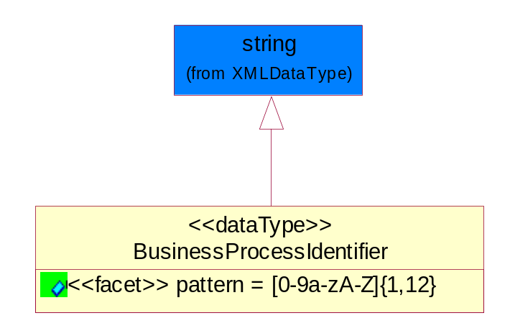
Figure 5-40 BusinessProcessIdentifier

Attribute | Type | Documentation
pattern |  | [0-9a-zA-Z]{1,12}

BusinessServiceInformation
The object allows the specification of the business service utilized within the partner company. This may or may not be the same as the information sent by the RNIF.
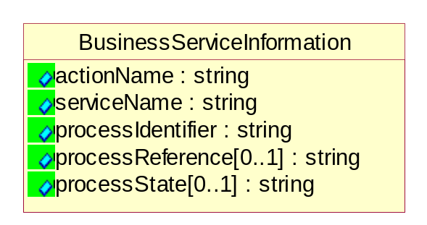
Figure 5-41 BusinessServiceInformation

Attribute | Type | Documentation
actionName | string | The name of Action. For RosettaNet usually any of Request/Confirm/Notify/Query/Response.
serviceName | string | The name of the Business Activity with the "Request/Confirm" part removed. E.g., for the Activity "Request Purchase Order"==> "Purchase Order".
processIdentifier | string | The name of the PIP e.g. Notify of Forecast Reply.
processReference[0..1] | string | The URN for the PIP that includes Cluster/Segment/Process pattern used to identify the interface process (such as PIP3A4)
processState[0..1] | string | The business process (or service) state of the sender of a document. When a service receives this document, the receiver may use the state as a precondition.

ContractInformation
A block of information used to correlate a contract in an executing choreography.

Figure 5-42 ContractInformation

Attribute | Type | Documentation
contractIdentifier[0..1] | string | Unique identification of a contract between the Sender and the Receiver
contractType[0..1] | string | The type of the contract: an attribute describing the type of the ContractIndentification. Valid values are URI, URN,ebXMLCPA, or other values defined by partners.

CorrelationInformation
A block of information used to correlate a requesting document to a responding document and to the contract in an executing choreography.
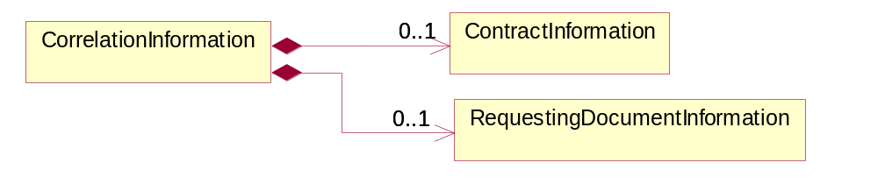
Figure 5-43 CorrelationInformation

Composition | Cardinality | Type | Documentation
ContractInformation | 0..1 | ContractInformation | A block of information used to correlate a contract in an executing choreography.
RequestingDocumentInformation | 0..1 | RequestingDocumentInformation | A block of information used to correlate a requesting document to a responding document in an executing choreography.

DocumentHeader
The object allows for the identification of the sender and receiver of the business document.
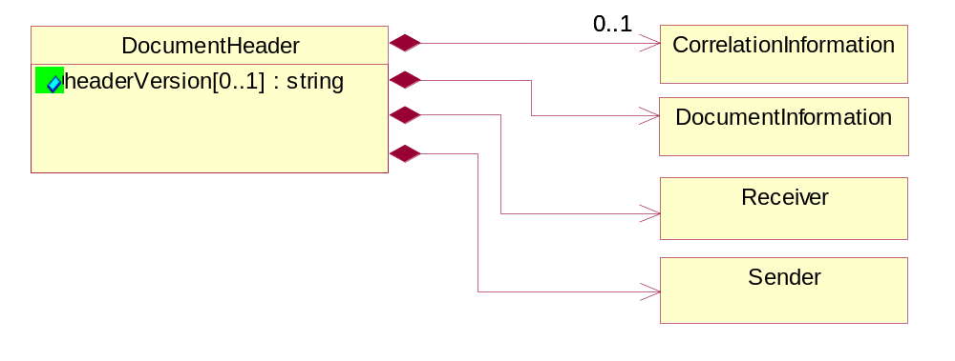
Figure 5-44 DocumentHeader

Attribute | Type | Documentation
headerVersion[0..1] | string | The UN/CEFACT version of the document header.

Composition | Cardinality | Type | Documentation
Sender | 1 | Sender | The object allows the identification of the initiating party of the business message.
CorrelationInformation | 0..1 | CorrelationInformation | A block of information used to correlate a requesting document to a responding document and to the contract in an executing choreography.
DocumentInformation | 1 | DocumentInformation | The object specifies information to identify the business document, a summary of attachments, and information about the business document security.
Receiver | 1 | Receiver | The object allows the identification of the receiving party of the business message.

DocumentIdentification
The object specifies all information necessary to identify the business document.
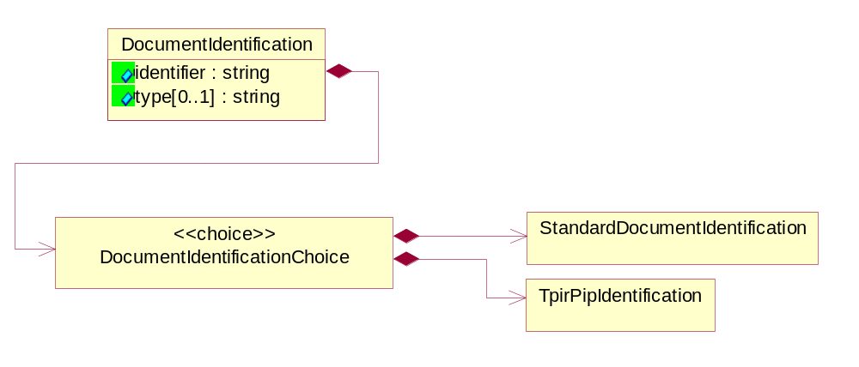
Figure 5-45 DocumentIdentification

Attribute | Type | Documentation
identifier | string | The unique identifier for the document being sent.
type[0..1] | string | Name of the Action Message

Composition | Cardinality | Type | Documentation
DocumentIdentificationChoice | 1 | DocumentIdentificationChoice

DocumentIdentificationChoice

Composition | Cardinality | Type | Documentation
StandardDocumentIdentification | 1 | StandardDocumentIdentification | The object specifies additional information necessary to identify the standard business document.
TpirPipIdentification | 1 | TpirPipIdentification | The object specifies all information necessary to uniquely identify a TPIR-PIP within a Registry or trading partner repository.

DocumentInformation
The object specifies information to identify the business document, a summary of attachments, and information about the business document security.
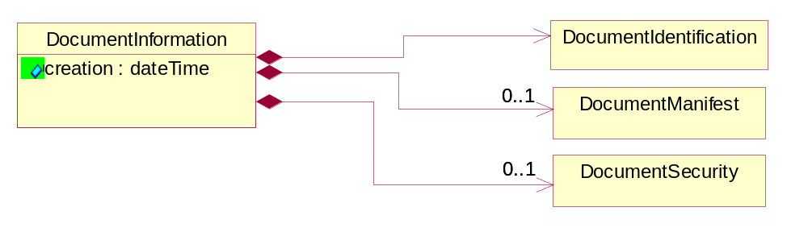
Figure 5-46 DocumentInformation

Attribute | Type | Documentation
creation | dateTime | The creation date and time of the specified Business Document (i.e. the Purchase Order date).

Composition | Cardinality | Type | Documentation
DocumentIdentification | 1 | DocumentIdentification | The object specifies all information necessary to identify the business document.
DocumentSecurity | 0..1 | DocumentSecurity | The object provides additional granularity in specifying business document security (this is in addition to the specified PIP security).
DocumentManifest | 0..1 | DocumentManifest | The block provides a brief summary of attachments and Service Content.

DocumentManifest
The block provides a brief summary of attachments and Service Content.
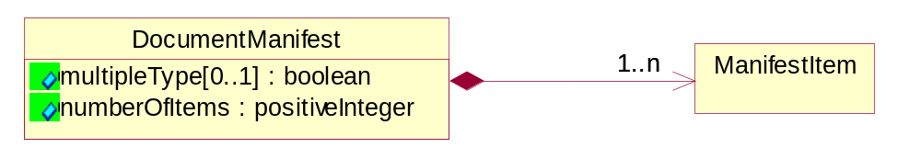
Figure 5-47 DocumentManifest

Attribute | Type | Documentation
multipleType[0..1] | boolean | Indicates whether the manifest contains documents of multiple types. True if yes, and False if no.
numberOfItems | positiveInteger | Total number of documents in the message. The physical count of the attachments in the payload plus the RosettaNet Business Message (for Service Content). The value of this field will be at least 1.

Composition | Cardinality | Type | Documentation
ManifestItem | 1..n | ManifestItem | The object provides details about the specific attachment(s).

DocumentSecurity
The object provides additional granularity in specifying business document security (this is in addition to the specified PIP security).

Figure 5-48 DocumentSecurity

Attribute | Type | Documentation
nonRepudiableReceipt | boolean | The value "true" will indicate that a signed acknowledgement for the business document is necessary.
persistentEncryption | boolean | The value "true" will indicate that the Business Document (including the header) needs to be encrypted when stored or transported.
persistentSignature | boolean | The value "true" will indicate that a signature is required to be stored with the document while stored or transported.

ManifestItem
The object provides details about the specific attachment(s).

Figure 5-49 ManifestItem

Attribute | Type | Documentation
description[0..1] | string | A description of the attachment.
length[0..1] | positiveInteger | The size of the attachment in bytes (i.e. 1 000 000 bytes)
universalResourceIdentifier | string | The generic set of all names/addresses that are short strings that refer to resources.

Composition | Cardinality | Type | Documentation
mimeTypeQualifier | 1 | MimeTypeQualifier | The MIME type as defined by IANA.  Please refer to http://www.iana.org/assignments/media-types/ for a list of types.
language | 0..1 | Language | For representation of Language name RosettaNet has adopted ISO 639-2; 1998. Refer to the following web page to get the latest version of the standard:  http://www.loc.gov/standards/iso639-2/iso639jac.html  If you need more information about the ISO standard please contact ISO for more details.

PipIdentifier
PIP Identification.[ i.e. PIP3A4]
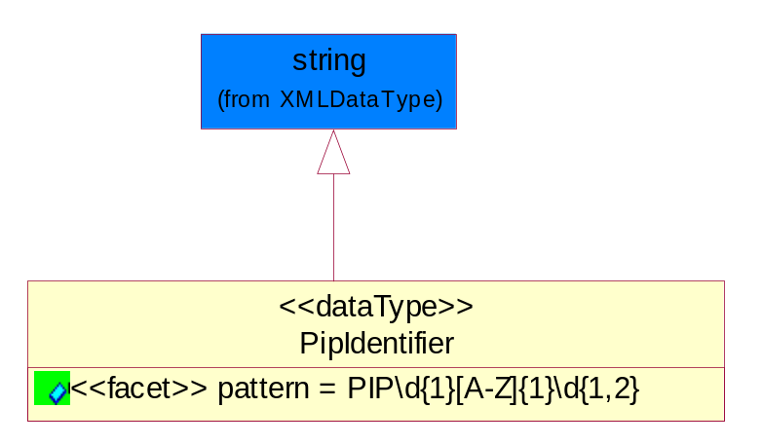
Figure 5-50 PipIdentifier

Attribute | Type | Documentation
pattern |  | PIP\d{1}[A-Z]{1}\d{1,2}

PipVersion
PIP version number (i.e. 02.02.00).
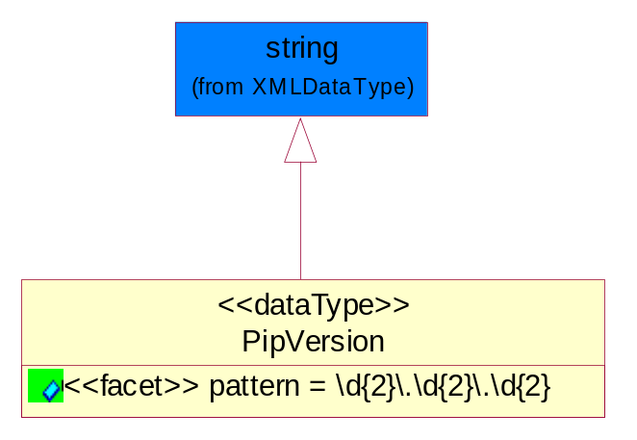
Figure 5-51 PipVersion

Attribute | Type | Documentation
pattern |  | \d{2}\.\d{2}\.\d{2}

Receiver
The object allows the identification of the receiving party of the business message.
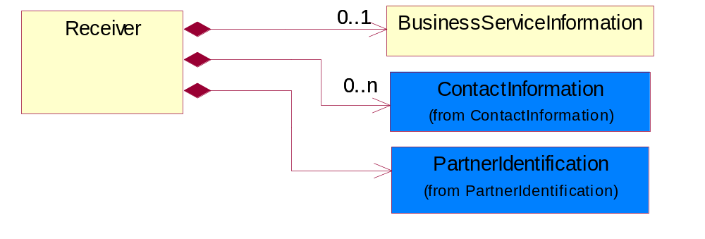
Figure 5-52 Receiver

Composition | Cardinality | Type | Documentation
BusinessServiceInformation | 0..1 | BusinessServiceInformation | The object allows the specification of the business service utilized within the partner company. This may or may not be the same as the information sent by the RNIF.
PartnerIdentification | 1 | PartnerIdentification | The business document must allow for the identity of one or more parties to the transaction.
ContactInformation | 0..n | ContactInformation | The business document must allow for the identification of the name of the department, service or individual to be contacted regarding the context of the business document.

RequestingDocumentInformation
A block of information used to correlate a requesting document to a responding document in an executing choreography.

Figure 5-53 RequestingDocumentInformation

Attribute | Type | Documentation
businessProcessInstanceIdentifier[0..1] | string | The identifier for the public business process instance being sent that both the sender and receiver can identify.
responseDateTime[0..1] | dateTime | The expected time to receive the response. This can not be greater than the PIP TimeToPerform.
requestingDocumentCreationDateTime[0..1] | dateTime | The date-time of the requesting business document.
requestingDocumentInstanceIdentifier | string | The Business Document identification number that identifies the requesting Business Document.

Sender
The object allows the identification of the initiating party of the business message.
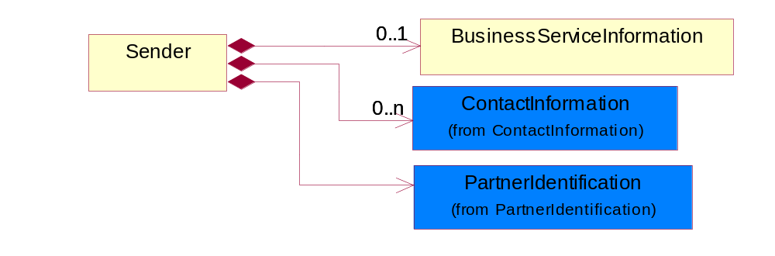
Figure 5-54 Sender

Composition | Cardinality | Type | Documentation
PartnerIdentification | 1 | PartnerIdentification | The business document must allow for the identity of one or more parties to the transaction.
BusinessServiceInformation | 0..1 | BusinessServiceInformation | The object allows the specification of the business service utilized within the partner company. This may or may not be the same as the information sent by the RNIF.
ContactInformation | 0..n | ContactInformation | The business document must allow for the identification of the name of the department, service or individual to be contacted regarding the context of the business document.

StandardDocumentIdentification
The object specifies additional information necessary to identify the standard business document.
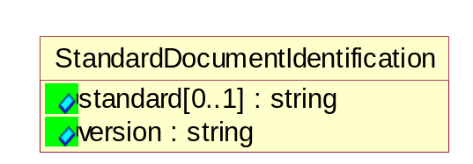
Figure 5-55 StandardDocumentIdentification

Attribute | Type | Documentation
standard[0..1] | string | Identifies the standard used to submit the business document. (e.g. RosettaNet).
version | string | PIP3A4v01.00

TpirPipIdentification
The object specifies all information necessary to uniquely identify a TPIR-PIP within a Registry or trading partner repository.

Figure 5-56 TpirPipIdentification

Attribute | Type | Documentation
partnerId | DUNSPlus4 | The Trading Partner Identification of MNC that is creating this TPIR PIP.
pipIdentifier | PipIdentifier | A TPIR PIP Identification [i.e., 3A4 ).
pipVersion | PipVersion | A TPIR PIP version number (i.e., 02.02.00)
tpirPipVersion | VersionIdentifier | A TPIR-PIP Version Number (i.e., major and minor version number as XX.XX).
tpirBusinessProcessIdentifier[0..1] | BusinessProcessIdentifier | A Business Process Identifier to uniquely define the TPIR-PIP 'role' within a Business Scenario at a company or MNC level. The identifier MUST be composed of alphanumeric characters only and its length MUST be between one and twelve characters.
uri[0..1] | anyURI | Describes the destination uri for the TPIR form.

Composition | Cardinality | Type | Documentation
fileType | 0..1 | TPIRFileType | Describes the file type of the TPIR form (PDF, XDP or XML).

VersionIdentifier
Version Number (i.e., major and minor version number as XX.XX).
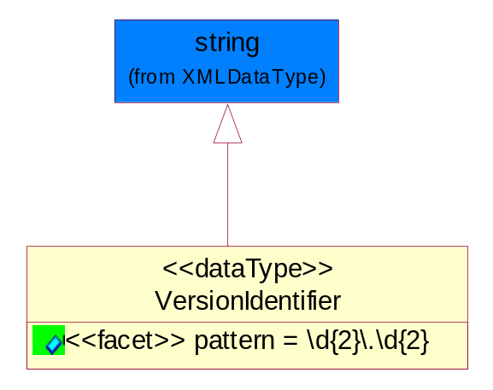
Figure 5-57 VersionIdentifier

Attribute | Type | Documentation
pattern |  | \d{2}\.\d{2}

CodeList

TPIRFileType
A code identifying the file type of TPIR form.

Name | Documentation
PDF | Portable Document Format.
XDP | XML Data Package.
XML | eXtensible Markup Language.

XML Data Type

anyURI
Represents a URI as defined by RFC 2396. An anyURI value can be absolute or relative, and may have an optional fragment identifier.

boolean
Represents Boolean values, which are either "true" or "false".

date
For the represents a calendar date.
The pattern for a date is CCYY-MM-DD where CC represents the century, YY the year, MM the month, and DD the day, with an optional time zone indicator as allowed for dateTime.

dateTime
Represents a specific instance of time.
The pattern for dateTime is CCYY-MM-DDThh:mm:ss where CC represents the century, YY the year, MM the month, and DD the day, preceded by an optional leading negative (-) character to indicate a negative number. If the negative character is omitted, positive (+) is assumed. The T is the date/time separator and hh, mm, and ss represent hour, minute, and second respectively. Additional digits can be used to increase the precision of fractional seconds if desired. For example, the format ss.ss... with any number of digits after the decimal point is supported. The fractional seconds part is optional.
This representation may be immediately followed by a "Z" to indicate Coordinated Universal Time (UTC) or to indicate the time zone. For example, the difference between the local time and Coordinated Universal Time, immediately followed by a sign, + or -, followed by the difference from UTC represented as hh:mm (minutes is required). If the time zone is included, both hours and minutes must be present.

float
Represents single-precision 32-bit floating-point numbers.

positiveInteger
Represents an integer that is greater than zero. This data type is derived from nonNegativeInteger.

string
Represents character string.

