

Description of
Partner Interface Process® for 3C1

Validated 11.01.00

Specification Information
Name | Request Return Product
Cluster | Order Management
Segment | Returns And Finance
Publication Date | 23 February 2010
Version Identifier | V11.01

Table of Contents
1 Document Management 4
1.1 Legal Disclaimer 4
1.2 Copyright 4
1.3 Trademarks 4
1.4 Acknowledgments 4
1.5 Related Documents 5
1.6 Document Version History 5
1.7 Document Structure 5
2 Business Process 6
2.1 Business Process Definition 6
2.2 PIP Scope Description 6
2.3 PIP Business Document 6
2.4 PIP Business Process Flow Diagram 7
2.5 PIP Start States 8
2.6 PIP End States 8
2.7 Partner Role Descriptions 9
2.8 Business Process Activity Controls 9
3 Network and Implementation Specification 10
3.1 Business Action and Business Signal Specifications 10
3.2 Business Transaction Dialog Specification 10
3.2.1 Message Exchange Controls 11
3.2.2 Communications Specification 11

List of Figures:
Figure 1: Activity Diagram of Request Return Product 7
Figure 2: Sequence Diagram of Request Return Product 10

List of Tables:
Table 1: PIP Business Document 6
Table 2: PIP Start State 8
Table 3: PIP End State 8
Table 4: PIP Failure State 8
Table 5: Partner Role Description 9
Table 6: Business Activity Description 9
Table 7: Business Activity Performance Control 9
Table 8: Network Component Specification 10
Table 9: Business Action – Business Document Mapping 10
Table 10: Message Exchange Control 11
Table 11: Dialog: Service-Service 11

Document Management

Legal Disclaimer
RosettaNet™, its members, officers, directors, employees, or agents shall not be liable for any injury, loss, damages, financial or otherwise, arising from, related to, or caused by the use of this document or the specifications herein, as well as associated guidelines and schemas. The use of said specifications shall constitute your express consent to the foregoing exculpation.

Copyright
©2010 RosettaNet. All rights reserved. No part of this publication may be reproduced, stored in a retrieval system, or transmitted, in any form or by any means, electronic, mechanical, photocopying, recording, or otherwise, without the prior written permission of the publisher. Printed in the United States of America.

Trademarks
RosettaNet, Partner Interface Process, PIP and the RosettaNet logo are trademarks or registered trademarks of "RosettaNet," a non-profit organization. All other product names and company logos mentioned herein are the trademarks of their respective owners. In the best effort, all terms mentioned in this document that are known to be trademarks or registered trademarks have been appropriately recognized in the first occurrence of the term.

Acknowledgments
This document has been prepared by RosettaNet (http://www.rosettanet.org/) from requirements gathered during the Milestone Program and in conformance with the methodology. Listed below are the legal entities that contributed to the design and development of this PIP.
BCM Electronics | HP Canada
CompTIA | Intel Corporation
CompuCom Systems | MIMOS Berhad
Globetronics SDH. BHD | NexInnovations
Hewlett Packard | Sterling Commerce
Hewlett-Packard Company | Unisys
HP

Related Documents
- Associated PIP Message Schemas (included within the PIP Specification package only)
- Description of 3C1 Message
- Messages Structure
- XML instance of ebXML BPSS for PIP 3C1

Document Version History
Version | Date | Description
Validated 11.00.00 | 30 June 2008 | Validated Version: RosettaNet Schema to Market to Validation 2008
Validated 11.01.00 | 23 February 2010 | Validated Version: MCC Program

Document Structure
A Partner Interface Process (PIP) Specification is comprised of the following two parts:
- Business Process. Captures the semantics of the business process and the flow of the message exchange between roles as they perform business activities.
- Network and Implementation Specification. Specifies the network protocol message formats and communications requirements between peer-protocols supported by network components in the RosettaNet Implementation Framework.

Business Process

Business Process Definition
The “Return Product” Partner Interface Process (PIP) enables a party (Return Requester) to submit a request to return a product to a Return Provider. The Return Provider either authorizes the return by issuing a Return Product Response, which may contain a Return Material Authorization (RMA) number, or denies the return. If the return is authorized, the Return Requester can ship the product to a location confirmed in the message exchange.
The request to return product may be linked to another Service Event, such as a Part Order and/or a Warranty Claim initiated in PIP 6C1. The associated Document Reference information, which may include original purchase order, invoice and / or entitlement information, may also be included.

PIP Scope Description
This PIP enables a party to notify the OEM of a product return or request authorization to return a product to a supplier. The message exchanges enable a provider/supplier to respond to the return product request.

PIP Business Document
Business Document are generated and exchanged by roles performing activities in this PIP. Business Document is listed and defined in Table 1.
Table 1: PIP Business Document
Business Document | Description
Return Product Request | Contains product information including product identification, purchase and/or sales order information.
Return Product Confirmation | Contains return location information, and/or RMA information or rejection reason.

PIP Business Process Flow Diagram
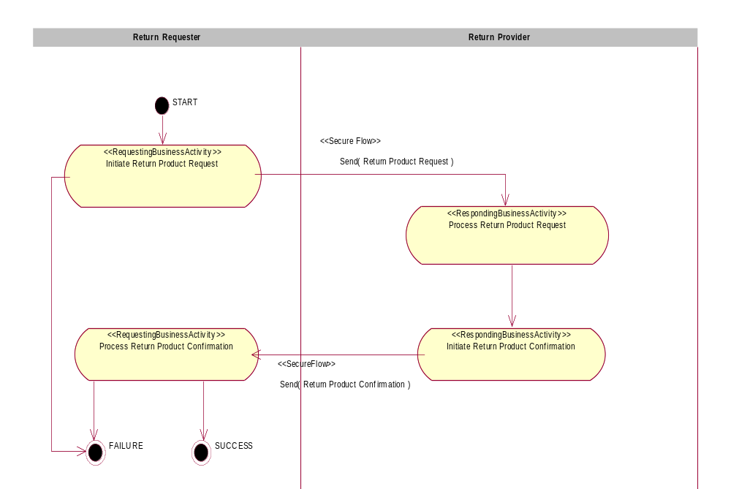
Figure 1: Activity Diagram

PIP Start States
The start state is comprised of the following conditions:
Table 2: PIP Start State
 | Approved | Exist |  | Valid | Non-Repudiated | Retry Count | Authorized
 | Approved | Party | In Backend System
TPA |  |  | 
Sending Partner |  |  |  | 
Receiving Partner |  | 
Business Document |  |  |  |  |  |  | 

PIP End States
The end state is comprised of the following conditions:
Table 3: PIP End State
 | Approved | Exist |  | Valid | Non-Repudiated | Retry Count | Authorized
 | Approved | Party | In Backend system
Acknowledgment of Receipt |  |  |  |  | 
Receiving Partner |  |  |  |  |  |  | 

The PIP failure state is comprised of one or more of the following conditions:
Table 4: PIP Failure State
 | NO | Exceeded
Success | 
Retry Count |  | 

Partner Role Descriptions
Table 5 describes the partner roles in this PIP.
Table 5: Partner Role Description
Role Name | Role Description
Return Requester | Any party wishing to return a product.
Return Provider | The party responsible for authorizing and/or processing the return.

Business Process Activity Controls
Table 6 describes the interaction between roles performing business activity in this PIP.
Table 6: Business Activity Description
Role  Name | Activity Name | Activity Description
Return Requester | Initiate Return Product Request | The Return Requester notifies of a product return or requests authorization to return a product for repair or replacement.
Return Provider | Initiate Return Product Confirmation | The Return Provider authorizes or rejects the Return Product Request.
Table 7 details the security, audit and process controls relating to activity performed in the PIP.
Table 7: Business Activity Performance Control
Role  Name | Activity  Name | Acknowledgment  of Receipt |  | Time to Perform | Retry Count | Is Authorization Required? | Non-Repudiation of Origin and Content?
Role  Name | Activity  Name | Non-Repudiation Required? | Time to Acknowledge
Return Requester | Initiate Return Product Request | Y | 1 hr | 1 hr | 3 | Y | Y
Return Provider | Initiate Return Product Confirmation | Y | 1 hr | N/A | 3 | Y | Y

Network and Implementation Specification
Each network component maps into a role of the PIP model. Table 8 specifies the mapping between roles and network components.
Table 8: Network Component Specification
Network Component | Classification | Maps to Role in Business Process
Return Requester Service | Business Service | Return Requester
Return Provider Service | Business Service | Return Provider

Business Action and Business Signal Specifications
Each business action maps to a Business Document of the PIP model. Table 9 specifies the mapping between Business Documents and business actions.
Table 9: Business Action – Business Document Mapping
Business Action | Business Document | Document Function
Return Product Request Action | Return Product Request | Request
Return Product Confirmation Action | Return Product Confirmation | Response

Business Transaction Dialog Specification
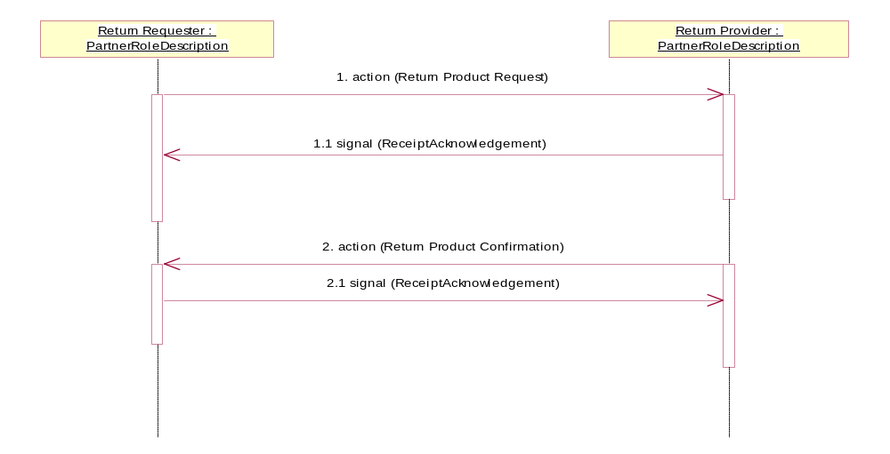
Figure 2: Sequence Diagram

Message Exchange Controls
Table 10: Message Exchange Control
# | Name |  | Time to Acknowledge Receipt Signal |  | Time to Respond to Action |  | Included in Time to Perform |  | Is Authorization Required? |  | Is Non-Repudiation Required? |  | Is Secure Transport Required?
1. |  | Return Product Request Action |  | 1 hr |  | 1 hr |  | Y |  | Y |  | Y |  | Y
1.1. |  | Receipt Acknowledgment |  | N/A |  | N/A |  | N/A |  | Y |  | Y |  | Y
2. |  | Return Product Confirmation Action |  | 1 hr |  | N/A |  | N/A |  | Y |  | Y |  | Y
2.1. |  | Receipt Acknowledgment |  | N/A |  | N/A |  | N/A |  | Y |  | Y |  | Y

Communications Specification
Table 11: Dialog: Service-Service
# | Business Message | Digital Signature Required? | SSL Required?
1. | Return Product Request | Y | Y
1.1. | Receipt Acknowledgment | Y | Y
2. | Return Product Confirmation | Y | Y
2.1. | Receipt Acknowledgment | Y | Y

