

Description of
Partner Interface Process® for 3C3

Validated 11.00.00

Specification Information
Name | Notify of Invoice
Cluster | Order Management
Segment | Returns & Finance Management
Publication Date | 04 April 2006
Version Identifier | V11.00

Table of Contents
1 Document Management 4
1.1 Legal Disclaimer 4
1.2 Copyright 4
1.3 Trademarks 4
1.4 Acknowledgments 4
1.5 Related Documents 4
1.6 Document Version History 4
1.7 Document Structure 5
2 Business Process 6
2.1 Business Process Definition 6
2.1.1 Executive Summary 6
2.1.2 Business Process Description 6
2.1.3 Business Process Context Diagram 7
2.2 PIP Scope Description 7
2.2.1 Business Process Scope Diagram 8
2.3 PIP Business Document 9
2.4 PIP Business Process Flow Diagram 9
2.5 PIP Start State 10
2.6 PIP End States 10
2.7 Partner Role Descriptions 11
2.8 Business Process Activity Controls 11
3 Network and Implementation Specification 11
3.1 Business Action and Business Signal Specifications 12
3.2 Business Transaction Dialog Specification 12
3.2.1 Message Exchange Controls 13
3.2.2 Communications Specification 13

List of Figures:
Figure 1: High-level Context Diagram 7
Figure 2: Business Process Scope Diagram 8
Figure 3: Activity Diagram of Request Material Composition Information 9
Figure 4: Sequence Diagram of Request Material Composition Information 12

List of Tables:
Table 1: PIP Business Document 9
Table 2: PIP Start State 10
Table 3: PIP End State 10
Table 4: PIP Failure State 10
Table 5: Partner Role Description 11
Table 6: Business Activity Description 11
Table 7: Business Activity Performance Control 11
Table 8: Network Component Specification 11
Table 9: Business Action – Business Document Mapping 12
Table 10: Message Exchange Control 13
Table 11: Dialog: Service-Service 13

Document Management

Legal Disclaimer
RosettaNet™, its members, officers, directors, employees, or agents shall not be liable for any injury, loss, damages, financial or otherwise, arising from, related to, or caused by the use of this document or the specifications herein, as well as associated guidelines and schemas. The use of said specifications shall constitute your express consent to the foregoing exculpation.

Copyright
©2006 RosettaNet. All rights reserved. No part of this publication may be reproduced, stored in a retrieval system, or transmitted, in any form or by any means, electronic, mechanical, photocopying, recording, or otherwise, without the prior written permission of the publisher. Printed in the United States of America.

Trademarks
RosettaNet, Partner Interface Process, PIP and the RosettaNet logo are trademarks or registered trademarks of "RosettaNet," a non-profit organization. All other product names and company logos mentioned herein are the trademarks of their respective owners. In the best effort, all terms mentioned in this document that are known to be trademarks or registered trademarks have been appropriately recognized in the first occurrence of the term.

Acknowledgments
This document has been prepared by RosettaNet (http://www.rosettanet.org/) from requirements gathered during the Milestone Program and in conformance with the methodology.

Related Documents
- Associated PIP Message Schemas (included within the PIP Specification package only)
- Description of 3C3 Message
- Messages Structure
- XML instance of ebXML BPSS for PIP 3C3

Document Version History
Version | Date | Description
Validated 11.00.00 | 04 April 2006 | Validated Version

Document Structure
A Partner Interface Process (PIP) Specification is comprised of the following two parts:
- Business Process. Captures the semantics of the business process and the flow of the message exchange between roles as they perform business activities.
- Network and Implementation Specification. Specifies the network protocol message formats and communications requirements between peer-protocols supported by network components in the RosettaNet Implementation Framework.

Business Process

Business Process Definition
The "Notify of Invoice" Partner Interface Process™ (PIP) enables a provider to invoice another party, such as a buyer or financing processor, for goods or services performed. A financing processor is an organization that helps a seller obtain financing by serving as an intermediary between the seller and financiers.

Executive Summary
Notify of Invoice standardizes the invoice notification process by defining a common vocabulary for transmission of invoice information. The value propositions of this initiative are:
- Standards based invoice information increases trading partners (seller and buyer) business efficiency.
- Standards based invoice information decreases IT support resources and overhead required to assure data integrity.
- Standards based invoice information enables on demand problem resolution between the trading partners.
- Standards based invoice information enables rapid new partner setup in B2B environment.
- Standards based invoice information can be used as a quantifiable metric for customer satisfaction.

Business Process Description
The “Notify of Invoice” Partner Interface Process (PIP) supports the process to send invoice information to a trading partner.
Invoicing occurs after a purchase order is issued with PIP3A4, "Request Purchase Order" and a packing slip has been generated. For some transactions, the original financial invoice must be attached to the shipment or sent in advance of the physical shipment; thus, the invoice must be generated prior to the time of shipment. The creation of a packing slip shall suffice to generate the invoice. An invoice can be a credit or a debit memo.
If the original invoice is sent to a financing processor, the financing processor may re-issue the invoice to the buyer.
The invoice is audited by the recipient’s internal systems. If the invoice is valid, payment may be scheduled for payment using PIP3C6, “Notify of Remittance Advice.” If the invoice is not valid, it may be rejected using PIP3C4, “Notify of Invoice Reject.”
The time to perform is the same for all parties, including the financing processor.
Should this transaction not complete successfully, the requesting partner executes PIP0A1, "Notification of Failure."

Business Process Context Diagram
Purchase Order Request
Prepare Packing Slip
Generate Invoice
Send Notification
Process Invoice
Seller
Buyer
Accept the Invoice and schedule for payment
Reject the Invoice and send notification
Notify of Remittance Advice
Notify of Invoice Reject
If invoice is acceptable
If there are problems with the invoice

Figure 1: High-level Context Diagram

PIP Scope Description
This PIP enables a provider to send an original invoice to another party, such as a buyer or financing processor.

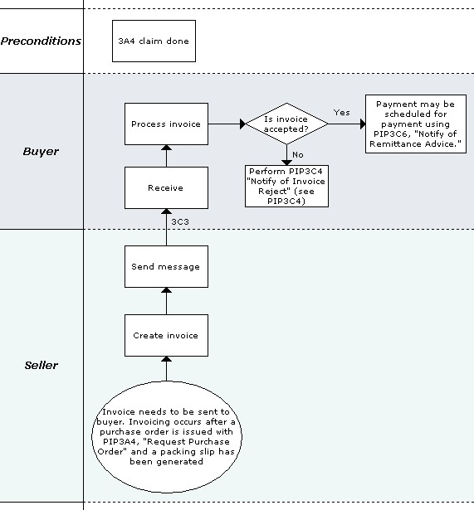
Business Process Scope Diagram
acceptable?

Figure 2: Business Process Scope Diagram

PIP Business Document
Business Document are generated and exchanged by roles performing activities in this PIP. Business Document is listed and defined in Table 1.
Table 1: PIP Business Document
Business Document | Description
Invoice Notification | Presents an invoice for products purchased and shipped or for services that have been purchased or contracted. The invoice may be either a credit or a debit memo The conditions that trigger the generation of an invoice may vary by organization.

PIP Business Process Flow Diagram
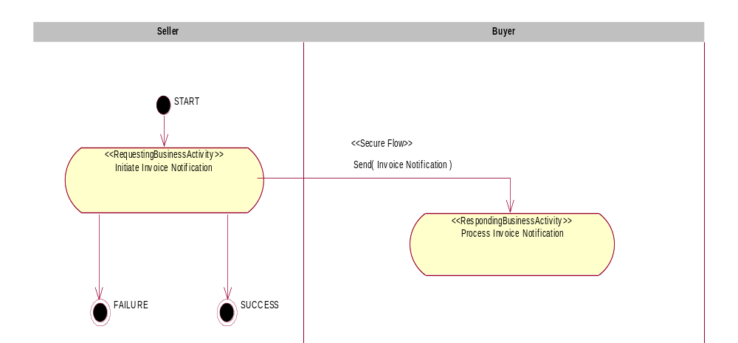
Figure 3: Activity Diagram of Request Material Composition Information

PIP Start State
The start state is comprised of the following conditions:
Table 2: PIP Start State
 | Approved | Exist |  | Valid | Non-Repudiated | Retry Count | Authorized
 | Approved | Party | In Backend System
TPA |  |  | 
Sending Partner |  |  |  |  |  |  | 
Receiving Partner |  | 
Business Document |  |  |  |  | 

PIP End States
The end state is comprised of the following conditions:
Table 3: PIP End State
 | Approved | Exist |  | Valid | Non-Repudiated | Retry Count | Authorized
 | Approved | Party | In Backend system
Acknowledgment of Receipt |  |  |  | 
Receiving Partner |  |  |  |  |  |  | 

The PIP failure state is comprised of one or more of the following conditions:
Table 4: PIP Failure State
 | NO | Exceeded
Success | 
Retry Count |  | 

Partner Role Descriptions
Table 5 describes the partner roles in this PIP.
Table 5: Partner Role Description
Role Name | Role Description
Seller | The organization that generates the invoice.
Buyer | The organization being invoiced.

Business Process Activity Controls
Table 6 describes the interaction between roles performing business activity in this PIP.
Table 6: Business Activity Description
Role  Name | Activity Name | Activity Description
Seller | Initiate Invoice Notification | The Seller issues an Invoice Notification  to an Buyer, who could be a financing  processor (if the order is financed) or a buyer (if  the order is not financed).
Table 7 details the security, audit and process controls relating to activity performed in the PIP.
Table 7: Business Activity Performance Control
Role  Name | Activity  Name | Acknowledgment  of Receipt |  | Time to Perform | Retry Count | Is Authorization Required? | Non-Repudiation of Origin and Content?
Role  Name | Activity  Name | Non-Repudiation Required? | Time to Acknowledge
Seller | Initiate Invoice Notification | Y | 2 hrs | N/A | 3 | N | Y
Note: All time parameters are defined as (hrs or mins), i.e. 2 hrs

Network and Implementation Specification
Each network component maps into a role of the PIP model. Table 8 specifies the mapping between roles and network components.
Table 8: Network Component Specification
Network Component | Classification | Maps to Role in Business Process
Customer Service | Business Service | Customer
Supplier Service | Business Service | Supplier

Business Action and Business Signal Specifications
Each business action maps to a Business Document of the PIP model. Table 9 specifies the mapping between Business Documents and business actions.
Table 9: Business Action – Business Document Mapping
Business Action | Business Document | Document Function
Initiate Invoice Notification Action | Invoice Notification | Notification

Business Transaction Dialog Specification
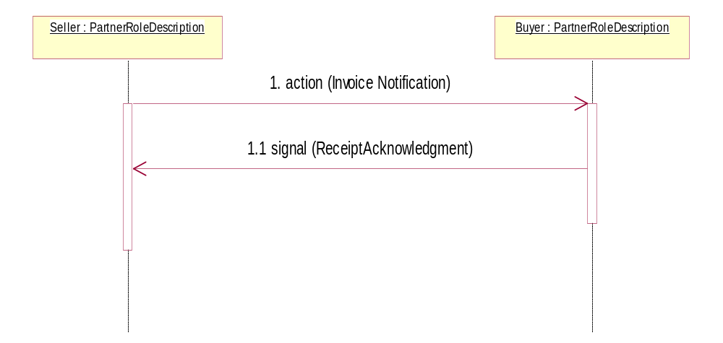
Figure 4: Sequence Diagram of Request Material Composition Information

Message Exchange Controls
Table 10: Message Exchange Control
# | Name |  | Time to Acknowledge Receipt Signal |  | Time to Respond to Action |  | Included in Time to Perform |  | Is Authorization Required? |  | Is Non-Repudiation Required? |  | Is Secure Transport Required?
1. |  | Invoice Notification |  | 2 hrs |  | N/A |  | N/A |  | N |  | Y |  | Y
1.1. |  | Receipt Acknowledgment |  | N/A |  | N/A |  | N/A |  | N |  | Y |  | Y
Note: All time parameters are defined as (hrs or mins), i.e. 2 hrs

Communications Specification
Table 11: Dialog: Service-Service
# | Business Message | Digital Signature Required? | SSL Required?
1. | Invoice Notification | Y | Y
1.1. | Receipt Acknowledgment | Y | Y

