

Description of 3C3 Message

PIP® 3C3
Validated 11.02.00

Specification Information
Name | Description Of 3C3 Message
PIP | Notify of Invoice
Cluster | Order Management
Segment | Returns and Finance
Publication Date | 22 August 2006
Version Identifier | V11.02

Table of Content

1. Document Management 7
1.1 Legal Disclaimer 7
1.2 Copyright 7
1.3 Trademarks 7
1.4 Acknowledgments 7
1.5 Related Documents 7
1.6 Document Version History 7
1.7 Document Purpose 8
2. Interchange Model 9
2.1 InvoiceNotification 9
2.1.1 Interchange Diagram 9
2.1.2 Dependency Diagram 10
2.1.3 Amount 10
2.1.4 Invoice 11
2.1.5 InvoiceLineItem 13
2.1.6 InvoiceNotification 14
2.1.7 OrderStatus 14
2.1.8 ProductDescription 15
2.1.9 ProductLineItem 16
2.1.10 PurchaseOrder 17
3. Domain Model 18
3.1 Procurement 18
3.1.1 Procurement 18
3.1.1.1 Dependency Diagram 18
3.1.1.2 AccountSummary 18
3.1.1.3 CurrencyConversion 19
3.1.1.4 DayOfMonth 19
3.1.1.5 Discounts 20
3.1.1.6 Financing 20
3.1.1.7 InvoiceAmount 21
3.1.1.8 LotIdentification 21
3.1.1.9 NetTerms 22
3.1.1.10 PaymentTerms 22
3.1.1.11 PrePaymentDetail 23
3.1.1.12 SpecifiedBusinessDocumentReference 23
3.1.1.13 TaxInformation 24
3.1.1.14 TaxPhrase 24
3.1.1.15 TaxSummary 25
3.1.2 CodeList 26
3.1.2.1 PaymentCondition 26
3.1.2.2 ShipmentTerms 26
3.1.2.3 PurchaseType 27
3.1.2.4 DocumentType 27
3.2 Logistics 29
3.2.1 Logistics 29
3.2.1.1 Dependency Diagram 29
3.2.1.2 TrackingReference 29
3.2.2 CodeList 30
3.2.2.1 TrackingReferenceType 30
3.2.2.2 NationalExportControlClassification 31
3.3 Shared 32
3.3.1 Shared 32
3.3.1.1 Dependency Diagram 32
3.3.1.2 MonetaryAmount 32
3.3.1.3 ProductQuantity 33
3.3.2 CodeList 33
3.3.2.1 InvoiceChargeType 33
3.3.2.2 MonetaryAmountType 34
3.3.2.3 ShippingServiceLevel 34
3.3.2.4 AmountType 36
4. Universal Structure 37
4.1 ContactInformation 37
4.1.1 ContactInformation 37
4.2 DataType 38
4.2.1 Contact 38
4.2.2 DUNS 38
4.2.3 DUNSPlus4 39
4.2.4 GLN 39
4.2.5 GTIN 40
4.2.6 PercentAmount 40
4.3 Locations 41
4.3.1 AlternativeIdentifier 41
4.3.2 Location 41
4.3.3 LocationChoice 42
4.3.4 PhysicalAddress 42
4.4 MonetaryExpression 44
4.4.1 FinancialAmount 44
4.4.2 TaxJurisdiction 45
4.5 PartnerIdentification 46
4.5.1 FullPartner 46
4.5.2 IntermittentPartner 46
4.5.3 KnownPartner 47
4.5.4 KnownPartnerContact 47
4.5.5 NewPartner 48
4.5.6 PartnerDescription 49
4.5.7 PartnerDescriptionChoice 49
4.5.8 PartnerIdentification 50
4.5.9 PartnerIdentificationChoice 50
4.5.10 SpecifiedFullPartner 51
4.5.11 SpecifiedIntermittentPartner 52
4.5.12 SpecifiedKnownPartner 52
4.5.13 SpecifiedKnownPartnerContact 53
4.5.14 SpecifiedNewPartner 53
4.5.15 SpecifiedPartnerDescription 54
4.5.16 SpecifiedPartnerDescriptionChoice 55
4.6 ProductIdentification 56
4.6.1 ProductIdentification 56
4.6.2 ProductIdentificationChoice 56
4.7 CodeList 57
4.7.1 Country 57
4.7.2 CountrySubdivision 57
4.7.3 Currency 57
4.7.4 Language 57
4.7.5 MimeTypeQualifier 57
4.7.6 UnitOfMeasure 68
4.7.7 ProcessRoleIdentifier 75
5. System Structure 78
5.1 BusinessProcessIdentifier 78
5.2 BusinessServiceInformation 78
5.3 ContractInformation 79
5.4 CorrelationInformation 79
5.5 DocumentHeader 80
5.6 DocumentIdentification 81
5.7 DocumentIdentificationChoice 81
5.8 DocumentInformation 82
5.9 DocumentManifest 82
5.10 DocumentSecurity 83
5.11 ManifestItem 84
5.12 PipIdentifier 85
5.13 PipVersion 85
5.14 Receiver 86
5.15 RequestingDocumentInformation 86
5.16 Sender 87
5.17 StandardDocumentIdentification 88
5.18 TpirPipIdentification 88
5.19 VersionIdentifier 89
5.20 CodeList 89
5.20.1 TPIRFileType 89
6. XML Data Type 90
6.1 anyURI 90
6.2 boolean 90
6.3 date 90
6.4 dateTime 90
6.5 decimal 90
6.6 float 90
6.7 gDay 90
6.8 positiveInteger 91
6.9 string 91

Table of Figures

Figure ‎2-1 Interchange 9
Figure ‎2-2 Dependency 10
Figure ‎2-3 Amount 10
Figure ‎2-4 Invoice 11
Figure ‎2-5 InvoiceLineItem 13
Figure ‎2-6 InvoiceNotification 14
Figure ‎2-7 OrderStatus 14
Figure ‎2-8 ProductDescription 15
Figure ‎2-9 ProductLineItem 16
Figure ‎2-10 PurchaseOrder 17
Figure ‎3-1 Dependency 18
Figure ‎3-2 AccountSummary 18
Figure ‎3-3 CurrencyConversion 19
Figure ‎3-4 DayOfMonth 19
Figure ‎3-5 Discounts 20
Figure ‎3-6 Financing 20
Figure ‎3-7 InvoiceAmount 21
Figure ‎3-8 LotIdentification 21
Figure ‎3-9 NetTerms 22
Figure ‎3-10 PaymentTerms 22
Figure ‎3-11 PrePaymentDetail 23
Figure ‎3-12 SpecifiedBusinessDocumentReference 23
Figure ‎3-13 TaxInformation 24
Figure ‎3-14 TaxPhrase 24
Figure ‎3-15 TaxSummary 25
Figure ‎3-16 Dependency 29
Figure ‎3-17 TrackingReference 29
Figure ‎3-18 Dependency 32
Figure ‎3-19 MonetaryAmount 32
Figure ‎3-20 ProductQuantity 33
Figure ‎4-1 ContactInformation 37
Figure ‎4-2 Contact 38
Figure ‎4-3 DUNS 38
Figure ‎4-4 DUNSPlus4 39
Figure ‎4-5 GLN 39
Figure ‎4-6 GTIN 40
Figure ‎4-7 PercentAmount 40
Figure ‎4-8 AlternativeIdentifier 41
Figure ‎4-9 Location 41
Figure ‎4-10 PhysicalAddress 42
Figure ‎4-11 FinancialAmount 44
Figure ‎4-12 TaxJurisdiction 45
Figure ‎4-13 FullPartner 46
Figure ‎4-14 IntermittentPartner 46
Figure ‎4-15 KnownPartner 47
Figure ‎4-16 KnownPartnerContact 47
Figure ‎4-17 NewPartner 48
Figure ‎4-18 PartnerDescription 49
Figure ‎4-19 PartnerIdentification 50
Figure ‎4-20 SpecifiedFullPartner 51
Figure ‎4-21 SpecifiedIntermittentPartner 52
Figure ‎4-22 SpecifiedKnownPartner 52
Figure ‎4-23 SpecifiedKnownPartnerContact 53
Figure ‎4-24 SpecifiedNewPartner 53
Figure ‎4-25 SpecifiedPartnerDescription 54
Figure ‎4-26 ProductIdentification 56
Figure ‎5-1 BusinessProcessIdentifier 78
Figure ‎5-2 BusinessServiceInformation 78
Figure ‎5-3 ContractInformation 79
Figure ‎5-4 CorrelationInformation 79
Figure ‎5-5 DocumentHeader 80
Figure ‎5-6 DocumentIdentification 81
Figure ‎5-7 DocumentInformation 82
Figure ‎5-8 DocumentManifest 82
Figure ‎5-9 DocumentSecurity 83
Figure ‎5-10 ManifestItem 84
Figure ‎5-11 PipIdentifier 85
Figure ‎5-12 PipVersion 85
Figure ‎5-13 Receiver 86
Figure ‎5-14 RequestingDocumentInformation 86
Figure ‎5-15 Sender 87
Figure ‎5-16 StandardDocumentIdentification 88
Figure ‎5-17 TpirPipIdentification 88
Figure ‎5-18 VersionIdentifier 89

Document Management

Legal Disclaimer
RosettaNet, its members, officers, directors, employees, or agents shall not be liable for any injury, loss, damages, financial or otherwise, arising from, related to, or caused by the use of this document or the specifications herein, as well as associated guidelines and schemas. The use of said specifications shall constitute your express consent to the foregoing exculpation.

Copyright
©2006 RosettaNet. All rights reserved. No part of this publication may be reproduced, stored in a retrieval system, or transmitted, in any form or by any means, electronic, mechanical, photocopying, recording, or otherwise, without the inclusion of this copyright notice. Any derivative works must cite the copyright notice. Any public redistribution or sale of this publication or derivative works requires prior written permission of the publisher.

Trademarks
RosettaNet, Partner Interface Process, PIP and the RosettaNet logo are trademarks or registered trademarks of "RosettaNet," a non-profit organization. All other product names and company logos mentioned herein are the trademarks of their respective owners. In the best effort, all terms mentioned in this document that are known to be trademarks or registered trademarks have been appropriately recognized in the first occurrence of the term.

Acknowledgments
This document has been prepared by RosettaNet (http://www.rosettanet.org/) from requirements gathered during the Milestone Program and in conformance with the methodology. Listed below are the legal entities that contributed to the design and development of this PIP.

Related Documents
- Associated PIP Message Schemas (included with PIP Specification only)
- Description of Partner Interface Process for 3C3
- Message Structure

Document Version History
Version | Date | Description
Validated 11.00.00 | 04 April 2006 | Validated Version
Validated 11.01.00 | 02 June 2006 | Validated Version
Validated 11.02.00 | 22 August 2006 | Validated Version

Document Purpose
The purpose of the document is to explain the structure, the association between objects, the content of objects and the definition for single elements to a non-technical audience.

Interchange Model

InvoiceNotification

Interchange Diagram

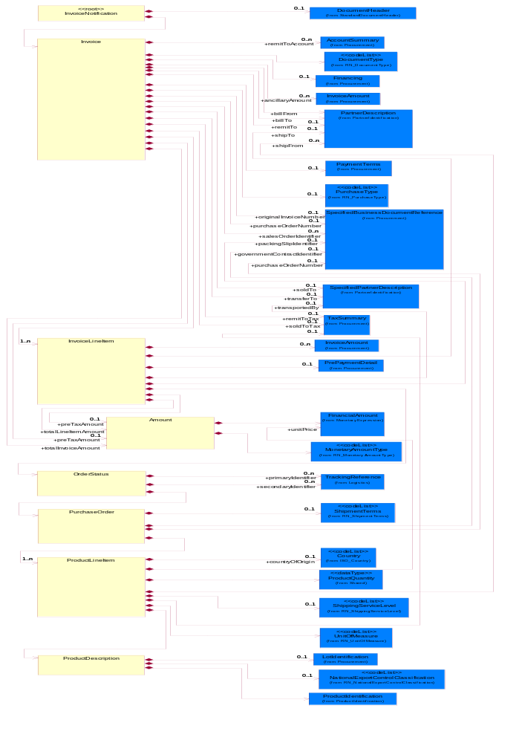
Figure ‎2-1 Interchange

Dependency Diagram

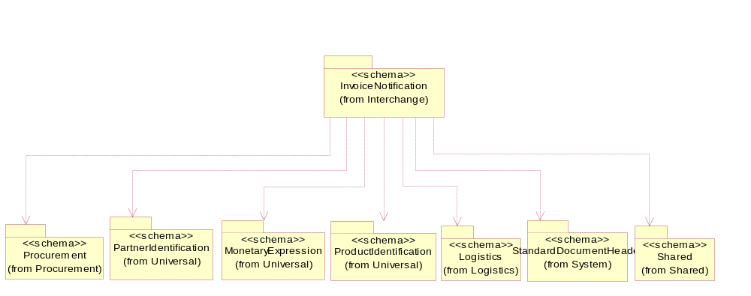
Figure ‎2-2 Dependency

Amount
The collection of business properties that describe the monetary amount.
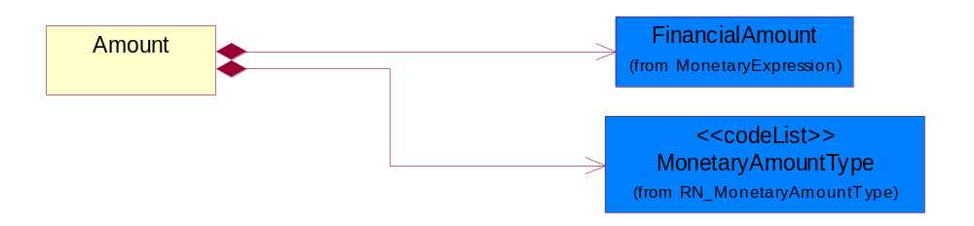
Figure ‎2-3 Amount

Composition | Cardinality | Type | Documentation
FinancialAmount | 1 | FinancialAmount | The business document must express financial amounts.
MonetaryAmountType | 1 | MonetaryAmountType | Code identifying whether the monetary amount is a debit or credit.

Invoice
An itemized list of goods or services specifying the price and the terms of sale.
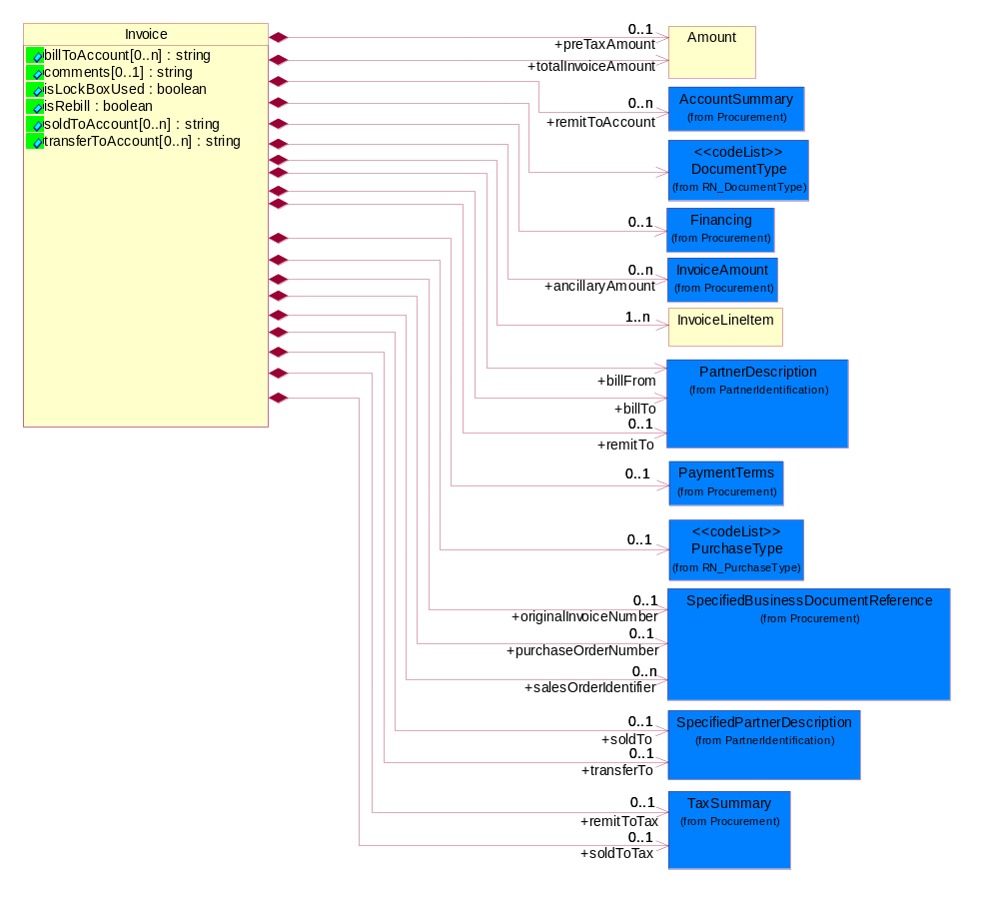
Figure ‎2-4 Invoice

Attribute | Type | Documentation
billToAccount[0..n] | string | The account number of the party that pays the invoice.
comments[0..1] | string | A free form textual description of information, relating to a product.
isLockBoxUsed | boolean | Indicates the appearance of a lock box number on an applicable address line and subsequent requirement.
isRebill | boolean | Indicates whether the business document is being resent.
soldToAccount[0..n] | string | The account number of the party that purchases of the product.
transferToAccount[0..n] | string | The account number of the party that transfers the product.

Composition | Cardinality | Type | Documentation
Financing | 0..1 | Financing | The collection of business properties that describe financial information.
InvoiceLineItem | 1..n | InvoiceLineItem | The collection of business properties that describe an invoice entry.
PurchaseType | 0..1 | PurchaseType | Code that denotes type of purchase
remitToAccount | 0..n | AccountSummary | The account number of the party to whom payment is sent.
remitToTax | 0..1 | TaxSummary | The total tax liability of the party to whom payment is sent.
totalInvoiceAmount | 1 | Amount | The total amount on an invoice.
DocumentType | 1 | DocumentType | Code identifying the type of financial document, e.g. invoice, credit memo or debit memo.
soldToTax | 0..1 | TaxSummary | The total tax liability of the party that purchases the product.
originalInvoiceNumber | 0..1 | SpecifiedBusinessDocumentReference | Unique identifier that represents the original invoice.
purchaseOrderNumber | 0..1 | SpecifiedBusinessDocumentReference | Unique number that identifies a purchase order.
salesOrderIdentifier | 0..n | SpecifiedBusinessDocumentReference | The unique identifier that represents a sales order.
ancillaryAmount | 0..n | InvoiceAmount | Ancillary costs that are not included in the line items.
preTaxAmount | 0..1 | Amount | The gross amount prior to calculating taxes.
soldTo | 0..1 | SpecifiedPartnerDescription | The party to whom a product has been sold.
transferTo | 0..1 | SpecifiedPartnerDescription | The partner to which the payment is transferred.
PaymentTerms | 0..1 | PaymentTerms | The collection of business properties that describe payment terms.
billFrom | 1 | PartnerDescription | The party that will issue the invoice.
billTo | 1 | PartnerDescription | The party that will pay the invoice.
remitTo | 0..1 | PartnerDescription | The partner to which payment for a business document is sent.

InvoiceLineItem
The collection of business properties that describe an invoice entry.
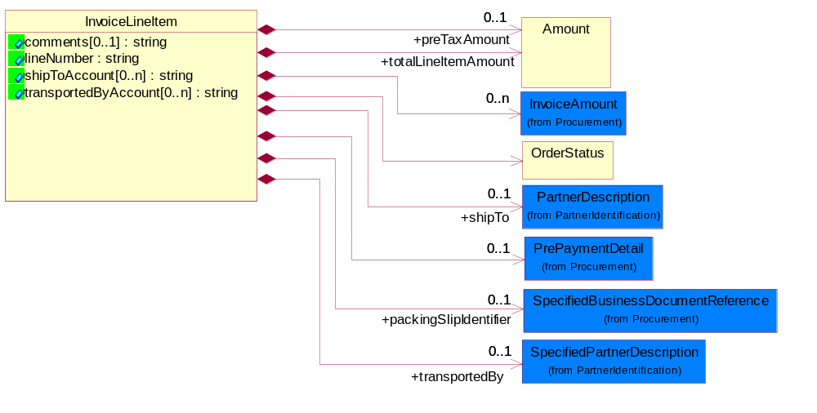
Figure ‎2-5 InvoiceLineItem

Attribute | Type | Documentation
comments[0..1] | string | A free form textual description of information, relating to a product.
lineNumber | string | Number of the line in the document.
shipToAccount[0..n] | string | The account number of the party where the product is shipped.
transportedByAccount[0..n] | string | The account number of the party that transports the product.

Composition | Cardinality | Type | Documentation
preTaxAmount | 0..1 | Amount | The gross amount prior to calculating taxes.
OrderStatus | 1 | OrderStatus | The collection of business properties that describe the fulfillment and shipping status of ordered products.
PrePaymentDetail | 0..1 | PrePaymentDetail | The collection of business properties that describe prepayment details used in countries where VAT applies from a date other than the invoice generation date.
InvoiceAmount | 0..n | InvoiceAmount | The monetary value of the invoice.
packingSlipIdentifier | 0..1 | SpecifiedBusinessDocumentReference | Unique number that identifies a packing slip.
totalLineItemAmount | 1 | Amount | The monetary total associated with a line item.
transportedBy | 0..1 | SpecifiedPartnerDescription | The party responsible for either carrying or forwarding the product.
shipTo | 0..1 | PartnerDescription | The partner and/or location to which the product must be delivered.

InvoiceNotification
The collection of business data structures that enables a provider to invoice another party.
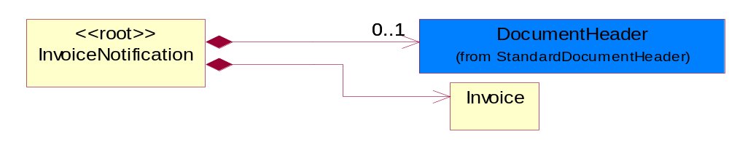
Figure ‎2-6 InvoiceNotification

Composition | Cardinality | Type | Documentation
DocumentHeader | 0..1 | DocumentHeader | The object allows for the identification of the sender and receiver of the business document.
Invoice | 1 | Invoice | An itemized list of goods or services specifying the price and the terms of sale.

OrderStatus
The collection of business properties that describe the fulfillment and shipping status of ordered products.
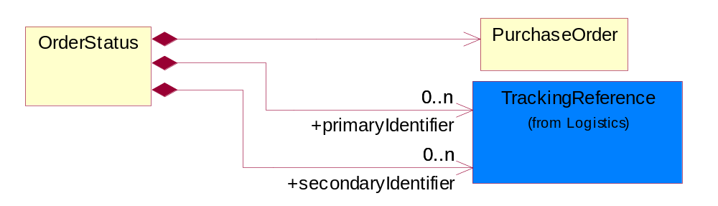
Figure ‎2-7 OrderStatus

Composition | Cardinality | Type | Documentation
primaryIdentifier | 0..n | TrackingReference | A unique tracking number (assigned by the carrier) to a package for the duration of a shipment, through all intermediaries.
secondaryIdentifier | 0..n | TrackingReference | A tracking number that will generally be carrier specific and will not be bound to a particular format.
PurchaseOrder | 1 | PurchaseOrder | The collection of business properties that describe a buyer's offer to purchase a quantity of products at an agreed price and schedule.

ProductDescription
The collection of business properties that provide a non-technical product description typically used for marketing, sales and trade documents.
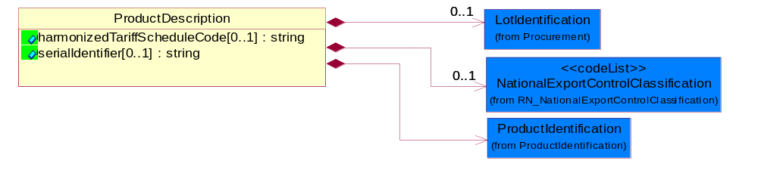
Figure ‎2-8 ProductDescription

Attribute | Type | Documentation
harmonizedTariffScheduleCode[0..1] | string | Code identifying product classification for international shipping.
serialIdentifier[0..1] | string | Unique serial identifier assigned to the product.

Composition | Cardinality | Type | Documentation
ProductIdentification | 1 | ProductIdentification | The object provides the identifier(s) of a product.
LotIdentification | 0..1 | LotIdentification | This object identifies a lot which associates the product with a specific group of products with some similar attributes.
NationalExportControlClassification | 0..1 | NationalExportControlClassification | Code identifying product classification for export regulation.

ProductLineItem
The collection of business properties that describe a business document entry for a product.
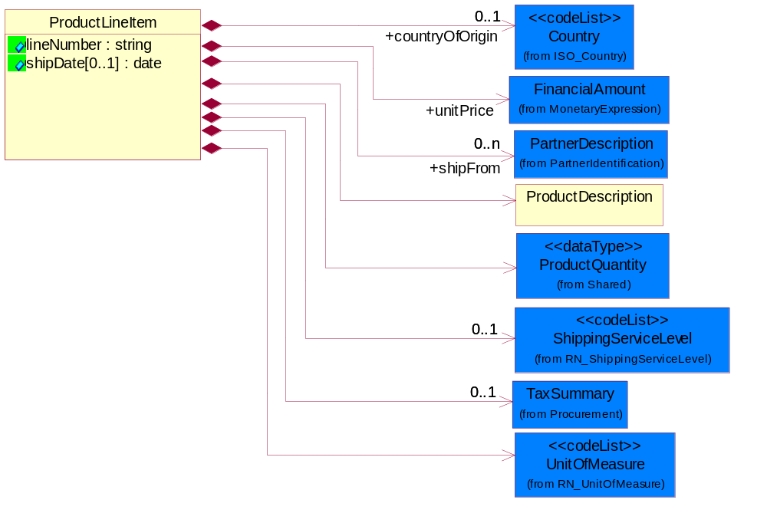
Figure ‎2-9 ProductLineItem

Attribute | Type | Documentation
lineNumber | string | Number of the line in the document.
shipDate[0..1] | date | The (GMT) local date the product is shipped.

Composition | Cardinality | Type | Documentation
countryOfOrigin | 0..1 | Country | Country where product originates.
UnitOfMeasure | 1 | UnitOfMeasure | Code identifying a product unit of measure.
unitPrice | 1 | FinancialAmount | Price for each unit.
ProductDescription | 1 | ProductDescription | The collection of business properties that provide a non-technical product description typically used for marketing, sales and trade documents.
TaxSummary | 0..1 | TaxSummary | The collection of business properties that describe the total tax information for a local, regional or national taxing authority.
shipFrom | 0..n | PartnerDescription | The DUNS or DUNS + 4 number of the location from where the product is to be shipped.
ShippingServiceLevel | 0..1 | ShippingServiceLevel | Code identifying the shipping service level, e.g., overnight, same day.
ProductQuantity | 1 | ProductQuantity | A quantity specifying the number of product units.

PurchaseOrder
The collection of business properties that describe a buyer's offer to purchase a quantity of products at an agreed price and schedule.
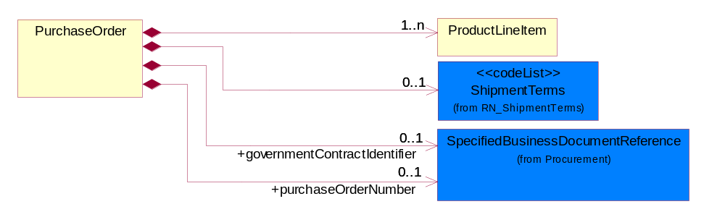
Figure ‎2-10 PurchaseOrder

Composition | Cardinality | Type | Documentation
ShipmentTerms | 0..1 | ShipmentTerms | Code identifying the terms under which a product is shipped.
ProductLineItem | 1..n | ProductLineItem | The collection of business properties that describe a business document entry for a product.
governmentContractIdentifier | 0..1 | SpecifiedBusinessDocumentReference | The unique number that identifies a government contract
purchaseOrderNumber | 0..1 | SpecifiedBusinessDocumentReference | Unique number that identifies a purchase order.

Domain Model

Procurement

Procurement

Dependency Diagram
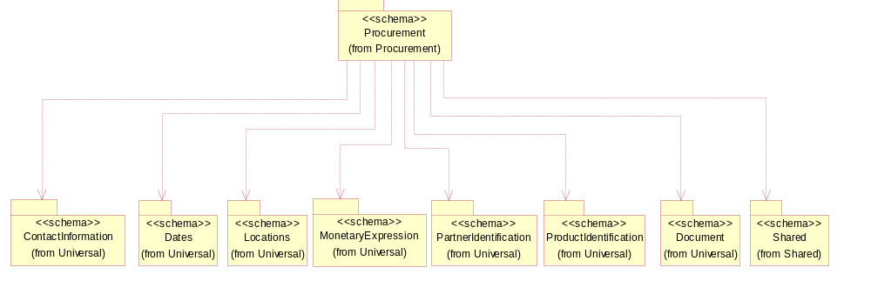
Figure ‎3-11 Dependency

AccountSummary
The collection of business properties that summarizes an account information.
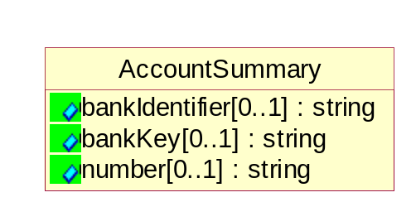
Figure ‎3-12 AccountSummary

Attribute | Type | Documentation
bankIdentifier[0..1] | string | A unique bank identifier such as an ISO standard Bank Identifier Code (BIC) of which SWIFT (Society for Worldwide Interbank Financial Telecommunication) is the registration authority.
bankKey[0..1] | string | Bank sort code required by some banks to enable transfers of funds.
number[0..1] | string | Identification number of an account.

CurrencyConversion
The collection of business properties that describe the exchange of money in circulation.
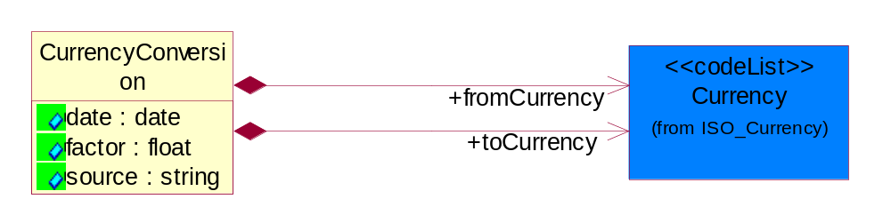
Figure ‎3-13 CurrencyConversion

Attribute | Type | Documentation
date | date | The date of the exchange rate used to convert between currencies.
factor | float | The conversion factor to apply to convert from the currency of the freight charges to the currency used for payment.
source | string | The source of the exchange rate used to convert between currencies.

Composition | Cardinality | Type | Documentation
toCurrency | 1 | Currency | The currency of the receiving partner in a business transaction.
fromCurrency | 1 | Currency | The currency of the initiating partner in a business transaction.

DayOfMonth
Specifies a specific day within a month. Value range from 1 to 31.
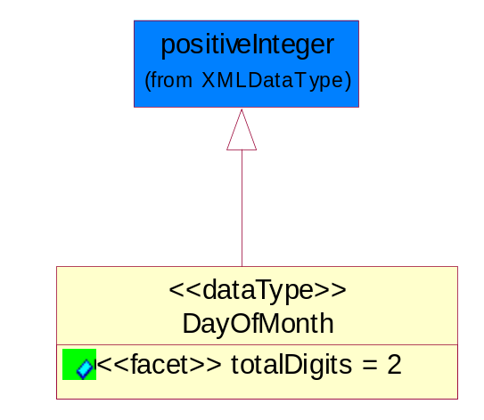
Figure ‎3-14 DayOfMonth

Attribute | Type | Documentation
totalDigits |  | Value with specific maximum number of decimal digits. For more information, see the W3C XML Schema Part 2: Datatypes Recommendation at http://www.w3.org/TR/2001/REC-xmlschema-2-20010502/#element-totalDigits.

Discounts
The collection of business properties that describe payment discounts.
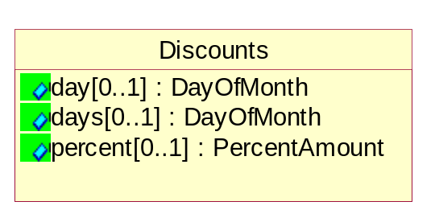
Figure ‎3-15 Discounts

Attribute | Type | Documentation
day[0..1] | DayOfMonth | The specific day of the month a payment is required in order to receive a discount.
days[0..1] | DayOfMonth | The number of days within which a payment is required in order to receive a discount.
percent[0..1] | PercentAmount | The financial percent representing a reduction to the total amount due.

Financing
The collection of business properties that describe financial information.
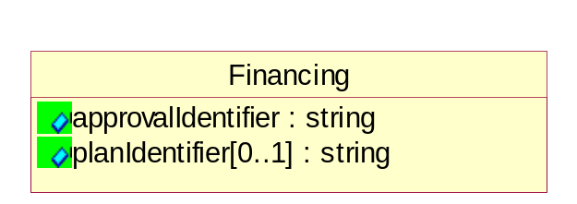
Figure ‎3-16 Financing

Attribute | Type | Documentation
approvalIdentifier | string | The unique number that identifies the approval of a request.
planIdentifier[0..1] | string | The unique number that identifies the tool by which the payment will be made.

InvoiceAmount
The monetary value of the invoice.
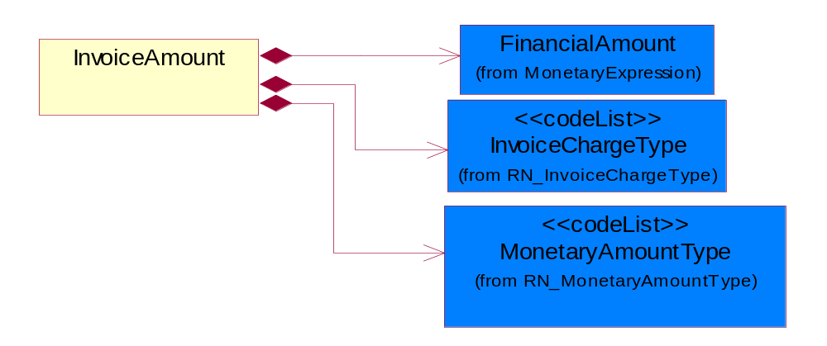
Figure ‎3-17 InvoiceAmount

Composition | Cardinality | Type | Documentation
FinancialAmount | 1 | FinancialAmount | The business document must express financial amounts.
InvoiceChargeType | 1 | InvoiceChargeType | Code identifying the values for the types of charges contained in an invoice.
MonetaryAmountType | 1 | MonetaryAmountType | Code identifying whether the monetary amount is a debit or credit.

LotIdentification
This object identifies a lot which associates the product with a specific group of products with some similar attributes.
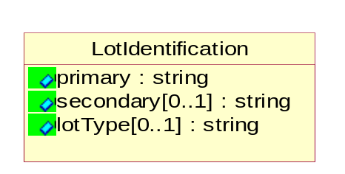
Figure ‎3-18 LotIdentification

Attribute | Type | Documentation
primary | string | The primary lot identifier
secondary[0..1] | string | The secondary lot identifier
lotType[0..1] | string | Identify the type of the lot whether it's for Production or Engineering.

NetTerms
The collection of business properties that describe net payment due terms.

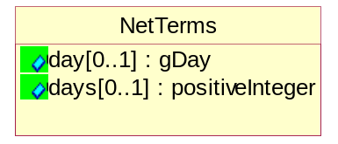
Figure ‎3-19 NetTerms

Attribute | Type | Documentation
day[0..1] | gDay | The specific day of the month a payment is due without incurring late charges.
days[0..1] | positiveInteger | The number of days within which a payment is due without incurring late charges.

PaymentTerms
The collection of business properties that describe payment terms.
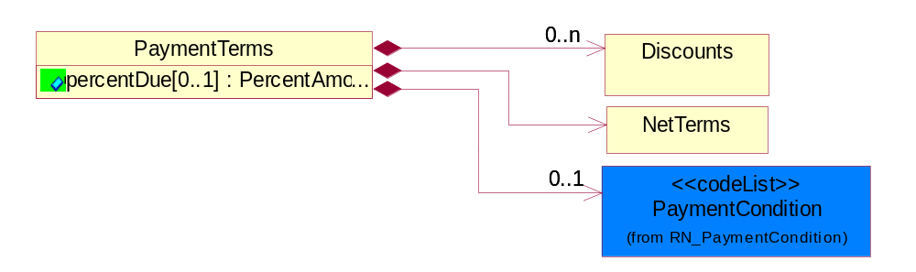
Figure ‎3-20 PaymentTerms

Attribute | Type | Documentation
percentDue[0..1] | PercentAmount | The amount owed expressed as a percentage.

Composition | Cardinality | Type | Documentation
PaymentCondition | 0..1 | PaymentCondition | A code identifying the conditions under which payment will be made.
Discounts | 0..n | Discounts | The collection of business properties that describe payment discounts.
NetTerms | 1 | NetTerms | The collection of business properties that describe net payment due terms.

PrePaymentDetail
The collection of business properties that describe prepayment details used in countries where VAT applies from a date other than the invoice generation date.
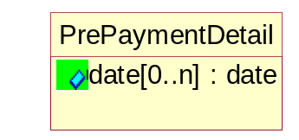
Figure ‎3-21 PrePaymentDetail

Attribute | Type | Documentation
date[0..n] | date | The date which VAT applies in the countries where the date is different than the invoice generation date.

SpecifiedBusinessDocumentReference
The business document reference object allows for the indirect referencing of a relationship to other specific business type related document.
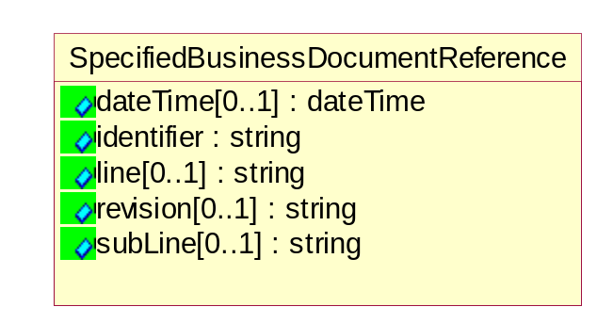
Figure ‎3-22 SpecifiedBusinessDocumentReference

Attribute | Type | Documentation
dateTime[0..1] | dateTime | The date-time stamp indicating on the referenced business document.
identifier | string | Unique identification of the referenced business document.
line[0..1] | string | References the specific line number of the specified business document.
revision[0..1] | string | Referenced the revision of the specified business document.
subLine[0..1] | string | References the specific subline number of the specified business document.

TaxInformation
The collection of business properties that describe tax information.
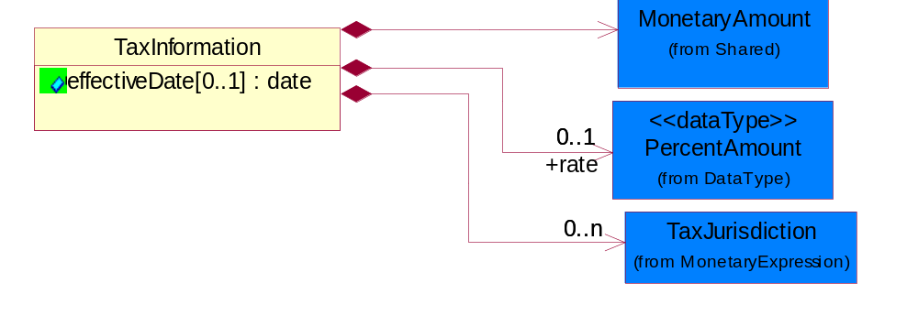
Figure ‎3-23 TaxInformation

Attribute | Type | Documentation
effectiveDate[0..1] | date | The date tax become effective or applicable.

Composition | Cardinality | Type | Documentation
TaxJurisdiction | 0..n | TaxJurisdiction | The business document must identify the specific tax collection authority.
rate | 0..1 | PercentAmount | The rate used to calculate tax liability.
MonetaryAmount | 1 | MonetaryAmount | The collection of business properties that describe the monetary amount defined by a specified currency.

TaxPhrase
The collection of business properties that describe VAT specific information.
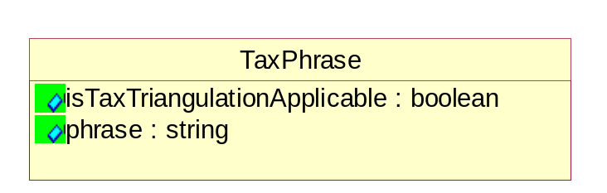
Figure ‎3-24 TaxPhrase

Attribute | Type | Documentation
isTaxTriangulationApplicable | boolean | Indicates whether intermediate suppliers in a triangulation chain may be able to use a simplified procedure available throughout the EC. Triangulation is a name for a type of transaction that can apply only to EU VAT registered companies dispatching goods to countries within the EU.
phrase | string | Country or territory specific tax qualifier verbiage as and when required for tax audit purposes. Such verbiage should be transmitted and stored with the invoice, and may be required to be in local language. Trading Partners are responsible for ensuring that appropriate verbiage is included as per individual tax authority requirements.

TaxSummary
The collection of business properties that describe the total tax information for a local, regional or national taxing authority.
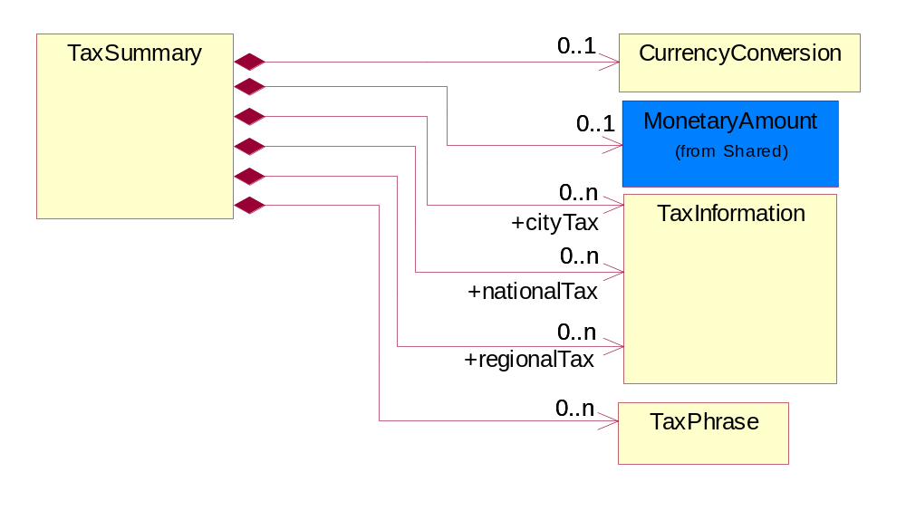
Figure ‎3-25 TaxSummary

Composition | Cardinality | Type | Documentation
CurrencyConversion | 0..1 | CurrencyConversion | The collection of business properties that describe the exchange of money in circulation.
TaxPhrase | 0..n | TaxPhrase | The collection of business properties that describe VAT specific information.
cityTax | 0..n | TaxInformation | The collection of business properties that describe tax information for the city levying the tax.
nationalTax | 0..n | TaxInformation | The collection of business properties that describe tax information for the country levying the tax.
regionalTax | 0..n | TaxInformation | The collection of business properties that describe tax information for the region levying the tax.
MonetaryAmount | 0..1 | MonetaryAmount | The collection of business properties that describe the monetary amount defined by a specified currency.

CodeList

PaymentCondition
A code identifying the conditions under which payment will be made.

Name | Documentation
ACC | Acceptance - Acceptance by buyer of tool/machine to be in working order per spec/contract.
CON | Consumption.
REG | Receipt of Goods.
REI | Receipt of Invoice.
SHI | Shipment.

ShipmentTerms
Code identifying the terms under which a product is shipped.

Name | Documentation
ADC | Advance collect.
ADP | Advance prepaid.
CAA | Cash in advance.
CAD | Cash on delivery.
CFC | Collect, freight credited to payment customer.
CFR | Cost and freight.
CIF | Cost, Insurance and Freight.
CIP | Carriage and Insurance Paid to.
COL | Collect.
CPT | Carriage Paid To.
CRC | Credit card.
CUP | Customer pick-up/backhaul.
DAF | Delivered at Frontier.
DDP | Delivered Duty Paid.
DDU | Delivered Duty Unpaid
DEQ | Delivered Exquay.
DES | Delivered Ex Ship.
EXW | Ex Works.
FAS | Free Alongside Ship.
FCA | Free Carrier.
FOB | Free On Board.
LEC | Letter of Credit.
NOS | Not specified.
PAE | Payable elsewhere.
PCC | Prepaid but charged to customer.
PIU | Pickup.
PRE | Prepaid only.
PRS | Prepaid (by seller).
RFC | Return container freight paid by customer.
RFF | Return container freight free.
RFS | Return container freight paid by supplier.
TPP | Third Party Pay.

PurchaseType
Code that denotes type of purchase

Name | Documentation
CAS | Cash.
CRE | Credit.
INS | Installment.

DocumentType
Code identifying the type of financial document, e.g. invoice, credit memo or debit memo.

Name | Documentation
ACM | ASP claim. The unique identifier assigned by the ASP for a warranty claim.
APO | ASP part order. The unique identifier assigned by the ASP for a part order.
APR | ASP part return. The unique identifier assigned by the ASP for a part return.
ARQ | ASP requisition. The unique identifier assigned by the ASP to reference a work order.
CIN | Commercial invoice.
CNT | Contract.
CRM | Credit memo.
DEM | Debit memo.
DEN | Delivery note.
DWN | Drawing number. Number associated with the drawing provided.
INV | Invoice.
LID | Location Identifier. Data for on-site work that have to be done on the machine (associated with preventative maintenance order)
MDN | Model number associated with the product.
MEN | Master event number.
MID | Machine identifier. Data for on-site work that have to be done on the machine (associated with preventative maintenance order).
OCM | OEM claim. The unique identifier assigned by the OEM for a warranty claim.
OPO | OEM part order. The unique identifier assigned by the OEM for a part order.
OPR | OEM part return. The unique identifier assigned by the OEM for a part return.
POI | Purchase Order IN.
POO | Purchase Order OUT.
POR | Purchase Order.
QOT | Quote.
REQ | Requisition.
RMA | Return material authorization.
SBC | Self Billing Credit memo-credit memo used in self-billing scenario.
SBD | Self Billing Debit memo, debit memo used in self-billing scenario.
SBI | Self Billing Invoice, invoice is used in self-billing scenario.
SEN | Serial number. Data for on-site work that have to be done on the machine (associated with preventative maintenance order).
SNC | Shipset number on code list.
SOR | Sales order.
SPN | Specification number. Data for on-site work that have to be done on the machine (associated with preventative maintenance order).
WBL | Waybill.
WCM | Warranty claim.
WOR | Work order.

Logistics

Logistics

Dependency Diagram
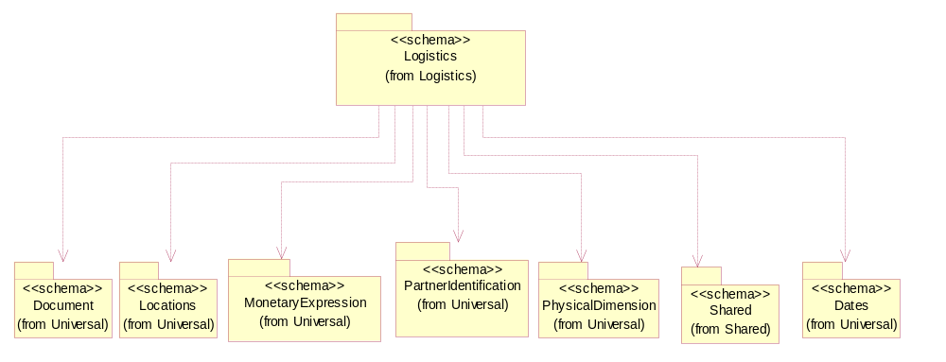
Figure ‎3-26 Dependency

TrackingReference
Proprietary unique identifier for tracking product shipments.
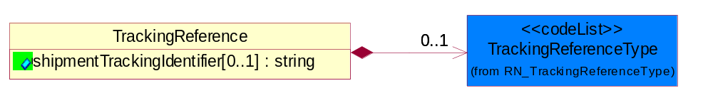
Figure ‎3-27 TrackingReference

Attribute | Type | Documentation
shipmentTrackingIdentifier[0..1] | string | Proprietary unique identifier for tracking product shipments.

Composition | Cardinality | Type | Documentation
TrackingReferenceType | 0..1 | TrackingReferenceType | Code identifying the type of document reference being used to track a shipment.

CodeList

TrackingReferenceType
Code identifying the type of document reference being used to track a shipment.

Name | Documentation
BKN | Booking Number - Shipment identification number assigned by shipper when booking freight shipment with carrier.
BOL | Bill of Lading Number - Shipment identification number on bill of lading issued by shipper, forwarder or carrier.
CIN | Commercial Invoice - An invoice for customs purposes to allow the determination of the proper import/export duty/taxes.
CRN | Carrier Reference Number - Carrier assigned shipment identification number on bill of lading.
FTR | Freight Tracking Reference - Reference number that describes information about tracing shipments during the transportation process.
HAN | House Airwaybill Number - Forwarder assigned shipment identification number on bill of lading issued by forwarder.
MAB | Master Airwaybill Number - Carrier assigned shipment identification number on bill of lading issued by carrier.
OBL | Ocean Bill of Lading Number - Carrier assigned shipment identification number on bill of lading issued by carrier.
PON | Purchase Order Number.
PRO | Pro Number - Carrier assigned shipment identification number on bill of lading.
PSN | Packing Slip Number - Shipment identification number on shipment contents packing list attached to shipment.
RFI | Radio Frequency Identification (RFID).
RRN | Route Reference Number.
SID | Seal Identifier - Trailer or container seal number assigned by party closing doors on trailer or container.
SON | Seller Sales Order Number.
SRN | Shipper Reference Number - Shipper assigned shipment identification number on bill of lading issued by shipper or forwarder.
TRN | Trailer Number - Owner assigned equipment identification number on trailer.

NationalExportControlClassification
Code identifying product classification for export regulation.

Name | Documentation
CLE | Clearance - The cargo will be or has been cleared.
CUC | Already customs cleared in the importing country, arrangement for inspection are not necessary because they were cleared before.
DET | Detention - The cargo has been or will be detained.
DOR | Documents Required - Pertinent documents are required.
DRC | Documents Requirements Completed - All requirements for documents have been completed.
FUM | Fumigation - The cargo has been or will be fumigated.
IAC | Inspection Arrangements Completed - Arrangements for inspection of the cargo have been completed.
IAR | Inspection Arrangements Required - Arrangements for inspection of the cargo are required.
INS | Inspection - The cargo has been or will be inspected.
LWI | Lowest Importance.
NCP | No Customs Procedure - Customs clearance not required.
SAC | Safety Arrangements Completed - Arrangements for safeguarding the cargo have been completed.
SAR | Safety Arrangements Required - Arrangements for safeguarding the cargo are required.
SCR | Security - The cargo has been or will be secured.
SEC | Security Arrangements Completed - Arrangements for storing the cargo have been completed.
SER | Security Arrangements Required - Arrangements for the security of the cargo are required.
STR | Storage arrangements required - Arrangements for storing the cargo are required.
TAC | Transport Arrangements Completed - All arrangements for transport have been completed.
TAR | Transport Arrangements Required - Transport has to be arranged.

Shared

Shared

Dependency Diagram
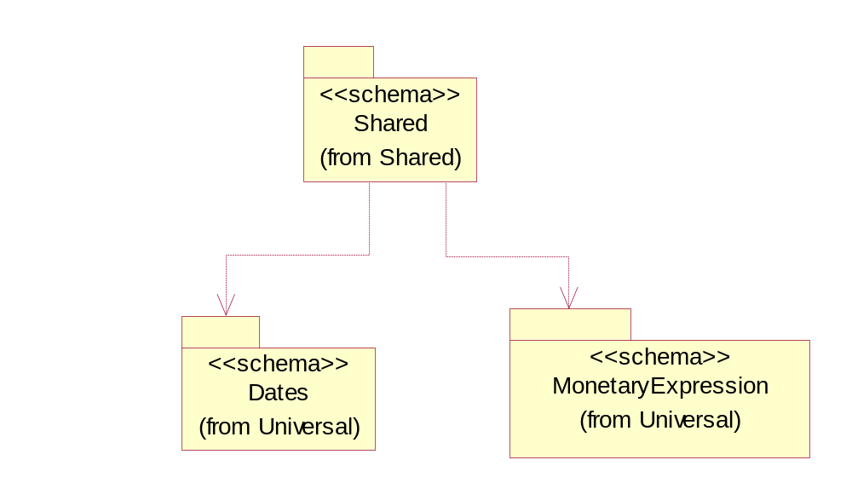
Figure ‎3-28 Dependency

MonetaryAmount
The collection of business properties that describe the monetary amount defined by a specified currency.

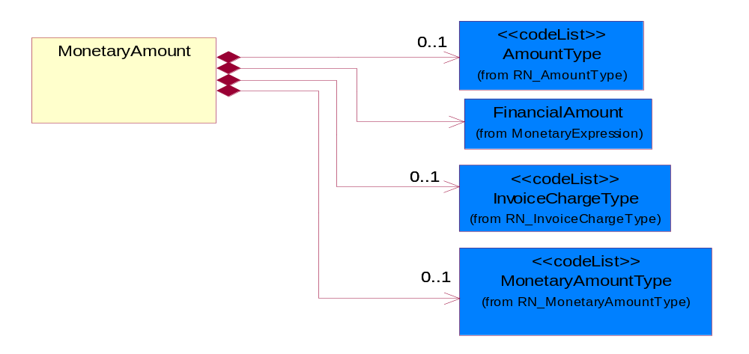
Figure ‎3-29 MonetaryAmount

Composition | Cardinality | Type | Documentation
FinancialAmount | 1 | FinancialAmount | The business document must express financial amounts.
InvoiceChargeType | 0..1 | InvoiceChargeType | Code identifying the values for the types of charges contained in an invoice.
MonetaryAmountType | 0..1 | MonetaryAmountType | Code identifying whether the monetary amount is a debit or credit.
AmountType | 0..1 | AmountType

ProductQuantity
A quantity specifying the number of product units.
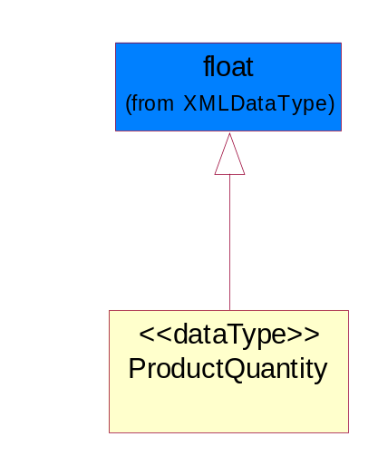
Figure ‎3-30 ProductQuantity

CodeList

InvoiceChargeType
Code identifying the values for the types of charges contained in an invoice.

Name | Documentation
ALC | Allowances and Charges.
CUC | Custom Charges.
DEA | Deposit Amount.
ESC | Expedited Shipping Charge - Charge for accelerating the delivery of a product.
FRC | Freight Charges.
HAC | Handling Charges.
LEC | Lease Charge - Charge for the use of a product in which the purchaser assumes certain responsibilities of ownership.
LIC | License Charge - Charge for the use of a product (usually software) in which the manufacturer maintains ownership of the product.
MAC | Maintenance Charge - Charge (usually periodic) for providing maintenance support for a product.
PUC | Purchase Charge - Charge for a product in which the buyer takes all responsibilities of ownership.
QUD | Quantity Discount.
REC | Rental Charge - Charge for the use of a product (usually hardware) in which the manufacturer maintains ownership of the product.

MonetaryAmountType
Code identifying whether the monetary amount is a debit or credit.

Name | Documentation
CRE | Credit.
DEB | Debit.
ZER | Zero remit.

ShippingServiceLevel
Code identifying the shipping service level, e.g., overnight, same day.

Name | Documentation
1BD | 1BD, Same Business Day - 4 hour Response Time.
5BD | 5 Business Days.
9AM | 9 A.M.
ACH | Air Charter.
AEC | Air Economy.
AIC | Air Cargo.
AM | A.M.
ARS | Authorized Return Service.
ATA | Airport to Airport.
ATD | Airport to Door.
BCT | Bulk Commodity Train.
BUC | Business Class.
CBS | Consignee Billing Service.
COE | Courier Express.
DCR | Delivery Confirmation Return.
DEC | Delivery Confirmation.
DES | Deferred Service.
DNO | Delivery Notification Only.
DOS | Door Service.
DSN | Delivery scheduled next day by cartage agent.
DSS | Delivery scheduled second day by cartage agent.
DST | Delivery scheduled third day by cartage agent.
DTA | Door to Airport.
DTD | Door to Door.
DTP | Door to Port (Ocean).
ESP | Express Service Plus.
ESV | Expedited Service.
ESW | Expedited Service Worldwide.
EXS | Express Service.
EXW | Express Service - Worldwide.
FIC | First Class.
GEN | General.
GRO | Ground.
ISS | Other intermodal and stack service.
MAF | Manifest freight.
MET | Metro.
MUW | Multiweight.
NBD | Next Business Day.
NDA | Next Day Air.
NEM | Next Morning.
NFO | Next Flight Out.
NHW | Next day Hundred Weight.
NOR | NORMAL - Normal delivery.
NOS | Not served.
OIS | Other Intermodal and Stack service
OTH | Other.
OVN | Overnight.
PAS | Passenger service.
PIU | Pickup.
PM | PM.
PMI | Priority Mail Insured.
POB | P.O. Box/Zip code.
POD | Proof of Delivery (POD) with Signature.
PRM | Priority Mail.
PRS | Premium Surface.
PS1 | Primary Service Area - Next Day by 10:30 A.M.
PS2 | Primary Service Area - Next Day by 5:00 P.M.
PS3 | Primary Service Area - Next Day By 9:30 A.M.
PS4 | Primary Service Area - Next Day by Noon.
PS5 | Primary Service Area - Second Day by Noon.
PTD | Port to Door (Ocean).
PTP | Port to Port (Ocean).
REG | Regular.
SAD | Same day.
SAP | Saturday Pickup.
SAT | Saturday.
SBD | SBD, Second Business Day.
SCH | Scheduled.
SDA | Second Day Air.
SDW | Second Day Hundred Weight.
SED | Second Day.
SEM | Second Morning.
SGW | Standard Ground Hundred Weight.
STC | Standard Class.
STG | Standard Ground.
STO | Standard Ocean.
STS | Standard Service.
SUH | Sunday and Holidays.
TDS | Three Day Service.
TIC | Time Critical.
TRG | Tracking - Ground.

AmountType

Name | Documentation
DIS | Discount Value - The monetary amount of the discount on the price applied to a customer order.
FRE | Freight Charges - The monetary amount to be paid for freight transportation.
INS | InsuranceCharges - The monetary amount to be paid for freight insurance.
MAT | Material Cost - This object represents the material cost for the product.
MIS | Miscellaneous Charges - The monetary amount to be paid for miscellaneous charges.
PRC | Processing Charges - The monetary amount to be paid by consignee for consignment manufacturer.
TOD | Total Amount Due - Total amount due upon receipt of statement.
TOT | Total Amount - Total price for an entire business document.
TOV | Total Value Added Amount - The total amount of the shipment including any value added tax.
UNI | Unit Price - Agreed upon sale price for each unit ordered.
VAD | Value Added Unit Price - The price of a unit including any value added tax.

Universal Structure

ContactInformation

ContactInformation
The business document must allow for the identification of the name of the department, service or individual to be contacted regarding the context of the business document.
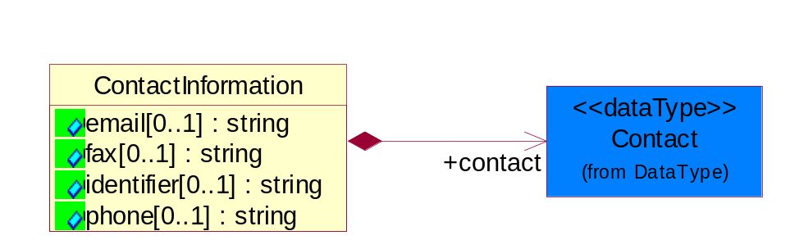
Figure ‎4-31 ContactInformation

Attribute | Type | Documentation
email[0..1] | string | The electronic mail for the specified contact.
fax[0..1] | string | The fax number for the specified contact.
identifier[0..1] | string | Identifies the role of the contact (i.e. Service Technician, Account Manager) in the Business Process.
phone[0..1] | string | The telephone number for the specified contact.

Composition | Cardinality | Type | Documentation
contact | 1 | Contact | The name of the department, service or individual to be contacted within the organization.

DataType

Contact
The name of the department, service or individual to be contacted within the organization.
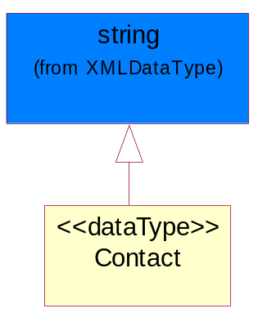
Figure ‎4-32 Contact

DUNS
A number assigned by Dun and Bradstreet to identify a business location.
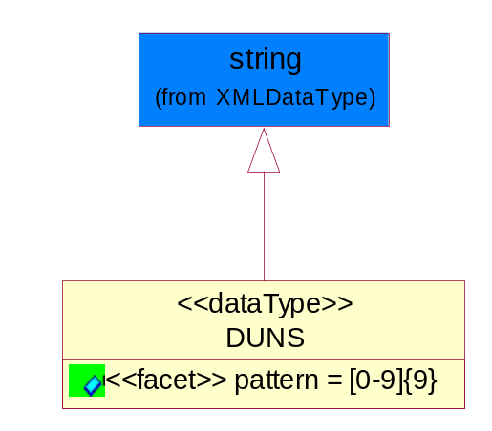
Figure ‎4-33 DUNS

Attribute | Type | Documentation
pattern |  | [0-9]{9}

DUNSPlus4
A identifier to specify a specific location within a business location.
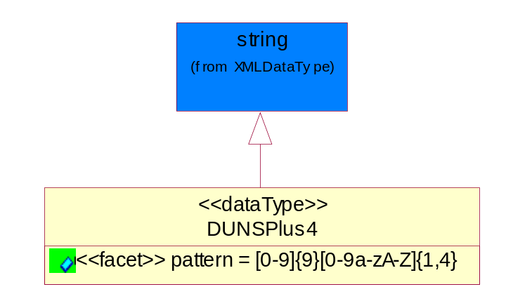
Figure ‎4-34 DUNSPlus4

Attribute | Type | Documentation
pattern |  | Data Universal Numbering System +4 (DUNS+4) number means the DUNS number assigned by Dun and Bradstreet, Inc. (D&B) plus an alphanumeric of length 4 suffix that may be assigned by a business concern.

GLN
Global Location Number (GLN) - A identifier to identify legal entities, trading parties and location.
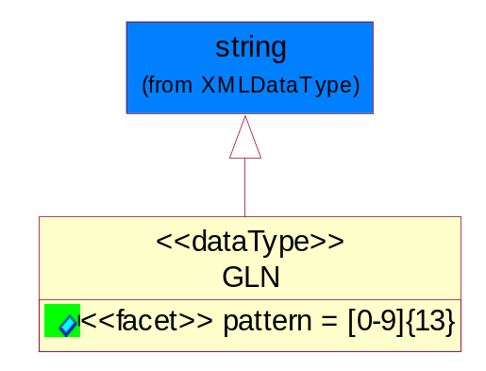
Figure ‎4-35 GLN

Attribute | Type | Documentation
pattern |  | [0-9]{13}

GTIN
Global Trade Identification Number (GTIN).
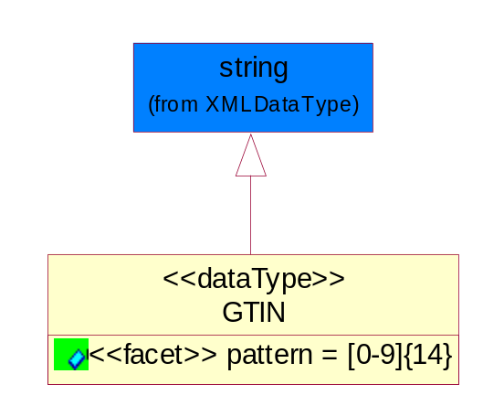
Figure ‎4-36 GTIN

Attribute | Type | Documentation
pattern |  | [0-9]{14}

PercentAmount
A number representing a percentage value, e.g. 75.125 represents 75 1/8 percent.
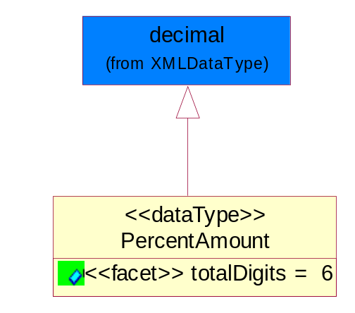
Figure ‎4-37 PercentAmount

Attribute | Type | Documentation
totalDigits |  | 6

Locations

AlternativeIdentifier
Identifies the specified code and the name of the organization that a code is utilized from.
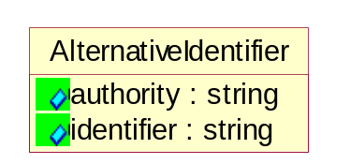
Figure ‎4-38 AlternativeIdentifier

Attribute | Type | Documentation
authority | string | The name of the organization that a code is utilized from.
identifier | string | The specified code to represent an entity (e.g. product, location, partner, etc.)

Location
The business document must specify a location.
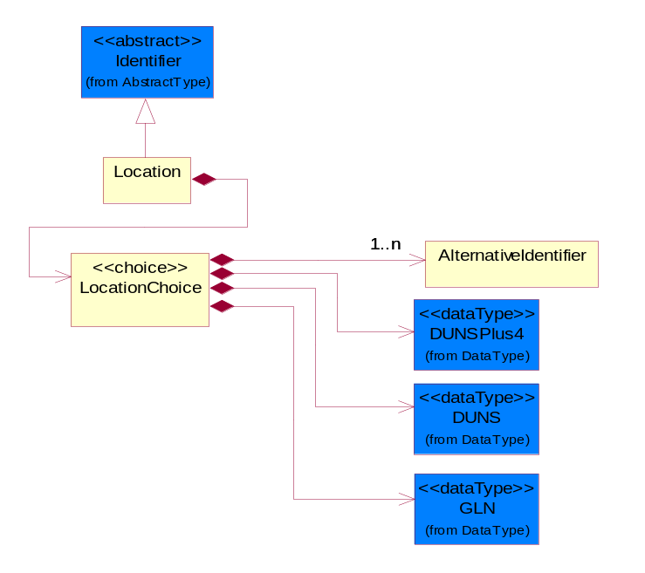
Figure ‎4-39 Location

Composition | Cardinality | Type | Documentation
LocationChoice | 1 | LocationChoice

LocationChoice

Composition | Cardinality | Type | Documentation
DUNSPlus4 | 1 | DUNSPlus4 | A identifier to specify a specific location within a business location.
DUNS | 1 | DUNS | A number assigned by Dun and Bradstreet to identify a business location.
AlternativeIdentifier | 1..n | AlternativeIdentifier | Identifies the specified code and the name of the organization that a code is utilized from.
GLN | 1 | GLN | Global Location Number (GLN) - A identifier to identify legal entities, trading parties and location.

PhysicalAddress
The business document must provide a physical address for a party to the business transaction.
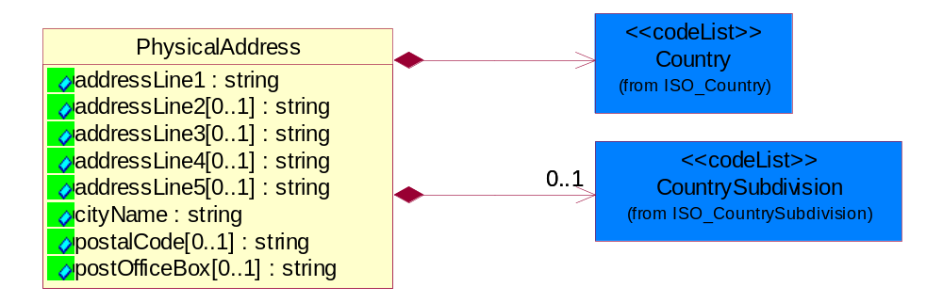
Figure ‎4-40 PhysicalAddress

Attribute | Type | Documentation
addressLine1 | string | The first line of a physical address.
addressLine2[0..1] | string | The second line of a physical address.
addressLine3[0..1] | string | The third line of a physical address.
addressLine4[0..1] | string | The fourth line of a physical address.
addressLine5[0..1] | string | The fifth line of a physical address.
cityName | string | The name of a city.
postalCode[0..1] | string | Identifying geographic location as specified by a national postal code.
postOfficeBox[0..1] | string | The Post Office Box identifier used to identify a party's post office box.

Composition | Cardinality | Type | Documentation
Country | 1 | Country | For representation of Country name RosettaNet has adopted ISO 3166-3; 1999. Refer to the following web page to get the latest version of the standard:  http://www.iso.ch/iso/en/prods-services/iso3166ma/02iso-3166-code-lists/index.html  If you need more information about the ISO standard please contact ISO for more details.
CountrySubdivision | 0..1 | CountrySubdivision | For representation of a Countries subdivisions RosettaNet has adopted ISO 3166-3; 1999. Refer to the following web page to get the latest version of the standard:  http://www.iso.ch/iso/en/prods-services/iso3166ma/02iso-3166-code-lists/index.html  If you need more information about the ISO standard please contact ISO for more details.

MonetaryExpression

FinancialAmount
The business document must express financial amounts.
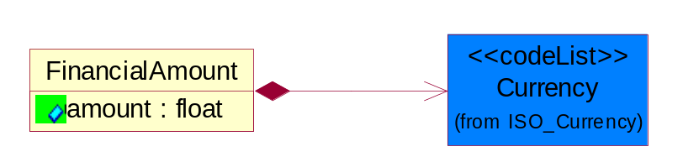
Figure ‎4-41 FinancialAmount

Attribute | Type | Documentation
amount | float | Specifies the monetary amount.

Composition | Cardinality | Type | Documentation
Currency | 1 | Currency | For representation of Currency codes RosettaNet has adopted ISO 4217; 1995. The British Standards Institution (BSI) is the ISO 4217 Maintenance Agency. Refer to the following web page to get the latest version of the standard:  http://www.bsi-global.com/Technical+Information/Publications/_Publications/tig90.xalter  If you need more information about the ISO standard please contact ISO for more details.

TaxJurisdiction
The business document must identify the specific tax collection authority.
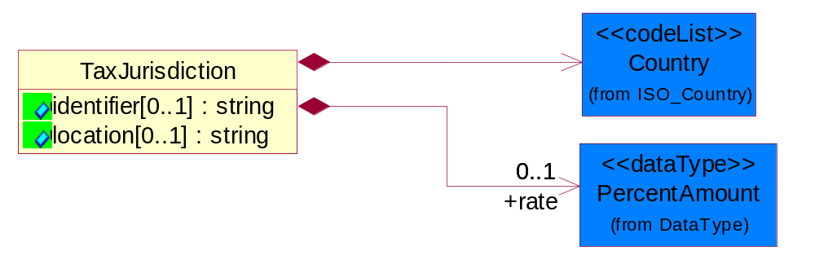
Figure ‎4-42 TaxJurisdiction

Attribute | Type | Documentation
identifier[0..1] | string | Unique identification for a taxing authority.
location[0..1] | string | Identification of the tax collection authority location.

Composition | Cardinality | Type | Documentation
rate | 0..1 | PercentAmount | A number representing a percentage value, e.g. 75.125 represents 75 1/8 percent.
Country | 1 | Country | For representation of Country name RosettaNet has adopted ISO 3166-3; 1999. Refer to the following web page to get the latest version of the standard:  http://www.iso.ch/iso/en/prods-services/iso3166ma/02iso-3166-code-lists/index.html  If you need more information about the ISO standard please contact ISO for more details.

PartnerIdentification

FullPartner
The business document must describe the trading partners in the business transaction. This data structure provide the flexibility to describe a partner in all possible methods as for new, existing or known partner.
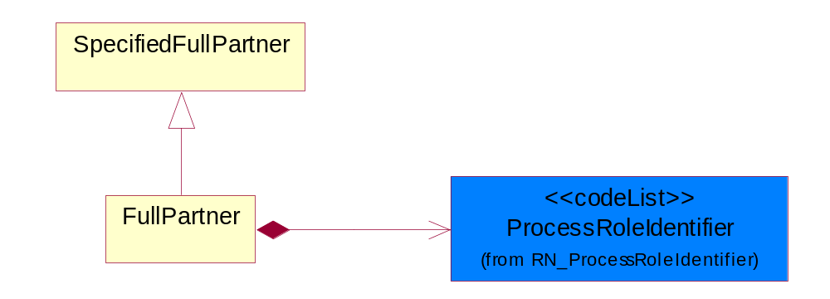
Figure ‎4-43 FullPartner

Composition | Cardinality | Type | Documentation
ProcessRoleIdentifier | 1 | ProcessRoleIdentifier | Describes the role of the partner in the business process. A partner will fulfill at least one or more roles during the business process.

IntermittentPartner
The business document must describe a physical address for a delivery.
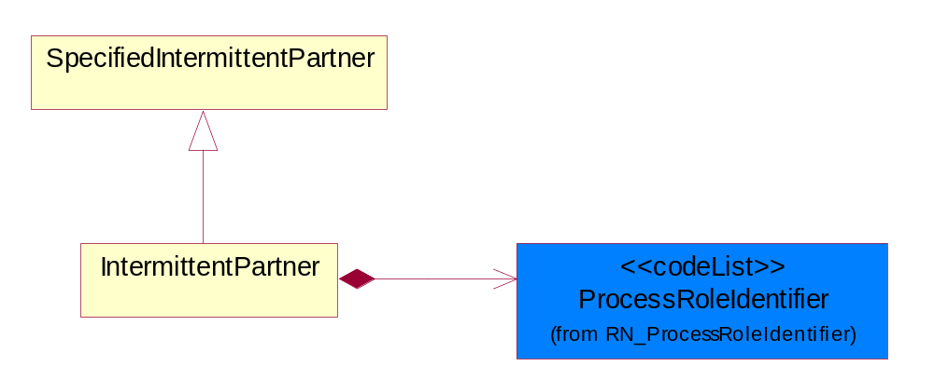
Figure ‎4-44 IntermittentPartner

Composition | Cardinality | Type | Documentation
ProcessRoleIdentifier | 1 | ProcessRoleIdentifier | Describes the role of the partner in the business process. A partner will fulfill at least one or more roles during the business process.

KnownPartner
The business document must describe the trading partners in the business transaction.
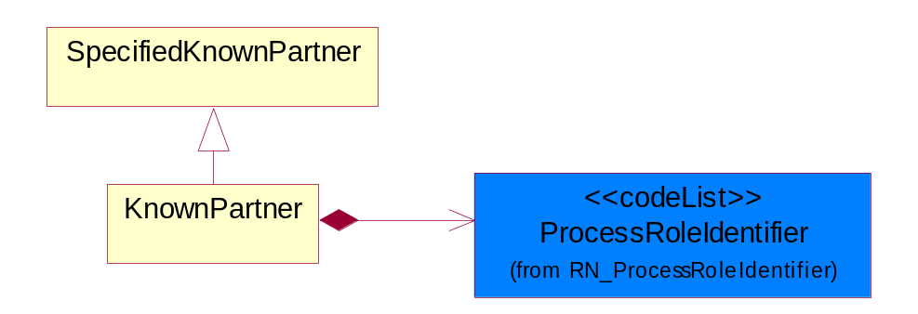
Figure ‎4-45 KnownPartner

Composition | Cardinality | Type | Documentation
ProcessRoleIdentifier | 1 | ProcessRoleIdentifier | Describes the role of the partner in the business process. A partner will fulfill at least one or more roles during the business process.

KnownPartnerContact
The business document must describe the trading partners in the business transaction.
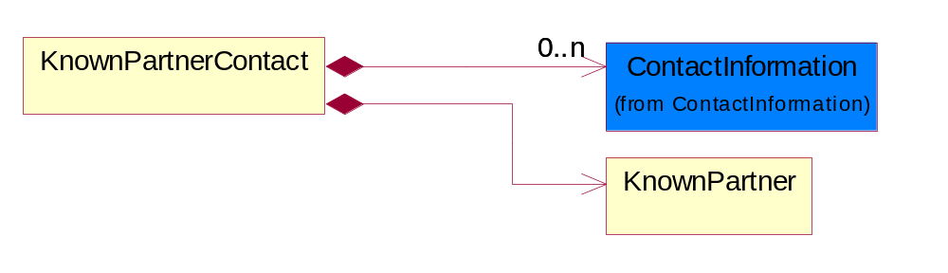
Figure ‎4-46 KnownPartnerContact

Composition | Cardinality | Type | Documentation
KnownPartner | 1 | KnownPartner | The business document must describe the trading partners in the business transaction.
ContactInformation | 0..n | ContactInformation | The business document must allow for the identification of the name of the department, service or individual to be contacted regarding the context of the business document.

NewPartner
The business document must describe a new, existing (but known to only one of the parties to the transaction) or an unknown party to the business transaction.
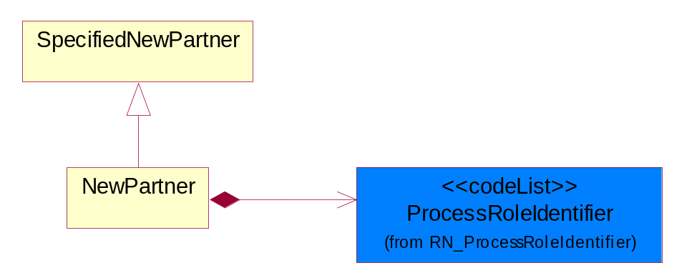
Figure ‎4-47 NewPartner

Composition | Cardinality | Type | Documentation
ProcessRoleIdentifier | 1 | ProcessRoleIdentifier | Describes the role of the partner in the business process. A partner will fulfill at least one or more roles during the business process.

PartnerDescription
The collection of business properties that describe a business partners' identity, their contact information, where they are physically located and their function in a supply chain.
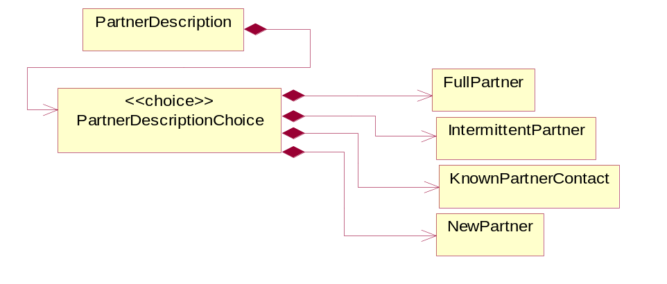
Figure ‎4-48 PartnerDescription

Composition | Cardinality | Type | Documentation
PartnerDescriptionChoice | 1 | PartnerDescriptionChoice

PartnerDescriptionChoice

Composition | Cardinality | Type | Documentation
KnownPartnerContact | 1 | KnownPartnerContact | The business document must describe the trading partners in the business transaction.
IntermittentPartner | 1 | IntermittentPartner | The business document must describe a physical address for a delivery.
NewPartner | 1 | NewPartner | The business document must describe a new, existing (but known to only one of the parties to the transaction) or an unknown party to the business transaction.
FullPartner | 1 | FullPartner | The business document must describe the trading partners in the business transaction. This data structure provide the flexibility to describe a partner in all possible methods as for new, existing or known partner.

PartnerIdentification
The business document must allow for the identity of one or more parties to the transaction.
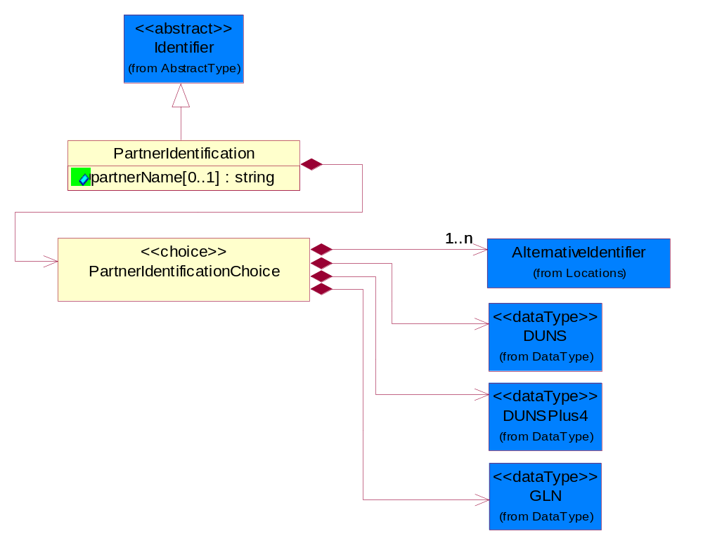
Figure ‎4-49 PartnerIdentification

Attribute | Type | Documentation
partnerName[0..1] | string | The name of the partner’s company/business.

Composition | Cardinality | Type | Documentation
PartnerIdentificationChoice | 1 | PartnerIdentificationChoice

PartnerIdentificationChoice

Composition | Cardinality | Type | Documentation
DUNS | 1 | DUNS | A number assigned by Dun and Bradstreet to identify a business location.
DUNSPlus4 | 1 | DUNSPlus4 | A identifier to specify a specific location within a business location.
AlternativeIdentifier | 1..n | AlternativeIdentifier | Identifies the specified code and the name of the organization that a code is utilized from.
GLN | 1 | GLN | Global Location Number (GLN) - A identifier to identify legal entities, trading parties and location.

SpecifiedFullPartner
The business document must describe the trading partners in the business transaction. This data structure provide the flexibility to describe a partner in all possible methods as for new, existing or known partner. This is specifically for partner who role has been specified.
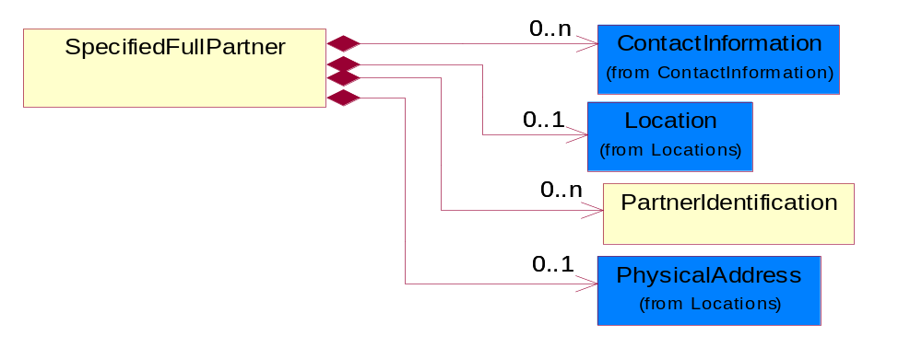
Figure ‎4-50 SpecifiedFullPartner

Composition | Cardinality | Type | Documentation
ContactInformation | 0..n | ContactInformation | The business document must allow for the identification of the name of the department, service or individual to be contacted regarding the context of the business document.
Location | 0..1 | Location | The business document must specify a location.
PartnerIdentification | 0..n | PartnerIdentification | The business document must allow for the identity of one or more parties to the transaction.
PhysicalAddress | 0..1 | PhysicalAddress | The business document must provide a physical address for a party to the business transaction.

SpecifiedIntermittentPartner
The business document must describe a physical address for a delivery.
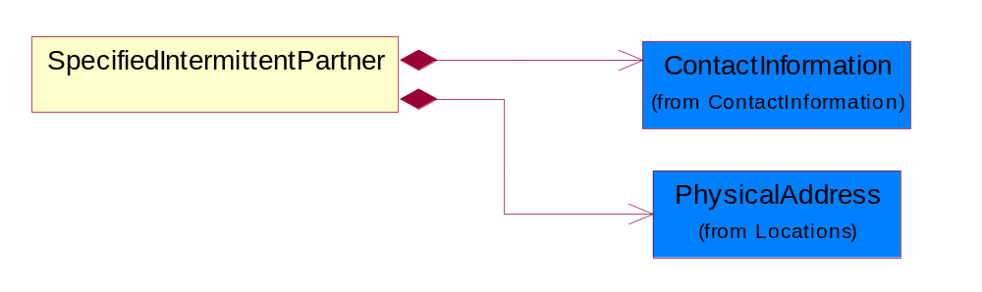
Figure ‎4-51 SpecifiedIntermittentPartner

Composition | Cardinality | Type | Documentation
ContactInformation | 1 | ContactInformation | The business document must allow for the identification of the name of the department, service or individual to be contacted regarding the context of the business document.
PhysicalAddress | 1 | PhysicalAddress | The business document must provide a physical address for a party to the business transaction.

SpecifiedKnownPartner
The business document must describe the trading partners in the business transaction.
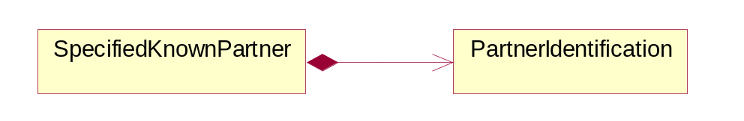
Figure ‎4-52 SpecifiedKnownPartner

Composition | Cardinality | Type | Documentation
PartnerIdentification | 1 | PartnerIdentification | The business document must allow for the identity of one or more parties to the transaction.

SpecifiedKnownPartnerContact
The business document must describe the trading partners in the business transaction and allow for a identification of an individual of the trading partner.
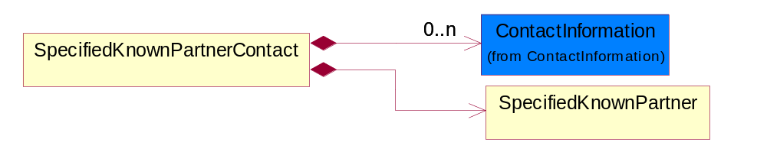
Figure ‎4-53 SpecifiedKnownPartnerContact

Composition | Cardinality | Type | Documentation
SpecifiedKnownPartner | 1 | SpecifiedKnownPartner | The business document must describe the trading partners in the business transaction.
ContactInformation | 0..n | ContactInformation | The business document must allow for the identification of the name of the department, service or individual to be contacted regarding the context of the business document.

SpecifiedNewPartner
The business document must describe a new, existing (but known to only one of the parties to the transaction) or an unknown party to the business transaction.
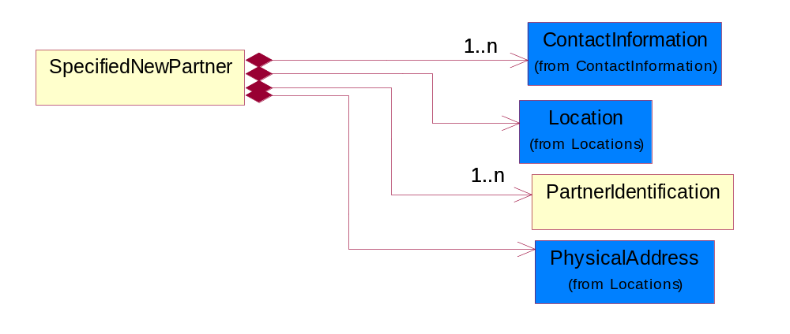
Figure ‎4-54 SpecifiedNewPartner

Composition | Cardinality | Type | Documentation
ContactInformation | 1..n | ContactInformation | The business document must allow for the identification of the name of the department, service or individual to be contacted regarding the context of the business document.
Location | 1 | Location | The business document must specify a location.
PhysicalAddress | 1 | PhysicalAddress | The business document must provide a physical address for a party to the business transaction.
PartnerIdentification | 1..n | PartnerIdentification | The business document must allow for the identity of one or more parties to the transaction.

SpecifiedPartnerDescription
The collection of business properties that describe a business partners' identity, their contact information, where they are physically located and their function in a supply chain.
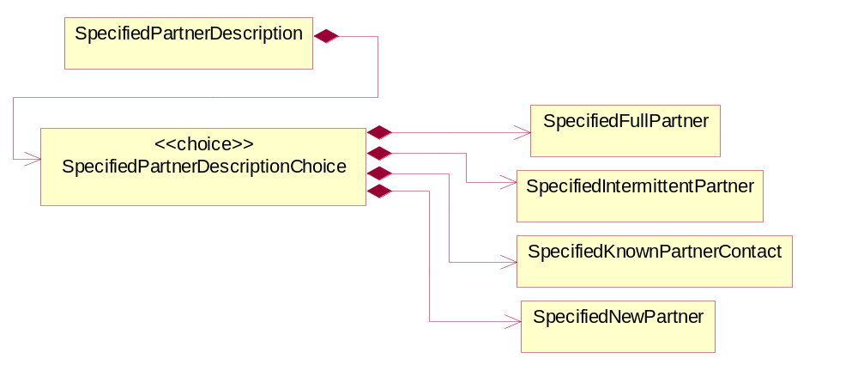
Figure ‎4-55 SpecifiedPartnerDescription

Composition | Cardinality | Type | Documentation
SpecifiedPartnerDescriptionChoice | 1 | SpecifiedPartnerDescriptionChoice

SpecifiedPartnerDescriptionChoice

Composition | Cardinality | Type | Documentation
SpecifiedKnownPartnerContact | 1 | SpecifiedKnownPartnerContact | The business document must describe the trading partners in the business transaction and allow for a identification of an individual of the trading partner.
SpecifiedIntermittentPartner | 1 | SpecifiedIntermittentPartner | The business document must describe a physical address for a delivery.
SpecifiedNewPartner | 1 | SpecifiedNewPartner | The business document must describe a new, existing (but known to only one of the parties to the transaction) or an unknown party to the business transaction.
SpecifiedFullPartner | 1 | SpecifiedFullPartner | The business document must describe the trading partners in the business transaction. This data structure provide the flexibility to describe a partner in all possible methods as for new, existing or known partner. This is specifically for partner who role has been specified.

ProductIdentification

ProductIdentification
The object provides the identifier(s) of a product.
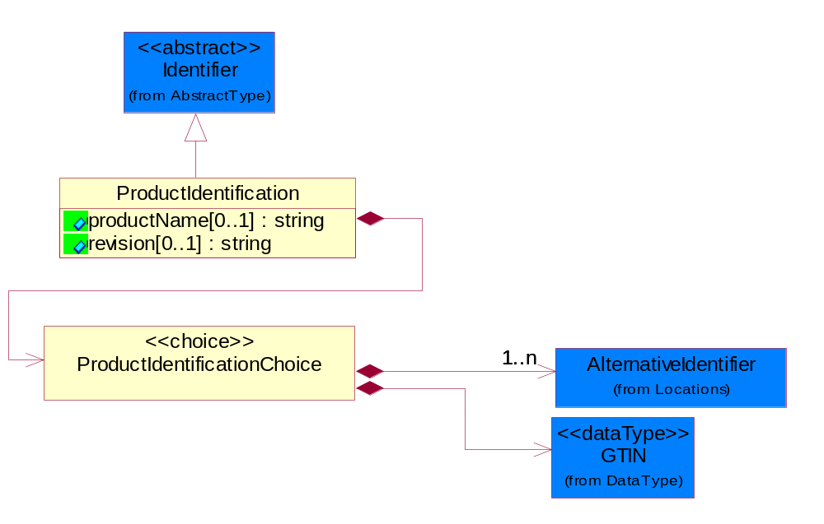
Figure ‎4-56 ProductIdentification

Attribute | Type | Documentation
productName[0..1] | string | The name of the product.
revision[0..1] | string | Referenced the specified product revision.

Composition | Cardinality | Type | Documentation
ProductIdentificationChoice | 1 | ProductIdentificationChoice

ProductIdentificationChoice

Composition | Cardinality | Type | Documentation
AlternativeIdentifier | 1..n | AlternativeIdentifier | Identifies the specified code and the name of the organization that a code is utilized from.
GTIN | 1 | GTIN | Global Trade Identification Number (GTIN).

CodeList

Country
For representation of Country name RosettaNet has adopted ISO 3166-3; 1999. Refer to the following web page to get the latest version of the standard:
http://www.iso.ch/iso/en/prods-services/iso3166ma/02iso-3166-code-lists/index.html

If you need more information about the ISO standard please contact ISO for more details.

CountrySubdivision
For representation of a Countries subdivisions RosettaNet has adopted ISO 3166-3; 1999. Refer to the following web page to get the latest version of the standard:
http://www.iso.ch/iso/en/prods-services/iso3166ma/02iso-3166-code-lists/index.html

If you need more information about the ISO standard please contact ISO for more details.

Currency
For representation of Currency codes RosettaNet has adopted ISO 4217; 1995. The British Standards Institution (BSI) is the ISO 4217 Maintenance Agency. Refer to the following web page to get the latest version of the standard:
http://www.bsi-global.com/Technical+Information/Publications/_Publications/tig90.xalter

If you need more information about the ISO standard please contact ISO for more details.

Language
For representation of Language name RosettaNet has adopted ISO 639-2; 1998. Refer to the following web page to get the latest version of the standard:

http://www.loc.gov/standards/iso639-2/iso639jac.html

If you need more information about the ISO standard please contact ISO for more details.

MimeTypeQualifier
The MIME type as defined by IANA.

Please refer to http://www.iana.org/assignments/media-types/ for a list of types.

Instance | Documentation
application/activemessage | [Shapiro]
application/andrew-inset | [Borenstein]
application/applefile | [Faltstrom]
application/atomicmail | [Borenstein]
application/batch-SMTP | [RFC2442]
application/beep+xml | [RFC3080]
application/cals-1840 | [RFC1895]
application/cnrp+xml | [RFCCNRP]
application/commonground | [Glazer]
application/cpl+xml
application/cybercash | [Eastlake]
application/dca-rft | [Campbell]
application/dec-dx | [Campbell]
application/dicom | [RFC3240]
application/dvcs | [RFC3029]
application/EDI-Consent | [RFC1767]
application/EDIFACT | [RFC1767]
application/EDI-X12 | [RFC1767]
application/eshop | [Katz]
application/font-tdpfr | [RFC3073]
application/http | [RFC2616]
application/hyperstudio | [Domino]
application/iges | [Parks]
application/index | [RFC2652]
application/index.cmd | [RFC2652]
application/index.obj | [RFC2652]
application/index.response | [RFC2652]
application/index.vnd | [RFC2652]
application/iotp | [RFC2935]
application/ipp | [RFC2910]
application/isup | [RFC3204]
application/mac-binhex40 | [Faltstrom]
application/macwriteii | [Lindner]
application/marc | [RFC2220]
application/mathematica | [Van Nostern]
application/msword | [Lindner]
application/news-message-id | [RFC1036,Spencer]
application/news-transmission | [RFC1036, Spencer]
application/ocsp-request | [RFC2560]
application/ocsp-response | [RFC2560]
application/octet-stream | [RFC2045,RFC2046]
application/oda | [RFC2045,RFC2046]
application/ogg | [RFC-walleij-ogg-mediatype-08.txt]
application/parityfec | [RFC3009]
application/pdf | [Lindner]
application/pgp-encrypted | [RFC3156]
application/pgp-keys | [RFC3156]
application/pgp-signature | [RFC3156]
application/pkcs10 | [RFC2311]
application/pkcs7-mime | [RFC2311]
application/pkcs7-signature | [RFC2311]
application/pkix-cert | [RFC2585]
application/pkixcmp | [RFC2510]
application/pkix-crl | [RFC2585]
application/postscript | [RFC2045,RFC2046]
application/prs.alvestrand.titrax-sheet | [Alvestrand]
application/prs.cww | [Rungchavalnont]
application/prs.nprend | [Doggett]
application/prs.plucker | [Janssen]
application/qsig | [RFC3204]
application/reginfo+xml | [RFC-ietf-sipping-reg-event-00.txt]
application/remote-printing | [RFC1486,Rose]
application/riscos | [Smith]
application/rtf | [Lindner]
application/sdp | [RFC2327]
application/set-payment | [Korver]
application/set-payment-initiation | [Korver]
application/set-registration | [Korver]
application/set-registration-initiation | [Korver]
application/sgml | [RFC1874]
application/sgml-open-catalog | [Grosso]
application/sieve | [RFC3028]
application/slate | [Crowley]
application/timestamp-query | [RFC3161]
application/timestamp-reply | [RFC3161]
application/tve-trigger | [Welsh]
application/vemmi | [RFC2122]
application/vnd.3gpp.pic-bw-large | [Meredith]
application/vnd.3gpp.pic-bw-small | [Meredith]
application/vnd.3gpp.pic-bw-var | [Meredith]
application/vnd.3gpp.sms | [Meredith]
application/vnd.3M.Post-it-Notes | [O'Brien]
application/vnd.accpac.simply.aso | [Leow]
application/vnd.accpac.simply.imp | [Leow]
application/vnd.acucobol | [Lubin]
application/vnd.acucorp | [Lubin]
application/vnd.adobe.xfdf | [Perelman]
application/vnd.aether.imp | [Moskowitz]
application/vnd.amiga.ami | [Blumberg]
application/vnd.anser-web-certificate-issue-initiation | [Mori]
application/vnd.anser-web-funds-transfer-initiation | [Mori]
application/vnd.audiograph | [Slusanschi]
application/vnd.blueice.multipass | [Holmstrom]
application/vnd.bmi | [Gotoh]
application/vnd.businessobjects | [Imoucha]
application/vnd.canon-cpdl | [Muto]
application/vnd.canon-lips | [Muto]
application/vnd.cinderella | [Kortenkamp]
application/vnd.claymore | [Simpson]
application/vnd.commerce-battelle | [Applebaum]
application/vnd.commonspace | [Chandhok]
application/vnd.contact.cmsg | [Patz]
application/vnd.cosmocaller | [Dellutri]
application/vnd.ctc-posml | [Kohlhepp]
application/vnd.cups-postscript | [Sweet]
application/vnd.cups-raster | [Sweet]
application/vnd.cups-raw | [Sweet]
application/vnd.curl | [Byrnes]
application/vnd.cybank | [Helmee]
application/vnd.data-vision.rdz | [Fields]
application/vnd.dna | [Searcy]
application/vnd.dpgraph | [Parker]
application/vnd.dreamfactory | [Appleton]
application/vnd.dxr | [Duffy]
application/vnd.ecdis-update | [Buettgenbach]
application/vnd.ecowin.chart | [Olsson]
application/vnd.ecowin.filerequest | [Olsson]
application/vnd.ecowin.fileupdate | [Olsson]
application/vnd.ecowin.series | [Olsson]
application/vnd.ecowin.seriesrequest | [Olsson]
application/vnd.ecowin.seriesupdate | [Olsson]
application/vnd.enliven | [Santinelli]
application/vnd.epson.esf | [Hoshina]
application/vnd.epson.msf | [Hoshina]
application/vnd.epson.quickanime | [Gu]
application/vnd.epson.salt | [Nagatomo]
application/vnd.epson.ssf | [Hoshina]
application/vnd.ericsson.quickcall | [Tidwell]
application/vnd.eudora.data | [Resnick]
application/vnd.fdf | [Zilles]
application/vnd.ffsns | [Holstage]
application/vnd.FloGraphIt | [Floersch]
application/vnd.framemaker | [Wexler]
application/vnd.fsc.weblaunch | [D.Smith]
application/vnd.fujitsu.oasys | [Togashi]
application/vnd.fujitsu.oasys2 | [Togashi]
application/vnd.fujitsu.oasys3 | [Okudaira]
application/vnd.fujitsu.oasysgp | [Sugimoto]
application/vnd.fujitsu.oasysprs | [Ogita]
application/vnd.fujixerox.ddd | [Onda]
application/vnd.fujixerox.docuworks | [Taguchi]
application/vnd.fujixerox.docuworks.binder | [Matsumoto]
application/vnd.fut-misnet | [Pruulmann]
application/vnd.grafeq | [Tupper]
application/vnd.groove-account | [Joseph]
application/vnd.groove-help | [Joseph]
application/vnd.groove-identity-message | [Joseph]
application/vnd.groove-injector | [Joseph]
application/vnd.groove-tool-message | [Joseph]
application/vnd.groove-tool-template | [Joseph]
application/vnd.groove-vcard | [Joseph]
application/vnd.hbci | [Hammann]
application/vnd.hhe.lesson-player | [Jones]
application/vnd.hp-HPGL | [Pentecost]
application/vnd.hp-hpid | [Gupta]
application/vnd.hp-hps | [Aubrey]
application/vnd.hp-PCL | [Pentecost]
application/vnd.hp-PCLXL | [Pentecost]
application/vnd.httphone | [Lefevre]
application/vnd.hzn-3d-crossword | [Minnis]
application/vnd.ibm.afplinedata | [Buis]
application/vnd.ibm.electronic-media | [Tantlinger]
application/vnd.ibm.MiniPay | [Herzberg]
application/vnd.ibm.modcap | [Hohensee]
application/vnd.ibm.secure-container | [Tantlinger]
application/vnd.informix-visionary | [Gales]
application/vnd.intercon.formnet | [Gurak]
application/vnd.intertrust.digibox | [Tomasello]
application/vnd.intertrust.nncp | [Tomasello]
application/vnd.intu.qbo | [Scratchley]
application/vnd.intu.qfx | [Scratchley]
application/vnd.irepository.package+xml | [Knowles]
application/vnd.is-xpr | [Natarajan]
application/vnd.japannet-directory-service | [Fujii]
application/vnd.japannet-jpnstore-wakeup | [Yoshitake]
application/vnd.japannet-payment-wakeup | [Fujii]
application/vnd.japannet-registration | [Yoshitake]
application/vnd.japannet-registration-wakeup | [Fujii]
application/vnd.japannet-setstore-wakeup | [Yoshitake]
application/vnd.japannet-verification | [Yoshitake]
application/vnd.japannet-verification-wakeup | [Fujii]
application/vnd.jisp | [Deckers]
application/vnd.kde.karbon | [Faure]
application/vnd.kde.kchart | [Faure]
application/vnd.kde.kformula | [Faure]
application/vnd.kde.kivio | [Faure]
application/vnd.kde.kontour | [Faure]
application/vnd.kde.kpresenter | [Faure]
application/vnd.kde.kspread | [Faure]
application/vnd.kde.kword | [Faure]
application/vnd.kenameaapp | [DiGiorgio-Haag]
application/vnd.koan | [Cole]
application/vnd.liberty-request+xml | [McDowell]
application/vnd.llamagraphics.life-balance.desktop | [White]
application/vnd.lotus-1-2-3 | [Wattenberger]
application/vnd.lotus-approach | [Wattenberger]
application/vnd.lotus-freelance | [Wattenberger]
application/vnd.lotus-notes | [Laramie]
application/vnd.lotus-organizer | [Wattenberger]
application/vnd.lotus-screencam | [Wattenberger]
application/vnd.lotus-wordpro | [Wattenberger]
application/vnd.mcd | [Gotoh]
application/vnd.mediastation.cdkey | [Flurry]
application/vnd.meridian-slingshot | [Wedel]
application/vnd.micrografx.flo | [Prevo]
application/vnd.micrografx.igx | [Prevo]
application/vnd.mif | [Wexler]
application/vnd.minisoft-hp3000-save | [Bartram]
application/vnd.mitsubishi.misty-guard.trustweb | [Tanaka]
application/vnd.Mobius.DAF | [Kabayama]
application/vnd.Mobius.DIS | [Kabayama]
application/vnd.Mobius.MBK | [Devasia]
application/vnd.Mobius.MQY | [Devasia]
application/vnd.Mobius.MSL | [Kabayama]
application/vnd.Mobius.PLC | [Kabayama]
application/vnd.Mobius.TXF | [Kabayama]
application/vnd.mophun.application | [Wennerstrom]
application/vnd.mophun.certificate | [Wennerstrom]
application/vnd.motorola.flexsuite | [Patton]
application/vnd.motorola.flexsuite.adsi | [Patton]
application/vnd.motorola.flexsuite.fis | [Patton]
application/vnd.motorola.flexsuite.gotap | [Patton]
application/vnd.motorola.flexsuite.kmr | [Patton]
application/vnd.motorola.flexsuite.ttc | [Patton]
application/vnd.motorola.flexsuite.wem | [Patton]
application/vnd.mozilla.xul+xml | [McDaniel]
application/vnd.ms-artgalry | [Slawson]
application/vnd.ms-asf | [Fleischman]
application/vnd.mseq | [Le Bodic]
application/vnd.ms-excel | [Gill]
application/vnd.msign | [Borcherding]
application/vnd.ms-lrm | [Ledoux]
application/vnd.ms-powerpoint | [Gill]
application/vnd.ms-project | [Gill]
application/vnd.ms-tnef | [Gill]
application/vnd.ms-works | [Gill]
application/vnd.ms-wpl | [Plastina]
application/vnd.musician | [Adams]
application/vnd.music-niff | [Butler]
application/vnd.netfpx | [Mutz]
application/vnd.noblenet-directory | [Solomon]
application/vnd.noblenet-sealer | [Solomon]
application/vnd.noblenet-web | [Solomon]
application/vnd.novadigm.EDM | [Swenson]
application/vnd.novadigm.EDX | [Swenson]
application/vnd.novadigm.EXT | [Swenson]
application/vnd.obn | [Hessling]
application/vnd.osa.netdeploy | [Klos]
application/vnd.palm | [Peacock]
application/vnd.pg.format | [Gandert]
application/vnd.pg.osasli | [Gandert]
application/vnd.powerbuilder6 | [Guy]
application/vnd.powerbuilder6-s | [Guy]
application/vnd.powerbuilder7 | [Shilts]
application/vnd.powerbuilder75 | [Shilts]
application/vnd.powerbuilder75-s | [Shilts]
application/vnd.powerbuilder7-s | [Shilts]
application/vnd.previewsystems.box | [Smolgovsky]
application/vnd.publishare-delta-tree | [Ben-Kiki]
application/vnd.pvi.ptid1 | [Lamb]
application/vnd.pwg-multiplexed | [RFC3391]
application/vnd.pwg-xhtml-print+xml | [Wright]
application/vnd.Quark.QuarkXPress | [Scheidler]
application/vnd.rapid | [Szekely]
application/vnd.s3sms | [Tarkkala]
application/vnd.sealed.net | [Lambert]
application/vnd.seemail | [Webb]
application/vnd.shana.informed.formdata | [Selzler]
application/vnd.shana.informed.formtemplate | [Selzler]
application/vnd.shana.informed.interchange | [Selzler]
application/vnd.shana.informed.package | [Selzler]
application/vnd.smaf | [Takahashi]
application/vnd.sss-cod | [Dani]
application/vnd.sss-dtf | [Bruno]
application/vnd.sss-ntf | [Bruno]
application/vnd.street-stream | [Levitt]
application/vnd.svd | [Becker]
application/vnd.swiftview-ics | [Widener]
application/vnd.triscape.mxs | [Simonoff]
application/vnd.trueapp | [Hepler]
application/vnd.truedoc | [Chase]
application/vnd.ufdl | [Manning]
application/vnd.uplanet.alert | [Martin]
application/vnd.uplanet.alert-wbxml | [Martin]
application/vnd.uplanet.bearer-choice | [Martin]
application/vnd.uplanet.bearer-choice-wbxml | [Martin]
application/vnd.uplanet.cacheop | [Martin]
application/vnd.uplanet.cacheop-wbxml | [Martin]
application/vnd.uplanet.channel | [Martin]
application/vnd.uplanet.channel-wbxml | [Martin]
application/vnd.uplanet.list | [Martin]
application/vnd.uplanet.listcmd | [Martin]
application/vnd.uplanet.listcmd-wbxml | [Martin]
application/vnd.uplanet.list-wbxml | [Martin]
application/vnd.uplanet.signal | [Martin]
application/vnd.vcx | [T.Sugimoto]
application/vnd.vectorworks | [Pharr]
application/vnd.vidsoft.vidconference | [Hess]
application/vnd.visio | [Sandal]
application/vnd.visionary | [Aravindakumar]
application/vnd.vividence.scriptfile | [Risher]
application/vnd.vsf | [Rowe]
application/vnd.wap.sic | [WAP-Forum]
application/vnd.wap.slc | [WAP-Forum]
application/vnd.wap.wbxml | [Stark]
application/vnd.wap.wmlc | [Stark]
application/vnd.wap.wmlscriptc | [Stark]
application/vnd.webturbo | [Rehem]
application/vnd.wrq-hp3000-labelled | [Bartram]
application/vnd.wt.stf | [Wohler]
application/vnd.wv.csp+wbxml | [Salmi]
application/vnd.xara | [Matthewman]
application/vnd.xfdl | [Manning]
application/vnd.yellowriver-custom-menu | [Yellow]
application/whoispp-query | [RFC2957]
application/whoispp-response | [RFC2958]
application/wita | [Campbell]
application/wordperfect5.1 | [Lindner]
application/x400-bp | [RFC1494]
application/xhtml+xml | [RFC3236]
application/xml | [RFC3023]
application/xml-dtd | [RFC3023]
application/xml-external-parsed-entity | [RFC3023]
application/zip | [Lindner]
audio/32kadpcm | [RFC2421,RFC2422]
audio/AMR | [RFC3267]
audio/AMR-WB | [RFC3267]
audio/basic | [RFC2045,RFC2046]
audio/CN | [RFC3389]
audio/DAT12 | [RFC3190]
audio/DVI4
audio/EVRC | [RFC-ietf-avt-evrc-smv-03.txt]
audio/EVRC0 | [RFC-ietf-avt-evrc-smv-03.txt]
audio/G.722.1 | [RFC3047]
audio/G722
audio/G723
audio/G726-16
audio/G726-24
audio/G726-32
audio/G726-40
audio/G728
audio/G729
audio/G729D
audio/G729E
audio/GSM
audio/GSM-EFR
audio/L16 | [RFC2586]
audio/L20 | [RFC3190]
audio/L24 | [RFC3190]
audio/L8
audio/LPC
audio/MP4A-LATM | [RFC3016]
audio/MPA
audio/mpa-robust | [RFC3119]
audio/mpeg | [RFC3003]
audio/parityfec | [RFC3009]
audio/PCMA
audio/PCMU
audio/prs.sid | [Walleij]
audio/QCELP
audio/RED
audio/SMV | [RFC-ietf-avt-evrc-smv-03.txt]
audio/SMV0 | [RFC-ietf-avt-evrc-smv-03.txt]
audio/telephone-event | [RFC2833]
audio/tone | [RFC2833]
audio/VDVI
audio/vnd.3gpp.iufp | [Belling]
audio/vnd.cisco.nse | [Kumar]
audio/vnd.cns.anp1 | [McLaughlin]
audio/vnd.cns.inf1 | [McLaughlin]
audio/vnd.digital-winds | [Strazds]
audio/vnd.everad.plj | [Cicelsky]
audio/vnd.lucent.voice | [Vaudreuil]
audio/vnd.nortel.vbk | [Parsons]
audio/vnd.nuera.ecelp4800 | [Fox]
audio/vnd.nuera.ecelp7470 | [Fox]
audio/vnd.nuera.ecelp9600 | [Fox]
audio/vnd.octel.sbc | [Vaudreuil]
audio/vnd.qcelp | [Lundblade]
audio/vnd.rhetorex.32kadpcm | [Vaudreuil]
audio/vnd.vmx.cvsd | [Vaudreuil]
image/cgm | Computer Graphics Metafile
image/g3fax | [RFC1494]
image/gif | [RFC2045,RFC2046]
image/ief | [RFC1314] Image Exchange Format
image/jpeg | [RFC2045,RFC2046]
image/naplps | [Ferber]
image/png | [Randers-Pehrson]
image/prs.btif | [Simon]
image/prs.pti | [Laun]
image/t38 | [RFC3362]
image/tiff | [RFC3302] Tag Image File Format
image/tiff-fx | [RFC3250] Tag Image File Format Fax eXtended
image/vnd.cns.inf2 | [McLaughlin]
image/vnd.djvu | [Bottou]
image/vnd.dwg | [Moline]
image/vnd.dxf | [Moline]
image/vnd.fastbidsheet | [Becker]
image/vnd.fpx | [Spencer]
image/vnd.fst | [Fuldseth]
image/vnd.fujixerox.edmics-mmr | [Onda]
image/vnd.fujixerox.edmics-rlc | [Onda]
image/vnd.globalgraphics.pgb | [Bailey]
image/vnd.mix | [Reddy]
image/vnd.ms-modi | [Vaughan]
image/vnd.net-fpx | [Spencer]
image/vnd.svf | [Moline]
image/vnd.wap.wbmp | [Stark]
image/vnd.xiff | [S.Martin]
message/delivery-status | [RFC1894]
message/disposition-notification | [RFC2298]
message/external-body | [RFC2045,RFC2046]
message/http | [RFC2616]
message/news | [RFC 1036, H.Spencer]
message/partial | [RFC2045,RFC2046]
message/rfc822 | [RFC2045,RFC2046]
message/s-http | [RFC2660]
message/sip | [RFC3261]
message/sipfrag | [RFC3420]
model/iges | [Parks]
model/mesh | [RFC2077]
model/vnd.dwf | [Pratt]
model/vnd.flatland.3dml | [Powers]
model/vnd.gdl | [Babits]
model/vnd.gs-gdl | [Babits]
model/vnd.gtw | [Ozaki]
model/vnd.mts | [Rabinovitch]
model/vnd.parasolid.transmit.binary | [Parasolid]
model/vnd.parasolid.transmit.text | [Parasolid]
model/vnd.vtu | [Rabinovitch]
model/vrml | [RFC2077]
multipart/alternative | [RFC2045,RFC2046]
multipart/appledouble | [Faltstrom]
multipart/byteranges | [RFC2068]
multipart/digest | [RFC2045,RFC2046]
multipart/encrypted | [RFC1847]
multipart/form-data | [RFC2388]
multipart/header-set | [Crocker]
multipart/mixed | [RFC2045,RFC2046]
multipart/parallel | [RFC2045,RFC2046]
multipart/related | [RFC2387]
multipart/report | [RFC1892]
multipart/signed | [RFC1847]
multipart/voice-message | [RFC2421,RFC2423]
text/calendar | [RFC2445]
text/css | [RFC2318]
text/directory | [RFC2425]
text/enriched | [RFC1896]
text/html | [RFC2854]
text/parityfec | [RFC3009]
text/plain | [RFC2646,RFC2046]
text/prs.lines.tag | [Lines]
text/rfc822-headers | [RFC1892]
text/richtext | [RFC2045,RFC2046]
text/rtf | [Lindner]
text/sgml | [RFC1874]
text/t140 | [RFC2793]
text/tab-separated-values | [Lindner]
text/uri-list | [RFC2483]
text/vnd.abc | [Allen]
text/vnd.curl | [Byrnes]
text/vnd.DMClientScript | [Bradley]
text/vnd.fly | [Gurney]
text/vnd.fmi.flexstor | [Hurtta]
text/vnd.in3d.3dml | [Powers]
text/vnd.in3d.spot | [Powers]
text/vnd.IPTC.NewsML | [IPTC]
text/vnd.IPTC.NITF | [IPTC]
text/vnd.latex-z | [Lubos]
text/vnd.motorola.reflex | [Patton]
text/vnd.ms-mediapackage | [Nelson]
text/vnd.net2phone.commcenter.command | [Xie]
text/vnd.sun.j2me.app-descriptor | [G.Adams]
text/vnd.wap.si | [WAP-Forum]
text/vnd.wap.sl | [WAP-Forum]
text/vnd.wap.wml | [Stark]
text/vnd.wap.wmlscript | [Stark]
text/xml | [RFC3023]
text/xml-external-parsed-entity | [RFC3023]
video/BMPEG
video/BT656
video/CelB
video/DV | [RFC3189]
video/H261
video/H263
video/H263-1998
video/H263-2000
video/JPEG
video/MP1S
video/MP2P
video/MP2T
video/MP4V-ES | [RFC3016]
video/mpeg | [RFC2045,RFC2046]
video/MPV
video/nv
video/parityfec | [RFC3009]
video/pointer | [RFC2862]
video/quicktime | [Lindner]
video/SMPTE292M | [RFC-avt-smpte292-video-08.txt]
video/vnd.fvt | [Fuldseth]
video/vnd.motorola.video | [McGinty]
video/vnd.motorola.videop | [McGinty]
video/vnd.mpegurl | [Recktenwald]
video/vnd.nokia.interleaved-multimedia | [Kangaslampi]
video/vnd.objectvideo | [Clark]
video/vnd.vivo | [Wolfe]

UnitOfMeasure
Code identifying a product unit of measure.

Instance | Documentation
10P | 10-pack.
1BF | 100 Board Feet.
1FC | 20 Foot Container.
1GR | Gram/Cubic Centimeter.
1GT | 10,000 Gallon Tankcar.
1KB | 25 Kilogram Bulk Bag.
1KD | 10 Kilogram Drum.
1KP | 1000-pack.
1PA | 20-Pack.
1PB | 50 Pound Bag.
1PD | 100 Pound Drum.
2FC | 40 Foot Container.
2GR | Gram/square meter.
2GT | 20,000 Gallon Tankcar.
2KB | 300 Kilogram Bulk Bag.
2KD | 15 Kilogram Drum.
2PA | 100-Pack.
3GR | Grams Per 100 Centimeters.
3KB | 500 Kilogram Bulk Bag.
3KD | 55 Gallon Drum.
4GR | Grams Per 100 Grams.
4KD | 115 Kilogram Drum.
50P | 50-pack.
5GR | Grams Per Cubic Centimeter.
6GR | Grams Per Square Centimeter.
7GR | Grams Per Square Meter.
ACR | Acre.
ACT | Actual Pounds.
ALU | Aluminum Pounds Only.
AMP | Ampere.
ASM | Angstrom.
BAB | Base Box.
BAC | Batch.
BAE | Bale.
BAG | Bag.
BAL | Ball.
BAN | Band.
BAP | Batting Pound.
BAR | Bar.
BAS | Basket.
BAT | Batt.
BAW | Base Weight.
BEA | Beam.
BEC | Becquerel/kilogram.
BEL | Belt.
BIL | Billet.
BIN | Bin.
BIT | Bit.
BKC | Bulk Car Load.
BLO | Block.
BOA | Board.
BOF | Board Feet.
BOL | Bolt.
BOT | Bottle.
BOX | Box.
BRD | Barrels Per Day.
BRE | Barrel.
BRI | Barrel (Imperial).
BRM | Barrels Per Minute.
BTF | British Thermal Units (BTUs) Per Cubic Foot.
BTP | British Thermal Units (BTUs) Per Pound.
BTU | British Thermal Unit (BTU).
BUC | Bucket.
BUD | Bushel, Dry Imperial.
BUK | Bunks.
BUL | Bulk.
BUN | Bundle.
BUP | Bulk Pack.
BUS | Bushel.
BYT | Bytes.
CAA | Carat.
CAB | Carboy.
CAC | Card.
CAD | Candela.
CAG | Cartridge.
CAK | Cask.
CAL | Calorie.
CAN | Can.
CAO | Carload.
CAR | Car.
CAS | Case.
CAT | Canister.
CAW | Catchweight.
CEL | Cell.
CEM | Centimeter.
CEP | Centipoise (CPS).
CET | Centiliter.
CGM | Centigram.
CHA | Chains (Land Survey).
CHE | Chest.
CNN | Connector.
COG | Coil Group.
COI | Coil.
COL | Coulomb.
COM | Composite Product Pounds (Total Weight).
CON | Cone.
COT | Container.
COV | Cover.
CRA | Crate.
CRT | Carton.
CSE | Cassette.
CUB | Cubic centimeter.
CUC | Cubic centimeter/second.
CUF | Cubic Foot.
CUI | Cubic inch.
CUM | Cubicmeter.
CUP | Cup.
CUY | Cubic yard.
CYC | Cycles.
CYL | Cylinder.
DAY | Day.
DCB | Decibels.
DCG | Decagram.
DCL | Deciliter.
DEA | Deal.
DEC | Decimeter.
DEF | Degree Fahrenheit.
DEG | Degree Celsius.
DEP | Dep. Factor.
DGM | Decigram.
DIE | Die.
DIL | Display.
DIP | Dispenser.
DOZ | Dozen.
DRA | Dram.
DRU | Drum.
DRY | Dry Pounds.
EAC | Each.
ELE | Electrical Capacitance.
FAR | Farads.
FFA | Femtofarad.
FLO | Fluid Ounce.
FOI | Fluid Ounce (Imperial).
FOO | Foot.
FOU | Fluid Ounce US.
FUU | Fuel Usage (Gallons).
GAL | Gallon.
GAS | Gage Systems.
GIH | Gigahertz.
GIJ | Gigajoules.
GIL | Gill (Imperial).
GOB | Gross Barrels.
GOG | Gross Gallons.
GOK | Gross Kilogram.
GOT | Gross Ton.
GOY | Gross Yard.
GRA | Gram.
GRG | Great Gross (Dozen Gross).
GRK | Grams Per Kilogram.
GRL | Grams Per Liter.
GRM | Grams Per Milliliter.
GRN | Grain.
GRO | Gross.
GRP | Group.
HAG | Half Gallon.
HAH | Half Hour.
HAL | Half Liter.
HAN | Hank.
HEA | Heat lots.
HEC | Hectare.
HEL | Hectoliter.
HEP | Hectopascal.
HER | Hertz.
HNY | Henry.
HOS | Hours.
HOU | Hour.
HUA | Hundredth of a Carat.
HUB | Hundred Boxes.
HUC | Hundred Count.
HUS | Hundred Sheets.
IMG | Imperial Gallons.
INC | Inch.
JAR | Jar.
JOI | Joint.
JOU | Joule.
KBY | Kilobyte.
KEG | Keg.
KEL | Kelvin.
KHO | Kilometer/hour.
KIC | Kilogram per cubic meter.
KIE | Kilometer.
KIG | Kilogram.
KIH | Kilohertz.
KIK | Kilobecquerel/Kilogram.
KIL | Kiloampere.
KIM | Kilogram/square meter.
KIO | Kiloohm.
KIS | Kilogramm pro Sekunde.
KIT | Kit.
KIV | Kilovolt.
KIW | Kilowatt.
KJL | Kilojoule.
KKG | Kilogram/Kilogram.
KUD | Kubikdezimeter.
KUM | Kubikmeter pro Sekunde.
KWH | Kilowatt-hour.
LIF | Lifts.
LIM | Link.
LIQ | Liquid Pounds.
LIT | Liter.
LOA | Load.
LOT | Lot.
LUG | Lug.
MAM | Milliamps/mm.
MAT | Mat.
MBY | Megabyte.
MCG | Microgram.
MCM | Milligrams Per Cubic Meter.
MCR | Micron.
MEG | Megagram.
MEH | Megahertz.
MEP | Megapascal.
MET | Meter.
MEW | Megawatt.
MGM | Milligram.
MIB | Million BTU's.
MIC | Mikrogram/cubic meter.
MIG | Micrograms Per Cubic Meter.
MIL | Mile.
MIM | Micrometer.
MIN | Minute.
MIP | Millipascal seconds.
MIS | Microsecond.
MIT | Miter.
MIV | Millivolt.
MIW | Milliwatt.
MJO | Millijoule.
MLA | Milliampere.
MLB | Millibar.
MLC | Milligram/cubic meter.
MLI | Milliliter.
MLK | Milligram/kilogram.
MLL | Milligram/Liter.
MLS | Miles.
MME | Millimeter.
MMH | Millimeter H20.
MMK | Millimol/kilogram.
MMO | Millimol.
MOK | Mol/kilogram.
MOL | Mol.
MON | Month.
MPH | Megagrams Per Hour.
MSC | Millisecond.
MSM | Milligrams Per Square Meter.
MTA | Millitesla.
MTQ | Meter pro Quadratsekunde.
MTS | Meters per second.
MUL | Multichip - When 2 or more dies (chips) are merged into one package.
MVS | Millivolts.
MVT | Millivolt.
NAA | Nanoamps.
NAM | Nanometer.
NAS | Nanosecond.
NEB | Net Barrels.
NEG | Net Gallons.
NEI | Net Imperial Gallons.
NEL | Net Liters.
NEW | Newton.
OCT | Ohm/ct.
OHM | Ohm.
OMM | Ohm/mm.
ONE | One.
OSQ | Ohm/sq.
OTP | One Thousand Pieces.
OUN | Ounce.
OVI | Ohm/via.
PAC | Parcel.
PAD | Pad.
PAG | Package.
PAI | Pail.
PAK | Pack (PAK).
PAL | Pallet.
PAN | Panel.
PAR | Pair.
PAS | Pascal.
PAT | Packet.
PEC | Percent.
PEG | Percentage.
PEH | Percent Per 1000 Hours.
PEN | Pennyweight.
PER | Per Hundred Pieces.
PEW | Percent Weight.
PFR | Picofarad.
PID | Pint U.S. Dry.
PIE | Piece.
PIL | Pint - US liquid.
PLA | Plate.
PLL | Pallet (Lift).
PLT | Pallete.
PLU | Pallet/Unit Load.
POF | Pounds Per Foot.
POG | Pounds Per Gallon.
PON | Pound.
POP | Pounds Per Piece of Product.
POS | Pounds Per 1000 Square Feet.
POT | Pounds Per Thousand.
PPB | Parts per billion (US).
PPM | Parts per million.
PPP | Pounds Per Pound of Product.
PSC | Picosecond.
PSS | Pascal second.
QUA | Quart - US liquid.
RAC | Rack.
REA | Ream of 500 Sheets.
REE | Reel.
RIN | Ring.
ROD | Rod.
ROL | Roll.
SAC | Sack.
SBB | Super Bulk Bag.
SEC | Second.
SET | Set.
SHE | Sheet.
SHI | Shipment.
SHM | Sheet - Metric measure.
SHO | Shot.
SID | Disk (Disc).
SKE | Skein.
SKI | Skid.
SLE | Sleeve.
SLI | Slip Sheet.
SMI | Square mile.
SMM | Square millimeter.
SPO | Spool.
SQF | Square foot.
SQI | Square inch.
SQK | Square kilometer.
SQM | Square meter.
SQS | Square meter/second.
SQU | Square.
SQY | Square Yard.
STI | Stick.
STM | Statute Mile.
STR | Strip.
TAB | Tablet.
TAN | Tank.
TAT | Tank Truck.
TES | Tesla.
THO | Thousand.
TNN | Tonne.
TON | Ton.
TOR | Torr.
TOT | Tote.
TRA | Train.
TRF | Track Foot.
TRL | Trailer.
TRO | Troy.
TRU | Truckload.
TRY | Tray.
TRZ | Troy OZ.
TUB | Tube.
ULU | Unitless Unit of Measure.
UNT | Unit.
USG | US gallon.
USP | US pound.
UST | US ton.
VIA | Vial.
VOL | Volt.
VTA | Volts (Alternating Current).
VTD | Volts (Direct Current).
VTM | Volts Per Meter.
WAF | Wafer.
WAR | Watt.
WEE | Week.
WRA | Wrap.
YAR | Yard.
YEA | Year.

ProcessRoleIdentifier
Describes the role of the partner in the business process. A partner will fulfill at least one or more roles during the business process.

Instance | Documentation
ADM | Administered by - The party who is the administrative authority of an account.
ALT | Alternate approval by - The party who has approved a request in the event the approver is not able to respond.
APP | Approval by - The party who has approved a request.
BIF | Bill from - The party that will issue the invoice.
BIT | Bill to - The party that will pay the invoice.
CBK | Customs Broker - CustomsBroker  This object represents the party that declare the shipment on behalf of declarant.
CLM | Claimed By - This object represents the claimant.
CNC | Cancellation party - The party who is cancelling the shipping order.
COR | Change originated by - The party who originates a proposed change.
COW | Change owned by - The party who owns or who is assigned responsibility for a proposed change.
CRA | Credit applicant - The party who is applying for credit.
CRE | Created by - The party responsible for creating a process or task.
DCT | Declared To - This object represents the party that the declaration goes to.
DIS | Distributed by - The party who supplies products to retailers.
DST | Distributed To - This object represents the party to send information to.
FIN | Financed by - The party who is the financier.
FNB | Founded by - The party who performs the act, process, or art of casting metals.
FOR | Forwarded to - The party to whom a business document has been forwarded.
INL | Inventory location - The party where the inventory product entry is located.
INO | Inventory owner - The party that owns the inventory product entry.
ITF | In transit from - The party sending the product quantity in a product location transfer.
ITT | In transit to - The party receiving the product quantity in a product location transfer.
LGP | Logistics Provided By - The party who handles the details of an operation.
MFG | Manufactured by - The party who creates, processes or produces goods especially in large quantities and by means of industrial machines.
OWN | Owned by - The party who owns a process.
PCW | Primary Contract With - The primary party with whom a contract is formed.
PNB | Planning By - The party who establishes goals, policies or procedures.
PUR | Purchased by - The party who is a purchaser of a product.
REA | Requested approval by - The party who has been selected to approve a request.
REC | Received by - The party who has received a product shipment.
REQ | Requested by - The party who has initiated a request.
RES | Respond to - The party to whom a responding business document must be sent when it is not equal to the partner specified in the document header.
RET | Return by - The party responsible for either carrying or forwarding the returned product.
REV | Reviewed by - The party responsible for reviewing a business document.
RLS | Released By - This object represents the party that releases the goods.
RTT | ReturnTo - The partner and/or location to which the returned product must be delivered.
SBF | Self-billing from - The party who initiates the billing in self-billing scenario.
SBT | Self-billing to - The party whom the invoice is addressed to.
SCB | Subcontracted By - The party who is contracted to perform part or all of another party's contract.
SCP | Shipping charges paid by - The party responsible for administering payment of the shipping charges.
SCW | Secondary Contract With - The subsequent party(ies) with whom a contract is formed.
SHF | Ship From - The collection of business properties used to identify the business partner initiating a shipment or transaction.
SHT | Ship To - The partner and/or location to which the product must be delivered.
SLD | Sold to - The party to whom a product has been sold.
SOB | Sold By - The seller involved in a business transaction.
SPL | Supplied by - The party who supplies an item, part or assembly.
SRT | Submit returns to - The party to whom product returns are to be submitted.
STR | Stored By - This object represents the party that stores the goods.
SVA | ShipVia - The partner and/or location through which the product must be shipped, such as the "cross dock" at a shipping hub.  It must not be specified for the last leg, since this would be the same as the final destination specified in the ShipmentInformation/shipTo.
TFR | Transfer From - The party responsible for making the payment (Payer).
TRA | Transported by - The party responsible for either carrying or forwarding the product.
TTR | Transfer To - The party who is receiving the payment (payee).
ULR | Ultimate recipient - The party who ultimately receives the shipment, when an intermediate party takes responsibility for payment and final delivery.
USE | Used by - The party who is the end user of the product.
UST | Unstuffed By - This object represents the party that unstuffs the goods.
WHB | Warehoused By - The party who stocks or stores products.

System Structure

BusinessProcessIdentifier
A Business Process Identifier to uniquely define the TPIR-PIP 'role' within a Business Scenario at a company or MNC level. The identifier MUST be composed of alphanumeric characters only and its length MUST be between one and twelve characters.
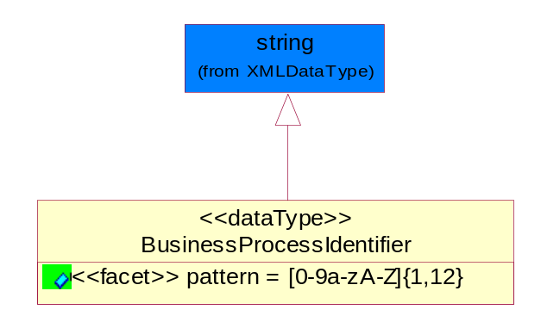
Figure ‎5-57 BusinessProcessIdentifier

Attribute | Type | Documentation
pattern |  | [0-9a-zA-Z]{1,12}

BusinessServiceInformation
The object allows the specification of the business service utilized within the partner company. This may or may not be the same as the information sent by the RNIF.
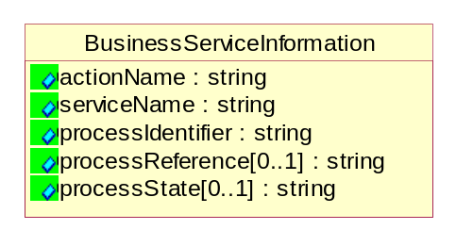
Figure ‎5-58 BusinessServiceInformation

Attribute | Type | Documentation
actionName | string | The name of Action. For RosettaNet usually any of Request/Confirm/Notify/Query/Response.
serviceName | string | The name of the Business Activity with the "Request/Confirm" part removed. E.g., for the Activity "Request Purchase Order"==> "Purchase Order".
processIdentifier | string | The name of the PIP e.g. Notify of Forecast Reply.
processReference[0..1] | string | The URN for the PIP that includes Cluster/Segment/Process pattern used to identify the interface process (such as PIP3A4)
processState[0..1] | string | The business process (or service) state of the sender of a document. When a service receives this document, the receiver may use the state as a precondition.

ContractInformation
A block of information used to correlate a contract in an executing choreography.
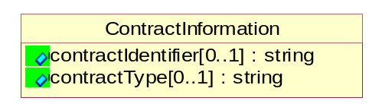
Figure ‎5-59 ContractInformation

Attribute | Type | Documentation
contractIdentifier[0..1] | string | Unique identification of a contract between the Sender and the Receiver
contractType[0..1] | string | The type of the contract: an attribute describing the type of the ContractIndentification. Valid values are URI, URN,ebXMLCPA, or other values defined by partners.

CorrelationInformation
A block of information used to correlate a requesting document to a responding document and to the contract in an executing choreography.
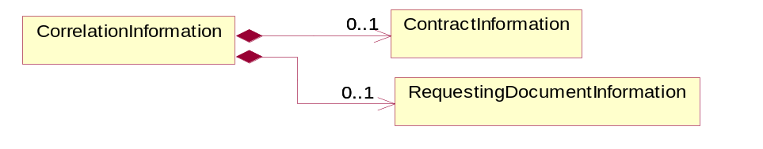
Figure ‎5-60 CorrelationInformation

Composition | Cardinality | Type | Documentation
ContractInformation | 0..1 | ContractInformation | A block of information used to correlate a contract in an executing choreography.
RequestingDocumentInformation | 0..1 | RequestingDocumentInformation | A block of information used to correlate a requesting document to a responding document in an executing choreography.

DocumentHeader
The object allows for the identification of the sender and receiver of the business document.
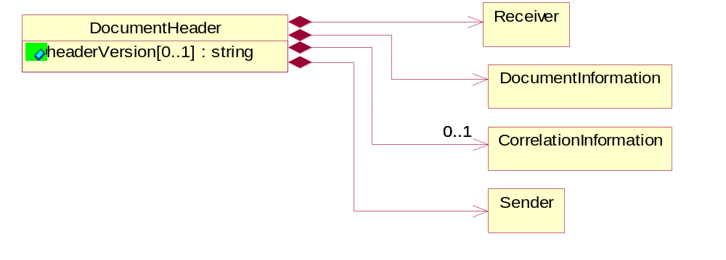
Figure ‎5-61 DocumentHeader

Attribute | Type | Documentation
headerVersion[0..1] | string | The UN/CEFACT version of the document header.

Composition | Cardinality | Type | Documentation
Sender | 1 | Sender | The object allows the identification of the initiating party of the business message.
CorrelationInformation | 0..1 | CorrelationInformation | A block of information used to correlate a requesting document to a responding document and to the contract in an executing choreography.
DocumentInformation | 1 | DocumentInformation | The object specifies information to identify the business document, a summary of attachments, and information about the business document security.
Receiver | 1 | Receiver | The object allows the identification of the receiving party of the business message.

DocumentIdentification
The object specifies all information necessary to identify the business document.
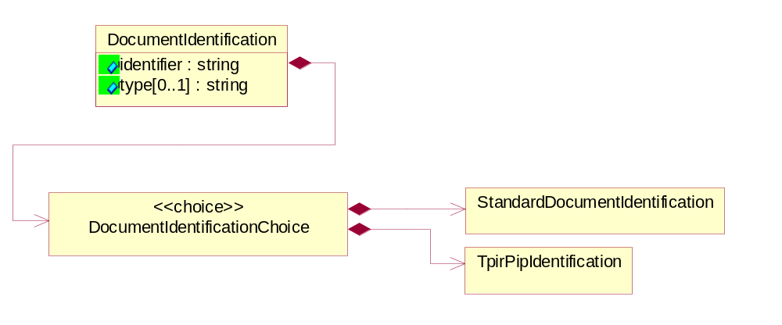
Figure ‎5-62 DocumentIdentification

Attribute | Type | Documentation
identifier | string | The unique identifier for the document being sent.
type[0..1] | string | Name of the Action Message

Composition | Cardinality | Type | Documentation
DocumentIdentificationChoice | 1 | DocumentIdentificationChoice

DocumentIdentificationChoice

Composition | Cardinality | Type | Documentation
StandardDocumentIdentification | 1 | StandardDocumentIdentification | The object specifies additional information necessary to identify the standard business document.
TpirPipIdentification | 1 | TpirPipIdentification | The object specifies all information necessary to uniquely identify a TPIR-PIP within a Registry or trading partner repository.

DocumentInformation
The object specifies information to identify the business document, a summary of attachments, and information about the business document security.
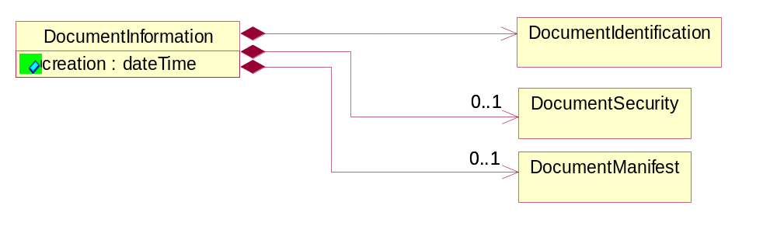
Figure ‎5-63 DocumentInformation

Attribute | Type | Documentation
creation | dateTime | The creation date and time of the specified Business Document (i.e. the Purchase Order date).

Composition | Cardinality | Type | Documentation
DocumentIdentification | 1 | DocumentIdentification | The object specifies all information necessary to identify the business document.
DocumentSecurity | 0..1 | DocumentSecurity | The object provides additional granularity in specifying business document security (this is in addition to the specified PIP security).
DocumentManifest | 0..1 | DocumentManifest | The block provides a brief summary of attachments and Service Content.

DocumentManifest
The block provides a brief summary of attachments and Service Content.
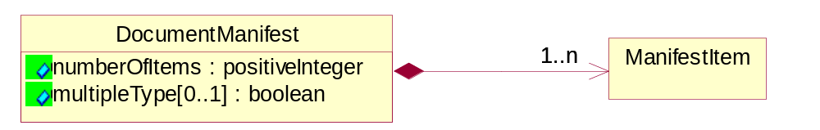
Figure ‎5-64 DocumentManifest

Attribute | Type | Documentation
numberOfItems | positiveInteger | Total number of documents in the message. The physical count of the attachments in the payload plus the RosettaNet Business Message (for Service Content). The value of this field will be at least 1.
multipleType[0..1] | boolean | Indicates whether the manifest contains documents of multiple types. True if yes, and False if no.

Composition | Cardinality | Type | Documentation
ManifestItem | 1..n | ManifestItem | The object provides details about the specific attachment(s).

DocumentSecurity
The object provides additional granularity in specifying business document security (this is in addition to the specified PIP security).

Figure ‎5-65 DocumentSecurity

Attribute | Type | Documentation
nonRepudiableReceipt | boolean | The value "true" will indicate that a signed acknowledgement for the business document is necessary.
persistentEncryption | boolean | The value "true" will indicate that the Business Document (including the header) needs to be encrypted when stored or transported.
persistentSignature | boolean | The value "true" will indicate that a signature is required to be stored with the document while stored or transported.

ManifestItem
The object provides details about the specific attachment(s).
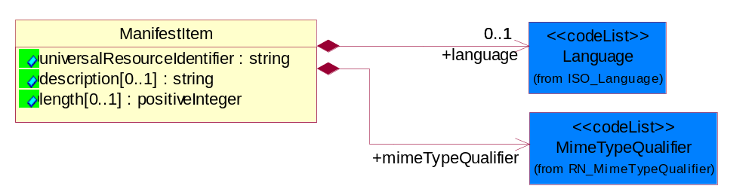
Figure ‎5-66 ManifestItem

Attribute | Type | Documentation
universalResourceIdentifier | string | The generic set of all names/addresses that are short strings that refer to resources.
description[0..1] | string | A description of the attachment.
length[0..1] | positiveInteger | The size of the attachment in bytes (i.e. 1 000 000 bytes)

Composition | Cardinality | Type | Documentation
mimeTypeQualifier | 1 | MimeTypeQualifier | The MIME type as defined by IANA.  Please refer to http://www.iana.org/assignments/media-types/ for a list of types.
language | 0..1 | Language | For representation of Language name RosettaNet has adopted ISO 639-2; 1998. Refer to the following web page to get the latest version of the standard:  http://www.loc.gov/standards/iso639-2/iso639jac.html  If you need more information about the ISO standard please contact ISO for more details.

PipIdentifier
PIP Identification.[ i.e. PIP3A4]
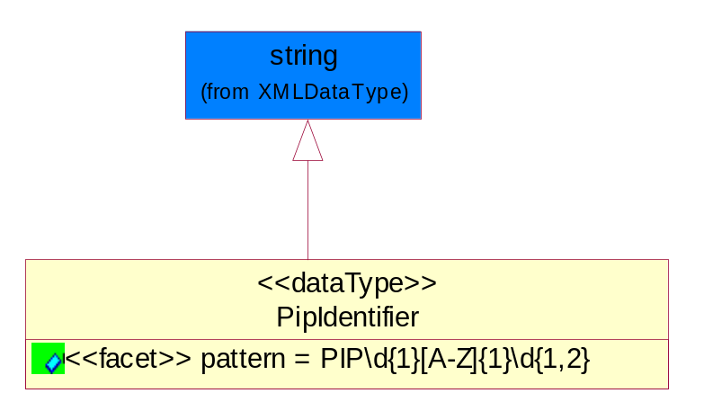
Figure ‎5-67 PipIdentifier

Attribute | Type | Documentation
pattern |  | PIP\d{1}[A-Z]{1}\d{1,2}

PipVersion
PIP version number (i.e. 02.02.00).
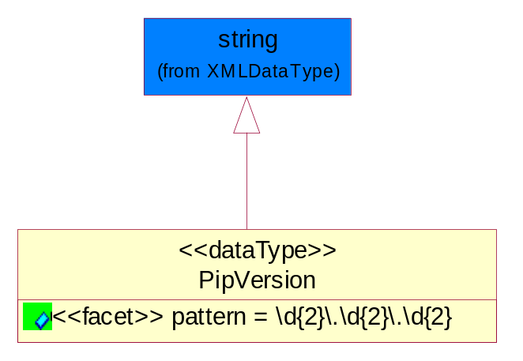
Figure ‎5-68 PipVersion

Attribute | Type | Documentation
pattern |  | \d{2}\.\d{2}\.\d{2}

Receiver
The object allows the identification of the receiving party of the business message.
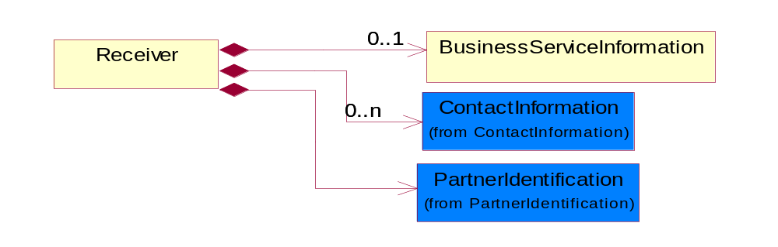
Figure ‎5-69 Receiver

Composition | Cardinality | Type | Documentation
BusinessServiceInformation | 0..1 | BusinessServiceInformation | The object allows the specification of the business service utilized within the partner company. This may or may not be the same as the information sent by the RNIF.
PartnerIdentification | 1 | PartnerIdentification | The business document must allow for the identity of one or more parties to the transaction.
ContactInformation | 0..n | ContactInformation | The business document must allow for the identification of the name of the department, service or individual to be contacted regarding the context of the business document.

RequestingDocumentInformation
A block of information used to correlate a requesting document to a responding document in an executing choreography.

Figure ‎5-70 RequestingDocumentInformation

Attribute | Type | Documentation
businessProcessInstanceIdentifier[0..1] | string | The identifier for the public business process instance being sent that both the sender and receiver can identify.
responseDateTime[0..1] | dateTime | The expected time to receive the response. This can not be greater than the PIP TimeToPerform.
requestingDocumentCreationDateTime[0..1] | dateTime | The date-time of the requesting business document.
requestingDocumentInstanceIdentifier | string | The Business Document identification number that identifies the requesting Business Document.

Sender
The object allows the identification of the initiating party of the business message.
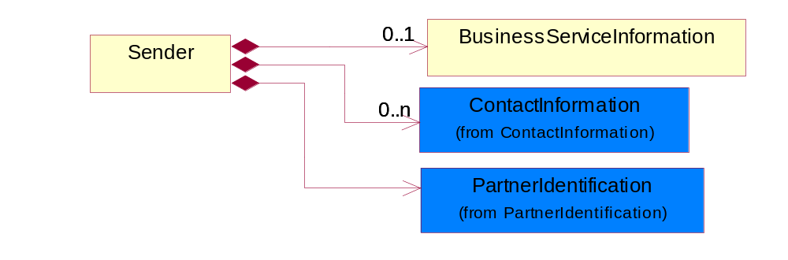
Figure ‎5-71 Sender

Composition | Cardinality | Type | Documentation
PartnerIdentification | 1 | PartnerIdentification | The business document must allow for the identity of one or more parties to the transaction.
BusinessServiceInformation | 0..1 | BusinessServiceInformation | The object allows the specification of the business service utilized within the partner company. This may or may not be the same as the information sent by the RNIF.
ContactInformation | 0..n | ContactInformation | The business document must allow for the identification of the name of the department, service or individual to be contacted regarding the context of the business document.

StandardDocumentIdentification
The object specifies additional information necessary to identify the standard business document.
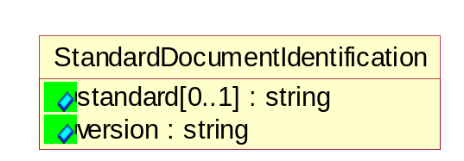
Figure ‎5-72 StandardDocumentIdentification

Attribute | Type | Documentation
standard[0..1] | string | Identifies the standard used to submit the business document. (e.g. RosettaNet).
version | string | PIP3A4v01.00

TpirPipIdentification
The object specifies all information necessary to uniquely identify a TPIR-PIP within a Registry or trading partner repository.

Figure ‎5-73 TpirPipIdentification

Attribute | Type | Documentation
partnerId | DUNSPlus4 | The Trading Partner Identification of MNC that is creating this TPIR PIP.
pipIdentifier | PipIdentifier | A TPIR PIP Identification [i.e., 3A4 ).
pipVersion | PipVersion | A TPIR PIP version number (i.e., 02.02.00)
tpirPipVersion | VersionIdentifier | A TPIR-PIP Version Number (i.e., major and minor version number as XX.XX).
tpirBusinessProcessIdentifier[0..1] | BusinessProcessIdentifier | A Business Process Identifier to uniquely define the TPIR-PIP 'role' within a Business Scenario at a company or MNC level. The identifier MUST be composed of alphanumeric characters only and its length MUST be between one and twelve characters.
uri[0..1] | anyURI | Describes the destination uri for the TPIR form.

Composition | Cardinality | Type | Documentation
fileType | 0..1 | TPIRFileType | Describes the file type of the TPIR form (PDF, XDP or XML).

VersionIdentifier
Version Number (i.e., major and minor version number as XX.XX).
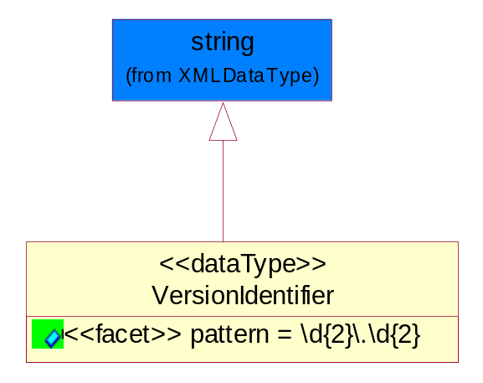
Figure ‎5-74 VersionIdentifier

Attribute | Type | Documentation
pattern |  | \d{2}\.\d{2}

CodeList

TPIRFileType
A code identifying the file type of TPIR form.

Name | Documentation
PDF | Portable Document Format.
XDP | XML Data Package.
XML | eXtensible Markup Language.

XML Data Type

anyURI
Represents a URI as defined by RFC 2396. An anyURI value can be absolute or relative, and may have an optional fragment identifier.

boolean
Represents Boolean values, which are either "true" or "false".

date
For the represents a calendar date.
The pattern for a date is CCYY-MM-DD where CC represents the century, YY the year, MM the month, and DD the day, with an optional time zone indicator as allowed for dateTime.

dateTime
Represents a specific instance of time.
The pattern for dateTime is CCYY-MM-DDThh:mm:ss where CC represents the century, YY the year, MM the month, and DD the day, preceded by an optional leading negative (-) character to indicate a negative number. If the negative character is omitted, positive (+) is assumed. The T is the date/time separator and hh, mm, and ss represent hour, minute, and second respectively. Additional digits can be used to increase the precision of fractional seconds if desired. For example, the format ss.ss... with any number of digits after the decimal point is supported. The fractional seconds part is optional.
This representation may be immediately followed by a "Z" to indicate Coordinated Universal Time (UTC) or to indicate the time zone. For example, the difference between the local time and Coordinated Universal Time, immediately followed by a sign, + or -, followed by the difference from UTC represented as hh:mm (minutes is required). If the time zone is included, both hours and minutes must be present.

decimal
A data type that contains decimal numbers scaled by a power of 10.

float
Represents single-precision 32-bit floating-point numbers.

gDay
Represents a Gregorian day that recurs, specifically a day of the month such as the fifth day of the month. A gDay is the space of a set of calendar dates. Specifically, it is a set of one-day long, monthly periodic instances.
The pattern for gDay is ---DD with optional time zone indicator as allowed for date.

positiveInteger
Represents an integer that is greater than zero. This data type is derived from nonNegativeInteger.

string
Represents character string.

