

Description of
Partner Interface Process® for 3C4

Validated 11.00.00

Specification Information
Name | Notify of Invoice Reject
Cluster | Order Management
Segment | Returns and Finance
Publication Date | 10 Apr 2006
Version Identifier | V11.00

Table of Contents
1 Document Management 4
1.1 Legal Disclaimer 4
1.2 Copyright 4
1.3 Trademarks 4
1.4 Acknowledgments 4
1.5 Related Documents 4
1.6 Document Version History 5
1.7 Document Structure 5
2 Business Process 6
2.1 Business Process Definition 6
2.1.1 Business Process Description 6
2.2 PIP Business Documents 6
2.3 PIP Business Process Flow Diagram 7
2.4 PIP Start State 8
2.5 PIP End States 8
2.6 Partner Role Descriptions 9
2.7 Business Process Activity Controls 9
3 Network and Implementation Specification 10
3.1 Business Action and Business Signal Specification 10
3.2 Business Transaction Dialog Specification 10
3.2.1 Message Exchange Controls 11
3.2.2 Communications Specification 11

List of Figures:
Figure 1: Activity Diagram of Notify of Invoice Reject 7
Figure 2: Sequence Diagram of Notify of Invoice Reject 10

List of Tables:
Table 1: PIP Business Documents 6
Table 2: PIP Start State 8
Table 3: PIP End State 8
Table 4: PIP Failure State 8
Table 5: Partner Role Descriptions 9
Table 6: Business Activity Descriptions 9
Table 7: Business Activity Performance Controls 9
Table 8: Network Component Specification 10
Table 9: Business Action – Business Document Mapping 10
Table 10: Message Exchange Controls 11
Table 11: Dialog: Service-Service 11

Document Management

Legal Disclaimer
RosettaNet™, its members, officers, directors, employees, or agents shall not be liable for any injury, loss, damages, financial or otherwise, arising from, related to, or caused by the use of this document or the specifications herein, as well as associated guidelines and schemas. The use of said specifications shall constitute your express consent to the foregoing exculpation.

Copyright
©2006 RosettaNet. All rights reserved. No part of this publication may be reproduced, stored in a retrieval system, or transmitted, in any form or by any means, electronic, mechanical, photocopying, recording, or otherwise, without the prior written permission of the publisher. Printed in the United States of America.

Trademarks
RosettaNet, Partner Interface Process, PIP and the RosettaNet logo are trademarks or registered trademarks of "RosettaNet," a non-profit organization. All other product names and company logos mentioned herein are the trademarks of their respective owners. In the best effort, all terms mentioned in this document that are known to be trademarks or registered trademarks have been appropriately recognized in the first occurrence of the term.

Acknowledgments
This document has been prepared by RosettaNet (http://www.rosettanet.org/) from requirements gathered during the Milestone Program and in conformance with the methodology.

Related Documents
- Associated PIP Message Schemas (included within the PIP Specification package only)
- Description of 3C4 Message
- Message Structure
- XML instance of ebXML BPSS for PIP 3C4

Document Version History
Version | Date | Description
Version 11.00.00 | 10 Apr 2006 | Validated version

Document Structure
A Partner Interface Process (PIP) Specification is comprised of the following two parts:
- Business Process. Captures the semantics of the business process and the flow of the message exchange between roles as they perform business activities.
- Network and Implementation Specification. Specifies the network protocol message formats and communications requirements between peer-protocols supported by network components in the RosettaNet Implementation Framework.

Business Process

Business Process Definition
The “Notify of Invoice Reject” Partner Interface Process (PIP) supports a process by which payees issue financial statements to payors; payors determine which payables to pay, optionally using the financial statement notification, and generate remittance advice notifications, which go to their banks; payors' banks make payments to payees' banks, who send payments to payees; payees process payments and use the remittance advice notification to reconcile payments or issue payment discrepancy notifications in the event payments are not as expected; if payment discrepancy notifications are generated, payors process payment discrepancy notifications and determine whether to reissue payments by remittance advice notifications

Business Process Description
The "Notify of Invoice Reject" Partner Interface Process™ (PIP) enables a party, such as a buyer or financing processor, to inform another party, such as a seller, that an invoice has been rejected. A financing processor is an organization that helps a seller obtain financing by serving as an intermediary between the seller and financiers.
This PIP may be executed after (1) a provider has issued an invoice with PIP3C3, “Notify of Invoice”, and (2) the invoice has been audited by the recipient’s internal systems and determined to be invalid.
This PIP enables a party to inform another party that an invoice has been rejected.
Should this transaction not complete successfully, the requesting partner executes PIP0A1, "Notification of Failure."

PIP Business Documents
Business Documents are generated and exchanged by roles performing activities in this PIP. Business Documents are listed and defined in Table 1.
Table 1: PIP Business Documents
Business Document | Description
Invoice Reject Notification | Rejects a previously received invoice. The reasons for rejection are indicated.

PIP Business Process Flow Diagram
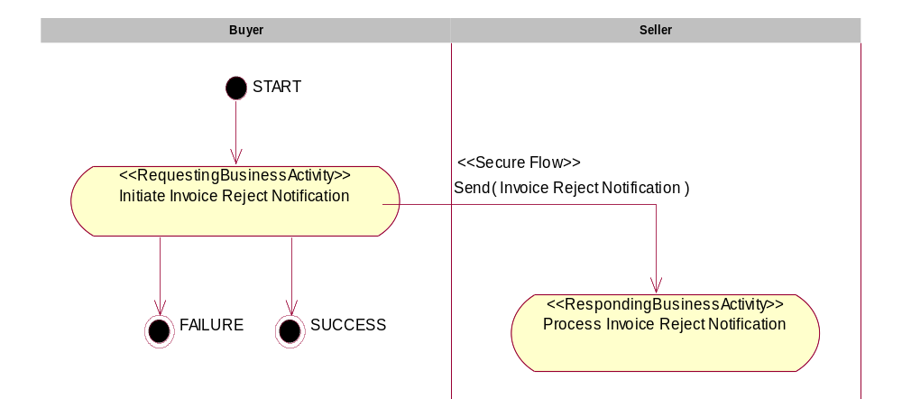
Figure 1: Activity Diagram of Notify of Invoice Reject

PIP Start State
The start state is comprised of the following condition(s):
Table 2: PIP Start State
 | Approved | Exist |  | Valid | Non-Repudiated | Retry Count | Authorized
 | Approved | Party | In Backend system
TPA |  |  | 
Sending Partner |  |  |  | 
Receiving Partner |  | 
Business Document |  |  |  |  |  |  | 

PIP End States
The end state is comprised of the following condition(s):
Table 3: PIP End State
 | Approved | Exist |  | Valid | Non-Repudiated | Retry Count | Authorized
 | Approved | Party | In Backend system
Acknowledgment of Receipt |  |  |  |  | 
Receiving Partner |  |  |  |  |  |  | 

The PIP failure state is comprised of one or more of the following condition(s):

Table 4: PIP Failure State
 | NO | Exceeded
Success | 
Retry Count |  | 

Partner Role Descriptions
Table 5 describes the partner roles in this PIP.
Table 5: Partner Role Descriptions
Role Name | Role Description
Buyer | The organization that rejects an invoice.
Seller | The organization being issued an Invoice Reject Notification.

Business Process Activity Controls
Table 6 describes the interaction between roles performing business activities in this PIP.
Table 6: Business Activity Descriptions
Role  Name | Activity Name | Activity Description
Buyer | Initiate Invoice Reject Notification | A Buyer issues an Invoice Reject Notification to a Seller.

Table 7 details the security, audit and process controls relating to activities performed in the PIP.
Table 7: Business Activity Performance Controls
Role  Name | Activity  Name | Acknowledgment  of Receipt |  | Time to Perform | Retry Count | Is Authorization Required? | Non-Repudiation of Origin and Content?
Role  Name | Activity  Name | Non-Repudiation Required? | Time to Acknowledge
Buyer | Initiate Invoice Reject Notification | Y | 2 hrs | N/A | 3 | N | Y

Network and Implementation Specification
Each network component maps into a role of the PIP model. Table 8 specifies the mapping between roles and network components.
Table 8: Network Component Specification
Network Component | Classification | Maps to Role in Business Process
Buyer Service | Business Service | Buyer
Seller Service | Business Service | Seller

Business Action and Business Signal Specification
Each business action maps to a Business Document of the PIP model. Table 9 specifies the mapping between Business Documents and business actions.
Table 9: Business Action – Business Document Mapping
Business Action | Business Document | Document Function
Invoice Reject Notification Action | Invoice Reject Notification | Request

Business Transaction Dialog Specification
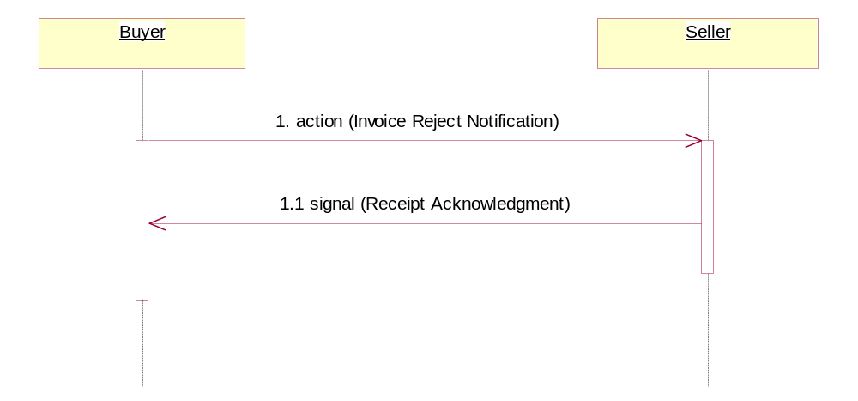
Figure 2: Sequence Diagram of Notify of Invoice Reject

Message Exchange Controls
Table 10: Message Exchange Controls
# | Name |  | Time to Acknowledge |  | Time to Respond to Action |  | Included in Time to Perform |  | Is Authorization Required? |  | Is Non-Repudiation Required? |  | Is Secure Transport Required?
1. |  | Invoice Reject Notification Action |  | 2 hrs |  | N/A |  | N/A |  | N |  | Y |  | Y
1.1. |  | Receipt Acknowledgment |  | N/A |  | N/A |  | N/A |  | N |  | Y |  | Y

Communications Specification
Table 11: Dialog: Service-Service
# | Business Message | Digital Signature Required? | SSL Required?
1. | Invoice Reject Notification | Y | Y
1.1. | Receipt Acknowledgment | Y | Y

