

Description of 3C6 Message

PIP® 3C6
Validated 11.01.00

Specification Information
Name | Description Of 3C6 Message
PIP | Notify Of Remittance Advice
Cluster | Order Management
Segment | Returns And Finance
Publication Date | 05 November 2007
Version Identifier | V11.01

Table of Content

1. Document Management 6
1.1 Legal Disclaimer 6
1.2 Copyright 6
1.3 Trademarks 6
1.4 Acknowledgments 6
1.5 Related Documents 7
1.6 Document Version History 7
1.7 Document Purpose 7
2. Interchange Model 8
2.1 RemittanceAdviceNotification 8
2.1.1 Interchange Diagram 8
2.1.2 Dependency Diagram 9
2.1.3 PaymentOrder 9
2.1.4 RemittanceAdvice 10
2.1.5 RemittanceAdviceNotification 11
2.1.6 RemittanceLineItem 11
3. Domain Model 13
3.1 Procurement 13
3.1.1 Procurement 13
3.1.1.1 Dependency Diagram 13
3.1.1.2 AccountDescription 13
3.1.1.3 CreditCard 14
3.1.2 CodeList 15
3.1.2.1 CreditCardClassification 15
3.1.2.2 AccountClassification 15
3.1.2.3 FinancialAdjustmentReason 15
3.2 Shared 16
3.2.1 Shared 16
3.2.1.1 Dependency Diagram 16
3.2.1.2 MonetaryAmount 16
3.2.2 CodeList 17
3.2.2.1 InvoiceChargeType 17
3.2.2.2 MonetaryAmountType 17
3.2.2.3 PaymentMethod 17
3.2.2.4 AmountType 20
4. Universal Structure 21
4.1 ContactInformation 21
4.1.1 ContactInformation 21
4.2 DataType 22
4.2.1 Contact 22
4.2.2 DUNS 22
4.2.3 DUNSPlus4 23
4.2.4 GLN 23
4.3 Document 24
4.3.1 BusinessDocumentReference 24
4.4 Locations 24
4.4.1 AlternativeIdentifier 24
4.4.2 Location 25
4.4.3 LocationChoice 25
4.4.4 PhysicalAddress 26
4.5 MonetaryExpression 27
4.5.1 FinancialAmount 27
4.6 PartnerIdentification 28
4.6.1 FullPartner 28
4.6.2 IntermittentPartner 28
4.6.3 KnownPartner 29
4.6.4 KnownPartnerContact 29
4.6.5 NewPartner 30
4.6.6 PartnerDescription 30
4.6.7 PartnerDescriptionChoice 31
4.6.8 PartnerIdentification 32
4.6.9 PartnerIdentificationChoice 32
4.6.10 SpecifiedFullPartner 33
4.6.11 SpecifiedIntermittentPartner 34
4.6.12 SpecifiedKnownPartner 34
4.6.13 SpecifiedNewPartner 35
4.7 CodeList 36
4.7.1 Country 36
4.7.2 CountrySubdivision 36
4.7.3 Currency 36
4.7.4 Language 36
4.7.5 DocumentType 36
4.7.6 MimeTypeQualifier 38
4.7.7 ProcessRoleIdentifier 49
5. System Structure 52
5.1 BusinessProcessIdentifier 52
5.2 BusinessServiceInformation 52
5.3 ContractInformation 53
5.4 CorrelationInformation 53
5.5 DocumentHeader 54
5.6 DocumentIdentification 55
5.7 DocumentIdentificationChoice 55
5.8 DocumentInformation 56
5.9 DocumentManifest 56
5.10 DocumentSecurity 57
5.11 ManifestItem 57
5.12 PipIdentifier 58
5.13 PipVersion 59
5.14 Receiver 59
5.15 RequestingDocumentInformation 60
5.16 Sender 60
5.17 StandardDocumentIdentification 61
5.18 TpirPipIdentification 61
5.19 VersionIdentifier 62
5.20 CodeList 62
5.20.1 TPIRFileType 62
6. XML Data Type 63
6.1 anyURI 63
6.2 boolean 63
6.3 date 63
6.4 dateTime 63
6.5 float 63
6.6 positiveInteger 63
6.7 string 63

Table of Figures

Figure ‎2-1 Interchange 8
Figure ‎2-2 Dependency 9
Figure ‎2-3 PaymentOrder 9
Figure ‎2-4 RemittanceAdvice 10
Figure ‎2-5 RemittanceAdviceNotification 11
Figure ‎2-6 RemittanceLineItem 11
Figure ‎3-1 Dependency 13
Figure ‎3-2 AccountDescription 13
Figure ‎3-3 CreditCard 14
Figure ‎3-4 Dependency 16
Figure ‎3-5 MonetaryAmount 16
Figure ‎4-1 ContactInformation 21
Figure ‎4-2 Contact 22
Figure ‎4-3 DUNS 22
Figure ‎4-4 DUNSPlus4 23
Figure ‎4-5 GLN 23
Figure ‎4-6 BusinessDocumentReference 24
Figure ‎4-7 AlternativeIdentifier 24
Figure ‎4-8 Location 25
Figure ‎4-9 PhysicalAddress 26
Figure ‎4-10 FinancialAmount 27
Figure ‎4-11 FullPartner 28
Figure ‎4-12 IntermittentPartner 28
Figure ‎4-13 KnownPartner 29
Figure ‎4-14 KnownPartnerContact 29
Figure ‎4-15 NewPartner 30
Figure ‎4-16 PartnerDescription 30
Figure ‎4-17 PartnerIdentification 32
Figure ‎4-18 SpecifiedFullPartner 33
Figure ‎4-19 SpecifiedIntermittentPartner 34
Figure ‎4-20 SpecifiedKnownPartner 34
Figure ‎4-21 SpecifiedNewPartner 35
Figure ‎5-1 BusinessProcessIdentifier 52
Figure ‎5-2 BusinessServiceInformation 52
Figure ‎5-3 ContractInformation 53
Figure ‎5-4 CorrelationInformation 53
Figure ‎5-5 DocumentHeader 54
Figure ‎5-6 DocumentIdentification 55
Figure ‎5-7 DocumentInformation 56
Figure ‎5-8 DocumentManifest 56
Figure ‎5-9 DocumentSecurity 57
Figure ‎5-10 ManifestItem 57
Figure ‎5-11 PipIdentifier 58
Figure ‎5-12 PipVersion 59
Figure ‎5-13 Receiver 59
Figure ‎5-14 RequestingDocumentInformation 60
Figure ‎5-15 Sender 60
Figure ‎5-16 StandardDocumentIdentification 61
Figure ‎5-17 TpirPipIdentification 61
Figure ‎5-18 VersionIdentifier 62

Document Management

Legal Disclaimer
RosettaNet, its members, officers, directors, employees, or agents shall not be liable for any injury, loss, damages, financial or otherwise, arising from, related to, or caused by the use of this document or the specifications herein, as well as associated guidelines and schemas. The use of said specifications shall constitute your express consent to the foregoing exculpation.

Copyright
©2007 RosettaNet. All rights reserved. No part of this publication may be reproduced, stored in a retrieval system, or transmitted, in any form or by any means, electronic, mechanical, photocopying, recording, or otherwise, without the inclusion of this copyright notice. Any derivative works must cite the copyright notice. Any public redistribution or sale of this publication or derivative works requires prior written permission of the publisher.

Trademarks
RosettaNet, Partner Interface Process, PIP and the RosettaNet logo are trademarks or registered trademarks of "RosettaNet," a non-profit organization. All other product names and company logos mentioned herein are the trademarks of their respective owners. In the best effort, all terms mentioned in this document that are known to be trademarks or registered trademarks have been appropriately recognized in the first occurrence of the term.

Acknowledgments
This document has been prepared by RosettaNet (http://www.rosettanet.org/) from requirements gathered during the Milestone Program and in conformance with the methodology. Listed below are the legal entities that contributed to the design and development of this PIP.
Amkor Technology, Inc. | Avnet Applied Computing
EDIFICE | Intel Corporation
Intel Corporations | MIMOS Berhad
Motorola | Motorola Europe
Motorola Semiconductor Products Sector | Motorola SPS
National Semiconductor GMBH | Nokia Oyj
Philips Semiconductors | Sterling Commerce
STMicroelectronics | Texas Instruments
Texas Instruments (Global) | Texas Instruments Limited

Related Documents
- Associated PIP Message Schemas (included with PIP Specification only)
- Description of Partner Interface Process for 3C6
- Message Structure

Document Version History
Version | Date | Description
Validated 11.00.00 | 19 July 2006 | Validated Version
Validated 11.01.00 | 5 November 2007 | Validated Version for Schema to Market 2007

Document Purpose
The purpose of the document is to explain the structure, the association between objects, the content of objects and the definition for single elements to a non-technical audience.

Interchange Model

RemittanceAdviceNotification

Interchange Diagram
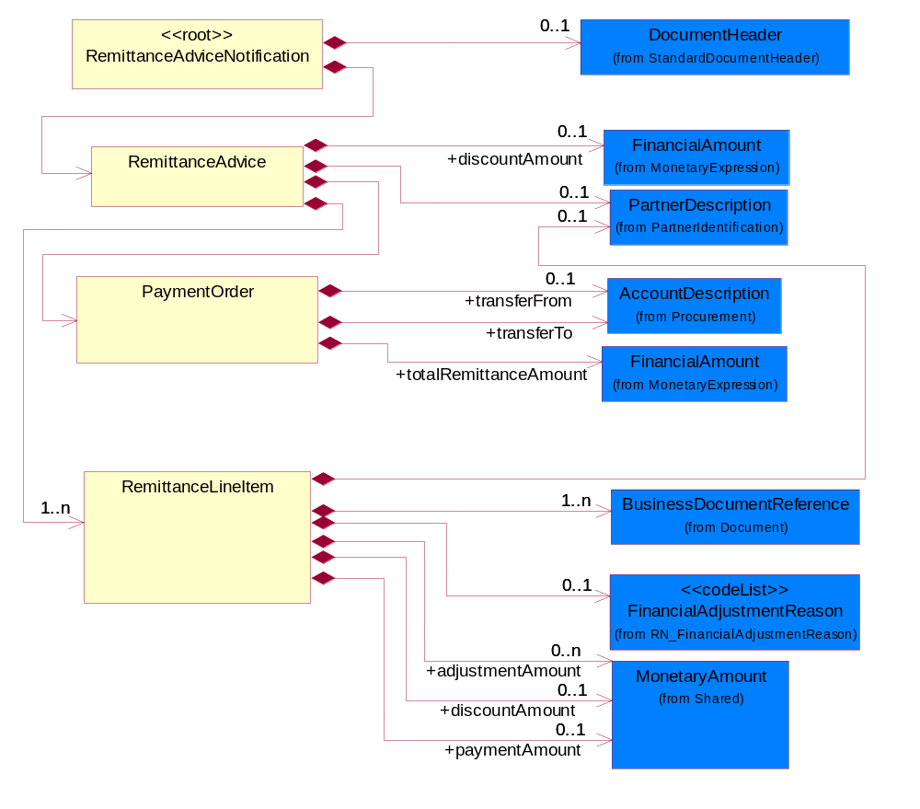
Figure ‎2-1 Interchange

Dependency Diagram
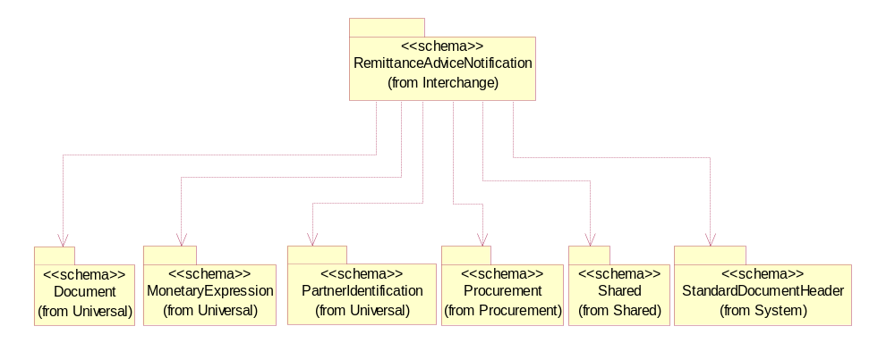
Figure ‎2-2 Dependency

PaymentOrder
The collection of business properties that describe a payment order.
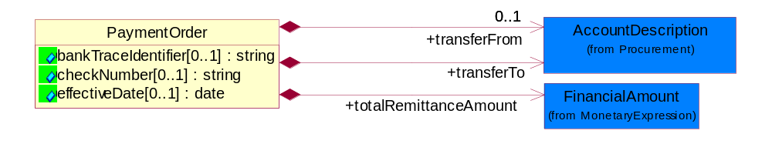
Figure ‎2-3 PaymentOrder

Attribute | Type | Documentation
bankTraceIdentifier[0..1] | string | The unique number assigned by a bank for auditing purposes.
checkNumber[0..1] | string | The identifier of a bank cheque.
effectiveDate[0..1] | date | The date information or an activity becomes effective.

Composition | Cardinality | Type | Documentation
totalRemittanceAmount | 1 | FinancialAmount | The total amount of an remittance advice.
transferFrom | 0..1 | AccountDescription | The partner from which the payment is transferred.
transferTo | 1 | AccountDescription | The partner to which the payment is transferred.

RemittanceAdvice
The collection of business properties that describe the Remittance Advice.

The recommended code used for ProcessRoleIdentifier in PartnerDescription is BIT - BillTo.
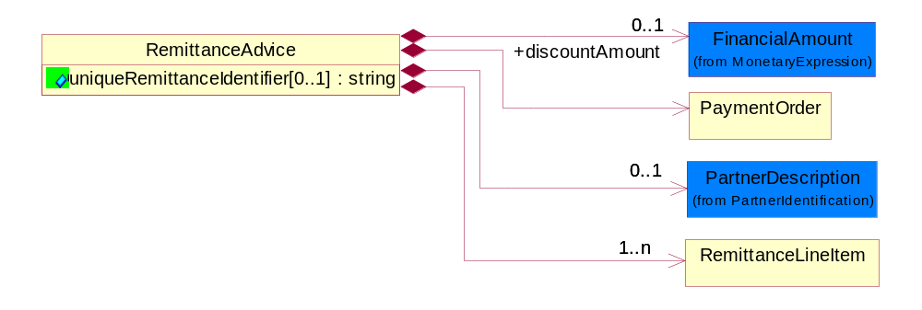
Figure ‎2-4 RemittanceAdvice

Attribute | Type | Documentation
uniqueRemittanceIdentifier[0..1] | string | A unique identifier for reassociation of a Credit Advice and/or Bank Statement to a Remittance Advice.The representation is defined as 9(9)X(9) where 9(9) is the DUNS number specified by Rosettanet and X(9) is alpha capital numeric.

Composition | Cardinality | Type | Documentation
discountAmount | 0..1 | FinancialAmount | The financial amount representing a reduction to the total amount due.
PaymentOrder | 1 | PaymentOrder | The collection of business properties that describe a payment order.
RemittanceLineItem | 1..n | RemittanceLineItem | The collection of business properties that describe a remittance advice entry.  The recommended code used for ProcessRoleIdentifier in PartnerDescription is PUR - Purchased By.
PartnerDescription | 0..1 | PartnerDescription | The collection of business properties that describe a business partners' identity, their contact information, where they are physically located and their function in a supply chain.

RemittanceAdviceNotification
A message wrapper for the PIP3C6.
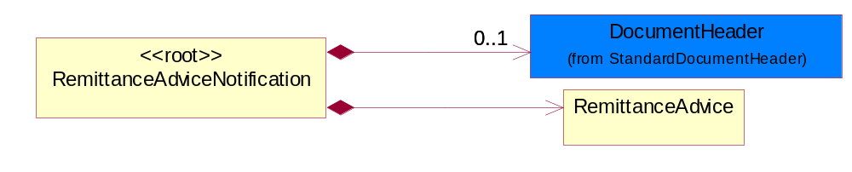
Figure ‎2-5 RemittanceAdviceNotification

Composition | Cardinality | Type | Documentation
DocumentHeader | 0..1 | DocumentHeader | The object allows for the identification of the sender and receiver of the business document.
RemittanceAdvice | 1 | RemittanceAdvice | The collection of business properties that describe the Remittance Advice.  The recommended code used for ProcessRoleIdentifier in PartnerDescription is BIT - BillTo.

RemittanceLineItem
The collection of business properties that describe a remittance advice entry.

The recommended code used for ProcessRoleIdentifier in PartnerDescription is PUR - Purchased By.
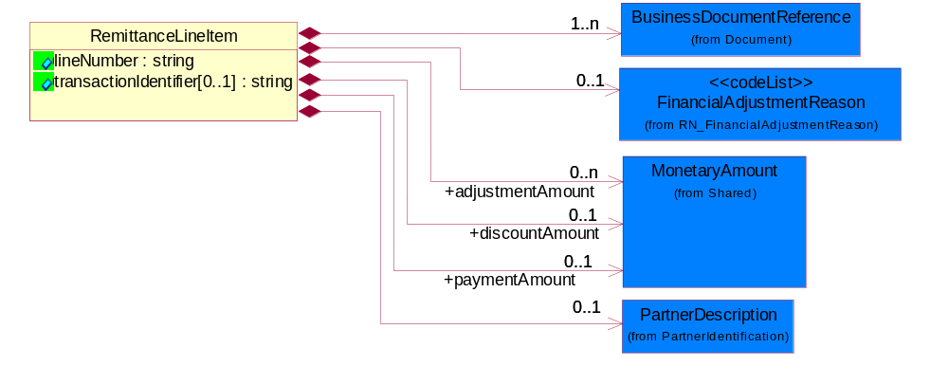
Figure ‎2-6 RemittanceLineItem

Attribute | Type | Documentation
lineNumber | string | Number of the line in the document.
transactionIdentifier[0..1] | string | A unique identification number tied to a specific transaction.

Composition | Cardinality | Type | Documentation
BusinessDocumentReference | 1..n | BusinessDocumentReference | The business document reference object allows for the indirect referencing of a relationship to other business related documents.
FinancialAdjustmentReason | 0..1 | FinancialAdjustmentReason | Code identifying the reason for adjustments to a monetary amount due for payment.
discountAmount | 0..1 | MonetaryAmount | The financial amount representing a reduction to the total amount due.
adjustmentAmount | 0..n | MonetaryAmount | The financial amount representing an increase or decrease to the total amount.
paymentAmount | 0..1 | MonetaryAmount | The financial amount representing what was paid.
PartnerDescription | 0..1 | PartnerDescription | The collection of business properties that describe a business partners' identity, their contact information, where they are physically located and their function in a supply chain.

Domain Model

Procurement

Procurement

Dependency Diagram
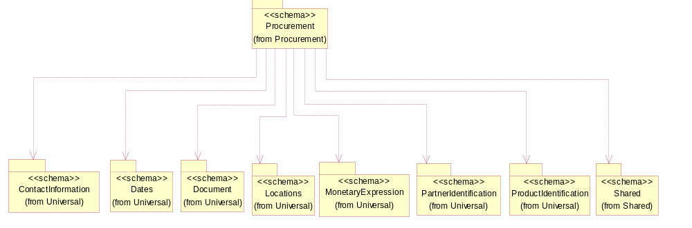
Figure ‎3-7 Dependency

AccountDescription
The collection of business properties that describe a customer or supplier account.
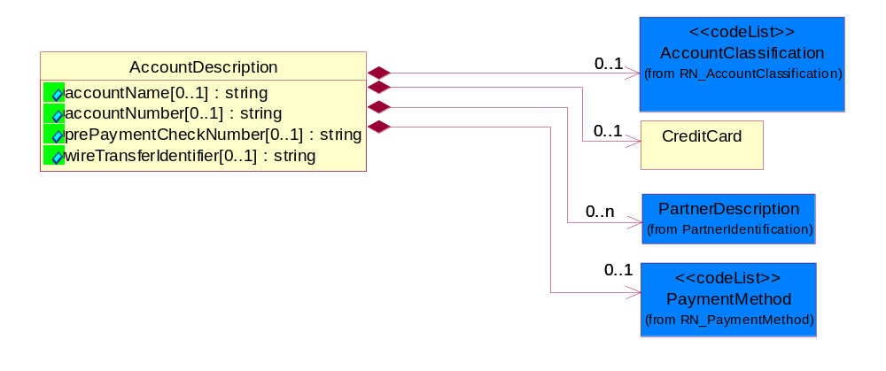
Figure ‎3-8 AccountDescription

Attribute | Type | Documentation
accountName[0..1] | string | The name of a bank account.
accountNumber[0..1] | string | Identification number of an account.
prePaymentCheckNumber[0..1] | string | The check number issued to prepay a monetary amount for an account.
wireTransferIdentifier[0..1] | string | A unique identity of a wire transfer used for reference.

Composition | Cardinality | Type | Documentation
AccountClassification | 0..1 | AccountClassification | Account classification indicating its functionality, e.g., credit card account, debit card account.
CreditCard | 0..1 | CreditCard | A collection of business properties that describe information about a credit card.
PartnerDescription | 0..n | PartnerDescription | The collection of business properties that describe a business partners' identity, their contact information, where they are physically located and their function in a supply chain.
PaymentMethod | 0..1 | PaymentMethod | Code identifying how the trading partner paid the seller for the product.

CreditCard
A collection of business properties that describe information about a credit card.
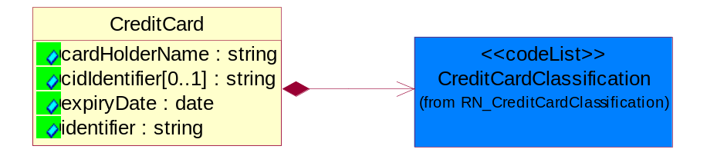
Figure ‎3-9 CreditCard

Attribute | Type | Documentation
cardHolderName | string | The name of the owner of a credit card.
cidIdentifier[0..1] | string | Unique identifier for credit card purchase activity utilized by American Express.
expiryDate | date | The date that a contractual agreement expires.
identifier | string | The unique number that identifies a credit card.

Composition | Cardinality | Type | Documentation
CreditCardClassification | 1 | CreditCardClassification | Code identifying the type of credit card used.

CodeList

CreditCardClassification
Code identifying the type of credit card used.

Name | Documentation
AMX | American express.
DIS | Discover.
EUC | EuroCard.
JCU | Japanese Credit Union.
MAC | Master card.
PRO | Procurement.
VIS | Visa.

AccountClassification
Account classification indicating its functionality, e.g., credit card account, debit card account.

Name | Documentation
CHK | Checking.
CRC | Credit Card.
SAV | Savings.

FinancialAdjustmentReason
Code identifying the reason for adjustments to a monetary amount due for payment.

Name | Documentation
CBB | Cancelled by Buyer.
FRE | Freight.
IPI | Incorrect Part Identifier.
IPO | Invalid Purchase Order number.
IPR | Incorrect pricing.
IQU | Incorrect quantity.
PPA | Partial payment - Payments that are made not fulfilling the total.
RMA | Returned Material.
SAD | Ship and Debit.
SNR | Shipment Not Received.
TAX | Tax.

Shared

Shared

Dependency Diagram
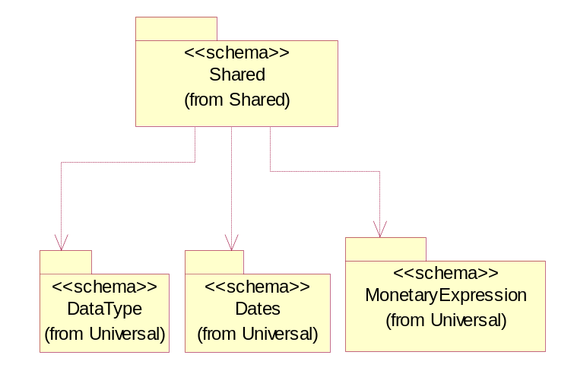
Figure ‎3-10 Dependency

MonetaryAmount
The collection of business properties that describe the monetary amount defined by a specified currency.
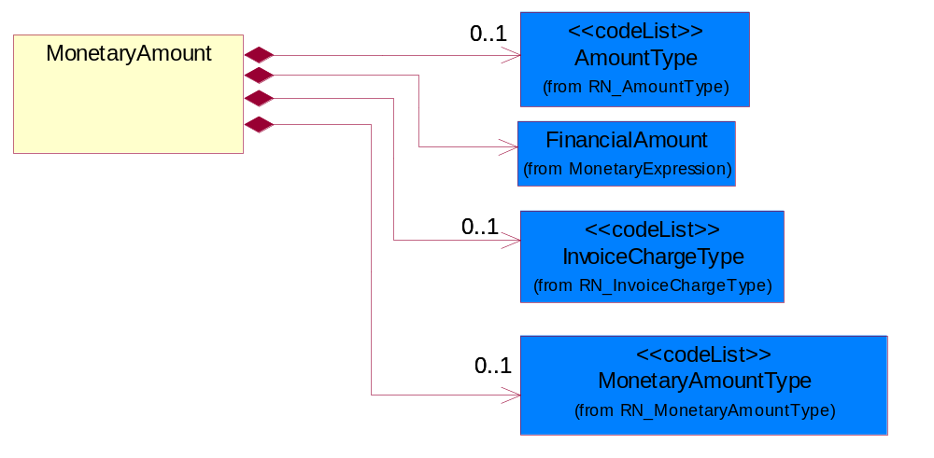
Figure ‎3-11 MonetaryAmount

Composition | Cardinality | Type | Documentation
FinancialAmount | 1 | FinancialAmount | The business document must express financial amounts.
InvoiceChargeType | 0..1 | InvoiceChargeType | Code identifying the values for the types of charges contained in an invoice.
MonetaryAmountType | 0..1 | MonetaryAmountType | Code identifying whether the monetary amount is a debit or credit.
AmountType | 0..1 | AmountType | Code identifying the type of monetary amount.

CodeList

InvoiceChargeType
Code identifying the values for the types of charges contained in an invoice.
Name | Documentation
ALC | Allowances and Charges.
CUC | Custom Charges.
DEA | Deposit Amount.
ESC | Expedited Shipping Charge - Charge for accelerating the delivery of a product.
FRC | Freight Charges.
HAC | Handling Charges.
LEC | Lease Charge - Charge for the use of a product in which the purchaser assumes certain responsibilities of ownership.
LIC | License Charge - Charge for the use of a product (usually software) in which the manufacturer maintains ownership of the product.
MAC | Maintenance Charge - Charge (usually periodic) for providing maintenance support for a product.
PUC | Purchase Charge - Charge for a product in which the buyer takes all responsibilities of ownership.
QUD | Quantity Discount.
REC | Rental Charge - Charge for the use of a product (usually hardware) in which the manufacturer maintains ownership of the product.

MonetaryAmountType
Code identifying whether the monetary amount is a debit or credit.
Name | Documentation
CRE | Credit.
DEB | Debit.
ZER | Zero remit.

PaymentMethod
Code identifying how the trading partner paid the seller for the product.
Name | Documentation
ACH | Automated Clearing House (ACH).
ACR | ACH Reversal.
BAD | Batched Delivery.
BIA | Billing Account.
BND | Bank Draft.
BOE | Book Entry.
CAC | Cashier's Check.
CAS | Cash.
CBB | Compensation by Balance.
CCP | ACH Savings Cash Concentration/Disbursement Plus (CCD+) Credit.
CCR | CCD+(NACHA Cash Concentration/Disbursement - Funds Transacted Plus an 80 Record Remittance Detail).
CCW | CCD (NACHA Cash Concentration/Disbursement - Funds Transacted without Remittance Information).
CDA | Credit/Debit Account.
CDD | Pre-Arranged Payment or Deposit (PPD) Credit to a Demand Deposit Account.
CDP | ACH Savings Cash Concentration/Disbursement Plus (CCD+) Debit.
CDS | Pre-Arranged Payment or Deposit (PPD) Credit to Savings.
CHE | Check.
CHIPS | Clearing House Interbank Payment System (CHIPS)Funds/Wire Transfer.
CLH | Clearinghouse.
CPC | Collect Payment by Company Check.
CPF | Collect Payment by Certified Funds.
CPP | Pre-Arranged Payment or Deposit Plus Addendum (PPD+) Credit to a Demand Deposit Account.
CRA | Credit Account.
CRC | Credit Card.
CRE | Credit.
CTC | ACH Savings Corporate Trade Exchange (CTX) Credit.
CTD | ACH Savings Corporate Trade Exchange (CTX) Debit.
CTP | CTP (NACHA Corporate Trade Payment - Transaction Plus Remittance Detail in Fixed Format).
CTX | CTX (NACHA Corporate Trade Exchange - Transaction Plus Remittance Detail in ANSI Standard Flexible Format).
CXC | ACH Demand Corporate Trade Exchange (CTX) Credit.
CXD | ACH Demand Corporate Trade Exchange (CTX) Debit.
DBT | Defined by TPA.
DCC | ACH Demand Cash Concentration/Disbursement (CCD) Credit.
DCD | ACH Demand Cash Concentration/Disbursement (CCD) Debit.
DCP | ACH Demand Cash Concentration/Disbursement Plus (CCD+) Credit.
DDA | Pre-Arranged Payment or Deposit (PPD) Debit to a Demand Deposit Account.
DDP | ACH Demand Cash Concentration/Disbursement Plus (CCD+) Debit.
DEB | Debit.
DEC | Debit Card.
DEM | Debit Memo.
DID | Direct Deposit.
DPP | Pre-Arranged Payment or Deposit Plus Addendum (PPD+) Debit to a Demand Deposit Account.
DRA | Draft.
DWO | Discount was Offered.
ECN | EDIBANX Clearing Network.
EFT | EFT.
EPS | Electronic Payment System.
EXC | 1035 Exchange.
FIN | Financed.
FIO | Financial Institution Option.
FPB | Freight Payment Bank.
FRN | Federal Reserve Funds/Wire Transfer - Nonrepetitive.
FRR | Federal Reserve Funds/Wire Transfer - Repetitive.
GRA | Graduated.
INS | Invoiced Separately.
JPO | Joint Purchase Option.
LAP | Lease Agreement is in Place.
LEV | Level (Sum Constant).
LOB | Lock Box.
LOC | Letter of Credit has been provided.
MOD | Money order.
MOO | Money Order.
MOR | Mail order.
NPD | Non-Payment Data.
NPR | No Payment is Required.
OTH | Other.
PAM | Payment has Already been Made.
PAN | Payment is Net.
PAS | Payment after shipment.
PBC | Payment is made by Check.
PBS | Payment before shipment.
PCC | Payment is pre-paid with Credit Card.
PCP | ACH Savings Cash Concentration/Disbursement (PPD+) Credit.
PDD | ACH Savings Cash Concentration/Disbursement (PDD) Debit.
PDP | ACH Savings Cash Concentration/Disbursement (PPD+) Debit.
PIK | Payment was made in Kind.
PME | Payment was Made Electronically.
PMI | Payment will be made the Month after the Invoice.
PMN | Promissory note.
PNA | Private Netting Agreement, Pay by Wire Transfer.
PPC | Payment is made by Pre-paid Check.
PPD | ACH Savings Cash Concentration/Disbursement (PPD) Credit.
PPW | Payment is Pre-paid by Wire.
PRC | Preauthorized Check (Draft).
PRN | Proprietary Network.
PVC | Previously Charged.
PVN | Private Netting, Pay by Check.
PWT | Payment is made via Wire Transfer.
PYN | Payment note.
RDA | Related Detail Account.
SCC | ACH Savings Cash Concentration/Disbursement (CCD) Credit.
SCD | ACH Savings Cash Concentration/Disbursement (CCD) Debit.
SPA | Special Account.
SUA | Summary Account.
SWIFT | Society for Worldwide Interbank Financial Telecommunications (S.W.I.F.T.).
TGT | Telegraphic transfer.
TOF | Transfer of Funds by the banking institution.
TRC | Traveler's Check.
VIS | VISA Special Electronic Funds Transfer Network.
WAI | Waived.
WIT | Wire Transfer.

AmountType
Code identifying the type of monetary amount.
Name | Documentation
DIS | Discount Value - The monetary amount of the discount on the price applied to a customer order.
FRE | Freight Charges - The monetary amount to be paid for freight transportation.
INS | InsuranceCharges - The monetary amount to be paid for freight insurance.
MAT | Material Cost - This object represents the material cost for the product.
MIS | Miscellaneous Charges - The monetary amount to be paid for miscellaneous charges.
PRC | Processing Charges - The monetary amount to be paid by consignee for consignment manufacturer.
TOD | Total Amount Due - Total amount due upon receipt of statement.
TOT | Total Amount - Total price for an entire business document.
TOV | Total Value Added Amount - The total amount of the shipment including any value added tax.
UNI | Unit Price - Agreed upon sale price for each unit ordered.
VAD | Value Added Unit Price - The price of a unit including any value added tax.

Universal Structure

ContactInformation

ContactInformation
The business document must allow for the identification of the name of the department, service or individual to be contacted regarding the context of the business document.
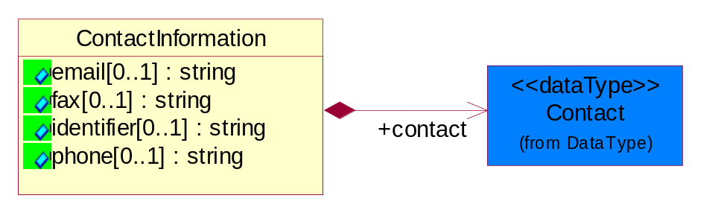
Figure ‎4-12 ContactInformation

Attribute | Type | Documentation
email[0..1] | string | The electronic mail for the specified contact.
fax[0..1] | string | The fax number for the specified contact.
identifier[0..1] | string | Identifies the role of the contact (i.e. Service Technician, Account Manager) in the Business Process.
phone[0..1] | string | The telephone number for the specified contact.

Composition | Cardinality | Type | Documentation
contact | 1 | Contact | The name of the department, service or individual to be contacted within the organization.

DataType

Contact
The name of the department, service or individual to be contacted within the organization.
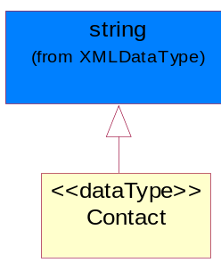
Figure ‎4-13 Contact

DUNS
A number assigned by Dun and Bradstreet to identify a business location.
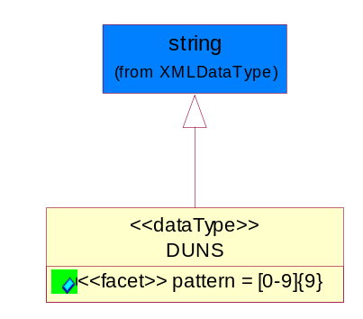
Figure ‎4-14 DUNS

Attribute | Type | Documentation
pattern |  | [0-9]{9}

DUNSPlus4
A identifier to specify a specific location within a business location.
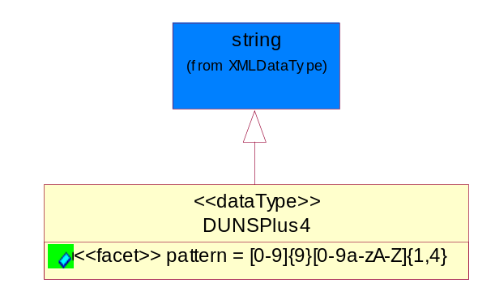
Figure ‎4-15 DUNSPlus4

Attribute | Type | Documentation
pattern |  | Data Universal Numbering System +4 (DUNS+4) number means the DUNS number assigned by Dun and Bradstreet, Inc. (D&B) plus an alphanumeric of length 4 suffix that may be assigned by a business concern.

GLN
Global Location Number (GLN) - A identifier to identify legal entities, trading parties and location.
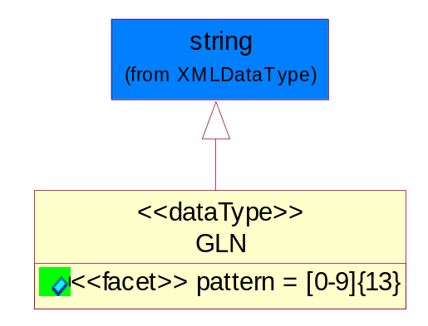
Figure ‎4-16 GLN

Attribute | Type | Documentation
pattern |  | [0-9]{13}

Document

BusinessDocumentReference
The business document reference object allows for the indirect referencing of a relationship to other business related documents.
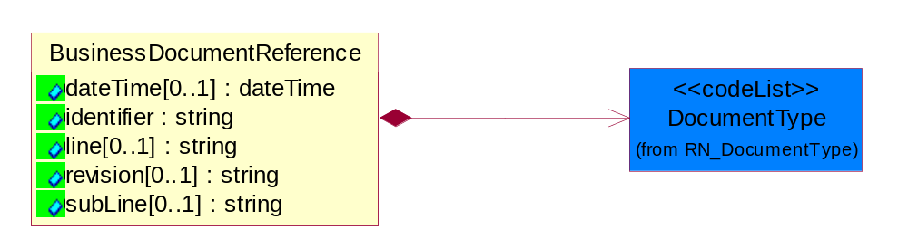
Figure ‎4-17 BusinessDocumentReference

Attribute | Type | Documentation
dateTime[0..1] | dateTime | The date-time stamp indicating on the referenced business document.
identifier | string | Unique identification of the referenced business document.
line[0..1] | string | References the specific line number of the specified business document.
revision[0..1] | string | Referenced the revision of the specified business document.
subLine[0..1] | string | References the specific subline number of the specified business document.

Composition | Cardinality | Type | Documentation
DocumentType | 1 | DocumentType | A code identifying the business context of a document.

Locations

AlternativeIdentifier
Identifies the specified code and the name of the organization that a code is utilized from.
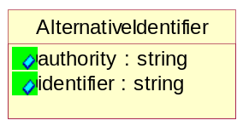
Figure ‎4-18 AlternativeIdentifier

Attribute | Type | Documentation
authority | string | The name of the organization that a code is utilized from.
identifier | string | The specified code to represent an entity (e.g. product, location, partner, etc.).

Location
The business document must specify a location.
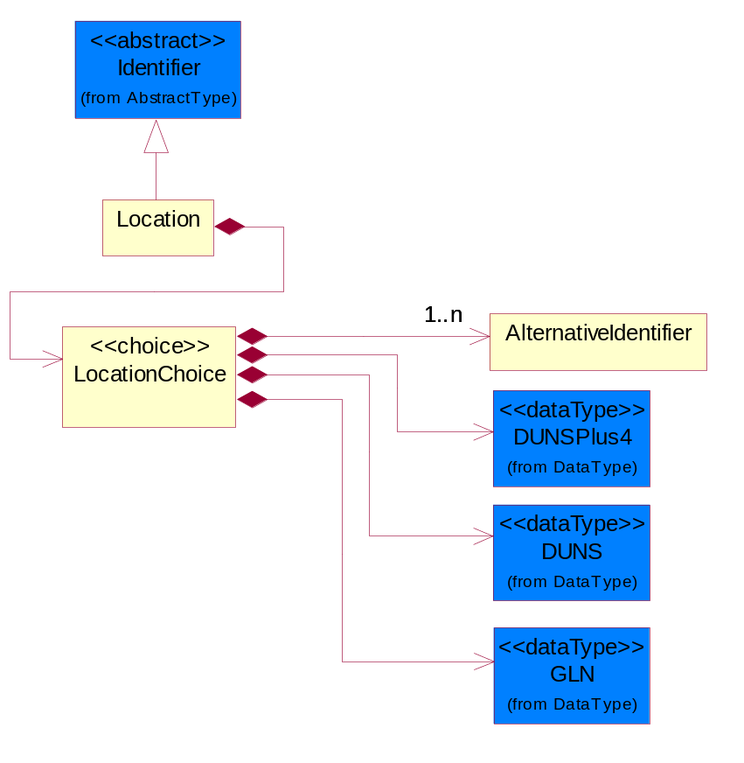
Figure ‎4-19 Location

Composition | Cardinality | Type | Documentation
LocationChoice | 1 | LocationChoice

LocationChoice

Composition | Cardinality | Type | Documentation
DUNSPlus4 | 1 | DUNSPlus4 | A identifier to specify a specific location within a business location.
DUNS | 1 | DUNS | A number assigned by Dun and Bradstreet to identify a business location.
AlternativeIdentifier | 1..n | AlternativeIdentifier | Identifies the specified code and the name of the organization that a code is utilized from.
GLN | 1 | GLN | Global Location Number (GLN) - A identifier to identify legal entities, trading parties and location.

PhysicalAddress
The business document must provide a physical address for a party to the business transaction.
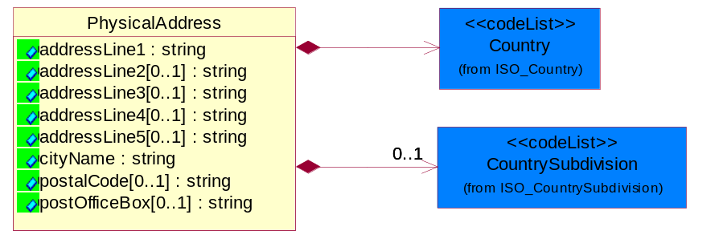
Figure ‎4-20 PhysicalAddress

Attribute | Type | Documentation
addressLine1 | string | The first line of a physical address.
addressLine2[0..1] | string | The second line of a physical address.
addressLine3[0..1] | string | The third line of a physical address.
addressLine4[0..1] | string | The fourth line of a physical address.
addressLine5[0..1] | string | The fifth line of a physical address.
cityName | string | The name of a city.
postalCode[0..1] | string | Identifying geographic location as specified by a national postal code.
postOfficeBox[0..1] | string | The Post Office Box identifier used to identify a party's post office box.

Composition | Cardinality | Type | Documentation
Country | 1 | Country | For representation of Country name RosettaNet has adopted ISO 3166-3; 1999. Refer to the following web page to get the latest version of the standard:  http://www.iso.ch/iso/en/prods-services/iso3166ma/02iso-3166-code-lists/index.html  If you need more information about the ISO standard please contact ISO for more details.
CountrySubdivision | 0..1 | CountrySubdivision | For representation of a Countries subdivisions RosettaNet has adopted ISO 3166-3; 1999. Refer to the following web page to get the latest version of the standard:  http://www.iso.ch/iso/en/prods-services/iso3166ma/02iso-3166-code-lists/index.html  If you need more information about the ISO standard please contact ISO for more details.

MonetaryExpression

FinancialAmount
The business document must express financial amounts.
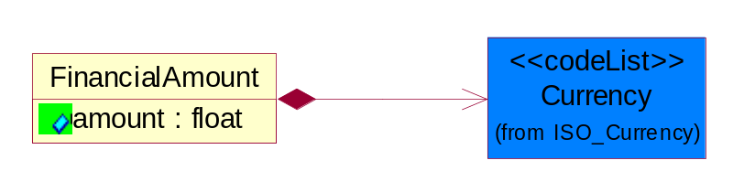
Figure ‎4-21 FinancialAmount

Attribute | Type | Documentation
amount | float | Specifies the monetary amount.

Composition | Cardinality | Type | Documentation
Currency | 1 | Currency | For representation of Currency codes RosettaNet has adopted ISO 4217; 1995. The British Standards Institution (BSI) is the ISO 4217 Maintenance Agency. Refer to the following web page to get the latest version of the standard:  http://www.bsi-global.com/Technical+Information/Publications/_Publications/tig90.xalter  If you need more information about the ISO standard please contact ISO for more details.

PartnerIdentification

FullPartner
The business document must describe the trading partners in the business transaction. This data structure provide the flexibility to describe a partner in all possible methods as for new, existing or known partner.
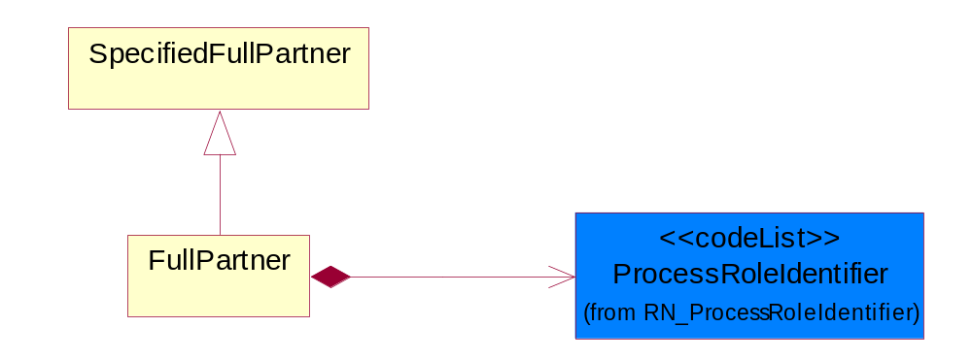
Figure ‎4-22 FullPartner

Composition | Cardinality | Type | Documentation
ProcessRoleIdentifier | 1 | ProcessRoleIdentifier | Describes the role of the partner in the business process. A partner will fulfill at least one or more roles during the business process.

IntermittentPartner
The business document must describe a physical address for a delivery.
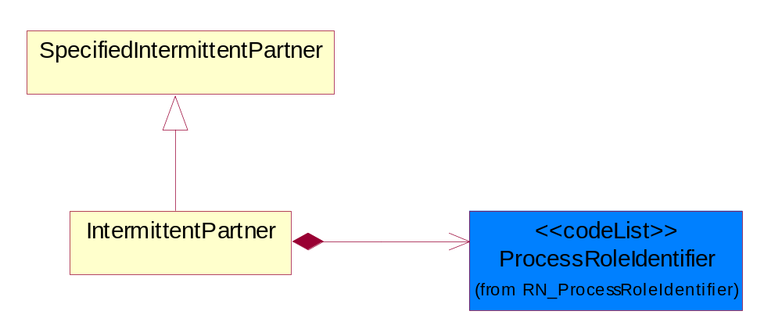
Figure ‎4-23 IntermittentPartner

Composition | Cardinality | Type | Documentation
ProcessRoleIdentifier | 1 | ProcessRoleIdentifier | Describes the role of the partner in the business process. A partner will fulfill at least one or more roles during the business process.

KnownPartner
The business document must describe the trading partners in the business transaction.
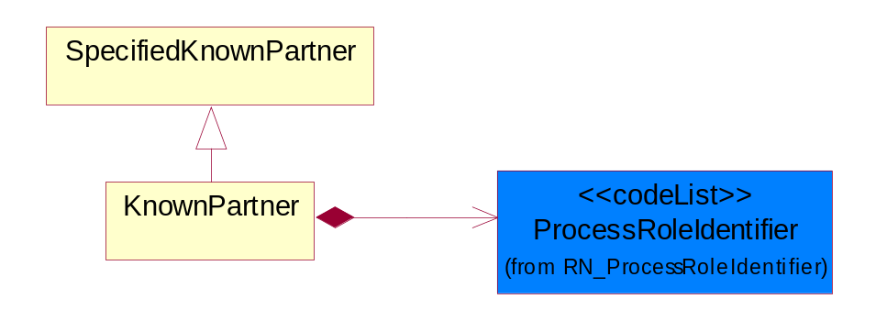
Figure ‎4-24 KnownPartner

Composition | Cardinality | Type | Documentation
ProcessRoleIdentifier | 1 | ProcessRoleIdentifier | Describes the role of the partner in the business process. A partner will fulfill at least one or more roles during the business process.

KnownPartnerContact
The business document must describe the trading partners in the business transaction.
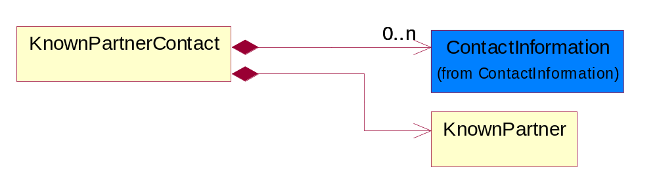
Figure ‎4-25 KnownPartnerContact

Composition | Cardinality | Type | Documentation
KnownPartner | 1 | KnownPartner | The business document must describe the trading partners in the business transaction.
ContactInformation | 0..n | ContactInformation | The business document must allow for the identification of the name of the department, service or individual to be contacted regarding the context of the business document.

NewPartner
The business document must describe a new, existing (but known to only one of the parties to the transaction) or an unknown party to the business transaction.
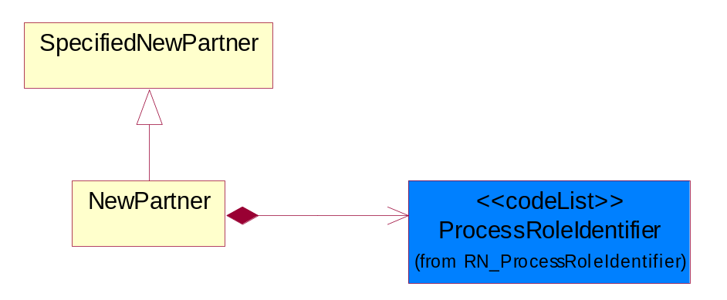
Figure ‎4-26 NewPartner

Composition | Cardinality | Type | Documentation
ProcessRoleIdentifier | 1 | ProcessRoleIdentifier | Describes the role of the partner in the business process. A partner will fulfill at least one or more roles during the business process.

PartnerDescription
The collection of business properties that describe a business partners' identity, their contact information, where they are physically located and their function in a supply chain.
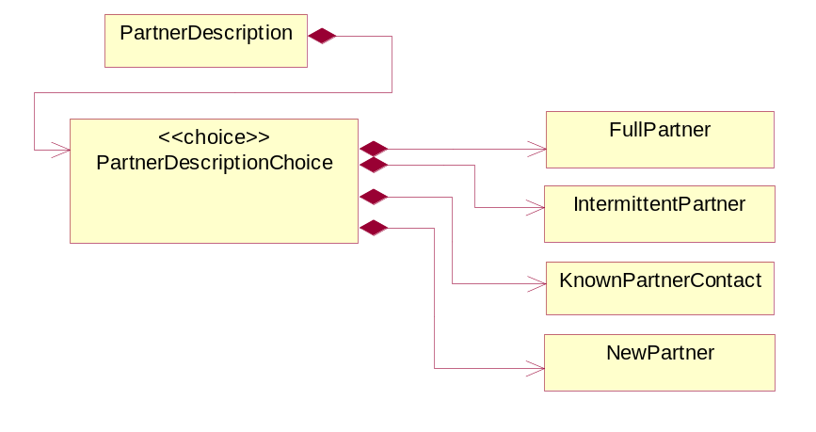
Figure ‎4-27 PartnerDescription

Composition | Cardinality | Type | Documentation
PartnerDescriptionChoice | 1 | PartnerDescriptionChoice

PartnerDescriptionChoice

Composition | Cardinality | Type | Documentation
KnownPartnerContact | 1 | KnownPartnerContact | The business document must describe the trading partners in the business transaction.
IntermittentPartner | 1 | IntermittentPartner | The business document must describe a physical address for a delivery.
NewPartner | 1 | NewPartner | The business document must describe a new, existing (but known to only one of the parties to the transaction) or an unknown party to the business transaction.
FullPartner | 1 | FullPartner | The business document must describe the trading partners in the business transaction. This data structure provide the flexibility to describe a partner in all possible methods as for new, existing or known partner.

PartnerIdentification
The business document must allow for the identity of one or more parties to the transaction.
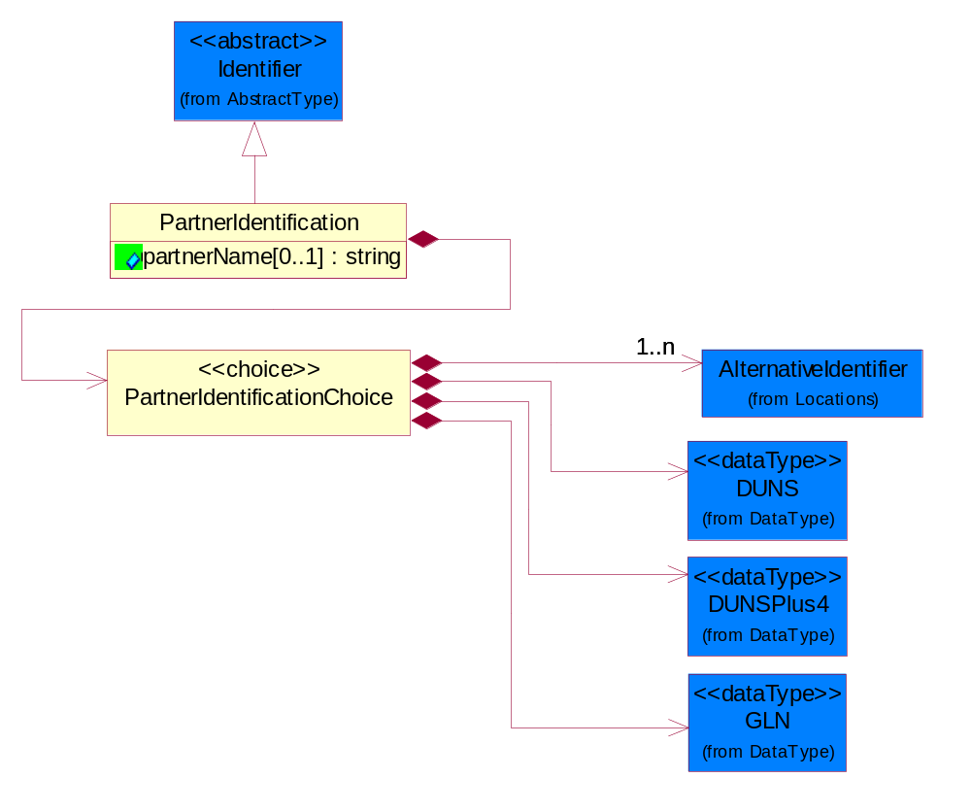
Figure ‎4-28 PartnerIdentification

Attribute | Type | Documentation
partnerName[0..1] | string | The name of the partner’s company/business.

Composition | Cardinality | Type | Documentation
PartnerIdentificationChoice | 1 | PartnerIdentificationChoice

PartnerIdentificationChoice

Composition | Cardinality | Type | Documentation
DUNS | 1 | DUNS | A number assigned by Dun and Bradstreet to identify a business location.
DUNSPlus4 | 1 | DUNSPlus4 | A identifier to specify a specific location within a business location.
AlternativeIdentifier | 1..n | AlternativeIdentifier | Identifies the specified code and the name of the organization that a code is utilized from.
GLN | 1 | GLN | Global Location Number (GLN) - A identifier to identify legal entities, trading parties and location.

SpecifiedFullPartner
The business document must describe the trading partners in the business transaction. This data structure provide the flexibility to describe a partner in all possible methods as for new, existing or known partner. This is specifically for partner who role has been specified.
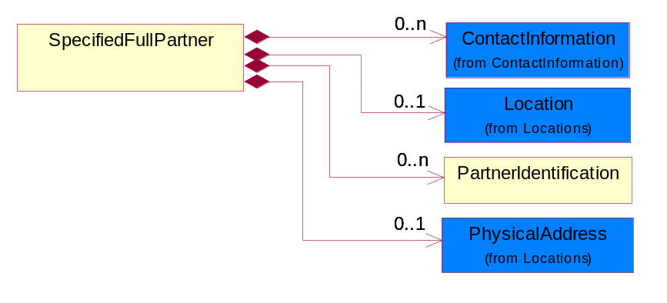
Figure ‎4-29 SpecifiedFullPartner

Composition | Cardinality | Type | Documentation
ContactInformation | 0..n | ContactInformation | The business document must allow for the identification of the name of the department, service or individual to be contacted regarding the context of the business document.
Location | 0..1 | Location | The business document must specify a location.
PartnerIdentification | 0..n | PartnerIdentification | The business document must allow for the identity of one or more parties to the transaction.
PhysicalAddress | 0..1 | PhysicalAddress | The business document must provide a physical address for a party to the business transaction.

SpecifiedIntermittentPartner
The business document must describe a physical address for a delivery.
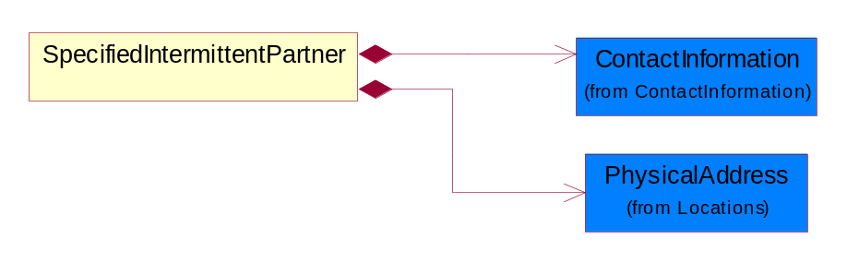
Figure ‎4-30 SpecifiedIntermittentPartner

Composition | Cardinality | Type | Documentation
ContactInformation | 1 | ContactInformation | The business document must allow for the identification of the name of the department, service or individual to be contacted regarding the context of the business document.
PhysicalAddress | 1 | PhysicalAddress | The business document must provide a physical address for a party to the business transaction.

SpecifiedKnownPartner
The business document must describe the trading partners in the business transaction.
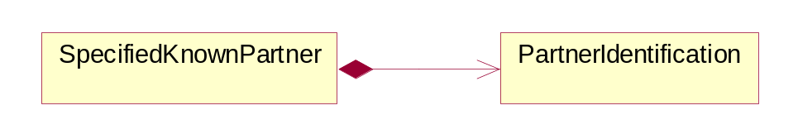
Figure ‎4-31 SpecifiedKnownPartner

Composition | Cardinality | Type | Documentation
PartnerIdentification | 1 | PartnerIdentification | The business document must allow for the identity of one or more parties to the transaction.

SpecifiedNewPartner
The business document must describe a new, existing (but known to only one of the parties to the transaction) or an unknown party to the business transaction.
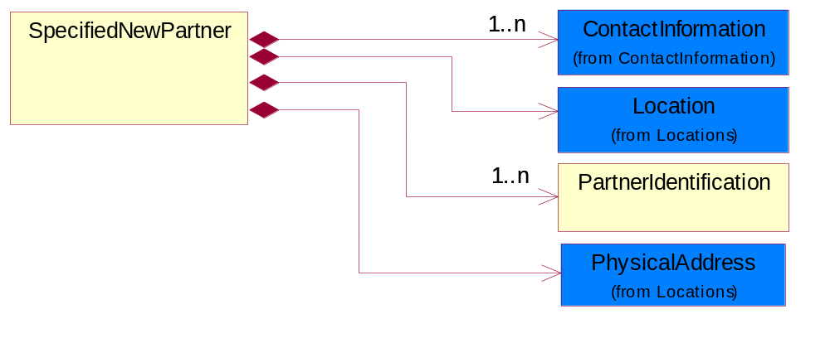
Figure ‎4-32 SpecifiedNewPartner

Composition | Cardinality | Type | Documentation
ContactInformation | 1..n | ContactInformation | The business document must allow for the identification of the name of the department, service or individual to be contacted regarding the context of the business document.
Location | 1 | Location | The business document must specify a location.
PhysicalAddress | 1 | PhysicalAddress | The business document must provide a physical address for a party to the business transaction.
PartnerIdentification | 1..n | PartnerIdentification | The business document must allow for the identity of one or more parties to the transaction.

CodeList

Country
For representation of Country name RosettaNet has adopted ISO 3166-3; 1999. Refer to the following web page to get the latest version of the standard:
http://www.iso.ch/iso/en/prods-services/iso3166ma/02iso-3166-code-lists/index.html

If you need more information about the ISO standard please contact ISO for more details.

CountrySubdivision
For representation of a Countries subdivisions RosettaNet has adopted ISO 3166-3; 1999. Refer to the following web page to get the latest version of the standard:
http://www.iso.ch/iso/en/prods-services/iso3166ma/02iso-3166-code-lists/index.html

If you need more information about the ISO standard please contact ISO for more details.

Currency
For representation of Currency codes RosettaNet has adopted ISO 4217; 1995. The British Standards Institution (BSI) is the ISO 4217 Maintenance Agency. Refer to the following web page to get the latest version of the standard:
http://www.bsi-global.com/Technical+Information/Publications/_Publications/tig90.xalter

If you need more information about the ISO standard please contact ISO for more details.

Language
For representation of Language name RosettaNet has adopted ISO 639-2; 1998. Refer to the following web page to get the latest version of the standard:

http://www.loc.gov/standards/iso639-2/iso639jac.html

If you need more information about the ISO standard please contact ISO for more details.

DocumentType
A code identifying the business context of a document.

Instance | Documentation
ARA | Authorization Request Approval.
CBN | Product batch number of customer.
CCN | Customs clearance number.
CFA | Failure Analysis - Request document that will accompany the product providing characteristics of the component failure.
CIN | Commercial Invoice.
CNM | Traditional credit note or memo.
CON | In a virtual sourcing relationship, a third party trading partner is supplying a part to a customer on behalf of another company that has taken the order for the customer. In this case a Customer Order Number is associated to the request for material that is sent to the virtual trading partners.
COS | Consumption Notice.
COT | Contract.
CRN | Unique consumption reference number identifying the product consumption issue i.e. one-to-one relationship with physical flow.
DEM | Traditional debit note or memo.
DEN | Delivery Note.
DIN | Discontinuation Notice.
DOR | Delivery Order.
DRN | Drawing Number.
DRR | Design Registration Request.
ECO | Engineering Change Order - The proprietary unique identification number that represents an engineering change order.
EIR | Engineering Information Request.
EOL | End of Life.
FUO | Sales order or transfer order fulfilling demand out of a facility (outbound shipment).
INV | Invoice.
LID | Location Identifier. Data for on-site work that have to be done on the machine (associated with preventive maintenance order).
MEN | Master Event Number.
MID | Machine Identifier. Data for on-site work that have to be done on the machine (associated with preventive maintenance order).
MON | Model Number.
OCL | The unique identifier assigned by the OEM for a warranty claim.
OGA | Other governmental agency issued document.
OPO | The unique identifier assigned by the OEM for a part order.
OPR | The unique identifier assigned by the OEM for a part return.
PCN | Product/Process Change.
PFA | Failure Analysis - Request document that will accompany the product providing characteristics of the product failure.
PII | Refers to previously issued invoice.
PLS | Unique number that identifies packing form prior to shipment.
POI | Purchase Order IN.
PON | Production order number for material release.
POO | Purchase Order OUT.
PRC | Product Catalog.
PSI | Refers to previously issued self-billing invoice.
PUO | Purchase Order.
QUO | Quote.
REC | Document identifying the receipt of materials or products into a facility against a purchase order or transfer order (inbound shipment).
REO | Purchase order or transfer order replenishing inventory into a facility (inbound shipment).
REQ | Requisition.
RMA | Returned Material Authorization.
RPO | Purchase order for materials or product returned to and reworked by a supplier.
RTA | Remittance Advice - Remittance details.
SAO | Sales Order.
SBC | Credit Memo used in self-billing scenario.
SBD | Debit Memo used in self-billing scenario.
SBI | Invoice in self billing scenario.
SBN | Product batch number of supplier.
SCA | Similar to contracts - Contains the quantity of an article that is to be ordered from a vendor and the price for article or service that is to be procured.
SEN | Serial Number.
SEO | A document that gives a repair provider the necessary authorization to repair or upgrade a product either at the customer site or at the repair provider’s site.
SHD | Shipping Document.
SNC | Shipset Number on Code List.
SPC | The unique identifier assigned by the ASP for a warranty claim.
SPN | Spec Number.
SPO | The unique identifier assigned by the ASP for a part order.
SPR | The unique identifier assigned by the ASP for a part return.
SPW | The unique identifier assigned by the ASP to reference a work order.
SRI | A document that contains the shipping reference number which allows the product to be tracked within the outsourced logistic providers network.
TRO | Order which results in materials or products being moved from one facility to another (outbound shipment and inbound shipment).
WAB | Waybill.
WAC | Denotes a warranty claim.
WOO | Work Order.

MimeTypeQualifier
The MIME type as defined by IANA.

Please refer to http://www.iana.org/assignments/media-types/ for a list of types.

Instance | Documentation
application/activemessage | [Shapiro]
application/andrew-inset | [Borenstein]
application/applefile | [Faltstrom]
application/atomicmail | [Borenstein]
application/batch-SMTP | [RFC2442]
application/beep+xml | [RFC3080]
application/cals-1840 | [RFC1895]
application/cnrp+xml | [RFCCNRP]
application/commonground | [Glazer]
application/cpl+xml
application/cybercash | [Eastlake]
application/dca-rft | [Campbell]
application/dec-dx | [Campbell]
application/dicom | [RFC3240]
application/dvcs | [RFC3029]
application/EDI-Consent | [RFC1767]
application/EDIFACT | [RFC1767]
application/EDI-X12 | [RFC1767]
application/eshop | [Katz]
application/font-tdpfr | [RFC3073]
application/http | [RFC2616]
application/hyperstudio | [Domino]
application/iges | [Parks]
application/index | [RFC2652]
application/index.cmd | [RFC2652]
application/index.obj | [RFC2652]
application/index.response | [RFC2652]
application/index.vnd | [RFC2652]
application/iotp | [RFC2935]
application/ipp | [RFC2910]
application/isup | [RFC3204]
application/mac-binhex40 | [Faltstrom]
application/macwriteii | [Lindner]
application/marc | [RFC2220]
application/mathematica | [Van Nostern]
application/msword | [Lindner]
application/news-message-id | [RFC1036,Spencer]
application/news-transmission | [RFC1036, Spencer]
application/ocsp-request | [RFC2560]
application/ocsp-response | [RFC2560]
application/octet-stream | [RFC2045,RFC2046]
application/oda | [RFC2045,RFC2046]
application/ogg | [RFC-walleij-ogg-mediatype-08.txt]
application/parityfec | [RFC3009]
application/pdf | [Lindner]
application/pgp-encrypted | [RFC3156]
application/pgp-keys | [RFC3156]
application/pgp-signature | [RFC3156]
application/pkcs10 | [RFC2311]
application/pkcs7-mime | [RFC2311]
application/pkcs7-signature | [RFC2311]
application/pkix-cert | [RFC2585]
application/pkixcmp | [RFC2510]
application/pkix-crl | [RFC2585]
application/postscript | [RFC2045,RFC2046]
application/prs.alvestrand.titrax-sheet | [Alvestrand]
application/prs.cww | [Rungchavalnont]
application/prs.nprend | [Doggett]
application/prs.plucker | [Janssen]
application/qsig | [RFC3204]
application/reginfo+xml | [RFC-ietf-sipping-reg-event-00.txt]
application/remote-printing | [RFC1486,Rose]
application/riscos | [Smith]
application/rtf | [Lindner]
application/sdp | [RFC2327]
application/set-payment | [Korver]
application/set-payment-initiation | [Korver]
application/set-registration | [Korver]
application/set-registration-initiation | [Korver]
application/sgml | [RFC1874]
application/sgml-open-catalog | [Grosso]
application/sieve | [RFC3028]
application/slate | [Crowley]
application/timestamp-query | [RFC3161]
application/timestamp-reply | [RFC3161]
application/tve-trigger | [Welsh]
application/vemmi | [RFC2122]
application/vnd.3gpp.pic-bw-large | [Meredith]
application/vnd.3gpp.pic-bw-small | [Meredith]
application/vnd.3gpp.pic-bw-var | [Meredith]
application/vnd.3gpp.sms | [Meredith]
application/vnd.3M.Post-it-Notes | [O'Brien]
application/vnd.accpac.simply.aso | [Leow]
application/vnd.accpac.simply.imp | [Leow]
application/vnd.acucobol | [Lubin]
application/vnd.acucorp | [Lubin]
application/vnd.adobe.xfdf | [Perelman]
application/vnd.aether.imp | [Moskowitz]
application/vnd.amiga.ami | [Blumberg]
application/vnd.anser-web-certificate-issue-initiation | [Mori]
application/vnd.anser-web-funds-transfer-initiation | [Mori]
application/vnd.audiograph | [Slusanschi]
application/vnd.blueice.multipass | [Holmstrom]
application/vnd.bmi | [Gotoh]
application/vnd.businessobjects | [Imoucha]
application/vnd.canon-cpdl | [Muto]
application/vnd.canon-lips | [Muto]
application/vnd.cinderella | [Kortenkamp]
application/vnd.claymore | [Simpson]
application/vnd.commerce-battelle | [Applebaum]
application/vnd.commonspace | [Chandhok]
application/vnd.contact.cmsg | [Patz]
application/vnd.cosmocaller | [Dellutri]
application/vnd.ctc-posml | [Kohlhepp]
application/vnd.cups-postscript | [Sweet]
application/vnd.cups-raster | [Sweet]
application/vnd.cups-raw | [Sweet]
application/vnd.curl | [Byrnes]
application/vnd.cybank | [Helmee]
application/vnd.data-vision.rdz | [Fields]
application/vnd.dna | [Searcy]
application/vnd.dpgraph | [Parker]
application/vnd.dreamfactory | [Appleton]
application/vnd.dxr | [Duffy]
application/vnd.ecdis-update | [Buettgenbach]
application/vnd.ecowin.chart | [Olsson]
application/vnd.ecowin.filerequest | [Olsson]
application/vnd.ecowin.fileupdate | [Olsson]
application/vnd.ecowin.series | [Olsson]
application/vnd.ecowin.seriesrequest | [Olsson]
application/vnd.ecowin.seriesupdate | [Olsson]
application/vnd.enliven | [Santinelli]
application/vnd.epson.esf | [Hoshina]
application/vnd.epson.msf | [Hoshina]
application/vnd.epson.quickanime | [Gu]
application/vnd.epson.salt | [Nagatomo]
application/vnd.epson.ssf | [Hoshina]
application/vnd.ericsson.quickcall | [Tidwell]
application/vnd.eudora.data | [Resnick]
application/vnd.fdf | [Zilles]
application/vnd.ffsns | [Holstage]
application/vnd.FloGraphIt | [Floersch]
application/vnd.framemaker | [Wexler]
application/vnd.fsc.weblaunch | [D.Smith]
application/vnd.fujitsu.oasys | [Togashi]
application/vnd.fujitsu.oasys2 | [Togashi]
application/vnd.fujitsu.oasys3 | [Okudaira]
application/vnd.fujitsu.oasysgp | [Sugimoto]
application/vnd.fujitsu.oasysprs | [Ogita]
application/vnd.fujixerox.ddd | [Onda]
application/vnd.fujixerox.docuworks | [Taguchi]
application/vnd.fujixerox.docuworks.binder | [Matsumoto]
application/vnd.fut-misnet | [Pruulmann]
application/vnd.grafeq | [Tupper]
application/vnd.groove-account | [Joseph]
application/vnd.groove-help | [Joseph]
application/vnd.groove-identity-message | [Joseph]
application/vnd.groove-injector | [Joseph]
application/vnd.groove-tool-message | [Joseph]
application/vnd.groove-tool-template | [Joseph]
application/vnd.groove-vcard | [Joseph]
application/vnd.hbci | [Hammann]
application/vnd.hhe.lesson-player | [Jones]
application/vnd.hp-HPGL | [Pentecost]
application/vnd.hp-hpid | [Gupta]
application/vnd.hp-hps | [Aubrey]
application/vnd.hp-PCL | [Pentecost]
application/vnd.hp-PCLXL | [Pentecost]
application/vnd.httphone | [Lefevre]
application/vnd.hzn-3d-crossword | [Minnis]
application/vnd.ibm.afplinedata | [Buis]
application/vnd.ibm.electronic-media | [Tantlinger]
application/vnd.ibm.MiniPay | [Herzberg]
application/vnd.ibm.modcap | [Hohensee]
application/vnd.ibm.secure-container | [Tantlinger]
application/vnd.informix-visionary | [Gales]
application/vnd.intercon.formnet | [Gurak]
application/vnd.intertrust.digibox | [Tomasello]
application/vnd.intertrust.nncp | [Tomasello]
application/vnd.intu.qbo | [Scratchley]
application/vnd.intu.qfx | [Scratchley]
application/vnd.irepository.package+xml | [Knowles]
application/vnd.is-xpr | [Natarajan]
application/vnd.japannet-directory-service | [Fujii]
application/vnd.japannet-jpnstore-wakeup | [Yoshitake]
application/vnd.japannet-payment-wakeup | [Fujii]
application/vnd.japannet-registration | [Yoshitake]
application/vnd.japannet-registration-wakeup | [Fujii]
application/vnd.japannet-setstore-wakeup | [Yoshitake]
application/vnd.japannet-verification | [Yoshitake]
application/vnd.japannet-verification-wakeup | [Fujii]
application/vnd.jisp | [Deckers]
application/vnd.kde.karbon | [Faure]
application/vnd.kde.kchart | [Faure]
application/vnd.kde.kformula | [Faure]
application/vnd.kde.kivio | [Faure]
application/vnd.kde.kontour | [Faure]
application/vnd.kde.kpresenter | [Faure]
application/vnd.kde.kspread | [Faure]
application/vnd.kde.kword | [Faure]
application/vnd.kenameaapp | [DiGiorgio-Haag]
application/vnd.koan | [Cole]
application/vnd.liberty-request+xml | [McDowell]
application/vnd.llamagraphics.life-balance.desktop | [White]
application/vnd.lotus-1-2-3 | [Wattenberger]
application/vnd.lotus-approach | [Wattenberger]
application/vnd.lotus-freelance | [Wattenberger]
application/vnd.lotus-notes | [Laramie]
application/vnd.lotus-organizer | [Wattenberger]
application/vnd.lotus-screencam | [Wattenberger]
application/vnd.lotus-wordpro | [Wattenberger]
application/vnd.mcd | [Gotoh]
application/vnd.mediastation.cdkey | [Flurry]
application/vnd.meridian-slingshot | [Wedel]
application/vnd.micrografx.flo | [Prevo]
application/vnd.micrografx.igx | [Prevo]
application/vnd.mif | [Wexler]
application/vnd.minisoft-hp3000-save | [Bartram]
application/vnd.mitsubishi.misty-guard.trustweb | [Tanaka]
application/vnd.Mobius.DAF | [Kabayama]
application/vnd.Mobius.DIS | [Kabayama]
application/vnd.Mobius.MBK | [Devasia]
application/vnd.Mobius.MQY | [Devasia]
application/vnd.Mobius.MSL | [Kabayama]
application/vnd.Mobius.PLC | [Kabayama]
application/vnd.Mobius.TXF | [Kabayama]
application/vnd.mophun.application | [Wennerstrom]
application/vnd.mophun.certificate | [Wennerstrom]
application/vnd.motorola.flexsuite | [Patton]
application/vnd.motorola.flexsuite.adsi | [Patton]
application/vnd.motorola.flexsuite.fis | [Patton]
application/vnd.motorola.flexsuite.gotap | [Patton]
application/vnd.motorola.flexsuite.kmr | [Patton]
application/vnd.motorola.flexsuite.ttc | [Patton]
application/vnd.motorola.flexsuite.wem | [Patton]
application/vnd.mozilla.xul+xml | [McDaniel]
application/vnd.ms-artgalry | [Slawson]
application/vnd.ms-asf | [Fleischman]
application/vnd.mseq | [Le Bodic]
application/vnd.ms-excel | [Gill]
application/vnd.msign | [Borcherding]
application/vnd.ms-lrm | [Ledoux]
application/vnd.ms-powerpoint | [Gill]
application/vnd.ms-project | [Gill]
application/vnd.ms-tnef | [Gill]
application/vnd.ms-works | [Gill]
application/vnd.ms-wpl | [Plastina]
application/vnd.musician | [Adams]
application/vnd.music-niff | [Butler]
application/vnd.netfpx | [Mutz]
application/vnd.noblenet-directory | [Solomon]
application/vnd.noblenet-sealer | [Solomon]
application/vnd.noblenet-web | [Solomon]
application/vnd.novadigm.EDM | [Swenson]
application/vnd.novadigm.EDX | [Swenson]
application/vnd.novadigm.EXT | [Swenson]
application/vnd.obn | [Hessling]
application/vnd.osa.netdeploy | [Klos]
application/vnd.palm | [Peacock]
application/vnd.pg.format | [Gandert]
application/vnd.pg.osasli | [Gandert]
application/vnd.powerbuilder6 | [Guy]
application/vnd.powerbuilder6-s | [Guy]
application/vnd.powerbuilder7 | [Shilts]
application/vnd.powerbuilder75 | [Shilts]
application/vnd.powerbuilder75-s | [Shilts]
application/vnd.powerbuilder7-s | [Shilts]
application/vnd.previewsystems.box | [Smolgovsky]
application/vnd.publishare-delta-tree | [Ben-Kiki]
application/vnd.pvi.ptid1 | [Lamb]
application/vnd.pwg-multiplexed | [RFC3391]
application/vnd.pwg-xhtml-print+xml | [Wright]
application/vnd.Quark.QuarkXPress | [Scheidler]
application/vnd.rapid | [Szekely]
application/vnd.s3sms | [Tarkkala]
application/vnd.sealed.net | [Lambert]
application/vnd.seemail | [Webb]
application/vnd.shana.informed.formdata | [Selzler]
application/vnd.shana.informed.formtemplate | [Selzler]
application/vnd.shana.informed.interchange | [Selzler]
application/vnd.shana.informed.package | [Selzler]
application/vnd.smaf | [Takahashi]
application/vnd.sss-cod | [Dani]
application/vnd.sss-dtf | [Bruno]
application/vnd.sss-ntf | [Bruno]
application/vnd.street-stream | [Levitt]
application/vnd.svd | [Becker]
application/vnd.swiftview-ics | [Widener]
application/vnd.triscape.mxs | [Simonoff]
application/vnd.trueapp | [Hepler]
application/vnd.truedoc | [Chase]
application/vnd.ufdl | [Manning]
application/vnd.uplanet.alert | [Martin]
application/vnd.uplanet.alert-wbxml | [Martin]
application/vnd.uplanet.bearer-choice | [Martin]
application/vnd.uplanet.bearer-choice-wbxml | [Martin]
application/vnd.uplanet.cacheop | [Martin]
application/vnd.uplanet.cacheop-wbxml | [Martin]
application/vnd.uplanet.channel | [Martin]
application/vnd.uplanet.channel-wbxml | [Martin]
application/vnd.uplanet.list | [Martin]
application/vnd.uplanet.listcmd | [Martin]
application/vnd.uplanet.listcmd-wbxml | [Martin]
application/vnd.uplanet.list-wbxml | [Martin]
application/vnd.uplanet.signal | [Martin]
application/vnd.vcx | [T.Sugimoto]
application/vnd.vectorworks | [Pharr]
application/vnd.vidsoft.vidconference | [Hess]
application/vnd.visio | [Sandal]
application/vnd.visionary | [Aravindakumar]
application/vnd.vividence.scriptfile | [Risher]
application/vnd.vsf | [Rowe]
application/vnd.wap.sic | [WAP-Forum]
application/vnd.wap.slc | [WAP-Forum]
application/vnd.wap.wbxml | [Stark]
application/vnd.wap.wmlc | [Stark]
application/vnd.wap.wmlscriptc | [Stark]
application/vnd.webturbo | [Rehem]
application/vnd.wrq-hp3000-labelled | [Bartram]
application/vnd.wt.stf | [Wohler]
application/vnd.wv.csp+wbxml | [Salmi]
application/vnd.xara | [Matthewman]
application/vnd.xfdl | [Manning]
application/vnd.yellowriver-custom-menu | [Yellow]
application/whoispp-query | [RFC2957]
application/whoispp-response | [RFC2958]
application/wita | [Campbell]
application/wordperfect5.1 | [Lindner]
application/x400-bp | [RFC1494]
application/xhtml+xml | [RFC3236]
application/xml | [RFC3023]
application/xml-dtd | [RFC3023]
application/xml-external-parsed-entity | [RFC3023]
application/zip | [Lindner]
audio/32kadpcm | [RFC2421,RFC2422]
audio/AMR | [RFC3267]
audio/AMR-WB | [RFC3267]
audio/basic | [RFC2045,RFC2046]
audio/CN | [RFC3389]
audio/DAT12 | [RFC3190]
audio/DVI4
audio/EVRC | [RFC-ietf-avt-evrc-smv-03.txt]
audio/EVRC0 | [RFC-ietf-avt-evrc-smv-03.txt]
audio/G.722.1 | [RFC3047]
audio/G722
audio/G723
audio/G726-16
audio/G726-24
audio/G726-32
audio/G726-40
audio/G728
audio/G729
audio/G729D
audio/G729E
audio/GSM
audio/GSM-EFR
audio/L16 | [RFC2586]
audio/L20 | [RFC3190]
audio/L24 | [RFC3190]
audio/L8
audio/LPC
audio/MP4A-LATM | [RFC3016]
audio/MPA
audio/mpa-robust | [RFC3119]
audio/mpeg | [RFC3003]
audio/parityfec | [RFC3009]
audio/PCMA
audio/PCMU
audio/prs.sid | [Walleij]
audio/QCELP
audio/RED
audio/SMV | [RFC-ietf-avt-evrc-smv-03.txt]
audio/SMV0 | [RFC-ietf-avt-evrc-smv-03.txt]
audio/telephone-event | [RFC2833]
audio/tone | [RFC2833]
audio/VDVI
audio/vnd.3gpp.iufp | [Belling]
audio/vnd.cisco.nse | [Kumar]
audio/vnd.cns.anp1 | [McLaughlin]
audio/vnd.cns.inf1 | [McLaughlin]
audio/vnd.digital-winds | [Strazds]
audio/vnd.everad.plj | [Cicelsky]
audio/vnd.lucent.voice | [Vaudreuil]
audio/vnd.nortel.vbk | [Parsons]
audio/vnd.nuera.ecelp4800 | [Fox]
audio/vnd.nuera.ecelp7470 | [Fox]
audio/vnd.nuera.ecelp9600 | [Fox]
audio/vnd.octel.sbc | [Vaudreuil]
audio/vnd.qcelp | [Lundblade]
audio/vnd.rhetorex.32kadpcm | [Vaudreuil]
audio/vnd.vmx.cvsd | [Vaudreuil]
image/cgm | Computer Graphics Metafile
image/g3fax | [RFC1494]
image/gif | [RFC2045,RFC2046]
image/ief | [RFC1314] Image Exchange Format
image/jpeg | [RFC2045,RFC2046]
image/naplps | [Ferber]
image/png | [Randers-Pehrson]
image/prs.btif | [Simon]
image/prs.pti | [Laun]
image/t38 | [RFC3362]
image/tiff | [RFC3302] Tag Image File Format
image/tiff-fx | [RFC3250] Tag Image File Format Fax eXtended
image/vnd.cns.inf2 | [McLaughlin]
image/vnd.djvu | [Bottou]
image/vnd.dwg | [Moline]
image/vnd.dxf | [Moline]
image/vnd.fastbidsheet | [Becker]
image/vnd.fpx | [Spencer]
image/vnd.fst | [Fuldseth]
image/vnd.fujixerox.edmics-mmr | [Onda]
image/vnd.fujixerox.edmics-rlc | [Onda]
image/vnd.globalgraphics.pgb | [Bailey]
image/vnd.mix | [Reddy]
image/vnd.ms-modi | [Vaughan]
image/vnd.net-fpx | [Spencer]
image/vnd.svf | [Moline]
image/vnd.wap.wbmp | [Stark]
image/vnd.xiff | [S.Martin]
message/delivery-status | [RFC1894]
message/disposition-notification | [RFC2298]
message/external-body | [RFC2045,RFC2046]
message/http | [RFC2616]
message/news | [RFC 1036, H.Spencer]
message/partial | [RFC2045,RFC2046]
message/rfc822 | [RFC2045,RFC2046]
message/s-http | [RFC2660]
message/sip | [RFC3261]
message/sipfrag | [RFC3420]
model/iges | [Parks]
model/mesh | [RFC2077]
model/vnd.dwf | [Pratt]
model/vnd.flatland.3dml | [Powers]
model/vnd.gdl | [Babits]
model/vnd.gs-gdl | [Babits]
model/vnd.gtw | [Ozaki]
model/vnd.mts | [Rabinovitch]
model/vnd.parasolid.transmit.binary | [Parasolid]
model/vnd.parasolid.transmit.text | [Parasolid]
model/vnd.vtu | [Rabinovitch]
model/vrml | [RFC2077]
multipart/alternative | [RFC2045,RFC2046]
multipart/appledouble | [Faltstrom]
multipart/byteranges | [RFC2068]
multipart/digest | [RFC2045,RFC2046]
multipart/encrypted | [RFC1847]
multipart/form-data | [RFC2388]
multipart/header-set | [Crocker]
multipart/mixed | [RFC2045,RFC2046]
multipart/parallel | [RFC2045,RFC2046]
multipart/related | [RFC2387]
multipart/report | [RFC1892]
multipart/signed | [RFC1847]
multipart/voice-message | [RFC2421,RFC2423]
text/calendar | [RFC2445]
text/css | [RFC2318]
text/directory | [RFC2425]
text/enriched | [RFC1896]
text/html | [RFC2854]
text/parityfec | [RFC3009]
text/plain | [RFC2646,RFC2046]
text/prs.lines.tag | [Lines]
text/rfc822-headers | [RFC1892]
text/richtext | [RFC2045,RFC2046]
text/rtf | [Lindner]
text/sgml | [RFC1874]
text/t140 | [RFC2793]
text/tab-separated-values | [Lindner]
text/uri-list | [RFC2483]
text/vnd.abc | [Allen]
text/vnd.curl | [Byrnes]
text/vnd.DMClientScript | [Bradley]
text/vnd.fly | [Gurney]
text/vnd.fmi.flexstor | [Hurtta]
text/vnd.in3d.3dml | [Powers]
text/vnd.in3d.spot | [Powers]
text/vnd.IPTC.NewsML | [IPTC]
text/vnd.IPTC.NITF | [IPTC]
text/vnd.latex-z | [Lubos]
text/vnd.motorola.reflex | [Patton]
text/vnd.ms-mediapackage | [Nelson]
text/vnd.net2phone.commcenter.command | [Xie]
text/vnd.sun.j2me.app-descriptor | [G.Adams]
text/vnd.wap.si | [WAP-Forum]
text/vnd.wap.sl | [WAP-Forum]
text/vnd.wap.wml | [Stark]
text/vnd.wap.wmlscript | [Stark]
text/xml | [RFC3023]
text/xml-external-parsed-entity | [RFC3023]
video/BMPEG
video/BT656
video/CelB
video/DV | [RFC3189]
video/H261
video/H263
video/H263-1998
video/H263-2000
video/JPEG
video/MP1S
video/MP2P
video/MP2T
video/MP4V-ES | [RFC3016]
video/mpeg | [RFC2045,RFC2046]
video/MPV
video/nv
video/parityfec | [RFC3009]
video/pointer | [RFC2862]
video/quicktime | [Lindner]
video/SMPTE292M | [RFC-avt-smpte292-video-08.txt]
video/vnd.fvt | [Fuldseth]
video/vnd.motorola.video | [McGinty]
video/vnd.motorola.videop | [McGinty]
video/vnd.mpegurl | [Recktenwald]
video/vnd.nokia.interleaved-multimedia | [Kangaslampi]
video/vnd.objectvideo | [Clark]
video/vnd.vivo | [Wolfe]

ProcessRoleIdentifier
Describes the role of the partner in the business process. A partner will fulfill at least one or more roles during the business process.

Instance | Documentation
ADM | Administered by - The party who is the administrative authority of an account.
ALT | Alternate approval by - The party who has approved a request in the event the approver is not able to respond.
APP | Approval by - The party who has approved a request.
BIF | Bill from - The party that will issue the invoice.
BIT | Bill to - The party that will pay the invoice.
CBK | Customs Broker - CustomsBroker  This object represents the party that declare the shipment on behalf of declarant.
CLF | Collect From - To enable the buyer to specify the location of where products not supplied directly by the seller/installer may be collected.
CLM | Claimed By - This object represents the claimant.
CNC | Cancellation party - The party who is cancelling the shipping order.
COR | Change originated by - The party who originates a proposed change.
COW | Change owned by - The party who owns or who is assigned responsibility for a proposed change.
CRA | Credit applicant - The party who is applying for credit.
CRE | Created by - The party responsible for creating a process or task.
CSP | Contract Service Provider.
CWN | contractOwner - The party who is the owner of the contract. For example, in the direct business, the buyer is the contract owner. In the distribution business, the buyer is the distributor and the contract owner is the reseller.
DCE | DesignCustomerApplicationEngineer. The demand customer's Field Application Engineer.
DCT | Declared To - This object represents the party that the declaration goes to.
DCU | DesignCustomer. The owner of the product for which the design has been created.
DIS | Distributed by - The party who supplies products to retailers.
DST | Distributed To - This object represents the party to send information to.
FCP | Forecast Partner - The collection of business properties that describes the partner types for a forecast.
FIA | From Install At - The collection of sender business properties that describes a business partners' identity, their contact information, where they are physically located and their function in a supply chain.
FIN | Financed by - The party who is the financier.
FNB | Founded by - The party who performs the act, process, or art of casting metals.
FOR | Forwarded to - The party to whom a business document has been forwarded.
IMB | Imported By - The party responsible for importing the product.
INL | Inventory location - The party where the inventory product entry is located.
INO | Inventory owner - The party that owns the inventory product entry.
ITF | In transit from - The party sending the product quantity in a product location transfer.
ITL | installAt - The partner and/or location to which the product must be set up for use or service.
ITT | In transit to - The party receiving the product quantity in a product location transfer.
LGP | Logistics Provided By - The party who handles the details of an operation.
MFG | Manufactured by - The party who creates, processes or produces goods especially in large quantities and by means of industrial machines.
OWN | Owned by - The party who owns a process.
PAE | ProductProviderFieldApplicationEngineer. The product provider Field Application Engineer.
PCW | Primary Contract With - The primary party with whom a contract is formed.
PNB | Planning By - The party who establishes goals, policies or procedures.
PSR | ProductProviderSalesRepresentative. The product provider sales representative.
PUR | Purchased by - The party who is a purchaser of a product.
REA | Requested approval by - The party who has been selected to approve a request.
REC | Received by - The party who has received a product shipment.
REQ | Requested by - The party who has initiated a request.
RES | Respond to - The party to whom a responding business document must be sent when it is not equal to the partner specified in the document header.
RET | Return by - The party responsible for either carrying or forwarding the returned product.
REV | Reviewed by - The party responsible for reviewing a business document.
RFR | receivedFrom - The partner and/or location from where the product was shipped.
RLS | Released By - This object represents the party that releases the goods.
RMT | remitTo - The partner to which payment for a business document is sent.
RPB | Repaired By - The collection of business properties used to identify the business partner responsible for the repair or  rework of a product.
RQT | Refer Quote To - The partner to whom a quote request is being referred.
RSF | Requested Ship From - The party where the product is requested to be shipped from.
RTT | ReturnTo - The partner and/or location to which the returned product must be delivered.
SBF | Self-billing from - The party who initiates the billing in self-billing scenario.
SBT | Self-billing to - The party whom the invoice is addressed to.
SCB | Subcontracted By - The party who is contracted to perform part or all of another party's contract.
SCP | Shipping charges paid by - The party responsible for administering payment of the shipping charges.
SCW | Secondary Contract With - The subsequent party(ies) with whom a contract is formed.
SHF | Ship From - The collection of business properties used to identify the business partner initiating a shipment or transaction.
SHT | Ship To - The partner and/or location to which the product must be delivered.
SLD | Sold to - The party to whom a product has been sold.
SOB | Sold By - The seller involved in a business transaction.
SPL | Supplied by - The party who supplies an item, part or assembly.
SPS | Service Provider Site - Identification for the location of the ASP site that is ordering the replacement parts and/or performing the repair.
SRT | Submit returns to - The party to whom product returns are to be submitted.
STR | Stored By - This object represents the party that stores the goods.
SVA | ShipVia - The partner and/or location through which the product must be shipped, such as the "cross dock" at a shipping hub.  It must not be specified for the last leg, since this would be the same as the final destination specified in the ShipmentInformation/shipTo.
TFR | Transfer From - The party responsible for making the payment (Payer).
TIA | To lnstall At - The collection of receiver business properties that describes business partners' identity, their contact information, where they are physically located and their function in a supply chain.
TMT | Transfer Manufacturing To - The movement of the manufacturing process to another site.
TRA | Transported by - The party responsible for either carrying or forwarding the product.
TSB | Tested By - The collection of business properties used to identify the specific location and resources used to conduct a defined cycle or steps or measurements required to confirm a result or event.
TTR | Transfer To - The party who is receiving the payment (payee).
ULR | Ultimate recipient - The party who ultimately receives the shipment, when an intermediate party takes responsibility for payment and final delivery.
USE | Used by - The party who is the end user of the product.
UST | Unstuffed By - This object represents the party that unstuffs the goods.
WHB | Warehoused By - The party who stocks or stores products.

System Structure

BusinessProcessIdentifier
A Business Process Identifier to uniquely define the TPIR-PIP 'role' within a Business Scenario at a company or MNC level. The identifier MUST be composed of alphanumeric characters only and its length MUST be between one and twelve characters.
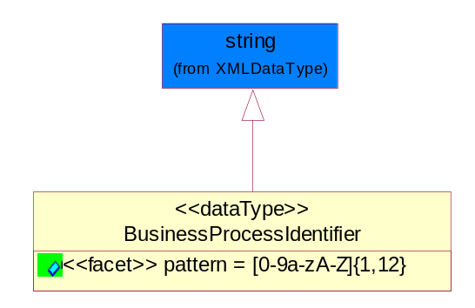
Figure ‎5-33 BusinessProcessIdentifier

Attribute | Type | Documentation
pattern |  | [0-9a-zA-Z]{1,12}

BusinessServiceInformation
The object allows the specification of the business service utilized within the partner company. This may or may not be the same as the information sent by the RNIF.
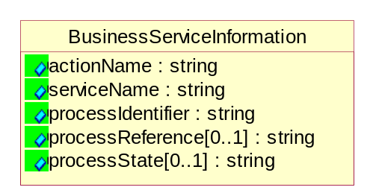
Figure ‎5-34 BusinessServiceInformation

Attribute | Type | Documentation
actionName | string | The name of Action. For RosettaNet usually any of Request/Confirm/Notify/Query/Response.
serviceName | string | The name of the Business Activity with the "Request/Confirm" part removed. E.g., for the Activity "Request Purchase Order"==> "Purchase Order".
processIdentifier | string | The name of the PIP e.g. Notify of Forecast Reply.
processReference[0..1] | string | The URN for the PIP that includes Cluster/Segment/Process pattern used to identify the interface process (such as PIP3A4)
processState[0..1] | string | The business process (or service) state of the sender of a document. When a service receives this document, the receiver may use the state as a precondition.

ContractInformation
A block of information used to correlate a contract in an executing choreography.

Figure ‎5-35 ContractInformation

Attribute | Type | Documentation
contractIdentifier[0..1] | string | Unique identification of a contract between the Sender and the Receiver
contractType[0..1] | string | The type of the contract: an attribute describing the type of the ContractIndentification. Valid values are URI, URN,ebXMLCPA, or other values defined by partners.

CorrelationInformation
A block of information used to correlate a requesting document to a responding document and to the contract in an executing choreography.
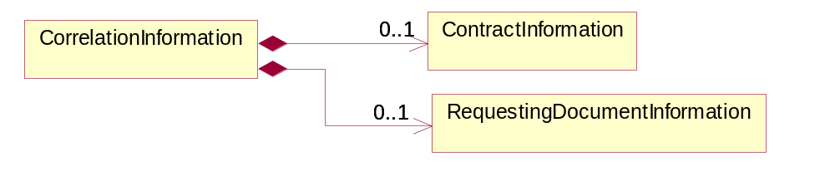
Figure ‎5-36 CorrelationInformation

Composition | Cardinality | Type | Documentation
ContractInformation | 0..1 | ContractInformation | A block of information used to correlate a contract in an executing choreography.
RequestingDocumentInformation | 0..1 | RequestingDocumentInformation | A block of information used to correlate a requesting document to a responding document in an executing choreography.

DocumentHeader
The object allows for the identification of the sender and receiver of the business document.
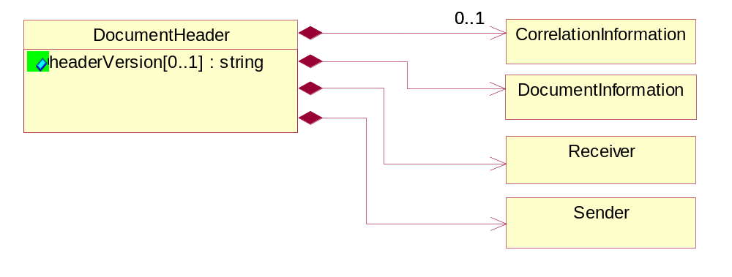
Figure ‎5-37 DocumentHeader

Attribute | Type | Documentation
headerVersion[0..1] | string | The UN/CEFACT version of the document header.

Composition | Cardinality | Type | Documentation
Sender | 1 | Sender | The object allows the identification of the initiating party of the business message.
CorrelationInformation | 0..1 | CorrelationInformation | A block of information used to correlate a requesting document to a responding document and to the contract in an executing choreography.
DocumentInformation | 1 | DocumentInformation | The object specifies information to identify the business document, a summary of attachments, and information about the business document security.
Receiver | 1 | Receiver | The object allows the identification of the receiving party of the business message.

DocumentIdentification
The object specifies all information necessary to identify the business document.
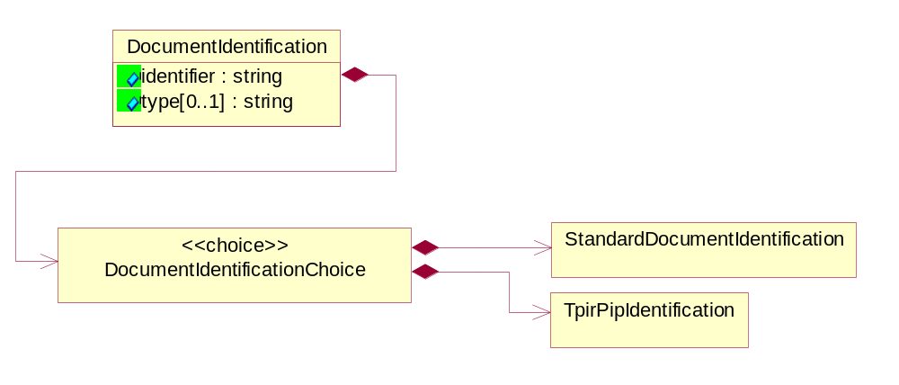
Figure ‎5-38 DocumentIdentification

Attribute | Type | Documentation
identifier | string | The unique identifier for the document being sent.
type[0..1] | string | Name of the Action Message

Composition | Cardinality | Type | Documentation
DocumentIdentificationChoice | 1 | DocumentIdentificationChoice

DocumentIdentificationChoice

Composition | Cardinality | Type | Documentation
StandardDocumentIdentification | 1 | StandardDocumentIdentification | The object specifies additional information necessary to identify the standard business document.
TpirPipIdentification | 1 | TpirPipIdentification | The object specifies all information necessary to uniquely identify a TPIR-PIP within a Registry or trading partner repository.

DocumentInformation
The object specifies information to identify the business document, a summary of attachments, and information about the business document security.
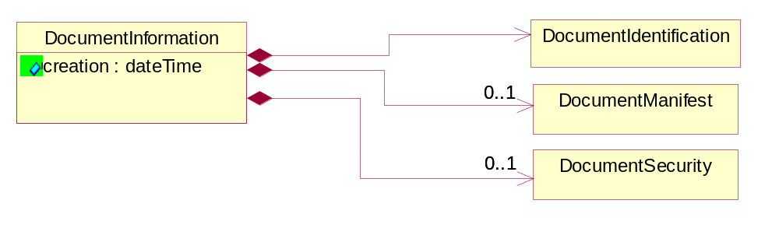
Figure ‎5-39 DocumentInformation

Attribute | Type | Documentation
creation | dateTime | The creation date and time of the specified Business Document (i.e. the Purchase Order date).

Composition | Cardinality | Type | Documentation
DocumentIdentification | 1 | DocumentIdentification | The object specifies all information necessary to identify the business document.
DocumentSecurity | 0..1 | DocumentSecurity | The object provides additional granularity in specifying business document security (this is in addition to the specified PIP security).
DocumentManifest | 0..1 | DocumentManifest | The block provides a brief summary of attachments and Service Content.

DocumentManifest
The block provides a brief summary of attachments and Service Content.
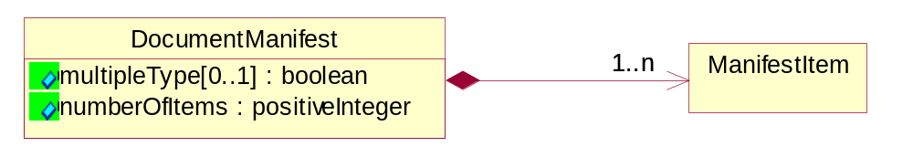
Figure ‎5-40 DocumentManifest

Attribute | Type | Documentation
multipleType[0..1] | boolean | Indicates whether the manifest contains documents of multiple types. True if yes, and False if no.
numberOfItems | positiveInteger | Total number of documents in the message. The physical count of the attachments in the payload plus the RosettaNet Business Message (for Service Content). The value of this field will be at least 1.

Composition | Cardinality | Type | Documentation
ManifestItem | 1..n | ManifestItem | The object provides details about the specific attachment(s).

DocumentSecurity
The object provides additional granularity in specifying business document security (this is in addition to the specified PIP security).

Figure ‎5-41 DocumentSecurity

Attribute | Type | Documentation
nonRepudiableReceipt | boolean | The value "true" will indicate that a signed acknowledgement for the business document is necessary.
persistentEncryption | boolean | The value "true" will indicate that the Business Document (including the header) needs to be encrypted when stored or transported.
persistentSignature | boolean | The value "true" will indicate that a signature is required to be stored with the document while stored or transported.

ManifestItem
The object provides details about the specific attachment(s).

Figure ‎5-42 ManifestItem

Attribute | Type | Documentation
description[0..1] | string | A description of the attachment.
length[0..1] | positiveInteger | The size of the attachment in bytes (i.e. 1 000 000 bytes)
universalResourceIdentifier | string | The generic set of all names/addresses that are short strings that refer to resources.

Composition | Cardinality | Type | Documentation
mimeTypeQualifier | 1 | MimeTypeQualifier | The MIME type as defined by IANA.  Please refer to http://www.iana.org/assignments/media-types/ for a list of types.
language | 0..1 | Language | For representation of Language name RosettaNet has adopted ISO 639-2; 1998. Refer to the following web page to get the latest version of the standard:  http://www.loc.gov/standards/iso639-2/iso639jac.html  If you need more information about the ISO standard please contact ISO for more details.

PipIdentifier
PIP Identification.[ i.e. PIP3A4]
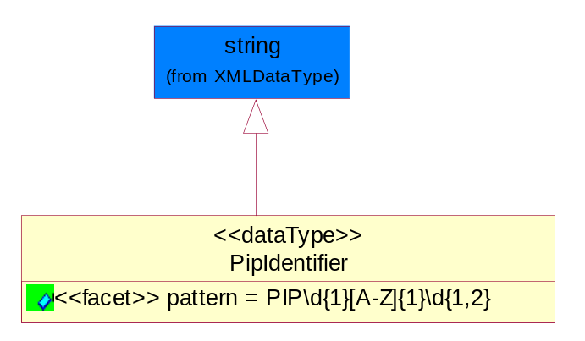
Figure ‎5-43 PipIdentifier

Attribute | Type | Documentation
pattern |  | PIP\d{1}[A-Z]{1}\d{1,2}

PipVersion
PIP version number (i.e. 02.02.00).
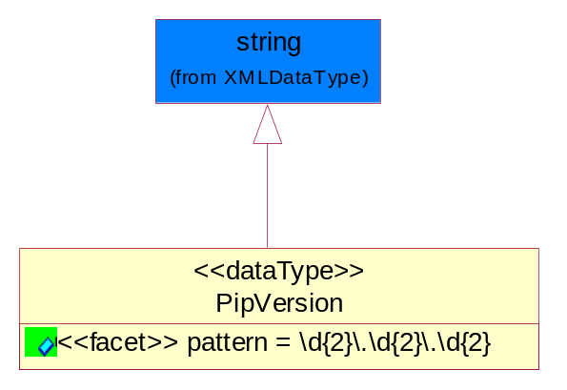
Figure ‎5-44 PipVersion

Attribute | Type | Documentation
pattern |  | \d{2}\.\d{2}\.\d{2}

Receiver
The object allows the identification of the receiving party of the business message.
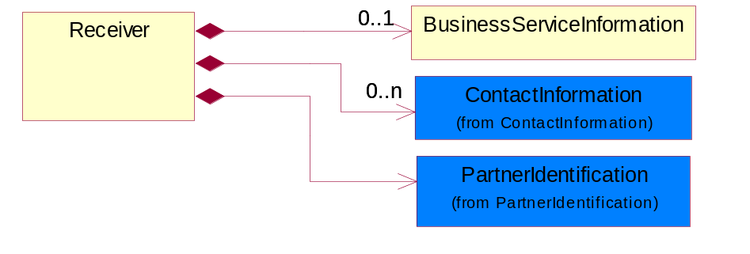
Figure ‎5-45 Receiver

Composition | Cardinality | Type | Documentation
BusinessServiceInformation | 0..1 | BusinessServiceInformation | The object allows the specification of the business service utilized within the partner company. This may or may not be the same as the information sent by the RNIF.
PartnerIdentification | 1 | PartnerIdentification | The business document must allow for the identity of one or more parties to the transaction.
ContactInformation | 0..n | ContactInformation | The business document must allow for the identification of the name of the department, service or individual to be contacted regarding the context of the business document.

RequestingDocumentInformation
A block of information used to correlate a requesting document to a responding document in an executing choreography.
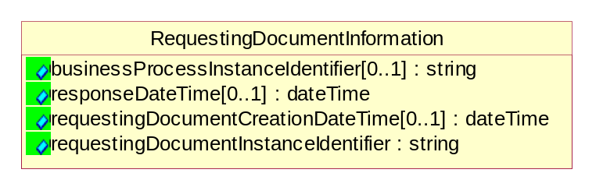
Figure ‎5-46 RequestingDocumentInformation

Attribute | Type | Documentation
businessProcessInstanceIdentifier[0..1] | string | The identifier for the public business process instance being sent that both the sender and receiver can identify.
responseDateTime[0..1] | dateTime | The expected time to receive the response. This can not be greater than the PIP TimeToPerform.
requestingDocumentCreationDateTime[0..1] | dateTime | The date-time of the requesting business document.
requestingDocumentInstanceIdentifier | string | The Business Document identification number that identifies the requesting Business Document.

Sender
The object allows the identification of the initiating party of the business message.
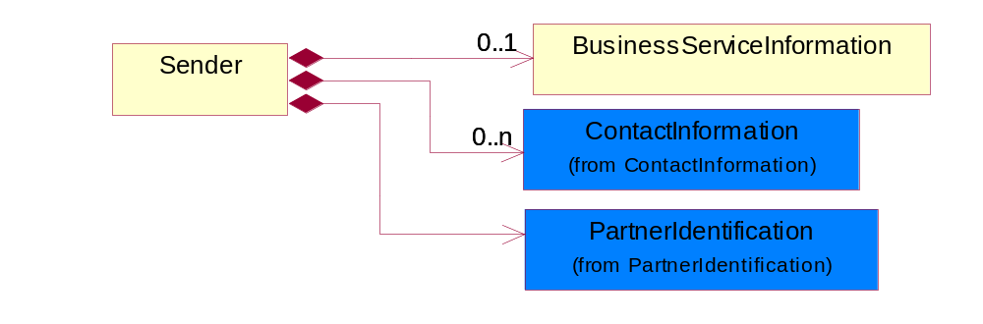
Figure ‎5-47 Sender

Composition | Cardinality | Type | Documentation
PartnerIdentification | 1 | PartnerIdentification | The business document must allow for the identity of one or more parties to the transaction.
BusinessServiceInformation | 0..1 | BusinessServiceInformation | The object allows the specification of the business service utilized within the partner company. This may or may not be the same as the information sent by the RNIF.
ContactInformation | 0..n | ContactInformation | The business document must allow for the identification of the name of the department, service or individual to be contacted regarding the context of the business document.

StandardDocumentIdentification
The object specifies additional information necessary to identify the standard business document.
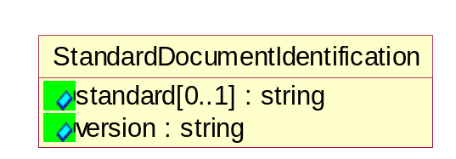
Figure ‎5-48 StandardDocumentIdentification

Attribute | Type | Documentation
standard[0..1] | string | Identifies the standard used to submit the business document. (e.g. RosettaNet).
version | string | PIP3A4v01.00

TpirPipIdentification
The object specifies all information necessary to uniquely identify a TPIR-PIP within a Registry or trading partner repository.

Figure ‎5-49 TpirPipIdentification

Attribute | Type | Documentation
partnerId | DUNSPlus4 | The Trading Partner Identification of MNC that is creating this TPIR PIP.
pipIdentifier | PipIdentifier | A TPIR PIP Identification [i.e., 3A4).
pipVersion | PipVersion | A TPIR PIP version number (i.e., 02.02.00)
tpirPipVersion | VersionIdentifier | A TPIR-PIP Version Number (i.e., major and minor version number as XX.XX).
tpirBusinessProcessIdentifier[0..1] | BusinessProcessIdentifier | A Business Process Identifier to uniquely define the TPIR-PIP 'role' within a Business Scenario at a company or MNC level. The identifier MUST be composed of alphanumeric characters only and its length MUST be between one and twelve characters.
uri[0..1] | anyURI | Describes the destination uri for the TPIR form.

Composition | Cardinality | Type | Documentation
fileType | 0..1 | TPIRFileType | Describes the file type of the TPIR form (PDF, XDP or XML).

VersionIdentifier
Version Number (i.e., major and minor version number as XX.XX).
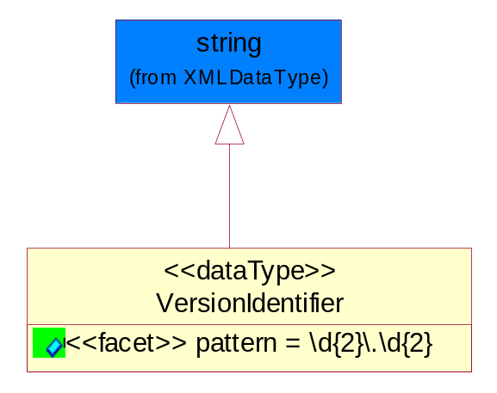
Figure ‎5-50 VersionIdentifier

Attribute | Type | Documentation
pattern |  | \d{2}\.\d{2}

CodeList

TPIRFileType
A code identifying the file type of TPIR form.

Name | Documentation
PDF | Portable Document Format.
XDP | XML Data Package.
XML | eXtensible Markup Language.

XML Data Type

anyURI
Represents a URI as defined by RFC 2396. An anyURI value can be absolute or relative, and may have an optional fragment identifier.

boolean
Represents Boolean values, which are either "true" or "false".

date
For the represents a calendar date.
The pattern for a date is CCYY-MM-DD where CC represents the century, YY the year, MM the month, and DD the day, with an optional time zone indicator as allowed for dateTime.

dateTime
Represents a specific instance of time.
The pattern for dateTime is CCYY-MM-DDThh:mm:ss where CC represents the century, YY the year, MM the month, and DD the day, preceded by an optional leading negative (-) character to indicate a negative number. If the negative character is omitted, positive (+) is assumed. The T is the date/time separator and hh, mm, and ss represent hour, minute, and second respectively. Additional digits can be used to increase the precision of fractional seconds if desired. For example, the format ss.ss... with any number of digits after the decimal point is supported. The fractional seconds part is optional.
This representation may be immediately followed by a "Z" to indicate Coordinated Universal Time (UTC) or to indicate the time zone. For example, the difference between the local time and Coordinated Universal Time, immediately followed by a sign, + or -, followed by the difference from UTC represented as hh:mm (minutes is required). If the time zone is included, both hours and minutes must be present.

float
Represents single-precision 32-bit floating-point numbers.

positiveInteger
Represents an integer that is greater than zero. This data type is derived from nonNegativeInteger.

string
Represents character string.

