

Description of
Partner Interface Process® for 3C6

Validated 11.01.00

Specification Information
Name | Notify Of Remittance Advice
Cluster | Order Management
Segment | Returns and Finance
Publication Date | 05 November 2007
Version Identifier | V11.01

Table of Contents
1 Document Management 4
1.1 Legal Disclaimer 4
1.2 Copyright 4
1.3 Trademarks 4
1.4 Acknowledgments 4
1.5 Related Documents 5
1.6 Document Version History 5
1.7 Document Structure 5
2 Business Process 6
2.1 Business Process Definition 6
2.2 PIP Scope Description 6
2.3 PIP Business Document 6
2.4 PIP Business Process Flow Diagram 7
2.5 PIP Start State 7
2.6 PIP End States 8
2.7 Partner Role Descriptions 8
2.8 Business Process Activity Controls 8
3 Network and Implementation Specification 10
3.1 Business Action and Business Signal Specifications 10
3.2 Business Transaction Dialog Specification 11
3.2.1 Message Exchange Controls 11
3.2.2 Communications Specification 12

List of Figures:

Figure 1: Activity Diagram of Notify Of Remittance Advice 7
Figure 2: Sequence Diagram of Notify Of Remittance Advice 11

List of Tables:
Table 1: PIP Business Document 6
Table 2: PIP Start State 7
Table 3: PIP End State 8
Table 4: PIP Failure State 8
Table 5: Partner Role Description 8
Table 6: Business Activity Description 8
Table 7: Business Activity Performance Control 9
Table 8: Network Component Specification 10
Table 9: Business Action – Business Document Mapping 10
Table 10: Message Exchange Control 11
Table 11: Dialog: Service-Service 12

Document Management

Legal Disclaimer
RosettaNet™, its members, officers, directors, employees, or agents shall not be liable for any injury, loss, damages, financial or otherwise, arising from, related to, or caused by the use of this document or the specifications herein, as well as associated guidelines and schemas. The use of said specifications shall constitute your express consent to the foregoing exculpation.

Copyright
©2007 RosettaNet. All rights reserved. No part of this publication may be reproduced, stored in a retrieval system, or transmitted, in any form or by any means, electronic, mechanical, photocopying, recording, or otherwise, without the prior written permission of the publisher. Printed in the United States of America.

Trademarks
RosettaNet, Partner Interface Process, PIP and the RosettaNet logo are trademarks or registered trademarks of "RosettaNet," a non-profit organization. All other product names and company logos mentioned herein are the trademarks of their respective owners. In the best effort, all terms mentioned in this document that are known to be trademarks or registered trademarks have been appropriately recognized in the first occurrence of the term.

Acknowledgments
This document has been prepared by RosettaNet (http://www.rosettanet.org/) from requirements gathered during the Milestone Program and in conformance with the methodology. Listed below are the legal entities that contributed to the design and development of this PIP.

Amkor Technology, Inc. | Avnet Applied Computing
EDIFICE | Intel Corporation
Intel Corporations | MIMOS Berhad
Motorola | Motorola Europe
Motorola Semiconductor Products Sector | Motorola SPS
National Semiconductor GMBH | Nokia Oyj
Philips Semiconductors | Sterling Commerce
STMicroelectronics | Texas Instruments
Texas Instruments (Global) | Texas Instruments Limited

Related Documents
- Associated PIP Message Schemas (included within the PIP Specification package only)
- Description of 3C6 Message
- Messages Structure
- XML instance of ebXML BPSS for PIP 3C6

Document Version History
Version | Date | Description
Validated 11.00.00 | 19 July 2006 | Validated Version
Validated 11.01.00 | 05 November 2007 | Validated Version for Schema to Market 2007

Document Structure
A Partner Interface Process (PIP) Specification is comprised of the following two parts:
- Business Process. Captures the semantics of the business process and the flow of the message exchange between roles as they perform business activities.
- Network and Implementation Specification. Specifies the network protocol message formats and communications requirements between peer-protocols supported by network components in the RosettaNet Implementation Framework.

Business Process

Business Process Definition
The "Notify Of Remittance Advice" Partner Interface Process (PIP) enables a payer to send remittance advice to a payee. It is usually executed when an outstanding accounts payable balance (credit or debit) exists.
Remittance advice specifies monetary amounts and account reconciliation information.
After a provider uses either PIP3C3, "Notify Of Invoice" to issue an invoice or PIP3C5, “Notify Of Billing Statement” to issue a billing statement, a payer may use this PIP to indicate which payables are scheduled for payment. A billing statement covers all monetary amounts due over a period of time, whereas an invoice notification is sent only on an event-by-event basis.
Payment may be processed through a bank rather than directly from the payer to the payee. In this case, the payee could reconcile remittance advice with invoices and billing statements to determine which demands for payment are being paid. If the payment is not as anticipated, the payee performs a manual process to handle the discrepancy.
Should this transaction not complete successfully, the requesting partner executes PIPA01, "Notification of Failure."

PIP Scope Description
This PIP enables a payer to issue a remittance advice to a payee.

PIP Business Document
Business Document are generated and exchanged by roles performing activities in this PIP. Business Document is listed and defined in Table 1.
Table 1: PIP Business Document
Business Document | Description
Remittance Advice Notification | Provides a detailed breakdown of a payment amount. It includes all credits, debits, discounts, adjustments taken on an invoice, and adjustment reason codes. A payment can attach a Remittance Advice Notification. Payment can be for products only, transportation, or other services.

PIP Business Process Flow Diagram
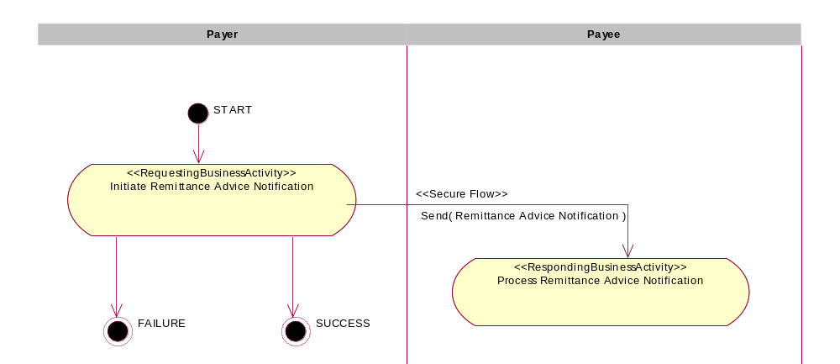
Figure 1: Activity Diagram of Notify Of Remittance Advice

PIP Start State
The start state is comprised of the following conditions:
Table 2: PIP Start State
 | Approved | Exist |  | Valid | Non-Repudiated | Retry Count | Authorized
 | Approved | Party | In Backend System
TPA |  |  | 
Sending Partner |  |  |  | 
Receiving Partner |  | 
Business Document |  |  |  |  |  |  | 

PIP End States
The end state is comprised of the following conditions:
Table 3: PIP End State
 | Approved | Exist |  | Valid | Non-Repudiated | Retry Count | Authorized
 | Approved | Party | In Backend system
Acknowledgment of Receipt |  |  |  |  | 
Receiving Partner |  |  |  |  |  |  | 

The PIP failure state is comprised of one or more of the following conditions:
Table 4: PIP Failure State
 | NO | Exceeded
Success | 
Retry Count |  | 

Partner Role Descriptions
Table 5 describes the partner roles in this PIP.
Table 5: Partner Role Description
Role Name | Role Description
Payer | The party issuing a payment.
Payee | The party receiving a payment.

Business Process Activity Controls
Table 6 describes the interaction between roles performing business activity in this PIP.
Table 6: Business Activity Description
Role  Name | Activity Name | Activity Description
Payer | Initiate Remittance Advice Notification | The Payer issues a Remittance Advice Notification to a Payee.

Table 7 details the security, audit and process controls relating to activity performed in the PIP.
Table 7: Business Activity Performance Control
Role  Name | Activity  Name | Acknowledgment  of Receipt |  | Time to Perform | Retry Count | Is Authorization Required? | Non-Repudiation of Origin and Content?
Role  Name | Activity  Name | Non-Repudiation Required? | Time to Acknowledge
Payer | Initiate Remittance Advice Notification | Y | 2 hrs | N/A | 3 | Y | Y

Network and Implementation Specification
Each network component maps into a role of the PIP model. Table 8 specifies the mapping between roles and network components.
Table 8: Network Component Specification
Network Component | Classification | Maps to Role in Business Process
Payer Service | Business Service | Payer
Payee Service | Business Service | Payee

Business Action and Business Signal Specifications
Each business action maps to a Business Document of the PIP model. Table 9 specifies the mapping between Business Documents and business actions.
Table 9: Business Action – Business Document Mapping
Business Action | Business Document | Document Function
Remittance Advice Notification Action | Remittance Advice Notification | Request

Business Transaction Dialog Specification
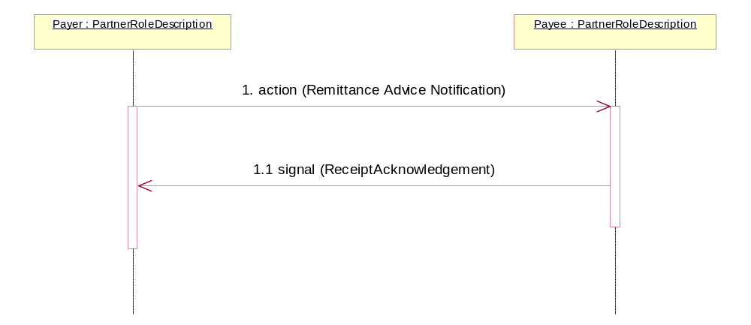
Figure 2: Sequence Diagram of Notify Of Remittance Advice

Message Exchange Controls
Table 10: Message Exchange Control
# | Name |  | Time to Acknowledge Receipt Signal |  | Time to Respond to Action |  | Included in Time to Perform |  | Is Authorization Required? |  | Is Non-Repudiation Required? |  | Is Secure Transport Required?
1. |  | Remittance Advice Notification Action |  | 2 hrs |  | N/A |  | N/A |  | Y |  | Y |  | Y
1.1. |  | Receipt Acknowledgment |  | N/A |  | N/A |  | N/A |  | Y |  | Y |  | Y

Communications Specification
Table 11: Dialog: Service-Service
# | Business Message | Digital Signature Required? | SSL Required?
1. | Remittance Advice Notification | Y | Y
1.1. | Receipt Acknowledgment | Y | Y

