

Description of 3C7 Message

PIP® 3C7
Validated 11.00.00

Specification Information
Name | Description Of 3C7 Message
PIP | Notify Of Self-Billing Invoice
Cluster | Order Management
Segment | Returns and Finance Management
Publication Date | 19 July 2006
Version Identifier | V11.00

Table of Content

1. Document Management 6
1.1 Legal Disclaimer 6
1.2 Copyright 6
1.3 Trademarks 6
1.4 Acknowledgments 6
1.5 Related Documents 7
1.6 Document Version History 7
1.7 Document Purpose 7
2. Interchange Model 8
2.1 SelfBillingInvoiceNotification 8
2.1.1 Interchange Diagram 8
2.1.2 Dependency Diagram 9
2.1.3 Invoice 9
2.1.4 InvoiceLineItem 11
2.1.5 ProductDescription 12
2.1.6 ProductMovement 13
2.1.7 SelfBillingInvoiceNotification 15
3. Domain Model 16
3.1 Procurement 16
3.1.1 Procurement 16
3.1.1.1 Dependency Diagram 16
3.1.1.2 AccountSummary 16
3.1.1.3 CurrencyConversion 17
3.1.1.4 DayOfMonth 18
3.1.1.5 Discounts 18
3.1.1.6 Financing 19
3.1.1.7 LotIdentification 19
3.1.1.8 NetTerms 20
3.1.1.9 PaymentTerms 20
3.1.1.10 TaxInformation 21
3.1.1.11 TaxPhrase 21
3.1.1.12 TaxSummary 22
3.1.2 CodeList 23
3.1.2.1 PaymentCondition 23
3.1.2.2 ShipmentTerms 23
3.1.2.3 SaleType 24
3.2 Logistics 25
3.2.1 Logistics 25
3.2.1.1 Dependency Diagram 25
CodeList 25
3.2.2.1 NationalExportControlClassification 25
3.3 Shared 27
3.3.1 Shared 27
3.3.1.1 Dependency Diagram 27
3.3.1.2 MonetaryAmount 27
3.3.1.3 ProductQuantity 28
3.3.2 CodeList 28
3.3.2.1 InvoiceChargeType 28
3.3.2.2 MonetaryAmountType 29
3.3.2.3 ShippingServiceLevel 29
3.3.2.4 AmountType 31
4. Universal Structure 32
4.1 ContactInformation 32
4.1.1 ContactInformation 32
4.2 DataType 33
4.2.1 Contact 33
4.2.2 DUNS 33
4.2.3 DUNSPlus4 34
4.2.4 GLN 34
4.2.5 GTIN 35
4.2.6 PercentAmount 35
4.3 Dates 36
4.4 Document 36
4.4.1 BusinessDocumentReference 36
4.5 Locations 37
4.5.1 AlternativeIdentifier 37
4.5.2 Location 37
4.5.3 LocationChoice 38
4.5.4 PhysicalAddress 38
4.6 MonetaryExpression 40
4.6.1 FinancialAmount 40
4.6.2 TaxJurisdiction 41
4.7 PartnerIdentification 42
4.7.1 PartnerIdentification 42
4.7.2 PartnerIdentificationChoice 43
4.7.3 SpecifiedFullPartner 43
4.7.4 SpecifiedIntermittentPartner 44
4.7.5 SpecifiedKnownPartner 45
4.7.6 SpecifiedKnownPartnerContact 45
4.7.7 SpecifiedNewPartner 46
4.7.8 SpecifiedPartnerDescription 47
4.7.9 SpecifiedPartnerDescriptionChoice 47
4.8 PhysicalDimension 49
4.9 ProductIdentification 49
4.9.1 ProductIdentification 49
4.9.2 ProductIdentificationChoice 50
4.9.3 ProductSerialIdentification 50
4.10 CodeList 50
4.10.1 Country 50
4.10.2 CountrySubdivision 50
4.10.3 Currency 51
4.10.4 Language 51
4.10.5 DocumentType 51
4.10.6 MimeTypeQualifier 53
4.10.7 UnitOfMeasure 63
5. System Structure 71
5.1 BusinessProcessIdentifier 71
5.2 BusinessServiceInformation 71
5.3 ContractInformation 72
5.4 CorrelationInformation 73
5.5 DocumentHeader 73
5.6 DocumentIdentification 74
5.7 DocumentIdentificationChoice 75
5.8 DocumentInformation 75
5.9 DocumentManifest 76
5.10 DocumentSecurity 76
5.11 ManifestItem 77
5.12 PipIdentifier 78
5.13 PipVersion 78
5.14 Receiver 79
5.15 RequestingDocumentInformation 80
5.16 Sender 80
5.17 StandardDocumentIdentification 81
5.18 TpirPipIdentification 81
5.19 VersionIdentifier 82
5.20 CodeList 83
5.20.1 TPIRFileType 83
6. XML Data Type 84
6.1 anyURI 84
6.2 boolean 84
6.3 date 84
6.4 dateTime 84
6.5 decimal 84
6.6 float 84
6.7 gDay 84
6.8 positiveInteger 85
6.9 string 85

Table of Figures

Figure ‎2-1 Interchange 8
Figure ‎2-2 Dependency 9
Figure ‎2-3 Invoice 9
Figure ‎2-4 InvoiceLineItem 11
Figure ‎2-5 ProductDescription 12
Figure ‎2-6 ProductMovement 13
Figure ‎2-7 SelfBillingInvoiceNotification 15
Figure ‎3-1 Dependency 16
Figure ‎3-2 AccountSummary 16
Figure ‎3-3 CurrencyConversion 17
Figure ‎3-4 DayOfMonth 18
Figure ‎3-5 Discounts 18
Figure ‎3-6 Financing 19
Figure ‎3-7 LotIdentification 19
Figure ‎3-8 NetTerms 20
Figure ‎3-9 PaymentTerms 20
Figure ‎3-10 TaxInformation 21
Figure ‎3-11 TaxPhrase 21
Figure ‎3-12 TaxSummary 22
Figure ‎3-13 Dependency 25
Figure ‎3-14 Dependency 27
Figure ‎3-15 MonetaryAmount 27
Figure ‎3-16 ProductQuantity 28
Figure ‎4-1 ContactInformation 32
Figure ‎4-2 Contact 33
Figure ‎4-3 DUNS 33
Figure ‎4-4 DUNSPlus4 34
Figure ‎4-5 GLN 34
Figure ‎4-6 GTIN 35
Figure ‎4-7 PercentAmount 35
Figure ‎4-8 BusinessDocumentReference 36
Figure ‎4-9 AlternativeIdentifier 37
Figure ‎4-10 Location 37
Figure ‎4-11 PhysicalAddress 38
Figure ‎4-12 FinancialAmount 40
Figure ‎4-13 TaxJurisdiction 41
Figure ‎4-14 PartnerIdentification 42
Figure ‎4-15 SpecifiedFullPartner 43
Figure ‎4-16 SpecifiedIntermittentPartner 44
Figure ‎4-17 SpecifiedKnownPartner 45
Figure ‎4-18 SpecifiedKnownPartnerContact 45
Figure ‎4-19 SpecifiedNewPartner 46
Figure ‎4-20 SpecifiedPartnerDescription 47
Figure ‎4-21 ProductIdentification 49
Figure ‎4-22 ProductSerialIdentification 50
Figure ‎5-1 BusinessProcessIdentifier 71
Figure ‎5-2 BusinessServiceInformation 71
Figure ‎5-3 ContractInformation 72
Figure ‎5-4 CorrelationInformation 73
Figure ‎5-5 DocumentHeader 73
Figure ‎5-6 DocumentIdentification 74
Figure ‎5-7 DocumentInformation 75
Figure ‎5-8 DocumentManifest 76
Figure ‎5-9 DocumentSecurity 76
Figure ‎5-10 ManifestItem 77
Figure ‎5-11 PipIdentifier 78
Figure ‎5-12 PipVersion 78
Figure ‎5-13 Receiver 79
Figure ‎5-14 RequestingDocumentInformation 80
Figure ‎5-15 Sender 80
Figure ‎5-16 StandardDocumentIdentification 81
Figure ‎5-17 TpirPipIdentification 81
Figure ‎5-18 VersionIdentifier 82

Document Management

Legal Disclaimer
RosettaNet, its members, officers, directors, employees, or agents shall not be liable for any injury, loss, damages, financial or otherwise, arising from, related to, or caused by the use of this document or the specifications herein, as well as associated guidelines and schemas. The use of said specifications shall constitute your express consent to the foregoing exculpation.

Copyright
©2006 RosettaNet. All rights reserved. No part of this publication may be reproduced, stored in a retrieval system, or transmitted, in any form or by any means, electronic, mechanical, photocopying, recording, or otherwise, without the inclusion of this copyright notice. Any derivative works must cite the copyright notice. Any public redistribution or sale of this publication or derivative works requires prior written permission of the publisher.

Trademarks
RosettaNet, Partner Interface Process, PIP and the RosettaNet logo are trademarks or registered trademarks of "RosettaNet," a non-profit organization. All other product names and company logos mentioned herein are the trademarks of their respective owners. In the best effort, all terms mentioned in this document that are known to be trademarks or registered trademarks have been appropriately recognized in the first occurrence of the term.

Acknowledgments
This document has been prepared by RosettaNet (http://www.rosettanet.org/) from requirements gathered during the Milestone Program and in conformance with the methodology. Listed below are the legal entities that contributed to the design and development of this PIP.
Amkor Technology, Inc. | Avnet Applied Computing
EDIFICE | Intel Corporation
Intel Corporations | MIMOS Berhad
Motorola | Motorola Europe
Motorola Semiconductor Products Sector | Motorola SPS
National Semiconductor GMBH | Nokia Oyj
Philips Semiconductors | Sterling Commerce
STMicroelectronics | Texas Instruments
Texas Instruments (Global) | Texas Instruments Limited

Related Documents
- Associated PIP Message Schemas (included with PIP Specification only)
- Description of Partner Interface Process for 3C7
- Message Structure

Document Version History
Version | Date | Description
Validated 11.00.00 | 19 July 2006 | Validated Version

Document Purpose
The purpose of the document is to explain the structure, the association between objects, the content of objects and the definition for single elements to a non-technical audience.

Interchange Model

SelfBillingInvoiceNotification

Interchange Diagram
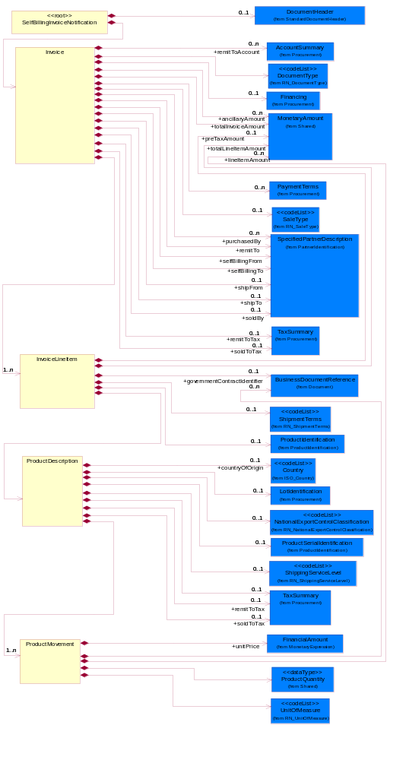
Figure ‎2-1 Interchange

Dependency Diagram
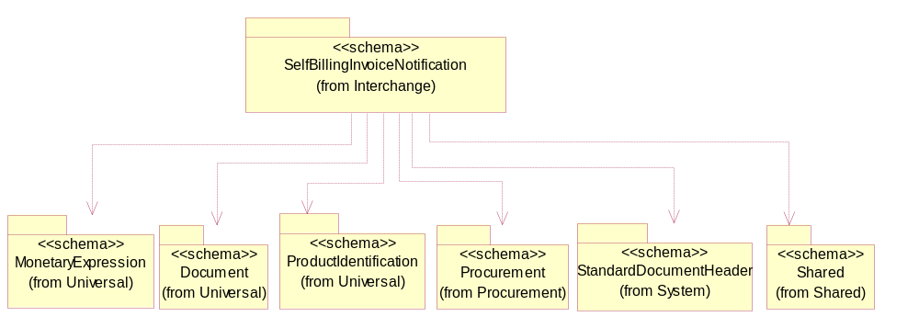
Figure ‎2-2 Dependency

Invoice
An itemized list of goods or services specifying the price and the terms of sale.
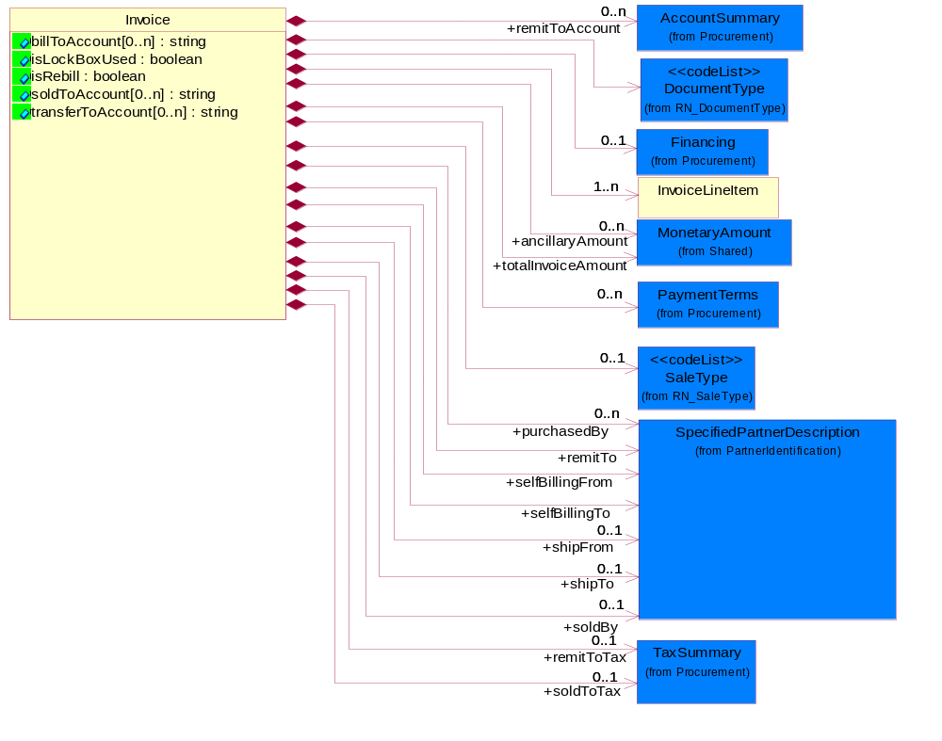
Figure ‎2-3 Invoice

Attribute | Type | Documentation
billToAccount[0..n] | string | The account number of the party that pays the invoice.
isLockBoxUsed | boolean | Indicates the appearance of a lock box number on an applicable address line and subsequent requirement.
isRebill | boolean | Indicates whether the business document is being resent.
soldToAccount[0..n] | string | The account number of the party that purchases of the product.
transferToAccount[0..n] | string | The account number of the party that transfers the product.

Composition | Cardinality | Type | Documentation
Financing | 0..1 | Financing | The collection of business properties that describe financial information.
DocumentType | 1 | DocumentType | A code identifying the business context of a document.
SaleType | 0..1 | SaleType | Code identifying the type of sale terms the trading partner bought from the seller.
InvoiceLineItem | 1..n | InvoiceLineItem | The collection of business properties that describe an invoice entry.
remitToAccount | 0..n | AccountSummary | The account number of the party to whom payment is sent.
remitToTax | 0..1 | TaxSummary | The total tax liability of the party to whom payment is sent.
soldToTax | 0..1 | TaxSummary | The total tax liability of the party that purchases the product.
shipTo | 0..1 | SpecifiedPartnerDescription | The partner and/or location to which the product must be delivered.
remitTo | 1 | SpecifiedPartnerDescription | The partner to which payment for a business document is sent.
selfBillingFrom | 1 | SpecifiedPartnerDescription | The party who initiates the billing in self-billing scenario.
selfBillingTo | 1 | SpecifiedPartnerDescription | The party whom the invoice is addressed to.
shipFrom | 0..1 | SpecifiedPartnerDescription | The DUNS or DUNS + 4 number of the location from where the product is to be shipped.
soldBy | 0..1 | SpecifiedPartnerDescription | The seller involved in a business transaction.
purchasedBy | 0..n | SpecifiedPartnerDescription | The party who is a purchaser of a product.
ancillaryAmount | 0..n | MonetaryAmount | Ancillary costs that are not included in the line items.
totalInvoiceAmount | 1 | MonetaryAmount | The total amount on an invoice.
PaymentTerms | 0..n | PaymentTerms | The collection of business properties that describe payment terms.

InvoiceLineItem
The collection of business properties that describe an invoice entry.
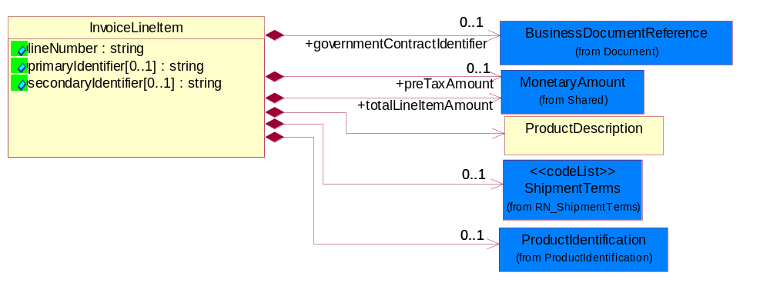
Figure ‎2-4 InvoiceLineItem

Attribute | Type | Documentation
lineNumber | string | Number of the line in the document.
primaryIdentifier[0..1] | string | A unique tracking number (assigned by the carrier) to a package for the duration of a shipment, through all intermediaries.
secondaryIdentifier[0..1] | string | A tracking number that will generally be carrier specific and will not be bound to a particular format.

Composition | Cardinality | Type | Documentation
ShipmentTerms | 0..1 | ShipmentTerms | Code identifying the terms under which a product is shipped.
governmentContractIdentifier | 0..1 | BusinessDocumentReference | The unique number that identifies a government contract.
ProductDescription | 1 | ProductDescription | The collection of business properties that describe a shipment receipt notification entry.
ProductIdentification | 0..1 | ProductIdentification | The object provides the identifier(s) of a product.
preTaxAmount | 0..1 | MonetaryAmount | The gross amount prior to calculating taxes.
totalLineItemAmount | 1 | MonetaryAmount | The monetary total associated with a line item.

ProductDescription
The collection of business properties that describe a shipment receipt notification entry.
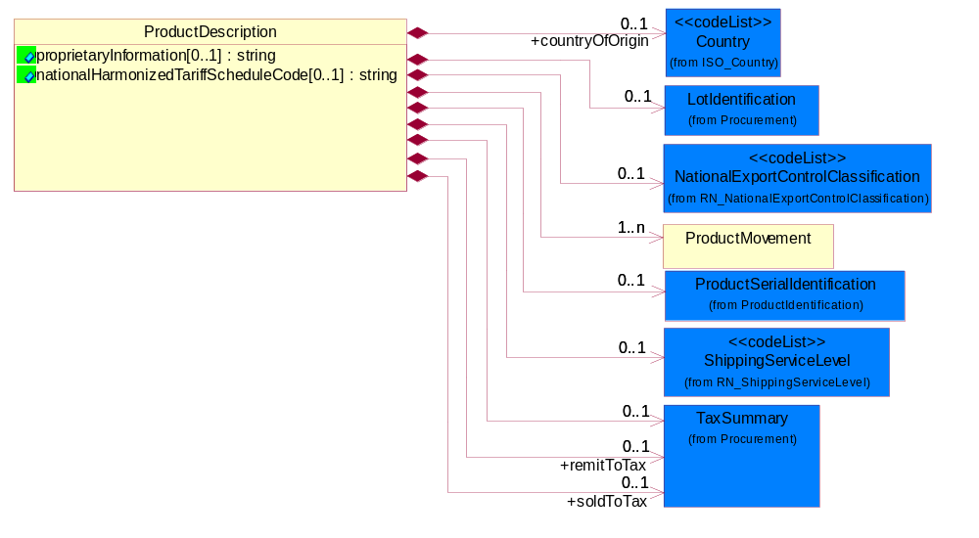
Figure ‎2-5 ProductDescription

Attribute | Type | Documentation
proprietaryInformation[0..1] | string | A free form textual description of information, relating to a product.
nationalHarmonizedTariffScheduleCode[0..1] | string | Code identifying product classification or procedure classification for international shipping.

Composition | Cardinality | Type | Documentation
countryOfOrigin | 0..1 | Country | Country where product originates.
LotIdentification | 0..1 | LotIdentification | This object identifies a lot which associates the product with a specific group of products with some similar attributes.
ProductMovement | 1..n | ProductMovement | The collection of business properties that describes the log of usage or consumption or arrival of a product.
NationalExportControlClassification | 0..1 | NationalExportControlClassification | Code identifying product classification for export regulation.
ProductSerialIdentification | 0..1 | ProductSerialIdentification | The object provides the serial identifier of a product.
TaxSummary | 0..1 | TaxSummary | The collection of business properties that describe the total tax information for a local, regional or national taxing authority.
remitToTax | 0..1 | TaxSummary | The total tax liability of the party to whom payment is sent.
soldToTax | 0..1 | TaxSummary | The total tax liability of the party that purchases the product.
ShippingServiceLevel | 0..1 | ShippingServiceLevel | Code identifying the shipping service level, e.g., overnight, same day.

ProductMovement
The collection of business properties that describes the log of usage or consumption or arrival of a product.
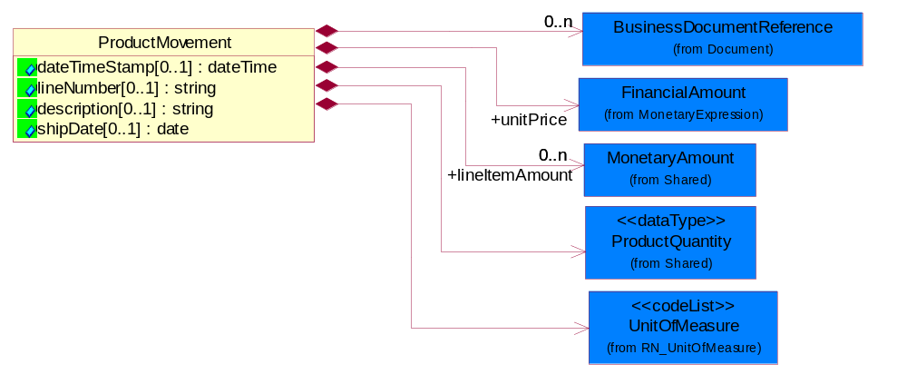
Figure ‎2-6 ProductMovement

Attribute | Type | Documentation
dateTimeStamp[0..1] | dateTime | Specifies an instance in time. Based on the ISO 8601 specification where "YYYY" represents the year, "MM" the month and "DD" the day. The letter "T" is the date/time separator and "hh", "mm", "ss.sss" represent hour, minute and second respectively. This representation is immediately followed by a "Z" to indicate Coordinated Universal Time. Informal format: YYYYMMDDThhmmss
lineNumber[0..1] | string | Number of the line in the document.
description[0..1] | string | Types of possible goods movements and code value set to be agreed between parties. Material consumption from consignment stock can happen under the following scenarios:  · when material is taken into use on the production line,  · when material is send to subcontractor,  · when material is taken to cost center i.e for sample purposes or  · when material is required for delivery.
shipDate[0..1] | date | The (GMT) local date the product is shipped.

Composition | Cardinality | Type | Documentation
BusinessDocumentReference | 0..n | BusinessDocumentReference | The business document reference object allows for the indirect referencing of a relationship to other business related documents.
UnitOfMeasure | 1 | UnitOfMeasure | Code identifying a product unit of measure.
unitPrice | 1 | FinancialAmount | Agreed upon sale price for each unit ordered.
lineItemAmount | 0..n | MonetaryAmount | The monetary value of line item (unit price * qty) or line item allowance.
ProductQuantity | 1 | ProductQuantity | A quantity specifying the number of product units.

SelfBillingInvoiceNotification
A message wrapper for 3C7.

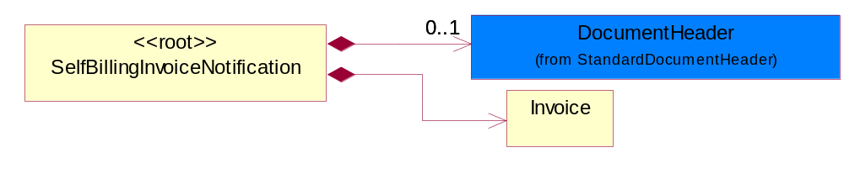
Figure ‎2-7 SelfBillingInvoiceNotification

Composition | Cardinality | Type | Documentation
DocumentHeader | 0..1 | DocumentHeader | The object allows for the identification of the sender and receiver of the business document.
Invoice | 1 | Invoice | An itemized list of goods or services specifying the price and the terms of sale.

Domain Model

Procurement

Procurement

Dependency Diagram
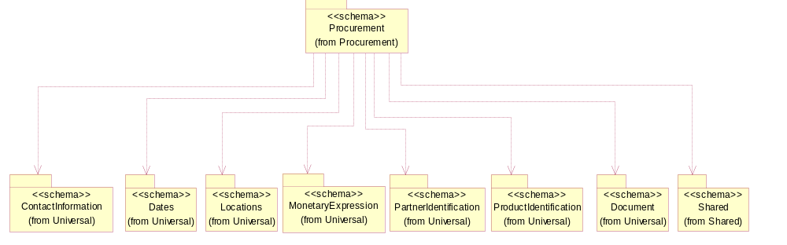
Figure ‎3-8 Dependency

AccountSummary
The collection of business properties that summarizes an account information.
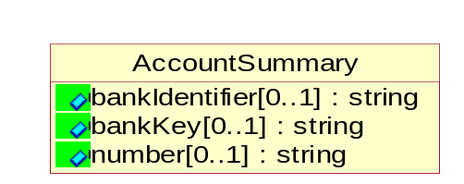
Figure ‎3-9 AccountSummary

Attribute | Type | Documentation
bankIdentifier[0..1] | string | A unique bank identifier such as an ISO standard Bank Identifier Code (BIC) of which SWIFT (Society for Worldwide Interbank Financial Telecommunication) is the registration authority.
bankKey[0..1] | string | Bank sort code required by some banks to enable transfers of funds.
number[0..1] | string | Identification number of an account.

CurrencyConversion
The collection of business properties that describe the exchange of money in circulation.
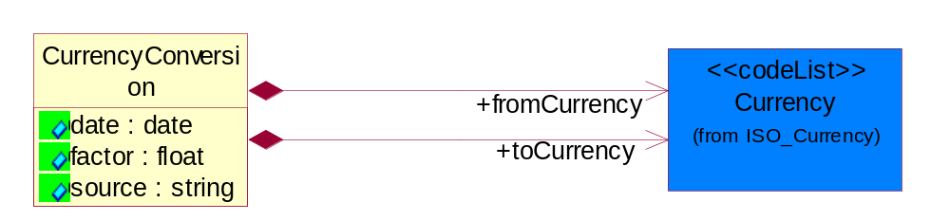
Figure ‎3-10 CurrencyConversion

Attribute | Type | Documentation
date | date | The date of the exchange rate used to convert between currencies.
factor | float | The conversion factor to apply to convert from the currency of the freight charges to the currency used for payment.
source | string | The source of the exchange rate used to convert between currencies.

Composition | Cardinality | Type | Documentation
toCurrency | 1 | Currency | The currency of the receiving partner in a business transaction.
fromCurrency | 1 | Currency | The currency of the initiating partner in a business transaction.

DayOfMonth
Specifies a specific day within a month. Value range from 1 to 31.
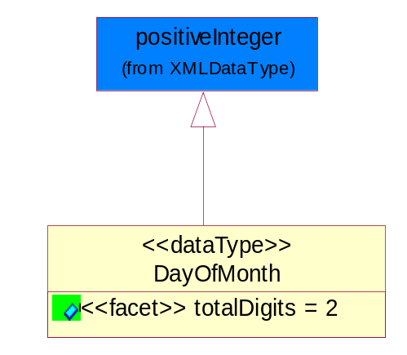
Figure ‎3-11 DayOfMonth

Attribute | Type | Documentation
totalDigits |  | Value with specific maximum number of decimal digits. For more information, see the W3C XML Schema Part 2: Datatypes Recommendation at http://www.w3.org/TR/2001/REC-xmlschema-2-20010502/#element-totalDigits.

Discounts
The collection of business properties that describe payment discounts.
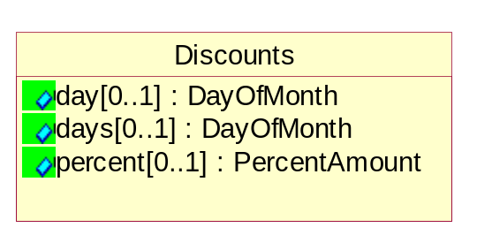
Figure ‎3-12 Discounts

Attribute | Type | Documentation
day[0..1] | DayOfMonth | The specific day of the month a payment is required in order to receive a discount.
days[0..1] | DayOfMonth | The number of days within which a payment is required in order to receive a discount.
percent[0..1] | PercentAmount | The financial percent representing a reduction to the total amount due.

Financing
The collection of business properties that describe financial information.
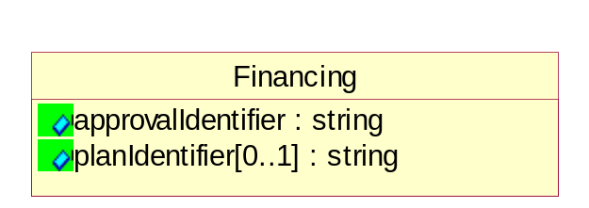
Figure ‎3-13 Financing

Attribute | Type | Documentation
approvalIdentifier | string | The unique number that identifies the approval of a request.
planIdentifier[0..1] | string | The unique number that identifies the tool by which the payment will be made.

LotIdentification
This object identifies a lot which associates the product with a specific group of products with some similar attributes.
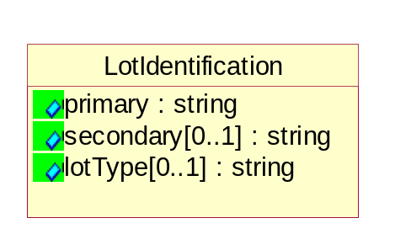
Figure ‎3-14 LotIdentification

Attribute | Type | Documentation
primary | string | The primary lot identifier
secondary[0..1] | string | The secondary lot identifier
lotType[0..1] | string | Identify the type of the lot whether it's for Production or Engineering.

NetTerms
The collection of business properties that describe net payment due terms.
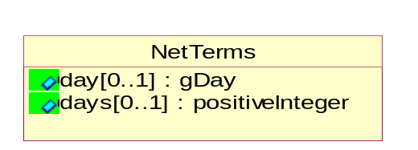
Figure ‎3-15 NetTerms

Attribute | Type | Documentation
day[0..1] | gDay | The specific day of the month a payment is due without incurring late charges.
days[0..1] | positiveInteger | The number of days within which a payment is due without incurring late charges.

PaymentTerms
The collection of business properties that describe payment terms.
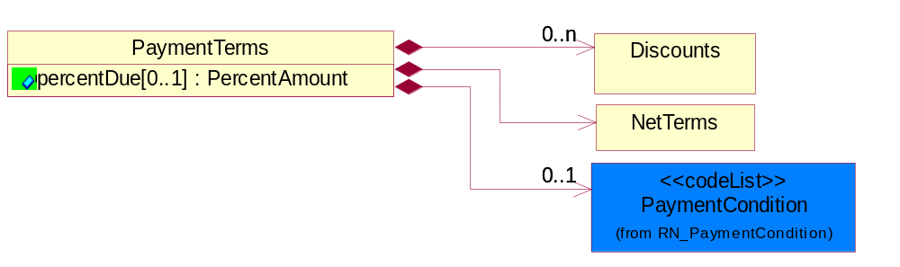
Figure ‎3-16 PaymentTerms

Attribute | Type | Documentation
percentDue[0..1] | PercentAmount | The amount owed expressed as a percentage.

Composition | Cardinality | Type | Documentation
PaymentCondition | 0..1 | PaymentCondition | A code identifying the conditions under which payment will be made.
Discounts | 0..n | Discounts | The collection of business properties that describe payment discounts.
NetTerms | 1 | NetTerms | The collection of business properties that describe net payment due terms.

TaxInformation
The collection of business properties that describe tax information.
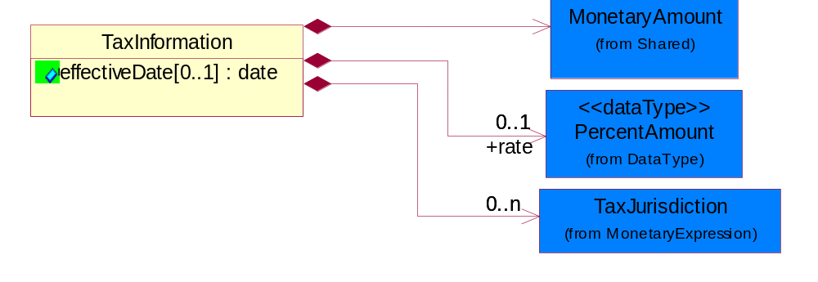
Figure ‎3-17 TaxInformation

Attribute | Type | Documentation
effectiveDate[0..1] | date | The date tax become effective or applicable.

Composition | Cardinality | Type | Documentation
TaxJurisdiction | 0..n | TaxJurisdiction | The business document must identify the specific tax collection authority.
rate | 0..1 | PercentAmount | The rate used to calculate tax liability.
MonetaryAmount | 1 | MonetaryAmount | The collection of business properties that describe the monetary amount defined by a specified currency.

TaxPhrase

The collection of business properties that describe VAT specific information.
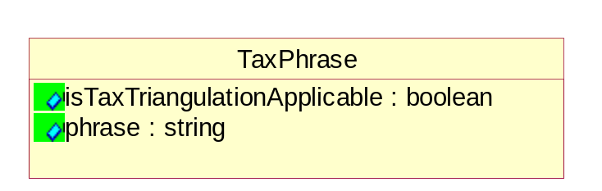
Figure ‎3-18 TaxPhrase

Attribute | Type | Documentation
isTaxTriangulationApplicable | boolean | Indicates whether intermediate suppliers in a triangulation chain may be able to use a simplified procedure available throughout the EC. Triangulation is a name for a type of transaction that can apply only to EU VAT registered companies dispatching goods to countries within the EU.
phrase | string | Country or territory specific tax qualifier verbiage as and when required for tax audit purposes. Such verbiage should be transmitted and stored with the invoice, and may be required to be in local language. Trading Partners are responsible for ensuring that appropriate verbiage is included as per individual tax authority requirements.

TaxSummary
The collection of business properties that describe the total tax information for a local, regional or national taxing authority.
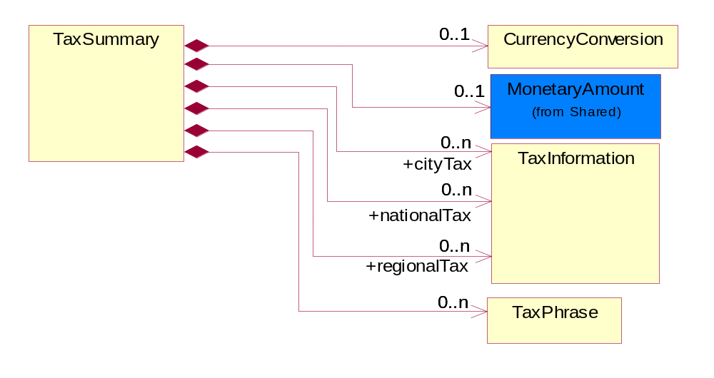
Figure ‎3-19 TaxSummary

Composition | Cardinality | Type | Documentation
CurrencyConversion | 0..1 | CurrencyConversion | The collection of business properties that describe the exchange of money in circulation.
TaxPhrase | 0..n | TaxPhrase | The collection of business properties that describe VAT specific information.
cityTax | 0..n | TaxInformation | The collection of business properties that describe tax information for the city levying the tax.
nationalTax | 0..n | TaxInformation | The collection of business properties that describe tax information for the country levying the tax.
regionalTax | 0..n | TaxInformation | The collection of business properties that describe tax information for the region levying the tax.
MonetaryAmount | 0..1 | MonetaryAmount | The collection of business properties that describe the monetary amount defined by a specified currency.

CodeList

PaymentCondition
A code identifying the conditions under which payment will be made.
Name | Documentation
ACC | Acceptance - Acceptance by buyer of tool/machine to be in working order per spec/contract.
CON | Consumption.
REG | Receipt of Goods.
REI | Receipt of Invoice.
SHI | Shipment.

ShipmentTerms
Code identifying the terms under which a product is shipped.
Name | Documentation
ADC | Advance collect.
ADP | Advance prepaid.
CAA | Cash in advance.
CAD | Cash on delivery.
CFC | Collect, freight credited to payment customer.
CFR | Cost and freight.
CIF | Cost, Insurance and Freight.
CIP | Carriage and Insurance Paid to.
COL | Collect.
CPT | Carriage Paid To.
CRC | Credit card.
CUP | Customer pick-up/backhaul.
DAF | Delivered at Frontier.
DDP | Delivered Duty Paid.
DDU | Delivered Duty Unpaid
DEQ | Delivered Exquay.
DES | Delivered Ex Ship.
EXW | Ex Works.
FAS | Free Alongside Ship.
FCA | Free Carrier.
FOB | Free On Board.
LEC | Letter of Credit.
NOS | Not specified.
PAE | Payable elsewhere.
PCC | Prepaid but charged to customer.
PIU | Pickup.
PRE | Prepaid only.
PRS | Prepaid (by seller).
RFC | Return container freight paid by customer.
RFF | Return container freight free.
RFS | Return container freight paid by supplier.
TPP | Third Party Pay.

SaleType
Code identifying the type of sale terms the trading partner bought from the seller.
Name | Documentation
CRD | Credit.
CSG | Product has been re-sold.
CSH | Cash.
INS | Installment.
LSE | Product has been leased.
PUR | Product has been purchased or bought.
RMK | Product has been repackaged, refurbished, etc. and has been sold.

Logistics

Logistics

Dependency Diagram
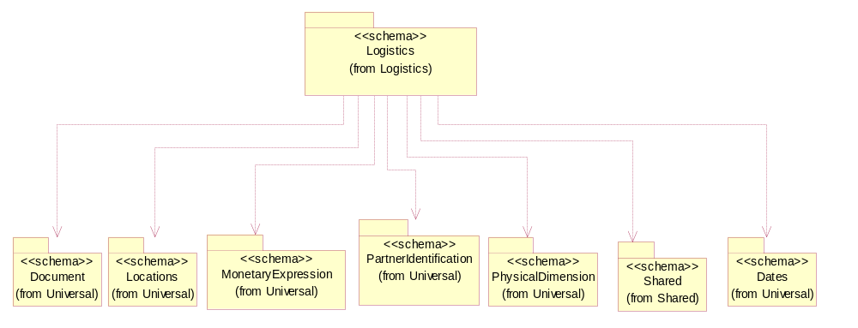
Figure ‎3-20 Dependency

CodeList

NationalExportControlClassification
Code identifying product classification for export regulation.
Name | Documentation
CLE | Clearance - The cargo will be or has been cleared.
CUC | Already customs cleared in the importing country, arrangement for inspection are not necessary because they were cleared before.
DET | Detention - The cargo has been or will be detained.
DOR | Documents Required - Pertinent documents are required.
DRC | Documents Requirements Completed - All requirements for documents have been completed.
FUM | Fumigation - The cargo has been or will be fumigated.
IAC | Inspection Arrangements Completed - Arrangements for inspection of the cargo have been completed.
IAR | Inspection Arrangements Required - Arrangements for inspection of the cargo are required.
INS | Inspection - The cargo has been or will be inspected.
LWI | Lowest Importance.
NCP | No Customs Procedure - Customs clearance not required.
SAC | Safety Arrangements Completed - Arrangements for safeguarding the cargo have been completed.
SAR | Safety Arrangements Required - Arrangements for safeguarding the cargo are required.
SCR | Security - The cargo has been or will be secured.
SEC | Security Arrangements Completed - Arrangements for storing the cargo have been completed.
SER | Security Arrangements Required - Arrangements for the security of the cargo are required.
STR | Storage arrangements required - Arrangements for storing the cargo are required.
TAC | Transport Arrangements Completed - All arrangements for transport have been completed.
TAR | Transport Arrangements Required - Transport has to be arranged.

Shared

Shared

Dependency Diagram
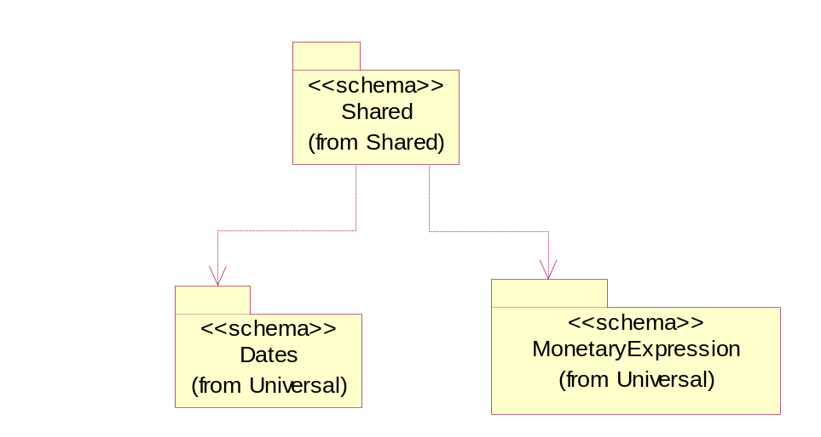
Figure ‎3-21 Dependency

MonetaryAmount
The collection of business properties that describe the monetary amount defined by a specified currency.
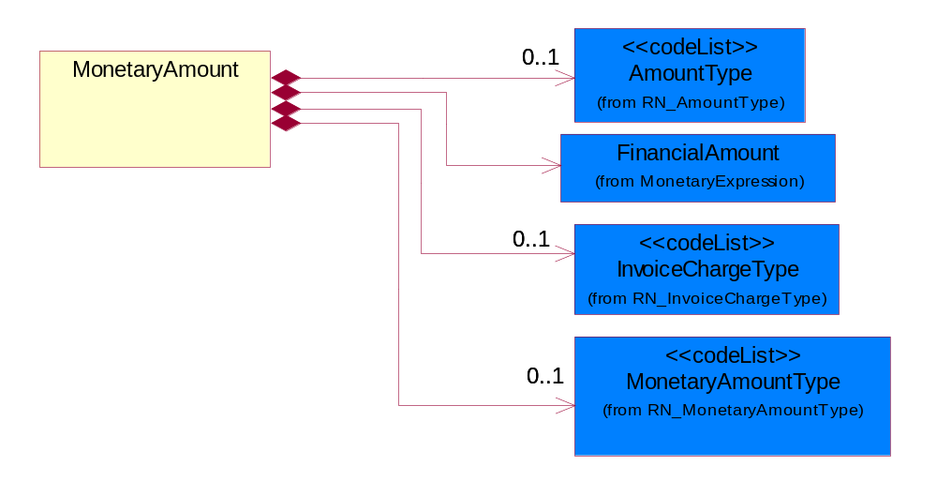
Figure ‎3-22 MonetaryAmount

Composition | Cardinality | Type | Documentation
FinancialAmount | 1 | FinancialAmount | The business document must express financial amounts.
InvoiceChargeType | 0..1 | InvoiceChargeType | Code identifying the values for the types of charges contained in an invoice.
MonetaryAmountType | 0..1 | MonetaryAmountType | Code identifying whether the monetary amount is a debit or credit.
AmountType | 0..1 | AmountType

ProductQuantity
A quantity specifying the number of product units.
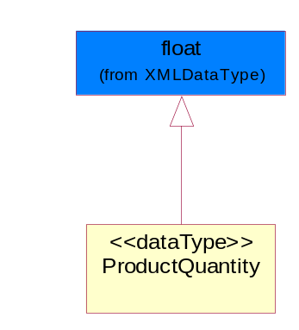
Figure ‎3-23 ProductQuantity

CodeList

InvoiceChargeType
Code identifying the values for the types of charges contained in an invoice.
Name | Documentation
ALC | Allowances and Charges.
CUC | Custom Charges.
DEA | Deposit Amount.
ESC | Expedited Shipping Charge - Charge for accelerating the delivery of a product.
FRC | Freight Charges.
HAC | Handling Charges.
LEC | Lease Charge - Charge for the use of a product in which the purchaser assumes certain responsibilities of ownership.
LIC | License Charge - Charge for the use of a product (usually software) in which the manufacturer maintains ownership of the product.
MAC | Maintenance Charge - Charge (usually periodic) for providing maintenance support for a product.
PUC | Purchase Charge - Charge for a product in which the buyer takes all responsibilities of ownership.
QUD | Quantity Discount.
REC | Rental Charge - Charge for the use of a product (usually hardware) in which the manufacturer maintains ownership of the product.

MonetaryAmountType
Code identifying whether the monetary amount is a debit or credit.
Name | Documentation
CRE | Credit.
DEB | Debit.
ZER | Zero remit.

ShippingServiceLevel
Code identifying the shipping service level, e.g., overnight, same day.
Name | Documentation
1BD | 1BD, Same Business Day - 4 hour Response Time.
5BD | 5 Business Days.
9AM | 9 A.M.
ACH | Air Charter.
AEC | Air Economy.
AIC | Air Cargo.
AM | A.M.
ARS | Authorized Return Service.
ATA | Airport to Airport.
ATD | Airport to Door.
BCT | Bulk Commodity Train.
BUC | Business Class.
CBS | Consignee Billing Service.
COE | Courier Express.
DCR | Delivery Confirmation Return.
DEC | Delivery Confirmation.
DES | Deferred Service.
DNO | Delivery Notification Only.
DOS | Door Service.
DSN | Delivery scheduled next day by cartage agent.
DSS | Delivery scheduled second day by cartage agent.
DST | Delivery scheduled third day by cartage agent.
DTA | Door to Airport.
DTD | Door to Door.
DTP | Door to Port (Ocean).
ESP | Express Service Plus.
ESV | Expedited Service.
ESW | Expedited Service Worldwide.
EXS | Express Service.
EXW | Express Service - Worldwide.
FIC | First Class.
GEN | General.
GRO | Ground.
ISS | Other intermodal and stack service.
MAF | Manifest freight.
MET | Metro.
MUW | Multiweight.
NBD | Next Business Day.
NDA | Next Day Air.
NEM | Next Morning.
NFO | Next Flight Out.
NHW | Next day Hundred Weight.
NOR | NORMAL - Normal delivery.
NOS | Not served.
OIS | Other Intermodal and Stack service
OTH | Other.
OVN | Overnight.
PAS | Passenger service.
PIU | Pickup.
PM | PM.
PMI | Priority Mail Insured.
POB | P.O. Box/Zip code.
POD | Proof of Delivery (POD) with Signature.
PRM | Priority Mail.
PRS | Premium Surface.
PS1 | Primary Service Area - Next Day by 10:30 A.M.
PS2 | Primary Service Area - Next Day by 5:00 P.M.
PS3 | Primary Service Area - Next Day By 9:30 A.M.
PS4 | Primary Service Area - Next Day by Noon.
PS5 | Primary Service Area - Second Day by Noon.
PTD | Port to Door (Ocean).
PTP | Port to Port (Ocean).
REG | Regular.
SAD | Same day.
SAP | Saturday Pickup.
SAT | Saturday.
SBD | SBD, Second Business Day.
SCH | Scheduled.
SDA | Second Day Air.
SDW | Second Day Hundred Weight.
SED | Second Day.
SEM | Second Morning.
SGW | Standard Ground Hundred Weight.
STC | Standard Class.
STG | Standard Ground.
STO | Standard Ocean.
STS | Standard Service.
SUH | Sunday and Holidays.
TDS | Three Day Service.
TIC | Time Critical.
TRG | Tracking - Ground.

AmountType
Name | Documentation
DIS | Discount Value - The monetary amount of the discount on the price applied to a customer order.
FRE | Freight Charges - The monetary amount to be paid for freight transportation.
INS | InsuranceCharges - The monetary amount to be paid for freight insurance.
MAT | Material Cost - This object represents the material cost for the product.
MIS | Miscellaneous Charges - The monetary amount to be paid for miscellaneous charges.
PRC | Processing Charges - The monetary amount to be paid by consignee for consignment manufacturer.
TOD | Total Amount Due - Total amount due upon receipt of statement.
TOT | Total Amount - Total price for an entire business document.
TOV | Total Value Added Amount - The total amount of the shipment including any value added tax.
UNI | Unit Price - Agreed upon sale price for each unit ordered.
VAD | Value Added Unit Price - The price of a unit including any value added tax.

Universal Structure

ContactInformation

ContactInformation
The business document must allow for the identification of the name of the department, service or individual to be contacted regarding the context of the business document.
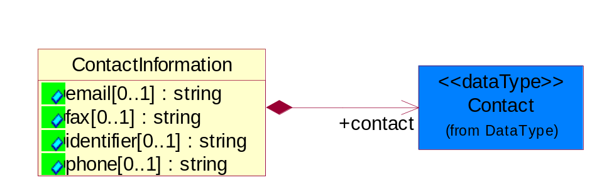
Figure ‎4-24 ContactInformation

Attribute | Type | Documentation
email[0..1] | string | The electronic mail for the specified contact.
fax[0..1] | string | The fax number for the specified contact.
identifier[0..1] | string | Identifies the role of the contact (i.e. Service Technician, Account Manager) in the Business Process.
phone[0..1] | string | The telephone number for the specified contact.

Composition | Cardinality | Type | Documentation
contact | 1 | Contact | The name of the department, service or individual to be contacted within the organization.

DataType

Contact
The name of the department, service or individual to be contacted within the organization.

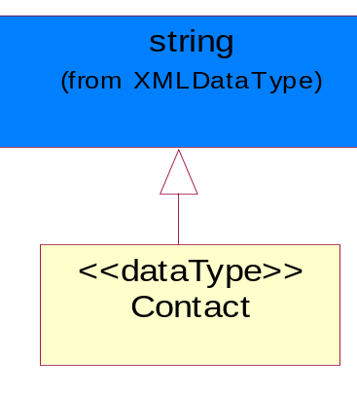
Figure ‎4-25 Contact

DUNS
A number assigned by Dun and Bradstreet to identify a business location.
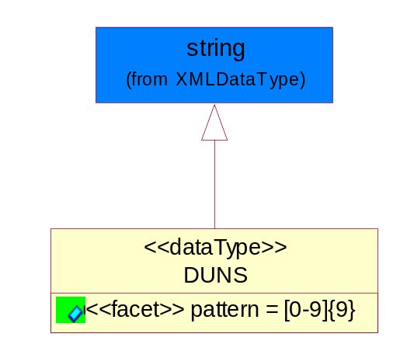
Figure ‎4-26 DUNS

Attribute | Type | Documentation
pattern |  | [0-9]{9}

DUNSPlus4
A identifier to specify a specific location within a business location.
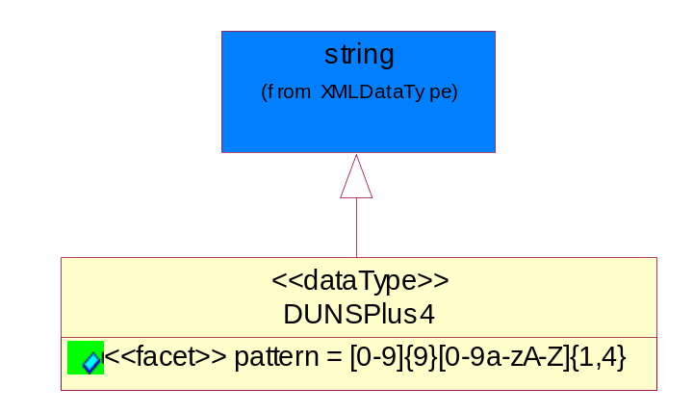
Figure ‎4-27 DUNSPlus4

Attribute | Type | Documentation
pattern |  | Data Universal Numbering System +4 (DUNS+4) number means the DUNS number assigned by Dun and Bradstreet, Inc. (D&B) plus an alphanumeric of length 4 suffix that may be assigned by a business concern.

GLN
Global Location Number (GLN) - A identifier to identify legal entities, trading parties and location.
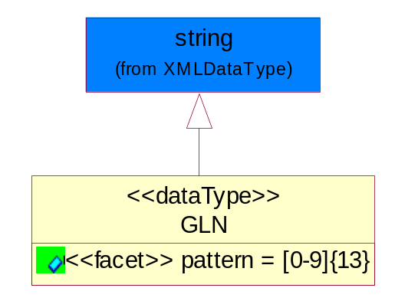
Figure ‎4-28 GLN

Attribute | Type | Documentation
pattern |  | [0-9]{13}

GTIN
Global Trade Identification Number (GTIN).
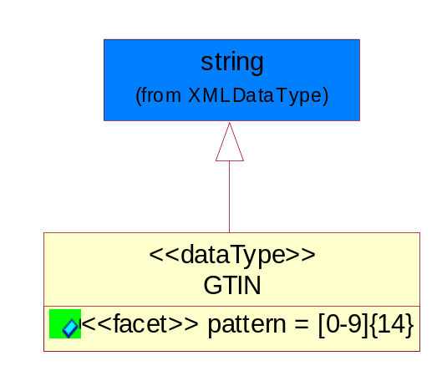
Figure ‎4-29 GTIN

Attribute | Type | Documentation
pattern |  | [0-9]{14}

PercentAmount
A number representing a percentage value, e.g. 75.125 represents 75 1/8 percent.
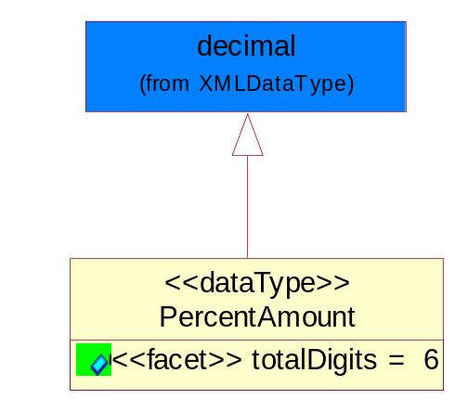
Figure ‎4-30 PercentAmount

Attribute | Type | Documentation
totalDigits |  | 6

Dates

Document

BusinessDocumentReference
The business document reference object allows for the indirect referencing of a relationship to other business related documents.
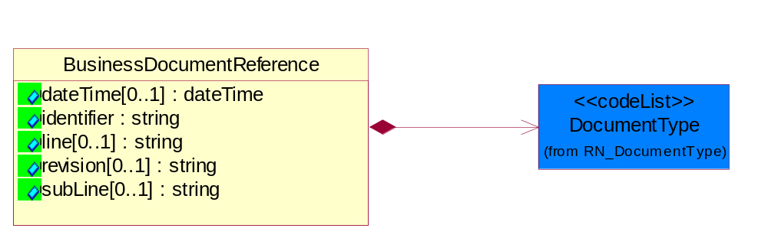
Figure ‎4-31 BusinessDocumentReference

Attribute | Type | Documentation
dateTime[0..1] | dateTime | The date-time stamp indicating on the referenced business document.
identifier | string | Unique identification of the referenced business document.
line[0..1] | string | References the specific line number of the specified business document.
revision[0..1] | string | Referenced the revision of the specified business document.
subLine[0..1] | string | References the specific subline number of the specified business document.

Composition | Cardinality | Type | Documentation
DocumentType | 1 | DocumentType | A code identifying the business context of a document.

Locations

AlternativeIdentifier
Identifies the specified code and the name of the organization that a code is utilized from.
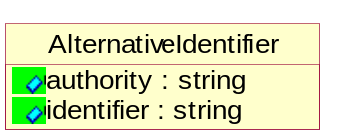
Figure ‎4-32 AlternativeIdentifier

Attribute | Type | Documentation
authority | string | The name of the organization that a code is utilized from.
identifier | string | The specified code to represent an entity (e.g. product, location, partner, etc.)

Location
The business document must specify a location.
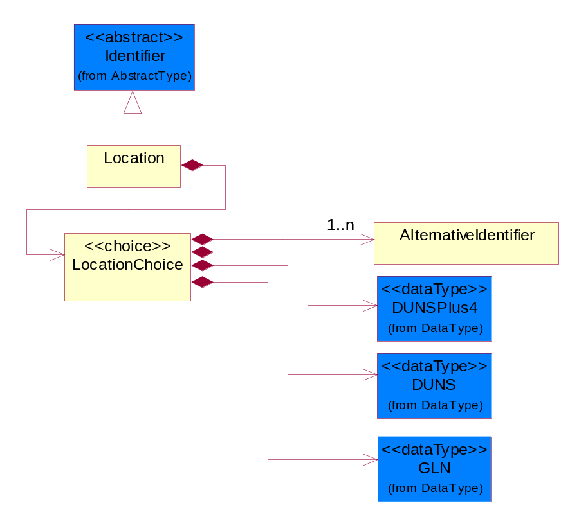
Figure ‎4-33 Location
Composition | Cardinality | Type | Documentation
LocationChoice | 1 | LocationChoice

LocationChoice

Composition | Cardinality | Type | Documentation
DUNSPlus4 | 1 | DUNSPlus4 | A identifier to specify a specific location within a business location.
DUNS | 1 | DUNS | A number assigned by Dun and Bradstreet to identify a business location.
AlternativeIdentifier | 1..n | AlternativeIdentifier | Identifies the specified code and the name of the organization that a code is utilized from.
GLN | 1 | GLN | Global Location Number (GLN) - A identifier to identify legal entities, trading parties and location.

PhysicalAddress
The business document must provide a physical address for a party to the business transaction.
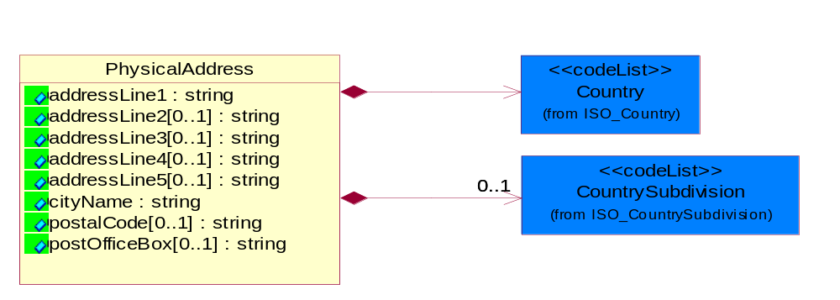
Figure ‎4-34 PhysicalAddress

Attribute | Type | Documentation
addressLine1 | string | The first line of a physical address.
addressLine2[0..1] | string | The second line of a physical address.
addressLine3[0..1] | string | The third line of a physical address.
addressLine4[0..1] | string | The fourth line of a physical address.
addressLine5[0..1] | string | The fifth line of a physical address.
cityName | string | The name of a city.
postalCode[0..1] | string | Identifying geographic location as specified by a national postal code.
postOfficeBox[0..1] | string | The Post Office Box identifier used to identify a party's post office box.

Composition | Cardinality | Type | Documentation
Country | 1 | Country | For representation of Country name RosettaNet has adopted ISO 3166-3; 1999. Refer to the following web page to get the latest version of the standard:  http://www.iso.ch/iso/en/prods-services/iso3166ma/02iso-3166-code-lists/index.html  If you need more information about the ISO standard please contact ISO for more details.
CountrySubdivision | 0..1 | CountrySubdivision | For representation of a Countries subdivisions RosettaNet has adopted ISO 3166-3; 1999. Refer to the following web page to get the latest version of the standard:  http://www.iso.ch/iso/en/prods-services/iso3166ma/02iso-3166-code-lists/index.html  If you need more information about the ISO standard please contact ISO for more details.

MonetaryExpression

FinancialAmount
The business document must express financial amounts.
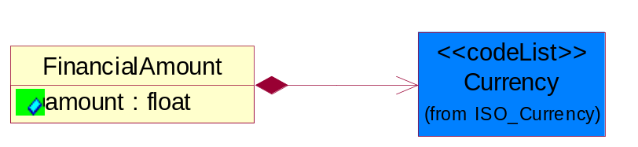
Figure ‎4-35 FinancialAmount

Attribute | Type | Documentation
amount | float | Specifies the monetary amount.

Composition | Cardinality | Type | Documentation
Currency | 1 | Currency | For representation of Currency codes RosettaNet has adopted ISO 4217; 1995. The British Standards Institution (BSI) is the ISO 4217 Maintenance Agency. Refer to the following web page to get the latest version of the standard:  http://www.bsi-global.com/Technical+Information/Publications/_Publications/tig90.xalter  If you need more information about the ISO standard please contact ISO for more details.

TaxJurisdiction
The business document must identify the specific tax collection authority.
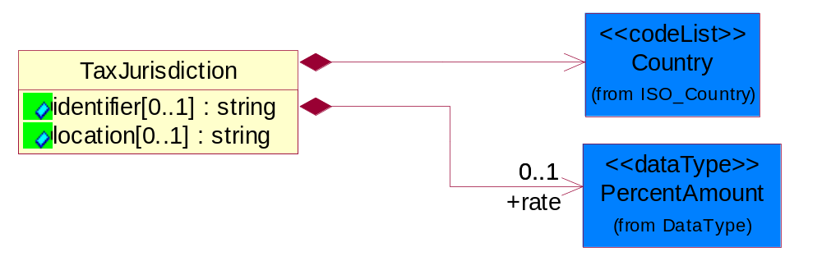
Figure ‎4-36 TaxJurisdiction

Attribute | Type | Documentation
identifier[0..1] | string | Unique identification for a taxing authority.
location[0..1] | string | Identification of the tax collection authority location.

Composition | Cardinality | Type | Documentation
rate | 0..1 | PercentAmount | A number representing a percentage value, e.g. 75.125 represents 75 1/8 percent.
Country | 1 | Country | For representation of Country name RosettaNet has adopted ISO 3166-3; 1999. Refer to the following web page to get the latest version of the standard:  http://www.iso.ch/iso/en/prods-services/iso3166ma/02iso-3166-code-lists/index.html  If you need more information about the ISO standard please contact ISO for more details.

PartnerIdentification

PartnerIdentification
The business document must allow for the identity of one or more parties to the transaction.
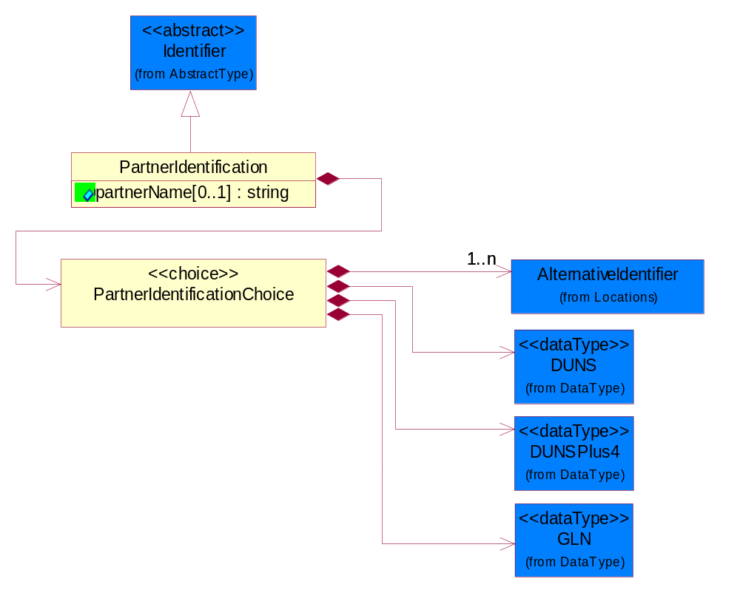
Figure ‎4-37 PartnerIdentification

Attribute | Type | Documentation
partnerName[0..1] | string | The name of the partner’s company/business.

Composition | Cardinality | Type | Documentation
PartnerIdentificationChoice | 1 | PartnerIdentificationChoice

PartnerIdentificationChoice

Composition | Cardinality | Type | Documentation
DUNS | 1 | DUNS | A number assigned by Dun and Bradstreet to identify a business location.
DUNSPlus4 | 1 | DUNSPlus4 | A identifier to specify a specific location within a business location.
AlternativeIdentifier | 1..n | AlternativeIdentifier | Identifies the specified code and the name of the organization that a code is utilized from.
GLN | 1 | GLN | Global Location Number (GLN) - A identifier to identify legal entities, trading parties and location.

SpecifiedFullPartner
The business document must describe the trading partners in the business transaction. This data structure provide the flexibility to describe a partner in all possible methods as for new, existing or known partner. This is specifically for partner who role has been specified.
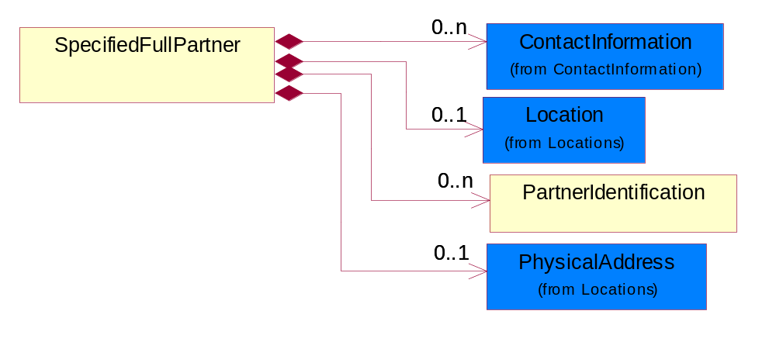
Figure ‎4-38 SpecifiedFullPartner

Composition | Cardinality | Type | Documentation
ContactInformation | 0..n | ContactInformation | The business document must allow for the identification of the name of the department, service or individual to be contacted regarding the context of the business document.
Location | 0..1 | Location | The business document must specify a location.
PartnerIdentification | 0..n | PartnerIdentification | The business document must allow for the identity of one or more parties to the transaction.
PhysicalAddress | 0..1 | PhysicalAddress | The business document must provide a physical address for a party to the business transaction.

SpecifiedIntermittentPartner
The business document must describe a physical address for a delivery.
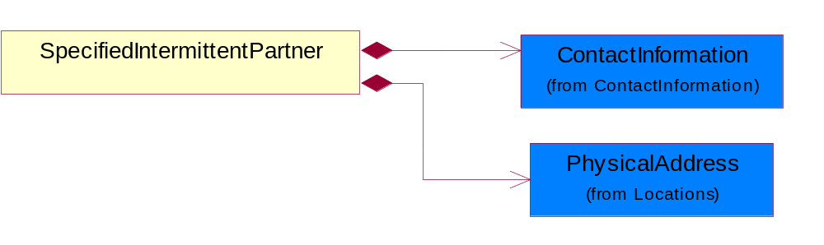
Figure ‎4-39 SpecifiedIntermittentPartner

Composition | Cardinality | Type | Documentation
ContactInformation | 1 | ContactInformation | The business document must allow for the identification of the name of the department, service or individual to be contacted regarding the context of the business document.
PhysicalAddress | 1 | PhysicalAddress | The business document must provide a physical address for a party to the business transaction.

SpecifiedKnownPartner
The business document must describe the trading partners in the business transaction.
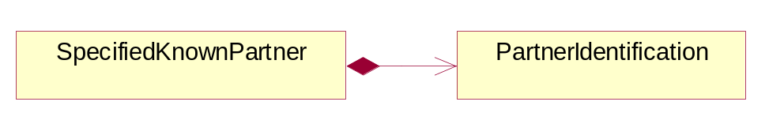
Figure ‎4-40 SpecifiedKnownPartner

Composition | Cardinality | Type | Documentation
PartnerIdentification | 1 | PartnerIdentification | The business document must allow for the identity of one or more parties to the transaction.

SpecifiedKnownPartnerContact
The business document must describe the trading partners in the business transaction and allow for a identification of an individual of the trading partner.
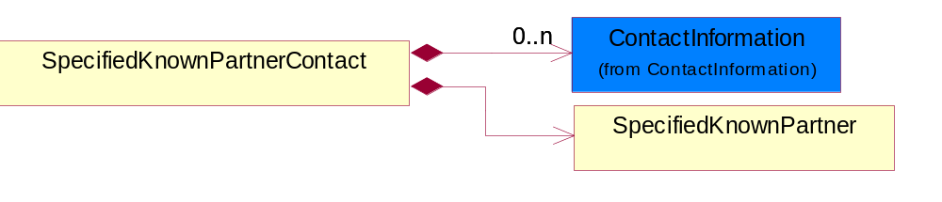
Figure ‎4-41 SpecifiedKnownPartnerContact

Composition | Cardinality | Type | Documentation
SpecifiedKnownPartner | 1 | SpecifiedKnownPartner | The business document must describe the trading partners in the business transaction.
ContactInformation | 0..n | ContactInformation | The business document must allow for the identification of the name of the department, service or individual to be contacted regarding the context of the business document.

SpecifiedNewPartner
The business document must describe a new, existing (but known to only one of the parties to the transaction) or an unknown party to the business transaction.
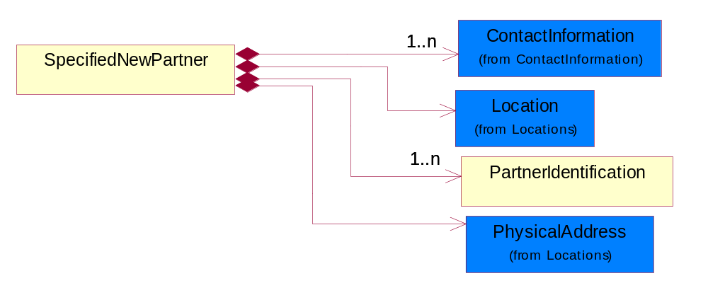
Figure ‎4-42 SpecifiedNewPartner

Composition | Cardinality | Type | Documentation
ContactInformation | 1..n | ContactInformation | The business document must allow for the identification of the name of the department, service or individual to be contacted regarding the context of the business document.
Location | 1 | Location | The business document must specify a location.
PhysicalAddress | 1 | PhysicalAddress | The business document must provide a physical address for a party to the business transaction.
PartnerIdentification | 1..n | PartnerIdentification | The business document must allow for the identity of one or more parties to the transaction.

SpecifiedPartnerDescription
The collection of business properties that describe a business partners' identity, their contact information, where they are physically located and their function in a supply chain.
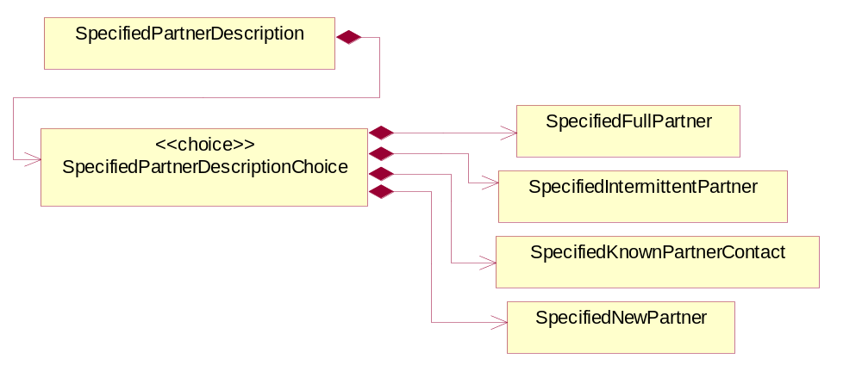
Figure ‎4-43 SpecifiedPartnerDescription

Composition | Cardinality | Type | Documentation
SpecifiedPartnerDescriptionChoice | 1 | SpecifiedPartnerDescriptionChoice

SpecifiedPartnerDescriptionChoice

Composition | Cardinality | Type | Documentation
SpecifiedKnownPartnerContact | 1 | SpecifiedKnownPartnerContact | The business document must describe the trading partners in the business transaction and allow for a identification of an individual of the trading partner.
SpecifiedIntermittentPartner | 1 | SpecifiedIntermittentPartner | The business document must describe a physical address for a delivery.
SpecifiedNewPartner | 1 | SpecifiedNewPartner | The business document must describe a new, existing (but known to only one of the parties to the transaction) or an unknown party to the business transaction.
SpecifiedFullPartner | 1 | SpecifiedFullPartner | The business document must describe the trading partners in the business transaction. This data structure provide the flexibility to describe a partner in all possible methods as for new, existing or known partner. This is specifically for partner who role has been specified.

PhysicalDimension

ProductIdentification

ProductIdentification
The object provides the identifier(s) of a product.
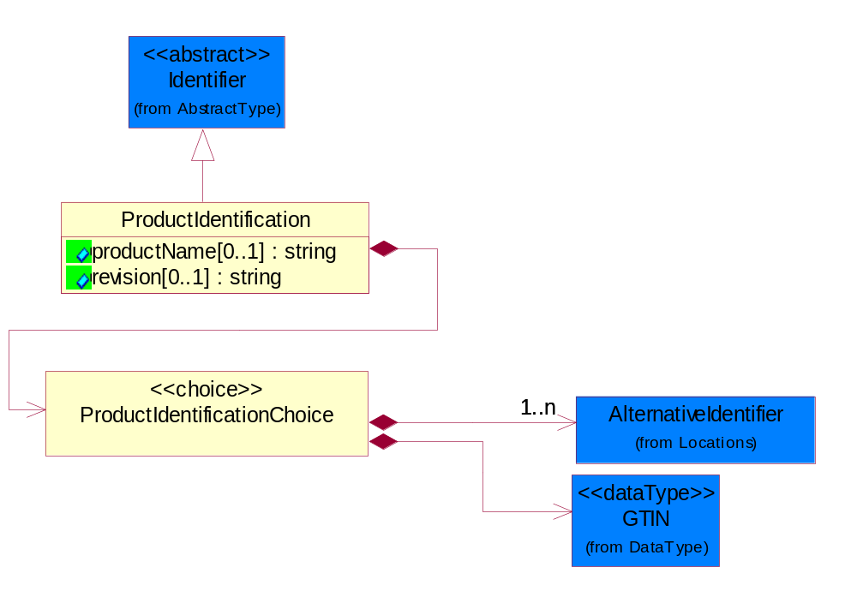
Figure ‎4-44 ProductIdentification

Attribute | Type | Documentation
productName[0..1] | string | The name of the product.
revision[0..1] | string | Referenced the specified product revision.

Composition | Cardinality | Type | Documentation
ProductIdentificationChoice | 1 | ProductIdentificationChoice

ProductIdentificationChoice

Composition | Cardinality | Type | Documentation
AlternativeIdentifier | 1..n | AlternativeIdentifier | Identifies the specified code and the name of the organization that a code is utilized from.
GTIN | 1 | GTIN | Global Trade Identification Number (GTIN).

ProductSerialIdentification
The object provides the serial identifier of a product.
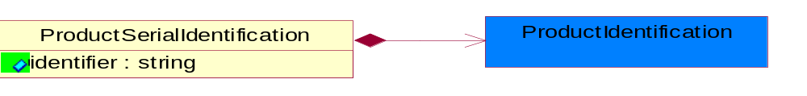
Figure ‎4-45 ProductSerialIdentification

Attribute | Type | Documentation
identifier | string | A unique serial identifier assigned to a product.

Composition | Cardinality | Type | Documentation
ProductIdentification | 1 | ProductIdentification | The object provides the identifier(s) of a product.

CodeList

Country
For representation of Country name RosettaNet has adopted ISO 3166-3; 1999. Refer to the following web page to get the latest version of the standard:
http://www.iso.ch/iso/en/prods-services/iso3166ma/02iso-3166-code-lists/index.html

If you need more information about the ISO standard please contact ISO for more details.

CountrySubdivision
For representation of a Countries subdivisions RosettaNet has adopted ISO 3166-3; 1999. Refer to the following web page to get the latest version of the standard:
http://www.iso.ch/iso/en/prods-services/iso3166ma/02iso-3166-code-lists/index.html

If you need more information about the ISO standard please contact ISO for more details.

Currency
For representation of Currency codes RosettaNet has adopted ISO 4217; 1995. The British Standards Institution (BSI) is the ISO 4217 Maintenance Agency. Refer to the following web page to get the latest version of the standard:
http://www.bsi-global.com/Technical+Information/Publications/_Publications/tig90.xalter

If you need more information about the ISO standard please contact ISO for more details.

Language
For representation of Language name RosettaNet has adopted ISO 639-2; 1998. Refer to the following web page to get the latest version of the standard:

http://www.loc.gov/standards/iso639-2/iso639jac.html

If you need more information about the ISO standard please contact ISO for more details.

DocumentType
A code identifying the business context of a document.
Instance | Documentation
CBN | Product batch number of customer.
CCN | Customs clearance number.
CFA | Failure Analysis - Request document that will accompany the product providing characteristics of the component failure.
CIN | Commercial Invoice.
CNM | Traditional credit note or memo.
CON | In a virtual sourcing relationship, a third party trading partner is supplying a part to a customer on behalf of another company that has taken the order for the customer. In this case a Customer Order Number is associated to the request for material that is sent to the virtual trading partners.
COT | Contract.
CRN | Unique consumption reference number identifying the product consumption issue i.e. one-to-one relationship with physical flow.
DEM | Traditional debit note or memo.
DEN | Delivery Note.
DIN | Discontinuation Notice.
DRN | Drawing Number.
FUO | Sales order or transfer order fulfilling demand out of a facility (outbound shipment).
INV | Invoice.
LID | Location Identifier. Data for on-site work that have to be done on the machine (associated with preventive maintenance order)
MEN | Master Event Number.
MID | Machine Identifier. Data for on-site work that have to be done on the machine (associated with preventive maintenance order)
MON | Model Number.
OCL | The unique identifier assigned by the OEM for a warranty claim.
OGA | Other governmental agency issued document.
OPO | The unique identifier assigned by the OEM for a part order.
OPR | The unique identifier assigned by the OEM for a part return.
PFA | Failure Analysis - Request document that will accompany the product providing characteristics of the product failure.
PII | Refers to previously issued invoice.
PLS | Unique number that identifies packing form prior to shipment.
POI | Purchase Order IN.
PON | Production order number for material release.
POO | Purchase Order OUT
PRC | Product Catalog.
PSI | Refers to previously issued self-billing invoice.
PUO | Purchase Order.
QUO | Quote.
REC | Document identifying the receipt of materials or products into a facility against a purchase order or transfer order (inbound shipment).
REO | Purchase order or transfer order replenishing inventory into a facility (inbound shipment).
REQ | Requisition.
RMA | Returned Material Authorization.
RPO | Purchase order for materials or product returned to and reworked by a supplier.
RTA | Remittance Advice - Remittance details.
SAO | Sales Order.
SBC | Credit Memo used in self-billing scenario.
SBD | Debit Memo used in self-billing scenario.
SBI | Invoice in self billing scenario.
SBN | Product batch number of supplier.
SCA | Similar to contracts - Contains the quantity of an article that is to be ordered from a vendor and the price for article or service that is to be procured.
SEN | Serial Number.
SEO | A document that gives a repair provider the necessary authorization to repair or upgrade a product either at the customer site or at the repair provider’s site.
SHD | Shipping Document.
SNC | Shipset Number on Code List.
SPC | The unique identifier assigned by the ASP for a warranty claim.
SPN | Spec Number.
SPO | The unique identifier assigned by the ASP for a part order.
SPR | The unique identifier assigned by the ASP for a part return.
SPW | The unique identifier assigned by the ASP to reference a work order.
SRI | A document that contains the shipping reference number which allows the product to be tracked within the outsourced logistic providers network.
TRO | Order which results in materials or products being moved from one facility to another (outbound shipment and inbound shipment).
WAB | Waybill.
WAC | Denotes a warranty claim.
WOO | Work Order.

MimeTypeQualifier
The MIME type as defined by IANA.
Please refer to http://www.iana.org/assignments/media-types/ for a list of types.
Instance | Documentation
application/activemessage | [Shapiro]
application/andrew-inset | [Borenstein]
application/applefile | [Faltstrom]
application/atomicmail | [Borenstein]
application/batch-SMTP | [RFC2442]
application/beep+xml | [RFC3080]
application/cals-1840 | [RFC1895]
application/cnrp+xml | [RFCCNRP]
application/commonground | [Glazer]
application/cpl+xml
application/cybercash | [Eastlake]
application/dca-rft | [Campbell]
application/dec-dx | [Campbell]
application/dicom | [RFC3240]
application/dvcs | [RFC3029]
application/EDI-Consent | [RFC1767]
application/EDIFACT | [RFC1767]
application/EDI-X12 | [RFC1767]
application/eshop | [Katz]
application/font-tdpfr | [RFC3073]
application/http | [RFC2616]
application/hyperstudio | [Domino]
application/iges | [Parks]
application/index | [RFC2652]
application/index.cmd | [RFC2652]
application/index.obj | [RFC2652]
application/index.response | [RFC2652]
application/index.vnd | [RFC2652]
application/iotp | [RFC2935]
application/ipp | [RFC2910]
application/isup | [RFC3204]
application/mac-binhex40 | [Faltstrom]
application/macwriteii | [Lindner]
application/marc | [RFC2220]
application/mathematica | [Van Nostern]
application/msword | [Lindner]
application/news-message-id | [RFC1036,Spencer]
application/news-transmission | [RFC1036, Spencer]
application/ocsp-request | [RFC2560]
application/ocsp-response | [RFC2560]
application/octet-stream | [RFC2045,RFC2046]
application/oda | [RFC2045,RFC2046]
application/ogg | [RFC-walleij-ogg-mediatype-08.txt]
application/parityfec | [RFC3009]
application/pdf | [Lindner]
application/pgp-encrypted | [RFC3156]
application/pgp-keys | [RFC3156]
application/pgp-signature | [RFC3156]
application/pkcs10 | [RFC2311]
application/pkcs7-mime | [RFC2311]
application/pkcs7-signature | [RFC2311]
application/pkix-cert | [RFC2585]
application/pkixcmp | [RFC2510]
application/pkix-crl | [RFC2585]
application/postscript | [RFC2045,RFC2046]
application/prs.alvestrand.titrax-sheet | [Alvestrand]
application/prs.cww | [Rungchavalnont]
application/prs.nprend | [Doggett]
application/prs.plucker | [Janssen]
application/qsig | [RFC3204]
application/reginfo+xml | [RFC-ietf-sipping-reg-event-00.txt]
application/remote-printing | [RFC1486,Rose]
application/riscos | [Smith]
application/rtf | [Lindner]
application/sdp | [RFC2327]
application/set-payment | [Korver]
application/set-payment-initiation | [Korver]
application/set-registration | [Korver]
application/set-registration-initiation | [Korver]
application/sgml | [RFC1874]
application/sgml-open-catalog | [Grosso]
application/sieve | [RFC3028]
application/slate | [Crowley]
application/timestamp-query | [RFC3161]
application/timestamp-reply | [RFC3161]
application/tve-trigger | [Welsh]
application/vemmi | [RFC2122]
application/vnd.3gpp.pic-bw-large | [Meredith]
application/vnd.3gpp.pic-bw-small | [Meredith]
application/vnd.3gpp.pic-bw-var | [Meredith]
application/vnd.3gpp.sms | [Meredith]
application/vnd.3M.Post-it-Notes | [O'Brien]
application/vnd.accpac.simply.aso | [Leow]
application/vnd.accpac.simply.imp | [Leow]
application/vnd.acucobol | [Lubin]
application/vnd.acucorp | [Lubin]
application/vnd.adobe.xfdf | [Perelman]
application/vnd.aether.imp | [Moskowitz]
application/vnd.amiga.ami | [Blumberg]
application/vnd.anser-web-certificate-issue-initiation | [Mori]
application/vnd.anser-web-funds-transfer-initiation | [Mori]
application/vnd.audiograph | [Slusanschi]
application/vnd.blueice.multipass | [Holmstrom]
application/vnd.bmi | [Gotoh]
application/vnd.businessobjects | [Imoucha]
application/vnd.canon-cpdl | [Muto]
application/vnd.canon-lips | [Muto]
application/vnd.cinderella | [Kortenkamp]
application/vnd.claymore | [Simpson]
application/vnd.commerce-battelle | [Applebaum]
application/vnd.commonspace | [Chandhok]
application/vnd.contact.cmsg | [Patz]
application/vnd.cosmocaller | [Dellutri]
application/vnd.ctc-posml | [Kohlhepp]
application/vnd.cups-postscript | [Sweet]
application/vnd.cups-raster | [Sweet]
application/vnd.cups-raw | [Sweet]
application/vnd.curl | [Byrnes]
application/vnd.cybank | [Helmee]
application/vnd.data-vision.rdz | [Fields]
application/vnd.dna | [Searcy]
application/vnd.dpgraph | [Parker]
application/vnd.dreamfactory | [Appleton]
application/vnd.dxr | [Duffy]
application/vnd.ecdis-update | [Buettgenbach]
application/vnd.ecowin.chart | [Olsson]
application/vnd.ecowin.filerequest | [Olsson]
application/vnd.ecowin.fileupdate | [Olsson]
application/vnd.ecowin.series | [Olsson]
application/vnd.ecowin.seriesrequest | [Olsson]
application/vnd.ecowin.seriesupdate | [Olsson]
application/vnd.enliven | [Santinelli]
application/vnd.epson.esf | [Hoshina]
application/vnd.epson.msf | [Hoshina]
application/vnd.epson.quickanime | [Gu]
application/vnd.epson.salt | [Nagatomo]
application/vnd.epson.ssf | [Hoshina]
application/vnd.ericsson.quickcall | [Tidwell]
application/vnd.eudora.data | [Resnick]
application/vnd.fdf | [Zilles]
application/vnd.ffsns | [Holstage]
application/vnd.FloGraphIt | [Floersch]
application/vnd.framemaker | [Wexler]
application/vnd.fsc.weblaunch | [D.Smith]
application/vnd.fujitsu.oasys | [Togashi]
application/vnd.fujitsu.oasys2 | [Togashi]
application/vnd.fujitsu.oasys3 | [Okudaira]
application/vnd.fujitsu.oasysgp | [Sugimoto]
application/vnd.fujitsu.oasysprs | [Ogita]
application/vnd.fujixerox.ddd | [Onda]
application/vnd.fujixerox.docuworks | [Taguchi]
application/vnd.fujixerox.docuworks.binder | [Matsumoto]
application/vnd.fut-misnet | [Pruulmann]
application/vnd.grafeq | [Tupper]
application/vnd.groove-account | [Joseph]
application/vnd.groove-help | [Joseph]
application/vnd.groove-identity-message | [Joseph]
application/vnd.groove-injector | [Joseph]
application/vnd.groove-tool-message | [Joseph]
application/vnd.groove-tool-template | [Joseph]
application/vnd.groove-vcard | [Joseph]
application/vnd.hbci | [Hammann]
application/vnd.hhe.lesson-player | [Jones]
application/vnd.hp-HPGL | [Pentecost]
application/vnd.hp-hpid | [Gupta]
application/vnd.hp-hps | [Aubrey]
application/vnd.hp-PCL | [Pentecost]
application/vnd.hp-PCLXL | [Pentecost]
application/vnd.httphone | [Lefevre]
application/vnd.hzn-3d-crossword | [Minnis]
application/vnd.ibm.afplinedata | [Buis]
application/vnd.ibm.electronic-media | [Tantlinger]
application/vnd.ibm.MiniPay | [Herzberg]
application/vnd.ibm.modcap | [Hohensee]
application/vnd.ibm.secure-container | [Tantlinger]
application/vnd.informix-visionary | [Gales]
application/vnd.intercon.formnet | [Gurak]
application/vnd.intertrust.digibox | [Tomasello]
application/vnd.intertrust.nncp | [Tomasello]
application/vnd.intu.qbo | [Scratchley]
application/vnd.intu.qfx | [Scratchley]
application/vnd.irepository.package+xml | [Knowles]
application/vnd.is-xpr | [Natarajan]
application/vnd.japannet-directory-service | [Fujii]
application/vnd.japannet-jpnstore-wakeup | [Yoshitake]
application/vnd.japannet-payment-wakeup | [Fujii]
application/vnd.japannet-registration | [Yoshitake]
application/vnd.japannet-registration-wakeup | [Fujii]
application/vnd.japannet-setstore-wakeup | [Yoshitake]
application/vnd.japannet-verification | [Yoshitake]
application/vnd.japannet-verification-wakeup | [Fujii]
application/vnd.jisp | [Deckers]
application/vnd.kde.karbon | [Faure]
application/vnd.kde.kchart | [Faure]
application/vnd.kde.kformula | [Faure]
application/vnd.kde.kivio | [Faure]
application/vnd.kde.kontour | [Faure]
application/vnd.kde.kpresenter | [Faure]
application/vnd.kde.kspread | [Faure]
application/vnd.kde.kword | [Faure]
application/vnd.kenameaapp | [DiGiorgio-Haag]
application/vnd.koan | [Cole]
application/vnd.liberty-request+xml | [McDowell]
application/vnd.llamagraphics.life-balance.desktop | [White]
application/vnd.lotus-1-2-3 | [Wattenberger]
application/vnd.lotus-approach | [Wattenberger]
application/vnd.lotus-freelance | [Wattenberger]
application/vnd.lotus-notes | [Laramie]
application/vnd.lotus-organizer | [Wattenberger]
application/vnd.lotus-screencam | [Wattenberger]
application/vnd.lotus-wordpro | [Wattenberger]
application/vnd.mcd | [Gotoh]
application/vnd.mediastation.cdkey | [Flurry]
application/vnd.meridian-slingshot | [Wedel]
application/vnd.micrografx.flo | [Prevo]
application/vnd.micrografx.igx | [Prevo]
application/vnd.mif | [Wexler]
application/vnd.minisoft-hp3000-save | [Bartram]
application/vnd.mitsubishi.misty-guard.trustweb | [Tanaka]
application/vnd.Mobius.DAF | [Kabayama]
application/vnd.Mobius.DIS | [Kabayama]
application/vnd.Mobius.MBK | [Devasia]
application/vnd.Mobius.MQY | [Devasia]
application/vnd.Mobius.MSL | [Kabayama]
application/vnd.Mobius.PLC | [Kabayama]
application/vnd.Mobius.TXF | [Kabayama]
application/vnd.mophun.application | [Wennerstrom]
application/vnd.mophun.certificate | [Wennerstrom]
application/vnd.motorola.flexsuite | [Patton]
application/vnd.motorola.flexsuite.adsi | [Patton]
application/vnd.motorola.flexsuite.fis | [Patton]
application/vnd.motorola.flexsuite.gotap | [Patton]
application/vnd.motorola.flexsuite.kmr | [Patton]
application/vnd.motorola.flexsuite.ttc | [Patton]
application/vnd.motorola.flexsuite.wem | [Patton]
application/vnd.mozilla.xul+xml | [McDaniel]
application/vnd.ms-artgalry | [Slawson]
application/vnd.ms-asf | [Fleischman]
application/vnd.mseq | [Le Bodic]
application/vnd.ms-excel | [Gill]
application/vnd.msign | [Borcherding]
application/vnd.ms-lrm | [Ledoux]
application/vnd.ms-powerpoint | [Gill]
application/vnd.ms-project | [Gill]
application/vnd.ms-tnef | [Gill]
application/vnd.ms-works | [Gill]
application/vnd.ms-wpl | [Plastina]
application/vnd.musician | [Adams]
application/vnd.music-niff | [Butler]
application/vnd.netfpx | [Mutz]
application/vnd.noblenet-directory | [Solomon]
application/vnd.noblenet-sealer | [Solomon]
application/vnd.noblenet-web | [Solomon]
application/vnd.novadigm.EDM | [Swenson]
application/vnd.novadigm.EDX | [Swenson]
application/vnd.novadigm.EXT | [Swenson]
application/vnd.obn | [Hessling]
application/vnd.osa.netdeploy | [Klos]
application/vnd.palm | [Peacock]
application/vnd.pg.format | [Gandert]
application/vnd.pg.osasli | [Gandert]
application/vnd.powerbuilder6 | [Guy]
application/vnd.powerbuilder6-s | [Guy]
application/vnd.powerbuilder7 | [Shilts]
application/vnd.powerbuilder75 | [Shilts]
application/vnd.powerbuilder75-s | [Shilts]
application/vnd.powerbuilder7-s | [Shilts]
application/vnd.previewsystems.box | [Smolgovsky]
application/vnd.publishare-delta-tree | [Ben-Kiki]
application/vnd.pvi.ptid1 | [Lamb]
application/vnd.pwg-multiplexed | [RFC3391]
application/vnd.pwg-xhtml-print+xml | [Wright]
application/vnd.Quark.QuarkXPress | [Scheidler]
application/vnd.rapid | [Szekely]
application/vnd.s3sms | [Tarkkala]
application/vnd.sealed.net | [Lambert]
application/vnd.seemail | [Webb]
application/vnd.shana.informed.formdata | [Selzler]
application/vnd.shana.informed.formtemplate | [Selzler]
application/vnd.shana.informed.interchange | [Selzler]
application/vnd.shana.informed.package | [Selzler]
application/vnd.smaf | [Takahashi]
application/vnd.sss-cod | [Dani]
application/vnd.sss-dtf | [Bruno]
application/vnd.sss-ntf | [Bruno]
application/vnd.street-stream | [Levitt]
application/vnd.svd | [Becker]
application/vnd.swiftview-ics | [Widener]
application/vnd.triscape.mxs | [Simonoff]
application/vnd.trueapp | [Hepler]
application/vnd.truedoc | [Chase]
application/vnd.ufdl | [Manning]
application/vnd.uplanet.alert | [Martin]
application/vnd.uplanet.alert-wbxml | [Martin]
application/vnd.uplanet.bearer-choice | [Martin]
application/vnd.uplanet.bearer-choice-wbxml | [Martin]
application/vnd.uplanet.cacheop | [Martin]
application/vnd.uplanet.cacheop-wbxml | [Martin]
application/vnd.uplanet.channel | [Martin]
application/vnd.uplanet.channel-wbxml | [Martin]
application/vnd.uplanet.list | [Martin]
application/vnd.uplanet.listcmd | [Martin]
application/vnd.uplanet.listcmd-wbxml | [Martin]
application/vnd.uplanet.list-wbxml | [Martin]
application/vnd.uplanet.signal | [Martin]
application/vnd.vcx | [T.Sugimoto]
application/vnd.vectorworks | [Pharr]
application/vnd.vidsoft.vidconference | [Hess]
application/vnd.visio | [Sandal]
application/vnd.visionary | [Aravindakumar]
application/vnd.vividence.scriptfile | [Risher]
application/vnd.vsf | [Rowe]
application/vnd.wap.sic | [WAP-Forum]
application/vnd.wap.slc | [WAP-Forum]
application/vnd.wap.wbxml | [Stark]
application/vnd.wap.wmlc | [Stark]
application/vnd.wap.wmlscriptc | [Stark]
application/vnd.webturbo | [Rehem]
application/vnd.wrq-hp3000-labelled | [Bartram]
application/vnd.wt.stf | [Wohler]
application/vnd.wv.csp+wbxml | [Salmi]
application/vnd.xara | [Matthewman]
application/vnd.xfdl | [Manning]
application/vnd.yellowriver-custom-menu | [Yellow]
application/whoispp-query | [RFC2957]
application/whoispp-response | [RFC2958]
application/wita | [Campbell]
application/wordperfect5.1 | [Lindner]
application/x400-bp | [RFC1494]
application/xhtml+xml | [RFC3236]
application/xml | [RFC3023]
application/xml-dtd | [RFC3023]
application/xml-external-parsed-entity | [RFC3023]
application/zip | [Lindner]
audio/32kadpcm | [RFC2421,RFC2422]
audio/AMR | [RFC3267]
audio/AMR-WB | [RFC3267]
audio/basic | [RFC2045,RFC2046]
audio/CN | [RFC3389]
audio/DAT12 | [RFC3190]
audio/DVI4
audio/EVRC | [RFC-ietf-avt-evrc-smv-03.txt]
audio/EVRC0 | [RFC-ietf-avt-evrc-smv-03.txt]
audio/G.722.1 | [RFC3047]
audio/G722
audio/G723
audio/G726-16
audio/G726-24
audio/G726-32
audio/G726-40
audio/G728
audio/G729
audio/G729D
audio/G729E
audio/GSM
audio/GSM-EFR
audio/L16 | [RFC2586]
audio/L20 | [RFC3190]
audio/L24 | [RFC3190]
audio/L8
audio/LPC
audio/MP4A-LATM | [RFC3016]
audio/MPA
audio/mpa-robust | [RFC3119]
audio/mpeg | [RFC3003]
audio/parityfec | [RFC3009]
audio/PCMA
audio/PCMU
audio/prs.sid | [Walleij]
audio/QCELP
audio/RED
audio/SMV | [RFC-ietf-avt-evrc-smv-03.txt]
audio/SMV0 | [RFC-ietf-avt-evrc-smv-03.txt]
audio/telephone-event | [RFC2833]
audio/tone | [RFC2833]
audio/VDVI
audio/vnd.3gpp.iufp | [Belling]
audio/vnd.cisco.nse | [Kumar]
audio/vnd.cns.anp1 | [McLaughlin]
audio/vnd.cns.inf1 | [McLaughlin]
audio/vnd.digital-winds | [Strazds]
audio/vnd.everad.plj | [Cicelsky]
audio/vnd.lucent.voice | [Vaudreuil]
audio/vnd.nortel.vbk | [Parsons]
audio/vnd.nuera.ecelp4800 | [Fox]
audio/vnd.nuera.ecelp7470 | [Fox]
audio/vnd.nuera.ecelp9600 | [Fox]
audio/vnd.octel.sbc | [Vaudreuil]
audio/vnd.qcelp | [Lundblade]
audio/vnd.rhetorex.32kadpcm | [Vaudreuil]
audio/vnd.vmx.cvsd | [Vaudreuil]
image/cgm | Computer Graphics Metafile
image/g3fax | [RFC1494]
image/gif | [RFC2045,RFC2046]
image/ief | [RFC1314] Image Exchange Format
image/jpeg | [RFC2045,RFC2046]
image/naplps | [Ferber]
image/png | [Randers-Pehrson]
image/prs.btif | [Simon]
image/prs.pti | [Laun]
image/t38 | [RFC3362]
image/tiff | [RFC3302] Tag Image File Format
image/tiff-fx | [RFC3250] Tag Image File Format Fax eXtended
image/vnd.cns.inf2 | [McLaughlin]
image/vnd.djvu | [Bottou]
image/vnd.dwg | [Moline]
image/vnd.dxf | [Moline]
image/vnd.fastbidsheet | [Becker]
image/vnd.fpx | [Spencer]
image/vnd.fst | [Fuldseth]
image/vnd.fujixerox.edmics-mmr | [Onda]
image/vnd.fujixerox.edmics-rlc | [Onda]
image/vnd.globalgraphics.pgb | [Bailey]
image/vnd.mix | [Reddy]
image/vnd.ms-modi | [Vaughan]
image/vnd.net-fpx | [Spencer]
image/vnd.svf | [Moline]
image/vnd.wap.wbmp | [Stark]
image/vnd.xiff | [S.Martin]
message/delivery-status | [RFC1894]
message/disposition-notification | [RFC2298]
message/external-body | [RFC2045,RFC2046]
message/http | [RFC2616]
message/news | [RFC 1036, H.Spencer]
message/partial | [RFC2045,RFC2046]
message/rfc822 | [RFC2045,RFC2046]
message/s-http | [RFC2660]
message/sip | [RFC3261]
message/sipfrag | [RFC3420]
model/iges | [Parks]
model/mesh | [RFC2077]
model/vnd.dwf | [Pratt]
model/vnd.flatland.3dml | [Powers]
model/vnd.gdl | [Babits]
model/vnd.gs-gdl | [Babits]
model/vnd.gtw | [Ozaki]
model/vnd.mts | [Rabinovitch]
model/vnd.parasolid.transmit.binary | [Parasolid]
model/vnd.parasolid.transmit.text | [Parasolid]
model/vnd.vtu | [Rabinovitch]
model/vrml | [RFC2077]
multipart/alternative | [RFC2045,RFC2046]
multipart/appledouble | [Faltstrom]
multipart/byteranges | [RFC2068]
multipart/digest | [RFC2045,RFC2046]
multipart/encrypted | [RFC1847]
multipart/form-data | [RFC2388]
multipart/header-set | [Crocker]
multipart/mixed | [RFC2045,RFC2046]
multipart/parallel | [RFC2045,RFC2046]
multipart/related | [RFC2387]
multipart/report | [RFC1892]
multipart/signed | [RFC1847]
multipart/voice-message | [RFC2421,RFC2423]
text/calendar | [RFC2445]
text/css | [RFC2318]
text/directory | [RFC2425]
text/enriched | [RFC1896]
text/html | [RFC2854]
text/parityfec | [RFC3009]
text/plain | [RFC2646,RFC2046]
text/prs.lines.tag | [Lines]
text/rfc822-headers | [RFC1892]
text/richtext | [RFC2045,RFC2046]
text/rtf | [Lindner]
text/sgml | [RFC1874]
text/t140 | [RFC2793]
text/tab-separated-values | [Lindner]
text/uri-list | [RFC2483]
text/vnd.abc | [Allen]
text/vnd.curl | [Byrnes]
text/vnd.DMClientScript | [Bradley]
text/vnd.fly | [Gurney]
text/vnd.fmi.flexstor | [Hurtta]
text/vnd.in3d.3dml | [Powers]
text/vnd.in3d.spot | [Powers]
text/vnd.IPTC.NewsML | [IPTC]
text/vnd.IPTC.NITF | [IPTC]
text/vnd.latex-z | [Lubos]
text/vnd.motorola.reflex | [Patton]
text/vnd.ms-mediapackage | [Nelson]
text/vnd.net2phone.commcenter.command | [Xie]
text/vnd.sun.j2me.app-descriptor | [G.Adams]
text/vnd.wap.si | [WAP-Forum]
text/vnd.wap.sl | [WAP-Forum]
text/vnd.wap.wml | [Stark]
text/vnd.wap.wmlscript | [Stark]
text/xml | [RFC3023]
text/xml-external-parsed-entity | [RFC3023]
video/BMPEG
video/BT656
video/CelB
video/DV | [RFC3189]
video/H261
video/H263
video/H263-1998
video/H263-2000
video/JPEG
video/MP1S
video/MP2P
video/MP2T
video/MP4V-ES | [RFC3016]
video/mpeg | [RFC2045,RFC2046]
video/MPV
video/nv
video/parityfec | [RFC3009]
video/pointer | [RFC2862]
video/quicktime | [Lindner]
video/SMPTE292M | [RFC-avt-smpte292-video-08.txt]
video/vnd.fvt | [Fuldseth]
video/vnd.motorola.video | [McGinty]
video/vnd.motorola.videop | [McGinty]
video/vnd.mpegurl | [Recktenwald]
video/vnd.nokia.interleaved-multimedia | [Kangaslampi]
video/vnd.objectvideo | [Clark]
video/vnd.vivo | [Wolfe]

UnitOfMeasure
Code identifying a product unit of measure.
Instance | Documentation
10P | 10-pack.
1BF | 100 Board Feet.
1FC | 20 Foot Container.
1GR | Gram/Cubic Centimeter.
1GT | 10,000 Gallon Tankcar.
1KB | 25 Kilogram Bulk Bag.
1KD | 10 Kilogram Drum.
1KP | 1000-pack.
1PA | 20-Pack.
1PB | 50 Pound Bag.
1PD | 100 Pound Drum.
2FC | 40 Foot Container.
2GR | Gram/square meter.
2GT | 20,000 Gallon Tankcar.
2KB | 300 Kilogram Bulk Bag.
2KD | 15 Kilogram Drum.
2PA | 100-Pack.
3GR | Grams Per 100 Centimeters.
3KB | 500 Kilogram Bulk Bag.
3KD | 55 Gallon Drum.
4GR | Grams Per 100 Grams.
4KD | 115 Kilogram Drum.
50P | 50-pack.
5GR | Grams Per Cubic Centimeter.
6GR | Grams Per Square Centimeter.
7GR | Grams Per Square Meter.
ACR | Acre.
ACT | Actual Pounds.
ALU | Aluminum Pounds Only.
AMP | Ampere.
ASM | Angstrom.
BAB | Base Box.
BAC | Batch.
BAE | Bale.
BAG | Bag.
BAL | Ball.
BAN | Band.
BAP | Batting Pound.
BAR | Bar.
BAS | Basket.
BAT | Batt.
BAW | Base Weight.
BEA | Beam.
BEC | Becquerel/kilogram.
BEL | Belt.
BIL | Billet.
BIN | Bin.
BIT | Bit.
BKC | Bulk Car Load.
BLO | Block.
BOA | Board.
BOF | Board Feet.
BOL | Bolt.
BOT | Bottle.
BOX | Box.
BRD | Barrels Per Day.
BRE | Barrel.
BRI | Barrel (Imperial).
BRM | Barrels Per Minute.
BTF | British Thermal Units (BTUs) Per Cubic Foot.
BTP | British Thermal Units (BTUs) Per Pound.
BTU | British Thermal Unit (BTU).
BUC | Bucket.
BUD | Bushel, Dry Imperial.
BUK | Bunks.
BUL | Bulk.
BUN | Bundle.
BUP | Bulk Pack.
BUS | Bushel.
BYT | Bytes.
CAA | Carat.
CAB | Carboy.
CAC | Card.
CAD | Candela.
CAG | Cartridge.
CAK | Cask.
CAL | Calorie.
CAN | Can.
CAO | Carload.
CAR | Car.
CAS | Case.
CAT | Canister.
CAW | Catchweight.
CEL | Cell.
CEM | Centimeter.
CEP | Centipoise (CPS).
CET | Centiliter.
CGM | Centigram.
CHA | Chains (Land Survey).
CHE | Chest.
CNN | Connector.
COG | Coil Group.
COI | Coil.
COL | Coulomb.
COM | Composite Product Pounds (Total Weight).
CON | Cone.
COT | Container.
COV | Cover.
CRA | Crate.
CRT | Carton.
CSE | Cassette.
CUB | Cubic centimeter.
CUC | Cubic centimeter/second.
CUF | Cubic Foot.
CUI | Cubic inch.
CUM | Cubicmeter.
CUP | Cup.
CUY | Cubic yard.
CYC | Cycles.
CYL | Cylinder.
DAY | Day.
DCB | Decibels.
DCG | Decagram.
DCL | Deciliter.
DEA | Deal.
DEC | Decimeter.
DEF | Degree Fahrenheit.
DEG | Degree Celsius.
DEP | Dep. Factor.
DGM | Decigram.
DIE | Die.
DIL | Display.
DIP | Dispenser.
DOZ | Dozen.
DRA | Dram.
DRU | Drum.
DRY | Dry Pounds.
EAC | Each.
ELE | Electrical Capacitance.
FAR | Farads.
FFA | Femtofarad.
FLO | Fluid Ounce.
FOI | Fluid Ounce (Imperial).
FOO | Foot.
FOU | Fluid Ounce US.
FUU | Fuel Usage (Gallons).
GAL | Gallon.
GAS | Gage Systems.
GIH | Gigahertz.
GIJ | Gigajoules.
GIL | Gill (Imperial).
GOB | Gross Barrels.
GOG | Gross Gallons.
GOK | Gross Kilogram.
GOT | Gross Ton.
GOY | Gross Yard.
GRA | Gram.
GRG | Great Gross (Dozen Gross).
GRK | Grams Per Kilogram.
GRL | Grams Per Liter.
GRM | Grams Per Milliliter.
GRN | Grain.
GRO | Gross.
GRP | Group.
HAG | Half Gallon.
HAH | Half Hour.
HAL | Half Liter.
HAN | Hank.
HEA | Heat lots.
HEC | Hectare.
HEL | Hectoliter.
HEP | Hectopascal.
HER | Hertz.
HNY | Henry.
HOS | Hours.
HOU | Hour.
HUA | Hundredth of a Carat.
HUB | Hundred Boxes.
HUC | Hundred Count.
HUS | Hundred Sheets.
IMG | Imperial Gallons.
INC | Inch.
JAR | Jar.
JOI | Joint.
JOU | Joule.
KBY | Kilobyte.
KEG | Keg.
KEL | Kelvin.
KHO | Kilometer/hour.
KIC | Kilogram per cubic meter.
KIE | Kilometer.
KIG | Kilogram.
KIH | Kilohertz.
KIK | Kilobecquerel/Kilogram.
KIL | Kiloampere.
KIM | Kilogram/square meter.
KIO | Kiloohm.
KIS | Kilogramm pro Sekunde.
KIT | Kit.
KIV | Kilovolt.
KIW | Kilowatt.
KJL | Kilojoule.
KKG | Kilogram/Kilogram.
KUD | Kubikdezimeter.
KUM | Kubikmeter pro Sekunde.
KWH | Kilowatt-hour.
LIF | Lifts.
LIM | Link.
LIQ | Liquid Pounds.
LIT | Liter.
LOA | Load.
LOT | Lot.
LUG | Lug.
MAM | Milliamps/mm.
MAT | Mat.
MBY | Megabyte.
MCG | Microgram.
MCM | Milligrams Per Cubic Meter.
MCR | Micron.
MEG | Megagram.
MEH | Megahertz.
MEP | Megapascal.
MET | Meter.
MEW | Megawatt.
MGM | Milligram.
MIB | Million BTU's.
MIC | Mikrogram/cubic meter.
MIG | Micrograms Per Cubic Meter.
MIL | Mile.
MIM | Micrometer.
MIN | Minute.
MIP | Millipascal seconds.
MIS | Microsecond.
MIT | Miter.
MIV | Millivolt.
MIW | Milliwatt.
MJO | Millijoule.
MLA | Milliampere.
MLB | Millibar.
MLC | Milligram/cubic meter.
MLI | Milliliter.
MLK | Milligram/kilogram.
MLL | Milligram/Liter.
MLS | Miles.
MME | Millimeter.
MMH | Millimeter H20.
MMK | Millimol/kilogram.
MMO | Millimol.
MOK | Mol/kilogram.
MOL | Mol.
MON | Month.
MPH | Megagrams Per Hour.
MSC | Millisecond.
MSM | Milligrams Per Square Meter.
MTA | Millitesla.
MTQ | Meter pro Quadratsekunde.
MTS | Meters per second.
MUL | Multichip - When 2 or more dies (chips) are merged into one package.
MVS | Millivolts.
MVT | Millivolt.
NAA | Nanoamps.
NAM | Nanometer.
NAS | Nanosecond.
NEB | Net Barrels.
NEG | Net Gallons.
NEI | Net Imperial Gallons.
NEL | Net Liters.
NEW | Newton.
OCT | Ohm/ct.
OHM | Ohm.
OMM | Ohm/mm.
ONE | One.
OSQ | Ohm/sq.
OTP | One Thousand Pieces.
OUN | Ounce.
OVI | Ohm/via.
PAC | Parcel.
PAD | Pad.
PAG | Package.
PAI | Pail.
PAK | Pack (PAK).
PAL | Pallet.
PAN | Panel.
PAR | Pair.
PAS | Pascal.
PAT | Packet.
PEC | Percent.
PEG | Percentage.
PEH | Percent Per 1000 Hours.
PEN | Pennyweight.
PER | Per Hundred Pieces.
PEW | Percent Weight.
PFR | Picofarad.
PID | Pint U.S. Dry.
PIE | Piece.
PIL | Pint - US liquid.
PLA | Plate.
PLL | Pallet (Lift).
PLT | Pallete.
PLU | Pallet/Unit Load.
POF | Pounds Per Foot.
POG | Pounds Per Gallon.
PON | Pound.
POP | Pounds Per Piece of Product.
POS | Pounds Per 1000 Square Feet.
POT | Pounds Per Thousand.
PPB | Parts per billion (US).
PPM | Parts per million.
PPP | Pounds Per Pound of Product.
PSC | Picosecond.
PSS | Pascal second.
QUA | Quart - US liquid.
RAC | Rack.
REA | Ream of 500 Sheets.
REE | Reel.
RIN | Ring.
ROD | Rod.
ROL | Roll.
SAC | Sack.
SBB | Super Bulk Bag.
SEC | Second.
SET | Set.
SHE | Sheet.
SHI | Shipment.
SHM | Sheet - Metric measure.
SHO | Shot.
SID | Disk (Disc).
SKE | Skein.
SKI | Skid.
SLE | Sleeve.
SLI | Slip Sheet.
SMI | Square mile.
SMM | Square millimeter.
SPO | Spool.
SQF | Square foot.
SQI | Square inch.
SQK | Square kilometer.
SQM | Square meter.
SQS | Square meter/second.
SQU | Square.
SQY | Square Yard.
STI | Stick.
STM | Statute Mile.
STR | Strip.
TAB | Tablet.
TAN | Tank.
TAT | Tank Truck.
TES | Tesla.
THO | Thousand.
TNN | Tonne.
TON | Ton.
TOR | Torr.
TOT | Tote.
TRA | Train.
TRF | Track Foot.
TRL | Trailer.
TRO | Troy.
TRU | Truckload.
TRY | Tray.
TRZ | Troy OZ.
TUB | Tube.
ULU | Unitless Unit of Measure.
UNT | Unit.
USG | US gallon.
USP | US pound.
UST | US ton.
VIA | Vial.
VOL | Volt.
VTA | Volts (Alternating Current).
VTD | Volts (Direct Current).
VTM | Volts Per Meter.
WAF | Wafer.
WAR | Watt.
WEE | Week.
WRA | Wrap.
YAR | Yard.
YEA | Year.

System Structure

BusinessProcessIdentifier
A Business Process Identifier to uniquely define the TPIR-PIP 'role' within a Business Scenario at a company or MNC level. The identifier MUST be composed of alphanumeric characters only and its length MUST be between one and twelve characters.
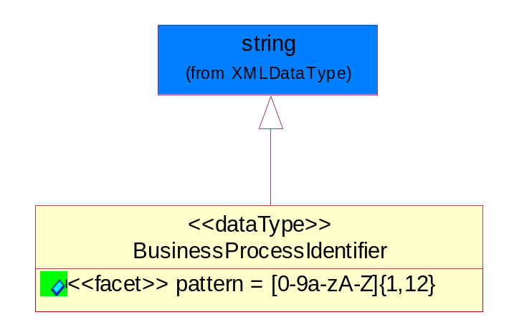
Figure ‎5-46 BusinessProcessIdentifier

Attribute | Type | Documentation
pattern |  | [0-9a-zA-Z]{1,12}

BusinessServiceInformation
The object allows the specification of the business service utilized within the partner company. This may or may not be the same as the information sent by the RNIF.
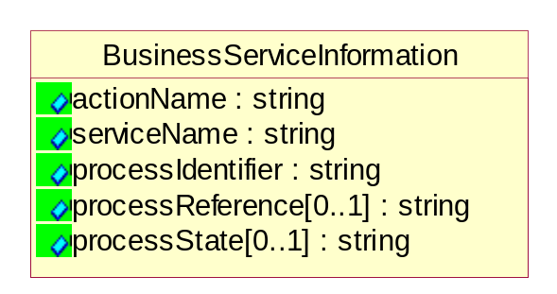
Figure ‎5-47 BusinessServiceInformation

Attribute | Type | Documentation
actionName | string | The name of Action. For RosettaNet usually any of Request/Confirm/Notify/Query/Response.
serviceName | string | The name of the Business Activity with the "Request/Confirm" part removed. E.g., for the Activity "Request Purchase Order"==> "Purchase Order".
processIdentifier | string | The name of the PIP e.g. Notify of Forecast Reply.
processReference[0..1] | string | The URN for the PIP that includes Cluster/Segment/Process pattern used to identify the interface process (such as PIP3A4)
processState[0..1] | string | The business process (or service) state of the sender of a document. When a service receives this document, the receiver may use the state as a precondition.

ContractInformation
A block of information used to correlate a contract in an executing choreography.

Figure ‎5-48 ContractInformation

Attribute | Type | Documentation
contractIdentifier[0..1] | string | Unique identification of a contract between the Sender and the Receiver
contractType[0..1] | string | The type of the contract: an attribute describing the type of the ContractIndentification. Valid values are URI, URN,ebXMLCPA, or other values defined by partners.

CorrelationInformation
A block of information used to correlate a requesting document to a responding document and to the contract in an executing choreography.
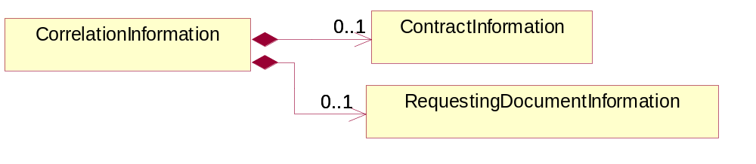
Figure ‎5-49 CorrelationInformation

Composition | Cardinality | Type | Documentation
ContractInformation | 0..1 | ContractInformation | A block of information used to correlate a contract in an executing choreography.
RequestingDocumentInformation | 0..1 | RequestingDocumentInformation | A block of information used to correlate a requesting document to a responding document in an executing choreography.

DocumentHeader
The object allows for the identification of the sender and receiver of the business document.
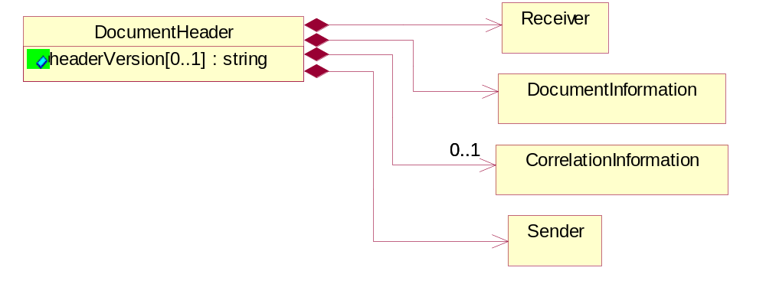
Figure ‎5-50 DocumentHeader

Attribute | Type | Documentation
headerVersion[0..1] | string | The UN/CEFACT version of the document header.

Composition | Cardinality | Type | Documentation
Sender | 1 | Sender | The object allows the identification of the initiating party of the business message.
CorrelationInformation | 0..1 | CorrelationInformation | A block of information used to correlate a requesting document to a responding document and to the contract in an executing choreography.
DocumentInformation | 1 | DocumentInformation | The object specifies information to identify the business document, a summary of attachments, and information about the business document security.
Receiver | 1 | Receiver | The object allows the identification of the receiving party of the business message.

DocumentIdentification
The object specifies all information necessary to identify the business document.
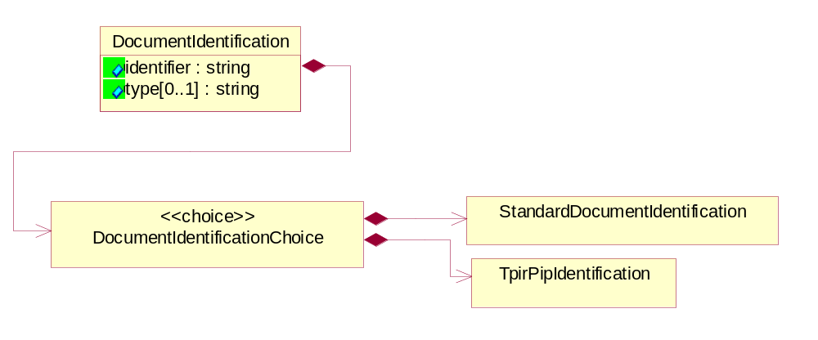
Figure ‎5-51 DocumentIdentification

Attribute | Type | Documentation
identifier | string | The unique identifier for the document being sent.
type[0..1] | string | Name of the Action Message

Composition | Cardinality | Type | Documentation
DocumentIdentificationChoice | 1 | DocumentIdentificationChoice

DocumentIdentificationChoice

Composition | Cardinality | Type | Documentation
StandardDocumentIdentification | 1 | StandardDocumentIdentification | The object specifies additional information necessary to identify the standard business document.
TpirPipIdentification | 1 | TpirPipIdentification | The object specifies all information necessary to uniquely identify a TPIR-PIP within a Registry or trading partner repository.

DocumentInformation
The object specifies information to identify the business document, a summary of attachments, and information about the business document security.
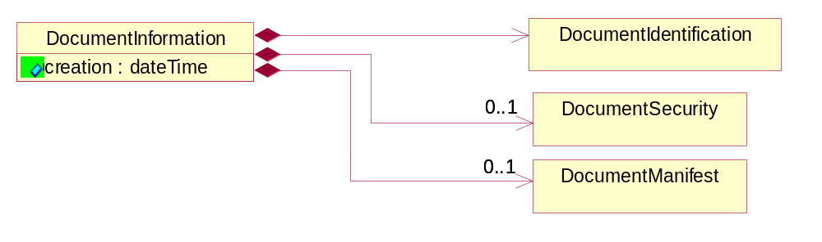
Figure ‎5-52 DocumentInformation

Attribute | Type | Documentation
creation | dateTime | The creation date and time of the specified Business Document (i.e. the Purchase Order date).

Composition | Cardinality | Type | Documentation
DocumentIdentification | 1 | DocumentIdentification | The object specifies all information necessary to identify the business document.
DocumentSecurity | 0..1 | DocumentSecurity | The object provides additional granularity in specifying business document security (this is in addition to the specified PIP security).
DocumentManifest | 0..1 | DocumentManifest | The block provides a brief summary of attachments and Service Content.

DocumentManifest
The block provides a brief summary of attachments and Service Content.
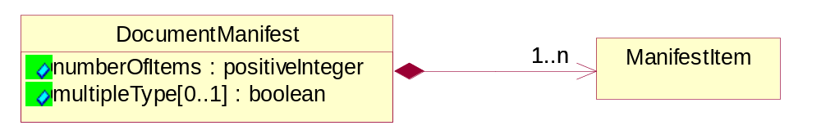
Figure ‎5-53 DocumentManifest

Attribute | Type | Documentation
numberOfItems | positiveInteger | Total number of documents in the message. The physical count of the attachments in the payload plus the RosettaNet Business Message (for Service Content). The value of this field will be at least 1.
multipleType[0..1] | boolean | Indicates whether the manifest contains documents of multiple types. True if yes, and False if no.

Composition | Cardinality | Type | Documentation
ManifestItem | 1..n | ManifestItem | The object provides details about the specific attachment(s).

DocumentSecurity
The object provides additional granularity in specifying business document security (this is in addition to the specified PIP security).

Figure ‎5-54 DocumentSecurity

Attribute | Type | Documentation
nonRepudiableReceipt | boolean | The value "true" will indicate that a signed acknowledgement for the business document is necessary.
persistentEncryption | boolean | The value "true" will indicate that the Business Document (including the header) needs to be encrypted when stored or transported.
persistentSignature | boolean | The value "true" will indicate that a signature is required to be stored with the document while stored or transported.

ManifestItem
The object provides details about the specific attachment(s).
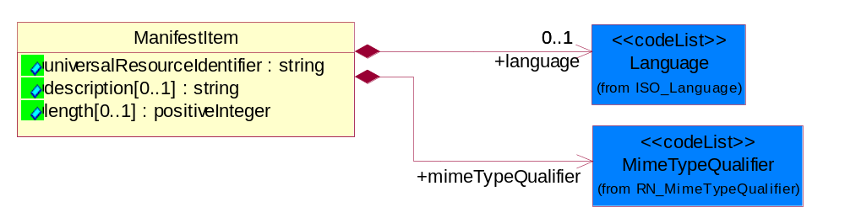
Figure ‎5-55 ManifestItem

Attribute | Type | Documentation
universalResourceIdentifier | string | The generic set of all names/addresses that are short strings that refer to resources.
description[0..1] | string | A description of the attachment.
length[0..1] | positiveInteger | The size of the attachment in bytes (i.e. 1 000 000 bytes)

Composition | Cardinality | Type | Documentation
mimeTypeQualifier | 1 | MimeTypeQualifier | The MIME type as defined by IANA.  Please refer to http://www.iana.org/assignments/media-types/ for a list of types.
language | 0..1 | Language | For representation of Language name RosettaNet has adopted ISO 639-2; 1998. Refer to the following web page to get the latest version of the standard:  http://www.loc.gov/standards/iso639-2/iso639jac.html  If you need more information about the ISO standard please contact ISO for more details.

PipIdentifier
PIP Identification.[ i.e. PIP3A4]
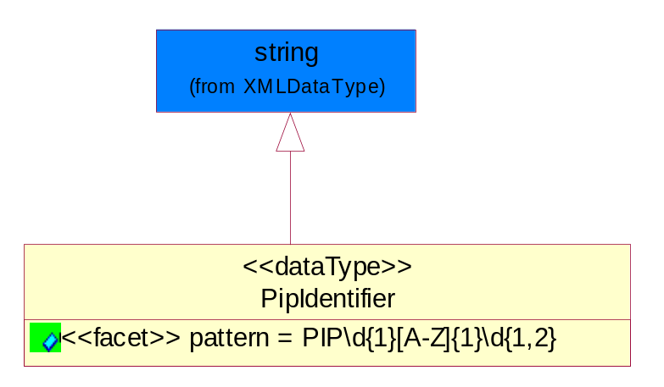
Figure ‎5-56 PipIdentifier

Attribute | Type | Documentation
pattern |  | PIP\d{1}[A-Z]{1}\d{1,2}

PipVersion
PIP version number (i.e. 02.02.00).
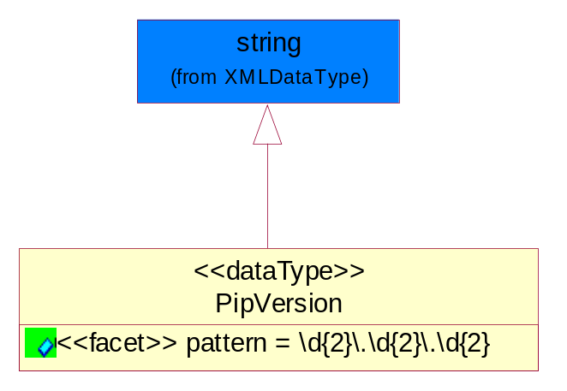
Figure ‎5-57 PipVersion

Attribute | Type | Documentation
pattern |  | \d{2}\.\d{2}\.\d{2}

Receiver
The object allows the identification of the receiving party of the business message.
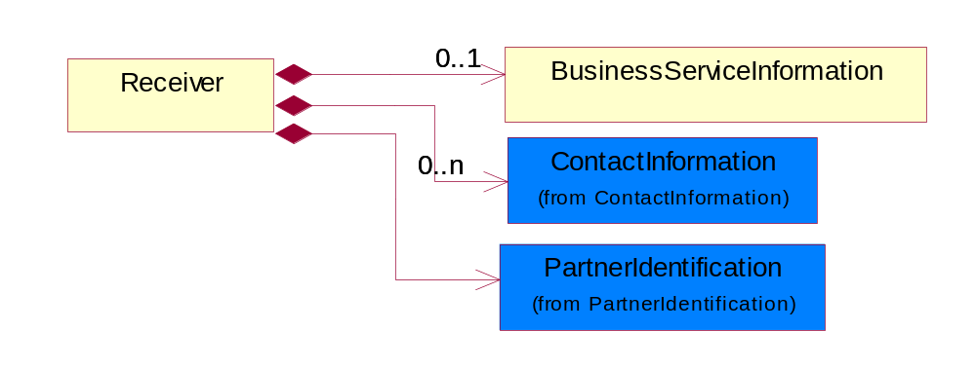
Figure ‎5-58 Receiver

Composition | Cardinality | Type | Documentation
BusinessServiceInformation | 0..1 | BusinessServiceInformation | The object allows the specification of the business service utilized within the partner company. This may or may not be the same as the information sent by the RNIF.
PartnerIdentification | 1 | PartnerIdentification | The business document must allow for the identity of one or more parties to the transaction.
ContactInformation | 0..n | ContactInformation | The business document must allow for the identification of the name of the department, service or individual to be contacted regarding the context of the business document.

RequestingDocumentInformation
A block of information used to correlate a requesting document to a responding document in an executing choreography.

Figure ‎5-59 RequestingDocumentInformation

Attribute | Type | Documentation
businessProcessInstanceIdentifier[0..1] | string | The identifier for the public business process instance being sent that both the sender and receiver can identify.
responseDateTime[0..1] | dateTime | The expected time to receive the response. This can not be greater than the PIP TimeToPerform.
requestingDocumentCreationDateTime[0..1] | dateTime | The date-time of the requesting business document.
requestingDocumentInstanceIdentifier | string | The Business Document identification number that identifies the requesting Business Document.

Sender
The object allows the identification of the initiating party of the business message.
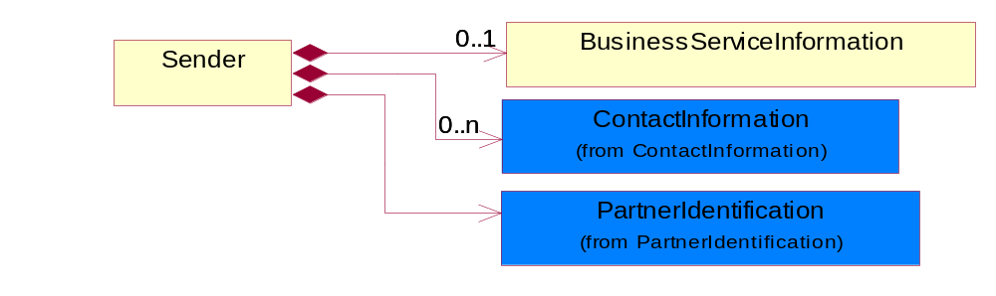
Figure ‎5-60 Sender

Composition | Cardinality | Type | Documentation
PartnerIdentification | 1 | PartnerIdentification | The business document must allow for the identity of one or more parties to the transaction.
BusinessServiceInformation | 0..1 | BusinessServiceInformation | The object allows the specification of the business service utilized within the partner company. This may or may not be the same as the information sent by the RNIF.
ContactInformation | 0..n | ContactInformation | The business document must allow for the identification of the name of the department, service or individual to be contacted regarding the context of the business document.

StandardDocumentIdentification
The object specifies additional information necessary to identify the standard business document.
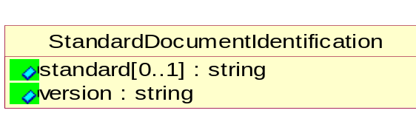
Figure ‎5-61 StandardDocumentIdentification

Attribute | Type | Documentation
standard[0..1] | string | Identifies the standard used to submit the business document. (e.g. RosettaNet).
version | string | PIP3A4v01.00

TpirPipIdentification
The object specifies all information necessary to uniquely identify a TPIR-PIP within a Registry or trading partner repository.

Figure ‎5-62 TpirPipIdentification

Attribute | Type | Documentation
partnerId | DUNSPlus4 | The Trading Partner Identification of MNC that is creating this TPIR PIP.
pipIdentifier | PipIdentifier | A TPIR PIP Identification [i.e., 3A4 ).
pipVersion | PipVersion | A TPIR PIP version number (i.e., 02.02.00)
tpirPipVersion | VersionIdentifier | A TPIR-PIP Version Number (i.e., major and minor version number as XX.XX).
tpirBusinessProcessIdentifier[0..1] | BusinessProcessIdentifier | A Business Process Identifier to uniquely define the TPIR-PIP 'role' within a Business Scenario at a company or MNC level. The identifier MUST be composed of alphanumeric characters only and its length MUST be between one and twelve characters.
uri[0..1] | anyURI | Describes the destination uri for the TPIR form.

Composition | Cardinality | Type | Documentation
fileType | 0..1 | TPIRFileType | Describes the file type of the TPIR form (PDF, XDP or XML).

VersionIdentifier
Version Number (i.e., major and minor version number as XX.XX).
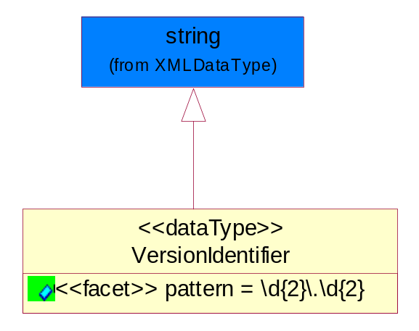
Figure ‎5-63 VersionIdentifier

Attribute | Type | Documentation
pattern |  | \d{2}\.\d{2}

CodeList

TPIRFileType
A code identifying the file type of TPIR form.
Name | Documentation
PDF | Portable Document Format.
XDP | XML Data Package.
XML | eXtensible Markup Language.

XML Data Type

anyURI
Represents a URI as defined by RFC 2396. An anyURI value can be absolute or relative, and may have an optional fragment identifier.

boolean
Represents Boolean values, which are either "true" or "false".

date
For the represents a calendar date.
The pattern for a date is CCYY-MM-DD where CC represents the century, YY the year, MM the month, and DD the day, with an optional time zone indicator as allowed for dateTime.

dateTime
Represents a specific instance of time.
The pattern for dateTime is CCYY-MM-DDThh:mm:ss where CC represents the century, YY the year, MM the month, and DD the day, preceded by an optional leading negative (-) character to indicate a negative number. If the negative character is omitted, positive (+) is assumed. The T is the date/time separator and hh, mm, and ss represent hour, minute, and second respectively. Additional digits can be used to increase the precision of fractional seconds if desired. For example, the format ss.ss... with any number of digits after the decimal point is supported. The fractional seconds part is optional.

This representation may be immediately followed by a "Z" to indicate Coordinated Universal Time (UTC) or to indicate the time zone. For example, the difference between the local time and Coordinated Universal Time, immediately followed by a sign, + or -, followed by the difference from UTC represented as hh:mm (minutes is required). If the time zone is included, both hours and minutes must be present.

decimal
A data type that contains decimal numbers scaled by a power of 10.

float
Represents single-precision 32-bit floating-point numbers.

gDay
Represents a Gregorian day that recurs, specifically a day of the month such as the fifth day of the month. A gDay is the space of a set of calendar dates. Specifically, it is a set of one-day long, monthly periodic instances.
The pattern for gDay is ---DD with optional time zone indicator as allowed for date.

positiveInteger
Represents an integer that is greater than zero. This data type is derived from nonNegativeInteger.

string
Represents character string.

