

Description of
Partner Interface Process® for 3C7

Validated 11.02.00

Specification Information
Name | Notify Of Self Billing Invoice
Cluster | Order Management
Segment | Returns and Finance
Publication Date | 25 September 2009
Version Identifier | V11.02

Table of Contents
1 Document Management 4
1.1 Legal Disclaimer 4
1.2 Copyright 4
1.3 Trademarks 4
1.4 Acknowledgments 4
1.5 Related Documents 5
1.6 Document Version History 5
1.7 Document Structure 5
2 Business Process 6
2.1 Business Process Definition 6
2.1.1 Business Process Description 6
2.1.2 Business Process Context Diagram 7
2.2 PIP Business Document 9
2.3 PIP Business Process Flow Diagram 9
2.4 PIP Start State 10
2.5 PIP End States 10
2.6 Partner Role Descriptions 11
2.7 Business Process Activity Controls 11
3 Network and Implementation Specification 12
3.1 Business Action and Business Signal Specifications 12
3.2 Business Transaction Dialog Specification 12
3.2.1 Message Exchange Controls 13
3.2.2 Communications Specification 13

List of Figures:
Figure 1-1: Consignment Stock Scenario 7
Figure 1-2: Evaluated Receipt Settlement (Non-Consignment) Scenario 8
Figure 2: Activity Diagram of Notify Of Self-Billing Invoice 9
Figure 3: Sequence Diagram of Notify Of Self-Billing Invoice 12

List of Tables:
Table 1: PIP Business Document 9
Table 2: PIP Start State 10
Table 3: PIP End State 10
Table 4: PIP Failure State 10
Table 5: Partner Role Description 11
Table 6: Business Activity Description 11
Table 7: Business Activity Performance Control 11
Table 8: Network Component Specification 12
Table 9: Business Action – Business Document Mapping 12
Table 10: Message Exchange Control 13
Table 11: Dialog: Service-Service 13

Document Management

Legal Disclaimer
RosettaNet™, its members, officers, directors, employees, or agents shall not be liable for any injury, loss, damages, financial or otherwise, arising from, related to, or caused by the use of this document or the specifications herein, as well as associated guidelines and schemas. The use of said specifications shall constitute your express consent to the foregoing exculpation.

Copyright
©2009 RosettaNet. All rights reserved. No part of this publication may be reproduced, stored in a retrieval system, or transmitted, in any form or by any means, electronic, mechanical, photocopying, recording, or otherwise, without the prior written permission of the publisher. Printed in the United States of America.

Trademarks
RosettaNet, Partner Interface Process, PIP and the RosettaNet logo are trademarks or registered trademarks of "RosettaNet," a non-profit organization. All other product names and company logos mentioned herein are the trademarks of their respective owners. In the best effort, all terms mentioned in this document that are known to be trademarks or registered trademarks have been appropriately recognized in the first occurrence of the term.

Acknowledgments
This document has been prepared by RosettaNet (http://www.rosettanet.org/) from requirements gathered during the Milestone Program and in conformance with the methodology. Listed below are the legal entities that contributed to the design and development of this PIP.
Amkor Technology, Inc. | Avnet Applied Computing
EDIFICE | Intel Corporation
Intel Corporations | MIMOS Berhad
Motorola | Motorola Europe
Motorola Semiconductor Products Sector | Motorola SPS
National Semiconductor GMBH | Nokia Oyj
Philips Semiconductors | Sterling Commerce
STMicroelectronics | Texas Instruments
Texas Instruments (Global) | Texas Instruments Limited

Related Documents
- Associated PIP Message Schemas (included within the PIP Specification package only)
- Description of 3C7 Message
- Messages Structure
- XML instance of ebXML BPSS for PIP 3C7

Document Version History
Version | Date | Description
Validated 11.00.00 | 19 July 2006 | Validated Version
Validated 11.01.00 | 21 September 2007 | Validated Version Milestone Program: Schema2Market
Validated 11.04.00 | 25 September 2009 | Validated Version for 2009 Maintenance

Document Structure
A Partner Interface Process (PIP) Specification is comprised of the following two parts:
- Business Process. Captures the semantics of the business process and the flow of the message exchange between roles as they perform business activities.
- Network and Implementation Specification. Specifies the network protocol message formats and communications requirements between peer-protocols supported by network components in the RosettaNet Implementation Framework.

Business Process

Business Process Definition
The purpose of this PIP, Notify of Self Billing Invoice is to enable customer to send self billing invoice to supplier for authorizing consolidated payment for received goods based on received or used/consumed quantities of goods.

Business Process Description
The "Notify of Self Billing Invoice" Partner Interface Process™ (PIP) is based on traditional invoice process, associated with liability settlements arising from business transactions between customer and supplier. The difference between self billing invoice and traditional invoice process is self billing is the procedure for authorizing payment on the customer side for received or used quantities of goods under two different business scenarios. On both conditions prices must be pre-negotiated and maintained by both the customer and the supplier.
The two distinct business scenarios where self billing is used:
- Consignment Stock
- Evaluated Receipt Settlement (ERS), which is a non-consignment Self Billing Invoice

Business Process Context Diagram

Consignment Stock
Goods on consignment are goods that are physically delivered to a customer or his agent but which remain the property of the supplier until the goods are consumed by the customer. When self billing on consignment is used, the customer issues the invoice for the goods used by him from the consignment stock.
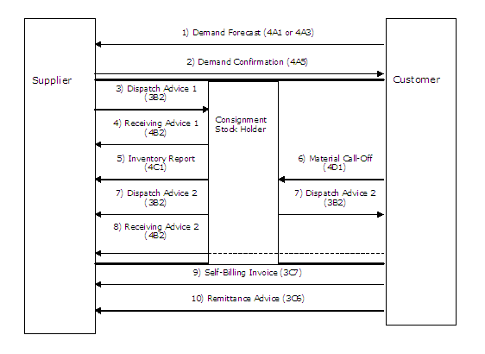
Figure 1-1: Consignment Stock Scenario

Evaluated Receipt Settlement (Non-Consignment)
The self billing procedure whereby the customer issues the invoice in respect of a shipment, after physical receipt of the shipment.
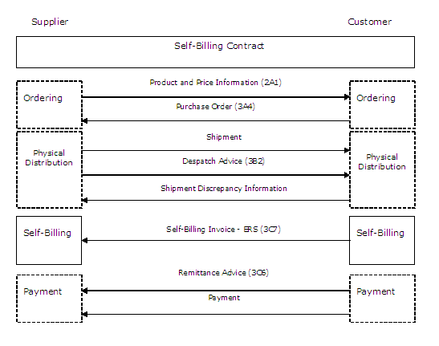
Figure 1-2: Evaluated Receipt Settlement (Non-Consignment) Scenario

PIP Business Document
Business Document are generated and exchanged by roles performing activities in this PIP. Business Document is listed and defined in Table 1.
Table 1: PIP Business Document
Business Document | Description
Self Billing Invoice Notification | Presents a self billing invoice for products purchased and shipped or for services that have been purchased or contracted. The self billing invoice may only be a credit in self billing scenarios. The conditions that trigger the generation of a self billing invoice may vary by organization.

PIP Business Process Flow Diagram
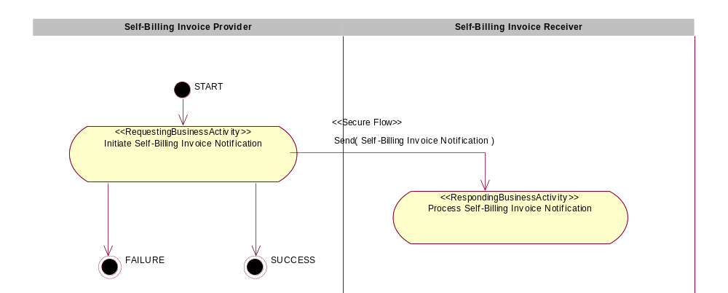
Figure 2: Activity Diagram of Notify Of Self Billing Invoice

PIP Start State
The start state is comprised of the following conditions:
Table 2: PIP Start State
 | Approved | Exist |  | Valid | Non-Repudiated | Retry Count | Authorized
 | Approved | Party | In Backend System
TPA |  |  | 
Sending Partner |  |  |  | 
Receiving Partner |  | 
Business Document |  |  |  |  |  |  | 

PIP End States
The end state is comprised of the following conditions:
Table 3: PIP End State
 | Approved | Exist |  | Valid | Non-Repudiated | Retry Count | Authorized
 | Approved | Party | In Backend system
Acknowledgment of Receipt |  |  |  |  | 
Receiving Partner |  |  |  |  |  |  | 

The PIP failure state is comprised of one or more of the following conditions:
Table 4: PIP Failure State
 | NO | Exceeded
Success | 
Retry Count |  | 

Partner Role Descriptions
Table 5 describes the partner roles in this PIP.
Table 5: Partner Role Description
Role Name | Role Description
Self Billing Invoice Provider | The organization that generates the self billing invoice plus being invoiced. It can re-issue the self billing invoice.
Self Billing Invoice Receiver | The organization that provides the services or goods. The organization that receives the payment.

Business Process Activity Controls
Table 6 describes the interaction between roles performing business activity in this PIP.
Table 6: Business Activity Description
Role  Name | Activity Name | Activity Description
Self Billing Invoice Provider | Initiate Self Billing Invoice Notification | The Self Billing Invoice Provider issues a Self Billing Invoice Notification to a Self Billing Invoice Receiver, who could be the service provider or goods supplier.

Table 7 details the security, audit and process controls relating to activity performed in the PIP.
Table 7: Business Activity Performance Control
Role  Name | Activity  Name | Acknowledgment  of Receipt |  | Time to Perform | Retry Count | Is Authorization Required? | Non-Repudiation of Origin and Content?
Role  Name | Activity  Name | Non-Repudiation Required? | Time to Acknowledge
Self Billing Invoice Provider | Initiate Self Billing Invoice Notification | Y | 2 hrs | N/A | 3 | Y | Y

Network and Implementation Specification
Each network component maps into a role of the PIP model. Table 8 specifies the mapping between roles and network components.
Table 8: Network Component Specification
Network Component | Classification | Maps to Role in Business Process
Self Billing Invoice Provider Service | Business Service | Self Billing Invoice
Self Billing Invoice Receiver Service | Business Service | Self Billing Invoice Receiver

Business Action and Business Signal Specifications
Each business action maps to a Business Document of the PIP model. Table 9 specifies the mapping between Business Documents and business actions.
Table 9: Business Action – Business Document Mapping
Business Action | Business Document | Document Function
Self Billing Notification Action | Self Billing Invoice Notification | Request

Business Transaction Dialog Specification
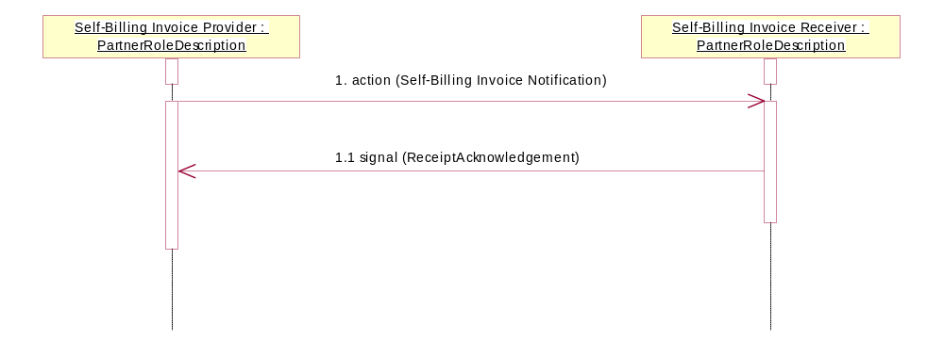
Figure 3: Sequence Diagram of Notify Of Self Billing Invoice

Message Exchange Controls
Table 10: Message Exchange Control
# | Name |  | Time to Acknowledge Receipt Signal |  | Time to Respond to Action |  | Included in Time to Perform |  | Is Authorization Required? |  | Is Non-Repudiation Required? |  | Is Secure Transport Required?
1. |  | Self Billing Invoice Notification Action |  | 2 hrs |  | N/A |  | N/A |  | Y |  | Y |  | Y
1.1. |  | Receipt Acknowledgment |  | N/A |  | N/A |  | N/A |  | Y |  | Y |  | Y

Communications Specification
Table 11: Dialog: Service-Service
# | Business Message | Digital Signature Required? | SSL Required?
1. | Self Billing Invoice Notification | Y | Y
1.1. | Receipt Acknowledgment | Y | Y

