

Description of
Partner Interface Process® for 4A1

Validated 11.00.00

Specification Information
Name | Notify Of Strategic Forecast
Cluster | Inventory Management
Segment | Collaborative Forecasting
Publication Date | 17 July 2008
Version Identifier | V11.00

Table of Contents
1 Document Management 4
1.1 Legal Disclaimer 4
1.2 Copyright 4
1.3 Trademarks 4
1.4 Acknowledgments 4
1.5 Related Documents 5
1.6 Document Version History 5
1.7 Document Structure 5
2 Business Process 6
2.1 Business Process Definition 6
2.1.1 Business Process Description 6
2.1.2 Business Process Context Diagram 7
2.2 PIP Scope Description 8
2.2.1 Business Process Scope Diagram 8
2.3 PIP Business Document 9
2.4 PIP Business Process Flow Diagram 9
2.5 PIP Start State 10
2.6 PIP End States 10
2.7 Partner Role Descriptions 11
2.8 Business Process Activity Controls 11
3 Network and Implementation Specification 12
3.1 Business Action and Business Signal Specifications 12
3.2 Business Transaction Dialog Specification 12
3.2.1 Message Exchange Control 13
3.2.2 Communications Specification 13

List of Figures:
Figure 1: High-level Context Diagram 7
Figure 2: Business Process Scope Diagram 8
Figure 3: Activity Diagram of Notify Of Strategic Forecast 9
Figure 4: Sequence Diagram of Notify Of Strategic Forecast 12

List of Tables:
Table 1: PIP Business Document 9
Table 2: PIP Start State 10
Table 3: PIP End State 10
Table 4: PIP Failure State 10
Table 5: Partner Role Description 11
Table 6: Business Activity Description 11
Table 7: Business Activity Performance Control 11
Table 8: Network Component Specification 12
Table 9: Business Action – Business Document Mapping 12
Table 10: Message Exchange Control 13
Table 11: Dialog: Service-Service 13

Document Management

Legal Disclaimer
RosettaNet™, its members, officers, directors, employees, or agents shall not be liable for any injury, loss, damages, financial or otherwise, arising from, related to, or caused by the use of this document or the specifications herein, as well as associated guidelines and schemas. The use of said specifications shall constitute your express consent to the foregoing exculpation.

Copyright
©2008 RosettaNet. All rights reserved. No part of this publication may be reproduced, stored in a retrieval system, or transmitted, in any form or by any means, electronic, mechanical, photocopying, recording, or otherwise, without the prior written permission of the publisher. Printed in the United States of America.

Trademarks
RosettaNet, Partner Interface Process, PIP and the RosettaNet logo are trademarks or registered trademarks of "RosettaNet," a non-profit organization. All other product names and company logos mentioned herein are the trademarks of their respective owners. In the best effort, all terms mentioned in this document that are known to be trademarks or registered trademarks have been appropriately recognized in the first occurrence of the term.

Acknowledgments
This document has been prepared by RosettaNet (http://www.rosettanet.org/) from requirements gathered during the Milestone Program and in conformance with the methodology. Listed below are the legal entities that contributed to the design and development of this PIP.
Aankhen, Inc. | Arrow Electronics, Inc.
AVX Corporation | Cisco Systems, Inc.
Delta Electronics | Delta Products Corp.
GridNode, Inc. | GridNode Pte. Ltd.
Hewlett-Packard Company | HP
i2 | Intel Corporation
KEMET Electronics Corp. | Micron Technology and its wholly owned subsidiaries
Motorola Europe | Motorola Semiconductor Sector
Motorola SPS | National Semiconductor Corporation
NEC Solutions America, Inc. | Nokia Oyj
Oracle Corporation | Philips Semiconductors
Pioneer-Standard Electronics | Samsung Electronics Co., Ltd. And Samsung Electronics Memory Division
SAP | Sterling Commerce
STMicroelectronics | Syncra Systems, Inc.
TeamJasper | Texas Instruments
Tyco Electronics | Uniform Code Council, Inc.
Viacore

Related Documents
- Associated PIP Message Schemas (included within the PIP Specification package only)
- Description of 4A1 Message
- Messages Structure
- XML instance of ebXML BPSS for PIP 4A1

Document Version History
Version | Date | Description
Validated 11.00.00 | 17 July 2008 | Validated Version : RosettaNet Schema to Market to Validation 2008

Document Structure
A Partner Interface Process (PIP) Specification is comprised of the following two parts:
- Business Process. Captures the semantics of the business process and the flow of the message exchange between roles as they perform business activities.
- Network and Implementation Specification. Specifies the network protocol message formats and communications requirements between peer-protocols supported by network components in the RosettaNet Implementation Framework.

Business Process

Business Process Definition
The "Notify Of Strategic Forecast" Partner Interface Process™ (PIP) supports a process in which a forecast owner sends a strategic forecast to a forecast recipient.

Business Process Description
The "Notify of Strategic Forecast" Partner Interface Process™ (PIP) supports a process in which a forecast owner sends a strategic forecast to a forecast recipient. The forecast is informational only. This may be any kind of forecast including but not limited to a sales forecast, capacity forecast, demand forecast, marketing forecast, or master scheduler pre-MRP run forecast. It is usually a mid-term to long-term forecast. There is no implied or embedded automated mechanism to trigger material release to the forecast owner. For information on forecasting processes that result in material release authorizations, please refer to PIP4A2, “Notify Of Embedded Release Forecast,” PIP4A3, “Notify Of Threshold Release Forecast” and PIP4A4, “Notify Of Planning Release Forecast.”
In accordance with the Start State (section 3.4), a Trading Partner Agreement (TPA) must be negotiated between the parties prior to the implementation of this PIP. The TPA should contain, but is not limited to, the following information:
a. Define which products or product families are to be included in the forecast.
b. Describe a procedure for adding products or product families to the forecast.
c. Describe a procedure for removing products or product families from the forecast.
d. Define the forecast transmission frequency.
e. Describe quantity definitions and netting procedures if needed, for example; using gross quantities versus net quantities.
f. Describe date definitions, for example; using scheduled dock dates versus scheduled ship dates.
The recipient may optionally respond to the forecast using PIP4A5, "Notify of Forecast Reply," if mutually agreed upon. The legal liability associated with forecast reply should be defined in the TPA.
This PIP is a one-way push of information. The communication process ensures that the forecast owner receives a non-repudiated acknowledgment of receipt, but does not require a confirmation or commitment from the forecast recipient.
Should this transaction not complete successfully, the requesting partner executes PIP0A1, "Notification Of Failure."

Business Process Context Diagram
Strategic Forecast Notification

Forecast Owner
Forecast Recipient

Prepare Strategic Forecast
Generate Strategic Forecast
Process Strategic Forecast
Send Notification

Figure 1: High-level Context Diagram

PIP Scope Description
The purpose of this PIP is to communicate informational strategic forecast data to a forecast recipient. The forecast recipient uses this information in their capacity or other planning related activities.

Business Process Scope Diagram
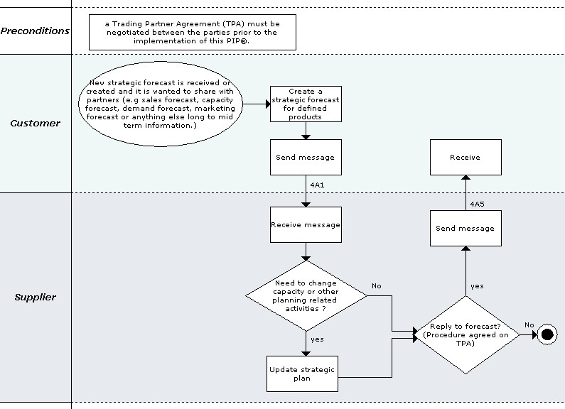
Figure 2: Business Process Scope Diagram

PIP Business Document
Business Document are generated and exchanged by roles performing activities in this PIP. Business Document is listed and defined in Table 1.
Table 1: PIP Business Document
Business Document | Description
Strategic Forecast Notification | Contains the Forecast Owner's anticipated product demand, and when this demand is expected to occur. Specific Global Trade Item Numbers (GTIN), or more general product groupings can be specified. The source of the demand (promotion, advertisement, etc.) can be identified. Strategic forecast could be in an initial, revised, or final stage.

PIP Business Process Flow Diagram
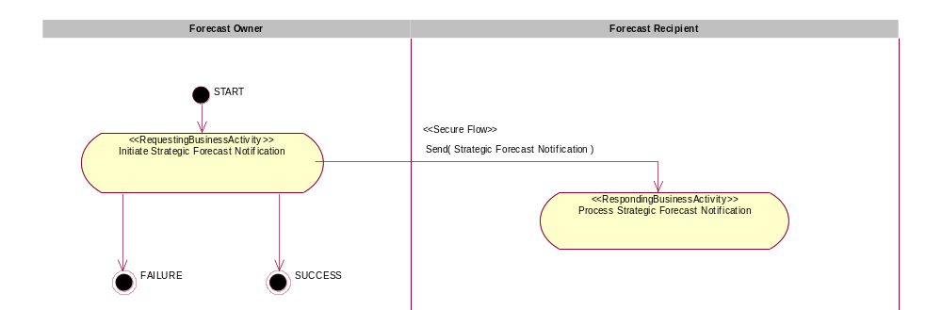
Figure 3: Activity Diagram of Notify Of Strategic Forecast

PIP Start State
The start state is comprised of the following conditions:
Table 2: PIP Start State
 | Approved | Exist |  | Valid | Non-Repudiated | Retry Count | Authorized
 | Approved | Party | In Backend System
TPA |  |  | 
Sending Partner |  |  |  |  |  |  | 
Receiving Partner |  | 
Business Document |  |  |  |  | 

PIP End States
The end state is comprised of the following conditions:
Table 3: PIP End State
 | Approved | Exist |  | Valid | Non-Repudiated | Retry Count | Authorized
 | Approved | Party | In Backend system
Acknowledgment of Receipt |  |  |  |  | 
Receiving Partner |  |  |  |  |  |  | 

The PIP failure state is comprised of one or more of the following conditions:
Table 4: PIP Failure State
 | NO | Exceeded
Success | 
Retry Count |  | 

Partner Role Descriptions
Table 5 describes the partner roles in this PIP.
Table 5: Partner Role Description
Role Name | Role Description
Forecast Owner | The party that creates a strategic or order forecast and is ultimately responsible for it.
Forecast Recipient | The party that receives a strategic or order forecast.

Business Process Activity Controls
Table 6 describes the interaction between roles performing business activity in this PIP.
Table 6: Business Activity Description
Role  Name | Activity Name | Activity Description
Forecast Owner | Initiate Strategic Forecast Notification | The Forecast Owner has prepared the Strategic Forecast Notification and sends it to the Forecast Recipient.

Table 7 details the security, audit and process controls relating to activity performed in the PIP.
Table 7: Business Activity Performance Control
Role  Name | Activity  Name | Acknowledgment  of Receipt |  | Time to Perform | Retry Count | Is Authorization Required? | Non-Repudiation of Origin and Content?
Role  Name | Activity  Name | Non-Repudiation Required? | Time to Acknowledge
Forecast Owner | Initiate Strategic Forecast Notification | Y | 2 hrs | N/A | 3 | Y | Y

Network and Implementation Specification
Each network component maps into a role of the PIP model. Table 8 specifies the mapping between roles and network components.
Table 8: Network Component Specification
Network Component | Classification | Maps to Role in Business Process
Forecast Owner Service | Business Service | Forecast Owner
Forecast Recipient Service | Business Service | Forecast Recipient

Business Action and Business Signal Specifications
Each business action maps to a Business Document of the PIP model. Table 9 specifies the mapping between Business Documents and business actions.
Table 9: Business Action – Business Document Mapping
Business Action | Business Document | Document Function
Strategic Forecast Notification Action | Strategic Forecast Notification | Request

Business Transaction Dialog Specification
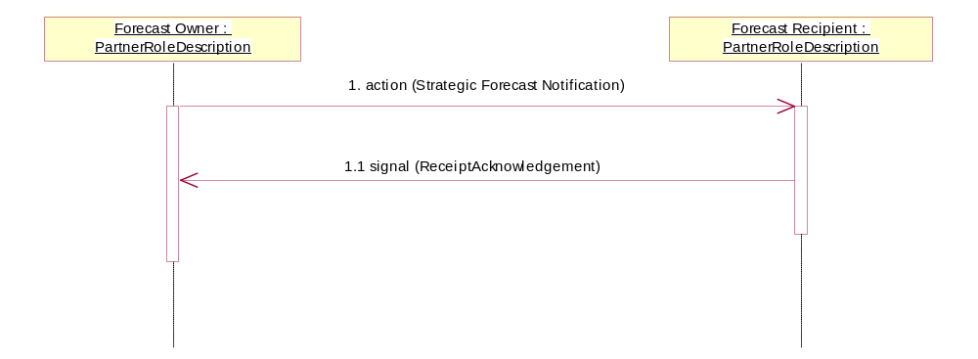
Figure 4: Sequence Diagram of Notify Of Strategic Forecast

Message Exchange Control
Table 10: Message Exchange Control
# | Name |  | Time to Acknowledge Receipt Signal |  | Time to Respond to Action |  | Included in Time to Perform |  | Is Authorization Required? |  | Is Non-Repudiation Required? |  | Is Secure Transport Required?
1. |  | Strategic Forecast Notification Action |  | 2 hrs |  | N/A |  | N/A |  | Y |  | Y |  | Y
1.1. |  | Receipt Acknowledgment |  | N/A |  | N/A |  | N/A |  | Y |  | Y |  | Y

Communications Specification
Table 11: Dialog: Service-Service
# | Business Message | Digital Signature Required? | SSL Required?
1. | Strategic Forecast Notification | Y | Y
1.1. | Receipt Acknowledgment | Y | Y

