

Description of 4A2 Message

PIP® 4A2
Validated 11.00.00

Specification Information
Name | Description of 4A2 Message
PIP | Notify Of Embedded Release Forecast
Cluster | Inventory Management
Segment | Collaborative Forecasting
Publication Date | 01 July 2008
Version Identifier | V11.00

Table of Content

1. Document Management 6
1.1 Legal Disclaimer 6
1.2 Copyright 6
1.3 Trademarks 6
1.4 Acknowledgments 6
1.5 Related Documents 6
1.6 Document Version History 6
1.7 Document Purpose 7
2. Interchange Model 8
2.1 EmbeddedReleaseForecastNotification 8
2.1.1 Interchange Diagram 8
2.1.2 Dependency Diagram 8
2.1.3 EmbeddedReleaseForecast 9
2.1.4 EmbeddedReleaseForecastNotification 10
2.1.5 PartnerProductForecast 10
2.1.6 ProductForecastInformation 11
2.1.7 ProductSchedule 11
3. Domain Model 13
3.1 Procurement 13
3.1.1 Procurement 13
3.1.1.1 Dependency Diagram 13
3.1.1.2 ForecastIdentifierReference 13
3.1.1.3 ForecastPeriod 14
3.1.1.4 ForecastProductSchedule 14
3.1.1.5 ProductFamilyReporting 15
3.1.1.6 ProductForecast 15
3.1.1.7 ProductReceiptReference 16
3.1.2 CodeList 17
3.1.2.1 ForecastEvent 17
3.1.2.2 ForecastQuantityType 17
3.1.2.3 ForecastReferenceType 18
3.1.2.4 TransportEvent 18
3.2 Shared 19
3.2.1 Shared 19
3.2.1.1 Dependency Diagram 19
3.2.1.2 ProductQuantity 19
CodeList 20
3.2.2.1 Interval 20
4. Universal Structure 21
4.1 ContactInformation 21
4.1.1 ContactInformation 21
4.2 DataType 22
4.2.1 Contact 22
4.2.2 DUNS 22
4.2.3 DUNSPlus4 23
4.2.4 GLN 23
4.2.5 GTIN 24
4.3 Dates 24
4.3.1 DatePeriod 24
4.4 Document 25
4.4.1 BusinessDocumentReference 25
4.5 Locations 25
4.5.1 AlternativeIdentifier 25
4.5.2 Location 26
4.5.3 LocationChoice 27
4.5.4 PhysicalAddress 27
4.6 MonetaryExpression 28
4.6.1 FinancialAmount 28
4.7 PartnerIdentification 29
4.7.1 FullPartner 29
4.7.2 IntermittentPartner 30
4.7.3 KnownPartner 30
4.7.4 KnownPartnerContact 31
4.7.5 NewPartner 31
4.7.6 PartnerDescription 32
4.7.7 PartnerDescriptionChoice 32
4.7.8 PartnerIdentification 33
4.7.9 PartnerIdentificationChoice 34
4.7.10 SpecifiedFullPartner 34
4.7.11 SpecifiedIntermittentPartner 35
4.7.12 SpecifiedKnownPartner 35
4.7.13 SpecifiedKnownPartnerContact 36
4.7.14 SpecifiedNewPartner 36
4.7.15 SpecifiedPartnerDescription 37
4.7.16 SpecifiedPartnerDescriptionChoice 38
4.8 ProductIdentification 39
4.8.1 ProductIdentification 39
4.8.2 ProductIdentificationChoice 39
4.9 CodeList 40
4.9.1 Country 40
4.9.2 CountrySubdivision 40
4.9.3 Currency 40
4.9.4 Language 40
4.9.5 DocumentType 40
4.9.6 MimeTypeQualifier 42
4.9.7 UnitOfMeasure 53
4.9.8 ProcessRoleIdentifier 60
5. System Structure 64
5.1 BusinessProcessIdentifier 64
5.2 BusinessServiceInformation 64
5.3 ContractInformation 65
5.4 CorrelationInformation 65
5.5 DocumentHeader 66
5.6 DocumentIdentification 67
5.7 DocumentIdentificationChoice 67
5.8 DocumentInformation 68
5.9 DocumentManifest 68
5.10 DocumentSecurity 69
5.11 ManifestItem 69
5.12 PipIdentifier 70
5.13 PipVersion 71
5.14 Receiver 71
5.15 RequestingDocumentInformation 72
5.16 Sender 72
5.17 StandardDocumentIdentification 73
5.18 TpirPipIdentification 73
5.19 VersionIdentifier 74
5.20 CodeList 74
5.20.1 TPIRFileType 74
6. XML Data Type 75
6.1 anyURI 75
6.2 boolean 75
6.3 date 75
6.4 dateTime 75
6.5 float 75
6.6 positiveInteger 75
6.7 string 75

Table of Figures

Figure 2-1 Interchange 8
Figure 2-2 Dependency 8
Figure 2-3 EmbeddedReleaseForecast 9
Figure 2-4 EmbeddedReleaseForecastNotification 10
Figure 2-5 PartnerProductForecast 10
Figure 2-6 ProductForecastInformation 11
Figure 2-7 ProductSchedule 11
Figure 3-1 Dependency 13
Figure 3-2 ForecastIdentifierReference 13
Figure 3-3 ForecastPeriod 14
Figure 3-4 ForecastProductSchedule 14
Figure 3-5 ProductFamilyReporting 15
Figure 3-6 ProductForecast 15
Figure 3-7 ProductReceiptReference 16
Figure 3-8 Dependency 19
Figure 3-9 ProductQuantity 19
Figure 4-1 ContactInformation 21
Figure 4-2 Contact 22
Figure 4-3 DUNS 22
Figure 4-4 DUNSPlus4 23
Figure 4-5 GLN 23
Figure 4-6 GTIN 24
Figure 4-7 DatePeriod 24
Figure 4-8 BusinessDocumentReference 25
Figure 4-9 AlternativeIdentifier 25
Figure 4-10 Location 26
Figure 4-11 PhysicalAddress 27
Figure 4-12 FinancialAmount 28
Figure 4-13 FullPartner 29
Figure 4-14 IntermittentPartner 30
Figure 4-15 KnownPartner 30
Figure 4-16 KnownPartnerContact 31
Figure 4-17 NewPartner 31
Figure 4-18 PartnerDescription 32
Figure 4-19 PartnerIdentification 33
Figure 4-20 SpecifiedFullPartner 34
Figure 4-21 SpecifiedIntermittentPartner 35
Figure 4-22 SpecifiedKnownPartner 35
Figure 4-23 SpecifiedKnownPartnerContact 36
Figure 4-24 SpecifiedNewPartner 36
Figure 4-25 SpecifiedPartnerDescription 37
Figure 4-26 ProductIdentification 39
Figure 5-1 BusinessProcessIdentifier 64
Figure 5-2 BusinessServiceInformation 64
Figure 5-3 ContractInformation 65
Figure 5-4 CorrelationInformation 65
Figure 5-5 DocumentHeader 66
Figure 5-6 DocumentIdentification 67
Figure 5-7 DocumentInformation 68
Figure 5-8 DocumentManifest 68
Figure 5-9 DocumentSecurity 69
Figure 5-10 ManifestItem 69
Figure 5-11 PipIdentifier 70
Figure 5-12 PipVersion 71
Figure 5-13 Receiver 71
Figure 5-14 RequestingDocumentInformation 72
Figure 5-15 Sender 72
Figure 5-16 StandardDocumentIdentification 73
Figure 5-17 TpirPipIdentification 73
Figure 5-18 VersionIdentifier 74

Document Management

Legal Disclaimer
RosettaNet, its members, officers, directors, employees, or agents shall not be liable for any injury, loss, damages, financial or otherwise, arising from, related to, or caused by the use of this document or the specifications herein, as well as associated guidelines and schemas. The use of said specifications shall constitute your express consent to the foregoing exculpation.

Copyright
©2008 RosettaNet. All rights reserved. No part of this publication may be reproduced, stored in a retrieval system, or transmitted, in any form or by any means, electronic, mechanical, photocopying, recording, or otherwise, without the inclusion of this copyright notice. Any derivative works must cite the copyright notice. Any public redistribution or sale of this publication or derivative works requires prior written permission of the publisher.

Trademarks
RosettaNet, Partner Interface Process, PIP and the RosettaNet logo are trademarks or registered trademarks of "RosettaNet," a non-profit organization. All other product names and company logos mentioned herein are the trademarks of their respective owners. In the best effort, all terms mentioned in this document that are known to be trademarks or registered trademarks have been appropriately recognized in the first occurrence of the term.

Acknowledgments
This document has been prepared by RosettaNet (http://www.rosettanet.org/) from requirements gathered during the Milestone Program and in conformance with the methodology. Listed below are the legal entities that contributed to the design and development of this PIP.

Related Documents
- Associated PIP Message Schemas (included with PIP Specification only)
- Description of Partner Interface Process for 4A2
- Message Structure

Document Version History
Version | Date | Description
Validated 11.00.00 | 01 July 2008 | Validated Version: RosettaNet Schema to Market to Validation 2008

Document Purpose
The purpose of the document is to explain the structure, the association between objects, the content of objects and the definition for single elements to a non-technical audience.

Interchange Model

EmbeddedReleaseForecastNotification

Interchange Diagram
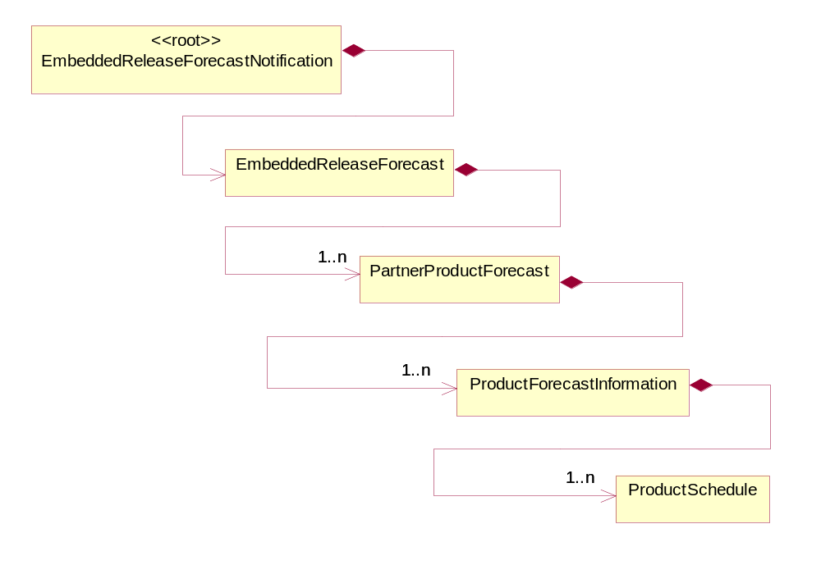
Figure 2-1 Interchange

Dependency Diagram
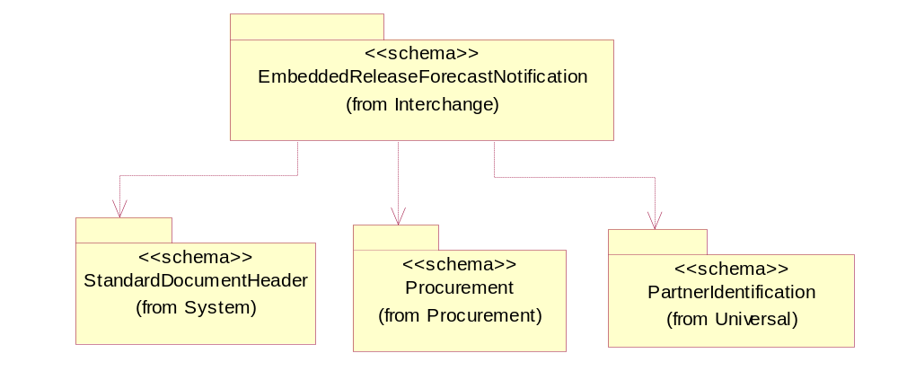
Figure 2-2 Dependency

EmbeddedReleaseForecast
The collection of business properties that describe future demand requirements information by product, for specific time periods, that can be used for build purposes with ship authorization trigger information.
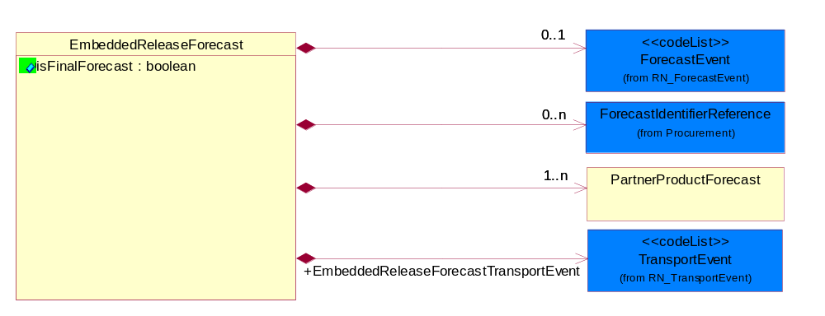
Figure 2-3 EmbeddedReleaseForecast

Attribute | Type | Documentation
isFinalForecast | boolean | Indicates whether the business document is final. When a forecast is final it is considered "constrained" forecast data that is "actionable" by the forecast recipient.

Composition | Cardinality | Type | Documentation
ForecastEvent | 0..1 | ForecastEvent | Code identifying the event that initiates a forecast.
ForecastIdentifierReference | 0..n | ForecastIdentifierReference | The collection of business properties that describe the various types of proprietary reference identifiers for forecast information.
PartnerProductForecast | 1..n | PartnerProductForecast | The collection of business properties that describe forecast and customer information for a product.
EmbeddedReleaseForecastTransportEvent | 1 | TransportEvent | Code identifying an event during the transportation of a shipment. Retricted to 2 codes: Only EmbeddedReleaseForecastTransportEvent equal to "Ship" or "Dock" is allowed.

EmbeddedReleaseForecastNotification
A Message wrapper or root element for PIP4A2.
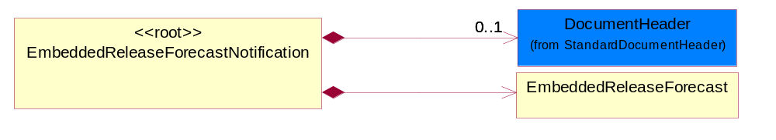
Figure 2-4 EmbeddedReleaseForecastNotification

Composition | Cardinality | Type | Documentation
DocumentHeader | 0..1 | DocumentHeader | The object allows for the identification of the sender and receiver of the business document.
EmbeddedReleaseForecast | 1 | EmbeddedReleaseForecast | The collection of business properties that describe future demand requirements information by product, for specific time periods, that can be used for build purposes with ship authorization trigger information.

PartnerProductForecast
The collection of business properties that describe forecast and customer information for a product.
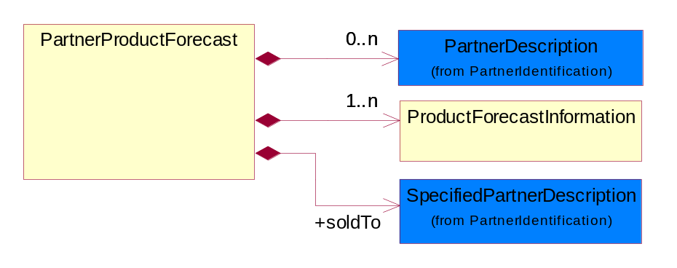
Figure 2-5 PartnerProductForecast

Composition | Cardinality | Type | Documentation
PartnerDescription | 0..n | PartnerDescription | The collection of business properties that describe a business partners' identity, their contact information, where they are physically located and their function in a supply chain.
ProductForecastInformation | 1..n | ProductForecastInformation | The collection of business properties that describe forecast information for a product.
soldTo | 1 | SpecifiedPartnerDescription | The party to whom a product has been sold.

ProductForecastInformation
The collection of business properties that describe forecast information for a product.
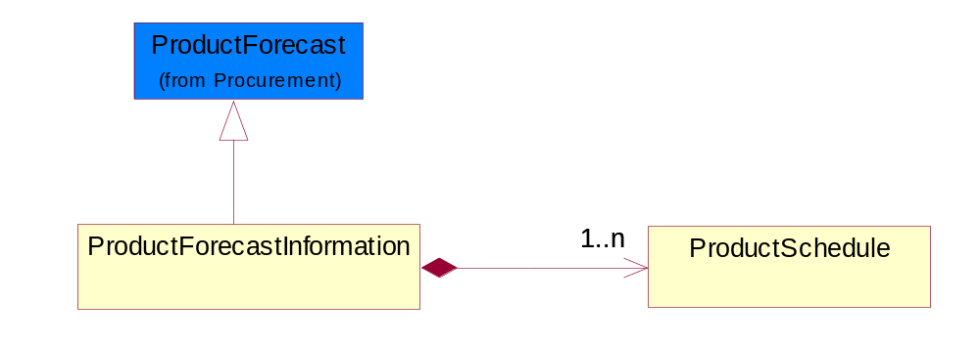
Figure 2-6 ProductForecastInformation

Composition | Cardinality | Type | Documentation
ProductSchedule | 1..n | ProductSchedule | The collection of business properties that describe forecast type, forecast date period and forecast quantity information.

ProductSchedule
The collection of business properties that describe forecast type, forecast date period and forecast quantity information.
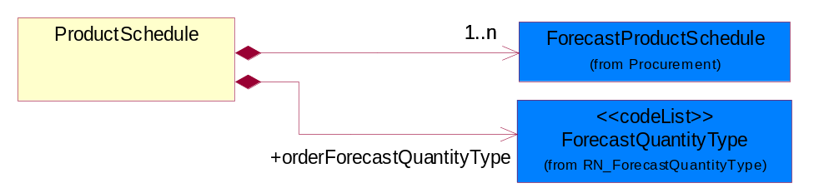
Figure 2-7 ProductSchedule

Composition | Cardinality | Type | Documentation
ForecastProductSchedule | 1..n | ForecastProductSchedule | The collection of business properties that describe quantity during a specific period for a particular product.
orderForecastQuantityType | 1 | ForecastQuantityType | Code identifying the type of product quantity for a order forecast.

Domain Model

Procurement

Procurement

Dependency Diagram
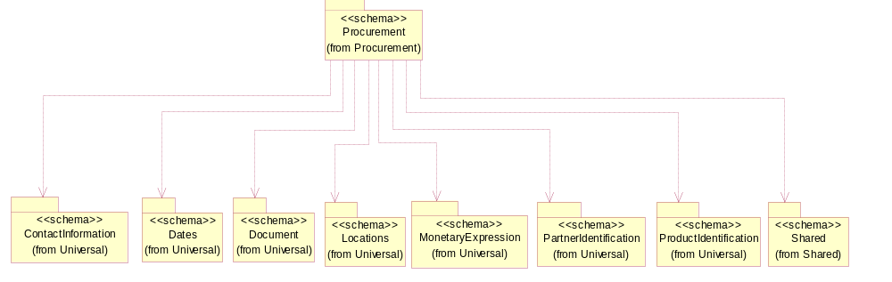
Figure 3-8 Dependency

ForecastIdentifierReference
The collection of business properties that describe the various types of proprietary reference identifiers for forecast information.
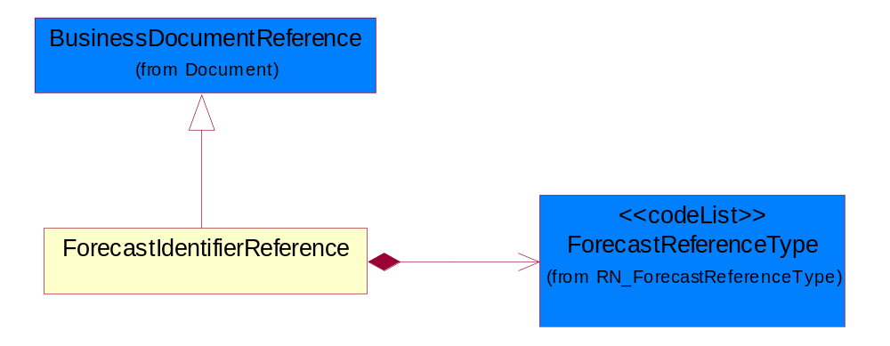
Figure 3-9 ForecastIdentifierReference

Composition | Cardinality | Type | Documentation
ForecastReferenceType | 1 | ForecastReferenceType | Code identifying the classification for type of forecast.

ForecastPeriod
The collection of business properties that describe periodicity as determined by the forecasting partner agreement.
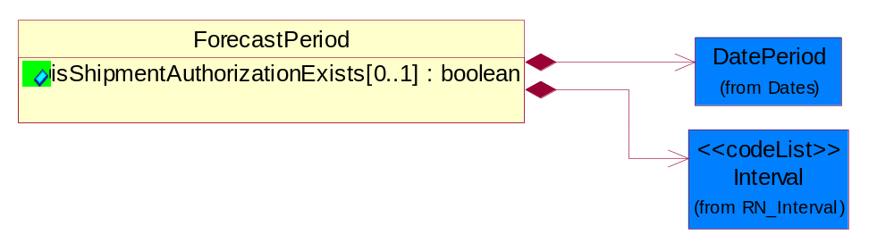
Figure 3-10 ForecastPeriod

Attribute | Type | Documentation
isShipmentAuthorizationExists[0..1] | boolean | Indicates the product is authorized for release.

Composition | Cardinality | Type | Documentation
DatePeriod | 1 | DatePeriod | The business document must allow for the computation or statement of a duration based upon a beginning and an ending date.
Interval | 1 | Interval | Code specifying a forecasting interval.

ForecastProductSchedule
The collection of business properties that describe quantity during a specific period for a particular product.
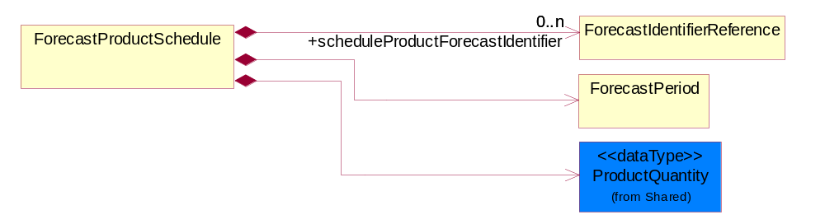
Figure 3-11 ForecastProductSchedule

Composition | Cardinality | Type | Documentation
scheduleProductForecastIdentifier | 0..n | ForecastIdentifierReference | The unique identifiers that reference documents in a Forecast.
ForecastPeriod | 1 | ForecastPeriod | The collection of business properties that describe periodicity as determined by the forecasting partner agreement.
ProductQuantity | 1 | ProductQuantity | A quantity specifying the number of product units.

ProductFamilyReporting
The collection of business properties that describe proprietary part information.
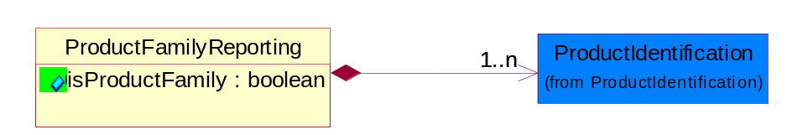
Figure 3-12 ProductFamilyReporting

Attribute | Type | Documentation
isProductFamily | boolean | Indicates whether the reporting is intended to report a product family or a product.

Composition | Cardinality | Type | Documentation
ProductIdentification | 1..n | ProductIdentification | The object provides the identifier(s) of a product.

ProductForecast
The collection of business properties that describe forecast information for a product.
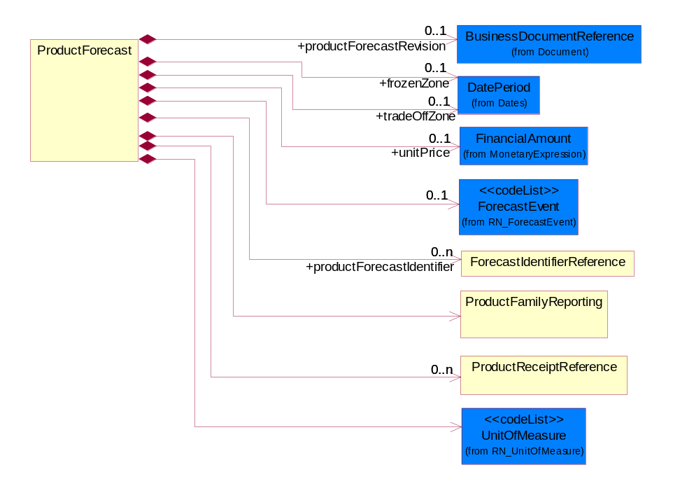
Figure 3-13 ProductForecast

Composition | Cardinality | Type | Documentation
productForecastRevision | 0..1 | BusinessDocumentReference | To use the identifier as an incremental number used to identify changes to ProductForecast.
frozenZone | 0..1 | DatePeriod | The date period for a forecast that is no longer open to change and within which all requirements are committed for release.
tradeOffZone | 0..1 | DatePeriod | The date period for a forecast in which there is a partial financial liability for product based on the TPA. Also known as the liability horizon.
unitPrice | 0..1 | FinancialAmount | Agreed upon sale price for each unit ordered.
ForecastEvent | 0..1 | ForecastEvent | Code identifying the event that initiates a forecast.
productForecastIdentifier | 0..n | ForecastIdentifierReference | The unique identifier that represents a forecast for a product.
ProductFamilyReporting | 1 | ProductFamilyReporting | The collection of business properties that describe proprietary part information.
ProductReceiptReference | 0..n | ProductReceiptReference | The collection of business properties that describe shipment, date and quantity information for a received product.
UnitOfMeasure | 1 | UnitOfMeasure | Code identifying a product unit of measure.

ProductReceiptReference
The collection of business properties that describe shipment, date and quantity information for a received product.
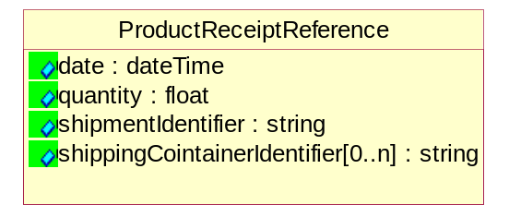
Figure 3-14 ProductReceiptReference

Attribute | Type | Documentation
date | dateTime | The date a product or service is received.
quantity | float | The product quantity received.
shipmentIdentifier | string | Reference identifier assigned by the partner originating a shipment to uniquely identify the shipment.
shippingCointainerIdentifier[0..n] | string | Unique identifier that represents a shipping container. Normally a UCC structured identifier. Also known as a "license plate".

CodeList

ForecastEvent
Code identifying the event that initiates a forecast.

Name | Documentation
ADV | Advertisement.
APA | Additional Parts Added.
DIP | Discontinued product.
FOB | Forward buy.
IPC | Inventory Policy Change.
LOC | Location closure.
MRP | Manufacturing Resource Planning run.
NLO | New location.
NPO | New product.
OPC | Order Policy Change.
PCO | Product changeover.
PRC | Price change.
PRO | Promotion.
QUC | Quantity change.
RPS | Related Product Shortage.
SCC | Schedule change.

ForecastQuantityType
Code identifying the type of product quantity for a order forecast.

Name | Documentation
CGD | Cumulative Gross Demand - a number which continues to increase over a period of time representing product requirements that have had no deductions.
CMT | Commit - Product quantity which is in response to a forecasted demand.
CND | A number which continue to increase over a period of time representing product requirements that have had deductions made from it.
DGD | Discrete Gross Demand - a non cumulative number representing product requirements that have had no deductions.
DND | Discrete Net Demand - a non cumulative number representing product requirements that have had deductions made from it.
DOD | Downside Demand.
PAI | Projected Available Inventory - The planned quantity of product that will be accessible in stock. Also known as Estimated Stock.
UPD | Upside Demand.
UPP | Unscheduled production plan; quantity that is known to be produced, but does not yet have a fixed schedule.
WQE | Work Queue - Defines the quantity that is planned to be produced at the defined day.

ForecastReferenceType
Code identifying the classification for type of forecast.

Name | Documentation
BPO | Blanket Purchase Order number.
CON | Contract number.
DPO | Discrete Purchase Order number.
PLN | Planning number.
PRN | Project number.
REN | Release number.
SAN | Scheduling Agreement Number.
SEN | Section number.

TransportEvent
Code identifying an event during the transportation of a shipment.

Name | Documentation
DOC | Dock.
PIC | Pickup.
SHP | Ship.

Shared

Shared

Dependency Diagram
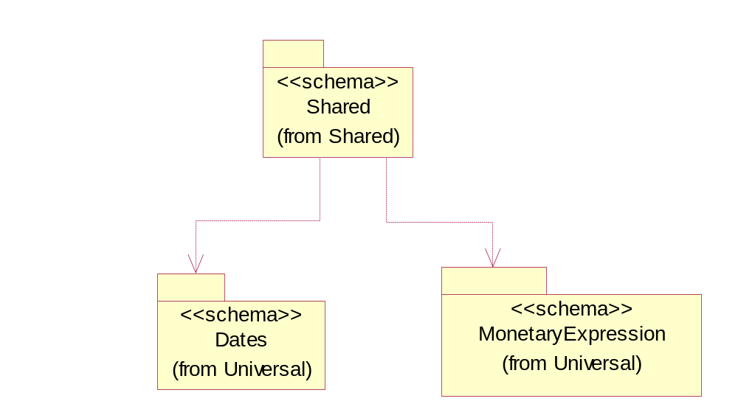
Figure 3-15 Dependency

ProductQuantity
A quantity specifying the number of product units.
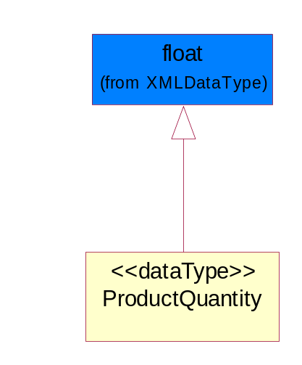
Figure 3-16 ProductQuantity

CodeList

Interval
Code specifying a forecasting interval.

Name | Documentation
1WM | 1st week of the month.
2WM | 2nd week of the month.
3WM | 3rd week of the month.
4WM | 4th week of the month.
5DW | 5 day work week-Monday through Friday.
5WM | 5th week of the month.
CAD | Calendar day-period given as a number of days including weekends and holidays.
CAW | Calendar week-period given as a number of 7 day-weeks including holidays.
DAY | Day.
FMP | Four month period.
FRI | Friday.
HFM | Half month.
HFW | Half week.
HFY | Half year.
HOU | Hour.
IND | Indefinite-an indefinite period.
MIN | Minute.
MOD | Monday.
MON | Month.
MTF | Monday through Friday.
MTS | Monday through Saturday.
MTU | Monday through Sunday.
QUA | Quarter.
SAT | Saturday.
SUN | Sunday.
TDP | Ten days period-period of 10 days.
THU | Thursday.
TMP | Two month period.
TUE | Tuesday.
TWP | Two week period.
UNS | Unspecified.
WDY | Work day.
WED | Wednesday.
WEE | Week.
WOR | Working days - days when the partner company normally works.
YEA | Year.

Universal Structure

ContactInformation

ContactInformation
The business document must allow for the identification of the name of the department, service or individual to be contacted regarding the context of the business document.
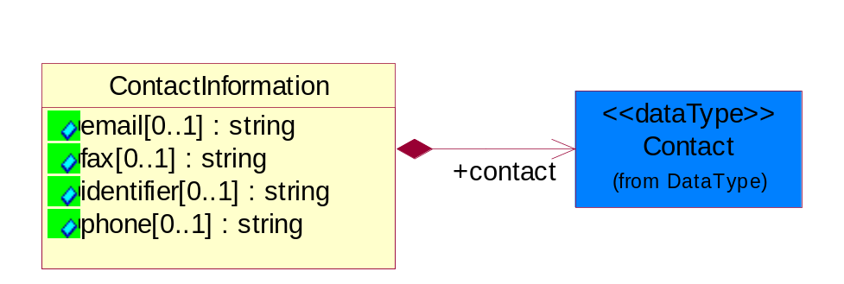
Figure 4-17 ContactInformation

Attribute | Type | Documentation
email[0..1] | string | The electronic mail for the specified contact.
fax[0..1] | string | The fax number for the specified contact.
identifier[0..1] | string | Identifies the role of the contact (i.e. Service Technician, Account Manager) in the Business Process.
phone[0..1] | string | The telephone number for the specified contact.

Composition | Cardinality | Type | Documentation
contact | 1 | Contact | The name of the department, service or individual to be contacted within the organization.

DataType

Contact
The name of the department, service or individual to be contacted within the organization.
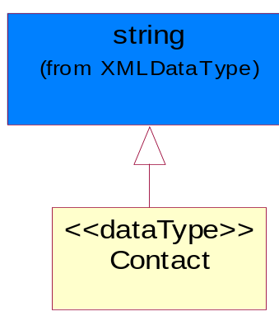
Figure 4-18 Contact

DUNS
A number assigned by Dun and Bradstreet to identify a business location.
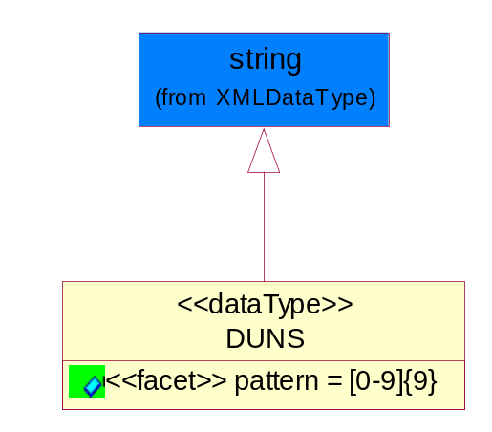
Figure 4-19 DUNS

Attribute | Type | Documentation
pattern |  | [0-9]{9}

DUNSPlus4
A identifier to specify a specific location within a business location.
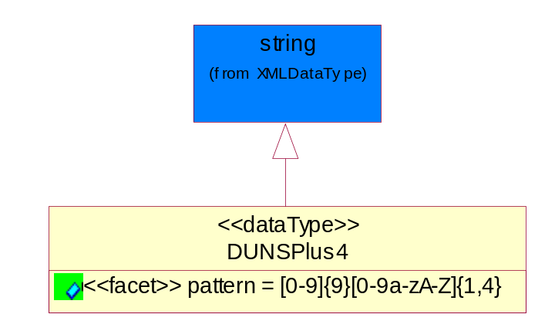
Figure 4-20 DUNSPlus4

Attribute | Type | Documentation
pattern |  | Data Universal Numbering System +4 (DUNS+4) number means the DUNS number assigned by Dun and Bradstreet, Inc. (D&B) plus an alphanumeric of length 4 suffix that may be assigned by a business concern.

GLN
Global Location Number (GLN) - A identifier to identify legal entities, trading parties and location.
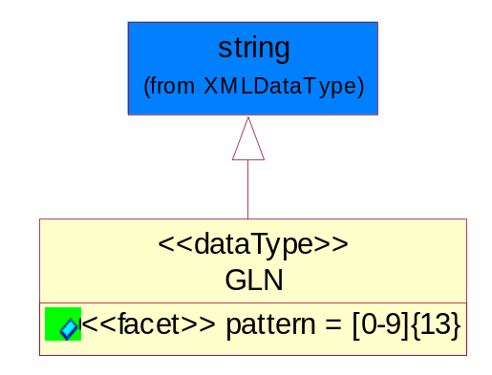
Figure 4-21 GLN

Attribute | Type | Documentation
pattern |  | [0-9]{13}

GTIN
Global Trade Identification Number (GTIN).
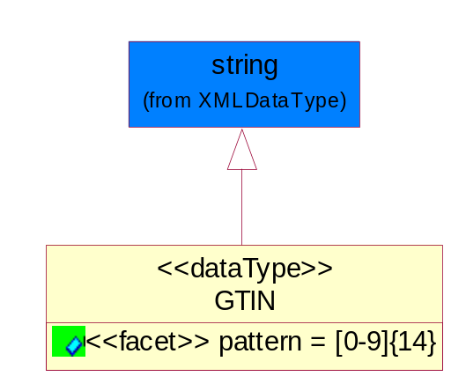
Figure 4-22 GTIN

Attribute | Type | Documentation
pattern |  | [0-9]{14}

Dates

DatePeriod
The business document must allow for the computation or statement of a duration based upon a beginning and an ending date.
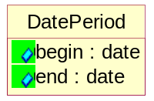
Figure 4-23 DatePeriod

Attribute | Type | Documentation
begin | date | The date indicating the beginning of the date period.
end | date | The date indicating the ending of the date period.

Document

BusinessDocumentReference
The business document reference object allows for the indirect referencing of a relationship to other business related documents.
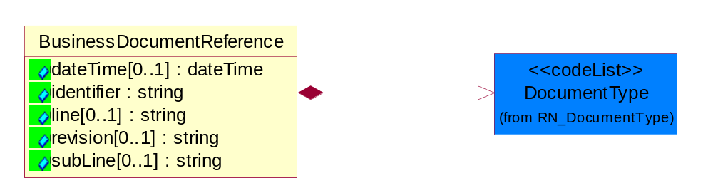
Figure 4-24 BusinessDocumentReference

Attribute | Type | Documentation
dateTime[0..1] | dateTime | The date-time stamp indicating on the referenced business document.
identifier | string | Unique identification of the referenced business document.
line[0..1] | string | References the specific line number of the specified business document.
revision[0..1] | string | Referenced the revision of the specified business document.
subLine[0..1] | string | References the specific subline number of the specified business document.

Composition | Cardinality | Type | Documentation
DocumentType | 1 | DocumentType | A code identifying the business context of a document.

Locations

AlternativeIdentifier
Identifies the specified code and the name of the organization that a code is utilized from.
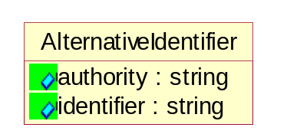
Figure 4-25 AlternativeIdentifier

Attribute | Type | Documentation
authority | string | The name of the organization that a code is utilized from.
identifier | string | The specified code to represent an entity (e.g. product, location, partner, etc.).

Location
The business document must specify a location.
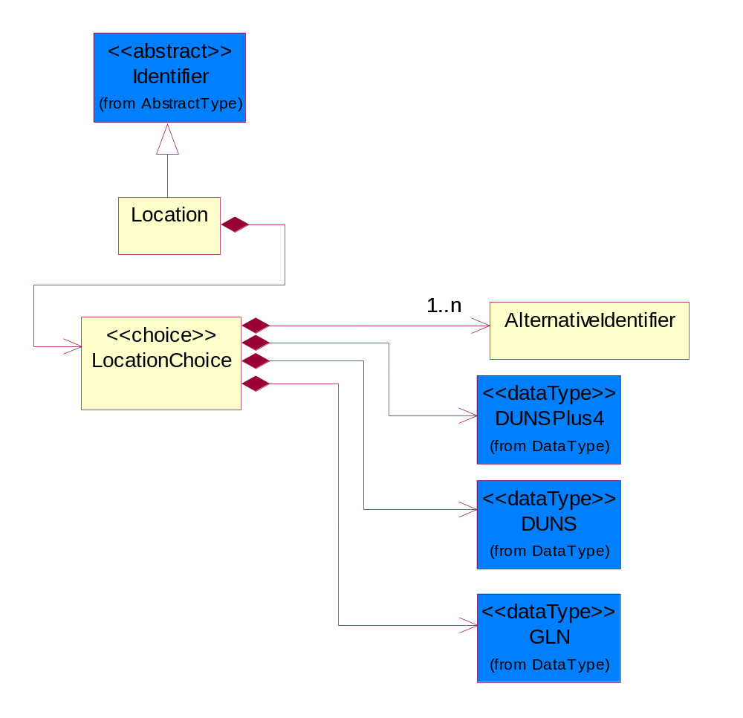
Figure 4-26 Location

Composition | Cardinality | Type | Documentation
LocationChoice | 1 | LocationChoice

LocationChoice

Composition | Cardinality | Type | Documentation
AlternativeIdentifier | 1..n | AlternativeIdentifier | Identifies the specified code and the name of the organization that a code is utilized from.
DUNSPlus4 | 1 | DUNSPlus4 | A identifier to specify a specific location within a business location.
DUNS | 1 | DUNS | A number assigned by Dun and Bradstreet to identify a business location.
GLN | 1 | GLN | Global Location Number (GLN) - A identifier to identify legal entities, trading parties and location.

PhysicalAddress
The business document must provide a physical address for a party to the business transaction.
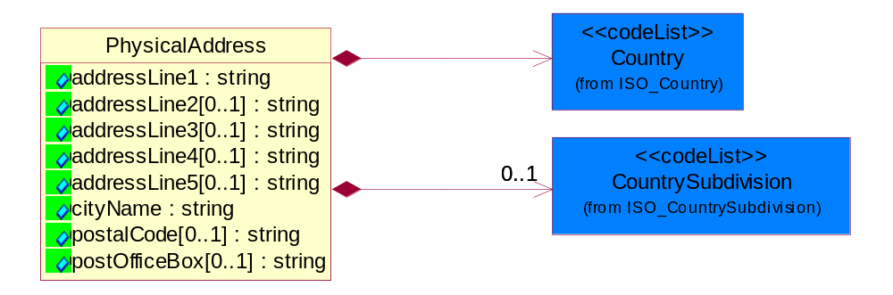
Figure 4-27 PhysicalAddress

Attribute | Type | Documentation
addressLine1 | string | The first line of a physical address.
addressLine2[0..1] | string | The second line of a physical address.
addressLine3[0..1] | string | The third line of a physical address.
addressLine4[0..1] | string | The fourth line of a physical address.
addressLine5[0..1] | string | The fifth line of a physical address.
cityName | string | The name of a city.
postalCode[0..1] | string | Identifying geographic location as specified by a national postal code.
postOfficeBox[0..1] | string | The Post Office Box identifier used to identify a party's post office box.

Composition | Cardinality | Type | Documentation
Country | 1 | Country | For representation of Country name RosettaNet has adopted ISO 3166-3; 1999. Refer to the following web page to get the latest version of the standard:  http://www.iso.ch/iso/en/prods-services/iso3166ma/02iso-3166-code-lists/index.html  If you need more information about the ISO standard please contact ISO for more details.
CountrySubdivision | 0..1 | CountrySubdivision | For representation of a Countries subdivisions RosettaNet has adopted ISO 3166-3; 1999. Refer to the following web page to get the latest version of the standard:  http://www.iso.ch/iso/en/prods-services/iso3166ma/02iso-3166-code-lists/index.html  If you need more information about the ISO standard please contact ISO for more details.

MonetaryExpression

FinancialAmount
The business document must express financial amounts.
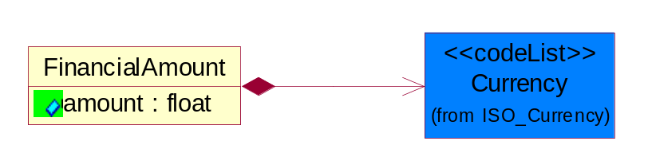
Figure 4-28 FinancialAmount

Attribute | Type | Documentation
amount | float | Specifies the monetary amount.

Composition | Cardinality | Type | Documentation
Currency | 1 | Currency | For representation of Currency codes RosettaNet has adopted ISO 4217; 1995. The British Standards Institution (BSI) is the ISO 4217 Maintenance Agency. Refer to the following web page to get the latest version of the standard:  http://www.bsi-global.com/Technical+Information/Publications/_Publications/tig90.xalter  If you need more information about the ISO standard please contact ISO for more details.

PartnerIdentification

FullPartner
The business document must describe the trading partners in the business transaction. This data structure provide the flexibility to describe a partner in all possible methods as for new, existing or known partner.
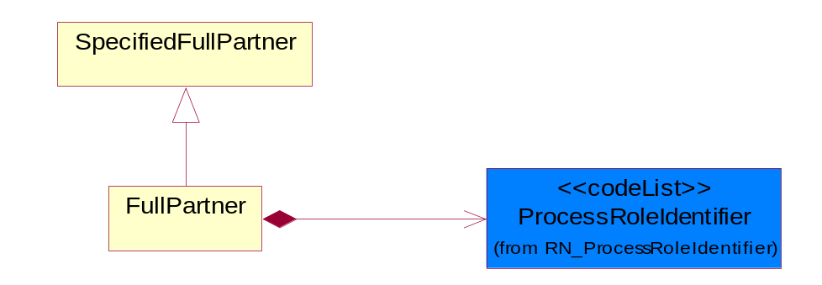
Figure 4-29 FullPartner

Composition | Cardinality | Type | Documentation
ProcessRoleIdentifier | 1 | ProcessRoleIdentifier | Describes the role of the partner in the business process. A partner will fulfill at least one or more roles during the business process.

IntermittentPartner
The business document must describe a physical address for a delivery.
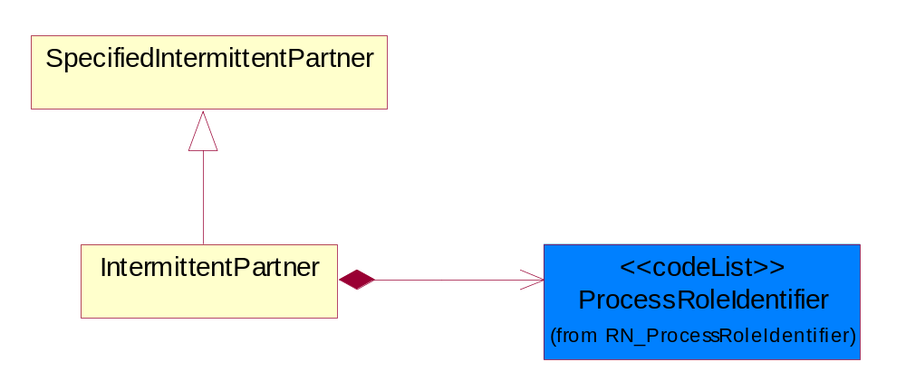
Figure 4-30 IntermittentPartner

Composition | Cardinality | Type | Documentation
ProcessRoleIdentifier | 1 | ProcessRoleIdentifier | Describes the role of the partner in the business process. A partner will fulfill at least one or more roles during the business process.

KnownPartner
The business document must describe the trading partners in the business transaction.
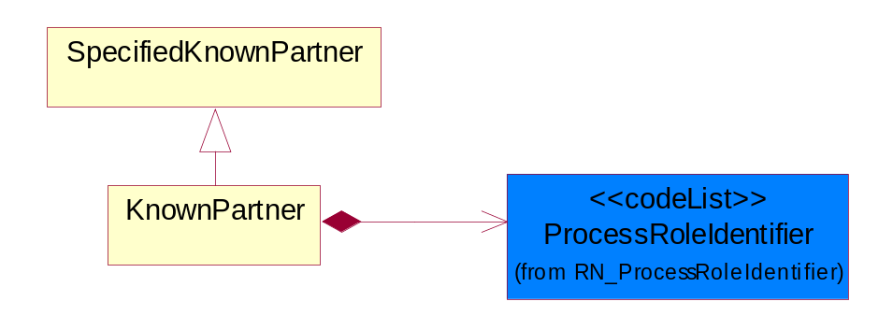
Figure 4-31 KnownPartner

Composition | Cardinality | Type | Documentation
ProcessRoleIdentifier | 1 | ProcessRoleIdentifier | Describes the role of the partner in the business process. A partner will fulfill at least one or more roles during the business process.

KnownPartnerContact
The business document must describe the trading partners in the business transaction.
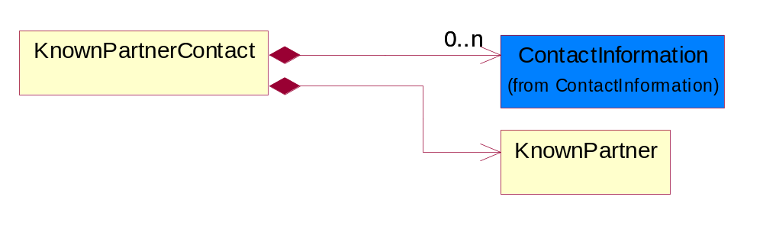
Figure 4-32 KnownPartnerContact

Composition | Cardinality | Type | Documentation
ContactInformation | 0..n | ContactInformation | The business document must allow for the identification of the name of the department, service or individual to be contacted regarding the context of the business document.
KnownPartner | 1 | KnownPartner | The business document must describe the trading partners in the business transaction.

NewPartner
The business document must describe a new, existing (but known to only one of the parties to the transaction) or an unknown party to the business transaction.
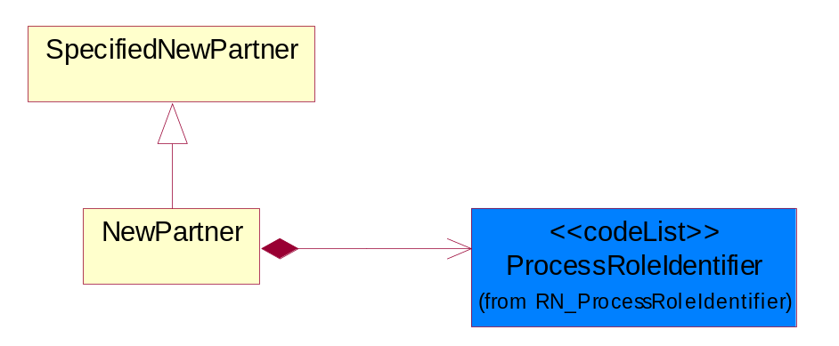
Figure 4-33 NewPartner

Composition | Cardinality | Type | Documentation
ProcessRoleIdentifier | 1 | ProcessRoleIdentifier | Describes the role of the partner in the business process. A partner will fulfill at least one or more roles during the business process.

PartnerDescription
The collection of business properties that describe a business partners' identity, their contact information, where they are physically located and their function in a supply chain.
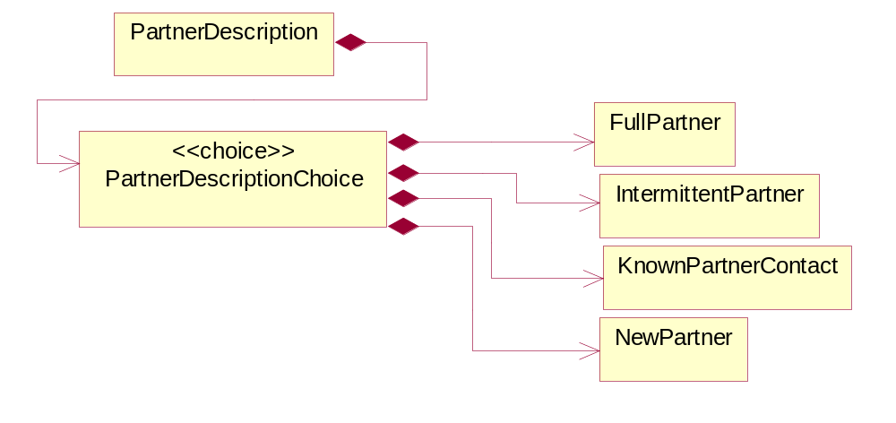
Figure 4-34 PartnerDescription

Composition | Cardinality | Type | Documentation
PartnerDescriptionChoice | 1 | PartnerDescriptionChoice

PartnerDescriptionChoice

Composition | Cardinality | Type | Documentation
FullPartner | 1 | FullPartner | The business document must describe the trading partners in the business transaction. This data structure provide the flexibility to describe a partner in all possible methods as for new, existing or known partner.
IntermittentPartner | 1 | IntermittentPartner | The business document must describe a physical address for a delivery.
KnownPartnerContact | 1 | KnownPartnerContact | The business document must describe the trading partners in the business transaction.
NewPartner | 1 | NewPartner | The business document must describe a new, existing (but known to only one of the parties to the transaction) or an unknown party to the business transaction.

PartnerIdentification
The business document must allow for the identity of one or more parties to the transaction.
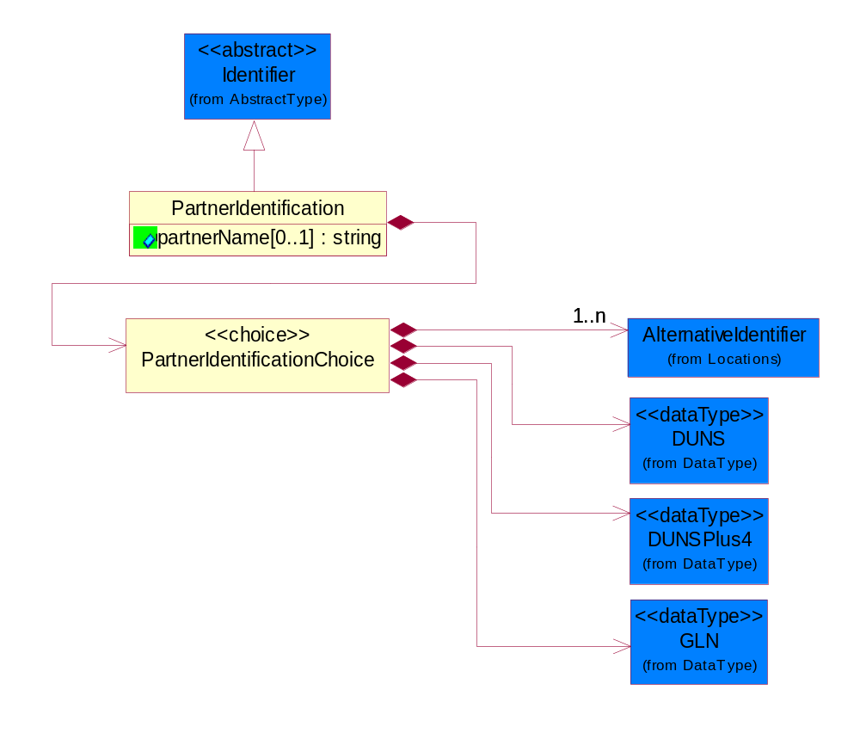
Figure 4-35 PartnerIdentification

Attribute | Type | Documentation
partnerName[0..1] | string | The name of the partner’s company/business.

Composition | Cardinality | Type | Documentation
PartnerIdentificationChoice | 1 | PartnerIdentificationChoice

PartnerIdentificationChoice

Composition | Cardinality | Type | Documentation
AlternativeIdentifier | 1..n | AlternativeIdentifier | Identifies the specified code and the name of the organization that a code is utilized from.
DUNS | 1 | DUNS | A number assigned by Dun and Bradstreet to identify a business location.
DUNSPlus4 | 1 | DUNSPlus4 | A identifier to specify a specific location within a business location.
GLN | 1 | GLN | Global Location Number (GLN) - A identifier to identify legal entities, trading parties and location.

SpecifiedFullPartner
The business document must describe the trading partners in the business transaction. This data structure provide the flexibility to describe a partner in all possible methods as for new, existing or known partner. This is specifically for partner who role has been specified.
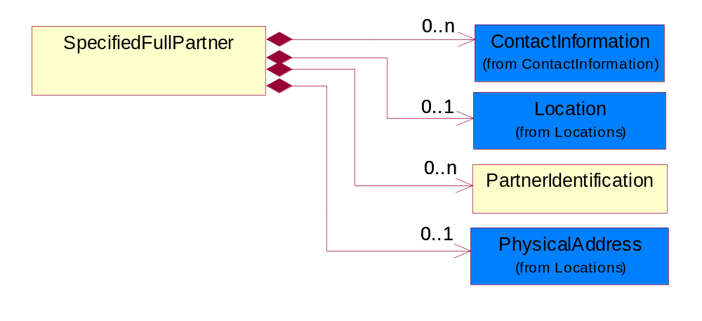
Figure 4-36 SpecifiedFullPartner

Composition | Cardinality | Type | Documentation
ContactInformation | 0..n | ContactInformation | The business document must allow for the identification of the name of the department, service or individual to be contacted regarding the context of the business document.
Location | 0..1 | Location | The business document must specify a location.
PartnerIdentification | 0..n | PartnerIdentification | The business document must allow for the identity of one or more parties to the transaction.
PhysicalAddress | 0..1 | PhysicalAddress | The business document must provide a physical address for a party to the business transaction.

SpecifiedIntermittentPartner
The business document must describe a physical address for a delivery.
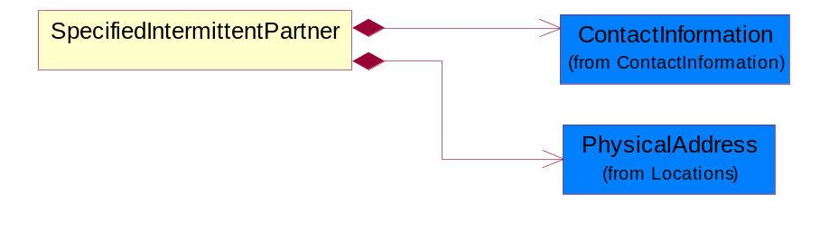
Figure 4-37 SpecifiedIntermittentPartner

Composition | Cardinality | Type | Documentation
ContactInformation | 1 | ContactInformation | The business document must allow for the identification of the name of the department, service or individual to be contacted regarding the context of the business document.
PhysicalAddress | 1 | PhysicalAddress | The business document must provide a physical address for a party to the business transaction.

SpecifiedKnownPartner
The business document must describe the trading partners in the business transaction.
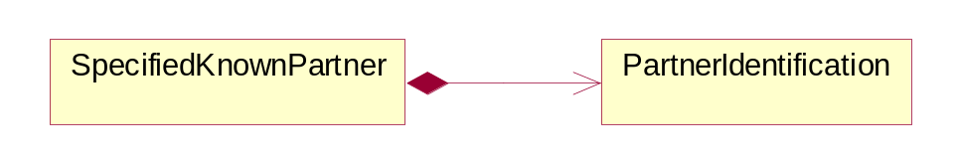
Figure 4-38 SpecifiedKnownPartner

Composition | Cardinality | Type | Documentation
PartnerIdentification | 1 | PartnerIdentification | The business document must allow for the identity of one or more parties to the transaction.

SpecifiedKnownPartnerContact
The business document must describe the trading partners in the business transaction and allow for a identification of an individual of the trading partner.
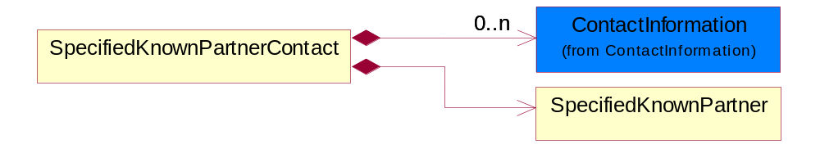
Figure 4-39 SpecifiedKnownPartnerContact

Composition | Cardinality | Type | Documentation
ContactInformation | 0..n | ContactInformation | The business document must allow for the identification of the name of the department, service or individual to be contacted regarding the context of the business document.
SpecifiedKnownPartner | 1 | SpecifiedKnownPartner | The business document must describe the trading partners in the business transaction.

SpecifiedNewPartner
The business document must describe a new, existing (but known to only one of the parties to the transaction) or an unknown party to the business transaction.
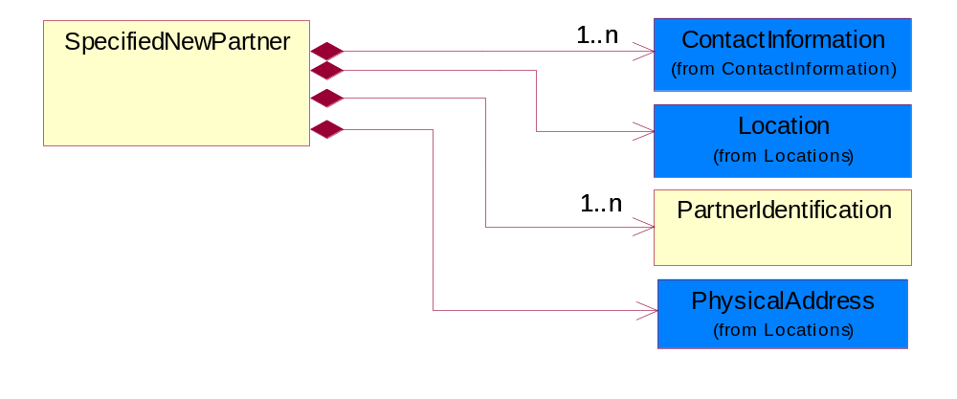
Figure 4-40 SpecifiedNewPartner

Composition | Cardinality | Type | Documentation
ContactInformation | 1..n | ContactInformation | The business document must allow for the identification of the name of the department, service or individual to be contacted regarding the context of the business document.
Location | 1 | Location | The business document must specify a location.
PartnerIdentification | 1..n | PartnerIdentification | The business document must allow for the identity of one or more parties to the transaction.
PhysicalAddress | 1 | PhysicalAddress | The business document must provide a physical address for a party to the business transaction.

SpecifiedPartnerDescription
The collection of business properties that describe a business partners' identity, their contact information, where they are physically located and their function in a supply chain.
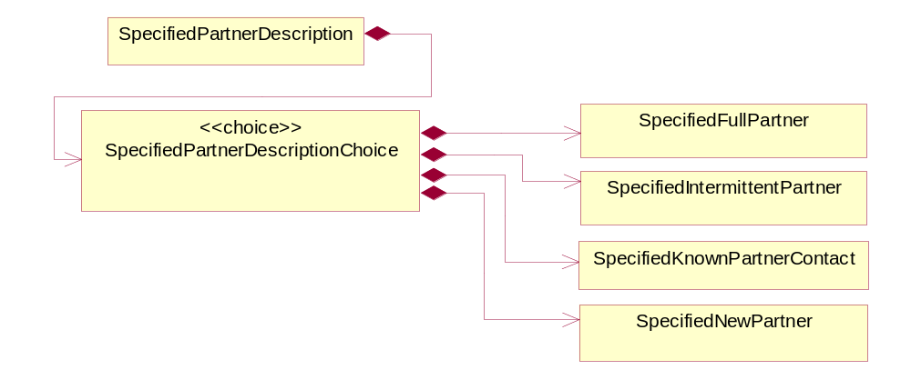
Figure 4-41 SpecifiedPartnerDescription

Composition | Cardinality | Type | Documentation
SpecifiedPartnerDescriptionChoice | 1 | SpecifiedPartnerDescriptionChoice

SpecifiedPartnerDescriptionChoice

Composition | Cardinality | Type | Documentation
SpecifiedFullPartner | 1 | SpecifiedFullPartner | The business document must describe the trading partners in the business transaction. This data structure provide the flexibility to describe a partner in all possible methods as for new, existing or known partner. This is specifically for partner who role has been specified.
SpecifiedIntermittentPartner | 1 | SpecifiedIntermittentPartner | The business document must describe a physical address for a delivery.
SpecifiedKnownPartnerContact | 1 | SpecifiedKnownPartnerContact | The business document must describe the trading partners in the business transaction and allow for a identification of an individual of the trading partner.
SpecifiedNewPartner | 1 | SpecifiedNewPartner | The business document must describe a new, existing (but known to only one of the parties to the transaction) or an unknown party to the business transaction.

ProductIdentification

ProductIdentification
The object provides the identifier(s) of a product.
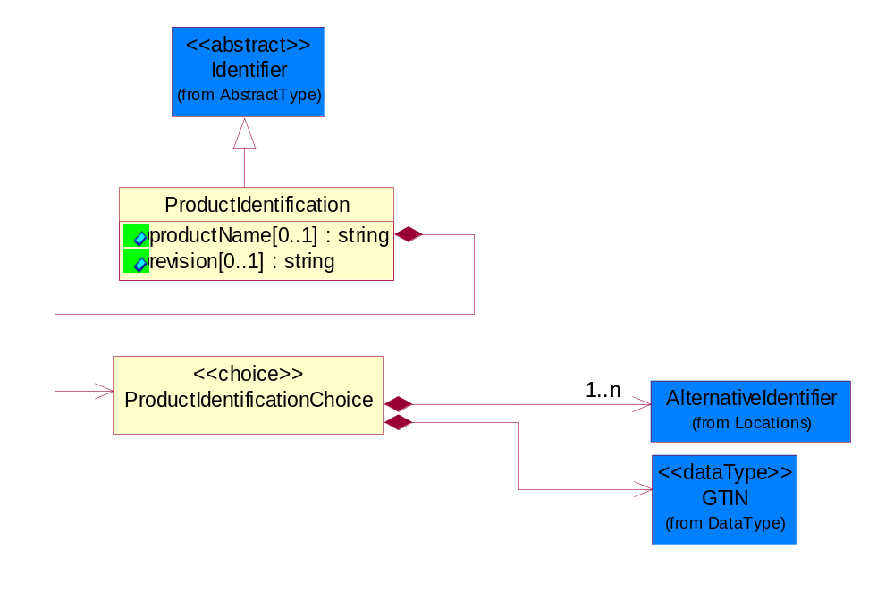
Figure 4-42 ProductIdentification

Attribute | Type | Documentation
productName[0..1] | string | The name of the product.
revision[0..1] | string | Referenced the specified product revision.

Composition | Cardinality | Type | Documentation
ProductIdentificationChoice | 1 | ProductIdentificationChoice

ProductIdentificationChoice

Composition | Cardinality | Type | Documentation
AlternativeIdentifier | 1..n | AlternativeIdentifier | Identifies the specified code and the name of the organization that a code is utilized from.
GTIN | 1 | GTIN | Global Trade Identification Number (GTIN).

CodeList

Country
For representation of Country name RosettaNet has adopted ISO 3166-3; 1999. Refer to the following web page to get the latest version of the standard:
http://www.iso.ch/iso/en/prods-services/iso3166ma/02iso-3166-code-lists/index.html

If you need more information about the ISO standard please contact ISO for more details.

CountrySubdivision
For representation of a Countries subdivisions RosettaNet has adopted ISO 3166-3; 1999. Refer to the following web page to get the latest version of the standard:
http://www.iso.ch/iso/en/prods-services/iso3166ma/02iso-3166-code-lists/index.html

If you need more information about the ISO standard please contact ISO for more details.

Currency
For representation of Currency codes RosettaNet has adopted ISO 4217; 1995. The British Standards Institution (BSI) is the ISO 4217 Maintenance Agency. Refer to the following web page to get the latest version of the standard:
http://www.bsi-global.com/Technical+Information/Publications/_Publications/tig90.xalter

If you need more information about the ISO standard please contact ISO for more details.

Language
For representation of Language name RosettaNet has adopted ISO 639-2; 1998. Refer to the following web page to get the latest version of the standard:

http://www.loc.gov/standards/iso639-2/iso639jac.html

If you need more information about the ISO standard please contact ISO for more details.

DocumentType
A code identifying the business context of a document.

Instance | Documentation
ARA | Authorization Request Approval.
CBN | Product batch number of customer.
CCN | Customs clearance number.
CFA | Failure Analysis - Request document that will accompany the product providing characteristics of the component failure.
CIN | Commercial Invoice.
CNM | Traditional credit note or memo.
CON | In a virtual sourcing relationship, a third party trading partner is supplying a part to a customer on behalf of another company that has taken the order for the customer. In this case a Customer Order Number is associated to the request for material that is sent to the virtual trading partners.
COS | Consumption Notice.
COT | Contract.
CRN | Unique consumption reference number identifying the product consumption issue i.e. one-to-one relationship with physical flow.
DEM | Traditional debit note or memo.
DEN | Delivery Note.
DIN | Discontinuation Notice.
DOR | Delivery Order.
DRN | Drawing Number.
DRR | Design Registration Request.
ECO | Engineering Change Order - The proprietary unique identification number that represents an engineering change order.
EIR | Engineering Information Request.
EOL | End of Life.
FUO | Sales order or transfer order fulfilling demand out of a facility (outbound shipment).
INV | Invoice.
LID | Location Identifier. Data for on-site work that have to be done on the machine (associated with preventive maintenance order).
MEN | Master Event Number.
MID | Machine Identifier. Data for on-site work that have to be done on the machine (associated with preventive maintenance order).
MON | Model Number.
OCL | The unique identifier assigned by the OEM for a warranty claim.
OGA | Other governmental agency issued document.
OPO | The unique identifier assigned by the OEM for a part order.
OPR | The unique identifier assigned by the OEM for a part return.
PCN | Product/Process Change.
PFA | Failure Analysis - Request document that will accompany the product providing characteristics of the product failure.
PII | Refers to previously issued invoice.
PLS | Unique number that identifies packing form prior to shipment.
POI | Purchase Order IN.
PON | Production order number for material release.
POO | Purchase Order OUT.
PRC | Product Catalog.
PSI | Refers to previously issued self-billing invoice.
PUO | Purchase Order.
QUO | Quote.
REC | Document identifying the receipt of materials or products into a facility against a purchase order or transfer order (inbound shipment).
REO | Purchase order or transfer order replenishing inventory into a facility (inbound shipment).
REQ | Requisition.
RMA | Returned Material Authorization.
RPO | Purchase order for materials or product returned to and reworked by a supplier.
RTA | Remittance Advice - Remittance details.
SAO | Sales Order.
SBC | Credit Memo used in self-billing scenario.
SBD | Debit Memo used in self-billing scenario.
SBI | Invoice in self billing scenario.
SBN | Product batch number of supplier.
SCA | Similar to contracts - Contains the quantity of an article that is to be ordered from a vendor and the price for article or service that is to be procured.
SEN | Serial Number.
SEO | A document that gives a repair provider the necessary authorization to repair or upgrade a product either at the customer site or at the repair provider’s site.
SHD | Shipping Document.
SNC | Shipset Number on Code List.
SPC | The unique identifier assigned by the ASP for a warranty claim.
SPN | Spec Number.
SPO | The unique identifier assigned by the ASP for a part order.
SPR | The unique identifier assigned by the ASP for a part return.
SPW | The unique identifier assigned by the ASP to reference a work order.
SRI | A document that contains the shipping reference number which allows the product to be tracked within the outsourced logistic providers network.
TRO | Order which results in materials or products being moved from one facility to another (outbound shipment and inbound shipment).
WAB | Waybill.
WAC | Denotes a warranty claim.
WOO | Work Order.

MimeTypeQualifier
The MIME type as defined by IANA.

Please refer to http://www.iana.org/assignments/media-types/ for a list of types.

Instance | Documentation
application/activemessage | [Shapiro]
application/andrew-inset | [Borenstein]
application/applefile | [Faltstrom]
application/atomicmail | [Borenstein]
application/batch-SMTP | [RFC2442]
application/beep+xml | [RFC3080]
application/cals-1840 | [RFC1895]
application/cnrp+xml | [RFCCNRP]
application/commonground | [Glazer]
application/cpl+xml
application/cybercash | [Eastlake]
application/dca-rft | [Campbell]
application/dec-dx | [Campbell]
application/dicom | [RFC3240]
application/dvcs | [RFC3029]
application/EDI-Consent | [RFC1767]
application/EDIFACT | [RFC1767]
application/EDI-X12 | [RFC1767]
application/eshop | [Katz]
application/font-tdpfr | [RFC3073]
application/http | [RFC2616]
application/hyperstudio | [Domino]
application/iges | [Parks]
application/index | [RFC2652]
application/index.cmd | [RFC2652]
application/index.obj | [RFC2652]
application/index.response | [RFC2652]
application/index.vnd | [RFC2652]
application/iotp | [RFC2935]
application/ipp | [RFC2910]
application/isup | [RFC3204]
application/mac-binhex40 | [Faltstrom]
application/macwriteii | [Lindner]
application/marc | [RFC2220]
application/mathematica | [Van Nostern]
application/msword | [Lindner]
application/news-message-id | [RFC1036,Spencer]
application/news-transmission | [RFC1036, Spencer]
application/ocsp-request | [RFC2560]
application/ocsp-response | [RFC2560]
application/octet-stream | [RFC2045,RFC2046]
application/oda | [RFC2045,RFC2046]
application/ogg | [RFC-walleij-ogg-mediatype-08.txt]
application/parityfec | [RFC3009]
application/pdf | [Lindner]
application/pgp-encrypted | [RFC3156]
application/pgp-keys | [RFC3156]
application/pgp-signature | [RFC3156]
application/pkcs10 | [RFC2311]
application/pkcs7-mime | [RFC2311]
application/pkcs7-signature | [RFC2311]
application/pkix-cert | [RFC2585]
application/pkixcmp | [RFC2510]
application/pkix-crl | [RFC2585]
application/postscript | [RFC2045,RFC2046]
application/prs.alvestrand.titrax-sheet | [Alvestrand]
application/prs.cww | [Rungchavalnont]
application/prs.nprend | [Doggett]
application/prs.plucker | [Janssen]
application/qsig | [RFC3204]
application/reginfo+xml | [RFC-ietf-sipping-reg-event-00.txt]
application/remote-printing | [RFC1486,Rose]
application/riscos | [Smith]
application/rtf | [Lindner]
application/sdp | [RFC2327]
application/set-payment | [Korver]
application/set-payment-initiation | [Korver]
application/set-registration | [Korver]
application/set-registration-initiation | [Korver]
application/sgml | [RFC1874]
application/sgml-open-catalog | [Grosso]
application/sieve | [RFC3028]
application/slate | [Crowley]
application/timestamp-query | [RFC3161]
application/timestamp-reply | [RFC3161]
application/tve-trigger | [Welsh]
application/vemmi | [RFC2122]
application/vnd.3gpp.pic-bw-large | [Meredith]
application/vnd.3gpp.pic-bw-small | [Meredith]
application/vnd.3gpp.pic-bw-var | [Meredith]
application/vnd.3gpp.sms | [Meredith]
application/vnd.3M.Post-it-Notes | [O'Brien]
application/vnd.accpac.simply.aso | [Leow]
application/vnd.accpac.simply.imp | [Leow]
application/vnd.acucobol | [Lubin]
application/vnd.acucorp | [Lubin]
application/vnd.adobe.xfdf | [Perelman]
application/vnd.aether.imp | [Moskowitz]
application/vnd.amiga.ami | [Blumberg]
application/vnd.anser-web-certificate-issue-initiation | [Mori]
application/vnd.anser-web-funds-transfer-initiation | [Mori]
application/vnd.audiograph | [Slusanschi]
application/vnd.blueice.multipass | [Holmstrom]
application/vnd.bmi | [Gotoh]
application/vnd.businessobjects | [Imoucha]
application/vnd.canon-cpdl | [Muto]
application/vnd.canon-lips | [Muto]
application/vnd.cinderella | [Kortenkamp]
application/vnd.claymore | [Simpson]
application/vnd.commerce-battelle | [Applebaum]
application/vnd.commonspace | [Chandhok]
application/vnd.contact.cmsg | [Patz]
application/vnd.cosmocaller | [Dellutri]
application/vnd.ctc-posml | [Kohlhepp]
application/vnd.cups-postscript | [Sweet]
application/vnd.cups-raster | [Sweet]
application/vnd.cups-raw | [Sweet]
application/vnd.curl | [Byrnes]
application/vnd.cybank | [Helmee]
application/vnd.data-vision.rdz | [Fields]
application/vnd.dna | [Searcy]
application/vnd.dpgraph | [Parker]
application/vnd.dreamfactory | [Appleton]
application/vnd.dxr | [Duffy]
application/vnd.ecdis-update | [Buettgenbach]
application/vnd.ecowin.chart | [Olsson]
application/vnd.ecowin.filerequest | [Olsson]
application/vnd.ecowin.fileupdate | [Olsson]
application/vnd.ecowin.series | [Olsson]
application/vnd.ecowin.seriesrequest | [Olsson]
application/vnd.ecowin.seriesupdate | [Olsson]
application/vnd.enliven | [Santinelli]
application/vnd.epson.esf | [Hoshina]
application/vnd.epson.msf | [Hoshina]
application/vnd.epson.quickanime | [Gu]
application/vnd.epson.salt | [Nagatomo]
application/vnd.epson.ssf | [Hoshina]
application/vnd.ericsson.quickcall | [Tidwell]
application/vnd.eudora.data | [Resnick]
application/vnd.fdf | [Zilles]
application/vnd.ffsns | [Holstage]
application/vnd.FloGraphIt | [Floersch]
application/vnd.framemaker | [Wexler]
application/vnd.fsc.weblaunch | [D.Smith]
application/vnd.fujitsu.oasys | [Togashi]
application/vnd.fujitsu.oasys2 | [Togashi]
application/vnd.fujitsu.oasys3 | [Okudaira]
application/vnd.fujitsu.oasysgp | [Sugimoto]
application/vnd.fujitsu.oasysprs | [Ogita]
application/vnd.fujixerox.ddd | [Onda]
application/vnd.fujixerox.docuworks | [Taguchi]
application/vnd.fujixerox.docuworks.binder | [Matsumoto]
application/vnd.fut-misnet | [Pruulmann]
application/vnd.grafeq | [Tupper]
application/vnd.groove-account | [Joseph]
application/vnd.groove-help | [Joseph]
application/vnd.groove-identity-message | [Joseph]
application/vnd.groove-injector | [Joseph]
application/vnd.groove-tool-message | [Joseph]
application/vnd.groove-tool-template | [Joseph]
application/vnd.groove-vcard | [Joseph]
application/vnd.hbci | [Hammann]
application/vnd.hhe.lesson-player | [Jones]
application/vnd.hp-HPGL | [Pentecost]
application/vnd.hp-hpid | [Gupta]
application/vnd.hp-hps | [Aubrey]
application/vnd.hp-PCL | [Pentecost]
application/vnd.hp-PCLXL | [Pentecost]
application/vnd.httphone | [Lefevre]
application/vnd.hzn-3d-crossword | [Minnis]
application/vnd.ibm.afplinedata | [Buis]
application/vnd.ibm.electronic-media | [Tantlinger]
application/vnd.ibm.MiniPay | [Herzberg]
application/vnd.ibm.modcap | [Hohensee]
application/vnd.ibm.secure-container | [Tantlinger]
application/vnd.informix-visionary | [Gales]
application/vnd.intercon.formnet | [Gurak]
application/vnd.intertrust.digibox | [Tomasello]
application/vnd.intertrust.nncp | [Tomasello]
application/vnd.intu.qbo | [Scratchley]
application/vnd.intu.qfx | [Scratchley]
application/vnd.irepository.package+xml | [Knowles]
application/vnd.is-xpr | [Natarajan]
application/vnd.japannet-directory-service | [Fujii]
application/vnd.japannet-jpnstore-wakeup | [Yoshitake]
application/vnd.japannet-payment-wakeup | [Fujii]
application/vnd.japannet-registration | [Yoshitake]
application/vnd.japannet-registration-wakeup | [Fujii]
application/vnd.japannet-setstore-wakeup | [Yoshitake]
application/vnd.japannet-verification | [Yoshitake]
application/vnd.japannet-verification-wakeup | [Fujii]
application/vnd.jisp | [Deckers]
application/vnd.kde.karbon | [Faure]
application/vnd.kde.kchart | [Faure]
application/vnd.kde.kformula | [Faure]
application/vnd.kde.kivio | [Faure]
application/vnd.kde.kontour | [Faure]
application/vnd.kde.kpresenter | [Faure]
application/vnd.kde.kspread | [Faure]
application/vnd.kde.kword | [Faure]
application/vnd.kenameaapp | [DiGiorgio-Haag]
application/vnd.koan | [Cole]
application/vnd.liberty-request+xml | [McDowell]
application/vnd.llamagraphics.life-balance.desktop | [White]
application/vnd.lotus-1-2-3 | [Wattenberger]
application/vnd.lotus-approach | [Wattenberger]
application/vnd.lotus-freelance | [Wattenberger]
application/vnd.lotus-notes | [Laramie]
application/vnd.lotus-organizer | [Wattenberger]
application/vnd.lotus-screencam | [Wattenberger]
application/vnd.lotus-wordpro | [Wattenberger]
application/vnd.mcd | [Gotoh]
application/vnd.mediastation.cdkey | [Flurry]
application/vnd.meridian-slingshot | [Wedel]
application/vnd.micrografx.flo | [Prevo]
application/vnd.micrografx.igx | [Prevo]
application/vnd.mif | [Wexler]
application/vnd.minisoft-hp3000-save | [Bartram]
application/vnd.mitsubishi.misty-guard.trustweb | [Tanaka]
application/vnd.Mobius.DAF | [Kabayama]
application/vnd.Mobius.DIS | [Kabayama]
application/vnd.Mobius.MBK | [Devasia]
application/vnd.Mobius.MQY | [Devasia]
application/vnd.Mobius.MSL | [Kabayama]
application/vnd.Mobius.PLC | [Kabayama]
application/vnd.Mobius.TXF | [Kabayama]
application/vnd.mophun.application | [Wennerstrom]
application/vnd.mophun.certificate | [Wennerstrom]
application/vnd.motorola.flexsuite | [Patton]
application/vnd.motorola.flexsuite.adsi | [Patton]
application/vnd.motorola.flexsuite.fis | [Patton]
application/vnd.motorola.flexsuite.gotap | [Patton]
application/vnd.motorola.flexsuite.kmr | [Patton]
application/vnd.motorola.flexsuite.ttc | [Patton]
application/vnd.motorola.flexsuite.wem | [Patton]
application/vnd.mozilla.xul+xml | [McDaniel]
application/vnd.ms-artgalry | [Slawson]
application/vnd.ms-asf | [Fleischman]
application/vnd.mseq | [Le Bodic]
application/vnd.ms-excel | [Gill]
application/vnd.msign | [Borcherding]
application/vnd.ms-lrm | [Ledoux]
application/vnd.ms-powerpoint | [Gill]
application/vnd.ms-project | [Gill]
application/vnd.ms-tnef | [Gill]
application/vnd.ms-works | [Gill]
application/vnd.ms-wpl | [Plastina]
application/vnd.musician | [Adams]
application/vnd.music-niff | [Butler]
application/vnd.netfpx | [Mutz]
application/vnd.noblenet-directory | [Solomon]
application/vnd.noblenet-sealer | [Solomon]
application/vnd.noblenet-web | [Solomon]
application/vnd.novadigm.EDM | [Swenson]
application/vnd.novadigm.EDX | [Swenson]
application/vnd.novadigm.EXT | [Swenson]
application/vnd.obn | [Hessling]
application/vnd.osa.netdeploy | [Klos]
application/vnd.palm | [Peacock]
application/vnd.pg.format | [Gandert]
application/vnd.pg.osasli | [Gandert]
application/vnd.powerbuilder6 | [Guy]
application/vnd.powerbuilder6-s | [Guy]
application/vnd.powerbuilder7 | [Shilts]
application/vnd.powerbuilder75 | [Shilts]
application/vnd.powerbuilder75-s | [Shilts]
application/vnd.powerbuilder7-s | [Shilts]
application/vnd.previewsystems.box | [Smolgovsky]
application/vnd.publishare-delta-tree | [Ben-Kiki]
application/vnd.pvi.ptid1 | [Lamb]
application/vnd.pwg-multiplexed | [RFC3391]
application/vnd.pwg-xhtml-print+xml | [Wright]
application/vnd.Quark.QuarkXPress | [Scheidler]
application/vnd.rapid | [Szekely]
application/vnd.s3sms | [Tarkkala]
application/vnd.sealed.net | [Lambert]
application/vnd.seemail | [Webb]
application/vnd.shana.informed.formdata | [Selzler]
application/vnd.shana.informed.formtemplate | [Selzler]
application/vnd.shana.informed.interchange | [Selzler]
application/vnd.shana.informed.package | [Selzler]
application/vnd.smaf | [Takahashi]
application/vnd.sss-cod | [Dani]
application/vnd.sss-dtf | [Bruno]
application/vnd.sss-ntf | [Bruno]
application/vnd.street-stream | [Levitt]
application/vnd.svd | [Becker]
application/vnd.swiftview-ics | [Widener]
application/vnd.triscape.mxs | [Simonoff]
application/vnd.trueapp | [Hepler]
application/vnd.truedoc | [Chase]
application/vnd.ufdl | [Manning]
application/vnd.uplanet.alert | [Martin]
application/vnd.uplanet.alert-wbxml | [Martin]
application/vnd.uplanet.bearer-choice | [Martin]
application/vnd.uplanet.bearer-choice-wbxml | [Martin]
application/vnd.uplanet.cacheop | [Martin]
application/vnd.uplanet.cacheop-wbxml | [Martin]
application/vnd.uplanet.channel | [Martin]
application/vnd.uplanet.channel-wbxml | [Martin]
application/vnd.uplanet.list | [Martin]
application/vnd.uplanet.listcmd | [Martin]
application/vnd.uplanet.listcmd-wbxml | [Martin]
application/vnd.uplanet.list-wbxml | [Martin]
application/vnd.uplanet.signal | [Martin]
application/vnd.vcx | [T.Sugimoto]
application/vnd.vectorworks | [Pharr]
application/vnd.vidsoft.vidconference | [Hess]
application/vnd.visio | [Sandal]
application/vnd.visionary | [Aravindakumar]
application/vnd.vividence.scriptfile | [Risher]
application/vnd.vsf | [Rowe]
application/vnd.wap.sic | [WAP-Forum]
application/vnd.wap.slc | [WAP-Forum]
application/vnd.wap.wbxml | [Stark]
application/vnd.wap.wmlc | [Stark]
application/vnd.wap.wmlscriptc | [Stark]
application/vnd.webturbo | [Rehem]
application/vnd.wrq-hp3000-labelled | [Bartram]
application/vnd.wt.stf | [Wohler]
application/vnd.wv.csp+wbxml | [Salmi]
application/vnd.xara | [Matthewman]
application/vnd.xfdl | [Manning]
application/vnd.yellowriver-custom-menu | [Yellow]
application/whoispp-query | [RFC2957]
application/whoispp-response | [RFC2958]
application/wita | [Campbell]
application/wordperfect5.1 | [Lindner]
application/x400-bp | [RFC1494]
application/xhtml+xml | [RFC3236]
application/xml | [RFC3023]
application/xml-dtd | [RFC3023]
application/xml-external-parsed-entity | [RFC3023]
application/zip | [Lindner]
audio/32kadpcm | [RFC2421,RFC2422]
audio/AMR | [RFC3267]
audio/AMR-WB | [RFC3267]
audio/basic | [RFC2045,RFC2046]
audio/CN | [RFC3389]
audio/DAT12 | [RFC3190]
audio/DVI4
audio/EVRC | [RFC-ietf-avt-evrc-smv-03.txt]
audio/EVRC0 | [RFC-ietf-avt-evrc-smv-03.txt]
audio/G.722.1 | [RFC3047]
audio/G722
audio/G723
audio/G726-16
audio/G726-24
audio/G726-32
audio/G726-40
audio/G728
audio/G729
audio/G729D
audio/G729E
audio/GSM
audio/GSM-EFR
audio/L16 | [RFC2586]
audio/L20 | [RFC3190]
audio/L24 | [RFC3190]
audio/L8
audio/LPC
audio/MP4A-LATM | [RFC3016]
audio/MPA
audio/mpa-robust | [RFC3119]
audio/mpeg | [RFC3003]
audio/parityfec | [RFC3009]
audio/PCMA
audio/PCMU
audio/prs.sid | [Walleij]
audio/QCELP
audio/RED
audio/SMV | [RFC-ietf-avt-evrc-smv-03.txt]
audio/SMV0 | [RFC-ietf-avt-evrc-smv-03.txt]
audio/telephone-event | [RFC2833]
audio/tone | [RFC2833]
audio/VDVI
audio/vnd.3gpp.iufp | [Belling]
audio/vnd.cisco.nse | [Kumar]
audio/vnd.cns.anp1 | [McLaughlin]
audio/vnd.cns.inf1 | [McLaughlin]
audio/vnd.digital-winds | [Strazds]
audio/vnd.everad.plj | [Cicelsky]
audio/vnd.lucent.voice | [Vaudreuil]
audio/vnd.nortel.vbk | [Parsons]
audio/vnd.nuera.ecelp4800 | [Fox]
audio/vnd.nuera.ecelp7470 | [Fox]
audio/vnd.nuera.ecelp9600 | [Fox]
audio/vnd.octel.sbc | [Vaudreuil]
audio/vnd.qcelp | [Lundblade]
audio/vnd.rhetorex.32kadpcm | [Vaudreuil]
audio/vnd.vmx.cvsd | [Vaudreuil]
image/cgm | Computer Graphics Metafile
image/g3fax | [RFC1494]
image/gif | [RFC2045,RFC2046]
image/ief | [RFC1314] Image Exchange Format
image/jpeg | [RFC2045,RFC2046]
image/naplps | [Ferber]
image/png | [Randers-Pehrson]
image/prs.btif | [Simon]
image/prs.pti | [Laun]
image/t38 | [RFC3362]
image/tiff | [RFC3302] Tag Image File Format
image/tiff-fx | [RFC3250] Tag Image File Format Fax eXtended
image/vnd.cns.inf2 | [McLaughlin]
image/vnd.djvu | [Bottou]
image/vnd.dwg | [Moline]
image/vnd.dxf | [Moline]
image/vnd.fastbidsheet | [Becker]
image/vnd.fpx | [Spencer]
image/vnd.fst | [Fuldseth]
image/vnd.fujixerox.edmics-mmr | [Onda]
image/vnd.fujixerox.edmics-rlc | [Onda]
image/vnd.globalgraphics.pgb | [Bailey]
image/vnd.mix | [Reddy]
image/vnd.ms-modi | [Vaughan]
image/vnd.net-fpx | [Spencer]
image/vnd.svf | [Moline]
image/vnd.wap.wbmp | [Stark]
image/vnd.xiff | [S.Martin]
message/delivery-status | [RFC1894]
message/disposition-notification | [RFC2298]
message/external-body | [RFC2045,RFC2046]
message/http | [RFC2616]
message/news | [RFC 1036, H.Spencer]
message/partial | [RFC2045,RFC2046]
message/rfc822 | [RFC2045,RFC2046]
message/s-http | [RFC2660]
message/sip | [RFC3261]
message/sipfrag | [RFC3420]
model/iges | [Parks]
model/mesh | [RFC2077]
model/vnd.dwf | [Pratt]
model/vnd.flatland.3dml | [Powers]
model/vnd.gdl | [Babits]
model/vnd.gs-gdl | [Babits]
model/vnd.gtw | [Ozaki]
model/vnd.mts | [Rabinovitch]
model/vnd.parasolid.transmit.binary | [Parasolid]
model/vnd.parasolid.transmit.text | [Parasolid]
model/vnd.vtu | [Rabinovitch]
model/vrml | [RFC2077]
multipart/alternative | [RFC2045,RFC2046]
multipart/appledouble | [Faltstrom]
multipart/byteranges | [RFC2068]
multipart/digest | [RFC2045,RFC2046]
multipart/encrypted | [RFC1847]
multipart/form-data | [RFC2388]
multipart/header-set | [Crocker]
multipart/mixed | [RFC2045,RFC2046]
multipart/parallel | [RFC2045,RFC2046]
multipart/related | [RFC2387]
multipart/report | [RFC1892]
multipart/signed | [RFC1847]
multipart/voice-message | [RFC2421,RFC2423]
text/calendar | [RFC2445]
text/css | [RFC2318]
text/directory | [RFC2425]
text/enriched | [RFC1896]
text/html | [RFC2854]
text/parityfec | [RFC3009]
text/plain | [RFC2646,RFC2046]
text/prs.lines.tag | [Lines]
text/rfc822-headers | [RFC1892]
text/richtext | [RFC2045,RFC2046]
text/rtf | [Lindner]
text/sgml | [RFC1874]
text/t140 | [RFC2793]
text/tab-separated-values | [Lindner]
text/uri-list | [RFC2483]
text/vnd.abc | [Allen]
text/vnd.curl | [Byrnes]
text/vnd.DMClientScript | [Bradley]
text/vnd.fly | [Gurney]
text/vnd.fmi.flexstor | [Hurtta]
text/vnd.in3d.3dml | [Powers]
text/vnd.in3d.spot | [Powers]
text/vnd.IPTC.NewsML | [IPTC]
text/vnd.IPTC.NITF | [IPTC]
text/vnd.latex-z | [Lubos]
text/vnd.motorola.reflex | [Patton]
text/vnd.ms-mediapackage | [Nelson]
text/vnd.net2phone.commcenter.command | [Xie]
text/vnd.sun.j2me.app-descriptor | [G.Adams]
text/vnd.wap.si | [WAP-Forum]
text/vnd.wap.sl | [WAP-Forum]
text/vnd.wap.wml | [Stark]
text/vnd.wap.wmlscript | [Stark]
text/xml | [RFC3023]
text/xml-external-parsed-entity | [RFC3023]
video/BMPEG
video/BT656
video/CelB
video/DV | [RFC3189]
video/H261
video/H263
video/H263-1998
video/H263-2000
video/JPEG
video/MP1S
video/MP2P
video/MP2T
video/MP4V-ES | [RFC3016]
video/mpeg | [RFC2045,RFC2046]
video/MPV
video/nv
video/parityfec | [RFC3009]
video/pointer | [RFC2862]
video/quicktime | [Lindner]
video/SMPTE292M | [RFC-avt-smpte292-video-08.txt]
video/vnd.fvt | [Fuldseth]
video/vnd.motorola.video | [McGinty]
video/vnd.motorola.videop | [McGinty]
video/vnd.mpegurl | [Recktenwald]
video/vnd.nokia.interleaved-multimedia | [Kangaslampi]
video/vnd.objectvideo | [Clark]
video/vnd.vivo | [Wolfe]

UnitOfMeasure
Code identifying a product unit of measure.

Instance | Documentation
10P | 10-pack.
1BF | 100 Board Feet.
1FC | 20 Foot Container.
1GR | Gram/Cubic Centimeter.
1GT | 10,000 Gallon Tankcar.
1KB | 25 Kilogram Bulk Bag.
1KD | 10 Kilogram Drum.
1KP | 1000-pack.
1PA | 20-Pack.
1PB | 50 Pound Bag.
1PD | 100 Pound Drum.
2FC | 40 Foot Container.
2GR | Gram/square meter.
2GT | 20,000 Gallon Tankcar.
2KB | 300 Kilogram Bulk Bag.
2KD | 15 Kilogram Drum.
2PA | 100-Pack.
3GR | Grams Per 100 Centimeters.
3KB | 500 Kilogram Bulk Bag.
3KD | 55 Gallon Drum.
4GR | Grams Per 100 Grams.
4KD | 115 Kilogram Drum.
50P | 50-pack.
5GR | Grams Per Cubic Centimeter.
6GR | Grams Per Square Centimeter.
7GR | Grams Per Square Meter.
ACR | Acre.
ACT | Actual Pounds.
ALU | Aluminum Pounds Only.
AMP | Ampere.
ASM | Angstrom.
BAB | Base Box.
BAC | Batch.
BAE | Bale.
BAG | Bag.
BAL | Ball.
BAN | Band.
BAP | Batting Pound.
BAR | Bar.
BAS | Basket.
BAT | Batt.
BAW | Base Weight.
BEA | Beam.
BEC | Becquerel/kilogram.
BEL | Belt.
BIL | Billet.
BIN | Bin.
BIT | Bit.
BKC | Bulk Car Load.
BLO | Block.
BOA | Board.
BOF | Board Feet.
BOL | Bolt.
BOT | Bottle.
BOX | Box.
BRD | Barrels Per Day.
BRE | Barrel.
BRI | Barrel (Imperial).
BRM | Barrels Per Minute.
BTF | British Thermal Units (BTUs) Per Cubic Foot.
BTP | British Thermal Units (BTUs) Per Pound.
BTU | British Thermal Unit (BTU).
BUC | Bucket.
BUD | Bushel, Dry Imperial.
BUK | Bunks.
BUL | Bulk.
BUN | Bundle.
BUP | Bulk Pack.
BUS | Bushel.
BYT | Bytes.
CAA | Carat.
CAB | Carboy.
CAC | Card.
CAD | Candela.
CAG | Cartridge.
CAK | Cask.
CAL | Calorie.
CAN | Can.
CAO | Carload.
CAR | Car.
CAS | Case.
CAT | Canister.
CAW | Catchweight.
CEL | Cell.
CEM | Centimeter.
CEP | Centipoise (CPS).
CET | Centiliter.
CGM | Centigram.
CHA | Chains (Land Survey).
CHE | Chest.
CNN | Connector.
COG | Coil Group.
COI | Coil.
COL | Coulomb.
COM | Composite Product Pounds (Total Weight).
CON | Cone.
COT | Container.
COV | Cover.
CRA | Crate.
CRT | Carton.
CSE | Cassette.
CUB | Cubic centimeter.
CUC | Cubic centimeter/second.
CUF | Cubic Foot.
CUI | Cubic inch.
CUM | Cubicmeter.
CUP | Cup.
CUY | Cubic yard.
CYC | Cycles.
CYL | Cylinder.
DAY | Day.
DCB | Decibels.
DCG | Decagram.
DCL | Deciliter.
DEA | Deal.
DEC | Decimeter.
DEF | Degree Fahrenheit.
DEG | Degree Celsius.
DEP | Dep. Factor.
DGM | Decigram.
DIE | Die.
DIL | Display.
DIP | Dispenser.
DOZ | Dozen.
DRA | Dram.
DRU | Drum.
DRY | Dry Pounds.
EAC | Each.
ELE | Electrical Capacitance.
FAR | Farads.
FFA | Femtofarad.
FLO | Fluid Ounce.
FOI | Fluid Ounce (Imperial).
FOO | Foot.
FOU | Fluid Ounce US.
FUU | Fuel Usage (Gallons).
GAL | Gallon.
GAS | Gage Systems.
GIH | Gigahertz.
GIJ | Gigajoules.
GIL | Gill (Imperial).
GOB | Gross Barrels.
GOG | Gross Gallons.
GOK | Gross Kilogram.
GOT | Gross Ton.
GOY | Gross Yard.
GRA | Gram.
GRG | Great Gross (Dozen Gross).
GRK | Grams Per Kilogram.
GRL | Grams Per Liter.
GRM | Grams Per Milliliter.
GRN | Grain.
GRO | Gross.
GRP | Group.
HAG | Half Gallon.
HAH | Half Hour.
HAL | Half Liter.
HAN | Hank.
HEA | Heat lots.
HEC | Hectare.
HEL | Hectoliter.
HEP | Hectopascal.
HER | Hertz.
HNY | Henry.
HOS | Hours.
HOU | Hour.
HUA | Hundredth of a Carat.
HUB | Hundred Boxes.
HUC | Hundred Count.
HUS | Hundred Sheets.
IMG | Imperial Gallons.
INC | Inch.
JAR | Jar.
JOI | Joint.
JOU | Joule.
KBY | Kilobyte.
KEG | Keg.
KEL | Kelvin.
KHO | Kilometer/hour.
KIC | Kilogram per cubic meter.
KIE | Kilometer.
KIG | Kilogram.
KIH | Kilohertz.
KIK | Kilobecquerel/Kilogram.
KIL | Kiloampere.
KIM | Kilogram/square meter.
KIO | Kiloohm.
KIS | Kilogramm pro Sekunde.
KIT | Kit.
KIV | Kilovolt.
KIW | Kilowatt.
KJL | Kilojoule.
KKG | Kilogram/Kilogram.
KUD | Kubikdezimeter.
KUM | Kubikmeter pro Sekunde.
KWH | Kilowatt-hour.
LIF | Lifts.
LIM | Link.
LIQ | Liquid Pounds.
LIT | Liter.
LOA | Load.
LOT | Lot.
LUG | Lug.
MAM | Milliamps/mm.
MAT | Mat.
MBY | Megabyte.
MCG | Microgram.
MCM | Milligrams Per Cubic Meter.
MCR | Micron.
MEG | Megagram.
MEH | Megahertz.
MEP | Megapascal.
MET | Meter.
MEW | Megawatt.
MGM | Milligram.
MIB | Million BTU's.
MIC | Mikrogram/cubic meter.
MIG | Micrograms Per Cubic Meter.
MIL | Mile.
MIM | Micrometer.
MIN | Minute.
MIP | Millipascal seconds.
MIS | Microsecond.
MIT | Miter.
MIV | Millivolt.
MIW | Milliwatt.
MJO | Millijoule.
MLA | Milliampere.
MLB | Millibar.
MLC | Milligram/cubic meter.
MLI | Milliliter.
MLK | Milligram/kilogram.
MLL | Milligram/Liter.
MLS | Miles.
MME | Millimeter.
MMH | Millimeter H20.
MMK | Millimol/kilogram.
MMO | Millimol.
MOK | Mol/kilogram.
MOL | Mol.
MON | Month.
MPH | Megagrams Per Hour.
MSC | Millisecond.
MSM | Milligrams Per Square Meter.
MTA | Millitesla.
MTQ | Meter pro Quadratsekunde.
MTS | Meters per second.
MUL | Multichip - When 2 or more dies (chips) are merged into one package.
MVS | Millivolts.
MVT | Millivolt.
NAA | Nanoamps.
NAM | Nanometer.
NAS | Nanosecond.
NEB | Net Barrels.
NEG | Net Gallons.
NEI | Net Imperial Gallons.
NEL | Net Liters.
NEW | Newton.
OCT | Ohm/ct.
OHM | Ohm.
OMM | Ohm/mm.
ONE | One.
OSQ | Ohm/sq.
OTP | One Thousand Pieces.
OUN | Ounce.
OVI | Ohm/via.
PAC | Parcel.
PAD | Pad.
PAG | Package.
PAI | Pail.
PAK | Pack (PAK).
PAL | Pallet.
PAN | Panel.
PAR | Pair.
PAS | Pascal.
PAT | Packet.
PEC | Percent.
PEG | Percentage.
PEH | Percent Per 1000 Hours.
PEN | Pennyweight.
PER | Per Hundred Pieces.
PEW | Percent Weight.
PFR | Picofarad.
PID | Pint U.S. Dry.
PIE | Piece.
PIL | Pint - US liquid.
PLA | Plate.
PLL | Pallet (Lift).
PLT | Pallete.
PLU | Pallet/Unit Load.
POF | Pounds Per Foot.
POG | Pounds Per Gallon.
PON | Pound.
POP | Pounds Per Piece of Product.
POS | Pounds Per 1000 Square Feet.
POT | Pounds Per Thousand.
PPB | Parts per billion (US).
PPM | Parts per million.
PPP | Pounds Per Pound of Product.
PSC | Picosecond.
PSS | Pascal second.
QUA | Quart - US liquid.
RAC | Rack.
REA | Ream of 500 Sheets.
REE | Reel.
RIN | Ring.
ROD | Rod.
ROL | Roll.
SAC | Sack.
SBB | Super Bulk Bag.
SEC | Second.
SET | Set.
SHE | Sheet.
SHI | Shipment.
SHM | Sheet - Metric measure.
SHO | Shot.
SID | Disk (Disc).
SKE | Skein.
SKI | Skid.
SLE | Sleeve.
SLI | Slip Sheet.
SMI | Square mile.
SMM | Square millimeter.
SPO | Spool.
SQF | Square foot.
SQI | Square inch.
SQK | Square kilometer.
SQM | Square meter.
SQS | Square meter/second.
SQU | Square.
SQY | Square Yard.
STI | Stick.
STM | Statute Mile.
STR | Strip.
TAB | Tablet.
TAN | Tank.
TAT | Tank Truck.
TES | Tesla.
THO | Thousand.
TNN | Tonne.
TON | Ton.
TOR | Torr.
TOT | Tote.
TRA | Train.
TRF | Track Foot.
TRL | Trailer.
TRO | Troy.
TRU | Truckload.
TRY | Tray.
TRZ | Troy OZ.
TUB | Tube.
ULU | Unitless Unit of Measure.
UNT | Unit.
USG | US gallon.
USP | US pound.
UST | US ton.
VIA | Vial.
VOL | Volt.
VTA | Volts (Alternating Current).
VTD | Volts (Direct Current).
VTM | Volts Per Meter.
WAF | Wafer.
WAR | Watt.
WEE | Week.
WRA | Wrap.
YAR | Yard.
YEA | Year.

ProcessRoleIdentifier
Describes the role of the partner in the business process. A partner will fulfill at least one or more roles during the business process.

Instance | Documentation
ADM | Administered by - The party who is the administrative authority of an account.
ALT | Alternate approval by - The party who has approved a request in the event the approver is not able to respond.
APP | Approval by - The party who has approved a request.
BIF | Bill from - The party that will issue the invoice.
BIT | Bill to - The party that will pay the invoice.
CBK | Customs Broker - CustomsBroker  This object represents the party that declare the shipment on behalf of declarant.
CLM | Claimed By - This object represents the claimant.
CNC | Cancellation party - The party who is canceling the shipping order.
COR | Change originated by - The party who originates a proposed change.
COW | Change owned by - The party who owns or who is assigned responsibility for a proposed change.
CRA | Credit applicant - The party who is applying for credit.
CRE | Created by - The party responsible for creating a process or task.
CSP | Contract Service Provider.
DCE | DesignCustomerApplicationEngineer. The demand customer's Field Application Engineer.
DCT | Declared To - This object represents the party that the declaration goes to.
DCU | DesignCustomer. The owner of the product for which the design has been created.
DIS | Distributed by - The party who supplies products to retailers.
DST | Distributed To - This object represents the party to send information to.
FIN | Financed by - The party who is the financier.
FNB | Founded by - The party who performs the act, process, or art of casting metals.
FOR | Forwarded to - The party to whom a business document has been forwarded.
INL | Inventory location - The party where the inventory product entry is located.
INO | Inventory owner - The party that owns the inventory product entry.
ITF | In transit from - The party sending the product quantity in a product location transfer.
ITT | In transit to - The party receiving the product quantity in a product location transfer.
LGP | Logistics Provided By - The party who handles the details of an operation.
MFG | Manufactured by - The party who creates, processes or produces goods especially in large quantities and by means of industrial machines.
OWN | Owned by - The party who owns a process.
PAE | ProductProviderFieldApplicationEngineer. The product provider Field Application Engineer.
PCW | Primary Contract With - The primary party with whom a contract is formed.
PNB | Planning By - The party who establishes goals, policies or procedures.
PSR | ProductProviderSalesRepresentative. The product provider sales representative.
PUR | Purchased by - The party who is a purchaser of a product.
REA | Requested approval by - The party who has been selected to approve a request.
REC | Received by - The party who has received a product shipment.
REQ | Requested by - The party who has initiated a request.
RES | Respond to - The party to whom a responding business document must be sent when it is not equal to the partner specified in the document header.
RET | Return by - The party responsible for either carrying or forwarding the returned product.
REV | Reviewed by - The party responsible for reviewing a business document.
RLS | Released By - This object represents the party that releases the goods.
RPB | Repaired By - The collection of business properties used to identify the business partner responsible for the repair or  rework of a product.
RTT | ReturnTo - The partner and/or location to which the returned product must be delivered.
SBF | Self-billing from - The party who initiates the billing in self-billing scenario.
SBT | Self-billing to - The party whom the invoice is addressed to.
SCB | Subcontracted By - The party who is contracted to perform part or all of another party's contract.
SCP | Shipping charges paid by - The party responsible for administering payment of the shipping charges.
SCW | Secondary Contract With - The subsequent party(ies) with whom a contract is formed.
SHF | Ship From - The collection of business properties used to identify the business partner initiating a shipment or transaction.
SHT | Ship To - The partner and/or location to which the product must be delivered.
SLD | Sold to - The party to whom a product has been sold.
SOB | Sold By - The seller involved in a business transaction.
SPL | Supplied by - The party who supplies an item, part or assembly.
SPS | Service Provider Site - Identification for the location of the ASP site that is ordering the replacement parts and/or performing the repair.
SRT | Submit returns to - The party to whom product returns are to be submitted.
STR | Stored By - This object represents the party that stores the goods.
SVA | ShipVia - The partner and/or location through which the product must be shipped, such as the "cross dock" at a shipping hub.  It must not be specified for the last leg, since this would be the same as the final destination specified in the ShipmentInformation/shipTo.
TFR | Transfer From - The party responsible for making the payment (Payer).
TRA | Transported by - The party responsible for either carrying or forwarding the product.
TSB | Tested By - The collection of business properties used to identify the specific location and resources used to conduct a defined cycle or steps or measurements required to confirm a result or event.
TTR | Transfer To - The party who is receiving the payment (payee).
ULR | Ultimate recipient - The party who ultimately receives the shipment, when an intermediate party takes responsibility for payment and final delivery.
USE | Used by - The party who is the end user of the product.
UST | Unstuffed By - This object represents the party that unstuffs the goods.
WHB | Warehoused By - The party who stocks or stores products.

System Structure

BusinessProcessIdentifier
A Business Process Identifier to uniquely define the TPIR-PIP 'role' within a Business Scenario at a company or MNC level. The identifier MUST be composed of alphanumeric characters only and its length MUST be between one and twelve characters.
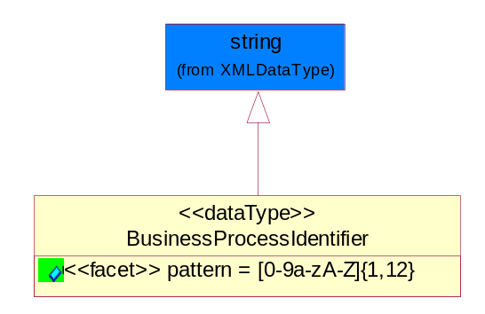
Figure 5-43 BusinessProcessIdentifier

Attribute | Type | Documentation
pattern |  | [0-9a-zA-Z]{1,12}

BusinessServiceInformation
The object allows the specification of the business service utilized within the partner company. This may or may not be the same as the information sent by the RNIF.
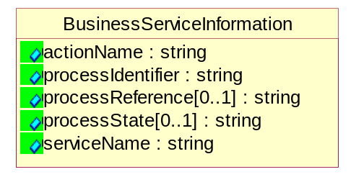
Figure 5-44 BusinessServiceInformation

Attribute | Type | Documentation
actionName | string | The name of Action. For RosettaNet usually any of Request/Confirm/Notify/Query/Response.
processIdentifier | string | The name of the PIP e.g. Notify of Forecast Reply.
processReference[0..1] | string | The URN for the PIP that includes Cluster/Segment/Process pattern used to identify the interface process (such as PIP3A4)
processState[0..1] | string | The business process (or service) state of the sender of a document. When a service receives this document, the receiver may use the state as a precondition.
serviceName | string | The name of the Business Activity with the "Request/Confirm" part removed. E.g., for the Activity "Request Purchase Order"==> "Purchase Order".

ContractInformation
A block of information used to correlate a contract in an executing choreography.

Figure 5-45 ContractInformation

Attribute | Type | Documentation
contractIdentifier[0..1] | string | Unique identification of a contract between the Sender and the Receiver
contractType[0..1] | string | The type of the contract: an attribute describing the type of the ContractIndentification. Valid values are URI, URN,ebXMLCPA, or other values defined by partners.

CorrelationInformation
A block of information used to correlate a requesting document to a responding document and to the contract in an executing choreography.
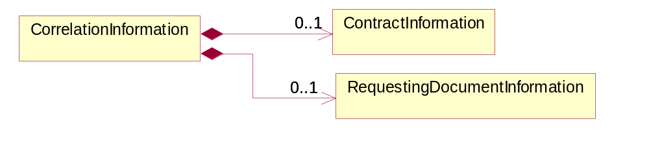
Figure 5-46 CorrelationInformation

Composition | Cardinality | Type | Documentation
ContractInformation | 0..1 | ContractInformation | A block of information used to correlate a contract in an executing choreography.
RequestingDocumentInformation | 0..1 | RequestingDocumentInformation | A block of information used to correlate a requesting document to a responding document in an executing choreography.

DocumentHeader
The object allows for the identification of the sender and receiver of the business document.
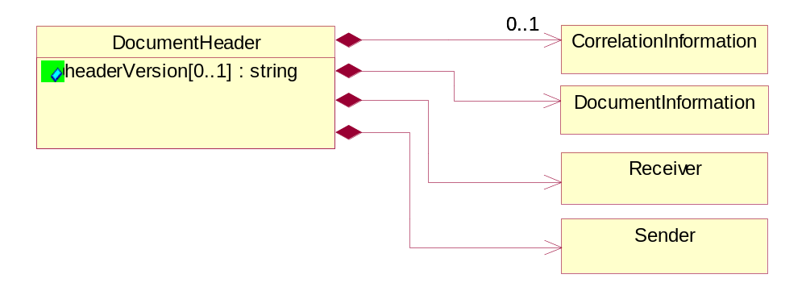
Figure 5-47 DocumentHeader

Attribute | Type | Documentation
headerVersion[0..1] | string | The UN/CEFACT version of the document header.

Composition | Cardinality | Type | Documentation
CorrelationInformation | 0..1 | CorrelationInformation | A block of information used to correlate a requesting document to a responding document and to the contract in an executing choreography.
DocumentInformation | 1 | DocumentInformation | The object specifies information to identify the business document, a summary of attachments, and information about the business document security.
Receiver | 1 | Receiver | The object allows the identification of the receiving party of the business message.
Sender | 1 | Sender | The object allows the identification of the initiating party of the business message.

DocumentIdentification
The object specifies all information necessary to identify the business document.
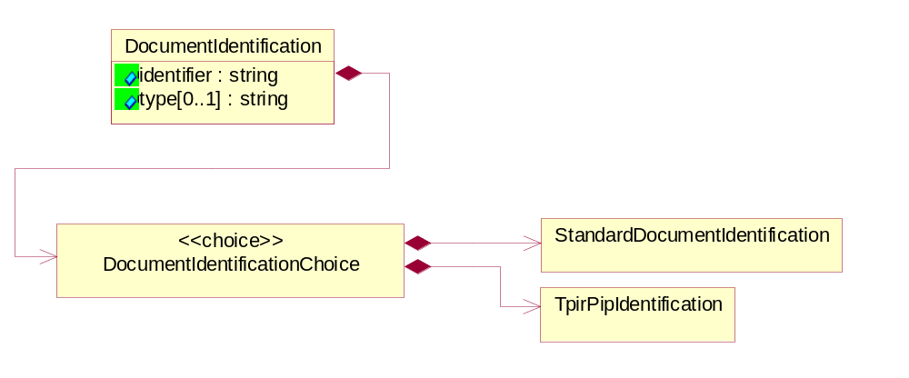
Figure 5-48 DocumentIdentification

Attribute | Type | Documentation
identifier | string | The unique identifier for the document being sent.
type[0..1] | string | Name of the Action Message

Composition | Cardinality | Type | Documentation
DocumentIdentificationChoice | 1 | DocumentIdentificationChoice

DocumentIdentificationChoice

Composition | Cardinality | Type | Documentation
StandardDocumentIdentification | 1 | StandardDocumentIdentification | The object specifies additional information necessary to identify the standard business document.
TpirPipIdentification | 1 | TpirPipIdentification | The object specifies all information necessary to uniquely identify a TPIR-PIP within a Registry or trading partner repository.

DocumentInformation
The object specifies information to identify the business document, a summary of attachments, and information about the business document security.
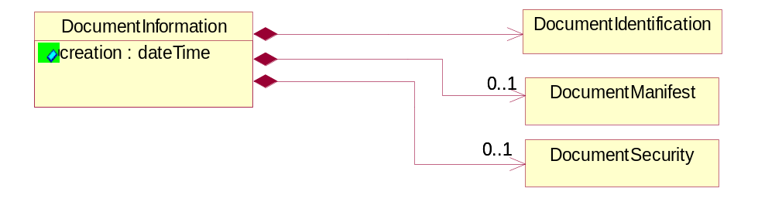
Figure 5-49 DocumentInformation

Attribute | Type | Documentation
creation | dateTime | The creation date and time of the specified Business Document (i.e. the Purchase Order date).

Composition | Cardinality | Type | Documentation
DocumentIdentification | 1 | DocumentIdentification | The object specifies all information necessary to identify the business document.
DocumentManifest | 0..1 | DocumentManifest | The block provides a brief summary of attachments and Service Content.
DocumentSecurity | 0..1 | DocumentSecurity | The object provides additional granularity in specifying business document security (this is in addition to the specified PIP security).

DocumentManifest
The block provides a brief summary of attachments and Service Content.
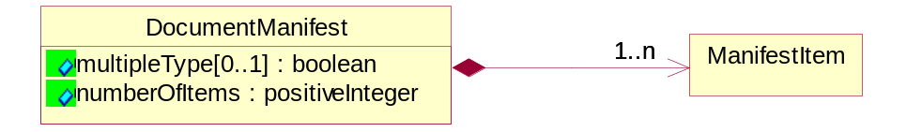
Figure 5-50 DocumentManifest

Attribute | Type | Documentation
multipleType[0..1] | boolean | Indicates whether the manifest contains documents of multiple types. True if yes, and False if no.
numberOfItems | positiveInteger | Total number of documents in the message. The physical count of the attachments in the payload plus the RosettaNet Business Message (for Service Content). The value of this field will be at least 1.

Composition | Cardinality | Type | Documentation
ManifestItem | 1..n | ManifestItem | The object provides details about the specific attachment(s).

DocumentSecurity
The object provides additional granularity in specifying business document security (this is in addition to the specified PIP security).

Figure 5-51 DocumentSecurity

Attribute | Type | Documentation
nonRepudiableReceipt | boolean | The value "true" will indicate that a signed acknowledgement for the business document is necessary.
persistentEncryption | boolean | The value "true" will indicate that the Business Document (including the header) needs to be encrypted when stored or transported.
persistentSignature | boolean | The value "true" will indicate that a signature is required to be stored with the document while stored or transported.

ManifestItem
The object provides details about the specific attachment(s).
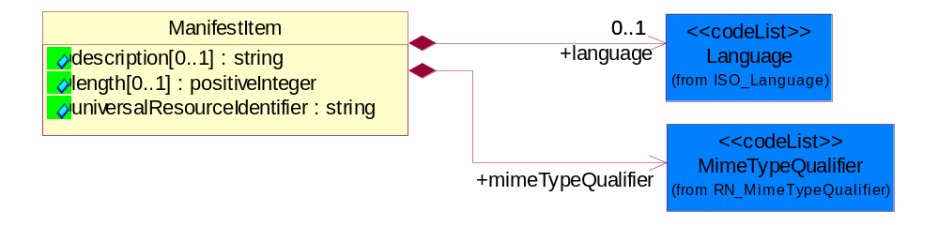
Figure 5-52 ManifestItem

Attribute | Type | Documentation
description[0..1] | string | A description of the attachment.
length[0..1] | positiveInteger | The size of the attachment in bytes (i.e. 1 000 000 bytes)
universalResourceIdentifier | string | The generic set of all names/addresses that are short strings that refer to resources.

Composition | Cardinality | Type | Documentation
language | 0..1 | Language | For representation of Language name RosettaNet has adopted ISO 639-2; 1998. Refer to the following web page to get the latest version of the standard:  http://www.loc.gov/standards/iso639-2/iso639jac.html  If you need more information about the ISO standard please contact ISO for more details.
mimeTypeQualifier | 1 | MimeTypeQualifier | The MIME type as defined by IANA.  Please refer to http://www.iana.org/assignments/media-types/ for a list of types.

PipIdentifier
PIP Identification.[ i.e. PIP3A4]
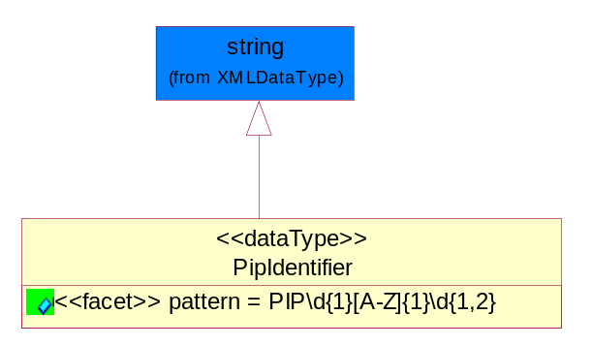
Figure 5-53 PipIdentifier

Attribute | Type | Documentation
pattern |  | PIP\d{1}[A-Z]{1}\d{1,2}

PipVersion
PIP version number (i.e. 02.02.00).
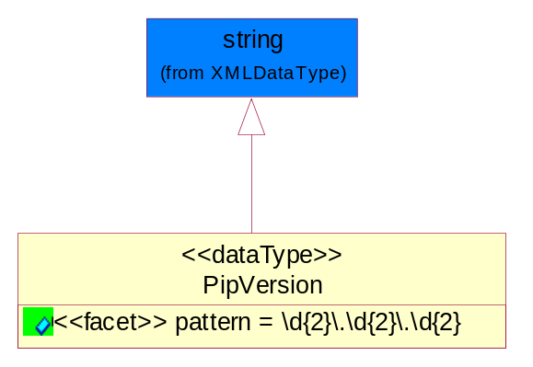
Figure 5-54 PipVersion

Attribute | Type | Documentation
pattern |  | \d{2}\.\d{2}\.\d{2}

Receiver
The object allows the identification of the receiving party of the business message.
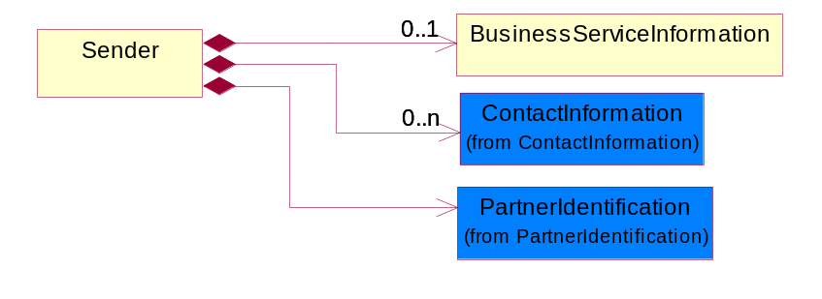
Figure 5-55 Receiver

Composition | Cardinality | Type | Documentation
BusinessServiceInformation | 0..1 | BusinessServiceInformation | The object allows the specification of the business service utilized within the partner company. This may or may not be the same as the information sent by the RNIF.
ContactInformation | 0..n | ContactInformation | The business document must allow for the identification of the name of the department, service or individual to be contacted regarding the context of the business document.
PartnerIdentification | 1 | PartnerIdentification | The business document must allow for the identity of one or more parties to the transaction.

RequestingDocumentInformation
A block of information used to correlate a requesting document to a responding document in an executing choreography.
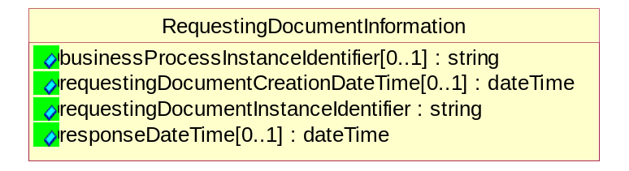
Figure 5-56 RequestingDocumentInformation

Attribute | Type | Documentation
businessProcessInstanceIdentifier[0..1] | string | The identifier for the public business process instance being sent that both the sender and receiver can identify.
requestingDocumentCreationDateTime[0..1] | dateTime | The date-time of the requesting business document.
requestingDocumentInstanceIdentifier | string | The Business Document identification number that identifies the requesting Business Document.
responseDateTime[0..1] | dateTime | The expected time to receive the response. This can not be greater than the PIP TimeToPerform.

Sender
The object allows the identification of the initiating party of the business message.
Figure 5-57 Sender

Composition | Cardinality | Type | Documentation
BusinessServiceInformation | 0..1 | BusinessServiceInformation | The object allows the specification of the business service utilized within the partner company. This may or may not be the same as the information sent by the RNIF.
ContactInformation | 0..n | ContactInformation | The business document must allow for the identification of the name of the department, service or individual to be contacted regarding the context of the business document.
PartnerIdentification | 1 | PartnerIdentification | The business document must allow for the identity of one or more parties to the transaction.

StandardDocumentIdentification
The object specifies additional information necessary to identify the standard business document.
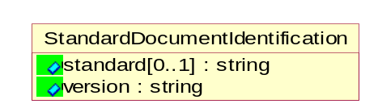
Figure 5-58 StandardDocumentIdentification

Attribute | Type | Documentation
standard[0..1] | string | Identifies the standard used to submit the business document. (e.g. RosettaNet).
version | string | PIP3A4v01.00

TpirPipIdentification
The object specifies all information necessary to uniquely identify a TPIR-PIP within a Registry or trading partner repository.
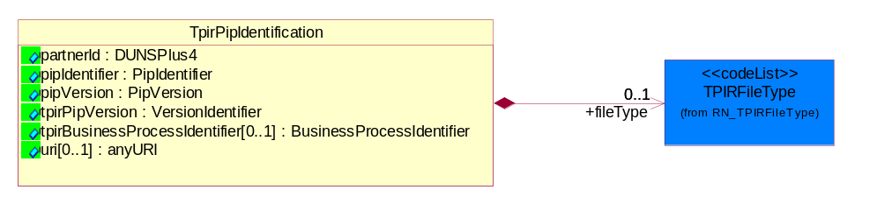
Figure 5-59 TpirPipIdentification

Attribute | Type | Documentation
partnerId | DUNSPlus4 | The Trading Partner Identification of MNC that is creating this TPIR PIP.
pipIdentifier | PipIdentifier | A TPIR PIP Identification [i.e., 3A4 ).
pipVersion | PipVersion | A TPIR PIP version number (i.e., 02.02.00)
tpirPipVersion | VersionIdentifier | A TPIR-PIP Version Number (i.e., major and minor version number as XX.XX).
tpirBusinessProcessIdentifier[0..1] | BusinessProcessIdentifier | A Business Process Identifier to uniquely define the TPIR-PIP 'role' within a Business Scenario at a company or MNC level. The identifier MUST be composed of alphanumeric characters only and its length MUST be between one and twelve characters.
uri[0..1] | anyURI | Describes the destination uri for the TPIR form.

Composition | Cardinality | Type | Documentation
fileType | 0..1 | TPIRFileType | Describes the file type of the TPIR form (PDF, XDP or XML).

VersionIdentifier
Version Number (i.e., major and minor version number as XX.XX).
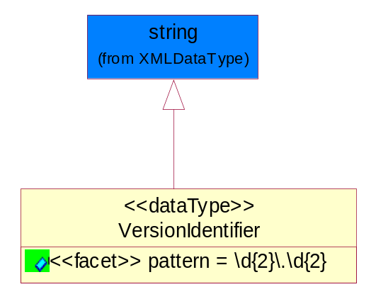
Figure 5-60 VersionIdentifier

Attribute | Type | Documentation
pattern |  | \d{2}\.\d{2}

CodeList

TPIRFileType
A code identifying the file type of TPIR form.

Name | Documentation
PDF | Portable Document Format.
XDP | XML Data Package.
XML | eXtensible Markup Language.

XML Data Type

anyURI
Represents a URI as defined by RFC 2396. An anyURI value can be absolute or relative, and may have an optional fragment identifier.

boolean
Represents Boolean values, which are either "true" or "false".

date
For the represents a calendar date.
The pattern for a date is CCYY-MM-DD where CC represents the century, YY the year, MM the month, and DD the day, with an optional time zone indicator as allowed for dateTime.

dateTime
Represents a specific instance of time.
The pattern for dateTime is CCYY-MM-DDThh:mm:ss where CC represents the century, YY the year, MM the month, and DD the day, preceded by an optional leading negative (-) character to indicate a negative number. If the negative character is omitted, positive (+) is assumed. The T is the date/time separator and hh, mm, and ss represent hour, minute, and second respectively. Additional digits can be used to increase the precision of fractional seconds if desired. For example, the format ss.ss... with any number of digits after the decimal point is supported. The fractional seconds part is optional.
This representation may be immediately followed by a "Z" to indicate Coordinated Universal Time (UTC) or to indicate the time zone. For example, the difference between the local time and Coordinated Universal Time, immediately followed by a sign, + or -, followed by the difference from UTC represented as hh:mm (minutes is required). If the time zone is included, both hours and minutes must be present.

float
Represents single-precision 32-bit floating-point numbers.

positiveInteger
Represents an integer that is greater than zero. This data type is derived from nonNegativeInteger.

string
Represents character string.

