

Description of
Partner Interface Process® for 4A2

Validated 11.00.00

Specification Information
Name | Notify Of Embedded Release Forecast
Cluster | Inventory Management
Segment | Collaborative Forecasting
Publication Date | 01 July 2008
Version Identifier | V11.00

Table of Contents
1 Document Management 4
1.1 Legal Disclaimer 4
1.2 Copyright 4
1.3 Trademarks 4
1.4 Acknowledgments 4
1.5 Related Documents 4
1.6 Document Version History 4
1.7 Document Structure 5
2 Business Process 6
2.1 Business Process Definition 6
2.2 PIP Scope Description 7
2.2.1 Business Process Scope Diagram 8
2.3 PIP Business Document 9
2.4 PIP Business Process Flow Diagram 9
2.5 PIP Start State 10
2.6 PIP End States 10
2.7 Partner Role Description 11
2.8 Business Process Activity Controls 11
3 Network and Implementation Specification 12
3.1 Business Action and Business Signal Specifications 12
3.2 Business Transaction Dialog Specification 12
3.2.1 Message Exchange Controls 13
3.2.2 Communications Specification 13

List of Figures:
Figure 1: Business Process Scope Diagram 8
Figure 2: Activity Diagram of Notify Of Embedded Release Forecast 9
Figure 3: Sequence Diagram of Notify Of Embedded Release Forecast 12

List of Tables:
Table 1: PIP Business Document 9
Table 2: PIP Start State 10
Table 3: PIP End State 10
Table 4: PIP Failure State 10
Table 5: Partner Role Description 11
Table 6: Business Activity Description 11
Table 7: Business Activity Performance Control 11
Table 8: Network Component Specification 12
Table 9: Business Action – Business Document Mapping 12
Table 10: Message Exchange Control 13
Table 11: Dialog: Service-Service 13

Document Management

Legal Disclaimer
RosettaNet™, its members, officers, directors, employees, or agents shall not be liable for any injury, loss, damages, financial or otherwise, arising from, related to, or caused by the use of this document or the specifications herein, as well as associated guidelines and schemas. The use of said specifications shall constitute your express consent to the foregoing exculpation.

Copyright
©2008 RosettaNet. All rights reserved. No part of this publication may be reproduced, stored in a retrieval system, or transmitted, in any form or by any means, electronic, mechanical, photocopying, recording, or otherwise, without the prior written permission of the publisher. Printed in the United States of America.

Trademarks
RosettaNet, Partner Interface Process, PIP and the RosettaNet logo are trademarks or registered trademarks of "RosettaNet," a non-profit organization. All other product names and company logos mentioned herein are the trademarks of their respective owners. In the best effort, all terms mentioned in this document that are known to be trademarks or registered trademarks have been appropriately recognized in the first occurrence of the term.

Acknowledgments
This document has been prepared by RosettaNet (http://www.rosettanet.org/) from requirements gathered during the Milestone Program and in conformance with the methodology. Listed below are the legal entities that contributed to the design and development of this PIP.

Related Documents
- Associated PIP Message Schemas (included within the PIP Specification package only)
- Description of 4A2 Message
- Messages Structure
- XML instance of ebXML BPSS for PIP 4A2

Document Version History
Version | Date | Description
Validated 11.00.00 | 01 July 2008 | Validated Version: RosettaNet Schema to Market to Validation 2008

Document Structure
A Partner Interface Process (PIP) Specification is comprised of the following two parts:
- Business Process. Captures the semantics of the business process and the flow of the message exchange between roles as they perform business activities.
- Network and Implementation Specification. Specifies the network protocol message formats and communications requirements between peer-protocols supported by network components in the RosettaNet Implementation Framework.

Business Process

Business Process Definition
The "Notify of Embedded Release Forecast" Partner Interface Process™ (PIP) supports a process in which a forecast owner sends an order forecast to a forecast recipient. The embedded release forecast contains product demand information (planning demand) and/or product release information (firm demand).
It is intended that the demand information be integrated in the forecast recipient’s tactical build plan. The product release information grants the forecast recipient authorization to ship product. The authorization (material release) is expressed by either:
a. A ship authorization indicator, equal to Yes, for a specific line item (product) and forecast period, or
b. Defining a frozen time zone, which authorizes release of all line items (product) for the specified forecast period.
Either expression notifies the forecast recipient of the forecast owner’s commitment to accept delivery of the designated product(s) for the specified time period. Typically, the forecast recipient is observing the migration of planning demand into firm demand.
The typical frequency of forecast transmissions is, at a minimum, weekly.
In accordance with the Start State (section 2.5), a Trading Partner Agreement (TPA) must be negotiated between the parties prior to the implementation of this PIP. The TPA should contain, but is not limited to, the following information:
a. Identify legal contact information, for example; name, address, e-mail, telephone.
b. Define which products are to be included in the forecast.
c. Describe a procedure for adding products to the forecast.
d. Describe a procedure for removing products from the forecast.
e. Define the forecast transmission frequency.
f. Describe pricing procedures.
g. Describe quantity definitions and netting procedures if needed, for example; using gross quantities versus net quantities.
h. Describe date definitions, for example; using scheduled dock dates versus scheduled ship dates.
i. Describe manufacturer’s planning horizon (forecast recipient’s requirements) and forecast horizon (forecast owner’s requirements), for example; forecast recipient may require 12 weeks of data for planning; forecast owner may send 26 weeks of forecast data.
j. Define financial liability (trade off zone).
k. Determine the shipment authorization trigger to use, for example; choose frozen zone or ship authorization indicator.
l. Identify transfer of title.
m. Describe billing and payment cycles.
As part of the End State, it will be assumed the forecast recipient integrates the forecast information into their build plan after each forecast transmission is sent, and ships product to the specified locations according to the material release information.
This PIP is a one-way push of information. The communication process ensures that the forecast owner receives a non-repudiated acknowledgment of receipt, but does not require a confirmation or commitment from the forecast recipient.
The forecast recipient may optionally respond to the forecast using PIP4A5, "Notify of Forecast Reply" if mutually agreed upon. The legal liability associated with forecast reply is defined in the TPA.
Should this transaction not complete successfully, the requesting partner executes PIP0A1, "Notification of Failure."

PIP Scope Description
The purpose of this PIP is to communicate future product demand information allowing a forecast recipient to use this information in their build plan, and to communicate firm demand (material release) information triggering a forecast recipient to ship product.
PIP4A2, "Notify of Embedded Release Forecast" is one of many forecast PIPs which may eliminate the need for PIP3A4, “Request Purchase Order” processing and will reduce the need for PIP3A8, “Request Purchase Order Change” processing.

Business Process Scope Diagram
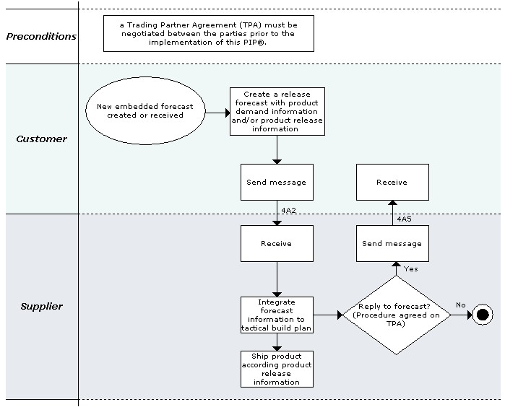
Figure 1: Business Process Scope Diagram

PIP Business Document
Business Document are generated and exchanged by roles performing activities in this PIP. Business Document is listed and defined in Table 1.
Table 1: PIP Business Document
Business Document | Description
Embedded Release Forecast Notification | Contains detailed order forecast information and references required to identify this forecast instance in the forecast cycle. Forecast quantity (as qualified by type) is projected at the product level for a certain location, customer and timeframe, with ship authorization information or frozen time zones to trigger product release.

PIP Business Process Flow Diagram
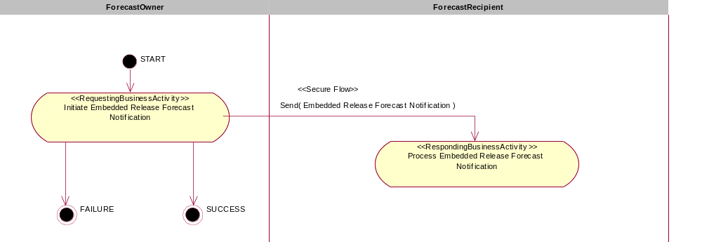

Figure 2: Activity Diagram of Notify Of Embedded Release Forecast

PIP Start State
The start state is comprised of the following conditions:
Table 2: PIP Start State
 | Approved | Exist |  | Valid | Non-Repudiated | Retry Count | Authorized
 | Approved | Party | In Backend System
TPA |  |  | 
Sending Partner |  |  |  | 
Receiving Partner |  | 
Business Document |  |  |  |  |  |  | 

PIP End States
The end state is comprised of the following conditions:
Table 3: PIP End State
 | Approved | Exist |  | Valid | Non-Repudiated | Retry Count | Authorized
 | Approved | Party | In Backend system
Acknowledgment of Receipt |  |  |  |  | 
Receiving Partner |  |  |  |  |  |  | 

The PIP failure state is comprised of one or more of the following conditions
Table 4: PIP Failure State
 | NO | Exceeded
Success | 
Retry Count |  | 

Partner Role Description
Table 5 describes the partner roles in this PIP:
Table 5: Partner Role Description
Role Name | Role Description
Forecast Owner | The party that creates a strategic or order forecast and is ultimately responsible for it.
Forecast Recipient | The party that receives a strategic or order forecast.

Business Process Activity Controls
Table 6 describes the interaction between roles performing business activity in this PIP.
Table 6: Business Activity Description
Role Name |  | Activity Name |  | Activity Description
Forecast Owner | Initiate Embedded Release Forecast Notification |  | A Forecast Owner sends an Embedded Release Forecast Notification to a Forecast Receiver. The Embedded Release Forecast Notification contains detailed order forecast information for certain products with ship authorization trigger information.

Table 7 details the security, audit and process controls relating to activity performed in the PIP.
Table 7: Business Activity Performance Control
Role  Name | Activity  Name | Acknowledgment  of Receipt |  | Time to Perform | Retry Count | Is Authorization Required? | Non-Repudiation of Origin and Content?
Role  Name | Activity  Name | Non-Repudiation Required? | Time to Acknowledge
Forecast Owner | Initiate Embedded Release Forecast Notification | Y | 2hrs | N/A | 3 | Y | Y

Network and Implementation Specification
Each network component maps into a role of the PIP model. Table 8 specifies the mapping between roles and network components.
Table 8: Network Component Specification
Network Component | Classification | Maps to Role in Business Process
Forecast Owner Service | Business Service | Forecast Owner
Forecast Recipient Service | Business Service | Forecast Recipient

Business Action and Business Signal Specifications
Each business action maps to a Business Document of the PIP model. Table 9 specifies the mapping between Business Documents and business actions.
Table 9: Business Action – Business Document Mapping
Business Action | Business Document | Document Function
Embedded Release Forecast Action | Embedded Release Forecast Notification | Request

Business Transaction Dialog Specification
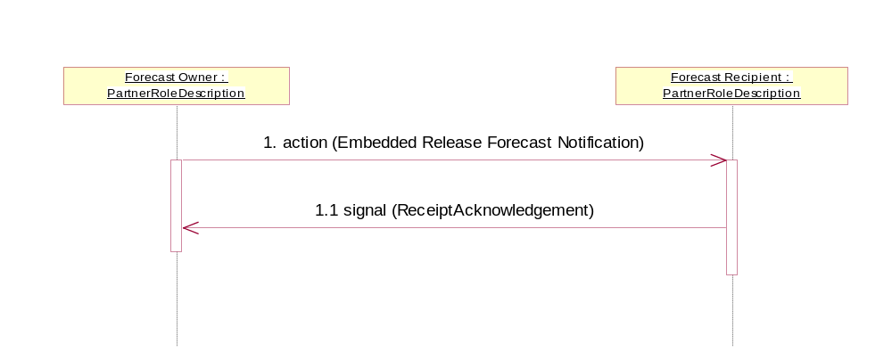
Figure 3: Sequence Diagram of Notify Of Embedded Release Forecast

Message Exchange Controls
Table 10: Message Exchange Control
# | Name |  | Time to Acknowledge Receipt Signal |  | Time to Respond to Action |  | Included in Time to Perform | Is Authorization Required? | Is Non-Repudiation Required? | Is Secure Transport Required?
1. |  | Embedded Release Forecast Notification Action |  | 2hrs |  | N/A | N | Y | Y | Y
1.1. |  | Receipt Acknowledgment |  | N/A |  | N/A | N | Y | Y | Y

Communications Specification
Table 11: Dialog: Service-Service
# | Business Message | Digital Signature Required? | SSL Required?
1. | Embedded Release Forecast Notification | Y | Y
1.1. | Receipt Acknowledgment | Y | Y

