

Description of
Partner Interface Process® for 4A3

Validated 11.00.00

Specification Information
Name | Notify Of Threshold Release Forecast
Cluster | Inventory Management
Segment | Collaborative Forecasting
Publication Date | 16 July 2008
Version Identifier | V11.00

Table of Contents
1 Document Management 4
1.1 Legal Disclaimer 4
1.2 Copyright 4
1.3 Trademarks 4
1.4 Acknowledgments 4
1.5 Related Documents 5
1.6 Document Version History 5
1.7 Document Structure 5
2 Business Process 6
2.1 Business Process Definition 6
2.1.1 Executive Summary 6
2.1.2 Business Process Description 7
2.1.3 Business Process Context Diagram 8
2.2 PIP Scope Description 9
2.2.1 Business Process Scope Diagram 9
2.3 PIP Business Document 10
2.4 PIP Business Process Flow Diagram 10
2.5 PIP Start State 11
2.6 PIP End States 11
2.7 Partner Role Descriptions 12
2.8 Business Process Activity Controls 12
3 Network and Implementation Specification 13
3.1 Business Action and Business Signal Specifications 13
3.2 Business Transaction Dialog Specification 13
3.2.1 Message Exchange Controls 14
3.2.2 Communications Specification 14

List of Figures:
Figure 1: High-level Context Diagram 8
Figure 2: Collaborative Forecasting context diagram 9
Figure 3: Activity Diagram of Notify Of Threshold Release Forecast 10
Figure 4: Sequence Diagram of Notify Of Threshold Release Forecast 13

List of Tables:
Figure 1: High-level Context Diagram 8
Figure 2: Collaborative Forecasting context diagram 9
Table 1: PIP Business Document 10
Table 2: PIP Start State 11
Table 3: PIP End State 11
Table 4: PIP Failure State 11
Table 5: Partner Role Description 12
Table 6: Business Activity Description 12
Table 7: Business Activity Performance Control 12
Table 8: Network Component Specification 13
Table 9: Business Action – Business Document Mapping 13
Table 10: Message Exchange Control 14
Table 11: Dialog: Service-Service 14

Document Management

Legal Disclaimer
RosettaNet™, its members, officers, directors, employees, or agents shall not be liable for any injury, loss, damages, financial or otherwise, arising from, related to, or caused by the use of this document or the specifications herein, as well as associated guidelines and schemas. The use of said specifications shall constitute your express consent to the foregoing exculpation.

Copyright
© 2008 RosettaNet. All rights reserved. No part of this publication may be reproduced, stored in a retrieval system, or transmitted, in any form or by any means, electronic, mechanical, photocopying, recording, or otherwise, without the prior written permission of the publisher. Printed in the United States of America.

Trademarks
RosettaNet, Partner Interface Process, PIP and the RosettaNet logo are trademarks or registered trademarks of "RosettaNet," a non-profit organization. All other product names and company logos mentioned herein are the trademarks of their respective owners. In the best effort, all terms mentioned in this document that are known to be trademarks or registered trademarks have been appropriately recognized in the first occurrence of the term.

Acknowledgments
This document has been prepared by RosettaNet (http://www.rosettanet.org/) from requirements gathered during the Milestone Program and in conformance with the methodology. Listed below are the legal entities that contributed to the design and development of this PIP.
Aankhen, Inc. | Arrow Electronics, Inc.
AVX Corporation | Cisco Systems, Inc.
Delta Electronics | Delta Products Corp.
GridNode, Inc. | GridNode Pte. Ltd.
Hewlett-Packard Company | HP
i2 | Intel Corporation
KEMET Electronics Corp. | Micron Technology and its wholly owned subsidiaries
Motorola Europe | Motorola Semiconductor Sector
Motorola SPS | National Semiconductor Corporation
NEC Solutions America, Inc. | Nokia Oyj
Oracle Corporation | Philips Semiconductors
Pioneer-Standard Electronics | Samsung Electronics Co., Ltd. and Samsung Electronics Memory Division
SAP | Sterling Commerce
STMicroelectronics | Syncra Systems, Inc.
TeamJasper | Texas Instruments
Tyco Electronics | Uniform Code Council, Inc.
Viacore

Related Documents
- Associated PIP Message Schemas (included within the PIP Specification package only)
- Description of Threshold Release Forecast Notification Message
- Threshold Release Forecast Notification Messages Structure
- XML instance of ebXML BPSS for PIP 4A3

Document Version History
Version | Date | Description
Validated 11.00.00 | 16 July 2008 | Validated Version : RosettaNet Schema to Market to Validation 2008

Document Structure
A Partner Interface Process (PIP) Specification is comprised of the following two parts:
- Business Process. Captures the semantics of the business process and the flow of the message exchange between roles as they perform business activities.
- Network and Implementation Specification. Specifies the network protocol message formats and communications requirements between peer-protocols supported by network components in the RosettaNet Implementation Framework.

Business Process

Business Process Definition
The Threshold Release Forecast contains planning demand, but also inventory status, inventory target and optional shipment receipts information enabling transfer of inventory management responsibility to the forecast recipient. In this case the order forecasting and replenishment are handled as a single integrated process by sharing the forecast in a frequent enough schedule. A separate order/release process is not needed.

Executive Summary
Collaborative Forecasting enables standardization of collaborative Order and Strategic Forecasting processes between supply-chain companies.
Collaborative Forecasting is a process by which trading partners work interactively to manage forecast requirements by sharing information affecting materials management decisions. Forecast exceptions are identified and forecast revisions are exchanged electronically until they are resolved. Collaborative Forecasting enables a better match between supply and demand, improvement in customer satisfaction, and inventory reduction throughout the supply chain.
The characteristics of a collaborative forecasting process in a particular supply chain vary depending on the forecasting capabilities of the trading partners in question. Still, as collaborative forecasting is a very data intense process, exception-based management techniques are valuable to support the collaboration process. Below are three examples of collaborative forecasting processes with different characteristics:
- In some retail supply chains a manufacturer (supplier) may have the expertise and knowledge to create the most accurate forecasts. In this scenario, the manufacturer would propose a joint forecast to a distributor (customer). The distributor then may or may not accept the proposed forecast or accepts it with changes. The manufacturer and distributor would collaborate to achieve a consensus forecast.
- It is possible that the trading partners may have equal capability to forecast accurately in a supply chain. In this scenario the trading partners would share forecasts. By collaborating on gaps between the forecasts a consensus forecast is achieved for both trading partners.
- Lastly, the most critical issue may be to align forecasts in the supply chain according to the latest demand picture from the end customer and to plan the upside and downside potential of the whole supply chain. By collaborating and resolving the gaps between forecasts, capacities or replenishment plans without delays, the trading partners can achieve the alignment between demand and supply in the supply chain.
Collaborative Forecasting is a part of the RosettaNet Cluster 4: Inventory Management. There is also an essential link between the Segments of Collaborative Forecasting and Inventory Replenishment within the Cluster 4. Figure 1: High-level Context Diagram shows how Inventory Management relates to the end-to-end business process.

Business Process Description
The "Notify Of Threshold Release Forecast" Partner Interface Process (PIP) supports a process in which a forecast owner sends an order forecast to a forecast recipient. The threshold release forecast contains product demand information (planning demand), current product inventory levels (on-hand quantity), and target product inventory levels (minimum/maximum). The forecast also contains optional shipment receipt information.
It is intended that the product demand information be sent directly into the forecast recipient’s tactical build plan. The target inventory levels define a minimum or maximum (threshold) level of desired inventory. The demand, inventory, and receipt information allows the forecast recipient to calculate material releases. With this PIP, inventory management responsibility is transferred to the forecast recipient. The typical frequency of forecast transmissions is, at a minimum, weekly.

Business Process Context Diagram
Figure 1: High-level Context Diagram
Provide Product Structure
Establish Relationship
Release Product
Fulfill Demand
Partner, Product and Service Review
Product Information
Marketing Information Management
Stimulate Market and Create Demand
Order Management
Provide Post-Sales Support
Service and Support
Inventory Management
Collaborative Forecasting
Inventory Replenishment
Replenishment
Strategic Forecast
Order Forecast
Manufacturing
Provide Capacity Equivalency

PIP Scope Description
The purpose of this PIP is to 1) communicate future product demand information allowing a forecast recipient to use this information in their build plan, 2) communicate current and target inventory levels, 3) optionally communicate shipment receipt information and, 4) for the forecast recipient to use this information to calculate and trigger material releases to meet the forecast owner's current demand needs.
The PIP4A3, "Notify Of Threshold Release Forecast" is a forecast PIPs which may eliminate the need for PIP3A4, "Request Purchase Order" processing and will reduce the need for PIP3A8, "Request Purchase Order Change" processing.

Business Process Scope Diagram
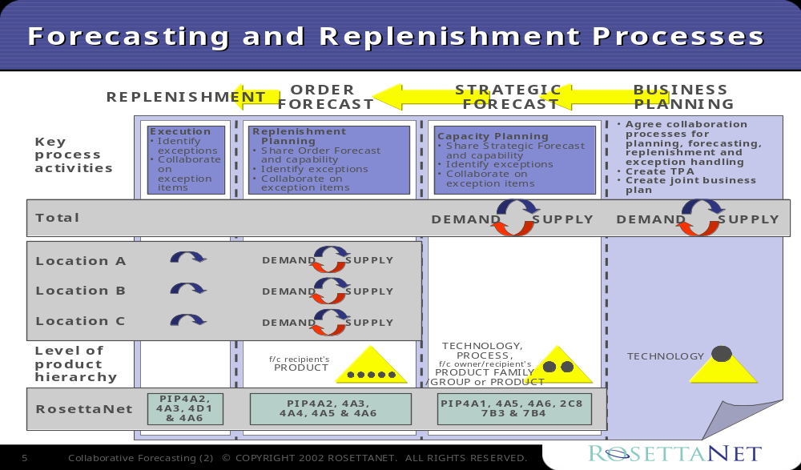The Collaborative Forecasting business processes include Business Planning, Strategic Forecast, Order Forecast, and Replenishment. The Collaborative Planning, Forecasting, and Replenishment (CPFR®) initiative in the retail industry offers a framework for defining the scope of these processes. It is used as a basis for the following model in Figure 2: Collaborative Forecasting context diagram. Interfaces and timeframes of the business processes should be clear.
Figure 2: Collaborative Forecasting context diagram

PIP Business Document
Business Document are generated and exchanged by roles performing activities in this PIP. Business Document is listed and defined in Table 1.
Table 1: PIP Business Document
Business Document | Description
Threshold Release Forecast Notification | Contains detailed order forecast information and references required to identify this forecast instance in the forecast cycle. Forecast quantity (as qualified by type) is projected at the product level for a certain location, customer and timeframe, and inventory thresholds (minimum/maximum).

PIP Business Process Flow Diagram
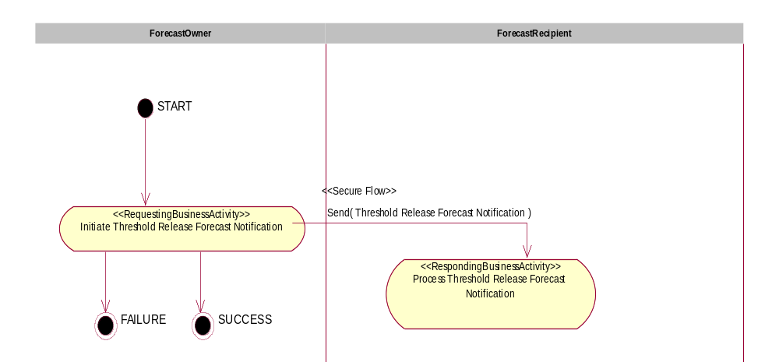
Figure 3: Activity Diagram of Notify Of Threshold Release Forecast

PIP Start State
The start state is comprised of the following conditions:
Table 2: PIP Start State
 | Approved | Exist |  | Valid | Non-Repudiated | Retry Count | Authorized
 | Approved | Party | In Backend System
TPA |  |  | 
Sending Partner |  |  |  | 
Receiving Partner |  | 
Business Document |  |  |  |  |  |  | 

PIP End States
The end state is comprised of the following conditions:
Table 3: PIP End State
 | Approved | Exist |  | Valid | Non-Repudiated | Retry Count | Authorized
 | Approved | Party | In Backend system
Acknowledgment of Receipt |  |  |  |  | 
Receiving Partner |  |  |  |  |  |  | 
The PIP failure state is comprised of one or more of the following conditions:
Table 4: PIP Failure State
 | NO | Exceeded
Success | 
Retry Count |  | 

Partner Role Descriptions
Table 5 describes the partner roles in this PIP.
Table 5: Partner Role Description
Role Name | Role Description
Forecast Owner | The party that creates a strategic or order forecast and is ultimately responsible for it.
Forecast Recipient | The party that receives a strategic or order forecast.

Business Process Activity Controls
Table 6 describes the interaction between roles performing business activity in this PIP.
Table 6: Business Activity Description
Role  Name | Activity Name | Activity Description
Forecast Owner | Initiate Threshold Release Forecast Notification | A Forecast Owner sends a Threshold Release Forecast Notification to a Forecast Recipient. The Threshold Release Forecast Notification contains detailed order forecast information for certain products with inventory thresholds (minimum/maximum).
Table 7 details the security, audit and process controls relating to activity performed in the PIP.
Table 7: Business Activity Performance Control
Role  Name | Activity  Name | Acknowledgment  of Receipt |  | Time to Perform | Retry Count | Is Authorization Required? | Non-Repudiation of Origin and Content?
Role  Name | Activity  Name | Non-Repudiation Required? | Time to Acknowledge
Forecast Owner | Initiate Threshold Release Forecast Notification | Y | 2 hrs | N/A | 3 | Y | Y

Network and Implementation Specification
Each network component maps into a role of the PIP model. Table 8 specifies the mapping between roles and network components.
Table 8: Network Component Specification
Network Component | Classification | Maps to Role in Business Process
Forecast Owner Service | Business Service | Forecast Owner
Forecast Recipient Service | Business Service | Forecast Recipient

Business Action and Business Signal Specifications
Each business action maps to a Business Document of the PIP model. Table 9 specifies the mapping between Business Documents and business actions.
Table 9: Business Action – Business Document Mapping
Business Action | Business Document | Document Function
Threshold Release Forecast Notification Action | Threshold Release Forecast Notification | Request

Business Transaction Dialog Specification
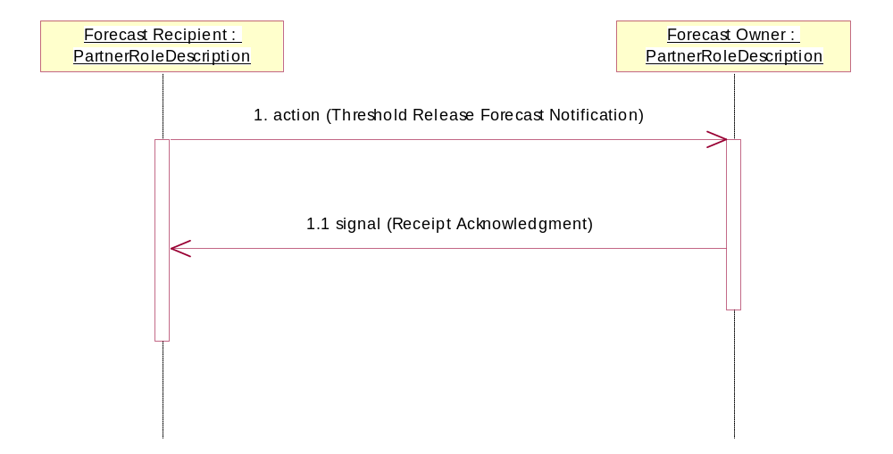
Figure 4: Sequence Diagram of Notify Of Threshold Release Forecast

Message Exchange Controls
Table 10: Message Exchange Control
# | Name |  | Time to Acknowledge Receipt Signal |  | Time to Respond to Action |  | Included in Time to Perform |  | Is Authorization Required? |  | Is Non-Repudiation Required? |  | Is Secure Transport Required?
1. |  | Threshold Release Forecast Notification Action |  | 2 hrs |  | N/A |  | N/A |  | Y |  | Y |  | Y
1.1. |  | Receipt Acknowledgment |  | N/A |  | N/A |  | N/A |  | Y |  | Y |  | Y

Communications Specification
Table 11: Dialog: Service-Service
# | Business Message | Digital Signature Required? | SSL Required?
1. | Threshold Release Forecast Notification Action | Y | Y
1.1. | Receipt Acknowledgment | Y | Y

 CPFR is a Registered Trademark of the Voluntary Interindustry Commerce Standards (VICS) Association. Additional information: http://www.cpfr.org/

