

Description of
Partner Interface Process® for 4A4

Validated 11.00.00

Specification Information
Name | Notify Of Planning Release Forecast
Cluster | Inventory Management
Segment | Collaborative Forecasting
Publication Date | 01 July 2008
Version Identifier | V11.00

Table of Contents
1 Document Management 4
1.1 Legal Disclaimer 4
1.2 Copyright 4
1.3 Trademarks 4
1.4 Acknowledgments 4
1.5 Related Documents 6
1.6 Document Version History 6
1.7 Document Structure 6
2 Business Process 7
2.1 Business Process Definition 7
2.1.1 Executive Summary 7
2.1.2 Business Process Description 8
2.1.3 Business Process Context Diagram 10
2.2 PIP Scope Description 11
2.2.1 Business Process Scope Diagram 11
2.3 PIP Business Document 12
2.4 PIP Business Process Flow Diagram 12
2.5 PIP Start State 13
2.6 PIP End States 13
2.7 Partner Role Descriptions 14
2.8 Business Process Activity Controls 14
3 Network and Implementation Specification 15
3.1 Business Action and Business Signal Specifications 15
3.2 Business Transaction Dialog Specification 15
3.2.1 Message Exchange Controls 16
3.2.2 Communications Specification 16

List of Figures:
Figure 1: High-level Context Diagram 10
Figure 2: Business Process Scope Diagram 11
Figure 3: Activity Diagram of Notify of Planning Release Forecast 12
Figure 4: Sequence Diagram of Notify of Planning Release Forecast 15

List of Tables:
Table 1: PIP Business Document 12
Table 2: PIP Start State 13
Table 3: PIP End State 13
Table 4: PIP Failure State 13
Table 5: Partner Role Description 14
Table 6: Business Activity Description 14
Table 7: Business Activity Performance Control 14
Table 8: Network Component Specification 15
Table 9: Business Action – Business Document Mapping 15
Table 10: Message Exchange Control 16
Table 11: Dialog: Service-Service 16

Document Management

Legal Disclaimer
RosettaNet™, its members, officers, directors, employees, or agents shall not be liable for any injury, loss, damages, financial or otherwise, arising from, related to, or caused by the use of this document or the specifications herein, as well as associated guidelines and schemas. The use of said specifications shall constitute your express consent to the foregoing exculpation.

Copyright
©2008 RosettaNet. All rights reserved. No part of this publication may be reproduced, stored in a retrieval system, or transmitted, in any form or by any means, electronic, mechanical, photocopying, recording, or otherwise, without the prior written permission of the publisher. Printed in the United States of America.

Trademarks
RosettaNet, Partner Interface Process, PIP and the RosettaNet logo are trademarks or registered trademarks of “RosettaNet,” a non-profit organization. All other product names and company logos mentioned herein are the trademarks of their respective owners. In the best effort, all terms mentioned in this document that are known to be trademarks or registered trademarks have been appropriately recognized in the first occurrence of the term.

Acknowledgments
This document has been prepared by RosettaNet (http://www.rosettanet.org/) from requirements gathered during the Milestone Program and in conformance with the methodology. Listed below are the legal entities that contributed to the design and development of this PIP.
Aankhen, Inc | Arrow Electronics
Arrow Electronics, Inc. | AVX Corporation
BCM Electronics | Cisco Systems
Cisco Systems, Inc. | Delta Electronics
Delta Products Corp. | Fujitsu Ltd.
Global eXchange Services, Inc. | Globetronics SDH. BHD
GridNode | GridNode, Inc.
GridNode Pte. Ltd. | Hewlett-Packard Company
Hewlett Packard | HP
HP Labs | Hitachi, Ltd. And Group Procurement Division
Hitachi, Ltd | i2
i2 Technologies | Infoteria
Infoteria Japan | Intel
Intel Corporation | KEMET Electronics Corp.
KYOCERA Corporation | Micron Technology and its wholly owned subsidiaries
MIMOS Berhad | Motorola
Motorola Europe | Motorola Semiconductor Sector
Motorola SPS | National Semiconductor Corporation
NEC | NEC Solutions America, Inc.
Nokia | Nokia Oyj
Oracle Corporation | Oracle Corporation APS Group
Paul Jasper | TeamJasper
Philips Semiconductors | Pioneer-Standard Electronics
Samsung Electronics Co., Ltd. | Samsung Electronics Memory Division
SAP | Sony EMCS Corporation
Stephenie Cooper | Sterling Commerce
STMicroelectronics | Syncra Systems, Inc.
Texas Instruments | Texas Instruments (Global)
Texas Instruments Limited | Tyco Electronics
Tyco Electronics AMP Japan | UCC
Uniform Code Council, Inc. | Viacore

Related Documents
- Associated PIP Message Schemas (included within the PIP Specification package only)
- Description of 4A4 Message
- Messages Structure
- XML instance of ebXML BPSS for PIP 4A4

Document Version History
Version | Date | Description
Validated 11.00.00 | 01 July 2008 | Validated Version: RosettaNet Schema to Market to Validation 2008

Document Structure
A Partner Interface Process (PIP) Specification is comprised of the following two parts:
- Business Process. Captures the semantics of the business process and the flow of the message exchange between roles as they perform business activities.
- Network and Implementation Specification. Specifies the network protocol message formats and communications requirements between peer-protocols supported by network components in the RosettaNet Implementation Framework.

Business Process

Business Process Definition
The purpose of this PIP is to communicate future product demand information allowing a forecast recipient to use this information in their build plan.
This process supports forecasting for a dual bin (kanban) type program where a material release trigger is sent directly from the shop floor when one bin is emptied. Bin sizes are planned so that product from the supplier should arrive before the second bin is emptied.

Executive Summary
Collaborative Forecasting enables standardization of collaborative Order and Strategic Forecasting processes between supply-chain companies.
Collaborative Forecasting is a process by which trading partners work interactively to manage forecast requirements by sharing information affecting materials management decisions. Forecast exceptions are identified and forecast revisions are exchanged electronically until they are resolved. Collaborative Forecasting enables a better match between supply and demand, improvement in customer satisfaction, and inventory reduction throughout the supply chain.
The characteristics of a collaborative forecasting process in a particular supply chain vary depending on the forecasting capabilities of the trading partners in question. Still, as collaborative forecasting is a very data intense process, exception-based management techniques are valuable to support the collaboration process. Below are three examples of collaborative forecasting processes with different characteristics:
- In some retail supply chains a manufacturer (supplier) may have the expertise and knowledge to create the most accurate forecasts. In this scenario, the manufacturer would propose a joint forecast to a distributor (customer). The distributor then may or may not accept the proposed forecast or accepts it with changes. The manufacturer and distributor would collaborate to achieve a consensus forecast.
- It is possible that the trading partners may have equal capability to forecast accurately in a supply chain. In this scenario the trading partners would share forecasts. By collaborating on gaps between the forecasts a consensus forecast is achieved for both trading partners.
- Lastly, the most critical issue may be to align forecasts in the supply chain according to the latest demand picture from the end customer and to plan the upside and downside potential of the whole supply chain. By collaborating and resolving the gaps between forecasts, capacities or replenishment plans without delays, the trading partners can achieve the alignment between demand and supply in the supply chain.
- Collaborative Forecasting is a part of the RosettaNet Cluster 4: Inventory Management. There is also an essential link between the Segments of Collaborative Forecasting and Inventory Replenishment within the Cluster 4.

Business Process Description
The "Notify of Planning Release Forecast" Partner Interface Process™ (PIP) supports a process in which a forecast owner sends an order forecast to a forecast recipient. The planning release forecast contains product demand information (planning demand).
It is intended that the forecast (planning demand) information be integrated in the forecast recipient’s tactical build plan. There is also an expectation of a logical relationship between the forecast data and a subsequent material release. This PIP, in and of itself, is not an authorization for material release. A formal process for material releases is required prior to product shipping. PIP 4D1, "Notify of Material Release", supports the material release process.
The typical frequency of forecast transmissions is, at a minimum, weekly. The expected material release trigger could occur multiple times during a week or multiple times during a day.
According to the Start State (section 3.4) a TPA must exist for this PIP. It is recommended that prior to using this PIP the following information be included in (but not limited to) the TPA:
a. Identify legal contact information, for example; name, address, e-mail, telephone.
b. Define which products are to be included in the forecast.
c. Describe a procedure for adding products to the forecast.
d. Describe a procedure for removing products from the forecast.
e. Define the forecast transmission frequency.
f. Describe pricing procedures.
g. Describe quantity definitions and netting procedures if needed, for example; using gross quantities versus net quantities.
h. Describe date definitions, for example; using scheduled dock dates versus scheduled ship dates.
i. Describe manufacturer’s planning horizon (forecast recipient’s requirements) and forecast horizon (forecast owner’s requirements); for example; forecast recipient may require 12 weeks of data for planning; forecast owner may send 26 weeks of forecast data.
j. Define financial liability (trade off zone).
k. Identify transfer of title.
l. Describe billing and payment cycles.
After successful completion of this PIP, it will be assumed the forecast recipient integrates the forecast information into their tactical build plan after each forecast transmission is sent.
The recipient may optionally respond to the forecast using PIP 4A5, "Notify of Forecast Reply", if mutually agreed upon. The legal liability associated with a forecast reply is defined in the TPA.
This PIP is a one-way push of information. The communication process ensures that the forecast owner receives a non-repudiated acknowledgment of receipt, but does not require a confirmation or commitment from the recipient.
Should this transaction not complete successfully, the requesting partner executes PIP0A1, "Notification of Failure."

Business Process Context Diagram

Provide Product Structure
Establish Relationship
Release Product
Fulfill Demand
Partner, Product and Service Review
Product Information
Marketing Information Management
Stimulate Market and Create Demand
Order Management
Provide Post-Sales Support
Service and Support
Inventory Management
Collaborative Forecasting
Inventory Replenishment
Replenishment
Strategic Forecast
Order Forecast
Manufacturing
Provide Capacity Equivalency
Figure 1: High-level Context Diagram

PIP Scope Description
PIP 4A4 "Notify of Planning Release Forecast" is one of many forecast PIPs which, with PIP 4D1, "Notify of Material Release", may eliminate the need for PIP 3A4 "Request Purchase Order" processing and will reduce the need for PIP 3A8 "Request Purchase Order Change" processing.

Business Process Scope Diagram
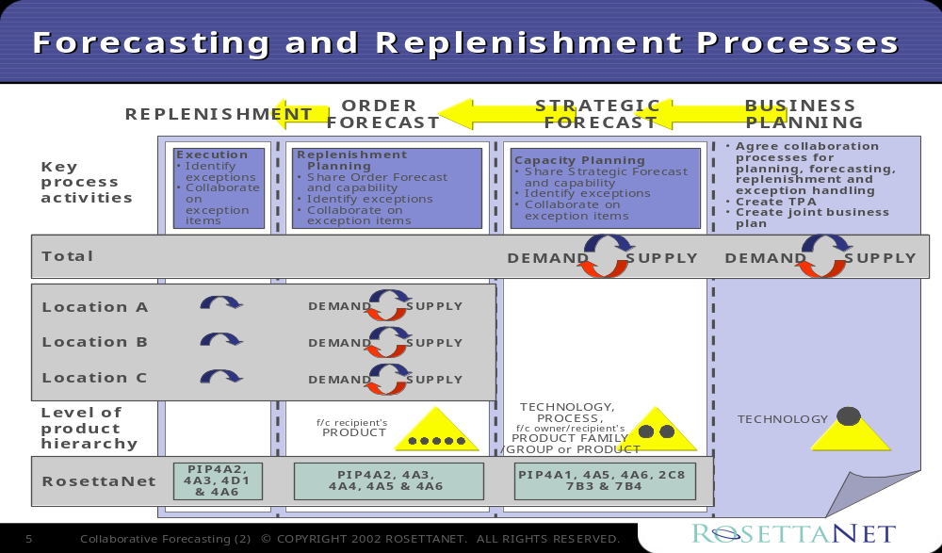The Collaborative Forecasting business processes include Business Planning, Strategic Forecast, Order Forecast, and Replenishment. The Collaborative Planning, Forecasting, and Replenishment (CPFR®) initiative in the retail industry offers a framework for defining the scope of these processes. It is used as a basis for the following model.

Figure 2: Business Process Scope Diagram

PIP Business Document
Business Document are generated and exchanged by roles performing activities in this PIP. Business Document is listed and defined in Table 1.
Table 1: PIP Business Document
Business Document | Description
Planning Release Forecast Notification | Contains detailed order forecast information and references required to identify this forecast instance in the forecast cycle. Forecast quantity (as qualified by type) is projected at the product level for a certain location, customer and timeframe.

PIP Business Process Flow Diagram
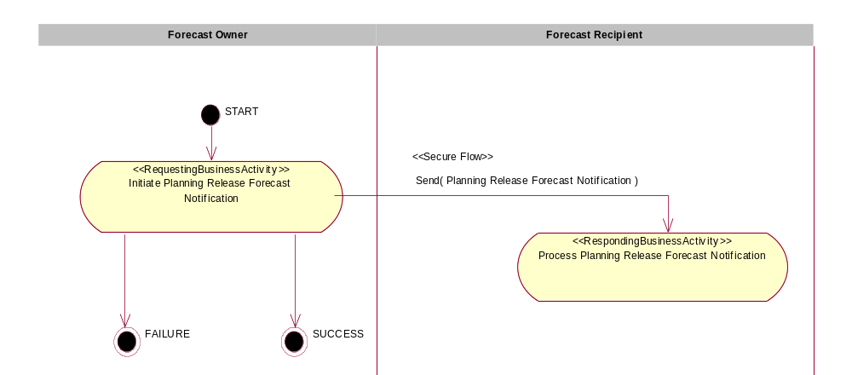
Figure 3: Activity Diagram of Notify of Planning Release Forecast

PIP Start State
The start state is comprised of the following conditions:
Table 2: PIP Start State
 | Approved | Exist |  | Valid | Non-Repudiated | Retry Count | Authorized
 | Approved | Party | In Backend System
TPA |  |  | 
Sending Partner |  |  |  | 
Receiving Partner |  | 
Business Document |  |  |  |  |  |  | 

PIP End States
The end state is comprised of the following conditions:
Table 3: PIP End State
 | Approved | Exist |  | Valid | Non-Repudiated | Retry Count | Authorized
 | Approved | Party | In Backend system
Acknowledgment of Receipt |  |  |  |  | 
Receiving Partner |  |  |  |  |  |  | 

The PIP failure state is comprised of one or more of the following conditions:
Table 4: PIP Failure State
 | NO | Exceeded
Success | 
Retry Count |  | 

Partner Role Descriptions
Table 5 describes the partner roles in this PIP.
Table 5: Partner Role Description
Role Name | Role Description
Forecast Owner | The party that creates a strategic or order forecast and is ultimately responsible for it.
Forecast Recipient | The party that receives a strategic or order forecast.

Business Process Activity Controls
Table 6 describes the interaction between roles performing business activity in this PIP.
Table 6: Business Activity Description
Role  Name | Activity Name | Activity Description
Forecast Owner | Initiate Planning Release Forecast Notification | A Forecast Owner sends a Planning Release Forecast Notification to a Forecast Recipient. The Planning Release Forecast Notification contains detailed order forecast information for certain products.
Table 7 details the security, audit and process controls relating to activity performed in the PIP.
Table 7: Business Activity Performance Control
Role  Name | Activity  Name | Acknowledgment  of Receipt |  | Time to Perform | Retry Count | Is Authorization Required? | Non-Repudiation of Origin and Content?
Role  Name | Activity  Name | Non-Repudiation Required? | Time to Acknowledge
Forecast Owner | Initiate Planning Release Forecast Notification | Y | 2 hrs | N/A | 3 | Y | Y

Network and Implementation Specification
Each network component maps into a role of the PIP model. Table 8 specifies the mapping between roles and network components.
Table 8: Network Component Specification
Network Component | Classification | Maps to Role in Business Process
Forecast Owner Service | Business Service | Forecast Owner
Forecast Recipient Service | Business Service | Forecast Recipient

Business Action and Business Signal Specifications
Each business action maps to a Business Document of the PIP model. Table 9 specifies the mapping between Business Documents and business actions.
Table 9: Business Action – Business Document Mapping
Business Action | Business Document | Document Function
Planning Release Forecast Notification Action | Planning Release Forecast Notification | Notification

Business Transaction Dialog Specification
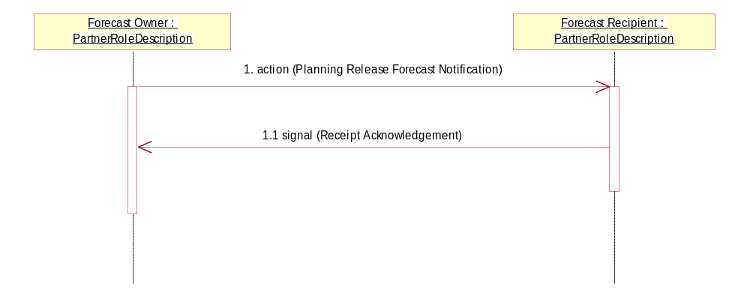
Figure 4: Sequence Diagram of Notify Of Planning Release Forecast

Message Exchange Controls
Table 10: Message Exchange Control
# | Name |  | Time to Acknowledge Receipt Signal |  | Time to Respond to Action |  | Included in Time to Perform |  | Is Authorization Required? |  | Is Non-Repudiation Required? |  | Is Secure Transport Required?
1. |  | Planning Release Forecast Notification Action |  | 2 hrs |  | N/A |  | N/A |  | Y |  | Y |  | Y
1.1. |  | Receipt Acknowledgment |  | N/A |  | N/A |  | N/A |  | Y |  | Y |  | Y

Communications Specification
Table 11: Dialog: Service-Service
# | Business Message | Digital Signature Required? | SSL Required?
1. | Planning Release Forecast Notification | Y | Y
1.1. | Receipt Acknowledgment | Y | Y

 CPFR is a Registered Trademark of the Voluntary Interindustry Commerce Standards (VICS) Association. Additional information: http://www.cpfr.org/

