

Description of
Partner Interface Process® for 4A5

Validated 11.00.00

Specification Information
Name | Notify Of Forecast Reply
Cluster | Inventory Management
Segment | Collaborative Forecasting
Publication Date | 15 July 2008
Version Identifier | V11.00

Table of Contents
1 Document Management 4
1.1 Legal Disclaimer 4
1.2 Copyright 4
1.3 Trademarks 4
1.4 Acknowledgments 4
1.5 Related Documents 5
1.6 Document Version History 5
1.7 Document Structure 5
2 Business Process 6
2.1 Business Process Definition 6
2.1.1 Executive Summary 6
2.1.2 Business Process Description 8
2.1.3 Business Process Context Diagram 9
2.2 PIP Scope Description 10
2.2.1 Business Process Scope Diagram 10
2.3 PIP Business Documents 11
2.4 PIP Business Process Flow Diagram 11
2.5 PIP Start State 12
2.6 PIP End State 12
2.7 Partner Role Descriptions 13
2.8 Business Process Activity Controls 13
3 Network and Implementation Specification 14
3.1 Business Action and Business Signal Specification 14
3.2 Business Transaction Dialog Specification 14
3.2.1 Message Exchange Controls 15
3.2.2 Communications Specification 15

List of Figures:
Figure 1: High-level Context Diagram 9
Figure 2: Business Process Scope Diagram 10
Figure 3: Activity Diagram of Notify of Forecast Reply 11
Figure 4: Sequence Diagram of Notify of Forecast Reply 14

List of Tables:
Table 1: PIP Business Documents 11
Table 2: PIP Start State 12
Table 3: PIP End State 12
Table 4: PIP Failure State 12
Table 5: Partner Role Descriptions 13
Table 6: Business Activity Descriptions 13
Table 7: Business Activity Performance Controls 13
Table 8: Network Component Specification 14
Table 9: Business Action – Business Document Mapping 14
Table 10: Message Exchange Controls 15
Table 11: Forecast Reply Notification Dialog: Service-Service 15

Document Management

Legal Disclaimer
RosettaNet™, its members, officers, directors, employees, or agents shall not be liable for any injury, loss, damages, financial or otherwise, arising from, related to, or caused by the use of this document or the specifications herein, as well as associated guidelines and schemas. The use of said specifications shall constitute your express consent to the foregoing exculpation.

Copyright
©2008 RosettaNet. All rights reserved. No part of this publication may be reproduced, stored in a retrieval system, or transmitted, in any form or by any means, electronic, mechanical, photocopying, recording, or otherwise, without the prior written permission of the publisher. Printed in the United States of America.

Trademarks
RosettaNet, Partner Interface Process, PIP and the RosettaNet logo are trademarks or registered trademarks of “RosettaNet,” a non-profit organization. All other product names and company logos mentioned herein are the trademarks of their respective owners. In the best effort, all terms mentioned in this document that are known to be trademarks or registered trademarks have been appropriately recognized in the first occurrence of the term.

Acknowledgments
This document has been prepared by RosettaNet (http://www.rosettanet.org/) from requirements gathered during the Milestone Program and in conformance with the methodology. Listed below are the legal entities that contributed to the design and development of this PIP.

Aankhen, Inc. | Arrow Electronics, Inc.
AVX Corporation | Cisco Systems, Inc.
Delta Electronics | Delta Products Corp.
GridNode, Inc. | GridNode Pte. Ltd.
Hewlett-Packard Company | HP
i2 | Intel Corporation
KEMET Electronics Corp. | Micron Technology and its wholly owned subsidiaries
Motorola Europe | Motorola Semiconductor Sector
Motorola SPS | National Semiconductor Corporation
NEC Solutions America, Inc. | Nokia Oyj
Oracle Corporation | Philips Semiconductors
Pioneer-Standard Electronics | Samsung Electronics Co., Ltd. And Samsung Electronics Memory Division
SAP | Sterling Commerce
STMicroelectronics | Syncra Systems, Inc.
TeamJasper | Texas Instruments
Tyco Electronics | Uniform Code Council, Inc.
Viacore

Related Documents
- Associated PIP Message Schemas (included within the PIP Specification package only)
- Description of 4A5 Message
- Message Structure
- XML instance of ebBPSS for PIP 4A5

Document Version History
Version | Date | Description
Validated 11.00.00 | 15 July 2008 | Validated Version : RosettaNet Schema to Market to Validation 2008

Document Structure
A Partner Interface Process (PIP) Specification is comprised of the following two parts:
- Business Process. Captures the semantics of the business process and the flow of the message exchange between roles as they perform business activities.
- Network and Implementation Specification. Specifies the network protocol message formats and communications requirements between peer-protocols supported by network components in the RosettaNet Implementation Framework.

Business Process

Business Process Definition
Forecast Reply allows the forecast recipient to provide visibility of projected available product quantities to the forecast owner. The Forecast Reply allows the forecast owner to recognize possible constraints in the expected flow of products or upside/downside potential and use this information to create subsequent forecasts and forecast replies to other trading partners in the supply chain. The Forecast Reply can also be used as input for negotiation. In a collaborative forecasting process, iterative exchanges of forecasts and forecast replies are used. Forecast replies can be used in both Strategic and Order Forecast processes.

Executive Summary
Forecast Reply standardizes the reply mechanisms and formats for interchange as part of the business value of collaborative strategic forecasting process.
Expected business value of collaborative strategic forecasting process triggered by a change in demand (basic course of action):
- enables Forecast Owner to use the forecast reply to recognize possible constraints in the expected flow of products or upside/downside potential and use this information to create subsequent forecasts and forecast replies to other trading partners in the supply chain
Expected business value of collaborative strategic forecasting process triggered by a change in Forecast Recipient's capability (alternate course of action):
- enables Forecast Recipient to give an unsolicited response to Forecast Owner when sudden changes (up or down) in Forecast Recipient's capability occur
- enables Forecast Owner to use the latest capability information in creation of new forecasts and forecast replies to Forecast Recipient and to other trading partners within the supply chain
Expected business value of collaborative strategic forecasting at the level of Forecast Owner's demand/products (basic and alternate course of action):
- simplified and focused information flow between trading partners in a supply chain
- collaboratively planning supply chain-wide capability directly to meet customer's demand
- monitoring and identifying exceptions directly at the level of end customer demand in a supply chain before drilling down to details for resolution

Inefficiencies created by inaccurate forecasts due to:
Data latency
- Unsynchronized planning cycles and slow demand data flow through the supply chain in the case of multiple OEMs, CMs, distributors and suppliers
- Too many forecast judgment points in the supply chain mess up the demand signal
Strategic forecasting problems
- Multiple OEMs, CMs, distributors and suppliers compete in the same market and forecast to the next tier - as result forecasted demand is multiplied
- Incomplete demand picture from supplier's perspective makes it difficult to reserve right capacity to meet true demand
- Mixing-up scope of Order and Strategic forecasting (replenishment and capacity planning)
Poor usage of exception information due to:
Lack of proactiveness
- Poor usage of information on available supply and constraints in generation of forecasts to supply chain members
- Standards do not support proactive exception alerts and exception resolution processes
Poor supply chain visibility due to:
Lack of visibility to forecast, supply and exception information in the supply chain
- E.g. OEM/3rd party may need visibility to collaboration between CM, distributor and supplier
No ability to trigger inventory replenishment through a separate trigger
Current RosettaNet PIPs available do not include an inventory replenishment trigger.
- It is an integral part of some forecasting and inventory replenishment process scenarios.
In addition, it was addressed that experiences of early implementers of the current RosettaNet Collaborative Forecasting PIPs have to be evaluated to gather possible new maintenance requests to fill gaps in the current functionality.
Furthermore, developing new PIP implementation collateral was seen necessary to help in PIP implementations as Collaborative Forecasting is a new process. The implementation collateral should include use cases and business process scenarios e.g. for contract manufacturing and capacity planning.
Forecast Reply Process is part of the Procurement domain.

Business Process Description
The “Notify Of Forecast Reply” Partner Interface Process (PIP) support a process in with a forecast recipient sends a reply on the projected available product quantity based on own capability. The Forecast Owner and the Forecast Recipient may have agreed that only relevant changes to the previous reply are communicated or that the forecast reply is given only when exceptions occur. Furthermore, forecast acceptance, forecast commit, upside capability and/or downside capability could be shared in a forecast reply if agreed upon. If the reply is given at higher than the orderable level, the product structure information received earlier supports in generating the reply.

Business Process Context Diagram

Provide Product Structure
Establish Relationship
Release Product
Fulfill Demand
Partner, Product and Service Review
Product Information
Marketing Information Management
Stimulate Market and Create Demand
Order Management
Provide Post-Sales Support
Service and Support
Inventory Management
Collaborative Forecasting
Inventory Replenishment
Replenishment
Strategic Forecast
Order Forecast
Manufacturing
Provide Capacity Equivalency

Figure 1: High-level Context Diagram

PIP Scope Description
The purpose of this PIP is to provide visibility of available forecasted product quantity as defined by a Trading Partner Agreement or other business protocol. This visibility allows the forecast reply recipient to determine possible constraints in the expected flow of products and/or upside/downside potential and use this information to create subsequent forecasts and forecast replies to other trading partners in the supply chain.
The forecast reply may act as input for negotiation and/or collaborative planning and be a component of a collaborative forecasting protocol. It is not, in itself, a collaborative forecast. Forecasts and forecast replies are designed to link the forecast reply recipient’s procurement and planning systems with the forecast recipient’s planning, scheduling, and ordering systems.

Business Process Scope Diagram
The Collaborative Forecasting business processes include Business Planning, Strategic Forecast, Order Forecast, and Replenishment. The Collaborative Planning, Forecasting, and Replenishment (CPFR®) initiative in the retail industry offers a framework for defining the scope of these processes. It is used as a basis for the following model in Figure 2: Business Process Context Diagram . Interfaces and timeframes of the business processes should be clear.
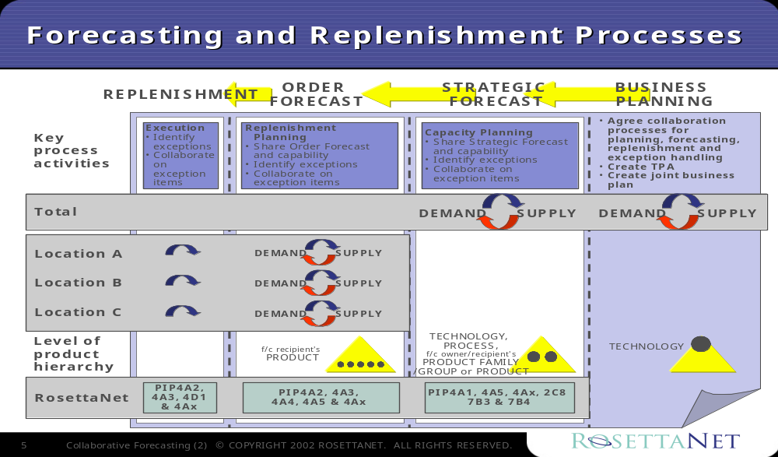
Figure 2: Business Process Scope Diagram

PIP Business Documents
Business Documents are generated and exchanged by roles performing activities in this PIP. Business Documents are listed and defined in Table 1.
Table 1: PIP Business Documents
Business Document | Description
Forecast Reply Notification | Contains detailed forecast reply information and references required to identify this forecast instance in the forecast cycle. Forecast reply quantity (as qualified by type) is projected at the level of agreed forecast line items and for agreed locations and timeframes. Forecast Recipient can optionally provide reason codes that support other than "Accept" response type.

PIP Business Process Flow Diagram
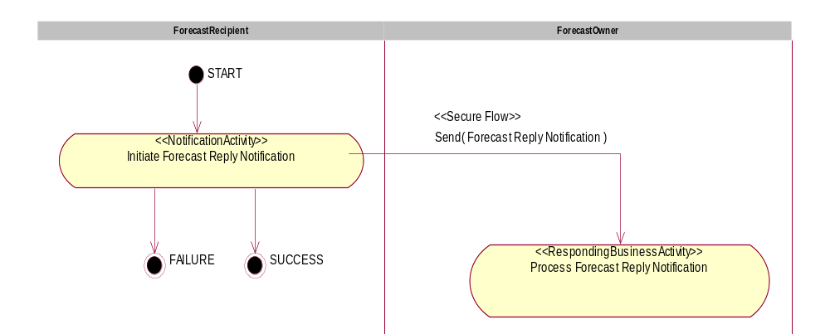
Figure 3: Activity Diagram of Notify Of Forecast Reply

PIP Start State
The start state is comprised of the following condition(s):
Table 2: PIP Start State
 | Approved | Exist |  | Valid | Non-Repudiated | Retry Count | Authorized
 | Approved | Party | In Backend system
TPA |  |  | 
Sending Partner |  |  |  | 
Receiving Partner |  | 
Business Document |  |  |  |  |  |  | 

PIP End State
The end state is comprised of the following condition(s):
Table 3: PIP End State
 | Approved | Exist |  | Valid | Non-Repudiated | Retry Count | Authorized
 | Approved | Party | In Backend system
Acknowledgment of Receipt |  |  |  |  | 
Receiving Partner |  |  |  |  |  |  | 

The PIP failure state is comprised of one or more of the following condition(s):

Table 4: PIP Failure State
 | NO | Exceeded
Success | 
Retry Count |  | 

Partner Role Descriptions
Table 5 describes the partner roles in this PIP.
Table 5: Partner Role Descriptions
Role Name | Role Description
Forecast Recipient | Party, which is requesting Business Activity.
Forecast Owner | Party, which is responding to a Business Activity Request.

Business Process Activity Controls
Table 6 describes the interaction between roles performing business activities in this PIP.
Table 6: Business Activity Descriptions
Role  Name | Activity Name | Activity Description
Forecast Recipient | Initiate Forecast Reply Notification | A Forecast Recipient submits a Forecast Reply to a Forecast Reply Recipient in response to a forecast

Table 7 details the security, audit and process controls relating to activities performed in the PIP.
Table 7: Business Activity Performance Controls
Role  Name | Activity  Name | Acknowledgment  of Receipt |  | Time to Perform | Retry Count | Is Authorization Required? | Non-Repudiation of Origin and Content?
Role  Name | Activity  Name | Non-Repudiation Required? | Time to Acknowledge
Forecast Recipient | Initiate Forecast Reply Notification | Y | 2 hrs | N/A | 3 | Y | Y

Network and Implementation Specification
Each network component maps into a role of the PIP model. Table 8 specifies the mapping between roles and network components.
Table 8: Network Component Specification
Network Component | Classification | Maps to Role in Business Process
Forecast Recipient Service | Business Service | Forecast Recipient
Forecast Owner Service | Business Service | Forecast Owner

Business Action and Business Signal Specification
Each business action maps to a Business Document of the PIP model. Table 9 specifies the mapping between Business Documents and business actions.
Table 9: Business Action – Business Document Mapping
Business Action | Business Document | Document Function
Forecast Reply Notification Action | Forecast Reply Notification | Request

Business Transaction Dialog Specification
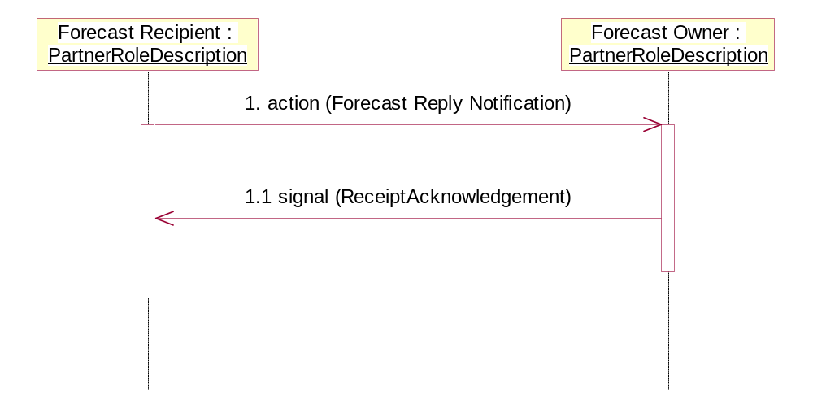
Figure 4: Sequence Diagram of Notify Of Forecast Reply

Message Exchange Controls
Table 10: Message Exchange Controls
# | Name |  | Time to Acknowledge |  | Time to Respond to Action |  | Included in Time to Perform |  | Is Authorization Required? |  | Is Non-Repudiation Required? |  | Is Secure Transport Required?
1. |  | Forecast Reply Notification Action |  | 2 hrs |  | N/A |  | N |  | Y |  | Y |  | Y
1.1. |  | Receipt Acknowledgment |  | N/A |  | N/A |  | N |  | Y |  | Y |  | Y

Communications Specification
Table 11: Forecast Reply Notification Dialog: Service-Service
# | Business Message | Digital Signature Required? | SSL Required?
1. | Forecast Reply Notification | Y | Y
1.1. | Receipt Acknowledgment | Y | Y

 CPFR is a Registered Trademark of the Voluntary Interindustry Commerce Standards (VICS) Association. Additional information: www.cpfr.org

