

Description of 4B2 Message

PIP® 4B2
Validated 11.00.00

Specification Information
Name | Description Of 4B2 Message
PIP | Notify Of Shipment Receipt
Cluster | Inventory Management
Segment | Inventory Allocation
Publication Date | 01 July 2008
Version Identifier | V11.00

Table of Content

1. Document Management 6
1.1 Legal Disclaimer 6
1.2 Copyright 6
1.3 Trademarks 6
1.4 Acknowledgments 6
1.5 Related Documents 7
1.6 Document Version History 7
1.7 Document Purpose 7
2. Interchange Model 8
2.1 ShipmentReceiptNotification 8
2.1.1 Interchange Diagram 8
2.1.2 Dependency Diagram 9
2.1.3 DiscrepancyInformation 9
2.1.4 QuantityInformation 9
2.1.5 ShipmentReceipt 10
2.1.6 ShipmentReceiptLineItem 11
2.1.7 ShipmentReceiptNotification 12
3. Domain Model 13
3.1 Logistics 13
3.1.1 Logistics 13
3.1.1.1 Dependency Diagram 13
3.1.1.2 LotReference 13
3.1.1.3 ManufacturerProfile 14
3.1.1.4 TrackingReference 14
3.1.2 CodeList 14
3.1.2.1 TrackingReferenceType 14
3.1.2.2 LotDiscrepancyReason 15
3.1.2.3 ReceivingDiscrepancyReason 15
3.1.2.4 ReceivingDiscrepancy 16
3.2 Procurement 17
3.2.1 Procurement 17
3.2.1.1 Dependency Diagram 17
3.2.1.2 PartPayment 17
3.3 Shared 18
3.3.1 Shared 18
3.3.1.1 Dependency Diagram 18
3.3.1.2 ProductQuantity 18
4. Universal Structure 19
4.1 ContactInformation 19
4.1.1 ContactInformation 19
4.2 DataType 19
4.2.1 Contact 19
4.2.2 DUNS 20
4.2.3 DUNSPlus4 20
4.2.4 GLN 21
4.2.5 GTIN 21
4.2.6 PercentAmount 22
4.3 Document 22
4.3.1 BusinessDocumentReference 22
4.4 Locations 23
4.4.1 AlternativeIdentifier 23
4.4.2 Location 23
4.4.3 LocationChoice 24
4.4.4 PhysicalAddress 24
4.5 MonetaryExpression 25
4.5.1 FinancialAmount 25
4.6 PartnerIdentification 26
4.6.1 FullPartner 26
4.6.2 IntermittentPartner 27
4.6.3 KnownPartner 27
4.6.4 KnownPartnerContact 28
4.6.5 NewPartner 28
4.6.6 PartnerDescription 29
4.6.7 PartnerDescriptionChoice 29
4.6.8 PartnerIdentification 30
4.6.9 PartnerIdentificationChoice 31
4.6.10 SpecifiedFullPartner 31
4.6.11 SpecifiedIntermittentPartner 32
4.6.12 SpecifiedKnownPartner 32
4.6.13 SpecifiedNewPartner 33
4.7 ProductIdentification 34
4.7.1 ProductIdentification 34
4.7.2 ProductIdentificationChoice 34
4.8 CodeList 35
4.8.1 Country 35
4.8.2 CountrySubdivision 35
4.8.3 Currency 35
4.8.4 Language 35
4.8.5 DocumentType 35
4.8.6 MimeTypeQualifier 37
4.8.7 UnitOfMeasure 48
4.8.8 ProcessRoleIdentifier 60
5. System Structure 64
5.1 BusinessProcessIdentifier 64
5.2 BusinessServiceInformation 64
5.3 ContractInformation 65
5.4 CorrelationInformation 65
5.5 DocumentHeader 65
5.6 DocumentIdentification 66
5.7 DocumentIdentificationChoice 67
5.8 DocumentInformation 67
5.9 DocumentManifest 68
5.10 DocumentSecurity 68
5.11 ManifestItem 69
5.12 PipIdentifier 70
5.13 PipVersion 70
5.14 Receiver 70
5.15 RequestingDocumentInformation 71
5.16 Sender 72
5.17 StandardDocumentIdentification 72
5.18 TpirPipIdentification 73
5.19 VersionIdentifier 73
5.20 CodeList 74
5.20.1 TPIRFileType 74
6. XML Data Type 75
6.1 anyURI 75
6.2 boolean 75
6.3 date 75
6.4 dateTime 75
6.5 decimal 75
6.6 float 75
6.7 integer 75
6.8 positiveInteger 75
6.9 string 76

Table of Figures

Figure 2-1 Interchange 8
Figure 2-2 Dependency 9
Figure 2-3 DiscrepancyInformation 9
Figure 2-4 QuantityInformation 9
Figure 2-5 ShipmentReceipt 10
Figure 2-6 ShipmentReceiptLineItem 11
Figure 2-7 ShipmentReceiptNotification 12
Figure 3-1 Dependency 13
Figure 3-2 LotReference 13
Figure 3-3 ManufacturerProfile 14
Figure 3-4 TrackingReference 14
Figure 3-5 Dependency 17
Figure 3-6 PartPayment 17
Figure 3-7 Dependency 18
Figure 3-8 ProductQuantity 18
Figure 4-1 ContactInformation 19
Figure 4-2 Contact 19
Figure 4-3 DUNS 20
Figure 4-4 DUNSPlus4 20
Figure 4-5 GLN 21
Figure 4-6 GTIN 21
Figure 4-7 PercentAmount 22
Figure 4-8 BusinessDocumentReference 22
Figure 4-9 AlternativeIdentifier 23
Figure 4-10 Location 23
Figure 4-11 PhysicalAddress 24
Figure 4-12 FinancialAmount 25
Figure 4-13 FullPartner 26
Figure 4-14 IntermittentPartner 27
Figure 4-15 KnownPartner 27
Figure 4-16 KnownPartnerContact 28
Figure 4-17 NewPartner 28
Figure 4-18 PartnerDescription 29
Figure 4-19 PartnerIdentification 30
Figure 4-20 SpecifiedFullPartner 31
Figure 4-21 SpecifiedIntermittentPartner 32
Figure 4-22 SpecifiedKnownPartner 32
Figure 4-23 SpecifiedNewPartner 33
Figure 4-24 ProductIdentification 34
Figure 5-1 BusinessProcessIdentifier 64
Figure 5-2 BusinessServiceInformation 64
Figure 5-3 ContractInformation 65
Figure 5-4 CorrelationInformation 65
Figure 5-5 DocumentHeader 65
Figure 5-6 DocumentIdentification 66
Figure 5-7 DocumentInformation 67
Figure 5-8 DocumentManifest 68
Figure 5-9 DocumentSecurity 68
Figure 5-10 ManifestItem 69
Figure 5-11 PipIdentifier 70
Figure 5-12 PipVersion 70
Figure 5-13 Receiver 70
Figure 5-14 RequestingDocumentInformation 71
Figure 5-15 Sender 72
Figure 5-16 StandardDocumentIdentification 72
Figure 5-17 TpirPipIdentification 73
Figure 5-18 VersionIdentifier 73

Document Management

Legal Disclaimer
RosettaNet, its members, officers, directors, employees, or agents shall not be liable for any injury, loss, damages, financial or otherwise, arising from, related to, or caused by the use of this document or the specifications herein, as well as associated guidelines and schemas. The use of said specifications shall constitute your express consent to the foregoing exculpation.

Copyright
©2008 RosettaNet. All rights reserved. No part of this publication may be reproduced, stored in a retrieval system, or transmitted, in any form or by any means, electronic, mechanical, photocopying, recording, or otherwise, without the inclusion of this copyright notice. Any derivative works must cite the copyright notice. Any public redistribution or sale of this publication or derivative works requires prior written permission of the publisher.

Trademarks
RosettaNet, Partner Interface Process, PIP and the RosettaNet logo are trademarks or registered trademarks of "RosettaNet," a non-profit organization. All other product names and company logos mentioned herein are the trademarks of their respective owners. In the best effort, all terms mentioned in this document that are known to be trademarks or registered trademarks have been appropriately recognized in the first occurrence of the term.

Acknowledgments
This document has been prepared by RosettaNet (http://www.rosettanet.org/) from requirements gathered during the Milestone Program and in conformance with the methodology. Listed below are the legal entities that contributed to the design and development of this PIP.
BAX Global | Mitac International Corp.
Cisco System, Inc. | Sterling Commerce
Danzas | Menlo Worldwide
GridNote, Inc. | MIMOS Berhad.
GridNote Pte, Ltd. | Intel Corporation

Related Documents
- Associated PIP Message Schemas (included with PIP Specification only)
- Description of Partner Interface Process for 4B2
- Message Structure

Document Version History
Version | Date | Description
Validated 11.00.00 | 01 July 2008 | Validated Version: RosettaNet Schema to Market to Validation 2008

Document Purpose
The purpose of the document is to explain the structure, the association between objects, the content of objects and the definition for single elements to a non-technical audience.

Interchange Model

ShipmentReceiptNotification

Interchange Diagram
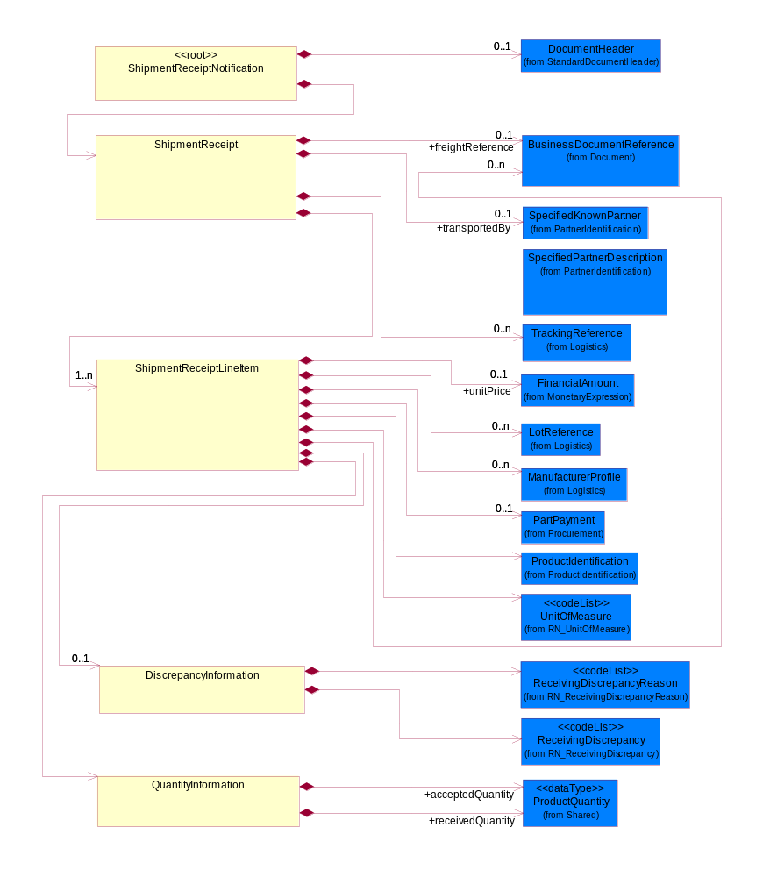
Figure 2-1 Interchange

Dependency Diagram
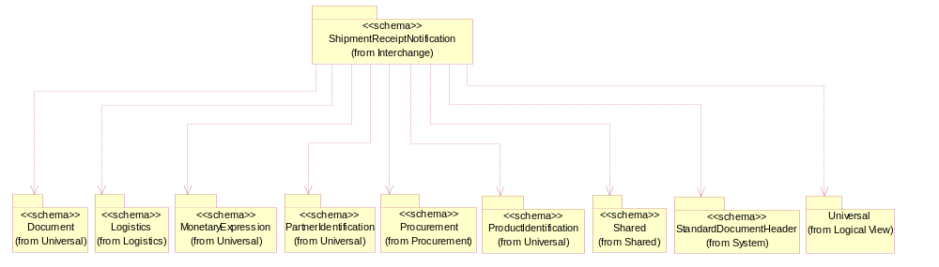
Figure 2-2 Dependency

DiscrepancyInformation
Structured electronic information containing shipment receipt information regarding shipment discrepancies.
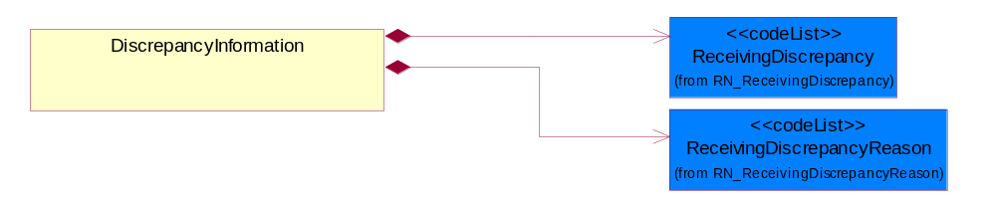
Figure 2-3 DiscrepancyInformation
Composition | Cardinality | Type | Documentation
ReceivingDiscrepancy | 1 | ReceivingDiscrepancy | Code identifying a descrepancy with a shipment at time of receipt.
ReceivingDiscrepancyReason | 1 | ReceivingDiscrepancyReason | Code identifying the reason for a descrepancy with a shipment at time of receipt.

QuantityInformation
The collection of business properties that describes information regarding the quantity of the product shipped.
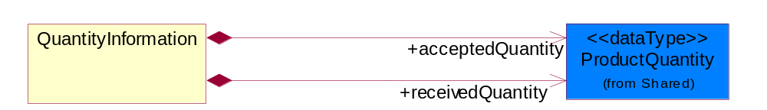
Figure 2-4 QuantityInformation
Composition | Cardinality | Type | Documentation
acceptedQuantity | 1 | ProductQuantity | The quantity of units accepted upon receipt of a shipment.
receivedQuantity | 1 | ProductQuantity | The product quantity received.

ShipmentReceipt
The collection of business properties that describe the receiving status of shipments received by consignee. The Recommended ProcessRoleIdentifier for PartnerDescription are REC - receiveBy and RFR - receivedFrom.
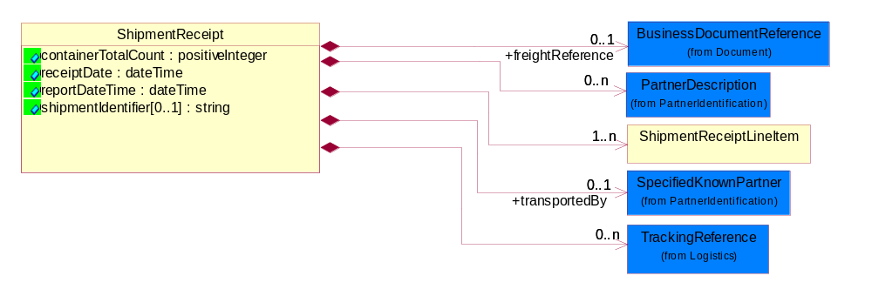
Figure 2-5 ShipmentReceipt
Attribute | Type | Documentation
containerTotalCount | positiveInteger | Indicates the total number of containers in the shipment that belong to this shipping order. This is usually the total number of packed cartons.
receiptDate | dateTime | The date a product or service is received.
reportDateTime | dateTime | The date-time when the shipment receiving report was generated.
shipmentIdentifier[0..1] | string | Reference identifier assigned by the partner originating a shipment to uniquely identify the shipment.

Composition | Cardinality | Type | Documentation
freightReference | 0..1 | BusinessDocumentReference | A reference identifier for the shipment, such as the Bill Of Lading.
PartnerDescription | 0..n | PartnerDescription | The collection of business properties that describe a business partners' identity, their contact information, where they are physically located and their function in a supply chain.
ShipmentReceiptLineItem | 1..n | ShipmentReceiptLineItem | The collection of business properties that describe a shipment receipt notification entry.
transportedBy | 0..1 | SpecifiedKnownPartner | The party responsible for either carrying or forwarding the product.
TrackingReference | 0..n | TrackingReference | Proprietary unique identifier for tracking product shipments.

ShipmentReceiptLineItem
The collection of business properties that describe a shipment receipt notification entry.
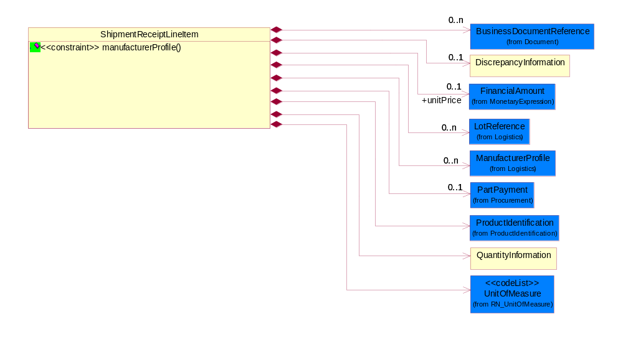
Figure 2-6 ShipmentReceiptLineItem
Composition | Cardinality | Type | Documentation
BusinessDocumentReference | 0..n | BusinessDocumentReference | The business document reference object allows for the indirect referencing of a relationship to other business related documents.
DiscrepancyInformation | 0..1 | DiscrepancyInformation | Structured electronic information containing shipment receipt information regarding shipment discrepancies.
unitPrice | 0..1 | FinancialAmount | Price for each unit.
LotReference | 0..n | LotReference | The collection of business properties that describe a manufacturing lot tendered for shipping.
ManufacturerProfile | 0..n | ManufacturerProfile | The collection of business properties that describe a manufacturer's product.
PartPayment | 0..1 | PartPayment | The collection of business properties that represent invoicing for part payments based on paying a percentage of the purchase price for the products or installation services being provided.
ProductIdentification | 1 | ProductIdentification | The object provides the identifier(s) of a product.
QuantityInformation | 1 | QuantityInformation | The collection of business properties that describes information regarding the quantity of the product shipped.
UnitOfMeasure | 1 | UnitOfMeasure | Code identifying a product unit of measure.

Constraint | Documentation
manufacturerProfile | At least one occurrence of dl:ManufacturerProfile/dl:CountryOfOrigin, dl:ManufacturerProfile/dl:ManufactureDate or dl:ManufacturerProfile/dl:ProductSerialIdentifier is required.

ShipmentReceiptNotification
The message wrapper for PIP 4B2.
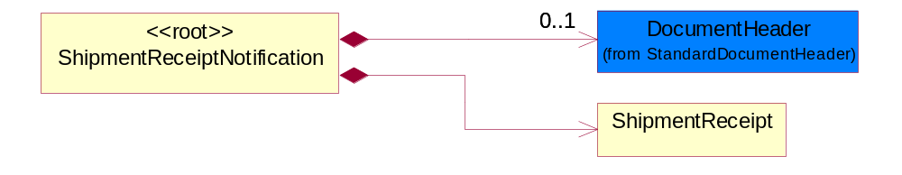
Figure 2-7 ShipmentReceiptNotification
Composition | Cardinality | Type | Documentation
DocumentHeader | 0..1 | DocumentHeader | The object allows for the identification of the sender and receiver of the business document.
ShipmentReceipt | 1 | ShipmentReceipt | The collection of business properties that describe the receiving status of shipments received by consignee. The Recommended ProcessRoleIdentifier for PartnerDescription are REC - receiveBy and RFR - receivedFrom.

Domain Model

Logistics

Logistics

Dependency Diagram
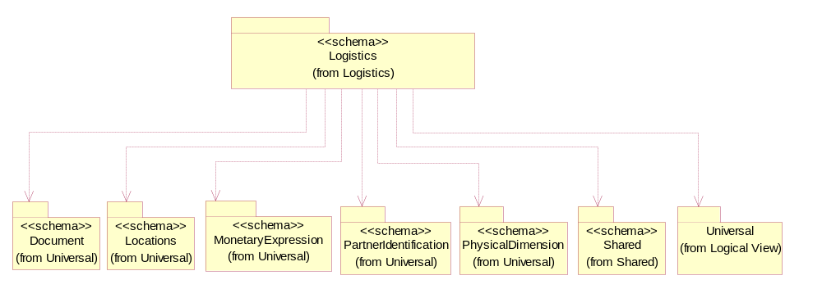
Figure 3-8 Dependency

LotReference
The collection of business properties that describe a manufacturing lot tendered for shipping.
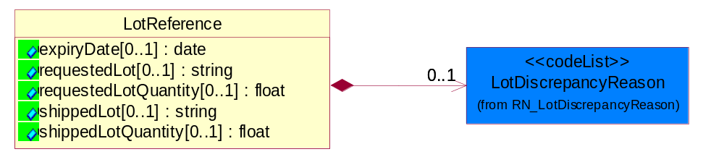
Figure 3-9 LotReference
Attribute | Type | Documentation
expiryDate[0..1] | date | The date that a contractual agreement expires.
requestedLot[0..1] | string | The identifier of a manufacturing lot from which a quantity of product was requested.
requestedLotQuantity[0..1] | float | The quantity of product requested from a specific manufacturing lot.
shippedLot[0..1] | string | The identifier of a manufacturing lot from which a quantity of product was shipped.
shippedLotQuantity[0..1] | float | A quantity of product shipped of a specific manufacturing lot within a shipping container.

Composition | Cardinality | Type | Documentation
LotDiscrepancyReason | 0..1 | LotDiscrepancyReason | Code identifying the reason for a discrepency in the lot composition of the shipment.

ManufacturerProfile
The collection of business properties that describe a manufacturer's product.
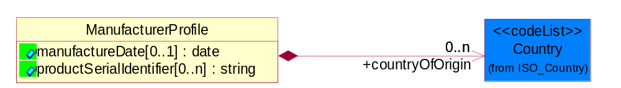
Figure 3-10 ManufacturerProfile
Attribute | Type | Documentation
manufactureDate[0..1] | date | The date the product was manufactured.
productSerialIdentifier[0..n] | string | Serial number(s) of a product.

Composition | Cardinality | Type | Documentation
countryOfOrigin | 0..n | Country | Country where product originates.

TrackingReference
Proprietary unique identifier for tracking product shipments.
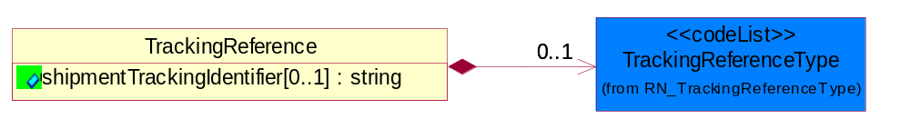
Figure 3-11 TrackingReference
Attribute | Type | Documentation
shipmentTrackingIdentifier[0..1] | string | Proprietary unique identifier for tracking product shipments.

Composition | Cardinality | Type | Documentation
TrackingReferenceType | 0..1 | TrackingReferenceType | Code identifying the type of document reference being used to track a shipment.

CodeList

TrackingReferenceType
Code identifying the type of document reference being used to track a shipment.

Name | Documentation
BKN | Booking Number - Shipment identification number assigned by shipper when booking freight shipment with carrier.
BOL | Bill of Lading Number - Shipment identification number on bill of lading issued by shipper, forwarder or carrier.
CIN | Commercial Invoice - An invoice for customs purposes to allow the determination of the proper import/export duty/taxes.
CRN | Carrier Reference Number - Carrier assigned shipment identification number on bill of lading.
FTR | Freight Tracking Reference - Reference number that describes information about tracing shipments during the transportation process.
HAN | House Airwaybill Number - Forwarder assigned shipment identification number on bill of lading issued by forwarder.
MAB | Master Airwaybill Number - Carrier assigned shipment identification number on bill of lading issued by carrier.
OBL | Ocean Bill of Lading Number - Carrier assigned shipment identification number on bill of lading issued by carrier.
PON | Purchase Order Number.
PRO | Pro Number - Carrier assigned shipment identification number on bill of lading.
PSN | Packing Slip Number - Shipment identification number on shipment contents packing list attached to shipment.
RFI | Radio Frequency Identification (RFID).
RRN | Route Reference Number.
SID | Seal Identifier - Trailer or container seal number assigned by party closing doors on trailer or container.
SON | Seller Sales Order Number.
SRN | Shipper Reference Number - Shipper assigned shipment identification number on bill of lading issued by shipper or forwarder.
TRN | Trailer Number - Owner assigned equipment identification number on trailer.

LotDiscrepancyReason
Code identifying the reason for a discrepancy in the lot composition of the shipment.

Name | Documentation
DLO | Damaged Lot - Lot was found to be damaged.
WLO | Wrong Lot - Expecting different lot.
WLQ | Wrong Lot Quantity - Expecting different lot quantity.

ReceivingDiscrepancyReason
Code identifying the reason for a discrepancy with a shipment at time of receipt.

Name | Documentation
BST | Blocked Stock - Product conditionally received (not allocatable).
DAM | Damage.
DOR | Duplicate Order - Order has already been received (doubled shipped).
ILA | Incorrect Labeling - Shipment had incorrect shipping or product labeling.
INM | Item Not Marked - No GTIN or serial number.
NPO | No Purchase Order.
NPS | No Packing Slip.
OVE | Over-ship.
PLD | Packing List Discrepancy.
SHO | Shortage.
WIT | Wrong Item.
WPA | Wrong Packaging.
WPO | Wrong Purchase Order.

ReceivingDiscrepancy
Code identifying a discrepancy with a shipment at time of receipt.

Name | Documentation
OHO | On Hold.
REJ | Rejected.

Procurement

Procurement

Dependency Diagram
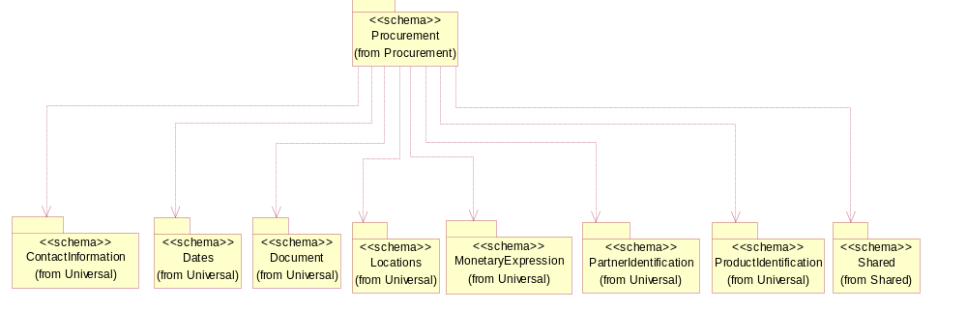
Figure 3-12 Dependency

PartPayment
The collection of business properties that represent invoicing for part payments based on paying a percentage of the purchase price for the products or installation services being provided.
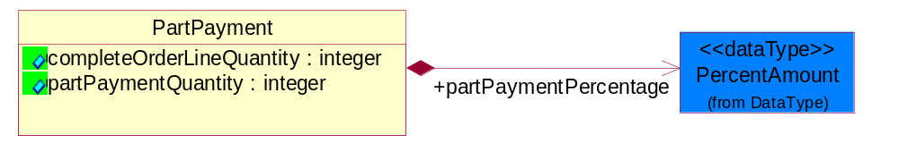
Figure 3-13 PartPayment
Attribute | Type | Documentation
completeOrderLineQuantity | integer | Complete order line quantity.
partPaymentQuantity | integer | The quantity which can be invoiced as a result of applying the part payment percentage to the full line quantity.

Composition | Cardinality | Type | Documentation
partPaymentPercentage | 1 | PercentAmount | The percentage of the total line quantity which can be invoiced to receive payment.

Shared

Shared

Dependency Diagram
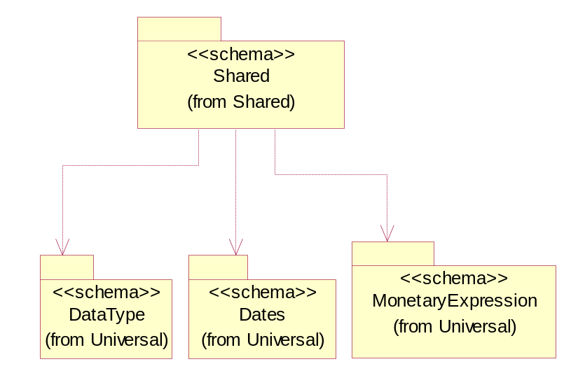
Figure 3-14 Dependency

ProductQuantity
A quantity specifying the number of product units.
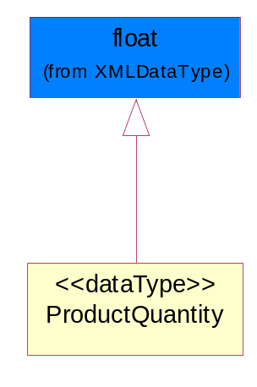
Figure 3-15 ProductQuantity

Universal Structure

ContactInformation

ContactInformation
The business document must allow for the identification of the name of the department, service or individual to be contacted regarding the context of the business document.
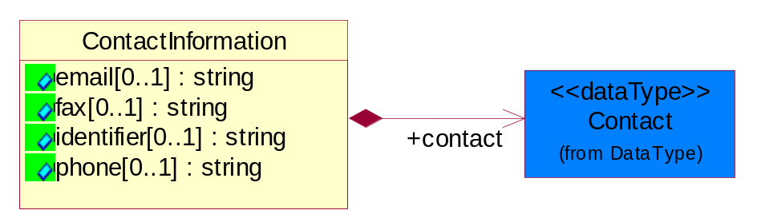
Figure 4-16 ContactInformation
Attribute | Type | Documentation
email[0..1] | string | The electronic mail for the specified contact.
fax[0..1] | string | The fax number for the specified contact.
identifier[0..1] | string | Identifies the role of the contact (i.e. Service Technician, Account Manager) in the Business Process.
phone[0..1] | string | The telephone number for the specified contact.

Composition | Cardinality | Type | Documentation
contact | 1 | Contact | The name of the department, service or individual to be contacted within the organization.

DataType

Contact
The name of the department, service or individual to be contacted within the organization.
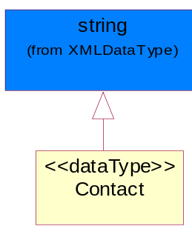
Figure 4-17 Contact

DUNS
A number assigned by Dun and Bradstreet to identify a business location.
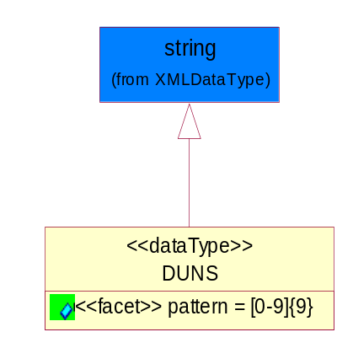
Figure 4-18 DUNS
Attribute | Type | Documentation
pattern |  | [0-9]{9}

DUNSPlus4
A identifier to specify a specific location within a business location.
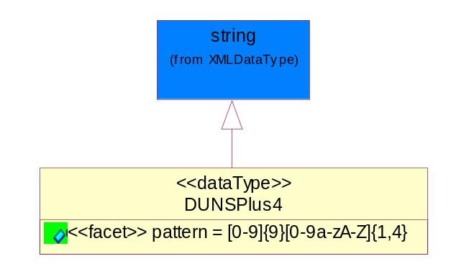
Figure 4-19 DUNSPlus4
Attribute | Type | Documentation
pattern |  | Data Universal Numbering System +4 (DUNS+4) number means the DUNS number assigned by Dun and Bradstreet, Inc. (D&B) plus an alphanumeric of length 4 suffix that may be assigned by a business concern.

GLN
Global Location Number (GLN) - A identifier to identify legal entities, trading parties and location.
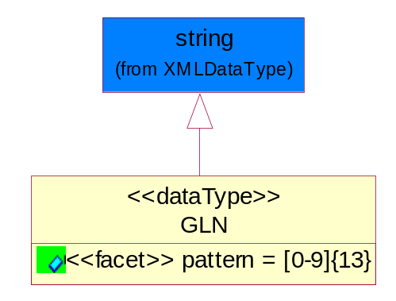
Figure 4-20 GLN
Attribute | Type | Documentation
pattern |  | [0-9]{13}

GTIN
Global Trade Identification Number (GTIN).
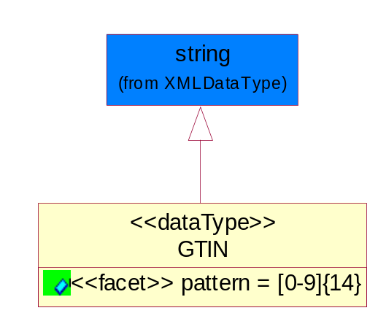
Figure 4-21 GTIN
Attribute | Type | Documentation
pattern |  | [0-9]{14}

PercentAmount
A number representing a percentage value, e.g. 75.125 represents 75 1/8 percent.
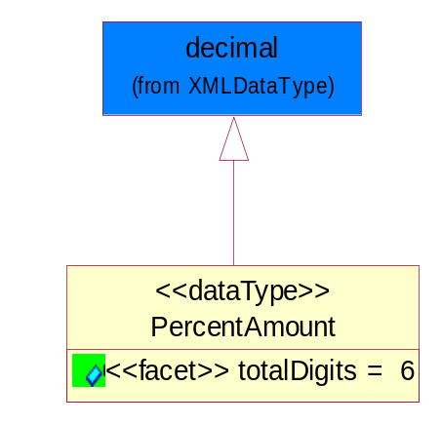
Figure 4-22 PercentAmount
Attribute | Type | Documentation
totalDigits |  | 6

Document

BusinessDocumentReference
The business document reference object allows for the indirect referencing of a relationship to other business related documents.
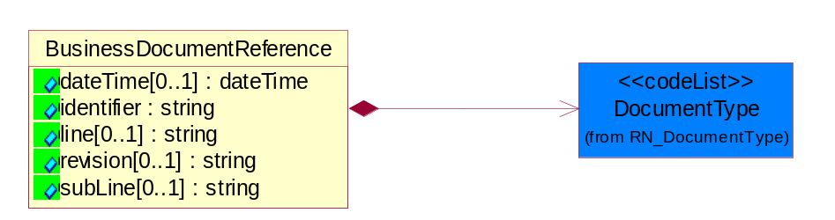
Figure 4-23 BusinessDocumentReference
Attribute | Type | Documentation
dateTime[0..1] | dateTime | The date-time stamp indicating on the referenced business document.
identifier | string | Unique identification of the referenced business document.
line[0..1] | string | References the specific line number of the specified business document.
revision[0..1] | string | Referenced the revision of the specified business document.
subLine[0..1] | string | References the specific subline number of the specified business document.

Composition | Cardinality | Type | Documentation
DocumentType | 1 | DocumentType | A code identifying the business context of a document.

Locations

AlternativeIdentifier
Identifies the specified code and the name of the organization that a code is utilized from.
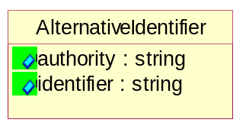
Figure 4-24 AlternativeIdentifier
Attribute | Type | Documentation
authority | string | The name of the organization that a code is utilized from.
identifier | string | The specified code to represent an entity (e.g. product, location, partner, etc.).

Location
The business document must specify a location.
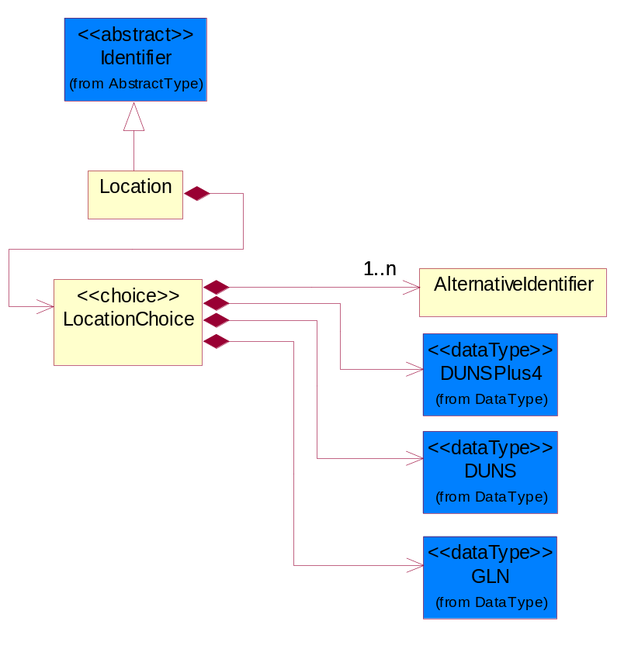
Figure 4-25 Location

Composition | Cardinality | Type | Documentation
LocationChoice | 1 | LocationChoice

LocationChoice

Composition | Cardinality | Type | Documentation
AlternativeIdentifier | 1..n | AlternativeIdentifier | Identifies the specified code and the name of the organization that a code is utilized from.
DUNSPlus4 | 1 | DUNSPlus4 | A identifier to specify a specific location within a business location.
DUNS | 1 | DUNS | A number assigned by Dun and Bradstreet to identify a business location.
GLN | 1 | GLN | Global Location Number (GLN) - A identifier to identify legal entities, trading parties and location.

PhysicalAddress
The business document must provide a physical address for a party to the business transaction.
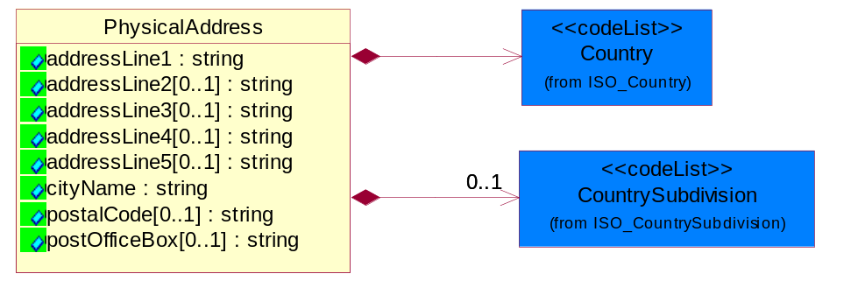
Figure 4-26 PhysicalAddress
Attribute | Type | Documentation
addressLine1 | string | The first line of a physical address.
addressLine2[0..1] | string | The second line of a physical address.
addressLine3[0..1] | string | The third line of a physical address.
addressLine4[0..1] | string | The fourth line of a physical address.
addressLine5[0..1] | string | The fifth line of a physical address.
cityName | string | The name of a city.
postalCode[0..1] | string | Identifying geographic location as specified by a national postal code.
postOfficeBox[0..1] | string | The Post Office Box identifier used to identify a party's post office box.

Composition | Cardinality | Type | Documentation
Country | 1 | Country | For representation of Country name RosettaNet has adopted ISO 3166-3; 1999. Refer to the following web page to get the latest version of the standard:  http://www.iso.ch/iso/en/prods-services/iso3166ma/02iso-3166-code-lists/index.html  If you need more information about the ISO standard please contact ISO for more details.
CountrySubdivision | 0..1 | CountrySubdivision | For representation of a Countries subdivisions RosettaNet has adopted ISO 3166-3; 1999. Refer to the following web page to get the latest version of the standard:  http://www.iso.ch/iso/en/prods-services/iso3166ma/02iso-3166-code-lists/index.html  If you need more information about the ISO standard please contact ISO for more details.

MonetaryExpression

FinancialAmount
The business document must express financial amounts.
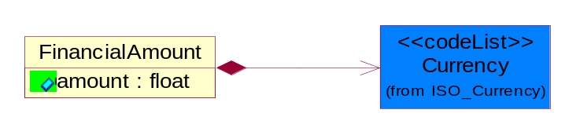
Figure 4-27 FinancialAmount
Attribute | Type | Documentation
amount | float | Specifies the monetary amount.

Composition | Cardinality | Type | Documentation
Currency | 1 | Currency | For representation of Currency codes RosettaNet has adopted ISO 4217; 1995. The British Standards Institution (BSI) is the ISO 4217 Maintenance Agency. Refer to the following web page to get the latest version of the standard:  http://www.bsi-global.com/Technical+Information/Publications/_Publications/tig90.xalter  If you need more information about the ISO standard please contact ISO for more details.

PartnerIdentification

FullPartner
The business document must describe the trading partners in the business transaction. This data structure provide the flexibility to describe a partner in all possible methods as for new, existing or known partner.
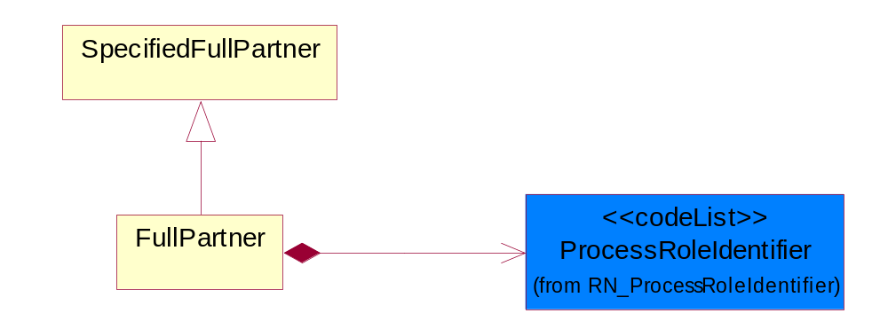
Figure 4-28 FullPartner

Composition | Cardinality | Type | Documentation
ProcessRoleIdentifier | 1 | ProcessRoleIdentifier | Describes the role of the partner in the business process. A partner will fulfill at least one or more roles during the business process.

IntermittentPartner
The business document must describe a physical address for a delivery.
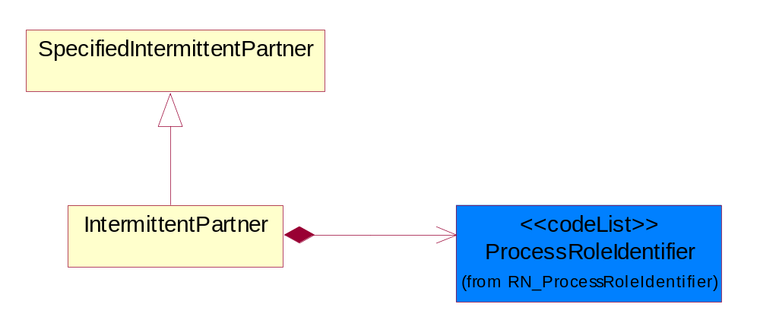
Figure 4-29 IntermittentPartner

Composition | Cardinality | Type | Documentation
ProcessRoleIdentifier | 1 | ProcessRoleIdentifier | Describes the role of the partner in the business process. A partner will fulfill at least one or more roles during the business process.

KnownPartner
The business document must describe the trading partners in the business transaction.
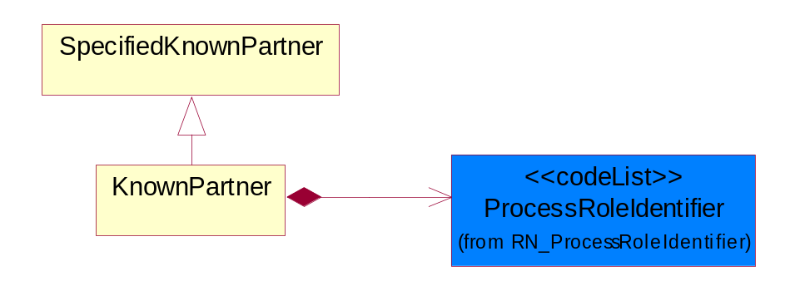
Figure 4-30 KnownPartner
Composition | Cardinality | Type | Documentation
ProcessRoleIdentifier | 1 | ProcessRoleIdentifier | Describes the role of the partner in the business process. A partner will fulfill at least one or more roles during the business process.

KnownPartnerContact
The business document must describe the trading partners in the business transaction.
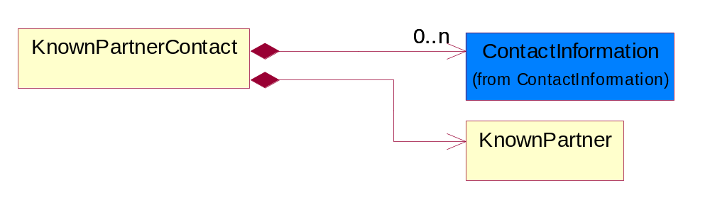
Figure 4-31 KnownPartnerContact

Composition | Cardinality | Type | Documentation
ContactInformation | 0..n | ContactInformation | The business document must allow for the identification of the name of the department, service or individual to be contacted regarding the context of the business document.
KnownPartner | 1 | KnownPartner | The business document must describe the trading partners in the business transaction.

NewPartner
The business document must describe a new, existing (but known to only one of the parties to the transaction) or an unknown party to the business transaction.
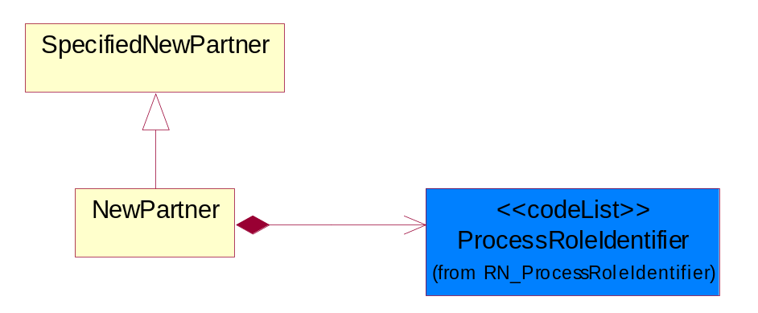
Figure 4-32 NewPartner

Composition | Cardinality | Type | Documentation
ProcessRoleIdentifier | 1 | ProcessRoleIdentifier | Describes the role of the partner in the business process. A partner will fulfill at least one or more roles during the business process.

PartnerDescription
The collection of business properties that describe a business partners' identity, their contact information, where they are physically located and their function in a supply chain.
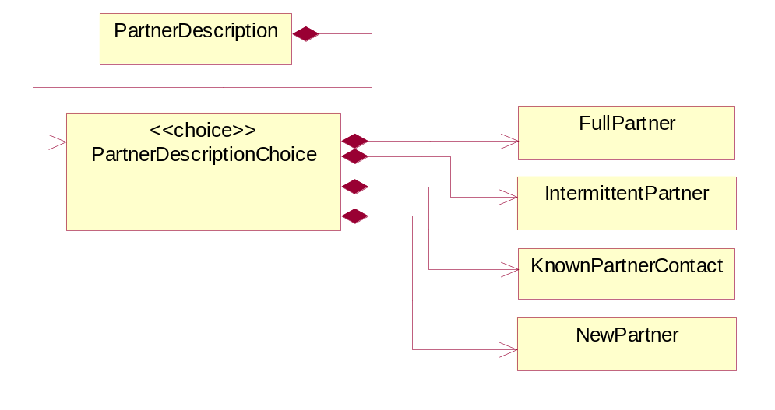
Figure 4-33 PartnerDescription

Composition | Cardinality | Type | Documentation
PartnerDescriptionChoice | 1 | PartnerDescriptionChoice

PartnerDescriptionChoice

Composition | Cardinality | Type | Documentation
FullPartner | 1 | FullPartner | The business document must describe the trading partners in the business transaction. This data structure provide the flexibility to describe a partner in all possible methods as for new, existing or known partner.
IntermittentPartner | 1 | IntermittentPartner | The business document must describe a physical address for a delivery.
KnownPartnerContact | 1 | KnownPartnerContact | The business document must describe the trading partners in the business transaction.
NewPartner | 1 | NewPartner | The business document must describe a new, existing (but known to only one of the parties to the transaction) or an unknown party to the business transaction.

PartnerIdentification
The business document must allow for the identity of one or more parties to the transaction.
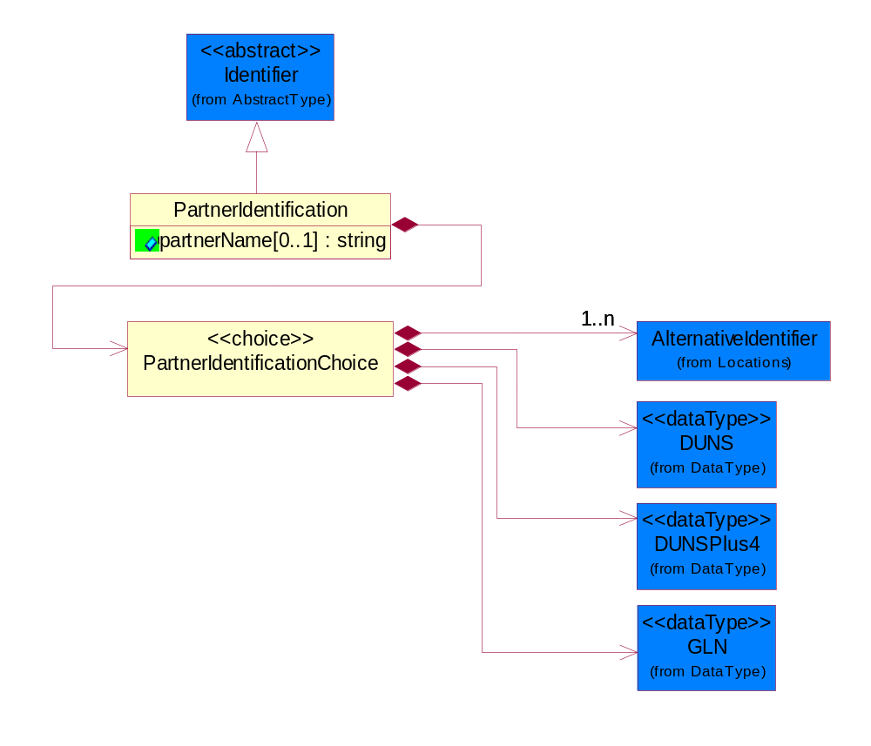
Figure 4-34 PartnerIdentification
Attribute | Type | Documentation
partnerName[0..1] | string | The name of the partner’s company/business.

Composition | Cardinality | Type | Documentation
PartnerIdentificationChoice | 1 | PartnerIdentificationChoice

PartnerIdentificationChoice

Composition | Cardinality | Type | Documentation
AlternativeIdentifier | 1..n | AlternativeIdentifier | Identifies the specified code and the name of the organization that a code is utilized from.
DUNS | 1 | DUNS | A number assigned by Dun and Bradstreet to identify a business location.
DUNSPlus4 | 1 | DUNSPlus4 | A identifier to specify a specific location within a business location.
GLN | 1 | GLN | Global Location Number (GLN) - A identifier to identify legal entities, trading parties and location.

SpecifiedFullPartner
The business document must describe the trading partners in the business transaction. This data structure provide the flexibility to describe a partner in all possible methods as for new, existing or known partner. This is specifically for partner who role has been specified.
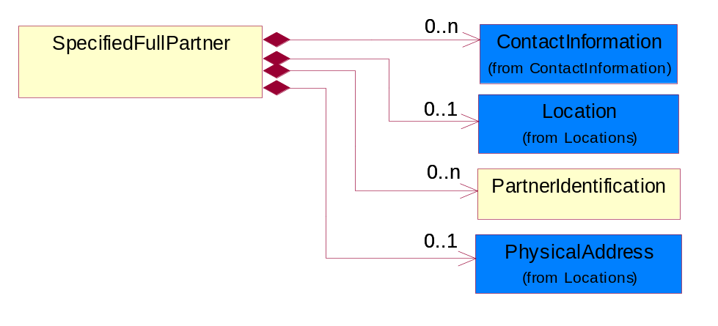
Figure 4-35 SpecifiedFullPartner
Composition | Cardinality | Type | Documentation
ContactInformation | 0..n | ContactInformation | The business document must allow for the identification of the name of the department, service or individual to be contacted regarding the context of the business document.
Location | 0..1 | Location | The business document must specify a location.
PartnerIdentification | 0..n | PartnerIdentification | The business document must allow for the identity of one or more parties to the transaction.
PhysicalAddress | 0..1 | PhysicalAddress | The business document must provide a physical address for a party to the business transaction.

SpecifiedIntermittentPartner
The business document must describe a physical address for a delivery.
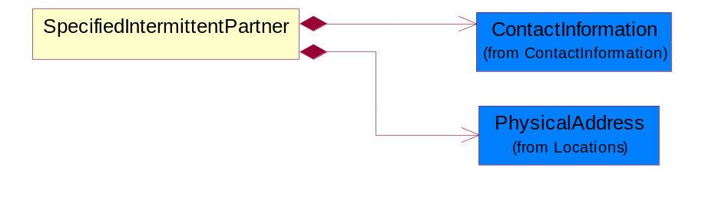
Figure 4-36 SpecifiedIntermittentPartner
Composition | Cardinality | Type | Documentation
ContactInformation | 1 | ContactInformation | The business document must allow for the identification of the name of the department, service or individual to be contacted regarding the context of the business document.
PhysicalAddress | 1 | PhysicalAddress | The business document must provide a physical address for a party to the business transaction.

SpecifiedKnownPartner
The business document must describe the trading partners in the business transaction.
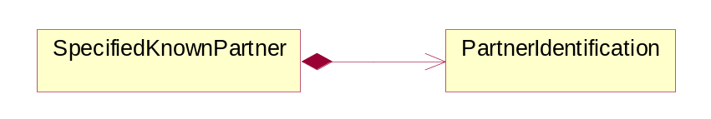
Figure 4-37 SpecifiedKnownPartner
Composition | Cardinality | Type | Documentation
PartnerIdentification | 1 | PartnerIdentification | The business document must allow for the identity of one or more parties to the transaction.

SpecifiedNewPartner
The business document must describe a new, existing (but known to only one of the parties to the transaction) or an unknown party to the business transaction.
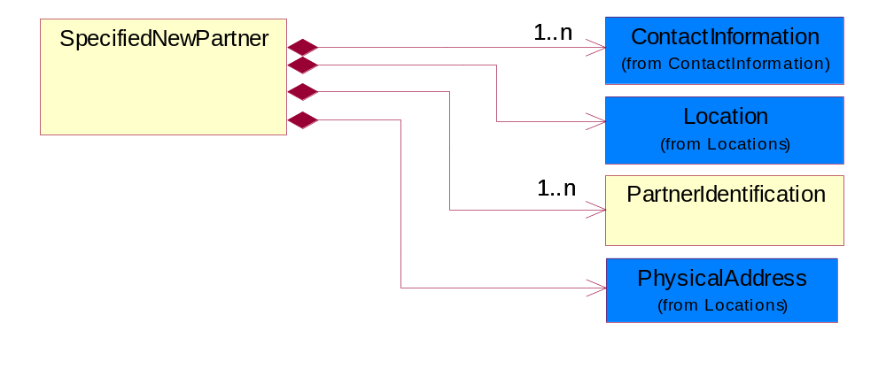
Figure 4-38 SpecifiedNewPartner

Composition | Cardinality | Type | Documentation
ContactInformation | 1..n | ContactInformation | The business document must allow for the identification of the name of the department, service or individual to be contacted regarding the context of the business document.
Location | 1 | Location | The business document must specify a location.
PartnerIdentification | 1..n | PartnerIdentification | The business document must allow for the identity of one or more parties to the transaction.
PhysicalAddress | 1 | PhysicalAddress | The business document must provide a physical address for a party to the business transaction.

ProductIdentification

ProductIdentification
The object provides the identifier(s) of a product.
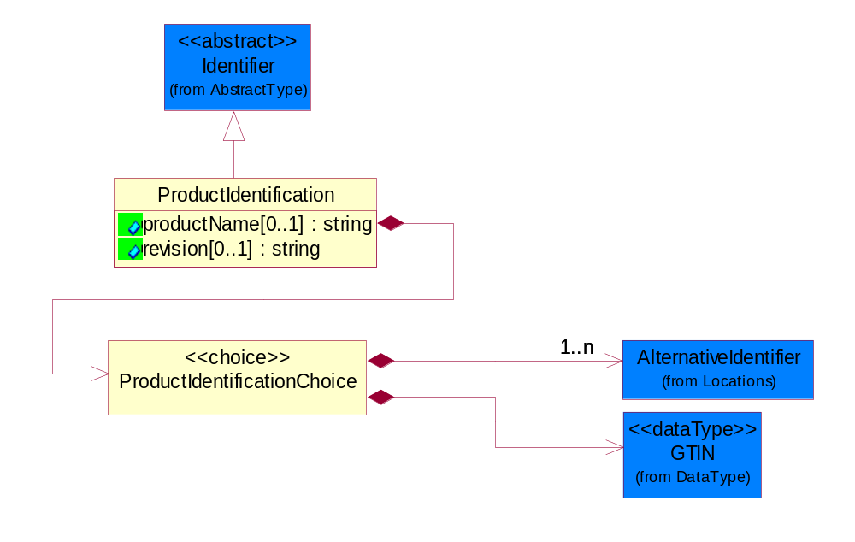
Figure 4-39 ProductIdentification
Attribute | Type | Documentation
productName[0..1] | string | The name of the product.
revision[0..1] | string | Referenced the specified product revision.

Composition | Cardinality | Type | Documentation
ProductIdentificationChoice | 1 | ProductIdentificationChoice

ProductIdentificationChoice

Composition | Cardinality | Type | Documentation
AlternativeIdentifier | 1..n | AlternativeIdentifier | Identifies the specified code and the name of the organization that a code is utilized from.
GTIN | 1 | GTIN | Global Trade Identification Number (GTIN).

CodeList

Country
For representation of Country name RosettaNet has adopted ISO 3166-3; 1999. Refer to the following web page to get the latest version of the standard:
http://www.iso.ch/iso/en/prods-services/iso3166ma/02iso-3166-code-lists/index.html

If you need more information about the ISO standard please contact ISO for more details.

CountrySubdivision
For representation of a Countries subdivisions RosettaNet has adopted ISO 3166-3; 1999. Refer to the following web page to get the latest version of the standard:
http://www.iso.ch/iso/en/prods-services/iso3166ma/02iso-3166-code-lists/index.html

If you need more information about the ISO standard please contact ISO for more details.

Currency
For representation of Currency codes RosettaNet has adopted ISO 4217; 1995. The British Standards Institution (BSI) is the ISO 4217 Maintenance Agency. Refer to the following web page to get the latest version of the standard:
http://www.bsi-global.com/Technical+Information/Publications/_Publications/tig90.xalter

If you need more information about the ISO standard please contact ISO for more details.

Language
For representation of Language name RosettaNet has adopted ISO 639-2; 1998. Refer to the following web page to get the latest version of the standard:

http://www.loc.gov/standards/iso639-2/iso639jac.html

If you need more information about the ISO standard please contact ISO for more details.

DocumentType
A code identifying the business context of a document.

Instance | Documentation
ARA | Authorization Request Approval.
CBN | Product batch number of customer.
CCN | Customs clearance number.
CFA | Failure Analysis - Request document that will accompany the product providing characteristics of the component failure.
CIN | Commercial Invoice.
CNM | Traditional credit note or memo.
COA | Certificate of Analysis.
CON | In a virtual sourcing relationship, a third party trading partner is supplying a part to a customer on behalf of another company that has taken the order for the customer. In this case a Customer Order Number is associated to the request for material that is sent to the virtual trading partners.
COS | Consumption Notice.
COT | Contract.
CRN | Unique consumption reference number identifying the product consumption issue i.e. one-to-one relationship with physical flow.
DEM | Traditional debit note or memo.
DEN | Delivery Note.
DIN | Discontinuation Notice.
DOR | Delivery Order.
DRN | Drawing Number.
DRR | Design Registration Request.
ECO | Engineering Change Order - The proprietary unique identification number that represents an engineering change order.
EIR | Engineering Information Request.
EOL | End of Life.
FUO | Sales order or transfer order fulfilling demand out of a facility (outbound shipment).
INV | Invoice.
LID | Location Identifier. Data for on-site work that have to be done on the machine (associated with preventive maintenance order).
MEN | Master Event Number.
MID | Machine Identifier. Data for on-site work that have to be done on the machine (associated with preventive maintenance order).
MON | Model Number.
OCL | The unique identifier assigned by the OEM for a warranty claim.
OGA | Other governmental agency issued document.
OPO | The unique identifier assigned by the OEM for a part order.
OPR | The unique identifier assigned by the OEM for a part return.
PCN | Product/Process Change.
PFA | Failure Analysis - Request document that will accompany the product providing characteristics of the product failure.
PII | Refers to previously issued invoice.
PLS | Unique number that identifies packing form prior to shipment.
POI | Purchase Order IN.
PON | Production order number for material release.
POO | Purchase Order OUT.
PRC | Product Catalog.
PSI | Refers to previously issued self-billing invoice.
PUO | Purchase Order.
QUO | Quote.
REC | Document identifying the receipt of materials or products into a facility against a purchase order or transfer order (inbound shipment).
REN | Release Number.
REO | Purchase order or transfer order replenishing inventory into a facility (inbound shipment).
REQ | Requisition.
RMA | Returned Material Authorization.
RPO | Purchase order for materials or product returned to and reworked by a supplier.
RTA | Remittance Advice - Remittance details.
SAO | Sales Order.
SBC | Credit Memo used in self-billing scenario.
SBD | Debit Memo used in self-billing scenario.
SBI | Invoice in self billing scenario.
SBN | Product batch number of supplier.
SCA | Similar to contracts - Contains the quantity of an article that is to be ordered from a vendor and the price for article or service that is to be procured.
SEN | Serial Number.
SEO | A document that gives a repair provider the necessary authorization to repair or upgrade a product either at the customer site or at the repair provider’s site.
SHD | Shipping Document.
SNC | Shipset Number on Code List.
SPC | The unique identifier assigned by the ASP for a warranty claim.
SPN | Spec Number.
SPO | The unique identifier assigned by the ASP for a part order.
SPR | The unique identifier assigned by the ASP for a part return.
SPW | The unique identifier assigned by the ASP to reference a work order.
SRI | A document that contains the shipping reference number which allows the product to be tracked within the outsourced logistic providers network.
TRO | Order which results in materials or products being moved from one facility to another (outbound shipment and inbound shipment).
WAB | Waybill.
WAC | Denotes a warranty claim.
WOO | Work Order.

MimeTypeQualifier
The MIME type as defined by IANA.

Please refer to http://www.iana.org/assignments/media-types/ for a list of types.

Instance | Documentation
application/activemessage | [Shapiro]
application/andrew-inset | [Borenstein]
application/applefile | [Faltstrom]
application/atomicmail | [Borenstein]
application/batch-SMTP | [RFC2442]
application/beep+xml | [RFC3080]
application/cals-1840 | [RFC1895]
application/cnrp+xml | [RFCCNRP]
application/commonground | [Glazer]
application/cpl+xml
application/cybercash | [Eastlake]
application/dca-rft | [Campbell]
application/dec-dx | [Campbell]
application/dicom | [RFC3240]
application/dvcs | [RFC3029]
application/EDI-Consent | [RFC1767]
application/EDIFACT | [RFC1767]
application/EDI-X12 | [RFC1767]
application/eshop | [Katz]
application/font-tdpfr | [RFC3073]
application/http | [RFC2616]
application/hyperstudio | [Domino]
application/iges | [Parks]
application/index | [RFC2652]
application/index.cmd | [RFC2652]
application/index.obj | [RFC2652]
application/index.response | [RFC2652]
application/index.vnd | [RFC2652]
application/iotp | [RFC2935]
application/ipp | [RFC2910]
application/isup | [RFC3204]
application/mac-binhex40 | [Faltstrom]
application/macwriteii | [Lindner]
application/marc | [RFC2220]
application/mathematica | [Van Nostern]
application/msword | [Lindner]
application/news-message-id | [RFC1036,Spencer]
application/news-transmission | [RFC1036, Spencer]
application/ocsp-request | [RFC2560]
application/ocsp-response | [RFC2560]
application/octet-stream | [RFC2045,RFC2046]
application/oda | [RFC2045,RFC2046]
application/ogg | [RFC-walleij-ogg-mediatype-08.txt]
application/parityfec | [RFC3009]
application/pdf | [Lindner]
application/pgp-encrypted | [RFC3156]
application/pgp-keys | [RFC3156]
application/pgp-signature | [RFC3156]
application/pkcs10 | [RFC2311]
application/pkcs7-mime | [RFC2311]
application/pkcs7-signature | [RFC2311]
application/pkix-cert | [RFC2585]
application/pkixcmp | [RFC2510]
application/pkix-crl | [RFC2585]
application/postscript | [RFC2045,RFC2046]
application/prs.alvestrand.titrax-sheet | [Alvestrand]
application/prs.cww | [Rungchavalnont]
application/prs.nprend | [Doggett]
application/prs.plucker | [Janssen]
application/qsig | [RFC3204]
application/reginfo+xml | [RFC-ietf-sipping-reg-event-00.txt]
application/remote-printing | [RFC1486,Rose]
application/riscos | [Smith]
application/rtf | [Lindner]
application/sdp | [RFC2327]
application/set-payment | [Korver]
application/set-payment-initiation | [Korver]
application/set-registration | [Korver]
application/set-registration-initiation | [Korver]
application/sgml | [RFC1874]
application/sgml-open-catalog | [Grosso]
application/sieve | [RFC3028]
application/slate | [Crowley]
application/timestamp-query | [RFC3161]
application/timestamp-reply | [RFC3161]
application/tve-trigger | [Welsh]
application/vemmi | [RFC2122]
application/vnd.3gpp.pic-bw-large | [Meredith]
application/vnd.3gpp.pic-bw-small | [Meredith]
application/vnd.3gpp.pic-bw-var | [Meredith]
application/vnd.3gpp.sms | [Meredith]
application/vnd.3M.Post-it-Notes | [O'Brien]
application/vnd.accpac.simply.aso | [Leow]
application/vnd.accpac.simply.imp | [Leow]
application/vnd.acucobol | [Lubin]
application/vnd.acucorp | [Lubin]
application/vnd.adobe.xfdf | [Perelman]
application/vnd.aether.imp | [Moskowitz]
application/vnd.amiga.ami | [Blumberg]
application/vnd.anser-web-certificate-issue-initiation | [Mori]
application/vnd.anser-web-funds-transfer-initiation | [Mori]
application/vnd.audiograph | [Slusanschi]
application/vnd.blueice.multipass | [Holmstrom]
application/vnd.bmi | [Gotoh]
application/vnd.businessobjects | [Imoucha]
application/vnd.canon-cpdl | [Muto]
application/vnd.canon-lips | [Muto]
application/vnd.cinderella | [Kortenkamp]
application/vnd.claymore | [Simpson]
application/vnd.commerce-battelle | [Applebaum]
application/vnd.commonspace | [Chandhok]
application/vnd.contact.cmsg | [Patz]
application/vnd.cosmocaller | [Dellutri]
application/vnd.ctc-posml | [Kohlhepp]
application/vnd.cups-postscript | [Sweet]
application/vnd.cups-raster | [Sweet]
application/vnd.cups-raw | [Sweet]
application/vnd.curl | [Byrnes]
application/vnd.cybank | [Helmee]
application/vnd.data-vision.rdz | [Fields]
application/vnd.dna | [Searcy]
application/vnd.dpgraph | [Parker]
application/vnd.dreamfactory | [Appleton]
application/vnd.dxr | [Duffy]
application/vnd.ecdis-update | [Buettgenbach]
application/vnd.ecowin.chart | [Olsson]
application/vnd.ecowin.filerequest | [Olsson]
application/vnd.ecowin.fileupdate | [Olsson]
application/vnd.ecowin.series | [Olsson]
application/vnd.ecowin.seriesrequest | [Olsson]
application/vnd.ecowin.seriesupdate | [Olsson]
application/vnd.enliven | [Santinelli]
application/vnd.epson.esf | [Hoshina]
application/vnd.epson.msf | [Hoshina]
application/vnd.epson.quickanime | [Gu]
application/vnd.epson.salt | [Nagatomo]
application/vnd.epson.ssf | [Hoshina]
application/vnd.ericsson.quickcall | [Tidwell]
application/vnd.eudora.data | [Resnick]
application/vnd.fdf | [Zilles]
application/vnd.ffsns | [Holstage]
application/vnd.FloGraphIt | [Floersch]
application/vnd.framemaker | [Wexler]
application/vnd.fsc.weblaunch | [D.Smith]
application/vnd.fujitsu.oasys | [Togashi]
application/vnd.fujitsu.oasys2 | [Togashi]
application/vnd.fujitsu.oasys3 | [Okudaira]
application/vnd.fujitsu.oasysgp | [Sugimoto]
application/vnd.fujitsu.oasysprs | [Ogita]
application/vnd.fujixerox.ddd | [Onda]
application/vnd.fujixerox.docuworks | [Taguchi]
application/vnd.fujixerox.docuworks.binder | [Matsumoto]
application/vnd.fut-misnet | [Pruulmann]
application/vnd.grafeq | [Tupper]
application/vnd.groove-account | [Joseph]
application/vnd.groove-help | [Joseph]
application/vnd.groove-identity-message | [Joseph]
application/vnd.groove-injector | [Joseph]
application/vnd.groove-tool-message | [Joseph]
application/vnd.groove-tool-template | [Joseph]
application/vnd.groove-vcard | [Joseph]
application/vnd.hbci | [Hammann]
application/vnd.hhe.lesson-player | [Jones]
application/vnd.hp-HPGL | [Pentecost]
application/vnd.hp-hpid | [Gupta]
application/vnd.hp-hps | [Aubrey]
application/vnd.hp-PCL | [Pentecost]
application/vnd.hp-PCLXL | [Pentecost]
application/vnd.httphone | [Lefevre]
application/vnd.hzn-3d-crossword | [Minnis]
application/vnd.ibm.afplinedata | [Buis]
application/vnd.ibm.electronic-media | [Tantlinger]
application/vnd.ibm.MiniPay | [Herzberg]
application/vnd.ibm.modcap | [Hohensee]
application/vnd.ibm.secure-container | [Tantlinger]
application/vnd.informix-visionary | [Gales]
application/vnd.intercon.formnet | [Gurak]
application/vnd.intertrust.digibox | [Tomasello]
application/vnd.intertrust.nncp | [Tomasello]
application/vnd.intu.qbo | [Scratchley]
application/vnd.intu.qfx | [Scratchley]
application/vnd.irepository.package+xml | [Knowles]
application/vnd.is-xpr | [Natarajan]
application/vnd.japannet-directory-service | [Fujii]
application/vnd.japannet-jpnstore-wakeup | [Yoshitake]
application/vnd.japannet-payment-wakeup | [Fujii]
application/vnd.japannet-registration | [Yoshitake]
application/vnd.japannet-registration-wakeup | [Fujii]
application/vnd.japannet-setstore-wakeup | [Yoshitake]
application/vnd.japannet-verification | [Yoshitake]
application/vnd.japannet-verification-wakeup | [Fujii]
application/vnd.jisp | [Deckers]
application/vnd.kde.karbon | [Faure]
application/vnd.kde.kchart | [Faure]
application/vnd.kde.kformula | [Faure]
application/vnd.kde.kivio | [Faure]
application/vnd.kde.kontour | [Faure]
application/vnd.kde.kpresenter | [Faure]
application/vnd.kde.kspread | [Faure]
application/vnd.kde.kword | [Faure]
application/vnd.kenameaapp | [DiGiorgio-Haag]
application/vnd.koan | [Cole]
application/vnd.liberty-request+xml | [McDowell]
application/vnd.llamagraphics.life-balance.desktop | [White]
application/vnd.lotus-1-2-3 | [Wattenberger]
application/vnd.lotus-approach | [Wattenberger]
application/vnd.lotus-freelance | [Wattenberger]
application/vnd.lotus-notes | [Laramie]
application/vnd.lotus-organizer | [Wattenberger]
application/vnd.lotus-screencam | [Wattenberger]
application/vnd.lotus-wordpro | [Wattenberger]
application/vnd.mcd | [Gotoh]
application/vnd.mediastation.cdkey | [Flurry]
application/vnd.meridian-slingshot | [Wedel]
application/vnd.micrografx.flo | [Prevo]
application/vnd.micrografx.igx | [Prevo]
application/vnd.mif | [Wexler]
application/vnd.minisoft-hp3000-save | [Bartram]
application/vnd.mitsubishi.misty-guard.trustweb | [Tanaka]
application/vnd.Mobius.DAF | [Kabayama]
application/vnd.Mobius.DIS | [Kabayama]
application/vnd.Mobius.MBK | [Devasia]
application/vnd.Mobius.MQY | [Devasia]
application/vnd.Mobius.MSL | [Kabayama]
application/vnd.Mobius.PLC | [Kabayama]
application/vnd.Mobius.TXF | [Kabayama]
application/vnd.mophun.application | [Wennerstrom]
application/vnd.mophun.certificate | [Wennerstrom]
application/vnd.motorola.flexsuite | [Patton]
application/vnd.motorola.flexsuite.adsi | [Patton]
application/vnd.motorola.flexsuite.fis | [Patton]
application/vnd.motorola.flexsuite.gotap | [Patton]
application/vnd.motorola.flexsuite.kmr | [Patton]
application/vnd.motorola.flexsuite.ttc | [Patton]
application/vnd.motorola.flexsuite.wem | [Patton]
application/vnd.mozilla.xul+xml | [McDaniel]
application/vnd.ms-artgalry | [Slawson]
application/vnd.ms-asf | [Fleischman]
application/vnd.mseq | [Le Bodic]
application/vnd.ms-excel | [Gill]
application/vnd.msign | [Borcherding]
application/vnd.ms-lrm | [Ledoux]
application/vnd.ms-powerpoint | [Gill]
application/vnd.ms-project | [Gill]
application/vnd.ms-tnef | [Gill]
application/vnd.ms-works | [Gill]
application/vnd.ms-wpl | [Plastina]
application/vnd.musician | [Adams]
application/vnd.music-niff | [Butler]
application/vnd.netfpx | [Mutz]
application/vnd.noblenet-directory | [Solomon]
application/vnd.noblenet-sealer | [Solomon]
application/vnd.noblenet-web | [Solomon]
application/vnd.novadigm.EDM | [Swenson]
application/vnd.novadigm.EDX | [Swenson]
application/vnd.novadigm.EXT | [Swenson]
application/vnd.obn | [Hessling]
application/vnd.osa.netdeploy | [Klos]
application/vnd.palm | [Peacock]
application/vnd.pg.format | [Gandert]
application/vnd.pg.osasli | [Gandert]
application/vnd.powerbuilder6 | [Guy]
application/vnd.powerbuilder6-s | [Guy]
application/vnd.powerbuilder7 | [Shilts]
application/vnd.powerbuilder75 | [Shilts]
application/vnd.powerbuilder75-s | [Shilts]
application/vnd.powerbuilder7-s | [Shilts]
application/vnd.previewsystems.box | [Smolgovsky]
application/vnd.publishare-delta-tree | [Ben-Kiki]
application/vnd.pvi.ptid1 | [Lamb]
application/vnd.pwg-multiplexed | [RFC3391]
application/vnd.pwg-xhtml-print+xml | [Wright]
application/vnd.Quark.QuarkXPress | [Scheidler]
application/vnd.rapid | [Szekely]
application/vnd.s3sms | [Tarkkala]
application/vnd.sealed.net | [Lambert]
application/vnd.seemail | [Webb]
application/vnd.shana.informed.formdata | [Selzler]
application/vnd.shana.informed.formtemplate | [Selzler]
application/vnd.shana.informed.interchange | [Selzler]
application/vnd.shana.informed.package | [Selzler]
application/vnd.smaf | [Takahashi]
application/vnd.sss-cod | [Dani]
application/vnd.sss-dtf | [Bruno]
application/vnd.sss-ntf | [Bruno]
application/vnd.street-stream | [Levitt]
application/vnd.svd | [Becker]
application/vnd.swiftview-ics | [Widener]
application/vnd.triscape.mxs | [Simonoff]
application/vnd.trueapp | [Hepler]
application/vnd.truedoc | [Chase]
application/vnd.ufdl | [Manning]
application/vnd.uplanet.alert | [Martin]
application/vnd.uplanet.alert-wbxml | [Martin]
application/vnd.uplanet.bearer-choice | [Martin]
application/vnd.uplanet.bearer-choice-wbxml | [Martin]
application/vnd.uplanet.cacheop | [Martin]
application/vnd.uplanet.cacheop-wbxml | [Martin]
application/vnd.uplanet.channel | [Martin]
application/vnd.uplanet.channel-wbxml | [Martin]
application/vnd.uplanet.list | [Martin]
application/vnd.uplanet.listcmd | [Martin]
application/vnd.uplanet.listcmd-wbxml | [Martin]
application/vnd.uplanet.list-wbxml | [Martin]
application/vnd.uplanet.signal | [Martin]
application/vnd.vcx | [T.Sugimoto]
application/vnd.vectorworks | [Pharr]
application/vnd.vidsoft.vidconference | [Hess]
application/vnd.visio | [Sandal]
application/vnd.visionary | [Aravindakumar]
application/vnd.vividence.scriptfile | [Risher]
application/vnd.vsf | [Rowe]
application/vnd.wap.sic | [WAP-Forum]
application/vnd.wap.slc | [WAP-Forum]
application/vnd.wap.wbxml | [Stark]
application/vnd.wap.wmlc | [Stark]
application/vnd.wap.wmlscriptc | [Stark]
application/vnd.webturbo | [Rehem]
application/vnd.wrq-hp3000-labelled | [Bartram]
application/vnd.wt.stf | [Wohler]
application/vnd.wv.csp+wbxml | [Salmi]
application/vnd.xara | [Matthewman]
application/vnd.xfdl | [Manning]
application/vnd.yellowriver-custom-menu | [Yellow]
application/whoispp-query | [RFC2957]
application/whoispp-response | [RFC2958]
application/wita | [Campbell]
application/wordperfect5.1 | [Lindner]
application/x400-bp | [RFC1494]
application/xhtml+xml | [RFC3236]
application/xml | [RFC3023]
application/xml-dtd | [RFC3023]
application/xml-external-parsed-entity | [RFC3023]
application/zip | [Lindner]
audio/32kadpcm | [RFC2421,RFC2422]
audio/AMR | [RFC3267]
audio/AMR-WB | [RFC3267]
audio/basic | [RFC2045,RFC2046]
audio/CN | [RFC3389]
audio/DAT12 | [RFC3190]
audio/DVI4
audio/EVRC | [RFC-ietf-avt-evrc-smv-03.txt]
audio/EVRC0 | [RFC-ietf-avt-evrc-smv-03.txt]
audio/G.722.1 | [RFC3047]
audio/G722
audio/G723
audio/G726-16
audio/G726-24
audio/G726-32
audio/G726-40
audio/G728
audio/G729
audio/G729D
audio/G729E
audio/GSM
audio/GSM-EFR
audio/L16 | [RFC2586]
audio/L20 | [RFC3190]
audio/L24 | [RFC3190]
audio/L8
audio/LPC
audio/MP4A-LATM | [RFC3016]
audio/MPA
audio/mpa-robust | [RFC3119]
audio/mpeg | [RFC3003]
audio/parityfec | [RFC3009]
audio/PCMA
audio/PCMU
audio/prs.sid | [Walleij]
audio/QCELP
audio/RED
audio/SMV | [RFC-ietf-avt-evrc-smv-03.txt]
audio/SMV0 | [RFC-ietf-avt-evrc-smv-03.txt]
audio/telephone-event | [RFC2833]
audio/tone | [RFC2833]
audio/VDVI
audio/vnd.3gpp.iufp | [Belling]
audio/vnd.cisco.nse | [Kumar]
audio/vnd.cns.anp1 | [McLaughlin]
audio/vnd.cns.inf1 | [McLaughlin]
audio/vnd.digital-winds | [Strazds]
audio/vnd.everad.plj | [Cicelsky]
audio/vnd.lucent.voice | [Vaudreuil]
audio/vnd.nortel.vbk | [Parsons]
audio/vnd.nuera.ecelp4800 | [Fox]
audio/vnd.nuera.ecelp7470 | [Fox]
audio/vnd.nuera.ecelp9600 | [Fox]
audio/vnd.octel.sbc | [Vaudreuil]
audio/vnd.qcelp | [Lundblade]
audio/vnd.rhetorex.32kadpcm | [Vaudreuil]
audio/vnd.vmx.cvsd | [Vaudreuil]
image/cgm | Computer Graphics Metafile
image/g3fax | [RFC1494]
image/gif | [RFC2045,RFC2046]
image/ief | [RFC1314] Image Exchange Format
image/jpeg | [RFC2045,RFC2046]
image/naplps | [Ferber]
image/png | [Randers-Pehrson]
image/prs.btif | [Simon]
image/prs.pti | [Laun]
image/t38 | [RFC3362]
image/tiff | [RFC3302] Tag Image File Format
image/tiff-fx | [RFC3250] Tag Image File Format Fax eXtended
image/vnd.cns.inf2 | [McLaughlin]
image/vnd.djvu | [Bottou]
image/vnd.dwg | [Moline]
image/vnd.dxf | [Moline]
image/vnd.fastbidsheet | [Becker]
image/vnd.fpx | [Spencer]
image/vnd.fst | [Fuldseth]
image/vnd.fujixerox.edmics-mmr | [Onda]
image/vnd.fujixerox.edmics-rlc | [Onda]
image/vnd.globalgraphics.pgb | [Bailey]
image/vnd.mix | [Reddy]
image/vnd.ms-modi | [Vaughan]
image/vnd.net-fpx | [Spencer]
image/vnd.svf | [Moline]
image/vnd.wap.wbmp | [Stark]
image/vnd.xiff | [S.Martin]
message/delivery-status | [RFC1894]
message/disposition-notification | [RFC2298]
message/external-body | [RFC2045,RFC2046]
message/http | [RFC2616]
message/news | [RFC 1036, H.Spencer]
message/partial | [RFC2045,RFC2046]
message/rfc822 | [RFC2045,RFC2046]
message/s-http | [RFC2660]
message/sip | [RFC3261]
message/sipfrag | [RFC3420]
model/iges | [Parks]
model/mesh | [RFC2077]
model/vnd.dwf | [Pratt]
model/vnd.flatland.3dml | [Powers]
model/vnd.gdl | [Babits]
model/vnd.gs-gdl | [Babits]
model/vnd.gtw | [Ozaki]
model/vnd.mts | [Rabinovitch]
model/vnd.parasolid.transmit.binary | [Parasolid]
model/vnd.parasolid.transmit.text | [Parasolid]
model/vnd.vtu | [Rabinovitch]
model/vrml | [RFC2077]
multipart/alternative | [RFC2045,RFC2046]
multipart/appledouble | [Faltstrom]
multipart/byteranges | [RFC2068]
multipart/digest | [RFC2045,RFC2046]
multipart/encrypted | [RFC1847]
multipart/form-data | [RFC2388]
multipart/header-set | [Crocker]
multipart/mixed | [RFC2045,RFC2046]
multipart/parallel | [RFC2045,RFC2046]
multipart/related | [RFC2387]
multipart/report | [RFC1892]
multipart/signed | [RFC1847]
multipart/voice-message | [RFC2421,RFC2423]
text/calendar | [RFC2445]
text/css | [RFC2318]
text/directory | [RFC2425]
text/enriched | [RFC1896]
text/html | [RFC2854]
text/parityfec | [RFC3009]
text/plain | [RFC2646,RFC2046]
text/prs.lines.tag | [Lines]
text/rfc822-headers | [RFC1892]
text/richtext | [RFC2045,RFC2046]
text/rtf | [Lindner]
text/sgml | [RFC1874]
text/t140 | [RFC2793]
text/tab-separated-values | [Lindner]
text/uri-list | [RFC2483]
text/vnd.abc | [Allen]
text/vnd.curl | [Byrnes]
text/vnd.DMClientScript | [Bradley]
text/vnd.fly | [Gurney]
text/vnd.fmi.flexstor | [Hurtta]
text/vnd.in3d.3dml | [Powers]
text/vnd.in3d.spot | [Powers]
text/vnd.IPTC.NewsML | [IPTC]
text/vnd.IPTC.NITF | [IPTC]
text/vnd.latex-z | [Lubos]
text/vnd.motorola.reflex | [Patton]
text/vnd.ms-mediapackage | [Nelson]
text/vnd.net2phone.commcenter.command | [Xie]
text/vnd.sun.j2me.app-descriptor | [G.Adams]
text/vnd.wap.si | [WAP-Forum]
text/vnd.wap.sl | [WAP-Forum]
text/vnd.wap.wml | [Stark]
text/vnd.wap.wmlscript | [Stark]
text/xml | [RFC3023]
text/xml-external-parsed-entity | [RFC3023]
video/BMPEG
video/BT656
video/CelB
video/DV | [RFC3189]
video/H261
video/H263
video/H263-1998
video/H263-2000
video/JPEG
video/MP1S
video/MP2P
video/MP2T
video/MP4V-ES | [RFC3016]
video/mpeg | [RFC2045,RFC2046]
video/MPV
video/nv
video/parityfec | [RFC3009]
video/pointer | [RFC2862]
video/quicktime | [Lindner]
video/SMPTE292M | [RFC-avt-smpte292-video-08.txt]
video/vnd.fvt | [Fuldseth]
video/vnd.motorola.video | [McGinty]
video/vnd.motorola.videop | [McGinty]
video/vnd.mpegurl | [Recktenwald]
video/vnd.nokia.interleaved-multimedia | [Kangaslampi]
video/vnd.objectvideo | [Clark]
video/vnd.vivo | [Wolfe]

UnitOfMeasure
Code identifying a product unit of measure.

Instance | Documentation
10P | 10-pack.
1BF | 100 Board Feet.
1FC | 20 Foot Container.
1GR | Gram/Cubic Centimeter.
1GT | 10,000 Gallon Tankcar.
1KB | 25 Kilogram Bulk Bag.
1KD | 10 Kilogram Drum.
1KP | 1000-pack.
1M2 | 1/Square Meter (1/M2).
1PA | 20-Pack.
1PB | 50 Pound Bag.
1PD | 100 Pound Drum.
1PM | 1/minute (1/min).
22S | Square Millimeter/Second (mm2/s).
2FC | 40 Foot Container.
2GR | Gram/square meter.
2GT | 20,000 Gallon Tankcar.
2KB | 300 Kilogram Bulk Bag.
2KD | 15 Kilogram Drum.
2PA | 100-Pack.
3GR | Grams Per 100 Centimeters.
3KB | 500 Kilogram Bulk Bag.
3KD | 55 Gallon Drum.
3MH | Cubic Millimeters/Hour (mm3/hour).
4GR | Grams Per 100 Grams.
4KD | 115 Kilogram Drum.
50P | 50-pack.
5GR | Grams Per Cubic Centimeter.
6GR | Grams Per Square Centimeter.
7GR | Grams Per Square Meter.
ABC | Absorbance per centimeter (Absorbance per cm).
ABU | Absorbance per Unit (absorbance per unit).
ACC | Atoms per Cubic Centimeters (atoms per cu cm).
ACR | Acre.
ACS | Acidic strength/concentration.
ACT | Actual Pounds.
ACU | Activity unit (Activ.unit).
ALU | Aluminum Pounds Only.
AM1 | Ampoule.
AMN | Ångstroms/Minute (Ångst/min).
AMP | Ampere.
ANG | Angstrom (A).
APB | Atomic Parts per Billion (atomic ppb).
APG | API Specific Gravity (API Grav).
APM | Atomic Parts per Million (atomic ppm).
APT | Atomic Parts per Trillion (atomic ppt).
APU | APHA Units (apha).
ASC | Atoms per Square Centimeters (atoms per sq cm).
ASM | Angstrom.
ASY | Assembly (ASY).
ATG | Atmospheric gauge.
ATM | Atmosphere absolute.
ATP | Atomic %.
ATY | Activity.
BAB | Base Box.
BAC | Batch.
BAE | Bale.
BAG | Bag.
BAL | Ball.
BAN | Band.
BAP | Batting Pound.
BAR | Bar.
BAS | Basket.
BAT | Batt.
BAW | Base Weight.
BEA | Beam.
BEC | Becquerel/kilogram.
BEL | Belt.
BHP | Brake HP.
BIL | Billet.
BIN | Bin.
BIT | Bit.
BKC | Bulk Car Load.
BLN | Balance.
BLO | Block.
BOA | Board.
BOF | Board Feet.
BOL | Bolt.
BOT | Bottle.
BOX | Box.
BRB | Bar absolute.
BRD | Barrels Per Day.
BRE | Barrel.
BRI | Barrel (Imperial).
BRM | Barrels Per Minute.
BTF | British Thermal Units (BTUs) Per Cubic Foot.
BTP | British Thermal Units (BTUs) Per Pound.
BTU | British Thermal Unit (BTU).
BUB | Bubbler.
BUC | Bucket.
BUD | Bushel, Dry Imperial.
BUK | Bunks.
BUL | Bulk.
BUN | Bundle.
BUP | Bulk Pack.
BUS | Bushel.
BYT | Bytes.
C0W | Counts per Wafer (Counts/wf).
C3M | Cubic centimeter per minute (cm3/minute).
CAA | Carat.
CAB | Carboy.
CAC | Card.
CAD | Candela.
CAG | Cartridge.
CAK | Cask.
CAL | Calorie.
CAN | Can.
CAO | Carload.
CAR | Car.
CAS | Case.
CAT | Canister.
CAW | Catchweight.
CC2 | Centipoises per hour per square centimeters (cps per hr per sq cm).
CCC | Counts per Square Centimeters (Counts/cm2).
CD3 | Cubic decimeter (Cubic dec).
CEL | Cell.
CEM | Centimeter.
CEP | Centipoises (CPS).
CET | Centiliter.
CGM | Centigram.
CHA | Chains (Land Survey).
CHE | Chest.
CM2 | Square centimeter (cm2).
CMH | Centimeter/hour (cm/h).
CML | Colony/Milliliter (col/ml).
CMS | Centimeter/Second (cm/s).
CNN | Connector.
COG | Coil Group.
COI | Coil.
COL | Coulomb.
COM | Composite Product Pounds (Total Weight).
CON | Cone.
COT | Container.
COV | Cover.
CRA | Crate.
CRT | Carton.
CSE | Cassette.
CST | Centistokes.
CUB | Cubic centimeter.
CUC | Cubic centimeter/second.
CUF | Cubic Foot.
CUI | Cubic inch.
CUM | Cubic meter.
CUP | Cup.
CUY | Cubic yard.
CYC | Cycles.
CYL | Cylinder.
DAL | Dalton units (dalton).
DAY | Day.
DCB | Decibels.
DCG | Decagram.
DCL | Deciliter.
DCM | Defects per Square Centimeters (Defects/cm2).
DE1 | Defects.
DE2 | Degrees in Angles.
DE3 | Degree.
DEA | Deal.
DEC | Decimeter.
DEF | Degree Fahrenheit.
DEG | Degree Celsius.
DEP | Dep. Factor.
DFW | Defects per Wafer (Defects/Wafer).
DGM | Decigram.
DIE | Die.
DIL | Display.
DIP | Dispenser.
DNC | Dynes per centimeter (Dynes per cm).
DOZ | Dozen.
DPM | Parts per Million per Day (ppm per day).
DRA | Dram.
DRU | Drum.
DRY | Dry Pounds.
EAC | Each.
ELE | Electrical Capacitance.
EML | Enzyme Units/Milliliter (Enzyme/ml).
ENU | Enzyme Units (Enzy.Units).
EQ2 | Milliequivalent per 30 Kg (mequ/30Kg).
EQG | Milliequivalent per gram (milliequivalent per g).
EQK | Milliequivalent per Kilogram (mequ/Kg).
EQM | Milliequivalent per Millimeter (milliequivalent per mm).
FAR | Farads.
FFA | Femtofarad.
FIN | 1/32 inch.
FLO | Fluid Ounce.
FOI | Fluid Ounce (Imperial).
FOO | Foot.
FOU | Fluid Ounce US.
FPS | Feet per second (Feet/s).
FRH | Sales FT3 at 60°F per hour (FTR/hour).
FRM | Sales FT3 at 60°F per minute (FTR/min).
FTR | Sales FT3 at 60°F, 14.7 psia (SFT3_60F_S).
FTS | Sales FT3 at 70°F, 14.7 psia (SFT3_70F_S).
FTT | 1000 FT3 at 60°F, 14.7 psia (KFT3_60F_S).
FTU | 1000 FT3 at 70°F, 14.7 psia (KFT3_70F_S).
FUU | Fuel Usage (Gallons).
G2S | Gram square per second (g²/s).
GAI | Gram act. ingrd. (g act.ing).
GAL | Gallon.
GAS | Gage Systems.
GAU | Gram Gold.
GCL | Gardner Color.
GEG | Keim/Gramm (keim/g).
GEQ | Gram per Equivalent (g/Eq).
GGM | Gram per gram mole (g/gmole).
GHG | Gram per Hectogram (g/hg).
GIH | Gigahertz.
GIJ | Gigajoules.
GIL | Gill (Imperial).
GM4 | Gram per 100 Milliliters (g/100ml).
GME | Gram per Mole Equivalent (g/mole Eq).
GMO | Gram per Mol (g/mol).
GNL | Gram act.Ingrd per Liter (gai/liter).
GOB | Gross Barrels.
GOG | Gross Gallons.
GOH | Gigaohm (GOhm).
GOK | Gross Kilogram.
GOT | Gross Ton.
GOY | Gross Yard.
GPN | US Gallon per minute (gpm US).
GRA | Gram.
GRG | Great Gross (Dozen Gross).
GRK | Grams Per Kilogram.
GRL | Grams Per Liter.
GRM | Grams Per Milliliter.
GRN | Grain.
GRO | Gross.
GRP | Group.
HAG | Half Gallon.
HAH | Half Hour.
HAL | Half Liter.
HAN | Hank.
HEA | Heat lots.
HEC | Hectare.
HEL | Hectoliter.
HEP | Hectopascal.
HER | Hertz.
HGM | Hegman.
HNY | Henry.
HOS | Hours.
HOU | Hour.
HUA | Hundredth of a Carat.
HUB | Hundred Boxes.
HUC | Hundred Count.
HUS | Hundred Sheets.
HZM | Hertz per Minute (Hertz per min).
IH2 | Inches of Water Gauge (inH2O-g).
IHG | Inches of Mercury Gauge (inHg-g).
ILB | Inch pounds (in.lb).
IMG | Imperial Gallons.
INC | Inch.
IPS | Inch per second (inch / sec).
JAR | Jar.
JKG | Joule/Kilogram (J/kg).
JMO | Joule/Mol (J/mol).
JOI | Joint.
JOU | Joule.
KAI | Kilogram act. Ingrd. (kg ac.ing.).
KAK | kg act.ingrd. / kg (kai/kg).
KBY | Kilobyte.
KCM | Kilogram per cm2 gauge (kg/cm2-g).
KD3 | Kilogram per Cubic Decimeter (kg/dm3).
KEG | Keg.
KEL | Kelvin.
KGE | Container Fill Weight in Kg/Ea.
KGH | Kilogram per Hour (kg/h).
KGL | Kilograms per Liter (kg/L).
KGM | Kilogram/Mol (kg/mol).
KGS | Kilogram per Second (kg/s).
KHO | Kilometer/hour.
KIC | Kilogram per cubic meter.
KIE | Kilometer.
KIG | Kilogram.
KIH | Kilohertz.
KIK | Kilobecquerel/Kilogram.
KIL | Kiloampere.
KIM | Kilogram/square meter.
KIO | Kiloohm.
KIS | Kilogramm pro Sekunde.
KIT | Kit.
KIV | Kilovolt.
KIW | Kilowatt.
KJK | Kilojoule per kilogram (KJ/kg).
KJL | Kilojoule.
KJM | Kilojoule/Mol (KJ/mol).
KKG | Kilogram/Kilogram.
KMK | Cubic meter/Cubic meter (m3/m3).
KMN | Kelvin per Minute (K/min).
KMS | Kelvin per Second (K/s).
KNM | Kilonewton per square meter (kN/m2).
KNT | Kilonewton (ND).
KPA | Kilopascal (kPa).
KRU | Kreb Unit.
KTN | Kilotonne (kt).
KUD | Kubikdezimeter.
KUM | Kubikmeter pro Sekunde.
KVA | Kilovoltampere (kVA).
KWH | Kilowatt-hour.
KWR | Kilovolt ampere reactive hours (KVAH reac.).
LBH | US Pound per Hour (lb/hour).
LBM | US Pound per minute (lb/min).
LG2 | Liter per Gram per Centimeter (l/g/cm).
LGC | Liters per Gram-Centimeters (l/g-cm).
LHK | Liter per 100 km (l/100 km).
LIF | Lifts.
LIM | Link.
LIQ | Liquid Pounds.
LIT | Liter.
LMI | Liter per Minute (l/min).
LMS | Liter per Molsecond (l/mol.s).
LOA | Load.
LOT | Lot.
LPD | Light Point Defects per Wafer (LPD/Wafer).
LPH | Liter per hour (l/hr).
LUG | Lug.
M15 | Micron per 15 Square Millimeters (mu per 15 sq mm).
M20 | Micron per 20 Square Millimeters (mu per 20 sq mm).
M25 | Micron per 25 Square Millimeters (mu per 25 sq mm).
M26 | Micron per 26 by 8 Millimeters (mu per 26 by 8 mm).
M2G | Meters square per gram (m sq per gram).
M3A | Sales m3 at 15 °C, 1 atmos (Sm3_15C_S).
M3B | Sales m3 at 21 °C, 1 atmos (Sm3_21C_S).
M3C | Sales m3 at 10 °C, 1 atmos (Sm3_10C_S).
M3D | Sales m3 at 43 °C, 1 bar (Sm3_43C_D).
M3E | Sales m3 at 9 °C, 1 bar (Sm3_9C_D).
M3F | Sales m3 at 15 °C, 1 bar (Sm3_15C_D).
M3G | Sales m3 at 27 °C, 1 atmos (Sm3_27C_S).
M3H | Cubic Meter per Hour (m3/h).
M3J | Sales m3 at 35 °C, 1 atmos (Sm3_35C_S).
M3K | Cubic Meter/Kilogram (m3/Kg).
M3M | Milliliter per Cubic Meter (ml/m3).
M3N | Mol per Cubic Meter (Mol/m3).
MAM | Milliamps/mm.
MAT | Mat.
MBY | Megabyte.
MBZ | Meterbar per Second (m.bar/s).
MC2 | Millisecond per Centimeter (mS/cm).
MCA | Microampere (µA).
MCG | Microgram.
MCH | Micromhos (µmhos).
MCK | Microcuries per Kilogram (µci/kg).
MCL | Microcuries per Gaseous Liter (µc/l).
MCM | Milligrams Per Cubic Meter.
MCN | Metal Can.
MCP | Manifolded Cylinder Pack.
MCR | Micron.
MEG | Megagram.
MEH | Megahertz.
MEJ | Megajoule (MJ).
MEP | Megapascal.
MET | Meter.
MEW | Megawatt.
MFD | Microfarad (µF).
MGA | Milligram per Amp (mg per amp).
MGF | Milligram per Square Centimeter (mg/cm2).
MGG | Milligram per Gram (mg/g).
MGL | Microgram per Liter (µg/l).
MGM | Milligram.
MGO | Megohm (MOhm).
MGR | Micrograms per Gram (µg/g).
MGS | Milligram per Second (mg per sec).
MH1 | Millimeter per Hour (mm/h).
MHC | Micromhos per Centimeter (µmhos/cm).
MHR | Meter per Hour (m/h).
MHV | Megavolt.
MIB | Million BTU's.
MIC | Mikrogram/cubic meter.
MIG | Micrograms Per Cubic Meter.
MIL | Mile.
MIM | Micrometer.
MIN | Minute.
MIP | Millipascal seconds.
MIS | Microsecond.
MIT | Miter.
MIV | Millivolt.
MIW | Milliwatt.
MJM | Wobbe Number (MJ/m3).
MJO | Millijoule.
MKG | Milligrams of KOH per Gram (mg KOH per g).
MKL | Millimol per Gram (mmol/g).
ML1 | Milliliter per Liter (ml/l).
ML2 | Milliliter per Liter (ml/l).
ML3 | Mol per Liter (Mol/Liter).
ML4 | Millimol per Liter (Millimol/l).
MLA | Milliampere.
MLB | Millibar.
MLC | Milligram/cubic meter.
MLG | Milliliter per Gallon (ml per gal).
MLI | Milliliter.
MLK | Milligram/kilogram.
MLL | Milligram/Liter.
MLM | Mole per Mole (mole/mole).
MLP | Mole Percent (% mole).
MLR | Microliter (µl).
MLS | Miles.
MLW | Milliliter act. Ingr. (ml act.in.).
MM3 | Cubic Millimeter (mm3).
MMA | Millimeter per Year (mm/a).
MME | Millimeter.
MMG | Millimol/gram (mmol/g).
MMH | Millimeter H20.
MMK | Millimol/kilogram.
MMM | 0.000001 meter (1 millionth of a meter). (Micrometer/Micron).
MMN | Meter per Minute (m/min).
MMO | Millimol.
MMS | Millimeter per Second (mm/s).
MNM | Millinewton per meter (mN/m).
MNT | Meganewton (MN).
MOK | Mol/kilogram.
MOL | Mol.
MON | Month.
MPB | Mass parts per billion (ppb(m)).
MPG | Miles per Gallon (US) (Mi/Gal(US)).
MPH | Megagrams Per Hour.
MPM | Mass Parts per Million (ppm(m)).
MPT | Mass Parts per Trillion (ppt(m)).
MPZ | Meterpascal per Second (m.Pa/s).
MQG | Mircoequivalent per Gram (microeq/g).
MRF | Millifarad (mF).
MS1 | MilliSiemen per Centimeter (mS/cm).
MS2 | Meter per Second Squared (m/s2).
MS3 | Microsiemens per Centimeter (µS/cm).
MSC | Millisecond.
MSM | Milligrams Per Square Meter.
MTA | Millitesla.
MTQ | Meter pro Quadratsekunde.
MTR | Meter (m).
MTS | Meters per second.
MUL | Multichip - When 2 or more dies (chips) are merged into one package.
MVA | Megavoltampere (MVA).
MVS | Millivolts.
MVT | Millivolt.
MWH | Megawatt Hours (mwh).
MWR | Megavolt Ampere Reactive Hours (MVAH reac.).
MWT | Molecular Weight (mW).
MYS | Micro Siemens (mic. Siem.).
N2M | Newton/Square millimeter (N/mm2).
NAA | Nanoamps.
NAM | Nanometer.
NAS | Nanosecond.
NEB | Net Barrels.
NEG | Net Gallons.
NEI | Net Imperial Gallons.
NEL | Net Liters.
NEW | Newton.
NM2 | Newton per Square Meter (N/m²).
NM3 | Normal m3 at 0°C, 1 atmos (Normal m3).
NMH | Newton per Hour (N/h).
NMM | Newton per Millimeter (N/mm).
NMR | Normal m3 per Hour (Nm3/h).
NOL | Normality.
NPK | Nowpac Container (Nowpac).
NRG | Bar Gauge.
NRU | Nanofarad (nF).
NTU | Nephelometric Turbidity Units (NTU).
NTY | Equivalents per Liter (equ/l).
NUM | Numbers.
NWM | Newton per Meter (N/m).
NXM | Newton per 25 mm (N/25mm).
O2P | Percent Oxygen (% Oxygen).
OCT | Ohm/ct.
OHC | Ohm-Centimeter (ohm cm).
OHM | Ohm.
OMM | Ohm/mm.
ONE | One.
OPH | Operating hour (Oper. Hour).
OSQ | Ohm/sq.
OTP | One Thousand Pieces.
OUN | Ounce.
OVI | Ohm/via.
OZG | Ounce per Gallon (oz per gal).
PAC | Parcel.
PAD | Pad.
PAG | Package.
PAI | Pail.
PAK | Pack (PAK).
PAL | Pallet.
PAN | Panel.
PAR | Pair.
PAS | Pascal.
PAT | Packet.
PBA | PPBA Silicon (ppba Si).
PBW | Parts Per Billion by Weight (ppbw).
PC2 | Parts per Square Centimeters (part per sq cm).
PCA | Percent Active (% Active).
PCL | Picocuries per Liter (pCi/l).
PEC | Percent.
PEG | Percentage.
PEH | Percent Per 1000 Hours.
PEN | Pennyweight.
PER | Per Hundred Pieces.
PEW | Percent Weight.
PF3 | Per Cubic Foot (per cu ft).
PF4 | Particles per Cubic Feet (particles per cu ft).
PFA | Percent Failed Area (Failed Area %).
PFR | Picofarad.
PH | PH Factor (pH).
PI2 | Parts per Square Inch (part per sq in).
PID | Pint U.S. Dry.
PIE | Piece.
PIL | Pint - US liquid.
PL1 | Parts per Liter (parts per l).
PL2 | Parts per Milliliter (parts per ml).
PL3 | Part per Millilitre (Part/ml).
PLA | Plate.
PLI | Pounds per Linear Inch (lb/Lin. In).
PLL | Pallet (Lift).
PLR | Per Liter.
PLT | Palette.
PLU | Pallet/Unit Load.
PMA | Percent Mass (%(m)).
PMI | Per Mille (%0).
PML | Particles per Milliliter (particles/mL).
PMO | Per Mille mass (%0(mass)).
PMP | Parts Per Million Platinum (ppm Pt).
PMV | Parts Per Million (weight/Vol) (ppm (w/v)).
PMW | Parts Per Million by Weight (ppmw).
PNJ | Particles per Injection (particles per inj).
PNT | Points.
POF | Pounds Per Foot.
POG | Pounds Per Gallon.
PON | Pound.
POP | Pounds Per Piece of Product.
POR | Pores.
POS | Pounds Per 1000 Square Feet.
POT | Pounds Per Thousand.
PP3 | Parts per Million mole (ppm mole).
PP4 | Parts per Billion Mole (ppb mole).
PPB | Parts per billion (US).
PPF | Parts per Ft3 (Parts/Ft3).
PPH | Parts Per Hundred (pph).
PPM | Parts per million.
PPP | Pounds Per Pound of Product.
PPT | Parts per Trillion (ppt).
PRS | Number of Persons.
PSA | Pounds per Square Inch Absolute.
PSC | Picosecond.
PSG | Pound per Square Inch Gauge (psi gauge).
PSI | PSI Unit (PSI).
PSS | Pascal second.
PSV | Poise.
PTL | Particles per Liter (Part/Liter).
PWF | Particles per Wafer (particles/wf).
QML | Kilomol (kmol).
QUA | Quart - US liquid.
RAC | Rack.
REA | Ream of 500 Sheets.
REE | Reel.
RIN | Ring.
RLU | Relative Light Unit (RLU).
ROD | Rod.
ROL | Roll.
RPM | Revolutions per Minute (Revs/min).
SAC | Sack.
SBB | Super Bulk Bag.
SCL | Scales.
SEC | Second.
SET | Set.
SHE | Sheet.
SHI | Shipment.
SHM | Sheet - Metric measure.
SHO | Shot.
SID | Disk (Disc).
SIE | Siemens per Meter (Siemens/m).
SKE | Skein.
SKI | Skid.
SLE | Sleeve.
SLI | Slip Sheet.
SMI | Square mile.
SMM | Square millimeter.
SPO | Spool.
SQF | Square foot.
SQI | Square inch.
SQK | Square kilometer.
SQM | Square meter.
SQS | Square meter/second.
SQU | Square.
SQY | Square Yard.
STI | Stick.
STM | Statute Mile.
STP | Steps.
STR | Strip.
STU | Stabilizer Units (SU).
SVU | Say Bolt Viscosity Units (SVU).
TAB | Tablet.
TAN | Tank.
TAR | Target pieces (target).
TAT | Tank Truck.
TES | Tesla.
THO | Thousand.
TM3 | 1/Cubic Meter (1/m3).
TNN | Tonne.
TOM | Ton per Cubic Meter (t/m3).
TON | Ton.
TOR | Torr.
TOT | Tote.
TPT | Pass Test (Pass).
TRA | Train.
TRF | Track Foot.
TRL | Trailer.
TRO | Troy.
TRU | Truckload.
TRY | Tray.
TRZ | Troy OZ.
TUB | Tube.
ULU | Unitless Unit of Measure.
UNT | Unit.
USG | US gallon.
USP | US pound.
UST | US ton.
VAL | VO mat. (Value).
VAP | Voltampere (VA).
VHN | Vickers Micro-Hardness (VHN10).
VIA | Vial.
VMP | Molar %.
VOL | Volt.
VPB | Volume Parts per Billion (ppb(V)).
VPC | Percent Volume (%(V)).
VPM | Volume Parts per Million (ppm(V)).
VPR | Per Mille Volume (%O(V)).
VPT | Volume parts per Trillion (ppt(V)).
VTA | Volts (Alternating Current).
VTD | Volts (Direct Current).
VTM | Volts Per Meter.
WAF | Wafer.
WAR | Watt.
WEE | Week.
WPT | Parts Per Trillion by Weight (pptw).
WRA | Wrap.
YAR | Yard.
YEA | Year.

ProcessRoleIdentifier
Describes the role of the partner in the business process. A partner will fulfill at least one or more roles during the business process.

Instance | Documentation
ADM | Administered by - The party who is the administrative authority of an account.
ALT | Alternate approval by - The party who has approved a request in the event the approver is not able to respond.
APP | Approval by - The party who has approved a request.
BIF | Bill from - The party that will issue the invoice.
BIT | Bill to - The party that will pay the invoice.
CBK | Customs Broker - CustomsBroker  This object represents the party that declare the shipment on behalf of declarant.
CLF | Collect From - To enable the buyer to specify the location of where products not supplied directly by the seller/installer may be collected.
CLM | Claimed By - This object represents the claimant.
CNC | Cancellation party - The party who is canceling the shipping order.
COR | Change originated by - The party who originates a proposed change.
COW | Change owned by - The party who owns or who is assigned responsibility for a proposed change.
CRA | Credit applicant - The party who is applying for credit.
CRE | Created by - The party responsible for creating a process or task.
CSP | Contract Service Provider.
CWN | contractOwner - The party who is the owner of the contract. For example, in the direct business, the buyer is the contract owner. In the distribution business, the buyer is the distributor and the contract owner is the reseller.
DCE | DesignCustomerApplicationEngineer. The demand customer's Field Application Engineer.
DCT | Declared To - This object represents the party that the declaration goes to.
DCU | DesignCustomer. The owner of the product for which the design has been created.
DIS | Distributed by - The party who supplies products to retailers.
DST | Distributed To - This object represents the party to send information to.
FCP | Forecast Partner - The collection of business properties that describes the partner types for a forecast.
FIA | From Install At - The collection of sender business properties that describes a business partners' identity, their contact information, where they are physically located and their function in a supply chain.
FIN | Financed by - The party who is the financier.
FNB | Founded by - The party who performs the act, process, or art of casting metals.
FOR | Forwarded to - The party to whom a business document has been forwarded.
IMB | Imported By - The party responsible for importing the product.
INL | Inventory location - The party where the inventory product entry is located.
INO | Inventory owner - The party that owns the inventory product entry.
ITF | In transit from - The party sending the product quantity in a product location transfer.
ITL | installAt - The partner and/or location to which the product must be set up for use or service.
ITT | In transit to - The party receiving the product quantity in a product location transfer.
LGP | Logistics Provided By - The party who handles the details of an operation.
MFG | Manufactured by - The party who creates, processes or produces goods especially in large quantities and by means of industrial machines.
OWN | Owned by - The party who owns a process.
PAE | ProductProviderFieldApplicationEngineer. The product provider Field Application Engineer.
PCW | Primary Contract With - The primary party with whom a contract is formed.
PNB | Planning By - The party who establishes goals, policies or procedures.
PSR | ProductProviderSalesRepresentative. The product provider sales representative.
PUR | Purchased by - The party who is a purchaser of a product.
REA | Requested approval by - The party who has been selected to approve a request.
REC | Received by - The party who has received a product shipment.
REQ | Requested by - The party who has initiated a request.
RES | Respond to - The party to whom a responding business document must be sent when it is not equal to the partner specified in the document header.
RET | Return by - The party responsible for either carrying or forwarding the returned product.
REV | Reviewed by - The party responsible for reviewing a business document.
RFR | receivedFrom - The partner and/or location from where the product was shipped.
RLS | Released By - This object represents the party that releases the goods.
RMT | remitTo - The partner to which payment for a business document is sent.
RPB | Repaired By - The collection of business properties used to identify the business partner responsible for the repair or  rework of a product.
RQT | Refer Quote To - The partner to whom a quote request is being referred.
RSF | Requested Ship From - The party where the product is requested to be shipped from.
RTT | ReturnTo - The partner and/or location to which the returned product must be delivered.
SBF | Self-billing from - The party who initiates the billing in self-billing scenario.
SBT | Self-billing to - The party whom the invoice is addressed to.
SCB | Subcontracted By - The party who is contracted to perform part or all of another party's contract.
SCP | Shipping charges paid by - The party responsible for administering payment of the shipping charges.
SCW | Secondary Contract With - The subsequent party(ies) with whom a contract is formed.
SHF | Ship From - The collection of business properties used to identify the business partner initiating a shipment or transaction.
SHT | Ship To - The partner and/or location to which the product must be delivered.
SLD | Sold to - The party to whom a product has been sold.
SOB | Sold By - The seller involved in a business transaction.
SPL | Supplied by - The party who supplies an item, part or assembly.
SPS | Service Provider Site - Identification for the location of the ASP site that is ordering the replacement parts and/or performing the repair.
SRT | Submit returns to - The party to whom product returns are to be submitted.
STR | Stored By - This object represents the party that stores the goods.
SVA | ShipVia - The partner and/or location through which the product must be shipped, such as the "cross dock" at a shipping hub.  It must not be specified for the last leg, since this would be the same as the final destination specified in the ShipmentInformation/shipTo.
TFR | Transfer From - The party responsible for making the payment (Payer).
TIA | To lnstall At - The collection of receiver business properties that describes business partners' identity, their contact information, where they are physically located and their function in a supply chain.
TMT | Transfer Manufacturing To - The movement of the manufacturing process to another site.
TRA | Transported by - The party responsible for either carrying or forwarding the product.
TSB | Tested By - The collection of business properties used to identify the specific location and resources used to conduct a defined cycle or steps or measurements required to confirm a result or event.
TTR | Transfer To - The party who is receiving the payment (payee).
ULR | Ultimate recipient - The party who ultimately receives the shipment, when an intermediate party takes responsibility for payment and final delivery.
USE | Used by - The party who is the end user of the product.
UST | Unstuffed By - This object represents the party that unstuffs the goods.
WHB | Warehoused By - The party who stocks or stores products.

System Structure

BusinessProcessIdentifier
A Business Process Identifier to uniquely define the TPIR-PIP 'role' within a Business Scenario at a company or MNC level. The identifier MUST be composed of alphanumeric characters only and its length MUST be between one and twelve characters.
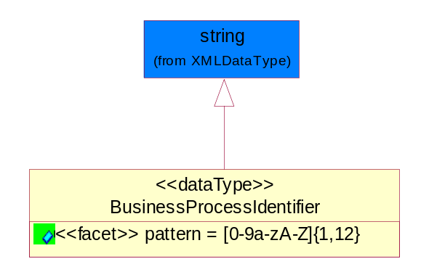
Figure 5-40 BusinessProcessIdentifier
Attribute | Type | Documentation
pattern |  | [0-9a-zA-Z]{1,12}

BusinessServiceInformation
The object allows the specification of the business service utilized within the partner company. This may or may not be the same as the information sent by the RNIF.
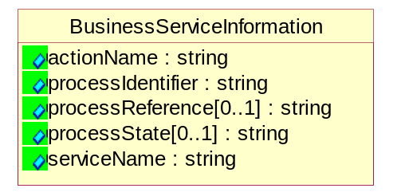
Figure 5-41 BusinessServiceInformation
Attribute | Type | Documentation
actionName | string | The name of Action. For RosettaNet usually any of Request/Confirm/Notify/Query/Response.
processIdentifier | string | The name of the PIP e.g. Notify of Forecast Reply.
processReference[0..1] | string | The URN for the PIP that includes Cluster/Segment/Process pattern used to identify the interface process (such as PIP3A4)
processState[0..1] | string | The business process (or service) state of the sender of a document. When a service receives this document, the receiver may use the state as a precondition.
serviceName | string | The name of the Business Activity with the "Request/Confirm" part removed. E.g., for the Activity "Request Purchase Order"==> "Purchase Order".

ContractInformation
A block of information used to correlate a contract in an executing choreography.
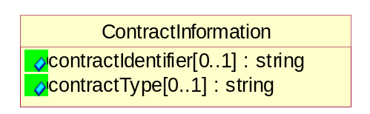
Figure 5-42 ContractInformation
Attribute | Type | Documentation
contractIdentifier[0..1] | string | Unique identification of a contract between the Sender and the Receiver
contractType[0..1] | string | The type of the contract: an attribute describing the type of the ContractIndentification. Valid values are URI, URN,ebXMLCPA, or other values defined by partners.

CorrelationInformation
A block of information used to correlate a requesting document to a responding document and to the contract in an executing choreography.
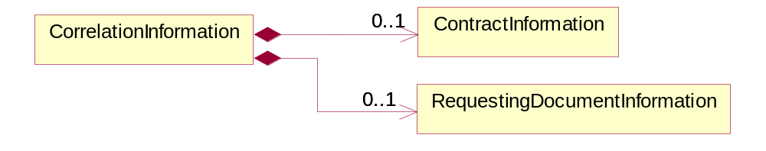
Figure 5-43 CorrelationInformation
Composition | Cardinality | Type | Documentation
ContractInformation | 0..1 | ContractInformation | A block of information used to correlate a contract in an executing choreography.
RequestingDocumentInformation | 0..1 | RequestingDocumentInformation | A block of information used to correlate a requesting document to a responding document in an executing choreography.

DocumentHeader
The object allows for the identification of the sender and receiver of the business document.
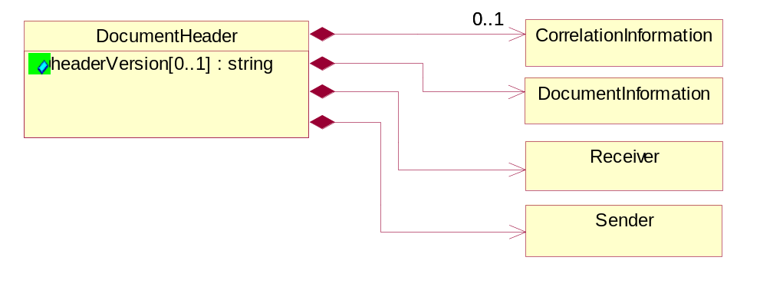
Figure 5-44 DocumentHeader
Attribute | Type | Documentation
headerVersion[0..1] | string | The UN/CEFACT version of the document header.

Composition | Cardinality | Type | Documentation
CorrelationInformation | 0..1 | CorrelationInformation | A block of information used to correlate a requesting document to a responding document and to the contract in an executing choreography.
DocumentInformation | 1 | DocumentInformation | The object specifies information to identify the business document, a summary of attachments, and information about the business document security.
Receiver | 1 | Receiver | The object allows the identification of the receiving party of the business message.
Sender | 1 | Sender | The object allows the identification of the initiating party of the business message.

DocumentIdentification
The object specifies all information necessary to identify the business document.
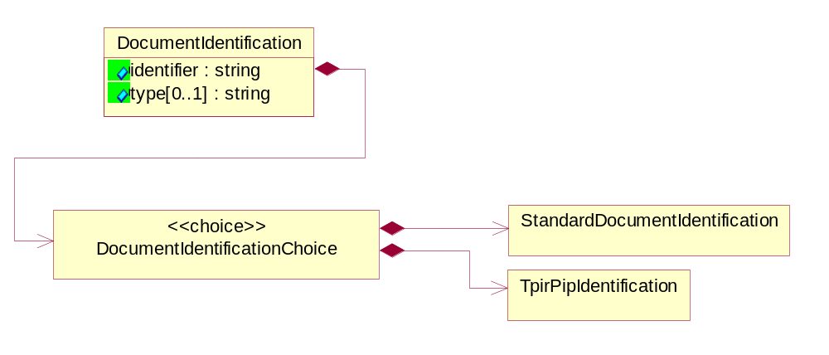
Figure 5-45 DocumentIdentification
Attribute | Type | Documentation
identifier | string | The unique identifier for the document being sent.
type[0..1] | string | Name of the Action Message

Composition | Cardinality | Type | Documentation
DocumentIdentificationChoice | 1 | DocumentIdentificationChoice

DocumentIdentificationChoice

Composition | Cardinality | Type | Documentation
StandardDocumentIdentification | 1 | StandardDocumentIdentification | The object specifies additional information necessary to identify the standard business document.
TpirPipIdentification | 1 | TpirPipIdentification | The object specifies all information necessary to uniquely identify a TPIR-PIP within a Registry or trading partner repository.

DocumentInformation
The object specifies information to identify the business document, a summary of attachments, and information about the business document security.
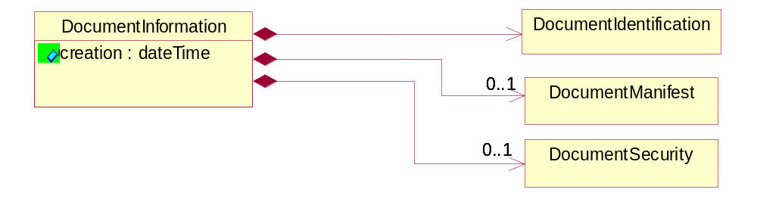
Figure 5-46 DocumentInformation
Attribute | Type | Documentation
creation | dateTime | The creation date and time of the specified Business Document (i.e. the Purchase Order date).

Composition | Cardinality | Type | Documentation
DocumentIdentification | 1 | DocumentIdentification | The object specifies all information necessary to identify the business document.
DocumentManifest | 0..1 | DocumentManifest | The block provides a brief summary of attachments and Service Content.
DocumentSecurity | 0..1 | DocumentSecurity | The object provides additional granularity in specifying business document security (this is in addition to the specified PIP security).

DocumentManifest
The block provides a brief summary of attachments and Service Content.
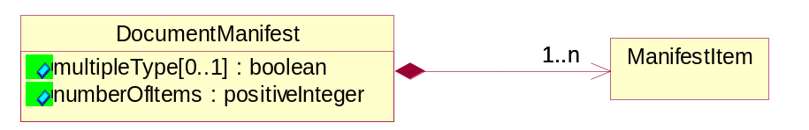
Figure 5-47 DocumentManifest
Attribute | Type | Documentation
multipleType[0..1] | boolean | Indicates whether the manifest contains documents of multiple types. True if yes, and False if no.
numberOfItems | positiveInteger | Total number of documents in the message. The physical count of the attachments in the payload plus the RosettaNet Business Message (for Service Content). The value of this field will be at least 1.

Composition | Cardinality | Type | Documentation
ManifestItem | 1..n | ManifestItem | The object provides details about the specific attachment(s).

DocumentSecurity
The object provides additional granularity in specifying business document security (this is in addition to the specified PIP security).
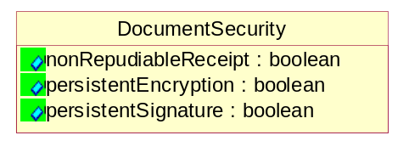
Figure 5-48 DocumentSecurity

Attribute | Type | Documentation
nonRepudiableReceipt | boolean | The value "true" will indicate that a signed acknowledgement for the business document is necessary.
persistentEncryption | boolean | The value "true" will indicate that the Business Document (including the header) needs to be encrypted when stored or transported.
persistentSignature | boolean | The value "true" will indicate that a signature is required to be stored with the document while stored or transported.

ManifestItem
The object provides details about the specific attachment(s).

Figure 5-49 ManifestItem
Attribute | Type | Documentation
description[0..1] | string | A description of the attachment.
length[0..1] | positiveInteger | The size of the attachment in bytes (i.e. 1 000 000 bytes)
universalResourceIdentifier | string | The generic set of all names/addresses that are short strings that refer to resources.

Composition | Cardinality | Type | Documentation
language | 0..1 | Language | For representation of Language name RosettaNet has adopted ISO 639-2; 1998. Refer to the following web page to get the latest version of the standard:  http://www.loc.gov/standards/iso639-2/iso639jac.html  If you need more information about the ISO standard please contact ISO for more details.
mimeTypeQualifier | 1 | MimeTypeQualifier | The MIME type as defined by IANA.  Please refer to http://www.iana.org/assignments/media-types/ for a list of types.

PipIdentifier
PIP Identification.[ i.e. PIP3A4]
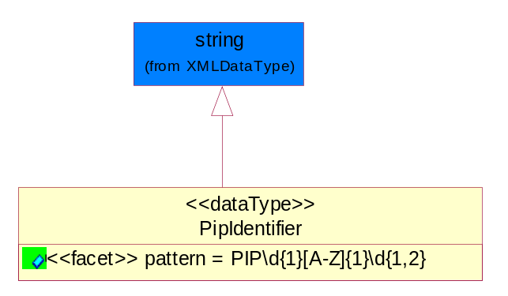
Figure 5-50 PipIdentifier
Attribute | Type | Documentation
pattern |  | PIP\d{1}[A-Z]{1}\d{1,2}

PipVersion
PIP version number (i.e. 02.02.00).
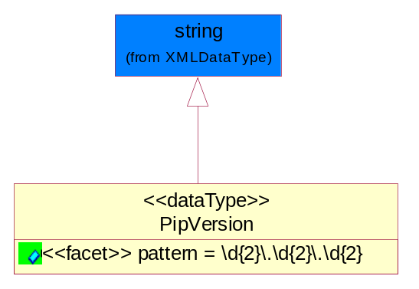
Figure 5-51 PipVersion
Attribute | Type | Documentation
pattern |  | \d{2}\.\d{2}\.\d{2}

Receiver
The object allows the identification of the receiving party of the business message.
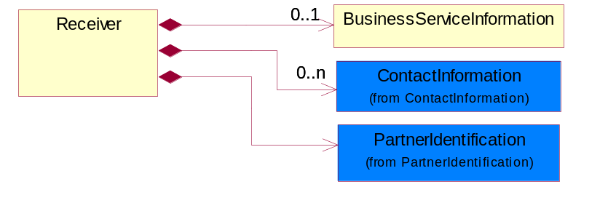
Figure 5-52 Receiver

Composition | Cardinality | Type | Documentation
BusinessServiceInformation | 0..1 | BusinessServiceInformation | The object allows the specification of the business service utilized within the partner company. This may or may not be the same as the information sent by the RNIF.
ContactInformation | 0..n | ContactInformation | The business document must allow for the identification of the name of the department, service or individual to be contacted regarding the context of the business document.
PartnerIdentification | 1 | PartnerIdentification | The business document must allow for the identity of one or more parties to the transaction.

RequestingDocumentInformation
A block of information used to correlate a requesting document to a responding document in an executing choreography.
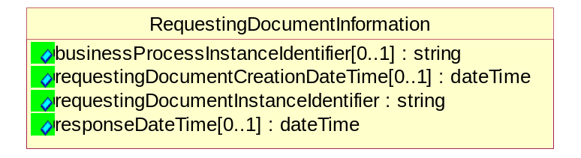
Figure 5-53 RequestingDocumentInformation
Attribute | Type | Documentation
businessProcessInstanceIdentifier[0..1] | string | The identifier for the public business process instance being sent that both the sender and receiver can identify.
requestingDocumentCreationDateTime[0..1] | dateTime | The date-time of the requesting business document.
requestingDocumentInstanceIdentifier | string | The Business Document identification number that identifies the requesting Business Document.
responseDateTime[0..1] | dateTime | The expected time to receive the response. This can not be greater than the PIP TimeToPerform.

Sender
The object allows the identification of the initiating party of the business message.
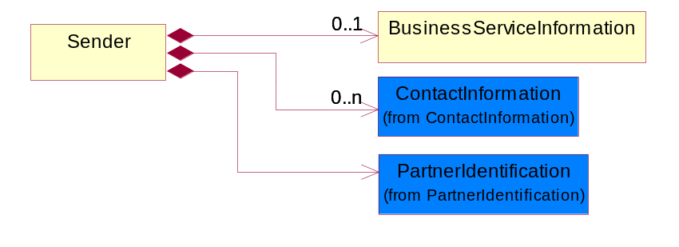
Figure 5-54 Sender
Composition | Cardinality | Type | Documentation
BusinessServiceInformation | 0..1 | BusinessServiceInformation | The object allows the specification of the business service utilized within the partner company. This may or may not be the same as the information sent by the RNIF.
ContactInformation | 0..n | ContactInformation | The business document must allow for the identification of the name of the department, service or individual to be contacted regarding the context of the business document.
PartnerIdentification | 1 | PartnerIdentification | The business document must allow for the identity of one or more parties to the transaction.

StandardDocumentIdentification
The object specifies additional information necessary to identify the standard business document.
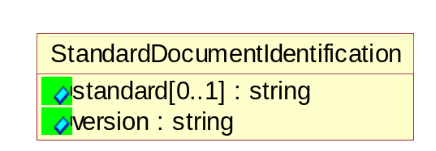
Figure 5-55 StandardDocumentIdentification
Attribute | Type | Documentation
standard[0..1] | string | Identifies the standard used to submit the business document. (e.g. RosettaNet).
version | string | PIP3A4v01.00

TpirPipIdentification
The object specifies all information necessary to uniquely identify a TPIR-PIP within a Registry or trading partner repository.

Figure 5-56 TpirPipIdentification
Attribute | Type | Documentation
partnerId | DUNSPlus4 | The Trading Partner Identification of MNC that is creating this TPIR PIP.
pipIdentifier | PipIdentifier | A TPIR PIP Identification [i.e., 3A4 ).
pipVersion | PipVersion | A TPIR PIP version number (i.e., 02.02.00)
tpirPipVersion | VersionIdentifier | A TPIR-PIP Version Number (i.e., major and minor version number as XX.XX).
tpirBusinessProcessIdentifier[0..1] | BusinessProcessIdentifier | A Business Process Identifier to uniquely define the TPIR-PIP 'role' within a Business Scenario at a company or MNC level. The identifier MUST be composed of alphanumeric characters only and its length MUST be between one and twelve characters.
uri[0..1] | anyURI | Describes the destination uri for the TPIR form.

Composition | Cardinality | Type | Documentation
fileType | 0..1 | TPIRFileType | Describes the file type of the TPIR form (PDF, XDP or XML).

VersionIdentifier
Version Number (i.e., major and minor version number as XX.XX).
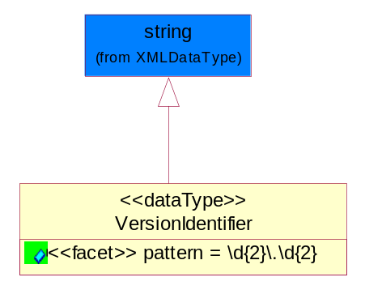
Figure 5-57 VersionIdentifier
Attribute | Type | Documentation
pattern |  | \d{2}\.\d{2}

CodeList

TPIRFileType
A code identifying the file type of TPIR form.

Name | Documentation
PDF | Portable Document Format.
XDP | XML Data Package.
XML | eXtensible Markup Language.

XML Data Type

anyURI
Represents a URI as defined by RFC 2396. An anyURI value can be absolute or relative, and may have an optional fragment identifier.

boolean
Represents Boolean values, which are either "true" or "false".

date
For the represents a calendar date.
The pattern for a date is CCYY-MM-DD where CC represents the century, YY the year, MM the month, and DD the day, with an optional time zone indicator as allowed for dateTime.

dateTime
Represents a specific instance of time.
The pattern for dateTime is CCYY-MM-DDThh:mm:ss where CC represents the century, YY the year, MM the month, and DD the day, preceded by an optional leading negative (-) character to indicate a negative number. If the negative character is omitted, positive (+) is assumed. The T is the date/time separator and hh, mm, and ss represent hour, minute, and second respectively. Additional digits can be used to increase the precision of fractional seconds if desired. For example, the format ss.ss... with any number of digits after the decimal point is supported. The fractional seconds part is optional.
This representation may be immediately followed by a "Z" to indicate Coordinated Universal Time (UTC) or to indicate the time zone. For example, the difference between the local time and Coordinated Universal Time, immediately followed by a sign, + or -, followed by the difference from UTC represented as hh:mm (minutes is required). If the time zone is included, both hours and minutes must be present.

decimal
A data type that contains decimal numbers scaled by a power of 10.

float
Represents single-precision 32-bit floating-point numbers.

integer
Represents a sequence of decimal digits with an optional leading sign (+ or -). This data type is derived from decimal.

positiveInteger
Represents an integer that is greater than zero. This data type is derived from nonNegativeInteger.

string
Represents character string.

