

Description of
Partner Interface Process® for 4B2

Validated 11.00.01

Specification Information
Name | Notify Of Shipment Receipt
Cluster | Inventory Management
Segment | Inventory Allocation
Publication Date | 22 July 2009
Version Identifier | V11.00

Table of Contents
1 Document Management 4
1.1 Legal Disclaimer 4
1.2 Copyright 4
1.3 Trademarks 4
1.4 Acknowledgments 4
1.5 Related Documents 4
1.6 Document Version History 4
1.7 Document Structure 5
2 Business Process 6
2.1 Business Process Definition 6
2.1.1 Executive Summary 6
2.1.2 Business Process Description 6
2.1.3 Business Process Context Diagram 7
2.2 PIP Scope Description 8
2.2.1 Business Process Scope Diagram 8
2.3 PIP Business Document 9
2.4 PIP Business Process Flow Diagram 9
2.5 PIP Start State 10
2.6 PIP End States 10
2.7 Partner Role Descriptions 11
2.8 Business Process Activity Controls 11
3 Network and Implementation Specification 12
3.1 Business Action and Business Signal Specifications 12
3.2 Business Transaction Dialog Specification 12
3.2.1 Message Exchange Controls 13
3.2.2 Communications Specification 13

List of Figures:
Figure 1: High-level Context Diagram 7
Figure 2: Business Process Scope Diagram 8
Figure 3: Activity Diagram of Notify Of Shipment Receipt 9
Figure 4: Sequence Diagram of Notify Of Shipment Receipt 12

List of Tables:
Table 1: PIP Business Document 9
Table 2: PIP Start State 10
Table 3: PIP End State 10
Table 4: PIP Failure State 10
Table 5: Partner Role Description 11
Table 6: Business Activity Description 11
Table 7: Business Activity Performance Control 11
Table 8: Network Component Specification 12
Table 9: Business Action – Business Document Mapping 12
Table 10: Message Exchange Control 13
Table 11: Dialog: Service-Service 13

Document Management

Legal Disclaimer
RosettaNet™, its members, officers, directors, employees, or agents shall not be liable for any injury, loss, damages, financial or otherwise, arising from, related to, or caused by the use of this document or the specifications herein, as well as associated guidelines and schemas. The use of said specifications shall constitute your express consent to the foregoing exculpation.

Copyright
©2009 RosettaNet. All rights reserved. No part of this publication may be reproduced, stored in a retrieval system, or transmitted, in any form or by any means, electronic, mechanical, photocopying, recording, or otherwise, without the prior written permission of the publisher. Printed in the United States of America.

Trademarks
RosettaNet, Partner Interface Process, PIP and the RosettaNet logo are trademarks or registered trademarks of "RosettaNet," a non-profit organization. All other product names and company logos mentioned herein are the trademarks of their respective owners. In the best effort, all terms mentioned in this document that are known to be trademarks or registered trademarks have been appropriately recognized in the first occurrence of the term.

Acknowledgments
This document has been prepared by RosettaNet (http://www.rosettanet.org/) from requirements gathered during the Milestone Program and in conformance with the methodology. Listed below are the legal entities that contributed to the design and development of this PIP.
BAX Global | Mitac International Corp.
Cisco System, Inc. | Sterling Commerce
Danzas | Menlo Worldwide
GridNote, Inc. | MIMOS Berhad.
GridNote Pte, Ltd. | Intel Corporation

Related Documents
- Associated PIP Message Schemas (included within the PIP Specification package only)
- Description of 4B2 Message
- Messages Structure
- XML instance of ebXML BPSS for PIP 4B2

Document Version History
Version | Date | Description
Validated 11.00.00 | 01 July 2008 | Validated Version - RosettaNet Schema to Market to Validation 2008
Validated 11.00.01 | 22 July 2009 | Internal Maintenance Release

Document Structure
A Partner Interface Process (PIP) Specification is comprised of the following two parts:
- Business Process. Captures the semantics of the business process and the flow of the message exchange between roles as they perform business activities.
- Network and Implementation Specification. Specifies the network protocol message formats and communications requirements between peer-protocols supported by network components in the RosettaNet Implementation Framework.

Business Process

Business Process Definition
This PIP enables a consignee to report the delivery, receipt and status of a shipment to interested parties.

Executive Summary
All businesses that sell products existing as physical goods, such as raw materials, components and finished goods, must deliver them from their manufacturing or storage location to the customer’s location. This physical movement of products may involve several parties. The first party to the shipment is usually the seller, which initiates the shipping of the products. The second party is usually the buyer, as the eventual consignee to which the products are shipped. Additionally, there may be third-party logistics (3PL) and even fourth-party logistics (4PL) providers, offering services to the shipper such as outsourced light manufacturing, product warehousing, routing and tracking, in addition to physically transporting the products.

Business Process Description
The “Description of Partner Interface Process for 4B2” Partner Interface Process™ (PIP) supports a process between two of these parties, in which a Consignee notifies a Shipment Information User that goods have been received. The Consignee is the organization receiving the shipment, such as an end-customer receiving products from a supplier, or a 3PL-operated warehouse receiving finished goods from a contract manufacturer. The Shipment Information User is an organization that is part of the supply chain involved in the shipment, which needs to know that the shipment has been received, such as a manufacturer, distributor, contract manufacturer or third-party logistics provider.
The Consignee initiates a transaction using this PIP after it has verified the validity of the shipment and its contents. It might, for example, compare the shipment to a previously placed purchase order or to a sales document that initiated the process. The Consignee may assume ownership of the received goods and, therefore, may be legally responsible if the goods are exported.
Should this transaction not complete successfully, the requesting partner executes PIP0A1, “Notification of Failure”.

Business Process Context Diagram
Shipment Receipt Notification

Consignee
Shipment Information User

Prepare Shipment Receipt Notification
Generate Shipment Receipt Notification
Process Shipment Receipt Notification
Send Notification

Figure 1: High-level Context Diagram

PIP Scope Description
This PIP enables a consignee to report the delivery, receipt and status of a shipment to interested parties.

Business Process Scope Diagram
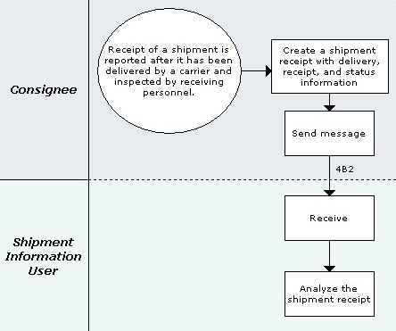
Figure 2: Business Process Scope Diagram

PIP Business Document
Business Document are generated and exchanged by roles performing activities in this PIP. Business Document is listed and defined in Table 1.
Table 1: PIP Business Document
Business Document | Description
Shipment Receipt Notification | Communicates the status of received product within a shipment. Contains product-level detail. Used when exceptions exist, or when the receiving process was successful. When exceptions exist, the shipment receipt notification indicates the reason(s). Examples of reasons: received without exception, short shipped, overage, wrong material, expired dates, wrong quantity, internal change, and defective.

PIP Business Process Flow Diagram
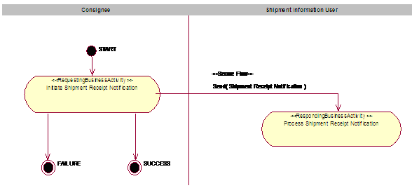
Figure 3: Activity Diagram of Notify Of Shipment Receipt

PIP Start State
The start state is comprised of the following conditions:
Table 2: PIP Start State
 | Approved | Exist |  | Valid | Non-Repudiated | Retry Count | Authorized
 | Approved | Party | In Backend System
TPA |  |  | 
Sending Partner |  |  |  | 
Receiving Partner |  | 
Business Document |  |  |  |  |  |  | 

PIP End States
The end state is comprised of the following conditions:
Table 3: PIP End State
 | Approved | Exist |  | Valid | Non-Repudiated | Retry Count | Authorized
 | Approved | Party | In Backend system
Acknowledgment of Receipt |  |  |  |  | 
Receiving Partner |  |  |  |  |  |  | 

The PIP failure state is comprised of one or more of the following conditions:
Table 4: PIP Failure State
 | NO | Exceeded
Success | 
Retry Count |  | 

Partner Role Descriptions
Table 5 describes the partner roles in this PIP.
Table 5: Partner Role Description
Role Name | Role Description
Consignee | The receiver of the shipment.
Shipment Information User | The party who receives shipment status information.

Business Process Activity Controls
Table 6 describes the interaction between roles performing business activity in this PIP.
Table 6: Business Activity Description
Role  Name | Activity Name | Activity Description
Consignee | Initiate Shipment Receipt Notification | A Consignee notifies a Shipment Information User of a shipment's receipt and status.

Table 7 details the security, audit and process controls relating to activity performed in the PIP.
Table 7: Business Activity Performance Control
Role  Name | Activity  Name | Acknowledgment  of Receipt |  | Time to Perform | Retry Count | Is Authorization Required? | Non-Repudiation of Origin and Content?
Role  Name | Activity  Name | Non-Repudiation Required? | Time to Acknowledge
Consignee | Initiate Shipment Receipt Notification | Y | 2 hrs | N/A | 3 | N | Y

Network and Implementation Specification
Each network component maps into a role of the PIP model. Table 8 specifies the mapping between roles and network components.
Table 8: Network Component Specification
Network Component | Classification | Maps to Role in Business Process
Consignee Service | Business Service | Consignee
Shipment Information User Service | Business Service | Shipment Information User

Business Action and Business Signal Specifications
Each business action maps to a Business Document of the PIP model. Table 9 specifies the mapping between Business Documents and business actions.
Table 9: Business Action – Business Document Mapping
Business Action | Business Document | Document Function
Shipment Receipt Notification Action | Shipment Receipt Notification | Request

Business Transaction Dialog Specification
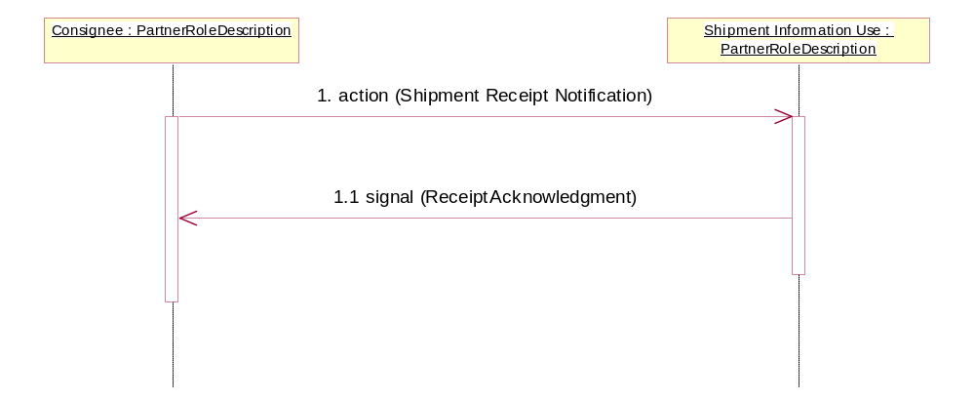
Figure 4: Sequence Diagram of Notify Of Shipment Receipt

Message Exchange Controls
Table 10: Message Exchange Control
# | Name |  | Time to Acknowledge Receipt Signal |  | Time to Respond to Action |  | Included in Time to Perform |  | Is Authorization Required? |  | Is Non-Repudiation Required? |  | Is Secure Transport Required?
1. |  | Shipment Receipt Notification Action |  | 2 hrs |  | N/A |  | N/A |  | N |  | Y |  | Y
1.1. |  | Receipt Acknowledgment |  | N/A |  | N/A |  | N/A |  | N |  | Y |  | Y

Communications Specification
Table 11: Dialog: Service-Service
# | Business Message | Digital Signature Required? | SSL Required?
1. | Shipment Receipt Notification | Y | Y
1.1. | Receipt Acknowledgment | Y | Y

