

Description of
Partner Interface Process® for 4B3

Validated 11.00.01

Specification Information
Name | Notify Of Consumption
Cluster | Inventory Management
Segment | Inventory Allocation
Publication Date | 22 July 2009
Version Identifier | V11.00

Table of Contents
1 Document Management 4
1.1 Legal Disclaimer 4
1.2 Copyright 4
1.3 Trademarks 4
1.4 Acknowledgments 4
1.5 Related Documents 4
1.6 Document Version History 4
1.7 Document Structure 4
2 Business Process 5
2.1 Business Process Definition 5
2.1.1 Business Process Context Diagram 6
2.2 PIP Scope Description 6
2.3 PIP Business Document 6
2.4 PIP Business Process Flow Diagram 7
2.5 PIP Start State 7
2.6 PIP End States 8
2.7 Partner Role Descriptions 8
2.8 Business Process Activity Controls 8
3 Network and Implementation Specification 10
3.1 Business Action and Business Signal Specifications 10
3.2 Business Transaction Dialog Specification 10
3.2.1 Message Exchange Controls 11
3.2.2 Communications Specification 11

List of Figures:
Figure 1: High-level Context Diagram 6
Figure 2: Activity Diagram of Notify Of Consumption 7
Figure 3: Sequence Diagram of Notify Of Consumption 10

List of Tables:
Table 1: PIP Business Document 6
Table 2: PIP Start State 7
Table 3: PIP End State 8
Table 4: PIP Failure State 8
Table 5: Partner Role Description 8
Table 6: Business Activity Description 8
Table 7: Business Activity Performance Control 9
Table 8: Network Component Specification 10
Table 9: Business Action – Business Document Mapping 10
Table 10: Message Exchange Control 11
Table 11: Dialog: Service-Service 11

Document Management

Legal Disclaimer
RosettaNet™, its members, officers, directors, employees, or agents shall not be liable for any injury, loss, damages, financial or otherwise, arising from, related to, or caused by the use of this document or the specifications herein, as well as associated guidelines and schemas. The use of said specifications shall constitute your express consent to the foregoing exculpation.

Copyright
©2009 RosettaNet. All rights reserved. No part of this publication may be reproduced, stored in a retrieval system, or transmitted, in any form or by any means, electronic, mechanical, photocopying, recording, or otherwise, without the prior written permission of the publisher. Printed in the United States of America.

Trademarks
RosettaNet, Partner Interface Process, PIP and the RosettaNet logo are trademarks or registered trademarks of "RosettaNet," a non-profit organization. All other product names and company logos mentioned herein are the trademarks of their respective owners. In the best effort, all terms mentioned in this document that are known to be trademarks or registered trademarks have been appropriately recognized in the first occurrence of the term.

Acknowledgments
This document has been prepared by RosettaNet (http://www.rosettanet.org/) from requirements gathered during the Milestone Program and in conformance with the methodology.

Related Documents
- Associated PIP Message Schemas (included within the PIP Specification package only)
- Description of 4B3 Message
- Messages Structure
- XML instance of ebXML BPSS for PIP 4B3

Document Version History
Version | Date | Description
Validated 11.00.00 | 15 July 2008 | Validated Version : RosettaNet Schema to Market to Validation 2008
Validated 11.00.01 | 22 July 2009 | Internal Maintenance Release

Document Structure
A Partner Interface Process (PIP) Specification is comprised of the following two parts:
- Business Process. Captures the semantics of the business process and the flow of the message exchange between roles as they perform business activities.
- Network and Implementation Specification. Specifies the network protocol message formats and communications requirements between peer-protocols supported by network components in the RosettaNet Implementation Framework.

Business Process

Business Process Definition
The "Notify Of Consumption" Partner Interface Process supports consumption notification within a consignment inventory management process where
-The supplier ships product to a consigned warehouse location based upon receipt of demand forecast and the subsequent calculation of replenishment requirements. RosettaNet PIP 4A3 Notify Of Threshold Release Forecast supports this process.
-The consignment warehouse manager ships product to the delivery location upon receipt of a Notify of Material Release. RosettaNet PIP 4D1 supports this process. The consignment warehouse manager may be the supplier, a 3rd party logistics provider, or even the customer and is responsible for managing inventory shipments prior to receipt of material releases.
-Upon consumption, a Consumption Notification is sent to the supplier identifying consumed product quantities. The actual point of consumption is agreed upon in the TPA and is most often shipment to the customer, receipt by the customer, or usage by the customer. The party sending the consumption notification is either the consignment warehouse manager or the customer depending on the point of consumption. RosettaNet PIP 4B3 supports this process.
-Supplier invoicing [and remittance] activities occur upon receipt of the consumption notification from the consignment warehouse manager. RosettaNet PIP 3C3 supports this process.
-Or customer Self-billings invoicing can vehicle this consumption simultaneously with financial reference data that will be used when payment is made. RosettaNet PIP 3C7 will support this process.
- Remittance will occur as per payment-terms; RosettaNet PIP 3C6 supports this process.

Business Process Context Diagram
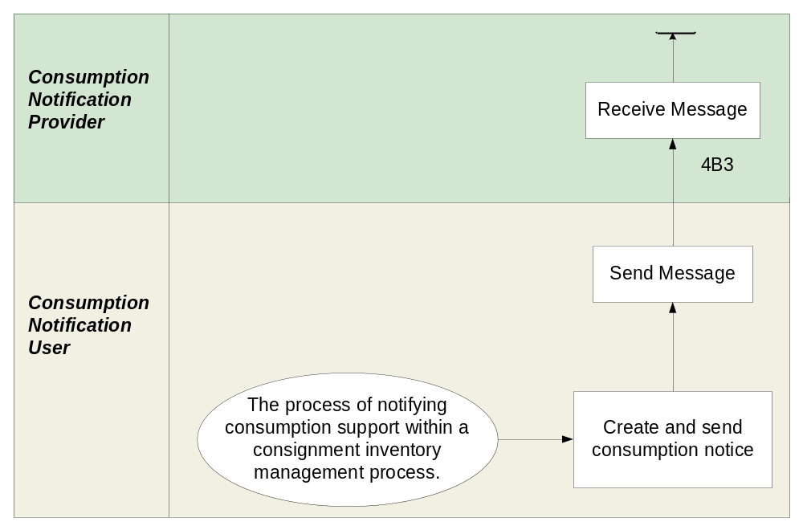
Figure 1: High-level Context Diagram

PIP Scope Description
The purpose of this PIP is to communicate material consumption to the supplier allowing the supplier to trigger invoicing for the consumed material.

PIP Business Document
Business Document are generated and exchanged by roles performing activities in this PIP. Business Document is listed and defined in Table 1.
Table 1: PIP Business Document
Business Document | Description
Consumption Notification | The Consumption Notification contains consumption information includes product identification, quantities; consumption dates, and may include payment reference number and purchase order number.

PIP Business Process Flow Diagram
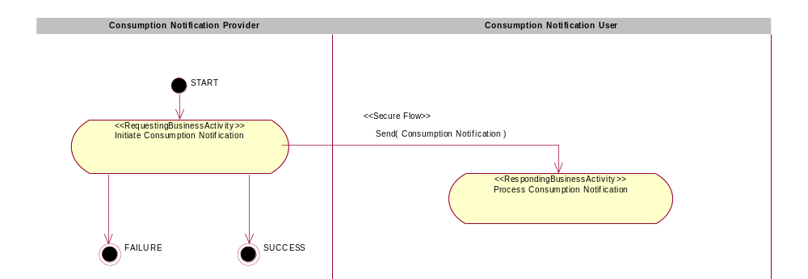

Figure 2: Activity Diagram of Notify Of Consumption

PIP Start State
The start state is comprised of the following conditions:
Table 2: PIP Start State
 | Approved | Exist |  | Valid | Non-Repudiated | Retry Count | Authorized
 | Approved | Party | In Backend System
TPA |  |  | 
Sending Partner |  |  |  | 
Receiving Partner |  | 
Business Document |  |  |  |  |  |  | 

PIP End States
The end state is comprised of the following conditions:
Table 3: PIP End State
 | Approved | Exist |  | Valid | Non-Repudiated | Retry Count | Authorized
 | Approved | Party | In Backend system
Acknowledgment of Receipt |  |  |  |  | 
Receiving Partner |  |  |  |  |  |  | 

The PIP failure state is comprised of one or more of the following conditions:
Table 4: PIP Failure State
 | NO | Exceeded
Success | 
Retry Count |  | 

Partner Role Descriptions
Table 5 describes the partner roles in this PIP.
Table 5: Partner Role Description
Role Name | Role Description
Consumption Notification Provider | The party that creates and sends consumption information to Supplier.
Consumption Notification User | The party that requires consumption information from the customer to manage inventory

Business Process Activity Controls
Table 6 describes the interaction between roles performing business activity in this PIP.
Table 6: Business Activity Description
Role  Name | Activity Name | Activity Description
Consumption Notification Provider | Initiate Consumption Notification | The Consumption Information Provider has prepared the Consumption Notification and sends it to the Consumption Information User.

Table 7 details the security, audit and process controls relating to activity performed in the PIP.
Table 7: Business Activity Performance Control
Role  Name | Activity  Name | Acknowledgment  of Receipt |  | Time to Perform | Retry Count | Is Authorization Required? | Non-Repudiation of Origin and Content?
Role  Name | Activity  Name | Non-Repudiation Required? | Time to Acknowledge
Consumption Notification Provider | Initiate Consumption Notification | Y | 2 hrs | N/A | 3 | Y | Y

Network and Implementation Specification
Each network component maps into a role of the PIP model. Table 8 specifies the mapping between roles and network components.
Table 8: Network Component Specification
Network Component | Classification | Maps to Role in Business Process
Consumption Notification Provider Service | Business Service | Consumption Notification Provider
Consumption Notification User Service | Business Service | Consumption Notification User

Business Action and Business Signal Specifications
Each business action maps to a Business Document of the PIP model. Table 9 specifies the mapping between Business Documents and business actions.
Table 9: Business Action – Business Document Mapping
Business Action | Business Document | Document Function
Consumption Notification Action | Consumption Notification | Request

Business Transaction Dialog Specification
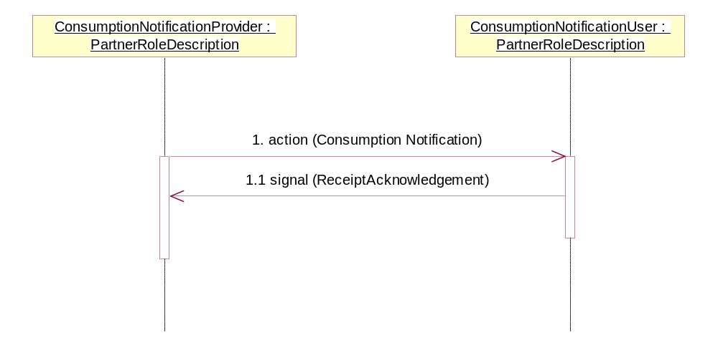
Figure 3: Sequence Diagram of Notify Of Consumption

Message Exchange Controls
Table 10: Message Exchange Control
# | Name |  | Time to Acknowledge Receipt Signal |  | Time to Respond to Action |  | Included in Time to Perform |  | Is Authorization Required? |  | Is Non-Repudiation Required? |  | Is Secure Transport Required?
1. |  | Consumption Notification Action |  | 2 hrs |  | N/A |  | N/A |  | Y |  | Y |  | Y
1.1. |  | Receipt Acknowledgment |  | N/A |  | N/A |  | N/A |  | Y |  | Y |  | Y

Communications Specification
Table 11: Dialog: Service-Service
# | Business Message | Digital Signature Required? | SSL Required?
1. | Consumption Notification | Y | Y
1.1. | Receipt Acknowledgment | Y | Y

