

Description of
Partner Interface Process® for 4C1

Validated 11.00.00

Specification Information
Name | Distribute Inventory Report
Cluster | Inventory Management
Segment | Inventory Reporting
Publication Date | 07 July 2008
Version Identifier | V11.00

Table of Contents
1 Document Management 4
1.1 Legal Disclaimer 4
1.2 Copyright 4
1.3 Trademarks 4
1.4 Acknowledgments 4
1.5 Related Documents 4
1.6 Document Version History 4
1.7 Document Structure 5
2 Business Process 6
2.1 Business Process Definition 6
2.1.1 Executive Summary 6
2.1.2 Business Process Description 6
2.1.3 Business Process Context Diagram 7
2.2 PIP Scope Description 7
2.2.1 Business Process Scope Diagram 8
2.3 PIP Business Document 9
2.4 PIP Business Process Flow Diagram 9
2.5 PIP Start State 9
2.6 PIP End States 10
2.7 Partner Role Descriptions 11
2.8 Business Process Activity Controls 11
3 Network and Implementation Specification 12
3.1 Business Action and Business Signal Specifications 12
3.2 Business Transaction Dialog Specification 12
3.2.1 Message Exchange Controls 13
3.2.2 Communications Specification 13

List of Figures:
Figure 1: High-level Context Diagram 7
Figure 2: Business Process Scope Diagram 8
Figure 3: Activity Diagram of Distribute Inventory Report 9
Figure 4: Sequence Diagram of Distribute Inventory Report 12

List of Tables:
Table 1: PIP Business Document 9
Table 2: PIP Start State 9
Table 3: PIP End State 10
Table 4: PIP Failure State 10
Table 5: Partner Role Description 11
Table 6: Business Activity Description 11
Table 7: Business Activity Performance Control 11
Table 8: Network Component Specification 12
Table 9: Business Action – Business Document Mapping 12
Table 10: Message Exchange Control 13
Table 11: Dialog: Service-Service 13

Document Management

Legal Disclaimer
RosettaNet™, its members, officers, directors, employees, or agents shall not be liable for any injury, loss, damages, financial or otherwise, arising from, related to, or caused by the use of this document or the specifications herein, as well as associated guidelines and schemas. The use of said specifications shall constitute your express consent to the foregoing exculpation.

Copyright
©2008 RosettaNet. All rights reserved. No part of this publication may be reproduced, stored in a retrieval system, or transmitted, in any form or by any means, electronic, mechanical, photocopying, recording, or otherwise, without the prior written permission of the publisher. Printed in the United States of America.

Trademarks
RosettaNet, Partner Interface Process, PIP and the RosettaNet logo are trademarks or registered trademarks of "RosettaNet," a non-profit organization. All other product names and company logos mentioned herein are the trademarks of their respective owners. In the best effort, all terms mentioned in this document that are known to be trademarks or registered trademarks have been appropriately recognized in the first occurrence of the term.

Acknowledgments
This document has been prepared by RosettaNet (http://www.rosettanet.org/) from requirements gathered during the Milestone Program and in conformance with the methodology. Listed below are the legal entities that contributed to the design and development of this PIP.
RosettaNet did not capture the name of companies or individuals which participated during the development of this PIP.

Related Documents
- Associated PIP Message Schemas (included within the PIP Specification package only)
- Description of 4C1 Message
- Messages Structure
- XML instance of ebXML BPSS for PIP 4C1

Document Version History
Version | Date | Description
Validated 11.00.00 | 07 July 2008 | Validated Version: RosettaNet Schema to Market to Validation 2008

Document Structure
A Partner Interface Process (PIP) Specification is comprised of the following two parts:
- Business Process. Captures the semantics of the business process and the flow of the message exchange between roles as they perform business activities.
- Network and Implementation Specification. Specifies the network protocol message formats and communications requirements between peer-protocols supported by network components in the RosettaNet Implementation Framework.

Business Process

Business Process Definition
The purpose of this PIP is to send an Inventory Information Provider’s inventory report to an Inventory Information User.

Executive Summary
Distribute Inventory Report standardizes the inventory report distribution process by defining a common vocabulary for transmission of inventory report information. The value propositions of this initiative are:
- Standards based inventory report information increases trading partners (inventory information provider and inventory information user) business efficiency.
- Standards based inventory report information decreases IT support resources and overhead required to assure data integrity.
- Standards based inventory report information enables on demand problem resolution between the trading partners.
- Standards based inventory report information enables rapid new partner setup in B2B environment.
- Standards based inventory report information can be used as a quantifiable metric for customer satisfaction.

Business Process Description
The "Distribute Inventory Report" Partner Interface Process™ (PIP) supports a process in which an Inventory Information Provider reports the status of the inventory owned or held by the Inventory Information Provider to an Inventory Information User. The inventory report can include any product, active or inactive, held in inventory.
The Inventory Information User may use PIP4C3, "Inventory Error Notification," to inform an Inventory Information Provider of errors in an inventory report.

Business Process Context Diagram
Inventory Report Distribution

Inventory Information Provider
Inventory Information User

Prepare Inventory Report
Generate Inventory Report
Process Inventory Report
Send Distribution

Figure 1: High-level Context Diagram

PIP Scope Description
This PIP enables an inventory information provider to send an inventory report to inventory information user.

Business Process Scope Diagram
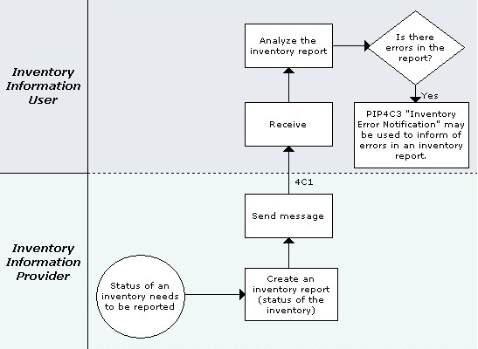
Figure 2: Business Process Scope Diagram

PIP Business Document
Business Document are generated and exchanged by roles performing activities in this PIP. Business Document is listed and defined in Table 1.
Table 1: PIP Business Document
Business Document | Description
Inventory Report Distribution | Contains inventory status and quantity data for a given reporting period. The inventory status of a product is reported in various categories, e.g., quantity at a location, quantity owned, quantity in transit between locations and details of the raw materials.

PIP Business Process Flow Diagram
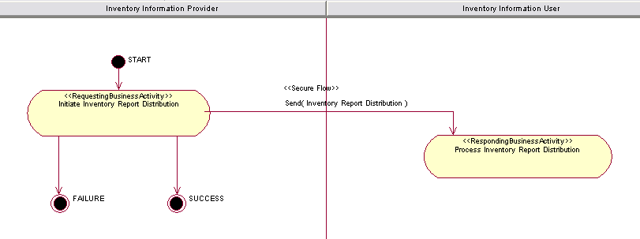
Figure 3: Activity Diagram of Distribute Inventory Report

PIP Start State
The start state is comprised of the following conditions:
Table 2: PIP Start State
 | Approved | Exist |  | Valid | Non-Repudiated | Retry Count | Authorized
 | Approved | Party | In Backend System
TPA |  |  | 
Sending Partner |  |  |  | 
Receiving Partner |  | 
Business Document |  |  |  | 

PIP End States
The end state is comprised of the following conditions:
Table 3: PIP End State
 | Approved | Exist |  | Valid | Non-Repudiated | Retry Count | Authorized
 | Approved | Party | In Backend system
Acknowledgment of Receipt |  |  |  | 
Receiving Partner |  |  |  |  |  |  | 

The PIP failure state is comprised of one or more of the following conditions:
Table 4: PIP Failure State
 | NO | Exceeded
Success | 
Retry Count |  | 

Partner Role Descriptions
Table 5 describes the partner roles in this PIP.
Table 5: Partner Role Description
Role Name | Role Description
Inventory Information Provider | An organization that owns or holds inventory and provides information about this inventory to partners in the supply chain. This may be a distributor, contract manufacturer, supplier or OEM reporting inventory that they hold and/or own.
Inventory Information User | An employee or organization that uses information about inventory.

Business Process Activity Controls
Table 6 describes the interaction between roles performing business activity in this PIP.
Table 6: Business Activity Description
Role  Name | Activity Name | Activity Description
Inventory Information Provider | Initiate Inventory Report Distribution | An Inventory Information Provider sends an inventory Report Notification business document to an Inventory Information User.

Table 7 details the security, audit and process controls relating to activity performed in the PIP.
Table 7: Business Activity Performance Control
Role  Name | Activity  Name | Acknowledgment  of Receipt |  | Time to Perform | Retry Count | Is Authorization Required? | Non-Repudiation of Origin and Content?
Role  Name | Activity  Name | Non-Repudiation Required? | Time to Acknowledge
Inventory Information Provider | Initiate Inventory Report Distribution | N | 2 hrs | N/A | 3 | N | N

Network and Implementation Specification
Each network component maps into a role of the PIP model. Table 8 specifies the mapping between roles and network components.
Table 8: Network Component Specification
Network Component | Classification | Maps to Role in Business Process
Inventory Information Provider Service | Business Service | Inventory Information Provider
Inventory Information User Service | Business Service | Inventory Information User

Business Action and Business Signal Specifications
Each business action maps to a Business Document of the PIP model. Table 9 specifies the mapping between Business Documents and business actions.
Table 9: Business Action – Business Document Mapping
Business Action | Business Document | Document Function
Inventory Report Distribution Action | Inventory Report Distribution | Request

Business Transaction Dialog Specification
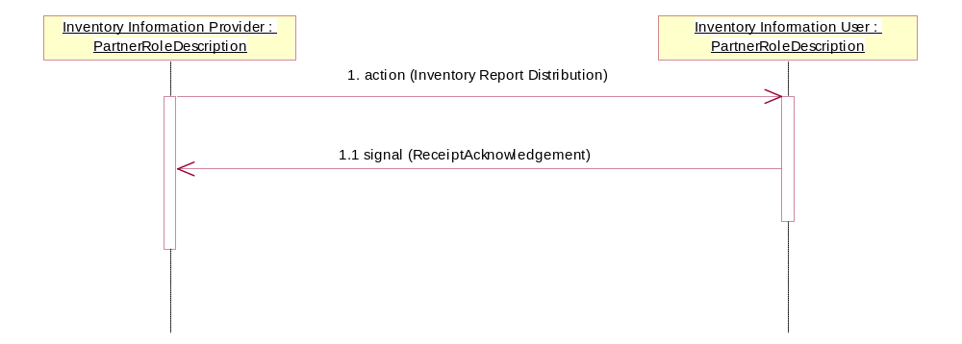
Figure 4: Sequence Diagram of Distribute Inventory Report

Message Exchange Controls
Table 10: Message Exchange Control
# | Name |  | Time to Acknowledge Receipt Signal |  | Time to Respond to Action |  | Included in Time to Perform |  | Is Authorization Required? |  | Is Non-Repudiation Required? |  | Is Secure Transport Required?
1. |  | Inventory Report Distribution Action |  | 2 hrs |  | N/A |  | N/A |  | N |  | N |  | Y
1.1. |  | Receipt Acknowledgment |  | N/A |  | N/A |  | N/A |  | N |  | N |  | Y

Communications Specification
Table 11: Dialog: Service-Service
# | Business Message | Digital Signature Required? | SSL Required?
1. | Inventory Report Distribution | N | Y
1.1. | Receipt Acknowledgment | N | Y

