

Description of 4D1 Message

PIP® 4D1
Validated 11.00.00

Specification Information
Name | Description Of 4D1 Message
PIP | Notify Of Material Release
Cluster | Inventory Management
Segment | Inventory Replenishment
Publication Date | 08 July 2008
Version Identifier | V11.00

Table of Content

1. Document Management 6
1.1 Legal Disclaimer 6
1.2 Copyright 6
1.3 Trademarks 6
1.4 Related Documents 6
1.5 Document Version History 6
1.6 Document Purpose 6
2. Interchange Model 7
2.1 MaterialReleaseNotification 7
2.1.1 Interchange Diagram 7
2.1.2 Dependency Diagram 7
2.1.3 JustInTimeSchedule 8
2.1.4 MaterialRelease 8
2.1.5 MaterialReleaseNotification 9
2.1.6 PartnerProductRelease 9
2.1.7 ProductReleaseSchedule 10
2.1.8 ReleaseProduct 11
3. Domain Model 13
3.1 Procurement 13
3.1.1 Procurement 13
3.1.1.1 Dependency Diagram 13
3.1.1.2 OrderShippingInformation 13
3.1.1.3 SpecialHandlingInstruction 14
3.1.2 CodeList 15
3.1.2.1 TransportEvent 15
3.1.2.2 ShipmentTerms 15
3.1.2.3 SpecialFulfillmentRequest 16
3.1.2.4 SpecialHandling 17
3.2 Logistics 26
3.2.1 Logistics 26
3.2.1.1 Dependency Diagram 26
3.2.1.2 ManufacturerProfile 26
3.3 Shared 27
3.3.1 Shared 27
3.3.1.1 Dependency Diagram 27
3.3.1.2 CarrierInformation 27
3.3.1.3 ProductQuantity 28
3.3.1.4 SCAC 28
3.3.2 CodeList 29
3.3.2.1 FreeOnBoard 29
3.3.2.2 ShippingServiceLevel 29
4. Universal Structure 31
4.1 ContactInformation 31
4.1.1 ContactInformation 31
4.2 DataType 31
4.2.1 Contact 31
4.2.2 DUNS 32
4.2.3 DUNSPlus4 32
4.2.4 GLN 33
4.2.5 GTIN 33
4.3 Document 34
4.3.1 BusinessDocumentReference 34
4.4 Locations 34
4.4.1 AlternativeIdentifier 34
4.4.2 Location 35
4.4.3 LocationChoice 35
4.4.4 PhysicalAddress 36
4.5 MonetaryExpression 37
4.5.1 FinancialAmount 37
4.6 PartnerIdentification 38
4.6.1 FullPartner 38
4.6.2 IntermittentPartner 38
4.6.3 KnownPartner 39
4.6.4 KnownPartnerContact 39
4.6.5 NewPartner 40
4.6.6 PartnerDescription 40
4.6.7 PartnerDescriptionChoice 41
4.6.8 PartnerIdentification 42
4.6.9 PartnerIdentificationChoice 42
4.6.10 SpecifiedFullPartner 43
4.6.11 SpecifiedIntermittentPartner 44
4.6.12 SpecifiedKnownPartner 44
4.6.13 SpecifiedNewPartner 45
4.7 ProductIdentification 46
4.7.1 ProductIdentification 46
4.7.2 ProductIdentificationChoice 46
4.8 CodeList 47
4.8.1 Country 47
4.8.2 CountrySubdivision 47
4.8.3 Currency 47
4.8.4 Language 47
4.8.5 DocumentType 47
4.8.6 MimeTypeQualifier 49
4.8.7 UnitOfMeasure 60
4.8.8 ProcessRoleIdentifier 67
5. System Structure 70
5.1 BusinessProcessIdentifier 70
5.2 BusinessServiceInformation 70
5.3 ContractInformation 71
5.4 CorrelationInformation 71
5.5 DocumentHeader 72
5.6 DocumentIdentification 73
5.7 DocumentIdentificationChoice 73
5.8 DocumentInformation 74
5.9 DocumentManifest 74
5.10 DocumentSecurity 75
5.11 ManifestItem 75
5.12 PipIdentifier 76
5.13 PipVersion 77
5.14 Receiver 77
5.15 RequestingDocumentInformation 78
5.16 Sender 78
5.17 StandardDocumentIdentification 79
5.18 TpirPipIdentification 79
5.19 VersionIdentifier 80
5.20 CodeList 80
5.20.1 TPIRFileType 80
6. XML Data Type 81
6.1 anyURI 81
6.2 boolean 81
6.3 date 81
6.4 dateTime 81
6.5 float 81
6.6 positiveInteger 81
6.7 string 81
6.8 time 81

Table of Figures

Figure ‎2-1 Interchange 7
Figure ‎2-2 Dependency 7
Figure ‎2-3 JustInTimeSchedule 8
Figure ‎2-4 MaterialRelease 8
Figure ‎2-5 MaterialReleaseNotification 9
Figure ‎2-6 PartnerProductRelease 9
Figure ‎2-7 ProductReleaseSchedule 10
Figure ‎2-8 ReleaseProduct 11
Figure ‎3-1 Dependency 13
Figure ‎3-2 OrderShippingInformation 13
Figure ‎3-3 SpecialHandlingInstruction 14
Figure ‎3-4 Dependency 26
Figure ‎3-5 ManufacturerProfile 26
Figure ‎3-6 Dependency 27
Figure ‎3-7 CarrierInformation 27
Figure ‎3-8 ProductQuantity 28
Figure ‎3-9 SCAC 28
Figure ‎4-1 ContactInformation 31
Figure ‎4-2 Contact 31
Figure ‎4-3 DUNS 32
Figure ‎4-4 DUNSPlus4 32
Figure ‎4-5 GLN 33
Figure ‎4-6 GTIN 33
Figure ‎4-7 BusinessDocumentReference 34
Figure ‎4-8 AlternativeIdentifier 34
Figure ‎4-9 Location 35
Figure ‎4-10 PhysicalAddress 36
Figure ‎4-11 FinancialAmount 37
Figure ‎4-12 FullPartner 38
Figure ‎4-13 IntermittentPartner 38
Figure ‎4-14 KnownPartner 39
Figure ‎4-15 KnownPartnerContact 39
Figure ‎4-16 NewPartner 40
Figure ‎4-17 PartnerDescription 40
Figure ‎4-18 PartnerIdentification 42
Figure ‎4-19 SpecifiedFullPartner 43
Figure ‎4-20 SpecifiedIntermittentPartner 44
Figure ‎4-21 SpecifiedKnownPartner 44
Figure ‎4-22 SpecifiedNewPartner 45
Figure ‎4-23 ProductIdentification 46
Figure ‎5-1 BusinessProcessIdentifier 70
Figure ‎5-2 BusinessServiceInformation 70
Figure ‎5-3 ContractInformation 71
Figure ‎5-4 CorrelationInformation 71
Figure ‎5-5 DocumentHeader 72
Figure ‎5-6 DocumentIdentification 73
Figure ‎5-7 DocumentInformation 74
Figure ‎5-8 DocumentManifest 74
Figure ‎5-9 DocumentSecurity 75
Figure ‎5-10 ManifestItem 75
Figure ‎5-11 PipIdentifier 76
Figure ‎5-12 PipVersion 77
Figure ‎5-13 Receiver 77
Figure ‎5-14 RequestingDocumentInformation 78
Figure ‎5-15 Sender 78
Figure ‎5-16 StandardDocumentIdentification 79
Figure ‎5-17 TpirPipIdentification 79
Figure ‎5-18 VersionIdentifier 80

Document Management

Legal Disclaimer
RosettaNet, its members, officers, directors, employees, or agents shall not be liable for any injury, loss, damages, financial or otherwise, arising from, related to, or caused by the use of this document or the specifications herein, as well as associated guidelines and schemas. The use of said specifications shall constitute your express consent to the foregoing exculpation.

Copyright
©2008 RosettaNet. All rights reserved. No part of this publication may be reproduced, stored in a retrieval system, or transmitted, in any form or by any means, electronic, mechanical, photocopying, recording, or otherwise, without the inclusion of this copyright notice. Any derivative works must cite the copyright notice. Any public redistribution or sale of this publication or derivative works requires prior written permission of the publisher.

Trademarks
RosettaNet, Partner Interface Process, PIP and the RosettaNet logo are trademarks or registered trademarks of "RosettaNet," a non-profit organization. All other product names and company logos mentioned herein are the trademarks of their respective owners. In the best effort, all terms mentioned in this document that are known to be trademarks or registered trademarks have been appropriately recognized in the first occurrence of the term.

Related Documents
- Associated PIP Message Schemas (included with PIP Specification only)
- Description of Partner Interface Process for 4D1
- Message Structure

Document Version History
Version | Date | Description
Validated 11.00.00 | 08 July 2008 | Validated Version : RosettaNet Schema to Market to Validation 2008

Document Purpose
The purpose of the document is to explain the structure, the association between objects, the content of objects and the definition for single elements to a non-technical audience.

Interchange Model

MaterialReleaseNotification

Interchange Diagram
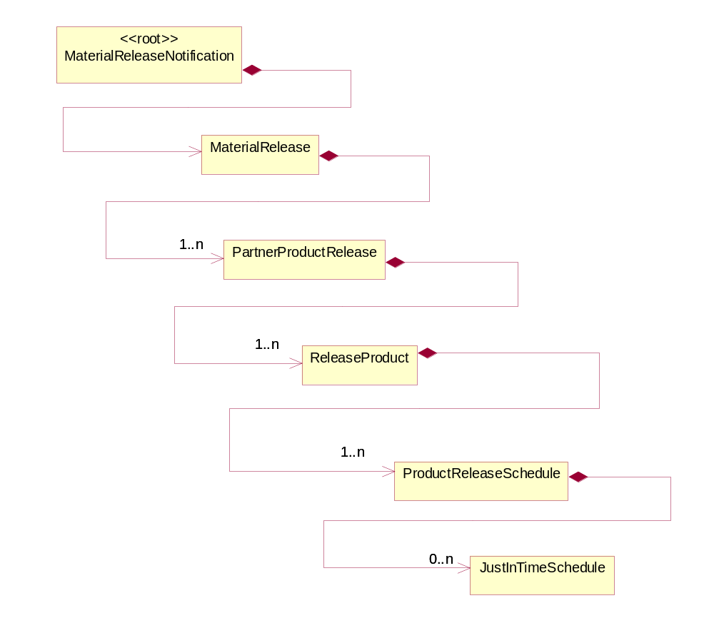
Figure ‎2-1 Interchange

Dependency Diagram
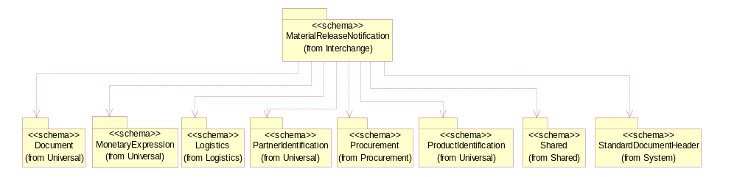
Figure ‎2-2 Dependency

JustInTimeSchedule
The collection of business properties that identifies the sub-line identification of time(s) and associated quantity(s) of Material Release if release is time sensitive.
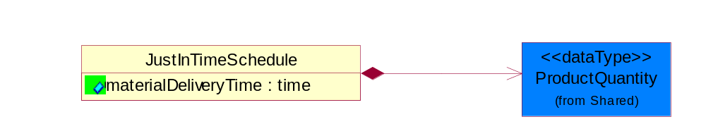
Figure ‎2-3 JustInTimeSchedule

Attribute | Type | Documentation
materialDeliveryTime | time | Time of expected shipment of material.

Composition | Cardinality | Type | Documentation
ProductQuantity | 1 | ProductQuantity | A quantity specifying the number of product units.

MaterialRelease
Business document that triggers the release of material to a delivery location.
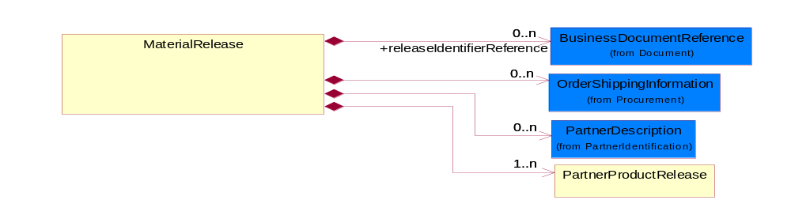
Figure ‎2-4 MaterialRelease

Composition | Cardinality | Type | Documentation
releaseIdentifierReference | 0..n | BusinessDocumentReference | The collection of business properties that describes the various types of proprietary reference identifiers for Material Release.
OrderShippingInformation | 0..n | OrderShippingInformation | The collection of business properties that describe information relating to shipping a product.
PartnerDescription | 0..n | PartnerDescription | The collection of business properties that describe a business partners' identity, their contact information, where they are physically located and their function in a supply chain.
PartnerProductRelease | 1..n | PartnerProductRelease | The collection of business properties that describes material release and partner information for a product.

MaterialReleaseNotification
Message wrapper for 4D1.
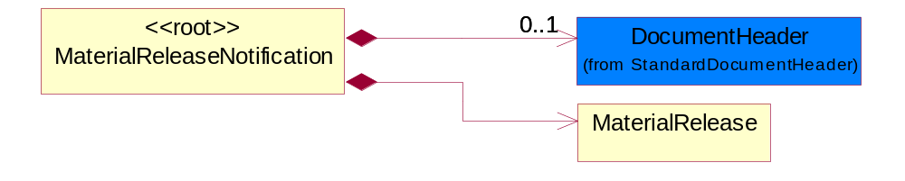
Figure ‎2-5 MaterialReleaseNotification

Composition | Cardinality | Type | Documentation
DocumentHeader | 0..1 | DocumentHeader | The object allows for the identification of the sender and receiver of the business document.
MaterialRelease | 1 | MaterialRelease | Business document that triggers the release of material to a delivery location.

PartnerProductRelease
The collection of business properties that describes material release and partner information for a product.
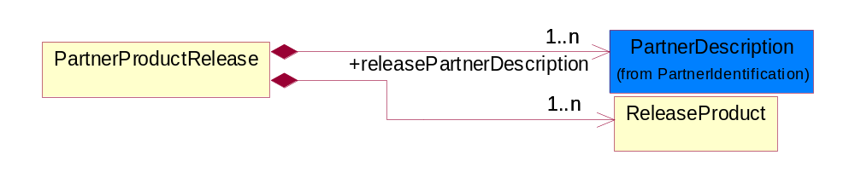
Figure ‎2-6 PartnerProductRelease

Composition | Cardinality | Type | Documentation
releasePartnerDescription | 1..n | PartnerDescription | The collection of business properties that describes the trading partner roles involved in triggering Material Release.
ReleaseProduct | 1..n | ReleaseProduct | The collection of business properties that describes the material being pulled(released) by customer for use at a delivery location.

ProductReleaseSchedule
The collection of business properties that identifies the dates(s), quantity(s) , times(s) and release number for Material Release.
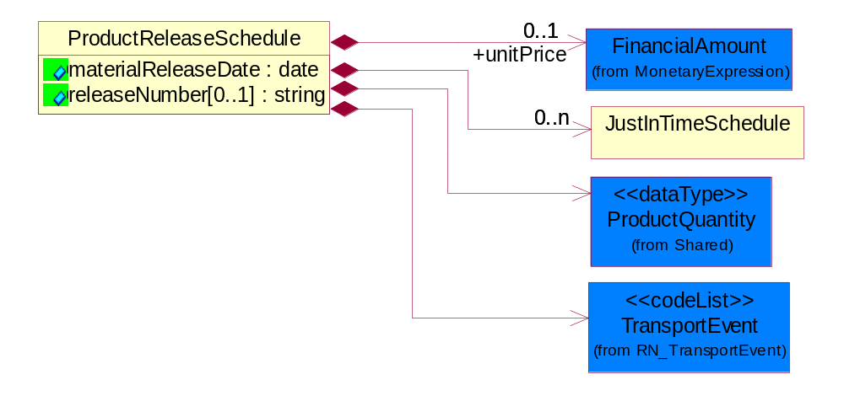
Figure ‎2-7 ProductReleaseSchedule

Attribute | Type | Documentation
materialReleaseDate | date | Date of material release.
releaseNumber[0..1] | string | Sub-line identifier of release signal within Material Release document. Unique number assigned to a release signal.

Composition | Cardinality | Type | Documentation
unitPrice | 0..1 | FinancialAmount | Agreed upon sale price for each unit ordered.
JustInTimeSchedule | 0..n | JustInTimeSchedule | The collection of business properties that identifies the sub-line identification of time(s) and associated quantity(s) of Material Release if release is time sensitive.
ProductQuantity | 1 | ProductQuantity | A quantity specifying the number of product units.
TransportEvent | 1 | TransportEvent | Code identifying an event during the transportation of a shipment.

ReleaseProduct
The collection of business properties that describes the material being pulled(released) by customer for use at a delivery location.
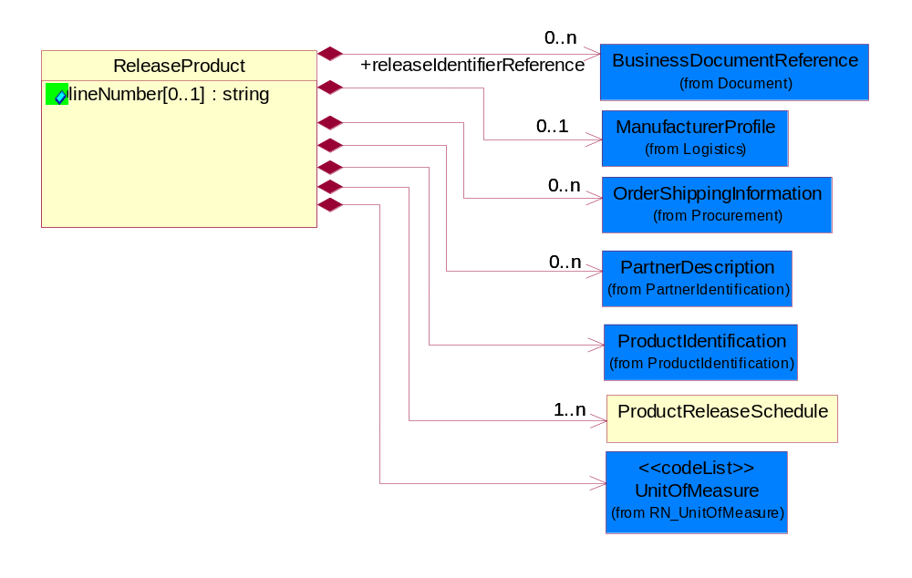
Figure ‎2-8 ReleaseProduct

Attribute | Type | Documentation
lineNumber[0..1] | string | Number of the line in the document.

Composition | Cardinality | Type | Documentation
releaseIdentifierReference | 0..n | BusinessDocumentReference | The collection of business properties that describes the various types of proprietary reference identifiers for Material Release.
ManufacturerProfile | 0..1 | ManufacturerProfile | The collection of business properties that describe a manufacturer's product.
OrderShippingInformation | 0..n | OrderShippingInformation | The collection of business properties that describe information relating to shipping a product.
PartnerDescription | 0..n | PartnerDescription | The collection of business properties that describe a business partners' identity, their contact information, where they are physically located and their function in a supply chain.
ProductIdentification | 1 | ProductIdentification | The object provides the identifier(s) of a product.
ProductReleaseSchedule | 1..n | ProductReleaseSchedule | The collection of business properties that identifies the dates(s), quantity(s) , times(s) and release number for Material Release.
UnitOfMeasure | 1 | UnitOfMeasure | Code identifying a product unit of measure.

Domain Model

Procurement

Procurement

Dependency Diagram
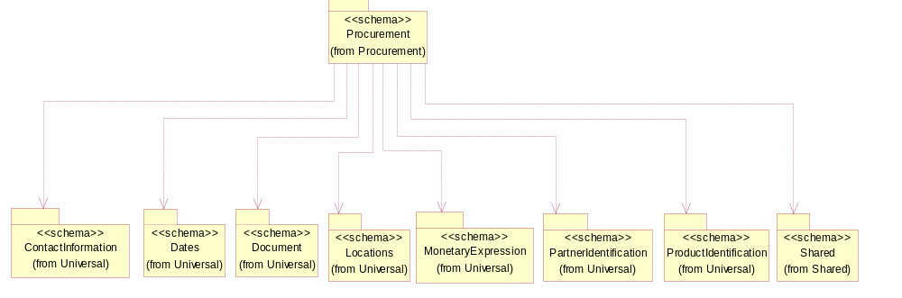
Figure ‎3-9 Dependency

OrderShippingInformation
The collection of business properties that describe information relating to shipping a product.
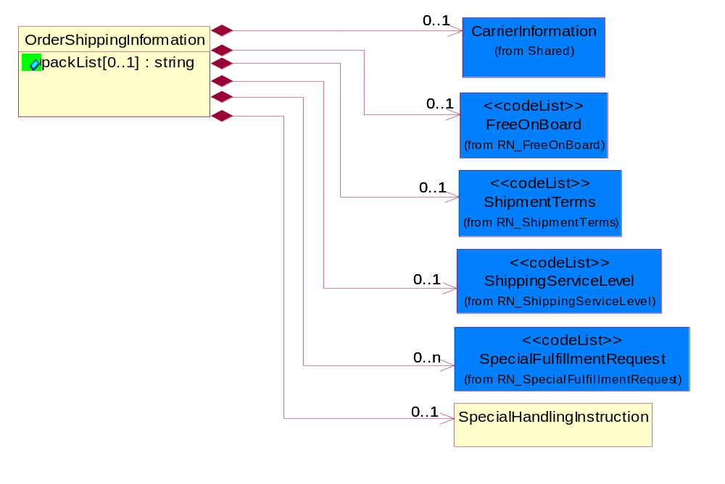
Figure ‎3-10 OrderShippingInformation

Attribute | Type | Documentation
packList[0..1] | string | Free form textual description, on the pack list, of requirements relating to the packing of the product.

Composition | Cardinality | Type | Documentation
CarrierInformation | 0..1 | CarrierInformation | The collection of business properties that describe a carrier's identification.
FreeOnBoard | 0..1 | FreeOnBoard | Code identifying a specified point where a product is delivered or placed on board a carrier without charge.
ShipmentTerms | 0..1 | ShipmentTerms | Code identifying the terms under which a product is shipped.
ShippingServiceLevel | 0..1 | ShippingServiceLevel | Code identifying the shipping service level, e.g., overnight, same day.
SpecialFulfillmentRequest | 0..n | SpecialFulfillmentRequest | Code identifying a special fulfillment request, e.g. delivery options.
SpecialHandlingInstruction | 0..1 | SpecialHandlingInstruction | The collection of business properties that describe product packaging or shipping handling instructions.

SpecialHandlingInstruction
The collection of business properties that describe product packaging or shipping handling instructions.
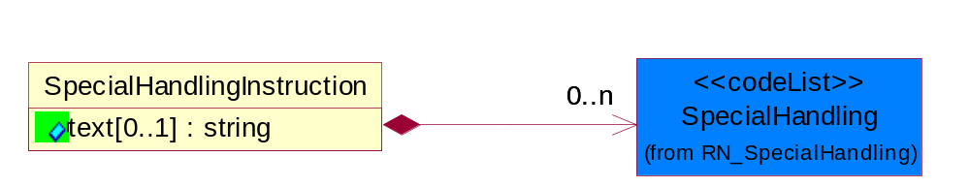
Figure ‎3-11 SpecialHandlingInstruction

Attribute | Type | Documentation
text[0..1] | string | Free form textual description for how specified goods, packages or containers should be handled.

Composition | Cardinality | Type | Documentation
SpecialHandling | 0..n | SpecialHandling | Code identifying special handling or packaging requirements for the product.

CodeList

TransportEvent
Code identifying an event during the transportation of a shipment.

Name | Documentation
DOC | Dock.
PIC | Pickup.
SHP | Ship.

ShipmentTerms
Code identifying the terms under which a product is shipped.

Name | Documentation
ADC | Advance collect.
ADP | Advance prepaid.
CAA | Cash in advance.
CAD | Cash on delivery.
CFC | Collect, freight credited to payment customer.
CFR | Cost and freight.
CIF | Cost, Insurance and Freight.
CIP | Carriage and Insurance Paid to.
COL | Collect.
CPT | Carriage Paid To.
CRC | Credit card.
CUP | Customer pick-up/backhaul.
DAF | Delivered at Frontier.
DDP | Delivered Duty Paid.
DDU | Delivered Duty Unpaid.
DEQ | Delivered Exquay.
DES | Delivered Ex Ship.
EXW | Ex Works.
FAS | Free Alongside Ship.
FCA | Free Carrier.
FOB | Free On Board.
LEC | Letter of Credit.
NOS | Not specified.
PAE | Payable elsewhere.
PCC | Prepaid but charged to customer.
PIU | Pickup.
PRE | Prepaid only.
PRS | Prepaid (by seller).
RFC | Return container freight paid by customer.
RFF | Return container freight free.
RFS | Return container freight paid by supplier.
TPP | Third Party Pay.

SpecialFulfillmentRequest
Code identifying a special fulfillment request, e.g. delivery options.

Name | Documentation
AQM | Add quantity to make minimum weight requirement.
BIG | Bid Guarantee.
BON | Back order only if new item.
BOO | Back order if out of stock.
BOS | Back order if items are out of stock or not yet published.
COM | Combined small disadvantaged business and labor surplus area set-aside.
CON | Consignment.
CSD | Consolidate Delivery.
DNP | Do Not Preship.
DNS | Do not ship/invoice only.
EIQ | Exclude Import Quota in First Cost.
EPA | Equal Product Allowed.
FAS | Factory Ship.
FIK | Fill or kill.
GUS | Guaranteed Sale.
IIQ | Include Import Quota in First Cost.
LPS | Large purchase set-aside for small business.
LSA | Labor surplus area set-Aside.
MAP | May Preship.
MUD | Mutually Defined.
MYA | Multi-year Award.
NBO | No Back Order.
NOS | No Substitutes.
NPS | Notify prior to shipment if quantity specified is not available.
OQB | On Qualified Bidders List.
OQM | On Qualified Manufacturers List.
OUS | Other Unlisted Sales Condition.
PLS | Partial labor surplus area set aside.
RAS | Restricted to approved sources.
REI | Restricted to educational institutions.
RHB | Restricted to historically black college or university or minority institution.
RIP | Restricted to industrial preparedness program participants.
RQP | Restricted to Qualified Products List (QPL) Products.
RUC | Restricted to U.S. and Canadian Sources.
RYI | Restricted to Young Investigator Program.
SA8 | Section (8a) set-aside.
SAI | Set-aside for american indian-owned business.
SAS | Ship as soon as possible.
SBA | Ship Per Release or Buyer Authorization.
SBS | Small business with small disadvantaged business consideration set-aside.
SDS | Small disadvantaged business set-aside.
SFT | Ship Full Truck only.
SHC | Ship Complete.
SIA | Substitute Item Allowed.
SIP | Ship In-Place.
SMP | Small purchase set aside for small businesses.
SP1 | Ship Partial - balance back order.
SP2 | Ship Partial - Balance Cancel.
SP3 | Ship Partial - Balance Substitute.
SP4 | Ship Partial - Carload Lots Only.
SP5 | Ship Partial - Item Qty Proportional To Total Order.
SP6 | Ship Partial - Truckload Lots Only.
SPR | Ship Per Release.
SPS | Ship Per Schedule.
SRA | Small Remaining Balance Cancellation Allowed.
SRN | Small Remaining Balance Cancellation Not Allowed.
URP | Unrestricted Procurement.
WAR | Warranty.
WHS | Warehouse Ship.

SpecialHandling
Code identifying special handling or packaging requirements for the product.

Name | Documentation
15M | 15 Minute Window.
24H | 24 Hour Availability.
AAO | Attachments - Advance Only Waybill.
ACC | Accepted by Carrier at Owner's Risk of Freezing.
ACD | Air Conditioning Disconnect and Connect.
ACU | Attachment - Customer's Document.
ADC | Additional Copy of Shipping Papers for Proof of Delivery.
ADF | Advanced Fee.
ADL | Advance Loading.
AGS | Armed Guard Service.
AHM | Accessible Hazardous Material.
AMD | A.M. Delivery Requirement.
ANU | Anchoring and Unanchoring.
ANV | Annual Volume.
APW | Attachment - Prepaid Waybill.
ART | Air Ride Truck Service.
ASE | Attachment - Shipper's Export Document.
ASM | Attachment - Shipper's Manifest.
ASP | Attachment - Shipper's Packing Instructions.
ASR | Assembly Service Requested.
ATD | Aggregate Tender Discount.
ATT | Air Ride Tractor Service.
AUS | Auxiliary Service.
BA1 | Bunker Adjustment - 20 Foot Container.
BA2 | Bunker Adjustment - 40 Foot Container.
BCC | Bill Consignee for Weigh Charges.
BCP | Bypass Consolidation Point.
BFS | Barge Freight All Kinds Service.
BKA | Bunker Adjustment.
BKS | Block Stowage.
BLB | Blocking and Bracing.
BLS | Blind Shipment.
BNS | If Bad Ordered Notify Shipper.
BOL | Bolster Load, Do Not Switch.
BSA | Bunker Surcharge Authorized.
BSC | Bill Shipper for Weigh Charge.
BUA | Bulky Article.
CA1 | Currency Adjustment - 20 Foot Container.
CA2 | Currency Adjustment - 40 Foot Container.
CAA | Cargo Aboard.
CAB | Chain and Binders.
CAC | Carrier Caboose.
CAR | Carrier.
CAT | Cargo Taxes.
CBC | Cargo on Board Certification Required.
CCB | Convert Commercial Bill of Lading (BOL) to Government BOL.
CCE | Certification that the Containers Being Returned Empty Were Received Filled by Rail Freight Service.
CCL | Container, Consolidator Load.
CER | Certification.
CFB | Cleared for Border Crossing.
CFC | Customs Fees - Container Level.
CFE | Cleared for Export.
CFI | Customs Fees - Lift Level.
CFL | Container, Factory Load.
CGC | Carrier Guard Car Service.
CHB | Clearinghouse Balance.
CIP | Commercial Invoice Preparation.
CIR | Circuitous Routing.
CLC | Carrier Load and Consignee Unload.
CLE | Cleaning.
CLH | Consolidation and Line Haul.
CLL | Commodity Loaded Less Than or Equal To the Car Ordered.
CLU | Carrier Load and Carrier Unload.
CNE | Certification That the Newsprint Winding Cores Being Returned Empty Were Received Filled by Rail Freight Service.
COA | Controlled Atmosphere.
COD | Container Diversion.
COL | Container Lease.
COM | Container Mounting.
CON | Conductivity/Anti-static Additive.
COO | Certificate of Origin.
COS | Completing Shipment.
COU | Consignee Unload.
COV | Courier, Overnight.
CPM | Customs Papers Mailed.
CPN | Customer Required PRO Number.
CRA | Class Rates Applied.
CRD | Comb. Rates over Detroit.
CRL | Customer Required Packing List.
CRN | Customer Required Appointment Number.
CRP | Contract Rates Apply.
CRT | Cross Town.
CSD | Courier, Same Day.
CSL | Consolidation.
CSR | Certification that this Shipment is for Recycling as Defined in Applicable Tariffs Containing Such Provisions.
CSU | Constant Surveillance.
CUI | Customs Inspection.
DAN | Dangerous.
DAR | Drop and Run.
DCE | Detention of Conveying Equipment and the Power Unit.
DEM | Demurrage.
DEP | Detention of Conveying Equipment Excluding the Power Unit.
DES | Delivery Service.
DEV | Detention (Vehicle).
DHI | Do not Hump or Hump into.
DID | Direct Delivery.
DNC | Do Not Couple to Double Shelf Couples.
DND | Do Not Divert.
DNF | Do Not Freeze.
DNH | Do Not Hump.
DNP | Do Not Pool.
DNT | Do Not Transfer Contents.
DNU | Do Not Uncouple.
DOD | DOD Constant Surveillance Service.
DOM | Domestic.
DOS | Documentation - Special.
DP1 | Detention With Power Units (30 minute periods).
DP2 | Detention With Power Units (60 minute periods).
DPD | Drayage at Port of Debarkation (Rate Zone).
DPE | Drayage at Port of Embarkation (Rate Zone).
DRO | Drop-Off Delivery.
DSR | Distribution Service Requested.
DSW | Delivery Only on Surrender of Written Order.
DVN | Delivery Verification Not Required.
DWA | Destination Weights Apply.
ECS | Escort/Courier Service.
EET | Electronic Equipment Transfer.
EHM | Endorsed as Hazardous Material.
ELB | Extra Labor.
EMM | Empty Movement.
EMR | Empty Return.
EMS | Emergency Service.
END | Endorsement.
EOS | Escort Service with Overnight Subsistence.
EPP | Export Preparation.
EPT | Export.
EQU | Equipment..
ERA | Expedited Rates Applied.
ERI | Expand Remove and Install.
ESC | Escort.
EST | Escort Services (Telephone).
EUV | Exclusive Use of Vehicle.
EVA | Excessive Valuation Authorized.
EXC | Exempt Commodity.
EXD | Extra Driver.
EXL | Extra Lights.
EXP | Expedite.
EXS | Expedited Service.
EXU | Exclusive Use.
EXW | Excessive Weight.
FIS | Filtration Service.
FLS | Flatrack Surcharge.
FOD | FOD, FOB - Destination.
FOS | FOS, FOB Shipping Point.
FPT | For Processing in Transit.
FRA | Fragile - Handle with Care.
FST | For Storage in Transit.
FUS | Full Service.
GGC | Government Guard Car.
GOC | Government-Owned Containers.
GSS | Greater Security Service.
GVC | Government Caboose.
HAL | Hold at Location.
HAN | Handling.
HAR | Harmless.
HCD | Hazardous Cargo On Deck.
HCT | High Cube Trailer Rates.
HEA | Heat.
HES | Heat - Special.
HFO | Hold for Orders.
HFR | Home for Repair.
HIT | Heat in Transit.
HMS | Hazardous Materials Surcharge.
HOR | Heater or Refrigeration.
HVL | High Value Load.
IHM | Inaccessible Hazardous Material.
IMP | Impactographs.
IMS | Import Shipment.
INB | In-bond.
IND | Inside Delivery.
INH | Inspect Hourly if Car Stopped.
INP | Inside Pickup.
INS | Insulated.
IPM | Intra-Plant Move.
ISS | Intermodal Shipment Service.
ITS | Interline Transfer Service.
JIT | Just-In-Time (JIT).
JLE | Joint Line Exception.
KFF | Keep From Freezing Percent Differential.
KMD | Keep Material Dry.
LAA | Labor Associated with Detention of Conveying Equipment.
LAB | Land Bridge (Import/Export).
LAD | Labor Disturbance.
LAO | Layover.
LAS | Layover Service.
LBD | Labor Disturbance.
LBS | Light Bar Service.
LBT | Low Boy Trailer/Flat Bed.
LC1 | Land Currency Adjustment - 40 Foot Container.
LC2 | Land Currency Adjustment Factor - 20 Foot Container.
LCA | Land Currency Adjustment - 40 Foot Container.
LCF | Land Currency Adjustment Factor - 20 Foot Container.
LDE | Labor Associated with Detention of Conveying Equipment.
LDP | Linehaul from Port of Debarkation.
LEP | Linehaul To Port of Embarkation.
LFC | Less Than Full Carload.
LFL | Less Than Container, Factory Load.
LFV | Loaded to Full Visible Capacity.
LIS | Linehaul Service.
LIU | Live Unload.
LOC | Liability of Carrier.
LOD | Loading Devices.
LPD | Linehaul Percent Differential.
LSO | Local Service Only.
LTC | Less Than Container.
LTD | Liner Terms at Port of Debarkation.
LTE | Liner Terms at Port of Embarkation.
LTL | Less Than Container, Consolidator Load.
LTT | Less Than Truckload.
MAW | Manifest Must Accompany Waybill.
MER | Mechanical Refrigeration.
MFI | Moving Under "For Furtherance Instructions" and May Be Delivered.
MOA | Modified Atmosphere.
MSS | Motor Surveillance Service.
MTS | Multi-Tank Surveillance Service.
MUP | Multiple Pickup.
NCB | Notify Consignee Before Delivery.
NEF | New Equipment First Transborder Movement.
NFE | Not for Export.
NFS | Nontransit Flat Shipment.
NMR | No Marshalling Required for Hazardous Materials.
NPR | No Placards Required.
NRC | Not Restricted Cargo.
NSB | Notify Shipper Before Reconsignment.
NSE | No Special Entrainment Required.
NSI | Notify Shipper Immediately if Shipment is Delayed en Route.
NUW | In Case of Fire Do Not Use Water.
OAH | Offshore - Alaska/Hawaii Service.
ODS | On Deck Stowage.
OHC | Over Height Container.
OTH | Other.
OVF | Overflow.
OVP | Oversized Premium.
OVW | Overweight.
OWR | One Way Rates Applied.
PAD | Pickup and Delivery.
PAS | Partial Shipment.
PAU | Pack and Unpack.
PAW | Preparation of Air Waybill - Origin.
PCC | Preparation of Canadian Customs Invoice.
PDB | Pickup and Delivery Beyond Service Area.
PDL | Percent Differential - Less Than Container.
PDS | Pickup and Delivery From Storage in Transit.
PEE | Preparation of Export Entry.
PFH | Protect From Heat.
PHR | Per Hour Rates Applied.
PIC | Preparation of Insurance Certificate.
PIT | Pier Time.
PIU | Pickup.
PLR | Protect Lowest Through Rate.
PMD | P.M. Delivery Requirement.
PMR | Per Mile Rates Apply.
POC | Port Changes.
PPC | PPC, FOB -Destination charge to customer.
PPD | PPD, Prepay+I35/Add Freight to Invoice.
PPS | Product Protection Service.
PRS | Priority Service.
PSC | Protective Security Service.
PSN | Pickup of Shipments on Saturday, Sunday, and/or Holidays Requiring Absolute Next Day Delivery.
PSP | Pallets/Skids/Platforms.
PSS | Pickup of Shipments Requiring Same Day Delivery Service.
PST | Pickup of Shipments Requiring Same Day Delivery Service and/or Delivery at a Specified Time.
PUE | Preparation of U.S. Export Documentation.
PUP | PUP Trailer Rates Apply.
RAH | Railhead Handling.
RAM | Radioactive Material.
RBC | Render Bill for Charges.
RCD | Reefer Cargo Percent Differential.
RCG | Return Carrier Guard Car Service.
RCP | Railroad Controlled Private Equipment Subject to Demurrage.
RCS | Reconsignment.
REA | Return Authorization.
REC | Return of Empty Container.
RED | Redelivery.
REF | Refrigerated.
REM | Reefer Maintenance.
RER | Reweight Requested.
RES | Reservations.
RFT | Record for Transit.
RMP | Return Movement of Pallet.
ROE | ROEE Van Type Truck.
ROS | Roadrailer Service.
RSC | Requires Shelf Couplers.
RSD | Residential Delivery.
RSM | Reshipment.
RST | Respotting.
RTS | Round Trip Service.
RUO | Rush Order.
RVC | Released Value Charge in Excess of Carrier Maximum Liability.
RWE | Roadway Easy Rates Applied.
SAD | Saturday Delivery.
SAH | Stow Away from Heat.
SAR | Shipper Authorization Required for Diversion or Consignment.
SCA | Service Charge Applies.
SCC | Shipper Load/Carrier Count.
SCG | Shipper Certifies Gross Weight under 240,000 pounds.
SCL | Apply a Uniform Code Council/International Article Numbering Association (UCC/EAN) Serial Shipping Container Label to the Shipping Containers.
SCW | Stretch Wrap.
SDS | Special Dromedary Service.
SEC | Special Equipment Charge.
SED | Shipper Export Declaration Required.
SEE | Stairs, Elevator, Excess Carry.
SES | Security Signature Service.
SFD | Single Factor Origination/Port of Debarkation.
SFO | Single Factor Origination/Destination.
SFP | Single Factor Port of Embarkation/Destination.
SFS | Satisfactory Service Standards.
SGD | Single Driver.
SHH | Shipment Holdover for Holidays.
SHL | Shiftable Load.
SHP | Sunday or Holiday Pickup or Delivery.
SHW | Shipment Holdover for Weekends.
SID | Shipment to be Inspected at Destination and Disposition Instructions will be Furnished.
SIR | Signature Required.
SIS | Single Shipment.
SLC | Shipper Load and Carrier Unload.
SLD | Split Delivery.
SLO | Shipper Load and Count.
SLP | Split Pickup.
SLS | Shipper Load and Consignee Unload.
SMP | Small Package.
SMS | Special Motor Surveillance.
SNT | Shipment from Non-Temp Storage.
SOD | Stop-off at Destination.
SOE | Shipment Holdover on Weekends.
SOH | Shipment Holdover on Holidays.
SOO | Stop-off at Origination.
SOW | Shipment Holdover on Weekdays.
SPC | Special Containers.
SPD | Saturday Pickup or Delivery.
SPL | Shipper Load.
SPP | Special Permit.
SPR | Speed Restricted.
SPS | Special Permits.
SPU | Saturday Pick-Up.
SR1 | Speed Restricted to 15 Miles per Hour.
SR2 | Speed Restricted to 25 Miles per Hour.
SR3 | Speed Restricted to 35 Miles per Hour.
SR4 | Speed Restricted to 45 Miles per Hour.
SRC | Shove to Rest and Cover.
SRG | Storage.
SSC | Stripping, Sorting and Consolidation.
SSD | Subject to Special Detention Rules/Charges.
SSN | Substitute Service Not to be Used.
SSS | Satellite Surveillance Service.
SST | Spot for Storage - No Shipment.
STM | Special Train Movement.
STO | Stop-off.
STR | Signature and Tally Record.
STT | Stack Train.
STW | Stowage.
SUR | Supervisor Requested.
SVR | Surveying Routes.
TAT | Tendered as Truckload (Truckload Service Requested).
TCL | Trailer, Consolidator Load.
TDS | Time of Delivery and Signature Required.
TEC | Temperature Control.
TER | Termination.
TFL | Trailer, Factory Load.
TFP | Transfer Product.
THC | Terminal Handling Charges.
TLO | Top Load Only.
TMV | Tendering of Multiple Vehicles.
TOC | Truckload-Double Operator-Common Carrier.
TOP | Truckload-Double Operator-Padded Van.
TOS | Total Shipment.
TPS | Third Party Service.
TRA | Truck Rates Applicable.
TRP | Trailer Preparation - Special.
TRS | Trade Show.
TSN | Transmit a Ship Notice/Manifest Transaction Set.
TSS | Transit Shipment.
TTD | Team Track Delivery.
TTR | Tentative Release - Tentatively releasing the shipment either for import or export and subject to compliance to additional conditions which could be executed later.
TVR | Time Volume Rates Only.
UAP | Unload as Placarded.
UAT | Use of Alternate Terminal.
ULS | Unload from Left Side of Car.
UNH | Use No Hooks.
UNI | Unitized.
UNP | Unpacking.
UOR | Unloading or Reloading.
UPP | Unprotected Perishable.
URS | Unload from Right Side of Car.
VEI | Ventilation Instructions.
VEW | Verification Weigh.
WAI | Waive Inspection.
WCO | Weigh to Check for Overload.
WEE | Weigh Empty.
WEV | Weight Verification.
WID | Waived Inspection - Set Direct.
WPD | Written Proof of Delivery.
WTA | Waiting Time Authorized.

Logistics

Logistics

Dependency Diagram
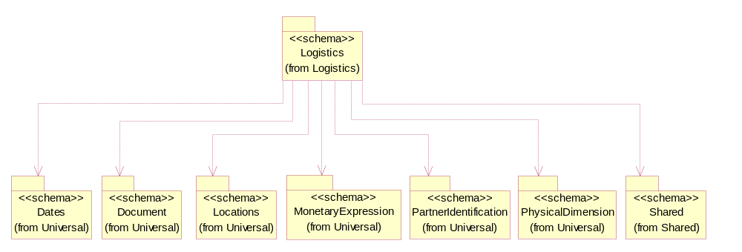
Figure ‎3-12 Dependency

ManufacturerProfile
The collection of business properties that describe a manufacturer's product.
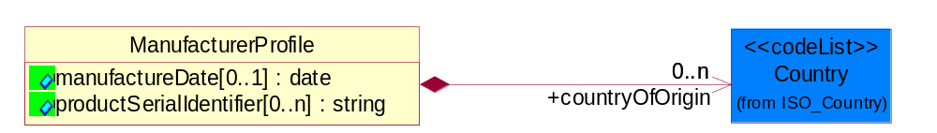
Figure ‎3-13 ManufacturerProfile

Attribute | Type | Documentation
manufactureDate[0..1] | date | The date the product was manufactured.
productSerialIdentifier[0..n] | string | Serial number(s) of a product.

Composition | Cardinality | Type | Documentation
countryOfOrigin | 0..n | Country | Country where product originates.

Shared

Shared

Dependency Diagram
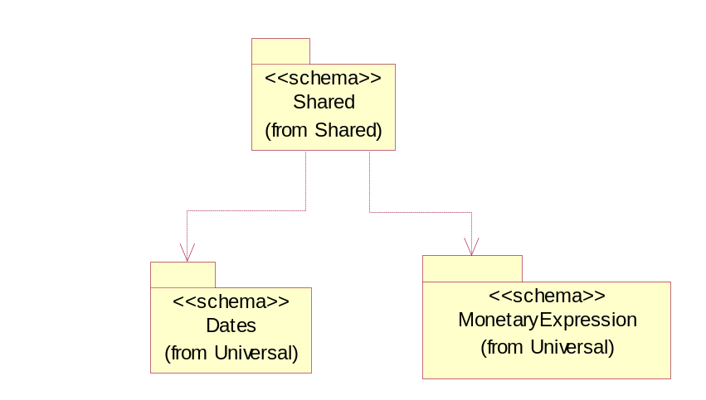
Figure ‎3-14 Dependency

CarrierInformation
The collection of business properties that describe a carrier's identification.
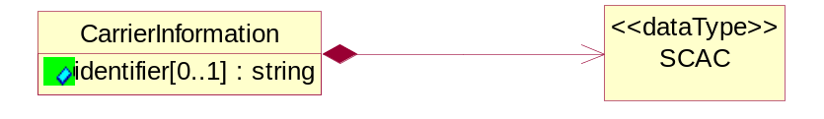
Figure ‎3-15 CarrierInformation

Attribute | Type | Documentation
identifier[0..1] | string | The unique identifier that identifies an account.

Composition | Cardinality | Type | Documentation
SCAC | 1 | SCAC | The Standard Carrier Alpha Code (SCAC) is a unique two-to-four-letter code used to identify transportation companies. NMFTA developed the SCAC identification codes in the mid 1960's to facilitate computerization in the transportation industry.  Refer http://www.nmfta.org for more detail.

ProductQuantity
A quantity specifying the number of product units.
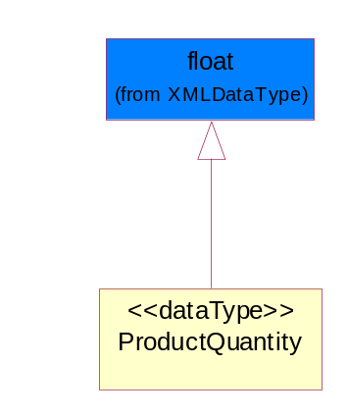
Figure ‎3-16 ProductQuantity

SCAC
The Standard Carrier Alpha Code (SCAC) is a unique two-to-four-letter code used to identify transportation companies. NMFTA developed the SCAC identification codes in the mid 1960's to facilitate computerization in the transportation industry.

Refer http://www.nmfta.org for more detail.
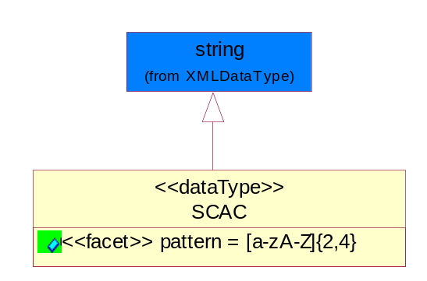
Figure ‎3-17 SCAC

Attribute | Type | Documentation
pattern |  | [a-zA-Z]{2,4}

CodeList

FreeOnBoard
Code identifying a specified point where a product is delivered or placed on board a carrier without charge.

Name | Documentation
DES | Destination.
NMA | Name Address.
ORG | Origin.

ShippingServiceLevel
Code identifying the shipping service level, e.g., overnight, same day.

Name | Documentation
1BD | 1BD, Same Business Day - 4 hour Response Time.
5BD | 5 Business Days.
9AM | 9 A.M.
ACH | Air Charter.
AEC | Air Economy.
AIC | Air Cargo.
AM | A.M.
ARS | Authorized Return Service.
ATA | Airport to Airport.
ATD | Airport to Door.
BCT | Bulk Commodity Train.
BUC | Business Class.
CBS | Consignee Billing Service.
COE | Courier Express.
DCR | Delivery Confirmation Return.
DEC | Delivery Confirmation.
DES | Deferred Service.
DNO | Delivery Notification Only.
DOS | Door Service.
DSN | Delivery scheduled next day by cartage agent.
DSS | Delivery scheduled second day by cartage agent.
DST | Delivery scheduled third day by cartage agent.
DTA | Door to Airport.
DTD | Door to Door.
DTP | Door to Port (Ocean).
ESP | Express Service Plus.
ESV | Expedited Service.
ESW | Expedited Service Worldwide.
EXS | Express Service.
EXW | Express Service - Worldwide.
FIC | First Class.
GEN | General.
GRO | Ground.
ISS | Other intermodal and stack service.
MAF | Manifest freight.
MET | Metro.
MUW | Multiweight.
NBD | Next Business Day.
NDA | Next Day Air.
NEM | Next Morning.
NFO | Next Flight Out.
NHW | Next day Hundred Weight.
NOR | NORMAL - Normal delivery.
NOS | Not served.
OIS | Other Intermodal and Stack service
OTH | Other.
OVN | Overnight.
PAS | Passenger service.
PIU | Pickup.
PM | PM.
PMI | Priority Mail Insured.
POB | P.O. Box/Zip code.
POD | Proof of Delivery (POD) with Signature.
PRM | Priority Mail.
PRS | Premium Surface.
PS1 | Primary Service Area - Next Day by 10:30 A.M.
PS2 | Primary Service Area - Next Day by 5:00 P.M.
PS3 | Primary Service Area - Next Day By 9:30 A.M.
PS4 | Primary Service Area - Next Day by Noon.
PS5 | Primary Service Area - Second Day by Noon.
PTD | Port to Door (Ocean).
PTP | Port to Port (Ocean).
REG | Regular.
SAD | Same day.
SAP | Saturday Pickup.
SAT | Saturday.
SBD | SBD, Second Business Day.
SCH | Scheduled.
SDA | Second Day Air.
SDW | Second Day Hundred Weight.
SED | Second Day.
SEM | Second Morning.
SGW | Standard Ground Hundred Weight.
STC | Standard Class.
STG | Standard Ground.
STO | Standard Ocean.
STS | Standard Service.
SUH | Sunday and Holidays.
TDS | Three Day Service.
TIC | Time Critical.
TRG | Tracking - Ground.

Universal Structure

ContactInformation

ContactInformation
The business document must allow for the identification of the name of the department, service or individual to be contacted regarding the context of the business document.
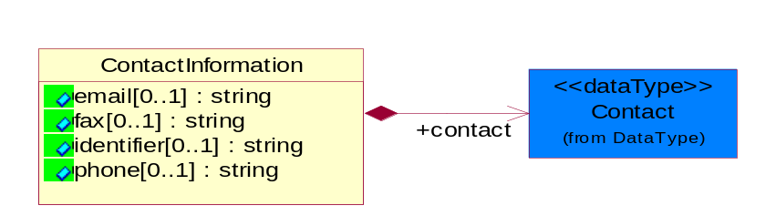
Figure ‎4-18 ContactInformation

Attribute | Type | Documentation
email[0..1] | string | The electronic mail for the specified contact.
fax[0..1] | string | The fax number for the specified contact.
identifier[0..1] | string | Identifies the role of the contact (i.e. Service Technician, Account Manager) in the Business Process.
phone[0..1] | string | The telephone number for the specified contact.

Composition | Cardinality | Type | Documentation
contact | 1 | Contact | The name of the department, service or individual to be contacted within the organization.

DataType

Contact
The name of the department, service or individual to be contacted within the organization.
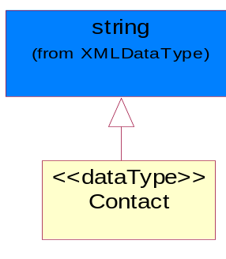
Figure ‎4-19 Contact

DUNS
A number assigned by Dun and Bradstreet to identify a business location.
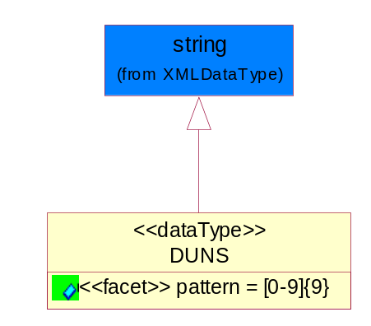
Figure ‎4-20 DUNS

Attribute | Type | Documentation
pattern |  | [0-9]{9}

DUNSPlus4
A identifier to specify a specific location within a business location.
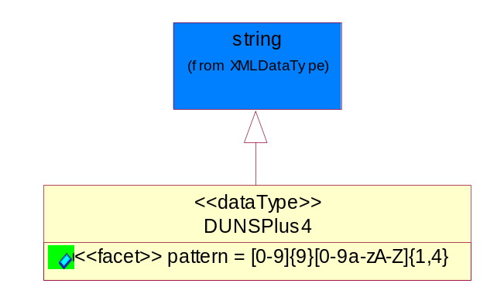
Figure ‎4-21 DUNSPlus4

Attribute | Type | Documentation
pattern |  | Data Universal Numbering System +4 (DUNS+4) number means the DUNS number assigned by Dun and Bradstreet, Inc. (D&B) plus an alphanumeric of length 4 suffix that may be assigned by a business concern.

GLN
Global Location Number (GLN) - A identifier to identify legal entities, trading parties and location.
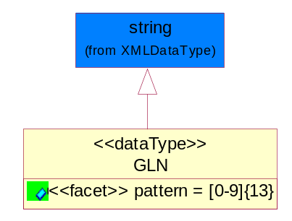
Figure ‎4-22 GLN

Attribute | Type | Documentation
pattern |  | [0-9]{13}

GTIN
Global Trade Identification Number (GTIN).
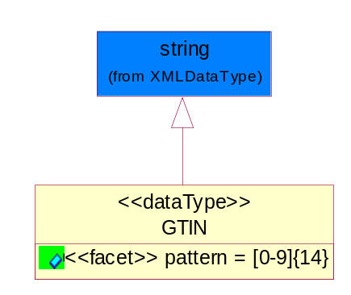
Figure ‎4-23 GTIN

Attribute | Type | Documentation
pattern |  | [0-9]{14}

Document

BusinessDocumentReference
The business document reference object allows for the indirect referencing of a relationship to other business related documents.
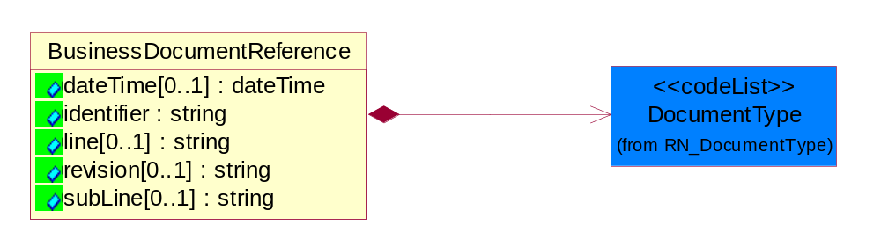
Figure ‎4-24 BusinessDocumentReference

Attribute | Type | Documentation
dateTime[0..1] | dateTime | The date-time stamp indicating on the referenced business document.
identifier | string | Unique identification of the referenced business document.
line[0..1] | string | References the specific line number of the specified business document.
revision[0..1] | string | Referenced the revision of the specified business document.
subLine[0..1] | string | References the specific subline number of the specified business document.

Composition | Cardinality | Type | Documentation
DocumentType | 1 | DocumentType | A code identifying the business context of a document.

Locations

AlternativeIdentifier
Identifies the specified code and the name of the organization that a code is utilized from.
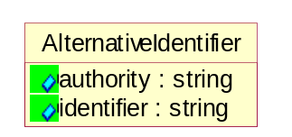
Figure ‎4-25 AlternativeIdentifier

Attribute | Type | Documentation
authority | string | The name of the organization that a code is utilized from.
identifier | string | The specified code to represent an entity (e.g. product, location, partner, etc.).

Location
The business document must specify a location.
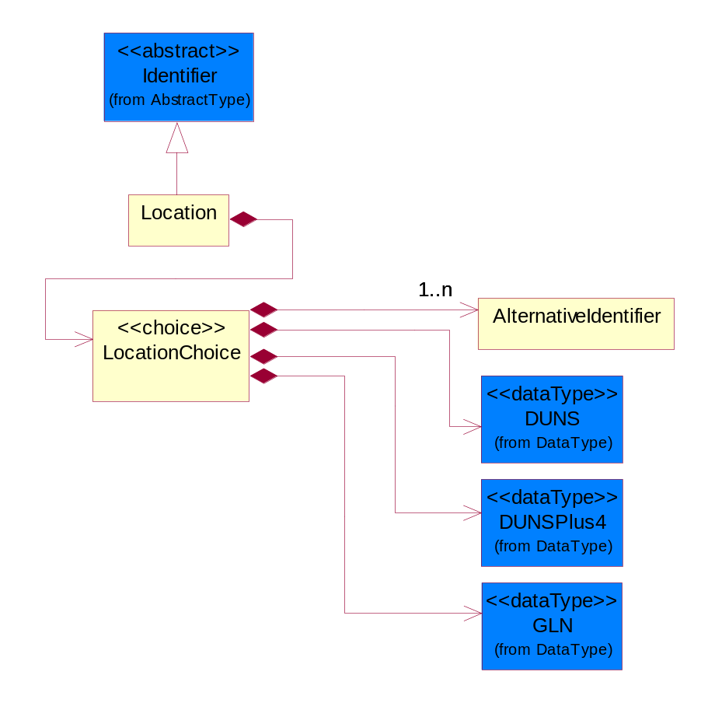
Figure ‎4-26 Location

Composition | Cardinality | Type | Documentation
LocationChoice | 1 | LocationChoice

LocationChoice
Composition | Cardinality | Type | Documentation
AlternativeIdentifier | 1..n | AlternativeIdentifier | Identifies the specified code and the name of the organization that a code is utilized from.
DUNS | 1 | DUNS | A number assigned by Dun and Bradstreet to identify a business location.
DUNSPlus4 | 1 | DUNSPlus4 | A identifier to specify a specific location within a business location.
GLN | 1 | GLN | Global Location Number (GLN) - A identifier to identify legal entities, trading parties and location.

PhysicalAddress
The business document must provide a physical address for a party to the business transaction.
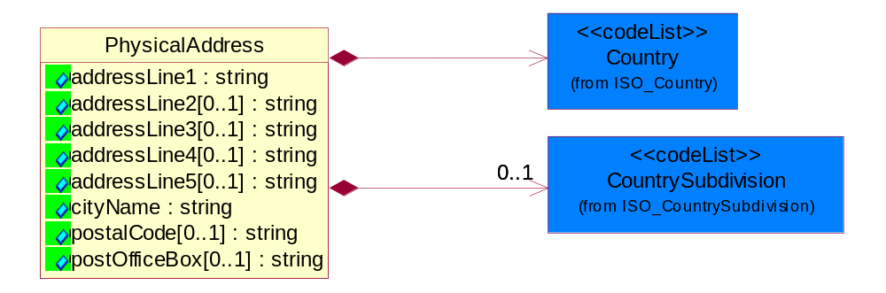
Figure ‎4-27 PhysicalAddress

Attribute | Type | Documentation
addressLine1 | string | The first line of a physical address.
addressLine2[0..1] | string | The second line of a physical address.
addressLine3[0..1] | string | The third line of a physical address.
addressLine4[0..1] | string | The fourth line of a physical address.
addressLine5[0..1] | string | The fifth line of a physical address.
cityName | string | The name of a city.
postalCode[0..1] | string | Identifying geographic location as specified by a national postal code.
postOfficeBox[0..1] | string | The Post Office Box identifier used to identify a party's post office box.

Composition | Cardinality | Type | Documentation
Country | 1 | Country | For representation of Country name RosettaNet has adopted ISO 3166-3; 1999. Refer to the following web page to get the latest version of the standard:  http://www.iso.ch/iso/en/prods-services/iso3166ma/02iso-3166-code-lists/index.html  If you need more information about the ISO standard please contact ISO for more details.
CountrySubdivision | 0..1 | CountrySubdivision | For representation of a Countries subdivisions RosettaNet has adopted ISO 3166-3; 1999. Refer to the following web page to get the latest version of the standard:  http://www.iso.ch/iso/en/prods-services/iso3166ma/02iso-3166-code-lists/index.html  If you need more information about the ISO standard please contact ISO for more details.

MonetaryExpression

FinancialAmount
The business document must express financial amounts.
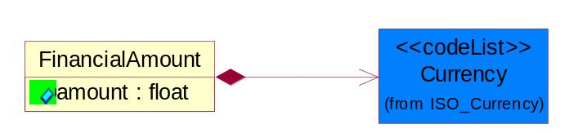
Figure ‎4-28 FinancialAmount

Attribute | Type | Documentation
amount | float | Specifies the monetary amount.

Composition | Cardinality | Type | Documentation
Currency | 1 | Currency | For representation of Currency codes RosettaNet has adopted ISO 4217; 1995. The British Standards Institution (BSI) is the ISO 4217 Maintenance Agency. Refer to the following web page to get the latest version of the standard:  http://www.bsi-global.com/Technical+Information/Publications/_Publications/tig90.xalter  If you need more information about the ISO standard please contact ISO for more details.

PartnerIdentification

FullPartner
The business document must describe the trading partners in the business transaction. This data structure provide the flexibility to describe a partner in all possible methods as for new, existing or known partner.
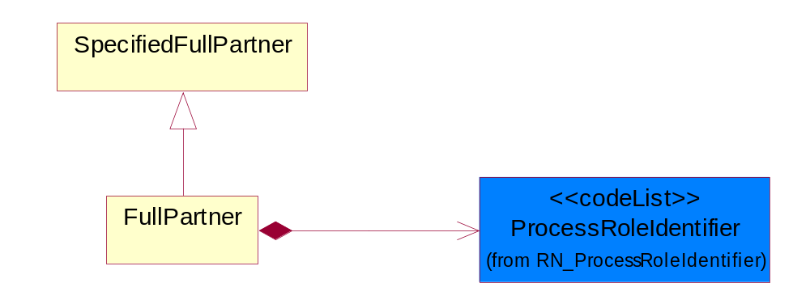
Figure ‎4-29 FullPartner

Composition | Cardinality | Type | Documentation
ProcessRoleIdentifier | 1 | ProcessRoleIdentifier | Describes the role of the partner in the business process. A partner will fulfill at least one or more roles during the business process.

IntermittentPartner
The business document must describe a physical address for a delivery.
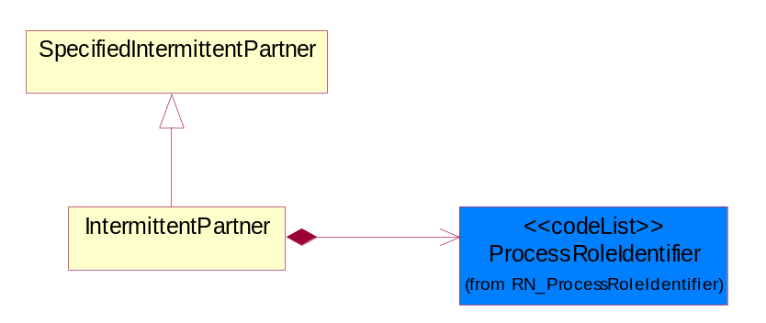
Figure ‎4-30 IntermittentPartner

Composition | Cardinality | Type | Documentation
ProcessRoleIdentifier | 1 | ProcessRoleIdentifier | Describes the role of the partner in the business process. A partner will fulfill at least one or more roles during the business process.

KnownPartner
The business document must describe the trading partners in the business transaction.
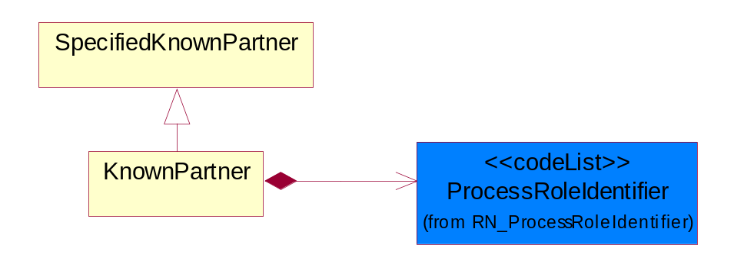
Figure ‎4-31 KnownPartner

Composition | Cardinality | Type | Documentation
ProcessRoleIdentifier | 1 | ProcessRoleIdentifier | Describes the role of the partner in the business process. A partner will fulfill at least one or more roles during the business process.

KnownPartnerContact
The business document must describe the trading partners in the business transaction.
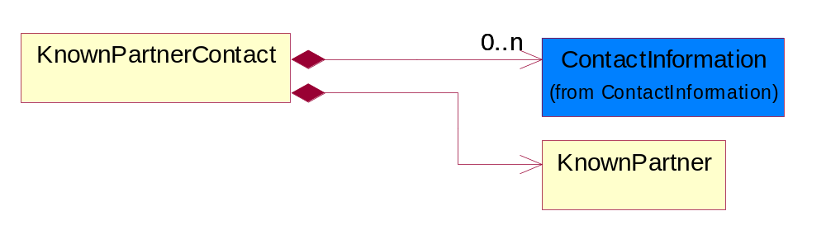
Figure ‎4-32 KnownPartnerContact

Composition | Cardinality | Type | Documentation
ContactInformation | 0..n | ContactInformation | The business document must allow for the identification of the name of the department, service or individual to be contacted regarding the context of the business document.
KnownPartner | 1 | KnownPartner | The business document must describe the trading partners in the business transaction.

NewPartner
The business document must describe a new, existing (but known to only one of the parties to the transaction) or an unknown party to the business transaction.
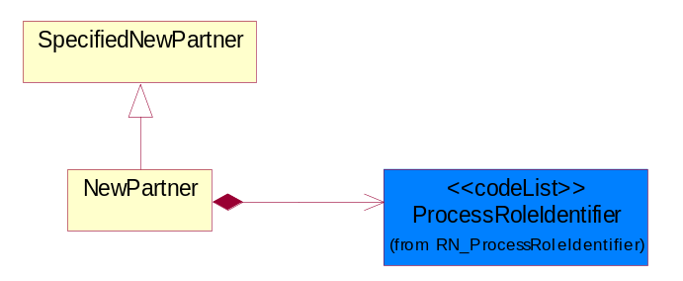
Figure ‎4-33 NewPartner

Composition | Cardinality | Type | Documentation
ProcessRoleIdentifier | 1 | ProcessRoleIdentifier | Describes the role of the partner in the business process. A partner will fulfill at least one or more roles during the business process.

PartnerDescription
The collection of business properties that describe a business partners' identity, their contact information, where they are physically located and their function in a supply chain.
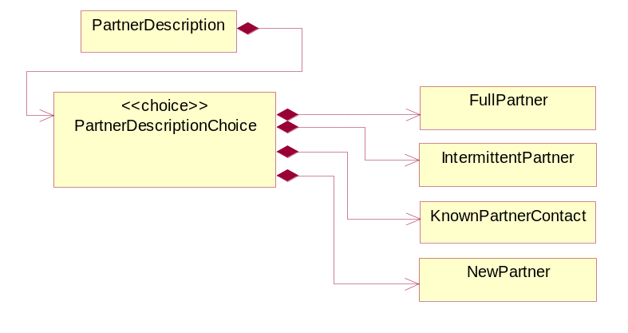
Figure ‎4-34 PartnerDescription

Composition | Cardinality | Type | Documentation
PartnerDescriptionChoice | 1 | PartnerDescriptionChoice

PartnerDescriptionChoice

Composition | Cardinality | Type | Documentation
FullPartner | 1 | FullPartner | The business document must describe the trading partners in the business transaction. This data structure provide the flexibility to describe a partner in all possible methods as for new, existing or known partner.
IntermittentPartner | 1 | IntermittentPartner | The business document must describe a physical address for a delivery.
KnownPartnerContact | 1 | KnownPartnerContact | The business document must describe the trading partners in the business transaction.
NewPartner | 1 | NewPartner | The business document must describe a new, existing (but known to only one of the parties to the transaction) or an unknown party to the business transaction.

PartnerIdentification
The business document must allow for the identity of one or more parties to the transaction.
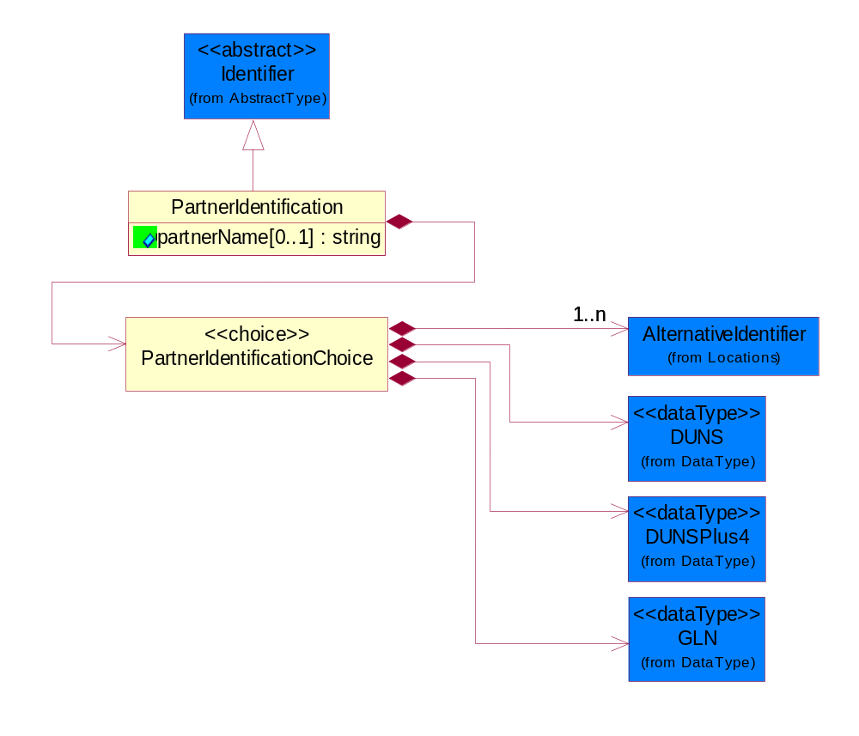
Figure ‎4-35 PartnerIdentification

Attribute | Type | Documentation
partnerName[0..1] | string | The name of the partner’s company/business.

Composition | Cardinality | Type | Documentation
PartnerIdentificationChoice | 1 | PartnerIdentificationChoice

PartnerIdentificationChoice
Composition | Cardinality | Type | Documentation
AlternativeIdentifier | 1..n | AlternativeIdentifier | Identifies the specified code and the name of the organization that a code is utilized from.
DUNS | 1 | DUNS | A number assigned by Dun and Bradstreet to identify a business location.
DUNSPlus4 | 1 | DUNSPlus4 | A identifier to specify a specific location within a business location.
GLN | 1 | GLN | Global Location Number (GLN) - A identifier to identify legal entities, trading parties and location.

SpecifiedFullPartner
The business document must describe the trading partners in the business transaction. This data structure provide the flexibility to describe a partner in all possible methods as for new, existing or known partner. This is specifically for partner who role has been specified.
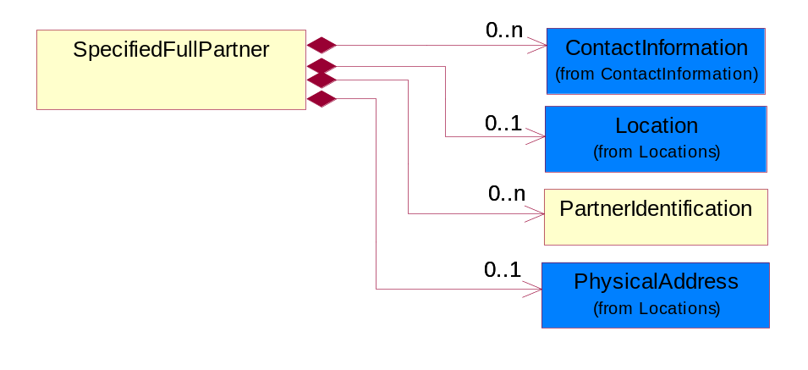
Figure ‎4-36 SpecifiedFullPartner

Composition | Cardinality | Type | Documentation
ContactInformation | 0..n | ContactInformation | The business document must allow for the identification of the name of the department, service or individual to be contacted regarding the context of the business document.
Location | 0..1 | Location | The business document must specify a location.
PartnerIdentification | 0..n | PartnerIdentification | The business document must allow for the identity of one or more parties to the transaction.
PhysicalAddress | 0..1 | PhysicalAddress | The business document must provide a physical address for a party to the business transaction.

SpecifiedIntermittentPartner
The business document must describe a physical address for a delivery.
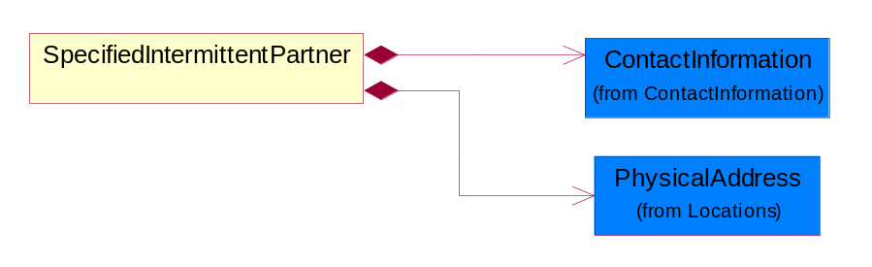
Figure ‎4-37 SpecifiedIntermittentPartner

Composition | Cardinality | Type | Documentation
ContactInformation | 1 | ContactInformation | The business document must allow for the identification of the name of the department, service or individual to be contacted regarding the context of the business document.
PhysicalAddress | 1 | PhysicalAddress | The business document must provide a physical address for a party to the business transaction.

SpecifiedKnownPartner
The business document must describe the trading partners in the business transaction.
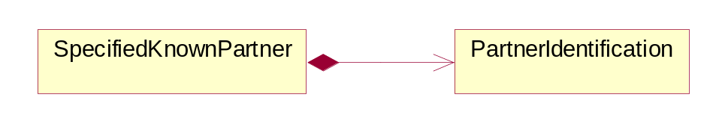
Figure ‎4-38 SpecifiedKnownPartner

Composition | Cardinality | Type | Documentation
PartnerIdentification | 1 | PartnerIdentification | The business document must allow for the identity of one or more parties to the transaction.

SpecifiedNewPartner
The business document must describe a new, existing (but known to only one of the parties to the transaction) or an unknown party to the business transaction.
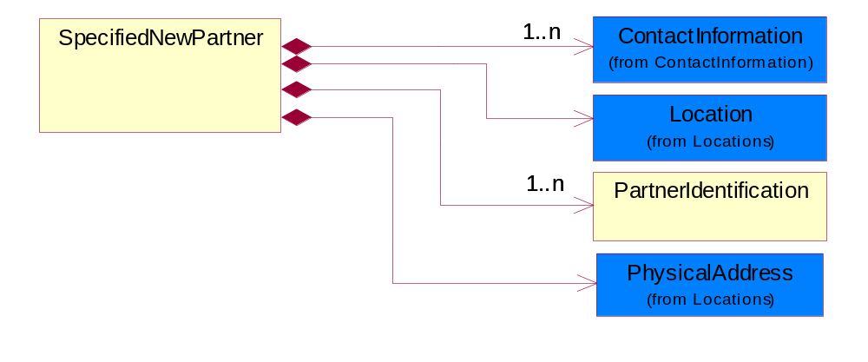
Figure ‎4-39 SpecifiedNewPartner

Composition | Cardinality | Type | Documentation
ContactInformation | 1..n | ContactInformation | The business document must allow for the identification of the name of the department, service or individual to be contacted regarding the context of the business document.
Location | 1 | Location | The business document must specify a location.
PartnerIdentification | 1..n | PartnerIdentification | The business document must allow for the identity of one or more parties to the transaction.
PhysicalAddress | 1 | PhysicalAddress | The business document must provide a physical address for a party to the business transaction.

ProductIdentification

ProductIdentification
The object provides the identifier(s) of a product.
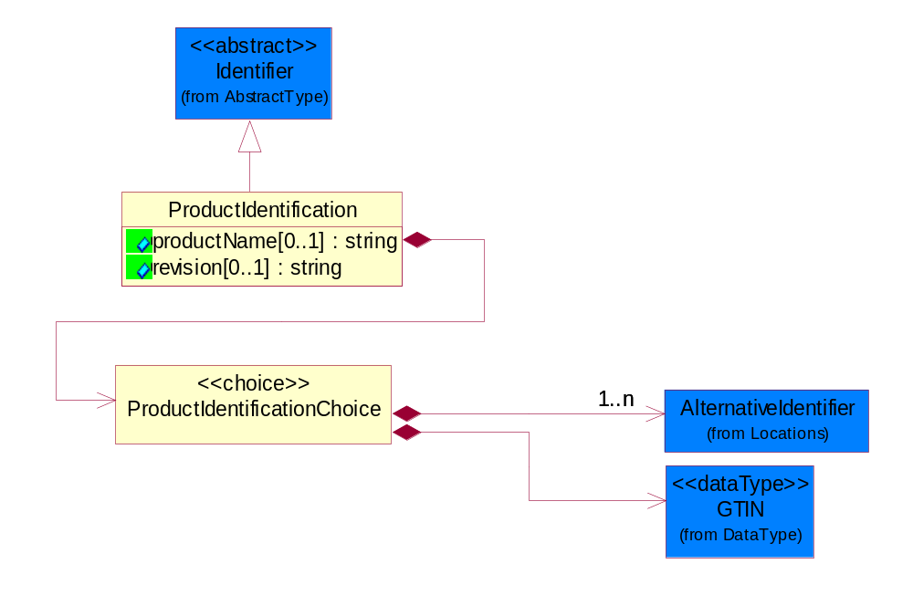
Figure ‎4-40 ProductIdentification

Attribute | Type | Documentation
productName[0..1] | string | The name of the product.
revision[0..1] | string | Referenced the specified product revision.

Composition | Cardinality | Type | Documentation
ProductIdentificationChoice | 1 | ProductIdentificationChoice

ProductIdentificationChoice
Composition | Cardinality | Type | Documentation
AlternativeIdentifier | 1..n | AlternativeIdentifier | Identifies the specified code and the name of the organization that a code is utilized from.
GTIN | 1 | GTIN | Global Trade Identification Number (GTIN).

CodeList

Country
For representation of Country name RosettaNet has adopted ISO 3166-3; 1999. Refer to the following web page to get the latest version of the standard:
http://www.iso.ch/iso/en/prods-services/iso3166ma/02iso-3166-code-lists/index.html

If you need more information about the ISO standard please contact ISO for more details.

CountrySubdivision
For representation of a Countries subdivisions RosettaNet has adopted ISO 3166-3; 1999. Refer to the following web page to get the latest version of the standard:
http://www.iso.ch/iso/en/prods-services/iso3166ma/02iso-3166-code-lists/index.html

If you need more information about the ISO standard please contact ISO for more details.

Currency
For representation of Currency codes RosettaNet has adopted ISO 4217; 1995. The British Standards Institution (BSI) is the ISO 4217 Maintenance Agency. Refer to the following web page to get the latest version of the standard:
http://www.bsi-global.com/Technical+Information/Publications/_Publications/tig90.xalter

If you need more information about the ISO standard please contact ISO for more details.

Language
For representation of Language name RosettaNet has adopted ISO 639-2; 1998. Refer to the following web page to get the latest version of the standard:

http://www.loc.gov/standards/iso639-2/iso639jac.html

If you need more information about the ISO standard please contact ISO for more details.

DocumentType
A code identifying the business context of a document.

Instance | Documentation
ARA | Authorization Request Approval.
CBN | Product batch number of customer.
CCN | Customs clearance number.
CFA | Failure Analysis - Request document that will accompany the product providing characteristics of the component failure.
CIN | Commercial Invoice.
CNM | Traditional credit note or memo.
CON | In a virtual sourcing relationship, a third party trading partner is supplying a part to a customer on behalf of another company that has taken the order for the customer. In this case a Customer Order Number is associated to the request for material that is sent to the virtual trading partners.
COS | Consumption Notice.
COT | Contract.
CRN | Unique consumption reference number identifying the product consumption issue i.e. one-to-one relationship with physical flow.
DEM | Traditional debit note or memo.
DEN | Delivery Note.
DIN | Discontinuation Notice.
DOR | Delivery Order.
DRN | Drawing Number.
DRR | Design Registration Request.
ECO | Engineering Change Order - The proprietary unique identification number that represents an engineering change order.
EIR | Engineering Information Request.
EOL | End of Life.
FUO | Sales order or transfer order fulfilling demand out of a facility (outbound shipment).
INV | Invoice.
LID | Location Identifier. Data for on-site work that have to be done on the machine (associated with preventive maintenance order).
MEN | Master Event Number.
MID | Machine Identifier. Data for on-site work that have to be done on the machine (associated with preventive maintenance order).
MON | Model Number.
OCL | The unique identifier assigned by the OEM for a warranty claim.
OGA | Other governmental agency issued document.
OPO | The unique identifier assigned by the OEM for a part order.
OPR | The unique identifier assigned by the OEM for a part return.
PCN | Product/Process Change.
PFA | Failure Analysis - Request document that will accompany the product providing characteristics of the product failure.
PII | Refers to previously issued invoice.
PLS | Unique number that identifies packing form prior to shipment.
POI | Purchase Order IN.
PON | Production order number for material release.
POO | Purchase Order OUT.
PRC | Product Catalog.
PSI | Refers to previously issued self-billing invoice.
PUO | Purchase Order.
QUO | Quote.
REC | Document identifying the receipt of materials or products into a facility against a purchase order or transfer order (inbound shipment).
REO | Purchase order or transfer order replenishing inventory into a facility (inbound shipment).
REQ | Requisition.
RMA | Returned Material Authorization.
RPO | Purchase order for materials or product returned to and reworked by a supplier.
RTA | Remittance Advice - Remittance details.
SAO | Sales Order.
SBC | Credit Memo used in self-billing scenario.
SBD | Debit Memo used in self-billing scenario.
SBI | Invoice in self billing scenario.
SBN | Product batch number of supplier.
SCA | Similar to contracts - Contains the quantity of an article that is to be ordered from a vendor and the price for article or service that is to be procured.
SEN | Serial Number.
SEO | A document that gives a repair provider the necessary authorization to repair or upgrade a product either at the customer site or at the repair provider’s site.
SHD | Shipping Document.
SNC | Shipset Number on Code List.
SPC | The unique identifier assigned by the ASP for a warranty claim.
SPN | Spec Number.
SPO | The unique identifier assigned by the ASP for a part order.
SPR | The unique identifier assigned by the ASP for a part return.
SPW | The unique identifier assigned by the ASP to reference a work order.
SRI | A document that contains the shipping reference number which allows the product to be tracked within the outsourced logistic providers network.
TRO | Order which results in materials or products being moved from one facility to another (outbound shipment and inbound shipment).
WAB | Waybill.
WAC | Denotes a warranty claim.
WOO | Work Order.

MimeTypeQualifier
The MIME type as defined by IANA.

Please refer to http://www.iana.org/assignments/media-types/ for a list of types.

Instance | Documentation
application/activemessage | [Shapiro]
application/andrew-inset | [Borenstein]
application/applefile | [Faltstrom]
application/atomicmail | [Borenstein]
application/batch-SMTP | [RFC2442]
application/beep+xml | [RFC3080]
application/cals-1840 | [RFC1895]
application/cnrp+xml | [RFCCNRP]
application/commonground | [Glazer]
application/cpl+xml
application/cybercash | [Eastlake]
application/dca-rft | [Campbell]
application/dec-dx | [Campbell]
application/dicom | [RFC3240]
application/dvcs | [RFC3029]
application/EDI-Consent | [RFC1767]
application/EDIFACT | [RFC1767]
application/EDI-X12 | [RFC1767]
application/eshop | [Katz]
application/font-tdpfr | [RFC3073]
application/http | [RFC2616]
application/hyperstudio | [Domino]
application/iges | [Parks]
application/index | [RFC2652]
application/index.cmd | [RFC2652]
application/index.obj | [RFC2652]
application/index.response | [RFC2652]
application/index.vnd | [RFC2652]
application/iotp | [RFC2935]
application/ipp | [RFC2910]
application/isup | [RFC3204]
application/mac-binhex40 | [Faltstrom]
application/macwriteii | [Lindner]
application/marc | [RFC2220]
application/mathematica | [Van Nostern]
application/msword | [Lindner]
application/news-message-id | [RFC1036,Spencer]
application/news-transmission | [RFC1036, Spencer]
application/ocsp-request | [RFC2560]
application/ocsp-response | [RFC2560]
application/octet-stream | [RFC2045,RFC2046]
application/oda | [RFC2045,RFC2046]
application/ogg | [RFC-walleij-ogg-mediatype-08.txt]
application/parityfec | [RFC3009]
application/pdf | [Lindner]
application/pgp-encrypted | [RFC3156]
application/pgp-keys | [RFC3156]
application/pgp-signature | [RFC3156]
application/pkcs10 | [RFC2311]
application/pkcs7-mime | [RFC2311]
application/pkcs7-signature | [RFC2311]
application/pkix-cert | [RFC2585]
application/pkixcmp | [RFC2510]
application/pkix-crl | [RFC2585]
application/postscript | [RFC2045,RFC2046]
application/prs.alvestrand.titrax-sheet | [Alvestrand]
application/prs.cww | [Rungchavalnont]
application/prs.nprend | [Doggett]
application/prs.plucker | [Janssen]
application/qsig | [RFC3204]
application/reginfo+xml | [RFC-ietf-sipping-reg-event-00.txt]
application/remote-printing | [RFC1486,Rose]
application/riscos | [Smith]
application/rtf | [Lindner]
application/sdp | [RFC2327]
application/set-payment | [Korver]
application/set-payment-initiation | [Korver]
application/set-registration | [Korver]
application/set-registration-initiation | [Korver]
application/sgml | [RFC1874]
application/sgml-open-catalog | [Grosso]
application/sieve | [RFC3028]
application/slate | [Crowley]
application/timestamp-query | [RFC3161]
application/timestamp-reply | [RFC3161]
application/tve-trigger | [Welsh]
application/vemmi | [RFC2122]
application/vnd.3gpp.pic-bw-large | [Meredith]
application/vnd.3gpp.pic-bw-small | [Meredith]
application/vnd.3gpp.pic-bw-var | [Meredith]
application/vnd.3gpp.sms | [Meredith]
application/vnd.3M.Post-it-Notes | [O'Brien]
application/vnd.accpac.simply.aso | [Leow]
application/vnd.accpac.simply.imp | [Leow]
application/vnd.acucobol | [Lubin]
application/vnd.acucorp | [Lubin]
application/vnd.adobe.xfdf | [Perelman]
application/vnd.aether.imp | [Moskowitz]
application/vnd.amiga.ami | [Blumberg]
application/vnd.anser-web-certificate-issue-initiation | [Mori]
application/vnd.anser-web-funds-transfer-initiation | [Mori]
application/vnd.audiograph | [Slusanschi]
application/vnd.blueice.multipass | [Holmstrom]
application/vnd.bmi | [Gotoh]
application/vnd.businessobjects | [Imoucha]
application/vnd.canon-cpdl | [Muto]
application/vnd.canon-lips | [Muto]
application/vnd.cinderella | [Kortenkamp]
application/vnd.claymore | [Simpson]
application/vnd.commerce-battelle | [Applebaum]
application/vnd.commonspace | [Chandhok]
application/vnd.contact.cmsg | [Patz]
application/vnd.cosmocaller | [Dellutri]
application/vnd.ctc-posml | [Kohlhepp]
application/vnd.cups-postscript | [Sweet]
application/vnd.cups-raster | [Sweet]
application/vnd.cups-raw | [Sweet]
application/vnd.curl | [Byrnes]
application/vnd.cybank | [Helmee]
application/vnd.data-vision.rdz | [Fields]
application/vnd.dna | [Searcy]
application/vnd.dpgraph | [Parker]
application/vnd.dreamfactory | [Appleton]
application/vnd.dxr | [Duffy]
application/vnd.ecdis-update | [Buettgenbach]
application/vnd.ecowin.chart | [Olsson]
application/vnd.ecowin.filerequest | [Olsson]
application/vnd.ecowin.fileupdate | [Olsson]
application/vnd.ecowin.series | [Olsson]
application/vnd.ecowin.seriesrequest | [Olsson]
application/vnd.ecowin.seriesupdate | [Olsson]
application/vnd.enliven | [Santinelli]
application/vnd.epson.esf | [Hoshina]
application/vnd.epson.msf | [Hoshina]
application/vnd.epson.quickanime | [Gu]
application/vnd.epson.salt | [Nagatomo]
application/vnd.epson.ssf | [Hoshina]
application/vnd.ericsson.quickcall | [Tidwell]
application/vnd.eudora.data | [Resnick]
application/vnd.fdf | [Zilles]
application/vnd.ffsns | [Holstage]
application/vnd.FloGraphIt | [Floersch]
application/vnd.framemaker | [Wexler]
application/vnd.fsc.weblaunch | [D.Smith]
application/vnd.fujitsu.oasys | [Togashi]
application/vnd.fujitsu.oasys2 | [Togashi]
application/vnd.fujitsu.oasys3 | [Okudaira]
application/vnd.fujitsu.oasysgp | [Sugimoto]
application/vnd.fujitsu.oasysprs | [Ogita]
application/vnd.fujixerox.ddd | [Onda]
application/vnd.fujixerox.docuworks | [Taguchi]
application/vnd.fujixerox.docuworks.binder | [Matsumoto]
application/vnd.fut-misnet | [Pruulmann]
application/vnd.grafeq | [Tupper]
application/vnd.groove-account | [Joseph]
application/vnd.groove-help | [Joseph]
application/vnd.groove-identity-message | [Joseph]
application/vnd.groove-injector | [Joseph]
application/vnd.groove-tool-message | [Joseph]
application/vnd.groove-tool-template | [Joseph]
application/vnd.groove-vcard | [Joseph]
application/vnd.hbci | [Hammann]
application/vnd.hhe.lesson-player | [Jones]
application/vnd.hp-HPGL | [Pentecost]
application/vnd.hp-hpid | [Gupta]
application/vnd.hp-hps | [Aubrey]
application/vnd.hp-PCL | [Pentecost]
application/vnd.hp-PCLXL | [Pentecost]
application/vnd.httphone | [Lefevre]
application/vnd.hzn-3d-crossword | [Minnis]
application/vnd.ibm.afplinedata | [Buis]
application/vnd.ibm.electronic-media | [Tantlinger]
application/vnd.ibm.MiniPay | [Herzberg]
application/vnd.ibm.modcap | [Hohensee]
application/vnd.ibm.secure-container | [Tantlinger]
application/vnd.informix-visionary | [Gales]
application/vnd.intercon.formnet | [Gurak]
application/vnd.intertrust.digibox | [Tomasello]
application/vnd.intertrust.nncp | [Tomasello]
application/vnd.intu.qbo | [Scratchley]
application/vnd.intu.qfx | [Scratchley]
application/vnd.irepository.package+xml | [Knowles]
application/vnd.is-xpr | [Natarajan]
application/vnd.japannet-directory-service | [Fujii]
application/vnd.japannet-jpnstore-wakeup | [Yoshitake]
application/vnd.japannet-payment-wakeup | [Fujii]
application/vnd.japannet-registration | [Yoshitake]
application/vnd.japannet-registration-wakeup | [Fujii]
application/vnd.japannet-setstore-wakeup | [Yoshitake]
application/vnd.japannet-verification | [Yoshitake]
application/vnd.japannet-verification-wakeup | [Fujii]
application/vnd.jisp | [Deckers]
application/vnd.kde.karbon | [Faure]
application/vnd.kde.kchart | [Faure]
application/vnd.kde.kformula | [Faure]
application/vnd.kde.kivio | [Faure]
application/vnd.kde.kontour | [Faure]
application/vnd.kde.kpresenter | [Faure]
application/vnd.kde.kspread | [Faure]
application/vnd.kde.kword | [Faure]
application/vnd.kenameaapp | [DiGiorgio-Haag]
application/vnd.koan | [Cole]
application/vnd.liberty-request+xml | [McDowell]
application/vnd.llamagraphics.life-balance.desktop | [White]
application/vnd.lotus-1-2-3 | [Wattenberger]
application/vnd.lotus-approach | [Wattenberger]
application/vnd.lotus-freelance | [Wattenberger]
application/vnd.lotus-notes | [Laramie]
application/vnd.lotus-organizer | [Wattenberger]
application/vnd.lotus-screencam | [Wattenberger]
application/vnd.lotus-wordpro | [Wattenberger]
application/vnd.mcd | [Gotoh]
application/vnd.mediastation.cdkey | [Flurry]
application/vnd.meridian-slingshot | [Wedel]
application/vnd.micrografx.flo | [Prevo]
application/vnd.micrografx.igx | [Prevo]
application/vnd.mif | [Wexler]
application/vnd.minisoft-hp3000-save | [Bartram]
application/vnd.mitsubishi.misty-guard.trustweb | [Tanaka]
application/vnd.Mobius.DAF | [Kabayama]
application/vnd.Mobius.DIS | [Kabayama]
application/vnd.Mobius.MBK | [Devasia]
application/vnd.Mobius.MQY | [Devasia]
application/vnd.Mobius.MSL | [Kabayama]
application/vnd.Mobius.PLC | [Kabayama]
application/vnd.Mobius.TXF | [Kabayama]
application/vnd.mophun.application | [Wennerstrom]
application/vnd.mophun.certificate | [Wennerstrom]
application/vnd.motorola.flexsuite | [Patton]
application/vnd.motorola.flexsuite.adsi | [Patton]
application/vnd.motorola.flexsuite.fis | [Patton]
application/vnd.motorola.flexsuite.gotap | [Patton]
application/vnd.motorola.flexsuite.kmr | [Patton]
application/vnd.motorola.flexsuite.ttc | [Patton]
application/vnd.motorola.flexsuite.wem | [Patton]
application/vnd.mozilla.xul+xml | [McDaniel]
application/vnd.ms-artgalry | [Slawson]
application/vnd.ms-asf | [Fleischman]
application/vnd.mseq | [Le Bodic]
application/vnd.ms-excel | [Gill]
application/vnd.msign | [Borcherding]
application/vnd.ms-lrm | [Ledoux]
application/vnd.ms-powerpoint | [Gill]
application/vnd.ms-project | [Gill]
application/vnd.ms-tnef | [Gill]
application/vnd.ms-works | [Gill]
application/vnd.ms-wpl | [Plastina]
application/vnd.musician | [Adams]
application/vnd.music-niff | [Butler]
application/vnd.netfpx | [Mutz]
application/vnd.noblenet-directory | [Solomon]
application/vnd.noblenet-sealer | [Solomon]
application/vnd.noblenet-web | [Solomon]
application/vnd.novadigm.EDM | [Swenson]
application/vnd.novadigm.EDX | [Swenson]
application/vnd.novadigm.EXT | [Swenson]
application/vnd.obn | [Hessling]
application/vnd.osa.netdeploy | [Klos]
application/vnd.palm | [Peacock]
application/vnd.pg.format | [Gandert]
application/vnd.pg.osasli | [Gandert]
application/vnd.powerbuilder6 | [Guy]
application/vnd.powerbuilder6-s | [Guy]
application/vnd.powerbuilder7 | [Shilts]
application/vnd.powerbuilder75 | [Shilts]
application/vnd.powerbuilder75-s | [Shilts]
application/vnd.powerbuilder7-s | [Shilts]
application/vnd.previewsystems.box | [Smolgovsky]
application/vnd.publishare-delta-tree | [Ben-Kiki]
application/vnd.pvi.ptid1 | [Lamb]
application/vnd.pwg-multiplexed | [RFC3391]
application/vnd.pwg-xhtml-print+xml | [Wright]
application/vnd.Quark.QuarkXPress | [Scheidler]
application/vnd.rapid | [Szekely]
application/vnd.s3sms | [Tarkkala]
application/vnd.sealed.net | [Lambert]
application/vnd.seemail | [Webb]
application/vnd.shana.informed.formdata | [Selzler]
application/vnd.shana.informed.formtemplate | [Selzler]
application/vnd.shana.informed.interchange | [Selzler]
application/vnd.shana.informed.package | [Selzler]
application/vnd.smaf | [Takahashi]
application/vnd.sss-cod | [Dani]
application/vnd.sss-dtf | [Bruno]
application/vnd.sss-ntf | [Bruno]
application/vnd.street-stream | [Levitt]
application/vnd.svd | [Becker]
application/vnd.swiftview-ics | [Widener]
application/vnd.triscape.mxs | [Simonoff]
application/vnd.trueapp | [Hepler]
application/vnd.truedoc | [Chase]
application/vnd.ufdl | [Manning]
application/vnd.uplanet.alert | [Martin]
application/vnd.uplanet.alert-wbxml | [Martin]
application/vnd.uplanet.bearer-choice | [Martin]
application/vnd.uplanet.bearer-choice-wbxml | [Martin]
application/vnd.uplanet.cacheop | [Martin]
application/vnd.uplanet.cacheop-wbxml | [Martin]
application/vnd.uplanet.channel | [Martin]
application/vnd.uplanet.channel-wbxml | [Martin]
application/vnd.uplanet.list | [Martin]
application/vnd.uplanet.listcmd | [Martin]
application/vnd.uplanet.listcmd-wbxml | [Martin]
application/vnd.uplanet.list-wbxml | [Martin]
application/vnd.uplanet.signal | [Martin]
application/vnd.vcx | [T.Sugimoto]
application/vnd.vectorworks | [Pharr]
application/vnd.vidsoft.vidconference | [Hess]
application/vnd.visio | [Sandal]
application/vnd.visionary | [Aravindakumar]
application/vnd.vividence.scriptfile | [Risher]
application/vnd.vsf | [Rowe]
application/vnd.wap.sic | [WAP-Forum]
application/vnd.wap.slc | [WAP-Forum]
application/vnd.wap.wbxml | [Stark]
application/vnd.wap.wmlc | [Stark]
application/vnd.wap.wmlscriptc | [Stark]
application/vnd.webturbo | [Rehem]
application/vnd.wrq-hp3000-labelled | [Bartram]
application/vnd.wt.stf | [Wohler]
application/vnd.wv.csp+wbxml | [Salmi]
application/vnd.xara | [Matthewman]
application/vnd.xfdl | [Manning]
application/vnd.yellowriver-custom-menu | [Yellow]
application/whoispp-query | [RFC2957]
application/whoispp-response | [RFC2958]
application/wita | [Campbell]
application/wordperfect5.1 | [Lindner]
application/x400-bp | [RFC1494]
application/xhtml+xml | [RFC3236]
application/xml | [RFC3023]
application/xml-dtd | [RFC3023]
application/xml-external-parsed-entity | [RFC3023]
application/zip | [Lindner]
audio/32kadpcm | [RFC2421,RFC2422]
audio/AMR | [RFC3267]
audio/AMR-WB | [RFC3267]
audio/basic | [RFC2045,RFC2046]
audio/CN | [RFC3389]
audio/DAT12 | [RFC3190]
audio/DVI4
audio/EVRC | [RFC-ietf-avt-evrc-smv-03.txt]
audio/EVRC0 | [RFC-ietf-avt-evrc-smv-03.txt]
audio/G.722.1 | [RFC3047]
audio/G722
audio/G723
audio/G726-16
audio/G726-24
audio/G726-32
audio/G726-40
audio/G728
audio/G729
audio/G729D
audio/G729E
audio/GSM
audio/GSM-EFR
audio/L16 | [RFC2586]
audio/L20 | [RFC3190]
audio/L24 | [RFC3190]
audio/L8
audio/LPC
audio/MP4A-LATM | [RFC3016]
audio/MPA
audio/mpa-robust | [RFC3119]
audio/mpeg | [RFC3003]
audio/parityfec | [RFC3009]
audio/PCMA
audio/PCMU
audio/prs.sid | [Walleij]
audio/QCELP
audio/RED
audio/SMV | [RFC-ietf-avt-evrc-smv-03.txt]
audio/SMV0 | [RFC-ietf-avt-evrc-smv-03.txt]
audio/telephone-event | [RFC2833]
audio/tone | [RFC2833]
audio/VDVI
audio/vnd.3gpp.iufp | [Belling]
audio/vnd.cisco.nse | [Kumar]
audio/vnd.cns.anp1 | [McLaughlin]
audio/vnd.cns.inf1 | [McLaughlin]
audio/vnd.digital-winds | [Strazds]
audio/vnd.everad.plj | [Cicelsky]
audio/vnd.lucent.voice | [Vaudreuil]
audio/vnd.nortel.vbk | [Parsons]
audio/vnd.nuera.ecelp4800 | [Fox]
audio/vnd.nuera.ecelp7470 | [Fox]
audio/vnd.nuera.ecelp9600 | [Fox]
audio/vnd.octel.sbc | [Vaudreuil]
audio/vnd.qcelp | [Lundblade]
audio/vnd.rhetorex.32kadpcm | [Vaudreuil]
audio/vnd.vmx.cvsd | [Vaudreuil]
image/cgm | Computer Graphics Metafile
image/g3fax | [RFC1494]
image/gif | [RFC2045,RFC2046]
image/ief | [RFC1314] Image Exchange Format
image/jpeg | [RFC2045,RFC2046]
image/naplps | [Ferber]
image/png | [Randers-Pehrson]
image/prs.btif | [Simon]
image/prs.pti | [Laun]
image/t38 | [RFC3362]
image/tiff | [RFC3302] Tag Image File Format
image/tiff-fx | [RFC3250] Tag Image File Format Fax eXtended
image/vnd.cns.inf2 | [McLaughlin]
image/vnd.djvu | [Bottou]
image/vnd.dwg | [Moline]
image/vnd.dxf | [Moline]
image/vnd.fastbidsheet | [Becker]
image/vnd.fpx | [Spencer]
image/vnd.fst | [Fuldseth]
image/vnd.fujixerox.edmics-mmr | [Onda]
image/vnd.fujixerox.edmics-rlc | [Onda]
image/vnd.globalgraphics.pgb | [Bailey]
image/vnd.mix | [Reddy]
image/vnd.ms-modi | [Vaughan]
image/vnd.net-fpx | [Spencer]
image/vnd.svf | [Moline]
image/vnd.wap.wbmp | [Stark]
image/vnd.xiff | [S.Martin]
message/delivery-status | [RFC1894]
message/disposition-notification | [RFC2298]
message/external-body | [RFC2045,RFC2046]
message/http | [RFC2616]
message/news | [RFC 1036, H.Spencer]
message/partial | [RFC2045,RFC2046]
message/rfc822 | [RFC2045,RFC2046]
message/s-http | [RFC2660]
message/sip | [RFC3261]
message/sipfrag | [RFC3420]
model/iges | [Parks]
model/mesh | [RFC2077]
model/vnd.dwf | [Pratt]
model/vnd.flatland.3dml | [Powers]
model/vnd.gdl | [Babits]
model/vnd.gs-gdl | [Babits]
model/vnd.gtw | [Ozaki]
model/vnd.mts | [Rabinovitch]
model/vnd.parasolid.transmit.binary | [Parasolid]
model/vnd.parasolid.transmit.text | [Parasolid]
model/vnd.vtu | [Rabinovitch]
model/vrml | [RFC2077]
multipart/alternative | [RFC2045,RFC2046]
multipart/appledouble | [Faltstrom]
multipart/byteranges | [RFC2068]
multipart/digest | [RFC2045,RFC2046]
multipart/encrypted | [RFC1847]
multipart/form-data | [RFC2388]
multipart/header-set | [Crocker]
multipart/mixed | [RFC2045,RFC2046]
multipart/parallel | [RFC2045,RFC2046]
multipart/related | [RFC2387]
multipart/report | [RFC1892]
multipart/signed | [RFC1847]
multipart/voice-message | [RFC2421,RFC2423]
text/calendar | [RFC2445]
text/css | [RFC2318]
text/directory | [RFC2425]
text/enriched | [RFC1896]
text/html | [RFC2854]
text/parityfec | [RFC3009]
text/plain | [RFC2646,RFC2046]
text/prs.lines.tag | [Lines]
text/rfc822-headers | [RFC1892]
text/richtext | [RFC2045,RFC2046]
text/rtf | [Lindner]
text/sgml | [RFC1874]
text/t140 | [RFC2793]
text/tab-separated-values | [Lindner]
text/uri-list | [RFC2483]
text/vnd.abc | [Allen]
text/vnd.curl | [Byrnes]
text/vnd.DMClientScript | [Bradley]
text/vnd.fly | [Gurney]
text/vnd.fmi.flexstor | [Hurtta]
text/vnd.in3d.3dml | [Powers]
text/vnd.in3d.spot | [Powers]
text/vnd.IPTC.NewsML | [IPTC]
text/vnd.IPTC.NITF | [IPTC]
text/vnd.latex-z | [Lubos]
text/vnd.motorola.reflex | [Patton]
text/vnd.ms-mediapackage | [Nelson]
text/vnd.net2phone.commcenter.command | [Xie]
text/vnd.sun.j2me.app-descriptor | [G.Adams]
text/vnd.wap.si | [WAP-Forum]
text/vnd.wap.sl | [WAP-Forum]
text/vnd.wap.wml | [Stark]
text/vnd.wap.wmlscript | [Stark]
text/xml | [RFC3023]
text/xml-external-parsed-entity | [RFC3023]
video/BMPEG
video/BT656
video/CelB
video/DV | [RFC3189]
video/H261
video/H263
video/H263-1998
video/H263-2000
video/JPEG
video/MP1S
video/MP2P
video/MP2T
video/MP4V-ES | [RFC3016]
video/mpeg | [RFC2045,RFC2046]
video/MPV
video/nv
video/parityfec | [RFC3009]
video/pointer | [RFC2862]
video/quicktime | [Lindner]
video/SMPTE292M | [RFC-avt-smpte292-video-08.txt]
video/vnd.fvt | [Fuldseth]
video/vnd.motorola.video | [McGinty]
video/vnd.motorola.videop | [McGinty]
video/vnd.mpegurl | [Recktenwald]
video/vnd.nokia.interleaved-multimedia | [Kangaslampi]
video/vnd.objectvideo | [Clark]
video/vnd.vivo | [Wolfe]

UnitOfMeasure
Code identifying a product unit of measure.

Instance | Documentation
10P | 10-pack.
1BF | 100 Board Feet.
1FC | 20 Foot Container.
1GR | Gram/Cubic Centimeter.
1GT | 10,000 Gallon Tankcar.
1KB | 25 Kilogram Bulk Bag.
1KD | 10 Kilogram Drum.
1KP | 1000-pack.
1PA | 20-Pack.
1PB | 50 Pound Bag.
1PD | 100 Pound Drum.
2FC | 40 Foot Container.
2GR | Gram/square meter.
2GT | 20,000 Gallon Tankcar.
2KB | 300 Kilogram Bulk Bag.
2KD | 15 Kilogram Drum.
2PA | 100-Pack.
3GR | Grams Per 100 Centimeters.
3KB | 500 Kilogram Bulk Bag.
3KD | 55 Gallon Drum.
4GR | Grams Per 100 Grams.
4KD | 115 Kilogram Drum.
50P | 50-pack.
5GR | Grams Per Cubic Centimeter.
6GR | Grams Per Square Centimeter.
7GR | Grams Per Square Meter.
ACR | Acre.
ACT | Actual Pounds.
ALU | Aluminum Pounds Only.
AMP | Ampere.
ASM | Angstrom.
BAB | Base Box.
BAC | Batch.
BAE | Bale.
BAG | Bag.
BAL | Ball.
BAN | Band.
BAP | Batting Pound.
BAR | Bar.
BAS | Basket.
BAT | Batt.
BAW | Base Weight.
BEA | Beam.
BEC | Becquerel/kilogram.
BEL | Belt.
BIL | Billet.
BIN | Bin.
BIT | Bit.
BKC | Bulk Car Load.
BLO | Block.
BOA | Board.
BOF | Board Feet.
BOL | Bolt.
BOT | Bottle.
BOX | Box.
BRD | Barrels Per Day.
BRE | Barrel.
BRI | Barrel (Imperial).
BRM | Barrels Per Minute.
BTF | British Thermal Units (BTUs) Per Cubic Foot.
BTP | British Thermal Units (BTUs) Per Pound.
BTU | British Thermal Unit (BTU).
BUC | Bucket.
BUD | Bushel, Dry Imperial.
BUK | Bunks.
BUL | Bulk.
BUN | Bundle.
BUP | Bulk Pack.
BUS | Bushel.
BYT | Bytes.
CAA | Carat.
CAB | Carboy.
CAC | Card.
CAD | Candela.
CAG | Cartridge.
CAK | Cask.
CAL | Calorie.
CAN | Can.
CAO | Carload.
CAR | Car.
CAS | Case.
CAT | Canister.
CAW | Catchweight.
CEL | Cell.
CEM | Centimeter.
CEP | Centipoise (CPS).
CET | Centiliter.
CGM | Centigram.
CHA | Chains (Land Survey).
CHE | Chest.
CNN | Connector.
COG | Coil Group.
COI | Coil.
COL | Coulomb.
COM | Composite Product Pounds (Total Weight).
CON | Cone.
COT | Container.
COV | Cover.
CRA | Crate.
CRT | Carton.
CSE | Cassette.
CUB | Cubic centimeter.
CUC | Cubic centimeter/second.
CUF | Cubic Foot.
CUI | Cubic inch.
CUM | Cubicmeter.
CUP | Cup.
CUY | Cubic yard.
CYC | Cycles.
CYL | Cylinder.
DAY | Day.
DCB | Decibels.
DCG | Decagram.
DCL | Deciliter.
DEA | Deal.
DEC | Decimeter.
DEF | Degree Fahrenheit.
DEG | Degree Celsius.
DEP | Dep. Factor.
DGM | Decigram.
DIE | Die.
DIL | Display.
DIP | Dispenser.
DOZ | Dozen.
DRA | Dram.
DRU | Drum.
DRY | Dry Pounds.
EAC | Each.
ELE | Electrical Capacitance.
FAR | Farads.
FFA | Femtofarad.
FLO | Fluid Ounce.
FOI | Fluid Ounce (Imperial).
FOO | Foot.
FOU | Fluid Ounce US.
FUU | Fuel Usage (Gallons).
GAL | Gallon.
GAS | Gage Systems.
GIH | Gigahertz.
GIJ | Gigajoules.
GIL | Gill (Imperial).
GOB | Gross Barrels.
GOG | Gross Gallons.
GOK | Gross Kilogram.
GOT | Gross Ton.
GOY | Gross Yard.
GRA | Gram.
GRG | Great Gross (Dozen Gross).
GRK | Grams Per Kilogram.
GRL | Grams Per Liter.
GRM | Grams Per Milliliter.
GRN | Grain.
GRO | Gross.
GRP | Group.
HAG | Half Gallon.
HAH | Half Hour.
HAL | Half Liter.
HAN | Hank.
HEA | Heat lots.
HEC | Hectare.
HEL | Hectoliter.
HEP | Hectopascal.
HER | Hertz.
HNY | Henry.
HOS | Hours.
HOU | Hour.
HUA | Hundredth of a Carat.
HUB | Hundred Boxes.
HUC | Hundred Count.
HUS | Hundred Sheets.
IMG | Imperial Gallons.
INC | Inch.
JAR | Jar.
JOI | Joint.
JOU | Joule.
KBY | Kilobyte.
KEG | Keg.
KEL | Kelvin.
KHO | Kilometer/hour.
KIC | Kilogram per cubic meter.
KIE | Kilometer.
KIG | Kilogram.
KIH | Kilohertz.
KIK | Kilobecquerel/Kilogram.
KIL | Kiloampere.
KIM | Kilogram/square meter.
KIO | Kiloohm.
KIS | Kilogramm pro Sekunde.
KIT | Kit.
KIV | Kilovolt.
KIW | Kilowatt.
KJL | Kilojoule.
KKG | Kilogram/Kilogram.
KUD | Kubikdezimeter.
KUM | Kubikmeter pro Sekunde.
KWH | Kilowatt-hour.
LIF | Lifts.
LIM | Link.
LIQ | Liquid Pounds.
LIT | Liter.
LOA | Load.
LOT | Lot.
LUG | Lug.
MAM | Milliamps/mm.
MAT | Mat.
MBY | Megabyte.
MCG | Microgram.
MCM | Milligrams Per Cubic Meter.
MCR | Micron.
MEG | Megagram.
MEH | Megahertz.
MEP | Megapascal.
MET | Meter.
MEW | Megawatt.
MGM | Milligram.
MIB | Million BTU's.
MIC | Mikrogram/cubic meter.
MIG | Micrograms Per Cubic Meter.
MIL | Mile.
MIM | Micrometer.
MIN | Minute.
MIP | Millipascal seconds.
MIS | Microsecond.
MIT | Miter.
MIV | Millivolt.
MIW | Milliwatt.
MJO | Millijoule.
MLA | Milliampere.
MLB | Millibar.
MLC | Milligram/cubic meter.
MLI | Milliliter.
MLK | Milligram/kilogram.
MLL | Milligram/Liter.
MLS | Miles.
MME | Millimeter.
MMH | Millimeter H20.
MMK | Millimol/kilogram.
MMO | Millimol.
MOK | Mol/kilogram.
MOL | Mol.
MON | Month.
MPH | Megagrams Per Hour.
MSC | Millisecond.
MSM | Milligrams Per Square Meter.
MTA | Millitesla.
MTQ | Meter pro Quadratsekunde.
MTS | Meters per second.
MUL | Multichip - When 2 or more dies (chips) are merged into one package.
MVS | Millivolts.
MVT | Millivolt.
NAA | Nanoamps.
NAM | Nanometer.
NAS | Nanosecond.
NEB | Net Barrels.
NEG | Net Gallons.
NEI | Net Imperial Gallons.
NEL | Net Liters.
NEW | Newton.
OCT | Ohm/ct.
OHM | Ohm.
OMM | Ohm/mm.
ONE | One.
OSQ | Ohm/sq.
OTP | One Thousand Pieces.
OUN | Ounce.
OVI | Ohm/via.
PAC | Parcel.
PAD | Pad.
PAG | Package.
PAI | Pail.
PAK | Pack (PAK).
PAL | Pallet.
PAN | Panel.
PAR | Pair.
PAS | Pascal.
PAT | Packet.
PEC | Percent.
PEG | Percentage.
PEH | Percent Per 1000 Hours.
PEN | Pennyweight.
PER | Per Hundred Pieces.
PEW | Percent Weight.
PFR | Picofarad.
PID | Pint U.S. Dry.
PIE | Piece.
PIL | Pint - US liquid.
PLA | Plate.
PLL | Pallet (Lift).
PLT | Pallete.
PLU | Pallet/Unit Load.
POF | Pounds Per Foot.
POG | Pounds Per Gallon.
PON | Pound.
POP | Pounds Per Piece of Product.
POS | Pounds Per 1000 Square Feet.
POT | Pounds Per Thousand.
PPB | Parts per billion (US).
PPM | Parts per million.
PPP | Pounds Per Pound of Product.
PSC | Picosecond.
PSS | Pascal second.
QUA | Quart - US liquid.
RAC | Rack.
REA | Ream of 500 Sheets.
REE | Reel.
RIN | Ring.
ROD | Rod.
ROL | Roll.
SAC | Sack.
SBB | Super Bulk Bag.
SEC | Second.
SET | Set.
SHE | Sheet.
SHI | Shipment.
SHM | Sheet - Metric measure.
SHO | Shot.
SID | Disk (Disc).
SKE | Skein.
SKI | Skid.
SLE | Sleeve.
SLI | Slip Sheet.
SMI | Square mile.
SMM | Square millimeter.
SPO | Spool.
SQF | Square foot.
SQI | Square inch.
SQK | Square kilometer.
SQM | Square meter.
SQS | Square meter/second.
SQU | Square.
SQY | Square Yard.
STI | Stick.
STM | Statute Mile.
STR | Strip.
TAB | Tablet.
TAN | Tank.
TAT | Tank Truck.
TES | Tesla.
THO | Thousand.
TNN | Tonne.
TON | Ton.
TOR | Torr.
TOT | Tote.
TRA | Train.
TRF | Track Foot.
TRL | Trailer.
TRO | Troy.
TRU | Truckload.
TRY | Tray.
TRZ | Troy OZ.
TUB | Tube.
ULU | Unitless Unit of Measure.
UNT | Unit.
USG | US gallon.
USP | US pound.
UST | US ton.
VIA | Vial.
VOL | Volt.
VTA | Volts (Alternating Current).
VTD | Volts (Direct Current).
VTM | Volts Per Meter.
WAF | Wafer.
WAR | Watt.
WEE | Week.
WRA | Wrap.
YAR | Yard.
YEA | Year.

ProcessRoleIdentifier
Describes the role of the partner in the business process. A partner will fulfill at least one or more roles during the business process.

Instance | Documentation
ADM | Administered by - The party who is the administrative authority of an account.
ALT | Alternate approval by - The party who has approved a request in the event the approver is not able to respond.
APP | Approval by - The party who has approved a request.
BIF | Bill from - The party that will issue the invoice.
BIT | Bill to - The party that will pay the invoice.
CBK | Customs Broker - CustomsBroker  This object represents the party that declare the shipment on behalf of declarant.
CLM | Claimed By - This object represents the claimant.
CNC | Cancellation party - The party who is canceling the shipping order.
COR | Change originated by - The party who originates a proposed change.
COW | Change owned by - The party who owns or who is assigned responsibility for a proposed change.
CRA | Credit applicant - The party who is applying for credit.
CRE | Created by - The party responsible for creating a process or task.
CSP | Contract Service Provider.
DCE | DesignCustomerApplicationEngineer. The demand customer's Field Application Engineer.
DCT | Declared To - This object represents the party that the declaration goes to.
DCU | DesignCustomer. The owner of the product for which the design has been created.
DIS | Distributed by - The party who supplies products to retailers.
DST | Distributed To - This object represents the party to send information to.
FIN | Financed by - The party who is the financier.
FNB | Founded by - The party who performs the act, process, or art of casting metals.
FOR | Forwarded to - The party to whom a business document has been forwarded.
INL | Inventory location - The party where the inventory product entry is located.
INO | Inventory owner - The party that owns the inventory product entry.
ITF | In transit from - The party sending the product quantity in a product location transfer.
ITT | In transit to - The party receiving the product quantity in a product location transfer.
LGP | Logistics Provided By - The party who handles the details of an operation.
MFG | Manufactured by - The party who creates, processes or produces goods especially in large quantities and by means of industrial machines.
OWN | Owned by - The party who owns a process.
PAE | ProductProviderFieldApplicationEngineer. The product provider Field Application Engineer.
PCW | Primary Contract With - The primary party with whom a contract is formed.
PNB | Planning By - The party who establishes goals, policies or procedures.
PSR | ProductProviderSalesRepresentative. The product provider sales representative.
PUR | Purchased by - The party who is a purchaser of a product.
REA | Requested approval by - The party who has been selected to approve a request.
REC | Received by - The party who has received a product shipment.
REQ | Requested by - The party who has initiated a request.
RES | Respond to - The party to whom a responding business document must be sent when it is not equal to the partner specified in the document header.
RET | Return by - The party responsible for either carrying or forwarding the returned product.
REV | Reviewed by - The party responsible for reviewing a business document.
RLS | Released By - This object represents the party that releases the goods.
RPB | Repaired By - The collection of business properties used to identify the business partner responsible for the repair or  rework of a product.
RTT | ReturnTo - The partner and/or location to which the returned product must be delivered.
SBF | Self-billing from - The party who initiates the billing in self-billing scenario.
SBT | Self-billing to - The party whom the invoice is addressed to.
SCB | Subcontracted By - The party who is contracted to perform part or all of another party's contract.
SCP | Shipping charges paid by - The party responsible for administering payment of the shipping charges.
SCW | Secondary Contract With - The subsequent party(ies) with whom a contract is formed.
SHF | Ship From - The collection of business properties used to identify the business partner initiating a shipment or transaction.
SHT | Ship To - The partner and/or location to which the product must be delivered.
SLD | Sold to - The party to whom a product has been sold.
SOB | Sold By - The seller involved in a business transaction.
SPL | Supplied by - The party who supplies an item, part or assembly.
SPS | Service Provider Site - Identification for the location of the ASP site that is ordering the replacement parts and/or performing the repair.
SRT | Submit returns to - The party to whom product returns are to be submitted.
STR | Stored By - This object represents the party that stores the goods.
SVA | ShipVia - The partner and/or location through which the product must be shipped, such as the "cross dock" at a shipping hub.  It must not be specified for the last leg, since this would be the same as the final destination specified in the ShipmentInformation/shipTo.
TFR | Transfer From - The party responsible for making the payment (Payer).
TRA | Transported by - The party responsible for either carrying or forwarding the product.
TSB | Tested By - The collection of business properties used to identify the specific location and resources used to conduct a defined cycle or steps or measurements required to confirm a result or event.
TTR | Transfer To - The party who is receiving the payment (payee).
ULR | Ultimate recipient - The party who ultimately receives the shipment, when an intermediate party takes responsibility for payment and final delivery.
USE | Used by - The party who is the end user of the product.
UST | Unstuffed By - This object represents the party that unstuffs the goods.
WHB | Warehoused By - The party who stocks or stores products.

System Structure

BusinessProcessIdentifier
A Business Process Identifier to uniquely define the TPIR-PIP 'role' within a Business Scenario at a company or MNC level. The identifier MUST be composed of alphanumeric characters only and its length MUST be between one and twelve characters.
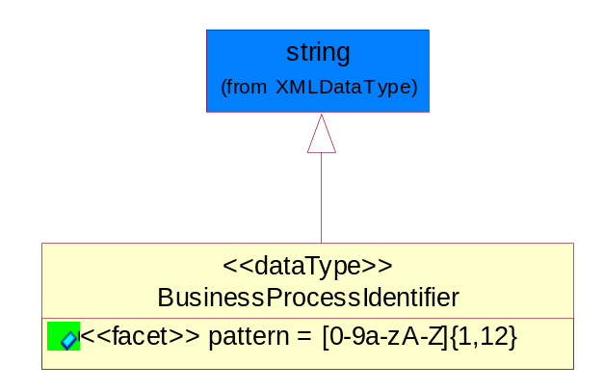
Figure ‎5-41 BusinessProcessIdentifier

Attribute | Type | Documentation
pattern |  | [0-9a-zA-Z]{1,12}

BusinessServiceInformation
The object allows the specification of the business service utilized within the partner company. This may or may not be the same as the information sent by the RNIF.
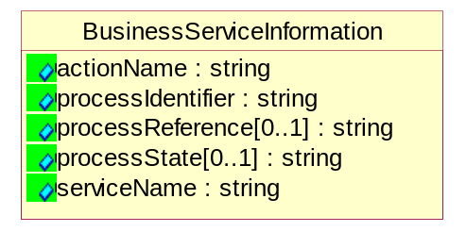
Figure ‎5-42 BusinessServiceInformation

Attribute | Type | Documentation
actionName | string | The name of Action. For RosettaNet usually any of Request/Confirm/Notify/Query/Response.
processIdentifier | string | The name of the PIP e.g. Notify of Forecast Reply.
processReference[0..1] | string | The URN for the PIP that includes Cluster/Segment/Process pattern used to identify the interface process (such as PIP3A4)
processState[0..1] | string | The business process (or service) state of the sender of a document. When a service receives this document, the receiver may use the state as a precondition.
serviceName | string | The name of the Business Activity with the "Request/Confirm" part removed. E.g., for the Activity "Request Purchase Order"==> "Purchase Order".

ContractInformation
A block of information used to correlate a contract in an executing choreography.
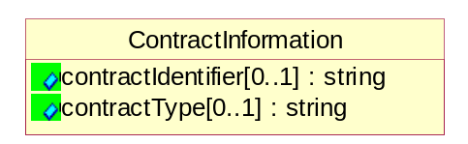
Figure ‎5-43 ContractInformation

Attribute | Type | Documentation
contractIdentifier[0..1] | string | Unique identification of a contract between the Sender and the Receiver
contractType[0..1] | string | The type of the contract: an attribute describing the type of the ContractIndentification. Valid values are URI, URN,ebXMLCPA, or other values defined by partners.

CorrelationInformation
A block of information used to correlate a requesting document to a responding document and to the contract in an executing choreography.
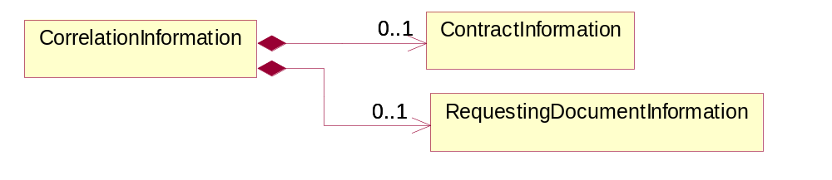
Figure ‎5-44 CorrelationInformation

Composition | Cardinality | Type | Documentation
ContractInformation | 0..1 | ContractInformation | A block of information used to correlate a contract in an executing choreography.
RequestingDocumentInformation | 0..1 | RequestingDocumentInformation | A block of information used to correlate a requesting document to a responding document in an executing choreography.

DocumentHeader
The object allows for the identification of the sender and receiver of the business document.
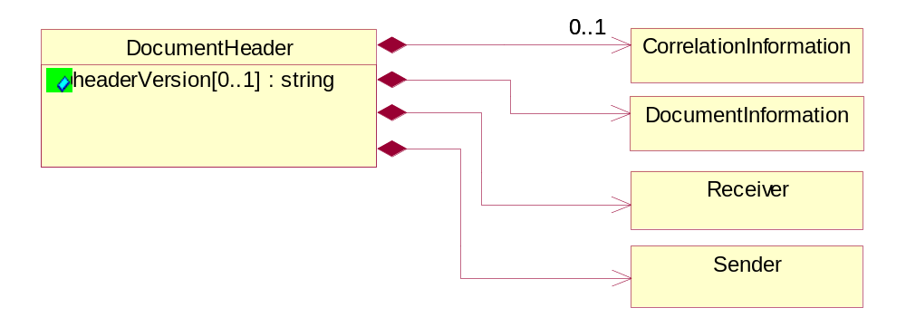
Figure ‎5-45 DocumentHeader

Attribute | Type | Documentation
headerVersion[0..1] | string | The UN/CEFACT version of the document header.

Composition | Cardinality | Type | Documentation
CorrelationInformation | 0..1 | CorrelationInformation | A block of information used to correlate a requesting document to a responding document and to the contract in an executing choreography.
DocumentInformation | 1 | DocumentInformation | The object specifies information to identify the business document, a summary of attachments, and information about the business document security.
Receiver | 1 | Receiver | The object allows the identification of the receiving party of the business message.
Sender | 1 | Sender | The object allows the identification of the initiating party of the business message.

DocumentIdentification
The object specifies all information necessary to identify the business document.
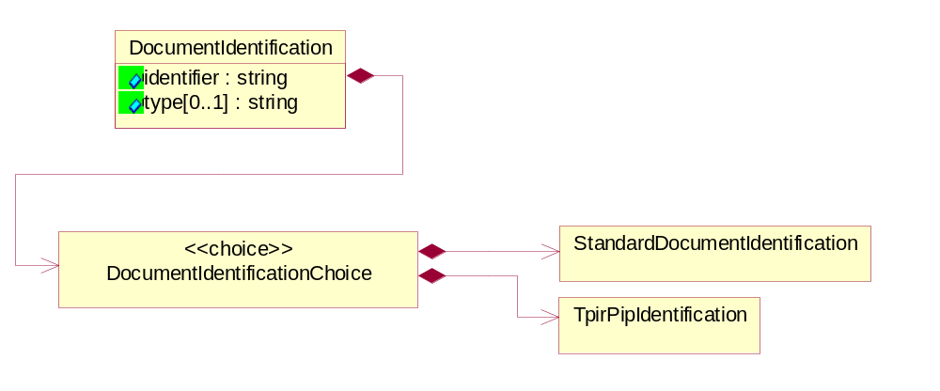
Figure ‎5-46 DocumentIdentification

Attribute | Type | Documentation
identifier | string | The unique identifier for the document being sent.
type[0..1] | string | Name of the Action Message

Composition | Cardinality | Type | Documentation
DocumentIdentificationChoice | 1 | DocumentIdentificationChoice

DocumentIdentificationChoice

Composition | Cardinality | Type | Documentation
StandardDocumentIdentification | 1 | StandardDocumentIdentification | The object specifies additional information necessary to identify the standard business document.
TpirPipIdentification | 1 | TpirPipIdentification | The object specifies all information necessary to uniquely identify a TPIR-PIP within a Registry or trading partner repository.

DocumentInformation
The object specifies information to identify the business document, a summary of attachments, and information about the business document security.
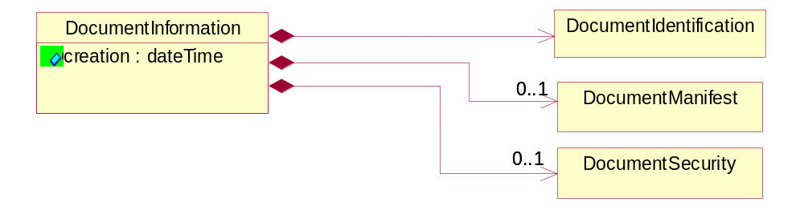
Figure ‎5-47 DocumentInformation

Attribute | Type | Documentation
creation | dateTime | The creation date and time of the specified Business Document (i.e. the Purchase Order date).

Composition | Cardinality | Type | Documentation
DocumentIdentification | 1 | DocumentIdentification | The object specifies all information necessary to identify the business document.
DocumentManifest | 0..1 | DocumentManifest | The block provides a brief summary of attachments and Service Content.
DocumentSecurity | 0..1 | DocumentSecurity | The object provides additional granularity in specifying business document security (this is in addition to the specified PIP security).

DocumentManifest
The block provides a brief summary of attachments and Service Content.
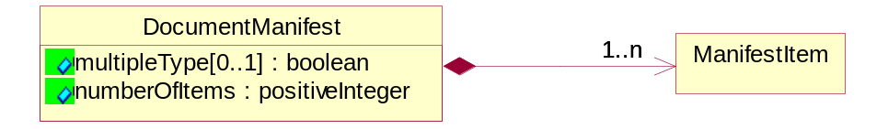
Figure ‎5-48 DocumentManifest

Attribute | Type | Documentation
multipleType[0..1] | boolean | Indicates whether the manifest contains documents of multiple types. True if yes, and False if no.
numberOfItems | positiveInteger | Total number of documents in the message. The physical count of the attachments in the payload plus the RosettaNet Business Message (for Service Content). The value of this field will be at least 1.

Composition | Cardinality | Type | Documentation
ManifestItem | 1..n | ManifestItem | The object provides details about the specific attachment(s).

DocumentSecurity
The object provides additional granularity in specifying business document security (this is in addition to the specified PIP security).
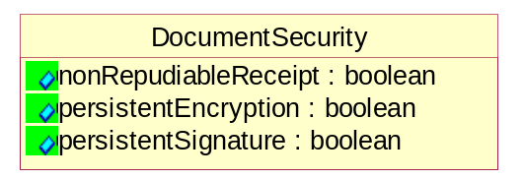
Figure ‎5-49 DocumentSecurity

Attribute | Type | Documentation
nonRepudiableReceipt | boolean | The value "true" will indicate that a signed acknowledgement for the business document is necessary.
persistentEncryption | boolean | The value "true" will indicate that the Business Document (including the header) needs to be encrypted when stored or transported.
persistentSignature | boolean | The value "true" will indicate that a signature is required to be stored with the document while stored or transported.

ManifestItem
The object provides details about the specific attachment(s).
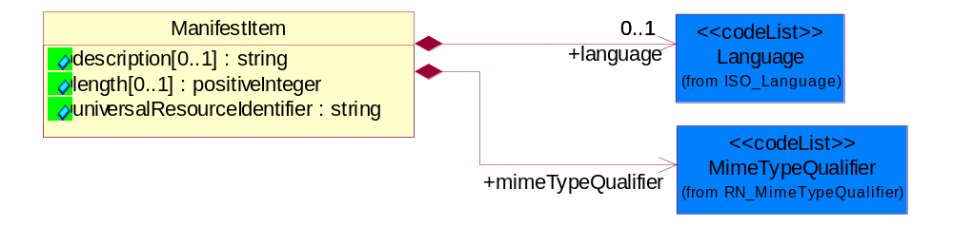
Figure ‎5-50 ManifestItem

Attribute | Type | Documentation
description[0..1] | string | A description of the attachment.
length[0..1] | positiveInteger | The size of the attachment in bytes (i.e. 1 000 000 bytes)
universalResourceIdentifier | string | The generic set of all names/addresses that are short strings that refer to resources.

Composition | Cardinality | Type | Documentation
language | 0..1 | Language | For representation of Language name RosettaNet has adopted ISO 639-2; 1998. Refer to the following web page to get the latest version of the standard:  http://www.loc.gov/standards/iso639-2/iso639jac.html  If you need more information about the ISO standard please contact ISO for more details.
mimeTypeQualifier | 1 | MimeTypeQualifier | The MIME type as defined by IANA.  Please refer to http://www.iana.org/assignments/media-types/ for a list of types.

PipIdentifier
PIP Identification.[ i.e. PIP3A4]
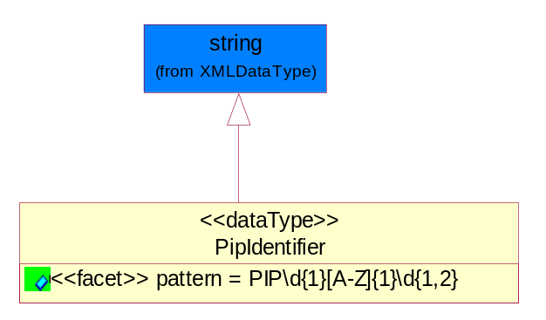
Figure ‎5-51 PipIdentifier

Attribute | Type | Documentation
pattern |  | PIP\d{1}[A-Z]{1}\d{1,2}

PipVersion
PIP version number (i.e. 02.02.00).
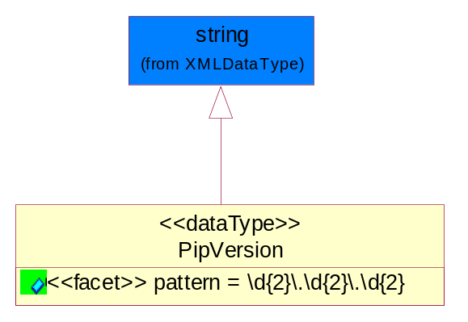
Figure ‎5-52 PipVersion

Attribute | Type | Documentation
pattern |  | \d{2}\.\d{2}\.\d{2}

Receiver
The object allows the identification of the receiving party of the business message.
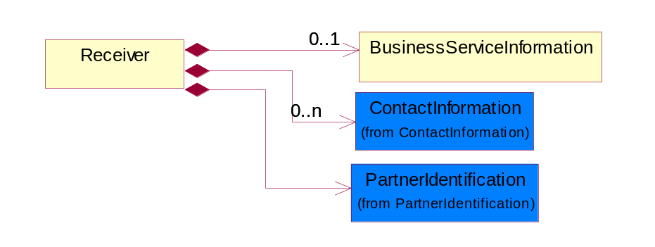
Figure ‎5-53 Receiver

Composition | Cardinality | Type | Documentation
BusinessServiceInformation | 0..1 | BusinessServiceInformation | The object allows the specification of the business service utilized within the partner company. This may or may not be the same as the information sent by the RNIF.
ContactInformation | 0..n | ContactInformation | The business document must allow for the identification of the name of the department, service or individual to be contacted regarding the context of the business document.
PartnerIdentification | 1 | PartnerIdentification | The business document must allow for the identity of one or more parties to the transaction.

RequestingDocumentInformation
A block of information used to correlate a requesting document to a responding document in an executing choreography.
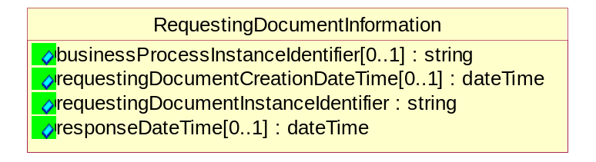
Figure ‎5-54 RequestingDocumentInformation

Attribute | Type | Documentation
businessProcessInstanceIdentifier[0..1] | string | The identifier for the public business process instance being sent that both the sender and receiver can identify.
requestingDocumentCreationDateTime[0..1] | dateTime | The date-time of the requesting business document.
requestingDocumentInstanceIdentifier | string | The Business Document identification number that identifies the requesting Business Document.
responseDateTime[0..1] | dateTime | The expected time to receive the response. This can not be greater than the PIP TimeToPerform.

Sender
The object allows the identification of the initiating party of the business message.
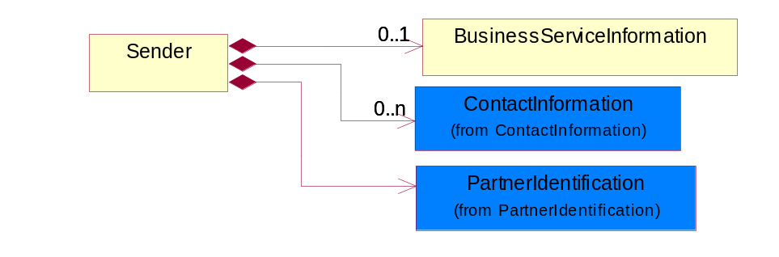
Figure ‎5-55 Sender

Composition | Cardinality | Type | Documentation
BusinessServiceInformation | 0..1 | BusinessServiceInformation | The object allows the specification of the business service utilized within the partner company. This may or may not be the same as the information sent by the RNIF.
ContactInformation | 0..n | ContactInformation | The business document must allow for the identification of the name of the department, service or individual to be contacted regarding the context of the business document.
PartnerIdentification | 1 | PartnerIdentification | The business document must allow for the identity of one or more parties to the transaction.

StandardDocumentIdentification
The object specifies additional information necessary to identify the standard business document.
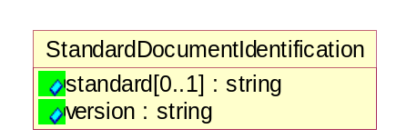
Figure ‎5-56 StandardDocumentIdentification

Attribute | Type | Documentation
standard[0..1] | string | Identifies the standard used to submit the business document. (e.g. RosettaNet).
version | string | PIP3A4v01.00

TpirPipIdentification
The object specifies all information necessary to uniquely identify a TPIR-PIP within a Registry or trading partner repository.
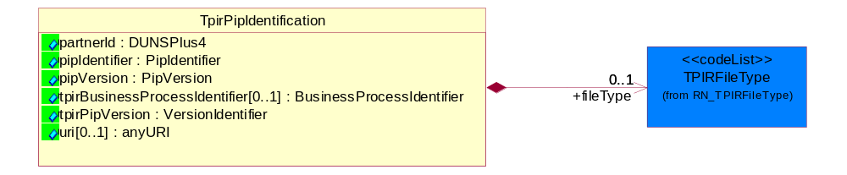
Figure ‎5-57 TpirPipIdentification

Attribute | Type | Documentation
partnerId | DUNSPlus4 | The Trading Partner Identification of MNC that is creating this TPIR PIP.
pipIdentifier | PipIdentifier | A TPIR PIP Identification [i.e., 3A4 ).
pipVersion | PipVersion | A TPIR PIP version number (i.e., 02.02.00)
tpirBusinessProcessIdentifier[0..1] | BusinessProcessIdentifier | A Business Process Identifier to uniquely define the TPIR-PIP 'role' within a Business Scenario at a company or MNC level. The identifier MUST be composed of alphanumeric characters only and its length MUST be between one and twelve characters.
tpirPipVersion | VersionIdentifier | A TPIR-PIP Version Number (i.e., major and minor version number as XX.XX).
uri[0..1] | anyURI | Describes the destination uri for the TPIR form.

Composition | Cardinality | Type | Documentation
fileType | 0..1 | TPIRFileType | Describes the file type of the TPIR form (PDF, XDP or XML).

VersionIdentifier
Version Number (i.e., major and minor version number as XX.XX).
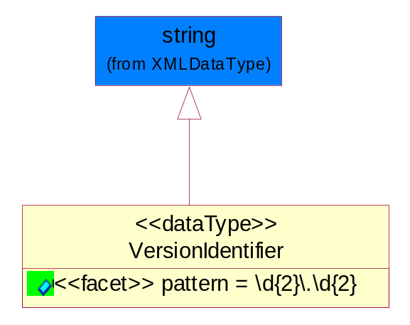
Figure ‎5-58 VersionIdentifier

Attribute | Type | Documentation
pattern |  | \d{2}\.\d{2}

CodeList

TPIRFileType
A code identifying the file type of TPIR form.

Name | Documentation
PDF | Portable Document Format.
XDP | XML Data Package.
XML | eXtensible Markup Language.

XML Data Type

anyURI
Represents a URI as defined by RFC 2396. An anyURI value can be absolute or relative, and may have an optional fragment identifier.

boolean
Represents Boolean values, which are either "true" or "false".

date
For the represents a calendar date.
The pattern for a date is CCYY-MM-DD where CC represents the century, YY the year, MM the month, and DD the day, with an optional time zone indicator as allowed for dateTime.

dateTime
Represents a specific instance of time.
The pattern for dateTime is CCYY-MM-DDThh:mm:ss where CC represents the century, YY the year, MM the month, and DD the day, preceded by an optional leading negative (-) character to indicate a negative number. If the negative character is omitted, positive (+) is assumed. The T is the date/time separator and hh, mm, and ss represent hour, minute, and second respectively. Additional digits can be used to increase the precision of fractional seconds if desired. For example, the format ss.ss... with any number of digits after the decimal point is supported. The fractional seconds part is optional.
This representation may be immediately followed by a "Z" to indicate Coordinated Universal Time (UTC) or to indicate the time zone. For example, the difference between the local time and Coordinated Universal Time, immediately followed by a sign, + or -, followed by the difference from UTC represented as hh:mm (minutes is required). If the time zone is included, both hours and minutes must be present.

float
Represents single-precision 32-bit floating-point numbers.

positiveInteger
Represents an integer that is greater than zero. This data type is derived from nonNegativeInteger.

string
Represents character string.

time
Represents an instance of time that recurs every day.
The pattern for time is hh:mm:ss.sss with optional time zone indicator.

