

Description of
Partner Interface Process® for 4D1

Validated 11.00.00

Specification Information
Name | Notify Of Material Release
Cluster | Inventory Management
Segment | Inventory Replenishment
Publication Date | 08 July 2008
Version Identifier | V11.00

Table of Contents
1 Document Management 4
1.1 Legal Disclaimer 4
1.2 Copyright 4
1.3 Trademarks 4
1.4 Related Documents 4
1.5 Document Version History 4
1.6 Document Structure 4
2 Business Process 5
2.1 Business Process Definition 5
2.1.1 Non-Consignment 5
2.1.2 Consignment 5
2.2 PIP Scope Description 5
2.3 PIP Business Document 6
2.4 PIP Business Process Flow Diagram 6
2.5 PIP Start State 7
2.6 PIP End States 7
2.7 Partner Role Description 8
2.8 Business Process Activity Controls 8
3 Network and Implementation Specification 9
3.1 Business Action and Business Signal Specifications 9
3.2 Business Transaction Dialog Specification 9
3.2.1 Message Exchange Controls 10
3.2.2 Communications Specification 10

List of Figures:
Figure 1: Activity Diagram of Notify Of Material Release 6
Figure 2: Sequence Diagram of Notify Of Material Release 9

List of Tables:
Table 1: PIP Business Document 6
Table 2: PIP Start State 7
Table 3: PIP End State 7
Table 4: PIP Failure State 7
Table 5: Partner Role Description 8
Table 6: Business Activity Description 8
Table 7: Business Activity Performance Control 8
Table 8: Network Component Specification 9
Table 9: Business Action – Business Document Mapping 9
Table 10: Message Exchange Control 10
Table 11: Dialog: Service-Service 10

Document Management

Legal Disclaimer
RosettaNet™, its members, officers, directors, employees, or agents shall not be liable for any injury, loss, damages, financial or otherwise, arising from, related to, or caused by the use of this document or the specifications herein, as well as associated guidelines and schemas. The use of said specifications shall constitute your express consent to the foregoing exculpation.

Copyright
©2008 RosettaNet. All rights reserved. No part of this publication may be reproduced, stored in a retrieval system, or transmitted, in any form or by any means, electronic, mechanical, photocopying, recording, or otherwise, without the prior written permission of the publisher. Printed in the United States of America.

Trademarks
RosettaNet, Partner Interface Process, PIP and the RosettaNet logo are trademarks or registered trademarks of "RosettaNet," a non-profit organization. All other product names and company logos mentioned herein are the trademarks of their respective owners. In the best effort, all terms mentioned in this document that are known to be trademarks or registered trademarks have been appropriately recognized in the first occurrence of the term.

Related Documents
- Associated PIP Message Schemas (included within the PIP Specification package only)
- Description of 4D1 Message
- Messages Structure
- XML instance of ebXML BPSS for PIP 4D1

Document Version History
Version | Date | Description
Validated 11.00.00 | 08 July 2008 | Validated Version : RosettaNet Schema to Market to Validation 2008

Document Structure
A Partner Interface Process (PIP) Specification is comprised of the following two parts:
- Business Process. Captures the semantics of the business process and the flow of the message exchange between roles as they perform business activities.
- Network and Implementation Specification. Specifies the network protocol message formats and communications requirements between peer-protocols supported by network components in the RosettaNet Implementation Framework.

Business Process

Business Process Definition
The "Notify of Material Release" Partner Interface Process™ (PIP) supports the release of orderable product to a delivery location. The release of product is separate from the forecast data. This process may be used in either a non-consignment or consignment scenario. The Material Release identifies product quantities within the replenishment horizon to be shipped to the delivery location. A material release number or purchase orders number is referenced in the material release. The decision to release materials belongs solely to the customer.

Non-Consignment
In this process, the supplier/vendor builds product based upon a demand forecast. RosettaNet PIP 4A4 Notify of Planning Release Forecast supports the demand forecasting process. The supplier’s ships product to the delivery location upon receipt of a Notify of Material Release from the customer. In the exchange of RosettaNet PIP 4D1, the supplier/vendor is the material release information user and the customer is the material release information provider.

Consignment
In this process, the supplier/vendor builds and ships product to a consigned location based upon receipt of a demand forecast and the subsequent calculation of replenishment requirements. RosettaNet PIP 4A3 Notify of Threshold Release Forecast supports this process. The consignment warehouse manager ships product to the delivery location upon receipt of a Notify of Material Release. The consignment warehouse manager may be the supplier, a 3rd party logistics provider, or even the customer and is responsible for managing inventory shipments prior to receipt of material releases. In the exchange of RosettaNet PIP 4D1, the consignment warehouse manager is the material release information user and the customer is the material release information provider.

PIP Scope Description
The purpose of this PIP is to enable a customer to request material shipment to a customer delivery location using a trigger separate from a forecast.

PIP Business Document
Business Document are generated and exchanged by roles performing activities in this PIP. Business Document is listed and defined in Table 1.
Table 1: PIP Business Document
Business Document | Description
Material Release Notification | Contains product identifier, quantity, delivery location, date(s), purchase order or contractual reference and material release reference number.

PIP Business Process Flow Diagram
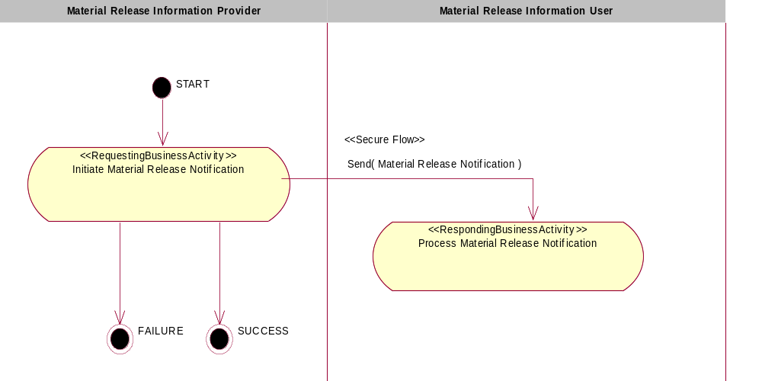

Figure 1: Activity Diagram of Notify Of Material Release

PIP Start State
The start state is comprised of the following conditions:
Table 2: PIP Start State
 | Approved | Exist |  | Valid | Non-Repudiated | Retry Count | Authorized
 | Approved | Party | In Backend System
TPA |  |  | 
Sending Partner |  |  |  | 
Receiving Partner |  | 
Business Document |  |  |  |  | 

PIP End State
The end state is comprised of the following conditions:
Table 3: PIP End State
 | Approved | Exist |  | Valid | Non-Repudiated | Retry Count | Authorized
 | Approved | Party | In Backend system
Acknowledgment of Receipt |  |  |  |  | 
Receiving Partner |  |  |  |  |  |  | 

The PIP failure state is comprised of one or more of the following conditions
Table 4: PIP Failure State
 | NO | Exceeded
Success | 
Retry Count |  | 

Partner Role Description
Table 5 describes the partner roles in this PIP:
Table 5: Partner Role Description
Role Name | Role Description
Material Release Information Provider | The party that creates and sends material release to Material Release Information User. (e.g.: Supplier)
Material Release Information User | The party that requires material release information from the Material Release Information Provider (e.g.: Customer) to manage shipments.

Business Process Activity Control
Table 6 describes the interaction between roles performing business activity in this PIP.
Table 6: Business Activity Description
Role Name |  | Activity Name |  | Activity Description
Material Release Information Provider | Initiate Material Release Notification |  | A material Release Information Provider sends a Material Release Notification to a Material Release Information User. The Material Release Notification contains replenishment requirements, includes product identification quantities, ship dates, and may include manufacturing lot and date code information.

Table 7 details the security, audit and process controls relating to activity performed in the PIP.
Table 7: Business Activity Performance Control
Role  Name | Activity  Name | Acknowledgment  of Receipt |  | Time to Perform | Retry Count | Is Authorization Required? | Non-Repudiation of Origin and Content?
Role  Name | Activity  Name | Non-Repudiation Required? | Time to Acknowledge
Material release Information Provider | Initiate Material Release Notification | Y | 2hrs | N/A | 3 | Y | Y

Network and Implementation Specification
Each network component maps into a role of the PIP model. Table 8 specifies the mapping between roles and network components.
Table 8: Network Component Specification
Network Component | Classification | Maps to Role in Business Process
Material Release Information Provider Service | Business Service | Material Release Information Provider
Material Release Information User Service | Business Service | Material Release Information User

Business Action and Business Signal Specifications
Each business action maps to a Business Document of the PIP model. Table 9 specifies the mapping between Business Documents and business actions.
Table 9: Business Action – Business Document Mapping
Business Action | Business Document | Document Function
Material Release Notification Action | Material Release Notification | Request

Business Transaction Dialog Specification
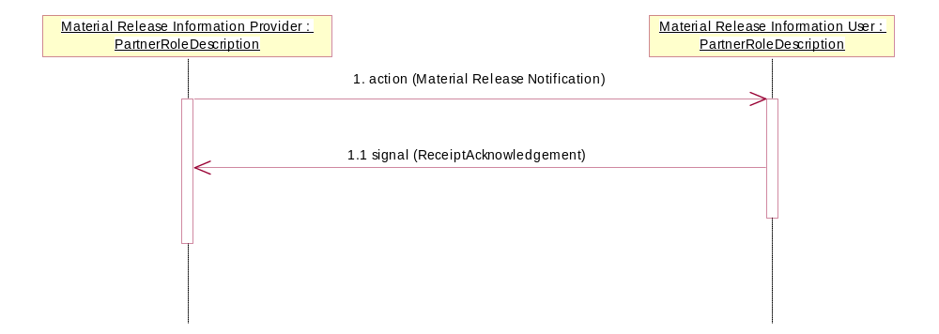

Figure 2: Sequence Diagram of Notify Of Material Release

Message Exchange Control
Table 10: Message Exchange Control
# | Name |  | Time to Acknowledge Receipt Signal |  | Time to Respond to Action |  | Included in Time to Perform | Is Authorization Required? | Is Non-Repudiation Required? | Is Secure Transport Required?
1. |  | Material Release Notification Action |  | 2hrs |  | N/A | N/A | Y | Y | Y
1.1. |  | Receipt Acknowledgment |  | N/A |  | N/A | N/A | Y | Y | Y

Communications Specification
Table 11: Dialog: Service-Service
# | Business Message | Digital Signature Required? | SSL Required?
1. | Material Release Notification | Y | Y
1.1. | Receipt Acknowledgment | Y | Y

