

Description of
Partner Interface Process®
for 4E1
Validated 11.00.00

Specification Information
Name | Notify of Sales Report
Cluster | Inventory Management
Segment | Sales Reporting
Publication Date | 17 July 2006
Version Identifier | V11.00

Table of Contents
1 Document Management 4
1.1 Legal Disclaimer 4
1.2 Copyright 4
1.3 Trademarks 4
1.4 Acknowledgments 4
1.5 Related Documents 5
1.6 Document Version History 5
1.7 Document Structure 5
2 Business Process 6
2.1 Business Process Definition 6
2.1.1 Executive Summary 6
2.1.2 Business Process Description 7
2.1.3 Business Process Context Diagram 8
2.2 PIP Scope Description 8
2.2.1 Business Process Scope Diagram 9
2.3 PIP Business Documents 10
2.4 PIP Business Process Flow Diagram 10
2.5 PIP Start State 11
2.6 PIP End States 11
2.7 Partner Role Descriptions 12
2.8 Business Process Activity Controls 12
3 Network and Implementation Specification 13
3.1 Business Action and Business Signal Specification 13
3.2 Business Transaction Dialog Specification 13
3.2.1 Message Exchange Controls 14
3.2.2 Communications Specification 14

List of Figures:
Figure 1: High-level Context Diagram 7
Figure 2: Sales Reporting Context Diagram 8
Figure 3: Notify of Sales Report 9
Figure 4: Notify of Sales Report Interactions: Service-Service 12

List of Tables:
Table 1: PIP Business Documents 9
Table 2: PIP Start State 10
Table 3: PIP End State 10
Table 4: PIP Failure State 10
Table 5: Partner Role Descriptions 11
Table 6: Business Activity Descriptions 11
Table 7: Business Activity Performance Controls 11
Table 8: Network Component Specification 12
Table 9: Business Action – Business Document Mapping 12
Table 10: Message Exchange Controls - Notify of Sales Report 13
Table 11: Sales Report Notification Dialog: Service-Service 13

Document Management
  - Legal Disclaimer
RosettaNet™, its members, officers, directors, employees, or agents shall not be liable for any injury, loss, damages, financial or otherwise, arising from, related to, or caused by the use of this document or the specifications herein, as well as associated guidelines and schemas. The use of said specifications shall constitute your express consent to the foregoing exculpation.
  - Copyright
©2006 RosettaNet. All rights reserved. No part of this publication may be reproduced, stored in a retrieval system, or transmitted, in any form or by any means, electronic, mechanical, photocopying, recording, or otherwise, without the inclusion of this copyright notice. Any derivative works must cite the copyright notice. Any public redistribution or sale of this publication or derivative works requires prior written permission of the publisher.
  - Trademarks
RosettaNet, Partner Interface Process, PIP® and the RosettaNet logo are trademarks or registered trademarks of "RosettaNet," a non-profit organization. All other product names and company logos mentioned herein are the trademarks of their respective owners. In the best effort, all terms mentioned in this document that are known to be trademarks or registered trademarks have been appropriately recognized in the first occurrence of the term.
  - Acknowledgments
This document has been prepared by RosettaNet (http://www.rosettanet.org/) from requirements gathered during the Milestone Program and in conformance with the methodology. Listed below are the legal entities that contributed to the design and development of this PIP.
BCM Electronics | Cisco
Cisco Systems | Electronics Industry Data Exchange Association (EIDX)
Hewlett Packard | Hewlett-Packard GmbH
HP | Globetronics SDH. BHD
GridNode | GridNode, Inc.
GridNode Pte. Ltd. | IBM
Intel | Intel Corp.
Intel Corp (UK) LTD | Intel Corporation
International Business Machines | MIMOS Berhad
Motorola | Motorola Semiconductor Sector
Motorola SPS | Nokia
Nokia Oyj | Philips Semiconductors
Seagate Technology | Sterling Commerce
  - Related Documents
- Associated PIP Message Schemas (included with PIP Specification only)
  - Document Version History
Version | Date | Description
Validated 11.00.00 | 17 July 2006 | Validated PIP Specification
  - Document Structure
A Partner Interface Process (PIP) Specification is comprised of the following two parts:
- Business Process. Captures the semantics of the business process and the flow of the message exchange between roles as they perform business activities.
- Network and Implementation Specification. Specifies the network protocol message formats and communications requirements between peer-protocols supported by network components in the RosettaNet Implementation Framework.

Business Process
  - Business Process Definition
Sales Reporting is a process of transmitting sale-out information from single or multiple points in the sales supply chain. The recipient of this information uses it for supply chain optimization, revenue recognition, special pricing claims, buyer/seller activity evaluation, distributors/resellers coverage area qualification and sales staff compensation. Recipient may acknowledge a sales report for data discrepancies found and/or special pricing confirmation.

Executive Summary
Currently, the originators of the data are being requested to send sales report in various formats. Extracting this data and then formatting the data in a different way depending on who the recipient is creates overhead, delays the sending of the information, increases the time to publish the information and often requires manual intervention thus leading to errors.
Depending on existing data exchange protocols, recipients of the information may spend unnecessary time to prepare the received data from the many partners such that it is able to flow into their ERP systems. Often the data is incomplete as during the course of the process some partners have issues preparing the information before sending it to the recipient.
Managing the manual process in weekly cycles is already flawed; as costs in the industry continue to be reviewed the need for more frequent cycles is required but hindered due to the ineffective methods used to exchange data. In addition, the need to penetrate further down the sales chain is an increasing requirement, managing the data manually and in many formats is impractical as the partner activity expands.
Information required to manage business could be inaccurate and delayed. This results in:
- Inaccurate inventory calculations hence over/under stated financial reserves
- Delayed payments to the partners for rebates and credits
- Inaccurate decision made on market conditions
- Inaccurate and delayed calculations of sales compensation.
Sales Reporting aims to design a standard process for notifying and acknowledging Sales Report information. The objectives are to improve the information flow and reduce the costs of managing the associated business processes that generate and utilize the information. In addition, this will help increase visibility throughout the supply chain.

Business Process Description
The "Notify of Sales Report" Partner Interface Process (PIP) supports a process in which a buyer sends a sales report to a seller. The buyer could be a re-seller or distributor and the seller could be a manufacturer. The sales report contains contract details, end-customer information (if known), and product sale-out. The sales report may also claim for special pricing.
Re-seller/distributor, where agreement has been previously determined, will send the sales report of the manufacturer's product at a frequency agreed to between the parties and to report at the organizational sales responsibility level (geographic area, branch level, sales region, corporate level) as agreed upon between parties.
Re-seller/distributor, ideally, receives sale-out information from each of the supply chain partners throughout the supply chain, i.e. data from each supply chain participant would be sent. Seller uses information to drive internal processes in support of benefits throughout the supply chain.

Business Process Context Diagram
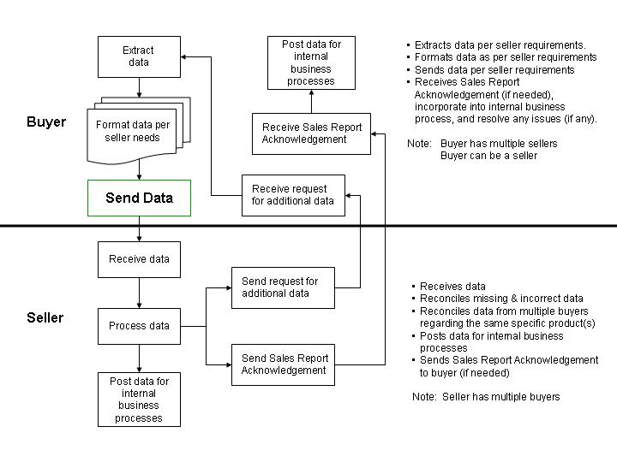

Figure 1: High-level Context Diagram

  - PIP Scope Description
The purpose of this PIP is to report sale-out information and claim for special pricing (if any). Information contained in this PIP is used to drive several sales-related processes by the recipient. If earlier agreed by the two parties, the recipient has to acknowledge this PIP by 4E2, “Notify of Sales Report Acknowledgement” for data discrepancies found and special pricing acknowledgement.

Business Process Scope Diagram
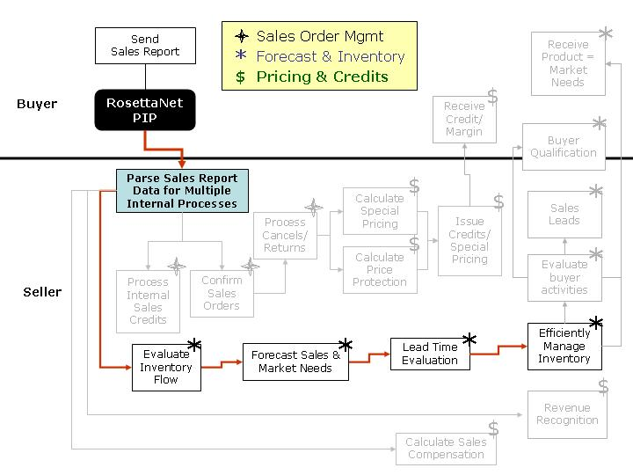
Figure 2: Sales Reporting Context Diagram

PIP Business Documents
Business Documents are generated and exchanged by roles performing activities in this PIP. Business Documents are listed and defined in Table 1.
Table 1: PIP Business Documents
Business Document | Description
Sales Report Notification | Contains sale-out information and claims for special pricing.
  - PIP Business Process Flow Diagram
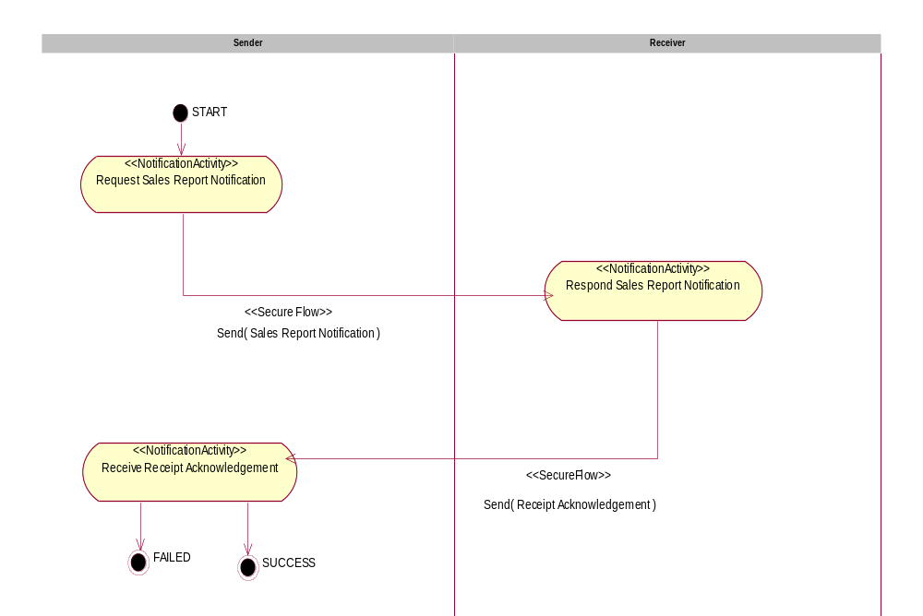
Figure 3: Notify of Sales Report
  - PIP Start State
The start state is comprised of the following condition(s):
Table 2: PIP Start State
 | Approved | Exist |  | Valid | Non-Repudiated | Authorized
 | Approved | Party | In Backend system | Valid | Non-Repudiated | Authorized
TPA |  |  | 
Sending Partner |  |  |  | 
Receiving Partner |  | 
Business Document |  |  |  |  |  | 
  - PIP End States
The end state is comprised of the following condition(s):
Table 3: PIP End State
 | Approved | Exist |  | Valid | Non-Repudiated | Authorized
 | Approved | Party | In Backend system | Valid | Non-Repudiated | Authorized
Acknowledgment of Receipt |  |  |  |  | 
Receiving Partner |  |  |  |  |  | 

The PIP failure state is comprised of one or more of the following conditions:
Table 4: PIP Failure State
 | NO | Exceeded
Success | 
Retry Count |  | 

  - Partner Role Descriptions
Table 5 describes the partner roles in this PIP.
Table 5: Partner Role Descriptions
Role Name | Role Description
Sender | Party, which is requesting Business Activity.
Receiver | Party, which is responding to a Business Activity Request.

  - Business Process Activity Controls
Table 6 describes the interaction contract between roles performing business activities in this PIP.
Table 6: Business Activity Descriptions
Role  Name | Activity Name | Activity Description
Sender | Notify of Sales Report | A Buyer sends a Sales Report Notification to a Seller. The Sales Report Notification contains sale-out information and claims for special pricing.

Table 7 details the security, audit and process controls relating to activities performed in the PIP.
Table 7: Business Activity Performance Controls
Role  Name | Activity  Name | Acknowledgment  of Receipt |  | Time to Acknowledge Acceptance | Time to Perform | Retry Count | Is Authorization Required? | Non-Repudiation of Origin and Content?
Role  Name | Activity  Name | Non-Repudiation Required? | Time to Acknowledge
Sender | Notify of Sales Report | Y | 2 hrs | N/A | 2 hrs | 3 | Y | Y

Network and Implementation Specification
Each network component maps into a role of the PIP model. Table 8 specifies the mapping between roles and network components.
Table 8: Network Component Specification
Network Component | Classification | Maps to Role in Business Process
Sender Service | Business Service | Sender
Receiver Service | Business Service | Receiver
  - Business Action and Business Signal Specification
Each business action maps to a Business Document of the PIP model. Table 9 specifies the mapping between Business Documents and business actions.
Table 9: Business Action – Business Document Mapping
Business Action | Business Document | Document Function
Sales Report Notification Action | Sales Report Notification | Request
  - Business Transaction Dialog Specification
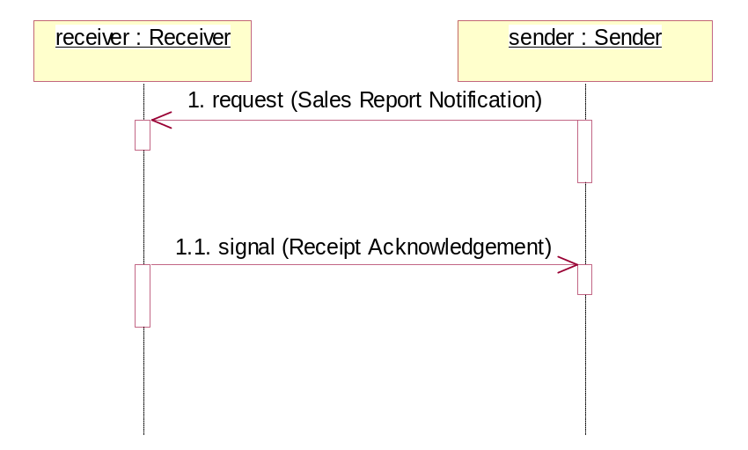
Figure 4: Notify of Sales Report Interactions: Service-Service

Message Exchange Controls
Table 10: Message Exchange Controls - Notify of Sales Report
# | Name |  | Time to Acknowledge Receipt Signal |  | Time to Acknowledge Acceptance Signal |  | Time to Respond to Action |  | Included in Time to Perform |  | Is Authorization Required? |  | Is Non-Repudiation Required? |  | Is Secure Transport Required?
1. |  | Sales Report Notification Action |  | 2 hrs |  | N/A |  | N/A |  | Y |  | Y |  | Y |  | Y
1.1. |  | Receipt Acknowledgment |  | N/A |  | N/A |  | N/A |  | Y |  | Y |  | Y |  | Y

Communications Specification
Table 11: Sales Report Notification Dialog: Service-Service
# | Business Message | Digital Signature Required? | SSL Required?
1. | Sales Report Notification | Y | Y
1.1. | Receipt Acknowledgment | Y | Y

