

Description of 4E1 Message

PIP® 4E1
Validated 11.11.00

Specification Information
Name | Description of 4E1 Message
PIP | Notify of Sales Report
Cluster | Inventory Management
Segment | Sales Reporting
Publication Date | 06 October 2007
Version Identifier | V11.11

Table of Content

1. Document Management 6
1.1 Legal Disclaimer 6
1.2 Copyright 6
1.3 Trademarks 6
1.4 Acknowledgments 6
1.5 Related Documents 7
1.6 Document Version History 7
1.7 Document Purpose 7
2. Interchange Model 8
2.1 SalesReportNotification 8
2.1.1 Interchange Diagram 8
2.1.2 Dependency Diagram 9
2.1.3 ProductInformation 9
2.1.4 ProductTransfer 10
2.1.5 SalesReport 10
2.1.6 SalesReportLineItem 12
2.1.7 SalesReportNotification 13
2.1.8 SpecialPriceClaim 14
3. Domain Model 15
3.1 Procurement 15
3.1.1 Procurement 15
3.1.1.1 Dependency Diagram 15
3.1.1.2 BookPrice 15
3.1.1.3 ContractDetails 16
3.1.1.4 LotIdentification 16
3.1.1.5 ProductSummary 17
3.1.1.6 ProductUnitTotal 17
3.1.1.7 SalesOut 18
3.1.1.8 SalesOutAndTransaction 18
3.1.1.9 SpecialPrice 19
3.1.2 CodeList 20
3.1.2.1 BookPriceQualifier 20
3.1.2.2 PurchaseMethod 20
3.1.2.3 ReportType 20
3.1.2.4 SaleType 21
3.1.2.5 TotalQualifier 21
3.1.2.6 TransactionType 21
3.2 Shared 22
3.2.1 Shared 22
3.2.1.1 Dependency Diagram 22
3.2.1.2 DatePeriodAndDuration 22
3.2.1.3 DatePeriodAndDurationChoice 23
3.2.1.4 Duration 23
3.2.1.5 ProductQuantity 23
3.2.2 CodeList 24
3.2.2.1 PaymentMethod 24
4. Universal Structure 27
4.1 ContactInformation 27
4.1.1 ContactInformation 27
4.2 DataType 27
4.2.1 Contact 27
4.2.2 DUNS 28
4.2.3 DUNSPlus4 28
4.2.4 GLN 29
4.2.5 GTIN 29
4.3 Dates 30
4.3.1 DatePeriod 30
4.3.2 DateTimePeriod 30
4.4 Document 30
4.4.1 BusinessDocumentReference 30
4.5 Locations 31
4.5.1 AlternativeIdentifier 31
4.5.2 Location 32
4.5.3 LocationChoice 32
4.5.4 PhysicalAddress 33
4.6 MonetaryExpression 34
4.6.1 FinancialAmount 34
4.6.2 ProductPricing 35
4.7 PartnerIdentification 35
4.7.1 FullPartner 35
4.7.2 IntermittentPartner 36
4.7.3 KnownPartner 36
4.7.4 KnownPartnerContact 37
4.7.5 NewPartner 37
4.7.6 PartnerDescription 38
4.7.7 PartnerDescriptionChoice 38
4.7.8 PartnerIdentification 39
4.7.9 PartnerIdentificationChoice 39
4.7.10 SpecifiedFullPartner 40
4.7.11 SpecifiedIntermittentPartner 41
4.7.12 SpecifiedKnownPartner 41
4.7.13 SpecifiedNewPartner 42
4.8 ProductIdentification 43
4.8.1 ProductIdentification 43
4.8.2 ProductIdentificationChoice 43
4.9 CodeList 44
4.9.1 Country 44
4.9.2 CountrySubdivision 44
4.9.3 Currency 44
4.9.4 Language 44
4.9.5 DocumentType 44
4.9.6 MimeTypeQualifier 46
4.9.7 UnitOfMeasure 57
4.9.8 ProcessRoleIdentifier 64
5. System Structure 68
5.1 BusinessProcessIdentifier 68
5.2 BusinessServiceInformation 68
5.3 ContractInformation 69
5.4 CorrelationInformation 69
5.5 DocumentHeader 70
5.6 DocumentIdentification 71
5.7 DocumentIdentificationChoice 71
5.8 DocumentInformation 72
5.9 DocumentManifest 72
5.10 DocumentSecurity 73
5.11 ManifestItem 73
5.12 PipIdentifier 74
5.13 PipVersion 75
5.14 Receiver 75
5.15 RequestingDocumentInformation 76
5.16 Sender 76
5.17 StandardDocumentIdentification 77
5.18 TpirPipIdentification 77
5.19 VersionIdentifier 78
5.20 CodeList 79
5.20.1 TPIRFileType 79
6. XML Data Type 80
6.1 anyURI 80
6.2 boolean 80
6.3 date 80
6.4 dateTime 80
6.5 duration 80
6.6 float 80
6.7 nonNegativeInteger 80
6.8 positiveInteger 81
6.9 string 81

Table of Figures

Figure 2-1 Interchange 8
Figure 2-2 Dependency 9
Figure 2-3 ProductInformation 9
Figure 2-4 ProductTransfer 10
Figure 2-5 SalesReport 10
Figure 2-6 SalesReportLineItem 12
Figure 2-7 SalesReportNotification 13
Figure 2-8 SpecialPriceClaim 14
Figure 3-1 Dependency 15
Figure 3-2 BookPrice 15
Figure 3-3 ContractDetails 16
Figure 3-4 LotIdentification 16
Figure 3-5 ProductSummary 17
Figure 3-6 ProductUnitTotal 17
Figure 3-7 SalesOut 18
Figure 3-8 SalesOutAndTransaction 18
Figure 3-9 SpecialPrice 19
Figure 3-10 Dependency 22
Figure 3-11 DatePeriodAndDuration 22
Figure 3-12 Duration 23
Figure 3-13 ProductQuantity 23
Figure 4-1 ContactInformation 27
Figure 4-2 Contact 27
Figure 4-3 DUNS 28
Figure 4-4 DUNSPlus4 28
Figure 4-5 GLN 29
Figure 4-6 GTIN 29
Figure 4-7 DatePeriod 30
Figure 4-8 DateTimePeriod 30
Figure 4-9 BusinessDocumentReference 30
Figure 4-10 AlternativeIdentifier 31
Figure 4-11 Location 32
Figure 4-12 PhysicalAddress 33
Figure 4-13 FinancialAmount 34
Figure 4-14 ProductPricing 35
Figure 4-15 FullPartner 35
Figure 4-16 IntermittentPartner 36
Figure 4-17 KnownPartner 36
Figure 4-18 KnownPartnerContact 37
Figure 4-19 NewPartner 37
Figure 4-20 PartnerDescription 38
Figure 4-21 PartnerIdentification 39
Figure 4-22 SpecifiedFullPartner 40
Figure 4-23 SpecifiedIntermittentPartner 41
Figure 4-24 SpecifiedKnownPartner 41
Figure 4-25 SpecifiedNewPartner 42
Figure 4-26 ProductIdentification 43
Figure 5-1 BusinessProcessIdentifier 68
Figure 5-2 BusinessServiceInformation 68
Figure 5-3 ContractInformation 69
Figure 5-4 CorrelationInformation 69
Figure 5-5 DocumentHeader 70
Figure 5-6 DocumentIdentification 71
Figure 5-7 DocumentInformation 72
Figure 5-8 DocumentManifest 72
Figure 5-9 DocumentSecurity 73
Figure 5-10 ManifestItem 73
Figure 5-11 PipIdentifier 74
Figure 5-12 PipVersion 75
Figure 5-13 Receiver 75
Figure 5-14 RequestingDocumentInformation 76
Figure 5-15 Sender 76
Figure 5-16 StandardDocumentIdentification 77
Figure 5-17 TpirPipIdentification 77
Figure 5-18 VersionIdentifier 78

Document Management

Legal Disclaimer
RosettaNet, its members, officers, directors, employees, or agents shall not be liable for any injury, loss, damages, financial or otherwise, arising from, related to, or caused by the use of this document or the specifications herein, as well as associated guidelines and schemas. The use of said specifications shall constitute your express consent to the foregoing exculpation.

Copyright
©2007 RosettaNet. All rights reserved. No part of this publication may be reproduced, stored in a retrieval system, or transmitted, in any form or by any means, electronic, mechanical, photocopying, recording, or otherwise, without the inclusion of this copyright notice. Any derivative works must cite the copyright notice. Any public redistribution or sale of this publication or derivative works requires prior written permission of the publisher.

Trademarks
RosettaNet, Partner Interface Process, PIP and the RosettaNet logo are trademarks or registered trademarks of "RosettaNet," a non-profit organization. All other product names and company logos mentioned herein are the trademarks of their respective owners. In the best effort, all terms mentioned in this document that are known to be trademarks or registered trademarks have been appropriately recognized in the first occurrence of the term.

Acknowledgments
This document has been prepared by RosettaNet (http://www.rosettanet.org/) from requirements gathered during the Milestone Program and in conformance with the methodology. Listed below are the legal entities that contributed to the design and development of this PIP.
BCM Electronics | Cisco
Cisco Systems | Electronics Industry Data Exchange Association (EIDX)
Hewlett Packard | Hewlett-Packard GmbH
HP | Globetronics SDH. BHD
GridNode | GridNode, Inc.
GridNode Pte. Ltd. | IBM
Intel | Intel Corp.
Intel Corp (UK) LTD | Intel Corporation
International Business Machines | MIMOS Berhad
Motorola | Motorola Semiconductor Sector
Motorola SPS | Nokia
Nokia Oyj | Philips Semiconductors
Seagate Technology | Sterling Commerce

Related Documents
- Associated PIP Message Schemas (included with PIP Specification only)
- Description of Partner Interface Process for 4E1
- Message Structure

Document Version History
Version | Date | Description
Validated 11.00.00 | 28 June 2006 | Validated Version
Validated 11.10.00 | 18 August 2006 | Validated Version
Validated 11.11.00 | 06 October 2007 | Validated Version  Milestone Program: Schema2Market

Document Purpose
The purpose of the document is to explain the structure, the association between objects, the content of objects and the definition for single elements to a non-technical audience.

Interchange Model

SalesReportNotification

Interchange Diagram
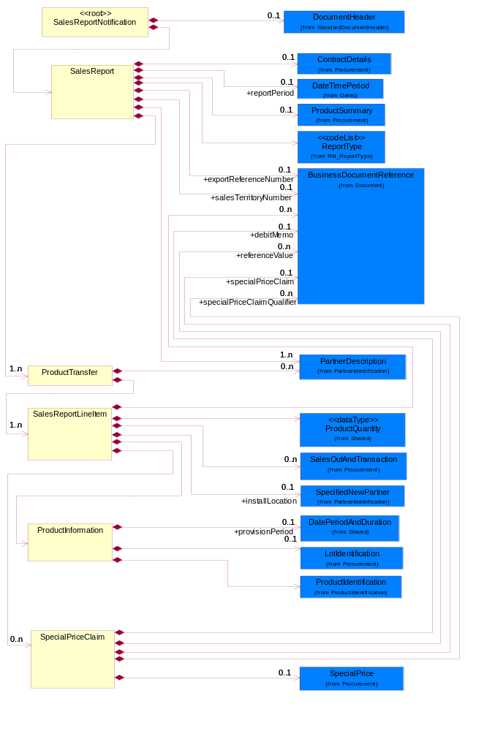
Figure 2-1 Interchange

Dependency Diagram
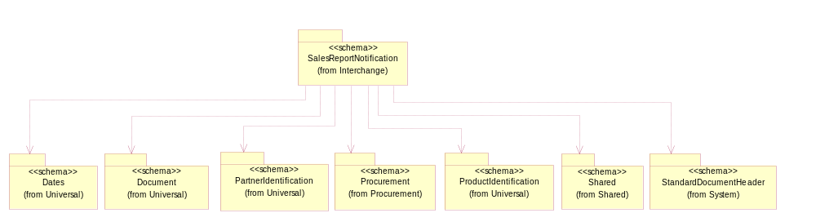
Figure 2-2 Dependency

ProductInformation
Describes the information pertaining to products sold.
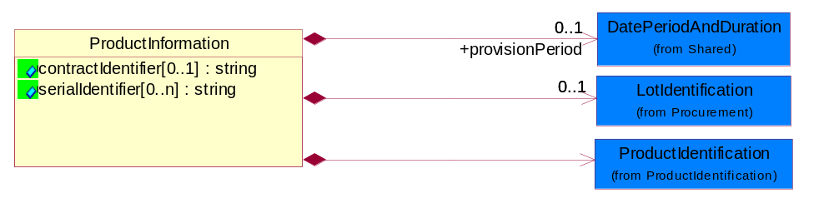
Figure 2-3 ProductInformation
Attribute | Type | Documentation
contractIdentifier[0..1] | string | The contract number. Unique identifier that pertains specifically to the contract.
serialIdentifier[0..n] | string | The serial number. There could be multiple serial numbers for a single product sold.

Composition | Cardinality | Type | Documentation
ProductIdentification | 1 | ProductIdentification | The object provides the identifier(s) of a product.
LotIdentification | 0..1 | LotIdentification | This object identifies a lot which associates the product with a specific group of products with some similar attributes.
provisionPeriod | 0..1 | DatePeriodAndDuration | This object allows representation of a date period by a duration or begin and an end dates.

ProductTransfer
This object describes a POS (point of sale) information for known/unknown end user(s).
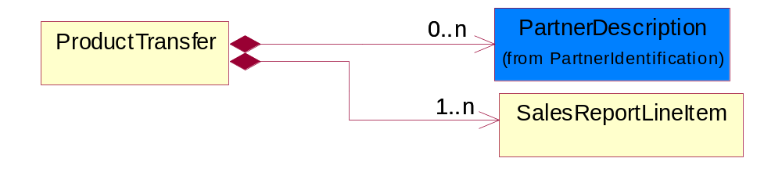
Figure 2-4 ProductTransfer
Composition | Cardinality | Type | Documentation
SalesReportLineItem | 1..n | SalesReportLineItem | This object describes an entry in a sales report. Group of attributes pertaining to the individual item in the report.
PartnerDescription | 0..n | PartnerDescription | The collection of business properties that describe a business partners' identity, their contact information, where they are physically located and their function in a supply chain.

SalesReport
The sales report document.
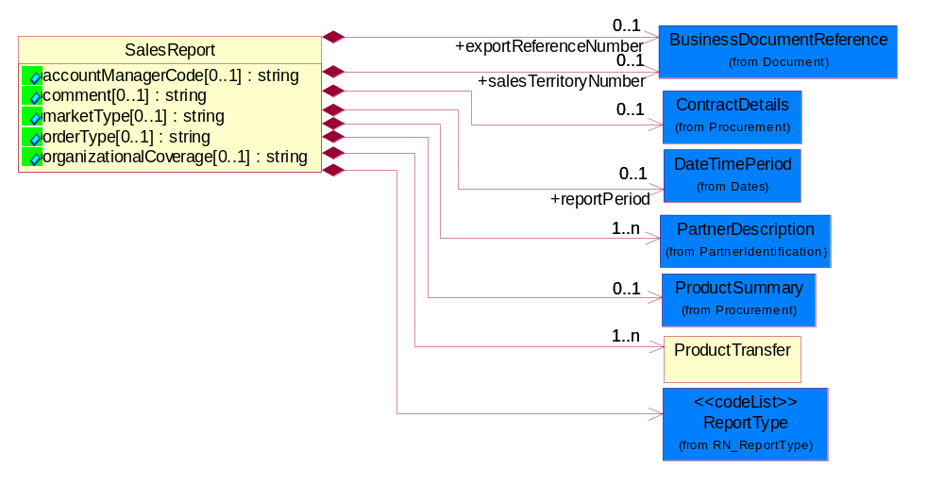
Figure 2-5 SalesReport

Attribute | Type | Documentation
accountManagerCode[0..1] | string | A code that identifies the account manager.
comment[0..1] | string | A textual description of information relating to a product sale.
marketType[0..1] | string | Type of market.
orderType[0..1] | string | The code used to classify purchase order type.
organizationalCoverage[0..1] | string | It is a 'Line of Business', used in conjunction with other information (order type) to correctly route data to the appropriate back-end application.

Composition | Cardinality | Type | Documentation
ContractDetails | 0..1 | ContractDetails | This object represents a business arrangement for the supply of goods or services. Group of attributes pertaining to the specific type of contract.
ProductTransfer | 1..n | ProductTransfer | This object describes a POS (point of sale) information for known/unknown end user(s).
ProductSummary | 0..1 | ProductSummary | This object describes the summary of information (products  and products sold). Information in this object is not  derivable from the line items.
ReportType | 1 | ReportType | Code identifying the specific type of report.
exportReferenceNumber | 0..1 | BusinessDocumentReference | A number for export reference.
salesTerritoryNumber | 0..1 | BusinessDocumentReference | Sales territory number.
reportPeriod | 0..1 | DateTimePeriod | The period of time covered by the specific report.
PartnerDescription | 1..n | PartnerDescription | The collection of business properties that describe a business partners' identity, their contact information, where they are physically located and their function in a supply chain.

SalesReportLineItem
This object describes an entry in a sales report. Group of attributes pertaining to the individual item in the report.
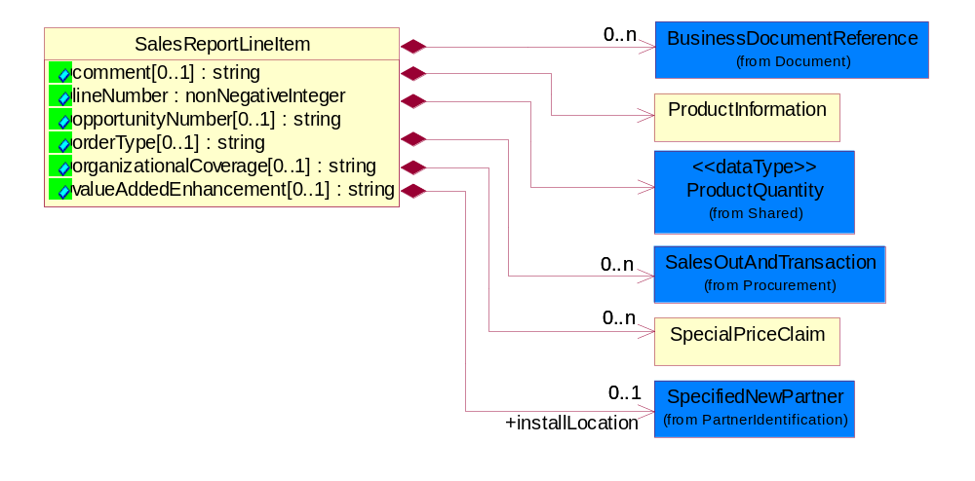
Figure 2-6 SalesReportLineItem
Attribute | Type | Documentation
comment[0..1] | string | A textual description of information relating to a product sale.
lineNumber | nonNegativeInteger | Number of the line in the document.
opportunityNumber[0..1] | string | The information used to correlate sales to sales lead management.
orderType[0..1] | string | The code used to classify purchase order type.
organizationalCoverage[0..1] | string | It is a 'Line of Business', used in conjunction with other information (order type) to correctly route data to the appropriate back-end application.
valueAddedEnhancement[0..1] | string | The number used to track the value added enhancement on the product. Certain products are allowed be sold by certain trading partners only if they are providing value add to the product before selling it.

Composition | Cardinality | Type | Documentation
SalesOutAndTransaction | 0..n | SalesOutAndTransaction | This object describes the sales out of a sale and those pertaining to a sale transaction.
BusinessDocumentReference | 0..n | BusinessDocumentReference | The business document reference object allows for the indirect referencing of a relationship to other business related documents.
SpecialPriceClaim | 0..n | SpecialPriceClaim | This object describes a claim for a special pricing/deal whereby a special price could be offered if number of units and period conditions are met.
installLocation | 0..1 | SpecifiedNewPartner | This object describes a customer's install location of a product. The physical address for the final destination of the product. This location may be different from the customer location.
ProductInformation | 1 | ProductInformation | Describes the information pertaining to products sold.
ProductQuantity | 1 | ProductQuantity | A quantity specifying the number of product units.

SalesReportNotification
Top level object for a Sales Report business document.
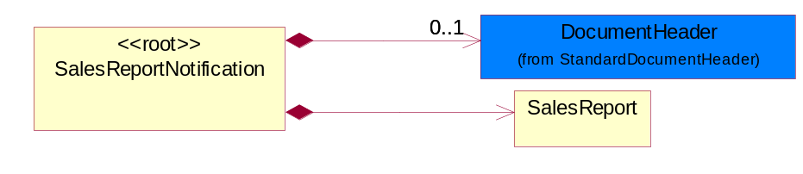
Figure 2-7 SalesReportNotification
Composition | Cardinality | Type | Documentation
DocumentHeader | 0..1 | DocumentHeader | The object allows for the identification of the sender and receiver of the business document.
SalesReport | 1 | SalesReport | The sales report document.

SpecialPriceClaim
This object describes a claim for a special pricing/deal whereby a special price could be offered if number of units and period conditions are met.
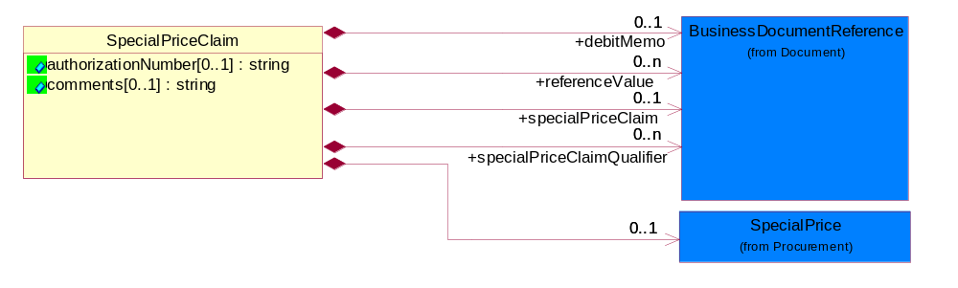
Figure 2-8 SpecialPriceClaim
Attribute | Type | Documentation
authorizationNumber[0..1] | string | An identifier that uniquely references a special price.
comments[0..1] | string | A textual description of a special price claim.

Composition | Cardinality | Type | Documentation
SpecialPrice | 0..1 | SpecialPrice | This object represents a special price based on number of unit of products and an eligible period.
debitMemo | 0..1 | BusinessDocumentReference | Debit memo number.
specialPriceClaim | 0..1 | BusinessDocumentReference | An identifier of a special price claim.
specialPriceClaimQualifier | 0..n | BusinessDocumentReference | Special price claim reference qualifier.
referenceValue | 0..n | BusinessDocumentReference | Special price claim reference value.

Domain Model

Procurement

Procurement

Dependency Diagram
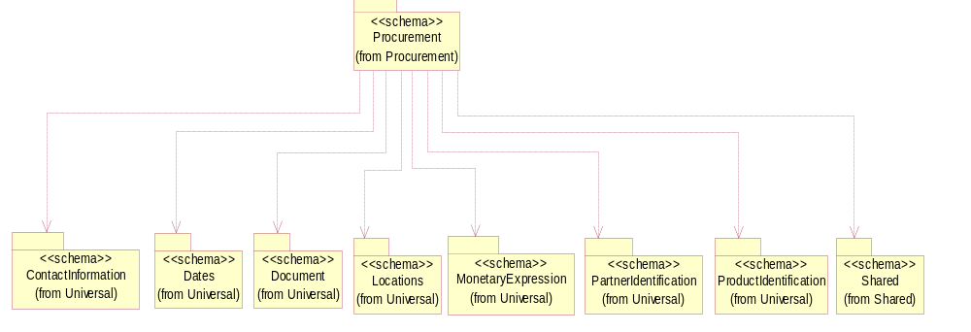
Figure 3-9 Dependency

BookPrice
This object represents a booking price. It describes the price the trading partner was charged by the seller.
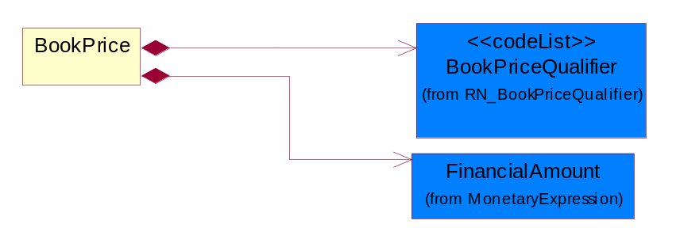
Figure 3-10 BookPrice
Composition | Cardinality | Type | Documentation
FinancialAmount | 1 | FinancialAmount | The business document must express financial amounts.
BookPriceQualifier | 1 | BookPriceQualifier | Code identifying the price the trading partner was charged by the seller.

ContractDetails
This object represents a business arrangement for the supply of goods or services. Group of attributes pertaining to the specific type of contract.
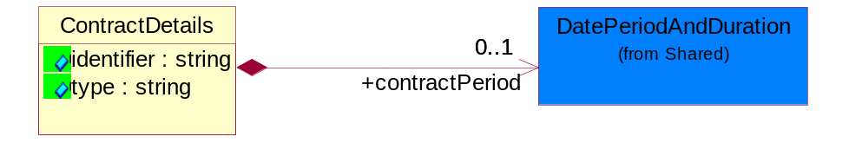
Figure 3-11 ContractDetails
Attribute | Type | Documentation
identifier | string | A unique proprietary number to identify a "solution" which is usually a combination of parts and services or software.
type | string | A textual description of a contract. Additional description pertaining to the type of contract.

Composition | Cardinality | Type | Documentation
contractPeriod | 0..1 | DatePeriodAndDuration | The effective period of contract.

LotIdentification
This object identifies a lot which associates the product with a specific group of products with some similar attributes.
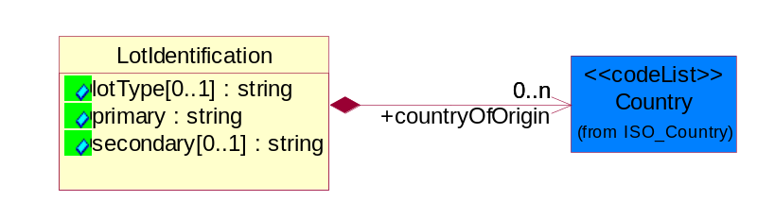
Figure 3-12 LotIdentification
Attribute | Type | Documentation
lotType[0..1] | string | Identify the type of the lot whether it's for Production or Engineering.
primary | string | The primary lot identifier.
secondary[0..1] | string | The secondary lot identifier.

Composition | Cardinality | Type | Documentation
countryOfOrigin | 0..n | Country | This object represents the country where the product originates.

ProductSummary
This object describes the summary of information (products and products sold). Information in this object is not derivable from the line items.
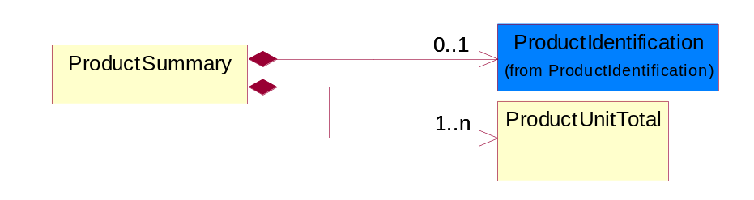
Figure 3-13 ProductSummary
Composition | Cardinality | Type | Documentation
ProductIdentification | 0..1 | ProductIdentification | The object provides the identifier(s) of a product.
ProductUnitTotal | 1..n | ProductUnitTotal | This object describes total units of a product. Total number of products sold by the trading partner.

ProductUnitTotal
This object describes total units of a product. Total number of products sold by the trading partner.
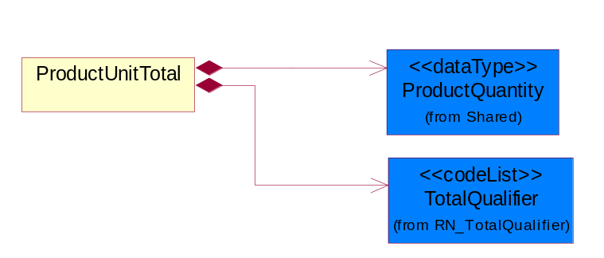
Figure 3-14 ProductUnitTotal
Composition | Cardinality | Type | Documentation
TotalQualifier | 1 | TotalQualifier | A code that qualifies a total.
ProductQuantity | 1 | ProductQuantity | A quantity specifying the number of product units.

SalesOut
This object describes the sales out of products.
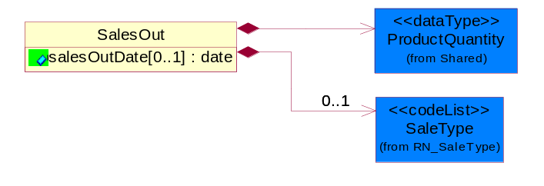
Figure 3-15 SalesOut
Attribute | Type | Documentation
salesOutDate[0..1] | date | Shipment date. This date is trading partner-specific (i.e could be when product left the port, when product left factory, etc).

Composition | Cardinality | Type | Documentation
SaleType | 0..1 | SaleType | Code identifying the type of sale terms the trading partner bought from the seller.
ProductQuantity | 1 | ProductQuantity | A quantity specifying the number of product units.

SalesOutAndTransaction
This object describes the sales out of a sale and those pertaining to a sale transaction.
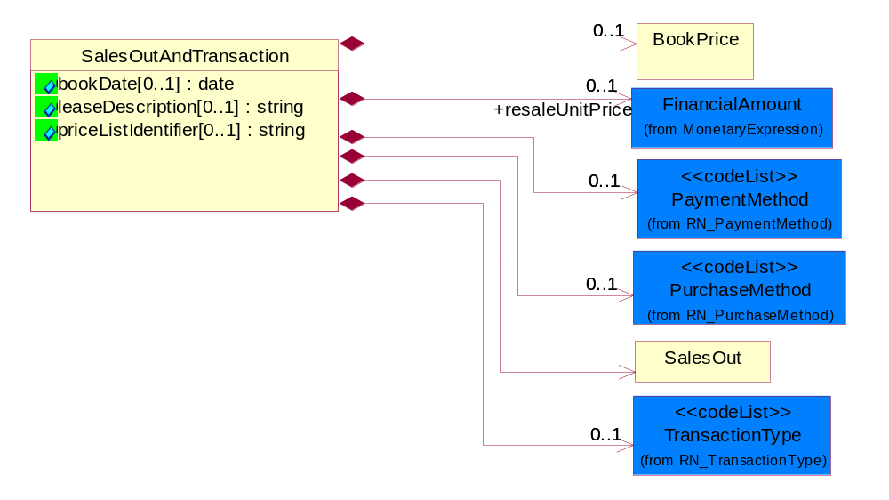
Figure 3-16 SalesOutAndTransaction
Attribute | Type | Documentation
bookDate[0..1] | date | Original book date of this shipment.
leaseDescription[0..1] | string | A textual description for a lease of product of this shipment.
priceListIdentifier[0..1] | string | An identifier of a price list that is related to this shipment.

Composition | Cardinality | Type | Documentation
BookPrice | 0..1 | BookPrice | This object represents a booking price. It describes the price the trading partner was charged by the seller.
resaleUnitPrice | 0..1 | FinancialAmount | The resale price per unit.
PurchaseMethod | 0..1 | PurchaseMethod | Code identifying the method by which the trading partner procured the product from the seller.
TransactionType | 0..1 | TransactionType | Code identifying the type of transaction pertaining to the line item in the sales report.
SalesOut | 1 | SalesOut | This object describes the sales out of products.
PaymentMethod | 0..1 | PaymentMethod | Code identifying how the trading partner paid the seller for the product.

SpecialPrice
This object represents a special price based on number of unit of products and an eligible period.
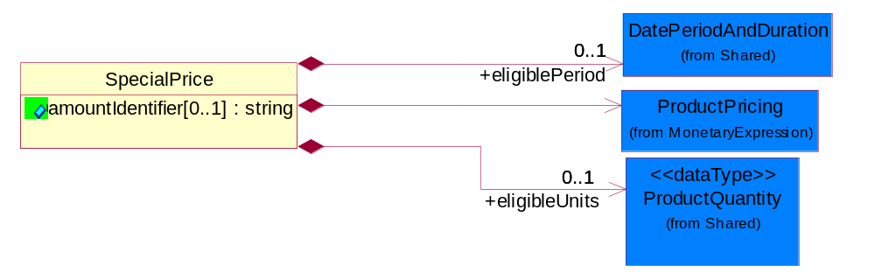
Figure 3-17 SpecialPrice
Attribute | Type | Documentation
amountIdentifier[0..1] | string | Identifies type of special pricing.

Composition | Cardinality | Type | Documentation
ProductPricing | 1 | ProductPricing | The business document must contain the price of the product.
eligiblePeriod | 0..1 | DatePeriodAndDuration | The period of time when the product is available in special price.
eligibleUnits | 0..1 | ProductQuantity | The number of units that has to be ordered to be eligible for a special price.

CodeList

BookPriceQualifier
Code identifying the price the trading partner was charged by the seller.

Name | Documentation
AVC | Average replacement cost.
LNC | Replacement cost including shipping.
NTC | Cost after rebates or special pricing.
RPC | Cost before rebates.
SAL | Sale. Indicates the price received for the product.

PurchaseMethod
Code identifying the method by which the trading partner procured the product from the seller.

Name | Documentation
CAT | Catalog order.
EDI | Electronic Data Interchange via VAN.
EML | EDI via XML gateway.
FAX | Facsimile.
MAL | Order was Mailed in.
ONL | On-Line.
PHN | Phoned-in.
ROS | RosettaNet PIP.
WRD | Wired.
WSV | Web Service.

ReportType
Code identifying the specific type of report.

Name | Documentation
CON | Indicates that products were in consignment.
INV | Inventory transfer. A transfer from one location to another within the same distributor.
MIX | Combination. A combination of INV and MOV.
MOV | Product Transfer. A product transfer from the distributor to an external party.
SLT | Indicates to whom the products were bought from and sold to.
STR | Sell-through sales report type.

SaleType
Code identifying the type of sale terms the trading partner bought from the seller.
Name | Documentation
CRD | Credit.
CSG | Product has been re-sold.
CSH | Cash.
INS | Installment.
LSE | Product has been leased.
PUR | Product has been purchased or bought.
RMK | Product has been repackaged, refurbished, etc. and has been sold.

TotalQualifier
A code that qualifies a total.
Name | Documentation
SIM | Total Sell - In from Manufacturer.
SIU | Total sell-in.
SLE | Total units sold to end users.
SLU | Total units sold.

TransactionType
Code identifying the type of transaction pertaining to the line item in the sales report.
Name | Documentation
CAN | Refers to items in a previous Sales Report: (1) Cancel and "back-out" line items for cancelled orders that are not shipped, (2) Cancel and "back-out" line items with wrong information (example: reported wrong end user) to be replaced with a new line item in a separate line.
COS | Order on manufacturer cancelled.
DSM | Indicates items Directly Shipped from Manufacturer.
ITC | Stock delivered direct from manufacturer to Partner's customer in transit.
ITR | Stock return from customer in transit.
ITT | Stock on intra-company transfer in transit.
MSI | Miscellaneous stock movement into inventory.
MSO | Miscellaneous stock movement out of inventory.
OOO | Stock on order from other distributor.
OOS | Stock on order from manufacturer.
RET | Indicates return of an item.
RPR | Indicates new transaction or line item to Replace a Previously Reported one.
SAL | Indicates sale of an item.
SEL | Stock returned to manufacturer or distributor.
SIN | Stock received from manufacturer or distributor.
STI | Intra-Company stock transfer received.
STO | Intra-Company stock transfer sent.
WHA | Stock available for general sale.
WHR | Stock reserved - unavailable for general sale.
WHS | Indicates items were sold from a warehouse.

Shared

Shared

Dependency Diagram
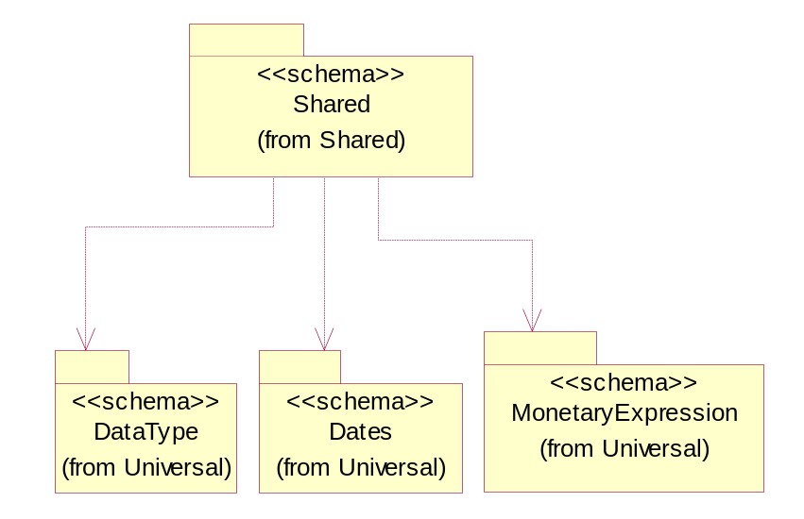
Figure 3-18 Dependency

DatePeriodAndDuration
The collection of business properties that describe a date period or duration.
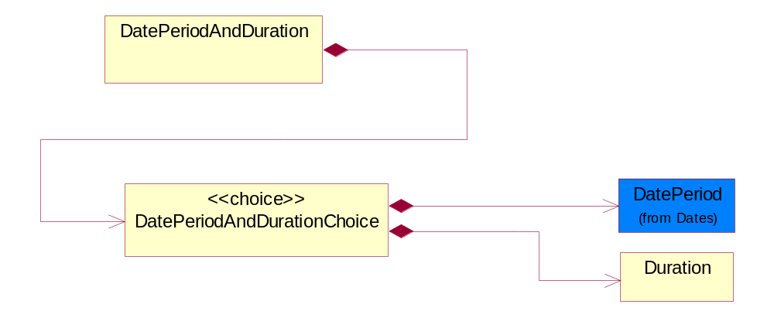
Figure 3-19 DatePeriodAndDuration

Composition | Cardinality | Type | Documentation
DatePeriodAndDurationChoice | 1 | DatePeriodAndDurationChoice | The choice structure for DatePeriodAndDuration.

DatePeriodAndDurationChoice
The choice structure for DatePeriodAndDuration.

Composition | Cardinality | Type | Documentation
DatePeriod | 1 | DatePeriod | The business document must allow for the computation or statement of a duration based upon a beginning and an ending date.
Duration | 1 | Duration | This object allows representation of a duration of time.

Duration
This object allows representation of a duration of time.
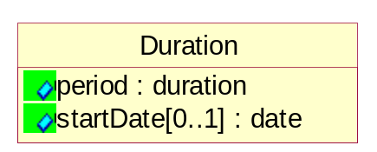
Figure 3-20 Duration
Attribute | Type | Documentation
period | duration | Represents a duration of time.
startDate[0..1] | date | The date indicating the beginning of the duration.

ProductQuantity
A quantity specifying the number of product units.
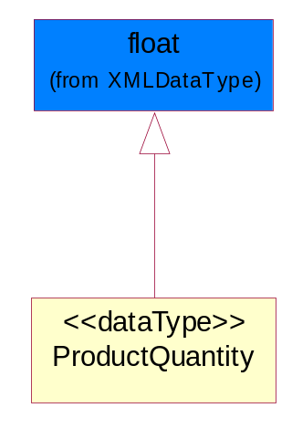
Figure 3-21 ProductQuantity

CodeList

PaymentMethod
Code identifying how the trading partner paid the seller for the product.

Name | Documentation
ACH | Automated Clearing House (ACH).
ACR | ACH Reversal.
BAD | Batched Delivery.
BIA | Billing Account.
BND | Bank Draft.
BOE | Book Entry.
CAC | Cashier's Check.
CAS | Cash.
CBB | Compensation by Balance.
CCP | ACH Savings Cash Concentration/Disbursement Plus (CCD+) Credit.
CCR | CCD+(NACHA Cash Concentration/Disbursement - Funds Transacted Plus an 80 Record Remittance Detail).
CCW | CCD (NACHA Cash Concentration/Disbursement - Funds Transacted without Remittance Information).
CDA | Credit/Debit Account.
CDD | Pre-Arranged Payment or Deposit (PPD) Credit to a Demand Deposit Account.
CDP | ACH Savings Cash Concentration/Disbursement Plus (CCD+) Debit.
CDS | Pre-Arranged Payment or Deposit (PPD) Credit to Savings.
CHE | Check.
CHIPS | Clearing House Interbank Payment System (CHIPS)Funds/Wire Transfer.
CLH | Clearinghouse.
CPC | Collect Payment by Company Check.
CPF | Collect Payment by Certified Funds.
CPP | Pre-Arranged Payment or Deposit Plus Addendum (PPD+) Credit to a Demand Deposit Account.
CRA | Credit Account.
CRC | Credit Card.
CRE | Credit.
CTC | ACH Savings Corporate Trade Exchange (CTX) Credit.
CTD | ACH Savings Corporate Trade Exchange (CTX) Debit.
CTP | CTP (NACHA Corporate Trade Payment - Transaction Plus Remittance Detail in Fixed Format).
CTX | CTX (NACHA Corporate Trade Exchange - Transaction Plus Remittance Detail in ANSI Standard Flexible Format).
CXC | ACH Demand Corporate Trade Exchange (CTX) Credit.
CXD | ACH Demand Corporate Trade Exchange (CTX) Debit.
DBT | Defined by TPA.
DCC | ACH Demand Cash Concentration/Disbursement (CCD) Credit.
DCD | ACH Demand Cash Concentration/Disbursement (CCD) Debit.
DCP | ACH Demand Cash Concentration/Disbursement Plus (CCD+) Credit.
DDA | Pre-Arranged Payment or Deposit (PPD) Debit to a Demand Deposit Account.
DDP | ACH Demand Cash Concentration/Disbursement Plus (CCD+) Debit.
DEB | Debit.
DEC | Debit Card.
DEM | Debit Memo.
DID | Direct Deposit.
DPP | Pre-Arranged Payment or Deposit Plus Addendum (PPD+) Debit to a Demand Deposit Account.
DRA | Draft.
DWO | Discount was Offered.
ECN | EDIBANX Clearing Network.
EFT | EFT.
EPS | Electronic Payment System.
EXC | 1035 Exchange.
FIN | Financed.
FIO | Financial Institution Option.
FPB | Freight Payment Bank.
FRN | Federal Reserve Funds/Wire Transfer - Nonrepetitive.
FRR | Federal Reserve Funds/Wire Transfer - Repetitive.
GRA | Graduated.
INS | Invoiced Separately.
JPO | Joint Purchase Option.
LAP | Lease Agreement is in Place.
LEV | Level (Sum Constant).
LOB | Lock Box.
LOC | Letter of Credit has been provided.
MOD | Money order.
MOO | Money Order.
MOR | Mail order.
NPD | Non-Payment Data.
NPR | No Payment is Required.
OTH | Other.
PAM | Payment has Already been Made.
PAN | Payment is Net.
PAS | Payment after shipment.
PBC | Payment is made by Check.
PBS | Payment before shipment.
PCC | Payment is pre-paid with Credit Card.
PCP | ACH Savings Cash Concentration/Disbursement (PPD+) Credit.
PDD | ACH Savings Cash Concentration/Disbursement (PDD) Debit.
PDP | ACH Savings Cash Concentration/Disbursement (PPD+) Debit.
PIK | Payment was made in Kind.
PME | Payment was Made Electronically.
PMI | Payment will be made the Month after the Invoice.
PMN | Promissory note.
PNA | Private Netting Agreement, Pay by Wire Transfer.
PPC | Payment is made by Pre-paid Check.
PPD | ACH Savings Cash Concentration/Disbursement (PPD) Credit.
PPW | Payment is Pre-paid by Wire.
PRC | Preauthorized Check (Draft).
PRN | Proprietary Network.
PVC | Previously Charged.
PVN | Private Netting, Pay by Check.
PWT | Payment is made via Wire Transfer.
PYN | Payment note.
RDA | Related Detail Account.
SCC | ACH Savings Cash Concentration/Disbursement (CCD) Credit.
SCD | ACH Savings Cash Concentration/Disbursement (CCD) Debit.
SPA | Special Account.
SUA | Summary Account.
SWIFT | Society for Worldwide Interbank Financial Telecommunications (S.W.I.F.T.).
TGT | Telegraphic transfer.
TOF | Transfer of Funds by the banking institution.
TRC | Traveler's Check.
VIS | VISA Special Electronic Funds Transfer Network.
WAI | Waived.
WIT | Wire Transfer.

Universal Structure

ContactInformation

ContactInformation
The business document must allow for the identification of the name of the department, service or individual to be contacted regarding the context of the business document.
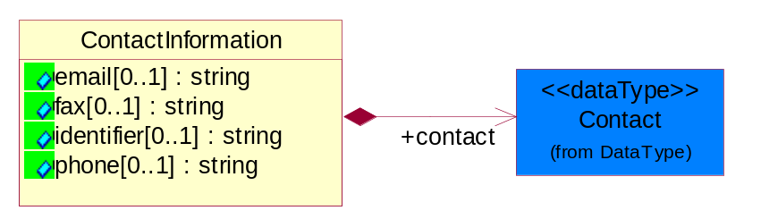
Figure 4-22 ContactInformation
Attribute | Type | Documentation
email[0..1] | string | The electronic mail for the specified contact.
fax[0..1] | string | The fax number for the specified contact.
identifier[0..1] | string | Identifies the role of the contact (i.e. Service Technician, Account Manager) in the Business Process.
phone[0..1] | string | The telephone number for the specified contact.

Composition | Cardinality | Type | Documentation
contact | 1 | Contact | The name of the department, service or individual to be contacted within the organization.

DataType

Contact
The name of the department, service or individual to be contacted within the organization.
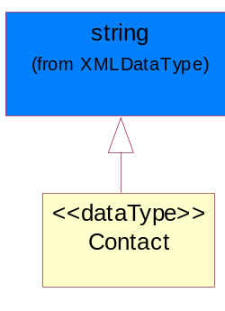
Figure 4-23 Contact

DUNS
A number assigned by Dun and Bradstreet to identify a business location.
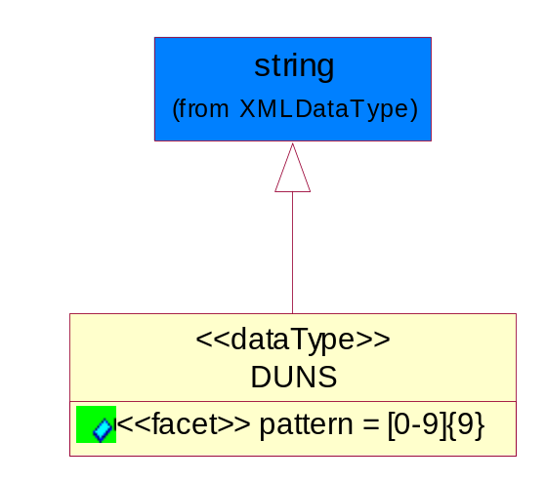
Figure 4-24 DUNS
Attribute | Type | Documentation
pattern |  | [0-9]{9}

DUNSPlus4
A identifier to specify a specific location within a business location.
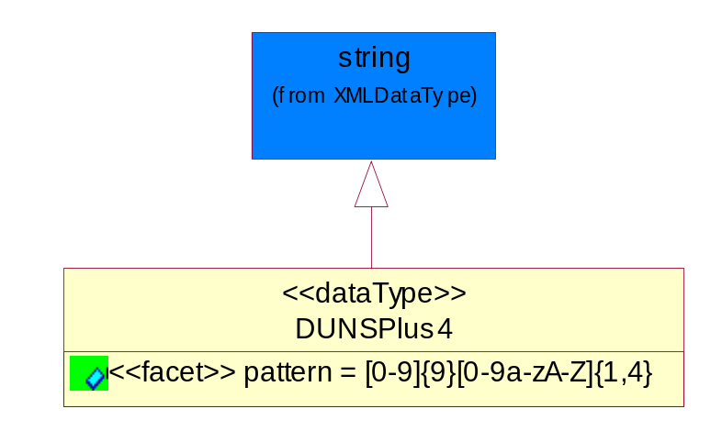
Figure 4-25 DUNSPlus4

Attribute | Type | Documentation
pattern |  | Data Universal Numbering System +4 (DUNS+4) number means the DUNS number assigned by Dun and Bradstreet, Inc. (D&B) plus an alphanumeric of length 4 suffix that may be assigned by a business concern.

GLN
Global Location Number (GLN) - A identifier to identify legal entities, trading parties and location.
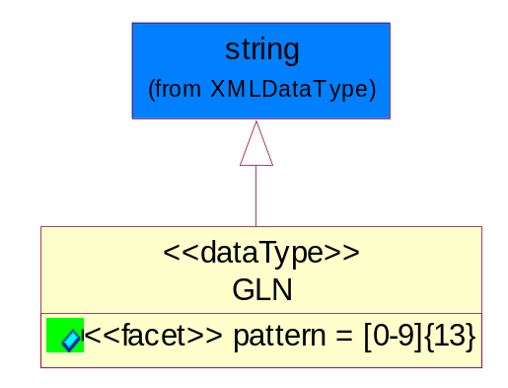
Figure 4-26 GLN

Attribute | Type | Documentation
pattern |  | [0-9]{13}

GTIN
Global Trade Identification Number (GTIN).
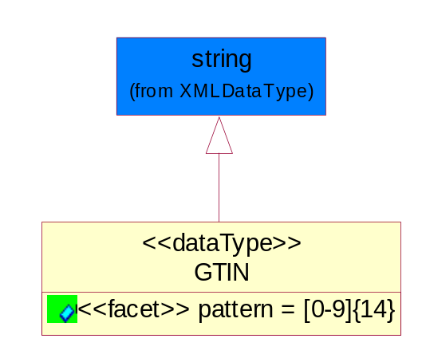
Figure 4-27 GTIN
Attribute | Type | Documentation
pattern |  | [0-9]{14}

Dates

DatePeriod
The business document must allow for the computation or statement of a duration based upon a beginning and an ending date.
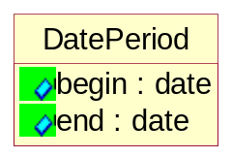
Figure 4-28 DatePeriod
Attribute | Type | Documentation
begin | date | The date indicating the beginning of the date period.
end | date | The date indicating the ending of the date period.

DateTimePeriod
The business document must allow for the computation or statement of a period of time based upon date and time.
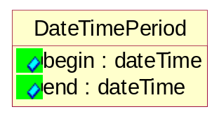
Figure 4-29 DateTimePeriod
Attribute | Type | Documentation
begin | dateTime | The date and time indicating the beginning of the date time period.
end | dateTime | The date and time indicating the ending of the date time period.

Document

BusinessDocumentReference
The business document reference object allows for the indirect referencing of a relationship to other business related documents.
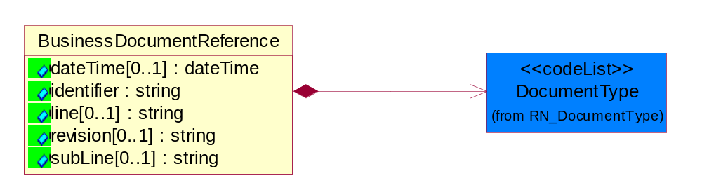
Figure 4-30 BusinessDocumentReference
Attribute | Type | Documentation
dateTime[0..1] | dateTime | The date-time stamp indicating on the referenced business document.
identifier | string | Unique identification of the referenced business document.
line[0..1] | string | References the specific line number of the specified business document.
revision[0..1] | string | Referenced the revision of the specified business document.
subLine[0..1] | string | References the specific subline number of the specified business document.

Composition | Cardinality | Type | Documentation
DocumentType | 1 | DocumentType | A code identifying the business context of a document.

Locations

AlternativeIdentifier
Identifies the specified code and the name of the organization that a code is utilized from.
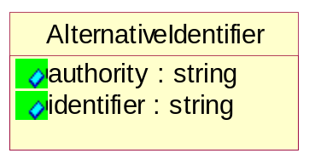
Figure 4-31 AlternativeIdentifier
Attribute | Type | Documentation
authority | string | The name of the organization that a code is utilized from.
identifier | string | The specified code to represent an entity (e.g. product, location, partner, etc.).

Location
The business document must specify a location.
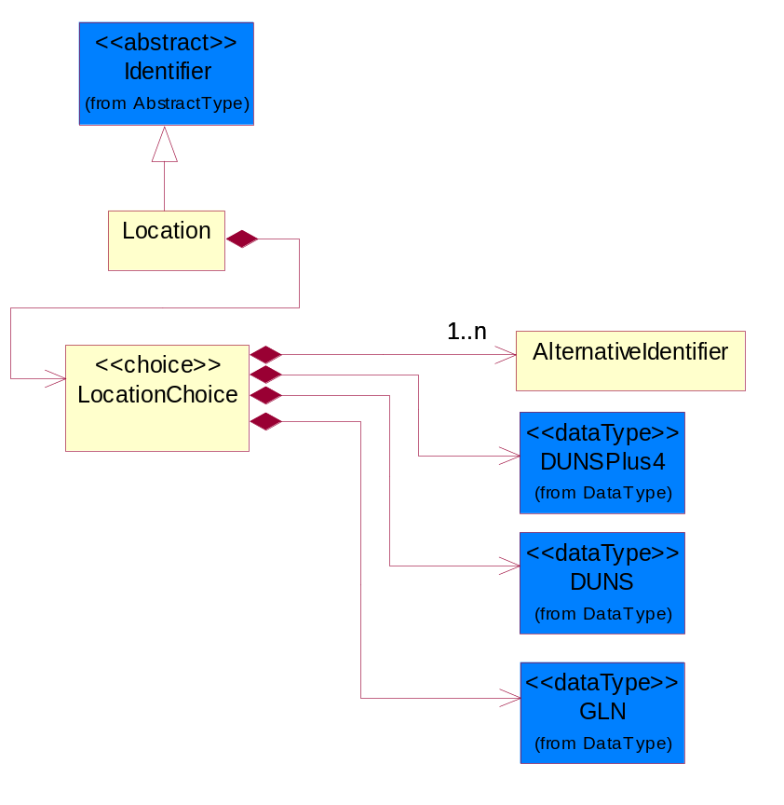
Figure 4-32 Location
Composition | Cardinality | Type | Documentation
LocationChoice | 1 | LocationChoice

LocationChoice
Composition | Cardinality | Type | Documentation
DUNSPlus4 | 1 | DUNSPlus4 | A identifier to specify a specific location within a business location.
DUNS | 1 | DUNS | A number assigned by Dun and Bradstreet to identify a business location.
AlternativeIdentifier | 1..n | AlternativeIdentifier | Identifies the specified code and the name of the organization that a code is utilized from.
GLN | 1 | GLN | Global Location Number (GLN) - A identifier to identify legal entities, trading parties and location.

PhysicalAddress
The business document must provide a physical address for a party to the business transaction.
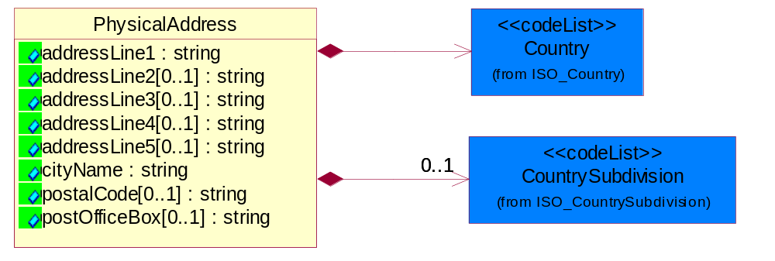
Figure 4-33 PhysicalAddress
Attribute | Type | Documentation
addressLine1 | string | The first line of a physical address.
addressLine2[0..1] | string | The second line of a physical address.
addressLine3[0..1] | string | The third line of a physical address.
addressLine4[0..1] | string | The fourth line of a physical address.
addressLine5[0..1] | string | The fifth line of a physical address.
cityName | string | The name of a city.
postalCode[0..1] | string | Identifying geographic location as specified by a national postal code.
postOfficeBox[0..1] | string | The Post Office Box identifier used to identify a party's post office box.

Composition | Cardinality | Type | Documentation
Country | 1 | Country | For representation of Country name RosettaNet has adopted ISO 3166-3; 1999. Refer to the following web page to get the latest version of the standard:  http://www.iso.ch/iso/en/prods-services/iso3166ma/02iso-3166-code-lists/index.html  If you need more information about the ISO standard please contact ISO for more details.
CountrySubdivision | 0..1 | CountrySubdivision | For representation of a Countries subdivisions RosettaNet has adopted ISO 3166-3; 1999. Refer to the following web page to get the latest version of the standard:  http://www.iso.ch/iso/en/prods-services/iso3166ma/02iso-3166-code-lists/index.html  If you need more information about the ISO standard please contact ISO for more details.

MonetaryExpression

FinancialAmount
The business document must express financial amounts.
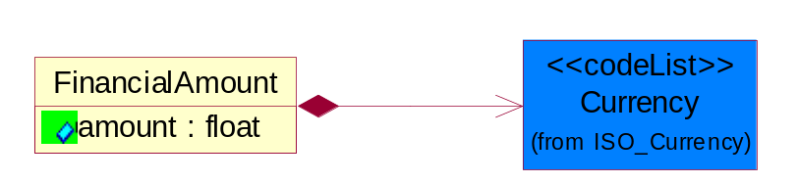
Figure 4-34 FinancialAmount

Attribute | Type | Documentation
amount | float | Specifies the monetary amount.

Composition | Cardinality | Type | Documentation
Currency | 1 | Currency | For representation of Currency codes RosettaNet has adopted ISO 4217; 1995. The British Standards Institution (BSI) is the ISO 4217 Maintenance Agency. Refer to the following web page to get the latest version of the standard:  http://www.bsi-global.com/Technical+Information/Publications/_Publications/tig90.xalter  If you need more information about the ISO standard please contact ISO for more details.

ProductPricing
The business document must contain the price of the product.
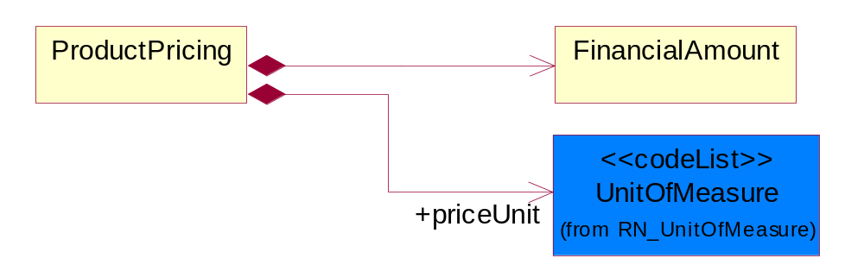
Figure 4-35 ProductPricing
Composition | Cardinality | Type | Documentation
FinancialAmount | 1 | FinancialAmount | The business document must express financial amounts.
priceUnit | 1 | UnitOfMeasure | This object represents the unit of the product.

PartnerIdentification

FullPartner
The business document must describe the trading partners in the business transaction. This data structure provide the flexibility to describe a partner in all possible methods as for new, existing or known partner.
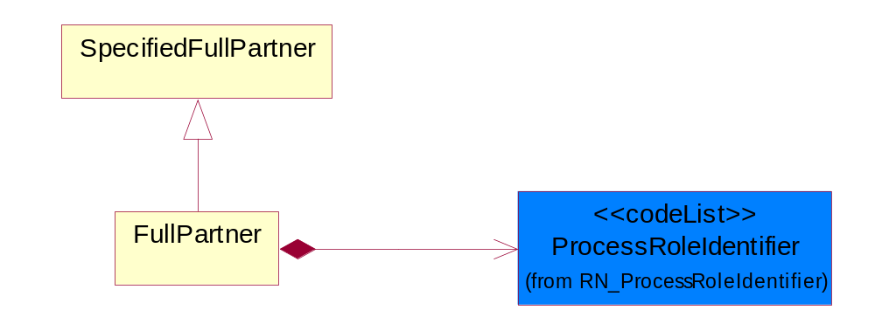
Figure 4-36 FullPartner
Composition | Cardinality | Type | Documentation
ProcessRoleIdentifier | 1 | ProcessRoleIdentifier | Describes the role of the partner in the business process. A partner will fulfill at least one or more roles during the business process.

IntermittentPartner
The business document must describe a physical address for a delivery.
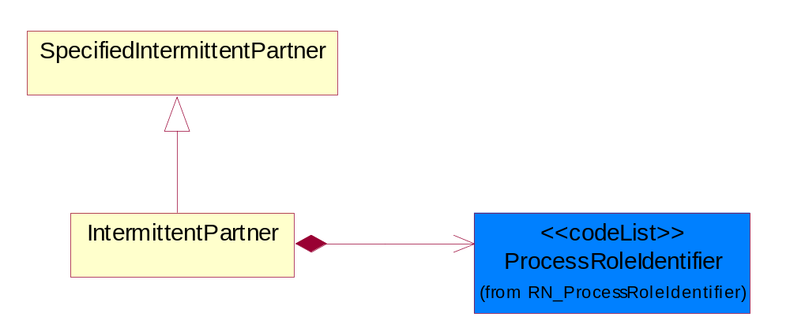
Figure 4-37 IntermittentPartner
Composition | Cardinality | Type | Documentation
ProcessRoleIdentifier | 1 | ProcessRoleIdentifier | Describes the role of the partner in the business process. A partner will fulfill at least one or more roles during the business process.

KnownPartner
The business document must describe the trading partners in the business transaction.
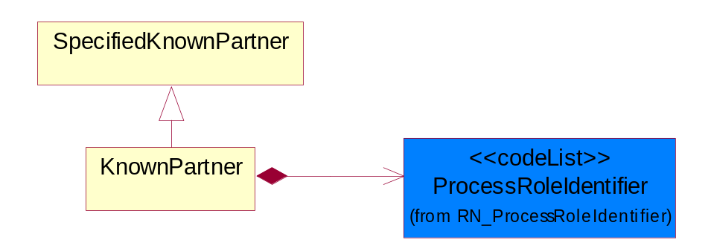
Figure 4-38 KnownPartner

Composition | Cardinality | Type | Documentation
ProcessRoleIdentifier | 1 | ProcessRoleIdentifier | Describes the role of the partner in the business process. A partner will fulfill at least one or more roles during the business process.

KnownPartnerContact
The business document must describe the trading partners in the business transaction.
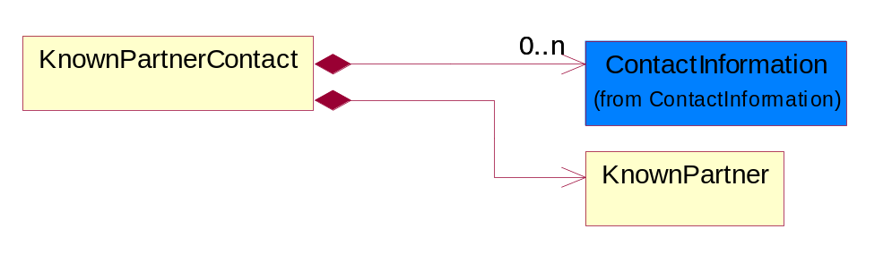
Figure 4-39 KnownPartnerContact
Composition | Cardinality | Type | Documentation
KnownPartner | 1 | KnownPartner | The business document must describe the trading partners in the business transaction.
ContactInformation | 0..n | ContactInformation | The business document must allow for the identification of the name of the department, service or individual to be contacted regarding the context of the business document.

NewPartner
The business document must describe a new, existing (but known to only one of the parties to the transaction) or an unknown party to the business transaction.
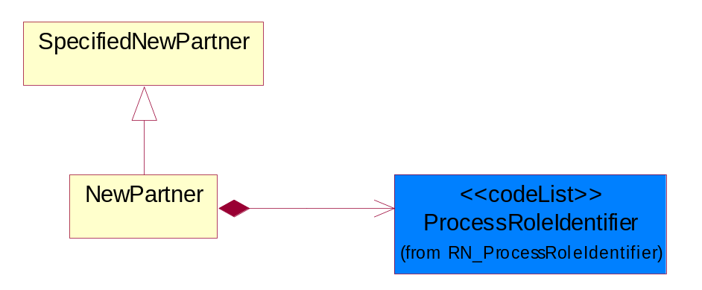
Figure 4-40 NewPartner
Composition | Cardinality | Type | Documentation
ProcessRoleIdentifier | 1 | ProcessRoleIdentifier | Describes the role of the partner in the business process. A partner will fulfill at least one or more roles during the business process.

PartnerDescription
The collection of business properties that describe a business partners' identity, their contact information, where they are physically located and their function in a supply chain.
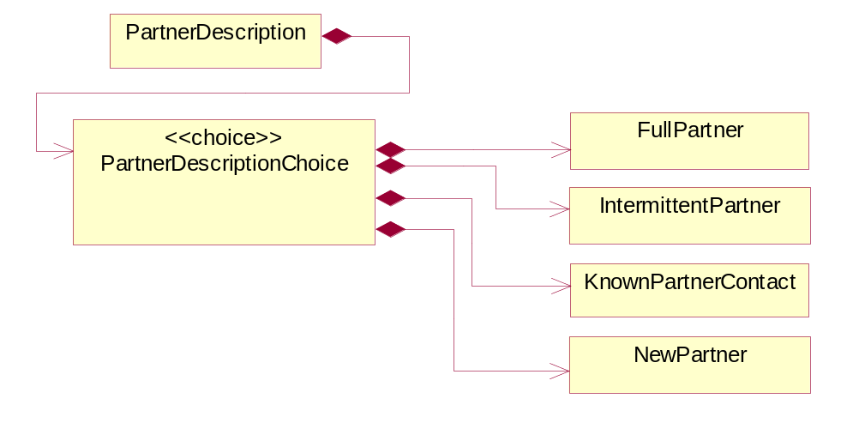
Figure 4-41 PartnerDescription
Composition | Cardinality | Type | Documentation
PartnerDescriptionChoice | 1 | PartnerDescriptionChoice

PartnerDescriptionChoice

Composition | Cardinality | Type | Documentation
KnownPartnerContact | 1 | KnownPartnerContact | The business document must describe the trading partners in the business transaction.
IntermittentPartner | 1 | IntermittentPartner | The business document must describe a physical address for a delivery.
NewPartner | 1 | NewPartner | The business document must describe a new, existing (but known to only one of the parties to the transaction) or an unknown party to the business transaction.
FullPartner | 1 | FullPartner | The business document must describe the trading partners in the business transaction. This data structure provide the flexibility to describe a partner in all possible methods as for new, existing or known partner.

PartnerIdentification
The business document must allow for the identity of one or more parties to the transaction.
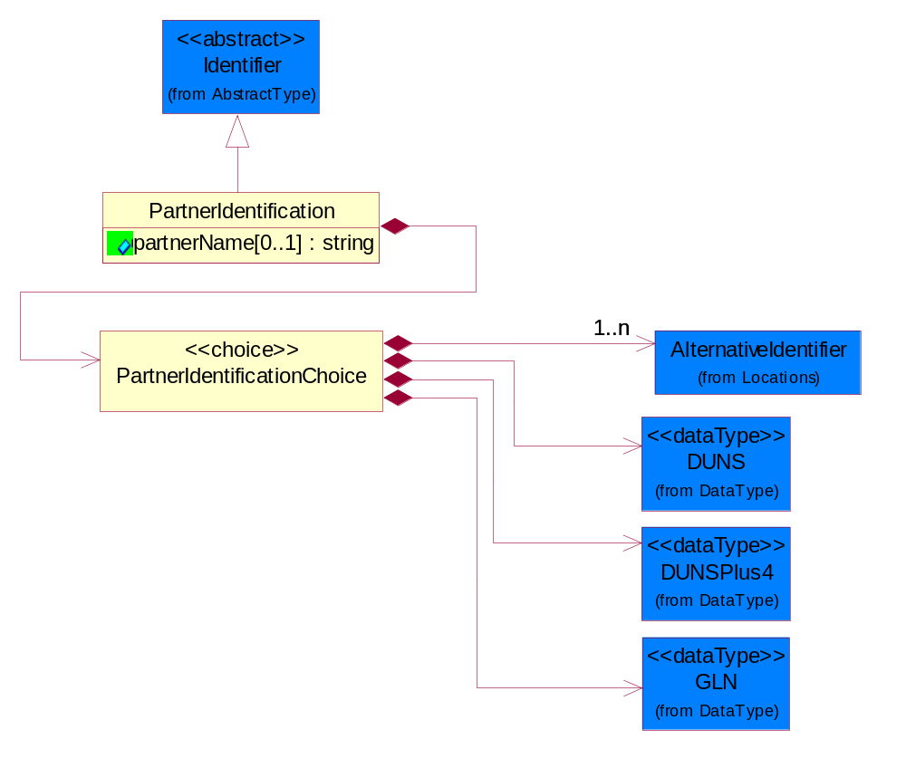
Figure 4-42 PartnerIdentification
Attribute | Type | Documentation
partnerName[0..1] | string | The name of the partner’s company/business.

Composition | Cardinality | Type | Documentation
PartnerIdentificationChoice | 1 | PartnerIdentificationChoice

PartnerIdentificationChoice
Composition | Cardinality | Type | Documentation
DUNS | 1 | DUNS | A number assigned by Dun and Bradstreet to identify a business location.
DUNSPlus4 | 1 | DUNSPlus4 | A identifier to specify a specific location within a business location.
AlternativeIdentifier | 1..n | AlternativeIdentifier | Identifies the specified code and the name of the organization that a code is utilized from.
GLN | 1 | GLN | Global Location Number (GLN) - A identifier to identify legal entities, trading parties and location.

SpecifiedFullPartner
The business document must describe the trading partners in the business transaction. This data structure provide the flexibility to describe a partner in all possible methods as for new, existing or known partner. This is specifically for partner who role has been specified.
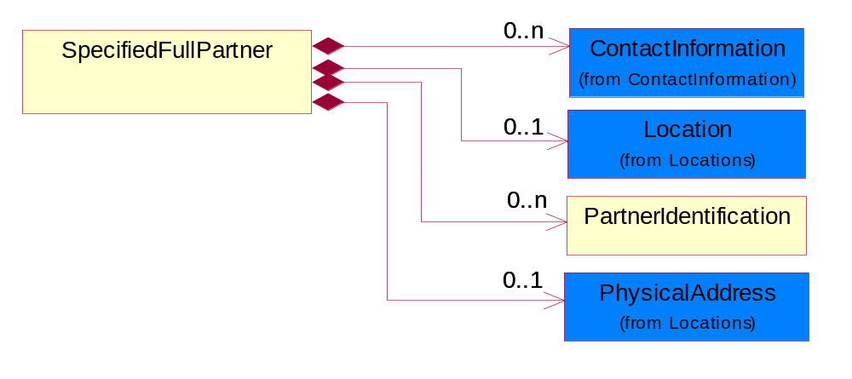
Figure 4-43 SpecifiedFullPartner

Composition | Cardinality | Type | Documentation
ContactInformation | 0..n | ContactInformation | The business document must allow for the identification of the name of the department, service or individual to be contacted regarding the context of the business document.
Location | 0..1 | Location | The business document must specify a location.
PartnerIdentification | 0..n | PartnerIdentification | The business document must allow for the identity of one or more parties to the transaction.
PhysicalAddress | 0..1 | PhysicalAddress | The business document must provide a physical address for a party to the business transaction.

SpecifiedIntermittentPartner
The business document must describe a physical address for a delivery.
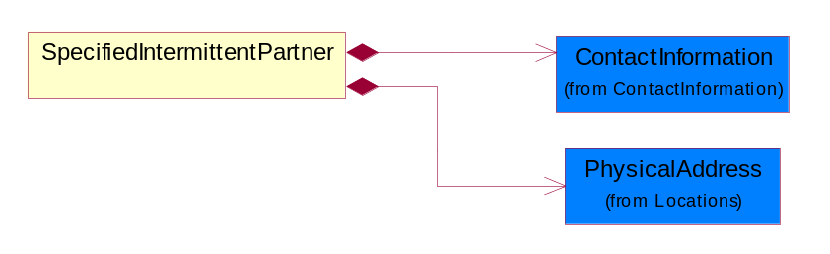
Figure 4-44 SpecifiedIntermittentPartner
Composition | Cardinality | Type | Documentation
ContactInformation | 1 | ContactInformation | The business document must allow for the identification of the name of the department, service or individual to be contacted regarding the context of the business document.
PhysicalAddress | 1 | PhysicalAddress | The business document must provide a physical address for a party to the business transaction.

SpecifiedKnownPartner
The business document must describe the trading partners in the business transaction.
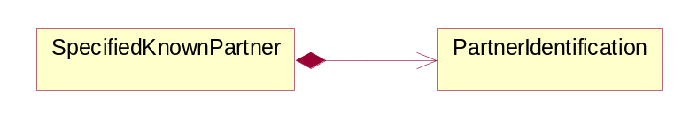
Figure 4-45 SpecifiedKnownPartner

Composition | Cardinality | Type | Documentation
PartnerIdentification | 1 | PartnerIdentification | The business document must allow for the identity of one or more parties to the transaction.

SpecifiedNewPartner
The business document must describe a new, existing (but known to only one of the parties to the transaction) or an unknown party to the business transaction.
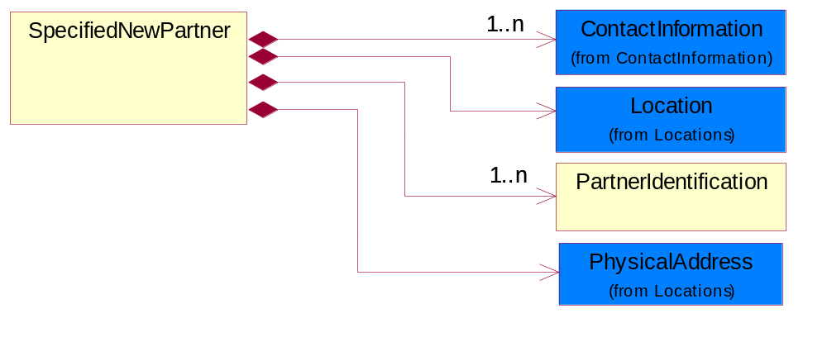
Figure 4-46 SpecifiedNewPartner
Composition | Cardinality | Type | Documentation
ContactInformation | 1..n | ContactInformation | The business document must allow for the identification of the name of the department, service or individual to be contacted regarding the context of the business document.
Location | 1 | Location | The business document must specify a location.
PhysicalAddress | 1 | PhysicalAddress | The business document must provide a physical address for a party to the business transaction.
PartnerIdentification | 1..n | PartnerIdentification | The business document must allow for the identity of one or more parties to the transaction.

ProductIdentification

ProductIdentification
The object provides the identifier(s) of a product.
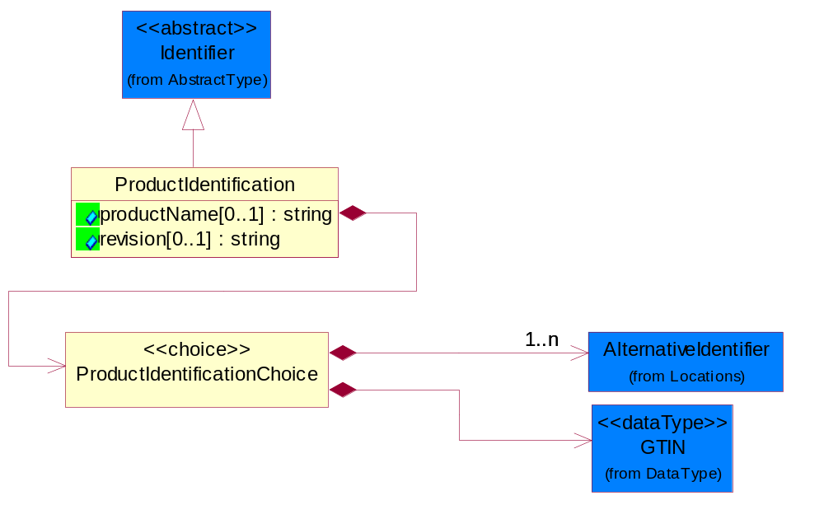
Figure 4-47 ProductIdentification

Attribute | Type | Documentation
productName[0..1] | string | The name of the product.
revision[0..1] | string | Referenced the specified product revision.

Composition | Cardinality | Type | Documentation
ProductIdentificationChoice | 1 | ProductIdentificationChoice

ProductIdentificationChoice

Composition | Cardinality | Type | Documentation
AlternativeIdentifier | 1..n | AlternativeIdentifier | Identifies the specified code and the name of the organization that a code is utilized from.
GTIN | 1 | GTIN | Global Trade Identification Number (GTIN).

CodeList

Country
For representation of Country name RosettaNet has adopted ISO 3166-3; 1999. Refer to the following web page to get the latest version of the standard:
http://www.iso.ch/iso/en/prods-services/iso3166ma/02iso-3166-code-lists/index.html

If you need more information about the ISO standard please contact ISO for more details.

CountrySubdivision
For representation of a Countries subdivisions RosettaNet has adopted ISO 3166-3; 1999. Refer to the following web page to get the latest version of the standard:
http://www.iso.ch/iso/en/prods-services/iso3166ma/02iso-3166-code-lists/index.html

If you need more information about the ISO standard please contact ISO for more details.

Currency
For representation of Currency codes RosettaNet has adopted ISO 4217; 1995. The British Standards Institution (BSI) is the ISO 4217 Maintenance Agency. Refer to the following web page to get the latest version of the standard:
http://www.bsi-global.com/Technical+Information/Publications/_Publications/tig90.xalter

If you need more information about the ISO standard please contact ISO for more details.

Language
For representation of Language name RosettaNet has adopted ISO 639-2; 1998. Refer to the following web page to get the latest version of the standard:

http://www.loc.gov/standards/iso639-2/iso639jac.html

If you need more information about the ISO standard please contact ISO for more details.

DocumentType
A code identifying the business context of a document.

Instance | Documentation
ARA | Authorization Request Approval.
CBN | Product batch number of customer.
CCN | Customs clearance number.
CFA | Failure Analysis - Request document that will accompany the product providing characteristics of the component failure.
CIN | Commercial Invoice.
CNM | Traditional credit note or memo.
CON | In a virtual sourcing relationship, a third party trading partner is supplying a part to a customer on behalf of another company that has taken the order for the customer. In this case a Customer Order Number is associated to the request for material that is sent to the virtual trading partners.
COS | Consumption Notice.
COT | Contract.
CRN | Unique consumption reference number identifying the product consumption issue i.e. one-to-one relationship with physical flow.
DEM | Traditional debit note or memo.
DEN | Delivery Note.
DIN | Discontinuation Notice.
DOR | Delivery Order.
DRN | Drawing Number.
DRR | Design Registration Request.
ECO | Engineering Change Order - The proprietary unique identification number that represents an engineering change order.
EIR | Engineering Information Request.
EOL | End of Life.
FUO | Sales order or transfer order fulfilling demand out of a facility (outbound shipment).
INV | Invoice.
LID | Location Identifier. Data for on-site work that have to be done on the machine (associated with preventive maintenance order).
MEN | Master Event Number.
MID | Machine Identifier. Data for on-site work that have to be done on the machine (associated with preventive maintenance order).
MON | Model Number.
OCL | The unique identifier assigned by the OEM for a warranty claim.
OGA | Other governmental agency issued document.
OPO | The unique identifier assigned by the OEM for a part order.
OPR | The unique identifier assigned by the OEM for a part return.
PCN | Product/Process Change.
PFA | Failure Analysis - Request document that will accompany the product providing characteristics of the product failure.
PII | Refers to previously issued invoice.
PLS | Unique number that identifies packing form prior to shipment.
POI | Purchase Order IN.
PON | Production order number for material release.
POO | Purchase Order OUT.
PRC | Product Catalog.
PSI | Refers to previously issued self-billing invoice.
PUO | Purchase Order.
QUO | Quote.
REC | Document identifying the receipt of materials or products into a facility against a purchase order or transfer order (inbound shipment).
REO | Purchase order or transfer order replenishing inventory into a facility (inbound shipment).
REQ | Requisition.
RMA | Returned Material Authorization.
RPO | Purchase order for materials or product returned to and reworked by a supplier.
RTA | Remittance Advice - Remittance details.
SAO | Sales Order.
SBC | Credit Memo used in self-billing scenario.
SBD | Debit Memo used in self-billing scenario.
SBI | Invoice in self billing scenario.
SBN | Product batch number of supplier.
SCA | Similar to contracts - Contains the quantity of an article that is to be ordered from a vendor and the price for article or service that is to be procured.
SEN | Serial Number.
SEO | A document that gives a repair provider the necessary authorization to repair or upgrade a product either at the customer site or at the repair provider’s site.
SHD | Shipping Document.
SNC | Shipset Number on Code List.
SPC | The unique identifier assigned by the ASP for a warranty claim.
SPN | Spec Number.
SPO | The unique identifier assigned by the ASP for a part order.
SPR | The unique identifier assigned by the ASP for a part return.
SPW | The unique identifier assigned by the ASP to reference a work order.
SRI | A document that contains the shipping reference number which allows the product to be tracked within the outsourced logistic providers network.
TRO | Order which results in materials or products being moved from one facility to another (outbound shipment and inbound shipment).
WAB | Waybill.
WAC | Denotes a warranty claim.
WOO | Work Order.

MimeTypeQualifier
The MIME type as defined by IANA.

Please refer to http://www.iana.org/assignments/media-types/ for a list of types.

Instance | Documentation
application/activemessage | [Shapiro]
application/andrew-inset | [Borenstein]
application/applefile | [Faltstrom]
application/atomicmail | [Borenstein]
application/batch-SMTP | [RFC2442]
application/beep+xml | [RFC3080]
application/cals-1840 | [RFC1895]
application/cnrp+xml | [RFCCNRP]
application/commonground | [Glazer]
application/cpl+xml
application/cybercash | [Eastlake]
application/dca-rft | [Campbell]
application/dec-dx | [Campbell]
application/dicom | [RFC3240]
application/dvcs | [RFC3029]
application/EDI-Consent | [RFC1767]
application/EDIFACT | [RFC1767]
application/EDI-X12 | [RFC1767]
application/eshop | [Katz]
application/font-tdpfr | [RFC3073]
application/http | [RFC2616]
application/hyperstudio | [Domino]
application/iges | [Parks]
application/index | [RFC2652]
application/index.cmd | [RFC2652]
application/index.obj | [RFC2652]
application/index.response | [RFC2652]
application/index.vnd | [RFC2652]
application/iotp | [RFC2935]
application/ipp | [RFC2910]
application/isup | [RFC3204]
application/mac-binhex40 | [Faltstrom]
application/macwriteii | [Lindner]
application/marc | [RFC2220]
application/mathematica | [Van Nostern]
application/msword | [Lindner]
application/news-message-id | [RFC1036,Spencer]
application/news-transmission | [RFC1036, Spencer]
application/ocsp-request | [RFC2560]
application/ocsp-response | [RFC2560]
application/octet-stream | [RFC2045,RFC2046]
application/oda | [RFC2045,RFC2046]
application/ogg | [RFC-walleij-ogg-mediatype-08.txt]
application/parityfec | [RFC3009]
application/pdf | [Lindner]
application/pgp-encrypted | [RFC3156]
application/pgp-keys | [RFC3156]
application/pgp-signature | [RFC3156]
application/pkcs10 | [RFC2311]
application/pkcs7-mime | [RFC2311]
application/pkcs7-signature | [RFC2311]
application/pkix-cert | [RFC2585]
application/pkixcmp | [RFC2510]
application/pkix-crl | [RFC2585]
application/postscript | [RFC2045,RFC2046]
application/prs.alvestrand.titrax-sheet | [Alvestrand]
application/prs.cww | [Rungchavalnont]
application/prs.nprend | [Doggett]
application/prs.plucker | [Janssen]
application/qsig | [RFC3204]
application/reginfo+xml | [RFC-ietf-sipping-reg-event-00.txt]
application/remote-printing | [RFC1486,Rose]
application/riscos | [Smith]
application/rtf | [Lindner]
application/sdp | [RFC2327]
application/set-payment | [Korver]
application/set-payment-initiation | [Korver]
application/set-registration | [Korver]
application/set-registration-initiation | [Korver]
application/sgml | [RFC1874]
application/sgml-open-catalog | [Grosso]
application/sieve | [RFC3028]
application/slate | [Crowley]
application/timestamp-query | [RFC3161]
application/timestamp-reply | [RFC3161]
application/tve-trigger | [Welsh]
application/vemmi | [RFC2122]
application/vnd.3gpp.pic-bw-large | [Meredith]
application/vnd.3gpp.pic-bw-small | [Meredith]
application/vnd.3gpp.pic-bw-var | [Meredith]
application/vnd.3gpp.sms | [Meredith]
application/vnd.3M.Post-it-Notes | [O'Brien]
application/vnd.accpac.simply.aso | [Leow]
application/vnd.accpac.simply.imp | [Leow]
application/vnd.acucobol | [Lubin]
application/vnd.acucorp | [Lubin]
application/vnd.adobe.xfdf | [Perelman]
application/vnd.aether.imp | [Moskowitz]
application/vnd.amiga.ami | [Blumberg]
application/vnd.anser-web-certificate-issue-initiation | [Mori]
application/vnd.anser-web-funds-transfer-initiation | [Mori]
application/vnd.audiograph | [Slusanschi]
application/vnd.blueice.multipass | [Holmstrom]
application/vnd.bmi | [Gotoh]
application/vnd.businessobjects | [Imoucha]
application/vnd.canon-cpdl | [Muto]
application/vnd.canon-lips | [Muto]
application/vnd.cinderella | [Kortenkamp]
application/vnd.claymore | [Simpson]
application/vnd.commerce-battelle | [Applebaum]
application/vnd.commonspace | [Chandhok]
application/vnd.contact.cmsg | [Patz]
application/vnd.cosmocaller | [Dellutri]
application/vnd.ctc-posml | [Kohlhepp]
application/vnd.cups-postscript | [Sweet]
application/vnd.cups-raster | [Sweet]
application/vnd.cups-raw | [Sweet]
application/vnd.curl | [Byrnes]
application/vnd.cybank | [Helmee]
application/vnd.data-vision.rdz | [Fields]
application/vnd.dna | [Searcy]
application/vnd.dpgraph | [Parker]
application/vnd.dreamfactory | [Appleton]
application/vnd.dxr | [Duffy]
application/vnd.ecdis-update | [Buettgenbach]
application/vnd.ecowin.chart | [Olsson]
application/vnd.ecowin.filerequest | [Olsson]
application/vnd.ecowin.fileupdate | [Olsson]
application/vnd.ecowin.series | [Olsson]
application/vnd.ecowin.seriesrequest | [Olsson]
application/vnd.ecowin.seriesupdate | [Olsson]
application/vnd.enliven | [Santinelli]
application/vnd.epson.esf | [Hoshina]
application/vnd.epson.msf | [Hoshina]
application/vnd.epson.quickanime | [Gu]
application/vnd.epson.salt | [Nagatomo]
application/vnd.epson.ssf | [Hoshina]
application/vnd.ericsson.quickcall | [Tidwell]
application/vnd.eudora.data | [Resnick]
application/vnd.fdf | [Zilles]
application/vnd.ffsns | [Holstage]
application/vnd.FloGraphIt | [Floersch]
application/vnd.framemaker | [Wexler]
application/vnd.fsc.weblaunch | [D.Smith]
application/vnd.fujitsu.oasys | [Togashi]
application/vnd.fujitsu.oasys2 | [Togashi]
application/vnd.fujitsu.oasys3 | [Okudaira]
application/vnd.fujitsu.oasysgp | [Sugimoto]
application/vnd.fujitsu.oasysprs | [Ogita]
application/vnd.fujixerox.ddd | [Onda]
application/vnd.fujixerox.docuworks | [Taguchi]
application/vnd.fujixerox.docuworks.binder | [Matsumoto]
application/vnd.fut-misnet | [Pruulmann]
application/vnd.grafeq | [Tupper]
application/vnd.groove-account | [Joseph]
application/vnd.groove-help | [Joseph]
application/vnd.groove-identity-message | [Joseph]
application/vnd.groove-injector | [Joseph]
application/vnd.groove-tool-message | [Joseph]
application/vnd.groove-tool-template | [Joseph]
application/vnd.groove-vcard | [Joseph]
application/vnd.hbci | [Hammann]
application/vnd.hhe.lesson-player | [Jones]
application/vnd.hp-HPGL | [Pentecost]
application/vnd.hp-hpid | [Gupta]
application/vnd.hp-hps | [Aubrey]
application/vnd.hp-PCL | [Pentecost]
application/vnd.hp-PCLXL | [Pentecost]
application/vnd.httphone | [Lefevre]
application/vnd.hzn-3d-crossword | [Minnis]
application/vnd.ibm.afplinedata | [Buis]
application/vnd.ibm.electronic-media | [Tantlinger]
application/vnd.ibm.MiniPay | [Herzberg]
application/vnd.ibm.modcap | [Hohensee]
application/vnd.ibm.secure-container | [Tantlinger]
application/vnd.informix-visionary | [Gales]
application/vnd.intercon.formnet | [Gurak]
application/vnd.intertrust.digibox | [Tomasello]
application/vnd.intertrust.nncp | [Tomasello]
application/vnd.intu.qbo | [Scratchley]
application/vnd.intu.qfx | [Scratchley]
application/vnd.irepository.package+xml | [Knowles]
application/vnd.is-xpr | [Natarajan]
application/vnd.japannet-directory-service | [Fujii]
application/vnd.japannet-jpnstore-wakeup | [Yoshitake]
application/vnd.japannet-payment-wakeup | [Fujii]
application/vnd.japannet-registration | [Yoshitake]
application/vnd.japannet-registration-wakeup | [Fujii]
application/vnd.japannet-setstore-wakeup | [Yoshitake]
application/vnd.japannet-verification | [Yoshitake]
application/vnd.japannet-verification-wakeup | [Fujii]
application/vnd.jisp | [Deckers]
application/vnd.kde.karbon | [Faure]
application/vnd.kde.kchart | [Faure]
application/vnd.kde.kformula | [Faure]
application/vnd.kde.kivio | [Faure]
application/vnd.kde.kontour | [Faure]
application/vnd.kde.kpresenter | [Faure]
application/vnd.kde.kspread | [Faure]
application/vnd.kde.kword | [Faure]
application/vnd.kenameaapp | [DiGiorgio-Haag]
application/vnd.koan | [Cole]
application/vnd.liberty-request+xml | [McDowell]
application/vnd.llamagraphics.life-balance.desktop | [White]
application/vnd.lotus-1-2-3 | [Wattenberger]
application/vnd.lotus-approach | [Wattenberger]
application/vnd.lotus-freelance | [Wattenberger]
application/vnd.lotus-notes | [Laramie]
application/vnd.lotus-organizer | [Wattenberger]
application/vnd.lotus-screencam | [Wattenberger]
application/vnd.lotus-wordpro | [Wattenberger]
application/vnd.mcd | [Gotoh]
application/vnd.mediastation.cdkey | [Flurry]
application/vnd.meridian-slingshot | [Wedel]
application/vnd.micrografx.flo | [Prevo]
application/vnd.micrografx.igx | [Prevo]
application/vnd.mif | [Wexler]
application/vnd.minisoft-hp3000-save | [Bartram]
application/vnd.mitsubishi.misty-guard.trustweb | [Tanaka]
application/vnd.Mobius.DAF | [Kabayama]
application/vnd.Mobius.DIS | [Kabayama]
application/vnd.Mobius.MBK | [Devasia]
application/vnd.Mobius.MQY | [Devasia]
application/vnd.Mobius.MSL | [Kabayama]
application/vnd.Mobius.PLC | [Kabayama]
application/vnd.Mobius.TXF | [Kabayama]
application/vnd.mophun.application | [Wennerstrom]
application/vnd.mophun.certificate | [Wennerstrom]
application/vnd.motorola.flexsuite | [Patton]
application/vnd.motorola.flexsuite.adsi | [Patton]
application/vnd.motorola.flexsuite.fis | [Patton]
application/vnd.motorola.flexsuite.gotap | [Patton]
application/vnd.motorola.flexsuite.kmr | [Patton]
application/vnd.motorola.flexsuite.ttc | [Patton]
application/vnd.motorola.flexsuite.wem | [Patton]
application/vnd.mozilla.xul+xml | [McDaniel]
application/vnd.ms-artgalry | [Slawson]
application/vnd.ms-asf | [Fleischman]
application/vnd.mseq | [Le Bodic]
application/vnd.ms-excel | [Gill]
application/vnd.msign | [Borcherding]
application/vnd.ms-lrm | [Ledoux]
application/vnd.ms-powerpoint | [Gill]
application/vnd.ms-project | [Gill]
application/vnd.ms-tnef | [Gill]
application/vnd.ms-works | [Gill]
application/vnd.ms-wpl | [Plastina]
application/vnd.musician | [Adams]
application/vnd.music-niff | [Butler]
application/vnd.netfpx | [Mutz]
application/vnd.noblenet-directory | [Solomon]
application/vnd.noblenet-sealer | [Solomon]
application/vnd.noblenet-web | [Solomon]
application/vnd.novadigm.EDM | [Swenson]
application/vnd.novadigm.EDX | [Swenson]
application/vnd.novadigm.EXT | [Swenson]
application/vnd.obn | [Hessling]
application/vnd.osa.netdeploy | [Klos]
application/vnd.palm | [Peacock]
application/vnd.pg.format | [Gandert]
application/vnd.pg.osasli | [Gandert]
application/vnd.powerbuilder6 | [Guy]
application/vnd.powerbuilder6-s | [Guy]
application/vnd.powerbuilder7 | [Shilts]
application/vnd.powerbuilder75 | [Shilts]
application/vnd.powerbuilder75-s | [Shilts]
application/vnd.powerbuilder7-s | [Shilts]
application/vnd.previewsystems.box | [Smolgovsky]
application/vnd.publishare-delta-tree | [Ben-Kiki]
application/vnd.pvi.ptid1 | [Lamb]
application/vnd.pwg-multiplexed | [RFC3391]
application/vnd.pwg-xhtml-print+xml | [Wright]
application/vnd.Quark.QuarkXPress | [Scheidler]
application/vnd.rapid | [Szekely]
application/vnd.s3sms | [Tarkkala]
application/vnd.sealed.net | [Lambert]
application/vnd.seemail | [Webb]
application/vnd.shana.informed.formdata | [Selzler]
application/vnd.shana.informed.formtemplate | [Selzler]
application/vnd.shana.informed.interchange | [Selzler]
application/vnd.shana.informed.package | [Selzler]
application/vnd.smaf | [Takahashi]
application/vnd.sss-cod | [Dani]
application/vnd.sss-dtf | [Bruno]
application/vnd.sss-ntf | [Bruno]
application/vnd.street-stream | [Levitt]
application/vnd.svd | [Becker]
application/vnd.swiftview-ics | [Widener]
application/vnd.triscape.mxs | [Simonoff]
application/vnd.trueapp | [Hepler]
application/vnd.truedoc | [Chase]
application/vnd.ufdl | [Manning]
application/vnd.uplanet.alert | [Martin]
application/vnd.uplanet.alert-wbxml | [Martin]
application/vnd.uplanet.bearer-choice | [Martin]
application/vnd.uplanet.bearer-choice-wbxml | [Martin]
application/vnd.uplanet.cacheop | [Martin]
application/vnd.uplanet.cacheop-wbxml | [Martin]
application/vnd.uplanet.channel | [Martin]
application/vnd.uplanet.channel-wbxml | [Martin]
application/vnd.uplanet.list | [Martin]
application/vnd.uplanet.listcmd | [Martin]
application/vnd.uplanet.listcmd-wbxml | [Martin]
application/vnd.uplanet.list-wbxml | [Martin]
application/vnd.uplanet.signal | [Martin]
application/vnd.vcx | [T.Sugimoto]
application/vnd.vectorworks | [Pharr]
application/vnd.vidsoft.vidconference | [Hess]
application/vnd.visio | [Sandal]
application/vnd.visionary | [Aravindakumar]
application/vnd.vividence.scriptfile | [Risher]
application/vnd.vsf | [Rowe]
application/vnd.wap.sic | [WAP-Forum]
application/vnd.wap.slc | [WAP-Forum]
application/vnd.wap.wbxml | [Stark]
application/vnd.wap.wmlc | [Stark]
application/vnd.wap.wmlscriptc | [Stark]
application/vnd.webturbo | [Rehem]
application/vnd.wrq-hp3000-labelled | [Bartram]
application/vnd.wt.stf | [Wohler]
application/vnd.wv.csp+wbxml | [Salmi]
application/vnd.xara | [Matthewman]
application/vnd.xfdl | [Manning]
application/vnd.yellowriver-custom-menu | [Yellow]
application/whoispp-query | [RFC2957]
application/whoispp-response | [RFC2958]
application/wita | [Campbell]
application/wordperfect5.1 | [Lindner]
application/x400-bp | [RFC1494]
application/xhtml+xml | [RFC3236]
application/xml | [RFC3023]
application/xml-dtd | [RFC3023]
application/xml-external-parsed-entity | [RFC3023]
application/zip | [Lindner]
audio/32kadpcm | [RFC2421,RFC2422]
audio/AMR | [RFC3267]
audio/AMR-WB | [RFC3267]
audio/basic | [RFC2045,RFC2046]
audio/CN | [RFC3389]
audio/DAT12 | [RFC3190]
audio/DVI4
audio/EVRC | [RFC-ietf-avt-evrc-smv-03.txt]
audio/EVRC0 | [RFC-ietf-avt-evrc-smv-03.txt]
audio/G.722.1 | [RFC3047]
audio/G722
audio/G723
audio/G726-16
audio/G726-24
audio/G726-32
audio/G726-40
audio/G728
audio/G729
audio/G729D
audio/G729E
audio/GSM
audio/GSM-EFR
audio/L16 | [RFC2586]
audio/L20 | [RFC3190]
audio/L24 | [RFC3190]
audio/L8
audio/LPC
audio/MP4A-LATM | [RFC3016]
audio/MPA
audio/mpa-robust | [RFC3119]
audio/mpeg | [RFC3003]
audio/parityfec | [RFC3009]
audio/PCMA
audio/PCMU
audio/prs.sid | [Walleij]
audio/QCELP
audio/RED
audio/SMV | [RFC-ietf-avt-evrc-smv-03.txt]
audio/SMV0 | [RFC-ietf-avt-evrc-smv-03.txt]
audio/telephone-event | [RFC2833]
audio/tone | [RFC2833]
audio/VDVI
audio/vnd.3gpp.iufp | [Belling]
audio/vnd.cisco.nse | [Kumar]
audio/vnd.cns.anp1 | [McLaughlin]
audio/vnd.cns.inf1 | [McLaughlin]
audio/vnd.digital-winds | [Strazds]
audio/vnd.everad.plj | [Cicelsky]
audio/vnd.lucent.voice | [Vaudreuil]
audio/vnd.nortel.vbk | [Parsons]
audio/vnd.nuera.ecelp4800 | [Fox]
audio/vnd.nuera.ecelp7470 | [Fox]
audio/vnd.nuera.ecelp9600 | [Fox]
audio/vnd.octel.sbc | [Vaudreuil]
audio/vnd.qcelp | [Lundblade]
audio/vnd.rhetorex.32kadpcm | [Vaudreuil]
audio/vnd.vmx.cvsd | [Vaudreuil]
image/cgm | Computer Graphics Metafile
image/g3fax | [RFC1494]
image/gif | [RFC2045,RFC2046]
image/ief | [RFC1314] Image Exchange Format
image/jpeg | [RFC2045,RFC2046]
image/naplps | [Ferber]
image/png | [Randers-Pehrson]
image/prs.btif | [Simon]
image/prs.pti | [Laun]
image/t38 | [RFC3362]
image/tiff | [RFC3302] Tag Image File Format
image/tiff-fx | [RFC3250] Tag Image File Format Fax eXtended
image/vnd.cns.inf2 | [McLaughlin]
image/vnd.djvu | [Bottou]
image/vnd.dwg | [Moline]
image/vnd.dxf | [Moline]
image/vnd.fastbidsheet | [Becker]
image/vnd.fpx | [Spencer]
image/vnd.fst | [Fuldseth]
image/vnd.fujixerox.edmics-mmr | [Onda]
image/vnd.fujixerox.edmics-rlc | [Onda]
image/vnd.globalgraphics.pgb | [Bailey]
image/vnd.mix | [Reddy]
image/vnd.ms-modi | [Vaughan]
image/vnd.net-fpx | [Spencer]
image/vnd.svf | [Moline]
image/vnd.wap.wbmp | [Stark]
image/vnd.xiff | [S.Martin]
message/delivery-status | [RFC1894]
message/disposition-notification | [RFC2298]
message/external-body | [RFC2045,RFC2046]
message/http | [RFC2616]
message/news | [RFC 1036, H.Spencer]
message/partial | [RFC2045,RFC2046]
message/rfc822 | [RFC2045,RFC2046]
message/s-http | [RFC2660]
message/sip | [RFC3261]
message/sipfrag | [RFC3420]
model/iges | [Parks]
model/mesh | [RFC2077]
model/vnd.dwf | [Pratt]
model/vnd.flatland.3dml | [Powers]
model/vnd.gdl | [Babits]
model/vnd.gs-gdl | [Babits]
model/vnd.gtw | [Ozaki]
model/vnd.mts | [Rabinovitch]
model/vnd.parasolid.transmit.binary | [Parasolid]
model/vnd.parasolid.transmit.text | [Parasolid]
model/vnd.vtu | [Rabinovitch]
model/vrml | [RFC2077]
multipart/alternative | [RFC2045,RFC2046]
multipart/appledouble | [Faltstrom]
multipart/byteranges | [RFC2068]
multipart/digest | [RFC2045,RFC2046]
multipart/encrypted | [RFC1847]
multipart/form-data | [RFC2388]
multipart/header-set | [Crocker]
multipart/mixed | [RFC2045,RFC2046]
multipart/parallel | [RFC2045,RFC2046]
multipart/related | [RFC2387]
multipart/report | [RFC1892]
multipart/signed | [RFC1847]
multipart/voice-message | [RFC2421,RFC2423]
text/calendar | [RFC2445]
text/css | [RFC2318]
text/directory | [RFC2425]
text/enriched | [RFC1896]
text/html | [RFC2854]
text/parityfec | [RFC3009]
text/plain | [RFC2646,RFC2046]
text/prs.lines.tag | [Lines]
text/rfc822-headers | [RFC1892]
text/richtext | [RFC2045,RFC2046]
text/rtf | [Lindner]
text/sgml | [RFC1874]
text/t140 | [RFC2793]
text/tab-separated-values | [Lindner]
text/uri-list | [RFC2483]
text/vnd.abc | [Allen]
text/vnd.curl | [Byrnes]
text/vnd.DMClientScript | [Bradley]
text/vnd.fly | [Gurney]
text/vnd.fmi.flexstor | [Hurtta]
text/vnd.in3d.3dml | [Powers]
text/vnd.in3d.spot | [Powers]
text/vnd.IPTC.NewsML | [IPTC]
text/vnd.IPTC.NITF | [IPTC]
text/vnd.latex-z | [Lubos]
text/vnd.motorola.reflex | [Patton]
text/vnd.ms-mediapackage | [Nelson]
text/vnd.net2phone.commcenter.command | [Xie]
text/vnd.sun.j2me.app-descriptor | [G.Adams]
text/vnd.wap.si | [WAP-Forum]
text/vnd.wap.sl | [WAP-Forum]
text/vnd.wap.wml | [Stark]
text/vnd.wap.wmlscript | [Stark]
text/xml | [RFC3023]
text/xml-external-parsed-entity | [RFC3023]
video/BMPEG
video/BT656
video/CelB
video/DV | [RFC3189]
video/H261
video/H263
video/H263-1998
video/H263-2000
video/JPEG
video/MP1S
video/MP2P
video/MP2T
video/MP4V-ES | [RFC3016]
video/mpeg | [RFC2045,RFC2046]
video/MPV
video/nv
video/parityfec | [RFC3009]
video/pointer | [RFC2862]
video/quicktime | [Lindner]
video/SMPTE292M | [RFC-avt-smpte292-video-08.txt]
video/vnd.fvt | [Fuldseth]
video/vnd.motorola.video | [McGinty]
video/vnd.motorola.videop | [McGinty]
video/vnd.mpegurl | [Recktenwald]
video/vnd.nokia.interleaved-multimedia | [Kangaslampi]
video/vnd.objectvideo | [Clark]
video/vnd.vivo | [Wolfe]

UnitOfMeasure
Code identifying a product unit of measure.

Instance | Documentation
10P | 10-pack.
1BF | 100 Board Feet.
1FC | 20 Foot Container.
1GR | Gram/Cubic Centimeter.
1GT | 10,000 Gallon Tankcar.
1KB | 25 Kilogram Bulk Bag.
1KD | 10 Kilogram Drum.
1KP | 1000-pack.
1PA | 20-Pack.
1PB | 50 Pound Bag.
1PD | 100 Pound Drum.
2FC | 40 Foot Container.
2GR | Gram/square meter.
2GT | 20,000 Gallon Tankcar.
2KB | 300 Kilogram Bulk Bag.
2KD | 15 Kilogram Drum.
2PA | 100-Pack.
3GR | Grams Per 100 Centimeters.
3KB | 500 Kilogram Bulk Bag.
3KD | 55 Gallon Drum.
4GR | Grams Per 100 Grams.
4KD | 115 Kilogram Drum.
50P | 50-pack.
5GR | Grams Per Cubic Centimeter.
6GR | Grams Per Square Centimeter.
7GR | Grams Per Square Meter.
ACR | Acre.
ACT | Actual Pounds.
ALU | Aluminum Pounds Only.
AMP | Ampere.
ASM | Angstrom.
BAB | Base Box.
BAC | Batch.
BAE | Bale.
BAG | Bag.
BAL | Ball.
BAN | Band.
BAP | Batting Pound.
BAR | Bar.
BAS | Basket.
BAT | Batt.
BAW | Base Weight.
BEA | Beam.
BEC | Becquerel/kilogram.
BEL | Belt.
BIL | Billet.
BIN | Bin.
BIT | Bit.
BKC | Bulk Car Load.
BLO | Block.
BOA | Board.
BOF | Board Feet.
BOL | Bolt.
BOT | Bottle.
BOX | Box.
BRD | Barrels Per Day.
BRE | Barrel.
BRI | Barrel (Imperial).
BRM | Barrels Per Minute.
BTF | British Thermal Units (BTUs) Per Cubic Foot.
BTP | British Thermal Units (BTUs) Per Pound.
BTU | British Thermal Unit (BTU).
BUC | Bucket.
BUD | Bushel, Dry Imperial.
BUK | Bunks.
BUL | Bulk.
BUN | Bundle.
BUP | Bulk Pack.
BUS | Bushel.
BYT | Bytes.
CAA | Carat.
CAB | Carboy.
CAC | Card.
CAD | Candela.
CAG | Cartridge.
CAK | Cask.
CAL | Calorie.
CAN | Can.
CAO | Carload.
CAR | Car.
CAS | Case.
CAT | Canister.
CAW | Catchweight.
CEL | Cell.
CEM | Centimeter.
CEP | Centipoise (CPS).
CET | Centiliter.
CGM | Centigram.
CHA | Chains (Land Survey).
CHE | Chest.
CNN | Connector.
COG | Coil Group.
COI | Coil.
COL | Coulomb.
COM | Composite Product Pounds (Total Weight).
CON | Cone.
COT | Container.
COV | Cover.
CRA | Crate.
CRT | Carton.
CSE | Cassette.
CUB | Cubic centimeter.
CUC | Cubic centimeter/second.
CUF | Cubic Foot.
CUI | Cubic inch.
CUM | Cubicmeter.
CUP | Cup.
CUY | Cubic yard.
CYC | Cycles.
CYL | Cylinder.
DAY | Day.
DCB | Decibels.
DCG | Decagram.
DCL | Deciliter.
DEA | Deal.
DEC | Decimeter.
DEF | Degree Fahrenheit.
DEG | Degree Celsius.
DEP | Dep. Factor.
DGM | Decigram.
DIE | Die.
DIL | Display.
DIP | Dispenser.
DOZ | Dozen.
DRA | Dram.
DRU | Drum.
DRY | Dry Pounds.
EAC | Each.
ELE | Electrical Capacitance.
FAR | Farads.
FFA | Femtofarad.
FLO | Fluid Ounce.
FOI | Fluid Ounce (Imperial).
FOO | Foot.
FOU | Fluid Ounce US.
FUU | Fuel Usage (Gallons).
GAL | Gallon.
GAS | Gage Systems.
GIH | Gigahertz.
GIJ | Gigajoules.
GIL | Gill (Imperial).
GOB | Gross Barrels.
GOG | Gross Gallons.
GOK | Gross Kilogram.
GOT | Gross Ton.
GOY | Gross Yard.
GRA | Gram.
GRG | Great Gross (Dozen Gross).
GRK | Grams Per Kilogram.
GRL | Grams Per Liter.
GRM | Grams Per Milliliter.
GRN | Grain.
GRO | Gross.
GRP | Group.
HAG | Half Gallon.
HAH | Half Hour.
HAL | Half Liter.
HAN | Hank.
HEA | Heat lots.
HEC | Hectare.
HEL | Hectoliter.
HEP | Hectopascal.
HER | Hertz.
HNY | Henry.
HOS | Hours.
HOU | Hour.
HUA | Hundredth of a Carat.
HUB | Hundred Boxes.
HUC | Hundred Count.
HUS | Hundred Sheets.
IMG | Imperial Gallons.
INC | Inch.
JAR | Jar.
JOI | Joint.
JOU | Joule.
KBY | Kilobyte.
KEG | Keg.
KEL | Kelvin.
KHO | Kilometer/hour.
KIC | Kilogram per cubic meter.
KIE | Kilometer.
KIG | Kilogram.
KIH | Kilohertz.
KIK | Kilobecquerel/Kilogram.
KIL | Kiloampere.
KIM | Kilogram/square meter.
KIO | Kiloohm.
KIS | Kilogramm pro Sekunde.
KIT | Kit.
KIV | Kilovolt.
KIW | Kilowatt.
KJL | Kilojoule.
KKG | Kilogram/Kilogram.
KUD | Kubikdezimeter.
KUM | Kubikmeter pro Sekunde.
KWH | Kilowatt-hour.
LIF | Lifts.
LIM | Link.
LIQ | Liquid Pounds.
LIT | Liter.
LOA | Load.
LOT | Lot.
LUG | Lug.
MAM | Milliamps/mm.
MAT | Mat.
MBY | Megabyte.
MCG | Microgram.
MCM | Milligrams Per Cubic Meter.
MCR | Micron.
MEG | Megagram.
MEH | Megahertz.
MEP | Megapascal.
MET | Meter.
MEW | Megawatt.
MGM | Milligram.
MIB | Million BTU's.
MIC | Mikrogram/cubic meter.
MIG | Micrograms Per Cubic Meter.
MIL | Mile.
MIM | Micrometer.
MIN | Minute.
MIP | Millipascal seconds.
MIS | Microsecond.
MIT | Miter.
MIV | Millivolt.
MIW | Milliwatt.
MJO | Millijoule.
MLA | Milliampere.
MLB | Millibar.
MLC | Milligram/cubic meter.
MLI | Milliliter.
MLK | Milligram/kilogram.
MLL | Milligram/Liter.
MLS | Miles.
MME | Millimeter.
MMH | Millimeter H20.
MMK | Millimol/kilogram.
MMO | Millimol.
MOK | Mol/kilogram.
MOL | Mol.
MON | Month.
MPH | Megagrams Per Hour.
MSC | Millisecond.
MSM | Milligrams Per Square Meter.
MTA | Millitesla.
MTQ | Meter pro Quadratsekunde.
MTS | Meters per second.
MUL | Multichip - When 2 or more dies (chips) are merged into one package.
MVS | Millivolts.
MVT | Millivolt.
NAA | Nanoamps.
NAM | Nanometer.
NAS | Nanosecond.
NEB | Net Barrels.
NEG | Net Gallons.
NEI | Net Imperial Gallons.
NEL | Net Liters.
NEW | Newton.
OCT | Ohm/ct.
OHM | Ohm.
OMM | Ohm/mm.
ONE | One.
OSQ | Ohm/sq.
OTP | One Thousand Pieces.
OUN | Ounce.
OVI | Ohm/via.
PAC | Parcel.
PAD | Pad.
PAG | Package.
PAI | Pail.
PAK | Pack (PAK).
PAL | Pallet.
PAN | Panel.
PAR | Pair.
PAS | Pascal.
PAT | Packet.
PEC | Percent.
PEG | Percentage.
PEH | Percent Per 1000 Hours.
PEN | Pennyweight.
PER | Per Hundred Pieces.
PEW | Percent Weight.
PFR | Picofarad.
PID | Pint U.S. Dry.
PIE | Piece.
PIL | Pint - US liquid.
PLA | Plate.
PLL | Pallet (Lift).
PLT | Pallete.
PLU | Pallet/Unit Load.
POF | Pounds Per Foot.
POG | Pounds Per Gallon.
PON | Pound.
POP | Pounds Per Piece of Product.
POS | Pounds Per 1000 Square Feet.
POT | Pounds Per Thousand.
PPB | Parts per billion (US).
PPM | Parts per million.
PPP | Pounds Per Pound of Product.
PSC | Picosecond.
PSS | Pascal second.
QUA | Quart - US liquid.
RAC | Rack.
REA | Ream of 500 Sheets.
REE | Reel.
RIN | Ring.
ROD | Rod.
ROL | Roll.
SAC | Sack.
SBB | Super Bulk Bag.
SEC | Second.
SET | Set.
SHE | Sheet.
SHI | Shipment.
SHM | Sheet - Metric measure.
SHO | Shot.
SID | Disk (Disc).
SKE | Skein.
SKI | Skid.
SLE | Sleeve.
SLI | Slip Sheet.
SMI | Square mile.
SMM | Square millimeter.
SPO | Spool.
SQF | Square foot.
SQI | Square inch.
SQK | Square kilometer.
SQM | Square meter.
SQS | Square meter/second.
SQU | Square.
SQY | Square Yard.
STI | Stick.
STM | Statute Mile.
STR | Strip.
TAB | Tablet.
TAN | Tank.
TAT | Tank Truck.
TES | Tesla.
THO | Thousand.
TNN | Tonne.
TON | Ton.
TOR | Torr.
TOT | Tote.
TRA | Train.
TRF | Track Foot.
TRL | Trailer.
TRO | Troy.
TRU | Truckload.
TRY | Tray.
TRZ | Troy OZ.
TUB | Tube.
ULU | Unitless Unit of Measure.
UNT | Unit.
USG | US gallon.
USP | US pound.
UST | US ton.
VIA | Vial.
VOL | Volt.
VTA | Volts (Alternating Current).
VTD | Volts (Direct Current).
VTM | Volts Per Meter.
WAF | Wafer.
WAR | Watt.
WEE | Week.
WRA | Wrap.
YAR | Yard.
YEA | Year.

ProcessRoleIdentifier
Describes the role of the partner in the business process. A partner will fulfill at least one or more roles during the business process.

Instance | Documentation
ADM | Administered by - The party who is the administrative authority of an account.
ALT | Alternate approval by - The party who has approved a request in the event the approver is not able to respond.
APP | Approval by - The party who has approved a request.
BIF | Bill from - The party that will issue the invoice.
BIT | Bill to - The party that will pay the invoice.
CBK | Customs Broker - CustomsBroker  This object represents the party that declare the shipment on behalf of declarant.
CLF | Collect From - To enable the buyer to specify the location of where products not supplied directly by the seller/installer may be collected.
CLM | Claimed By - This object represents the claimant.
CNC | Cancellation party - The party who is cancelling the shipping order.
COR | Change originated by - The party who originates a proposed change.
COW | Change owned by - The party who owns or who is assigned responsibility for a proposed change.
CRA | Credit applicant - The party who is applying for credit.
CRE | Created by - The party responsible for creating a process or task.
CSP | Contract Service Provider.
CWN | contractOwner - The party who is the owner of the contract. For example, in the direct business, the buyer is the contract owner. In the distribution business, the buyer is the distributor and the contract owner is the reseller.
DCE | DesignCustomerApplicationEngineer. The demand customer's Field Application Engineer.
DCT | Declared To - This object represents the party that the declaration goes to.
DCU | DesignCustomer. The owner of the product for which the design has been created.
DIS | Distributed by - The party who supplies products to retailers.
DST | Distributed To - This object represents the party to send information to.
FCP | Forecast Partner - The collection of business properties that describes the partner types for a forecast.
FIA | From Install At - The collection of sender business properties that describes a business partners' identity, their contact information, where they are physically located and their function in a supply chain.
FIN | Financed by - The party who is the financier.
FNB | Founded by - The party who performs the act, process, or art of casting metals.
FOR | Forwarded to - The party to whom a business document has been forwarded.
IMB | Imported By - The party responsible for importing the product.
INL | Inventory location - The party where the inventory product entry is located.
INO | Inventory owner - The party that owns the inventory product entry.
ITF | In transit from - The party sending the product quantity in a product location transfer.
ITL | installAt - The partner and/or location to which the product must be set up for use or service.
ITT | In transit to - The party receiving the product quantity in a product location transfer.
LGP | Logistics Provided By - The party who handles the details of an operation.
MFG | Manufactured by - The party who creates, processes or produces goods especially in large quantities and by means of industrial machines.
OWN | Owned by - The party who owns a process.
PAE | ProductProviderFieldApplicationEngineer. The product provider Field Application Engineer.
PCW | Primary Contract With - The primary party with whom a contract is formed.
PNB | Planning By - The party who establishes goals, policies or procedures.
PSR | ProductProviderSalesRepresentative. The product provider sales representative.
PUR | Purchased by - The party who is a purchaser of a product.
REA | Requested approval by - The party who has been selected to approve a request.
REC | Received by - The party who has received a product shipment.
REQ | Requested by - The party who has initiated a request.
RES | Respond to - The party to whom a responding business document must be sent when it is not equal to the partner specified in the document header.
RET | Return by - The party responsible for either carrying or forwarding the returned product.
REV | Reviewed by - The party responsible for reviewing a business document.
RFR | receivedFrom - The partner and/or location from where the product was shipped.
RLS | Released By - This object represents the party that releases the goods.
RMT | remitTo - The partner to which payment for a business document is sent.
RPB | Repaired By - The collection of business properties used to identify the business partner responsible for the repair or  rework of a product.
RQT | Refer Quote To - The partner to whom a quote request is being referred.
RSF | Requested Ship From - The party where the product is requested to be shipped from.
RTT | ReturnTo - The partner and/or location to which the returned product must be delivered.
SBF | Self-billing from - The party who initiates the billing in self-billing scenario.
SBT | Self-billing to - The party whom the invoice is addressed to.
SCB | Subcontracted By - The party who is contracted to perform part or all of another party's contract.
SCP | Shipping charges paid by - The party responsible for administering payment of the shipping charges.
SCW | Secondary Contract With - The subsequent party(ies) with whom a contract is formed.
SHF | Ship From - The collection of business properties used to identify the business partner initiating a shipment or transaction.
SHT | Ship To - The partner and/or location to which the product must be delivered.
SLD | Sold to - The party to whom a product has been sold.
SOB | Sold By - The seller involved in a business transaction.
SPL | Supplied by - The party who supplies an item, part or assembly.
SPS | Service Provider Site - Identification for the location of the ASP site that is ordering the replacement parts and/or performing the repair.
SRT | Submit returns to - The party to whom product returns are to be submitted.
STR | Stored By - This object represents the party that stores the goods.
SVA | ShipVia - The partner and/or location through which the product must be shipped, such as the "cross dock" at a shipping hub.  It must not be specified for the last leg, since this would be the same as the final destination specified in the ShipmentInformation/shipTo.
TFR | Transfer From - The party responsible for making the payment (Payer).
TIA | To lnstall At - The collection of receiver business properties that describes business partners' identity, their contact information, where they are physically located and their function in a supply chain.
TMT | Transfer Manufacturing To - The movement of the manufacturing process to another site.
TRA | Transported by - The party responsible for either carrying or forwarding the product.
TSB | Tested By - The collection of business properties used to identify the specific location and resources used to conduct a defined cycle or steps or measurements required to confirm a result or event.
TTR | Transfer To - The party who is receiving the payment (payee).
ULR | Ultimate recipient - The party who ultimately receives the shipment, when an intermediate party takes responsibility for payment and final delivery.
USE | Used by - The party who is the end user of the product.
UST | Unstuffed By - This object represents the party that unstuffs the goods.
WHB | Warehoused By - The party who stocks or stores products.

System Structure

BusinessProcessIdentifier
A Business Process Identifier to uniquely define the TPIR-PIP 'role' within a Business Scenario at a company or MNC level. The identifier MUST be composed of alphanumeric characters only and its length MUST be between one and twelve characters.
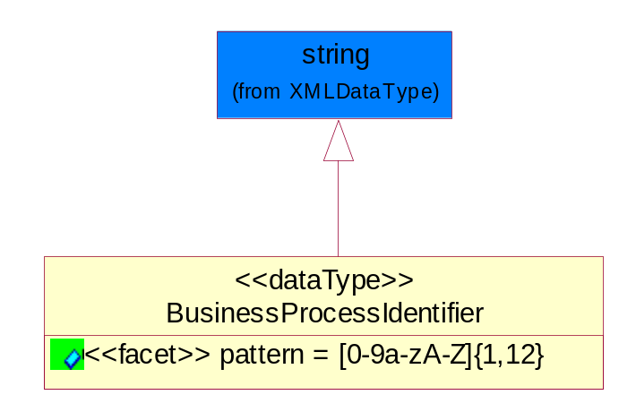
Figure 5-48 BusinessProcessIdentifier

Attribute | Type | Documentation
pattern |  | [0-9a-zA-Z]{1,12}

BusinessServiceInformation
The object allows the specification of the business service utilized within the partner company. This may or may not be the same as the information sent by the RNIF.
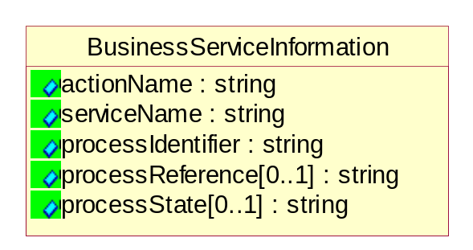
Figure 5-49 BusinessServiceInformation

Attribute | Type | Documentation
actionName | string | The name of Action. For RosettaNet usually any of Request/Confirm/Notify/Query/Response.
serviceName | string | The name of the Business Activity with the "Request/Confirm" part removed. E.g., for the Activity "Request Purchase Order"==> "Purchase Order".
processIdentifier | string | The name of the PIP e.g. Notify of Forecast Reply.
processReference[0..1] | string | The URN for the PIP that includes Cluster/Segment/Process pattern used to identify the interface process (such as PIP3A4)
processState[0..1] | string | The business process (or service) state of the sender of a document. When a service receives this document, the receiver may use the state as a precondition.

ContractInformation
A block of information used to correlate a contract in an executing choreography.

Figure 5-50 ContractInformation

Attribute | Type | Documentation
contractIdentifier[0..1] | string | Unique identification of a contract between the Sender and the Receiver
contractType[0..1] | string | The type of the contract: an attribute describing the type of the ContractIndentification. Valid values are URI, URN,ebXMLCPA, or other values defined by partners.

CorrelationInformation
A block of information used to correlate a requesting document to a responding document and to the contract in an executing choreography.
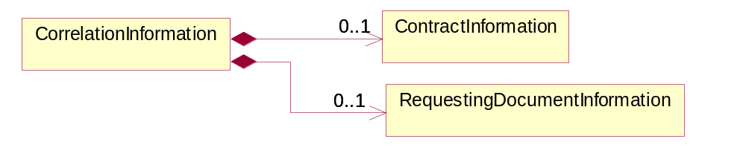
Figure 5-51 CorrelationInformation

Composition | Cardinality | Type | Documentation
ContractInformation | 0..1 | ContractInformation | A block of information used to correlate a contract in an executing choreography.
RequestingDocumentInformation | 0..1 | RequestingDocumentInformation | A block of information used to correlate a requesting document to a responding document in an executing choreography.

DocumentHeader
The object allows for the identification of the sender and receiver of the business document.
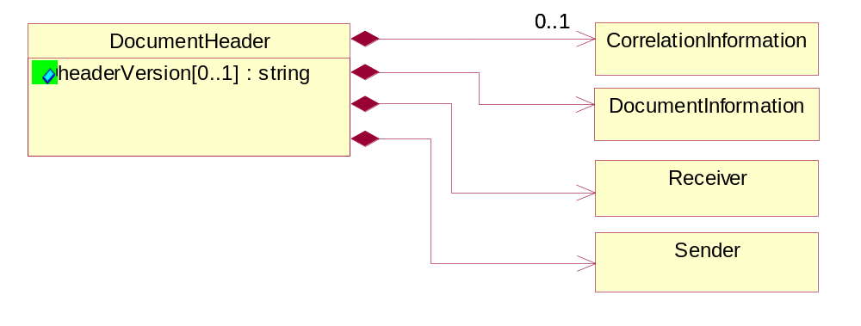
Figure 5-52 DocumentHeader

Attribute | Type | Documentation
headerVersion[0..1] | string | The UN/CEFACT version of the document header.

Composition | Cardinality | Type | Documentation
Sender | 1 | Sender | The object allows the identification of the initiating party of the business message.
CorrelationInformation | 0..1 | CorrelationInformation | A block of information used to correlate a requesting document to a responding document and to the contract in an executing choreography.
DocumentInformation | 1 | DocumentInformation | The object specifies information to identify the business document, a summary of attachments, and information about the business document security.
Receiver | 1 | Receiver | The object allows the identification of the receiving party of the business message.

DocumentIdentification
The object specifies all information necessary to identify the business document.
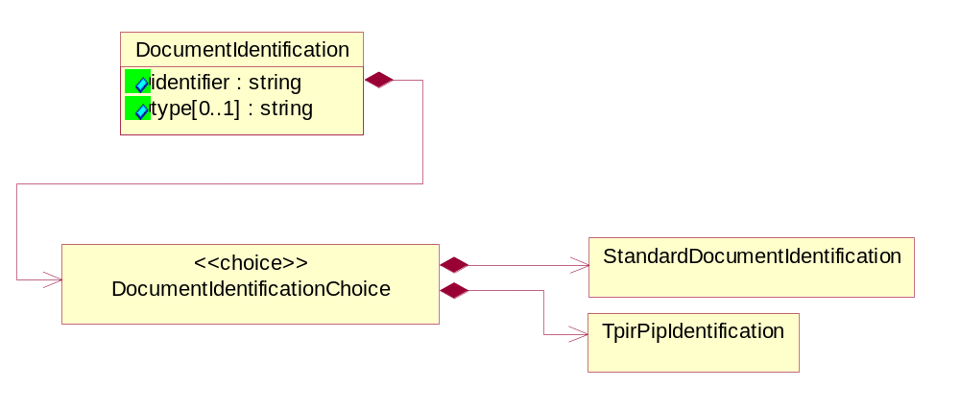
Figure 5-53 DocumentIdentification
Attribute | Type | Documentation
identifier | string | The unique identifier for the document being sent.
type[0..1] | string | Name of the Action Message

Composition | Cardinality | Type | Documentation
DocumentIdentificationChoice | 1 | DocumentIdentificationChoice

DocumentIdentificationChoice

Composition | Cardinality | Type | Documentation
StandardDocumentIdentification | 1 | StandardDocumentIdentification | The object specifies additional information necessary to identify the standard business document.
TpirPipIdentification | 1 | TpirPipIdentification | The object specifies all information necessary to uniquely identify a TPIR-PIP within a Registry or trading partner repository.

DocumentInformation
The object specifies information to identify the business document, a summary of attachments, and information about the business document security.
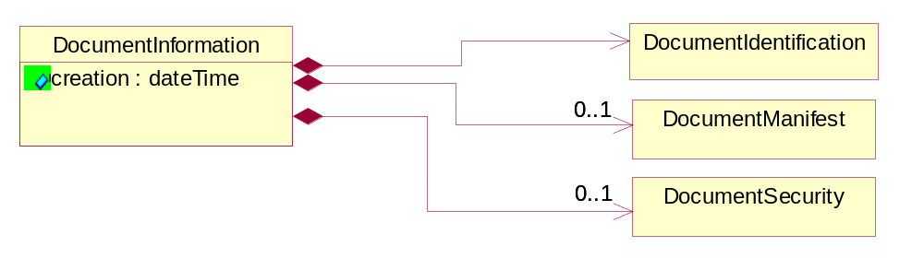
Figure 5-54 DocumentInformation
Attribute | Type | Documentation
creation | dateTime | The creation date and time of the specified Business Document (i.e. the Purchase Order date).

Composition | Cardinality | Type | Documentation
DocumentIdentification | 1 | DocumentIdentification | The object specifies all information necessary to identify the business document.
DocumentSecurity | 0..1 | DocumentSecurity | The object provides additional granularity in specifying business document security (this is in addition to the specified PIP security).
DocumentManifest | 0..1 | DocumentManifest | The block provides a brief summary of attachments and Service Content.

DocumentManifest
The block provides a brief summary of attachments and Service Content.
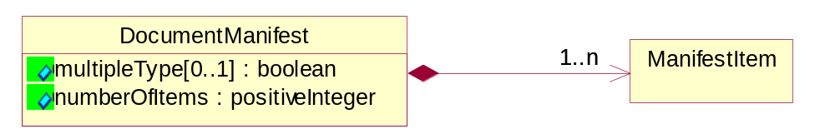
Figure 5-55 DocumentManifest
Attribute | Type | Documentation
multipleType[0..1] | boolean | Indicates whether the manifest contains documents of multiple types. True if yes, and False if no.
numberOfItems | positiveInteger | Total number of documents in the message. The physical count of the attachments in the payload plus the RosettaNet Business Message (for Service Content). The value of this field will be at least 1.

Composition | Cardinality | Type | Documentation
ManifestItem | 1..n | ManifestItem | The object provides details about the specific attachment(s).

DocumentSecurity
The object provides additional granularity in specifying business document security (this is in addition to the specified PIP security).

Figure 5-56 DocumentSecurity

Attribute | Type | Documentation
nonRepudiableReceipt | boolean | The value "true" will indicate that a signed acknowledgement for the business document is necessary.
persistentEncryption | boolean | The value "true" will indicate that the Business Document (including the header) needs to be encrypted when stored or transported.
persistentSignature | boolean | The value "true" will indicate that a signature is required to be stored with the document while stored or transported.

ManifestItem
The object provides details about the specific attachment(s).

Figure 5-57 ManifestItem
Attribute | Type | Documentation
description[0..1] | string | A description of the attachment.
length[0..1] | positiveInteger | The size of the attachment in bytes (i.e. 1 000 000 bytes)
universalResourceIdentifier | string | The generic set of all names/addresses that are short strings that refer to resources.

Composition | Cardinality | Type | Documentation
mimeTypeQualifier | 1 | MimeTypeQualifier | The MIME type as defined by IANA.  Please refer to http://www.iana.org/assignments/media-types/ for a list of types.
language | 0..1 | Language | For representation of Language name RosettaNet has adopted ISO 639-2; 1998. Refer to the following web page to get the latest version of the standard:  http://www.loc.gov/standards/iso639-2/iso639jac.html  If you need more information about the ISO standard please contact ISO for more details.

PipIdentifier
PIP Identification.[ i.e. PIP3A4]
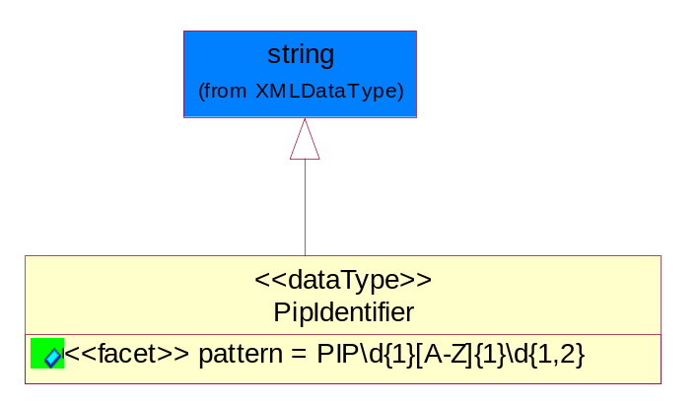
Figure 5-58 PipIdentifier

Attribute | Type | Documentation
pattern |  | PIP\d{1}[A-Z]{1}\d{1,2}

PipVersion
PIP version number (i.e. 02.02.00).
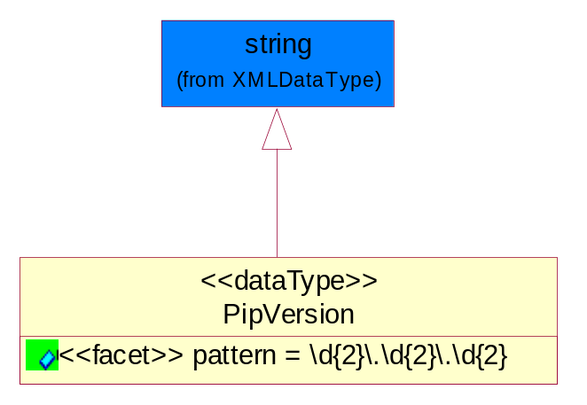
Figure 5-59 PipVersion

Attribute | Type | Documentation
pattern |  | \d{2}\.\d{2}\.\d{2}

Receiver
The object allows the identification of the receiving party of the business message.
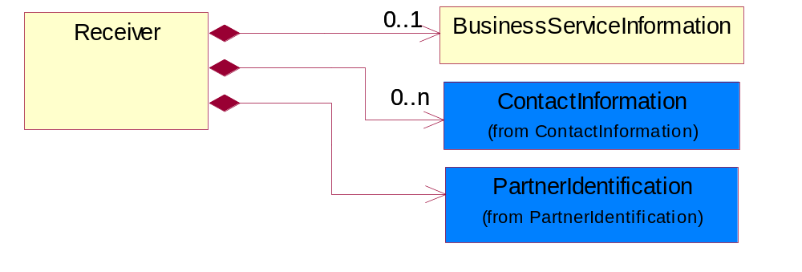
Figure 5-60 Receiver

Composition | Cardinality | Type | Documentation
BusinessServiceInformation | 0..1 | BusinessServiceInformation | The object allows the specification of the business service utilized within the partner company. This may or may not be the same as the information sent by the RNIF.
PartnerIdentification | 1 | PartnerIdentification | The business document must allow for the identity of one or more parties to the transaction.
ContactInformation | 0..n | ContactInformation | The business document must allow for the identification of the name of the department, service or individual to be contacted regarding the context of the business document.

RequestingDocumentInformation
A block of information used to correlate a requesting document to a responding document in an executing choreography.

Figure 5-61 RequestingDocumentInformation

Attribute | Type | Documentation
businessProcessInstanceIdentifier[0..1] | string | The identifier for the public business process instance being sent that both the sender and receiver can identify.
responseDateTime[0..1] | dateTime | The expected time to receive the response. This can not be greater than the PIP TimeToPerform.
requestingDocumentCreationDateTime[0..1] | dateTime | The date-time of the requesting business document.
requestingDocumentInstanceIdentifier | string | The Business Document identification number that identifies the requesting Business Document.

Sender
The object allows the identification of the initiating party of the business message.
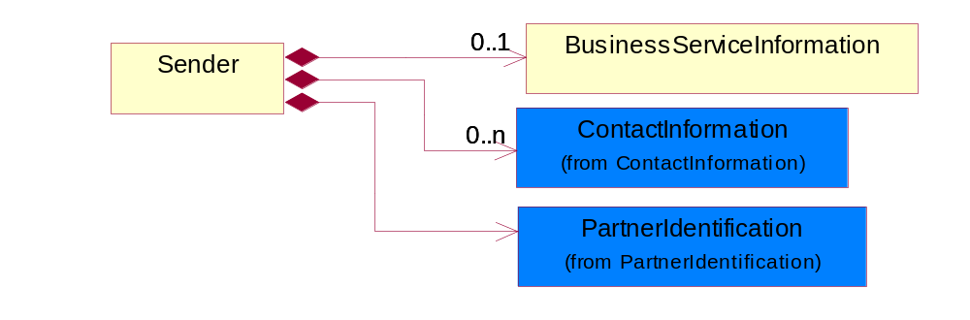
Figure 5-62 Sender

Composition | Cardinality | Type | Documentation
PartnerIdentification | 1 | PartnerIdentification | The business document must allow for the identity of one or more parties to the transaction.
BusinessServiceInformation | 0..1 | BusinessServiceInformation | The object allows the specification of the business service utilized within the partner company. This may or may not be the same as the information sent by the RNIF.
ContactInformation | 0..n | ContactInformation | The business document must allow for the identification of the name of the department, service or individual to be contacted regarding the context of the business document.

StandardDocumentIdentification
The object specifies additional information necessary to identify the standard business document.
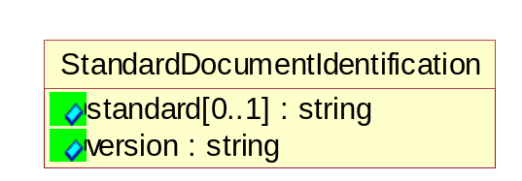
Figure 5-63 StandardDocumentIdentification

Attribute | Type | Documentation
standard[0..1] | string | Identifies the standard used to submit the business document. (e.g. RosettaNet).
version | string | PIP3A4v01.00

TpirPipIdentification
The object specifies all information necessary to uniquely identify a TPIR-PIP within a Registry or trading partner repository.

Figure 5-64 TpirPipIdentification

Attribute | Type | Documentation
partnerId | DUNSPlus4 | The Trading Partner Identification of MNC that is creating this TPIR PIP.
pipIdentifier | PipIdentifier | A TPIR PIP Identification [i.e., 3A4 ).
pipVersion | PipVersion | A TPIR PIP version number (i.e., 02.02.00)
tpirPipVersion | VersionIdentifier | A TPIR-PIP Version Number (i.e., major and minor version number as XX.XX).
tpirBusinessProcessIdentifier[0..1] | BusinessProcessIdentifier | A Business Process Identifier to uniquely define the TPIR-PIP 'role' within a Business Scenario at a company or MNC level. The identifier MUST be composed of alphanumeric characters only and its length MUST be between one and twelve characters.
uri[0..1] | anyURI | Describes the destination uri for the TPIR form.

Composition | Cardinality | Type | Documentation
fileType | 0..1 | TPIRFileType | Describes the file type of the TPIR form (PDF, XDP or XML).

VersionIdentifier
Version Number (i.e., major and minor version number as XX.XX).
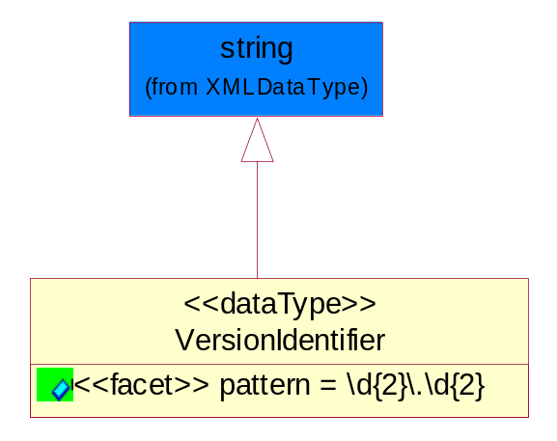
Figure 5-65 VersionIdentifier

Attribute | Type | Documentation
pattern |  | \d{2}\.\d{2}

CodeList

TPIRFileType
A code identifying the file type of TPIR form.

Name | Documentation
PDF | Portable Document Format.
XDP | XML Data Package.
XML | eXtensible Markup Language.

XML Data Type

anyURI
Represents a URI as defined by RFC 2396. An anyURI value can be absolute or relative, and may have an optional fragment identifier.

boolean
Represents Boolean values, which are either "true" or "false".

date
For the represents a calendar date.
The pattern for a date is CCYY-MM-DD where CC represents the century, YY the year, MM the month, and DD the day, with an optional time zone indicator as allowed for dateTime.

dateTime
Represents a specific instance of time.
The pattern for dateTime is CCYY-MM-DDThh:mm:ss where CC represents the century, YY the year, MM the month, and DD the day, preceded by an optional leading negative (-) character to indicate a negative number. If the negative character is omitted, positive (+) is assumed. The T is the date/time separator and hh, mm, and ss represent hour, minute, and second respectively. Additional digits can be used to increase the precision of fractional seconds if desired. For example, the format ss.ss... with any number of digits after the decimal point is supported. The fractional seconds part is optional.
This representation may be immediately followed by a "Z" to indicate Coordinated Universal Time (UTC) or to indicate the time zone. For example, the difference between the local time and Coordinated Universal Time, immediately followed by a sign, + or -, followed by the difference from UTC represented as hh:mm (minutes is required). If the time zone is included, both hours and minutes must be present.

duration
Represents a duration of time.
The pattern for duration is PnYnMnDTnHnMnS, where nY represents the number of years, nM the number of months, nD the number of days, T the date/time separator, nH the number of hours, nM the number of minutes, and nS the number of seconds.

float
Represents single-precision 32-bit floating-point numbers.

nonNegativeInteger
Represents an integer that is greater than or equal to zero. This data type is derived from integer.

positiveInteger
Represents an integer that is greater than zero. This data type is derived from nonNegativeInteger.

string
Represents character string.

