

Description of
Partner Interface Process® for 4E1

Validated 11.11.00

Specification Information
Name | Notify of Sales Report
Cluster | Inventory Management
Segment | Sales Reporting
Publication Date | 06 October 2007
Version Identifier | V11.11

Table of Contents
1 Document Management 4
1.1 Legal Disclaimer 4
1.2 Copyright 4
1.3 Trademarks 4
1.4 Acknowledgments 4
1.5 Related Documents 5
1.6 Document Version History 5
1.7 Document Structure 5
2 Business Process 6
2.1 Business Process Definition 6
2.1.1 Executive Summary 6
2.1.2 Business Process Description 6
2.1.3 Business Process Context Diagram 7
2.2 PIP Scope Description 7
2.2.1 Business Process Scope Diagram 8
2.3 PIP Business Document 9
2.4 PIP Business Process Flow Diagram 9
2.5 PIP Start State 10
2.6 PIP End States 10
2.7 Partner Role Descriptions 11
2.8 Business Process Activity Controls 11
3 Network and Implementation Specification 12
3.1 Business Action and Business Signal Specifications 12
3.2 Business Transaction Dialog Specification 12
3.2.1 Message Exchange Controls 13
3.2.2 Communications Specification 13

List of Figures:
Figure 1: High-level Context Diagram 7
Figure 2: Business Process Context Diagram 8
Figure 3: Activity Diagram of Notify Of Sales Report 9
Figure 4: Sequence Diagram of Notify Of Sales Report 12

List of Tables:
Table 1: PIP Business Document 9
Table 2: PIP Start State 10
Table 3: PIP End State 10
Table 4: PIP Failure State 10
Table 5: Partner Role Description 11
Table 6: Business Activity Description 11
Table 7: Business Activity Performance Control 11
Table 8: Network Component Specification 12
Table 9: Business Action – Business Document Mapping 12
Table 10: Message Exchange Control 13
Table 11: Dialog: Service-Service 13

Document Management

Legal Disclaimer
RosettaNet™, its members, officers, directors, employees, or agents shall not be liable for any injury, loss, damages, financial or otherwise, arising from, related to, or caused by the use of this document or the specifications herein, as well as associated guidelines and schemas. The use of said specifications shall constitute your express consent to the foregoing exculpation.

Copyright
©2007 RosettaNet. All rights reserved. No part of this publication may be reproduced, stored in a retrieval system, or transmitted, in any form or by any means, electronic, mechanical, photocopying, recording, or otherwise, without the prior written permission of the publisher. Printed in the United States of America.

Trademarks
RosettaNet, Partner Interface Process, PIP and the RosettaNet logo are trademarks or registered trademarks of “RosettaNet,” a non-profit organization. All other product names and company logos mentioned herein are the trademarks of their respective owners. In the best effort, all terms mentioned in this document that are known to be trademarks or registered trademarks have been appropriately recognized in the first occurrence of the term.

Acknowledgments
This document has been prepared by RosettaNet (http://www.rosettanet.org/) from requirements gathered during the Milestone Program and in conformance with the methodology. Listed below are the legal entities that contributed to the design and development of this PIP.
BCM Electronics | Cisco
Cisco Systems | Electronics Industry Data Exchange Association (EIDX)
Hewlett Packard | Hewlett-Packard GmbH
HP | Globetronics SDH. BHD
GridNode | GridNode, Inc.
GridNode Pte. Ltd. | IBM
Intel | Intel Corp.
Intel Corp (UK) LTD | Intel Corporation
International Business Machines | MIMOS Berhad
Motorola | Motorola Semiconductor Sector
Motorola SPS | Nokia
Nokia Oyj | Philips Semiconductors
Seagate Technology | Sterling Commerce

Related Documents
- Associated PIP Message Schemas (included within the PIP Specification package only)
- Description of 4E1 Message
- Messages Structure
- XML instance of ebXML BPSS for PIP 4E1

Document Version History
Version | Date | Description
Validated 11.00.00 | 28 June 2006 | Validated Version from Release 11.01.00B
Validated 11.10.00 | 18 August 2006 | Validated Version
Validated 11.11.00 | 06 October 2007 | Validated Version  Milestone Program: Schema2Market

Document Structure
A Partner Interface Process (PIP) Specification is comprised of the following two parts:
- Business Process. Captures the semantics of the business process and the flow of the message exchange between roles as they perform business activities.
- Network and Implementation Specification. Specifies the network protocol message formats and communications requirements between peer-protocols supported by network components in the RosettaNet Implementation Framework.

Business Process

Business Process Definition
Sales Reporting is a process of transmitting sale-out information from single or multiple points in the sales supply chain. The recipient of this information uses it for supply chain optimization, revenue recognition, special pricing claims, buyer/seller activity evaluation, distributors/resellers coverage area qualification and sales staff compensation. Recipient may acknowledge a sales report for data discrepancies found and/or special pricing confirmation.

Executive Summary
Currently, the originators of the data are being requested to send sales report in various formats. Extracting this data and then formatting the data in a different way depending on who the recipient is creates overhead, delays the sending of the information, increases the time to publish the information and often requires manual intervention thus leading to errors.
Depending on existing data exchange protocols, recipients of the information may spend unnecessary time to prepare the received data from the many partners such that it is able to flow into their ERP systems. Often the data is incomplete as during the course of the process some partners have issues preparing the information before sending it to the recipient.
Managing the manual process in weekly cycles is already flawed; as costs in the industry continue to be reviewed the need for more frequent cycles is required but hindered due to the ineffective methods used to exchange data. In addition, the need to penetrate further down the sales chain is an increasing requirement, managing the data manually and in many formats is impractical as the partner activity expands.
Information required to manage business could be inaccurate and delayed. This results in:
- Inaccurate inventory calculations hence over/under stated financial reserves
- Delayed payments to the partners for rebates and credits
- Inaccurate decision made on market conditions
- Inaccurate and delayed calculations of sales compensation.
Sales Reporting aims to design a standard process for notifying and acknowledging Sales Report information. The objectives are to improve the information flow and reduce the costs of managing the associated business processes that generate and utilize the information. In addition, this will help increase visibility throughout the supply chain.

Business Process Description
The "Notify of Sales Report" Partner Interface Process (PIP) supports a process in which a buyer sends a sales report to a seller. The buyer could be a re-seller or distributor and the seller could be a manufacturer. The sales report contains contract details, end-customer information (if known), and product sale-out. The sales report may also claim for special pricing.
Re-seller/distributor, where agreement has been previously determined, will send the sales report of the manufacturer's product at a frequency agreed to between the parties and to report at the organizational sales responsibility level (geographic area, branch level, sales region, corporate level) as agreed upon between parties.
Re-seller/distributor, ideally, receives sale-out information from each of the supply chain partners throughout the supply chain, i.e. data from each supply chain participant would be sent. Seller uses information to drive internal processes in support of benefits throughout the supply chain.

Business Process Context Diagram
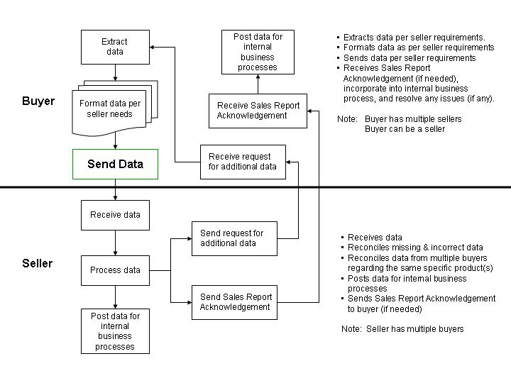
Figure 1: High-level Context Diagram

PIP Scope Description
The purpose of this PIP is to report sale-out information and claim for special pricing (if any). Information contained in this PIP is used to drive several sales-related processes by the recipient. If earlier agreed by the two parties, the recipient has to acknowledge this PIP by 4E2, “Notify of Sales Report Acknowledgement” for data discrepancies found and special pricing acknowledgement.

Business Process Scope Diagram
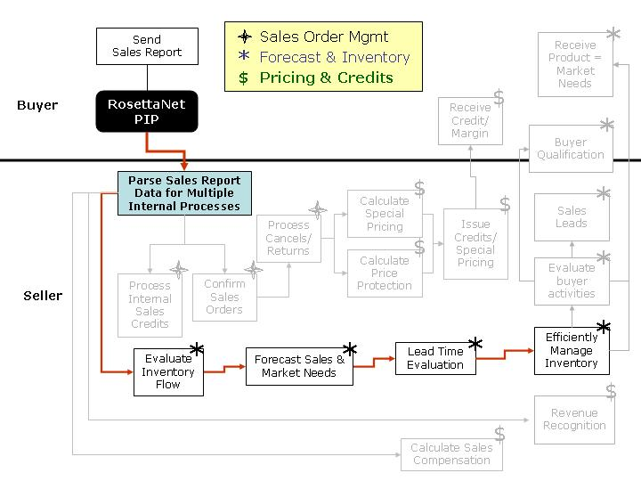
Figure 2: Business Process Context Diagram

PIP Business Document
Business Document are generated and exchanged by roles performing activities in this PIP. Business Document is listed and defined in Table 1.
Table 1: PIP Business Document
Business Document | Description
Sales Report Notification | Contains sale-out information and claims for special pricing.

PIP Business Process Flow Diagram
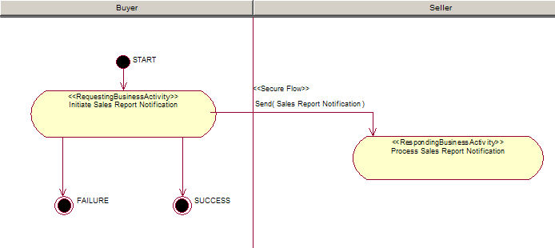
Figure 3: Activity Diagram of Notify Of Sales Report

PIP Start State
The start state is comprised of the following conditions:
Table 2: PIP Start State
 | Approved | Exist |  | Valid | Non-Repudiated | Retry Count | Authorized
 | Approved | Party | In Backend System
TPA |  |  | 
Sending Partner |  |  |  | 
Receiving Partner |  | 
Business Document |  |  |  |  |  |  | 

PIP End States
The end state is comprised of the following conditions:
Table 3: PIP End State
 | Approved | Exist |  | Valid | Non-Repudiated | Retry Count | Authorized
 | Approved | Party | In Backend system
Acknowledgment of Receipt |  |  |  |  | 
Receiving Partner |  |  |  |  |  |  | 

The PIP failure state is comprised of one or more of the following conditions:
Table 4: PIP Failure State
 | NO | Exceeded
Success | 
Retry Count |  | 

Partner Role Descriptions
Table 5 describes the partner roles in this PIP.
Table 5: Partner Role Description
Role Name | Role Description
Buyer | Buyer sends a sales report to a seller. The buyer could be a re-seller or distributor and the seller could be a manufacturer.
Seller | Seller uses information to drive internal processes in support of benefits throughout the supply chain.

Business Process Activity Controls
Table 6 describes the interaction between roles performing business activity in this PIP.
Table 6: Business Activity Description
Role  Name | Activity Name | Activity Description
Buyer | Initiate Sales Report Notification | A Buyer sends a Sales Report Notification to a Seller. The Sales Report Notification contains sales-out information and may provide claims for special pricing.

Table 7 details the security, audit and process controls relating to activity performed in the PIP.
Table 7: Business Activity Performance Control
Role  Name | Activity  Name | Acknowledgment  of Receipt |  | Time to Perform | Retry Count | Is Authorization Required? | Non-Repudiation of Origin and Content?
Role  Name | Activity  Name | Non-Repudiation Required? | Time to Acknowledge
Buyer | Initiate Sales Report Notification | Y | 2 hrs | N/A | 3 | Y | Y

Network and Implementation Specification
Each network component maps into a role of the PIP model. Table 8 specifies the mapping between roles and network components.
Table 8: Network Component Specification
Network Component | Classification | Maps to Role in Business Process
Buyer Service | Business Service | Buyer
Seller Service | Business Service | Sender

Business Action and Business Signal Specifications
Each business action maps to a Business Document of the PIP model. Table 9 specifies the mapping between Business Documents and business actions.
Table 9: Business Action – Business Document Mapping
Business Action | Business Document | Document Function
Sales Report Notification Action | Sales Report Notification | Request

Business Transaction Dialog Specification
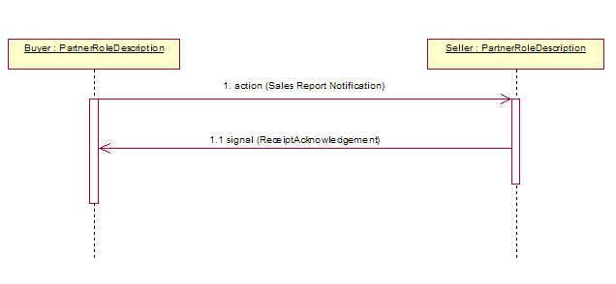
Figure 4: Sequence Diagram of Notify of Sales Report

Message Exchange Controls
Table 10: Message Exchange Control
# | Name |  | Time to Acknowledge Receipt Signal |  | Time to Respond to Action |  | Included in Time to Perform |  | Is Authorization Required? |  | Is Non-Repudiation Required? |  | Is Secure Transport Required?
1. |  | Sales Report Notification Action |  | 2 hrs |  | N/A |  | N/A |  | Y |  | Y |  | Y
1.1. |  | Receipt Acknowledgment |  | N/A |  | N/A |  | N/A |  | Y |  | Y |  | Y

Communications Specification
Table 11: Dialog: Service-Service
# | Business Message | Digital Signature Required? | SSL Required?
1. | Sales Report Notification | Y | Y
1.1. | Receipt Acknowledgment | Y | Y

