

Description of 4E2 Message

PIP® 4E2
Release R11.00.00A

Specification Information
Name | Description of 4E2 Message
PIP | Notify of Sales Report Acknowledgement
Cluster | Inventory Management
Segment | Sales Reporting
Publication Date | 8 March 2004
Version Identifier | R11.00A

Table of Content

1. Document Management 5
1.1 Legal Disclaimer 5
1.2 Copyright 5
1.3 Trademarks 5
1.4 Acknowledgments 5
1.5 Related Documents 6
1.6 Document Version History 6
1.7 Document Purpose 6
1.8 Document Structure 6
2. Interchange Model 7
2.1 Dependency 7
2.2 SalesReportAcknowledgementNotification 8
2.2.1 ProductTransfer 9
2.2.2 SalesReportAcknowledgementLineItem 10
2.2.3 SalesReportAcknowledgementNotification 11
2.2.4 SalesReportAcknowledgment 12
2.2.5 SalesReportDiscrepancy 13
2.2.6 SpecialPriceAcknowledgement 14
3. Domain Model 15
3.1 SalesReporting 15
3.1.1 SalesReporting 15
3.1.1.1 Dependency 15
3.1.1.2 ContractDetails 16
3.1.1.3 DatePeriodAndDuration 17
3.1.1.4 ParticipatingPartner 18
3.1.1.5 SpecialPrice 19
3.1.2 CodeList 20
3.1.2.1 ReportType 20
3.1.2.2 SalesReportDiscrepancyCode 21
4. Universal Structure 22
4.1 AbstractType 22
4.1.1 Identifier 22
4.2 ContactInformation 23
4.2.1 ContactInformation 23
4.3 DataType 24
4.3.1 Contact 24
4.3.2 Duns 24
4.3.3 DunsPlus4 25
4.3.4 PercentAmount 25
4.3.5 ReceiverIdentifier 26
4.3.6 SenderIdentifier 26
4.4 Dates 27
4.4.1 DatePeriod 27
4.5 Locations 28
4.5.1 PhysicalAddress 28
4.6 MonetaryExpression 30
4.6.1 FinancialAmount 30
4.6.2 ProductPricing 31
4.6.3 TaxJurisdiction 32
4.7 PartnerIdentification 33
4.7.1 IntermittentPartner 33
4.7.2 KnownPartner 34
4.7.3 PartnerIdentification 35
4.8 CodeList 36
4.8.1 Country 36
4.8.2 CountrySubdivision 36
4.8.3 Currency 36
4.8.4 Language 36
4.8.5 MimeTypeQualifier 37
4.8.6 ProcessRoleIdentifier 48
4.8.7 UnitOfMeasure 50
5. System Structure 57
5.1 BusinessServiceInformation 57
5.2 ContractInformation 58
5.3 CorrelationInformation 59
5.4 DocumentHeader 60
5.5 DocumentIdentification 61
5.6 DocumentInformation 62
5.7 DocumentManifest 63
5.8 DocumentSecurity 64
5.9 ManifestItem 65
5.10 Receiver 66
5.11 RequestingDocumentInformation 67
5.12 Sender 68
6. XML Data Type 69
6.1 boolean 69
6.2 date 69
6.3 dateTime 69
6.4 decimal 69
6.5 duration 69
6.6 float 69
6.7 nonNegativeInteger 69
6.8 positiveInteger 70
6.9 string 70

Table of Figures

Figure 2-1 Dependency 7
Figure 2-2 Interchange 8
Figure 2-3 ProductTransfer 9
Figure 2-4 SalesReportAcknowledgementLineItem 10
Figure 2-5 SalesReportAcknowledgementNotification 11
Figure 2-6 SalesReportAcknowledgment 12
Figure 2-7 SalesReportDiscrepancy 13
Figure 2-8 SpecialPriceAcknowledgement 14
Figure 3-1 Dependency 15
Figure 3-2 ContractDetails 16
Figure 3-3 DatePeriodAndDuration 17
Figure 3-4 ParticipatingPartner 18
Figure 3-5 SpecialPrice 19
Figure 4-1 Identifier 22
Figure 4-2 ContactInformation 23
Figure 4-3 Contact 24
Figure 4-4 Duns 24
Figure 4-5 DunsPlus4 25
Figure 4-6 PercentAmount 25
Figure 4-7 ReceiverIdentifier 26
Figure 4-8 SenderIdentifier 26
Figure 4-9 DatePeriod 27
Figure 4-10 PhysicalAddress 28
Figure 4-11 FinancialAmount 30
Figure 4-12 ProductPricing 31
Figure 4-13 TaxJurisdiction 32
Figure 4-14 IntermittentPartner 33
Figure 4-15 KnownPartner 34
Figure 4-16 PartnerIdentification 35
Figure 5-1 BusinessServiceInformation 57
Figure 5-2 ContractInformation 58
Figure 5-3 CorrelationInformation 59
Figure 5-4 DocumentHeader 60
Figure 5-5 DocumentIdentification 61
Figure 5-6 DocumentInformation 62
Figure 5-7 DocumentManifest 63
Figure 5-8 DocumentSecurity 64
Figure 5-9 ManifestItem 65
Figure 5-10 Receiver 66
Figure 5-11 RequestingDocumentInformation 67
Figure 5-12 Sender 68

Document Management

Legal Disclaimer
RosettaNet, its members, officers, directors, employees, or agents shall not be liable for any injury, loss, damages, financial or otherwise, arising from, related to, or caused by the use of this document or the specifications herein, as well as associated guidelines and schemas. The use of said specifications shall constitute your express consent to the foregoing exculpation.

Copyright
©2004 RosettaNet. All rights reserved. No part of this publication may be reproduced, stored in a retrieval system, or transmitted, in any form or by any means, electronic, mechanical, photocopying, recording, or otherwise, without the inclusion of this copyright notice. Any derivative works must cite the copyright notice. Any public redistribution or sale of this publication or derivative works requires prior written permission of the publisher.

Trademarks
RosettaNet, Partner Interface Process, PIP and the RosettaNet logo are trademarks or registered trademarks of "RosettaNet," a non-profit organization. All other product names and company logos mentioned herein are the trademarks of their respective owners. In the best effort, all terms mentioned in this document that are known to be trademarks or registered trademarks have been appropriately recognized in the first occurrence of the term.
  - Acknowledgments
This document has been prepared by RosettaNet (http://www.rosettanet.org/) from requirements gathered during the Milestone Program and in conformance with the methodology. Listed below are the legal entities that contributed to the design and development of this PIP.
BCM Electronics | Cisco
Cisco Systems | Electronics Industry Data Exchange Association (EIDX)
Hewlett Packard | Hewlett-Packard GmbH
HP | Globetronics SDH. BHD
GridNode | GridNode, Inc.
GridNode Pte. Ltd. | IBM
Intel | Intel Corp.
Intel Corp (UK) LTD | Intel Corporation
International Business Machines | MIMOS Berhad
Motorola | Motorola Semiconductor Sector
Motorola SPS | Nokia
Nokia Oyj | Philips Semiconductors
Seagate Technology | Sterling Commerce

Related Documents
- Associated PIP Message Schemas (included with PIP Specification only)
- Description of Partner Interface Process for 4E2
- Sales Report Acknowledgement Notification Message Structure

Document Version History
Version | Date | Description
Release 11.00.00A | 8 March 2004 | Release Version

Document Purpose
The purpose of the document is to explain the structure, the association between objects, the content of objects and the definition for single elements to a non-technical audience.

Document Structure
The Message Description document is composed of five sections. The sections are:

- Description of the structures used in the Interchange Model.
- Description of the structures used in the Domain Model.
- Description of the structures used in the Universal Structure.
- Description of the structures used in the System Structure.
- Alphabetic description of the data types used in the message.

Interchange Model

Dependency

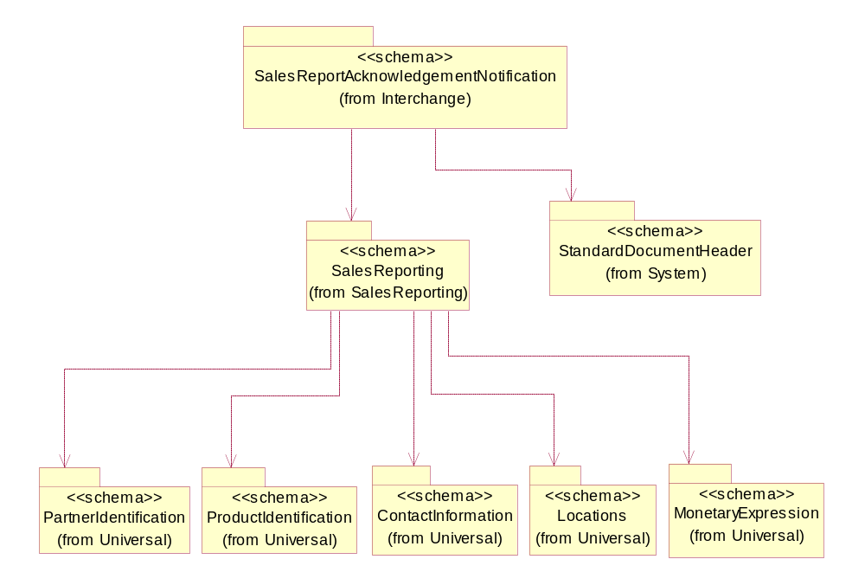
Figure 2-1 Dependency

SalesReportAcknowledgementNotification

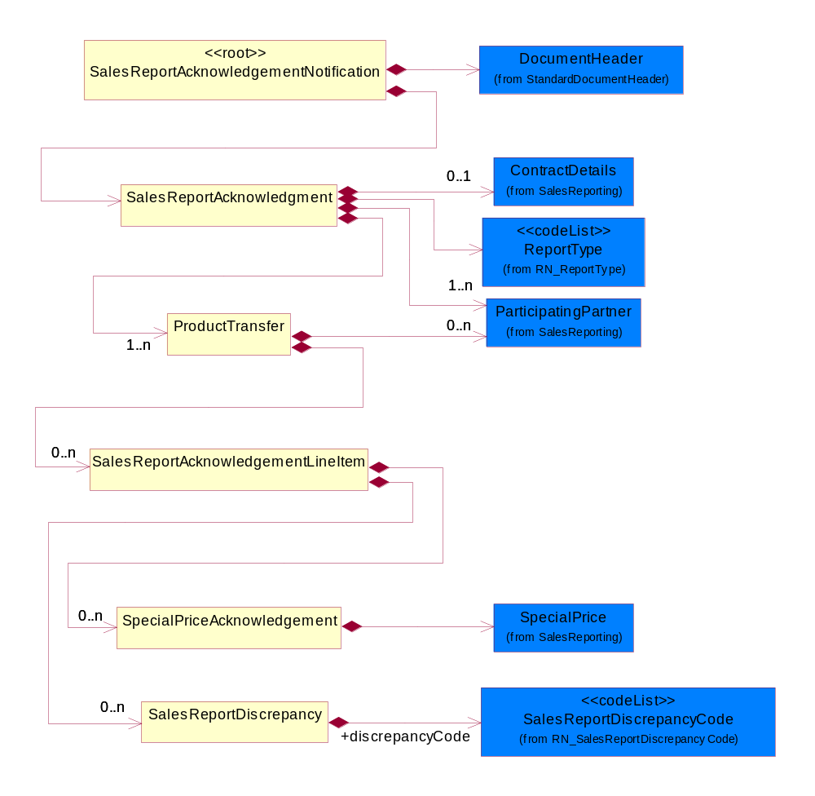
Figure 2-2 Interchange

ProductTransfer
This object describes the acknowledgment of point of sale information for a single known/unkown end user.

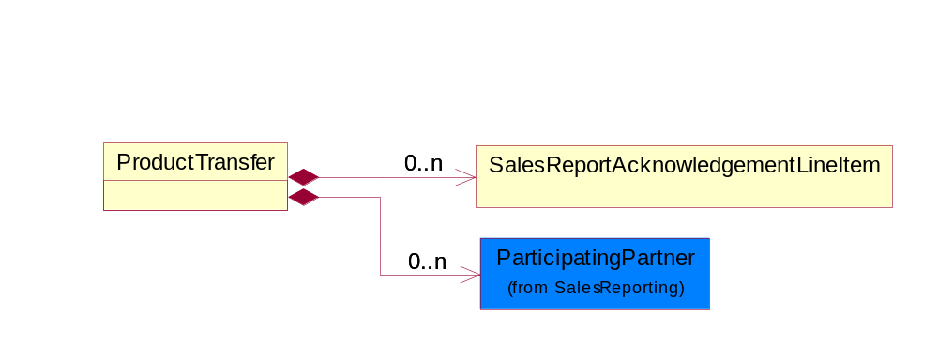
Figure 2-3 ProductTransfer

Composition | Cardinality | Type | Documentation
SalesReportAcknowledgementLineItem | 0..n | SalesReportAcknowledgementLineItem | This object describes an entry in a sales report acknowledgement.
ParticipatingPartner | 0..n | ParticipatingPartner | This object describes a partner that participates in a point of sale transaction which can either be a reseller, distributor, manufacturer or end-user.

SalesReportAcknowledgementLineItem
This object describes an entry in a sales report acknowledgement.
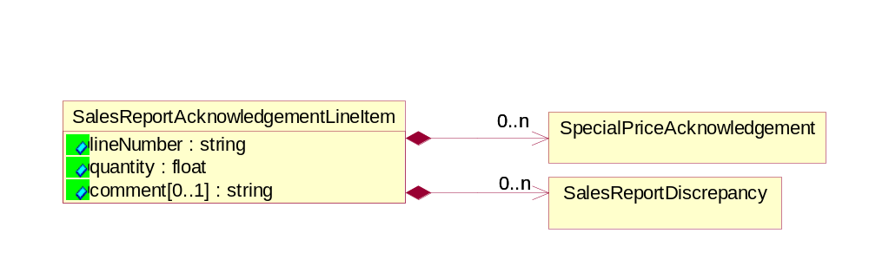
Figure 2-4 SalesReportAcknowledgementLineItem

Attribute | Type | Documentation
lineNumber | string | Specific line number.
quantity | float | Quantity of product.
comment[0..1] | string | A textual description of information relating to a product sale.

Composition | Cardinality | Type | Documentation
SalesReportDiscrepancy | 0..n | SalesReportDiscrepancy | This object describes data discrepancies found.
SpecialPriceAcknowledgement | 0..n | SpecialPriceAcknowledgement | This object describes an acknowledgement (verification) of a special price.

SalesReportAcknowledgementNotification
A message wrapper for the PIP4E2.
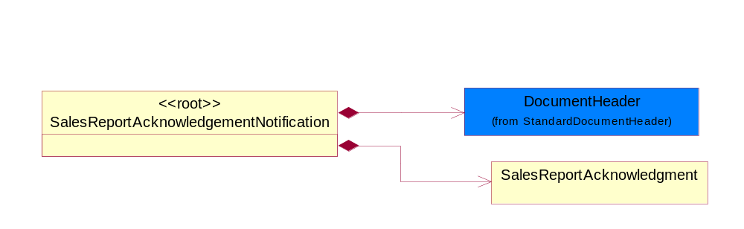
Figure 2-5 SalesReportAcknowledgementNotification

Composition | Cardinality | Type | Documentation
SalesReportAcknowledgment | 1 | SalesReportAcknowledgment | The sales report acknowledgement document.
DocumentHeader | 1 | DocumentHeader | The object allows for the identification of the sender and receiver of the business document.

SalesReportAcknowledgment
The sales report acknowledgement document.
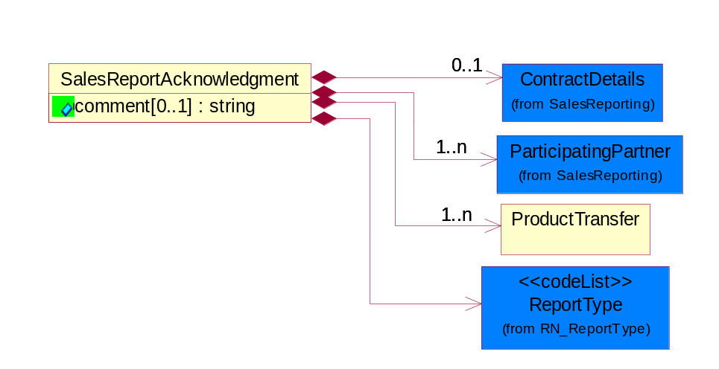
Figure 2-6 SalesReportAcknowledgment

Attribute | Type | Documentation
comment[0..1] | string | A textual description of information relating to a product sale

Composition | Cardinality | Type | Documentation
ContractDetails | 0..1 | ContractDetails | This object represents a business arrangement for the supply of goods or services. Group of attributes pertaining to the specific type of contract.
ProductTransfer | 1..n | ProductTransfer | This object describes the acknowledgment of point of sale information for a single known/unkown end user.
ParticipatingPartner | 1..n | ParticipatingPartner | This object describes a partner that participates in a point of sale transaction which can either be a reseller, distributor, manufacturer or end-user.
ReportType | 1 | ReportType | Code identifying the specific type of report.

SalesReportDiscrepancy
This object describes data discrepancies found.
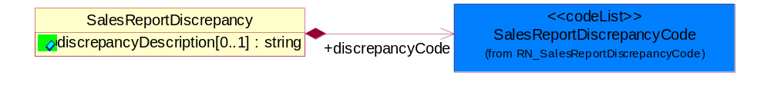
Figure 2-7 SalesReportDiscrepancy

Attribute | Type | Documentation
discrepancyDescription[0..1] | string | A textual description of a discrepancy found in the originating sales report

Composition | Cardinality | Type | Documentation
discrepancyCode | 1 | SalesReportDiscrepancyCode | Code identifying the types of discrepancies in the sales report notification document. Allows the receipient of the sales report to communicate the type of discrepancy to the sender via the acknowledgement.

SpecialPriceAcknowledgement
This object describes an acknowledgement (verification) of a special price.
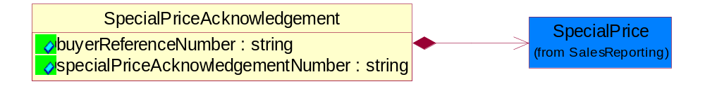
Figure 2-8 SpecialPriceAcknowledgement

Attribute | Type | Documentation
buyerReferenceNumber | string | An identifier of a special price
specialPriceAcknowledgementNumber | string | An identifier assigned to a special price acknowledgement

Composition | Cardinality | Type | Documentation
SpecialPrice | 1 | SpecialPrice | This object represents a special price based on number of unit of products and an eligible period.

Domain Model

SalesReporting

SalesReporting

Dependency

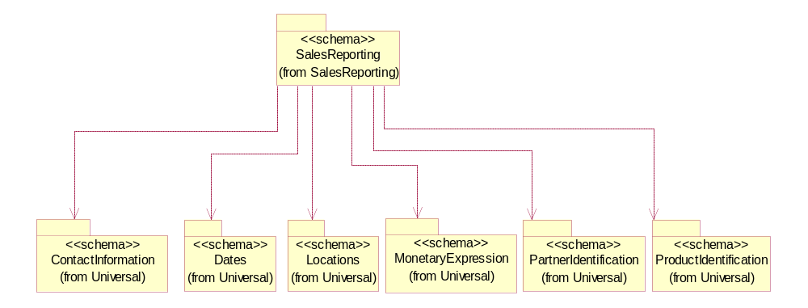
Figure 3-9 Dependency

ContractDetails
This object represents a business arrangement for the supply of goods or services. Group of attributes pertaining to the specific type of contract.

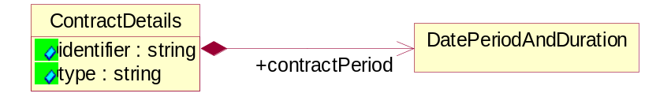
Figure 3-10 ContractDetails

Attribute | Type | Documentation
identifier | string | A unique proprietary number to identify a "solution" which is usually a combination of parts and services or software
type | string | A textual description of a contract. Additional description pertaining to the type of contract.

Composition | Cardinality | Type | Documentation
contractPeriod | 1 | DatePeriodAndDuration | This object allows representation of a date period by a duration or begin and an end dates.

DatePeriodAndDuration
This object allows representation of a date period by a duration or begin and an end dates.

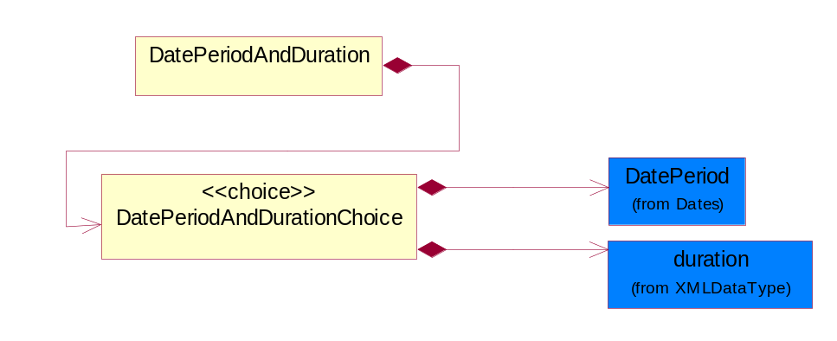
Figure 3-11 DatePeriodAndDuration

Composition | Cardinality | Type | Documentation
DatePeriodAndDurationChoice | 1 | DatePeriodAndDurationChoice

ParticipatingPartner
This object describes a partner that participates in a point of sale transaction which can either be a reseller, distributor, manufacturer or end-user.

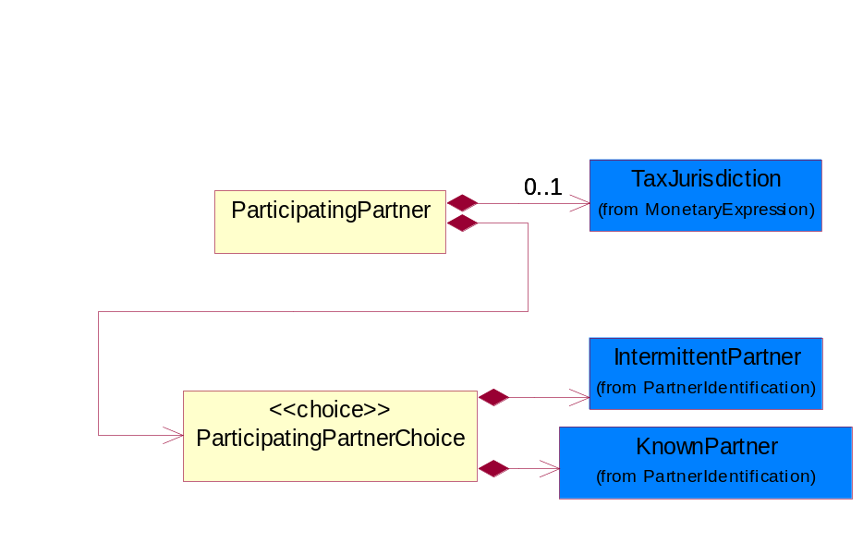
Figure 3-12 ParticipatingPartner

Composition | Cardinality | Type | Documentation
TaxJurisdiction | 0..1 | TaxJurisdiction | The business document must identify the specific tax collection authority.
ParticipatingPartnerChoice | 1 | ParticipatingPartnerChoice

SpecialPrice
This object represents a special price based on number of unit of products and an eligible period.

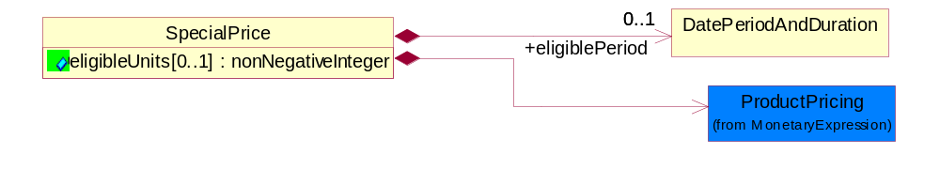
Figure 3-13 SpecialPrice

Attribute | Type | Documentation
eligibleUnits[0..1] | nonNegativeInteger | The number of units that has to be ordered to be eligible for a special price.

Composition | Cardinality | Type | Documentation
ProductPricing | 1 | ProductPricing | The business document must contain the price of the product.
eligiblePeriod | 0..1 | DatePeriodAndDuration | This object allows representation of a date period by a duration or begin and an end dates.

CodeList

ReportType
Code identifying the specific type of report.

Name | Documentation
CON | Indicates that products were in consignment
SLT | Indicates to whom the products were bought from and sold to
STR | Sell-through sales report type

SalesReportDiscrepancyCode
Code identifying the types of discrepancies in the sales report notification document. Allows the recipient of the sales report to communicate the type of discrepancy to the sender via the acknowledgement.

Name | Documentation
DIN | Invoice number has been provided before
DLZ | Cost is less than zero
DNR | Registration is not available for device
DRF | Line item is a duplicate of a previous record
DXP | Product does not qualify for special pricing because claim submitted after expiration date or shipped after expiration date
ICR | Cost currency code provided is not valid
IPN | Part number provided is inaccurate
IRC | Currency code provided is not valid
ISN | Serial number provided is inaccurate
ITC | Transaction code is not valid
MCR | Currency code is not provided
MCX | End customer does not match record
MDL | Distributor location code is not provided
MDR | Distributor reference code is not provided
MIL | Invoice line number is not provided
MIN | Invoice number is not provided
MPN | Part number is not provided
MQS | Quantity sold is not provided
MRC | Currency code was not provided
MRP | Resale price is not provided
MSD | Ship date is not provided
MTC | Transaction code is not provided
ONF | Special price is not valid
PDO | Date provided is past POS date reporting limit
PNE | Part number not valid
PSF | POS report was sent by freight forwarders
PXL | Price provided is above the upper limit for resale
RCD | Customer is a distributor
RCL | Registration is closed
RNA | Registration is not approved
RNF | ASP provided is not in the record
SDF | Date provided is a future date
SDL | Product does not qualify for special pricing because the ship date was after date
SDP | Product does not qualify for special pricing because the ship date was prior to approval date
XAP | Product does not qualify for special pricing because claim submitted after expiration date or shipped after expiration date

Universal Structure

AbstractType

Identifier
This is the Meta class for all identifier classes.

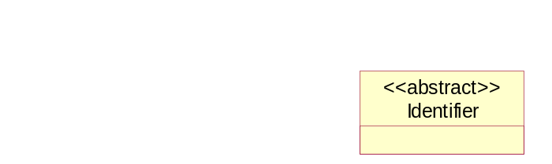
Figure 4-14 Identifier

ContactInformation

ContactInformation
The business document must allow for the identification of the name of the department, service or individual to be contacted regarding the context of the business document.

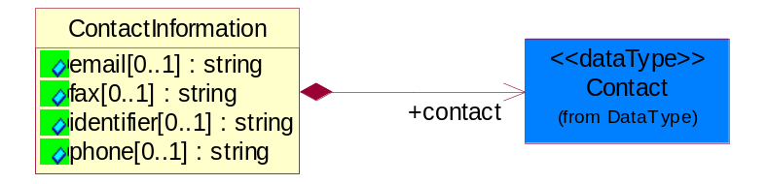
Figure 4-15 ContactInformation

Attribute | Type | Documentation
email[0..1] | string | The electronic mail for the specified contact.
fax[0..1] | string | The fax number for the specified contact.
identifier[0..1] | string | Identifies the role of the contact (i.e. Service Technician, Account Manager) in the Business Process.
phone[0..1] | string | The telephone number for the specified contact.

Composition | Cardinality | Type | Documentation
contact | 1 | Contact | The name of the department, service or individual to be contacted within the organization.

DataType

Contact
The name of the department, service or individual to be contacted within the organization.

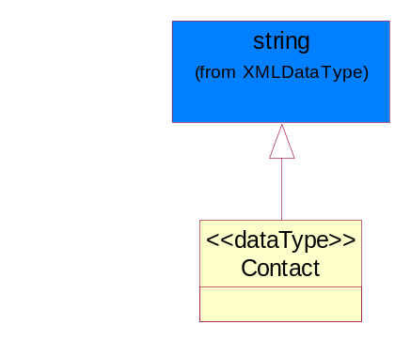
Figure 4-16 Contact

Duns
A number assigned by Dun and Bradstreet to identify a business location.

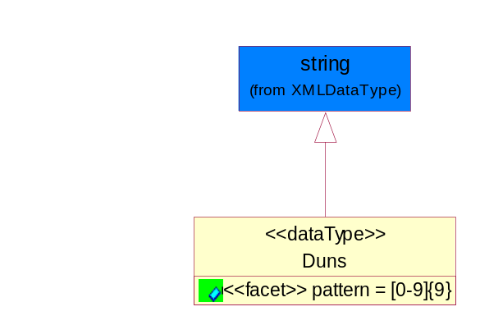
Figure 4-17 Duns

Attribute | Type | Documentation
pattern |  | [0-9]{9}

DunsPlus4
A identifier to specify a specific location within a business location.

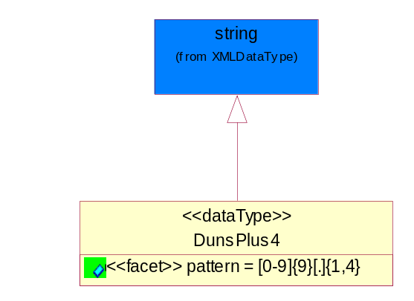
Figure 4-18 DunsPlus4

Attribute | Type | Documentation
pattern |  | [0-9]{9}[.]{1,4}

PercentAmount
A number representing a percentage value, e.g. 75.125 represents 75 1/8 percent.

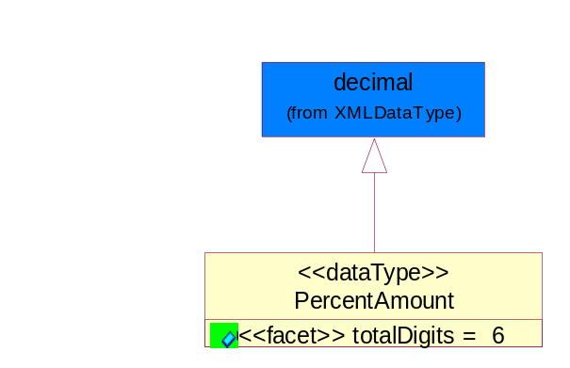
Figure 4-19 PercentAmount

Attribute | Type | Documentation
totalDigits |  | 6

ReceiverIdentifier
A receiver assigned identifier.

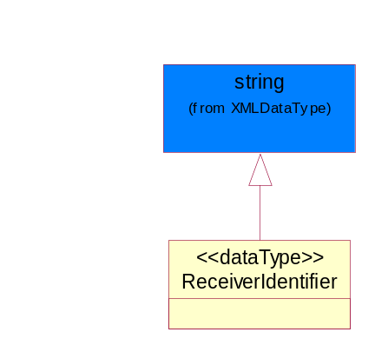
Figure 4-20 ReceiverIdentifier

SenderIdentifier
A sender assigned identifier.

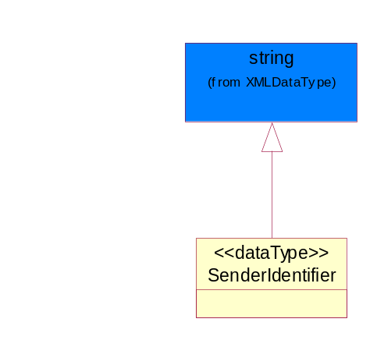
Figure 4-21 SenderIdentifier

Dates

DatePeriod
The business document must allow for the computation or statement of a duration based upon a beginning and an ending date.

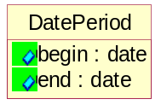
Figure 4-22 DatePeriod

Attribute | Type | Documentation
begin | date | The date indicating the beginning of the date period.
end | date | The date indicating the ending of the date period.

Locations

PhysicalAddress
The business document must provide a physical address for a party to the business transaction.

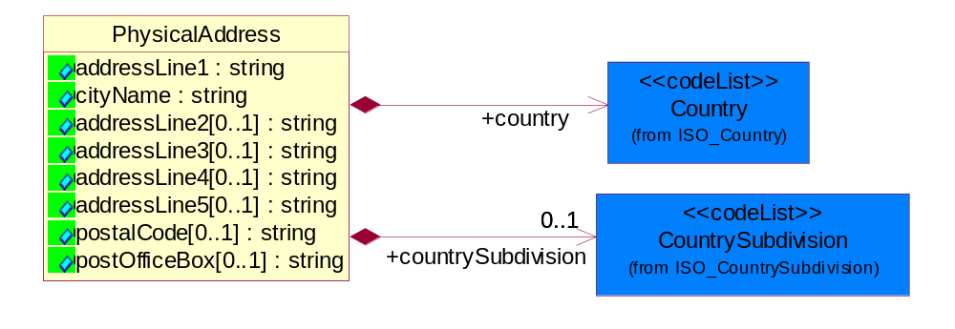
Figure 4-23 PhysicalAddress

Attribute | Type | Documentation
addressLine1 | string | The first line of a physical address.
cityName | string | The name of a city.
addressLine2[0..1] | string | The second line of a physical address.
addressLine3[0..1] | string | The third line of a physical address.
addressLine4[0..1] | string | The fourth line of a physical address.
addressLine5[0..1] | string | The fifth line of a physical address.
postalCode[0..1] | string | Identifying geographic location as specified by a national postal code.
postOfficeBox[0..1] | string | The Post Office Box identifier used to identify a party’s post office box.

Composition | Cardinality | Type | Documentation
country | 1 | Country | For representation of Country name RosettaNet has adopted ISO 3166-3; 1999. Refer to the following web page to get the latest version of the standard:  http://www.iso.ch/iso/en/prods-services/iso3166ma/02iso-3166-code-lists/index.html  If you need more information about the ISO standard please contact ISO for more details.
countrySubdivision | 0..1 | CountrySubdivision | For representation of a Countries subdivisions RosettaNet has adopted ISO 3166-3; 1999. Refer to the following web page to get the latest version of the standard:  http://www.iso.ch/iso/en/prods-services/iso3166ma/02iso-3166-code-lists/index.html  If you need more information about the ISO standard please contact ISO for more details.

MonetaryExpression

FinancialAmount
The business document must express financial amounts.

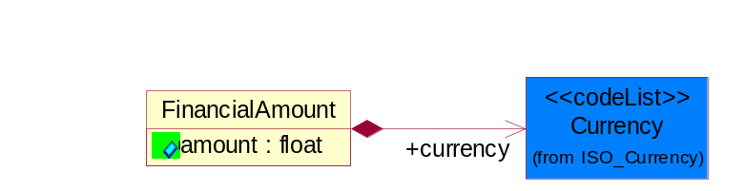
Figure 4-24 FinancialAmount

Attribute | Type | Documentation
amount | float | Specifies the monetary amount.

Composition | Cardinality | Type | Documentation
currency | 1 | Currency | For representation of Currency codes RosettaNet has adopted ISO 4217; 1995. The British Standards Institution (BSI) is the ISO 4217 Maintenance Agency. Refer to the following web page to get the latest version of the standard:  http://www.bsi-global.com/Technical+Information/Publications/_Publications/tig90.xalter  If you need more information about the ISO standard please contact ISO for more details.

ProductPricing
The business document must contain the price of the product.

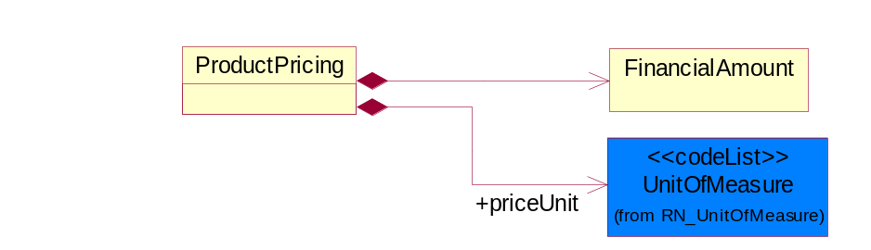
Figure 4-25 ProductPricing

Composition | Cardinality | Type | Documentation
FinancialAmount | 1 | FinancialAmount | The business document must express financial amounts.
priceUnit | 1 | UnitOfMeasure | Code identifying a product unit of measure.

TaxJurisdiction
The business document must identify the specific tax collection authority.

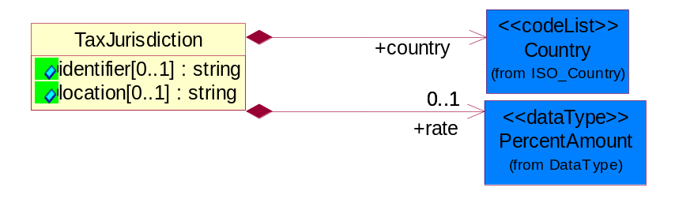
Figure 4-26 TaxJurisdiction

Attribute | Type | Documentation
identifier[0..1] | string | Unique identification for a taxing authority.
location[0..1] | string | Identification of the tax collection authority location.

Composition | Cardinality | Type | Documentation
rate | 0..1 | PercentAmount | A number representing a percentage value, e.g. 75.125 represents 75 1/8 percent.
country | 1 | Country | For representation of Country name RosettaNet has adopted ISO 3166-3; 1999. Refer to the following web page to get the latest version of the standard:  http://www.iso.ch/iso/en/prods-services/iso3166ma/02iso-3166-code-lists/index.html  If you need more information about the ISO standard please contact ISO for more details.

PartnerIdentification

IntermittentPartner
The business document must describe a physical address for a delivery.

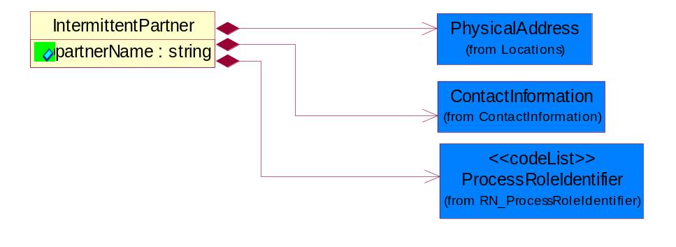
Figure 4-27 IntermittentPartner

Attribute | Type | Documentation
partnerName | string | The name of the partner’s company/business.

Composition | Cardinality | Type | Documentation
PhysicalAddress | 1 | PhysicalAddress | The business document must provide a physical address for a party to the business transaction.
ContactInformation | 1 | ContactInformation | The business document must allow for the identification of the name of the department, service or individual to be contacted regarding the context of the business document.
ProcessRoleIdentifier | 1 | ProcessRoleIdentifier | Describes the role of the partner in the business process. A partner will fulfill at least one or more roles during the business process.

KnownPartner
The business document must describe the trading partners in the business transaction.

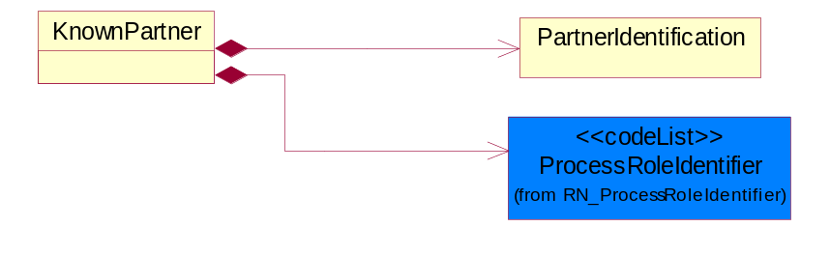
Figure 4-28 KnownPartner

Composition | Cardinality | Type | Documentation
PartnerIdentification | 1 | PartnerIdentification | The business document must allow for the identity of one or more parties to the transaction.
ProcessRoleIdentifier | 1 | ProcessRoleIdentifier | Describes the role of the partner in the business process. A partner will fulfill at least one or more roles during the business process.

PartnerIdentification
The business document must allow for the identity of one or more parties to the transaction.

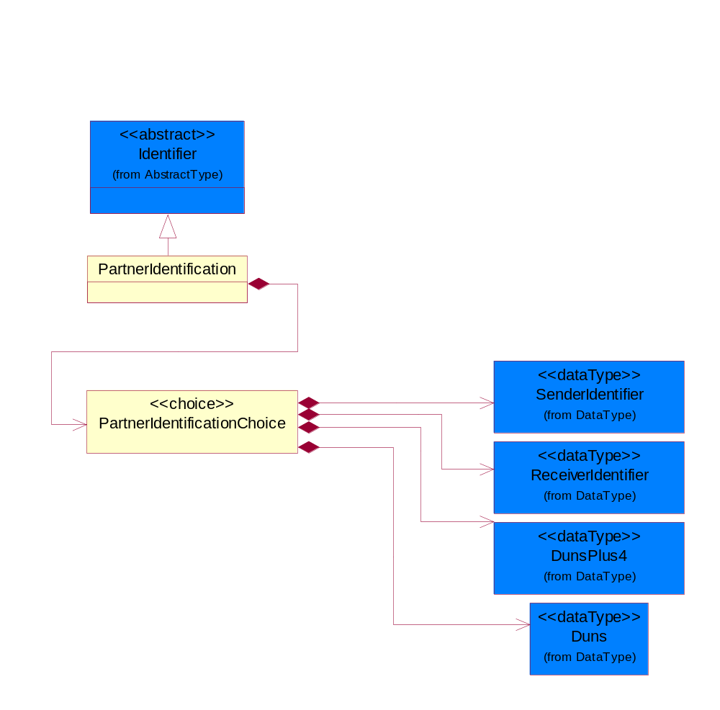
Figure 4-29 PartnerIdentification

Composition | Cardinality | Type | Documentation
PartnerIdentificationChoice | 1 | PartnerIdentificationChoice

CodeList

Country
For representation of Country name RosettaNet has adopted ISO 3166-3; 1999. Refer to the following web page to get the latest version of the standard:
http://www.iso.ch/iso/en/prods-services/iso3166ma/02iso-3166-code-lists/index.html
If you need more information about the ISO standard please contact ISO for more details.

CountrySubdivision
For representation of a Countries subdivisions RosettaNet has adopted ISO 3166-3; 1999. Refer to the following web page to get the latest version of the standard:
http://www.iso.ch/iso/en/prods-services/iso3166ma/02iso-3166-code-lists/index.html

If you need more information about the ISO standard please contact ISO for more details.

Currency
For representation of Currency codes RosettaNet has adopted ISO 4217; 1995. The British Standards Institution (BSI) is the ISO 4217 Maintenance Agency. Refer to the following web page to get the latest version of the standard:
http://www.bsi-global.com/Technical+Information/Publications/_Publications/tig90.xalter

If you need more information about the ISO standard please contact ISO for more details.

Language
For representation of Language name RosettaNet has adopted ISO 639-2; 1998. Refer to the following web page to get the latest version of the standard:
http://www.loc.gov/standards/iso639-2/iso639jac.html

If you need more information about the ISO standard please contact ISO for more details.

MimeTypeQualifier
The MIME type as defined by IANA.

Please refer to http://www.iana.org/assignments/media-types/ for a list of types.

Instance | Documentation
application/activemessage | [Shapiro]
application/andrew-inset | [Borenstein]
application/applefile | [Faltstrom]
application/atomicmail | [Borenstein]
application/batch-SMTP | [RFC2442]
application/beep+xml | [RFC3080]
application/cals-1840 | [RFC1895]
application/cnrp+xml | [RFCCNRP]
application/commonground | [Glazer]
application/cpl+xml
application/cybercash | [Eastlake]
application/dca-rft | [Campbell]
application/dec-dx | [Campbell]
application/dicom | [RFC3240]
application/dvcs | [RFC3029]
application/EDI-Consent | [RFC1767]
application/EDIFACT | [RFC1767]
application/EDI-X12 | [RFC1767]
application/eshop | [Katz]
application/font-tdpfr | [RFC3073]
application/http | [RFC2616]
application/hyperstudio | [Domino]
application/iges | [Parks]
application/index | [RFC2652]
application/index.cmd | [RFC2652]
application/index.obj | [RFC2652]
application/index.response | [RFC2652]
application/index.vnd | [RFC2652]
application/iotp | [RFC2935]
application/ipp | [RFC2910]
application/isup | [RFC3204]
application/mac-binhex40 | [Faltstrom]
application/macwriteii | [Lindner]
application/marc | [RFC2220]
application/mathematica | [Van Nostern]
application/msword | [Lindner]
application/news-message-id | [RFC1036,Spencer]
application/news-transmission | [RFC1036, Spencer]
application/ocsp-request | [RFC2560]
application/ocsp-response | [RFC2560]
application/octet-stream | [RFC2045,RFC2046]
application/oda | [RFC2045,RFC2046]
application/ogg | [RFC-walleij-ogg-mediatype-08.txt]
application/parityfec | [RFC3009]
application/pdf | [Lindner]
application/pgp-encrypted | [RFC3156]
application/pgp-keys | [RFC3156]
application/pgp-signature | [RFC3156]
application/pkcs10 | [RFC2311]
application/pkcs7-mime | [RFC2311]
application/pkcs7-signature | [RFC2311]
application/pkix-cert | [RFC2585]
application/pkixcmp | [RFC2510]
application/pkix-crl | [RFC2585]
application/postscript | [RFC2045,RFC2046]
application/prs.alvestrand.titrax-sheet | [Alvestrand]
application/prs.cww | [Rungchavalnont]
application/prs.nprend | [Doggett]
application/prs.plucker | [Janssen]
application/qsig | [RFC3204]
application/reginfo+xml | [RFC-ietf-sipping-reg-event-00.txt]
application/remote-printing | [RFC1486,Rose]
application/riscos | [Smith]
application/rtf | [Lindner]
application/sdp | [RFC2327]
application/set-payment | [Korver]
application/set-payment-initiation | [Korver]
application/set-registration | [Korver]
application/set-registration-initiation | [Korver]
application/sgml | [RFC1874]
application/sgml-open-catalog | [Grosso]
application/sieve | [RFC3028]
application/slate | [Crowley]
application/timestamp-query | [RFC3161]
application/timestamp-reply | [RFC3161]
application/tve-trigger | [Welsh]
application/vemmi | [RFC2122]
application/vnd.3gpp.pic-bw-large | [Meredith]
application/vnd.3gpp.pic-bw-small | [Meredith]
application/vnd.3gpp.pic-bw-var | [Meredith]
application/vnd.3gpp.sms | [Meredith]
application/vnd.3M.Post-it-Notes | [O'Brien]
application/vnd.accpac.simply.aso | [Leow]
application/vnd.accpac.simply.imp | [Leow]
application/vnd.acucobol | [Lubin]
application/vnd.acucorp | [Lubin]
application/vnd.adobe.xfdf | [Perelman]
application/vnd.aether.imp | [Moskowitz]
application/vnd.amiga.ami | [Blumberg]
application/vnd.anser-web-certificate-issue-initiation | [Mori]
application/vnd.anser-web-funds-transfer-initiation | [Mori]
application/vnd.audiograph | [Slusanschi]
application/vnd.blueice.multipass | [Holmstrom]
application/vnd.bmi | [Gotoh]
application/vnd.businessobjects | [Imoucha]
application/vnd.canon-cpdl | [Muto]
application/vnd.canon-lips | [Muto]
application/vnd.cinderella | [Kortenkamp]
application/vnd.claymore | [Simpson]
application/vnd.commerce-battelle | [Applebaum]
application/vnd.commonspace | [Chandhok]
application/vnd.contact.cmsg | [Patz]
application/vnd.cosmocaller | [Dellutri]
application/vnd.ctc-posml | [Kohlhepp]
application/vnd.cups-postscript | [Sweet]
application/vnd.cups-raster | [Sweet]
application/vnd.cups-raw | [Sweet]
application/vnd.curl | [Byrnes]
application/vnd.cybank | [Helmee]
application/vnd.data-vision.rdz | [Fields]
application/vnd.dna | [Searcy]
application/vnd.dpgraph | [Parker]
application/vnd.dreamfactory | [Appleton]
application/vnd.dxr | [Duffy]
application/vnd.ecdis-update | [Buettgenbach]
application/vnd.ecowin.chart | [Olsson]
application/vnd.ecowin.filerequest | [Olsson]
application/vnd.ecowin.fileupdate | [Olsson]
application/vnd.ecowin.series | [Olsson]
application/vnd.ecowin.seriesrequest | [Olsson]
application/vnd.ecowin.seriesupdate | [Olsson]
application/vnd.enliven | [Santinelli]
application/vnd.epson.esf | [Hoshina]
application/vnd.epson.msf | [Hoshina]
application/vnd.epson.quickanime | [Gu]
application/vnd.epson.salt | [Nagatomo]
application/vnd.epson.ssf | [Hoshina]
application/vnd.ericsson.quickcall | [Tidwell]
application/vnd.eudora.data | [Resnick]
application/vnd.fdf | [Zilles]
application/vnd.ffsns | [Holstage]
application/vnd.FloGraphIt | [Floersch]
application/vnd.framemaker | [Wexler]
application/vnd.fsc.weblaunch | [D.Smith]
application/vnd.fujitsu.oasys | [Togashi]
application/vnd.fujitsu.oasys2 | [Togashi]
application/vnd.fujitsu.oasys3 | [Okudaira]
application/vnd.fujitsu.oasysgp | [Sugimoto]
application/vnd.fujitsu.oasysprs | [Ogita]
application/vnd.fujixerox.ddd | [Onda]
application/vnd.fujixerox.docuworks | [Taguchi]
application/vnd.fujixerox.docuworks.binder | [Matsumoto]
application/vnd.fut-misnet | [Pruulmann]
application/vnd.grafeq | [Tupper]
application/vnd.groove-account | [Joseph]
application/vnd.groove-help | [Joseph]
application/vnd.groove-identity-message | [Joseph]
application/vnd.groove-injector | [Joseph]
application/vnd.groove-tool-message | [Joseph]
application/vnd.groove-tool-template | [Joseph]
application/vnd.groove-vcard | [Joseph]
application/vnd.hbci | [Hammann]
application/vnd.hhe.lesson-player | [Jones]
application/vnd.hp-HPGL | [Pentecost]
application/vnd.hp-hpid | [Gupta]
application/vnd.hp-hps | [Aubrey]
application/vnd.hp-PCL | [Pentecost]
application/vnd.hp-PCLXL | [Pentecost]
application/vnd.httphone | [Lefevre]
application/vnd.hzn-3d-crossword | [Minnis]
application/vnd.ibm.afplinedata | [Buis]
application/vnd.ibm.electronic-media | [Tantlinger]
application/vnd.ibm.MiniPay | [Herzberg]
application/vnd.ibm.modcap | [Hohensee]
application/vnd.ibm.secure-container | [Tantlinger]
application/vnd.informix-visionary | [Gales]
application/vnd.intercon.formnet | [Gurak]
application/vnd.intertrust.digibox | [Tomasello]
application/vnd.intertrust.nncp | [Tomasello]
application/vnd.intu.qbo | [Scratchley]
application/vnd.intu.qfx | [Scratchley]
application/vnd.irepository.package+xml | [Knowles]
application/vnd.is-xpr | [Natarajan]
application/vnd.japannet-directory-service | [Fujii]
application/vnd.japannet-jpnstore-wakeup | [Yoshitake]
application/vnd.japannet-payment-wakeup | [Fujii]
application/vnd.japannet-registration | [Yoshitake]
application/vnd.japannet-registration-wakeup | [Fujii]
application/vnd.japannet-setstore-wakeup | [Yoshitake]
application/vnd.japannet-verification | [Yoshitake]
application/vnd.japannet-verification-wakeup | [Fujii]
application/vnd.jisp | [Deckers]
application/vnd.kde.karbon | [Faure]
application/vnd.kde.kchart | [Faure]
application/vnd.kde.kformula | [Faure]
application/vnd.kde.kivio | [Faure]
application/vnd.kde.kontour | [Faure]
application/vnd.kde.kpresenter | [Faure]
application/vnd.kde.kspread | [Faure]
application/vnd.kde.kword | [Faure]
application/vnd.kenameaapp | [DiGiorgio-Haag]
application/vnd.koan | [Cole]
application/vnd.liberty-request+xml | [McDowell]
application/vnd.llamagraphics.life-balance.desktop | [White]
application/vnd.lotus-1-2-3 | [Wattenberger]
application/vnd.lotus-approach | [Wattenberger]
application/vnd.lotus-freelance | [Wattenberger]
application/vnd.lotus-notes | [Laramie]
application/vnd.lotus-organizer | [Wattenberger]
application/vnd.lotus-screencam | [Wattenberger]
application/vnd.lotus-wordpro | [Wattenberger]
application/vnd.mcd | [Gotoh]
application/vnd.mediastation.cdkey | [Flurry]
application/vnd.meridian-slingshot | [Wedel]
application/vnd.micrografx.flo | [Prevo]
application/vnd.micrografx.igx | [Prevo]
application/vnd.mif | [Wexler]
application/vnd.minisoft-hp3000-save | [Bartram]
application/vnd.mitsubishi.misty-guard.trustweb | [Tanaka]
application/vnd.Mobius.DAF | [Kabayama]
application/vnd.Mobius.DIS | [Kabayama]
application/vnd.Mobius.MBK | [Devasia]
application/vnd.Mobius.MQY | [Devasia]
application/vnd.Mobius.MSL | [Kabayama]
application/vnd.Mobius.PLC | [Kabayama]
application/vnd.Mobius.TXF | [Kabayama]
application/vnd.mophun.application | [Wennerstrom]
application/vnd.mophun.certificate | [Wennerstrom]
application/vnd.motorola.flexsuite | [Patton]
application/vnd.motorola.flexsuite.adsi | [Patton]
application/vnd.motorola.flexsuite.fis | [Patton]
application/vnd.motorola.flexsuite.gotap | [Patton]
application/vnd.motorola.flexsuite.kmr | [Patton]
application/vnd.motorola.flexsuite.ttc | [Patton]
application/vnd.motorola.flexsuite.wem | [Patton]
application/vnd.mozilla.xul+xml | [McDaniel]
application/vnd.ms-artgalry | [Slawson]
application/vnd.ms-asf | [Fleischman]
application/vnd.mseq | [Le Bodic]
application/vnd.ms-excel | [Gill]
application/vnd.msign | [Borcherding]
application/vnd.ms-lrm | [Ledoux]
application/vnd.ms-powerpoint | [Gill]
application/vnd.ms-project | [Gill]
application/vnd.ms-tnef | [Gill]
application/vnd.ms-works | [Gill]
application/vnd.ms-wpl | [Plastina]
application/vnd.musician | [Adams]
application/vnd.music-niff | [Butler]
application/vnd.netfpx | [Mutz]
application/vnd.noblenet-directory | [Solomon]
application/vnd.noblenet-sealer | [Solomon]
application/vnd.noblenet-web | [Solomon]
application/vnd.novadigm.EDM | [Swenson]
application/vnd.novadigm.EDX | [Swenson]
application/vnd.novadigm.EXT | [Swenson]
application/vnd.obn | [Hessling]
application/vnd.osa.netdeploy | [Klos]
application/vnd.palm | [Peacock]
application/vnd.pg.format | [Gandert]
application/vnd.pg.osasli | [Gandert]
application/vnd.powerbuilder6 | [Guy]
application/vnd.powerbuilder6-s | [Guy]
application/vnd.powerbuilder7 | [Shilts]
application/vnd.powerbuilder75 | [Shilts]
application/vnd.powerbuilder75-s | [Shilts]
application/vnd.powerbuilder7-s | [Shilts]
application/vnd.previewsystems.box | [Smolgovsky]
application/vnd.publishare-delta-tree | [Ben-Kiki]
application/vnd.pvi.ptid1 | [Lamb]
application/vnd.pwg-multiplexed | [RFC3391]
application/vnd.pwg-xhtml-print+xml | [Wright]
application/vnd.Quark.QuarkXPress | [Scheidler]
application/vnd.rapid | [Szekely]
application/vnd.s3sms | [Tarkkala]
application/vnd.sealed.net | [Lambert]
application/vnd.seemail | [Webb]
application/vnd.shana.informed.formdata | [Selzler]
application/vnd.shana.informed.formtemplate | [Selzler]
application/vnd.shana.informed.interchange | [Selzler]
application/vnd.shana.informed.package | [Selzler]
application/vnd.smaf | [Takahashi]
application/vnd.sss-cod | [Dani]
application/vnd.sss-dtf | [Bruno]
application/vnd.sss-ntf | [Bruno]
application/vnd.street-stream | [Levitt]
application/vnd.svd | [Becker]
application/vnd.swiftview-ics | [Widener]
application/vnd.triscape.mxs | [Simonoff]
application/vnd.trueapp | [Hepler]
application/vnd.truedoc | [Chase]
application/vnd.ufdl | [Manning]
application/vnd.uplanet.alert | [Martin]
application/vnd.uplanet.alert-wbxml | [Martin]
application/vnd.uplanet.bearer-choice | [Martin]
application/vnd.uplanet.bearer-choice-wbxml | [Martin]
application/vnd.uplanet.cacheop | [Martin]
application/vnd.uplanet.cacheop-wbxml | [Martin]
application/vnd.uplanet.channel | [Martin]
application/vnd.uplanet.channel-wbxml | [Martin]
application/vnd.uplanet.list | [Martin]
application/vnd.uplanet.listcmd | [Martin]
application/vnd.uplanet.listcmd-wbxml | [Martin]
application/vnd.uplanet.list-wbxml | [Martin]
application/vnd.uplanet.signal | [Martin]
application/vnd.vcx | [T.Sugimoto]
application/vnd.vectorworks | [Pharr]
application/vnd.vidsoft.vidconference | [Hess]
application/vnd.visio | [Sandal]
application/vnd.visionary | [Aravindakumar]
application/vnd.vividence.scriptfile | [Risher]
application/vnd.vsf | [Rowe]
application/vnd.wap.sic | [WAP-Forum]
application/vnd.wap.slc | [WAP-Forum]
application/vnd.wap.wbxml | [Stark]
application/vnd.wap.wmlc | [Stark]
application/vnd.wap.wmlscriptc | [Stark]
application/vnd.webturbo | [Rehem]
application/vnd.wrq-hp3000-labelled | [Bartram]
application/vnd.wt.stf | [Wohler]
application/vnd.wv.csp+wbxml | [Salmi]
application/vnd.xara | [Matthewman]
application/vnd.xfdl | [Manning]
application/vnd.yellowriver-custom-menu | [Yellow]
application/whoispp-query | [RFC2957]
application/whoispp-response | [RFC2958]
application/wita | [Campbell]
application/wordperfect5.1 | [Lindner]
application/x400-bp | [RFC1494]
application/xhtml+xml | [RFC3236]
application/xml | [RFC3023]
application/xml-dtd | [RFC3023]
application/xml-external-parsed-entity | [RFC3023]
application/zip | [Lindner]
audio/32kadpcm | [RFC2421,RFC2422]
audio/AMR | [RFC3267]
audio/AMR-WB | [RFC3267]
audio/basic | [RFC2045,RFC2046]
audio/CN | [RFC3389]
audio/DAT12 | [RFC3190]
audio/DVI4
audio/EVRC | [RFC-ietf-avt-evrc-smv-03.txt]
audio/EVRC0 | [RFC-ietf-avt-evrc-smv-03.txt]
audio/G.722.1 | [RFC3047]
audio/G722
audio/G723
audio/G726-16
audio/G726-24
audio/G726-32
audio/G726-40
audio/G728
audio/G729
audio/G729D
audio/G729E
audio/GSM
audio/GSM-EFR
audio/L16 | [RFC2586]
audio/L20 | [RFC3190]
audio/L24 | [RFC3190]
audio/L8
audio/LPC
audio/MP4A-LATM | [RFC3016]
audio/MPA
audio/mpa-robust | [RFC3119]
audio/mpeg | [RFC3003]
audio/parityfec | [RFC3009]
audio/PCMA
audio/PCMU
audio/prs.sid | [Walleij]
audio/QCELP
audio/RED
audio/SMV | [RFC-ietf-avt-evrc-smv-03.txt]
audio/SMV0 | [RFC-ietf-avt-evrc-smv-03.txt]
audio/telephone-event | [RFC2833]
audio/tone | [RFC2833]
audio/VDVI
audio/vnd.3gpp.iufp | [Belling]
audio/vnd.cisco.nse | [Kumar]
audio/vnd.cns.anp1 | [McLaughlin]
audio/vnd.cns.inf1 | [McLaughlin]
audio/vnd.digital-winds | [Strazds]
audio/vnd.everad.plj | [Cicelsky]
audio/vnd.lucent.voice | [Vaudreuil]
audio/vnd.nortel.vbk | [Parsons]
audio/vnd.nuera.ecelp4800 | [Fox]
audio/vnd.nuera.ecelp7470 | [Fox]
audio/vnd.nuera.ecelp9600 | [Fox]
audio/vnd.octel.sbc | [Vaudreuil]
audio/vnd.qcelp | [Lundblade]
audio/vnd.rhetorex.32kadpcm | [Vaudreuil]
audio/vnd.vmx.cvsd | [Vaudreuil]
image/cgm | Computer Graphics Metafile
image/g3fax | [RFC1494]
image/gif | [RFC2045,RFC2046]
image/ief | [RFC1314] Image Exchange Format
image/jpeg | [RFC2045,RFC2046]
image/naplps | [Ferber]
image/png | [Randers-Pehrson]
image/prs.btif | [Simon]
image/prs.pti | [Laun]
image/t38 | [RFC3362]
image/tiff | [RFC3302] Tag Image File Format
image/tiff-fx | [RFC3250] Tag Image File Format Fax eXtended
image/vnd.cns.inf2 | [McLaughlin]
image/vnd.djvu | [Bottou]
image/vnd.dwg | [Moline]
image/vnd.dxf | [Moline]
image/vnd.fastbidsheet | [Becker]
image/vnd.fpx | [Spencer]
image/vnd.fst | [Fuldseth]
image/vnd.fujixerox.edmics-mmr | [Onda]
image/vnd.fujixerox.edmics-rlc | [Onda]
image/vnd.globalgraphics.pgb | [Bailey]
image/vnd.mix | [Reddy]
image/vnd.ms-modi | [Vaughan]
image/vnd.net-fpx | [Spencer]
image/vnd.svf | [Moline]
image/vnd.wap.wbmp | [Stark]
image/vnd.xiff | [S.Martin]
message/delivery-status | [RFC1894]
message/disposition-notification | [RFC2298]
message/external-body | [RFC2045,RFC2046]
message/http | [RFC2616]
message/news | [RFC 1036, H.Spencer]
message/partial | [RFC2045,RFC2046]
message/rfc822 | [RFC2045,RFC2046]
message/s-http | [RFC2660]
message/sip | [RFC3261]
message/sipfrag | [RFC3420]
model/iges | [Parks]
model/mesh | [RFC2077]
model/vnd.dwf | [Pratt]
model/vnd.flatland.3dml | [Powers]
model/vnd.gdl | [Babits]
model/vnd.gs-gdl | [Babits]
model/vnd.gtw | [Ozaki]
model/vnd.mts | [Rabinovitch]
model/vnd.parasolid.transmit.binary | [Parasolid]
model/vnd.parasolid.transmit.text | [Parasolid]
model/vnd.vtu | [Rabinovitch]
model/vrml | [RFC2077]
multipart/alternative | [RFC2045,RFC2046]
multipart/appledouble | [Faltstrom]
multipart/byteranges | [RFC2068]
multipart/digest | [RFC2045,RFC2046]
multipart/encrypted | [RFC1847]
multipart/form-data | [RFC2388]
multipart/header-set | [Crocker]
multipart/mixed | [RFC2045,RFC2046]
multipart/parallel | [RFC2045,RFC2046]
multipart/related | [RFC2387]
multipart/report | [RFC1892]
multipart/signed | [RFC1847]
multipart/voice-message | [RFC2421,RFC2423]
text/calendar | [RFC2445]
text/css | [RFC2318]
text/directory | [RFC2425]
text/enriched | [RFC1896]
text/html | [RFC2854]
text/parityfec | [RFC3009]
text/plain | [RFC2646,RFC2046]
text/prs.lines.tag | [Lines]
text/rfc822-headers | [RFC1892]
text/richtext | [RFC2045,RFC2046]
text/rtf | [Lindner]
text/sgml | [RFC1874]
text/t140 | [RFC2793]
text/tab-separated-values | [Lindner]
text/uri-list | [RFC2483]
text/vnd.abc | [Allen]
text/vnd.curl | [Byrnes]
text/vnd.DMClientScript | [Bradley]
text/vnd.fly | [Gurney]
text/vnd.fmi.flexstor | [Hurtta]
text/vnd.in3d.3dml | [Powers]
text/vnd.in3d.spot | [Powers]
text/vnd.IPTC.NewsML | [IPTC]
text/vnd.IPTC.NITF | [IPTC]
text/vnd.latex-z | [Lubos]
text/vnd.motorola.reflex | [Patton]
text/vnd.ms-mediapackage | [Nelson]
text/vnd.net2phone.commcenter.command | [Xie]
text/vnd.sun.j2me.app-descriptor | [G.Adams]
text/vnd.wap.si | [WAP-Forum]
text/vnd.wap.sl | [WAP-Forum]
text/vnd.wap.wml | [Stark]
text/vnd.wap.wmlscript | [Stark]
text/xml | [RFC3023]
text/xml-external-parsed-entity | [RFC3023]
video/BMPEG
video/BT656
video/CelB
video/DV | [RFC3189]
video/H261
video/H263
video/H263-1998
video/H263-2000
video/JPEG
video/MP1S
video/MP2P
video/MP2T
video/MP4V-ES | [RFC3016]
video/mpeg | [RFC2045,RFC2046]
video/MPV
video/nv
video/parityfec | [RFC3009]
video/pointer | [RFC2862]
video/quicktime | [Lindner]
video/SMPTE292M | [RFC-avt-smpte292-video-08.txt]
video/vnd.fvt | [Fuldseth]
video/vnd.motorola.video | [McGinty]
video/vnd.motorola.videop | [McGinty]
video/vnd.mpegurl | [Recktenwald]
video/vnd.nokia.interleaved-multimedia | [Kangaslampi]
video/vnd.objectvideo | [Clark]
video/vnd.vivo | [Wolfe]

ProcessRoleIdentifier
Describes the role of the partner in the business process. A partner will fulfill at least one or more roles during the business process.

Instance | Documentation
ADM | Administered by, the party who is the administrative authority of an account.
ALT | Alternate approval by, the party who has approved a request in the event the approver is not able to respond.
APP | Approval by, the party who has approved a request.
BIF | Bill from, the party that will issue the invoice.
BIT | Bill to, the party that will pay the invoice.
CNC | Cancellation party, the party who is cancelling the shipping order.
COR | Change originated by, the party who originates a proposed change.
COW | Change owned by, the party who owns or who is assigned responsibility for a proposed change.
CRA | Credit applicant, the party who is applying for credit.
CRE | Created by, the party responsible for creating a process or task.
DIS | Distributed by, the party who supplies products to retailers.
FIN | Financed by, the party who is the financier.
FOR | Forwarded to, the party to whom a business document has been forwarded.
INL | Inventory location, the party where the inventory product entry is located.
INO | Inventory owner, the party that owns the inventory product entry.
ITF | In transit from, the party sending the product quantity in a product location transfer.
ITT | In transit to, the party receiving the product quantity in a product location transfer.
MFG | Manufactured by, the party who creates, processes or produces goods especially in large quantities and by means of industrial machines.
OWN | Owned by, the party who owns a process.
PUR | Purchased by, the party who is a purchaser of a product.
REA | Requested approval by, the party who has been selected to approve a request.
REC | Received by, the party who has received a product shipment.
REQ | Requested by, the party who has initiated a request.
RES | Respond to, the party to whom a responding business document must be sent when it is not equal to the partner specified in the document header.
RET | Return by, the party responsible for either carrying or forwarding the returned product.
REV | Reviewed by, the party responsible for reviewing a business document.
SBF | Self-billing from, the party who initiates the billing in self-billing scenario.
SBT | Self-billing to, the party whom the invoice is addressed to.
SCP | Shipping charges paid by, the party responsible for administering payment of the shipping charges.
SLD | Sold to, the party to whom a product has been sold.
SPL | Supplied by, the party who supplies an item, part or assembly.
SRT | Submit returns to, the party to whom product returns are to be submitted.
TRA | Transported by, the party responsible for either carrying or forwarding the product.
ULR | Ultimate recipient, the party who ultimately receives the shipment, when an intermediate party takes responsibility for payment and final delivery.
USE | Used by, the party who is the end user of the product.

UnitOfMeasure
Code identifying a product unit of measure.

Instance | Documentation
1BF | 100 Board Feet
1FC | 20 Foot Container
1GR | Gram/Cubic Centimeter
1GT | 10,000 Gallon Tankcar
1KB | 25 Kilogram Bulk Bag
1KD | 10 Kilogram Drum
1PA | 20-Pack
1PB | 50 Pound Bag
1PD | 100 Pound Drum
2FC | 40 Foot Container
2GR | Gram/square meter
2GT | 20,000 Gallon Tankcar
2KB | 300 Kilogram Bulk Bag
2KD | 15 Kilogram Drum
2PA | 100-Pack
3GR | Grams Per 100 Centimeters
3KB | 500 Kilogram Bulk Bag
3KD | 55 Gallon Drum
4GR | Grams Per 100 Grams
4KD | 115 Kilogram Drum
5GR | Grams Per Cubic Centimeter
6GR | Grams Per Square Centimeter
7GR | Grams Per Square Meter
ACR | Acre
ACT | Actual Pounds
ALU | Aluminum Pounds Only
AMP | Ampere
BAB | Base Box
BAC | Batch
BAE | Bale
BAG | Bag
BAL | Ball
BAN | Band
BAP | Batting Pound
BAR | Bar
BAS | Basket
BAT | Batt
BAW | Base Weight
BEA | Beam
BEC | Becquerel/kilogram
BEL | Belt
BIL | Billet
BIN | Bin
BKC | Bulk Car Load
BLO | Block
BOA | Board
BOF | Board Feet
BOL | Bolt
BOT | Bottle
BOX | Box
BRD | Barrels Per Day
BRE | Barrel
BRI | Barrel (Imperial)
BRM | Barrels Per Minute
BTF | British Thermal Units (BTUs) Per Cubic Foot
BTP | British Thermal Units (BTUs) Per Pound
BTU | British Thermal Unit (BTU)
BUC | Bucket
BUD | Bushel, Dry Imperial
BUK | Bunks
BUL | Bulk
BUN | Bundle
BUP | Bulk Pack
BUS | Bushel
CAA | Carat
CAB | Carboy
CAC | Card
CAD | Candela
CAG | Cartridge
CAK | Cask
CAL | Calorie
CAN | Can
CAO | Carload
CAR | Car
CAS | Case
CAT | Canister
CAW | Catchweight
CEL | Cell
CEM | Centimeter
CEP | Centipoise (CPS)
CET | Centiliter
CHA | Chains (Land Survey)
CHE | Chest
CNN | Connector
COG | Coil Group
COI | Coil
COM | Composite Product Pounds (Total Weight)
CON | Cone
COT | Container
COV | Cover
CRA | Crate
CRT | Carton
CSE | Cassette
CUB | Cubic centimeter
CUC | Cubic centimeter/second
CUF | Cubic Foot
CUI | Cubic inch
CUM | Cubicmeter
CUP | Cup
CUY | Cubic yard
CYC | Cycles
CYL | Cylinder
DAY | Day
DEA | Deal
DEC | Decimeter
DEF | Degree Fahrenheit
DEG | Degree Celsius
DEP | Dep. Factor
DIE | Die
DIL | Display
DIP | Dispenser
DOZ | Dozen
DRA | Dram
DRU | Drum
DRY | Dry Pounds
EAC | Each
ELE | Electrical Capacitance
FLO | Fluid Ounce
FOI | Fluid Ounce (Imperial)
FOO | Foot
FOU | Fluid Ounce US
FUU | Fuel Usage (Gallons)
GAL | Gallon
GAS | Gage Systems
GIJ | Gigajoules
GIL | Gill (Imperial)
GOB | Gross Barrels
GOG | Gross Gallons
GOK | Gross Kilogram
GOT | Gross Ton
GOY | Gross Yard
GRA | Gram
GRG | Great Gross (Dozen Gross)
GRK | Grams Per Kilogram
GRL | Grams Per Liter
GRM | Grams Per Milliliter
GRN | Grain
GRO | Gross
GRP | Group
HAG | Half Gallon
HAH | Half Hour
HAL | Half Liter
HAN | Hank
HEA | Heat lots
HEC | Hectare
HEL | Hectoliter
HEP | Hectopascal
HER | Hertz
HOS | Hours
HOU | Hour
HUA | Hundredth of a Carat
HUB | Hundred Boxes
HUC | Hundred Count
HUS | Hundred Sheets
IMG | Imperial Gallons
INC | Inch
JAR | Jar
JOI | Joint
JOU | Joule
KEG | Keg
KEL | Kelvin
KHO | Kilometer/hour
KIC | Kilogram per cubic meter
KIE | Kilometer
KIG | Kilogram
KIH | Kilohertz
KIK | Kilobecquerel/Kilogram
KIL | Kiloampere
KIM | Kilogram/square meter
KIO | Kiloohm
KIS | Kilogramm pro Sekunde
KIT | Kit
KIV | Kilovolt
KIW | Kilowatt
KKG | Kilogram/Kilogram
KUD | Kubikdezimeter
KUM | Kubikmeter pro Sekunde
KWH | Kilowatt-hour
LIF | Lifts
LIM | Link
LIQ | Liquid Pounds
LIT | Liter
LOA | Load
LOT | Lot
LUG | Lug
MAT | Mat
MCM | Milligrams Per Cubic Meter
MEG | Megagram
MEH | Megahertz
MEP | Megapascal
MET | Meter
MEW | Megawatt
MIB | Million BTU's
MIC | Mikrogram/cubic meter
MIG | Micrograms Per Cubic Meter
MIL | Mile
MIM | Micrometer
MIN | Minute
MIP | Millipascal seconds
MIS | Microsecond
MIT | Miter
MIV | Millivolt
MIW | Milliwatt
MJO | Millijoule
MLA | Milliampere
MLB | Millibar
MLC | Milligram/cubic meter
MLI | Milliliter
MLK | Milligram/kilogram
MLL | Milligram/Liter
MME | Millimeter
MMH | Millimeter H20
MMK | Millimol/kilogram
MMO | Millimol
MOK | Mol/kilogram
MOL | Mol
MON | Month
MPH | Megagrams Per Hour
MSC | Millisecond
MSM | Milligrams Per Square Meter
MTA | Millitesla
MTQ | Meter pro Quadratsekunde
MTS | Meters per second
MUL | Multichip - When 2 or more dies (chips) are merged into one package.
NAM | Nanometer
NAS | Nanosecond
NEB | Net Barrels
NEG | Net Gallons
NEI | Net Imperial Gallons
NEL | Net Liters
NEW | Newton
OHM | Ohm
ONE | One
OTP | One Thousand Pieces
OUN | Ounce
PAC | Parcel
PAD | Pad
PAG | Package
PAI | Pail
PAK | Pack (PAK)
PAL | Pallet
PAN | Panel
PAR | Pair
PAS | Pascal
PAT | Packet
PEC | Percent
PEG | Percentage
PEH | Percent Per 1000 Hours
PEN | Pennyweight
PER | Per Hundred Pieces
PEW | Percent Weight
PID | Pint U.S. Dry
PIE | Piece
PIL | Pint - US liquid
PLA | Plate
PLL | Pallet (Lift)
PLT | Pallete
PLU | Pallet/Unit Load
POF | Pounds Per Foot
POG | Pounds Per Gallon
PON | Pound
POP | Pounds Per Piece of Product
POS | Pounds Per 1000 Square Feet
POT | Pounds Per Thousand
PPB | Parts per billion (US)
PPM | Parts per million
PPP | Pounds Per Pound of Product
PSS | Pascal second
QUA | Quart - US liquid
RAC | Rack
REA | Ream of 500 Sheets
REE | Reel
RIN | Ring
ROD | Rod
ROL | Roll
SAC | Sack
SBB | Super Bulk Bag
SEC | Second
SET | Set
SHE | Sheet
SHI | Shipment
SHM | Sheet-Metric measure
SHO | Shot
SID | Disk (Disc)
SKE | Skein
SKI | Skid
SLE | Sleeve
SLI | Slip Sheet
SMI | Square mile
SMM | Square millimeter
SPO | Spool
SQF | Square foot
SQI | Square inch
SQK | Square kilometer
SQM | Square meter
SQS | Square meter/second
SQU | Square
SQY | Square Yard
STI | Stick
STM | Statute Mile
STR | Strip
TAB | Tablet
TAN | Tank
TAT | Tank Truck
TES | Tesla
THO | Thousand
TNN | Tonne
TON | Ton
TOR | Torr
TOT | Tote
TRA | Train
TRF | Track Foot
TRL | Trailer
TRO | Troy
TRU | Truckload
TRY | Tray
TRZ | Troy OZ
TUB | Tube
ULU | Unitless Unit of Measure
USG | US gallon
USP | US pound
UST | US ton
VIA | Vial
VOL | Volt
WAF | Wafer
WAR | Watt
WEE | Week
WRA | Wrap
YAR | Yard
YEA | Year

System Structure

BusinessServiceInformation
The object allows the specification of the business service utilized within the partner company. This may or may not be the same as the information sent by the RNIF.
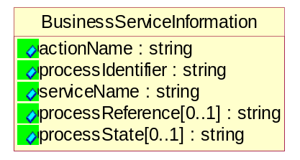
Figure 5-30 BusinessServiceInformation

Attribute | Type | Documentation
actionName | string | The name of Action. For RosettaNet usually any of Request/Confirm/Notify/Query/Response.
processIdentifier | string | The name of the PIP e.g. Notify of Forecast Reply.
serviceName | string | The name of the Business Activity with the "Request/Confirm" part removed. E.g., for the Activity "Request Purchase Order"==> "Purchase Order".
processReference[0..1] | string | The URN for the PIP that includes Cluster/Segment/Process pattern used to identify the interface process (such as PIP3A4)
processState[0..1] | string | The business process (or service) state of the sender of a document. When a service receives this document, the receiver may use the state as a precondition.

ContractInformation
A block of information used to correlate a contract in an executing choreography.

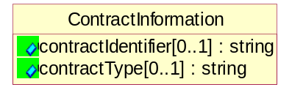
Figure 5-31 ContractInformation

Attribute | Type | Documentation
contractIdentifier[0..1] | string | Unique identification of a contract between the Sender and the Receiver
contractType[0..1] | string | The type of the contract: an attribute describing the type of the ContractIndentification. Valid values are URI, URN,ebXMLCPA, or other values defined by partners.

CorrelationInformation
A block of information used to correlate a requesting document to a responding document and to the contract in an executing choreography.

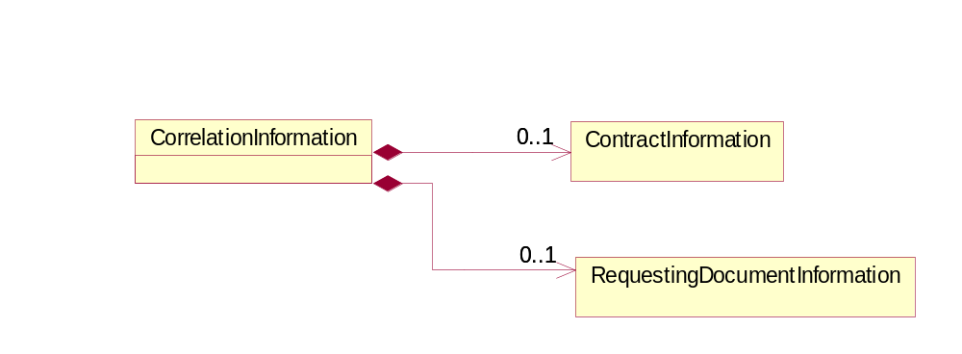
Figure 5-32 CorrelationInformation

Composition | Cardinality | Type | Documentation
ContractInformation | 0..1 | ContractInformation | A block of information used to correlate a contract in an executing choreography.
RequestingDocumentInformation | 0..1 | RequestingDocumentInformation | A block of information used to correlate a requesting document to a responding document in an executing choreography.

DocumentHeader
The object allows for the identification of the sender and receiver of the business document.

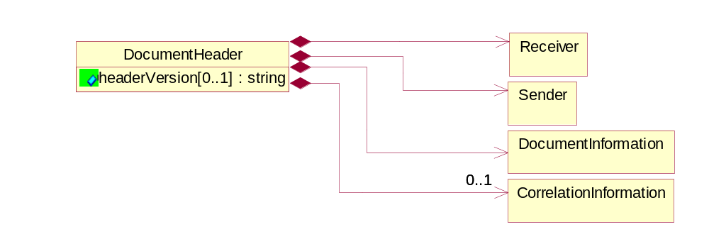
Figure 5-33 DocumentHeader

Attribute | Type | Documentation
headerVersion[0..1] | string | The UN/CEFACT version of the document header.

Composition | Cardinality | Type | Documentation
Sender | 1 | Sender | The object allows the identification of the initiating party of the business message.
CorrelationInformation | 0..1 | CorrelationInformation | A block of information used to correlate a requesting document to a responding document and to the contract in an executing choreography.
DocumentInformation | 1 | DocumentInformation | The object specifies information to identify the business document, a summary of attachments and information about the business document security.
Receiver | 1 | Receiver | The object allows the identification of the receiving party of the business message.

DocumentIdentification
The object specifies all information necessary to identify the business document.

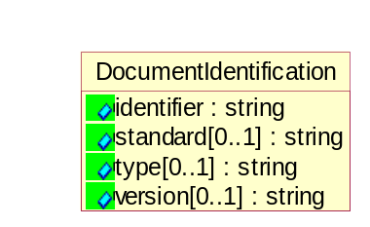
Figure 5-34 DocumentIdentification

Attribute | Type | Documentation
identifier | string | The unique identifier for the document being sent.
standard[0..1] | string | Identifies the standard used to submit the business document. (e.g. RosettaNet).
type[0..1] | string | Name of the Action Message.
version[0..1] | string | PIP3A4v01.00

DocumentInformation
The object specifies information to identify the business document, a summary of attachments and information about the business document security.

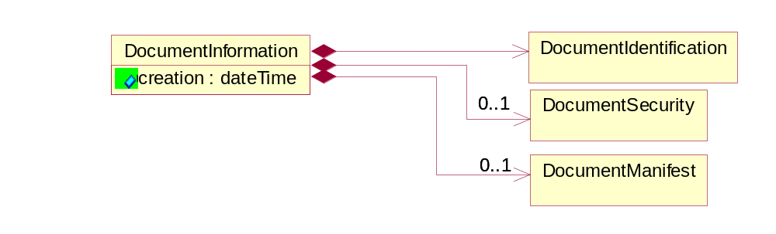
Figure 5-35 DocumentInformation

Attribute | Type | Documentation
creation | dateTime | The creation date and time of the specified Business Document (i.e. the Purchase Order date).

Composition | Cardinality | Type | Documentation
DocumentIdentification | 1 | DocumentIdentification | The object specifies all information necessary to identify the business document.
DocumentSecurity | 0..1 | DocumentSecurity | The object provides additional granularity in specifying business document security (this is in addition to the specified PIP security).
DocumentManifest | 0..1 | DocumentManifest | The block provides a brief summary of attachments and Service Content.

DocumentManifest
The block provides a brief summary of attachments and Service Content.

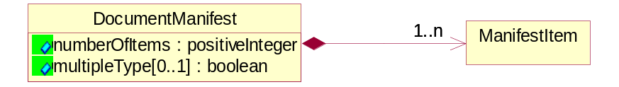
Figure 5-36 DocumentManifest

Attribute | Type | Documentation
numberOfItems | PositiveInteger | Total number of documents in the message. The physical count of the attachments in the payload plus the RosettaNet Business Message (for Service Content). The value of this field will be at least 1.
multipleType[0..1] | boolean | Indicates whether the manifest contains documents of multiple types. True if yes, and False if no.

Composition | Cardinality | Type | Documentation
ManifestItem | 1..n | ManifestItem | The object provides details about the specific attachment(s).

DocumentSecurity
The object provides additional granularity in specifying business document security (this is in addition to the specified PIP security).

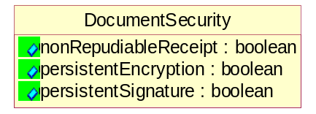
Figure 5-37 DocumentSecurity

Attribute | Type | Documentation
nonRepudiableReceipt | boolean | The value "true" will indicate that a signed acknowledgement for the business document is necessary.
persistentEncryption | boolean | The value "true" will indicate that the Business Document (including the header) needs to be encrypted when stored or transported.
persistentSignature | boolean | The value "true" will indicate that a signature is required to be stored with the document while stored or transported.

ManifestItem
The object provides details about the specific attachment(s).

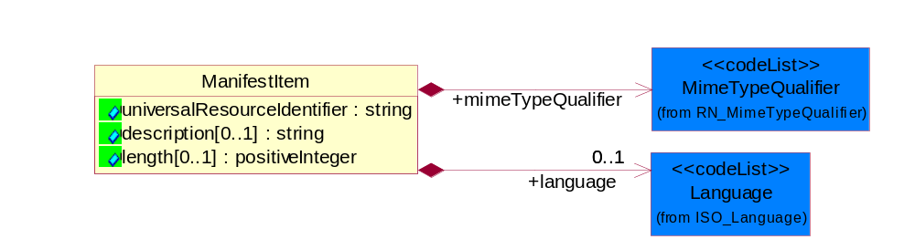
Figure 5-38 ManifestItem

Attribute | Type | Documentation
universalResourceIdentifier | string | The generic set of all names/addresses that are short strings that refer to resources.
description[0..1] | string | A description of the attachment.
length[0..1] | positiveInteger | The size of the attachment in bytes (i.e. 1 000 000 bytes)

Composition | Cardinality | Type | Documentation
mimeTypeQualifier | 1 | MimeTypeQualifier | The MIME type as defined by IANA.  Please refer to http://www.iana.org/assignments/media-types/ for a list of types.
language | 0..1 | Language | For representation of Language name RosettaNet has adopted ISO 639-2; 1998. Refer to the following web page to get the latest version of the standard:  http://www.loc.gov/standards/iso639-2/iso639jac.html  If you need more information about the ISO standard please contact ISO for more details.

Receiver
The object allows the identification of the receiving party of the business message.

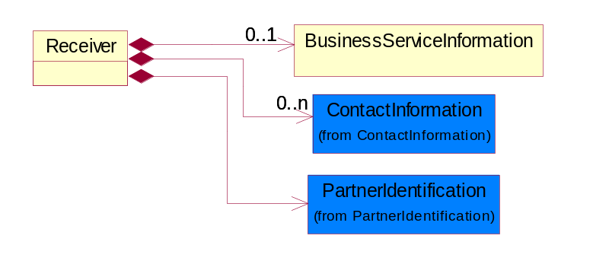
Figure 5-39 Receiver

Composition | Cardinality | Type | Documentation
BusinessServiceInformation | 0..1 | BusinessServiceInformation | The object allows the specification of the business service utilized within the partner company. This may or may not be the same as the information sent by the RNIF.
PartnerIdentification | 1 | PartnerIdentification | The business document must allow for the identity of one or more parties to the transaction.
ContactInformation | 0..n | ContactInformation | The business document must allow for the identification of the name of the department, service or individual to be contacted regarding the context of the business document.

RequestingDocumentInformation
A block of information used to correlate a requesting document to a responding document in an executing choreography.

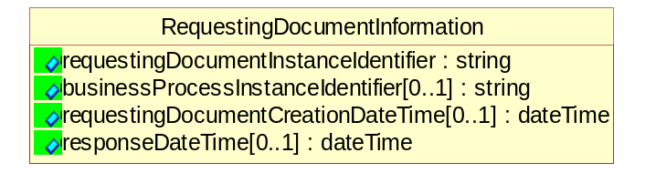
Figure 5-40 RequestingDocumentInformation

Attribute | Type | Documentation
requestingDocumentInstanceIdentifier | string | The Business Document identification number that identifies the requesting Business Document.
businessProcessInstanceIdentifier[0..1] | string | The identifier for the public business process instance being sent that both the sender and receiver can identify.
requestingDocumentCreationDateTime[0..1] | dateTime | The date-time of the requesting business document.
responseDateTime[0..1] | dateTime | The expected time to receive the response. This cannot be greater than the PIP TimeToPerform.

Sender
The object allows the identification of the initiating party of the business message.

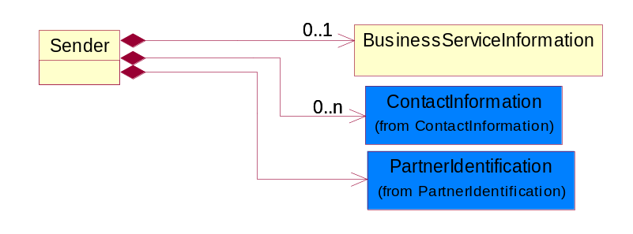
Figure 5-41 Sender

Composition | Cardinality | Type | Documentation
PartnerIdentification | 1 | PartnerIdentification | The business document must allow for the identity of one or more parties to the transaction.
BusinessServiceInformation | 0..1 | BusinessServiceInformation | The object allows the specification of the business service utilized within the partner company. This may or may not be the same as the information sent by the RNIF.
ContactInformation | 0..n | ContactInformation | The business document must allow for the identification of the name of the department, service or individual to be contacted regarding the context of the business document.

XML Data Type

boolean
Represents Boolean values, which are either "true" or "false".

date
For the represents a calendar date.
The pattern for a date is CCYY-MM-DD where CC represents the century, YY the year, MM the month, and DD the day, with an optional time zone indicator as allowed for dateTime.

dateTime
Represents a specific instance of time.
The pattern for dateTime is CCYY-MM-DDThh:mm:ss where CC represents the century, YY the year, MM the month, and DD the day, preceded by an optional leading negative (-) character to indicate a negative number. If the negative character is omitted, positive (+) is assumed. The T is the date/time separator and hh, mm, and ss represent hour, minute, and second respectively. Additional digits can be used to increase the precision of fractional seconds if desired. For example, the format ss.ss... with any number of digits after the decimal point is supported. The fractional seconds part is optional.
This representation may be immediately followed by a "Z" to indicate Coordinated Universal Time (UTC) or to indicate the time zone. For example, the difference between the local time and Coordinated Universal Time, immediately followed by a sign, + or -, followed by the difference from UTC represented as hh:mm (minutes is required). If the time zone is included, both hours and minutes must be present.

decimal
A data type that contains decimal numbers scaled by a power of 10.

duration
Represents a duration of time.
The pattern for duration is PnYnMnDTnHnMnS, where nY represents the number of years, nM the number of months, nD the number of days, T the date/time separator, nH the number of hours, nM the number of minutes, and nS the number of seconds.

float
Represents single-precision 32-bit floating-point numbers.

nonNegativeInteger
Represents an integer that is greater than or equal to zero. This data type is derived from integer.

positiveInteger
Represents an integer that is greater than zero. This data type is derived from nonNegativeInteger.

string
Represents character string.

