

Description of
Partner Interface Process®
for 4E2
Release 11.00.00A

Specification Information
Name | Notify of Sales Report Acknowledgement
Cluster | Inventory Management
Segment | Sales Reporting
Publication Date | 8 March 2004
Version Identifier | R11.00A

Table of Contents
1 Document Management 4
1.1 Legal Disclaimer 4
1.2 Copyright 4
1.3 Trademarks 4
1.4 Acknowledgments 4
1.5 Related Documents 5
1.6 Document Version History 5
1.7 Document Structure 5
2 Business Process 6
2.1 Business Process Definition 6
2.1.1 Executive Summary 6
2.1.2 Business Process Description 7
2.1.3 Business Process Context Diagram 8
2.2 PIP Scope Description 9
2.2.1 Business Process Scope Diagram 9
2.3 PIP Business Documents 10
2.4 PIP Business Process Flow Diagram 10
2.5 PIP Start State 11
2.6 PIP End States 11
2.7 Partner Role Descriptions 12
2.8 Business Process Activity Controls 12
3 Network and Implementation Specification 13
3.1 Business Action and Business Signal Specification 13
3.2 Business Transaction Dialog Specification 13
3.2.1 Message Exchange Controls 14
3.2.2 Communications Specification 14

List of Figures:
Figure 1: High-level Context Diagram 8
Figure 2: Sales Reporting Context Diagram 9
Figure 3: Notify of Sales Report Acknowledgement 10
Figure 4: Notify of Sales Report Acknowledgement Interactions: Service-Service 13

List of Tables:
Table 1: PIP Business Documents 10
Table 2: PIP Start State 11
Table 3: PIP End State 11
Table 4: PIP Failure State 11
Table 5: Partner Role Descriptions 12
Table 6: Business Activity Descriptions 12
Table 7: Business Activity Performance Controls 12
Table 8: Network Component Specification 13
Table 9: Business Action – Business Document Mapping 13
Table 10: Message Exchange Controls - Notify of Sales Report Acknowledgement 14
Table 11: Sales Report Acknowledgement Notification Dialog: Service-Service 14

Document Management
  - Legal Disclaimer
RosettaNet, its members, officers, directors, employees, or agents shall not be liable for any injury, loss, damages, financial or otherwise, arising from, related to, or caused by the use of this document or the specifications herein, as well as associated guidelines and schemas. The use of said specifications shall constitute your express consent to the foregoing exculpation.
  - Copyright
©2004 RosettaNet. All rights reserved. No part of this publication may be reproduced, stored in a retrieval system, or transmitted, in any form or by any means, electronic, mechanical, photocopying, recording, or otherwise, without the inclusion of this copyright notice. Any derivative works must cite the copyright notice. Any public redistribution or sale of this publication or derivative works requires prior written permission of the publisher.
  - Trademarks
RosettaNet, Partner Interface Process, PIP® and the RosettaNet logo are trademarks or registered trademarks of "RosettaNet," a non-profit organization. All other product names and company logos mentioned herein are the trademarks of their respective owners. In the best effort, all terms mentioned in this document that are known to be trademarks or registered trademarks have been appropriately recognized in the first occurrence of the term.
  - Acknowledgments
This document has been prepared by RosettaNet (http://www.rosettanet.org/) from requirements gathered during the Milestone Program and in conformance with the methodology. Listed below are the legal entities that contributed to the design and development of this PIP.
BCM Electronics | Cisco
Cisco Systems | Electronics Industry Data Exchange Association (EIDX)
Hewlett Packard | Hewlett-Packard GmbH
HP | Globetronics SDH. BHD
GridNode | GridNode, Inc.
GridNode Pte. Ltd. | IBM
Intel | Intel Corp.
Intel Corp (UK) LTD | Intel Corporation
International Business Machines | MIMOS Berhad
Motorola | Motorola Semiconductor Sector
Motorola SPS | Nokia
Nokia Oyj | Philips Semiconductors
Seagate Technology | Sterling Commerce
  - Related Documents
- Associated PIP Message Schemas (included with PIP Specification only)
  - Document Version History
Version | Date | Description
Release 11.00.00A | 8 March 2004 | Release Description of PIP
  - Document Structure
A Partner Interface Process (PIP) Specification is comprised of the following two parts:
- Business Process. Captures the semantics of the business process and the flow of the message exchange between roles as they perform business activities.
- Network and Implementation Specification. Specifies the network protocol message formats and communications requirements between peer-protocols supported by network components in the RosettaNet Implementation Framework.

Business Process
  - Business Process Definition
Sales Reporting Acknowledgment is a process that allows recipient of sales report to acknowledge the sender of data discrepancies found and to confirm special pricing claims in the originating document. This enables the sender of the sales report to resolve inaccurate sales information and be able to identify which products were sold under a specific special pricing program and get credit for the pricing in a timely manner.

Executive Summary
Currently, the originators of the data are being requested to send sales report in various formats. Extracting this data and then formatting the data in a different way depending on who the recipient is creates overhead, delays the sending of the information, increases the time to publish the information and often requires manual intervention thus leading to errors.
Depending on existing data exchange protocols, recipients of the information may spend unnecessary time to prepare the received data from the many partners such that it is able to flow into their ERP systems. Often the data is incomplete as during the course of the process some partners have issues preparing the information before sending it to the recipient.
Managing the manual process in weekly cycles is already flawed; as costs in the industry continue to be reviewed the need for more frequent cycles is required but hindered due to the ineffective methods used to exchange data. In addition, the need to penetrate further down the sales chain is an increasing requirement, managing the data manually and in many formats is impractical as the partner activity expands.
Information required to manage business could be inaccurate and delayed. This results in:
- Inaccurate inventory calculations hence over/under stated financial reserves
- Delayed payments to the partners for rebates and credits
- Inaccurate decision made on market conditions
- Inaccurate and delayed calculations of sales compensation.
Sales Reporting aims to design a standard process for notifying and acknowledging Sales Report information. The objectives are to improve the information flow and reduce the costs of managing the associated business processes that generate and utilize the information. In addition, this will help increase visibility throughout the supply chain.

Business Process Description
Sales report sent from the buyer to the seller may contain data discrepancies and because of this, the seller has to have a way to acknowledge the buyer of data discrepancies found in the originating sales report. Sales report acknowledgement also serves to acknowledge confirmation of special pricing claims by the buyer.
The "Notify of Sales Report Acknowledgement" Partner Interface Process (PIP) supports a process in which a seller sends a sales report acknowledgement to a buyer. The buyer could be a re-seller or distributor and the seller could be a manufacturer. The sales report acknowledgment contains data discrepancy information and special pricing confirmation.

Business Process Context Diagram
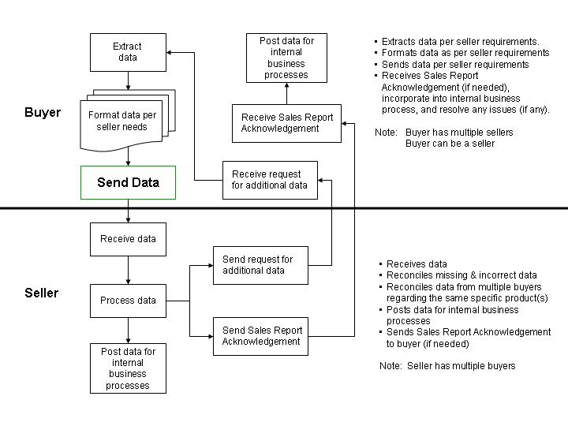
Figure 1: High-level Context Diagram

  - PIP Scope Description
The purpose of this PIP is to acknowledge any data discrepancies found and to confirm special pricing claims in a 4E1, “Notify of Sales Report” PIP.

Business Process Scope Diagram
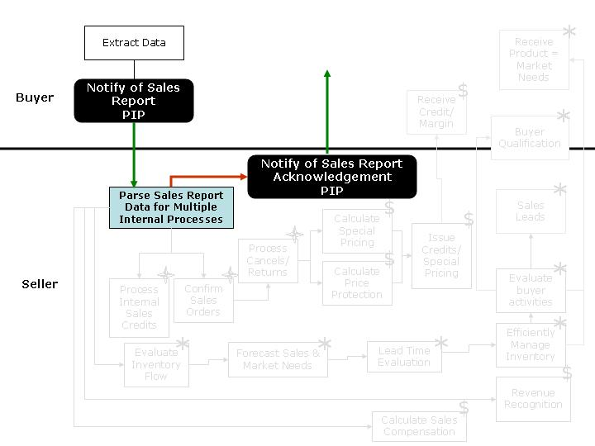
Figure 2: Sales Reporting Context Diagram
  - PIP Business Documents
Business Documents are generated and exchanged by roles performing activities in this PIP. Business Documents are listed and defined in Table 1.
Table 1: PIP Business Documents
Business Document | Description
Sales Report Acknowledgment Notification | Contains data discrepancy information and confirmation of special pricing claims.
  - PIP Business Process Flow Diagram
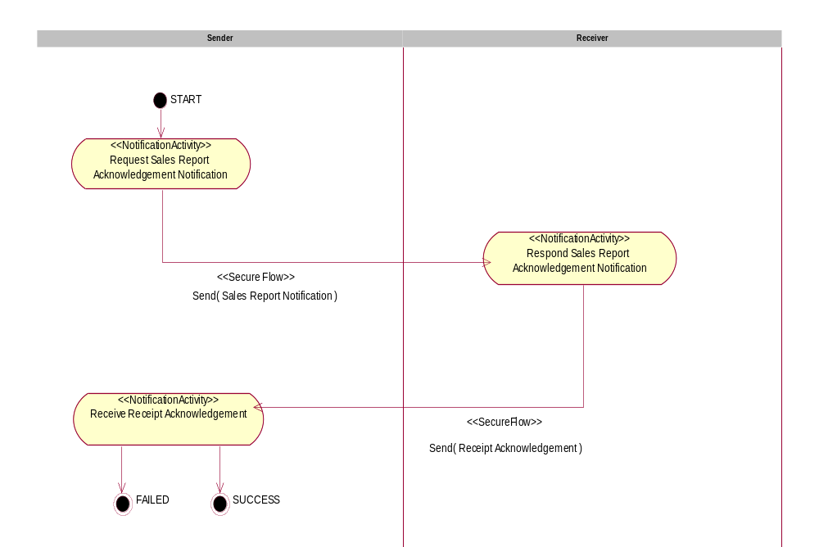
Figure 3: Notify of Sales Report Acknowledgement
  - PIP Start State
The start state is comprised of the following condition(s):
Table 2: PIP Start State
 | Approved | Exist |  | Valid | Non-Repudiated | Authorized
 | Approved | Party | In Backend system | Valid | Non-Repudiated | Authorized
TPA |  |  | 
Sending Partner |  |  |  | 
Receiving Partner |  | 
Business Document |  |  |  |  |  | 
  - PIP End States
The end state is comprised of the following condition(s):
Table 3: PIP End State
 | Approved | Exist |  | Valid | Non-Repudiated | Authorized
 | Approved | Party | In Backend system | Valid | Non-Repudiated | Authorized
Acknowledgment of Receipt |  |  |  |  | 
Receiving Partner |  |  |  |  |  | 

The PIP failure state is comprised of one or more of the following conditions:
Table 4: PIP Failure State
 | NO | Exceeded
Success | 
Retry Count |  | 

  - Partner Role Descriptions
Table 5 describes the partner roles in this PIP.
Table 5: Partner Role Descriptions
Role Name | Role Description
Sender | Party, which is requesting Business Activity.
Receiver | Party, which is responding to a Business Activity Request.

  - Business Process Activity Controls
Table 6 describes the interaction contract between roles performing business activities in this PIP.
Table 6: Business Activity Descriptions
Role  Name | Activity Name | Activity Description
Sender | Notify of Sales Report Acknowledgement | A Seller sends a Sales Report Acknowledgment Notification to a Buyer. The Sales Report Acknowledgement Notification contains data discrepancy information and confirmation of special pricing claims.

Table 7 details the security, audit and process controls relating to activities performed in the PIP.
Table 7: Business Activity Performance Controls
Role  Name | Activity  Name | Acknowledgment  of Receipt |  | Time to Acknowledge Acceptance | Time to Perform | Retry Count | Is Authorization Required? | Non-Repudiation of Origin and Content?
Role  Name | Activity  Name | Non-Repudiation Required? | Time to Acknowledge
Sender | Notify of Sales Report Acknowledgment | Y | 2 hrs | N/A | 24 hrs | 3 | Y | Y

Network and Implementation Specification
Each network component maps into a role of the PIP model. Table 8 specifies the mapping between roles and network components.
Table 8: Network Component Specification
Network Component | Classification | Maps to Role in Business Process
Sender Service | Business Service | Sender
Receiver Service | Business Service | Receiver
  - Business Action and Business Signal Specification
Each business action maps to a Business Document of the PIP model. Table 9 specifies the mapping between Business Documents and business actions.
Table 9: Business Action – Business Document Mapping
Business Action | Business Document | Document Function
Sales Report Acknowledgement Notification Action | Sales Report Acknowledgment Notification | Request
  - Business Transaction Dialog Specification
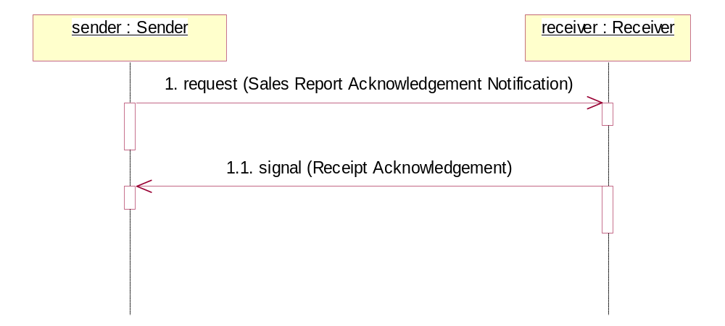
Figure 4: Notify of Sales Report Acknowledgement Interactions: Service-Service

Message Exchange Controls
Table 10: Message Exchange Controls - Notify of Sales Report Acknowledgement
# | Name | Time to Acknowledge Receipt Signal | Time to Acknowledge Acceptance Signal | Time to Respond to Action | Included in Time to Perform | Is Authorization Required? | Is Non-Repudiation Required? | Is Secure Transport Required?
1. | Sales Report Acknowledgement Notification Action | 2 hrs | N/A | N/A | Y | Y | Y | Y
1.1. | Receipt Acknowledgment | N/A | N/A | N/A | Y | Y | Y | Y

Communications Specification
Table 11: Sales Report Acknowledgement Notification Dialog: Service-Service
# | Business Message | Digital Signature Required? | SSL Required?
1. | Sales Report Acknowledgement Notification | Y | Y
1.1. | Receipt Acknowledgment | Y | Y

