

Description of 4E2 Message

PIP® 4E2
Release 11.01.00B

Specification Information
Name | Description of 4E2 Message
PIP | Notify of Sales Report Acknowledgement
Cluster | Inventory Management
Segment | Sales Reporting
Publication Date | 19 Oct 2005
Version Identifier | R11.01B

Table of Content

1. Document Management 6
1.1 Legal Disclaimer 6
1.2 Copyright 6
1.3 Trademarks 6
1.4 Acknowledgments 6
1.5 Related Documents 7
1.6 Document Version History 7
1.7 Document Purpose 7
2. Interchange Model 8
2.1 SalesReportAcknowledgementNotification 8
2.1.1 Interchange Diagram 8
2.1.2 Dependency Diagram 9
2.1.3 ParticipatingPartner 9
2.1.4 ProductTransfer 10
2.1.5 SalesReportAcknowledgementLineItem 10
2.1.6 SalesReportAcknowledgementNotification 11
2.1.7 SalesReportAcknowledgment 11
2.1.8 SalesReportDiscrepancy 12
2.1.9 SpecialPriceAcknowledgement 12
3. Domain Model 14
3.1 Procurement 14
3.1.1 Procurement 14
3.1.1.1 Dependency Diagram 14
3.1.1.2 ContractDetails 14
3.1.1.3 DatePeriodAndDuration 15
3.1.1.4 Duration 15
3.1.1.5 ProductQuantity 15
3.1.1.6 SpecialPrice 16
3.1.2 CodeList 17
3.1.2.1 ReportType 17
3.1.2.2 SalesReportDiscrepancyCode 17
4. Universal Structure 19
4.1 ContactInformation 19
4.1.1 ContactInformation 19
4.2 DataType 20
4.2.1 Contact 20
4.2.2 DUNS 20
4.2.3 DUNSPlus4 21
4.2.4 GLN 21
4.2.5 PercentAmount 22
4.3 Dates 22
4.3.1 DatePeriod 22
4.4 Locations 23
4.4.1 AlternativeIdentifier 23
4.4.2 Location 23
4.4.3 LocationChoice 24
4.4.4 PhysicalAddress 24
4.5 MonetaryExpression 26
4.5.1 FinancialAmount 26
4.5.2 ProductPricing 27
4.5.3 TaxJurisdiction 27
4.6 PartnerIdentification 28
4.6.1 FullPartner 28
4.6.2 IntermittentPartner 29
4.6.3 KnownPartner 29
4.6.4 KnownPartnerContact 30
4.6.5 NewPartner 30
4.6.6 PartnerDescription 31
4.6.7 PartnerDescriptionChoice 31
4.6.8 PartnerIdentification 32
4.6.9 PartnerIdentificationChoice 33
4.6.10 SpecifiedFullPartner 33
4.6.11 SpecifiedIntermittentPartner 34
4.6.12 SpecifiedKnownPartner 34
4.6.13 SpecifiedNewPartner 35
4.7 CodeList 36
4.7.1 Country 36
4.7.2 CountrySubdivision 36
4.7.3 Currency 36
4.7.4 Language 36
4.7.5 MimeTypeQualifier 37
4.7.6 UnitOfMeasure 47
4.7.7 ProcessRoleIdentifier 54
5. System Structure 56
5.1 BusinessProcessIdentifier 56
5.2 BusinessServiceInformation 56
5.3 ContractInformation 57
5.4 CorrelationInformation 58
5.5 DocumentHeader 58
5.6 DocumentIdentification 59
5.7 DocumentIdentificationChoice 60
5.8 DocumentInformation 60
5.9 DocumentManifest 61
5.10 DocumentSecurity 61
5.11 ManifestItem 62
5.12 PipIdentifier 63
5.13 PipVersion 63
5.14 Receiver 64
5.15 RequestingDocumentInformation 65
5.16 Sender 65
5.17 StandardDocumentIdentification 66
5.18 TpirPipIdentification 66
5.19 VersionIdentifier 67
5.20 CodeList 68
5.20.1 TPIRFileType 68
6. XML Data Type 69
6.1 anyURI 69
6.2 boolean 69
6.3 date 69
6.4 dateTime 69
6.5 decimal 69
6.6 duration 69
6.7 float 69
6.8 positiveInteger 69
6.9 string 70

Table of Figures

Figure 2-1 Interchange 8
Figure 2-2 Dependency 9
Figure 2-3 ParticipatingPartner 9
Figure 2-4 ProductTransfer 10
Figure 2-5 SalesReportAcknowledgementLineItem 10
Figure 2-6 SalesReportAcknowledgementNotification 11
Figure 2-7 SalesReportAcknowledgment 11
Figure 2-8 SalesReportDiscrepancy 12
Figure 2-9 SpecialPriceAcknowledgement 13
Figure 3-1 Dependency 14
Figure 3-2 ContractDetails 14
Figure 3-3 DatePeriodAndDuration 15
Figure 3-4 Duration 15
Figure 3-5 ProductQuantity 16
Figure 3-6 SpecialPrice 16
Figure 4-1 ContactInformation 19
Figure 4-2 Contact 20
Figure 4-3 DUNS 20
Figure 4-4 DUNSPlus4 21
Figure 4-5 GLN 21
Figure 4-6 PercentAmount 22
Figure 4-7 DatePeriod 22
Figure 4-8 AlternativeIdentifier 23
Figure 4-9 Location 23
Figure 4-10 PhysicalAddress 24
Figure 4-11 FinancialAmount 26
Figure 4-12 ProductPricing 27
Figure 4-13 TaxJurisdiction 27
Figure 4-14 FullPartner 28
Figure 4-15 IntermittentPartner 29
Figure 4-16 KnownPartner 29
Figure 4-17 KnownPartnerContact 30
Figure 4-18 NewPartner 30
Figure 4-19 PartnerDescription 31
Figure 4-20 PartnerIdentification 32
Figure 4-21 SpecifiedFullPartner 33
Figure 4-22 SpecifiedIntermittentPartner 34
Figure 4-23 SpecifiedKnownPartner 34
Figure 4-24 SpecifiedNewPartner 35
Figure 5-1 BusinessProcessIdentifier 56
Figure 5-2 BusinessServiceInformation 56
Figure 5-3 ContractInformation 57
Figure 5-4 CorrelationInformation 58
Figure 5-5 DocumentHeader 58
Figure 5-6 DocumentIdentification 59
Figure 5-7 DocumentInformation 60
Figure 5-8 DocumentManifest 61
Figure 5-9 DocumentSecurity 61
Figure 5-10 ManifestItem 62
Figure 5-11 PipIdentifier 63
Figure 5-12 PipVersion 63
Figure 5-13 Receiver 64
Figure 5-14 RequestingDocumentInformation 65
Figure 5-15 Sender 65
Figure 5-16 StandardDocumentIdentification 66
Figure 5-17 TpirPipIdentification 66
Figure 5-18 VersionIdentifier 67

Document Management

Legal Disclaimer
RosettaNet, its members, officers, directors, employees, or agents shall not be liable for any injury, loss, damages, financial or otherwise, arising from, related to, or caused by the use of this document or the specifications herein, as well as associated guidelines and schemas. The use of said specifications shall constitute your express consent to the foregoing exculpation.

Copyright
©2005 RosettaNet. All rights reserved. No part of this publication may be reproduced, stored in a retrieval system, or transmitted, in any form or by any means, electronic, mechanical, photocopying, recording, or otherwise, without the inclusion of this copyright notice. Any derivative works must cite the copyright notice. Any public redistribution or sale of this publication or derivative works requires prior written permission of the publisher.

Trademarks
RosettaNet, Partner Interface Process, PIP and the RosettaNet logo are trademarks or registered trademarks of "RosettaNet," a non-profit organization. All other product names and company logos mentioned herein are the trademarks of their respective owners. In the best effort, all terms mentioned in this document that are known to be trademarks or registered trademarks have been appropriately recognized in the first occurrence of the term.

Acknowledgments
This document has been prepared by RosettaNet (http://www.rosettanet.org/) from requirements gathered during the Milestone Program and in conformance with the methodology. Listed below are the legal entities that contributed to the design and development of this PIP.
BCM Electronics | Cisco
Cisco Systems | Electronics Industry Data Exchange Association (EIDX)
Hewlett Packard | Hewlett-Packard GmbH
HP | Globetronics SDH. BHD
GridNode | GridNode, Inc.
GridNode Pte. Ltd. | IBM
Intel | Intel Corp.
Intel Corp (UK) LTD | Intel Corporation
International Business Machines | MIMOS Berhad
Motorola | Motorola Semiconductor Sector
Motorola SPS | Nokia
Nokia Oyj | Philips Semiconductors
Seagate Technology | Sterling Commerce

Related Documents
- Associated PIP Message Schemas (included with PIP Specification only)
- Description of Partner Interface Process for 4E2
- Message Structure

Document Version History
Version | Date | Description
Release 11.00.00A | 8 Mar 2004 | Release version.
Release 11.01.00B | 19 Oct 2005 | Release version with updated domains model.

Document Purpose
The purpose of the document is to explain the structure, the association between objects, the content of objects and the definition for single elements to a non-technical audience.

Interchange Model

SalesReportAcknowledgementNotification

Interchange Diagram
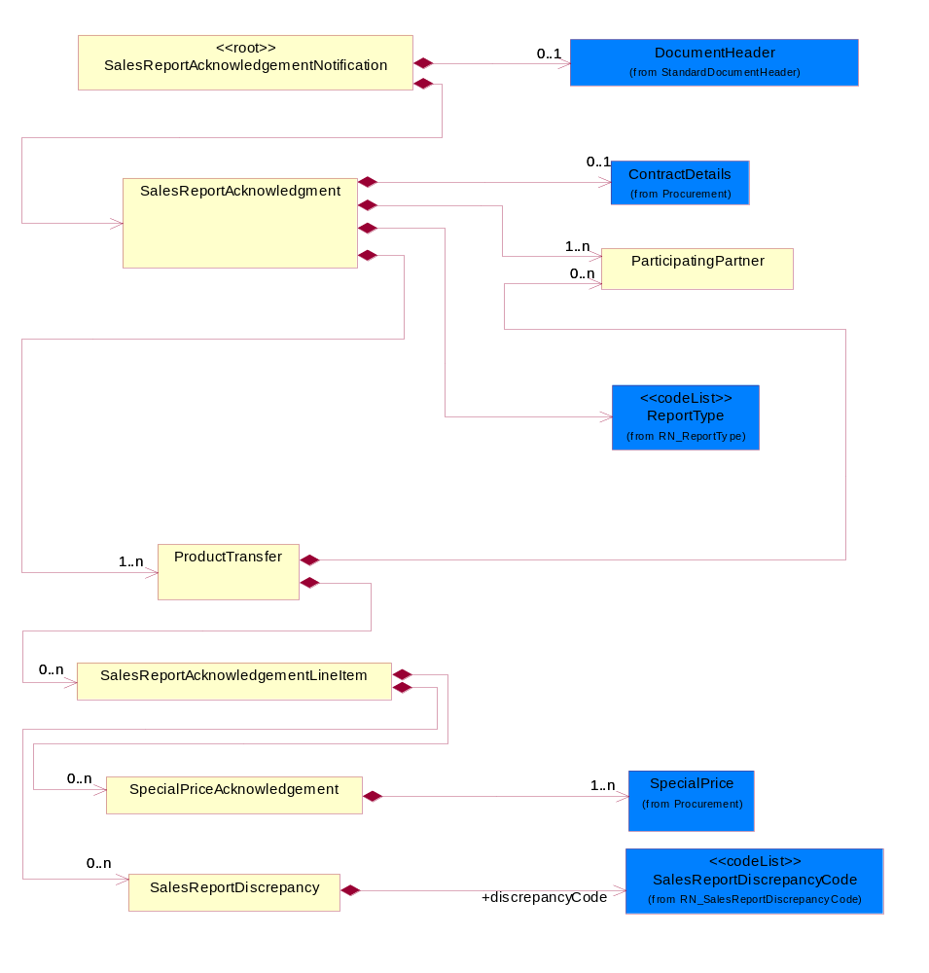
Figure 2-1 Interchange

Dependency Diagram
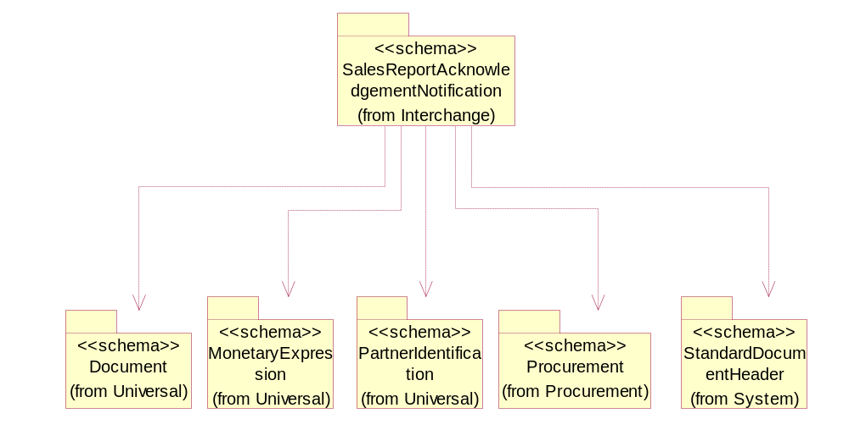
Figure 2-2 Dependency

ParticipatingPartner

This object describes a partner that participates in a point of sale transaction which can either be a reseller, distributor, manufacturer or end-user.

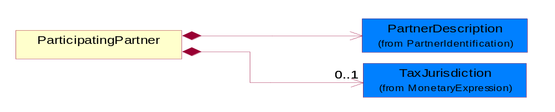
Figure 2-3 ParticipatingPartner

Composition | Cardinality | Type | Documentation
PartnerDescription | 1 | PartnerDescription | The collection of business properties that describe a business partners' identity, their contact information, where they are physically located and their function in a supply chain.
TaxJurisdiction | 0..1 | TaxJurisdiction | The business document must identify the specific tax collection authority.

ProductTransfer

This object describes the acknowledgment of point of sale information for a single known/unkown end user.

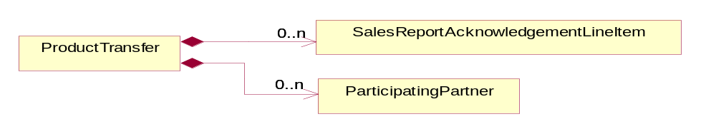
Figure 2-4 ProductTransfer

Composition | Cardinality | Type | Documentation
SalesReportAcknowledgementLineItem | 0..n | SalesReportAcknowledgementLineItem | This object describes an entry in a sales report acknowledgement.
ParticipatingPartner | 0..n | ParticipatingPartner

SalesReportAcknowledgementLineItem

This object describes an entry in a sales report acknowledgement.

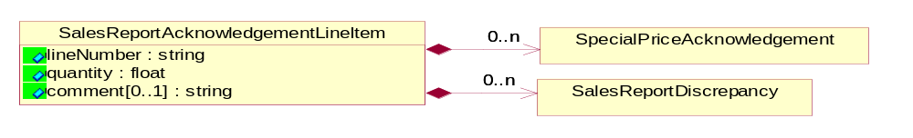
Figure 2-5 SalesReportAcknowledgementLineItem

Attribute | Type | Documentation
lineNumber | string | Specific line number.
quantity | float | Quantity of product.
comment[0..1] | string | A textual description of information relating to a product sale

Composition | Cardinality | Type | Documentation
SalesReportDiscrepancy | 0..n | SalesReportDiscrepancy | This object describes data discrepancies found.
SpecialPriceAcknowledgement | 0..n | SpecialPriceAcknowledgement | This object describes an acknowledgement (verification) of a special price.

SalesReportAcknowledgementNotification

A message wrapper for the PIP4E2.

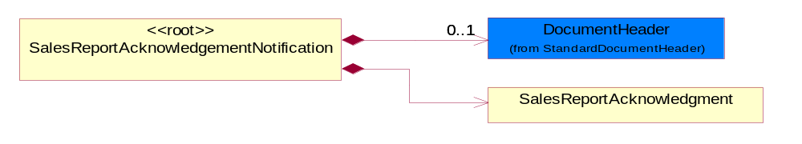
Figure 2-6 SalesReportAcknowledgementNotification

Composition | Cardinality | Type | Documentation
SalesReportAcknowledgment | 1 | SalesReportAcknowledgment | The sales report acknowledgement document.
DocumentHeader | 0..1 | DocumentHeader | The object allows for the identification of the sender and receiver of the business document.

SalesReportAcknowledgment

The sales report acknowledgement document.

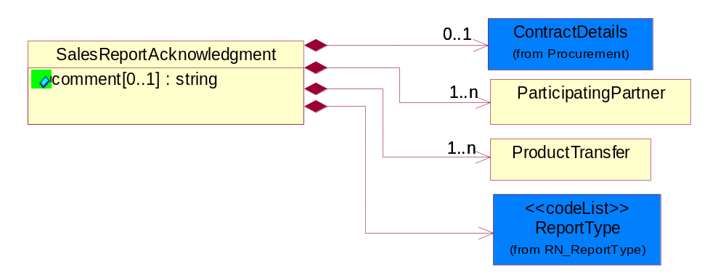
Figure 2-7 SalesReportAcknowledgment

Attribute | Type | Documentation
comment[0..1] | string | A textual description of information relating to a product sale

Composition | Cardinality | Type | Documentation
ProductTransfer | 1..n | ProductTransfer | This object describes the acknowledgment of point of sale information for a single known/unkown end user.
ReportType | 1 | ReportType | Code identifying the specific type of report.
ContractDetails | 0..1 | ContractDetails | This object represents a business arrangement for the supply of goods or services. Group of attributes pertaining to the specific type of contract.
ParticipatingPartner | 1..n | ParticipatingPartner

SalesReportDiscrepancy

This object describes data discrepancies found.

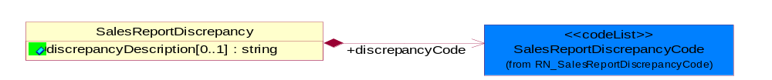
Figure 2-8 SalesReportDiscrepancy

Attribute | Type | Documentation
discrepancyDescription[0..1] | string | A textual description of a discrepancy found in the originating sales report

Composition | Cardinality | Type | Documentation
discrepancyCode | 1 | SalesReportDiscrepancyCode | Code identifying the types of discrepancies in the sales report notification document. Allows the receipient of the sales report to communicate the type of discrepancy to the sender via the acknowledgement.

SpecialPriceAcknowledgement

This object describes an acknowledgement (verification) of a special price.

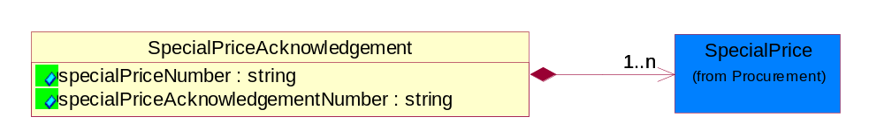
Figure 2-9 SpecialPriceAcknowledgement

Attribute | Type | Documentation
specialPriceNumber | string | An identifier of a special price
specialPriceAcknowledgementNumber | string | An identifier assigned to a special price acknowledgement

Composition | Cardinality | Type | Documentation
SpecialPrice | 1..n | SpecialPrice | This object represents a special price based on number of unit of products and an eligible period.

Domain Model

Procurement

Procurement

Dependency Diagram
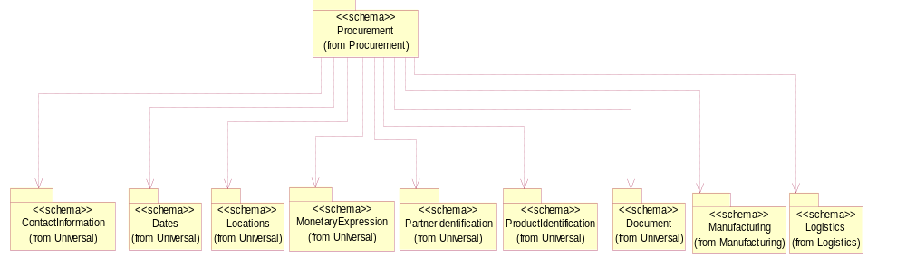
Figure 3-10 Dependency

ContractDetails

This object represents a business arrangement for the supply of goods or services. Group of attributes pertaining to the specific type of contract.

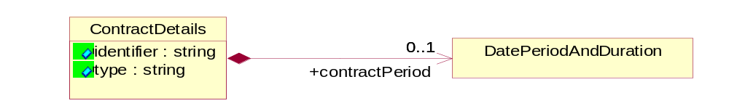
Figure 3-11 ContractDetails

Attribute | Type | Documentation
identifier | string | A unique proprietary number to identify a "solution" which is usually a combination of parts and services or software
type | string | A textual description of a contract. Additional description pertaining to the type of contract.

Composition | Cardinality | Type | Documentation
contractPeriod | 0..1 | DatePeriodAndDuration | The effective period of contract.

DatePeriodAndDuration

This object allows representation of a date period by a duration or begin and an end dates.

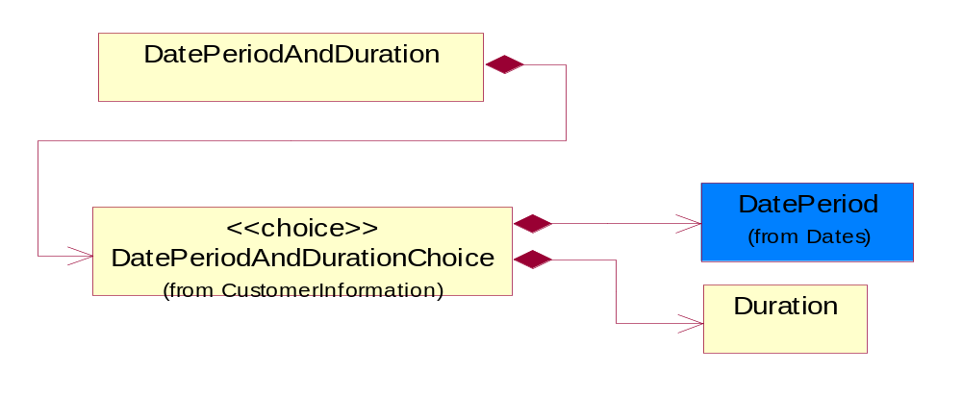
Figure 3-12 DatePeriodAndDuration

Composition | Cardinality | Type | Documentation
DatePeriodAndDurationChoice | 1 | DatePeriodAndDurationChoice

Duration

This object allows representation of a duration of time.

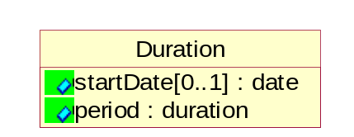
Figure 3-13 Duration

Attribute | Type | Documentation
startDate[0..1] | date | The date indicating the beginning of the duration.
period | duration | Represents a duration of time.

ProductQuantity

A quantity specifying the number of product units.

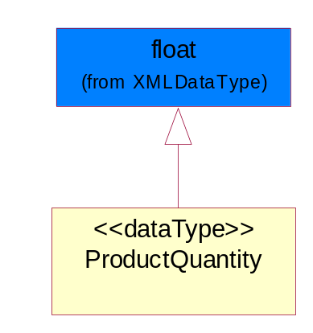
Figure 3-14 ProductQuantity

SpecialPrice

This object represents a special price based on number of unit of products and an eligible period.

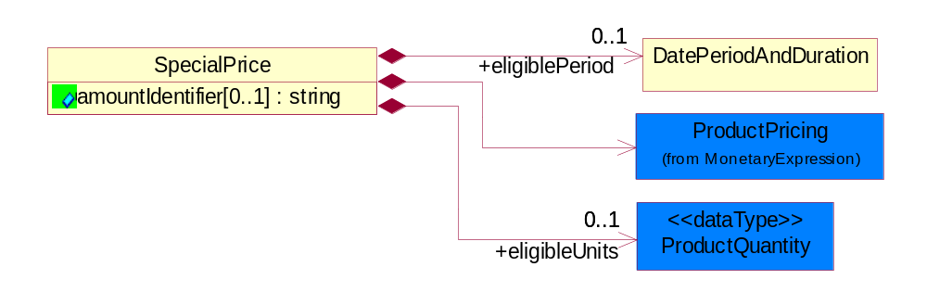
Figure 3-15 SpecialPrice

Attribute | Type | Documentation
amountIdentifier[0..1] | string | Identifies type of special pricing.

Composition | Cardinality | Type | Documentation
ProductPricing | 1 | ProductPricing | The business document must contain the price of the product.
eligibleUnits | 0..1 | ProductQuantity | The number of units that has to be ordered to be eligible for a special price.
eligiblePeriod | 0..1 | DatePeriodAndDuration | The period of time when the product is available in special price.

CodeList

ReportType

Code identifying the specific type of report.

Name | Documentation
CON | Indicates that products were in consignment.
INV | Inventory transfer. A transfer from one location to another within the same distributor.
MIX | Combination. A combination of INV and MOV.
MOV | Product Transfer. A product transfer from the distributor to an external party.
SLT | Indicates to whom the products were bought from and sold to.
STR | Sell-through sales report type.

SalesReportDiscrepancyCode

Code identifying the types of discrepancies in the sales report notification document. Allows the receipient of the sales report to communicate the type of discrepancy to the sender via the acknowledgement.

Name | Documentation
DIN | Invoice number has been provided before.
DLZ | Cost is less than zero.
DNR | Registration is not available for device.
DRF | Line item is a duplicate of a previous record.
DXP | Product does not qualify for special pricing because claim submitted after expiration date or shipped after expiration date.
ICR | Cost currency code provided is not valid.
IPN | Part number provided is inaccurate.
IRC | Currency code provided is not valid.
ISN | Serial number provided is inaccurate.
ITC | Transaction code is not valid.
MCR | Currency code is not provided.
MCX | End customer does not match record.
MDL | Distributor location code is not provided.
MDR | Distributor reference code is not provided.
MIL | Invoice line number is not provided.
MIN | Invoice number is not provided.
MPN | Part number is not provided.
MQS | Quantity sold is not provided.
MRC | Currency code was not provided.
MRP | Resale price is not provided.
MSD | Ship date is not provided.
MTC | Transaction code is not provided.
ONF | Special price is not valid.
PDO | Date provided is past POS date reporting limit
PNE | Part number not valid.
PSF | POS report was sent by freight forwarders.
PXL | Price provided is above the upper limit for resale.
RCD | Customer is a distributor.
RCL | Registration is closed.
RNA | Registration is not approved.
RNF | ASP provided is not in the record.
SDF | Date provided is a future date.
SDL | Product does not qualify for special pricing because the ship date was after date.
SDP | Product does not qualify for special pricing because the ship date was prior to approval date.
XAP | Product does not qualify for special pricing because claim submitted after expiration date or shipped after expiration date.

Universal Structure

ContactInformation

ContactInformation

The business document must allow for the identification of the name of the department, service or individual to be contacted regarding the context of the business document.

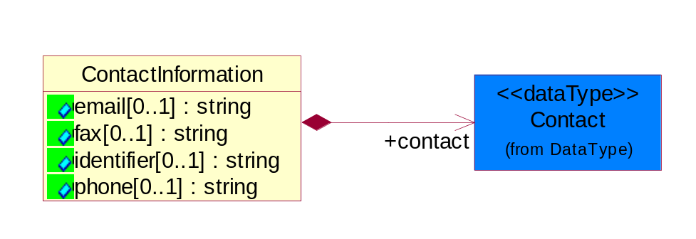
Figure 4-16 ContactInformation

Attribute | Type | Documentation
email[0..1] | string | The electronic mail for the specified contact.
fax[0..1] | string | The fax number for the specified contact.
identifier[0..1] | string | Identifies the role of the contact (i.e. Service Technician, Account Manager) in the Business Process.
phone[0..1] | string | The telephone number for the specified contact.

Composition | Cardinality | Type | Documentation
contact | 1 | Contact | The name of the department, service or individual to be contacted within the organization.

DataType

Contact

The name of the department, service or individual to be contacted within the organization.

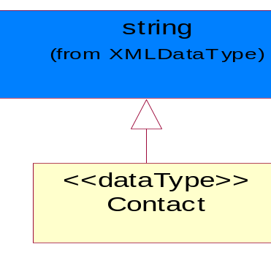
Figure 4-17 Contact

DUNS

A number assigned by Dun and Bradstreet to identify a business location.

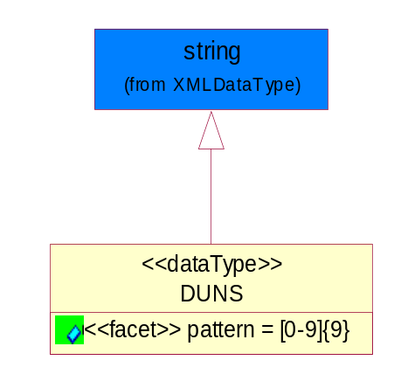
Figure 4-18 DUNS

Attribute | Type | Documentation
pattern |  | [0-9]{9}

DUNSPlus4

A identifier to specify a specific location within a business location.

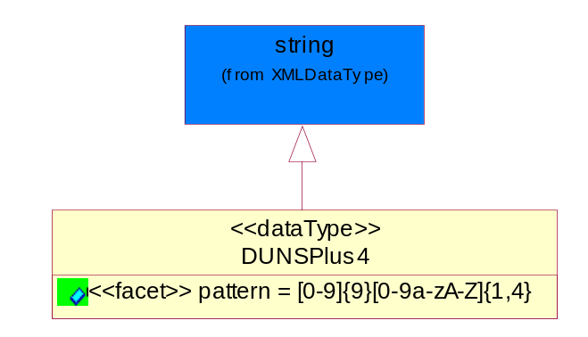
Figure 4-19 DUNSPlus4

Attribute | Type | Documentation
pattern |  | Data Universal Numbering System +4 (DUNS+4) number means the DUNS number assigned by Dun and Bradstreet, Inc. (D&B) plus an alphanumeric of length 4 suffix that may be assigned by a business concern.

GLN

Global Location Number (GLN) - A identifier to identify legal entities, trading parties and location.

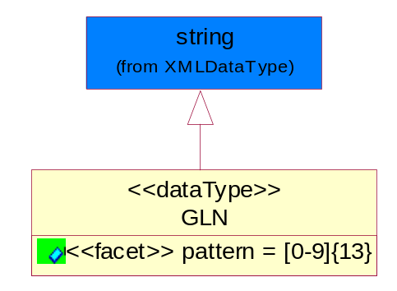
Figure 4-20 GLN

Attribute | Type | Documentation
pattern |  | [0-9]{13}

PercentAmount

A number representing a percentage value, e.g. 75.125 represents 75 1/8 percent.

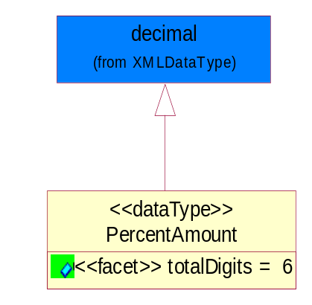
Figure 4-21 PercentAmount

Attribute | Type | Documentation
totalDigits |  | 6

Dates

DatePeriod

The business document must allow for the computation or statement of a duration based upon a beginning and an ending date.

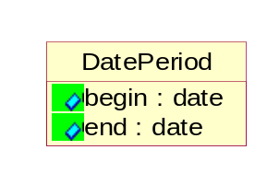
Figure 4-22 DatePeriod

Attribute | Type | Documentation
begin | date | The date indicating the beginning of the date period.
end | date | The date indicating the ending of the date period.

Locations

AlternativeIdentifier

Identifies the specified code and the name of the organization that a code is utilized from.

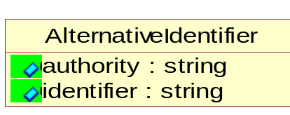
Figure 4-23 AlternativeIdentifier

Attribute | Type | Documentation
authority | string | The name of the organization that a code is utilized from.
identifier | string | The specified code to represent an entity (e.g. product, location, partner, etc.)

Location

The business document must specify a location.

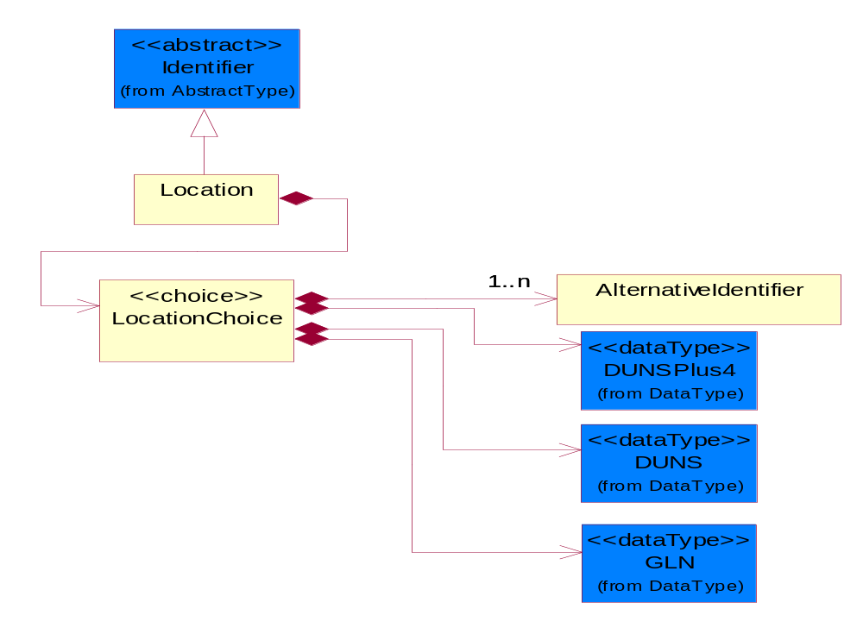
Figure 4-24 Location

Composition | Cardinality | Type | Documentation
LocationChoice | 1 | LocationChoice

LocationChoice

Composition | Cardinality | Type | Documentation
DUNSPlus4 | 1 | DUNSPlus4 | A identifier to specify a specific location within a business location.
DUNS | 1 | DUNS | A number assigned by Dun and Bradstreet to identify a business location.
AlternativeIdentifier | 1..n | AlternativeIdentifier | Identifies the specified code and the name of the organization that a code is utilized from.
GLN | 1 | GLN | Global Location Number (GLN) - A identifier to identify legal entities, trading parties and location.

PhysicalAddress

The business document must provide a physical address for a party to the business transaction.

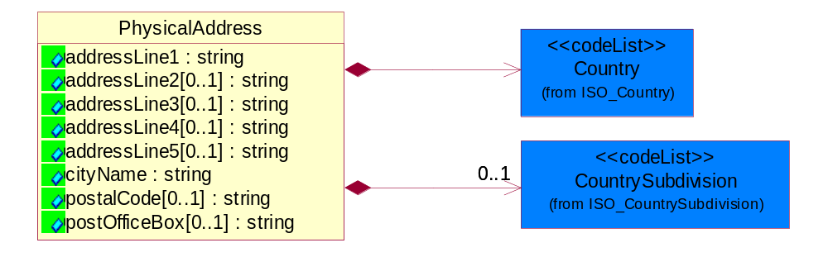
Figure 4-25 PhysicalAddress

Attribute | Type | Documentation
addressLine1 | string | The first line of a physical address.
addressLine2[0..1] | string | The second line of a physical address.
addressLine3[0..1] | string | The third line of a physical address.
addressLine4[0..1] | string | The fourth line of a physical address.
addressLine5[0..1] | string | The fifth line of a physical address.
cityName | string | The name of a city.
postalCode[0..1] | string | Identifying geographic location as specified by a national postal code.
postOfficeBox[0..1] | string | The Post Office Box identifier used to identify a party's post office box.

Composition | Cardinality | Type | Documentation
Country | 1 | Country | For representation of Country name RosettaNet has adopted ISO 3166-3; 1999. Refer to the following web page to get the latest version of the standard:  http://www.iso.ch/iso/en/prods-services/iso3166ma/02iso-3166-code-lists/index.html  If you need more information about the ISO standard please contact ISO for more details.
CountrySubdivision | 0..1 | CountrySubdivision | For representation of a Countries subdivisions RosettaNet has adopted ISO 3166-3; 1999. Refer to the following web page to get the latest version of the standard:  http://www.iso.ch/iso/en/prods-services/iso3166ma/02iso-3166-code-lists/index.html  If you need more information about the ISO standard please contact ISO for more details.

MonetaryExpression

FinancialAmount

The business document must express financial amounts.

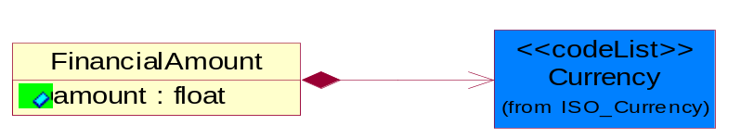
Figure 4-26 FinancialAmount

Attribute | Type | Documentation
amount | float | Specifies the monetary amount.

Composition | Cardinality | Type | Documentation
Currency | 1 | Currency | For representation of Currency codes RosettaNet has adopted ISO 4217; 1995. The British Standards Institution (BSI) is the ISO 4217 Maintenance Agency. Refer to the following web page to get the latest version of the standard:  http://www.bsi-global.com/Technical+Information/Publications/_Publications/tig90.xalter  If you need more information about the ISO standard please contact ISO for more details.

ProductPricing

The business document must contain the price of the product.

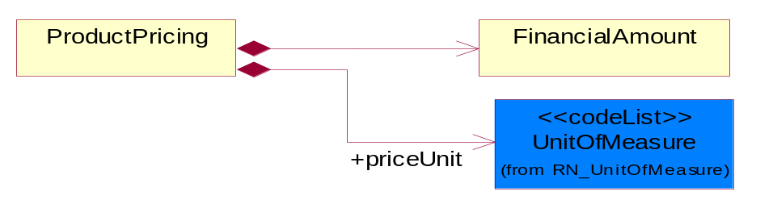
Figure 4-27 ProductPricing

Composition | Cardinality | Type | Documentation
FinancialAmount | 1 | FinancialAmount | The business document must express financial amounts.
priceUnit | 1 | UnitOfMeasure | Code identifying a product unit of measure.

TaxJurisdiction

The business document must identify the specific tax collection authority.

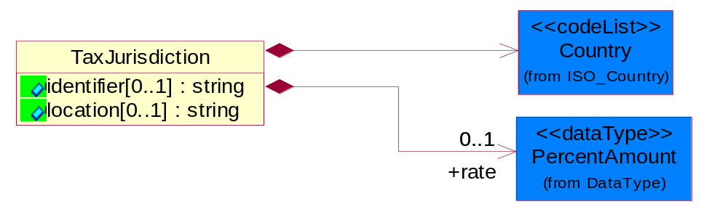
Figure 4-28 TaxJurisdiction

Attribute | Type | Documentation
identifier[0..1] | string | Unique identification for a taxing authority.
location[0..1] | string | Identification of the tax collection authority location.

Composition | Cardinality | Type | Documentation
rate | 0..1 | PercentAmount | A number representing a percentage value, e.g. 75.125 represents 75 1/8 percent.
Country | 1 | Country | For representation of Country name RosettaNet has adopted ISO 3166-3; 1999. Refer to the following web page to get the latest version of the standard:  http://www.iso.ch/iso/en/prods-services/iso3166ma/02iso-3166-code-lists/index.html  If you need more information about the ISO standard please contact ISO for more details.

PartnerIdentification

FullPartner

The business document must describe the trading partners in the business transaction. This data structure provide the flexibility to describe a partner in all possible methods as for new, existing or known partner.

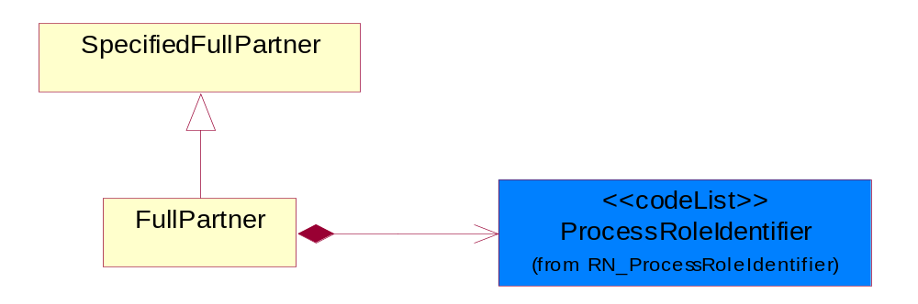
Figure 4-29 FullPartner

Composition | Cardinality | Type | Documentation
ProcessRoleIdentifier | 1 | ProcessRoleIdentifier | Describes the role of the partner in the business process. A partner will fulfill at least one or more roles during the business process.

IntermittentPartner

The business document must describe a physical address for a delivery.

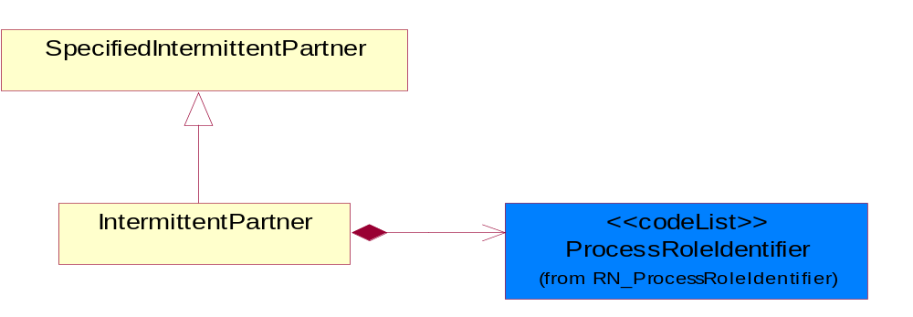
Figure 4-30 IntermittentPartner

Composition | Cardinality | Type | Documentation
ProcessRoleIdentifier | 1 | ProcessRoleIdentifier | Describes the role of the partner in the business process. A partner will fulfill at least one or more roles during the business process.

KnownPartner

The business document must describe the trading partners in the business transaction.

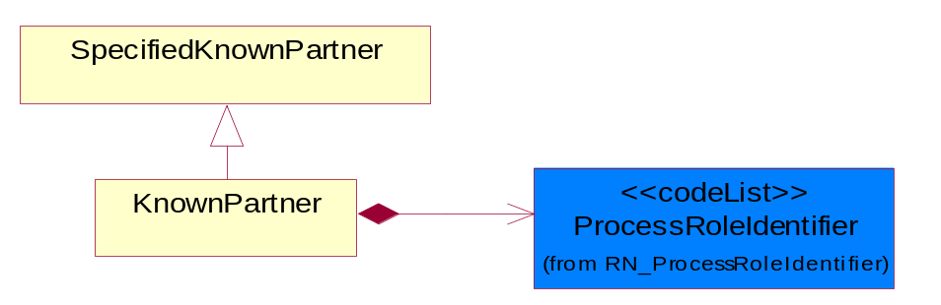
Figure 4-31 KnownPartner

Composition | Cardinality | Type | Documentation
ProcessRoleIdentifier | 1 | ProcessRoleIdentifier | Describes the role of the partner in the business process. A partner will fulfill at least one or more roles during the business process.

KnownPartnerContact

The business document must describe the trading partners in the business transaction.

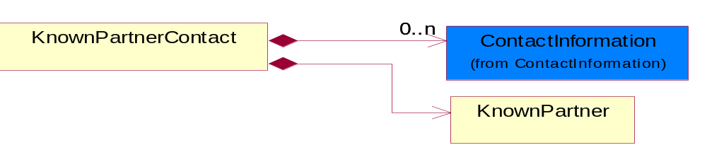
Figure 4-32 KnownPartnerContact

Composition | Cardinality | Type | Documentation
KnownPartner | 1 | KnownPartner | The business document must describe the trading partners in the business transaction.
ContactInformation | 0..n | ContactInformation | The business document must allow for the identification of the name of the department, service or individual to be contacted regarding the context of the business document.

NewPartner

The business document must describe a new, existing (but known to only one of the parties to the transaction) or an unknown party to the business transaction.

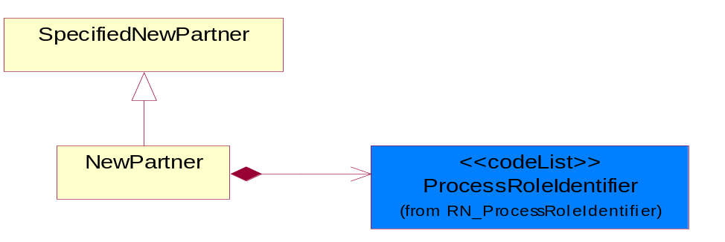
Figure 4-33 NewPartner

Composition | Cardinality | Type | Documentation
ProcessRoleIdentifier | 1 | ProcessRoleIdentifier | Describes the role of the partner in the business process. A partner will fulfill at least one or more roles during the business process.

PartnerDescription

The collection of business properties that describe a business partners' identity, their contact information, where they are physically located and their function in a supply chain.

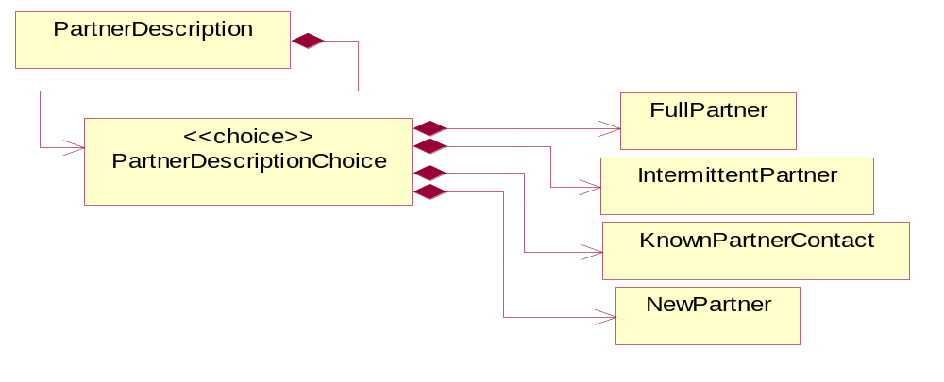
Figure 4-34 PartnerDescription

Composition | Cardinality | Type | Documentation
PartnerDescriptionChoice | 1 | PartnerDescriptionChoice

PartnerDescriptionChoice

Composition | Cardinality | Type | Documentation
KnownPartnerContact | 1 | KnownPartnerContact | The business document must describe the trading partners in the business transaction.
IntermittentPartner | 1 | IntermittentPartner | The business document must describe a physical address for a delivery.
NewPartner | 1 | NewPartner | The business document must describe a new, existing (but known to only one of the parties to the transaction) or an unknown party to the business transaction.
FullPartner | 1 | FullPartner | The business document must describe the trading partners in the business transaction. This data structure provide the flexibility to describe a partner in all possible methods as for new, existing or known partner.

PartnerIdentification

The business document must allow for the identity of one or more parties to the transaction.

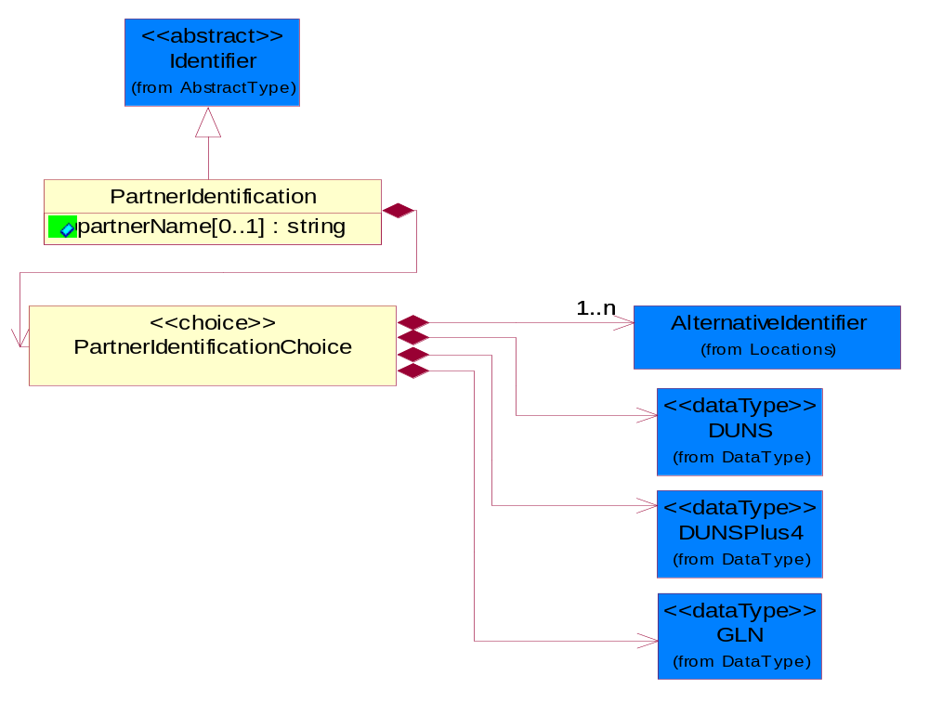
Figure 4-35 PartnerIdentification

Attribute | Type | Documentation
partnerName[0..1] | string | The name of the partner’s company/business.

Composition | Cardinality | Type | Documentation
PartnerIdentificationChoice | 1 | PartnerIdentificationChoice

PartnerIdentificationChoice

Composition | Cardinality | Type | Documentation
DUNS | 1 | DUNS | A number assigned by Dun and Bradstreet to identify a business location.
DUNSPlus4 | 1 | DUNSPlus4 | A identifier to specify a specific location within a business location.
AlternativeIdentifier | 1..n | AlternativeIdentifier | Identifies the specified code and the name of the organization that a code is utilized from.
GLN | 1 | GLN | Global Location Number (GLN) - A identifier to identify legal entities, trading parties and location.

SpecifiedFullPartner

The business document must describe the trading partners in the business transaction. This data structure provide the flexibility to describe a partner in all possible methods as for new, existing or known partner. This is specifically for partner who role has been specified.

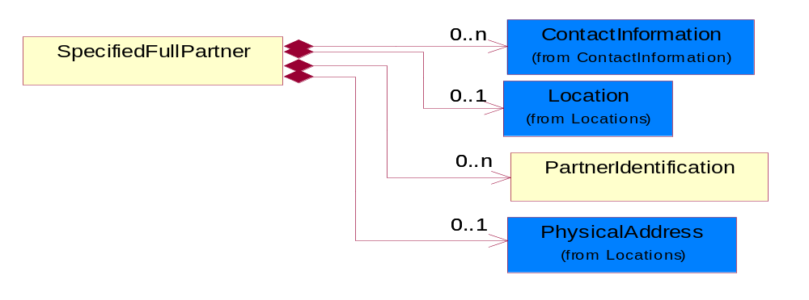
Figure 4-36 SpecifiedFullPartner

Composition | Cardinality | Type | Documentation
ContactInformation | 0..n | ContactInformation | The business document must allow for the identification of the name of the department, service or individual to be contacted regarding the context of the business document.
Location | 0..1 | Location | The business document must specify a location.
PartnerIdentification | 0..n | PartnerIdentification | The business document must allow for the identity of one or more parties to the transaction.
PhysicalAddress | 0..1 | PhysicalAddress | The business document must provide a physical address for a party to the business transaction.

SpecifiedIntermittentPartner

The business document must describe a physical address for a delivery.

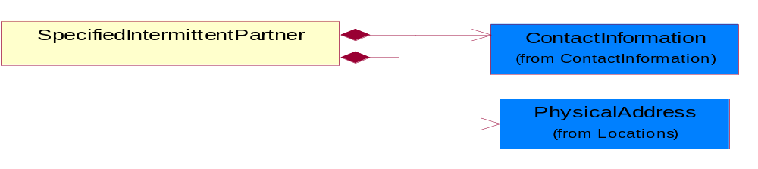
Figure 4-37 SpecifiedIntermittentPartner

Composition | Cardinality | Type | Documentation
ContactInformation | 1 | ContactInformation | The business document must allow for the identification of the name of the department, service or individual to be contacted regarding the context of the business document.
PhysicalAddress | 1 | PhysicalAddress | The business document must provide a physical address for a party to the business transaction.

SpecifiedKnownPartner

The business document must describe the trading partners in the business transaction.

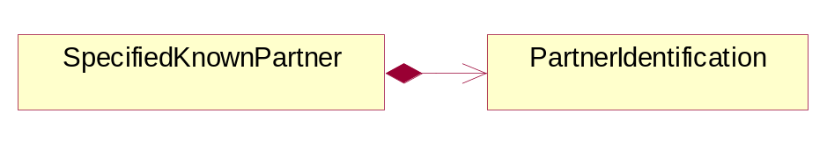
Figure 4-38 SpecifiedKnownPartner

Composition | Cardinality | Type | Documentation
PartnerIdentification | 1 | PartnerIdentification | The business document must allow for the identity of one or more parties to the transaction.

SpecifiedNewPartner

The business document must describe a new, existing (but known to only one of the parties to the transaction) or an unknown party to the business transaction.

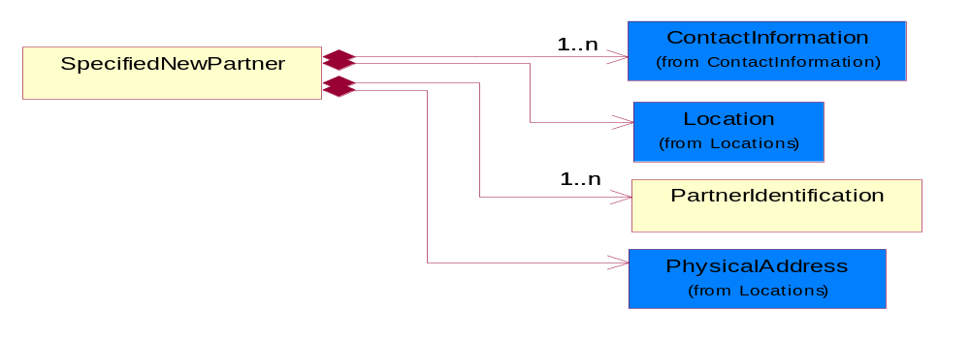
Figure 4-39 SpecifiedNewPartner

Composition | Cardinality | Type | Documentation
ContactInformation | 1..n | ContactInformation | The business document must allow for the identification of the name of the department, service or individual to be contacted regarding the context of the business document.
Location | 1 | Location | The business document must specify a location.
PhysicalAddress | 1 | PhysicalAddress | The business document must provide a physical address for a party to the business transaction.
PartnerIdentification | 1..n | PartnerIdentification | The business document must allow for the identity of one or more parties to the transaction.

CodeList

Country

For representation of Country name RosettaNet has adopted ISO 3166-3; 1999. Refer to the following web page to get the latest version of the standard:
http://www.iso.ch/iso/en/prods-services/iso3166ma/02iso-3166-code-lists/index.html

If you need more information about the ISO standard please contact ISO for more details.

CountrySubdivision

For representation of a Countries subdivisions RosettaNet has adopted ISO 3166-3; 1999. Refer to the following web page to get the latest version of the standard:
http://www.iso.ch/iso/en/prods-services/iso3166ma/02iso-3166-code-lists/index.html

If you need more information about the ISO standard please contact ISO for more details.

Currency

For representation of Currency codes RosettaNet has adopted ISO 4217; 1995. The British Standards Institution (BSI) is the ISO 4217 Maintenance Agency. Refer to the following web page to get the latest version of the standard:
http://www.bsi-global.com/Technical+Information/Publications/_Publications/tig90.xalter

If you need more information about the ISO standard please contact ISO for more details.

Language

For representation of Language name RosettaNet has adopted ISO 639-2; 1998. Refer to the following web page to get the latest version of the standard:

http://www.loc.gov/standards/iso639-2/iso639jac.html

If you need more information about the ISO standard please contact ISO for more details.

MimeTypeQualifier

The MIME type as defined by IANA.

Please refer to http://www.iana.org/assignments/media-types/ for a list of types.

Instance | Documentation
application/activemessage | [Shapiro]
application/andrew-inset | [Borenstein]
application/applefile | [Faltstrom]
application/atomicmail | [Borenstein]
application/batch-SMTP | [RFC2442]
application/beep+xml | [RFC3080]
application/cals-1840 | [RFC1895]
application/cnrp+xml | [RFCCNRP]
application/commonground | [Glazer]
application/cpl+xml
application/cybercash | [Eastlake]
application/dca-rft | [Campbell]
application/dec-dx | [Campbell]
application/dicom | [RFC3240]
application/dvcs | [RFC3029]
application/EDI-Consent | [RFC1767]
application/EDIFACT | [RFC1767]
application/EDI-X12 | [RFC1767]
application/eshop | [Katz]
application/font-tdpfr | [RFC3073]
application/http | [RFC2616]
application/hyperstudio | [Domino]
application/iges | [Parks]
application/index | [RFC2652]
application/index.cmd | [RFC2652]
application/index.obj | [RFC2652]
application/index.response | [RFC2652]
application/index.vnd | [RFC2652]
application/iotp | [RFC2935]
application/ipp | [RFC2910]
application/isup | [RFC3204]
application/mac-binhex40 | [Faltstrom]
application/macwriteii | [Lindner]
application/marc | [RFC2220]
application/mathematica | [Van Nostern]
application/msword | [Lindner]
application/news-message-id | [RFC1036,Spencer]
application/news-transmission | [RFC1036, Spencer]
application/ocsp-request | [RFC2560]
application/ocsp-response | [RFC2560]
application/octet-stream | [RFC2045,RFC2046]
application/oda | [RFC2045,RFC2046]
application/ogg | [RFC-walleij-ogg-mediatype-08.txt]
application/parityfec | [RFC3009]
application/pdf | [Lindner]
application/pgp-encrypted | [RFC3156]
application/pgp-keys | [RFC3156]
application/pgp-signature | [RFC3156]
application/pkcs10 | [RFC2311]
application/pkcs7-mime | [RFC2311]
application/pkcs7-signature | [RFC2311]
application/pkix-cert | [RFC2585]
application/pkixcmp | [RFC2510]
application/pkix-crl | [RFC2585]
application/postscript | [RFC2045,RFC2046]
application/prs.alvestrand.titrax-sheet | [Alvestrand]
application/prs.cww | [Rungchavalnont]
application/prs.nprend | [Doggett]
application/prs.plucker | [Janssen]
application/qsig | [RFC3204]
application/reginfo+xml | [RFC-ietf-sipping-reg-event-00.txt]
application/remote-printing | [RFC1486,Rose]
application/riscos | [Smith]
application/rtf | [Lindner]
application/sdp | [RFC2327]
application/set-payment | [Korver]
application/set-payment-initiation | [Korver]
application/set-registration | [Korver]
application/set-registration-initiation | [Korver]
application/sgml | [RFC1874]
application/sgml-open-catalog | [Grosso]
application/sieve | [RFC3028]
application/slate | [Crowley]
application/timestamp-query | [RFC3161]
application/timestamp-reply | [RFC3161]
application/tve-trigger | [Welsh]
application/vemmi | [RFC2122]
application/vnd.3gpp.pic-bw-large | [Meredith]
application/vnd.3gpp.pic-bw-small | [Meredith]
application/vnd.3gpp.pic-bw-var | [Meredith]
application/vnd.3gpp.sms | [Meredith]
application/vnd.3M.Post-it-Notes | [O'Brien]
application/vnd.accpac.simply.aso | [Leow]
application/vnd.accpac.simply.imp | [Leow]
application/vnd.acucobol | [Lubin]
application/vnd.acucorp | [Lubin]
application/vnd.adobe.xfdf | [Perelman]
application/vnd.aether.imp | [Moskowitz]
application/vnd.amiga.ami | [Blumberg]
application/vnd.anser-web-certificate-issue-initiation | [Mori]
application/vnd.anser-web-funds-transfer-initiation | [Mori]
application/vnd.audiograph | [Slusanschi]
application/vnd.blueice.multipass | [Holmstrom]
application/vnd.bmi | [Gotoh]
application/vnd.businessobjects | [Imoucha]
application/vnd.canon-cpdl | [Muto]
application/vnd.canon-lips | [Muto]
application/vnd.cinderella | [Kortenkamp]
application/vnd.claymore | [Simpson]
application/vnd.commerce-battelle | [Applebaum]
application/vnd.commonspace | [Chandhok]
application/vnd.contact.cmsg | [Patz]
application/vnd.cosmocaller | [Dellutri]
application/vnd.ctc-posml | [Kohlhepp]
application/vnd.cups-postscript | [Sweet]
application/vnd.cups-raster | [Sweet]
application/vnd.cups-raw | [Sweet]
application/vnd.curl | [Byrnes]
application/vnd.cybank | [Helmee]
application/vnd.data-vision.rdz | [Fields]
application/vnd.dna | [Searcy]
application/vnd.dpgraph | [Parker]
application/vnd.dreamfactory | [Appleton]
application/vnd.dxr | [Duffy]
application/vnd.ecdis-update | [Buettgenbach]
application/vnd.ecowin.chart | [Olsson]
application/vnd.ecowin.filerequest | [Olsson]
application/vnd.ecowin.fileupdate | [Olsson]
application/vnd.ecowin.series | [Olsson]
application/vnd.ecowin.seriesrequest | [Olsson]
application/vnd.ecowin.seriesupdate | [Olsson]
application/vnd.enliven | [Santinelli]
application/vnd.epson.esf | [Hoshina]
application/vnd.epson.msf | [Hoshina]
application/vnd.epson.quickanime | [Gu]
application/vnd.epson.salt | [Nagatomo]
application/vnd.epson.ssf | [Hoshina]
application/vnd.ericsson.quickcall | [Tidwell]
application/vnd.eudora.data | [Resnick]
application/vnd.fdf | [Zilles]
application/vnd.ffsns | [Holstage]
application/vnd.FloGraphIt | [Floersch]
application/vnd.framemaker | [Wexler]
application/vnd.fsc.weblaunch | [D.Smith]
application/vnd.fujitsu.oasys | [Togashi]
application/vnd.fujitsu.oasys2 | [Togashi]
application/vnd.fujitsu.oasys3 | [Okudaira]
application/vnd.fujitsu.oasysgp | [Sugimoto]
application/vnd.fujitsu.oasysprs | [Ogita]
application/vnd.fujixerox.ddd | [Onda]
application/vnd.fujixerox.docuworks | [Taguchi]
application/vnd.fujixerox.docuworks.binder | [Matsumoto]
application/vnd.fut-misnet | [Pruulmann]
application/vnd.grafeq | [Tupper]
application/vnd.groove-account | [Joseph]
application/vnd.groove-help | [Joseph]
application/vnd.groove-identity-message | [Joseph]
application/vnd.groove-injector | [Joseph]
application/vnd.groove-tool-message | [Joseph]
application/vnd.groove-tool-template | [Joseph]
application/vnd.groove-vcard | [Joseph]
application/vnd.hbci | [Hammann]
application/vnd.hhe.lesson-player | [Jones]
application/vnd.hp-HPGL | [Pentecost]
application/vnd.hp-hpid | [Gupta]
application/vnd.hp-hps | [Aubrey]
application/vnd.hp-PCL | [Pentecost]
application/vnd.hp-PCLXL | [Pentecost]
application/vnd.httphone | [Lefevre]
application/vnd.hzn-3d-crossword | [Minnis]
application/vnd.ibm.afplinedata | [Buis]
application/vnd.ibm.electronic-media | [Tantlinger]
application/vnd.ibm.MiniPay | [Herzberg]
application/vnd.ibm.modcap | [Hohensee]
application/vnd.ibm.secure-container | [Tantlinger]
application/vnd.informix-visionary | [Gales]
application/vnd.intercon.formnet | [Gurak]
application/vnd.intertrust.digibox | [Tomasello]
application/vnd.intertrust.nncp | [Tomasello]
application/vnd.intu.qbo | [Scratchley]
application/vnd.intu.qfx | [Scratchley]
application/vnd.irepository.package+xml | [Knowles]
application/vnd.is-xpr | [Natarajan]
application/vnd.japannet-directory-service | [Fujii]
application/vnd.japannet-jpnstore-wakeup | [Yoshitake]
application/vnd.japannet-payment-wakeup | [Fujii]
application/vnd.japannet-registration | [Yoshitake]
application/vnd.japannet-registration-wakeup | [Fujii]
application/vnd.japannet-setstore-wakeup | [Yoshitake]
application/vnd.japannet-verification | [Yoshitake]
application/vnd.japannet-verification-wakeup | [Fujii]
application/vnd.jisp | [Deckers]
application/vnd.kde.karbon | [Faure]
application/vnd.kde.kchart | [Faure]
application/vnd.kde.kformula | [Faure]
application/vnd.kde.kivio | [Faure]
application/vnd.kde.kontour | [Faure]
application/vnd.kde.kpresenter | [Faure]
application/vnd.kde.kspread | [Faure]
application/vnd.kde.kword | [Faure]
application/vnd.kenameaapp | [DiGiorgio-Haag]
application/vnd.koan | [Cole]
application/vnd.liberty-request+xml | [McDowell]
application/vnd.llamagraphics.life-balance.desktop | [White]
application/vnd.lotus-1-2-3 | [Wattenberger]
application/vnd.lotus-approach | [Wattenberger]
application/vnd.lotus-freelance | [Wattenberger]
application/vnd.lotus-notes | [Laramie]
application/vnd.lotus-organizer | [Wattenberger]
application/vnd.lotus-screencam | [Wattenberger]
application/vnd.lotus-wordpro | [Wattenberger]
application/vnd.mcd | [Gotoh]
application/vnd.mediastation.cdkey | [Flurry]
application/vnd.meridian-slingshot | [Wedel]
application/vnd.micrografx.flo | [Prevo]
application/vnd.micrografx.igx | [Prevo]
application/vnd.mif | [Wexler]
application/vnd.minisoft-hp3000-save | [Bartram]
application/vnd.mitsubishi.misty-guard.trustweb | [Tanaka]
application/vnd.Mobius.DAF | [Kabayama]
application/vnd.Mobius.DIS | [Kabayama]
application/vnd.Mobius.MBK | [Devasia]
application/vnd.Mobius.MQY | [Devasia]
application/vnd.Mobius.MSL | [Kabayama]
application/vnd.Mobius.PLC | [Kabayama]
application/vnd.Mobius.TXF | [Kabayama]
application/vnd.mophun.application | [Wennerstrom]
application/vnd.mophun.certificate | [Wennerstrom]
application/vnd.motorola.flexsuite | [Patton]
application/vnd.motorola.flexsuite.adsi | [Patton]
application/vnd.motorola.flexsuite.fis | [Patton]
application/vnd.motorola.flexsuite.gotap | [Patton]
application/vnd.motorola.flexsuite.kmr | [Patton]
application/vnd.motorola.flexsuite.ttc | [Patton]
application/vnd.motorola.flexsuite.wem | [Patton]
application/vnd.mozilla.xul+xml | [McDaniel]
application/vnd.ms-artgalry | [Slawson]
application/vnd.ms-asf | [Fleischman]
application/vnd.mseq | [Le Bodic]
application/vnd.ms-excel | [Gill]
application/vnd.msign | [Borcherding]
application/vnd.ms-lrm | [Ledoux]
application/vnd.ms-powerpoint | [Gill]
application/vnd.ms-project | [Gill]
application/vnd.ms-tnef | [Gill]
application/vnd.ms-works | [Gill]
application/vnd.ms-wpl | [Plastina]
application/vnd.musician | [Adams]
application/vnd.music-niff | [Butler]
application/vnd.netfpx | [Mutz]
application/vnd.noblenet-directory | [Solomon]
application/vnd.noblenet-sealer | [Solomon]
application/vnd.noblenet-web | [Solomon]
application/vnd.novadigm.EDM | [Swenson]
application/vnd.novadigm.EDX | [Swenson]
application/vnd.novadigm.EXT | [Swenson]
application/vnd.obn | [Hessling]
application/vnd.osa.netdeploy | [Klos]
application/vnd.palm | [Peacock]
application/vnd.pg.format | [Gandert]
application/vnd.pg.osasli | [Gandert]
application/vnd.powerbuilder6 | [Guy]
application/vnd.powerbuilder6-s | [Guy]
application/vnd.powerbuilder7 | [Shilts]
application/vnd.powerbuilder75 | [Shilts]
application/vnd.powerbuilder75-s | [Shilts]
application/vnd.powerbuilder7-s | [Shilts]
application/vnd.previewsystems.box | [Smolgovsky]
application/vnd.publishare-delta-tree | [Ben-Kiki]
application/vnd.pvi.ptid1 | [Lamb]
application/vnd.pwg-multiplexed | [RFC3391]
application/vnd.pwg-xhtml-print+xml | [Wright]
application/vnd.Quark.QuarkXPress | [Scheidler]
application/vnd.rapid | [Szekely]
application/vnd.s3sms | [Tarkkala]
application/vnd.sealed.net | [Lambert]
application/vnd.seemail | [Webb]
application/vnd.shana.informed.formdata | [Selzler]
application/vnd.shana.informed.formtemplate | [Selzler]
application/vnd.shana.informed.interchange | [Selzler]
application/vnd.shana.informed.package | [Selzler]
application/vnd.smaf | [Takahashi]
application/vnd.sss-cod | [Dani]
application/vnd.sss-dtf | [Bruno]
application/vnd.sss-ntf | [Bruno]
application/vnd.street-stream | [Levitt]
application/vnd.svd | [Becker]
application/vnd.swiftview-ics | [Widener]
application/vnd.triscape.mxs | [Simonoff]
application/vnd.trueapp | [Hepler]
application/vnd.truedoc | [Chase]
application/vnd.ufdl | [Manning]
application/vnd.uplanet.alert | [Martin]
application/vnd.uplanet.alert-wbxml | [Martin]
application/vnd.uplanet.bearer-choice | [Martin]
application/vnd.uplanet.bearer-choice-wbxml | [Martin]
application/vnd.uplanet.cacheop | [Martin]
application/vnd.uplanet.cacheop-wbxml | [Martin]
application/vnd.uplanet.channel | [Martin]
application/vnd.uplanet.channel-wbxml | [Martin]
application/vnd.uplanet.list | [Martin]
application/vnd.uplanet.listcmd | [Martin]
application/vnd.uplanet.listcmd-wbxml | [Martin]
application/vnd.uplanet.list-wbxml | [Martin]
application/vnd.uplanet.signal | [Martin]
application/vnd.vcx | [T.Sugimoto]
application/vnd.vectorworks | [Pharr]
application/vnd.vidsoft.vidconference | [Hess]
application/vnd.visio | [Sandal]
application/vnd.visionary | [Aravindakumar]
application/vnd.vividence.scriptfile | [Risher]
application/vnd.vsf | [Rowe]
application/vnd.wap.sic | [WAP-Forum]
application/vnd.wap.slc | [WAP-Forum]
application/vnd.wap.wbxml | [Stark]
application/vnd.wap.wmlc | [Stark]
application/vnd.wap.wmlscriptc | [Stark]
application/vnd.webturbo | [Rehem]
application/vnd.wrq-hp3000-labelled | [Bartram]
application/vnd.wt.stf | [Wohler]
application/vnd.wv.csp+wbxml | [Salmi]
application/vnd.xara | [Matthewman]
application/vnd.xfdl | [Manning]
application/vnd.yellowriver-custom-menu | [Yellow]
application/whoispp-query | [RFC2957]
application/whoispp-response | [RFC2958]
application/wita | [Campbell]
application/wordperfect5.1 | [Lindner]
application/x400-bp | [RFC1494]
application/xhtml+xml | [RFC3236]
application/xml | [RFC3023]
application/xml-dtd | [RFC3023]
application/xml-external-parsed-entity | [RFC3023]
application/zip | [Lindner]
audio/32kadpcm | [RFC2421,RFC2422]
audio/AMR | [RFC3267]
audio/AMR-WB | [RFC3267]
audio/basic | [RFC2045,RFC2046]
audio/CN | [RFC3389]
audio/DAT12 | [RFC3190]
audio/DVI4
audio/EVRC | [RFC-ietf-avt-evrc-smv-03.txt]
audio/EVRC0 | [RFC-ietf-avt-evrc-smv-03.txt]
audio/G.722.1 | [RFC3047]
audio/G722
audio/G723
audio/G726-16
audio/G726-24
audio/G726-32
audio/G726-40
audio/G728
audio/G729
audio/G729D
audio/G729E
audio/GSM
audio/GSM-EFR
audio/L16 | [RFC2586]
audio/L20 | [RFC3190]
audio/L24 | [RFC3190]
audio/L8
audio/LPC
audio/MP4A-LATM | [RFC3016]
audio/MPA
audio/mpa-robust | [RFC3119]
audio/mpeg | [RFC3003]
audio/parityfec | [RFC3009]
audio/PCMA
audio/PCMU
audio/prs.sid | [Walleij]
audio/QCELP
audio/RED
audio/SMV | [RFC-ietf-avt-evrc-smv-03.txt]
audio/SMV0 | [RFC-ietf-avt-evrc-smv-03.txt]
audio/telephone-event | [RFC2833]
audio/tone | [RFC2833]
audio/VDVI
audio/vnd.3gpp.iufp | [Belling]
audio/vnd.cisco.nse | [Kumar]
audio/vnd.cns.anp1 | [McLaughlin]
audio/vnd.cns.inf1 | [McLaughlin]
audio/vnd.digital-winds | [Strazds]
audio/vnd.everad.plj | [Cicelsky]
audio/vnd.lucent.voice | [Vaudreuil]
audio/vnd.nortel.vbk | [Parsons]
audio/vnd.nuera.ecelp4800 | [Fox]
audio/vnd.nuera.ecelp7470 | [Fox]
audio/vnd.nuera.ecelp9600 | [Fox]
audio/vnd.octel.sbc | [Vaudreuil]
audio/vnd.qcelp | [Lundblade]
audio/vnd.rhetorex.32kadpcm | [Vaudreuil]
audio/vnd.vmx.cvsd | [Vaudreuil]
image/cgm | Computer Graphics Metafile
image/g3fax | [RFC1494]
image/gif | [RFC2045,RFC2046]
image/ief | [RFC1314] Image Exchange Format
image/jpeg | [RFC2045,RFC2046]
image/naplps | [Ferber]
image/png | [Randers-Pehrson]
image/prs.btif | [Simon]
image/prs.pti | [Laun]
image/t38 | [RFC3362]
image/tiff | [RFC3302] Tag Image File Format
image/tiff-fx | [RFC3250] Tag Image File Format Fax eXtended
image/vnd.cns.inf2 | [McLaughlin]
image/vnd.djvu | [Bottou]
image/vnd.dwg | [Moline]
image/vnd.dxf | [Moline]
image/vnd.fastbidsheet | [Becker]
image/vnd.fpx | [Spencer]
image/vnd.fst | [Fuldseth]
image/vnd.fujixerox.edmics-mmr | [Onda]
image/vnd.fujixerox.edmics-rlc | [Onda]
image/vnd.globalgraphics.pgb | [Bailey]
image/vnd.mix | [Reddy]
image/vnd.ms-modi | [Vaughan]
image/vnd.net-fpx | [Spencer]
image/vnd.svf | [Moline]
image/vnd.wap.wbmp | [Stark]
image/vnd.xiff | [S.Martin]
message/delivery-status | [RFC1894]
message/disposition-notification | [RFC2298]
message/external-body | [RFC2045,RFC2046]
message/http | [RFC2616]
message/news | [RFC 1036, H.Spencer]
message/partial | [RFC2045,RFC2046]
message/rfc822 | [RFC2045,RFC2046]
message/s-http | [RFC2660]
message/sip | [RFC3261]
message/sipfrag | [RFC3420]
model/iges | [Parks]
model/mesh | [RFC2077]
model/vnd.dwf | [Pratt]
model/vnd.flatland.3dml | [Powers]
model/vnd.gdl | [Babits]
model/vnd.gs-gdl | [Babits]
model/vnd.gtw | [Ozaki]
model/vnd.mts | [Rabinovitch]
model/vnd.parasolid.transmit.binary | [Parasolid]
model/vnd.parasolid.transmit.text | [Parasolid]
model/vnd.vtu | [Rabinovitch]
model/vrml | [RFC2077]
multipart/alternative | [RFC2045,RFC2046]
multipart/appledouble | [Faltstrom]
multipart/byteranges | [RFC2068]
multipart/digest | [RFC2045,RFC2046]
multipart/encrypted | [RFC1847]
multipart/form-data | [RFC2388]
multipart/header-set | [Crocker]
multipart/mixed | [RFC2045,RFC2046]
multipart/parallel | [RFC2045,RFC2046]
multipart/related | [RFC2387]
multipart/report | [RFC1892]
multipart/signed | [RFC1847]
multipart/voice-message | [RFC2421,RFC2423]
text/calendar | [RFC2445]
text/css | [RFC2318]
text/directory | [RFC2425]
text/enriched | [RFC1896]
text/html | [RFC2854]
text/parityfec | [RFC3009]
text/plain | [RFC2646,RFC2046]
text/prs.lines.tag | [Lines]
text/rfc822-headers | [RFC1892]
text/richtext | [RFC2045,RFC2046]
text/rtf | [Lindner]
text/sgml | [RFC1874]
text/t140 | [RFC2793]
text/tab-separated-values | [Lindner]
text/uri-list | [RFC2483]
text/vnd.abc | [Allen]
text/vnd.curl | [Byrnes]
text/vnd.DMClientScript | [Bradley]
text/vnd.fly | [Gurney]
text/vnd.fmi.flexstor | [Hurtta]
text/vnd.in3d.3dml | [Powers]
text/vnd.in3d.spot | [Powers]
text/vnd.IPTC.NewsML | [IPTC]
text/vnd.IPTC.NITF | [IPTC]
text/vnd.latex-z | [Lubos]
text/vnd.motorola.reflex | [Patton]
text/vnd.ms-mediapackage | [Nelson]
text/vnd.net2phone.commcenter.command | [Xie]
text/vnd.sun.j2me.app-descriptor | [G.Adams]
text/vnd.wap.si | [WAP-Forum]
text/vnd.wap.sl | [WAP-Forum]
text/vnd.wap.wml | [Stark]
text/vnd.wap.wmlscript | [Stark]
text/xml | [RFC3023]
text/xml-external-parsed-entity | [RFC3023]
video/BMPEG
video/BT656
video/CelB
video/DV | [RFC3189]
video/H261
video/H263
video/H263-1998
video/H263-2000
video/JPEG
video/MP1S
video/MP2P
video/MP2T
video/MP4V-ES | [RFC3016]
video/mpeg | [RFC2045,RFC2046]
video/MPV
video/nv
video/parityfec | [RFC3009]
video/pointer | [RFC2862]
video/quicktime | [Lindner]
video/SMPTE292M | [RFC-avt-smpte292-video-08.txt]
video/vnd.fvt | [Fuldseth]
video/vnd.motorola.video | [McGinty]
video/vnd.motorola.videop | [McGinty]
video/vnd.mpegurl | [Recktenwald]
video/vnd.nokia.interleaved-multimedia | [Kangaslampi]
video/vnd.objectvideo | [Clark]
video/vnd.vivo | [Wolfe]

UnitOfMeasure

Code identifying a product unit of measure.

Instance | Documentation
1BF | 100 Board Feet.
1FC | 20 Foot Container.
1GR | Gram/Cubic Centimeter.
1GT | 10,000 Gallon Tankcar.
1KB | 25 Kilogram Bulk Bag.
1KD | 10 Kilogram Drum.
1PA | 20-Pack.
1PB | 50 Pound Bag.
1PD | 100 Pound Drum.
2FC | 40 Foot Container.
2GR | Gram/square meter.
2GT | 20,000 Gallon Tankcar.
2KB | 300 Kilogram Bulk Bag.
2KD | 15 Kilogram Drum.
2PA | 100-Pack.
3GR | Grams Per 100 Centimeters.
3KB | 500 Kilogram Bulk Bag.
3KD | 55 Gallon Drum.
4GR | Grams Per 100 Grams.
4KD | 115 Kilogram Drum.
5GR | Grams Per Cubic Centimeter.
6GR | Grams Per Square Centimeter.
7GR | Grams Per Square Meter.
ACR | Acre.
ACT | Actual Pounds.
ALU | Aluminum Pounds Only.
AMP | Ampere.
BAB | Base Box.
BAC | Batch.
BAE | Bale.
BAG | Bag.
BAL | Ball.
BAN | Band.
BAP | Batting Pound.
BAR | Bar.
BAS | Basket.
BAT | Batt.
BAW | Base Weight.
BEA | Beam.
BEC | Becquerel/kilogram.
BEL | Belt.
BIL | Billet.
BIN | Bin.
BKC | Bulk Car Load.
BLO | Block.
BOA | Board.
BOF | Board Feet.
BOL | Bolt.
BOT | Bottle.
BOX | Box.
BRD | Barrels Per Day.
BRE | Barrel.
BRI | Barrel (Imperial).
BRM | Barrels Per Minute.
BTF | British Thermal Units (BTUs) Per Cubic Foot.
BTP | British Thermal Units (BTUs) Per Pound.
BTU | British Thermal Unit (BTU).
BUC | Bucket.
BUD | Bushel, Dry Imperial.
BUK | Bunks.
BUL | Bulk.
BUN | Bundle.
BUP | Bulk Pack.
BUS | Bushel.
CAA | Carat.
CAB | Carboy.
CAC | Card.
CAD | Candela.
CAG | Cartridge.
CAK | Cask.
CAL | Calorie.
CAN | Can.
CAO | Carload.
CAR | Car.
CAS | Case.
CAT | Canister.
CAW | Catchweight.
CEL | Cell.
CEM | Centimeter.
CEP | Centipoise (CPS).
CET | Centiliter.
CHA | Chains (Land Survey).
CHE | Chest.
CNN | Connector.
COG | Coil Group.
COI | Coil.
COL | Coulomb.
COM | Composite Product Pounds (Total Weight).
CON | Cone.
COT | Container.
COV | Cover.
CRA | Crate.
CRT | Carton.
CSE | Cassette.
CUB | Cubic centimeter.
CUC | Cubic centimeter/second.
CUF | Cubic Foot.
CUI | Cubic inch.
CUM | Cubicmeter.
CUP | Cup.
CUY | Cubic yard.
CYC | Cycles.
CYL | Cylinder.
DAY | Day.
DEA | Deal.
DEC | Decimeter.
DEF | Degree Fahrenheit.
DEG | Degree Celsius.
DEP | Dep. Factor.
DIE | Die.
DIL | Display.
DIP | Dispenser.
DOZ | Dozen.
DRA | Dram.
DRU | Drum.
DRY | Dry Pounds.
EAC | Each.
ELE | Electrical Capacitance.
FAR | Farads.
FFA | Femtofarad.
FLO | Fluid Ounce.
FOI | Fluid Ounce (Imperial).
FOO | Foot.
FOU | Fluid Ounce US.
FUU | Fuel Usage (Gallons).
GAL | Gallon.
GAS | Gage Systems.
GIH | Gigahertz.
GIJ | Gigajoules.
GIL | Gill (Imperial).
GOB | Gross Barrels.
GOG | Gross Gallons.
GOK | Gross Kilogram.
GOT | Gross Ton.
GOY | Gross Yard.
GRA | Gram.
GRG | Great Gross (Dozen Gross).
GRK | Grams Per Kilogram.
GRL | Grams Per Liter.
GRM | Grams Per Milliliter.
GRN | Grain.
GRO | Gross.
GRP | Group.
HAG | Half Gallon.
HAH | Half Hour.
HAL | Half Liter.
HAN | Hank.
HEA | Heat lots.
HEC | Hectare.
HEL | Hectoliter.
HEP | Hectopascal.
HER | Hertz.
HOS | Hours.
HOU | Hour.
HUA | Hundredth of a Carat.
HUB | Hundred Boxes.
HUC | Hundred Count.
HUS | Hundred Sheets.
IMG | Imperial Gallons.
INC | Inch.
JAR | Jar.
JOI | Joint.
JOU | Joule.
KEG | Keg.
KEL | Kelvin.
KHO | Kilometer/hour.
KIC | Kilogram per cubic meter.
KIE | Kilometer.
KIG | Kilogram.
KIH | Kilohertz.
KIK | Kilobecquerel/Kilogram.
KIL | Kiloampere.
KIM | Kilogram/square meter.
KIO | Kiloohm.
KIS | Kilogramm pro Sekunde.
KIT | Kit.
KIV | Kilovolt.
KIW | Kilowatt.
KKG | Kilogram/Kilogram.
KUD | Kubikdezimeter.
KUM | Kubikmeter pro Sekunde.
KWH | Kilowatt-hour.
LIF | Lifts.
LIM | Link.
LIQ | Liquid Pounds.
LIT | Liter.
LOA | Load.
LOT | Lot.
LUG | Lug.
MAM | Milliamps/mm.
MAT | Mat.
MCM | Milligrams Per Cubic Meter.
MCR | Micron.
MEG | Megagram.
MEH | Megahertz.
MEP | Megapascal.
MET | Meter.
MEW | Megawatt.
MIB | Million BTU's.
MIC | Mikrogram/cubic meter.
MIG | Micrograms Per Cubic Meter.
MIL | Mile.
MIM | Micrometer.
MIN | Minute.
MIP | Millipascal seconds.
MIS | Microsecond.
MIT | Miter.
MIV | Millivolt.
MIW | Milliwatt.
MJO | Millijoule.
MLA | Milliampere.
MLB | Millibar.
MLC | Milligram/cubic meter.
MLI | Milliliter.
MLK | Milligram/kilogram.
MLL | Milligram/Liter.
MME | Millimeter.
MMH | Millimeter H20.
MMK | Millimol/kilogram.
MMO | Millimol.
MOK | Mol/kilogram.
MOL | Mol.
MON | Month.
MPH | Megagrams Per Hour.
MSC | Millisecond.
MSM | Milligrams Per Square Meter.
MTA | Millitesla.
MTQ | Meter pro Quadratsekunde.
MTS | Meters per second.
MUL | Multichip - When 2 or more dies (chips) are merged into one package.
NAA | Nanoamps.
NAM | Nanometer.
NAS | Nanosecond.
NEB | Net Barrels.
NEG | Net Gallons.
NEI | Net Imperial Gallons.
NEL | Net Liters.
NEW | Newton.
OCT | Ohm/ct.
OHM | Ohm.
OMM | Ohm/mm.
ONE | One.
OSQ | Ohm/sq.
OTP | One Thousand Pieces.
OUN | Ounce.
OVI | Ohm/via.
PAC | Parcel.
PAD | Pad.
PAG | Package.
PAI | Pail.
PAK | Pack (PAK).
PAL | Pallet.
PAN | Panel.
PAR | Pair.
PAS | Pascal.
PAT | Packet.
PEC | Percent.
PEG | Percentage.
PEH | Percent Per 1000 Hours.
PEN | Pennyweight.
PER | Per Hundred Pieces.
PEW | Percent Weight.
PID | Pint U.S. Dry.
PIE | Piece.
PIL | Pint - US liquid.
PLA | Plate.
PLL | Pallet (Lift).
PLT | Pallete.
PLU | Pallet/Unit Load.
POF | Pounds Per Foot.
POG | Pounds Per Gallon.
PON | Pound.
POP | Pounds Per Piece of Product.
POS | Pounds Per 1000 Square Feet.
POT | Pounds Per Thousand.
PPB | Parts per billion (US).
PPM | Parts per million.
PPP | Pounds Per Pound of Product.
PSC | Picosecond.
PSS | Pascal second.
QUA | Quart - US liquid.
RAC | Rack.
REA | Ream of 500 Sheets.
REE | Reel.
RIN | Ring.
ROD | Rod.
ROL | Roll.
SAC | Sack.
SBB | Super Bulk Bag.
SEC | Second.
SET | Set.
SHE | Sheet.
SHI | Shipment.
SHM | Sheet - Metric measure.
SHO | Shot.
SID | Disk (Disc).
SKE | Skein.
SKI | Skid.
SLE | Sleeve.
SLI | Slip Sheet.
SMI | Square mile.
SMM | Square millimeter.
SPO | Spool.
SQF | Square foot.
SQI | Square inch.
SQK | Square kilometer.
SQM | Square meter.
SQS | Square meter/second.
SQU | Square.
SQY | Square Yard.
STI | Stick.
STM | Statute Mile.
STR | Strip.
TAB | Tablet.
TAN | Tank.
TAT | Tank Truck.
TES | Tesla.
THO | Thousand.
TNN | Tonne.
TON | Ton.
TOR | Torr.
TOT | Tote.
TRA | Train.
TRF | Track Foot.
TRL | Trailer.
TRO | Troy.
TRU | Truckload.
TRY | Tray.
TRZ | Troy OZ.
TUB | Tube.
ULU | Unitless Unit of Measure.
USG | US gallon.
USP | US pound.
UST | US ton.
VIA | Vial.
VOL | Volt.
WAF | Wafer.
WAR | Watt.
WEE | Week.
WRA | Wrap.
YAR | Yard.
YEA | Year.

ProcessRoleIdentifier

Describes the role of the partner in the business process. A partner will fulfill at least one or more roles during the business process.

Instance | Documentation
ADM | Administered by - The party who is the administrative authority of an account.
ALT | Alternate approval by - The party who has approved a request in the event the approver is not able to respond.
APP | Approval by - The party who has approved a request.
BIF | Bill from - The party that will issue the invoice.
BIT | Bill to - The party that will pay the invoice.
CNC | Cancellation party - The party who is cancelling the shipping order.
COR | Change originated by - The party who originates a proposed change.
COW | Change owned by - The party who owns or who is assigned responsibility for a proposed change.
CRA | Credit applicant - The party who is applying for credit.
CRE | Created by - The party responsible for creating a process or task.
DIS | Distributed by - The party who supplies products to retailers.
FIN | Financed by - The party who is the financier.
FOR | Forwarded to - The party to whom a business document has been forwarded.
INL | Inventory location - The party where the inventory product entry is located.
INO | Inventory owner - The party that owns the inventory product entry.
ITF | In transit from - The party sending the product quantity in a product location transfer.
ITT | In transit to - The party receiving the product quantity in a product location transfer.
MFG | Manufactured by - The party who creates, processes or produces goods especially in large quantities and by means of industrial machines.
OWN | Owned by - The party who owns a process.
PUR | Purchased by - The party who is a purchaser of a product.
REA | Requested approval by - The party who has been selected to approve a request.
REC | Received by - The party who has received a product shipment.
REQ | Requested by - The party who has initiated a request.
RES | Respond to - The party to whom a responding business document must be sent when it is not equal to the partner specified in the document header.
RET | Return by - The party responsible for either carrying or forwarding the returned product.
REV | Reviewed by - The party responsible for reviewing a business document.
SBF | Self-billing from - The party who initiates the billing in self-billing scenario.
SBT | Self-billing to - The party whom the invoice is addressed to.
SCP | Shipping charges paid by - The party responsible for administering payment of the shipping charges.
SHF | Ship From - The collection of business properties used to identify the business partner initiating a shipment or transaction.
SHT | Ship To - The partner and/or location to which the product must be delivered.
SLD | Sold to - The party to whom a product has been sold.
SOB | Sold By - The seller involved in a business transaction.
SPL | Supplied by - The party who supplies an item, part or assembly.
SRT | Submit returns to - The party to whom product returns are to be submitted.
TRA | Transported by - The party responsible for either carrying or forwarding the product.
ULR | Ultimate recipient - The party who ultimately receives the shipment, when an intermediate party takes responsibility for payment and final delivery.
USE | Used by - The party who is the end user of the product.

System Structure

BusinessProcessIdentifier

A Business Process Identifier to uniquely define the TPIR-PIP 'role' within a Business Scenario at a company or MNC level. The identifier MUST be composed of alphanumeric characters only and its length MUST be between one and twelve characters.

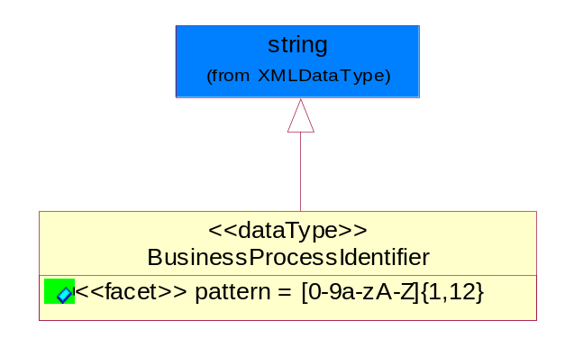
Figure 5-40 BusinessProcessIdentifier

Attribute | Type | Documentation
pattern |  | [0-9a-zA-Z]{1,12}

BusinessServiceInformation

The object allows the specification of the business service utilized within the partner company. This may or may not be the same as the information sent by the RNIF.

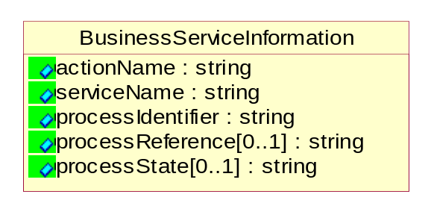
Figure 5-41 BusinessServiceInformation

Attribute | Type | Documentation
actionName | string | The name of Action. For RosettaNet usually any of Request/Confirm/Notify/Query/Response.
serviceName | string | The name of the Business Activity with the "Request/Confirm" part removed. E.g., for the Activity "Request Purchase Order"==> "Purchase Order".
processIdentifier | string | The name of the PIP e.g. Notify of Forecast Reply.
processReference[0..1] | string | The URN for the PIP that includes Cluster/Segment/Process pattern used to identify the interface process (such as PIP3A4)
processState[0..1] | string | The business process (or service) state of the sender of a document. When a service receives this document, the receiver may use the state as a precondition.

ContractInformation

A block of information used to correlate a contract in an executing choreography.

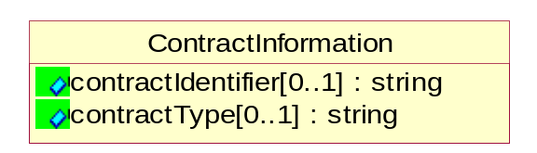
Figure 5-42 ContractInformation

Attribute | Type | Documentation
contractIdentifier[0..1] | string | Unique identification of a contract between the Sender and the Receiver
contractType[0..1] | string | The type of the contract: an attribute describing the type of the ContractIndentification. Valid values are URI, URN,ebXMLCPA, or other values defined by partners.

CorrelationInformation

A block of information used to correlate a requesting document to a responding document and to the contract in an executing choreography.

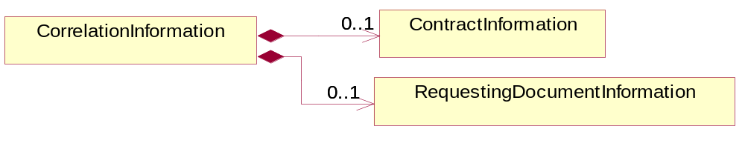
Figure 5-43 CorrelationInformation

Composition | Cardinality | Type | Documentation
ContractInformation | 0..1 | ContractInformation | A block of information used to correlate a contract in an executing choreography.
RequestingDocumentInformation | 0..1 | RequestingDocumentInformation | A block of information used to correlate a requesting document to a responding document in an executing choreography.

DocumentHeader

The object allows for the identification of the sender and receiver of the business document.

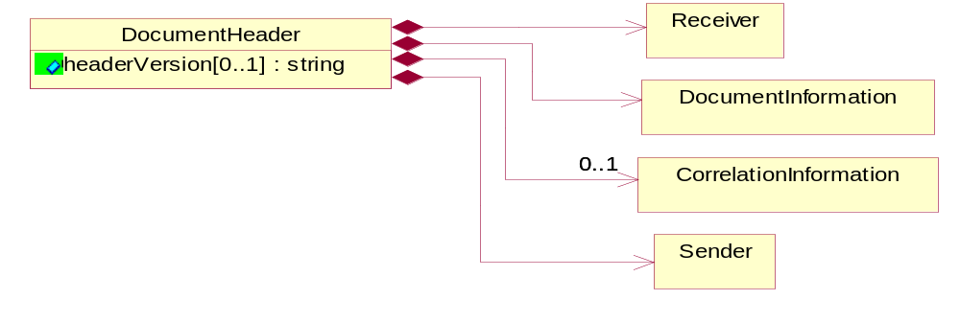
Figure 5-44 DocumentHeader

Attribute | Type | Documentation
headerVersion[0..1] | string | The UN/CEFACT version of the document header.

Composition | Cardinality | Type | Documentation
Sender | 1 | Sender | The object allows the identification of the initiating party of the business message.
CorrelationInformation | 0..1 | CorrelationInformation | A block of information used to correlate a requesting document to a responding document and to the contract in an executing choreography.
DocumentInformation | 1 | DocumentInformation | The object specifies information to identify the business document, a summary of attachments, and information about the business document security.
Receiver | 1 | Receiver | The object allows the identification of the receiving party of the business message.

DocumentIdentification

The object specifies all information necessary to identify the business document.

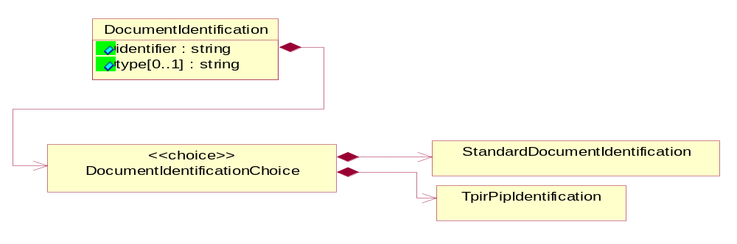
Figure 5-45 DocumentIdentification

Attribute | Type | Documentation
identifier | string | The unique identifier for the document being sent.
type[0..1] | string | Name of the Action Message

Composition | Cardinality | Type | Documentation
DocumentIdentificationChoice | 1 | DocumentIdentificationChoice

DocumentIdentificationChoice

Composition | Cardinality | Type | Documentation
StandardDocumentIdentification | 1 | StandardDocumentIdentification | The object specifies additional information necessary to identify the standard business document.
TpirPipIdentification | 1 | TpirPipIdentification | The object specifies all information necessary to uniquely identify a TPIR-PIP within a Registry or trading partner repository.

DocumentInformation

The object specifies information to identify the business document, a summary of attachments, and information about the business document security.

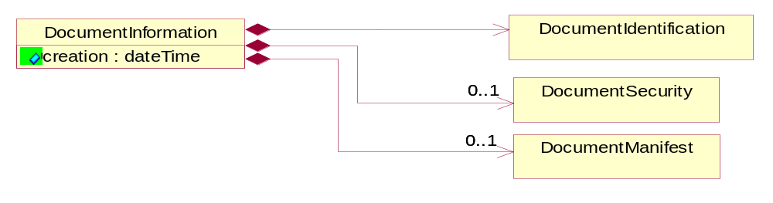
Figure 5-46 DocumentInformation

Attribute | Type | Documentation
creation | dateTime | The creation date and time of the specified Business Document (i.e. the Purchase Order date).

Composition | Cardinality | Type | Documentation
DocumentIdentification | 1 | DocumentIdentification | The object specifies all information necessary to identify the business document.
DocumentSecurity | 0..1 | DocumentSecurity | The object provides additional granularity in specifying business document security (this is in addition to the specified PIP security).
DocumentManifest | 0..1 | DocumentManifest | The block provides a brief summary of attachments and Service Content.

DocumentManifest

The block provides a brief summary of attachments and Service Content.

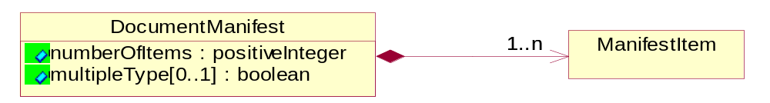
Figure 5-47 DocumentManifest

Attribute | Type | Documentation
numberOfItems | positiveInteger | Total number of documents in the message. The physical count of the attachments in the payload plus the RosettaNet Business Message (for Service Content). The value of this field will be at least 1.
multipleType[0..1] | boolean | Indicates whether the manifest contains documents of multiple types. True if yes, and False if no.

Composition | Cardinality | Type | Documentation
ManifestItem | 1..n | ManifestItem | The object provides details about the specific attachment(s).

DocumentSecurity

The object provides additional granularity in specifying business document security (this is in addition to the specified PIP security).

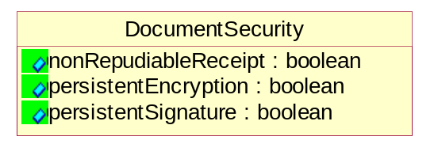
Figure 5-48 DocumentSecurity

Attribute | Type | Documentation
nonRepudiableReceipt | boolean | The value "true" will indicate that a signed acknowledgement for the business document is necessary.
persistentEncryption | boolean | The value "true" will indicate that the Business Document (including the header) needs to be encrypted when stored or transported.
persistentSignature | boolean | The value "true" will indicate that a signature is required to be stored with the document while stored or transported.

ManifestItem

The object provides details about the specific attachment(s).

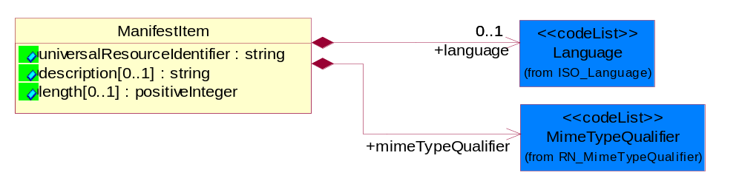
Figure 5-49 ManifestItem

Attribute | Type | Documentation
universalResourceIdentifier | string | The generic set of all names/addresses that are short strings that refer to resources.
description[0..1] | string | A description of the attachment.
length[0..1] | positiveInteger | The size of the attachment in bytes (i.e. 1 000 000 bytes)

Composition | Cardinality | Type | Documentation
mimeTypeQualifier | 1 | MimeTypeQualifier | The MIME type as defined by IANA.  Please refer to http://www.iana.org/assignments/media-types/ for a list of types.
language | 0..1 | Language | For representation of Language name RosettaNet has adopted ISO 639-2; 1998. Refer to the following web page to get the latest version of the standard:  http://www.loc.gov/standards/iso639-2/iso639jac.html  If you need more information about the ISO standard please contact ISO for more details.

PipIdentifier

PIP Identification.[ i.e. PIP3A4]

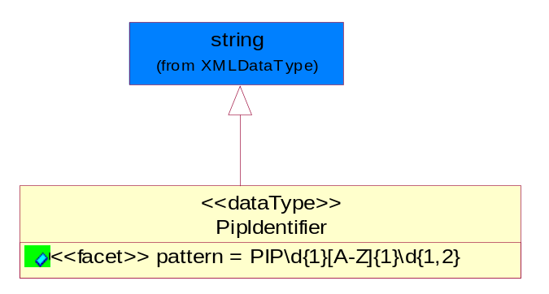
Figure 5-50 PipIdentifier

Attribute | Type | Documentation
pattern |  | PIP\d{1}[A-Z]{1}\d{1,2}

PipVersion

PIP version number (i.e. 02.02.00).

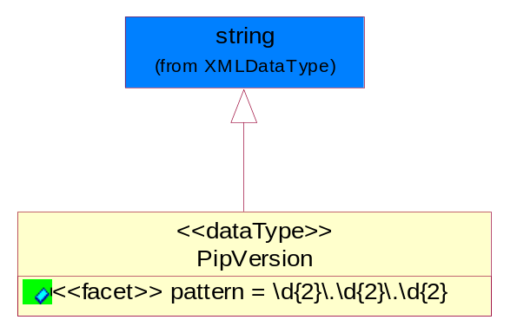
Figure 5-51 PipVersion

Attribute | Type | Documentation
pattern |  | \d{2}\.\d{2}\.\d{2}

Receiver

The object allows the identification of the receiving party of the business message.

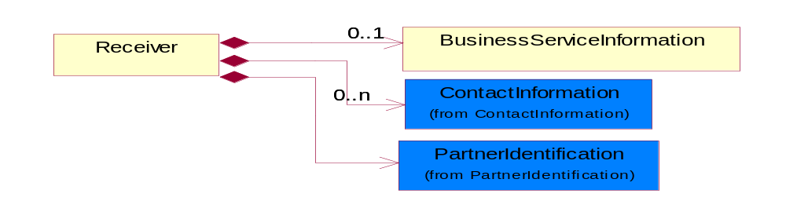
Figure 5-52 Receiver

Composition | Cardinality | Type | Documentation
BusinessServiceInformation | 0..1 | BusinessServiceInformation | The object allows the specification of the business service utilized within the partner company. This may or may not be the same as the information sent by the RNIF.
PartnerIdentification | 1 | PartnerIdentification | The business document must allow for the identity of one or more parties to the transaction.
ContactInformation | 0..n | ContactInformation | The business document must allow for the identification of the name of the department, service or individual to be contacted regarding the context of the business document.

RequestingDocumentInformation

A block of information used to correlate a requesting document to a responding document in an executing choreography.

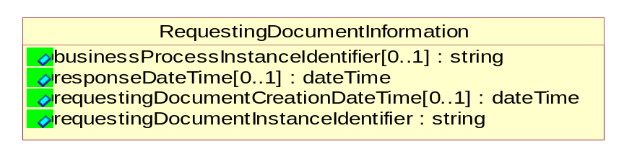
Figure 5-53 RequestingDocumentInformation

Attribute | Type | Documentation
businessProcessInstanceIdentifier[0..1] | string | The identifier for the public business process instance being sent that both the sender and receiver can identify.
responseDateTime[0..1] | dateTime | The expected time to receive the response. This can not be greater than the PIP TimeToPerform.
requestingDocumentCreationDateTime[0..1] | dateTime | The date-time of the requesting business document.
requestingDocumentInstanceIdentifier | string | The Business Document identification number that identifies the requesting Business Document.

Sender

The object allows the identification of the initiating party of the business message.

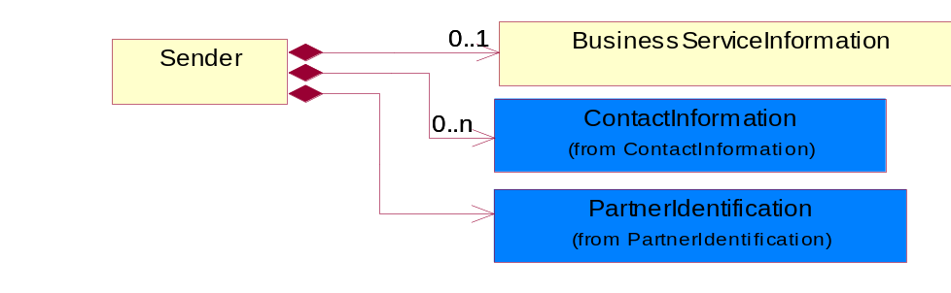
Figure 5-54 Sender

Composition | Cardinality | Type | Documentation
PartnerIdentification | 1 | PartnerIdentification | The business document must allow for the identity of one or more parties to the transaction.
BusinessServiceInformation | 0..1 | BusinessServiceInformation | The object allows the specification of the business service utilized within the partner company. This may or may not be the same as the information sent by the RNIF.
ContactInformation | 0..n | ContactInformation | The business document must allow for the identification of the name of the department, service or individual to be contacted regarding the context of the business document.

StandardDocumentIdentification

The object specifies additional information necessary to identify the standard business document.

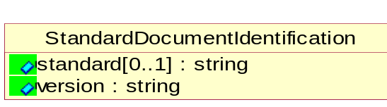
Figure 5-55 StandardDocumentIdentification

Attribute | Type | Documentation
standard[0..1] | string | Identifies the standard used to submit the business document. (e.g. RosettaNet).
version | string | PIP3A4v01.00

TpirPipIdentification

The object specifies all information necessary to uniquely identify a TPIR-PIP within a Registry or trading partner repository.

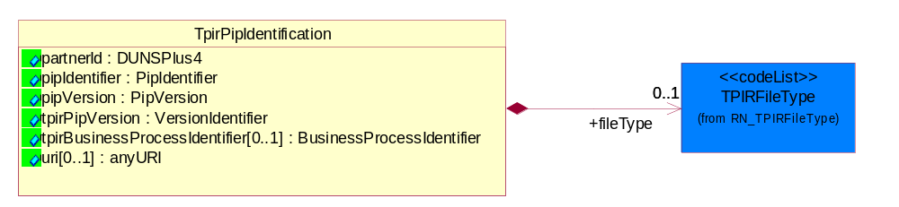
Figure 5-56 TpirPipIdentification

Attribute | Type | Documentation
partnerId | DUNSPlus4 | The Trading Partner Identification of MNC that is creating this TPIR PIP.
pipIdentifier | PipIdentifier | A TPIR PIP Identification [i.e., 3A4 ).
pipVersion | PipVersion | A TPIR PIP version number (i.e., 02.02.00)
tpirPipVersion | VersionIdentifier | A TPIR-PIP Version Number (i.e., major and minor version number as XX.XX).
tpirBusinessProcessIdentifier[0..1] | BusinessProcessIdentifier | A Business Process Identifier to uniquely define the TPIR-PIP 'role' within a Business Scenario at a company or MNC level. The identifier MUST be composed of alphanumeric characters only and its length MUST be between one and twelve characters.
uri[0..1] | anyURI | Describes the destination uri for the TPIR form.

Composition | Cardinality | Type | Documentation
fileType | 0..1 | TPIRFileType | Describes the file type of the TPIR form (PDF, XDP or XML).

VersionIdentifier

Version Number (i.e., major and minor version number as XX.XX).

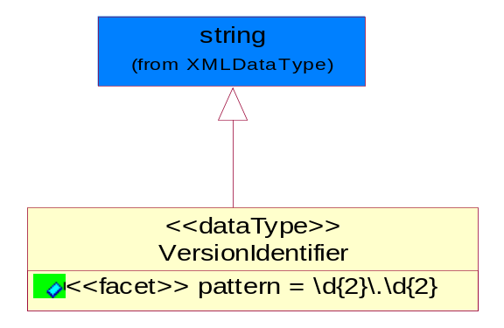
Figure 5-57 VersionIdentifier

Attribute | Type | Documentation
pattern |  | \d{2}\.\d{2}

CodeList

TPIRFileType

A code identifying the file type of TPIR form.

Name | Documentation
PDF | Portable Document Format.
XDP | XML Data Package.
XML | eXtensible Markup Language.

XML Data Type

anyURI
Represents a URI as defined by RFC 2396. An anyURI value can be absolute or relative, and may have an optional fragment identifier.

boolean
Represents Boolean values, which are either "true" or "false".

date
For the represents a calendar date.
The pattern for a date is CCYY-MM-DD where CC represents the century, YY the year, MM the month, and DD the day, with an optional time zone indicator as allowed for dateTime.

dateTime
Represents a specific instance of time.
The pattern for dateTime is CCYY-MM-DDThh:mm:ss where CC represents the century, YY the year, MM the month, and DD the day, preceded by an optional leading negative (-) character to indicate a negative number. If the negative character is omitted, positive (+) is assumed. The T is the date/time separator and hh, mm, and ss represent hour, minute, and second respectively. Additional digits can be used to increase the precision of fractional seconds if desired. For example, the format ss.ss... with any number of digits after the decimal point is supported. The fractional seconds part is optional.

This representation may be immediately followed by a "Z" to indicate Coordinated Universal Time (UTC) or to indicate the time zone. For example, the difference between the local time and Coordinated Universal Time, immediately followed by a sign, + or -, followed by the difference from UTC represented as hh:mm (minutes is required). If the time zone is included, both hours and minutes must be present.

decimal
A data type that contains decimal numbers scaled by a power of 10.

duration
Represents a duration of time.
The pattern for duration is PnYnMnDTnHnMnS, where nY represents the number of years, nM the number of months, nD the number of days, T the date/time separator, nH the number of hours, nM the number of minutes, and nS the number of seconds.

float
Represents single-precision 32-bit floating-point numbers.

positiveInteger
Represents an integer that is greater than zero. This data type is derived from nonNegativeInteger.

string
Represents character string.

