

Description of 5C1 Message

PIP® 5C1
Validated 11.00.00

Specification Information
Name | Description Of 5C1 Message
PIP | Distribute Product List
Cluster | Marketing Information Management
Segment | Design Win Management (EC)
Publication Date | 03 July 2008
Version Identifier | V11.00

Table of Content

1. Document Management 6
1.1 Legal Disclaimer 6
1.2 Copyright 6
1.3 Trademarks 6
1.4 Acknowledgments 6
1.5 Related Documents 6
1.6 Document Version History 6
1.7 Document Purpose 7
2. Interchange Model 8
2.1 ProductListDistribution 8
2.1.1 Interchange Diagram 8
2.1.2 Dependency Diagram 9
2.1.3 CoreProductInformation 9
2.1.4 DeviceProductInformation 9
2.1.5 DocumentIdentification 10
2.1.6 EligibleProductInformation 11
2.1.7 EligibleProductList 12
2.1.8 EligibleProductListChoice 13
2.1.9 ProductListDistribution 13
2.2 CodeList 13
2.2.1 Notification 13
2.2.2 PartType 14
3. Domain Model 15
3.1 Procurement 15
3.1.1 Procurement 15
3.1.1.1 Dependency Diagram 15
3.1.1.2 IsCallFactory 15
3.1.1.3 IsCostChange 16
3.1.1.4 IsPriceProtect 16
3.1.1.5 IsSuggestedResaleChange 17
3.1.1.6 PriceList 17
3.1.1.7 PricingDetail 18
3.1.1.8 ProductClassification 19
3.1.1.9 ProductClassificationChoice 19
3.1.1.10 ProductPricing 20
3.1.1.11 ProductQuantityRange 21
3.1.1.12 SubstituteProductReference 21
3.1.1.13 UNSPSC 22
CodeList 23
3.1.2.1 ProductSubstitutionReason 23
3.2 Marketing 24
3.2.1 Marketing 24
3.2.1.1 Dependency Diagram 24
3.2.1.2 GeographicRegion 24
3.2.1.3 IsRegisterable 25
3.2.2 CodeList 25
3.2.2.1 GeographicRegionCode 25
3.3 Shared 26
3.3.1 Shared 26
3.3.1.1 Dependency Diagram 26
3.3.1.2 MonetaryAmount 26
3.3.1.3 ProductQuantity 27
CodeList 27
3.3.2.1 InvoiceChargeType 27
3.3.2.2 MonetaryAmountType 28
3.3.2.3 PricingTypeCode 28
3.3.2.4 AmountType 29
4. Universal Structure 31
4.1 ContactInformation 31
4.1.1 ContactInformation 31
4.2 DataType 32
4.2.1 Contact 32
4.2.2 DUNS 32
4.2.3 DUNSPlus4 33
4.2.4 GLN 33
4.2.5 GTIN 34
4.3 Dates 34
4.3.1 DatePeriod 34
4.4 Locations 35
4.4.1 AlternativeIdentifier 35
4.5 MonetaryExpression 35
4.5.1 FinancialAmount 35
4.6 PartnerIdentification 36
4.6.1 PartnerIdentification 36
4.6.2 PartnerIdentificationChoice 37
4.7 ProductIdentification 37
4.7.1 ProductIdentification 37
4.7.2 ProductIdentificationChoice 38
4.7.3 TextualDescription 38
4.8 CodeList 39
4.8.1 Country 39
4.8.2 Currency 39
4.8.3 Language 39
4.8.4 MimeTypeQualifier 39
4.8.5 UnitOfMeasure 50
5. System Structure 58
5.1 BusinessProcessIdentifier 58
5.2 BusinessServiceInformation 58
5.3 ContractInformation 59
5.4 CorrelationInformation 59
5.5 DocumentHeader 60
5.6 DocumentIdentification 61
5.7 DocumentIdentificationChoice 61
5.8 DocumentInformation 62
5.9 DocumentManifest 62
5.10 DocumentSecurity 63
5.11 ManifestItem 63
5.12 PipIdentifier 64
5.13 PipVersion 65
5.14 Receiver 65
5.15 RequestingDocumentInformation 66
5.16 Sender 66
5.17 StandardDocumentIdentification 67
5.18 TpirPipIdentification 67
5.19 VersionIdentifier 68
5.20 CodeList 69
5.20.1 TPIRFileType 69
6. XML Data Type 70
6.1 anyURI 70
6.2 boolean 70
6.3 date 70
6.4 dateTime 70
6.5 float 70
6.6 positiveInteger 70
6.7 string 70

Table of Figures

Figure 2-1 Interchange 8
Figure 2-2 Dependency 9
Figure 2-3 CoreProductInformation 9
Figure 2-4 DeviceProductInformation 9
Figure 2-5 DocumentIdentification 10
Figure 2-6 EligibleProductInformation 11
Figure 2-7 EligibleProductList 12
Figure 2-8 ProductListDistribution 13
Figure 3-1 Dependency 15
Figure 3-2 IsCallFactory 15
Figure 3-3 IsCostChange 16
Figure 3-4 IsPriceProtect 16
Figure 3-5 IsSuggestedResaleChange 17
Figure 3-6 PriceList 17
Figure 3-7 PricingDetail 18
Figure 3-8 ProductClassification 19
Figure 3-9 ProductPricing 20
Figure 3-10 ProductQuantityRange 21
Figure 3-11 SubstituteProductReference 21
Figure 3-12 UNSPSC 22
Figure 3-13 Dependency 24
Figure 3-14 GeographicRegion 24
Figure 3-15 IsRegisterable 25
Figure 3-16 Dependency 26
Figure 3-17 MonetaryAmount 26
Figure 3-18 ProductQuantity 27
Figure 4-1 ContactInformation 31
Figure 4-2 Contact 32
Figure 4-3 DUNS 32
Figure 4-4 DUNSPlus4 33
Figure 4-5 GLN 33
Figure 4-6 GTIN 34
Figure 4-7 DatePeriod 34
Figure 4-8 AlternativeIdentifier 35
Figure 4-9 FinancialAmount 35
Figure 4-10 PartnerIdentification 36
Figure 4-11 ProductIdentification 37
Figure 4-12 TextualDescription 38
Figure 5-1 BusinessProcessIdentifier 58
Figure 5-2 BusinessServiceInformation 58
Figure 5-3 ContractInformation 59
Figure 5-4 CorrelationInformation 59
Figure 5-5 DocumentHeader 60
Figure 5-6 DocumentIdentification 61
Figure 5-7 DocumentInformation 62
Figure 5-8 DocumentManifest 62
Figure 5-9 DocumentSecurity 63
Figure 5-10 ManifestItem 63
Figure 5-11 PipIdentifier 64
Figure 5-12 PipVersion 65
Figure 5-13 Receiver 65
Figure 5-14 RequestingDocumentInformation 66
Figure 5-15 Sender 66
Figure 5-16 StandardDocumentIdentification 67
Figure 5-17 TpirPipIdentification 67
Figure 5-18 VersionIdentifier 68

Document Management

Legal Disclaimer
RosettaNet, its members, officers, directors, employees, or agents shall not be liable for any injury, loss, damages, financial or otherwise, arising from, related to, or caused by the use of this document or the specifications herein, as well as associated guidelines and schemas. The use of said specifications shall constitute your express consent to the foregoing exculpation.

Copyright
©2008 RosettaNet. All rights reserved. No part of this publication may be reproduced, stored in a retrieval system, or transmitted, in any form or by any means, electronic, mechanical, photocopying, recording, or otherwise, without the inclusion of this copyright notice. Any derivative works must cite the copyright notice. Any public redistribution or sale of this publication or derivative works requires prior written permission of the publisher.

Trademarks
RosettaNet, Partner Interface Process, PIP and the RosettaNet logo are trademarks or registered trademarks of "RosettaNet," a non-profit organization. All other product names and company logos mentioned herein are the trademarks of their respective owners. In the best effort, all terms mentioned in this document that are known to be trademarks or registered trademarks have been appropriately recognized in the first occurrence of the term.

Acknowledgments
This document has been prepared by RosettaNet (http://www.rosettanet.org/) from requirements gathered during the Milestone Program and in conformance with the methodology. Listed below are the legal entities that contributed to the design and development of this PIP.

Related Documents
- Associated PIP Message Schemas (included with PIP Specification only)
- Description of Partner Interface Process for 5C1
- Message Structure

Document Version History
Version | Date | Description
Validated 11.00.00 | 03 July 2008 | Validated Version : RosettaNet Schema to Market to Validation 2008

Document Purpose
The purpose of the document is to explain the structure, the association between objects, the content of objects and the definition for single elements to a non-technical audience.

Interchange Model

ProductListDistribution

Interchange Diagram
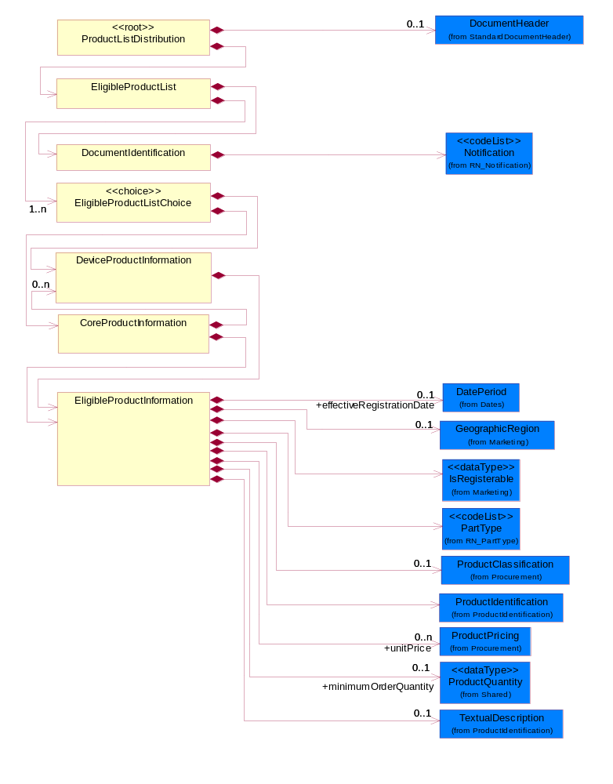
Figure 2-1 Interchange

Dependency Diagram
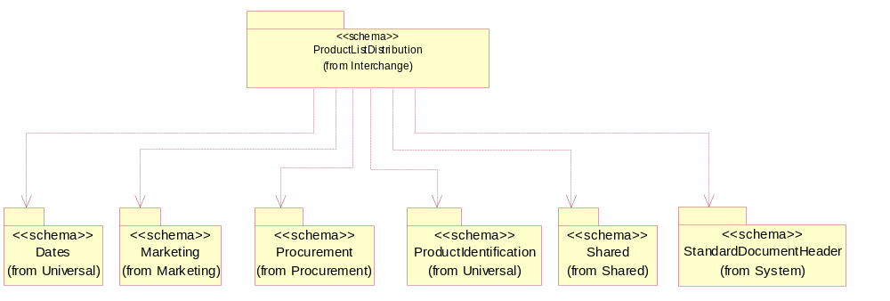
Figure 2-2 Dependency

CoreProductInformation
The collection of business properties that represent a family or series of related products.
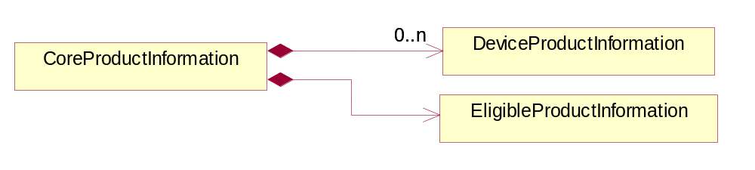
Figure 2-3 CoreProductInformation

Composition | Cardinality | Type | Documentation
DeviceProductInformation | 0..n | DeviceProductInformation | The collection of business properties that describe product information at a more detailed level.
EligibleProductInformation | 1 | EligibleProductInformation | The collection of business properties that describe eligible product information.

DeviceProductInformation
The collection of business properties that describe product information at a more detailed level.
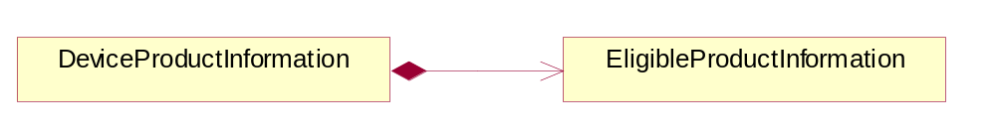
Figure 2-4 DeviceProductInformation

Composition | Cardinality | Type | Documentation
EligibleProductInformation | 1 | EligibleProductInformation | The collection of business properties that describe eligible product information.

DocumentIdentification
The collection of business properties that describe information regarding the eligible product list document.
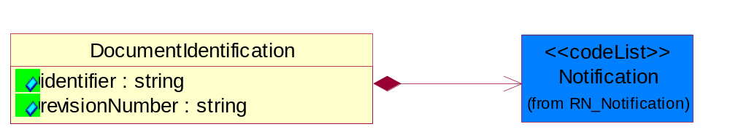
Figure 2-5 DocumentIdentification

Attribute | Type | Documentation
identifier | string | The proprietary identity of an eligible product list.
revisionNumber | string | An incremental number used to identify changes.

Composition | Cardinality | Type | Documentation
Notification | 1 | Notification | Code identifying the purpose of a notification document.

EligibleProductInformation
The collection of business properties that describe eligible product information.
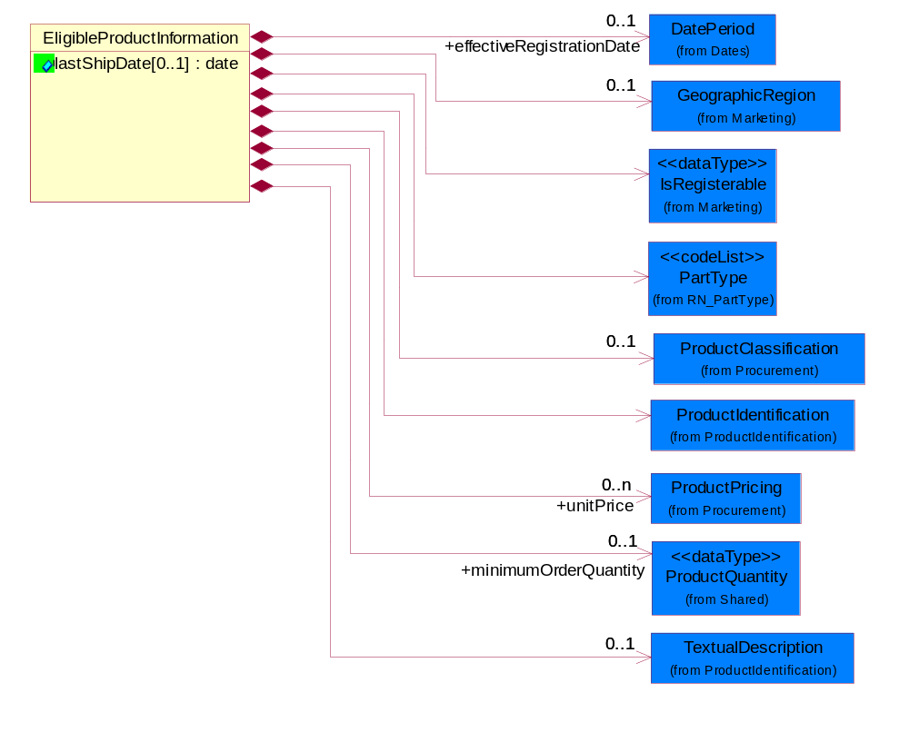
Figure 2-6 EligibleProductInformation

Attribute | Type | Documentation
lastShipDate[0..1] | date | The final date a product can be shipped.

Composition | Cardinality | Type | Documentation
effectiveRegistrationDate | 0..1 | DatePeriod | The date registration becomes effective.
GeographicRegion | 0..1 | GeographicRegion | The collection of business properties that reflects multiple countries of choice or a specified region.
IsRegisterable | 1 | IsRegisterable | Indicates whether a part is a registerable or a non-registerable product.
PartType | 1 | PartType | Code identifying the eligibility of a part for a design win process.
ProductClassification | 0..1 | ProductClassification | Identifier to identify product classification.
ProductIdentification | 1 | ProductIdentification | The object provides the identifier(s) of a product.
unitPrice | 0..n | ProductPricing | Agreed upon sale price for each unit ordered.
minimumOrderQuantity | 0..1 | ProductQuantity | A numeric expression of the minimum number of product line items that may be ordered.
TextualDescription | 0..1 | TextualDescription | The business document must allow for multiple levels of textual description of an event or object.

EligibleProductList
The collection of business properties that describe eligible products for a design win process.
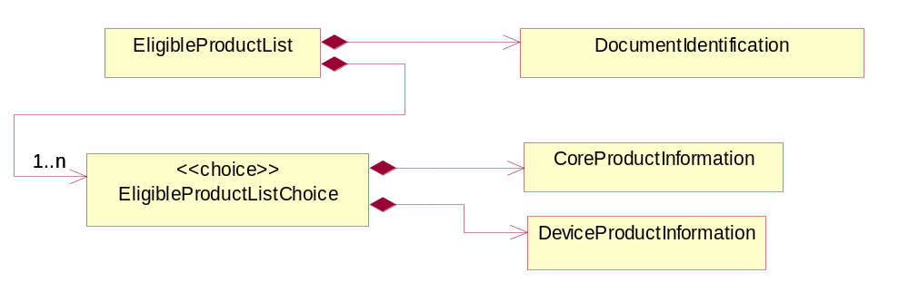
Figure 2-7 EligibleProductList

Composition | Cardinality | Type | Documentation
EligibleProductListChoice | 1..n | EligibleProductListChoice | Choice is a functional entity.
DocumentIdentification | 1 | DocumentIdentification | The collection of business properties that describe information regarding the eligible product list document.

EligibleProductListChoice
Choice is a functional entity.

Composition | Cardinality | Type | Documentation
CoreProductInformation | 1 | CoreProductInformation | The collection of business properties that represent a family or series of related products.
DeviceProductInformation | 1 | DeviceProductInformation | The collection of business properties that describe product information at a more detailed level.

ProductListDistribution
A message wrapper or root element for PIP 5C1.
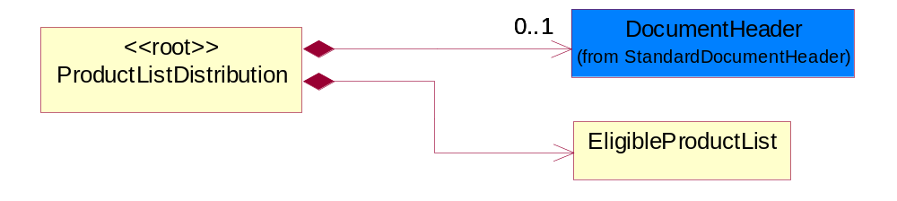
Figure 2-8 ProductListDistribution

Composition | Cardinality | Type | Documentation
DocumentHeader | 0..1 | DocumentHeader | The object allows for the identification of the sender and receiver of the business document.
EligibleProductList | 1 | EligibleProductList | The collection of business properties that describe eligible products for a design win process.

CodeList

Notification
Code identifying the purpose of a notification document.

Name | Documentation
INI | Initial
UPD | Update

PartType
Code identifying the eligibility of a part for a design win process.

Name | Documentation
RAP | Registerable Associated Product. Supplier parts which can be included in the board / assembly opportunity.
RDT | Registerable Development Tool. Supplier or third party solutions that are tools for the designer to assist in the implementation of the supplier part on the board / assembly.
RKP | Registerable Key Product. Supplier parts that warrant a registration number as an indication of a specific distributor strategic alliance. This is an eligible part included in the supplier's design registration program.

Domain Model

Procurement

Procurement

Dependency Diagram
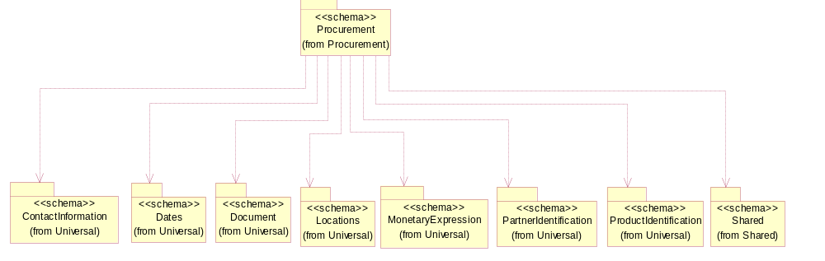
Figure 3-9 Dependency

IsCallFactory
An indicator for the receiver to call the manufacturer to obtain current information.
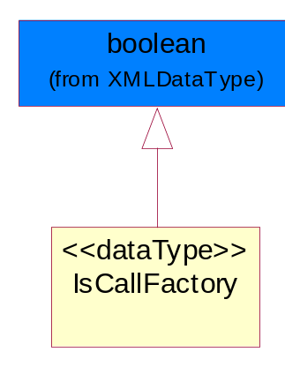
Figure 3-10 IsCallFactory

IsCostChange
An indicator for the receiver to take note that the cost has changed.
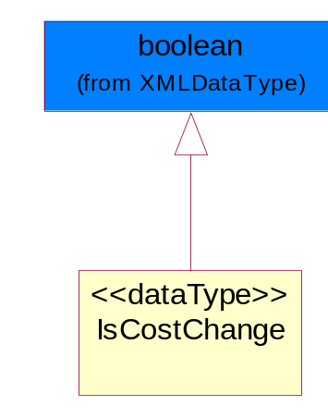
Figure 3-11 IsCostChange

IsPriceProtect
Indicates whether the product pricing is protected.
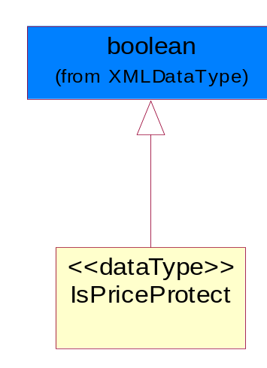
Figure 3-12 IsPriceProtect

IsSuggestedResaleChange
An indicator for the receiver to take note that the Suggested Resale Price has changed.
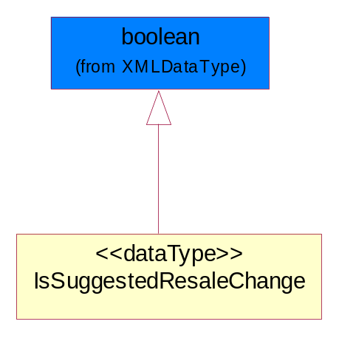
Figure 3-13 IsSuggestedResaleChange

PriceList
The collection of business properties that describe product pricing in a proprietary price list document.
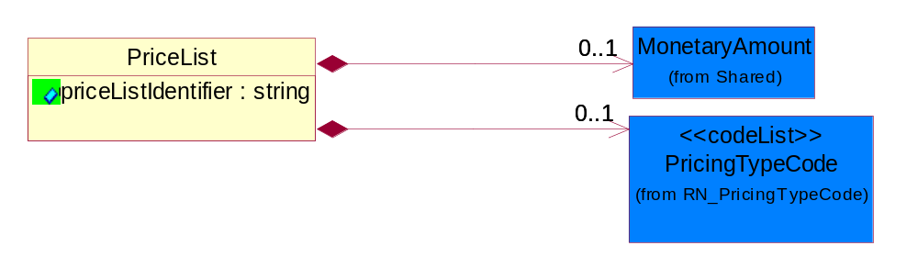
Figure 3-14 PriceList

Attribute | Type | Documentation
priceListIdentifier | string | The unique identifier that references a specific price list used for product pricing.

Composition | Cardinality | Type | Documentation
MonetaryAmount | 0..1 | MonetaryAmount | The collection of business properties that describe the monetary amount defined by a specified currency.
PricingTypeCode | 0..1 | PricingTypeCode | Code identifying the type of pricing available for a product.

PricingDetail
The collection of business properties that describe pricing for a product or service.
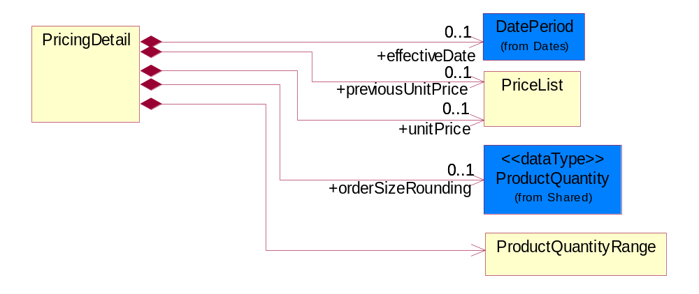
Figure 3-15 PricingDetail

Composition | Cardinality | Type | Documentation
effectiveDate | 0..1 | DatePeriod | The date information or an activity becomes effective.
previousUnitPrice | 0..1 | PriceList | The partner's cost to purchase the product prior to the effective date of the price drop.
unitPrice | 0..1 | PriceList | Agreed upon sale price for each unit ordered.
orderSizeRounding | 0..1 | ProductQuantity | The quantity of products which is a standard ordering unit. Actual order quantities must be multiples of this quantity and is equal to or smaller than the minimum order quantity.
ProductQuantityRange | 1 | ProductQuantityRange | The collection of business properties that describe an upper and lower range of product quantity.

ProductClassification
Identifier to identify product classification.
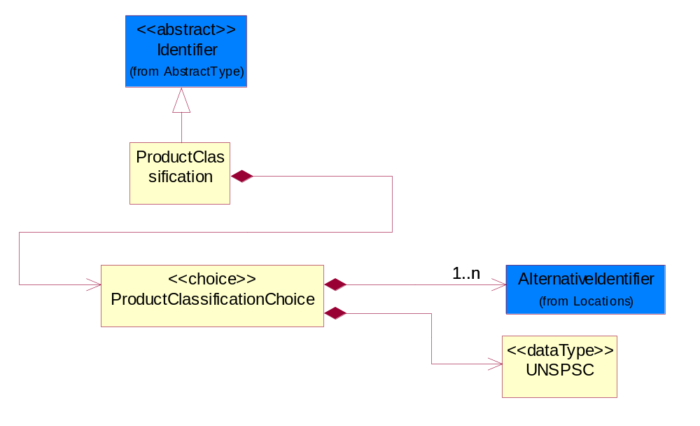
Figure 3-16 ProductClassification

Composition | Cardinality | Type | Documentation
ProductClassificationChoice | 1 | ProductClassificationChoice | Choices to identify product classification.

ProductClassificationChoice
Choices to identify product classification.

Composition | Cardinality | Type | Documentation
AlternativeIdentifier | 1..n | AlternativeIdentifier | Identifies the specified code and the name of the organization that a code is utilized from.
UNSPSC | 1 | UNSPSC | Identifier to identify product classification. RosettaNet has adopted the UNSPSC. Refer to UN/SPSC Website for specific values: http://www.unspsc.org/.

ProductPricing
The collection of business properties that describe the type of pricing and financial amount for a product.
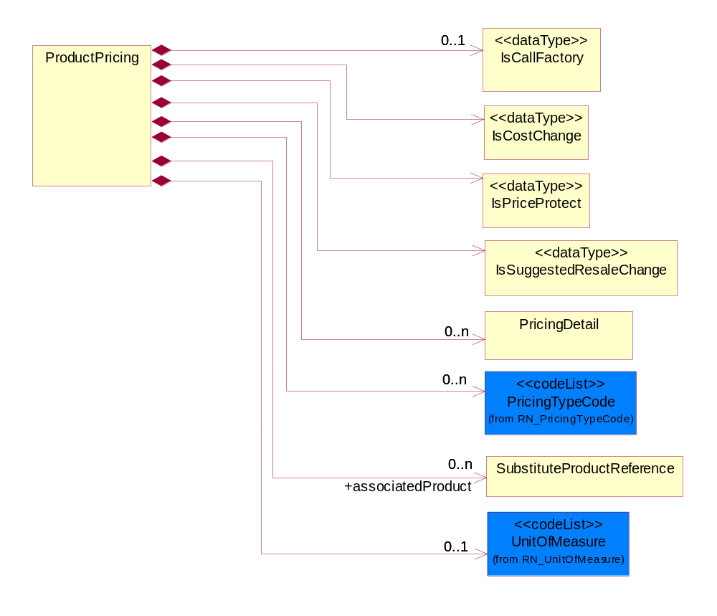
Figure 3-17 ProductPricing

Composition | Cardinality | Type | Documentation
IsCallFactory | 0..1 | IsCallFactory | An indicator for the receiver to call the manufacturer to obtain current information.
IsCostChange | 1 | IsCostChange | An indicator for the receiver to take note that the cost has changed.
IsPriceProtect | 1 | IsPriceProtect | Indicates whether the product pricing is protected.
IsSuggestedResaleChange | 1 | IsSuggestedResaleChange | An indicator for the receiver to take note that the Suggested Resale Price has changed.
PricingDetail | 0..n | PricingDetail | The collection of business properties that describe pricing for a product or service.
PricingTypeCode | 0..n | PricingTypeCode | Code identifying the type of pricing available for a product.
associatedProduct | 0..n | SubstituteProductReference | The product associated.
UnitOfMeasure | 0..1 | UnitOfMeasure | Code identifying a product unit of measure.

ProductQuantityRange
The collection of business properties that describe an upper and lower range of product quantity.
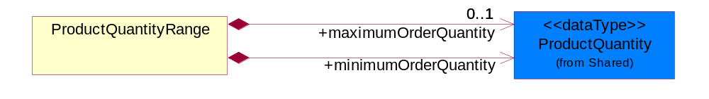
Figure 3-18 ProductQuantityRange

Composition | Cardinality | Type | Documentation
maximumOrderQuantity | 0..1 | ProductQuantity | A numeric expression of the maximum number of product line items that may be ordered.
minimumOrderQuantity | 1 | ProductQuantity | A numeric expression of the minimum number of product line items that may be ordered.

SubstituteProductReference
The collection of business properties describing a product that is being substituted for a requested product.
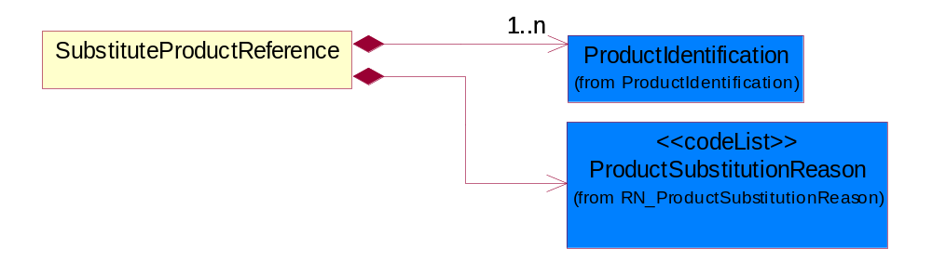
Figure 3-19 SubstituteProductReference

Composition | Cardinality | Type | Documentation
ProductIdentification | 1..n | ProductIdentification | The object provides the identifier(s) of a product.
ProductSubstitutionReason | 1 | ProductSubstitutionReason | A code identifying the reason a product is substituted for the original product requested.

UNSPSC
Identifier to identify product classification. RosettaNet has adopted the UNSPSC. Refer to UN/SPSC Website for specific values: http://www.unspsc.org/.
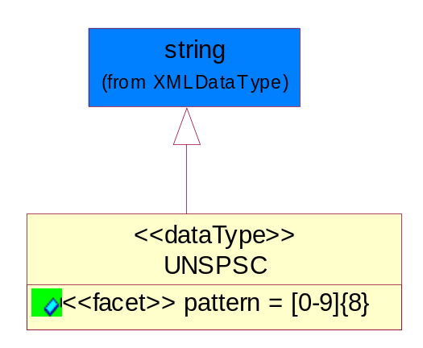
Figure 3-20 UNSPSC

Attribute | Type | Documentation
pattern

CodeList

ProductSubstitutionReason
A code identifying the reason a product is substituted for the original product requested.

Name | Documentation
BEP | Better Product - The requested part number is currently not available offering product upgrade.
CMP | Component of the identified product is a component of this referenced product.
DWN | Downgrade - The identified product is a downgrade for this referenced product.
IPN | Invalid Part Number - The requested part number is invalid.
PRE | Predecessor - The product that existed prior.
QRH | Quality / Reliability Hold.
REP | Retired product - The requested part number is no longer available.
RPL | Replace - The identified product is a replacement for this referenced product.
SCC | Successor - The superseding product that will be replacing the current product.

Marketing

Marketing

Dependency Diagram
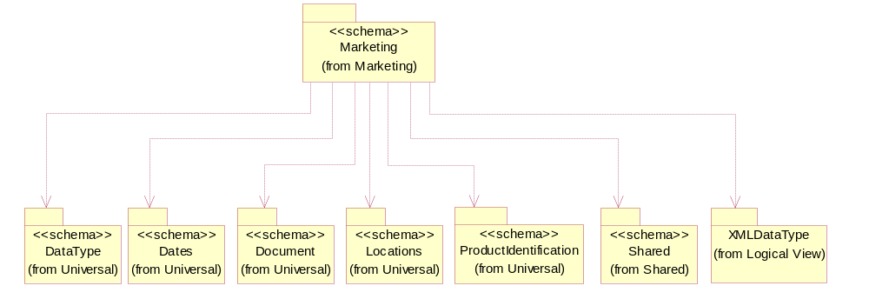
Figure 3-21 Dependency

GeographicRegion
The collection of business properties that reflects multiple countries of choice or a specified region.
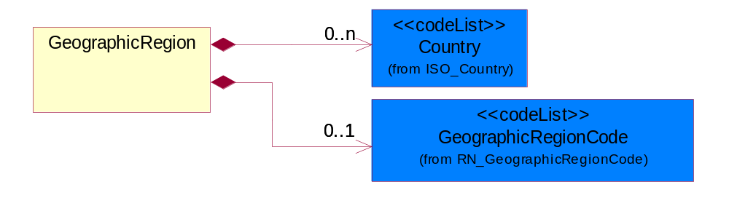
Figure 3-22 GeographicRegion

Composition | Cardinality | Type | Documentation
Country | 0..n | Country | For representation of Country name RosettaNet has adopted ISO 3166-3; 1999. Refer to the following web page to get the latest version of the standard:  http://www.iso.ch/iso/en/prods-services/iso3166ma/02iso-3166-code-lists/index.html  If you need more information about the ISO standard please contact ISO for more details.
GeographicRegionCode | 0..1 | GeographicRegionCode | Code identifying a geographic region.

IsRegisterable
Indicates whether a part is a registerable or a non-registerable product.
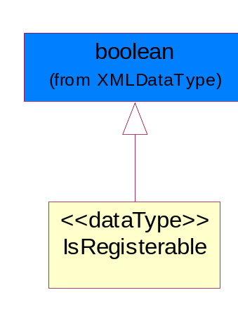
Figure 3-23 IsRegisterable

CodeList

GeographicRegionCode
Code identifying a geographic region.

Name | Documentation
GLO | Global - All countries.

Shared

Shared

Dependency Diagram
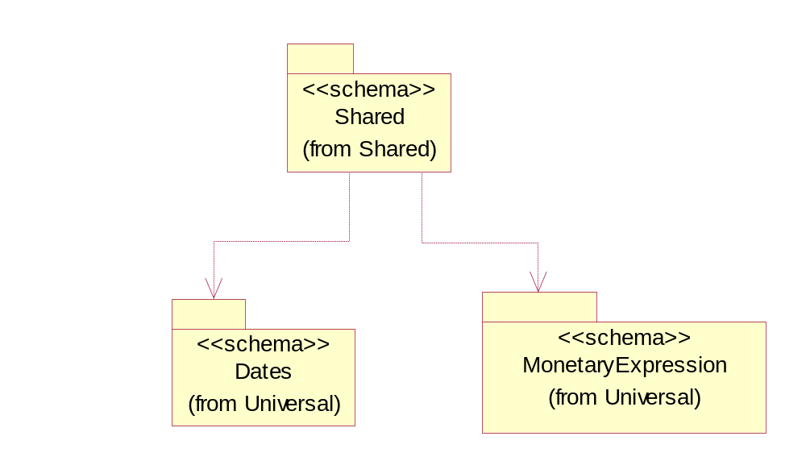
Figure 3-24 Dependency

MonetaryAmount
The collection of business properties that describe the monetary amount defined by a specified currency.
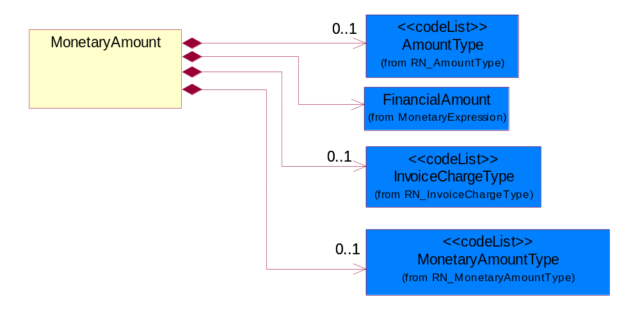
Figure 3-25 MonetaryAmount

Composition | Cardinality | Type | Documentation
AmountType | 0..1 | AmountType | Code identifying the type of monetary amount.
FinancialAmount | 1 | FinancialAmount | The business document must express financial amounts.
InvoiceChargeType | 0..1 | InvoiceChargeType | Code identifying the values for the types of charges contained in an invoice.
MonetaryAmountType | 0..1 | MonetaryAmountType | Code identifying whether the monetary amount is a debit or credit.

ProductQuantity
A quantity specifying the number of product units.
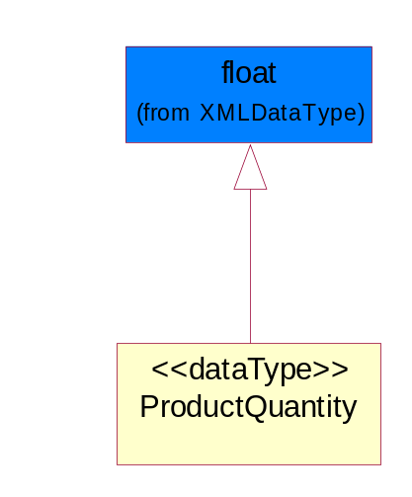
Figure 3-26 ProductQuantity

CodeList

InvoiceChargeType
Code identifying the values for the types of charges contained in an invoice.

Name | Documentation
ALC | Allowances and Charges.
CUC | Custom Charges.
DEA | Deposit Amount.
ESC | Expedited Shipping Charge - Charge for accelerating the delivery of a product.
FRC | Freight Charges.
HAC | Handling Charges.
LEC | Lease Charge - Charge for the use of a product in which the purchaser assumes certain responsibilities of ownership.
LIC | License Charge - Charge for the use of a product (usually software) in which the manufacturer maintains ownership of the product.
MAC | Maintenance Charge - Charge (usually periodic) for providing maintenance support for a product.
PUC | Purchase Charge - Charge for a product in which the buyer takes all responsibilities of ownership.
QUD | Quantity Discount.
REC | Rental Charge - Charge for the use of a product (usually hardware) in which the manufacturer maintains ownership of the product.

MonetaryAmountType
Code identifying whether the monetary amount is a debit or credit.

Name | Documentation
CRE | Credit.
DEB | Debit.
ZER | Zero remit.

PricingTypeCode
Code identifying the type of pricing available for a product.

Name | Documentation
ACR | Authorized Cost and Resale.
ACS | Authorized Cost - The negotiated cost agreed upon between the supplier and distributor at the time the “debit?is authorized.
ACT | Authorized cost.
ANY | Any available.
ARS | Authorized resale.
ASP | Average Selling Price - Manufacturer's published price.
BPA | Budgetary Price Amount.
BPP | Broken Purchase Price.
BSH | Book-Ship.
CAT | Catalog price - Book (the supplier’s published cost at the time of transaction) or Published Price.
CMC | Commercial.
CMD | Commodity.
CMF | Contract Manufacturing.
CON | Contract.
COS | Cost - Price for which the distributor purchased the parts.
DBC | Disti Book Cost.
DFR | Duty free.
DIS | Distribution.
DPD | Duty paid.
DTP | Distribution price.
EDU | Education.
ERT | E-Rate.
EXC | Exception.
FGM | Federal government.
GEN | General.
HIE | Higher Education.
LCL | Local.
LGM | Local government.
LIS | List.
MPR | Market price.
MRP | Manufacturer's recommendation for unit pricing.
MSR | Manufacturer Suggested Retail Price (MSRP).
MUS | Minimum Unit Sale (MUS) - Manufacturer requirement of total dollar value for design opportunity.
NPF | Nonprofit.
OEM | Original Equipment Manufacturing (OEM).
OVP | OEM Volume Pricing - Original equipment manufacturing price per volume ordered.
PED | Primary Education.
QUO | Quote Price
RCS | Requested Cost (RCS) - Reseller requested cost to the manufacturer.
RFB | Refurbished.
RIN | Religious Institution.
RSP | Resale - Price the distributor is authorized to use for sale to their customer (RSP).
SCE | Special Education.
SEC | Security and management reseller.
SED | Secondary Education.
SEV | Service provider.
SGM | State Government.
SPD | Special Discount Price.
SPE | Special Education.
SPL | Samples.
SRP | Suggested Resale Price.
STR | Standard Rebate.
THP | Threshold Price.
TOC | Total Other Charges - Suggested resale price - The sum total of all distributor added charges to the customer for value added services, including but not limited to programming, tape and reel, labeling, date coding, kitting and in-house assembly.

AmountType
Code identifying the type of monetary amount.

Name | Documentation
DIS | Discount Value - The monetary amount of the discount on the price applied to a customer order.
FRE | Freight Charges - The monetary amount to be paid for freight transportation.
INS | InsuranceCharges - The monetary amount to be paid for freight insurance.
MAT | Material Cost - This object represents the material cost for the product.
MIS | Miscellaneous Charges - The monetary amount to be paid for miscellaneous charges.
PRC | Processing Charges - The monetary amount to be paid by consignee for consignment manufacturer.
TOD | Total Amount Due - Total amount due upon receipt of statement.
TOT | Total Amount - Total price for an entire business document.
TOV | Total Value Added Amount - The total amount of the shipment including any value added tax.
UNI | Unit Price - Agreed upon sale price for each unit ordered.
VAD | Value Added Unit Price - The price of a unit including any value added tax.

Universal Structure

ContactInformation

ContactInformation
The business document must allow for the identification of the name of the department, service or individual to be contacted regarding the context of the business document.
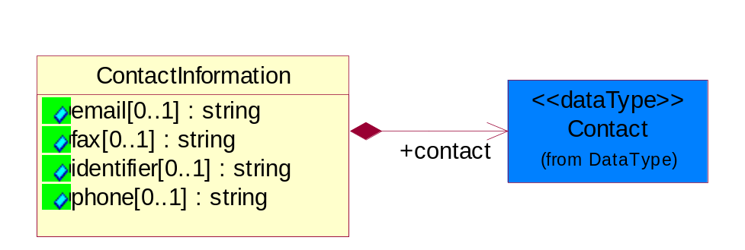
Figure 4-27 ContactInformation

Attribute | Type | Documentation
email[0..1] | string | The electronic mail for the specified contact.
fax[0..1] | string | The fax number for the specified contact.
identifier[0..1] | string | Identifies the role of the contact (i.e. Service Technician, Account Manager) in the Business Process.
phone[0..1] | string | The telephone number for the specified contact.

Composition | Cardinality | Type | Documentation
contact | 1 | Contact | The name of the department, service or individual to be contacted within the organization.

DataType

Contact
The name of the department, service or individual to be contacted within the organization.
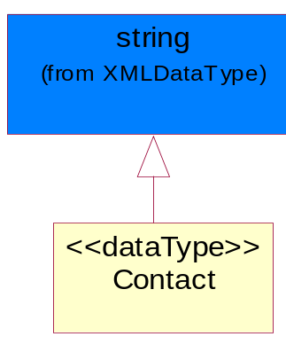
Figure 4-28 Contact

DUNS
A number assigned by Dun and Bradstreet to identify a business location.
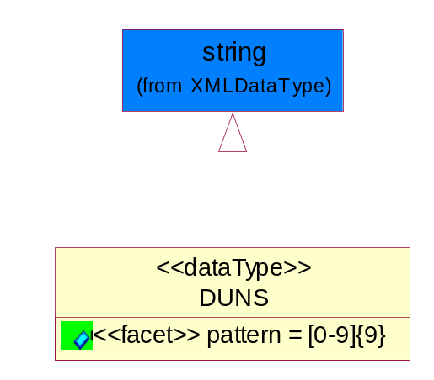
Figure 4-29 DUNS

Attribute | Type | Documentation
pattern |  | [0-9]{9}

DUNSPlus4
A identifier to specify a specific location within a business location.
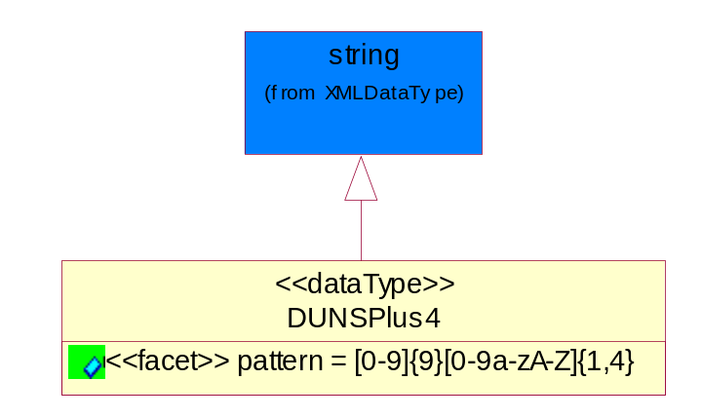
Figure 4-30 DUNSPlus4

Attribute | Type | Documentation
pattern |  | Data Universal Numbering System +4 (DUNS+4) number means the DUNS number assigned by Dun and Bradstreet, Inc. (D&B) plus an alphanumeric of length 4 suffix that may be assigned by a business concern.

GLN
Global Location Number (GLN) - A identifier to identify legal entities, trading parties and location.
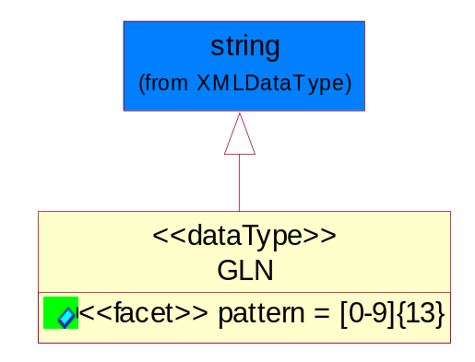
Figure 4-31 GLN

Attribute | Type | Documentation
pattern |  | [0-9]{13}

GTIN
Global Trade Identification Number (GTIN).
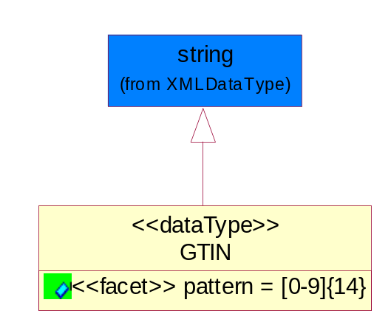
Figure 4-32 GTIN

Attribute | Type | Documentation
pattern |  | [0-9]{14}

Dates

DatePeriod
The business document must allow for the computation or statement of a duration based upon a beginning and an ending date.
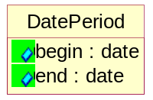
Figure 4-33 DatePeriod

Attribute | Type | Documentation
begin | date | The date indicating the beginning of the date period.
end | date | The date indicating the ending of the date period.

Locations

AlternativeIdentifier
Identifies the specified code and the name of the organization that a code is utilized from.
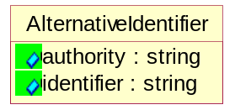
Figure 4-34 AlternativeIdentifier

Attribute | Type | Documentation
authority | string | The name of the organization that a code is utilized from.
identifier | string | The specified code to represent an entity (e.g. product, location, partner, etc.).

MonetaryExpression

FinancialAmount
The business document must express financial amounts.
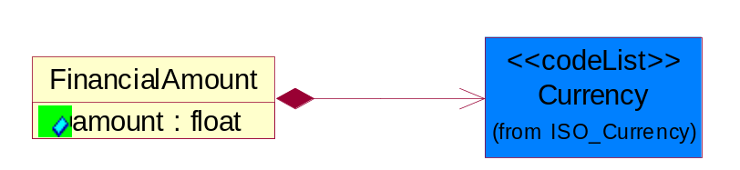
Figure 4-35 FinancialAmount

Attribute | Type | Documentation
amount | float | Specifies the monetary amount.

Composition | Cardinality | Type | Documentation
Currency | 1 | Currency | For representation of Currency codes RosettaNet has adopted ISO 4217; 1995. The British Standards Institution (BSI) is the ISO 4217 Maintenance Agency. Refer to the following web page to get the latest version of the standard:  http://www.bsi-global.com/Technical+Information/Publications/_Publications/tig90.xalter  If you need more information about the ISO standard please contact ISO for more details.

PartnerIdentification

PartnerIdentification
The business document must allow for the identity of one or more parties to the transaction.
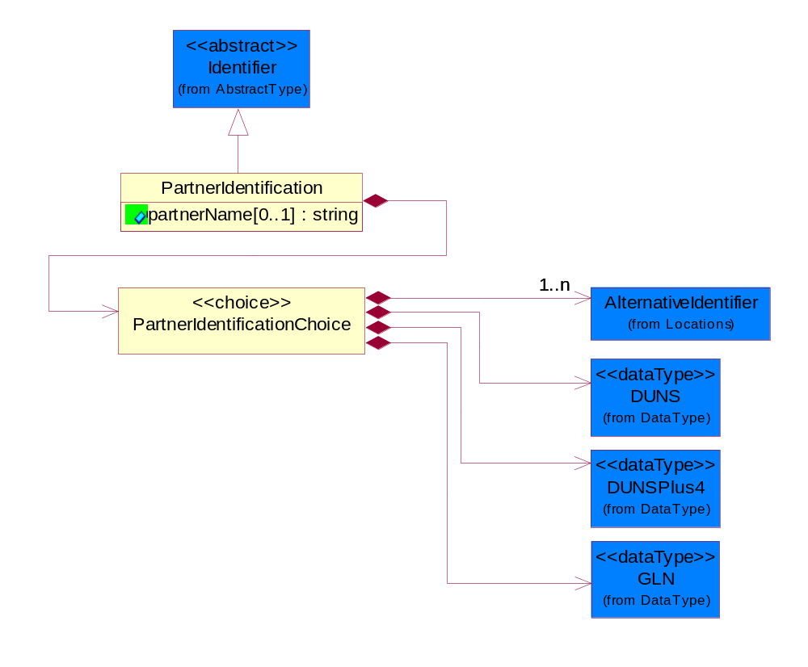
Figure 4-36 PartnerIdentification

Attribute | Type | Documentation
partnerName[0..1] | string | The name of the partner’s company/business.

Composition | Cardinality | Type | Documentation
PartnerIdentificationChoice | 1 | PartnerIdentificationChoice

PartnerIdentificationChoice

Composition | Cardinality | Type | Documentation
AlternativeIdentifier | 1..n | AlternativeIdentifier | Identifies the specified code and the name of the organization that a code is utilized from.
DUNS | 1 | DUNS | A number assigned by Dun and Bradstreet to identify a business location.
DUNSPlus4 | 1 | DUNSPlus4 | A identifier to specify a specific location within a business location.
GLN | 1 | GLN | Global Location Number (GLN) - A identifier to identify legal entities, trading parties and location.

ProductIdentification

ProductIdentification
The object provides the identifier(s) of a product.
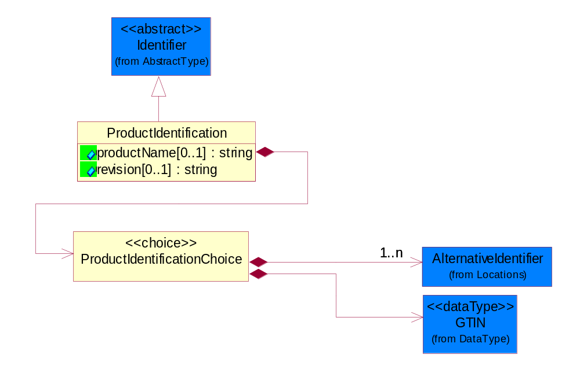
Figure 4-37 ProductIdentification

Attribute | Type | Documentation
productName[0..1] | string | The name of the product.
revision[0..1] | string | Referenced the specified product revision.

Composition | Cardinality | Type | Documentation
ProductIdentificationChoice | 1 | ProductIdentificationChoice

ProductIdentificationChoice

Composition | Cardinality | Type | Documentation
AlternativeIdentifier | 1..n | AlternativeIdentifier | Identifies the specified code and the name of the organization that a code is utilized from.
GTIN | 1 | GTIN | Global Trade Identification Number (GTIN).

TextualDescription
The business document must allow for multiple levels of textual description of an event or object.
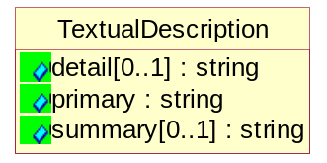
Figure 4-38 TextualDescription

Attribute | Type | Documentation
detail[0..1] | string | A detail description of an event or object.
primary | string | A phrase or single word description of an event or object.
summary[0..1] | string | A condensed description of an event or object.

CodeList

Country
For representation of Country name RosettaNet has adopted ISO 3166-3; 1999. Refer to the following web page to get the latest version of the standard:
http://www.iso.ch/iso/en/prods-services/iso3166ma/02iso-3166-code-lists/index.html

If you need more information about the ISO standard please contact ISO for more details.

Currency
For representation of Currency codes RosettaNet has adopted ISO 4217; 1995. The British Standards Institution (BSI) is the ISO 4217 Maintenance Agency. Refer to the following web page to get the latest version of the standard:
http://www.bsi-global.com/Technical+Information/Publications/_Publications/tig90.xalter

If you need more information about the ISO standard please contact ISO for more details.

Language
For representation of Language name RosettaNet has adopted ISO 639-2; 1998. Refer to the following web page to get the latest version of the standard:

http://www.loc.gov/standards/iso639-2/iso639jac.html

If you need more information about the ISO standard please contact ISO for more details.

MimeTypeQualifier
The MIME type as defined by IANA.

Please refer to http://www.iana.org/assignments/media-types/ for a list of types.

Instance | Documentation
application/activemessage | [Shapiro]
application/andrew-inset | [Borenstein]
application/applefile | [Faltstrom]
application/atomicmail | [Borenstein]
application/batch-SMTP | [RFC2442]
application/beep+xml | [RFC3080]
application/cals-1840 | [RFC1895]
application/cnrp+xml | [RFCCNRP]
application/commonground | [Glazer]
application/cpl+xml
application/cybercash | [Eastlake]
application/dca-rft | [Campbell]
application/dec-dx | [Campbell]
application/dicom | [RFC3240]
application/dvcs | [RFC3029]
application/EDI-Consent | [RFC1767]
application/EDIFACT | [RFC1767]
application/EDI-X12 | [RFC1767]
application/eshop | [Katz]
application/font-tdpfr | [RFC3073]
application/http | [RFC2616]
application/hyperstudio | [Domino]
application/iges | [Parks]
application/index | [RFC2652]
application/index.cmd | [RFC2652]
application/index.obj | [RFC2652]
application/index.response | [RFC2652]
application/index.vnd | [RFC2652]
application/iotp | [RFC2935]
application/ipp | [RFC2910]
application/isup | [RFC3204]
application/mac-binhex40 | [Faltstrom]
application/macwriteii | [Lindner]
application/marc | [RFC2220]
application/mathematica | [Van Nostern]
application/msword | [Lindner]
application/news-message-id | [RFC1036,Spencer]
application/news-transmission | [RFC1036, Spencer]
application/ocsp-request | [RFC2560]
application/ocsp-response | [RFC2560]
application/octet-stream | [RFC2045,RFC2046]
application/oda | [RFC2045,RFC2046]
application/ogg | [RFC-walleij-ogg-mediatype-08.txt]
application/parityfec | [RFC3009]
application/pdf | [Lindner]
application/pgp-encrypted | [RFC3156]
application/pgp-keys | [RFC3156]
application/pgp-signature | [RFC3156]
application/pkcs10 | [RFC2311]
application/pkcs7-mime | [RFC2311]
application/pkcs7-signature | [RFC2311]
application/pkix-cert | [RFC2585]
application/pkixcmp | [RFC2510]
application/pkix-crl | [RFC2585]
application/postscript | [RFC2045,RFC2046]
application/prs.alvestrand.titrax-sheet | [Alvestrand]
application/prs.cww | [Rungchavalnont]
application/prs.nprend | [Doggett]
application/prs.plucker | [Janssen]
application/qsig | [RFC3204]
application/reginfo+xml | [RFC-ietf-sipping-reg-event-00.txt]
application/remote-printing | [RFC1486,Rose]
application/riscos | [Smith]
application/rtf | [Lindner]
application/sdp | [RFC2327]
application/set-payment | [Korver]
application/set-payment-initiation | [Korver]
application/set-registration | [Korver]
application/set-registration-initiation | [Korver]
application/sgml | [RFC1874]
application/sgml-open-catalog | [Grosso]
application/sieve | [RFC3028]
application/slate | [Crowley]
application/timestamp-query | [RFC3161]
application/timestamp-reply | [RFC3161]
application/tve-trigger | [Welsh]
application/vemmi | [RFC2122]
application/vnd.3gpp.pic-bw-large | [Meredith]
application/vnd.3gpp.pic-bw-small | [Meredith]
application/vnd.3gpp.pic-bw-var | [Meredith]
application/vnd.3gpp.sms | [Meredith]
application/vnd.3M.Post-it-Notes | [O'Brien]
application/vnd.accpac.simply.aso | [Leow]
application/vnd.accpac.simply.imp | [Leow]
application/vnd.acucobol | [Lubin]
application/vnd.acucorp | [Lubin]
application/vnd.adobe.xfdf | [Perelman]
application/vnd.aether.imp | [Moskowitz]
application/vnd.amiga.ami | [Blumberg]
application/vnd.anser-web-certificate-issue-initiation | [Mori]
application/vnd.anser-web-funds-transfer-initiation | [Mori]
application/vnd.audiograph | [Slusanschi]
application/vnd.blueice.multipass | [Holmstrom]
application/vnd.bmi | [Gotoh]
application/vnd.businessobjects | [Imoucha]
application/vnd.canon-cpdl | [Muto]
application/vnd.canon-lips | [Muto]
application/vnd.cinderella | [Kortenkamp]
application/vnd.claymore | [Simpson]
application/vnd.commerce-battelle | [Applebaum]
application/vnd.commonspace | [Chandhok]
application/vnd.contact.cmsg | [Patz]
application/vnd.cosmocaller | [Dellutri]
application/vnd.ctc-posml | [Kohlhepp]
application/vnd.cups-postscript | [Sweet]
application/vnd.cups-raster | [Sweet]
application/vnd.cups-raw | [Sweet]
application/vnd.curl | [Byrnes]
application/vnd.cybank | [Helmee]
application/vnd.data-vision.rdz | [Fields]
application/vnd.dna | [Searcy]
application/vnd.dpgraph | [Parker]
application/vnd.dreamfactory | [Appleton]
application/vnd.dxr | [Duffy]
application/vnd.ecdis-update | [Buettgenbach]
application/vnd.ecowin.chart | [Olsson]
application/vnd.ecowin.filerequest | [Olsson]
application/vnd.ecowin.fileupdate | [Olsson]
application/vnd.ecowin.series | [Olsson]
application/vnd.ecowin.seriesrequest | [Olsson]
application/vnd.ecowin.seriesupdate | [Olsson]
application/vnd.enliven | [Santinelli]
application/vnd.epson.esf | [Hoshina]
application/vnd.epson.msf | [Hoshina]
application/vnd.epson.quickanime | [Gu]
application/vnd.epson.salt | [Nagatomo]
application/vnd.epson.ssf | [Hoshina]
application/vnd.ericsson.quickcall | [Tidwell]
application/vnd.eudora.data | [Resnick]
application/vnd.fdf | [Zilles]
application/vnd.ffsns | [Holstage]
application/vnd.FloGraphIt | [Floersch]
application/vnd.framemaker | [Wexler]
application/vnd.fsc.weblaunch | [D.Smith]
application/vnd.fujitsu.oasys | [Togashi]
application/vnd.fujitsu.oasys2 | [Togashi]
application/vnd.fujitsu.oasys3 | [Okudaira]
application/vnd.fujitsu.oasysgp | [Sugimoto]
application/vnd.fujitsu.oasysprs | [Ogita]
application/vnd.fujixerox.ddd | [Onda]
application/vnd.fujixerox.docuworks | [Taguchi]
application/vnd.fujixerox.docuworks.binder | [Matsumoto]
application/vnd.fut-misnet | [Pruulmann]
application/vnd.grafeq | [Tupper]
application/vnd.groove-account | [Joseph]
application/vnd.groove-help | [Joseph]
application/vnd.groove-identity-message | [Joseph]
application/vnd.groove-injector | [Joseph]
application/vnd.groove-tool-message | [Joseph]
application/vnd.groove-tool-template | [Joseph]
application/vnd.groove-vcard | [Joseph]
application/vnd.hbci | [Hammann]
application/vnd.hhe.lesson-player | [Jones]
application/vnd.hp-HPGL | [Pentecost]
application/vnd.hp-hpid | [Gupta]
application/vnd.hp-hps | [Aubrey]
application/vnd.hp-PCL | [Pentecost]
application/vnd.hp-PCLXL | [Pentecost]
application/vnd.httphone | [Lefevre]
application/vnd.hzn-3d-crossword | [Minnis]
application/vnd.ibm.afplinedata | [Buis]
application/vnd.ibm.electronic-media | [Tantlinger]
application/vnd.ibm.MiniPay | [Herzberg]
application/vnd.ibm.modcap | [Hohensee]
application/vnd.ibm.secure-container | [Tantlinger]
application/vnd.informix-visionary | [Gales]
application/vnd.intercon.formnet | [Gurak]
application/vnd.intertrust.digibox | [Tomasello]
application/vnd.intertrust.nncp | [Tomasello]
application/vnd.intu.qbo | [Scratchley]
application/vnd.intu.qfx | [Scratchley]
application/vnd.irepository.package+xml | [Knowles]
application/vnd.is-xpr | [Natarajan]
application/vnd.japannet-directory-service | [Fujii]
application/vnd.japannet-jpnstore-wakeup | [Yoshitake]
application/vnd.japannet-payment-wakeup | [Fujii]
application/vnd.japannet-registration | [Yoshitake]
application/vnd.japannet-registration-wakeup | [Fujii]
application/vnd.japannet-setstore-wakeup | [Yoshitake]
application/vnd.japannet-verification | [Yoshitake]
application/vnd.japannet-verification-wakeup | [Fujii]
application/vnd.jisp | [Deckers]
application/vnd.kde.karbon | [Faure]
application/vnd.kde.kchart | [Faure]
application/vnd.kde.kformula | [Faure]
application/vnd.kde.kivio | [Faure]
application/vnd.kde.kontour | [Faure]
application/vnd.kde.kpresenter | [Faure]
application/vnd.kde.kspread | [Faure]
application/vnd.kde.kword | [Faure]
application/vnd.kenameaapp | [DiGiorgio-Haag]
application/vnd.koan | [Cole]
application/vnd.liberty-request+xml | [McDowell]
application/vnd.llamagraphics.life-balance.desktop | [White]
application/vnd.lotus-1-2-3 | [Wattenberger]
application/vnd.lotus-approach | [Wattenberger]
application/vnd.lotus-freelance | [Wattenberger]
application/vnd.lotus-notes | [Laramie]
application/vnd.lotus-organizer | [Wattenberger]
application/vnd.lotus-screencam | [Wattenberger]
application/vnd.lotus-wordpro | [Wattenberger]
application/vnd.mcd | [Gotoh]
application/vnd.mediastation.cdkey | [Flurry]
application/vnd.meridian-slingshot | [Wedel]
application/vnd.micrografx.flo | [Prevo]
application/vnd.micrografx.igx | [Prevo]
application/vnd.mif | [Wexler]
application/vnd.minisoft-hp3000-save | [Bartram]
application/vnd.mitsubishi.misty-guard.trustweb | [Tanaka]
application/vnd.Mobius.DAF | [Kabayama]
application/vnd.Mobius.DIS | [Kabayama]
application/vnd.Mobius.MBK | [Devasia]
application/vnd.Mobius.MQY | [Devasia]
application/vnd.Mobius.MSL | [Kabayama]
application/vnd.Mobius.PLC | [Kabayama]
application/vnd.Mobius.TXF | [Kabayama]
application/vnd.mophun.application | [Wennerstrom]
application/vnd.mophun.certificate | [Wennerstrom]
application/vnd.motorola.flexsuite | [Patton]
application/vnd.motorola.flexsuite.adsi | [Patton]
application/vnd.motorola.flexsuite.fis | [Patton]
application/vnd.motorola.flexsuite.gotap | [Patton]
application/vnd.motorola.flexsuite.kmr | [Patton]
application/vnd.motorola.flexsuite.ttc | [Patton]
application/vnd.motorola.flexsuite.wem | [Patton]
application/vnd.mozilla.xul+xml | [McDaniel]
application/vnd.ms-artgalry | [Slawson]
application/vnd.ms-asf | [Fleischman]
application/vnd.mseq | [Le Bodic]
application/vnd.ms-excel | [Gill]
application/vnd.msign | [Borcherding]
application/vnd.ms-lrm | [Ledoux]
application/vnd.ms-powerpoint | [Gill]
application/vnd.ms-project | [Gill]
application/vnd.ms-tnef | [Gill]
application/vnd.ms-works | [Gill]
application/vnd.ms-wpl | [Plastina]
application/vnd.musician | [Adams]
application/vnd.music-niff | [Butler]
application/vnd.netfpx | [Mutz]
application/vnd.noblenet-directory | [Solomon]
application/vnd.noblenet-sealer | [Solomon]
application/vnd.noblenet-web | [Solomon]
application/vnd.novadigm.EDM | [Swenson]
application/vnd.novadigm.EDX | [Swenson]
application/vnd.novadigm.EXT | [Swenson]
application/vnd.obn | [Hessling]
application/vnd.osa.netdeploy | [Klos]
application/vnd.palm | [Peacock]
application/vnd.pg.format | [Gandert]
application/vnd.pg.osasli | [Gandert]
application/vnd.powerbuilder6 | [Guy]
application/vnd.powerbuilder6-s | [Guy]
application/vnd.powerbuilder7 | [Shilts]
application/vnd.powerbuilder75 | [Shilts]
application/vnd.powerbuilder75-s | [Shilts]
application/vnd.powerbuilder7-s | [Shilts]
application/vnd.previewsystems.box | [Smolgovsky]
application/vnd.publishare-delta-tree | [Ben-Kiki]
application/vnd.pvi.ptid1 | [Lamb]
application/vnd.pwg-multiplexed | [RFC3391]
application/vnd.pwg-xhtml-print+xml | [Wright]
application/vnd.Quark.QuarkXPress | [Scheidler]
application/vnd.rapid | [Szekely]
application/vnd.s3sms | [Tarkkala]
application/vnd.sealed.net | [Lambert]
application/vnd.seemail | [Webb]
application/vnd.shana.informed.formdata | [Selzler]
application/vnd.shana.informed.formtemplate | [Selzler]
application/vnd.shana.informed.interchange | [Selzler]
application/vnd.shana.informed.package | [Selzler]
application/vnd.smaf | [Takahashi]
application/vnd.sss-cod | [Dani]
application/vnd.sss-dtf | [Bruno]
application/vnd.sss-ntf | [Bruno]
application/vnd.street-stream | [Levitt]
application/vnd.svd | [Becker]
application/vnd.swiftview-ics | [Widener]
application/vnd.triscape.mxs | [Simonoff]
application/vnd.trueapp | [Hepler]
application/vnd.truedoc | [Chase]
application/vnd.ufdl | [Manning]
application/vnd.uplanet.alert | [Martin]
application/vnd.uplanet.alert-wbxml | [Martin]
application/vnd.uplanet.bearer-choice | [Martin]
application/vnd.uplanet.bearer-choice-wbxml | [Martin]
application/vnd.uplanet.cacheop | [Martin]
application/vnd.uplanet.cacheop-wbxml | [Martin]
application/vnd.uplanet.channel | [Martin]
application/vnd.uplanet.channel-wbxml | [Martin]
application/vnd.uplanet.list | [Martin]
application/vnd.uplanet.listcmd | [Martin]
application/vnd.uplanet.listcmd-wbxml | [Martin]
application/vnd.uplanet.list-wbxml | [Martin]
application/vnd.uplanet.signal | [Martin]
application/vnd.vcx | [T.Sugimoto]
application/vnd.vectorworks | [Pharr]
application/vnd.vidsoft.vidconference | [Hess]
application/vnd.visio | [Sandal]
application/vnd.visionary | [Aravindakumar]
application/vnd.vividence.scriptfile | [Risher]
application/vnd.vsf | [Rowe]
application/vnd.wap.sic | [WAP-Forum]
application/vnd.wap.slc | [WAP-Forum]
application/vnd.wap.wbxml | [Stark]
application/vnd.wap.wmlc | [Stark]
application/vnd.wap.wmlscriptc | [Stark]
application/vnd.webturbo | [Rehem]
application/vnd.wrq-hp3000-labelled | [Bartram]
application/vnd.wt.stf | [Wohler]
application/vnd.wv.csp+wbxml | [Salmi]
application/vnd.xara | [Matthewman]
application/vnd.xfdl | [Manning]
application/vnd.yellowriver-custom-menu | [Yellow]
application/whoispp-query | [RFC2957]
application/whoispp-response | [RFC2958]
application/wita | [Campbell]
application/wordperfect5.1 | [Lindner]
application/x400-bp | [RFC1494]
application/xhtml+xml | [RFC3236]
application/xml | [RFC3023]
application/xml-dtd | [RFC3023]
application/xml-external-parsed-entity | [RFC3023]
application/zip | [Lindner]
audio/32kadpcm | [RFC2421,RFC2422]
audio/AMR | [RFC3267]
audio/AMR-WB | [RFC3267]
audio/basic | [RFC2045,RFC2046]
audio/CN | [RFC3389]
audio/DAT12 | [RFC3190]
audio/DVI4
audio/EVRC | [RFC-ietf-avt-evrc-smv-03.txt]
audio/EVRC0 | [RFC-ietf-avt-evrc-smv-03.txt]
audio/G.722.1 | [RFC3047]
audio/G722
audio/G723
audio/G726-16
audio/G726-24
audio/G726-32
audio/G726-40
audio/G728
audio/G729
audio/G729D
audio/G729E
audio/GSM
audio/GSM-EFR
audio/L16 | [RFC2586]
audio/L20 | [RFC3190]
audio/L24 | [RFC3190]
audio/L8
audio/LPC
audio/MP4A-LATM | [RFC3016]
audio/MPA
audio/mpa-robust | [RFC3119]
audio/mpeg | [RFC3003]
audio/parityfec | [RFC3009]
audio/PCMA
audio/PCMU
audio/prs.sid | [Walleij]
audio/QCELP
audio/RED
audio/SMV | [RFC-ietf-avt-evrc-smv-03.txt]
audio/SMV0 | [RFC-ietf-avt-evrc-smv-03.txt]
audio/telephone-event | [RFC2833]
audio/tone | [RFC2833]
audio/VDVI
audio/vnd.3gpp.iufp | [Belling]
audio/vnd.cisco.nse | [Kumar]
audio/vnd.cns.anp1 | [McLaughlin]
audio/vnd.cns.inf1 | [McLaughlin]
audio/vnd.digital-winds | [Strazds]
audio/vnd.everad.plj | [Cicelsky]
audio/vnd.lucent.voice | [Vaudreuil]
audio/vnd.nortel.vbk | [Parsons]
audio/vnd.nuera.ecelp4800 | [Fox]
audio/vnd.nuera.ecelp7470 | [Fox]
audio/vnd.nuera.ecelp9600 | [Fox]
audio/vnd.octel.sbc | [Vaudreuil]
audio/vnd.qcelp | [Lundblade]
audio/vnd.rhetorex.32kadpcm | [Vaudreuil]
audio/vnd.vmx.cvsd | [Vaudreuil]
image/cgm | Computer Graphics Metafile
image/g3fax | [RFC1494]
image/gif | [RFC2045,RFC2046]
image/ief | [RFC1314] Image Exchange Format
image/jpeg | [RFC2045,RFC2046]
image/naplps | [Ferber]
image/png | [Randers-Pehrson]
image/prs.btif | [Simon]
image/prs.pti | [Laun]
image/t38 | [RFC3362]
image/tiff | [RFC3302] Tag Image File Format
image/tiff-fx | [RFC3250] Tag Image File Format Fax eXtended
image/vnd.cns.inf2 | [McLaughlin]
image/vnd.djvu | [Bottou]
image/vnd.dwg | [Moline]
image/vnd.dxf | [Moline]
image/vnd.fastbidsheet | [Becker]
image/vnd.fpx | [Spencer]
image/vnd.fst | [Fuldseth]
image/vnd.fujixerox.edmics-mmr | [Onda]
image/vnd.fujixerox.edmics-rlc | [Onda]
image/vnd.globalgraphics.pgb | [Bailey]
image/vnd.mix | [Reddy]
image/vnd.ms-modi | [Vaughan]
image/vnd.net-fpx | [Spencer]
image/vnd.svf | [Moline]
image/vnd.wap.wbmp | [Stark]
image/vnd.xiff | [S.Martin]
message/delivery-status | [RFC1894]
message/disposition-notification | [RFC2298]
message/external-body | [RFC2045,RFC2046]
message/http | [RFC2616]
message/news | [RFC 1036, H.Spencer]
message/partial | [RFC2045,RFC2046]
message/rfc822 | [RFC2045,RFC2046]
message/s-http | [RFC2660]
message/sip | [RFC3261]
message/sipfrag | [RFC3420]
model/iges | [Parks]
model/mesh | [RFC2077]
model/vnd.dwf | [Pratt]
model/vnd.flatland.3dml | [Powers]
model/vnd.gdl | [Babits]
model/vnd.gs-gdl | [Babits]
model/vnd.gtw | [Ozaki]
model/vnd.mts | [Rabinovitch]
model/vnd.parasolid.transmit.binary | [Parasolid]
model/vnd.parasolid.transmit.text | [Parasolid]
model/vnd.vtu | [Rabinovitch]
model/vrml | [RFC2077]
multipart/alternative | [RFC2045,RFC2046]
multipart/appledouble | [Faltstrom]
multipart/byteranges | [RFC2068]
multipart/digest | [RFC2045,RFC2046]
multipart/encrypted | [RFC1847]
multipart/form-data | [RFC2388]
multipart/header-set | [Crocker]
multipart/mixed | [RFC2045,RFC2046]
multipart/parallel | [RFC2045,RFC2046]
multipart/related | [RFC2387]
multipart/report | [RFC1892]
multipart/signed | [RFC1847]
multipart/voice-message | [RFC2421,RFC2423]
text/calendar | [RFC2445]
text/css | [RFC2318]
text/directory | [RFC2425]
text/enriched | [RFC1896]
text/html | [RFC2854]
text/parityfec | [RFC3009]
text/plain | [RFC2646,RFC2046]
text/prs.lines.tag | [Lines]
text/rfc822-headers | [RFC1892]
text/richtext | [RFC2045,RFC2046]
text/rtf | [Lindner]
text/sgml | [RFC1874]
text/t140 | [RFC2793]
text/tab-separated-values | [Lindner]
text/uri-list | [RFC2483]
text/vnd.abc | [Allen]
text/vnd.curl | [Byrnes]
text/vnd.DMClientScript | [Bradley]
text/vnd.fly | [Gurney]
text/vnd.fmi.flexstor | [Hurtta]
text/vnd.in3d.3dml | [Powers]
text/vnd.in3d.spot | [Powers]
text/vnd.IPTC.NewsML | [IPTC]
text/vnd.IPTC.NITF | [IPTC]
text/vnd.latex-z | [Lubos]
text/vnd.motorola.reflex | [Patton]
text/vnd.ms-mediapackage | [Nelson]
text/vnd.net2phone.commcenter.command | [Xie]
text/vnd.sun.j2me.app-descriptor | [G.Adams]
text/vnd.wap.si | [WAP-Forum]
text/vnd.wap.sl | [WAP-Forum]
text/vnd.wap.wml | [Stark]
text/vnd.wap.wmlscript | [Stark]
text/xml | [RFC3023]
text/xml-external-parsed-entity | [RFC3023]
video/BMPEG
video/BT656
video/CelB
video/DV | [RFC3189]
video/H261
video/H263
video/H263-1998
video/H263-2000
video/JPEG
video/MP1S
video/MP2P
video/MP2T
video/MP4V-ES | [RFC3016]
video/mpeg | [RFC2045,RFC2046]
video/MPV
video/nv
video/parityfec | [RFC3009]
video/pointer | [RFC2862]
video/quicktime | [Lindner]
video/SMPTE292M | [RFC-avt-smpte292-video-08.txt]
video/vnd.fvt | [Fuldseth]
video/vnd.motorola.video | [McGinty]
video/vnd.motorola.videop | [McGinty]
video/vnd.mpegurl | [Recktenwald]
video/vnd.nokia.interleaved-multimedia | [Kangaslampi]
video/vnd.objectvideo | [Clark]
video/vnd.vivo | [Wolfe]

UnitOfMeasure
Code identifying a product unit of measure.

Instance | Documentation
10P | 10-pack.
1BF | 100 Board Feet.
1FC | 20 Foot Container.
1GR | Gram/Cubic Centimeter.
1GT | 10,000 Gallon Tankcar.
1KB | 25 Kilogram Bulk Bag.
1KD | 10 Kilogram Drum.
1KP | 1000-pack.
1PA | 20-Pack.
1PB | 50 Pound Bag.
1PD | 100 Pound Drum.
2FC | 40 Foot Container.
2GR | Gram/square meter.
2GT | 20,000 Gallon Tankcar.
2KB | 300 Kilogram Bulk Bag.
2KD | 15 Kilogram Drum.
2PA | 100-Pack.
3GR | Grams Per 100 Centimeters.
3KB | 500 Kilogram Bulk Bag.
3KD | 55 Gallon Drum.
4GR | Grams Per 100 Grams.
4KD | 115 Kilogram Drum.
50P | 50-pack.
5GR | Grams Per Cubic Centimeter.
6GR | Grams Per Square Centimeter.
7GR | Grams Per Square Meter.
ACR | Acre.
ACT | Actual Pounds.
ALU | Aluminum Pounds Only.
AMP | Ampere.
ASM | Angstrom.
BAB | Base Box.
BAC | Batch.
BAE | Bale.
BAG | Bag.
BAL | Ball.
BAN | Band.
BAP | Batting Pound.
BAR | Bar.
BAS | Basket.
BAT | Batt.
BAW | Base Weight.
BEA | Beam.
BEC | Becquerel/kilogram.
BEL | Belt.
BIL | Billet.
BIN | Bin.
BIT | Bit.
BKC | Bulk Car Load.
BLO | Block.
BOA | Board.
BOF | Board Feet.
BOL | Bolt.
BOT | Bottle.
BOX | Box.
BRD | Barrels Per Day.
BRE | Barrel.
BRI | Barrel (Imperial).
BRM | Barrels Per Minute.
BTF | British Thermal Units (BTUs) Per Cubic Foot.
BTP | British Thermal Units (BTUs) Per Pound.
BTU | British Thermal Unit (BTU).
BUC | Bucket.
BUD | Bushel, Dry Imperial.
BUK | Bunks.
BUL | Bulk.
BUN | Bundle.
BUP | Bulk Pack.
BUS | Bushel.
BYT | Bytes.
CAA | Carat.
CAB | Carboy.
CAC | Card.
CAD | Candela.
CAG | Cartridge.
CAK | Cask.
CAL | Calorie.
CAN | Can.
CAO | Carload.
CAR | Car.
CAS | Case.
CAT | Canister.
CAW | Catchweight.
CEL | Cell.
CEM | Centimeter.
CEP | Centipoise (CPS).
CET | Centiliter.
CGM | Centigram.
CHA | Chains (Land Survey).
CHE | Chest.
CNN | Connector.
COG | Coil Group.
COI | Coil.
COL | Coulomb.
COM | Composite Product Pounds (Total Weight).
CON | Cone.
COT | Container.
COV | Cover.
CRA | Crate.
CRT | Carton.
CSE | Cassette.
CUB | Cubic centimeter.
CUC | Cubic centimeter/second.
CUF | Cubic Foot.
CUI | Cubic inch.
CUM | Cubicmeter.
CUP | Cup.
CUY | Cubic yard.
CYC | Cycles.
CYL | Cylinder.
DAY | Day.
DCB | Decibels.
DCG | Decagram.
DCL | Deciliter.
DEA | Deal.
DEC | Decimeter.
DEF | Degree Fahrenheit.
DEG | Degree Celsius.
DEP | Dep. Factor.
DGM | Decigram.
DIE | Die.
DIL | Display.
DIP | Dispenser.
DOZ | Dozen.
DRA | Dram.
DRU | Drum.
DRY | Dry Pounds.
EAC | Each.
ELE | Electrical Capacitance.
FAR | Farads.
FFA | Femtofarad.
FLO | Fluid Ounce.
FOI | Fluid Ounce (Imperial).
FOO | Foot.
FOU | Fluid Ounce US.
FUU | Fuel Usage (Gallons).
GAL | Gallon.
GAS | Gage Systems.
GIH | Gigahertz.
GIJ | Gigajoules.
GIL | Gill (Imperial).
GOB | Gross Barrels.
GOG | Gross Gallons.
GOK | Gross Kilogram.
GOT | Gross Ton.
GOY | Gross Yard.
GRA | Gram.
GRG | Great Gross (Dozen Gross).
GRK | Grams Per Kilogram.
GRL | Grams Per Liter.
GRM | Grams Per Milliliter.
GRN | Grain.
GRO | Gross.
GRP | Group.
HAG | Half Gallon.
HAH | Half Hour.
HAL | Half Liter.
HAN | Hank.
HEA | Heat lots.
HEC | Hectare.
HEL | Hectoliter.
HEP | Hectopascal.
HER | Hertz.
HNY | Henry.
HOS | Hours.
HOU | Hour.
HUA | Hundredth of a Carat.
HUB | Hundred Boxes.
HUC | Hundred Count.
HUS | Hundred Sheets.
IMG | Imperial Gallons.
INC | Inch.
JAR | Jar.
JOI | Joint.
JOU | Joule.
KBY | Kilobyte.
KEG | Keg.
KEL | Kelvin.
KHO | Kilometer/hour.
KIC | Kilogram per cubic meter.
KIE | Kilometer.
KIG | Kilogram.
KIH | Kilohertz.
KIK | Kilobecquerel/Kilogram.
KIL | Kiloampere.
KIM | Kilogram/square meter.
KIO | Kiloohm.
KIS | Kilogramm pro Sekunde.
KIT | Kit.
KIV | Kilovolt.
KIW | Kilowatt.
KJL | Kilojoule.
KKG | Kilogram/Kilogram.
KUD | Kubikdezimeter.
KUM | Kubikmeter pro Sekunde.
KWH | Kilowatt-hour.
LIF | Lifts.
LIM | Link.
LIQ | Liquid Pounds.
LIT | Liter.
LOA | Load.
LOT | Lot.
LUG | Lug.
MAM | Milliamps/mm.
MAT | Mat.
MBY | Megabyte.
MCG | Microgram.
MCM | Milligrams Per Cubic Meter.
MCR | Micron.
MEG | Megagram.
MEH | Megahertz.
MEP | Megapascal.
MET | Meter.
MEW | Megawatt.
MGM | Milligram.
MIB | Million BTU's.
MIC | Mikrogram/cubic meter.
MIG | Micrograms Per Cubic Meter.
MIL | Mile.
MIM | Micrometer.
MIN | Minute.
MIP | Millipascal seconds.
MIS | Microsecond.
MIT | Miter.
MIV | Millivolt.
MIW | Milliwatt.
MJO | Millijoule.
MLA | Milliampere.
MLB | Millibar.
MLC | Milligram/cubic meter.
MLI | Milliliter.
MLK | Milligram/kilogram.
MLL | Milligram/Liter.
MLS | Miles.
MME | Millimeter.
MMH | Millimeter H20.
MMK | Millimol/kilogram.
MMO | Millimol.
MOK | Mol/kilogram.
MOL | Mol.
MON | Month.
MPH | Megagrams Per Hour.
MSC | Millisecond.
MSM | Milligrams Per Square Meter.
MTA | Millitesla.
MTQ | Meter pro Quadratsekunde.
MTS | Meters per second.
MUL | Multichip - When 2 or more dies (chips) are merged into one package.
MVS | Millivolts.
MVT | Millivolt.
NAA | Nanoamps.
NAM | Nanometer.
NAS | Nanosecond.
NEB | Net Barrels.
NEG | Net Gallons.
NEI | Net Imperial Gallons.
NEL | Net Liters.
NEW | Newton.
OCT | Ohm/ct.
OHM | Ohm.
OMM | Ohm/mm.
ONE | One.
OSQ | Ohm/sq.
OTP | One Thousand Pieces.
OUN | Ounce.
OVI | Ohm/via.
PAC | Parcel.
PAD | Pad.
PAG | Package.
PAI | Pail.
PAK | Pack (PAK).
PAL | Pallet.
PAN | Panel.
PAR | Pair.
PAS | Pascal.
PAT | Packet.
PEC | Percent.
PEG | Percentage.
PEH | Percent Per 1000 Hours.
PEN | Pennyweight.
PER | Per Hundred Pieces.
PEW | Percent Weight.
PFR | Picofarad.
PID | Pint U.S. Dry.
PIE | Piece.
PIL | Pint - US liquid.
PLA | Plate.
PLL | Pallet (Lift).
PLT | Pallete.
PLU | Pallet/Unit Load.
POF | Pounds Per Foot.
POG | Pounds Per Gallon.
PON | Pound.
POP | Pounds Per Piece of Product.
POS | Pounds Per 1000 Square Feet.
POT | Pounds Per Thousand.
PPB | Parts per billion (US).
PPM | Parts per million.
PPP | Pounds Per Pound of Product.
PSC | Picosecond.
PSS | Pascal second.
QUA | Quart - US liquid.
RAC | Rack.
REA | Ream of 500 Sheets.
REE | Reel.
RIN | Ring.
ROD | Rod.
ROL | Roll.
SAC | Sack.
SBB | Super Bulk Bag.
SEC | Second.
SET | Set.
SHE | Sheet.
SHI | Shipment.
SHM | Sheet - Metric measure.
SHO | Shot.
SID | Disk (Disc).
SKE | Skein.
SKI | Skid.
SLE | Sleeve.
SLI | Slip Sheet.
SMI | Square mile.
SMM | Square millimeter.
SPO | Spool.
SQF | Square foot.
SQI | Square inch.
SQK | Square kilometer.
SQM | Square meter.
SQS | Square meter/second.
SQU | Square.
SQY | Square Yard.
STI | Stick.
STM | Statute Mile.
STR | Strip.
TAB | Tablet.
TAN | Tank.
TAT | Tank Truck.
TES | Tesla.
THO | Thousand.
TNN | Tonne.
TON | Ton.
TOR | Torr.
TOT | Tote.
TRA | Train.
TRF | Track Foot.
TRL | Trailer.
TRO | Troy.
TRU | Truckload.
TRY | Tray.
TRZ | Troy OZ.
TUB | Tube.
ULU | Unitless Unit of Measure.
UNT | Unit.
USG | US gallon.
USP | US pound.
UST | US ton.
VIA | Vial.
VOL | Volt.
VTA | Volts (Alternating Current).
VTD | Volts (Direct Current).
VTM | Volts Per Meter.
WAF | Wafer.
WAR | Watt.
WEE | Week.
WRA | Wrap.
YAR | Yard.
YEA | Year.

System Structure

BusinessProcessIdentifier
A Business Process Identifier to uniquely define the TPIR-PIP 'role' within a Business Scenario at a company or MNC level. The identifier MUST be composed of alphanumeric characters only and its length MUST be between one and twelve characters.
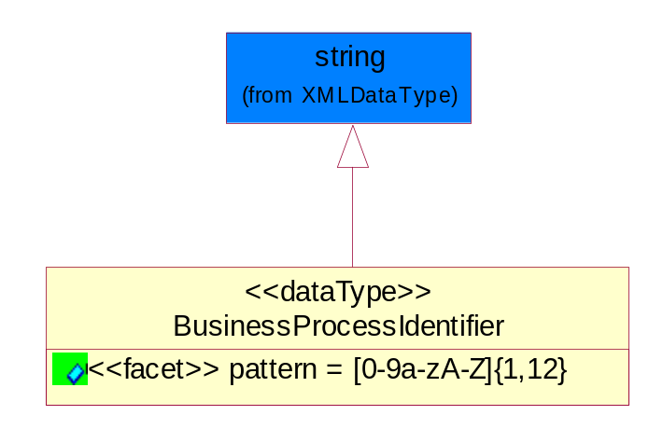
Figure 5-39 BusinessProcessIdentifier

Attribute | Type | Documentation
pattern |  | [0-9a-zA-Z]{1,12}

BusinessServiceInformation
The object allows the specification of the business service utilized within the partner company. This may or may not be the same as the information sent by the RNIF.
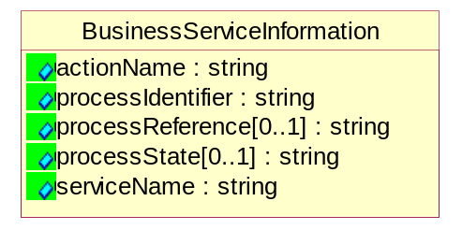
Figure 5-40 BusinessServiceInformation

Attribute | Type | Documentation
actionName | string | The name of Action. For RosettaNet usually any of Request/Confirm/Notify/Query/Response.
processIdentifier | string | The name of the PIP e.g. Notify of Forecast Reply.
processReference[0..1] | string | The URN for the PIP that includes Cluster/Segment/Process pattern used to identify the interface process (such as PIP3A4)
processState[0..1] | string | The business process (or service) state of the sender of a document. When a service receives this document, the receiver may use the state as a precondition.
serviceName | string | The name of the Business Activity with the "Request/Confirm" part removed. E.g., for the Activity "Request Purchase Order"==> "Purchase Order".

ContractInformation
A block of information used to correlate a contract in an executing choreography.
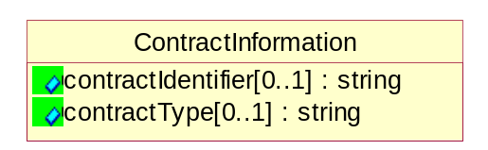
Figure 5-41 ContractInformation

Attribute | Type | Documentation
contractIdentifier[0..1] | string | Unique identification of a contract between the Sender and the Receiver
contractType[0..1] | string | The type of the contract: an attribute describing the type of the ContractIndentification. Valid values are URI, URN,ebXMLCPA, or other values defined by partners.

CorrelationInformation
A block of information used to correlate a requesting document to a responding document and to the contract in an executing choreography.
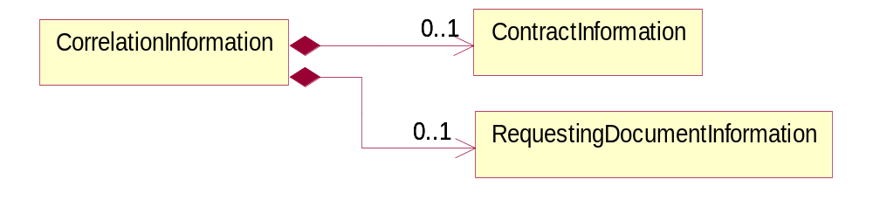
Figure 5-42 CorrelationInformation

Composition | Cardinality | Type | Documentation
ContractInformation | 0..1 | ContractInformation | A block of information used to correlate a contract in an executing choreography.
RequestingDocumentInformation | 0..1 | RequestingDocumentInformation | A block of information used to correlate a requesting document to a responding document in an executing choreography.

DocumentHeader
The object allows for the identification of the sender and receiver of the business document.
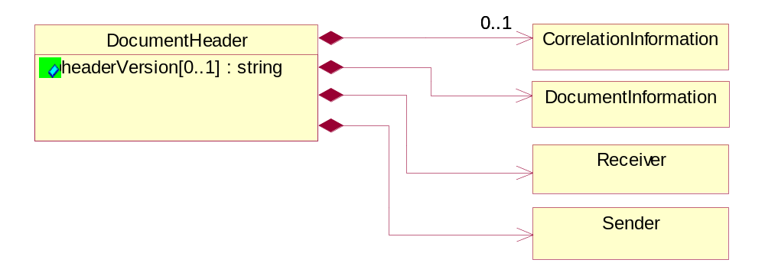
Figure 5-43 DocumentHeader

Attribute | Type | Documentation
headerVersion[0..1] | string | The UN/CEFACT version of the document header.

Composition | Cardinality | Type | Documentation
CorrelationInformation | 0..1 | CorrelationInformation | A block of information used to correlate a requesting document to a responding document and to the contract in an executing choreography.
DocumentInformation | 1 | DocumentInformation | The object specifies information to identify the business document, a summary of attachments, and information about the business document security.
Receiver | 1 | Receiver | The object allows the identification of the receiving party of the business message.
Sender | 1 | Sender | The object allows the identification of the initiating party of the business message.

DocumentIdentification
The object specifies all information necessary to identify the business document.
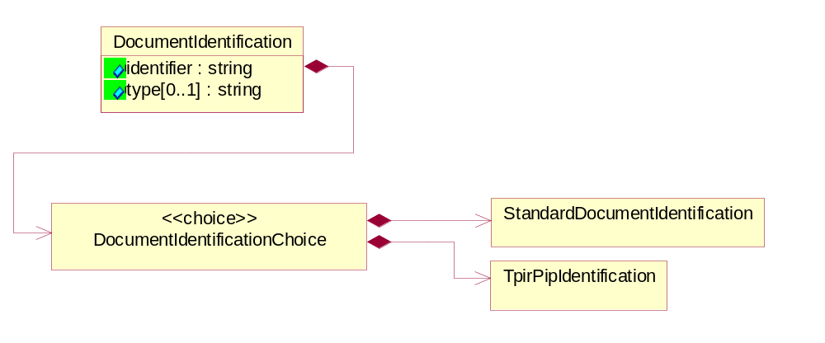
Figure 5-44 DocumentIdentification

Attribute | Type | Documentation
identifier | string | The unique identifier for the document being sent.
type[0..1] | string | Name of the Action Message

Composition | Cardinality | Type | Documentation
DocumentIdentificationChoice | 1 | DocumentIdentificationChoice

DocumentIdentificationChoice

Composition | Cardinality | Type | Documentation
StandardDocumentIdentification | 1 | StandardDocumentIdentification | The object specifies additional information necessary to identify the standard business document.
TpirPipIdentification | 1 | TpirPipIdentification | The object specifies all information necessary to uniquely identify a TPIR-PIP within a Registry or trading partner repository.

DocumentInformation
The object specifies information to identify the business document, a summary of attachments, and information about the business document security.
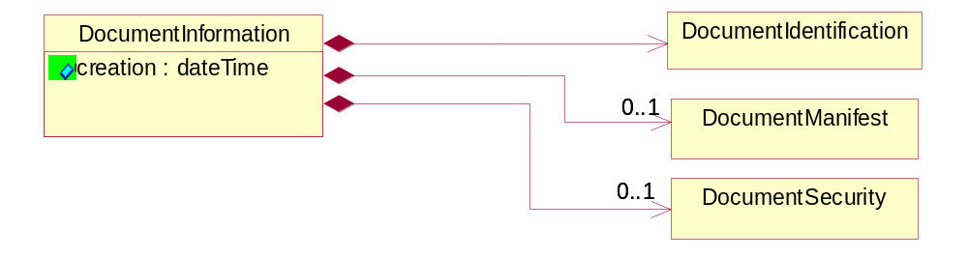
Figure 5-45 DocumentInformation

Attribute | Type | Documentation
creation | dateTime | The creation date and time of the specified Business Document (i.e. the Purchase Order date).

Composition | Cardinality | Type | Documentation
DocumentIdentification | 1 | DocumentIdentification | The object specifies all information necessary to identify the business document.
DocumentManifest | 0..1 | DocumentManifest | The block provides a brief summary of attachments and Service Content.
DocumentSecurity | 0..1 | DocumentSecurity | The object provides additional granularity in specifying business document security (this is in addition to the specified PIP security).

DocumentManifest
The block provides a brief summary of attachments and Service Content.
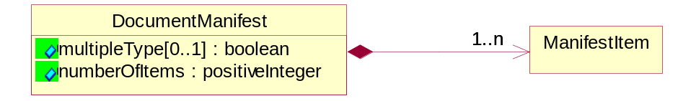
Figure 5-46 DocumentManifest

Attribute | Type | Documentation
multipleType[0..1] | boolean | Indicates whether the manifest contains documents of multiple types. True if yes, and False if no.
numberOfItems | positiveInteger | Total number of documents in the message. The physical count of the attachments in the payload plus the RosettaNet Business Message (for Service Content). The value of this field will be at least 1.

Composition | Cardinality | Type | Documentation
ManifestItem | 1..n | ManifestItem | The object provides details about the specific attachment(s).

DocumentSecurity
The object provides additional granularity in specifying business document security (this is in addition to the specified PIP security).
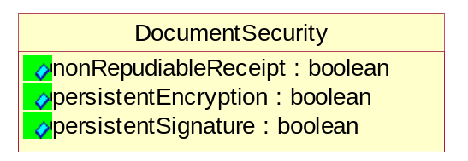
Figure 5-47 DocumentSecurity

Attribute | Type | Documentation
nonRepudiableReceipt | boolean | The value "true" will indicate that a signed acknowledgement for the business document is necessary.
persistentEncryption | boolean | The value "true" will indicate that the Business Document (including the header) needs to be encrypted when stored or transported.
persistentSignature | boolean | The value "true" will indicate that a signature is required to be stored with the document while stored or transported.

ManifestItem
The object provides details about the specific attachment(s).
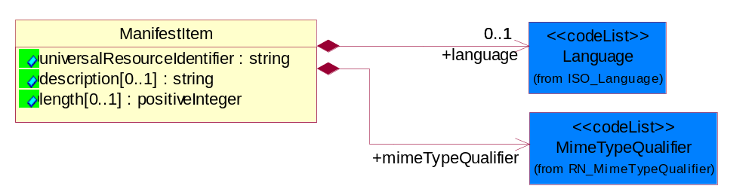
Figure 5-48 ManifestItem

Attribute | Type | Documentation
universalResourceIdentifier | string | The generic set of all names/addresses that are short strings that refer to resources.
description[0..1] | string | A description of the attachment.
length[0..1] | positiveInteger | The size of the attachment in bytes (i.e. 1 000 000 bytes)

Composition | Cardinality | Type | Documentation
language | 0..1 | Language | For representation of Language name RosettaNet has adopted ISO 639-2; 1998. Refer to the following web page to get the latest version of the standard:  http://www.loc.gov/standards/iso639-2/iso639jac.html  If you need more information about the ISO standard please contact ISO for more details.
mimeTypeQualifier | 1 | MimeTypeQualifier | The MIME type as defined by IANA.  Please refer to http://www.iana.org/assignments/media-types/ for a list of types.

PipIdentifier
PIP Identification. [i.e. PIP3A4]
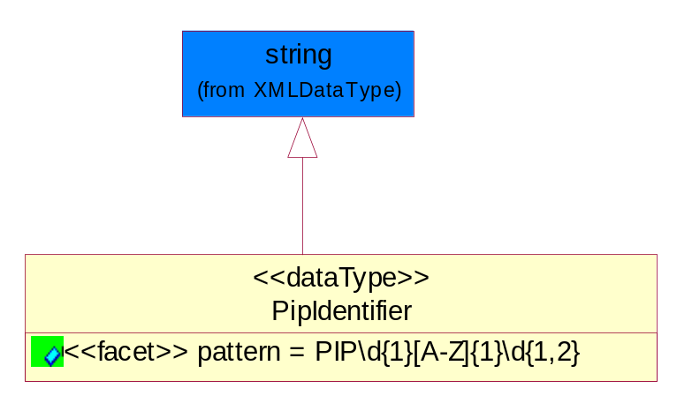
Figure 5-49 PipIdentifier

Attribute | Type | Documentation
pattern |  | PIP\d{1}[A-Z]{1}\d{1,2}

PipVersion
PIP version number (i.e. 02.02.00).
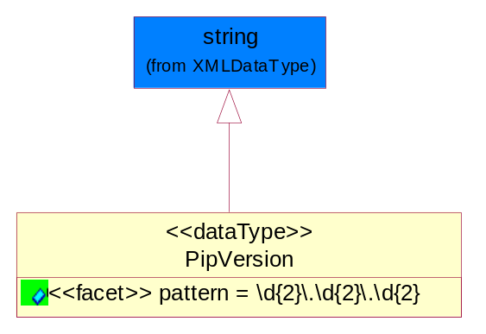
Figure 5-50 PipVersion

Attribute | Type | Documentation
pattern |  | \d{2}\.\d{2}\.\d{2}

Receiver
The object allows the identification of the receiving party of the business message.
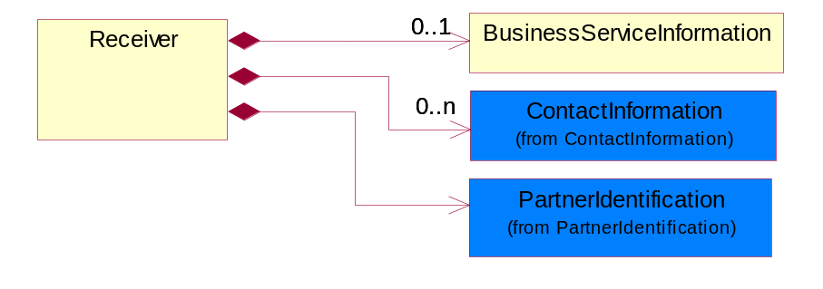
Figure 5-51 Receiver

Composition | Cardinality | Type | Documentation
BusinessServiceInformation | 0..1 | BusinessServiceInformation | The object allows the specification of the business service utilized within the partner company. This may or may not be the same as the information sent by the RNIF.
ContactInformation | 0..n | ContactInformation | The business document must allow for the identification of the name of the department, service or individual to be contacted regarding the context of the business document.
PartnerIdentification | 1 | PartnerIdentification | The business document must allow for the identity of one or more parties to the transaction.

RequestingDocumentInformation
A block of information used to correlate a requesting document to a responding document in an executing choreography.
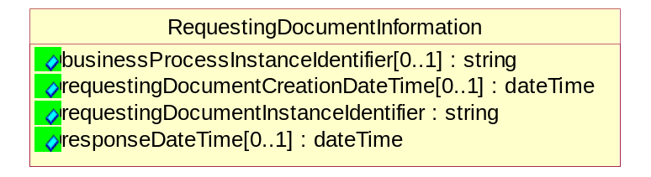
Figure 5-52 RequestingDocumentInformation

Attribute | Type | Documentation
businessProcessInstanceIdentifier[0..1] | string | The identifier for the public business process instance being sent that both the sender and receiver can identify.
requestingDocumentCreationDateTime[0..1] | dateTime | The date-time of the requesting business document.
requestingDocumentInstanceIdentifier | string | The Business Document identification number that identifies the requesting Business Document.
responseDateTime[0..1] | dateTime | The expected time to receive the response. This can not be greater than the PIP TimeToPerform.

Sender
The object allows the identification of the initiating party of the business message.
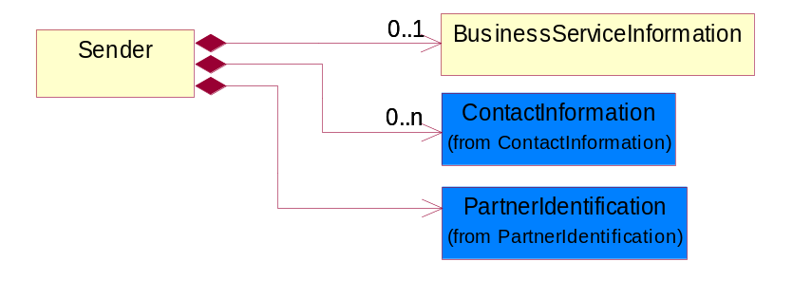
Figure 5-53 Sender

Composition | Cardinality | Type | Documentation
BusinessServiceInformation | 0..1 | BusinessServiceInformation | The object allows the specification of the business service utilized within the partner company. This may or may not be the same as the information sent by the RNIF.
ContactInformation | 0..n | ContactInformation | The business document must allow for the identification of the name of the department, service or individual to be contacted regarding the context of the business document.
PartnerIdentification | 1 | PartnerIdentification | The business document must allow for the identity of one or more parties to the transaction.

StandardDocumentIdentification
The object specifies additional information necessary to identify the standard business document.
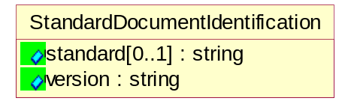
Figure 5-54 StandardDocumentIdentification

Attribute | Type | Documentation
standard[0..1] | string | Identifies the standard used to submit the business document. (e.g. RosettaNet).
version | string | PIP3A4v01.00

TpirPipIdentification
The object specifies all information necessary to uniquely identify a TPIR-PIP within a Registry or trading partner repository.
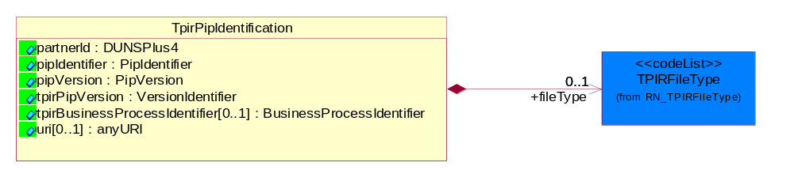
Figure 5-55 TpirPipIdentification

Attribute | Type | Documentation
partnerId | DUNSPlus4 | The Trading Partner Identification of MNC that is creating this TPIR PIP.
pipIdentifier | PipIdentifier | A TPIR PIP Identification [i.e., 3A4 ).
pipVersion | PipVersion | A TPIR PIP version number (i.e., 02.02.00)
tpirPipVersion | VersionIdentifier | A TPIR-PIP Version Number (i.e., major and minor version number as XX.XX).
tpirBusinessProcessIdentifier[0..1] | BusinessProcessIdentifier | A Business Process Identifier to uniquely define the TPIR-PIP 'role' within a Business Scenario at a company or MNC level. The identifier MUST be composed of alphanumeric characters only and its length MUST be between one and twelve characters.
uri[0..1] | anyURI | Describes the destination uri for the TPIR form.

Composition | Cardinality | Type | Documentation
fileType | 0..1 | TPIRFileType | Describes the file type of the TPIR form (PDF, XDP or XML).

VersionIdentifier
Version Number (i.e. major and minor version number as XX.XX).
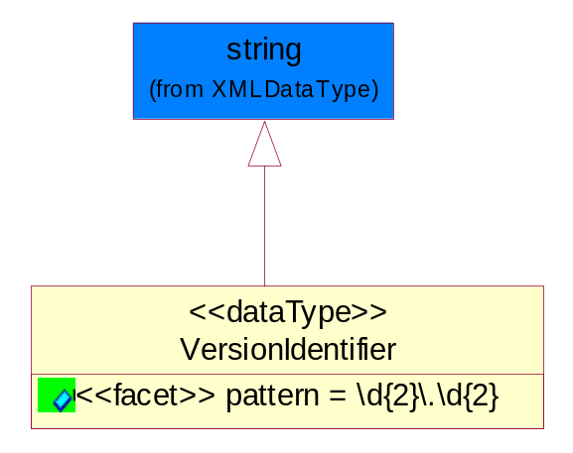
Figure 5-56 VersionIdentifier

Attribute | Type | Documentation
pattern |  | \d{2}\.\d{2}

CodeList

TPIRFileType
A code identifying the file type of TPIR form.

Name | Documentation
PDF | Portable Document Format.
XDP | XML Data Package.
XML | eXtensible Markup Language.

XML Data Type

anyURI
Represents a URI as defined by RFC 2396. An anyURI value can be absolute or relative, and may have an optional fragment identifier.

boolean
Represents Boolean values, which are either "true" or "false".

date
For the represents a calendar date.
The pattern for a date is CCYY-MM-DD where CC represents the century, YY the year, MM the month, and DD the day, with an optional time zone indicator as allowed for dateTime.

dateTime
Represents a specific instance of time.
The pattern for dateTime is CCYY-MM-DDThh:mm:ss where CC represents the century, YY the year, MM the month, and DD the day, preceded by an optional leading negative (-) character to indicate a negative number. If the negative character is omitted, positive (+) is assumed. The T is the date/time separator and hh, mm, and ss represent hour, minute, and second respectively. Additional digits can be used to increase the precision of fractional seconds if desired. For example, the format ss.ss... with any number of digits after the decimal point is supported. The fractional seconds part is optional.
This representation may be immediately followed by a "Z" to indicate Coordinated Universal Time (UTC) or to indicate the time zone. For example, the difference between the local time and Coordinated Universal Time, immediately followed by a sign, + or -, followed by the difference from UTC represented as hh:mm (minutes is required). If the time zone is included, both hours and minutes must be present.

float
Represents single-precision 32-bit floating-point numbers.

positiveInteger
Represents an integer that is greater than zero. This data type is derived from nonNegativeInteger.

string
Represents character string.

