

Description of
Partner Interface Process® for 5C1

Validated 11.00.00

Specification Information
Name | Distribute Product List
Cluster | Marketing Information Management
Segment | Design Win Management (EC)
Publication Date | 03 July 2008
Version Identifier | V11.00

Table of Contents
1 Document Management 4
1.1 Legal Disclaimer 4
1.2 Copyright 4
1.3 Trademarks 4
1.4 Acknowledgments 4
1.5 Related Documents 4
1.6 Document Version History 4
1.7 Document Structure 5
2 Business Process 6
2.1 Business Process Definition 6
2.2 PIP Scope Description 6
2.2.1 Business Process Scope Diagram 7
2.3 PIP Business Document 7
2.4 PIP Business Process Flow Diagram 8
2.5 PIP Start State 8
2.6 PIP End States 9
2.7 Partner Role Descriptions 9
2.8 Business Process Activity Controls 9
3 Network and Implementation Specification 11
3.1 Business Action and Business Signal Specifications 11
3.2 Business Transaction Dialog Specification 11
3.2.1 Message Exchange Controls 12
3.2.2 Communications Specification 12

List of Figures:
Figure 1: High-level Context Diagram 7
Figure 2: Activity Diagram of Distribute Product List 8
Figure 3: Sequence Diagram of Distribute Product List 11

List of Tables:
Table 1: PIP Business Document 7
Table 2: PIP Start State 8
Table 3: PIP End State 9
Table 4: PIP Failure State 9
Table 5: Partner Role Description 9
Table 6: Business Activity Description 9
Table 7: Business Activity Performance Control 10
Table 8: Network Component Specification 11
Table 9: Business Action – Business Document Mapping 11
Table 10: Message Exchange Control 12
Table 11: Dialog: Service-Service 12

Document Management

Legal Disclaimer
RosettaNet™, its members, officers, directors, employees, or agents shall not be liable for any injury, loss, damages, financial or otherwise, arising from, related to, or caused by the use of this document or the specifications herein, as well as associated guidelines and schemas. The use of said specifications shall constitute your express consent to the foregoing exculpation.

Copyright
©2008 RosettaNet. All rights reserved. No part of this publication may be reproduced, stored in a retrieval system, or transmitted, in any form or by any means, electronic, mechanical, photocopying, recording, or otherwise, without the prior written permission of the publisher. Printed in the United States of America.

Trademarks
RosettaNet, Partner Interface Process, PIP and the RosettaNet logo are trademarks or registered trademarks of "RosettaNet," a non-profit organization. All other product names and company logos mentioned herein are the trademarks of their respective owners. In the best effort, all terms mentioned in this document that are known to be trademarks or registered trademarks have been appropriately recognized in the first occurrence of the term.

Acknowledgments
This document has been prepared by RosettaNet (http://www.rosettanet.org/) from requirements gathered during the Milestone Program and in conformance with the methodology.

Related Documents
- Associated PIP Message Schemas (included within the PIP Specification package only)
- Description of 5C1 Message
- Messages Structure
- XML instance of ebXML BPSS for PIP 5C1

Document Version History
Version | Date | Description
Validated 11.00.00 | 03 July 2008 | Validated Version : RosettaNet Schema to Market to Validation 2008

Document Structure
A Partner Interface Process (PIP) Specification is comprised of the following two parts:
- Business Process. Captures the semantics of the business process and the flow of the message exchange between roles as they perform business activities.
- Network and Implementation Specification. Specifies the network protocol message formats and communications requirements between peer-protocols supported by network components in the RosettaNet Implementation Framework.

Business Process

Business Process Definition
The "Distribute Product List" Partner Interface Process™ (PIP) enables a provider to distribute a list of products eligible for design registration to a party needing differentiated products (demand creator). The following product types may be registered: key product, associated product, and development tools.
Before using this PIP to distribute a product list:
- A provider must have a strategic demand creation program.
- A provider must have defined a registration program for a demand creator based on terms and conditions, time frame for the registration, and target values that were previously agreed upon.
Upon receiving a list of eligible products, a demand creator may:
- Establish and maintain a list of eligible products, including an eligibility check that detects missing or erroneous product part numbers.
- Use PIP5C2, “Request Design Registration,” to submit a design registration.
Partners may communicate updates using this PIP or PIP5C2, “Request Design Registration.”
Should this transaction not complete successfully, the requesting partner executes PIPA01, "Notification of Failure."

PIP Scope Description
This PIP enables a provider to inform a party needing differentiated products (demand creator) of products eligible for design registration.

Business Process Scope Diagram
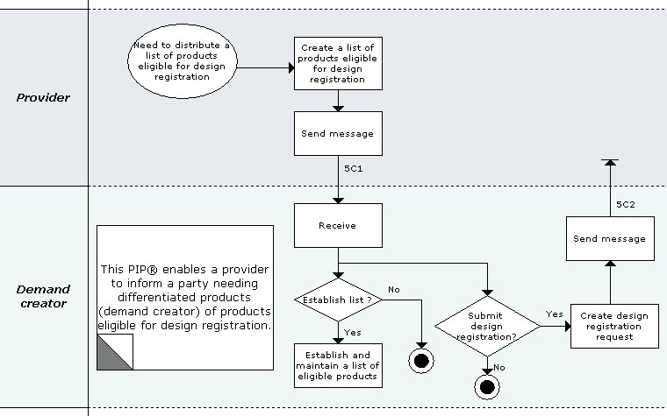
Figure 1: High-level Context Diagram

PIP Business Document
Business Document are generated and exchanged by roles performing activities in this PIP. Business Document is listed and defined in Table 1.
Table 1: PIP Business Document
Business Document | Description
Product List Distribution | A list of products eligible for design registration. The list includes the Product Provider's Global Trade Item Numbers (GTIN) and eligible product descriptions.

PIP Business Process Flow Diagram
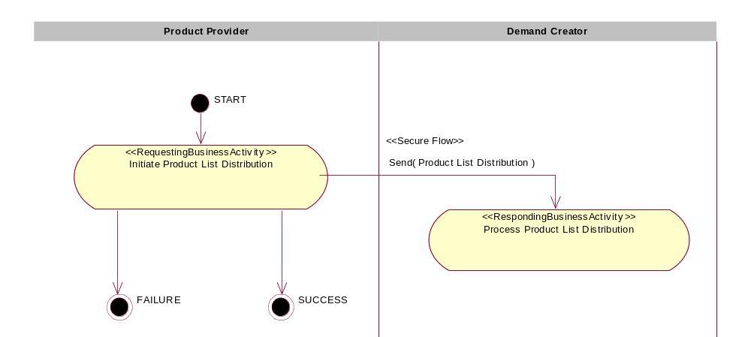
Figure 2: Activity Diagram of Distribute Product List

PIP Start State
The start state is comprised of the following conditions:
Table 2: PIP Start State
 | Approved | Exist |  | Valid | Non-Repudiated | Retry Count | Authorized
 | Approved | Party | In Backend System
TPA |  |  | 
Sending Partner |  |  |  | 
Receiving Partner |  | 
Business Document |  |  |  | 

PIP End States
The end state is comprised of the following conditions:
Table 3: PIP End State
 | Approved | Exist |  | Valid | Non-Repudiated | Retry Count | Authorized
 | Approved | Party | In Backend system
Acknowledgment of Receipt |  |  |  | 
Receiving Partner |  |  |  |  |  |  | 
The PIP failure state is comprised of one or more of the following conditions:
Table 4: PIP Failure State
 | NO | Exceeded
Success | 
Retry Count |  | 

Partner Role Descriptions
Table 5 describes the partner roles in this PIP.
Table 5: Partner Role Description
Role Name | Role Description
Product Provider | The partner role that creates a differentiated product, owns the registration process, and creates a list of eligible products for use in design registration.
Demand Creator | The partner role that identifies the opportunity, submits design registration, provides engineering support to advance the opportunity towards design win, and generates revenue by satisfying customer demand for a product.

Business Process Activity Controls
Table 6 describes the interaction between roles performing business activity in this PIP.
Table 6: Business Activity Description
Role  Name | Activity Name | Activity Description
Product Provider | Initiate Product List Distribution | A Product Provider sends a list of products eligible for design registration to a Demand Creator.
Table 7 details the security, audit and process controls relating to activity performed in the PIP.
Table 7: Business Activity Performance Control
Role  Name | Activity  Name | Acknowledgment  of Receipt |  | Time to Perform | Retry Count | Is Authorization Required? | Non-Repudiation of Origin and Content?
Role  Name | Activity  Name | Non-Repudiation Required? | Time to Acknowledge
Product Provider | Initiate Product List Distribution | N | 2 hrs | N/A | 3 | N | N

Network and Implementation Specification
Each network component maps into a role of the PIP model. Table 8 specifies the mapping between roles and network components.
Table 8: Network Component Specification
Network Component | Classification | Maps to Role in Business Process
Product Provider Service | Business Service | Product Provider
Demand Creator Service | Business Service | Demand Creator

Business Action and Business Signal Specifications
Each business action maps to a Business Document of the PIP model. Table 9 specifies the mapping between Business Documents and business actions.
Table 9: Business Action – Business Document Mapping
Business Action | Business Document | Document Function
Product List Distribution Action | Product List Distribution | Request

Business Transaction Dialog Specification
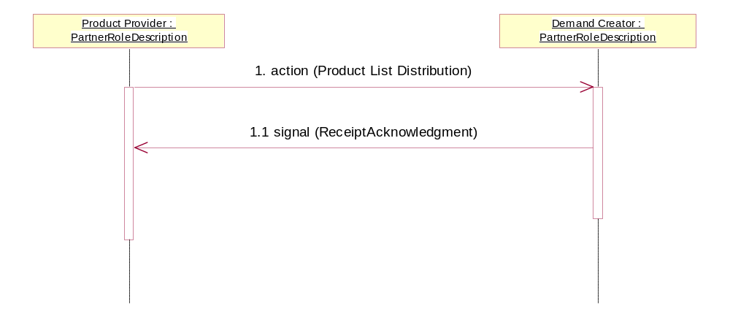
Figure 3: Sequence Diagram of Distribute Product List

Message Exchange Controls
Table 10: Message Exchange Control
# | Name |  | Time to Acknowledge Receipt Signal |  | Time to Respond to Action |  | Included in Time to Perform |  | Is Authorization Required? |  | Is Non-Repudiation Required? |  | Is Secure Transport Required?
1. |  | Product List Distribution Action |  | 2 hrs |  | N/A |  | N/A |  | N |  | N |  | Y
1.1. |  | Receipt Acknowledgment |  | N/A |  | N/A |  | N/A |  | N |  | N |  | Y

Communications Specification
Table 11: Dialog: Service-Service
# | Business Message | Digital Signature Required? | SSL Required?
1. | Product List Distribution | N | Y
1.1. | Receipt Acknowledgment | N | Y

