

Description of
Partner Interface Process® for 5C2

Validated 11.00.00

Specification Information
Name | Request Design Registration
Cluster | Marketing Information Management
Segment | Design Win Management (EC)
Publication Date | 09 July 2008
Version Identifier | V11.00

Table of Contents
1 Document Management 4
1.1 Legal Disclaimer 4
1.2 Copyright 4
1.3 Trademarks 4
1.4 Acknowledgments 4
1.5 Related Documents 5
1.6 Document Version History 5
1.7 Document Structure 5
2 Business Process 6
2.1 Business Process Definition 6
2.2 PIP Scope Description 6
2.3 PIP Business Document 7
2.4 PIP Business Process Flow Diagram 7
2.5 PIP Start State 8
2.6 PIP End States 8
2.7 Partner Role Description 9
2.8 Business Process Activity Controls 9
3 Network and Implementation Specification 10
3.1 Business Action and Business Signal Specifications 10
3.2 Business Transaction Dialog Specification 10
3.2.1 Message Exchange Controls 11
3.2.2 Communications Specification 11

List of Figures:
Figure 1: Activity Diagram of Request Design Registration 6
Figure 2: Sequence Diagram of Request Design Registration 10

List of Tables:
Table 1: PIP Business Document 7
Table 2: PIP Start State 8
Table 3: PIP End State 8
Table 4: PIP Failure State 8
Table 5: Partner Role Description 9
Table 6: Business Activity Description 9
Table 7: Business Activity Performance Control 9
Table 8: Network Component Specification 10
Table 9: Business Action – Business Document Mapping 10
Table 10: Message Exchange Control 11
Table 11: Dialog: Service-Service 11

Document Management

Legal Disclaimer
RosettaNet™, its members, officers, directors, employees, or agents shall not be liable for any injury, loss, damages, financial or otherwise, arising from, related to, or caused by the use of this document or the specifications herein, as well as associated guidelines and schemas. The use of said specifications shall constitute your express consent to the foregoing exculpation.

Copyright
©2008 RosettaNet. All rights reserved. No part of this publication may be reproduced, stored in a retrieval system, or transmitted, in any form or by any means, electronic, mechanical, photocopying, recording, or otherwise, without the prior written permission of the publisher. Printed in the United States of America.

Trademarks
RosettaNet, Partner Interface Process, PIP and the RosettaNet logo are trademarks or registered trademarks of "RosettaNet," a non-profit organization. All other product names and company logos mentioned herein are the trademarks of their respective owners. In the best effort, all terms mentioned in this document that are known to be trademarks or registered trademarks have been appropriately recognized in the first occurrence of the term.

Acknowledgments
This document has been prepared by RosettaNet (http://www.rosettanet.org/) from requirements gathered during the Milestone Program and in conformance with the methodology. Listed below are the legal entities that contributed to the design and development of this PIP.
Agilent Technologies | Arrow
Arrow Electronics | Arrow Electronics, Inc.
Arrow Nothern Europe | Avnet
Avnet, Inc. | BCM Electronics
Eurodis Electron PLC | Future Electronics
Globetronics SDH. BHD | Hitachi Semiconductor (America) Inc
Inovis, Inc. | Intel Corporation
MIMOS Berhad | Motorola SPS
Motorola Semiconductor | Motorola Semiconductor Sector
National Semiconductor | National Semiconductor Corporation
NEC Electronics Inc. | NEC Solutions America, Inc.
Peregrine Connectivity, Inc. | Philips Semiconductors
Pioneer-Standard Electronics | Renesas Technology
Sterling Commerce | STMicroelectronics
Texas Instruments | Texas Instruments, Inc.
UMC | United Microelectronics Corp.
Viacore | Viacore Inc.

Related Documents
- Associated PIP Message Schemas (included within the PIP Specification package only)
- Description of 5C2 Message
- Messages Structure
- XML instance of ebXML BPSS for PIP 5C2

Document Version History
Version | Date | Description
Validated 11.00.00 | 09 July 2008 | Validated Version : RosettaNet Schema to Market to Validation 2008

Document Structure
A Partner Interface Process (PIP) Specification is comprised of the following two parts:
- Business Process. Captures the semantics of the business process and the flow of the message exchange between roles as they perform business activities.
- Network and Implementation Specification. Specifies the network protocol message formats and communications requirements between peer-protocols supported by network components in the RosettaNet Implementation Framework.

Business Process

Business Process Definition
The "Request Design Registration" Partner Interface Process (PIP) enables a party needing a differentiated product (demand creator) to request that a provider create or change a design registration. Such a request can occur at different stages of design registration definition or approval. For example, a request could be submitted as an initial design registration document or as an update to an existing design registration. Dates, confidence level, and detailed technical information can be changed as part of the updating and refining of a design registration. The following product types may be registered: key product, associated product, and development tools.
Upon receiving a design request, a provider assesses the request and responds by returning the design registration, the registration status, and other information. Status can be provided at either the assembly level, core product level or device (multiple parts) product level. The lowest level registration status indicated (found in the corresponding information block of the Core Product, Device Product within Core Product or Device Product) takes precedence for the core or device specified in that information block.
Registration status communicates the overall "stage" of a design win. A design win can either:
· Progress to accepted, win, and production, or
· Be revoked
· Be pending
If a provider’s response to a design registration request contains any registration statuses (at any level; assembly, core or device) that are "pending,” the provider must subsequently use, PIP5C4, "Distribute Registration Status," until all pending statuses are resolved.
Before using this PIP:
· The two partners must have established terms and conditions for the design registration program.
· The provider must have provided a list of products eligible for design registration using PIP5C1, “Distribute Product List.”
Updates may be implemented with this PIP or PIP5C1, “Distribute Product List.”
Should this transaction not complete successfully, the requesting partner executes PIP0A1, "Notification of Failure."

PIP Scope Description
This PIP enables (1) a party needing a differentiated product (demand creator) to request that a design registration be created or changed, and (2) a product provider to respond to the request.

PIP Business Document
Business Document are generated and exchanged by roles performing activities in this PIP. Business Document is listed and defined in Table 1.
Table 1: PIP Business Document
Business Document | Description
Design Registration Request | Contains a hierarchically-structured project assembly registration that identifies detailed project/assembly/product part/customer layers. The request also identifies the part, design request business opportunity, and design registration.
Design Registration Confirmation | Confirms the registration status of a Design Registration Request. The status indicates the stage of the design win process (e.g., accepted, rejected, win, revoked or pended).

PIP Business Process Flow Diagram
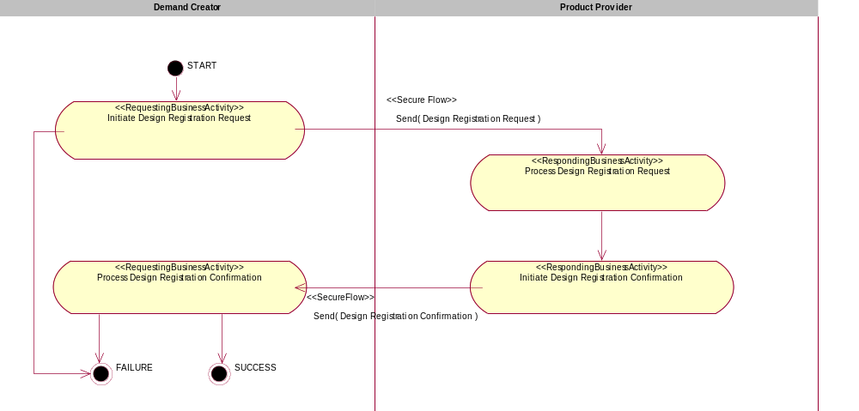

Figure 1: Activity Diagram of Request Design Registration

PIP Start State
The start state is comprised of the following conditions:
Table 2: PIP Start State
 | Approved | Exist |  | Valid | Non-Repudiated | Retry Count | Authorized
 | Approved | Party | In Backend System
TPA |  |  | 
Sending Partner |  |  |  | 
Receiving Partner |  | 
Business Document |  |  |  |  |  |  | 

PIP End States
The end state is comprised of the following conditions:
Table 3: PIP End State
 |  | Approved |  | Exist |  |  |  | Valid |  | Non-Repudiated |  | Retry Count |  | Authorized
 |  |  |  | Party |  | In Backend system
Acknowledgment of Receipt |  |  |  |  |  |  |  |  |  | 
Receiving Partner |  |  |  |  |  |  |  |  |  |  |  |  | 

The PIP failure state is comprised of one or more of the following conditions
Table 4: PIP Failure State
 | NO | Exceeded
Success | 
Retry Count |  | 

Partner Role Description
Table 5 describes the partner roles in this PIP:
Table 5: Partner Role Description
Role Name | Role Description
Demand Creator | The partner role that identifies the opportunity, submits design registration, provides engineering support to advance the opportunity towards design win, and generates revenue by satisfying customer demand for a product.
Product Provider | The partner role that creates a differentiated product, owns the registration process, and creates a list of eligible products for use in design registration.

Business Process Activity Controls
Table 6 describes the interaction between roles performing business activity in this PIP.
Table 6: Business Activity Description
Role Name |  | Activity Name |  | Activity Description
Demand Creator | Initiate Design Registration Request |  | A Demand Creator submits a Design Registration Request as an initial design registration document or as an update to the existing design registration.
Product Provider | Initiate Design Registration Confirmation |  | A Product Provider returns a Design Registration Confirmation.

Table 7 details the security, audit and process controls relating to activity performed in the PIP.
Table 7: Business Activity Performance Control
Role  Name | Activity  Name | Acknowledgment  of Receipt |  | Time to Perform | Retry Count | Is Authorization Required? | Non-Repudiation of Origin and Content?
Role  Name | Activity  Name | Non-Repudiation Required? | Time to Acknowledge
Demand Creator | Initiate Design Registration Request | N | 2hrs | 72hrs | 3 | Y | N
Product Provider | Initiate Design Registration Confirmation | N | 2hrs | 2hrs | 3 | Y | N

Network and Implementation Specification
Each network component maps into a role of the PIP model. Table 8 specifies the mapping between roles and network components.
Table 8: Network Component Specification
Network Component | Classification | Maps to Role in Business Process
Demand Creator Service | Business Service | Demand Creator
Product Provider Service | Business Service | Product Provider

Business Action and Business Signal Specifications
Each business action maps to a Business Document of the PIP model. Table 9 specifies the mapping between Business Documents and business actions.
Table 9: Business Action – Business Document Mapping
Business Action | Business Document | Document Function
Design Registration Request Action | Design Registration Request | Request
Design Registration Confirmation Action | Design Registration Confirmation | Response

Business Transaction Dialog Specification
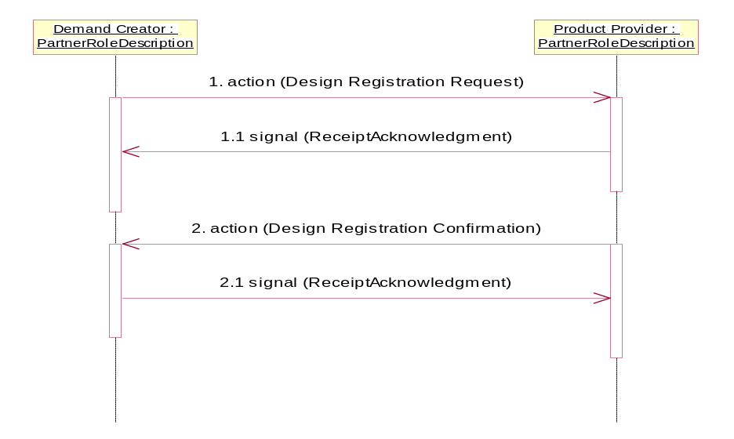

Figure 2: Sequence Diagram of Request Design Registration

Message Exchange Controls
Table 10: Message Exchange Control
# | Name |  | Time to Acknowledge Receipt Signal |  | Time to Respond to Action |  | Included in Time to Perform | Is Authorization Required? | Is Non-Repudiation Required? | Is Secure Transport Required?
1. |  | Design Registration Request Action |  | 2hrs |  | 72hrs | Y | Y | N | Y
1.1. |  | Receipt Acknowledgment |  | N/A |  | N/A | Y | Y | N | Y
2. |  | Design Registration Confirmation Action |  | 2hrs |  | N/A | Y | Y | N | Y
2.1. |  | Receipt Acknowledgment |  | N/A |  | N/A | N | Y | N | Y

Communications Specification
Table 11: Dialog: Service-Service
# | Business Message | Digital Signature Required? | SSL Required?
1. | Design Registration Request | Y | Y
1.1. | Receipt Acknowledgment | Y | Y
2. | Design Registration Confirmation | Y | Y
2.1. | Receipt Acknowledgment | Y | Y

