

Description of
Partner Interface Process® for 5C3

Validated 11.01.00

Specification Information
Name | Request Design Win
Cluster | Design Win Management (EC)
Segment | Marketing Information Management
Publication Date | 24 February 2010
Version Identifier | V11.01

Table of Contents
1 Document Management 4
1.1 Legal Disclaimer 4
1.2 Copyright 4
1.3 Trademarks 4
1.4 Acknowledgments 4
1.5 Related Documents 5
1.6 Document Version History 5
1.7 Document Structure 5
2 Business Process 6
2.1 Business Process Definition 6
2.2 PIP Scope Description 7
2.2.1 Business Process Scope Diagram 7
2.3 PIP Business Documents 8
2.4 PIP Business Process Flow Diagram 8
2.5 PIP Start State 9
2.6 PIP End States 9
2.7 Partner Role Descriptions 10
2.8 Business Process Activity Controls 10
3 Network and Implementation Specification 11
3.1 Business Action and Business Signal Specification 11
3.2 Business Transaction Dialog Specification 11
3.2.1 Message Exchange Controls 12
3.2.2 Communications Specification 12

List of Figures
Figure 1: Business Process Context Diagram 7
Figure 2: Activity Diagram 8
Figure 3: Sequence Diagram 11

List of Tables
Table 1: PIP Business Documents 8
Table 2: PIP Start State 9
Table 3: PIP End State 9
Table 4: PIP Failure State 9
Table 5: Partner Role Descriptions 10
Table 6: Business Activity Descriptions 10
Table 7: Business Activity Performance Controls 10
Table 8: Network Component Specification 11
Table 9: Business Action – Business Document Mapping 11
Table 10: Message Exchange Controls 12
Table 11: Dialog: Service-Service 12

Document Management

Legal Disclaimer
RosettaNet™, its members, officers, directors, employees, or agents shall not be liable for any injury, loss, damages, financial or otherwise, arising from, related to, or caused by the use of this document or the specifications herein, as well as associated guidelines and schemas. The use of said specifications shall constitute your express consent to the foregoing exculpation.

Copyright
©2010 RosettaNet. All rights reserved. No part of this publication may be reproduced, stored in a retrieval system, or transmitted, in any form or by any means, electronic, mechanical, photocopying, recording, or otherwise, without the prior written permission of the publisher. Printed in the United States of America.

Trademarks
RosettaNet, Partner Interface Process, PIP and the RosettaNet logo are trademarks or registered trademarks of "RosettaNet," a non-profit organization. All other product names and company logos mentioned herein are the trademarks of their respective owners. In the best effort, all terms mentioned in this document that are known to be trademarks or registered trademarks have been appropriately recognized in the first occurrence of the term.

Acknowledgments
This document has been prepared by RosettaNet (http://www.rosettanet.org/) from requirements gathered during the Milestone Program and in conformance with the methodology. Listed below are the legal entities that contributed to the design and development of this PIP.
Agilent Technologies | Motorola Semiconductor Sector
Arrow | National Semiconductor
Arrow Electronics | National Semiconductor Corporation
Arrow Electronics, Inc. | NEC Electronics Inc.
Arrow Northern Europe | NEC Solutions America, Inc.
Avnet | Peregrine Connectivity, Inc.
Avnet, Inc. | Philips Semiconductors
BCM Electronics | Pioneer-Standard Electronics
Eurodis Electron PLC | Renesas Technology
Future Electronics | Sterling Commerce
Globetronics SDH. BHD | STMicroelectronics
Hitachi Semiconductor (America) Inc | Texas Instruments
Inovis, Inc. | Texas Instruments, Inc.
Intel Corporation | UMC
MIMOS Berhad | United Microelectronics Corp.
Motorola SPS | Viacore
Motorola Semiconductor | Viacore Inc.

Related Documents
- Associated PIP Message Schemas (included within the PIP Specification package only)
- Description of PIP5C3 Message
- Message Structure
- XML instance of ebBPSS for PIP 5C3

Document Version History
Version | Date | Description
Validated 11.00.00 | 03 July 2008 | Validated Version : RosettaNet Schema to Market to Validation 2008
Validated 11.01.00 | 24 February 2010 | Validated Version : MCC Program

Document Structure
A Partner Interface Process (PIP) Specification is comprised of the following two parts:
- Business Process. Captures the semantics of the business process and the flow of the message exchange between roles as they perform business activities.
- Network and Implementation Specification. Specifies the network protocol message formats and communications requirements between peer-protocols supported by network components in the RosettaNet Implementation Framework.

Business Process

Business Process Definition
The "Request Design Win" Partner Interface Process™ (PIP) enables a party to submit a win claim request to a provider who has met previously agreed-upon metrics for a registered design.
A win claim request can be submitted at multiple stages as the design win process advances. Five levels of win claim, as established by the trading partners in a trading partner agreement, are available
Upon accepting a win claim request, the provider commits to delivering specified components at the specified target resale price, in the estimated quantities, and on the indicated dates.
Before using this PIP:
· A design registration must have been created using PIP5C2, “Request Design Registration.”
· A customer must have ordered a product for which a design has been registered.
· Win metrics must have been met.
Should this transaction not complete successfully, the requesting partner executes PIPA01, "Notification of Failure."

PIP Scope Description
This PIP enables (1) a party, for whom design registration win metrics have been met, to offer a win claim request, and (2) a provider to respond to the win claim request.

Business Process Scope Diagram
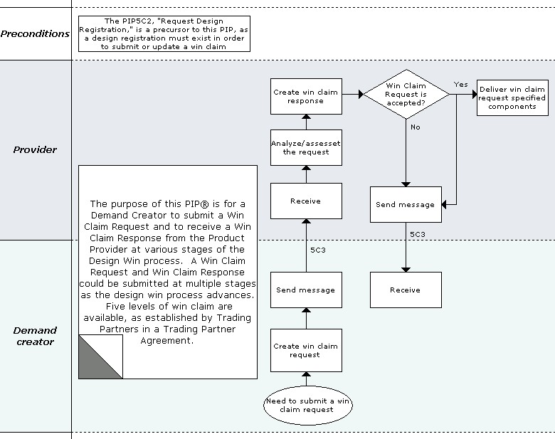
Figure 1: Business Process Context Diagram

PIP Business Documents
Business Documents are generated and exchanged by roles performing activities in this PIP. Business Documents are listed and defined in Table 1.
Table 1: PIP Business Documents
Business Document | Description
Win Claim Request | Contains design registration identifying numbers, win type, quantity and financial value of units shipped, and corresponding invoice numbers.
Win Claim Confirmation | Contains design registration identifying numbers, win type, and a claim status or rejection reason code.

PIP Business Process Flow Diagram
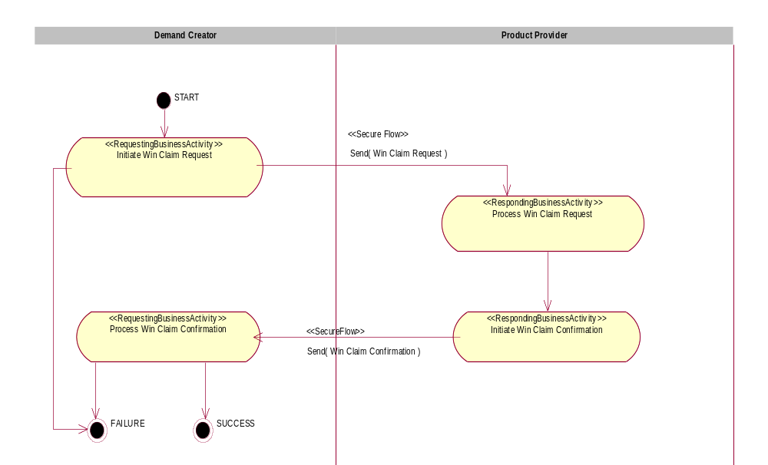
Figure 2: Activity Diagram

PIP Start State
The start state is comprised of the following condition(s):
Table 2: PIP Start State
 | Approved | Exist |  | Valid | Non-Repudiated | Retry Count | Authorized
 | Approved | Party | In Backend system
TPA |  |  | 
Sending Partner |  |  |  |  |  |  | 
Receiving Partner |  | 
Business Document |  |  |  |  | 

PIP End States
The end state is comprised of the following condition(s):
Table 3: PIP End State
 | Approved | Exist |  | Valid | Non-Repudiated | Retry Count | Authorized
 | Approved | Party | In Backend system
Acknowledgment of Receipt |  |  |  |  | 
Receiving Partner |  |  |  |  |  |  | 
Business Document |  |  |  |  | 

The PIP failure state is comprised of one or more of the following condition(s):
Table 4: PIP Failure State
 | NO | Exceeded
Success | 
Retry Count |  | 

Partner Role Descriptions
Table 5 describes the partner roles in this PIP.
Table 5: Partner Role Descriptions
Role Name | Role Description
Demand Creator | The partner role that identifies the opportunity, submits design registration, provides engineering support to advance the opportunity towards design win, and generates revenue by satisfying customer demand for a product.
Product Provider | The partner role that creates a differentiated product, owns the registration process, and creates a list of eligible products for use in design registration.

Business Process Activity Controls
Table 6 describes the interaction between roles performing business activities in this PIP.
Table 6: Business Activity Descriptions
Role  Name | Activity Name | Activity Description
Demand Creator | Initiate Win Claim Request | Demand Creator submits a Win Claim Request in and up to five levels of win claim to a Product Provider. Win type, along with updated quantity of units shipped and value of sales, are provided as resolution of win claim stages occurs.
Product Provider | Initiate Win Claim Confirmation | The Product Provider confirms a Win Claim from a Demand Creator.

Table 7 details the security, audit and process controls relating to activities performed in the PIP.
Table 7: Business Activity Performance Controls
Role  Name | Activity  Name | Acknowledgment  of Receipt |  | Time to Perform | Retry Count | Is Authorization Required? | Non-Repudiation of Origin and Content?
Role  Name | Activity  Name | Non-Repudiation Required? | Time to Acknowledge
Demand Creator | Initiate Win Claim Request | Y | 2 hrs | 24 hrs | 3 | Y | Y
Product Provider | Initiate Win Claim Confirmation | Y | 2 hrs | N/A | 3 | Y | Y

Network and Implementation Specification
Each network component maps into a role of the PIP model. Table 8 specifies the mapping between roles and network components.
Table 8: Network Component Specification
Network Component | Classification | Maps to Role in Business Process
Demand Creator Service | Business Service | Demand Creator
Product Provider Service | Business Service | Product Provider

Business Action and Business Signal Specification
Each business action maps to a Business Document of the PIP model. Table 10 specifies the mapping between Business Documents and business actions.
Table 9: Business Action – Business Document Mapping
Business Action | Business Document | Document Function
Win Claim Request Action | Win Claim Request | Request
Win Claim Confirmation Action | Win Claim Confirmation | Respond

Business Transaction Dialog Specification
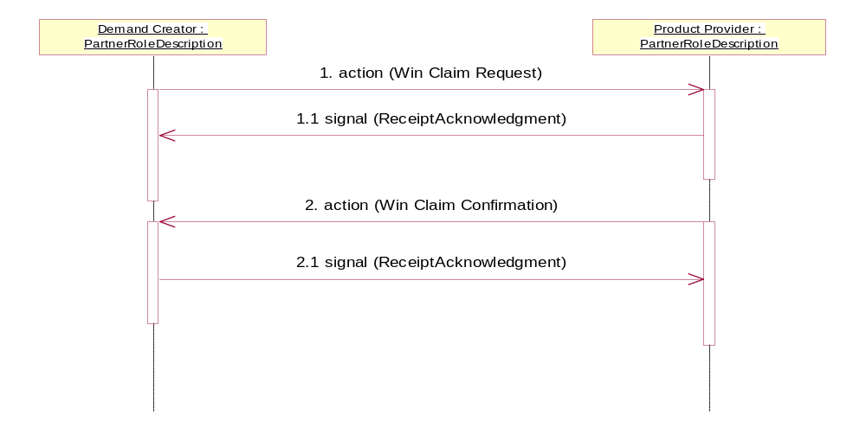
Figure 3: Sequence Diagram

Message Exchange Controls
Table 10: Message Exchange Controls
# | Name |  | Time to Acknowledge |  | Time to Respond to Action |  | Included in Time to Perform |  | Is Authorization Required? |  | Is Non-Repudiation Required? |  | Is Secure Transport Required?
1. |  | Win Claim Request Action |  | 2 hrs |  | N/A |  | 24 hrs |  | Y |  | Y |  | Y
1.1. |  | Receipt Acknowledgment |  | N/A |  | N/A |  | N/A |  | Y |  | Y |  | Y
2. |  | Win Claim Confirmation Action |  | 2 hrs |  | N/A |  | N/A |  | Y |  | Y |  | Y
2.1. |  | Receipt Acknowledgment |  | N/A |  | N/A |  | N/A |  | Y |  | Y |  | Y

Communications Specification
Table 11: Dialog: Service-Service
# | Business Message | Digital Signature Required? | SSL Required?
1. | Win Claim Request | Y | Y
1.1. | Receipt Acknowledgment | Y | Y
2. | Win Claim Confirmation | Y | Y
2.1. | Receipt Acknowledgment | Y | Y

