

Description of 5C6 Message

PIP® 5C6
Validated 11.00.00

Specification Information
Name | Description Of 5C2 Message
PIP | Notify of Design Registration Request
Cluster | Marketing Information Management
Segment | Design Win Management (EC)
Publication Date | 4 March 2010
Version Identifier | V11.00

Table of Content

1. Document Management 7
1.1 Legal Disclaimer 7
1.2 Copyright 7
1.3 Trademarks 7
1.4 Acknowledgments 7
1.5 Related Documents 7
1.6 Document Version History 7
1.7 Document Purpose 7
2. Interchange Model 8
2.1 DesignRegistrationRequestNotification 8
2.1.1 Interchange Diagram 8
2.1.2 Dependency Diagram 9
2.1.3 Attachment 9
2.1.4 DesignAssemblyInformation 10
2.1.5 DesignCustomerInformation 12
2.1.6 DesignPartInformation 13
2.1.7 DesignPartInformationChoice 15
2.1.8 DesignProjectInformation 15
2.1.9 DesignRegistrationRequest 16
3. Domain Model 17
3.1 Marketing 17
3.1.1 Dependency Diagram 17
3.1.2 CoreProductRegistration 18
3.1.3 DebitAuthorizationNumber 20
3.1.4 DemandCreatorTrackingIdentifier 21
3.1.5 DesignCompetitorInformation 21
3.1.6 DesignProjectDescription 22
3.1.7 DesignRegistrationIdentification 22
3.1.8 DesignWinStatusReasonCodeExplanation 23
3.1.9 DeviceProductRegistration 24
3.1.10 GeographicRegion 27
3.1.11 IsDeveloperToolKit 28
3.1.12 IsPartSelected 28
3.1.13 IsRegisterable 29
3.1.14 ProductProviderLeadDescription 29
3.1.15 ProductProviderLeadTrackingIdentifier 30
3.1.16 ProjectIdentifier 30
3.1.17 RegistrationStatus 31
3.1.18 CodeList 32
3.1.18.1 RegistrationComplexityLevel 32
3.1.18.2 RegistrationInvolvementLevel 32
3.1.18.3 DesignWinStatusReason 32
3.1.18.4 RegistrationStatusCode 34
3.1.18.5 GeographicRegionCode 35
3.1.18.6 DesignRegistrationNotification 35
3.1.18.7 ProjectStatus 35
3.1.18.8 ProjectMarketSegment 35
3.2 Shared 36
3.2.1 Dependency Diagram 36
3.2.2 MonetaryAmount 36
3.2.3 ProductPricing 37
3.2.4 ProductQuantity 38
3.2.5 CodeList 38
3.2.5.1 InvoiceChargeType 38
3.2.5.2 MonetaryAmountType 39
3.2.5.3 PricingTypeCode 39
3.2.5.4 AmountType 40
4. Universal Structure 41
4.1 ContactInformation 41
4.1.1 ContactInformation 41
4.2 DataType 42
4.2.1 Contact 42
4.2.2 DUNS 42
4.2.3 DUNSPlus4 43
4.2.4 GLN 43
4.2.5 GTIN 44
4.2.6 PercentAmount 44
4.3 Dates 45
4.3.1 DatePeriod 45
4.4 Document 45
4.4.1 BusinessDocumentReference 45
4.5 Locations 46
4.5.1 AlternativeIdentifier 46
4.5.2 Location 47
4.5.3 LocationChoice 48
4.5.4 PhysicalAddress 48
4.6 MonetaryExpression 49
4.6.1 FinancialAmount 49
4.7 PartnerIdentification 50
4.7.1 FullPartner 50
4.7.2 IntermittentPartner 51
4.7.3 KnownPartner 51
4.7.4 KnownPartnerContact 52
4.7.5 NewPartner 53
4.7.6 PartnerDescription 54
4.7.7 PartnerDescriptionChoice 55
4.7.8 PartnerIdentification 56
4.7.9 PartnerIdentificationChoice 57
4.7.10 SpecifiedFullPartner 57
4.7.11 SpecifiedIntermittentPartner 58
4.7.12 SpecifiedKnownPartner 59
4.7.13 SpecifiedKnownPartnerContact 59
4.7.14 SpecifiedNewPartner 60
4.7.15 SpecifiedPartnerDescription 61
4.7.16 SpecifiedPartnerDescriptionChoice 62
4.8 ProductIdentification 63
4.8.1 ProductIdentification 63
4.8.2 ProductIdentificationChoice 63
4.8.3 TextualDescription 64
4.9 CodeList 65
4.9.1 Country 65
4.9.2 CountrySubdivision 65
4.9.3 Currency 65
4.9.4 Language 65
4.9.5 DocumentType 66
4.9.6 MimeTypeQualifier 68
4.9.7 ProcessRoleIdentifier 79
5. System Structure 82
5.1 BusinessProcessIdentifier 82
5.2 BusinessServiceInformation 83
5.3 ContractInformation 83
5.4 CorrelationInformation 84
5.5 DocumentHeader 85
5.6 DocumentIdentification 86
5.7 DocumentIdentificationChoice 86
5.8 DocumentInformation 87
5.9 DocumentManifest 88
5.10 DocumentSecurity 88
5.11 ManifestItem 89
5.12 PipIdentifier 90
5.13 PipVersion 90
5.14 Receiver 91
5.15 RequestingDocumentInformation 92
5.16 Sender 93
5.17 StandardDocumentIdentification 94
5.18 TpirPipIdentification 95
5.19 VersionIdentifier 96
5.20 CodeList 96
5.20.1 TPIRFileType 96
6. XML Data Type 97
6.1 anyURI 97
6.2 boolean 97
6.3 date 97
6.4 dateTime 97
6.5 decimal 97
6.6 float 97
6.7 positiveInteger 97
6.8 string 97

Table of Figures

Figure ‎2-1 Interchange 8
Figure ‎2-2 Dependency 9
Figure ‎2-3 Attachment 9
Figure ‎2-4 DesignAssemblyInformation 10
Figure ‎2-5 DesignCustomerInformation 12
Figure ‎2-6 DesignPartInformation 13
Figure ‎2-7 DesignProjectInformation 15
Figure ‎2-8 DesignRegistrationRequest 16
Figure ‎3-1 Dependency 17
Figure ‎3-2 CoreProductRegistration 18
Figure ‎3-3 DebitAuthorizationNumber 20
Figure ‎3-4 DemandCreatorTrackingIdentifier 21
Figure ‎3-5 DesignCompetitorInformation 21
Figure ‎3-6 DesignProjectDescription 22
Figure ‎3-7 DesignRegistrationIdentification 22
Figure ‎3-8 DesignWinStatusReasonCodeExplanation 23
Figure ‎3-9 DeviceProductRegistration 24
Figure ‎3-10 GeographicRegion 27
Figure ‎3-11 IsDeveloperToolKit 28
Figure ‎3-12 IsPartSelected 28
Figure ‎3-13 IsRegisterable 29
Figure ‎3-14 ProductProviderLeadDescription 29
Figure ‎3-15 ProductProviderLeadTrackingIdentifier 30
Figure ‎3-16 ProjectIdentifier 30
Figure ‎3-17 RegistrationStatus 31
Figure ‎3-18 Dependency 36
Figure ‎3-19 MonetaryAmount 36
Figure ‎3-20 ProductPricing 37
Figure ‎3-21 ProductQuantity 38
Figure ‎4-1 ContactInformation 41
Figure ‎4-2 Contact 42
Figure ‎4-3 DUNS 42
Figure ‎4-4 DUNSPlus4 43
Figure ‎4-5 GLN 43
Figure ‎4-6 GTIN 44
Figure ‎4-7 PercentAmount 44
Figure ‎4-8 DatePeriod 45
Figure ‎4-9 BusinessDocumentReference 45
Figure ‎4-10 AlternativeIdentifier 46
Figure ‎4-11 Location 47
Figure ‎4-12 PhysicalAddress 48
Figure ‎4-13 FinancialAmount 49
Figure ‎4-14 FullPartner 50
Figure ‎4-15 IntermittentPartner 51
Figure ‎4-16 KnownPartner 51
Figure ‎4-17 KnownPartnerContact 52
Figure ‎4-18 NewPartner 53
Figure ‎4-19 PartnerDescription 54
Figure ‎4-20 PartnerIdentification 56
Figure ‎4-21 SpecifiedFullPartner 57
Figure ‎4-22 SpecifiedIntermittentPartner 58
Figure ‎4-23 SpecifiedKnownPartner 59
Figure ‎4-24 SpecifiedKnownPartnerContact 59
Figure ‎4-25 SpecifiedNewPartner 60
Figure ‎4-26 SpecifiedPartnerDescription 61
Figure ‎4-27 ProductIdentification 63
Figure ‎4-28 TextualDescription 64
Figure ‎5-1 BusinessProcessIdentifier 82
Figure ‎5-2 BusinessServiceInformation 83
Figure ‎5-3 ContractInformation 83
Figure ‎5-4 CorrelationInformation 84
Figure ‎5-5 DocumentHeader 85
Figure ‎5-6 DocumentIdentification 86
Figure ‎5-7 DocumentInformation 87
Figure ‎5-8 DocumentManifest 88
Figure ‎5-9 DocumentSecurity 88
Figure ‎5-10 ManifestItem 89
Figure ‎5-11 PipIdentifier 90
Figure ‎5-12 PipVersion 90
Figure ‎5-13 Receiver 91
Figure ‎5-14 RequestingDocumentInformation 92
Figure ‎5-15 Sender 93
Figure ‎5-16 StandardDocumentIdentification 94
Figure ‎5-17 TpirPipIdentification 95
Figure ‎5-18 VersionIdentifier 96

Document Management

Legal Disclaimer
RosettaNet, its members, officers, directors, employees, or agents shall not be liable for any injury, loss, damages, financial or otherwise, arising from, related to, or caused by the use of this document or the specifications herein, as well as associated guidelines and schemas. The use of said specifications shall constitute your express consent to the foregoing exculpation.

Copyright
©2010 RosettaNet. All rights reserved. No part of this publication may be reproduced, stored in a retrieval system, or transmitted, in any form or by any means, electronic, mechanical, photocopying, recording, or otherwise, without the inclusion of this copyright notice. Any derivative works must cite the copyright notice. Any public redistribution or sale of this publication or derivative works requires prior written permission of the publisher.

Trademarks
RosettaNet, Partner Interface Process, PIP and the RosettaNet logo are trademarks or registered trademarks of "RosettaNet," a non-profit organization. All other product names and company logos mentioned herein are the trademarks of their respective owners. In the best effort, all terms mentioned in this document that are known to be trademarks or registered trademarks have been appropriately recognized in the first occurrence of the term.

Acknowledgments
This document has been prepared by RosettaNet (http://www.rosettanet.org/) from requirements gathered during the Milestone Program and in conformance with the methodology.

Related Documents
- Associated PIP Message Schemas (included with PIP Specification only)
- Description of Partner Interface Process for 5C6
- Message Structure

Document Version History
Version | Date | Description
Validated 11.00.00 | 4 March 2010 | Validated Version : MCC Program

Document Purpose
The purpose of the document is to explain the structure, the association between objects, the content of objects and the definition for single elements to a non-technical audience.

Interchange Model

DesignRegistrationRequestNotification

Interchange Diagram
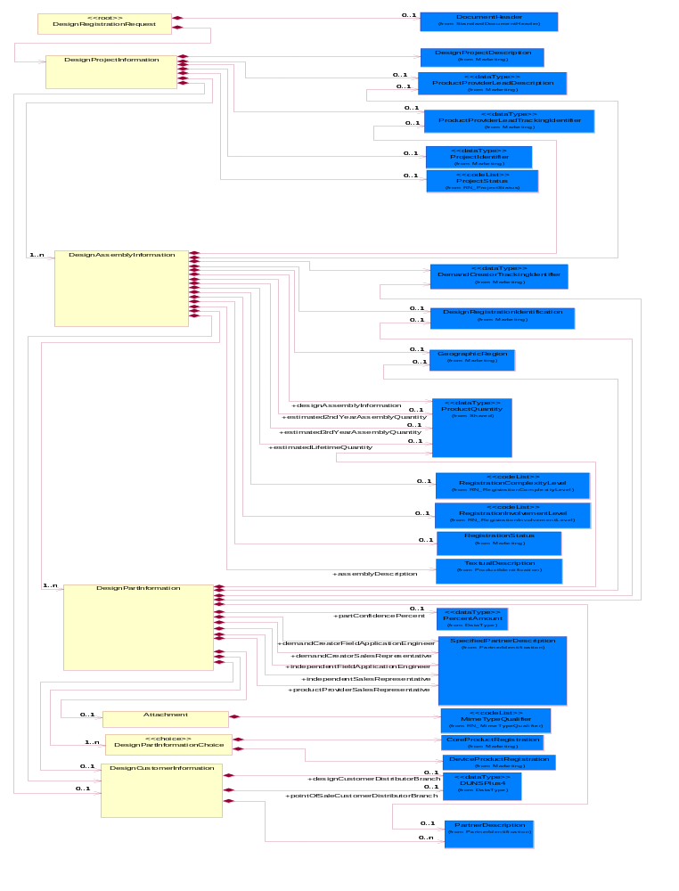
Figure ‎2-1 Interchange

Dependency Diagram
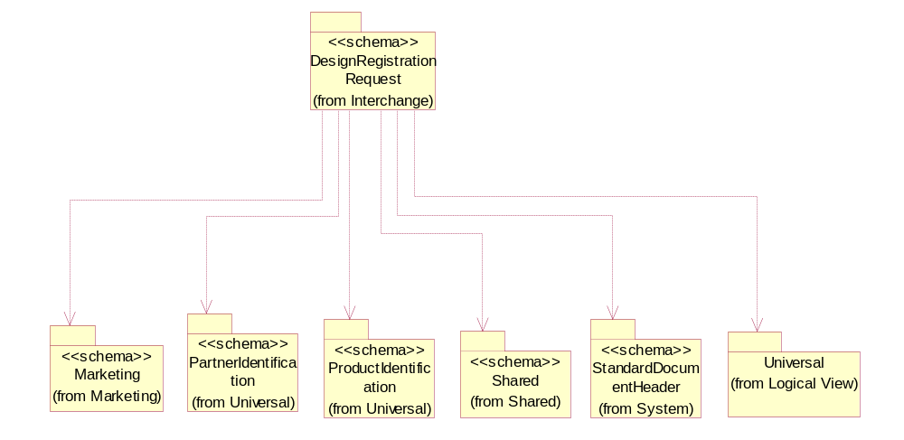
Figure ‎2-2 Dependency

Attachment
A business property that describes additional information regarding a product or process.
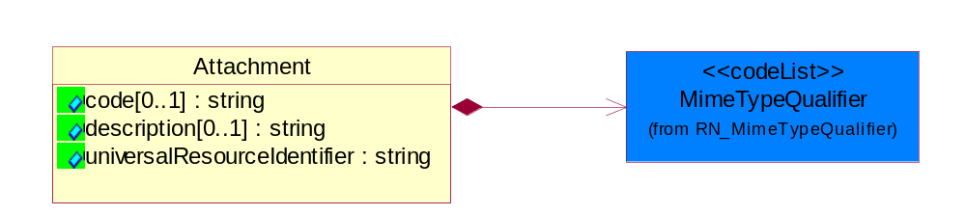
Figure ‎2-3 Attachment
Attribute | Type | Documentation
code[0..1] | string | Code identifying the type of product attachment, e.g. assembly instructions, block diagrams, test requirements, etc.
description[0..1] | string | A description of a process, thing, action, etc.
universalResourceIdentifier | string | A network-centric identifier that provides the identity of a resource.

Composition | Cardinality | Type | Documentation
MimeTypeQualifier | 1 | MimeTypeQualifier | The MIME type as defined by IANA.  Please refer to http://www.iana.org/assignments/media-types/ for a list of types.

DesignAssemblyInformation
The collection of business properties that describe a product design board/assembly.
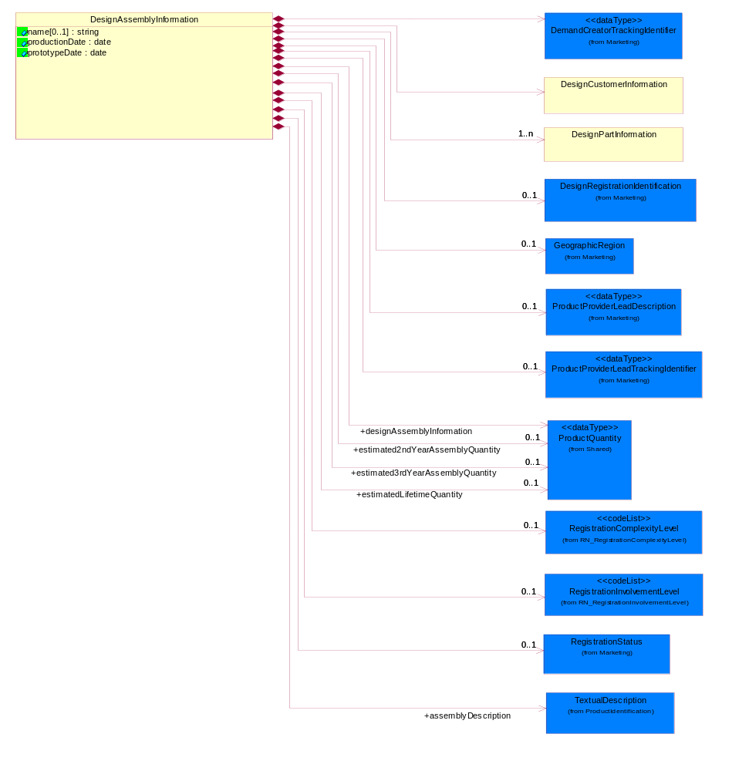
Figure ‎2-4 DesignAssemblyInformation

Attribute | Type | Documentation
name[0..1] | string | The name designation for a board / assembly that resides within the project definition.
productionDate | date | The date the design board / assembly will transition from prototype status to the production status.
prototypeDate | date | The date the design board / assembly will transition from the design status to the prototype status.

Composition | Cardinality | Type | Documentation
estimatedLifetimeQuantity | 0..1 | ProductQuantity | The estimated production quantity, defined as units, of the board / assembly to be shipped within the lifetime of the product.
estimated3rdYearAssemblyQuantity | 0..1 | ProductQuantity | The estimated production quantity, defined as units, of the board / assembly to be shipped within the third year of production.
estimated2ndYearAssemblyQuantity | 0..1 | ProductQuantity | The estimated production quantity, defined as units, of the board / assembly to be shipped within the second year of production.
designAssemblyInformation | 1 | ProductQuantity | The estimated production quantity, defined as units, of the board / assembly to be shipped within the first year of production.
DesignRegistrationIdentification | 0..1 | DesignRegistrationIdentification | The collection of business properties that describe design registration identification.
GeographicRegion | 0..1 | GeographicRegion | The collection of business properties that reflects multiple countries of choice or a specified region.
RegistrationStatus | 0..1 | RegistrationStatus | The collection of business properties that describe the registration status of a product.
RegistrationInvolvementLevel | 0..1 | RegistrationInvolvementLevel | Code identifying the level of involvement for a field application engineer for registering a product.
RegistrationComplexityLevel | 0..1 | RegistrationComplexityLevel | Code identifying the level of complexity for registering a product.
ProductProviderLeadTrackingIdentifier | 0..1 | ProductProviderLeadTrackingIdentifier | A proprietary identifier communicated from the product provider to the demand creator for the purpose of identifying and tracking supplier generated leads.
ProductProviderLeadDescription | 0..1 | ProductProviderLeadDescription | Description of a lead generated by the product provider and provided to the demand creator.
DemandCreatorTrackingIdentifier | 1 | DemandCreatorTrackingIdentifier | The proprietary unique identifier that represents a design registration request for a demand creator.
DesignPartInformation | 1..n | DesignPartInformation | The collection of business properties that describe a product part for a product design registration.
DesignCustomerInformation | 1 | DesignCustomerInformation | The collection of business properties that describe a product design's customer data.
assemblyDescription | 1 | TextualDescription | Free form textual description of a product assembly.

DesignCustomerInformation
The collection of business properties that describe a product design's customer data.
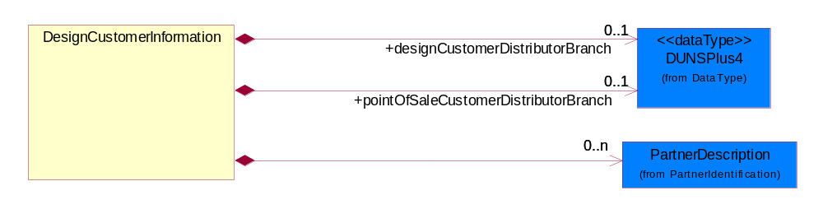
Figure ‎2-5 DesignCustomerInformation

Composition | Cardinality | Type | Documentation
pointOfSaleCustomerDistributorBranch | 0..1 | DUNSPlus4 | The DUNS number for a distributor branch in a Point Of Sale Customer location.
designCustomerDistributorBranch | 0..1 | DUNSPlus4 | The DUNS number for a distributor branch in a Design Customer location.
PartnerDescription | 0..n | PartnerDescription | The collection of business properties that describe a business partners' identity, their contact information, where they are physically located and their function in a supply chain.

DesignPartInformation
The collection of business properties that describe a product part for a product design registration.
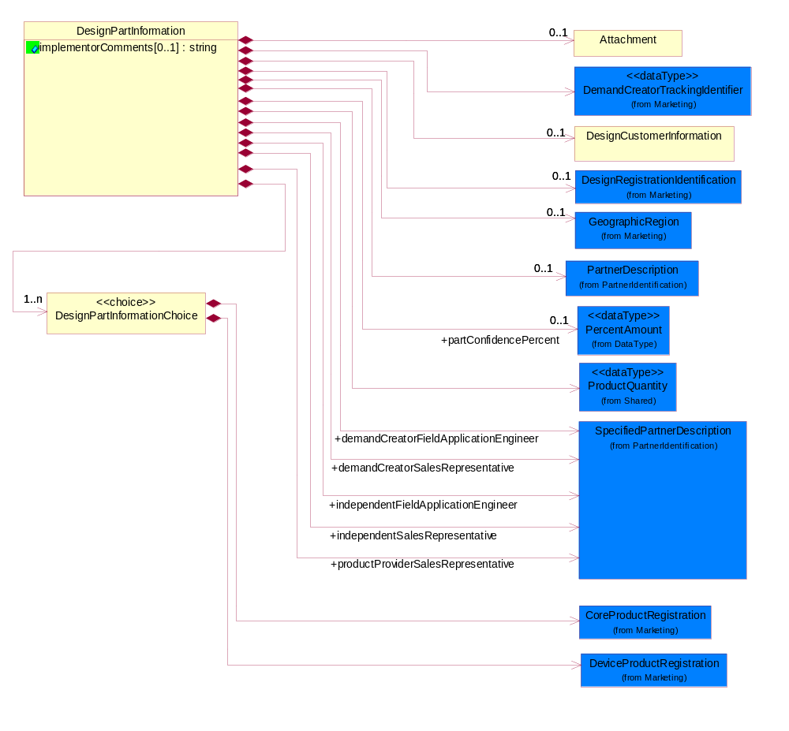
Figure ‎2-6 DesignPartInformation

Attribute | Type | Documentation
implementorComments[0..1] | string | Free form textual description provided for a part implementor regarding a product.

Composition | Cardinality | Type | Documentation
ProductQuantity | 1 | ProductQuantity | A quantity specifying the number of product units.
DesignPartInformationChoice | 1..n | DesignPartInformationChoice | Choice is a functional entity.
demandCreatorFieldApplicationEngineer | 1 | SpecifiedPartnerDescription | The demand creator (I.e., Distributor's) Field Application Engineer.
independentFieldApplicationEngineer | 1 | SpecifiedPartnerDescription | An independent Field Application Engineer representing the product provider.
productProviderSalesRepresentative | 1 | SpecifiedPartnerDescription | The product provider sales representative.
independentSalesRepresentative | 1 | SpecifiedPartnerDescription | An independent sales representative for the product provider.
demandCreatorSalesRepresentative | 1 | SpecifiedPartnerDescription | The demand creator (I.e. Distributor's) sales representative.
DemandCreatorTrackingIdentifier | 1 | DemandCreatorTrackingIdentifier | The proprietary unique identifier that represents a design registration request for a demand creator.
GeographicRegion | 0..1 | GeographicRegion | The collection of business properties that reflects multiple countries of choice or a specified region.
DesignRegistrationIdentification | 0..1 | DesignRegistrationIdentification | The collection of business properties that describe design registration identification.
DesignCustomerInformation | 0..1 | DesignCustomerInformation | The collection of business properties that describe a product design's customer data.
partConfidencePercent | 0..1 | PercentAmount | The percentage value which represents the likelihood the supplier part will reach a part registration status of "win".
Attachment | 0..1 | Attachment | A business property that describes additional information regarding a product or process.
PartnerDescription | 0..1 | PartnerDescription | The collection of business properties that describe a business partners' identity, their contact information, where they are physically located and their function in a supply chain.

DesignPartInformationChoice
Choice is a functional entity.

Composition | Cardinality | Type | Documentation
DeviceProductRegistration | 1 | DeviceProductRegistration | The collection of business properties that describe the registration of a core product.
CoreProductRegistration | 1 | CoreProductRegistration | The collection of business properties that describe the registration of a core product.

DesignProjectInformation
The collection of business properties that compose a product design project.
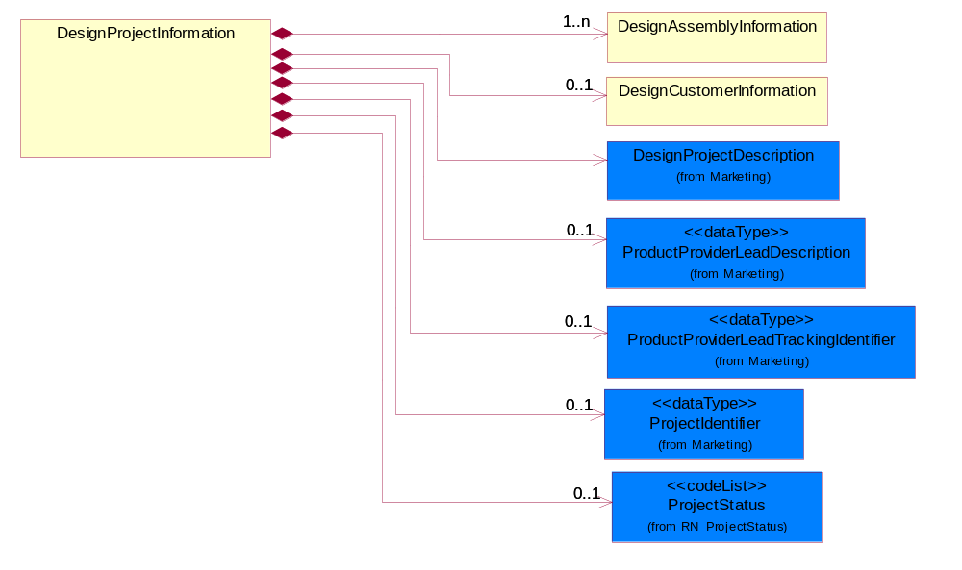
Figure ‎2-7 DesignProjectInformation

Composition | Cardinality | Type | Documentation
DesignProjectDescription | 1 | DesignProjectDescription | The collection of properties describing a product design project description.
ProductProviderLeadDescription | 0..1 | ProductProviderLeadDescription | Description of a lead generated by the product provider and provided to the demand creator.
ProductProviderLeadTrackingIdentifier | 0..1 | ProductProviderLeadTrackingIdentifier | A proprietary identifier communicated from the product provider to the demand creator for the purpose of identifying and tracking supplier generated leads.
ProjectIdentifier | 0..1 | ProjectIdentifier | Unique tracking identification number that identifies a project.
ProjectStatus | 0..1 | ProjectStatus | Code identifying the status of a design project.
DesignCustomerInformation | 0..1 | DesignCustomerInformation | The collection of business properties that describe a product design's customer data.
DesignAssemblyInformation | 1..n | DesignAssemblyInformation | The collection of business properties that describe a product design board/assembly.

DesignRegistrationRequest
Top level object for a Design Registration Request business document.
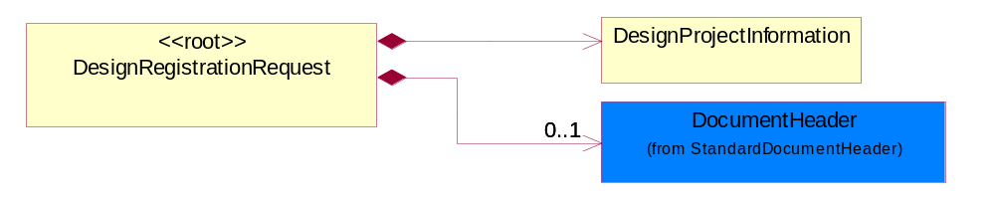
Figure ‎2-8 DesignRegistrationRequest
Composition | Cardinality | Type | Documentation
DesignProjectInformation | 1 | DesignProjectInformation | The collection of business properties that compose a product design project.
DocumentHeader | 0..1 | DocumentHeader | The object allows for the identification of the sender and receiver of the business document.

Domain Model

Marketing

Dependency Diagram
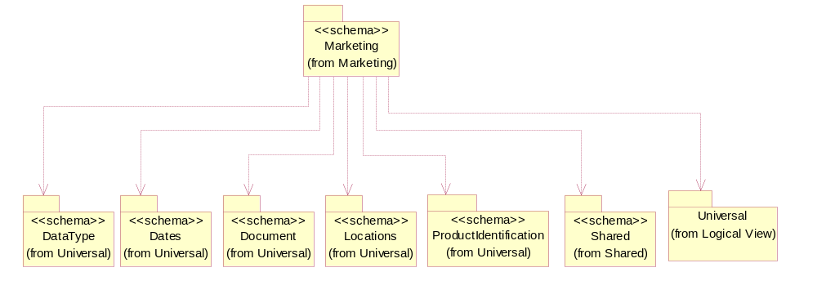
Figure ‎3-9 Dependency

CoreProductRegistration
The collection of business properties that describe the registration of a core product.
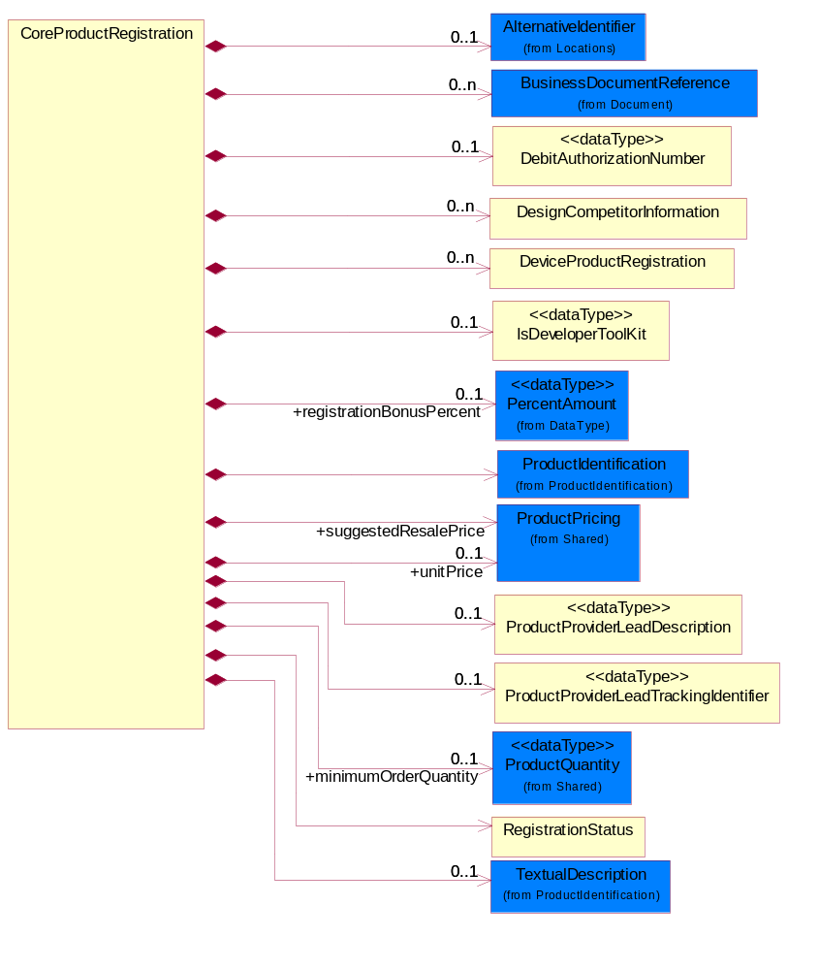
Figure ‎3-10 CoreProductRegistration

Composition | Cardinality | Type | Documentation
DebitAuthorizationNumber | 0..1 | DebitAuthorizationNumber | The number associated with the debit assigned to the pricing of a particular part number.
IsDeveloperToolKit | 0..1 | IsDeveloperToolKit | Development tools, evaluation kits, and software purchased from the supplier and used by the design engineers to perform design-in of the registerable parts.
ProductProviderLeadDescription | 0..1 | ProductProviderLeadDescription | Description of a lead generated by the product provider and provided to the demand creator.
ProductProviderLeadTrackingIdentifier | 0..1 | ProductProviderLeadTrackingIdentifier | A proprietary identifier communicated from the product provider to the demand creator for the purpose of identifying and tracking supplier generated leads.
DesignCompetitorInformation | 0..n | DesignCompetitorInformation | The collection of business properties that describe a competitor's information regarding a product design board / assembly.
BusinessDocumentReference | 0..n | BusinessDocumentReference | The business document reference object allows for the indirect referencing of a relationship to other business related documents.
RegistrationStatus | 1 | RegistrationStatus | The collection of business properties that describe the registration status of a product.
TextualDescription | 0..1 | TextualDescription | The business document must allow for multiple levels of textual description of an event or object.
ProductIdentification | 1 | ProductIdentification | The object provides the identifier(s) of a product.
AlternativeIdentifier | 0..1 | AlternativeIdentifier | Identifies the specified code and the name of the organization that a code is utilized from.
registrationBonusPercent | 0..1 | PercentAmount | The amount that the manufacturer will pay the distributor upon successfully winning a design expressed as a percentage.
DeviceProductRegistration | 0..n | DeviceProductRegistration | The collection of business properties that describe the registration of a core product.
suggestedResalePrice | 1 | ProductPricing | Represents the suggested market price the customer should pay the distributor for the product.
unitPrice | 0..1 | ProductPricing | Agreed upon sale price for each unit ordered.
minimumOrderQuantity | 0..1 | ProductQuantity | A numeric expression of the minimum number of product line items that may be ordered.
IsPartSelected | 1 | IsPartSelected | Enables the distributor to notify the supplier when the design customer commits to using a specific part.
IsRegisterable | 1 | IsRegisterable | Indicates whether a part is a registerable or a non-registerable product.

DebitAuthorizationNumber
The number associated with the debit assigned to the pricing of a particular part number.
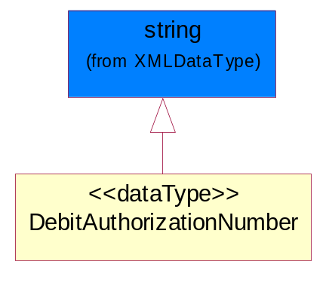
Figure ‎3-11 DebitAuthorizationNumber

DemandCreatorTrackingIdentifier
The proprietary unique identifier that represents a design registration request for a demand creator.
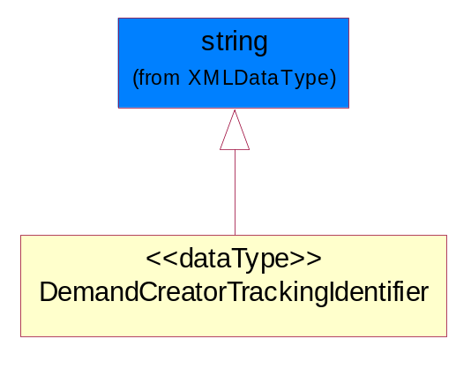
Figure ‎3-12 DemandCreatorTrackingIdentifier

DesignCompetitorInformation
The collection of business properties that describe a competitor's information regarding a product design board / assembly.
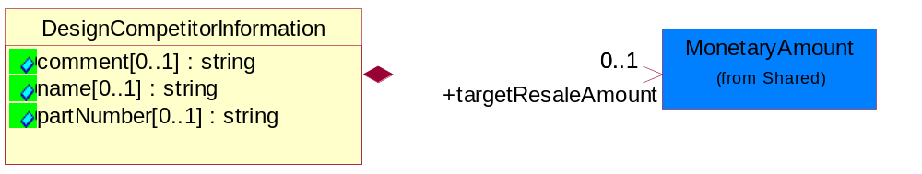
Figure ‎3-13 DesignCompetitorInformation

Attribute | Type | Documentation
comment[0..1] | string | Free form textual comment attached to a business document.
name[0..1] | string | Free form text description of a competing supplier's name.
partNumber[0..1] | string | The unique identifier representing a competing supplier's part number.

Composition | Cardinality | Type | Documentation
targetResaleAmount | 0..1 | MonetaryAmount | The resale price required to secure a design commitment on the product design board and/or assembly.

DesignProjectDescription
The collection of properties describing a product design project description.
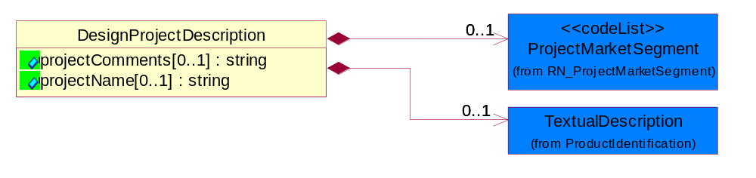
Figure ‎3-14 DesignProjectDescription

Attribute | Type | Documentation
projectComments[0..1] | string | Free form textual description regarding a project.
projectName[0..1] | string | Free form description of the project.

Composition | Cardinality | Type | Documentation
TextualDescription | 0..1 | TextualDescription | The business document must allow for multiple levels of textual description of an event or object.
ProjectMarketSegment | 0..1 | ProjectMarketSegment | The first two characters of the UNSPCS code (I.e., the Global Product Classification Code); which is used to identify the market segment.

DesignRegistrationIdentification
The collection of business properties that describe design registration identification.
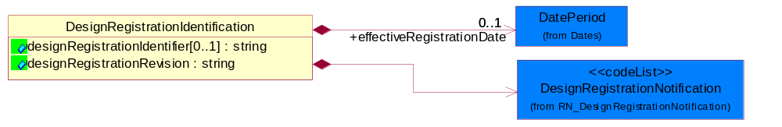
Figure ‎3-15 DesignRegistrationIdentification

Attribute | Type | Documentation
designRegistrationIdentifier[0..1] | string | A proprietary unique identifier for a design registration.
designRegistrationRevision | string | Indicates a new or updated design registration.

Composition | Cardinality | Type | Documentation
effectiveRegistrationDate | 0..1 | DatePeriod | The date registration becomes effective.
DesignRegistrationNotification | 1 | DesignRegistrationNotification | Code identifying the purpose of a design registration notification, e.g. an initial notification or an update.

DesignWinStatusReasonCodeExplanation
Further explanation provided by the product provider or the demand creator to clarify/explain the particular DesignWinStatusReasonCode.
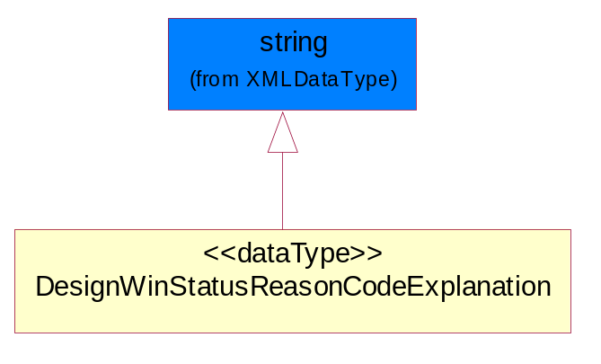
Figure ‎3-16 DesignWinStatusReasonCodeExplanation

DeviceProductRegistration
The collection of business properties that describe the registration of a core product.
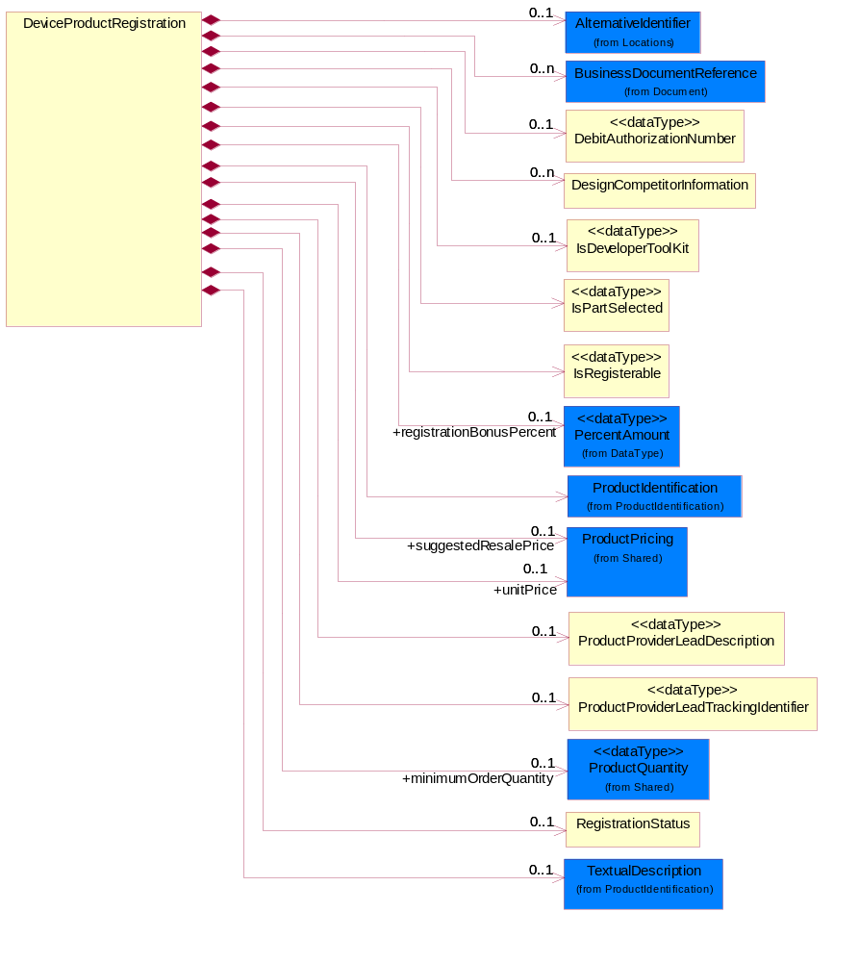
Figure ‎3-17 DeviceProductRegistration

Composition | Cardinality | Type | Documentation
IsDeveloperToolKit | 0..1 | IsDeveloperToolKit | Development tools, evaluation kits, and software purchased from the supplier and used by the design engineers to perform design-in of the registerable parts.
ProductProviderLeadTrackingIdentifier | 0..1 | ProductProviderLeadTrackingIdentifier | A proprietary identifier communicated from the product provider to the demand creator for the purpose of identifying and tracking supplier generated leads.
RegistrationStatus | 0..1 | RegistrationStatus | The collection of business properties that describe the registration status of a product.
registrationBonusPercent | 0..1 | PercentAmount | The amount that the manufacturer will pay the distributor upon successfully winning a design expressed as a percentage.
DebitAuthorizationNumber | 0..1 | DebitAuthorizationNumber | The number associated with the debit assigned to the pricing of a particular part number.
DesignCompetitorInformation | 0..n | DesignCompetitorInformation | The collection of business properties that describe a competitor's information regarding a product design board / assembly.
TextualDescription | 0..1 | TextualDescription | The business document must allow for multiple levels of textual description of an event or object.
IsRegisterable | 1 | IsRegisterable | Indicates whether a part is a registerable or a non-registerable product.
AlternativeIdentifier | 0..1 | AlternativeIdentifier | Identifies the specified code and the name of the organization that a code is utilized from.
ProductProviderLeadDescription | 0..1 | ProductProviderLeadDescription | Description of a lead generated by the product provider and provided to the demand creator.
ProductIdentification | 1 | ProductIdentification | The object provides the identifier(s) of a product.
IsPartSelected | 1 | IsPartSelected | Enables the distributor to notify the supplier when the design customer commits to using a specific part.
BusinessDocumentReference | 0..n | BusinessDocumentReference | The business document reference object allows for the indirect referencing of a relationship to other business related documents.
minimumOrderQuantity | 0..1 | ProductQuantity | The minimum quantity of products that manufacturer will pay the distributor.
suggestedResalePrice | 0..1 | ProductPricing | Represents the suggested market price the customer should pay the distributor for the product.
unitPrice | 0..1 | ProductPricing | Agreed upon sale price for each unit ordered.

GeographicRegion
The collection of business properties that reflects multiple countries of choice or a specified region.
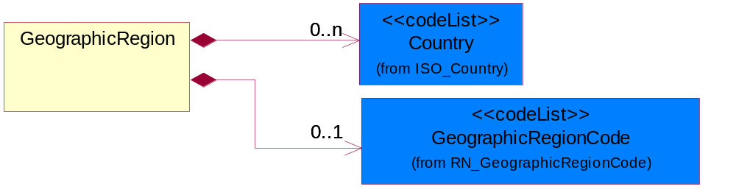
Figure ‎3-18 GeographicRegion

Composition | Cardinality | Type | Documentation
Country | 0..n | Country | For representation of Country name RosettaNet has adopted ISO 3166-3; 1999. Refer to the following web page to get the latest version of the standard:  http://www.iso.ch/iso/en/prods-services/iso3166ma/02iso-3166-code-lists/index.html  If you need more information about the ISO standard please contact ISO for more details.
GeographicRegionCode | 0..1 | GeographicRegionCode | Code identifying a geographic region.

IsDeveloperToolKit
Development tools, evaluation kits, and software purchased from the supplier and used by the design engineers to perform design-in of the registerable parts.
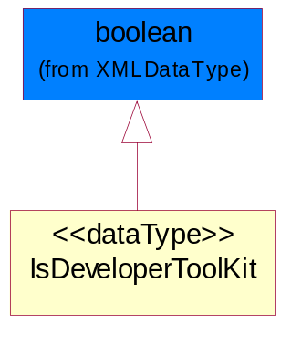
Figure ‎3-19 IsDeveloperToolKit

IsPartSelected
Enables the distributor to notify the supplier when the design customer commits to using a specific part.
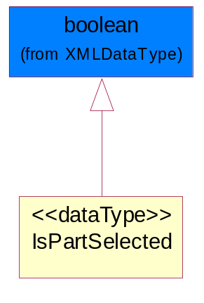
Figure ‎3-20 IsPartSelected

IsRegisterable
Indicates whether a part is a registerable or a non-registerable product.
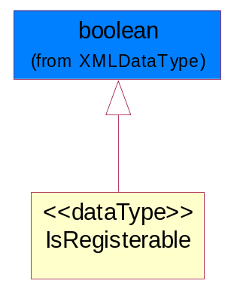
Figure ‎3-21 IsRegisterable

ProductProviderLeadDescription
Description of a lead generated by the product provider and provided to the demand creator.
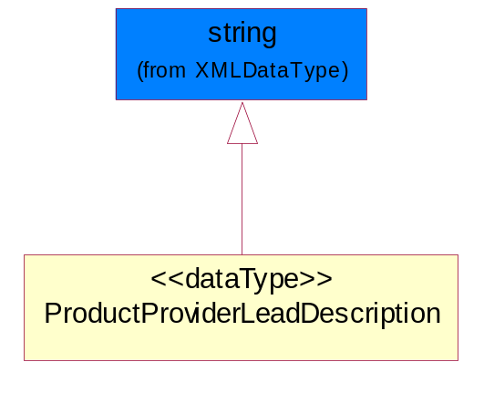
Figure ‎3-22 ProductProviderLeadDescription

ProductProviderLeadTrackingIdentifier
A proprietary identifier communicated from the product provider to the demand creator for the purpose of identifying and tracking supplier generated leads.
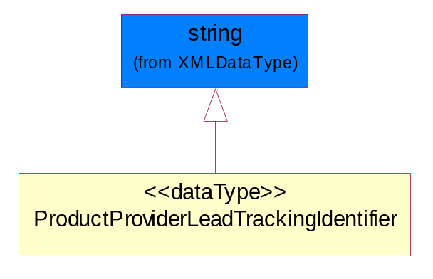
Figure ‎3-23 ProductProviderLeadTrackingIdentifier

ProjectIdentifier
Unique tracking identification number that identifies a project.
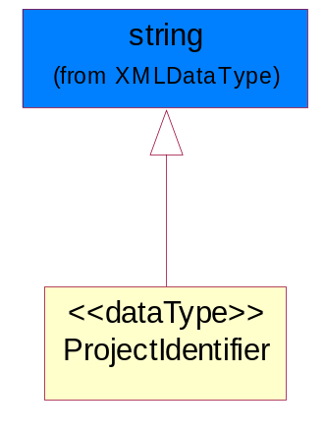
Figure ‎3-24 ProjectIdentifier

RegistrationStatus
The collection of business properties that describe the registration status of a product.
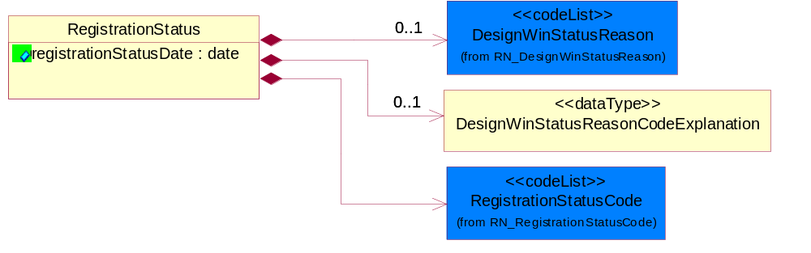
Figure ‎3-25 RegistrationStatus

Attribute | Type | Documentation
registrationStatusDate | date | The date stamp when the registration status was generated.

Composition | Cardinality | Type | Documentation
RegistrationStatusCode | 1 | RegistrationStatusCode | Code identifying the registration status of a design; namely, the acknowledgment, collaboration and continuation on the submitted supplier part business opportunity between a supplier (manufacture representative) and a distributor.
DesignWinStatusReason | 0..1 | DesignWinStatusReason | Code identifying the reason for the disposition of a design registration request or the status of a particular design registration assigned by the product provider or requested by the demand creator.
DesignWinStatusReasonCodeExplanation | 0..1 | DesignWinStatusReasonCodeExplanation | Further explanation provided by the product provider or the demand creator to clarify/explain the particular DesignWinStatusReasonCode.

CodeList

RegistrationComplexityLevel
Code identifying the level of complexity for registering a product.

Name | Documentation
AAV | Above Average - Above average complexity.
AVE | Average - Average complexity.
MAX | Maximum - Maximum complexity.
MIN | Minimum - Minimal complexity.
NON | None - No complexity.
SOM | Some - Some complexity.

RegistrationInvolvementLevel
Code identifying the level of involvement for a field application engineer for registering a product.

Name | Documentation
AAV | Above average - 80% dedicated involvement of the Field Application Engineer.
AVE | Average - 60% dedicated involvement of the Field Application Engineer.
MIN | Minimum - 20% dedicated involvement of the Field Application Engineer.
NON | None - No involvement of the Field Application Engineer.
SOM | Some - 40% dedicated involvement of the Field Application Engineer.
TOT | Total - 100% dedicated involvement of the Field Application Engineer.

DesignWinStatusReason
Code identifying the reason for the disposition of a design registration request or the status of a particular design registration assigned by the product provider or requested by the demand creator.

Name | Documentation
CAP | Contact Approve - Please call to resolve issue with request.
CMA | Contract Manufacturer - Manufacturing is now serviced by the contract manufacturer, not distribution.
COO | Company Out of Business - Company is out of business.
CRP | Competing Registration Present - Registration for part and customer already exists with another distributor.
CRT | Customer Requested to Close the Opportunity - The end customer has asked the product provider to close the registration.
DAD | Design Already Done - The design has already been completed and therefore the demand creator is not eligible for design registration for this project.
DCL | Duplicate Claim - A Design Win claim for the same registration has previously been accepted and approved.
DRE | Duplicate Registration - Registration for part and customer already exists with requesting distributor.
DWD | Design Win Date Must Be a Future Date - The design win date supplied by the demand creator is in the past and the product provider requires the date to be in the future.
EDR | Expired Design Registration Status - Project expired and therefore no longer eligible for design registration.
ICC | Invalid Company Contact - The company contact supplied was determined invalid by the product provider.
ICD | Invalid Customer Code - The product provider cannot identify the customer code or the customer code supplied is invalid.
ICE | Invalid Customer Contact - The customer contact has been determined invalid by the product provider.
IIN | Insufficient Information - One or more required data elements was not provided or information in a given data element is incomplete.
IOA | Invalid Opportunity Attachment - The opportunity attachment has been determined invalid by the product provider.
ION | Invalid Opportunity Note or Comment - The opportunity note or comment has been determined invalid by the product provider.
IOS | Invalid Opportunity Status - The opportunity status sent in is not valid.
IPC | Invalid Partner Code - The partner code has been determined invalid by the product provider.
IPN | Invalid Part Number - Supplier cannot identify part number as one of its own.
IPP | Invalid Product Price - The product price has been determined invalid by the product provider.
IPQ | Invalid Product Quantity Per System - The product quantity per system has been determined invalid by the product provider.
IPR | Invalid Partner Role - The partner role has been determined invalid by the product provider.
IPS | Invalid Product - The product has been determined invalid by the product provider.
IPT | Invalid Projected Sales Quantity - The projected sales quantity has been determined invalid by the product provider.
LDE | Lost Design - Design has been lost and is therefore no longer eligible for registration.
MDG | Multiple Distributors Give Support - Multiple demand creators are providing support for this project and therefore it is not eligible for design registration.
NAR | Not a Registerable Part Number or Part Number Not Eligible For Registration - Part number is a good supplier part, but is not eligible for registration.
NAV | Not a Valid Customer Project - The customer project has been determined invalid for design registration.
NCR | No Commercial Relation - The demand creator submitting the design does not have a valid commercial relationship (e.g., franchise agreement) with the product provider.
NDF | No Distributor Field Application Engineer - The demand creator no longer has a field application engineer supporting the project.
NES | No Engineer Services Required - The customer or design does not require technical investment of resources and therefore the registration is deemed invalid by the product provider.
NSB | Not Supported By Distributor - The product provider has determined that this registration is invalid because it is not being supported by the demand creator.
OAT | Opportunity Attachment Too Large - The opportunity attachment has been determined to be too large by the product provider.
PCB | Project Cancelled By Customer - The customer has cancelled the project for this design registration.
PDB | Project Delayed By Customer - The customer has delayed the project for this design registration.
PNN | Part Number Not In Price Book - Some suppliers require that a part be in the price book before issuing a registration.
PSN | Project Safety Not Green - The use of the part in this particular project does not meet the product provider's eligibility requirements for design registration.
PWD | Production Win Date Must Be Future Date - The production win date supplied by the demand creator is in the past and the product provider requires the date to be in the future.
QMN | Quantity Metric Not Met - Quantity of parts required to satisfy Design Win threshold requirement has not been met.
RFI | Required Fields Incomplete - Minimum fields of information required by supplier was not met.
RIN | Resale Inactivity - Registration was in production win status, but there have not been sufficient resales to keep it active.
RNI | Registration Number is Not Valid - Supplier cannot identify register number with any valid register numbers for that distributor.
SMN | Sales Metric Not Met - Dollar sales volume required to satisfy Design Win threshold requirement has not been met.
URE | Under Review - Design registration request has not completed the review process.
VNH | Value Not High Enough - Value of opportunity does not meet minimum requirements for registration.
WCN | Wrong Customer Name - Customer name does not match name on existing registration.

RegistrationStatusCode
Code identifying the registration status of a design; namely, the acknowledgment, collaboration and continuation on the submitted supplier part business opportunity between a supplier (manufacture representative) and a distributor.

Name | Documentation
APP | Approved - Registration has been approved as Design Win eligible.
CLO | Closed - Registration has been closed by supplier or customer request and is not subject to renewal.
DEN | Denied - Registration has been rejected (turned down) for Design Win eligible status.
EXP | Opportunity was not updated within 90 days.
FRE | Final Registration - Indicates limited incentives apply from here on.
OSW | Production in the other geography has been verified and the offshore win claim has been approved.
OWC | Production is being done in a geography different than the geography the opportunity was generated in.
PEN | Pending - Registration has been submitted and logged (on the supplier's system), but approval is pending or on hold.
PRO | Production - Approved registration, has reached Production Win threshold, making sales eligible for enhanced margin, rebates or bonuses.
VAL | Valid - Design registration acknowledged by the supplier, but not yet approved for design win. The Valid stage allows the distributor to finish the design, submit Bill of Materials or block diagrams as required to meet conditions for Approval. The supplier is not yet protected as there are still outstanding conditions for getting to Approved.
WIN | Win - Approved registration has reached the Design Win threshold, making sales eligible for enhanced margin, rebates or bonuses.

GeographicRegionCode
Code identifying a geographic region.

Name | Documentation
GLO | Global - All countries.

DesignRegistrationNotification
Code identifying the purpose of a design registration notification, e.g. an initial notification or an update.

Name | Documentation
CAN | Cancel - Request to cancel the existing registration ("Closed" status).
CHA | Change - Request to change the existing registration and/or status.
INI | Initial - The first-time response or notification regarding design registration status.
NRE | New Request - Request for a new registration.
UPD | Update - An updated response or notification regarding design registration status.

ProjectStatus
Code identifying the status of a design project.

Name | Documentation
CON | Concept - Indicates a potential opportunity for a "design in" exists.
DES | Design - Indicates that an engineer and project name has been assigned.
PRO | Production - POS (Point of Sale) reports indicate that product has been shipped for production builds, and the project is successfully completed.
PRP | Prototype - Indicates that a prototype build and evaluation is underway.

ProjectMarketSegment
The first two characters of the UNSPCS code (I.e., the Global Product Classification Code); which is used to identify the market segment.

Name | Documentation
UCT | UN/SPSC Codes to be used.

Shared

Dependency Diagram
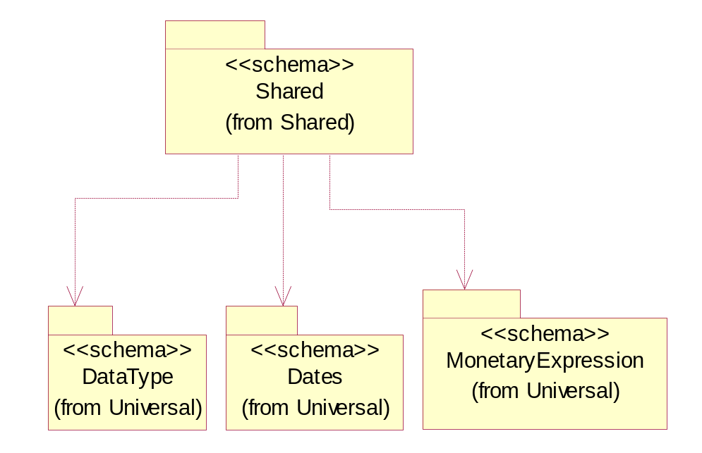
Figure ‎3-26 Dependency

MonetaryAmount
The collection of business properties that describe the monetary amount defined by a specified currency.
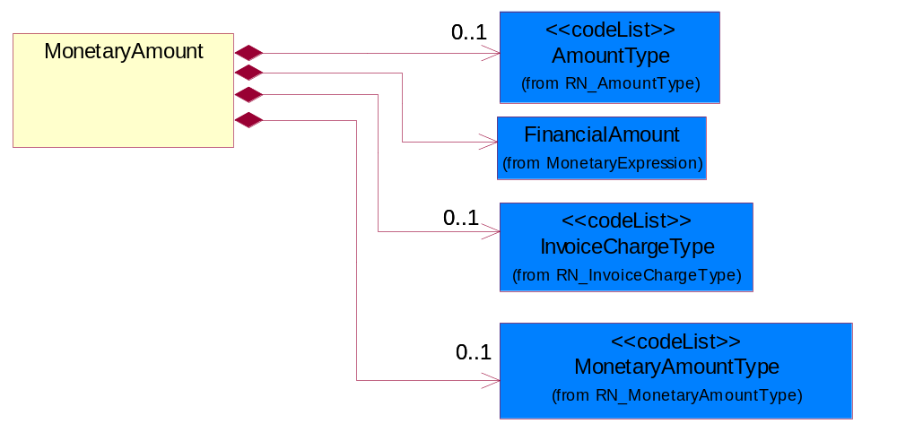
Figure ‎3-27 MonetaryAmount

Composition | Cardinality | Type | Documentation
FinancialAmount | 1 | FinancialAmount | The business document must express financial amounts.
InvoiceChargeType | 0..1 | InvoiceChargeType | Code identifying the values for the types of charges contained in an invoice.
MonetaryAmountType | 0..1 | MonetaryAmountType | Code identifying whether the monetary amount is a debit or credit.
AmountType | 0..1 | AmountType | Code identifying the type of monetary amount.

ProductPricing
The collection of business properties that describe the type of pricing and financial amount for a product.
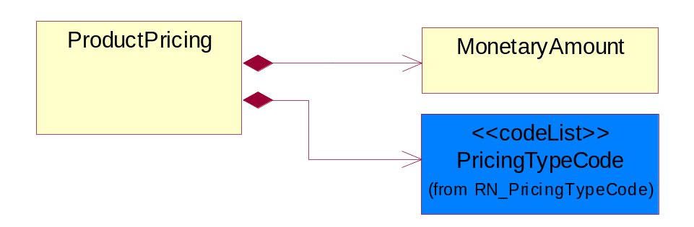
Figure ‎3-28 ProductPricing

Composition | Cardinality | Type | Documentation
MonetaryAmount | 1 | MonetaryAmount | The collection of business properties that describe the monetary amount defined by a specified currency.
PricingTypeCode | 1 | PricingTypeCode | Code identifying the type of pricing available for a product.

ProductQuantity
A quantity specifying the number of product units.
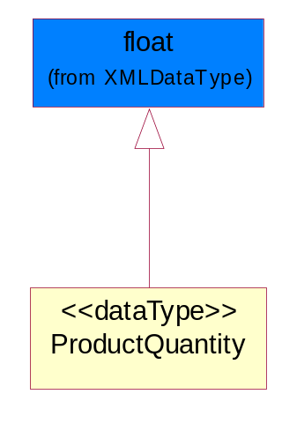
Figure ‎3-29 ProductQuantity

CodeList

InvoiceChargeType
Code identifying the values for the types of charges contained in an invoice.

Name | Documentation
ALC | Allowances and Charges.
CUC | Custom Charges.
DEA | Deposit Amount.
ESC | Expedited Shipping Charge - Charge for accelerating the delivery of a product.
FRC | Freight Charges.
HAC | Handling Charges.
LEC | Lease Charge - Charge for the use of a product in which the purchaser assumes certain responsibilities of ownership.
LIC | License Charge - Charge for the use of a product (usually software) in which the manufacturer maintains ownership of the product.
MAC | Maintenance Charge - Charge (usually periodic) for providing maintenance support for a product.
PUC | Purchase Charge - Charge for a product in which the buyer takes all responsibilities of ownership.
QUD | Quantity Discount.
REC | Rental Charge - Charge for the use of a product (usually hardware) in which the manufacturer maintains ownership of the product.

MonetaryAmountType
Code identifying whether the monetary amount is a debit or credit.
Name | Documentation
CRE | Credit.
DEB | Debit.
ZER | Zero remit.

PricingTypeCode
Code identifying the type of pricing available for a product.
Name | Documentation
ACR | Authorized Cost and Resale.
ACS | Authorized Cost - The negotiated cost agreed upon between the supplier and distributor at the time the “debit?is authorized.
ACT | Authorized cost.
ANY | Any available.
ARS | Authorized resale.
ASP | Average Selling Price - Manufacturer's published price.
BPA | Budgetary Price Amount.
BPP | Broken Purchase Price.
BSH | Book-Ship.
CAT | Catalog price - Book (the supplier’s published cost at the time of transaction) or Published Price.
CLM | Claim Amount.
CMC | Commercial.
CMD | Commodity.
CMF | Contract Manufacturing.
CON | Contract.
COS | Cost - Price for which the distributor purchased the parts.
CPL | Country Price List.
DBC | Disti Book Cost.
DFR | Duty free.
DIS | Distribution.
DPD | Duty paid.
DTP | Distribution price.
EDU | Education.
ERT | E-Rate.
EXC | Exception.
FGM | Federal government.
GEN | General.
HIE | Higher Education.
LCL | Local.
LGM | Local government.
LIS | List.
MPR | Market price.
MRP | Manufacturer's recommendation for unit pricing.
MSR | Manufacturer Suggested Retail Price (MSRP).
MUS | Minimum Unit Sale (MUS) - Manufacturer requirement of total dollar value for design opportunity.
NPF | Nonprofit.
OEM | Original Equipment Manufacturing (OEM).
OVP | OEM Volume Pricing - Original equipment manufacturing price per volume ordered.
PED | Primary Education.
QUO | Quote Price
RCS | Requested Cost (RCS) - Reseller requested cost to the manufacturer.
REX | Reseller Expects.
RFB | Refurbished.
RIN | Religious Institution.
RSP | Resale - Price the distributor is authorized to use for sale to their customer (RSP).
SCE | Special Education.
SEC | Security and management reseller.
SED | Secondary Education.
SEV | Service provider.
SGM | State Government.
SPD | Special Discount Price.
SPE | Special Education.
SPL | Samples.
SRP | Suggested Resale Price.
STR | Standard Rebate.
THP | Threshold Price.
TOC | Total Other Charges - Suggested resale price - The sum total of all distributor added charges to the customer for value added services, including but not limited to programming, tape and reel, labeling, date coding, kitting and in-house assembly.

AmountType
Code identifying the type of monetary amount.
Name | Documentation
DIP | Discount Percentage.
DIS | Discount Value - The monetary amount of the discount on the price applied to a customer order.
FRE | Freight Charges - The monetary amount to be paid for freight transportation.
INS | InsuranceCharges - The monetary amount to be paid for freight insurance.
MAT | Material Cost - This object represents the material cost for the product.
MIS | Miscellaneous Charges - The monetary amount to be paid for miscellaneous charges.
NET | Net Amount.
PRC | Processing Charges - The monetary amount to be paid by consignee for consignment manufacturer.
TOD | Total Amount Due - Total amount due upon receipt of statement.
TOT | Total Amount - Total price for an entire business document.
TOV | Total Value Added Amount - The total amount of the shipment including any value added tax.
UNI | Unit Price - Agreed upon sale price for each unit ordered.
VAD | Value Added Unit Price - The price of a unit including any value added tax.

Universal Structure

ContactInformation

ContactInformation
The business document must allow for the identification of the name of the department, service or individual to be contacted regarding the context of the business document.
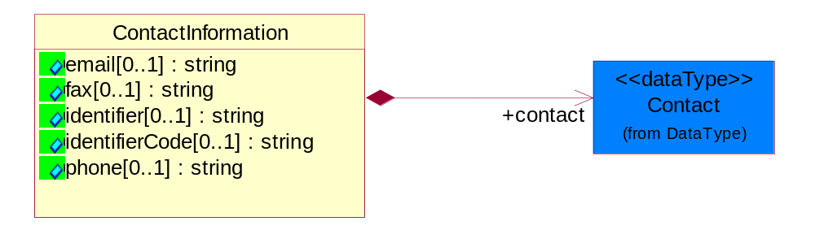
Figure ‎4-30 ContactInformation

Attribute | Type | Documentation
email[0..1] | string | The electronic mail for the specified contact.
fax[0..1] | string | The fax number for the specified contact.
identifier[0..1] | string | Identifies the role of the contact (i.e. Service Technician, Account Manager) in the Business Process.
identifierCode[0..1] | string | IdentifierCode is a unique security authorization code to identify the contact- ie. badge ID.
phone[0..1] | string | The telephone number for the specified contact.

Composition | Cardinality | Type | Documentation
contact | 1 | Contact | The name of the department, service or individual to be contacted within the organization.

DataType

Contact
The name of the department, service or individual to be contacted within the organization.
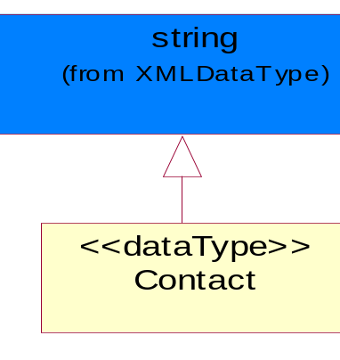
Figure ‎4-31 Contact

DUNS
A number assigned by Dun and Bradstreet to identify a business location.
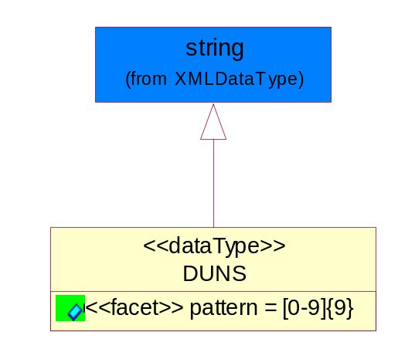
Figure ‎4-32 DUNS

Attribute | Type | Documentation
pattern |  | [0-9]{9}

DUNSPlus4
A identifier to specify a specific location within a business location.
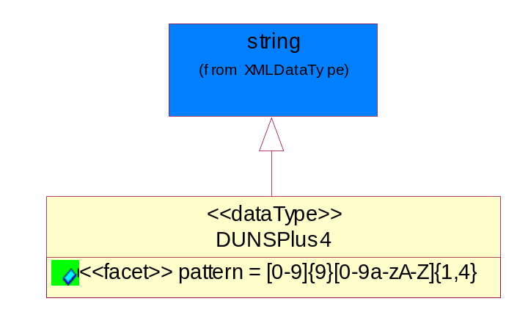
Figure ‎4-33 DUNSPlus4

Attribute | Type | Documentation
pattern |  | Data Universal Numbering System +4 (DUNS+4) number means the DUNS number assigned by Dun and Bradstreet, Inc. (D&B) plus an alphanumeric of length 4 suffix that may be assigned by a business concern.

GLN
Global Location Number (GLN) - A identifier to identify legal entities, trading parties and location.
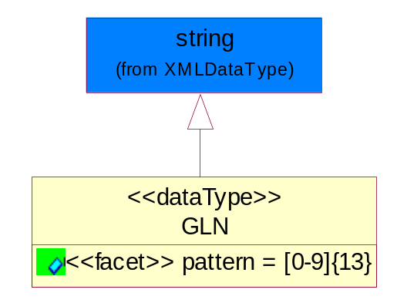
Figure ‎4-34 GLN

Attribute | Type | Documentation
pattern |  | [0-9]{13}

GTIN
Global Trade Identification Number (GTIN).
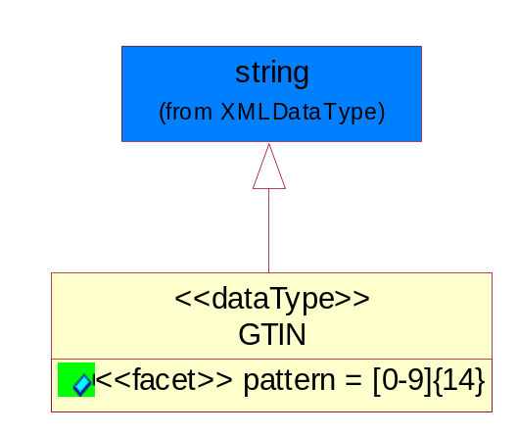
Figure ‎4-35 GTIN

Attribute | Type | Documentation
pattern |  | [0-9]{14}

PercentAmount
A number representing a percentage value, e.g. 75.125 represents 75 1/8 percent.
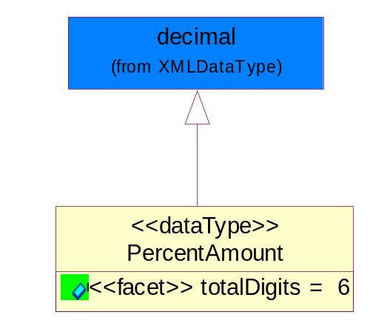
Figure ‎4-36 PercentAmount

Attribute | Type | Documentation
totalDigits |  | 6

Dates

DatePeriod
The business document must allow for the computation or statement of a duration based upon a beginning and an ending date.
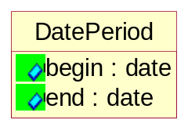
Figure ‎4-37 DatePeriod

Attribute | Type | Documentation
begin | date | The date indicating the beginning of the date period.
end | date | The date indicating the ending of the date period.

Document

BusinessDocumentReference
The business document reference object allows for the indirect referencing of a relationship to other business related documents.
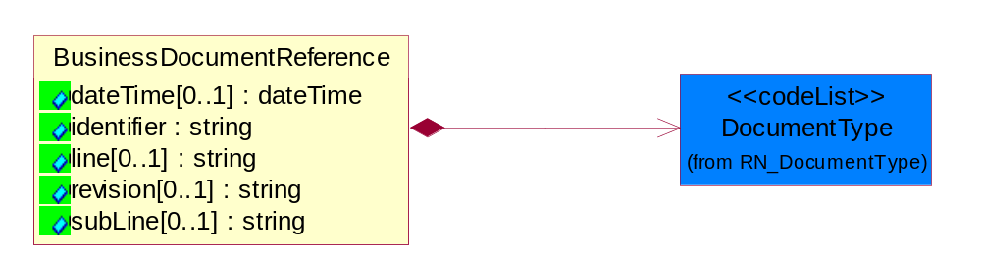
Figure ‎4-38 BusinessDocumentReference

Attribute | Type | Documentation
dateTime[0..1] | dateTime | The date-time stamp indicating on the referenced business document.
identifier | string | Unique identification of the referenced business document.
line[0..1] | string | References the specific line number of the specified business document.
revision[0..1] | string | Referenced the revision of the specified business document.
subLine[0..1] | string | References the specific subline number of the specified business document.

Composition | Cardinality | Type | Documentation
DocumentType | 1 | DocumentType | A code identifying the business context of a document.

Locations

AlternativeIdentifier
Identifies the specified code and the name of the organization that a code is utilized from.
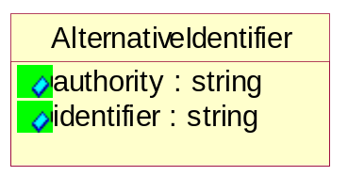
Figure ‎4-39 AlternativeIdentifier

Attribute | Type | Documentation
authority | string | The name of the organization that a code is utilized from.
identifier | string | The specified code to represent an entity (e.g. product, location, partner, etc.).

Location
The business document must specify a location.
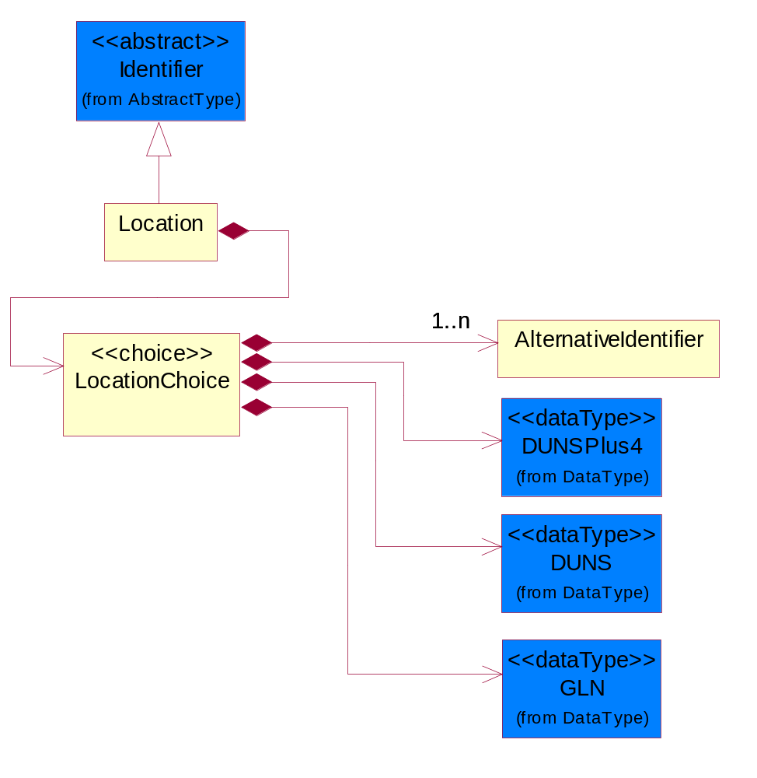
Figure ‎4-40 Location

Composition | Cardinality | Type | Documentation
LocationChoice | 1 | LocationChoice

LocationChoice

Composition | Cardinality | Type | Documentation
DUNSPlus4 | 1 | DUNSPlus4 | A identifier to specify a specific location within a business location.
DUNS | 1 | DUNS | A number assigned by Dun and Bradstreet to identify a business location.
AlternativeIdentifier | 1..n | AlternativeIdentifier | Identifies the specified code and the name of the organization that a code is utilized from.
GLN | 1 | GLN | Global Location Number (GLN) - A identifier to identify legal entities, trading parties and location.

PhysicalAddress
The business document must provide a physical address for a party to the business transaction.
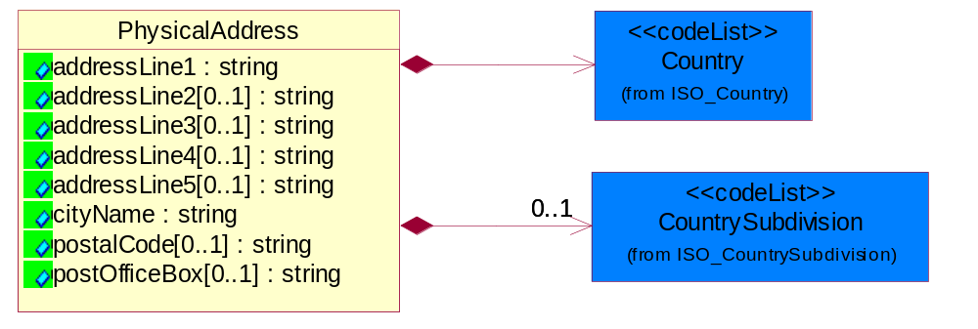
Figure ‎4-41 PhysicalAddress

Attribute | Type | Documentation
addressLine1 | string | The first line of a physical address.
addressLine2[0..1] | string | The second line of a physical address.
addressLine3[0..1] | string | The third line of a physical address.
addressLine4[0..1] | string | The fourth line of a physical address.
addressLine5[0..1] | string | The fifth line of a physical address.
cityName | string | The name of a city.
postalCode[0..1] | string | Identifying geographic location as specified by a national postal code.
postOfficeBox[0..1] | string | The Post Office Box identifier used to identify a party's post office box.

Composition | Cardinality | Type | Documentation
Country | 1 | Country | For representation of Country name RosettaNet has adopted ISO 3166-3; 1999. Refer to the following web page to get the latest version of the standard:  http://www.iso.ch/iso/en/prods-services/iso3166ma/02iso-3166-code-lists/index.html  If you need more information about the ISO standard please contact ISO for more details.
CountrySubdivision | 0..1 | CountrySubdivision | For representation of a Countries subdivisions RosettaNet has adopted ISO 3166-3; 1999. Refer to the following web page to get the latest version of the standard:  http://www.iso.ch/iso/en/prods-services/iso3166ma/02iso-3166-code-lists/index.html  If you need more information about the ISO standard please contact ISO for more details.

MonetaryExpression

FinancialAmount
The business document must express financial amounts.
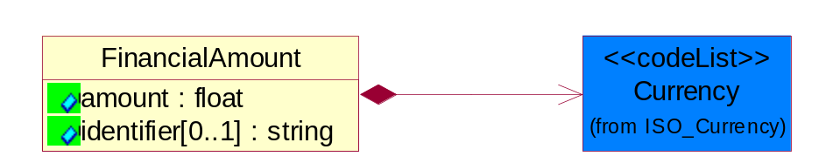
Figure ‎4-42 FinancialAmount

Attribute | Type | Documentation
amount | float | Specifies the monetary amount.
identifier[0..1] | string | Identifier is a unique identifier to which the specific price is tied - ie. promotion name/ program.

Composition | Cardinality | Type | Documentation
Currency | 1 | Currency | For representation of Currency codes RosettaNet has adopted ISO 4217; 1995. The British Standards Institution (BSI) is the ISO 4217 Maintenance Agency. Refer to the following web page to get the latest version of the standard:  http://www.bsi-global.com/Technical+Information/Publications/_Publications/tig90.xalter  If you need more information about the ISO standard please contact ISO for more details.

PartnerIdentification

FullPartner
The business document must describe the trading partners in the business transaction. This data structure provide the flexibility to describe a partner in all possible methods as for new, existing or known partner.
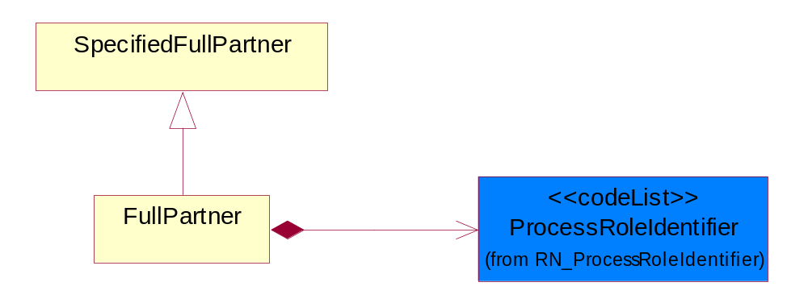
Figure ‎4-43 FullPartner

Composition | Cardinality | Type | Documentation
ProcessRoleIdentifier | 1 | ProcessRoleIdentifier | Describes the role of the partner in the business process. A partner will fulfill at least one or more roles during the business process.

IntermittentPartner
The business document must describe a physical address for a delivery.
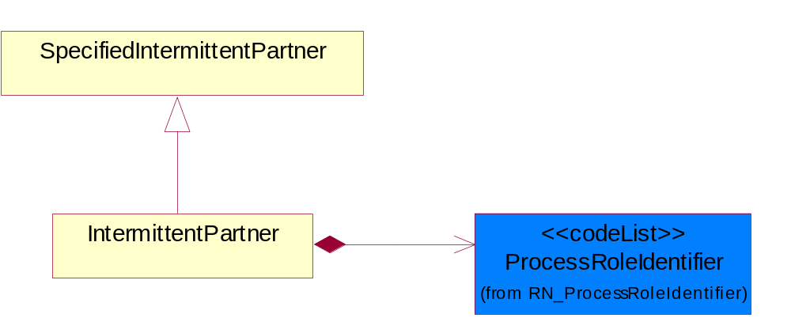
Figure ‎4-44 IntermittentPartner

Composition | Cardinality | Type | Documentation
ProcessRoleIdentifier | 1 | ProcessRoleIdentifier | Describes the role of the partner in the business process. A partner will fulfill at least one or more roles during the business process.

KnownPartner
The business document must describe the trading partners in the business transaction.
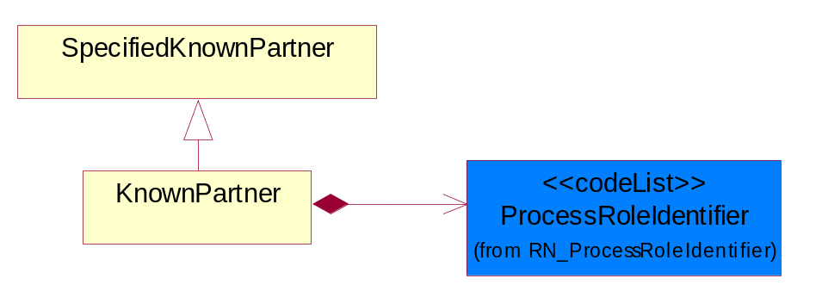
Figure ‎4-45 KnownPartner

Composition | Cardinality | Type | Documentation
ProcessRoleIdentifier | 1 | ProcessRoleIdentifier | Describes the role of the partner in the business process. A partner will fulfill at least one or more roles during the business process.

KnownPartnerContact
The business document must describe the trading partners in the business transaction.
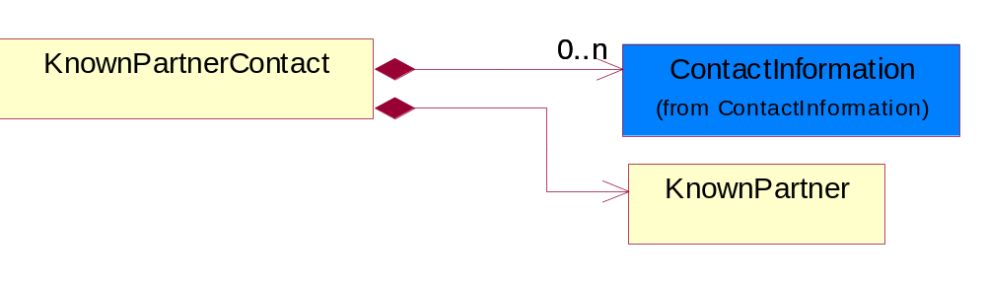
Figure ‎4-46 KnownPartnerContact

Composition | Cardinality | Type | Documentation
KnownPartner | 1 | KnownPartner | The business document must describe the trading partners in the business transaction.
ContactInformation | 0..n | ContactInformation | The business document must allow for the identification of the name of the department, service or individual to be contacted regarding the context of the business document.

NewPartner
The business document must describe a new, existing (but known to only one of the parties to the transaction) or an unknown party to the business transaction.
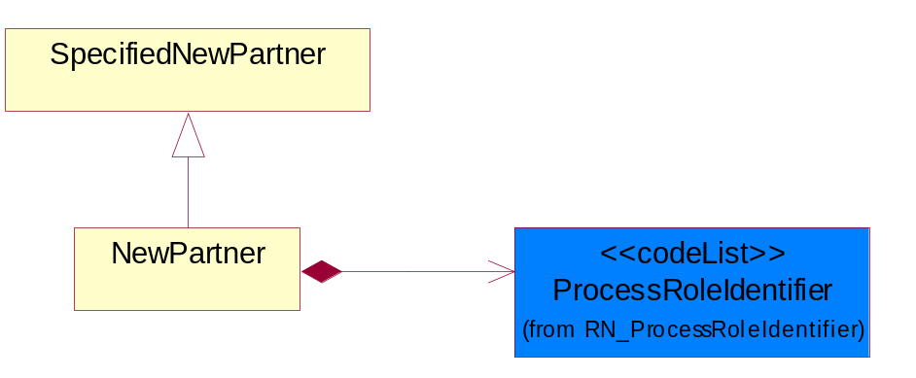
Figure ‎4-47 NewPartner

Composition | Cardinality | Type | Documentation
ProcessRoleIdentifier | 1 | ProcessRoleIdentifier | Describes the role of the partner in the business process. A partner will fulfill at least one or more roles during the business process.

PartnerDescription
The collection of business properties that describe a business partners' identity, their contact information, where they are physically located and their function in a supply chain.
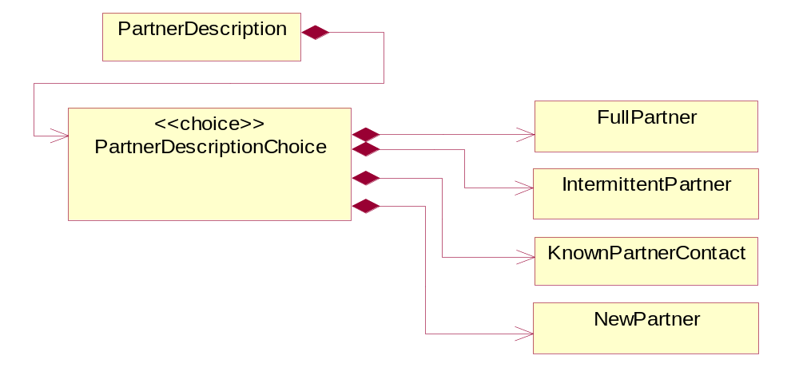
Figure ‎4-48 PartnerDescription

Composition | Cardinality | Type | Documentation
PartnerDescriptionChoice | 1 | PartnerDescriptionChoice

PartnerDescriptionChoice

Composition | Cardinality | Type | Documentation
KnownPartnerContact | 1 | KnownPartnerContact | The business document must describe the trading partners in the business transaction.
IntermittentPartner | 1 | IntermittentPartner | The business document must describe a physical address for a delivery.
NewPartner | 1 | NewPartner | The business document must describe a new, existing (but known to only one of the parties to the transaction) or an unknown party to the business transaction.
FullPartner | 1 | FullPartner | The business document must describe the trading partners in the business transaction. This data structure provide the flexibility to describe a partner in all possible methods as for new, existing or known partner.

PartnerIdentification
The business document must allow for the identity of one or more parties to the transaction.
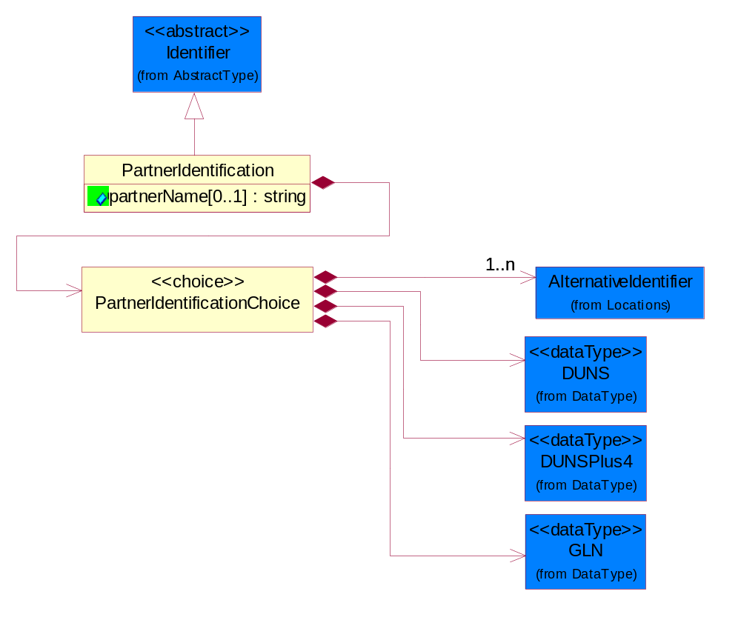
Figure ‎4-49 PartnerIdentification

Attribute | Type | Documentation
partnerName[0..1] | string | The name of the partner’s company/business.

Composition | Cardinality | Type | Documentation
PartnerIdentificationChoice | 1 | PartnerIdentificationChoice

PartnerIdentificationChoice

Composition | Cardinality | Type | Documentation
DUNS | 1 | DUNS | A number assigned by Dun and Bradstreet to identify a business location.
DUNSPlus4 | 1 | DUNSPlus4 | A identifier to specify a specific location within a business location.
AlternativeIdentifier | 1..n | AlternativeIdentifier | Identifies the specified code and the name of the organization that a code is utilized from.
GLN | 1 | GLN | Global Location Number (GLN) - A identifier to identify legal entities, trading parties and location.

SpecifiedFullPartner
The business document must describe the trading partners in the business transaction. This data structure provide the flexibility to describe a partner in all possible methods as for new, existing or known partner. This is specifically for partner who role has been specified.
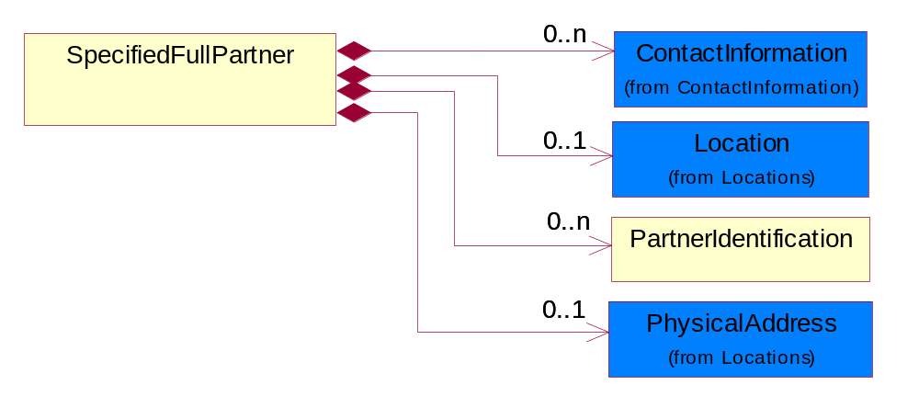
Figure ‎4-50 SpecifiedFullPartner

Composition | Cardinality | Type | Documentation
ContactInformation | 0..n | ContactInformation | The business document must allow for the identification of the name of the department, service or individual to be contacted regarding the context of the business document.
Location | 0..1 | Location | The business document must specify a location.
PartnerIdentification | 0..n | PartnerIdentification | The business document must allow for the identity of one or more parties to the transaction.
PhysicalAddress | 0..1 | PhysicalAddress | The business document must provide a physical address for a party to the business transaction.

SpecifiedIntermittentPartner
The business document must describe a physical address for a delivery.
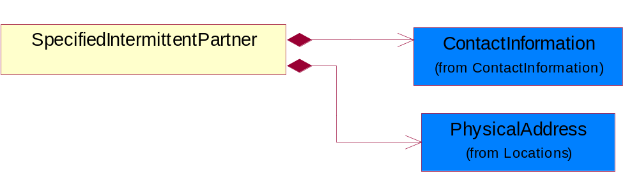
Figure ‎4-51 SpecifiedIntermittentPartner

Composition | Cardinality | Type | Documentation
ContactInformation | 1 | ContactInformation | The business document must allow for the identification of the name of the department, service or individual to be contacted regarding the context of the business document.
PhysicalAddress | 1 | PhysicalAddress | The business document must provide a physical address for a party to the business transaction.

SpecifiedKnownPartner
The business document must describe the trading partners in the business transaction.
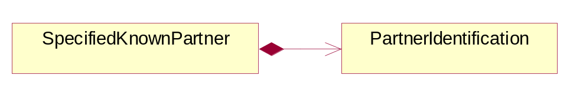
Figure ‎4-52 SpecifiedKnownPartner

Composition | Cardinality | Type | Documentation
PartnerIdentification | 1 | PartnerIdentification | The business document must allow for the identity of one or more parties to the transaction.

SpecifiedKnownPartnerContact
The business document must describe the trading partners in the business transaction and allow for a identification of an individual of the trading partner.
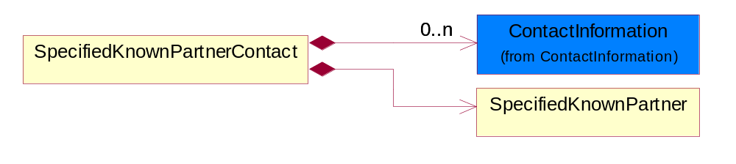
Figure ‎4-53 SpecifiedKnownPartnerContact

Composition | Cardinality | Type | Documentation
SpecifiedKnownPartner | 1 | SpecifiedKnownPartner | The business document must describe the trading partners in the business transaction.
ContactInformation | 0..n | ContactInformation | The business document must allow for the identification of the name of the department, service or individual to be contacted regarding the context of the business document.

SpecifiedNewPartner
The business document must describe a new, existing (but known to only one of the parties to the transaction) or an unknown party to the business transaction.
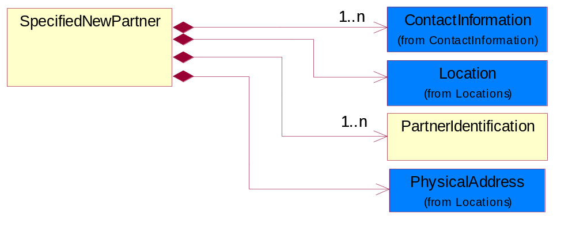
Figure ‎4-54 SpecifiedNewPartner

Composition | Cardinality | Type | Documentation
ContactInformation | 1..n | ContactInformation | The business document must allow for the identification of the name of the department, service or individual to be contacted regarding the context of the business document.
Location | 1 | Location | The business document must specify a location.
PhysicalAddress | 1 | PhysicalAddress | The business document must provide a physical address for a party to the business transaction.
PartnerIdentification | 1..n | PartnerIdentification | The business document must allow for the identity of one or more parties to the transaction.

SpecifiedPartnerDescription
The collection of business properties that describe a business partners' identity, their contact information, where they are physically located and their function in a supply chain.
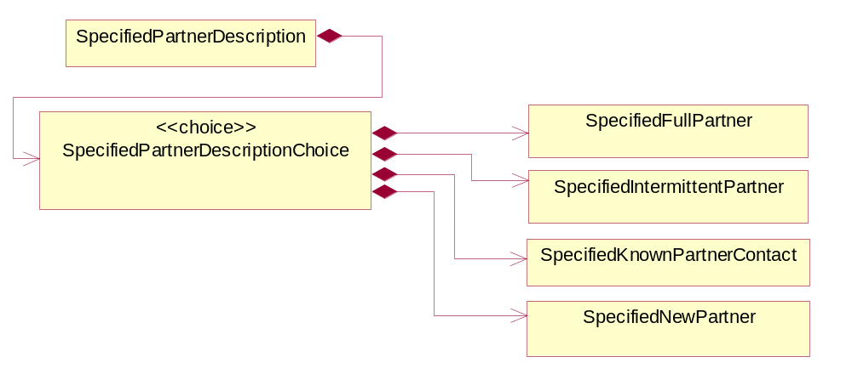
Figure ‎4-55 SpecifiedPartnerDescription

Composition | Cardinality | Type | Documentation
SpecifiedPartnerDescriptionChoice | 1 | SpecifiedPartnerDescriptionChoice

SpecifiedPartnerDescriptionChoice

Composition | Cardinality | Type | Documentation
SpecifiedKnownPartnerContact | 1 | SpecifiedKnownPartnerContact | The business document must describe the trading partners in the business transaction and allow for a identification of an individual of the trading partner.
SpecifiedIntermittentPartner | 1 | SpecifiedIntermittentPartner | The business document must describe a physical address for a delivery.
SpecifiedNewPartner | 1 | SpecifiedNewPartner | The business document must describe a new, existing (but known to only one of the parties to the transaction) or an unknown party to the business transaction.
SpecifiedFullPartner | 1 | SpecifiedFullPartner | The business document must describe the trading partners in the business transaction. This data structure provide the flexibility to describe a partner in all possible methods as for new, existing or known partner. This is specifically for partner who role has been specified.

ProductIdentification

ProductIdentification
The object provides the identifier(s) of a product.
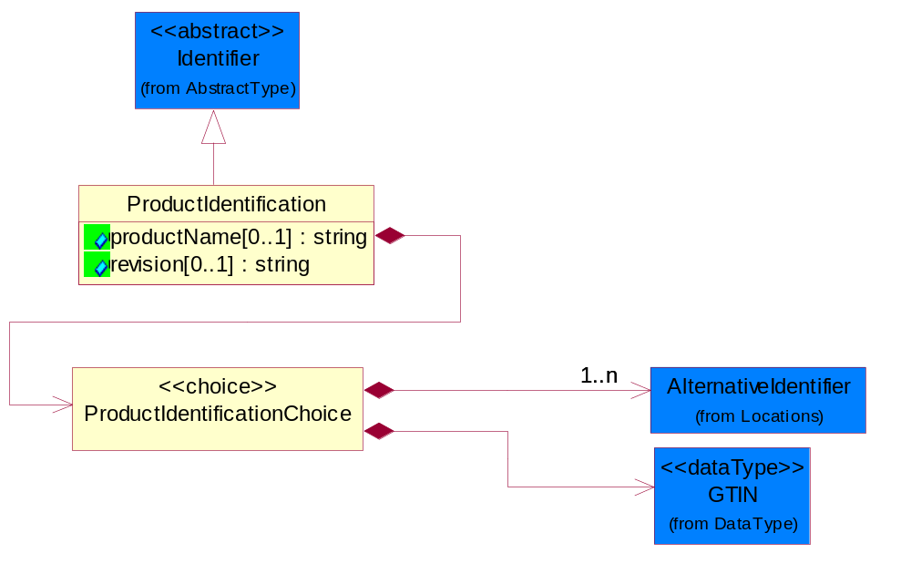
Figure ‎4-56 ProductIdentification

Attribute | Type | Documentation
productName[0..1] | string | The name of the product.
revision[0..1] | string | Referenced the specified product revision.

Composition | Cardinality | Type | Documentation
ProductIdentificationChoice | 1 | ProductIdentificationChoice

ProductIdentificationChoice

Composition | Cardinality | Type | Documentation
AlternativeIdentifier | 1..n | AlternativeIdentifier | Identifies the specified code and the name of the organization that a code is utilized from.
GTIN | 1 | GTIN | Global Trade Identification Number (GTIN).

TextualDescription
The business document must allow for multiple levels of textual description of an event or object.
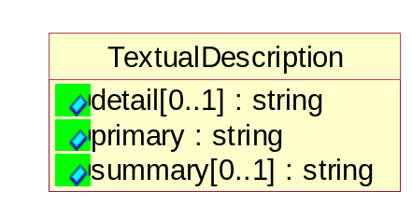
Figure ‎4-57 TextualDescription

Attribute | Type | Documentation
detail[0..1] | string | A detail description of an event or object.
primary | string | A phrase or single word description of an event or object.
summary[0..1] | string | A condensed description of an event or object.

CodeList

Country
For representation of Country name RosettaNet has adopted ISO 3166-3; 1999. Refer to the following web page to get the latest version of the standard:
http://www.iso.ch/iso/en/prods-services/iso3166ma/02iso-3166-code-lists/index.html

If you need more information about the ISO standard please contact ISO for more details.

CountrySubdivision
For representation of a Countries subdivisions RosettaNet has adopted ISO 3166-3; 1999. Refer to the following web page to get the latest version of the standard:
http://www.iso.ch/iso/en/prods-services/iso3166ma/02iso-3166-code-lists/index.html

If you need more information about the ISO standard please contact ISO for more details.

Currency
For representation of Currency codes RosettaNet has adopted ISO 4217; 1995. The British Standards Institution (BSI) is the ISO 4217 Maintenance Agency. Refer to the following web page to get the latest version of the standard:
http://www.bsi-global.com/Technical+Information/Publications/_Publications/tig90.xalter

If you need more information about the ISO standard please contact ISO for more details.

Language
For representation of Language name RosettaNet has adopted ISO 639-2; 1998. Refer to the following web page to get the latest version of the standard:

http://www.loc.gov/standards/iso639-2/iso639jac.html

If you need more information about the ISO standard please contact ISO for more details.

DocumentType
A code identifying the business context of a document.

Instance | Documentation
APM | Applied Promotions.
ARA | Authorization Request Approval.
CAR | Certificate of Analysis Response.
CBN | Product batch number of customer.
CCN | Customs clearance number.
CFA | Failure Analysis - Request document that will accompany the product providing characteristics of the component failure.
CIN | Commercial Invoice.
CNM | Traditional credit note or memo.
COA | Certificate of Analysis.
CON | In a virtual sourcing relationship, a third party trading partner is supplying a part to a customer on behalf of another company that has taken the order for the customer. In this case a Customer Order Number is associated to the request for material that is sent to the virtual trading partners.
COS | Consumption Notice.
COT | Contract.
CRN | Unique consumption reference number identifying the product consumption issue i.e. one-to-one relationship with physical flow.
DEM | Traditional debit note or memo.
DEN | Delivery Note.
DIN | Discontinuation Notice.
DOR | Delivery Order.
DRN | Drawing Number.
DRR | Design Registration Request.
ECO | Engineering Change Order - The proprietary unique identification number that represents an engineering change order.
EDD | Export Declaration Document.
EIR | Engineering Information Request.
EOL | End of Life.
FUO | Sales order or transfer order fulfilling demand out of a facility (outbound shipment).
IDD | Import Declaration Document.
INV | Invoice.
LID | Location Identifier. Data for on-site work that have to be done on the machine (associated with preventive maintenance order).
MEN | Master Event Number.
MID | Machine Identifier. Data for on-site work that have to be done on the machine (associated with preventive maintenance order).
MON | Model Number.
NTS | Notes.
OCL | The unique identifier assigned by the OEM for a warranty claim.
OGA | Other governmental agency issued document.
OPO | The unique identifier assigned by the OEM for a part order.
OPR | The unique identifier assigned by the OEM for a part return.
PCN | Product/Process Change.
PFA | Failure Analysis - Request document that will accompany the product providing characteristics of the product failure.
PII | Refers to previously issued invoice.
PLS | Unique number that identifies packing form prior to shipment.
POI | Purchase Order IN.
PON | Production order number for material release.
POO | Purchase Order OUT.
PRC | Product Catalog.
PSI | Refers to previously issued self-billing invoice.
PUO | Purchase Order.
QUO | Quote.
REC | Document identifying the receipt of materials or products into a facility against a purchase order or transfer order (inbound shipment).
REN | Release Number.
REO | Purchase order or transfer order replenishing inventory into a facility (inbound shipment).
REQ | Requisition.
RMA | Returned Material Authorization.
RPO | Purchase order for materials or product returned to and reworked by a supplier.
RTA | Remittance Advice - Remittance details.
SAO | Sales Order.
SBC | Credit Memo used in self-billing scenario.
SBD | Debit Memo used in self-billing scenario.
SBI | Invoice in self billing scenario.
SBN | Product batch number of supplier.
SCA | Similar to contracts - Contains the quantity of an article that is to be ordered from a vendor and the price for article or service that is to be procured.
SEN | Serial Number.
SEO | A document that gives a repair provider the necessary authorization to repair or upgrade a product either at the customer site or at the repair provider’s site.
SHD | Shipping Document.
SNC | Shipset Number on Code List.
SPC | The unique identifier assigned by the ASP for a warranty claim.
SPN | Spec Number.
SPO | The unique identifier assigned by the ASP for a part order.
SPR | The unique identifier assigned by the ASP for a part return.
SPW | The unique identifier assigned by the ASP to reference a work order.
SRI | A document that contains the shipping reference number which allows the product to be tracked within the outsourced logistic providers network.
SWT | Switch Authorization.
TCS | Terms and Conditions.
TRO | Order which results in materials or products being moved from one facility to another (outbound shipment and inbound shipment).
WAB | Waybill.
WAC | Denotes a warranty claim.
WOO | Work Order.

MimeTypeQualifier
The MIME type as defined by IANA.

Please refer to http://www.iana.org/assignments/media-types/ for a list of types.

Instance | Documentation
application/activemessage | [Shapiro]
application/andrew-inset | [Borenstein]
application/applefile | [Faltstrom]
application/atomicmail | [Borenstein]
application/batch-SMTP | [RFC2442]
application/beep+xml | [RFC3080]
application/cals-1840 | [RFC1895]
application/cnrp+xml | [RFCCNRP]
application/commonground | [Glazer]
application/cpl+xml
application/cybercash | [Eastlake]
application/dca-rft | [Campbell]
application/dec-dx | [Campbell]
application/dicom | [RFC3240]
application/dvcs | [RFC3029]
application/EDI-Consent | [RFC1767]
application/EDIFACT | [RFC1767]
application/EDI-X12 | [RFC1767]
application/eshop | [Katz]
application/font-tdpfr | [RFC3073]
application/http | [RFC2616]
application/hyperstudio | [Domino]
application/iges | [Parks]
application/index | [RFC2652]
application/index.cmd | [RFC2652]
application/index.obj | [RFC2652]
application/index.response | [RFC2652]
application/index.vnd | [RFC2652]
application/iotp | [RFC2935]
application/ipp | [RFC2910]
application/isup | [RFC3204]
application/mac-binhex40 | [Faltstrom]
application/macwriteii | [Lindner]
application/marc | [RFC2220]
application/mathematica | [Van Nostern]
application/msword | [Lindner]
application/news-message-id | [RFC1036,Spencer]
application/news-transmission | [RFC1036, Spencer]
application/ocsp-request | [RFC2560]
application/ocsp-response | [RFC2560]
application/octet-stream | [RFC2045,RFC2046]
application/oda | [RFC2045,RFC2046]
application/ogg | [RFC-walleij-ogg-mediatype-08.txt]
application/parityfec | [RFC3009]
application/pdf | [Lindner]
application/pgp-encrypted | [RFC3156]
application/pgp-keys | [RFC3156]
application/pgp-signature | [RFC3156]
application/pkcs10 | [RFC2311]
application/pkcs7-mime | [RFC2311]
application/pkcs7-signature | [RFC2311]
application/pkix-cert | [RFC2585]
application/pkixcmp | [RFC2510]
application/pkix-crl | [RFC2585]
application/postscript | [RFC2045,RFC2046]
application/prs.alvestrand.titrax-sheet | [Alvestrand]
application/prs.cww | [Rungchavalnont]
application/prs.nprend | [Doggett]
application/prs.plucker | [Janssen]
application/qsig | [RFC3204]
application/reginfo+xml | [RFC-ietf-sipping-reg-event-00.txt]
application/remote-printing | [RFC1486,Rose]
application/riscos | [Smith]
application/rtf | [Lindner]
application/sdp | [RFC2327]
application/set-payment | [Korver]
application/set-payment-initiation | [Korver]
application/set-registration | [Korver]
application/set-registration-initiation | [Korver]
application/sgml | [RFC1874]
application/sgml-open-catalog | [Grosso]
application/sieve | [RFC3028]
application/slate | [Crowley]
application/timestamp-query | [RFC3161]
application/timestamp-reply | [RFC3161]
application/tve-trigger | [Welsh]
application/vemmi | [RFC2122]
application/vnd.3gpp.pic-bw-large | [Meredith]
application/vnd.3gpp.pic-bw-small | [Meredith]
application/vnd.3gpp.pic-bw-var | [Meredith]
application/vnd.3gpp.sms | [Meredith]
application/vnd.3M.Post-it-Notes | [O'Brien]
application/vnd.accpac.simply.aso | [Leow]
application/vnd.accpac.simply.imp | [Leow]
application/vnd.acucobol | [Lubin]
application/vnd.acucorp | [Lubin]
application/vnd.adobe.xfdf | [Perelman]
application/vnd.aether.imp | [Moskowitz]
application/vnd.amiga.ami | [Blumberg]
application/vnd.anser-web-certificate-issue-initiation | [Mori]
application/vnd.anser-web-funds-transfer-initiation | [Mori]
application/vnd.audiograph | [Slusanschi]
application/vnd.blueice.multipass | [Holmstrom]
application/vnd.bmi | [Gotoh]
application/vnd.businessobjects | [Imoucha]
application/vnd.canon-cpdl | [Muto]
application/vnd.canon-lips | [Muto]
application/vnd.cinderella | [Kortenkamp]
application/vnd.claymore | [Simpson]
application/vnd.commerce-battelle | [Applebaum]
application/vnd.commonspace | [Chandhok]
application/vnd.contact.cmsg | [Patz]
application/vnd.cosmocaller | [Dellutri]
application/vnd.ctc-posml | [Kohlhepp]
application/vnd.cups-postscript | [Sweet]
application/vnd.cups-raster | [Sweet]
application/vnd.cups-raw | [Sweet]
application/vnd.curl | [Byrnes]
application/vnd.cybank | [Helmee]
application/vnd.data-vision.rdz | [Fields]
application/vnd.dna | [Searcy]
application/vnd.dpgraph | [Parker]
application/vnd.dreamfactory | [Appleton]
application/vnd.dxr | [Duffy]
application/vnd.ecdis-update | [Buettgenbach]
application/vnd.ecowin.chart | [Olsson]
application/vnd.ecowin.filerequest | [Olsson]
application/vnd.ecowin.fileupdate | [Olsson]
application/vnd.ecowin.series | [Olsson]
application/vnd.ecowin.seriesrequest | [Olsson]
application/vnd.ecowin.seriesupdate | [Olsson]
application/vnd.enliven | [Santinelli]
application/vnd.epson.esf | [Hoshina]
application/vnd.epson.msf | [Hoshina]
application/vnd.epson.quickanime | [Gu]
application/vnd.epson.salt | [Nagatomo]
application/vnd.epson.ssf | [Hoshina]
application/vnd.ericsson.quickcall | [Tidwell]
application/vnd.eudora.data | [Resnick]
application/vnd.fdf | [Zilles]
application/vnd.ffsns | [Holstage]
application/vnd.FloGraphIt | [Floersch]
application/vnd.framemaker | [Wexler]
application/vnd.fsc.weblaunch | [D.Smith]
application/vnd.fujitsu.oasys | [Togashi]
application/vnd.fujitsu.oasys2 | [Togashi]
application/vnd.fujitsu.oasys3 | [Okudaira]
application/vnd.fujitsu.oasysgp | [Sugimoto]
application/vnd.fujitsu.oasysprs | [Ogita]
application/vnd.fujixerox.ddd | [Onda]
application/vnd.fujixerox.docuworks | [Taguchi]
application/vnd.fujixerox.docuworks.binder | [Matsumoto]
application/vnd.fut-misnet | [Pruulmann]
application/vnd.grafeq | [Tupper]
application/vnd.groove-account | [Joseph]
application/vnd.groove-help | [Joseph]
application/vnd.groove-identity-message | [Joseph]
application/vnd.groove-injector | [Joseph]
application/vnd.groove-tool-message | [Joseph]
application/vnd.groove-tool-template | [Joseph]
application/vnd.groove-vcard | [Joseph]
application/vnd.hbci | [Hammann]
application/vnd.hhe.lesson-player | [Jones]
application/vnd.hp-HPGL | [Pentecost]
application/vnd.hp-hpid | [Gupta]
application/vnd.hp-hps | [Aubrey]
application/vnd.hp-PCL | [Pentecost]
application/vnd.hp-PCLXL | [Pentecost]
application/vnd.httphone | [Lefevre]
application/vnd.hzn-3d-crossword | [Minnis]
application/vnd.ibm.afplinedata | [Buis]
application/vnd.ibm.electronic-media | [Tantlinger]
application/vnd.ibm.MiniPay | [Herzberg]
application/vnd.ibm.modcap | [Hohensee]
application/vnd.ibm.secure-container | [Tantlinger]
application/vnd.informix-visionary | [Gales]
application/vnd.intercon.formnet | [Gurak]
application/vnd.intertrust.digibox | [Tomasello]
application/vnd.intertrust.nncp | [Tomasello]
application/vnd.intu.qbo | [Scratchley]
application/vnd.intu.qfx | [Scratchley]
application/vnd.irepository.package+xml | [Knowles]
application/vnd.is-xpr | [Natarajan]
application/vnd.japannet-directory-service | [Fujii]
application/vnd.japannet-jpnstore-wakeup | [Yoshitake]
application/vnd.japannet-payment-wakeup | [Fujii]
application/vnd.japannet-registration | [Yoshitake]
application/vnd.japannet-registration-wakeup | [Fujii]
application/vnd.japannet-setstore-wakeup | [Yoshitake]
application/vnd.japannet-verification | [Yoshitake]
application/vnd.japannet-verification-wakeup | [Fujii]
application/vnd.jisp | [Deckers]
application/vnd.kde.karbon | [Faure]
application/vnd.kde.kchart | [Faure]
application/vnd.kde.kformula | [Faure]
application/vnd.kde.kivio | [Faure]
application/vnd.kde.kontour | [Faure]
application/vnd.kde.kpresenter | [Faure]
application/vnd.kde.kspread | [Faure]
application/vnd.kde.kword | [Faure]
application/vnd.kenameaapp | [DiGiorgio-Haag]
application/vnd.koan | [Cole]
application/vnd.liberty-request+xml | [McDowell]
application/vnd.llamagraphics.life-balance.desktop | [White]
application/vnd.lotus-1-2-3 | [Wattenberger]
application/vnd.lotus-approach | [Wattenberger]
application/vnd.lotus-freelance | [Wattenberger]
application/vnd.lotus-notes | [Laramie]
application/vnd.lotus-organizer | [Wattenberger]
application/vnd.lotus-screencam | [Wattenberger]
application/vnd.lotus-wordpro | [Wattenberger]
application/vnd.mcd | [Gotoh]
application/vnd.mediastation.cdkey | [Flurry]
application/vnd.meridian-slingshot | [Wedel]
application/vnd.micrografx.flo | [Prevo]
application/vnd.micrografx.igx | [Prevo]
application/vnd.mif | [Wexler]
application/vnd.minisoft-hp3000-save | [Bartram]
application/vnd.mitsubishi.misty-guard.trustweb | [Tanaka]
application/vnd.Mobius.DAF | [Kabayama]
application/vnd.Mobius.DIS | [Kabayama]
application/vnd.Mobius.MBK | [Devasia]
application/vnd.Mobius.MQY | [Devasia]
application/vnd.Mobius.MSL | [Kabayama]
application/vnd.Mobius.PLC | [Kabayama]
application/vnd.Mobius.TXF | [Kabayama]
application/vnd.mophun.application | [Wennerstrom]
application/vnd.mophun.certificate | [Wennerstrom]
application/vnd.motorola.flexsuite | [Patton]
application/vnd.motorola.flexsuite.adsi | [Patton]
application/vnd.motorola.flexsuite.fis | [Patton]
application/vnd.motorola.flexsuite.gotap | [Patton]
application/vnd.motorola.flexsuite.kmr | [Patton]
application/vnd.motorola.flexsuite.ttc | [Patton]
application/vnd.motorola.flexsuite.wem | [Patton]
application/vnd.mozilla.xul+xml | [McDaniel]
application/vnd.ms-artgalry | [Slawson]
application/vnd.ms-asf | [Fleischman]
application/vnd.mseq | [Le Bodic]
application/vnd.ms-excel | [Gill]
application/vnd.msign | [Borcherding]
application/vnd.ms-lrm | [Ledoux]
application/vnd.ms-powerpoint | [Gill]
application/vnd.ms-project | [Gill]
application/vnd.ms-tnef | [Gill]
application/vnd.ms-works | [Gill]
application/vnd.ms-wpl | [Plastina]
application/vnd.musician | [Adams]
application/vnd.music-niff | [Butler]
application/vnd.netfpx | [Mutz]
application/vnd.noblenet-directory | [Solomon]
application/vnd.noblenet-sealer | [Solomon]
application/vnd.noblenet-web | [Solomon]
application/vnd.novadigm.EDM | [Swenson]
application/vnd.novadigm.EDX | [Swenson]
application/vnd.novadigm.EXT | [Swenson]
application/vnd.obn | [Hessling]
application/vnd.osa.netdeploy | [Klos]
application/vnd.palm | [Peacock]
application/vnd.pg.format | [Gandert]
application/vnd.pg.osasli | [Gandert]
application/vnd.powerbuilder6 | [Guy]
application/vnd.powerbuilder6-s | [Guy]
application/vnd.powerbuilder7 | [Shilts]
application/vnd.powerbuilder75 | [Shilts]
application/vnd.powerbuilder75-s | [Shilts]
application/vnd.powerbuilder7-s | [Shilts]
application/vnd.previewsystems.box | [Smolgovsky]
application/vnd.publishare-delta-tree | [Ben-Kiki]
application/vnd.pvi.ptid1 | [Lamb]
application/vnd.pwg-multiplexed | [RFC3391]
application/vnd.pwg-xhtml-print+xml | [Wright]
application/vnd.Quark.QuarkXPress | [Scheidler]
application/vnd.rapid | [Szekely]
application/vnd.s3sms | [Tarkkala]
application/vnd.sealed.net | [Lambert]
application/vnd.seemail | [Webb]
application/vnd.shana.informed.formdata | [Selzler]
application/vnd.shana.informed.formtemplate | [Selzler]
application/vnd.shana.informed.interchange | [Selzler]
application/vnd.shana.informed.package | [Selzler]
application/vnd.smaf | [Takahashi]
application/vnd.sss-cod | [Dani]
application/vnd.sss-dtf | [Bruno]
application/vnd.sss-ntf | [Bruno]
application/vnd.street-stream | [Levitt]
application/vnd.svd | [Becker]
application/vnd.swiftview-ics | [Widener]
application/vnd.triscape.mxs | [Simonoff]
application/vnd.trueapp | [Hepler]
application/vnd.truedoc | [Chase]
application/vnd.ufdl | [Manning]
application/vnd.uplanet.alert | [Martin]
application/vnd.uplanet.alert-wbxml | [Martin]
application/vnd.uplanet.bearer-choice | [Martin]
application/vnd.uplanet.bearer-choice-wbxml | [Martin]
application/vnd.uplanet.cacheop | [Martin]
application/vnd.uplanet.cacheop-wbxml | [Martin]
application/vnd.uplanet.channel | [Martin]
application/vnd.uplanet.channel-wbxml | [Martin]
application/vnd.uplanet.list | [Martin]
application/vnd.uplanet.listcmd | [Martin]
application/vnd.uplanet.listcmd-wbxml | [Martin]
application/vnd.uplanet.list-wbxml | [Martin]
application/vnd.uplanet.signal | [Martin]
application/vnd.vcx | [T.Sugimoto]
application/vnd.vectorworks | [Pharr]
application/vnd.vidsoft.vidconference | [Hess]
application/vnd.visio | [Sandal]
application/vnd.visionary | [Aravindakumar]
application/vnd.vividence.scriptfile | [Risher]
application/vnd.vsf | [Rowe]
application/vnd.wap.sic | [WAP-Forum]
application/vnd.wap.slc | [WAP-Forum]
application/vnd.wap.wbxml | [Stark]
application/vnd.wap.wmlc | [Stark]
application/vnd.wap.wmlscriptc | [Stark]
application/vnd.webturbo | [Rehem]
application/vnd.wrq-hp3000-labelled | [Bartram]
application/vnd.wt.stf | [Wohler]
application/vnd.wv.csp+wbxml | [Salmi]
application/vnd.xara | [Matthewman]
application/vnd.xfdl | [Manning]
application/vnd.yellowriver-custom-menu | [Yellow]
application/whoispp-query | [RFC2957]
application/whoispp-response | [RFC2958]
application/wita | [Campbell]
application/wordperfect5.1 | [Lindner]
application/x400-bp | [RFC1494]
application/xhtml+xml | [RFC3236]
application/xml | [RFC3023]
application/xml-dtd | [RFC3023]
application/xml-external-parsed-entity | [RFC3023]
application/zip | [Lindner]
audio/32kadpcm | [RFC2421,RFC2422]
audio/AMR | [RFC3267]
audio/AMR-WB | [RFC3267]
audio/basic | [RFC2045,RFC2046]
audio/CN | [RFC3389]
audio/DAT12 | [RFC3190]
audio/DVI4
audio/EVRC | [RFC-ietf-avt-evrc-smv-03.txt]
audio/EVRC0 | [RFC-ietf-avt-evrc-smv-03.txt]
audio/G.722.1 | [RFC3047]
audio/G722
audio/G723
audio/G726-16
audio/G726-24
audio/G726-32
audio/G726-40
audio/G728
audio/G729
audio/G729D
audio/G729E
audio/GSM
audio/GSM-EFR
audio/L16 | [RFC2586]
audio/L20 | [RFC3190]
audio/L24 | [RFC3190]
audio/L8
audio/LPC
audio/MP4A-LATM | [RFC3016]
audio/MPA
audio/mpa-robust | [RFC3119]
audio/mpeg | [RFC3003]
audio/parityfec | [RFC3009]
audio/PCMA
audio/PCMU
audio/prs.sid | [Walleij]
audio/QCELP
audio/RED
audio/SMV | [RFC-ietf-avt-evrc-smv-03.txt]
audio/SMV0 | [RFC-ietf-avt-evrc-smv-03.txt]
audio/telephone-event | [RFC2833]
audio/tone | [RFC2833]
audio/VDVI
audio/vnd.3gpp.iufp | [Belling]
audio/vnd.cisco.nse | [Kumar]
audio/vnd.cns.anp1 | [McLaughlin]
audio/vnd.cns.inf1 | [McLaughlin]
audio/vnd.digital-winds | [Strazds]
audio/vnd.everad.plj | [Cicelsky]
audio/vnd.lucent.voice | [Vaudreuil]
audio/vnd.nortel.vbk | [Parsons]
audio/vnd.nuera.ecelp4800 | [Fox]
audio/vnd.nuera.ecelp7470 | [Fox]
audio/vnd.nuera.ecelp9600 | [Fox]
audio/vnd.octel.sbc | [Vaudreuil]
audio/vnd.qcelp | [Lundblade]
audio/vnd.rhetorex.32kadpcm | [Vaudreuil]
audio/vnd.vmx.cvsd | [Vaudreuil]
image/cgm | Computer Graphics Metafile
image/g3fax | [RFC1494]
image/gif | [RFC2045,RFC2046]
image/ief | [RFC1314] Image Exchange Format
image/jpeg | [RFC2045,RFC2046]
image/naplps | [Ferber]
image/png | [Randers-Pehrson]
image/prs.btif | [Simon]
image/prs.pti | [Laun]
image/t38 | [RFC3362]
image/tiff | [RFC3302] Tag Image File Format
image/tiff-fx | [RFC3250] Tag Image File Format Fax eXtended
image/vnd.cns.inf2 | [McLaughlin]
image/vnd.djvu | [Bottou]
image/vnd.dwg | [Moline]
image/vnd.dxf | [Moline]
image/vnd.fastbidsheet | [Becker]
image/vnd.fpx | [Spencer]
image/vnd.fst | [Fuldseth]
image/vnd.fujixerox.edmics-mmr | [Onda]
image/vnd.fujixerox.edmics-rlc | [Onda]
image/vnd.globalgraphics.pgb | [Bailey]
image/vnd.mix | [Reddy]
image/vnd.ms-modi | [Vaughan]
image/vnd.net-fpx | [Spencer]
image/vnd.svf | [Moline]
image/vnd.wap.wbmp | [Stark]
image/vnd.xiff | [S.Martin]
message/delivery-status | [RFC1894]
message/disposition-notification | [RFC2298]
message/external-body | [RFC2045,RFC2046]
message/http | [RFC2616]
message/news | [RFC 1036, H.Spencer]
message/partial | [RFC2045,RFC2046]
message/rfc822 | [RFC2045,RFC2046]
message/s-http | [RFC2660]
message/sip | [RFC3261]
message/sipfrag | [RFC3420]
model/iges | [Parks]
model/mesh | [RFC2077]
model/vnd.dwf | [Pratt]
model/vnd.flatland.3dml | [Powers]
model/vnd.gdl | [Babits]
model/vnd.gs-gdl | [Babits]
model/vnd.gtw | [Ozaki]
model/vnd.mts | [Rabinovitch]
model/vnd.parasolid.transmit.binary | [Parasolid]
model/vnd.parasolid.transmit.text | [Parasolid]
model/vnd.vtu | [Rabinovitch]
model/vrml | [RFC2077]
multipart/alternative | [RFC2045,RFC2046]
multipart/appledouble | [Faltstrom]
multipart/byteranges | [RFC2068]
multipart/digest | [RFC2045,RFC2046]
multipart/encrypted | [RFC1847]
multipart/form-data | [RFC2388]
multipart/header-set | [Crocker]
multipart/mixed | [RFC2045,RFC2046]
multipart/parallel | [RFC2045,RFC2046]
multipart/related | [RFC2387]
multipart/report | [RFC1892]
multipart/signed | [RFC1847]
multipart/voice-message | [RFC2421,RFC2423]
text/calendar | [RFC2445]
text/css | [RFC2318]
text/directory | [RFC2425]
text/enriched | [RFC1896]
text/html | [RFC2854]
text/parityfec | [RFC3009]
text/plain | [RFC2646,RFC2046]
text/prs.lines.tag | [Lines]
text/rfc822-headers | [RFC1892]
text/richtext | [RFC2045,RFC2046]
text/rtf | [Lindner]
text/sgml | [RFC1874]
text/t140 | [RFC2793]
text/tab-separated-values | [Lindner]
text/uri-list | [RFC2483]
text/vnd.abc | [Allen]
text/vnd.curl | [Byrnes]
text/vnd.DMClientScript | [Bradley]
text/vnd.fly | [Gurney]
text/vnd.fmi.flexstor | [Hurtta]
text/vnd.in3d.3dml | [Powers]
text/vnd.in3d.spot | [Powers]
text/vnd.IPTC.NewsML | [IPTC]
text/vnd.IPTC.NITF | [IPTC]
text/vnd.latex-z | [Lubos]
text/vnd.motorola.reflex | [Patton]
text/vnd.ms-mediapackage | [Nelson]
text/vnd.net2phone.commcenter.command | [Xie]
text/vnd.sun.j2me.app-descriptor | [G.Adams]
text/vnd.wap.si | [WAP-Forum]
text/vnd.wap.sl | [WAP-Forum]
text/vnd.wap.wml | [Stark]
text/vnd.wap.wmlscript | [Stark]
text/xml | [RFC3023]
text/xml-external-parsed-entity | [RFC3023]
video/BMPEG
video/BT656
video/CelB
video/DV | [RFC3189]
video/H261
video/H263
video/H263-1998
video/H263-2000
video/JPEG
video/MP1S
video/MP2P
video/MP2T
video/MP4V-ES | [RFC3016]
video/mpeg | [RFC2045,RFC2046]
video/MPV
video/nv
video/parityfec | [RFC3009]
video/pointer | [RFC2862]
video/quicktime | [Lindner]
video/SMPTE292M | [RFC-avt-smpte292-video-08.txt]
video/vnd.fvt | [Fuldseth]
video/vnd.motorola.video | [McGinty]
video/vnd.motorola.videop | [McGinty]
video/vnd.mpegurl | [Recktenwald]
video/vnd.nokia.interleaved-multimedia | [Kangaslampi]
video/vnd.objectvideo | [Clark]
video/vnd.vivo | [Wolfe]

ProcessRoleIdentifier
Describes the role of the partner in the business process. A partner will fulfill at least one or more roles during the business process.

Instance | Documentation
ADM | Administered by - The party who is the administrative authority of an account.
ALT | Alternate approval by - The party who has approved a request in the event the approver is not able to respond.
APP | Approval by - The party who has approved a request.
AUT | Authorized By - The party who has authorized a request.
BIF | Bill from - The party that will issue the invoice.
BIT | Bill to - The party that will pay the invoice.
CBK | Customs Broker - CustomsBroker  This object represents the party that declare the shipment on behalf of declarant.
CLF | Collect From - To enable the buyer to specify the location of where products not supplied directly by the seller/installer may be collected.
CLM | Claimed By - This object represents the claimant.
CNC | Cancellation party - The party who is cancelling the shipping order.
COR | Change originated by - The party who originates a proposed change.
COW | Change owned by - The party who owns or who is assigned responsibility for a proposed change.
CRA | Credit applicant - The party who is applying for credit.
CRE | Created by - The party responsible for creating a process or task.
CSP | Contract Service Provider.
CWN | contractOwner - The party who is the owner of the contract. For example, in the direct business, the buyer is the contract owner. In the distribution business, the buyer is the distributor and the contract owner is the reseller.
DCE | DesignCustomerApplicationEngineer. The demand customer's Field Application Engineer.
DCT | Declared To - This object represents the party that the declaration goes to.
DCU | DesignCustomer. The owner of the product for which the design has been created.
DIS | Distributed by - The party who supplies products to retailers.
DLR | Declared By - This object represents the party that declare the shipment.
DST | Distributed To - This object represents the party to send information to.
FCP | Forecast Partner - The collection of business properties that describes the partner types for a forecast.
FIA | From Install At - The collection of sender business properties that describes a business partners' identity, their contact information, where they are physically located and their function in a supply chain.
FIN | Financed by - The party who is the financier.
FNB | Founded by - The party who performs the act, process, or art of casting metals.
FOR | Forwarded to - The party to whom a business document has been forwarded.
IMB | Imported By - The party responsible for importing the product.
INL | Inventory location - The party where the inventory product entry is located.
INO | Inventory owner - The party that owns the inventory product entry.
ITF | In transit from - The party sending the product quantity in a product location transfer.
ITL | installAt - The partner and/or location to which the product must be set up for use or service.
ITT | In transit to - The party receiving the product quantity in a product location transfer.
LGP | Logistics Provided By - The party who handles the details of an operation.
MFG | Manufactured by - The party who creates, processes or produces goods especially in large quantities and by means of industrial machines.
OWN | Owned by - The party who owns a process.
PAE | ProductProviderFieldApplicationEngineer. The product provider Field Application Engineer.
PCW | Primary Contract With - The primary party with whom a contract is formed.
PNB | Planning By - The party who establishes goals, policies or procedures.
PSR | ProductProviderSalesRepresentative. The product provider sales representative.
PUR | Purchased by - The party who is a purchaser of a product.
REA | Requested approval by - The party who has been selected to approve a request.
REC | Received by - The party who has received a product shipment.
REQ | Requested by - The party who has initiated a request.
RES | Respond to - The party to whom a responding business document must be sent when it is not equal to the partner specified in the document header.
RET | Return by - The party responsible for either carrying or forwarding the returned product.
REV | Reviewed by - The party responsible for reviewing a business document.
RFR | receivedFrom - The partner and/or location from where the product was shipped.
RLS | Released By - This object represents the party that releases the goods.
RMT | remitTo - The partner to which payment for a business document is sent.
RPB | Repaired By - The collection of business properties used to identify the business partner responsible for the repair or  rework of a product.
RQT | Refer Quote To - The partner to whom a quote request is being referred.
RSF | Requested Ship From - The party where the product is requested to be shipped from.
RTT | ReturnTo - The partner and/or location to which the returned product must be delivered.
SBF | Self-billing from - The party who initiates the billing in self-billing scenario.
SBT | Self-billing to - The party whom the invoice is addressed to.
SCB | Subcontracted By - The party who is contracted to perform part or all of another party's contract.
SCP | Shipping charges paid by - The party responsible for administering payment of the shipping charges.
SCW | Secondary Contract With - The subsequent party(ies) with whom a contract is formed.
SHF | Ship From - The collection of business properties used to identify the business partner initiating a shipment or transaction.
SHT | Ship To - The partner and/or location to which the product must be delivered.
SLD | Sold to - The party to whom a product has been sold.
SOB | Sold By - The seller involved in a business transaction.
SPL | Supplied by - The party who supplies an item, part or assembly.
SPS | Service Provider Site - Identification for the location of the ASP site that is ordering the replacement parts and/or performing the repair.
SRT | Submit returns to - The party to whom product returns are to be submitted.
STR | Stored By - This object represents the party that stores the goods.
SVA | ShipVia - The partner and/or location through which the product must be shipped, such as the "cross dock" at a shipping hub.  It must not be specified for the last leg, since this would be the same as the final destination specified in the ShipmentInformation/shipTo.
TFR | Transfer From - The party responsible for making the payment (Payer).
TIA | To lnstall At - The collection of receiver business properties that describes business partners' identity, their contact information, where they are physically located and their function in a supply chain.
TMT | Transfer Manufacturing To - The movement of the manufacturing process to another site.
TRA | Transported by - The party responsible for either carrying or forwarding the product.
TSB | Tested By - The collection of business properties used to identify the specific location and resources used to conduct a defined cycle or steps or measurements required to confirm a result or event.
TTR | Transfer To - The party who is receiving the payment (payee).
ULR | Ultimate recipient - The party who ultimately receives the shipment, when an intermediate party takes responsibility for payment and final delivery.
USE | Used by - The party who is the end user of the product.
UST | Unstuffed By - This object represents the party that unstuffs the goods.
WHB | Warehoused By - The party who stocks or stores products.

System Structure

BusinessProcessIdentifier
A Business Process Identifier to uniquely define the TPIR-PIP 'role' within a Business Scenario at a company or MNC level. The identifier MUST be composed of alphanumeric characters only and its length MUST be between one and twelve characters.
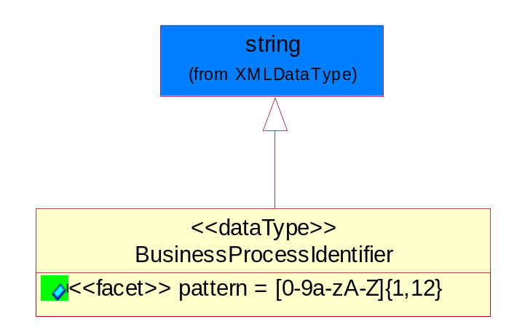
Figure ‎5-58 BusinessProcessIdentifier

Attribute | Type | Documentation
pattern |  | [0-9a-zA-Z]{1,12}

BusinessServiceInformation
The object allows the specification of the business service utilized within the partner company. This may or may not be the same as the information sent by the RNIF.
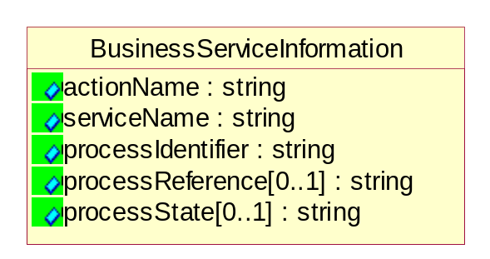
Figure ‎5-59 BusinessServiceInformation
Attribute | Type | Documentation
actionName | string | The name of Action. For RosettaNet usually any of Request/Confirm/Notify/Query/Response.
serviceName | string | The name of the Business Activity with the "Request/Confirm" part removed. E.g., for the Activity "Request Purchase Order"==> "Purchase Order".
processIdentifier | string | The name of the PIP e.g. Notify of Forecast Reply.
processReference[0..1] | string | The URN for the PIP that includes Cluster/Segment/Process pattern used to identify the interface process (such as PIP3A4)
processState[0..1] | string | The business process (or service) state of the sender of a document. When a service receives this document, the receiver may use the state as a precondition.

ContractInformation
A block of information used to correlate a contract in an executing choreography.

Figure ‎5-60 ContractInformation
Attribute | Type | Documentation
contractIdentifier[0..1] | string | Unique identification of a contract between the Sender and the Receiver
contractType[0..1] | string | The type of the contract: an attribute describing the type of the ContractIndentification. Valid values are URI, URN,ebXMLCPA, or other values defined by partners.

CorrelationInformation
A block of information used to correlate a requesting document to a responding document and to the contract in an executing choreography.
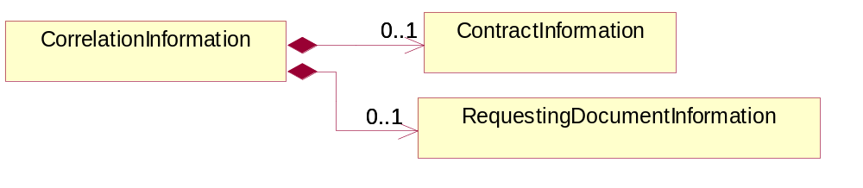
Figure ‎5-61 CorrelationInformation

Composition | Cardinality | Type | Documentation
ContractInformation | 0..1 | ContractInformation | A block of information used to correlate a contract in an executing choreography.
RequestingDocumentInformation | 0..1 | RequestingDocumentInformation | A block of information used to correlate a requesting document to a responding document in an executing choreography.

DocumentHeader
The object allows for the identification of the sender and receiver of the business document.
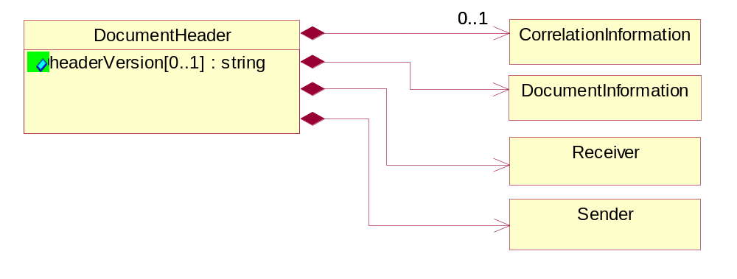
Figure ‎5-62 DocumentHeader

Attribute | Type | Documentation
headerVersion[0..1] | string | The UN/CEFACT version of the document header.

Composition | Cardinality | Type | Documentation
Sender | 1 | Sender | The object allows the identification of the initiating party of the business message.
CorrelationInformation | 0..1 | CorrelationInformation | A block of information used to correlate a requesting document to a responding document and to the contract in an executing choreography.
DocumentInformation | 1 | DocumentInformation | The object specifies information to identify the business document, a summary of attachments, and information about the business document security.
Receiver | 1 | Receiver | The object allows the identification of the receiving party of the business message.

DocumentIdentification
The object specifies all information necessary to identify the business document.
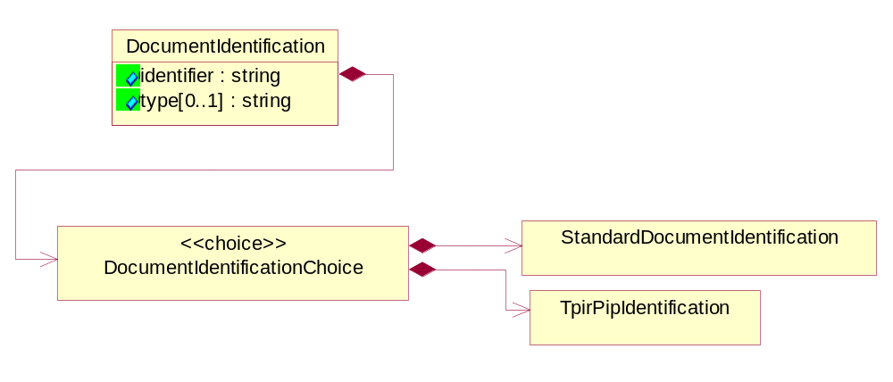
Figure ‎5-63 DocumentIdentification

Attribute | Type | Documentation
identifier | string | The unique identifier for the document being sent.
type[0..1] | string | Name of the Action Message

Composition | Cardinality | Type | Documentation
DocumentIdentificationChoice | 1 | DocumentIdentificationChoice

DocumentIdentificationChoice

Composition | Cardinality | Type | Documentation
StandardDocumentIdentification | 1 | StandardDocumentIdentification | The object specifies additional information necessary to identify the standard business document.
TpirPipIdentification | 1 | TpirPipIdentification | The object specifies all information necessary to uniquely identify a TPIR-PIP within a Registry or trading partner repository.

DocumentInformation
The object specifies information to identify the business document, a summary of attachments, and information about the business document security.
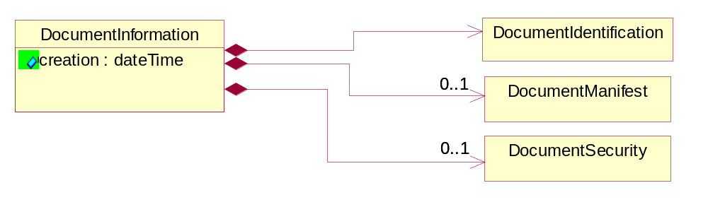
Figure ‎5-64 DocumentInformation

Attribute | Type | Documentation
creation | dateTime | The creation date and time of the specified Business Document (i.e. the Purchase Order date).

Composition | Cardinality | Type | Documentation
DocumentIdentification | 1 | DocumentIdentification | The object specifies all information necessary to identify the business document.
DocumentSecurity | 0..1 | DocumentSecurity | The object provides additional granularity in specifying business document security (this is in addition to the specified PIP security).
DocumentManifest | 0..1 | DocumentManifest | The block provides a brief summary of attachments and Service Content.

DocumentManifest
The block provides a brief summary of attachments and Service Content.
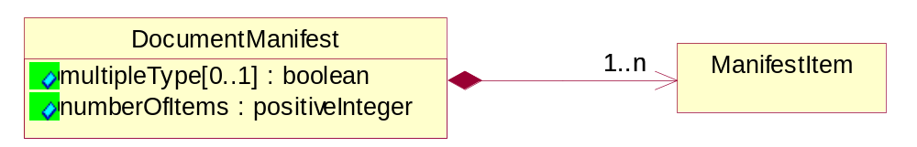
Figure ‎5-65 DocumentManifest

Attribute | Type | Documentation
multipleType[0..1] | boolean | Indicates whether the manifest contains documents of multiple types. True if yes, and False if no.
numberOfItems | positiveInteger | Total number of documents in the message. The physical count of the attachments in the payload plus the RosettaNet Business Message (for Service Content). The value of this field will be at least 1.

Composition | Cardinality | Type | Documentation
ManifestItem | 1..n | ManifestItem | The object provides details about the specific attachment(s).

DocumentSecurity
The object provides additional granularity in specifying business document security (this is in addition to the specified PIP security).

Figure ‎5-66 DocumentSecurity

Attribute | Type | Documentation
nonRepudiableReceipt | boolean | The value "true" will indicate that a signed acknowledgement for the business document is necessary.
persistentEncryption | boolean | The value "true" will indicate that the Business Document (including the header) needs to be encrypted when stored or transported.
persistentSignature | boolean | The value "true" will indicate that a signature is required to be stored with the document while stored or transported.

ManifestItem
The object provides details about the specific attachment(s).

Figure ‎5-67 ManifestItem

Attribute | Type | Documentation
description[0..1] | string | A description of the attachment.
length[0..1] | positiveInteger | The size of the attachment in bytes (i.e. 1 000 000 bytes)
universalResourceIdentifier | string | The generic set of all names/addresses that are short strings that refer to resources.

Composition | Cardinality | Type | Documentation
mimeTypeQualifier | 1 | MimeTypeQualifier | The MIME type as defined by IANA.  Please refer to http://www.iana.org/assignments/media-types/ for a list of types.
language | 0..1 | Language | For representation of Language name RosettaNet has adopted ISO 639-2; 1998. Refer to the following web page to get the latest version of the standard:  http://www.loc.gov/standards/iso639-2/iso639jac.html  If you need more information about the ISO standard please contact ISO for more details.

PipIdentifier
PIP Identification.[ i.e. PIP3A4]
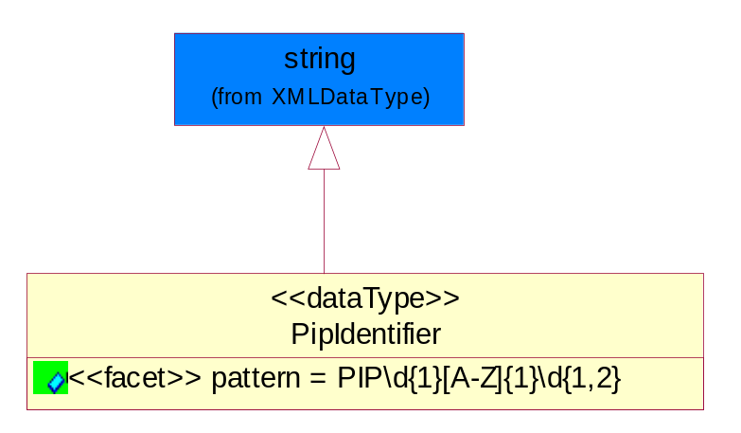
Figure ‎5-68 PipIdentifier

Attribute | Type | Documentation
pattern |  | PIP\d{1}[A-Z]{1}\d{1,2}

PipVersion
PIP version number (i.e. 02.02.00).
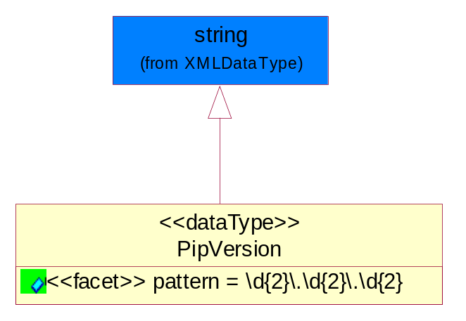
Figure ‎5-69 PipVersion

Attribute | Type | Documentation
pattern |  | \d{2}\.\d{2}\.\d{2}

Receiver
The object allows the identification of the receiving party of the business message.
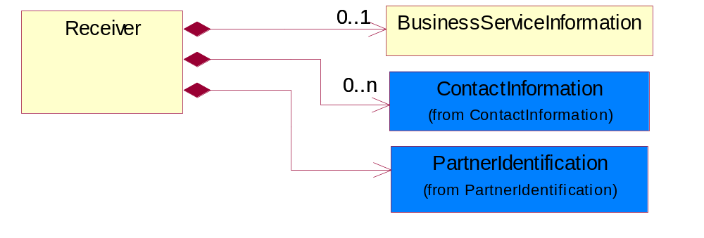
Figure ‎5-70 Receiver

Composition | Cardinality | Type | Documentation
BusinessServiceInformation | 0..1 | BusinessServiceInformation | The object allows the specification of the business service utilized within the partner company. This may or may not be the same as the information sent by the RNIF.
PartnerIdentification | 1 | PartnerIdentification | The business document must allow for the identity of one or more parties to the transaction.
ContactInformation | 0..n | ContactInformation | The business document must allow for the identification of the name of the department, service or individual to be contacted regarding the context of the business document.

RequestingDocumentInformation
A block of information used to correlate a requesting document to a responding document in an executing choreography.

Figure ‎5-71 RequestingDocumentInformation

Attribute | Type | Documentation
businessProcessInstanceIdentifier[0..1] | string | The identifier for the public business process instance being sent that both the sender and receiver can identify.
responseDateTime[0..1] | dateTime | The expected time to receive the response. This can not be greater than the PIP TimeToPerform.
requestingDocumentCreationDateTime[0..1] | dateTime | The date-time of the requesting business document.
requestingDocumentInstanceIdentifier | string | The Business Document identification number that identifies the requesting Business Document.

Sender
The object allows the identification of the initiating party of the business message.
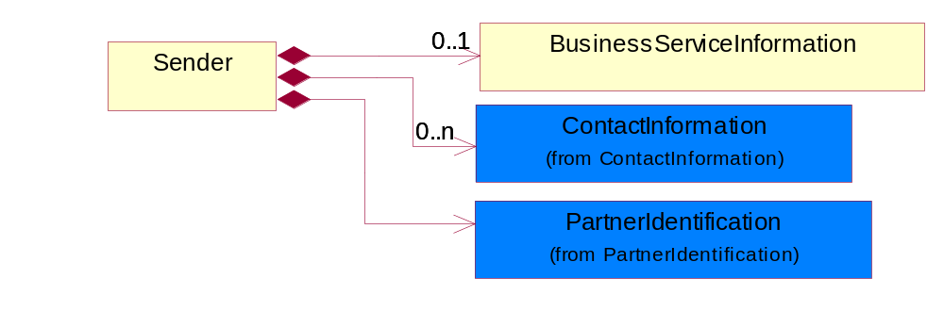
Figure ‎5-72 Sender

Composition | Cardinality | Type | Documentation
PartnerIdentification | 1 | PartnerIdentification | The business document must allow for the identity of one or more parties to the transaction.
BusinessServiceInformation | 0..1 | BusinessServiceInformation | The object allows the specification of the business service utilized within the partner company. This may or may not be the same as the information sent by the RNIF.
ContactInformation | 0..n | ContactInformation | The business document must allow for the identification of the name of the department, service or individual to be contacted regarding the context of the business document.

StandardDocumentIdentification
The object specifies additional information necessary to identify the standard business document.
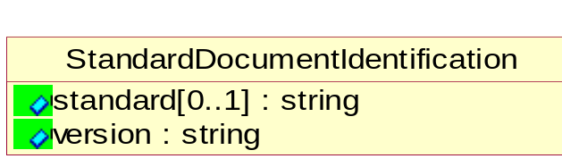
Figure ‎5-73 StandardDocumentIdentification

Attribute | Type | Documentation
standard[0..1] | string | Identifies the standard used to submit the business document. (e.g. RosettaNet).
version | string | PIP3A4v01.00

TpirPipIdentification
The object specifies all information necessary to uniquely identify a TPIR-PIP within a Registry or trading partner repository.

Figure ‎5-74 TpirPipIdentification

Attribute | Type | Documentation
partnerId | DUNSPlus4 | The Trading Partner Identification of MNC that is creating this TPIR PIP.
pipIdentifier | PipIdentifier | A TPIR PIP Identification [i.e., 3A4 ).
pipVersion | PipVersion | A TPIR PIP version number (i.e., 02.02.00)
tpirPipVersion | VersionIdentifier | A TPIR-PIP Version Number (i.e., major and minor version number as XX.XX).
tpirBusinessProcessIdentifier[0..1] | BusinessProcessIdentifier | A Business Process Identifier to uniquely define the TPIR-PIP 'role' within a Business Scenario at a company or MNC level. The identifier MUST be composed of alphanumeric characters only and its length MUST be between one and twelve characters.
uri[0..1] | anyURI | Describes the destination uri for the TPIR form.

Composition | Cardinality | Type | Documentation
fileType | 0..1 | TPIRFileType | Describes the file type of the TPIR form (PDF, XDP or XML).

VersionIdentifier
Version Number (i.e., major and minor version number as XX.XX).
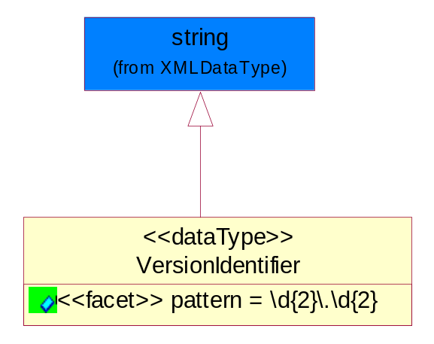
Figure ‎5-75 VersionIdentifier

Attribute | Type | Documentation
pattern |  | \d{2}\.\d{2}

CodeList

TPIRFileType
A code identifying the file type of TPIR form.

Name | Documentation
PDF | Portable Document Format.
XDP | XML Data Package.
XML | eXtensible Markup Language.

XML Data Type

anyURI
Represents a URI as defined by RFC 2396. An anyURI value can be absolute or relative, and may have an optional fragment identifier.

boolean
Represents Boolean values, which are either "true" or "false".

date
For the represents a calendar date.
The pattern for a date is CCYY-MM-DD where CC represents the century, YY the year, MM the month, and DD the day, with an optional time zone indicator as allowed for dateTime.

dateTime
Represents a specific instance of time.
The pattern for dateTime is CCYY-MM-DDThh:mm:ss where CC represents the century, YY the year, MM the month, and DD the day, preceded by an optional leading negative (-) character to indicate a negative number. If the negative character is omitted, positive (+) is assumed. The T is the date/time separator and hh, mm, and ss represent hour, minute, and second respectively. Additional digits can be used to increase the precision of fractional seconds if desired. For example, the format ss.ss... with any number of digits after the decimal point is supported. The fractional seconds part is optional.

This representation may be immediately followed by a "Z" to indicate Coordinated Universal Time (UTC) or to indicate the time zone. For example, the difference between the local time and Coordinated Universal Time, immediately followed by a sign, + or -, followed by the difference from UTC represented as hh:mm (minutes is required). If the time zone is included, both hours and minutes must be present.

decimal
A data type that contains decimal numbers scaled by a power of 10.

float
Represents single-precision 32-bit floating-point numbers.

positiveInteger
Represents an integer that is greater than zero. This data type is derived from nonNegativeInteger.

string
Represents character string.

