

Description of 5C9 Message

PIP® 5C9
Validated 11.00.00

Specification Information
Name | Description of 5C9 Message
PIP | Notify of Win Claim Confirmation
Cluster | Design Win Management (EC)
Segment | Marketing Information Management
Publication Date | 5 March 2010
Version Identifier | V11.00

Table of Content

1. Document Management 6
1.1 Legal Disclaimer 6
1.2 Copyright 6
1.3 Trademarks 6
1.4 Acknowledgments 6
1.5 Related Documents 6
1.6 Document Version History 6
1.7 Document Purpose 6
2. Interchange Model 7
2.1 WinClaimConfirmationNotification 7
2.1.1 Interchange Diagram 7
2.1.2 Dependency Diagram 8
2.1.3 DesignRegistrationIdentification 8
2.1.4 DesignWinClaim 10
2.1.5 Invoice 10
2.1.6 InvoiceLineItem 11
2.1.7 WinClaimConfirmation 11
3. Domain Model 13
3.1 Marketing 13
3.1.1 Dependency Diagram 13
3.1.2 DebitAuthorizationNumber 13
3.1.3 DemandCreatorTrackingIdentifier 14
3.1.4 DesignWinStatusReasonCodeExplanation 14
3.1.5 GeographicRegion 15
3.1.6 RegistrationDisposition 15
3.1.7 RegistrationStatus 16
3.1.8 CodeList 18
3.1.8.1 DesignWinStatusReason 18
3.1.8.2 RegistrationStatusCode 20
3.1.8.3 GeographicRegionCode 20
3.1.8.4 ProjectStatus 20
3.1.8.5 Disposition 21
3.1.8.6 DesignWinClassification 21
3.2 Shared 21
3.2.1 Dependency Diagram 21
3.2.2 ProductQuantity 22
4. Universal Structure 23
4.1 ContactInformation 23
4.1.1 ContactInformation 23
4.2 DataType 24
4.2.1 Contact 24
4.2.2 DUNS 24
4.2.3 DUNSPlus4 25
4.2.4 GLN 25
4.3 Document 26
4.3.1 BusinessDocumentReference 26
4.4 Locations 27
4.4.1 AlternativeIdentifier 27
4.4.2 Location 28
4.4.3 LocationChoice 28
4.4.4 PhysicalAddress 29
4.5 MonetaryExpression 31
4.5.1 FinancialAmount 31
4.6 PartnerIdentification 32
4.6.1 FullPartner 32
4.6.2 IntermittentPartner 32
4.6.3 KnownPartner 33
4.6.4 KnownPartnerContact 33
4.6.5 NewPartner 34
4.6.6 PartnerDescription 35
4.6.7 PartnerDescriptionChoice 36
4.6.8 PartnerIdentification 37
4.6.9 PartnerIdentificationChoice 38
4.6.10 SpecifiedFullPartner 38
4.6.11 SpecifiedIntermittentPartner 39
4.6.12 SpecifiedKnownPartner 40
4.6.13 SpecifiedNewPartner 40
4.7 CodeList 42
4.7.1 Country 42
4.7.2 CountrySubdivision 42
4.7.3 Currency 42
4.7.4 Language 42
4.7.5 DocumentType 43
4.7.6 MimeTypeQualifier 45
4.7.7 UnitOfMeasure 55
4.7.8 ProcessRoleIdentifier 69
5. System Structure 72
5.1 BusinessProcessIdentifier 72
5.2 BusinessServiceInformation 72
5.3 ContractInformation 73
5.4 CorrelationInformation 74
5.5 DocumentHeader 75
5.6 DocumentIdentification 76
5.7 DocumentIdentificationChoice 76
5.8 DocumentInformation 77
5.9 DocumentManifest 78
5.10 DocumentSecurity 79
5.11 ManifestItem 80
5.12 PipIdentifier 81
5.13 PipVersion 81
5.14 Receiver 82
5.15 RequestingDocumentInformation 83
5.16 Sender 84
5.17 StandardDocumentIdentification 85
5.18 TpirPipIdentification 86
5.19 VersionIdentifier 87
5.20 CodeList 87
5.20.1 TPIRFileType 87
6. XML Data Type 88
6.1 anyURI 88
6.2 boolean 88
6.3 date 88
6.4 dateTime 88
6.5 float 88
6.6 positiveInteger 88
6.7 string 88

Table of Figures

Figure ‎2-1 Interchange 7
Figure ‎2-2 Dependency 8
Figure ‎2-3 DesignRegistrationIdentification 8
Figure ‎2-4 DesignWinClaim 10
Figure ‎2-5 Invoice 10
Figure ‎2-6 InvoiceLineItem 11
Figure ‎2-7 WinClaimConfirmation 11
Figure ‎3-1 Dependency 13
Figure ‎3-2 DebitAuthorizationNumber 13
Figure ‎3-3 DemandCreatorTrackingIdentifier 14
Figure ‎3-4 DesignWinStatusReasonCodeExplanation 14
Figure ‎3-5 GeographicRegion 15
Figure ‎3-6 RegistrationDisposition 15
Figure ‎3-7 RegistrationStatus 16
Figure ‎3-8 Dependency 21
Figure ‎3-9 ProductQuantity 22
Figure ‎4-1 ContactInformation 23
Figure ‎4-2 Contact 24
Figure ‎4-3 DUNS 24
Figure ‎4-4 DUNSPlus4 25
Figure ‎4-5 GLN 25
Figure ‎4-6 BusinessDocumentReference 26
Figure ‎4-7 AlternativeIdentifier 27
Figure ‎4-8 Location 28
Figure ‎4-9 PhysicalAddress 29
Figure ‎4-10 FinancialAmount 31
Figure ‎4-11 FullPartner 32
Figure ‎4-12 IntermittentPartner 32
Figure ‎4-13 KnownPartner 33
Figure ‎4-14 KnownPartnerContact 33
Figure ‎4-15 NewPartner 34
Figure ‎4-16 PartnerDescription 35
Figure ‎4-17 PartnerIdentification 37
Figure ‎4-18 SpecifiedFullPartner 38
Figure ‎4-19 SpecifiedIntermittentPartner 39
Figure ‎4-20 SpecifiedKnownPartner 40
Figure ‎4-21 SpecifiedNewPartner 40
Figure ‎5-1 BusinessProcessIdentifier 72
Figure ‎5-2 BusinessServiceInformation 72
Figure ‎5-3 ContractInformation 73
Figure ‎5-4 CorrelationInformation 74
Figure ‎5-5 DocumentHeader 75
Figure ‎5-6 DocumentIdentification 76
Figure ‎5-7 DocumentInformation 77
Figure ‎5-8 DocumentManifest 78
Figure ‎5-9 DocumentSecurity 79
Figure ‎5-10 ManifestItem 80
Figure ‎5-11 PipIdentifier 81
Figure ‎5-12 PipVersion 81
Figure ‎5-13 Receiver 82
Figure ‎5-14 RequestingDocumentInformation 83
Figure ‎5-15 Sender 84
Figure ‎5-16 StandardDocumentIdentification 85
Figure ‎5-17 TpirPipIdentification 86
Figure ‎5-18 VersionIdentifier 87

Document Management

Legal Disclaimer
RosettaNet, its members, officers, directors, employees, or agents shall not be liable for any injury, loss, damages, financial or otherwise, arising from, related to, or caused by the use of this document or the specifications herein, as well as associated guidelines and schemas. The use of said specifications shall constitute your express consent to the foregoing exculpation.

Copyright
©2010 RosettaNet. All rights reserved. No part of this publication may be reproduced, stored in a retrieval system, or transmitted, in any form or by any means, electronic, mechanical, photocopying, recording, or otherwise, without the inclusion of this copyright notice. Any derivative works must cite the copyright notice. Any public redistribution or sale of this publication or derivative works requires prior written permission of the publisher.

Trademarks
RosettaNet, Partner Interface Process, PIP and the RosettaNet logo are trademarks or registered trademarks of "RosettaNet," a non-profit organization. All other product names and company logos mentioned herein are the trademarks of their respective owners. In the best effort, all terms mentioned in this document that are known to be trademarks or registered trademarks have been appropriately recognized in the first occurrence of the term.

Acknowledgments
This document has been prepared by RosettaNet (http://www.rosettanet.org/) from requirements gathered during the Milestone Program and in conformance with the methodology.

Related Documents
- Associated PIP Message Schemas (included with PIP Specification only)
- Description of Partner Interface Process for 5C9
- Message Structure

Document Version History
Version | Date | Description
Validated 11.00.00 | 5 March 2010 | Validated Version : MCC Program

Document Purpose
The purpose of the document is to explain the structure, the association between objects, the content of objects and the definition for single elements to a non-technical audience.

Interchange Model

WinClaimConfirmationNotification

Interchange Diagram
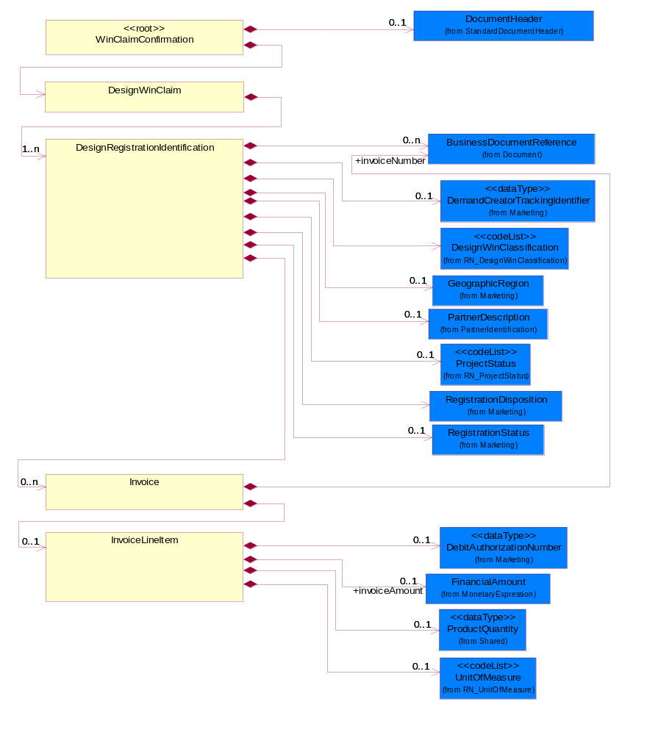
Figure ‎2-1 Interchange

Dependency Diagram
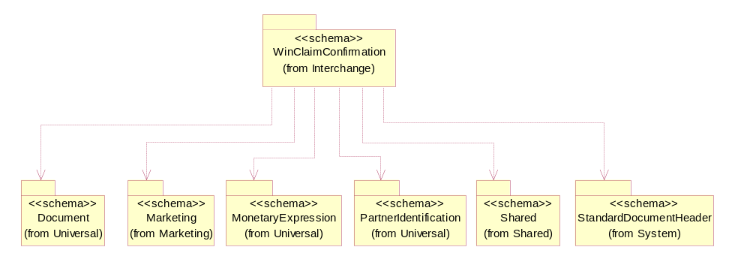
Figure ‎2-2 Dependency

DesignRegistrationIdentification
The collection of business properties that describe design registration identification.
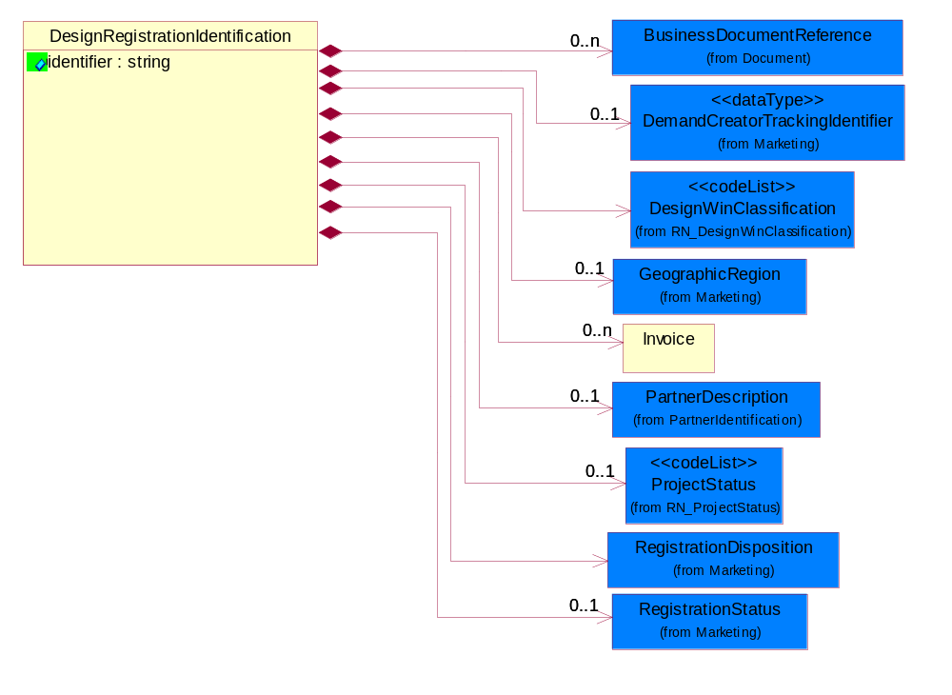
Figure ‎2-3 DesignRegistrationIdentification

Attribute | Type | Documentation
identifier | string | A proprietary unique identifier for a design registration.

Composition | Cardinality | Type | Documentation
BusinessDocumentReference | 0..n | BusinessDocumentReference | The business document reference object allows for the indirect referencing of a relationship to other business related documents.
Invoice | 0..n | Invoice | An itemized list of goods or services specifying the price and the terms of sale.
PartnerDescription | 0..1 | PartnerDescription | The collection of business properties that describe a business partners' identity, their contact information, where they are physically located and their function in a supply chain.
DemandCreatorTrackingIdentifier | 0..1 | DemandCreatorTrackingIdentifier | The proprietary unique identifier that represents a design registration request for a demand creator.
RegistrationStatus | 0..1 | RegistrationStatus | The collection of business properties that describe the registration status of a product.
ProjectStatus | 0..1 | ProjectStatus | Code identifying the status of a design project.
RegistrationDisposition | 1 | RegistrationDisposition | The collection of business properties that describe the disposition of a design registration request.
GeographicRegion | 0..1 | GeographicRegion | The collection of business properties that reflects multiple countries of choice or a specified region.
DesignWinClassification | 1 | DesignWinClassification | Code specifying the type of Design Win claim, as determined in a trading partner agreement and the terms and conditions of the Design Win Registration program.

DesignWinClaim
The collection of business properties that describe the various stages of a design win claim.
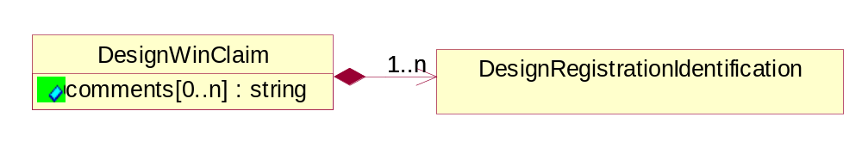
Figure ‎2-4 DesignWinClaim

Attribute | Type | Documentation
comments[0..n] | string | Free form textual description of a general nature.

Composition | Cardinality | Type | Documentation
DesignRegistrationIdentification | 1..n | DesignRegistrationIdentification | The collection of business properties that describe design registration identification.

Invoice
An itemized list of goods or services specifying the price and the terms of sale.
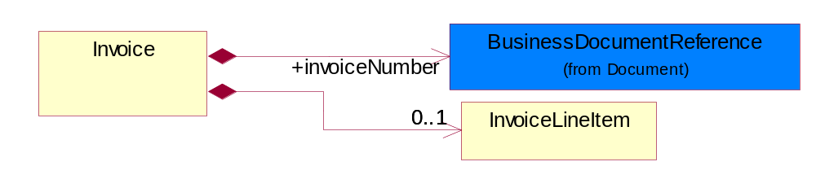
Figure ‎2-5 Invoice

Composition | Cardinality | Type | Documentation
invoiceNumber | 1 | BusinessDocumentReference | Unique identifier that represents an invoice.
InvoiceLineItem | 0..1 | InvoiceLineItem | The collection of business properties that describe an invoice entry.

InvoiceLineItem
The collection of business properties that describe an invoice entry.
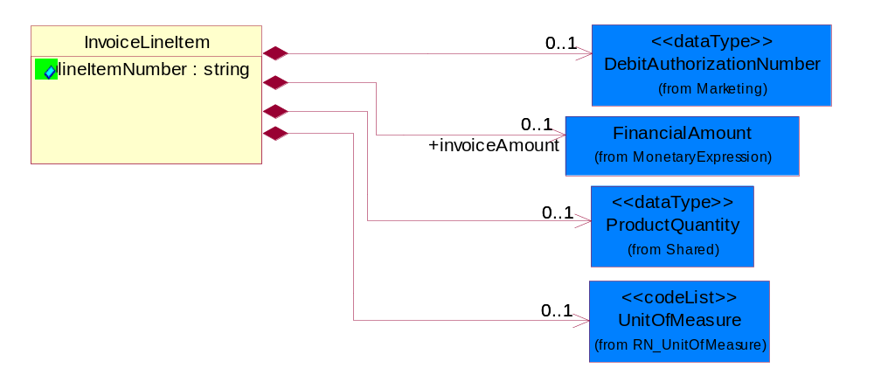
Figure ‎2-6 InvoiceLineItem

Attribute | Type | Documentation
lineItemNumber | string | Reference to an item by the number of the line in the document.

Composition | Cardinality | Type | Documentation
UnitOfMeasure | 0..1 | UnitOfMeasure | Code identifying a product unit of measure.
invoiceAmount | 0..1 | FinancialAmount | The monetary value of the invoice.
DebitAuthorizationNumber | 0..1 | DebitAuthorizationNumber | The number associated with the debit assigned to the pricing of a particular part number.
ProductQuantity | 0..1 | ProductQuantity | A quantity specifying the number of product units.

WinClaimConfirmation
Top level object for a Win Claim Confirmation document.
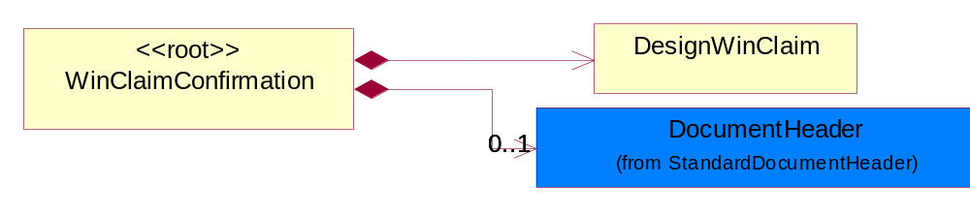
Figure ‎2-7 WinClaimConfirmation

Composition | Cardinality | Type | Documentation
DocumentHeader | 0..1 | DocumentHeader | The object allows for the identification of the sender and receiver of the business document.
DesignWinClaim | 1 | DesignWinClaim | The collection of business properties that describe the various stages of a design win claim.

Domain Model

Marketing

Dependency Diagram
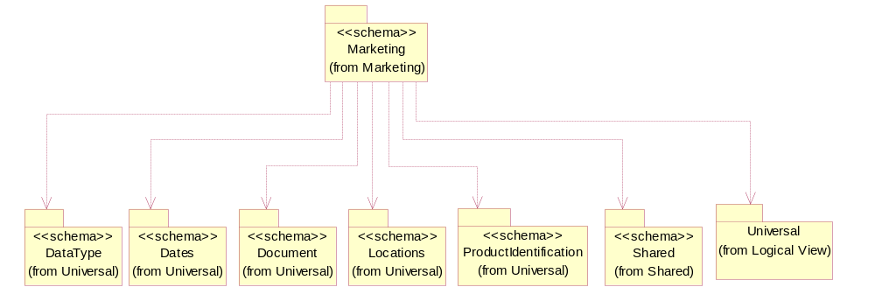
Figure ‎3-8 Dependency

DebitAuthorizationNumber
The number associated with the debit assigned to the pricing of a particular part number.
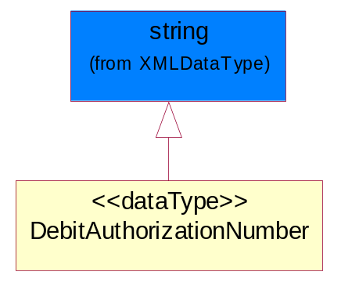
Figure ‎3-9 DebitAuthorizationNumber

DemandCreatorTrackingIdentifier
The proprietary unique identifier that represents a design registration request for a demand creator.
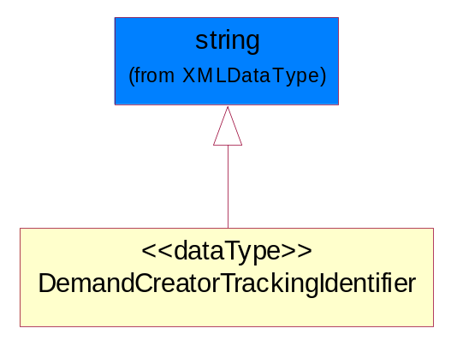
Figure ‎3-10 DemandCreatorTrackingIdentifier

DesignWinStatusReasonCodeExplanation
Further explanation provided by the product provider or the demand creator to clarify/explain the particular DesignWinStatusReasonCode.
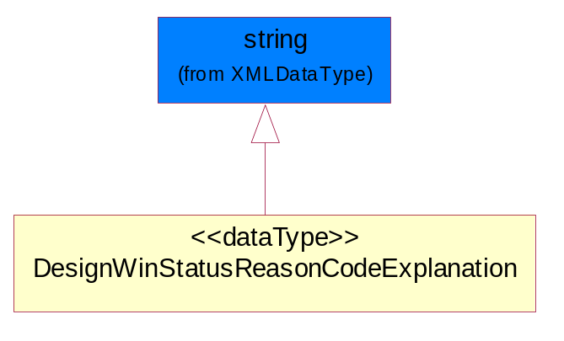
Figure ‎3-11 DesignWinStatusReasonCodeExplanation

GeographicRegion
The collection of business properties that reflects multiple countries of choice or a specified region.
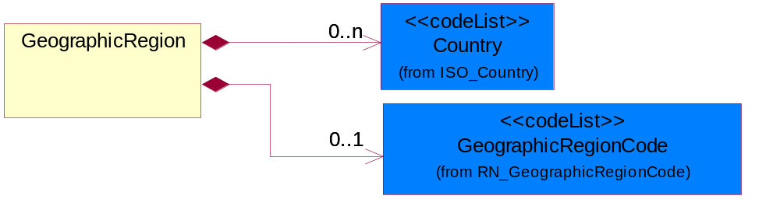
Figure ‎3-12 GeographicRegion

Composition | Cardinality | Type | Documentation
Country | 0..n | Country | For representation of Country name RosettaNet has adopted ISO 3166-3; 1999. Refer to the following web page to get the latest version of the standard:  http://www.iso.ch/iso/en/prods-services/iso3166ma/02iso-3166-code-lists/index.html  If you need more information about the ISO standard please contact ISO for more details.
GeographicRegionCode | 0..1 | GeographicRegionCode | Code identifying a geographic region.

RegistrationDisposition
The collection of business properties that describe the disposition of a design registration request.
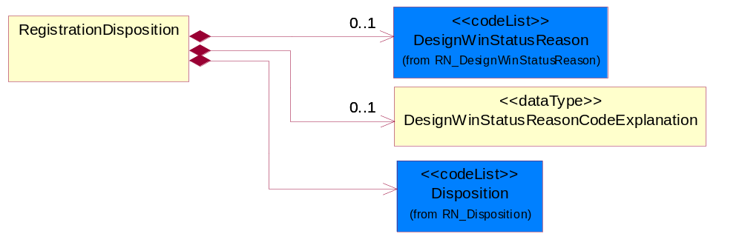
Figure ‎3-13 RegistrationDisposition

Composition | Cardinality | Type | Documentation
Disposition | 1 | Disposition | Code identifying the registration disposition of a design registration request; namely the response by the product supplier as to how the current status of the request.
DesignWinStatusReasonCodeExplanation | 0..1 | DesignWinStatusReasonCodeExplanation | Further explanation provided by the product provider or the demand creator to clarify/explain the particular DesignWinStatusReasonCode.
DesignWinStatusReason | 0..1 | DesignWinStatusReason | Code identifying the reason for the disposition of a design registration request or the status of a particular design registration assigned by the product provider or requested by the demand creator.

RegistrationStatus
The collection of business properties that describe the registration status of a product.
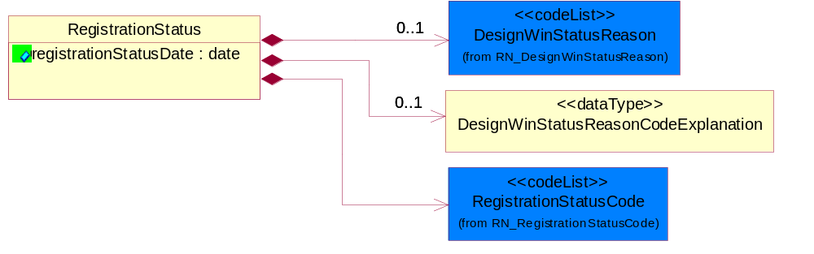
Figure ‎3-14 RegistrationStatus

Attribute | Type | Documentation
registrationStatusDate | date | The date stamp when the registration status was generated.

Composition | Cardinality | Type | Documentation
RegistrationStatusCode | 1 | RegistrationStatusCode | Code identifying the registration status of a design; namely, the acknowledgment, collaboration and continuation on the submitted supplier part business opportunity between a supplier (manufacture representative) and a distributor.
DesignWinStatusReason | 0..1 | DesignWinStatusReason | Code identifying the reason for the disposition of a design registration request or the status of a particular design registration assigned by the product provider or requested by the demand creator.
DesignWinStatusReasonCodeExplanation | 0..1 | DesignWinStatusReasonCodeExplanation | Further explanation provided by the product provider or the demand creator to clarify/explain the particular DesignWinStatusReasonCode.

CodeList

DesignWinStatusReason
Code identifying the reason for the disposition of a design registration request or the status of a particular design registration assigned by the product provider or requested by the demand creator.

Name | Documentation
CAP | Contact Approve - Please call to resolve issue with request.
CMA | Contract Manufacturer - Manufacturing is now serviced by the contract manufacturer, not distribution.
COO | Company Out of Business - Company is out of business.
CRP | Competing Registration Present - Registration for part and customer already exists with another distributor.
CRT | Customer Requested to Close the Opportunity - The end customer has asked the product provider to close the registration.
DAD | Design Already Done - The design has already been completed and therefore the demand creator is not eligible for design registration for this project.
DCL | Duplicate Claim - A Design Win claim for the same registration has previously been accepted and approved.
DRE | Duplicate Registration - Registration for part and customer already exists with requesting distributor.
DWD | Design Win Date Must Be a Future Date - The design win date supplied by the demand creator is in the past and the product provider requires the date to be in the future.
EDR | Expired Design Registration Status - Project expired and therefore no longer eligible for design registration.
ICC | Invalid Company Contact - The company contact supplied was determined invalid by the product provider.
ICD | Invalid Customer Code - The product provider cannot identify the customer code or the customer code supplied is invalid.
ICE | Invalid Customer Contact - The customer contact has been determined invalid by the product provider.
IIN | Insufficient Information - One or more required data elements was not provided or information in a given data element is incomplete.
IOA | Invalid Opportunity Attachment - The opportunity attachment has been determined invalid by the product provider.
ION | Invalid Opportunity Note or Comment - The opportunity note or comment has been determined invalid by the product provider.
IOS | Invalid Opportunity Status - The opportunity status sent in is not valid.
IPC | Invalid Partner Code - The partner code has been determined invalid by the product provider.
IPN | Invalid Part Number - Supplier cannot identify part number as one of its own.
IPP | Invalid Product Price - The product price has been determined invalid by the product provider.
IPQ | Invalid Product Quantity Per System - The product quantity per system has been determined invalid by the product provider.
IPR | Invalid Partner Role - The partner role has been determined invalid by the product provider.
IPS | Invalid Product - The product has been determined invalid by the product provider.
IPT | Invalid Projected Sales Quantity - The projected sales quantity has been determined invalid by the product provider.
LDE | Lost Design - Design has been lost and is therefore no longer eligible for registration.
MDG | Multiple Distributors Give Support - Multiple demand creators are providing support for this project and therefore it is not eligible for design registration.
NAR | Not a Registerable Part Number or Part Number Not Eligible For Registration - Part number is a good supplier part, but is not eligible for registration.
NAV | Not a Valid Customer Project - The customer project has been determined invalid for design registration.
NCR | No Commercial Relation - The demand creator submitting the design does not have a valid commercial relationship (e.g., franchise agreement) with the product provider.
NDF | No Distributor Field Application Engineer - The demand creator no longer has a field application engineer supporting the project.
NES | No Engineer Services Required - The customer or design does not require technical investment of resources and therefore the registration is deemed invalid by the product provider.
NSB | Not Supported By Distributor - The product provider has determined that this registration is invalid because it is not being supported by the demand creator.
OAT | Opportunity Attachment Too Large - The opportunity attachment has been determined to be too large by the product provider.
PCB | Project Cancelled By Customer - The customer has cancelled the project for this design registration.
PDB | Project Delayed By Customer - The customer has delayed the project for this design registration.
PNN | Part Number Not In Price Book - Some suppliers require that a part be in the price book before issuing a registration.
PSN | Project Safety Not Green - The use of the part in this particular project does not meet the product provider's eligibility requirements for design registration.
PWD | Production Win Date Must Be Future Date - The production win date supplied by the demand creator is in the past and the product provider requires the date to be in the future.
QMN | Quantity Metric Not Met - Quantity of parts required to satisfy Design Win threshold requirement has not been met.
RFI | Required Fields Incomplete - Minimum fields of information required by supplier was not met.
RIN | Resale Inactivity - Registration was in production win status, but there have not been sufficient resales to keep it active.
RNI | Registration Number is Not Valid - Supplier cannot identify register number with any valid register numbers for that distributor.
SMN | Sales Metric Not Met - Dollar sales volume required to satisfy Design Win threshold requirement has not been met.
URE | Under Review - Design registration request has not completed the review process.
VNH | Value Not High Enough - Value of opportunity does not meet minimum requirements for registration.
WCN | Wrong Customer Name - Customer name does not match name on existing registration.

RegistrationStatusCode
Code identifying the registration status of a design; namely, the acknowledgment, collaboration and continuation on the submitted supplier part business opportunity between a supplier (manufacture representative) and a distributor.

Name | Documentation
APP | Approved - Registration has been approved as Design Win eligible.
CLO | Closed - Registration has been closed by supplier or customer request and is not subject to renewal.
DEN | Denied - Registration has been rejected (turned down) for Design Win eligible status.
EXP | Opportunity was not updated within 90 days.
FRE | Final Registration - Indicates limited incentives apply from here on.
OSW | Production in the other geography has been verified and the offshore win claim has been approved.
OWC | Production is being done in a geography different than the geography the opportunity was generated in.
PEN | Pending - Registration has been submitted and logged (on the supplier's system), but approval is pending or on hold.
PRO | Production - Approved registration, has reached Production Win threshold, making sales eligible for enhanced margin, rebates or bonuses.
VAL | Valid - Design registration acknowledged by the supplier, but not yet approved for design win. The Valid stage allows the distributor to finish the design, submit Bill of Materials or block diagrams as required to meet conditions for Approval. The supplier is not yet protected as there are still outstanding conditions for getting to Approved.
WIN | Win - Approved registration has reached the Design Win threshold, making sales eligible for enhanced margin, rebates or bonuses.

GeographicRegionCode
Code identifying a geographic region.
Name | Documentation
GLO | Global - All countries.

ProjectStatus
Code identifying the status of a design project.
Name | Documentation
CON | Concept - Indicates a potential opportunity for a "design in" exists.
DES | Design - Indicates that an engineer and project name has been assigned.
PRO | Production - POS (Point of Sale) reports indicate that product has been shipped for production builds, and the project is successfully completed.
PRP | Prototype - Indicates that a prototype build and evaluation is underway.

Disposition
Code identifying the registration disposition of a design registration request; namely the response by the product supplier as to how the current status of the request.

Name | Documentation
ACC | Accepted - Confirmation of receipt of request and responding with a registration status in this exchange.
PEN | Pending - The demand creator's request has been accepted (e.g., all data is complete, but the data changes must be validated before a status update/confirmation can be sent), but an updated/confirmed registration status will be provided subsequently (with a 5C4 message).
REJ | Rejected - The demand creator's request has been rejected because of exceptions in the document (i.e. missing data). The response will not include an updated or confirmed registration.

DesignWinClassification
Code specifying the type of Design Win claim, as determined in a trading partner agreement and the terms and conditions of the Design Win Registration program.

Name | Documentation
DIN | Design In - Pre-order stage.
DWI | Design Win - Initial / prototype order.
PWI | Production Win - Production order.

Shared

Dependency Diagram
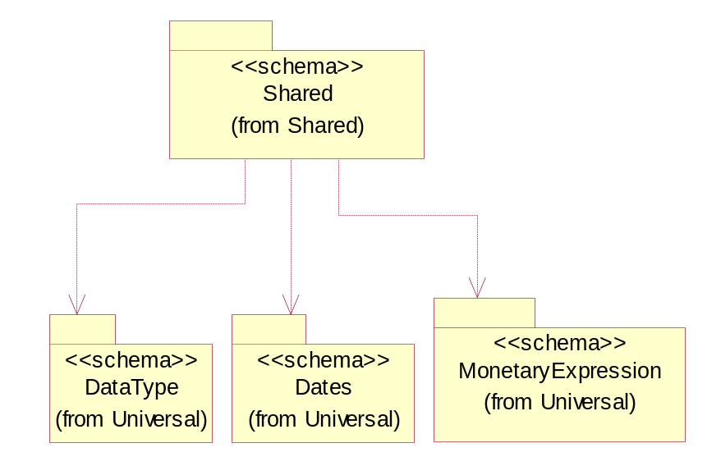
Figure ‎3-15 Dependency

ProductQuantity
A quantity specifying the number of product units.
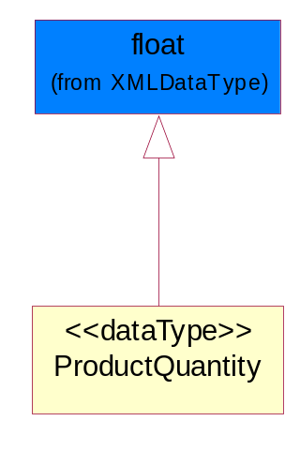
Figure ‎3-16 ProductQuantity

Universal Structure

ContactInformation

ContactInformation
The business document must allow for the identification of the name of the department, service or individual to be contacted regarding the context of the business document.
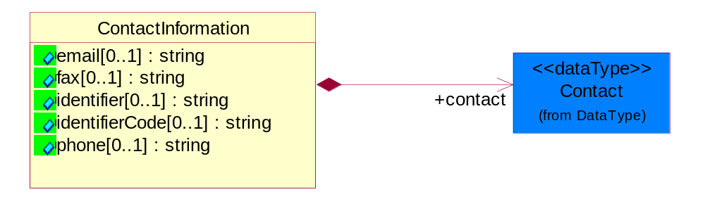
Figure ‎4-17 ContactInformation

Attribute | Type | Documentation
email[0..1] | string | The electronic mail for the specified contact.
fax[0..1] | string | The fax number for the specified contact.
identifier[0..1] | string | Identifies the role of the contact (i.e. Service Technician, Account Manager) in the Business Process.
identifierCode[0..1] | string | IdentifierCode is a unique security authorization code to identify the contact- ie. badge ID.
phone[0..1] | string | The telephone number for the specified contact.

Composition | Cardinality | Type | Documentation
contact | 1 | Contact | The name of the department, service or individual to be contacted within the organization.

DataType

Contact
The name of the department, service or individual to be contacted within the organization.
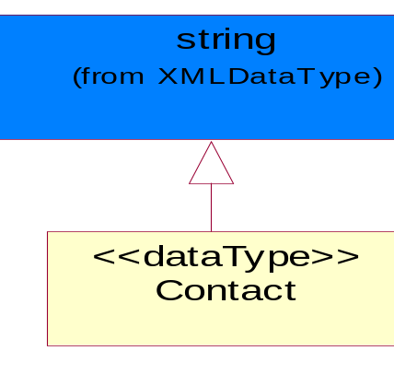
Figure ‎4-18 Contact

DUNS
A number assigned by Dun and Bradstreet to identify a business location.
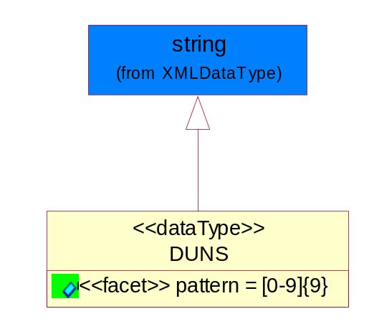
Figure ‎4-19 DUNS

Attribute | Type | Documentation
pattern |  | [0-9]{9}

DUNSPlus4
A identifier to specify a specific location within a business location.
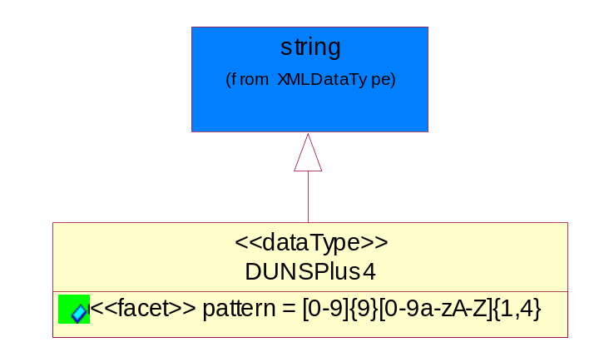
Figure ‎4-20 DUNSPlus4

Attribute | Type | Documentation
pattern |  | Data Universal Numbering System +4 (DUNS+4) number means the DUNS number assigned by Dun and Bradstreet, Inc. (D&B) plus an alphanumeric of length 4 suffix that may be assigned by a business concern.

GLN
Global Location Number (GLN) - A identifier to identify legal entities, trading parties and location.
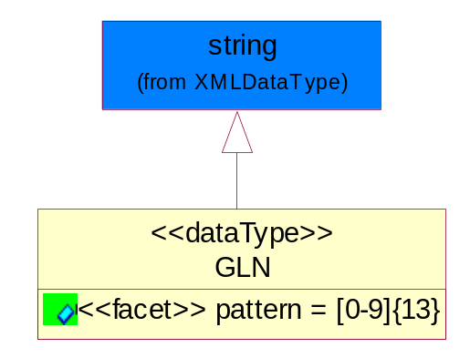
Figure ‎4-21 GLN

Attribute | Type | Documentation
pattern |  | [0-9]{13}

Document

BusinessDocumentReference
The business document reference object allows for the indirect referencing of a relationship to other business related documents.
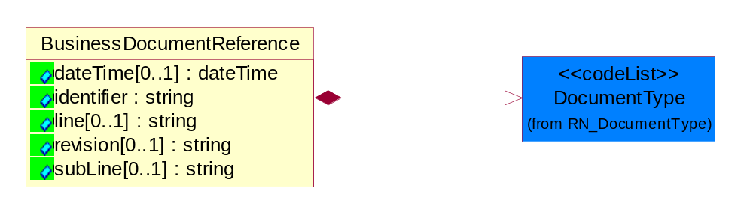
Figure ‎4-22 BusinessDocumentReference

Attribute | Type | Documentation
dateTime[0..1] | dateTime | The date-time stamp indicating on the referenced business document.
identifier | string | Unique identification of the referenced business document.
line[0..1] | string | References the specific line number of the specified business document.
revision[0..1] | string | Referenced the revision of the specified business document.
subLine[0..1] | string | References the specific subline number of the specified business document.

Composition | Cardinality | Type | Documentation
DocumentType | 1 | DocumentType | A code identifying the business context of a document.

Locations

AlternativeIdentifier
Identifies the specified code and the name of the organization that a code is utilized from.
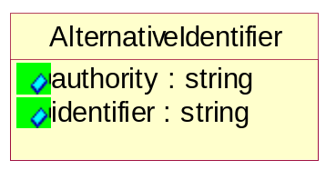
Figure ‎4-23 AlternativeIdentifier

Attribute | Type | Documentation
authority | string | The name of the organization that a code is utilized from.
identifier | string | The specified code to represent an entity (e.g. product, location, partner, etc.).

Location
The business document must specify a location.
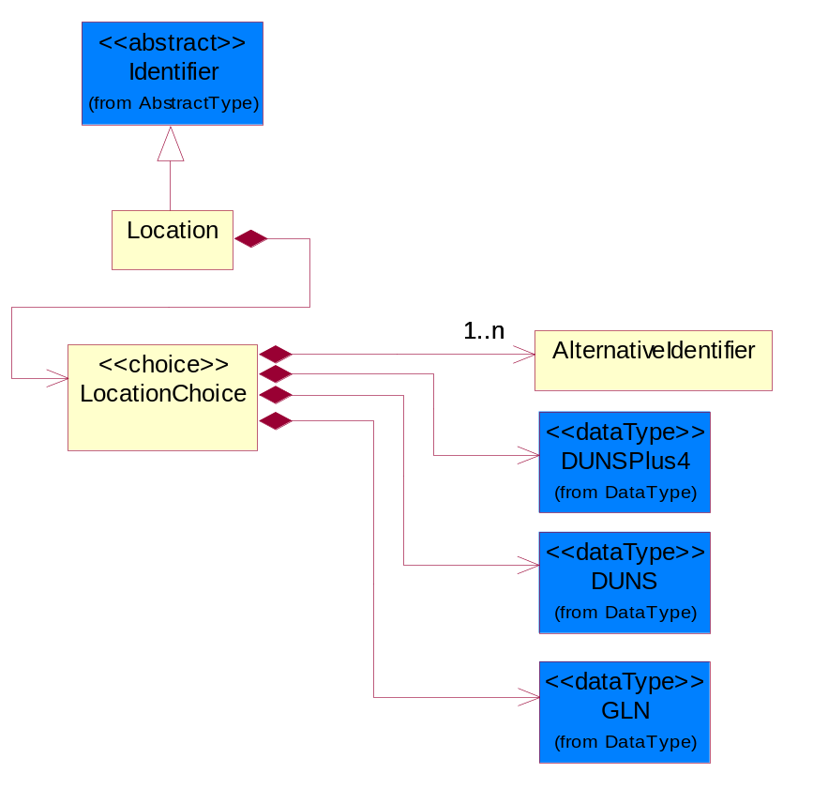
Figure ‎4-24 Location

Composition | Cardinality | Type | Documentation
LocationChoice | 1 | LocationChoice

LocationChoice

Composition | Cardinality | Type | Documentation
DUNSPlus4 | 1 | DUNSPlus4 | A identifier to specify a specific location within a business location.
DUNS | 1 | DUNS | A number assigned by Dun and Bradstreet to identify a business location.
AlternativeIdentifier | 1..n | AlternativeIdentifier | Identifies the specified code and the name of the organization that a code is utilized from.
GLN | 1 | GLN | Global Location Number (GLN) - A identifier to identify legal entities, trading parties and location.

PhysicalAddress
The business document must provide a physical address for a party to the business transaction.
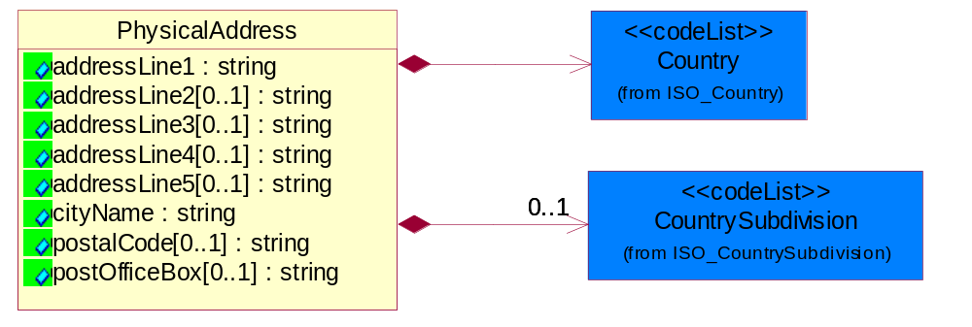
Figure ‎4-25 PhysicalAddress

Attribute | Type | Documentation
addressLine1 | string | The first line of a physical address.
addressLine2[0..1] | string | The second line of a physical address.
addressLine3[0..1] | string | The third line of a physical address.
addressLine4[0..1] | string | The fourth line of a physical address.
addressLine5[0..1] | string | The fifth line of a physical address.
cityName | string | The name of a city.
postalCode[0..1] | string | Identifying geographic location as specified by a national postal code.
postOfficeBox[0..1] | string | The Post Office Box identifier used to identify a party's post office box.

Composition | Cardinality | Type | Documentation
Country | 1 | Country | For representation of Country name RosettaNet has adopted ISO 3166-3; 1999. Refer to the following web page to get the latest version of the standard:  http://www.iso.ch/iso/en/prods-services/iso3166ma/02iso-3166-code-lists/index.html  If you need more information about the ISO standard please contact ISO for more details.
CountrySubdivision | 0..1 | CountrySubdivision | For representation of a Countries subdivisions RosettaNet has adopted ISO 3166-3; 1999. Refer to the following web page to get the latest version of the standard:  http://www.iso.ch/iso/en/prods-services/iso3166ma/02iso-3166-code-lists/index.html  If you need more information about the ISO standard please contact ISO for more details.

MonetaryExpression

FinancialAmount
The business document must express financial amounts.
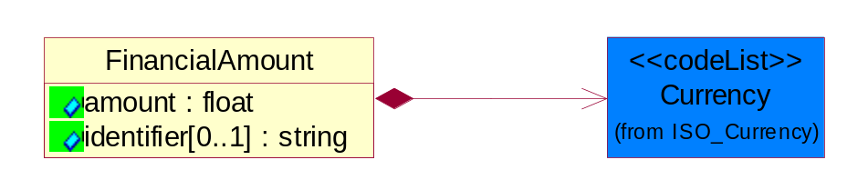
Figure ‎4-26 FinancialAmount

Attribute | Type | Documentation
amount | float | Specifies the monetary amount.
identifier[0..1] | string | Identifier is a unique identifier to which the specific price is tied - ie. promotion name/ program.

Composition | Cardinality | Type | Documentation
Currency | 1 | Currency | For representation of Currency codes RosettaNet has adopted ISO 4217; 1995. The British Standards Institution (BSI) is the ISO 4217 Maintenance Agency. Refer to the following web page to get the latest version of the standard:  http://www.bsi-global.com/Technical+Information/Publications/_Publications/tig90.xalter  If you need more information about the ISO standard please contact ISO for more details.

PartnerIdentification

FullPartner
The business document must describe the trading partners in the business transaction. This data structure provide the flexibility to describe a partner in all possible methods as for new, existing or known partner.
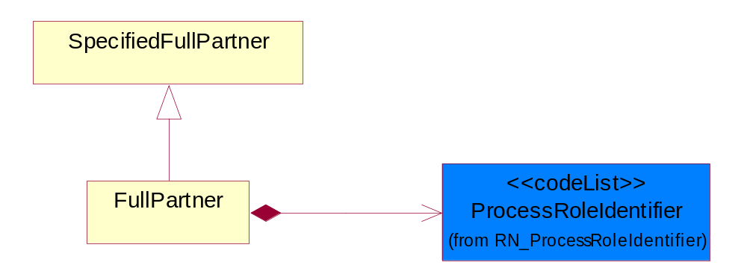
Figure ‎4-27 FullPartner

Composition | Cardinality | Type | Documentation
ProcessRoleIdentifier | 1 | ProcessRoleIdentifier | Describes the role of the partner in the business process. A partner will fulfill at least one or more roles during the business process.

IntermittentPartner
The business document must describe a physical address for a delivery.
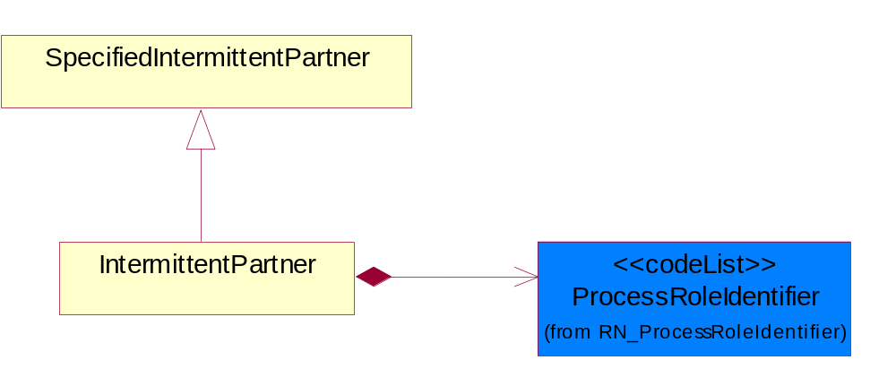
Figure ‎4-28 IntermittentPartner

Composition | Cardinality | Type | Documentation
ProcessRoleIdentifier | 1 | ProcessRoleIdentifier | Describes the role of the partner in the business process. A partner will fulfill at least one or more roles during the business process.

KnownPartner
The business document must describe the trading partners in the business transaction.
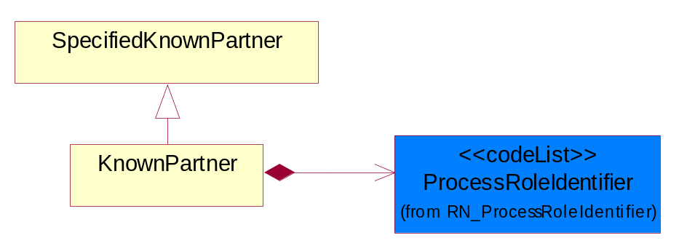
Figure ‎4-29 KnownPartner

Composition | Cardinality | Type | Documentation
ProcessRoleIdentifier | 1 | ProcessRoleIdentifier | Describes the role of the partner in the business process. A partner will fulfill at least one or more roles during the business process.

KnownPartnerContact
The business document must describe the trading partners in the business transaction.
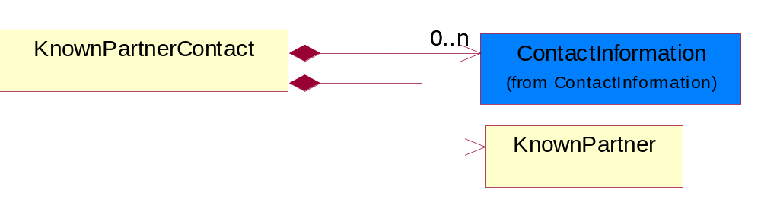
Figure ‎4-30 KnownPartnerContact

Composition | Cardinality | Type | Documentation
KnownPartner | 1 | KnownPartner | The business document must describe the trading partners in the business transaction.
ContactInformation | 0..n | ContactInformation | The business document must allow for the identification of the name of the department, service or individual to be contacted regarding the context of the business document.

NewPartner
The business document must describe a new, existing (but known to only one of the parties to the transaction) or an unknown party to the business transaction.
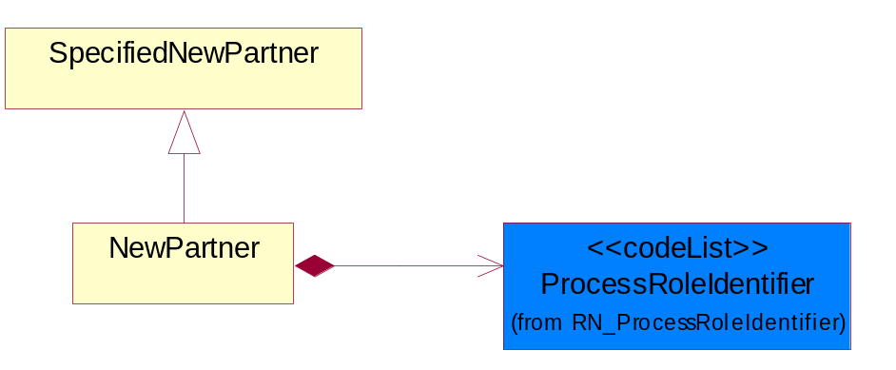
Figure ‎4-31 NewPartner

Composition | Cardinality | Type | Documentation
ProcessRoleIdentifier | 1 | ProcessRoleIdentifier | Describes the role of the partner in the business process. A partner will fulfill at least one or more roles during the business process.

PartnerDescription
The collection of business properties that describe a business partners' identity, their contact information, where they are physically located and their function in a supply chain.
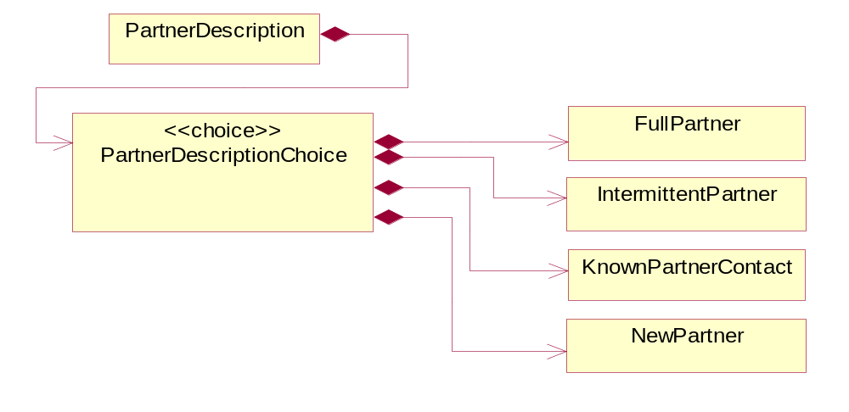
Figure ‎4-32 PartnerDescription

Composition | Cardinality | Type | Documentation
PartnerDescriptionChoice | 1 | PartnerDescriptionChoice

PartnerDescriptionChoice

Composition | Cardinality | Type | Documentation
KnownPartnerContact | 1 | KnownPartnerContact | The business document must describe the trading partners in the business transaction.
IntermittentPartner | 1 | IntermittentPartner | The business document must describe a physical address for a delivery.
NewPartner | 1 | NewPartner | The business document must describe a new, existing (but known to only one of the parties to the transaction) or an unknown party to the business transaction.
FullPartner | 1 | FullPartner | The business document must describe the trading partners in the business transaction. This data structure provide the flexibility to describe a partner in all possible methods as for new, existing or known partner.

PartnerIdentification
The business document must allow for the identity of one or more parties to the transaction.
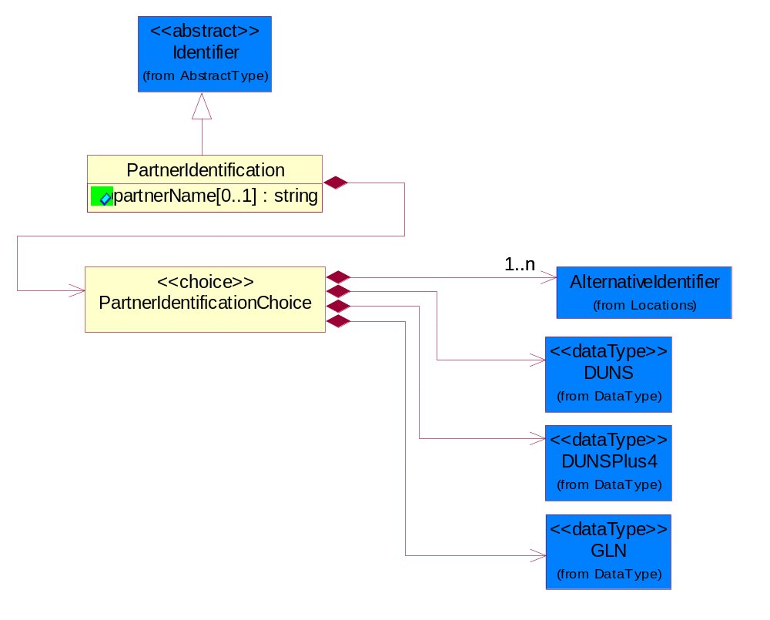
Figure ‎4-33 PartnerIdentification

Attribute | Type | Documentation
partnerName[0..1] | string | The name of the partner’s company/business.

Composition | Cardinality | Type | Documentation
PartnerIdentificationChoice | 1 | PartnerIdentificationChoice

PartnerIdentificationChoice

Composition | Cardinality | Type | Documentation
DUNS | 1 | DUNS | A number assigned by Dun and Bradstreet to identify a business location.
DUNSPlus4 | 1 | DUNSPlus4 | A identifier to specify a specific location within a business location.
AlternativeIdentifier | 1..n | AlternativeIdentifier | Identifies the specified code and the name of the organization that a code is utilized from.
GLN | 1 | GLN | Global Location Number (GLN) - A identifier to identify legal entities, trading parties and location.

SpecifiedFullPartner
The business document must describe the trading partners in the business transaction. This data structure provide the flexibility to describe a partner in all possible methods as for new, existing or known partner. This is specifically for partner who role has been specified.
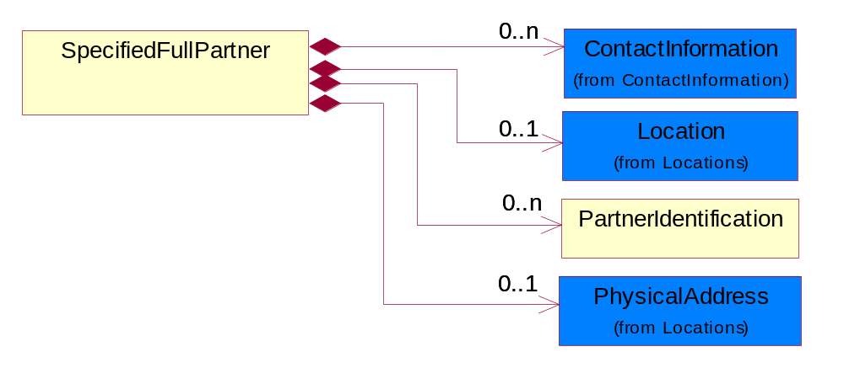
Figure ‎4-34 SpecifiedFullPartner

Composition | Cardinality | Type | Documentation
ContactInformation | 0..n | ContactInformation | The business document must allow for the identification of the name of the department, service or individual to be contacted regarding the context of the business document.
Location | 0..1 | Location | The business document must specify a location.
PartnerIdentification | 0..n | PartnerIdentification | The business document must allow for the identity of one or more parties to the transaction.
PhysicalAddress | 0..1 | PhysicalAddress | The business document must provide a physical address for a party to the business transaction.

SpecifiedIntermittentPartner
The business document must describe a physical address for a delivery.
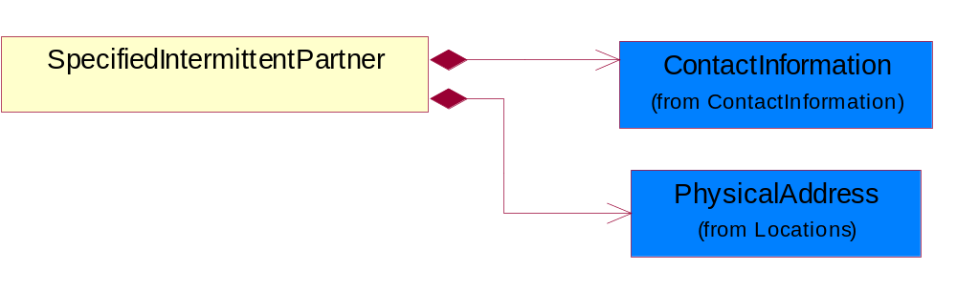
Figure ‎4-35 SpecifiedIntermittentPartner

Composition | Cardinality | Type | Documentation
ContactInformation | 1 | ContactInformation | The business document must allow for the identification of the name of the department, service or individual to be contacted regarding the context of the business document.
PhysicalAddress | 1 | PhysicalAddress | The business document must provide a physical address for a party to the business transaction.

SpecifiedKnownPartner
The business document must describe the trading partners in the business transaction.
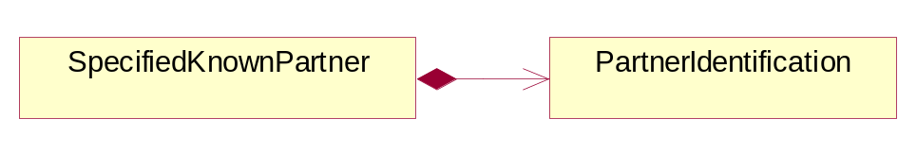
Figure ‎4-36 SpecifiedKnownPartner

Composition | Cardinality | Type | Documentation
PartnerIdentification | 1 | PartnerIdentification | The business document must allow for the identity of one or more parties to the transaction.

SpecifiedNewPartner
The business document must describe a new, existing (but known to only one of the parties to the transaction) or an unknown party to the business transaction.
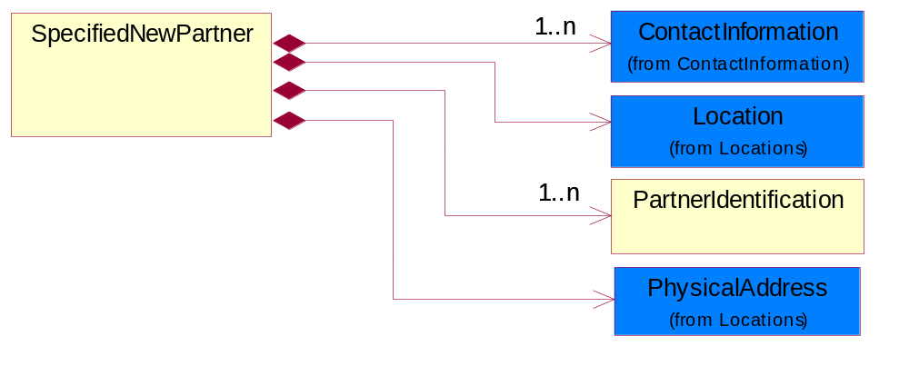
Figure ‎4-37 SpecifiedNewPartner

Composition | Cardinality | Type | Documentation
ContactInformation | 1..n | ContactInformation | The business document must allow for the identification of the name of the department, service or individual to be contacted regarding the context of the business document.
Location | 1 | Location | The business document must specify a location.
PhysicalAddress | 1 | PhysicalAddress | The business document must provide a physical address for a party to the business transaction.
PartnerIdentification | 1..n | PartnerIdentification | The business document must allow for the identity of one or more parties to the transaction.

CodeList

Country
For representation of Country name RosettaNet has adopted ISO 3166-3; 1999. Refer to the following web page to get the latest version of the standard:
http://www.iso.ch/iso/en/prods-services/iso3166ma/02iso-3166-code-lists/index.html

If you need more information about the ISO standard please contact ISO for more details.

CountrySubdivision
For representation of a Countries subdivisions RosettaNet has adopted ISO 3166-3; 1999. Refer to the following web page to get the latest version of the standard:
http://www.iso.ch/iso/en/prods-services/iso3166ma/02iso-3166-code-lists/index.html

If you need more information about the ISO standard please contact ISO for more details.

Currency
For representation of Currency codes RosettaNet has adopted ISO 4217; 1995. The British Standards Institution (BSI) is the ISO 4217 Maintenance Agency. Refer to the following web page to get the latest version of the standard:
http://www.bsi-global.com/Technical+Information/Publications/_Publications/tig90.xalter

If you need more information about the ISO standard please contact ISO for more details.

Language
For representation of Language name RosettaNet has adopted ISO 639-2; 1998. Refer to the following web page to get the latest version of the standard:

http://www.loc.gov/standards/iso639-2/iso639jac.html

If you need more information about the ISO standard please contact ISO for more details.

DocumentType
A code identifying the business context of a document.

Instance | Documentation
APM | Applied Promotions.
ARA | Authorization Request Approval.
CAR | Certificate of Analysis Response.
CBN | Product batch number of customer.
CCN | Customs clearance number.
CFA | Failure Analysis - Request document that will accompany the product providing characteristics of the component failure.
CIN | Commercial Invoice.
CNM | Traditional credit note or memo.
COA | Certificate of Analysis.
CON | In a virtual sourcing relationship, a third party trading partner is supplying a part to a customer on behalf of another company that has taken the order for the customer. In this case a Customer Order Number is associated to the request for material that is sent to the virtual trading partners.
COS | Consumption Notice.
COT | Contract.
CRN | Unique consumption reference number identifying the product consumption issue i.e. one-to-one relationship with physical flow.
DEM | Traditional debit note or memo.
DEN | Delivery Note.
DIN | Discontinuation Notice.
DOR | Delivery Order.
DRN | Drawing Number.
DRR | Design Registration Request.
ECO | Engineering Change Order - The proprietary unique identification number that represents an engineering change order.
EDD | Export Declaration Document.
EIR | Engineering Information Request.
EOL | End of Life.
FUO | Sales order or transfer order fulfilling demand out of a facility (outbound shipment).
IDD | Import Declaration Document.
INV | Invoice.
LID | Location Identifier. Data for on-site work that have to be done on the machine (associated with preventive maintenance order).
MEN | Master Event Number.
MID | Machine Identifier. Data for on-site work that have to be done on the machine (associated with preventive maintenance order).
MON | Model Number.
NTS | Notes.
OCL | The unique identifier assigned by the OEM for a warranty claim.
OGA | Other governmental agency issued document.
OPO | The unique identifier assigned by the OEM for a part order.
OPR | The unique identifier assigned by the OEM for a part return.
PCN | Product/Process Change.
PFA | Failure Analysis - Request document that will accompany the product providing characteristics of the product failure.
PII | Refers to previously issued invoice.
PLS | Unique number that identifies packing form prior to shipment.
POI | Purchase Order IN.
PON | Production order number for material release.
POO | Purchase Order OUT.
PRC | Product Catalog.
PSI | Refers to previously issued self-billing invoice.
PUO | Purchase Order.
QUO | Quote.
REC | Document identifying the receipt of materials or products into a facility against a purchase order or transfer order (inbound shipment).
REN | Release Number.
REO | Purchase order or transfer order replenishing inventory into a facility (inbound shipment).
REQ | Requisition.
RMA | Returned Material Authorization.
RPO | Purchase order for materials or product returned to and reworked by a supplier.
RTA | Remittance Advice - Remittance details.
SAO | Sales Order.
SBC | Credit Memo used in self-billing scenario.
SBD | Debit Memo used in self-billing scenario.
SBI | Invoice in self billing scenario.
SBN | Product batch number of supplier.
SCA | Similar to contracts - Contains the quantity of an article that is to be ordered from a vendor and the price for article or service that is to be procured.
SEN | Serial Number.
SEO | A document that gives a repair provider the necessary authorization to repair or upgrade a product either at the customer site or at the repair provider’s site.
SHD | Shipping Document.
SNC | Shipset Number on Code List.
SPC | The unique identifier assigned by the ASP for a warranty claim.
SPN | Spec Number.
SPO | The unique identifier assigned by the ASP for a part order.
SPR | The unique identifier assigned by the ASP for a part return.
SPW | The unique identifier assigned by the ASP to reference a work order.
SRI | A document that contains the shipping reference number which allows the product to be tracked within the outsourced logistic providers network.
SWT | Switch Authorization.
TCS | Terms and Conditions.
TRO | Order which results in materials or products being moved from one facility to another (outbound shipment and inbound shipment).
WAB | Waybill.
WAC | Denotes a warranty claim.
WOO | Work Order.

MimeTypeQualifier
The MIME type as defined by IANA.

Please refer to http://www.iana.org/assignments/media-types/ for a list of types.

Instance | Documentation
application/activemessage | [Shapiro]
application/andrew-inset | [Borenstein]
application/applefile | [Faltstrom]
application/atomicmail | [Borenstein]
application/batch-SMTP | [RFC2442]
application/beep+xml | [RFC3080]
application/cals-1840 | [RFC1895]
application/cnrp+xml | [RFCCNRP]
application/commonground | [Glazer]
application/cpl+xml
application/cybercash | [Eastlake]
application/dca-rft | [Campbell]
application/dec-dx | [Campbell]
application/dicom | [RFC3240]
application/dvcs | [RFC3029]
application/EDI-Consent | [RFC1767]
application/EDIFACT | [RFC1767]
application/EDI-X12 | [RFC1767]
application/eshop | [Katz]
application/font-tdpfr | [RFC3073]
application/http | [RFC2616]
application/hyperstudio | [Domino]
application/iges | [Parks]
application/index | [RFC2652]
application/index.cmd | [RFC2652]
application/index.obj | [RFC2652]
application/index.response | [RFC2652]
application/index.vnd | [RFC2652]
application/iotp | [RFC2935]
application/ipp | [RFC2910]
application/isup | [RFC3204]
application/mac-binhex40 | [Faltstrom]
application/macwriteii | [Lindner]
application/marc | [RFC2220]
application/mathematica | [Van Nostern]
application/msword | [Lindner]
application/news-message-id | [RFC1036,Spencer]
application/news-transmission | [RFC1036, Spencer]
application/ocsp-request | [RFC2560]
application/ocsp-response | [RFC2560]
application/octet-stream | [RFC2045,RFC2046]
application/oda | [RFC2045,RFC2046]
application/ogg | [RFC-walleij-ogg-mediatype-08.txt]
application/parityfec | [RFC3009]
application/pdf | [Lindner]
application/pgp-encrypted | [RFC3156]
application/pgp-keys | [RFC3156]
application/pgp-signature | [RFC3156]
application/pkcs10 | [RFC2311]
application/pkcs7-mime | [RFC2311]
application/pkcs7-signature | [RFC2311]
application/pkix-cert | [RFC2585]
application/pkixcmp | [RFC2510]
application/pkix-crl | [RFC2585]
application/postscript | [RFC2045,RFC2046]
application/prs.alvestrand.titrax-sheet | [Alvestrand]
application/prs.cww | [Rungchavalnont]
application/prs.nprend | [Doggett]
application/prs.plucker | [Janssen]
application/qsig | [RFC3204]
application/reginfo+xml | [RFC-ietf-sipping-reg-event-00.txt]
application/remote-printing | [RFC1486,Rose]
application/riscos | [Smith]
application/rtf | [Lindner]
application/sdp | [RFC2327]
application/set-payment | [Korver]
application/set-payment-initiation | [Korver]
application/set-registration | [Korver]
application/set-registration-initiation | [Korver]
application/sgml | [RFC1874]
application/sgml-open-catalog | [Grosso]
application/sieve | [RFC3028]
application/slate | [Crowley]
application/timestamp-query | [RFC3161]
application/timestamp-reply | [RFC3161]
application/tve-trigger | [Welsh]
application/vemmi | [RFC2122]
application/vnd.3gpp.pic-bw-large | [Meredith]
application/vnd.3gpp.pic-bw-small | [Meredith]
application/vnd.3gpp.pic-bw-var | [Meredith]
application/vnd.3gpp.sms | [Meredith]
application/vnd.3M.Post-it-Notes | [O'Brien]
application/vnd.accpac.simply.aso | [Leow]
application/vnd.accpac.simply.imp | [Leow]
application/vnd.acucobol | [Lubin]
application/vnd.acucorp | [Lubin]
application/vnd.adobe.xfdf | [Perelman]
application/vnd.aether.imp | [Moskowitz]
application/vnd.amiga.ami | [Blumberg]
application/vnd.anser-web-certificate-issue-initiation | [Mori]
application/vnd.anser-web-funds-transfer-initiation | [Mori]
application/vnd.audiograph | [Slusanschi]
application/vnd.blueice.multipass | [Holmstrom]
application/vnd.bmi | [Gotoh]
application/vnd.businessobjects | [Imoucha]
application/vnd.canon-cpdl | [Muto]
application/vnd.canon-lips | [Muto]
application/vnd.cinderella | [Kortenkamp]
application/vnd.claymore | [Simpson]
application/vnd.commerce-battelle | [Applebaum]
application/vnd.commonspace | [Chandhok]
application/vnd.contact.cmsg | [Patz]
application/vnd.cosmocaller | [Dellutri]
application/vnd.ctc-posml | [Kohlhepp]
application/vnd.cups-postscript | [Sweet]
application/vnd.cups-raster | [Sweet]
application/vnd.cups-raw | [Sweet]
application/vnd.curl | [Byrnes]
application/vnd.cybank | [Helmee]
application/vnd.data-vision.rdz | [Fields]
application/vnd.dna | [Searcy]
application/vnd.dpgraph | [Parker]
application/vnd.dreamfactory | [Appleton]
application/vnd.dxr | [Duffy]
application/vnd.ecdis-update | [Buettgenbach]
application/vnd.ecowin.chart | [Olsson]
application/vnd.ecowin.filerequest | [Olsson]
application/vnd.ecowin.fileupdate | [Olsson]
application/vnd.ecowin.series | [Olsson]
application/vnd.ecowin.seriesrequest | [Olsson]
application/vnd.ecowin.seriesupdate | [Olsson]
application/vnd.enliven | [Santinelli]
application/vnd.epson.esf | [Hoshina]
application/vnd.epson.msf | [Hoshina]
application/vnd.epson.quickanime | [Gu]
application/vnd.epson.salt | [Nagatomo]
application/vnd.epson.ssf | [Hoshina]
application/vnd.ericsson.quickcall | [Tidwell]
application/vnd.eudora.data | [Resnick]
application/vnd.fdf | [Zilles]
application/vnd.ffsns | [Holstage]
application/vnd.FloGraphIt | [Floersch]
application/vnd.framemaker | [Wexler]
application/vnd.fsc.weblaunch | [D.Smith]
application/vnd.fujitsu.oasys | [Togashi]
application/vnd.fujitsu.oasys2 | [Togashi]
application/vnd.fujitsu.oasys3 | [Okudaira]
application/vnd.fujitsu.oasysgp | [Sugimoto]
application/vnd.fujitsu.oasysprs | [Ogita]
application/vnd.fujixerox.ddd | [Onda]
application/vnd.fujixerox.docuworks | [Taguchi]
application/vnd.fujixerox.docuworks.binder | [Matsumoto]
application/vnd.fut-misnet | [Pruulmann]
application/vnd.grafeq | [Tupper]
application/vnd.groove-account | [Joseph]
application/vnd.groove-help | [Joseph]
application/vnd.groove-identity-message | [Joseph]
application/vnd.groove-injector | [Joseph]
application/vnd.groove-tool-message | [Joseph]
application/vnd.groove-tool-template | [Joseph]
application/vnd.groove-vcard | [Joseph]
application/vnd.hbci | [Hammann]
application/vnd.hhe.lesson-player | [Jones]
application/vnd.hp-HPGL | [Pentecost]
application/vnd.hp-hpid | [Gupta]
application/vnd.hp-hps | [Aubrey]
application/vnd.hp-PCL | [Pentecost]
application/vnd.hp-PCLXL | [Pentecost]
application/vnd.httphone | [Lefevre]
application/vnd.hzn-3d-crossword | [Minnis]
application/vnd.ibm.afplinedata | [Buis]
application/vnd.ibm.electronic-media | [Tantlinger]
application/vnd.ibm.MiniPay | [Herzberg]
application/vnd.ibm.modcap | [Hohensee]
application/vnd.ibm.secure-container | [Tantlinger]
application/vnd.informix-visionary | [Gales]
application/vnd.intercon.formnet | [Gurak]
application/vnd.intertrust.digibox | [Tomasello]
application/vnd.intertrust.nncp | [Tomasello]
application/vnd.intu.qbo | [Scratchley]
application/vnd.intu.qfx | [Scratchley]
application/vnd.irepository.package+xml | [Knowles]
application/vnd.is-xpr | [Natarajan]
application/vnd.japannet-directory-service | [Fujii]
application/vnd.japannet-jpnstore-wakeup | [Yoshitake]
application/vnd.japannet-payment-wakeup | [Fujii]
application/vnd.japannet-registration | [Yoshitake]
application/vnd.japannet-registration-wakeup | [Fujii]
application/vnd.japannet-setstore-wakeup | [Yoshitake]
application/vnd.japannet-verification | [Yoshitake]
application/vnd.japannet-verification-wakeup | [Fujii]
application/vnd.jisp | [Deckers]
application/vnd.kde.karbon | [Faure]
application/vnd.kde.kchart | [Faure]
application/vnd.kde.kformula | [Faure]
application/vnd.kde.kivio | [Faure]
application/vnd.kde.kontour | [Faure]
application/vnd.kde.kpresenter | [Faure]
application/vnd.kde.kspread | [Faure]
application/vnd.kde.kword | [Faure]
application/vnd.kenameaapp | [DiGiorgio-Haag]
application/vnd.koan | [Cole]
application/vnd.liberty-request+xml | [McDowell]
application/vnd.llamagraphics.life-balance.desktop | [White]
application/vnd.lotus-1-2-3 | [Wattenberger]
application/vnd.lotus-approach | [Wattenberger]
application/vnd.lotus-freelance | [Wattenberger]
application/vnd.lotus-notes | [Laramie]
application/vnd.lotus-organizer | [Wattenberger]
application/vnd.lotus-screencam | [Wattenberger]
application/vnd.lotus-wordpro | [Wattenberger]
application/vnd.mcd | [Gotoh]
application/vnd.mediastation.cdkey | [Flurry]
application/vnd.meridian-slingshot | [Wedel]
application/vnd.micrografx.flo | [Prevo]
application/vnd.micrografx.igx | [Prevo]
application/vnd.mif | [Wexler]
application/vnd.minisoft-hp3000-save | [Bartram]
application/vnd.mitsubishi.misty-guard.trustweb | [Tanaka]
application/vnd.Mobius.DAF | [Kabayama]
application/vnd.Mobius.DIS | [Kabayama]
application/vnd.Mobius.MBK | [Devasia]
application/vnd.Mobius.MQY | [Devasia]
application/vnd.Mobius.MSL | [Kabayama]
application/vnd.Mobius.PLC | [Kabayama]
application/vnd.Mobius.TXF | [Kabayama]
application/vnd.mophun.application | [Wennerstrom]
application/vnd.mophun.certificate | [Wennerstrom]
application/vnd.motorola.flexsuite | [Patton]
application/vnd.motorola.flexsuite.adsi | [Patton]
application/vnd.motorola.flexsuite.fis | [Patton]
application/vnd.motorola.flexsuite.gotap | [Patton]
application/vnd.motorola.flexsuite.kmr | [Patton]
application/vnd.motorola.flexsuite.ttc | [Patton]
application/vnd.motorola.flexsuite.wem | [Patton]
application/vnd.mozilla.xul+xml | [McDaniel]
application/vnd.ms-artgalry | [Slawson]
application/vnd.ms-asf | [Fleischman]
application/vnd.mseq | [Le Bodic]
application/vnd.ms-excel | [Gill]
application/vnd.msign | [Borcherding]
application/vnd.ms-lrm | [Ledoux]
application/vnd.ms-powerpoint | [Gill]
application/vnd.ms-project | [Gill]
application/vnd.ms-tnef | [Gill]
application/vnd.ms-works | [Gill]
application/vnd.ms-wpl | [Plastina]
application/vnd.musician | [Adams]
application/vnd.music-niff | [Butler]
application/vnd.netfpx | [Mutz]
application/vnd.noblenet-directory | [Solomon]
application/vnd.noblenet-sealer | [Solomon]
application/vnd.noblenet-web | [Solomon]
application/vnd.novadigm.EDM | [Swenson]
application/vnd.novadigm.EDX | [Swenson]
application/vnd.novadigm.EXT | [Swenson]
application/vnd.obn | [Hessling]
application/vnd.osa.netdeploy | [Klos]
application/vnd.palm | [Peacock]
application/vnd.pg.format | [Gandert]
application/vnd.pg.osasli | [Gandert]
application/vnd.powerbuilder6 | [Guy]
application/vnd.powerbuilder6-s | [Guy]
application/vnd.powerbuilder7 | [Shilts]
application/vnd.powerbuilder75 | [Shilts]
application/vnd.powerbuilder75-s | [Shilts]
application/vnd.powerbuilder7-s | [Shilts]
application/vnd.previewsystems.box | [Smolgovsky]
application/vnd.publishare-delta-tree | [Ben-Kiki]
application/vnd.pvi.ptid1 | [Lamb]
application/vnd.pwg-multiplexed | [RFC3391]
application/vnd.pwg-xhtml-print+xml | [Wright]
application/vnd.Quark.QuarkXPress | [Scheidler]
application/vnd.rapid | [Szekely]
application/vnd.s3sms | [Tarkkala]
application/vnd.sealed.net | [Lambert]
application/vnd.seemail | [Webb]
application/vnd.shana.informed.formdata | [Selzler]
application/vnd.shana.informed.formtemplate | [Selzler]
application/vnd.shana.informed.interchange | [Selzler]
application/vnd.shana.informed.package | [Selzler]
application/vnd.smaf | [Takahashi]
application/vnd.sss-cod | [Dani]
application/vnd.sss-dtf | [Bruno]
application/vnd.sss-ntf | [Bruno]
application/vnd.street-stream | [Levitt]
application/vnd.svd | [Becker]
application/vnd.swiftview-ics | [Widener]
application/vnd.triscape.mxs | [Simonoff]
application/vnd.trueapp | [Hepler]
application/vnd.truedoc | [Chase]
application/vnd.ufdl | [Manning]
application/vnd.uplanet.alert | [Martin]
application/vnd.uplanet.alert-wbxml | [Martin]
application/vnd.uplanet.bearer-choice | [Martin]
application/vnd.uplanet.bearer-choice-wbxml | [Martin]
application/vnd.uplanet.cacheop | [Martin]
application/vnd.uplanet.cacheop-wbxml | [Martin]
application/vnd.uplanet.channel | [Martin]
application/vnd.uplanet.channel-wbxml | [Martin]
application/vnd.uplanet.list | [Martin]
application/vnd.uplanet.listcmd | [Martin]
application/vnd.uplanet.listcmd-wbxml | [Martin]
application/vnd.uplanet.list-wbxml | [Martin]
application/vnd.uplanet.signal | [Martin]
application/vnd.vcx | [T.Sugimoto]
application/vnd.vectorworks | [Pharr]
application/vnd.vidsoft.vidconference | [Hess]
application/vnd.visio | [Sandal]
application/vnd.visionary | [Aravindakumar]
application/vnd.vividence.scriptfile | [Risher]
application/vnd.vsf | [Rowe]
application/vnd.wap.sic | [WAP-Forum]
application/vnd.wap.slc | [WAP-Forum]
application/vnd.wap.wbxml | [Stark]
application/vnd.wap.wmlc | [Stark]
application/vnd.wap.wmlscriptc | [Stark]
application/vnd.webturbo | [Rehem]
application/vnd.wrq-hp3000-labelled | [Bartram]
application/vnd.wt.stf | [Wohler]
application/vnd.wv.csp+wbxml | [Salmi]
application/vnd.xara | [Matthewman]
application/vnd.xfdl | [Manning]
application/vnd.yellowriver-custom-menu | [Yellow]
application/whoispp-query | [RFC2957]
application/whoispp-response | [RFC2958]
application/wita | [Campbell]
application/wordperfect5.1 | [Lindner]
application/x400-bp | [RFC1494]
application/xhtml+xml | [RFC3236]
application/xml | [RFC3023]
application/xml-dtd | [RFC3023]
application/xml-external-parsed-entity | [RFC3023]
application/zip | [Lindner]
audio/32kadpcm | [RFC2421,RFC2422]
audio/AMR | [RFC3267]
audio/AMR-WB | [RFC3267]
audio/basic | [RFC2045,RFC2046]
audio/CN | [RFC3389]
audio/DAT12 | [RFC3190]
audio/DVI4
audio/EVRC | [RFC-ietf-avt-evrc-smv-03.txt]
audio/EVRC0 | [RFC-ietf-avt-evrc-smv-03.txt]
audio/G.722.1 | [RFC3047]
audio/G722
audio/G723
audio/G726-16
audio/G726-24
audio/G726-32
audio/G726-40
audio/G728
audio/G729
audio/G729D
audio/G729E
audio/GSM
audio/GSM-EFR
audio/L16 | [RFC2586]
audio/L20 | [RFC3190]
audio/L24 | [RFC3190]
audio/L8
audio/LPC
audio/MP4A-LATM | [RFC3016]
audio/MPA
audio/mpa-robust | [RFC3119]
audio/mpeg | [RFC3003]
audio/parityfec | [RFC3009]
audio/PCMA
audio/PCMU
audio/prs.sid | [Walleij]
audio/QCELP
audio/RED
audio/SMV | [RFC-ietf-avt-evrc-smv-03.txt]
audio/SMV0 | [RFC-ietf-avt-evrc-smv-03.txt]
audio/telephone-event | [RFC2833]
audio/tone | [RFC2833]
audio/VDVI
audio/vnd.3gpp.iufp | [Belling]
audio/vnd.cisco.nse | [Kumar]
audio/vnd.cns.anp1 | [McLaughlin]
audio/vnd.cns.inf1 | [McLaughlin]
audio/vnd.digital-winds | [Strazds]
audio/vnd.everad.plj | [Cicelsky]
audio/vnd.lucent.voice | [Vaudreuil]
audio/vnd.nortel.vbk | [Parsons]
audio/vnd.nuera.ecelp4800 | [Fox]
audio/vnd.nuera.ecelp7470 | [Fox]
audio/vnd.nuera.ecelp9600 | [Fox]
audio/vnd.octel.sbc | [Vaudreuil]
audio/vnd.qcelp | [Lundblade]
audio/vnd.rhetorex.32kadpcm | [Vaudreuil]
audio/vnd.vmx.cvsd | [Vaudreuil]
image/cgm | Computer Graphics Metafile
image/g3fax | [RFC1494]
image/gif | [RFC2045,RFC2046]
image/ief | [RFC1314] Image Exchange Format
image/jpeg | [RFC2045,RFC2046]
image/naplps | [Ferber]
image/png | [Randers-Pehrson]
image/prs.btif | [Simon]
image/prs.pti | [Laun]
image/t38 | [RFC3362]
image/tiff | [RFC3302] Tag Image File Format
image/tiff-fx | [RFC3250] Tag Image File Format Fax eXtended
image/vnd.cns.inf2 | [McLaughlin]
image/vnd.djvu | [Bottou]
image/vnd.dwg | [Moline]
image/vnd.dxf | [Moline]
image/vnd.fastbidsheet | [Becker]
image/vnd.fpx | [Spencer]
image/vnd.fst | [Fuldseth]
image/vnd.fujixerox.edmics-mmr | [Onda]
image/vnd.fujixerox.edmics-rlc | [Onda]
image/vnd.globalgraphics.pgb | [Bailey]
image/vnd.mix | [Reddy]
image/vnd.ms-modi | [Vaughan]
image/vnd.net-fpx | [Spencer]
image/vnd.svf | [Moline]
image/vnd.wap.wbmp | [Stark]
image/vnd.xiff | [S.Martin]
message/delivery-status | [RFC1894]
message/disposition-notification | [RFC2298]
message/external-body | [RFC2045,RFC2046]
message/http | [RFC2616]
message/news | [RFC 1036, H.Spencer]
message/partial | [RFC2045,RFC2046]
message/rfc822 | [RFC2045,RFC2046]
message/s-http | [RFC2660]
message/sip | [RFC3261]
message/sipfrag | [RFC3420]
model/iges | [Parks]
model/mesh | [RFC2077]
model/vnd.dwf | [Pratt]
model/vnd.flatland.3dml | [Powers]
model/vnd.gdl | [Babits]
model/vnd.gs-gdl | [Babits]
model/vnd.gtw | [Ozaki]
model/vnd.mts | [Rabinovitch]
model/vnd.parasolid.transmit.binary | [Parasolid]
model/vnd.parasolid.transmit.text | [Parasolid]
model/vnd.vtu | [Rabinovitch]
model/vrml | [RFC2077]
multipart/alternative | [RFC2045,RFC2046]
multipart/appledouble | [Faltstrom]
multipart/byteranges | [RFC2068]
multipart/digest | [RFC2045,RFC2046]
multipart/encrypted | [RFC1847]
multipart/form-data | [RFC2388]
multipart/header-set | [Crocker]
multipart/mixed | [RFC2045,RFC2046]
multipart/parallel | [RFC2045,RFC2046]
multipart/related | [RFC2387]
multipart/report | [RFC1892]
multipart/signed | [RFC1847]
multipart/voice-message | [RFC2421,RFC2423]
text/calendar | [RFC2445]
text/css | [RFC2318]
text/directory | [RFC2425]
text/enriched | [RFC1896]
text/html | [RFC2854]
text/parityfec | [RFC3009]
text/plain | [RFC2646,RFC2046]
text/prs.lines.tag | [Lines]
text/rfc822-headers | [RFC1892]
text/richtext | [RFC2045,RFC2046]
text/rtf | [Lindner]
text/sgml | [RFC1874]
text/t140 | [RFC2793]
text/tab-separated-values | [Lindner]
text/uri-list | [RFC2483]
text/vnd.abc | [Allen]
text/vnd.curl | [Byrnes]
text/vnd.DMClientScript | [Bradley]
text/vnd.fly | [Gurney]
text/vnd.fmi.flexstor | [Hurtta]
text/vnd.in3d.3dml | [Powers]
text/vnd.in3d.spot | [Powers]
text/vnd.IPTC.NewsML | [IPTC]
text/vnd.IPTC.NITF | [IPTC]
text/vnd.latex-z | [Lubos]
text/vnd.motorola.reflex | [Patton]
text/vnd.ms-mediapackage | [Nelson]
text/vnd.net2phone.commcenter.command | [Xie]
text/vnd.sun.j2me.app-descriptor | [G.Adams]
text/vnd.wap.si | [WAP-Forum]
text/vnd.wap.sl | [WAP-Forum]
text/vnd.wap.wml | [Stark]
text/vnd.wap.wmlscript | [Stark]
text/xml | [RFC3023]
text/xml-external-parsed-entity | [RFC3023]
video/BMPEG
video/BT656
video/CelB
video/DV | [RFC3189]
video/H261
video/H263
video/H263-1998
video/H263-2000
video/JPEG
video/MP1S
video/MP2P
video/MP2T
video/MP4V-ES | [RFC3016]
video/mpeg | [RFC2045,RFC2046]
video/MPV
video/nv
video/parityfec | [RFC3009]
video/pointer | [RFC2862]
video/quicktime | [Lindner]
video/SMPTE292M | [RFC-avt-smpte292-video-08.txt]
video/vnd.fvt | [Fuldseth]
video/vnd.motorola.video | [McGinty]
video/vnd.motorola.videop | [McGinty]
video/vnd.mpegurl | [Recktenwald]
video/vnd.nokia.interleaved-multimedia | [Kangaslampi]
video/vnd.objectvideo | [Clark]
video/vnd.vivo | [Wolfe]

UnitOfMeasure
Code identifying a product unit of measure.

Instance | Documentation
10P | 10-pack.
1BF | 100 Board Feet.
1FC | 20 Foot Container.
1GR | Gram/Cubic Centimeter.
1GT | 10,000 Gallon Tankcar.
1KB | 25 Kilogram Bulk Bag.
1KD | 10 Kilogram Drum.
1KP | 1000-pack.
1M2 | 1/Square Meter (1/M2).
1PA | 20-Pack.
1PB | 50 Pound Bag.
1PD | 100 Pound Drum.
1PM | 1/minute (1/min).
22S | Square Millimeter/Second (mm2/s).
2FC | 40 Foot Container.
2GR | Gram/square meter.
2GT | 20,000 Gallon Tankcar.
2KB | 300 Kilogram Bulk Bag.
2KD | 15 Kilogram Drum.
2PA | 100-Pack.
3GR | Grams Per 100 Centimeters.
3KB | 500 Kilogram Bulk Bag.
3KD | 55 Gallon Drum.
3MH | Cubic Millimeters/Hour (mm3/hour).
4GR | Grams Per 100 Grams.
4KD | 115 Kilogram Drum.
50P | 50-pack.
5GR | Grams Per Cubic Centimeter.
6GR | Grams Per Square Centimeter.
7GR | Grams Per Square Meter.
ABC | Absorbance per centimeter (Absorbance per cm).
ABU | Absorbance per Unit (absorbance per unit).
ACC | Atoms per Cubic Centimeters (atoms per cu cm).
ACR | Acre.
ACS | Acidic strength/concentration.
ACT | Actual Pounds.
ACU | Activity unit (Activ.unit).
ALU | Aluminum Pounds Only.
AM1 | Ampoule.
AMN | Ångstroms/Minute (Ångst/min).
AMP | Ampere.
ANG | Angstrom (A).
APB | Atomic Parts per Billion (atomic ppb).
APG | API Specific Gravity (API Grav).
APM | Atomic Parts per Million (atomic ppm).
APT | Atomic Parts per Trillion (atomic ppt).
APU | APHA Units (apha).
ASC | Atoms per Square Centimeters (atoms per sq cm).
ASM | Angstrom.
ASY | Assembly (ASY).
ATG | Atmospheric gauge.
ATM | Atmosphere absolute.
ATP | Atomic %.
ATY | Activity.
BAB | Base Box.
BAC | Batch.
BAE | Bale.
BAG | Bag.
BAL | Ball.
BAN | Band.
BAP | Batting Pound.
BAR | Bar.
BAS | Basket.
BAT | Batt.
BAW | Base Weight.
BEA | Beam.
BEC | Becquerel/kilogram.
BEL | Belt.
BHP | Brake HP.
BIL | Billet.
BIN | Bin.
BIT | Bit.
BKC | Bulk Car Load.
BLN | Balance.
BLO | Block.
BOA | Board.
BOF | Board Feet.
BOL | Bolt.
BOT | Bottle.
BOX | Box.
BRB | Bar absolute.
BRD | Barrels Per Day.
BRE | Barrel.
BRI | Barrel (Imperial).
BRM | Barrels Per Minute.
BTF | British Thermal Units (BTUs) Per Cubic Foot.
BTP | British Thermal Units (BTUs) Per Pound.
BTU | British Thermal Unit (BTU).
BUB | Bubbler.
BUC | Bucket.
BUD | Bushel, Dry Imperial.
BUK | Bunks.
BUL | Bulk.
BUN | Bundle.
BUP | Bulk Pack.
BUS | Bushel.
BYT | Bytes.
C0W | Counts per Wafer (Counts/wf).
C3M | Cubic centimeter per minute (cm3/minute).
CAA | Carat.
CAB | Carboy.
CAC | Card.
CAD | Candela.
CAG | Cartridge.
CAK | Cask.
CAL | Calorie.
CAN | Can.
CAO | Carload.
CAR | Car.
CAS | Case.
CAT | Canister.
CAW | Catchweight.
CC2 | Centipoises per hour per square centimeters (cps per hr per sq cm).
CCC | Counts per Square Centimeters (Counts/cm2).
CD3 | Cubic decimeter (Cubic dec).
CEL | Cell.
CEM | Centimeter.
CEP | Centipoises (CPS).
CET | Centiliter.
CGM | Centigram.
CHA | Chains (Land Survey).
CHE | Chest.
CM2 | Square centimeter (cm2).
CMH | Centimeter/hour (cm/h).
CML | Colony/Milliliter (col/ml).
CMS | Centimeter/Second (cm/s).
CNN | Connector.
COG | Coil Group.
COI | Coil.
COL | Coulomb.
COM | Composite Product Pounds (Total Weight).
CON | Cone.
COT | Container.
COV | Cover.
CRA | Crate.
CRT | Carton.
CSE | Cassette.
CST | Centistokes.
CUB | Cubic centimeter.
CUC | Cubic centimeter/second.
CUF | Cubic Foot.
CUI | Cubic inch.
CUM | Cubic meter.
CUP | Cup.
CUY | Cubic yard.
CYC | Cycles.
CYL | Cylinder.
DAL | Dalton units (dalton).
DAY | Day.
DCB | Decibels.
DCG | Decagram.
DCL | Deciliter.
DCM | Defects per Square Centimeters (Defects/cm2).
DE1 | Defects.
DE2 | Degrees in Angles.
DE3 | Degree.
DEA | Deal.
DEC | Decimeter.
DEF | Degree Fahrenheit.
DEG | Degree Celsius.
DEP | Dep. Factor.
DFW | Defects per Wafer (Defects/Wafer).
DGM | Decigram.
DIE | Die.
DIL | Display.
DIP | Dispenser.
DNC | Dynes per centimeter (Dynes per cm).
DOZ | Dozen.
DPM | Parts per Million per Day (ppm per day).
DRA | Dram.
DRU | Drum.
DRY | Dry Pounds.
EAC | Each.
ELE | Electrical Capacitance.
EML | Enzyme Units/Milliliter (Enzyme/ml).
ENU | Enzyme Units (Enzy.Units).
EQ2 | Milliequivalent per 30 Kg (mequ/30Kg).
EQG | Milliequivalent per gram (milliequivalent per g).
EQK | Milliequivalent per Kilogram (mequ/Kg).
EQM | Milliequivalent per Millimeter (milliequivalent per mm).
FAR | Farads.
FFA | Femtofarad.
FIN | 1/32 inch.
FLO | Fluid Ounce.
FOI | Fluid Ounce (Imperial).
FOO | Foot.
FOU | Fluid Ounce US.
FPS | Feet per second (Feet/s).
FRH | Sales FT3 at 60°F per hour (FTR/hour).
FRM | Sales FT3 at 60°F per minute (FTR/min).
FTR | Sales FT3 at 60°F, 14.7 psia (SFT3_60F_S).
FTS | Sales FT3 at 70°F, 14.7 psia (SFT3_70F_S).
FTT | 1000 FT3 at 60°F, 14.7 psia (KFT3_60F_S).
FTU | 1000 FT3 at 70°F, 14.7 psia (KFT3_70F_S).
FUU | Fuel Usage (Gallons).
G2S | Gram square per second (g²/s).
GAI | Gram act. ingrd. (g act.ing).
GAL | Gallon.
GAS | Gage Systems.
GAU | Gram Gold.
GCL | Gardner Color.
GEG | Keim/Gramm (keim/g).
GEQ | Gram per Equivalent (g/Eq).
GGM | Gram per gram mole (g/gmole).
GHG | Gram per Hectogram (g/hg).
GIH | Gigahertz.
GIJ | Gigajoules.
GIL | Gill (Imperial).
GM4 | Gram per 100 Milliliters (g/100ml).
GME | Gram per Mole Equivalent (g/mole Eq).
GMO | Gram per Mol (g/mol).
GNL | Gram act.Ingrd per Liter (gai/liter).
GOB | Gross Barrels.
GOG | Gross Gallons.
GOH | Gigaohm (GOhm).
GOK | Gross Kilogram.
GOT | Gross Ton.
GOY | Gross Yard.
GPN | US Gallon per minute (gpm US).
GRA | Gram.
GRG | Great Gross (Dozen Gross).
GRK | Grams Per Kilogram.
GRL | Grams Per Liter.
GRM | Grams Per Milliliter.
GRN | Grain.
GRO | Gross.
GRP | Group.
HAG | Half Gallon.
HAH | Half Hour.
HAL | Half Liter.
HAN | Hank.
HEA | Heat lots.
HEC | Hectare.
HEL | Hectoliter.
HEP | Hectopascal.
HER | Hertz.
HGM | Hegman.
HNY | Henry.
HOS | Hours.
HOU | Hour.
HUA | Hundredth of a Carat.
HUB | Hundred Boxes.
HUC | Hundred Count.
HUS | Hundred Sheets.
HZM | Hertz per Minute (Hertz per min).
IH2 | Inches of Water Gauge (inH2O-g).
IHG | Inches of Mercury Gauge (inHg-g).
ILB | Inch pounds (in.lb).
IMG | Imperial Gallons.
INC | Inch.
IPS | Inch per second (inch / sec).
JAR | Jar.
JKG | Joule/Kilogram (J/kg).
JMO | Joule/Mol (J/mol).
JOI | Joint.
JOU | Joule.
KAI | Kilogram act. Ingrd. (kg ac.ing.).
KAK | kg act.ingrd. / kg (kai/kg).
KBY | Kilobyte.
KCM | Kilogram per cm2 gauge (kg/cm2-g).
KD3 | Kilogram per Cubic Decimeter (kg/dm3).
KEG | Keg.
KEL | Kelvin.
KGE | Container Fill Weight in Kg/Ea.
KGH | Kilogram per Hour (kg/h).
KGL | Kilograms per Liter (kg/L).
KGM | Kilogram/Mol (kg/mol).
KGS | Kilogram per Second (kg/s).
KHO | Kilometer/hour.
KIC | Kilogram per cubic meter.
KIE | Kilometer.
KIG | Kilogram.
KIH | Kilohertz.
KIK | Kilobecquerel/Kilogram.
KIL | Kiloampere.
KIM | Kilogram/square meter.
KIO | Kiloohm.
KIS | Kilogramm pro Sekunde.
KIT | Kit.
KIV | Kilovolt.
KIW | Kilowatt.
KJK | Kilojoule per kilogram (KJ/kg).
KJL | Kilojoule.
KJM | Kilojoule/Mol (KJ/mol).
KKG | Kilogram/Kilogram.
KMK | Cubic meter/Cubic meter (m3/m3).
KMN | Kelvin per Minute (K/min).
KMS | Kelvin per Second (K/s).
KNM | Kilonewton per square meter (kN/m2).
KNT | Kilonewton (ND).
KPA | Kilopascal (kPa).
KRU | Kreb Unit.
KTN | Kilotonne (kt).
KUD | Kubikdezimeter.
KUM | Kubikmeter pro Sekunde.
KVA | Kilovoltampere (kVA).
KWH | Kilowatt-hour.
KWR | Kilovolt ampere reactive hours (KVAH reac.).
LBH | US Pound per Hour (lb/hour).
LBM | US Pound per minute (lb/min).
LG2 | Liter per Gram per Centimeter (l/g/cm).
LGC | Liters per Gram-Centimeters (l/g-cm).
LHK | Liter per 100 km (l/100 km).
LIF | Lifts.
LIM | Link.
LIQ | Liquid Pounds.
LIT | Liter.
LMI | Liter per Minute (l/min).
LMS | Liter per Molsecond (l/mol.s).
LOA | Load.
LOT | Lot.
LPD | Light Point Defects per Wafer (LPD/Wafer).
LPH | Liter per hour (l/hr).
LUG | Lug.
M15 | Micron per 15 Square Millimeters (mu per 15 sq mm).
M20 | Micron per 20 Square Millimeters (mu per 20 sq mm).
M25 | Micron per 25 Square Millimeters (mu per 25 sq mm).
M26 | Micron per 26 by 8 Millimeters (mu per 26 by 8 mm).
M2G | Meters square per gram (m sq per gram).
M3A | Sales m3 at 15 °C, 1 atmos (Sm3_15C_S).
M3B | Sales m3 at 21 °C, 1 atmos (Sm3_21C_S).
M3C | Sales m3 at 10 °C, 1 atmos (Sm3_10C_S).
M3D | Sales m3 at 43 °C, 1 bar (Sm3_43C_D).
M3E | Sales m3 at 9 °C, 1 bar (Sm3_9C_D).
M3F | Sales m3 at 15 °C, 1 bar (Sm3_15C_D).
M3G | Sales m3 at 27 °C, 1 atmos (Sm3_27C_S).
M3H | Cubic Meter per Hour (m3/h).
M3J | Sales m3 at 35 °C, 1 atmos (Sm3_35C_S).
M3K | Cubic Meter/Kilogram (m3/Kg).
M3M | Milliliter per Cubic Meter (ml/m3).
M3N | Mol per Cubic Meter (Mol/m3).
MAM | Milliamps/mm.
MAT | Mat.
MBY | Megabyte.
MBZ | Meterbar per Second (m.bar/s).
MC2 | Millisecond per Centimeter (mS/cm).
MCA | Microampere (µA).
MCG | Microgram.
MCH | Micromhos (µmhos).
MCK | Microcuries per Kilogram (µci/kg).
MCL | Microcuries per Gaseous Liter (µc/l).
MCM | Milligrams Per Cubic Meter.
MCN | Metal Can.
MCP | Manifolded Cylinder Pack.
MCR | Micron.
MEG | Megagram.
MEH | Megahertz.
MEJ | Megajoule (MJ).
MEP | Megapascal.
MET | Meter.
MEW | Megawatt.
MFD | Microfarad (µF).
MGA | Milligram per Amp (mg per amp).
MGF | Milligram per Square Centimeter (mg/cm2).
MGG | Milligram per Gram (mg/g).
MGL | Microgram per Liter (µg/l).
MGM | Milligram.
MGO | Megohm (MOhm).
MGR | Micrograms per Gram (µg/g).
MGS | Milligram per Second (mg per sec).
MH1 | Millimeter per Hour (mm/h).
MHC | Micromhos per Centimeter (µmhos/cm).
MHR | Meter per Hour (m/h).
MHV | Megavolt.
MIB | Million BTU's.
MIC | Mikrogram/cubic meter.
MIG | Micrograms Per Cubic Meter.
MIL | Mile.
MIM | Micrometer.
MIN | Minute.
MIP | Millipascal seconds.
MIS | Microsecond.
MIT | Miter.
MIV | Millivolt.
MIW | Milliwatt.
MJM | Wobbe Number (MJ/m3).
MJO | Millijoule.
MKG | Milligrams of KOH per Gram (mg KOH per g).
MKL | Millimol per Gram (mmol/g).
ML1 | Milliliter per Liter (ml/l).
ML2 | Milliliter per Liter (ml/l).
ML3 | Mol per Liter (Mol/Liter).
ML4 | Millimol per Liter (Millimol/l).
MLA | Milliampere.
MLB | Millibar.
MLC | Milligram/cubic meter.
MLG | Milliliter per Gallon (ml per gal).
MLI | Milliliter.
MLK | Milligram/kilogram.
MLL | Milligram/Liter.
MLM | Mole per Mole (mole/mole).
MLP | Mole Percent (% mole).
MLR | Microliter (µl).
MLS | Miles.
MLW | Milliliter act. Ingr. (ml act.in.).
MM3 | Cubic Millimeter (mm3).
MMA | Millimeter per Year (mm/a).
MME | Millimeter.
MMG | Millimol/gram (mmol/g).
MMH | Millimeter H20.
MMK | Millimol/kilogram.
MMM | 0.000001 meter (1 millionth of a meter). (Micrometer/Micron).
MMN | Meter per Minute (m/min).
MMO | Millimol.
MMS | Millimeter per Second (mm/s).
MNM | Millinewton per meter (mN/m).
MNT | Meganewton (MN).
MOK | Mol/kilogram.
MOL | Mol.
MON | Month.
MPB | Mass parts per billion (ppb(m)).
MPG | Miles per Gallon (US) (Mi/Gal(US)).
MPH | Megagrams Per Hour.
MPM | Mass Parts per Million (ppm(m)).
MPT | Mass Parts per Trillion (ppt(m)).
MPZ | Meterpascal per Second (m.Pa/s).
MQG | Mircoequivalent per Gram (microeq/g).
MRF | Millifarad (mF).
MS1 | MilliSiemen per Centimeter (mS/cm).
MS2 | Meter per Second Squared (m/s2).
MS3 | Microsiemens per Centimeter (µS/cm).
MSC | Millisecond.
MSM | Milligrams Per Square Meter.
MTA | Millitesla.
MTQ | Meter pro Quadratsekunde.
MTR | Meter (m).
MTS | Meters per second.
MUL | Multichip - When 2 or more dies (chips) are merged into one package.
MVA | Megavoltampere (MVA).
MVS | Millivolts.
MVT | Millivolt.
MWH | Megawatt Hours (mwh).
MWR | Megavolt Ampere Reactive Hours (MVAH reac.).
MWT | Molecular Weight (mW).
MYS | Micro Siemens (mic. Siem.).
N2M | Newton/Square millimeter (N/mm2).
NAA | Nanoamps.
NAM | Nanometer.
NAS | Nanosecond.
NEB | Net Barrels.
NEG | Net Gallons.
NEI | Net Imperial Gallons.
NEL | Net Liters.
NEW | Newton.
NM2 | Newton per Square Meter (N/m²).
NM3 | Normal m3 at 0°C, 1 atmos (Normal m3).
NMH | Newton per Hour (N/h).
NMM | Newton per Millimeter (N/mm).
NMR | Normal m3 per Hour (Nm3/h).
NOL | Normality.
NPK | Nowpac Container (Nowpac).
NRG | Bar Gauge.
NRU | Nanofarad (nF).
NTU | Nephelometric Turbidity Units (NTU).
NTY | Equivalents per Liter (equ/l).
NUM | Numbers.
NWM | Newton per Meter (N/m).
NXM | Newton per 25 mm (N/25mm).
O2P | Percent Oxygen (% Oxygen).
OCT | Ohm/ct.
OHC | Ohm-Centimeter (ohm cm).
OHM | Ohm.
OMM | Ohm/mm.
ONE | One.
OPH | Operating hour (Oper. Hour).
OSQ | Ohm/sq.
OTP | One Thousand Pieces.
OUN | Ounce.
OVI | Ohm/via.
OZG | Ounce per Gallon (oz per gal).
PAC | Parcel.
PAD | Pad.
PAG | Package.
PAI | Pail.
PAK | Pack (PAK).
PAL | Pallet.
PAN | Panel.
PAR | Pair.
PAS | Pascal.
PAT | Packet.
PBA | PPBA Silicon (ppba Si).
PBW | Parts Per Billion by Weight (ppbw).
PC2 | Parts per Square Centimeters (part per sq cm).
PCA | Percent Active (% Active).
PCL | Picocuries per Liter (pCi/l).
PEC | Percent.
PEG | Percentage.
PEH | Percent Per 1000 Hours.
PEN | Pennyweight.
PER | Per Hundred Pieces.
PEW | Percent Weight.
PF3 | Per Cubic Foot (per cu ft).
PF4 | Particles per Cubic Feet (particles per cu ft).
PFA | Percent Failed Area (Failed Area %).
PFR | Picofarad.
PH | PH Factor (pH).
PI2 | Parts per Square Inch (part per sq in).
PID | Pint U.S. Dry.
PIE | Piece.
PIL | Pint - US liquid.
PL1 | Parts per Liter (parts per l).
PL2 | Parts per Milliliter (parts per ml).
PL3 | Part per Millilitre (Part/ml).
PLA | Plate.
PLI | Pounds per Linear Inch (lb/Lin. In).
PLL | Pallet (Lift).
PLR | Per Liter.
PLT | Palette.
PLU | Pallet/Unit Load.
PMA | Percent Mass (%(m)).
PMI | Per Mille (%0).
PML | Particles per Milliliter (particles/mL).
PMO | Per Mille mass (%0(mass)).
PMP | Parts Per Million Platinum (ppm Pt).
PMV | Parts Per Million (weight/Vol) (ppm (w/v)).
PMW | Parts Per Million by Weight (ppmw).
PNJ | Particles per Injection (particles per inj).
PNT | Points.
POF | Pounds Per Foot.
POG | Pounds Per Gallon.
PON | Pound.
POP | Pounds Per Piece of Product.
POR | Pores.
POS | Pounds Per 1000 Square Feet.
POT | Pounds Per Thousand.
PP3 | Parts per Million mole (ppm mole).
PP4 | Parts per Billion Mole (ppb mole).
PPB | Parts per billion (US).
PPF | Parts per Ft3 (Parts/Ft3).
PPH | Parts Per Hundred (pph).
PPM | Parts per million.
PPP | Pounds Per Pound of Product.
PPT | Parts per Trillion (ppt).
PRS | Number of Persons.
PSA | Pounds per Square Inch Absolute.
PSC | Picosecond.
PSG | Pound per Square Inch Gauge (psi gauge).
PSI | PSI Unit (PSI).
PSS | Pascal second.
PSV | Poise.
PTL | Particles per Liter (Part/Liter).
PWF | Particles per Wafer (particles/wf).
QML | Kilomol (kmol).
QUA | Quart - US liquid.
RAC | Rack.
REA | Ream of 500 Sheets.
REE | Reel.
RIN | Ring.
RLU | Relative Light Unit (RLU).
ROD | Rod.
ROL | Roll.
RPM | Revolutions per Minute (Revs/min).
SAC | Sack.
SBB | Super Bulk Bag.
SCL | Scales.
SEC | Second.
SET | Set.
SHE | Sheet.
SHI | Shipment.
SHM | Sheet - Metric measure.
SHO | Shot.
SID | Disk (Disc).
SIE | Siemens per Meter (Siemens/m).
SKE | Skein.
SKI | Skid.
SLE | Sleeve.
SLI | Slip Sheet.
SMI | Square mile.
SMM | Square millimeter.
SPO | Spool.
SQF | Square foot.
SQI | Square inch.
SQK | Square kilometer.
SQM | Square meter.
SQS | Square meter/second.
SQU | Square.
SQY | Square Yard.
STI | Stick.
STM | Statute Mile.
STP | Steps.
STR | Strip.
STU | Stabilizer Units (SU).
SVU | Say Bolt Viscosity Units (SVU).
TAB | Tablet.
TAN | Tank.
TAR | Target pieces (target).
TAT | Tank Truck.
TES | Tesla.
THO | Thousand.
TM3 | 1/Cubic Meter (1/m3).
TNN | Tonne.
TOM | Ton per Cubic Meter (t/m3).
TON | Ton.
TOR | Torr.
TOT | Tote.
TPT | Pass Test (Pass).
TRA | Train.
TRF | Track Foot.
TRL | Trailer.
TRO | Troy.
TRU | Truckload.
TRY | Tray.
TRZ | Troy OZ.
TUB | Tube.
ULU | Unitless Unit of Measure.
UNT | Unit.
USG | US gallon.
USP | US pound.
UST | US ton.
VAL | VO mat. (Value).
VAP | Voltampere (VA).
VHN | Vickers Micro-Hardness (VHN10).
VIA | Vial.
VMP | Molar %.
VOL | Volt.
VPB | Volume Parts per Billion (ppb(V)).
VPC | Percent Volume (%(V)).
VPM | Volume Parts per Million (ppm(V)).
VPR | Per Mille Volume (%O(V)).
VPT | Volume parts per Trillion (ppt(V)).
VTA | Volts (Alternating Current).
VTD | Volts (Direct Current).
VTM | Volts Per Meter.
WAF | Wafer.
WAR | Watt.
WEE | Week.
WPT | Parts Per Trillion by Weight (pptw).
WRA | Wrap.
YAR | Yard.
YEA | Year.

ProcessRoleIdentifier
Describes the role of the partner in the business process. A partner will fulfill at least one or more roles during the business process.

Instance | Documentation
ADM | Administered by - The party who is the administrative authority of an account.
ALT | Alternate approval by - The party who has approved a request in the event the approver is not able to respond.
APP | Approval by - The party who has approved a request.
AUT | Authorized By - The party who has authorized a request.
BIF | Bill from - The party that will issue the invoice.
BIT | Bill to - The party that will pay the invoice.
CBK | Customs Broker - CustomsBroker  This object represents the party that declare the shipment on behalf of declarant.
CLF | Collect From - To enable the buyer to specify the location of where products not supplied directly by the seller/installer may be collected.
CLM | Claimed By - This object represents the claimant.
CNC | Cancellation party - The party who is cancelling the shipping order.
COR | Change originated by - The party who originates a proposed change.
COW | Change owned by - The party who owns or who is assigned responsibility for a proposed change.
CRA | Credit applicant - The party who is applying for credit.
CRE | Created by - The party responsible for creating a process or task.
CSP | Contract Service Provider.
CWN | contractOwner - The party who is the owner of the contract. For example, in the direct business, the buyer is the contract owner. In the distribution business, the buyer is the distributor and the contract owner is the reseller.
DCE | DesignCustomerApplicationEngineer. The demand customer's Field Application Engineer.
DCT | Declared To - This object represents the party that the declaration goes to.
DCU | DesignCustomer. The owner of the product for which the design has been created.
DIS | Distributed by - The party who supplies products to retailers.
DLR | Declared By - This object represents the party that declare the shipment.
DST | Distributed To - This object represents the party to send information to.
FCP | Forecast Partner - The collection of business properties that describes the partner types for a forecast.
FIA | From Install At - The collection of sender business properties that describes a business partners' identity, their contact information, where they are physically located and their function in a supply chain.
FIN | Financed by - The party who is the financier.
FNB | Founded by - The party who performs the act, process, or art of casting metals.
FOR | Forwarded to - The party to whom a business document has been forwarded.
IMB | Imported By - The party responsible for importing the product.
INL | Inventory location - The party where the inventory product entry is located.
INO | Inventory owner - The party that owns the inventory product entry.
ITF | In transit from - The party sending the product quantity in a product location transfer.
ITL | installAt - The partner and/or location to which the product must be set up for use or service.
ITT | In transit to - The party receiving the product quantity in a product location transfer.
LGP | Logistics Provided By - The party who handles the details of an operation.
MFG | Manufactured by - The party who creates, processes or produces goods especially in large quantities and by means of industrial machines.
OWN | Owned by - The party who owns a process.
PAE | ProductProviderFieldApplicationEngineer. The product provider Field Application Engineer.
PCW | Primary Contract With - The primary party with whom a contract is formed.
PNB | Planning By - The party who establishes goals, policies or procedures.
PSR | ProductProviderSalesRepresentative. The product provider sales representative.
PUR | Purchased by - The party who is a purchaser of a product.
REA | Requested approval by - The party who has been selected to approve a request.
REC | Received by - The party who has received a product shipment.
REQ | Requested by - The party who has initiated a request.
RES | Respond to - The party to whom a responding business document must be sent when it is not equal to the partner specified in the document header.
RET | Return by - The party responsible for either carrying or forwarding the returned product.
REV | Reviewed by - The party responsible for reviewing a business document.
RFR | receivedFrom - The partner and/or location from where the product was shipped.
RLS | Released By - This object represents the party that releases the goods.
RMT | remitTo - The partner to which payment for a business document is sent.
RPB | Repaired By - The collection of business properties used to identify the business partner responsible for the repair or  rework of a product.
RQT | Refer Quote To - The partner to whom a quote request is being referred.
RSF | Requested Ship From - The party where the product is requested to be shipped from.
RTT | ReturnTo - The partner and/or location to which the returned product must be delivered.
SBF | Self-billing from - The party who initiates the billing in self-billing scenario.
SBT | Self-billing to - The party whom the invoice is addressed to.
SCB | Subcontracted By - The party who is contracted to perform part or all of another party's contract.
SCP | Shipping charges paid by - The party responsible for administering payment of the shipping charges.
SCW | Secondary Contract With - The subsequent party(ies) with whom a contract is formed.
SHF | Ship From - The collection of business properties used to identify the business partner initiating a shipment or transaction.
SHT | Ship To - The partner and/or location to which the product must be delivered.
SLD | Sold to - The party to whom a product has been sold.
SOB | Sold By - The seller involved in a business transaction.
SPL | Supplied by - The party who supplies an item, part or assembly.
SPS | Service Provider Site - Identification for the location of the ASP site that is ordering the replacement parts and/or performing the repair.
SRT | Submit returns to - The party to whom product returns are to be submitted.
STR | Stored By - This object represents the party that stores the goods.
SVA | ShipVia - The partner and/or location through which the product must be shipped, such as the "cross dock" at a shipping hub.  It must not be specified for the last leg, since this would be the same as the final destination specified in the ShipmentInformation/shipTo.
TFR | Transfer From - The party responsible for making the payment (Payer).
TIA | To lnstall At - The collection of receiver business properties that describes business partners' identity, their contact information, where they are physically located and their function in a supply chain.
TMT | Transfer Manufacturing To - The movement of the manufacturing process to another site.
TRA | Transported by - The party responsible for either carrying or forwarding the product.
TSB | Tested By - The collection of business properties used to identify the specific location and resources used to conduct a defined cycle or steps or measurements required to confirm a result or event.
TTR | Transfer To - The party who is receiving the payment (payee).
ULR | Ultimate recipient - The party who ultimately receives the shipment, when an intermediate party takes responsibility for payment and final delivery.
USE | Used by - The party who is the end user of the product.
UST | Unstuffed By - This object represents the party that unstuffs the goods.
WHB | Warehoused By - The party who stocks or stores products.

System Structure

BusinessProcessIdentifier
A Business Process Identifier to uniquely define the TPIR-PIP 'role' within a Business Scenario at a company or MNC level. The identifier MUST be composed of alphanumeric characters only and its length MUST be between one and twelve characters.
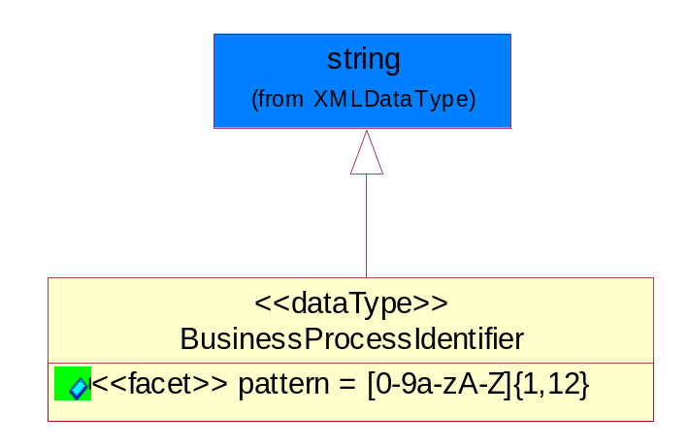
Figure ‎5-38 BusinessProcessIdentifier

Attribute | Type | Documentation
pattern |  | [0-9a-zA-Z]{1,12}

BusinessServiceInformation
The object allows the specification of the business service utilized within the partner company. This may or may not be the same as the information sent by the RNIF.
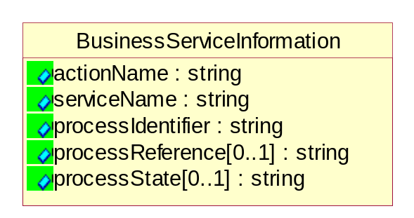
Figure ‎5-39 BusinessServiceInformation

Attribute | Type | Documentation
actionName | string | The name of Action. For RosettaNet usually any of Request/Confirm/Notify/Query/Response.
serviceName | string | The name of the Business Activity with the "Request/Confirm" part removed. E.g., for the Activity "Request Purchase Order"==> "Purchase Order".
processIdentifier | string | The name of the PIP e.g. Notify of Forecast Reply.
processReference[0..1] | string | The URN for the PIP that includes Cluster/Segment/Process pattern used to identify the interface process (such as PIP3A4)
processState[0..1] | string | The business process (or service) state of the sender of a document. When a service receives this document, the receiver may use the state as a precondition.

ContractInformation
A block of information used to correlate a contract in an executing choreography.

Figure ‎5-40 ContractInformation

Attribute | Type | Documentation
contractIdentifier[0..1] | string | Unique identification of a contract between the Sender and the Receiver
contractType[0..1] | string | The type of the contract: an attribute describing the type of the ContractIndentification. Valid values are URI, URN,ebXMLCPA, or other values defined by partners.

CorrelationInformation
A block of information used to correlate a requesting document to a responding document and to the contract in an executing choreography.
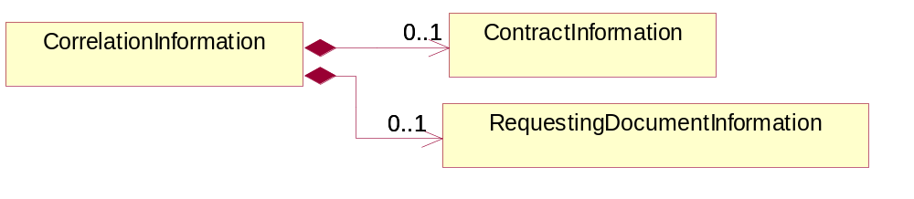
Figure ‎5-41 CorrelationInformation

Composition | Cardinality | Type | Documentation
ContractInformation | 0..1 | ContractInformation | A block of information used to correlate a contract in an executing choreography.
RequestingDocumentInformation | 0..1 | RequestingDocumentInformation | A block of information used to correlate a requesting document to a responding document in an executing choreography.

DocumentHeader
The object allows for the identification of the sender and receiver of the business document.
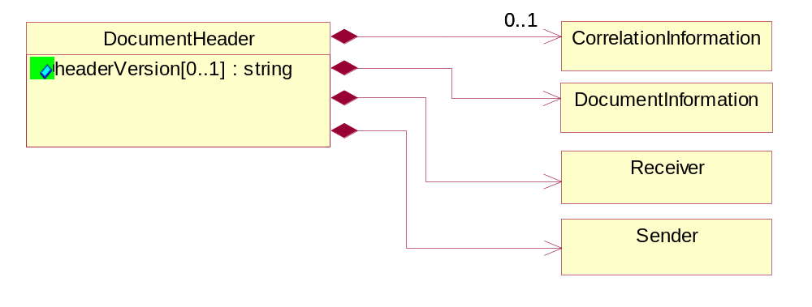
Figure ‎5-42 DocumentHeader

Attribute | Type | Documentation
headerVersion[0..1] | string | The UN/CEFACT version of the document header.

Composition | Cardinality | Type | Documentation
Sender | 1 | Sender | The object allows the identification of the initiating party of the business message.
CorrelationInformation | 0..1 | CorrelationInformation | A block of information used to correlate a requesting document to a responding document and to the contract in an executing choreography.
DocumentInformation | 1 | DocumentInformation | The object specifies information to identify the business document, a summary of attachments, and information about the business document security.
Receiver | 1 | Receiver | The object allows the identification of the receiving party of the business message.

DocumentIdentification
The object specifies all information necessary to identify the business document.
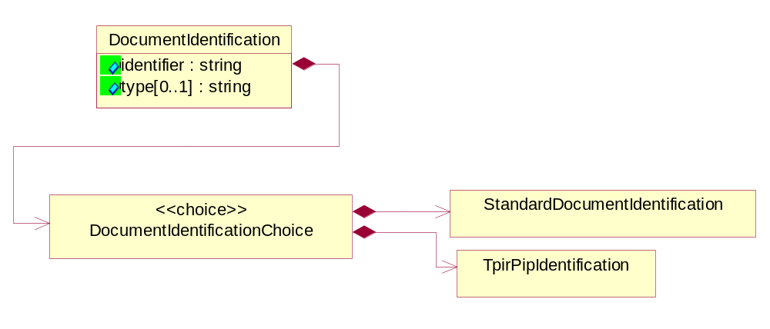
Figure ‎5-43 DocumentIdentification

Attribute | Type | Documentation
identifier | string | The unique identifier for the document being sent.
type[0..1] | string | Name of the Action Message

Composition | Cardinality | Type | Documentation
DocumentIdentificationChoice | 1 | DocumentIdentificationChoice

DocumentIdentificationChoice

Composition | Cardinality | Type | Documentation
StandardDocumentIdentification | 1 | StandardDocumentIdentification | The object specifies additional information necessary to identify the standard business document.
TpirPipIdentification | 1 | TpirPipIdentification | The object specifies all information necessary to uniquely identify a TPIR-PIP within a Registry or trading partner repository.

DocumentInformation
The object specifies information to identify the business document, a summary of attachments, and information about the business document security.
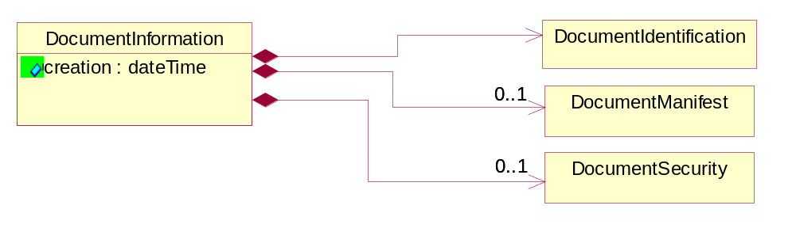
Figure ‎5-44 DocumentInformation

Attribute | Type | Documentation
creation | dateTime | The creation date and time of the specified Business Document (i.e. the Purchase Order date).

Composition | Cardinality | Type | Documentation
DocumentIdentification | 1 | DocumentIdentification | The object specifies all information necessary to identify the business document.
DocumentSecurity | 0..1 | DocumentSecurity | The object provides additional granularity in specifying business document security (this is in addition to the specified PIP security).
DocumentManifest | 0..1 | DocumentManifest | The block provides a brief summary of attachments and Service Content.

DocumentManifest
The block provides a brief summary of attachments and Service Content.
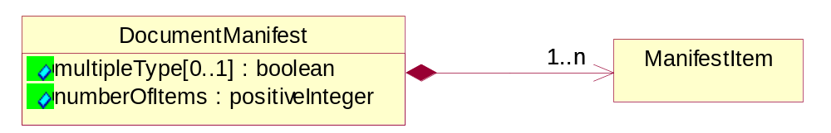
Figure ‎5-45 DocumentManifest

Attribute | Type | Documentation
multipleType[0..1] | boolean | Indicates whether the manifest contains documents of multiple types. True if yes, and False if no.
numberOfItems | positiveInteger | Total number of documents in the message. The physical count of the attachments in the payload plus the RosettaNet Business Message (for Service Content). The value of this field will be at least 1.

Composition | Cardinality | Type | Documentation
ManifestItem | 1..n | ManifestItem | The object provides details about the specific attachment(s).

DocumentSecurity
The object provides additional granularity in specifying business document security (this is in addition to the specified PIP security).

Figure ‎5-46 DocumentSecurity

Attribute | Type | Documentation
nonRepudiableReceipt | boolean | The value "true" will indicate that a signed acknowledgement for the business document is necessary.
persistentEncryption | boolean | The value "true" will indicate that the Business Document (including the header) needs to be encrypted when stored or transported.
persistentSignature | boolean | The value "true" will indicate that a signature is required to be stored with the document while stored or transported.

ManifestItem
The object provides details about the specific attachment(s).

Figure ‎5-47 ManifestItem

Attribute | Type | Documentation
description[0..1] | string | A description of the attachment.
length[0..1] | positiveInteger | The size of the attachment in bytes (i.e. 1 000 000 bytes)
universalResourceIdentifier | string | The generic set of all names/addresses that are short strings that refer to resources.

Composition | Cardinality | Type | Documentation
mimeTypeQualifier | 1 | MimeTypeQualifier | The MIME type as defined by IANA.  Please refer to http://www.iana.org/assignments/media-types/ for a list of types.
language | 0..1 | Language | For representation of Language name RosettaNet has adopted ISO 639-2; 1998. Refer to the following web page to get the latest version of the standard:  http://www.loc.gov/standards/iso639-2/iso639jac.html  If you need more information about the ISO standard please contact ISO for more details.

PipIdentifier
PIP Identification.[ i.e. PIP3A4]
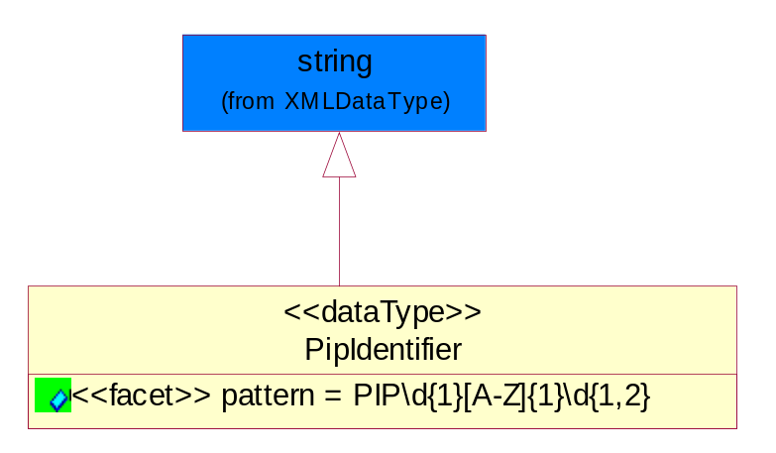
Figure ‎5-48 PipIdentifier

Attribute | Type | Documentation
pattern |  | PIP\d{1}[A-Z]{1}\d{1,2}

PipVersion
PIP version number (i.e. 02.02.00).
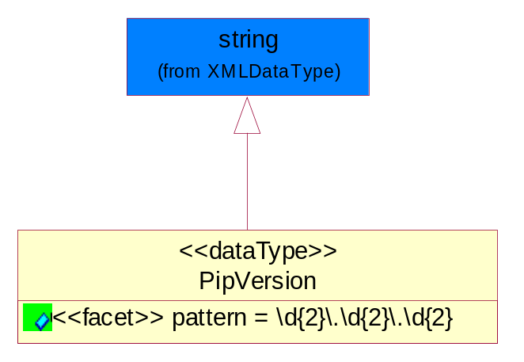
Figure ‎5-49 PipVersion

Attribute | Type | Documentation
pattern |  | \d{2}\.\d{2}\.\d{2}

Receiver
The object allows the identification of the receiving party of the business message.
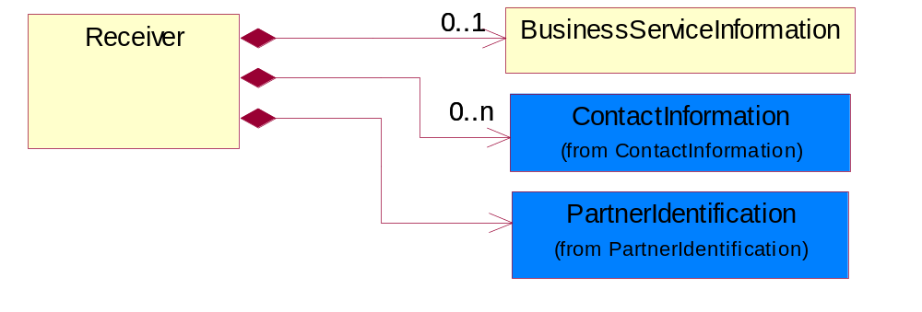
Figure ‎5-50 Receiver

Composition | Cardinality | Type | Documentation
BusinessServiceInformation | 0..1 | BusinessServiceInformation | The object allows the specification of the business service utilized within the partner company. This may or may not be the same as the information sent by the RNIF.
PartnerIdentification | 1 | PartnerIdentification | The business document must allow for the identity of one or more parties to the transaction.
ContactInformation | 0..n | ContactInformation | The business document must allow for the identification of the name of the department, service or individual to be contacted regarding the context of the business document.

RequestingDocumentInformation
A block of information used to correlate a requesting document to a responding document in an executing choreography.

Figure ‎5-51 RequestingDocumentInformation

Attribute | Type | Documentation
businessProcessInstanceIdentifier[0..1] | string | The identifier for the public business process instance being sent that both the sender and receiver can identify.
responseDateTime[0..1] | dateTime | The expected time to receive the response. This can not be greater than the PIP TimeToPerform.
requestingDocumentCreationDateTime[0..1] | dateTime | The date-time of the requesting business document.
requestingDocumentInstanceIdentifier | string | The Business Document identification number that identifies the requesting Business Document.

Sender
The object allows the identification of the initiating party of the business message.
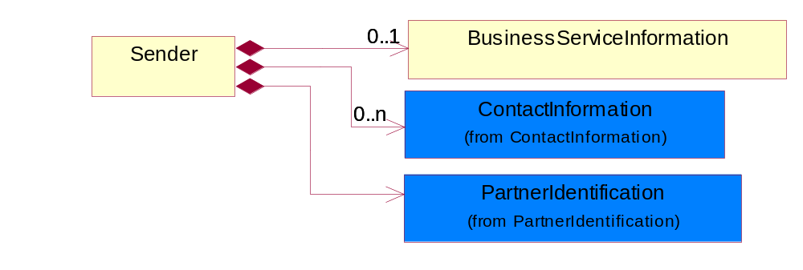
Figure ‎5-52 Sender

Composition | Cardinality | Type | Documentation
PartnerIdentification | 1 | PartnerIdentification | The business document must allow for the identity of one or more parties to the transaction.
BusinessServiceInformation | 0..1 | BusinessServiceInformation | The object allows the specification of the business service utilized within the partner company. This may or may not be the same as the information sent by the RNIF.
ContactInformation | 0..n | ContactInformation | The business document must allow for the identification of the name of the department, service or individual to be contacted regarding the context of the business document.

StandardDocumentIdentification
The object specifies additional information necessary to identify the standard business document.
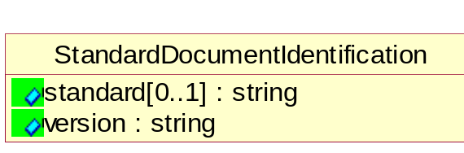
Figure ‎5-53 StandardDocumentIdentification

Attribute | Type | Documentation
standard[0..1] | string | Identifies the standard used to submit the business document. (e.g. RosettaNet).
version | string | PIP3A4v01.00

TpirPipIdentification
The object specifies all information necessary to uniquely identify a TPIR-PIP within a Registry or trading partner repository.

Figure ‎5-54 TpirPipIdentification

Attribute | Type | Documentation
partnerId | DUNSPlus4 | The Trading Partner Identification of MNC that is creating this TPIR PIP.
pipIdentifier | PipIdentifier | A TPIR PIP Identification [i.e., 3A4 ).
pipVersion | PipVersion | A TPIR PIP version number (i.e., 02.02.00)
tpirPipVersion | VersionIdentifier | A TPIR-PIP Version Number (i.e., major and minor version number as XX.XX).
tpirBusinessProcessIdentifier[0..1] | BusinessProcessIdentifier | A Business Process Identifier to uniquely define the TPIR-PIP 'role' within a Business Scenario at a company or MNC level. The identifier MUST be composed of alphanumeric characters only and its length MUST be between one and twelve characters.
uri[0..1] | anyURI | Describes the destination uri for the TPIR form.

Composition | Cardinality | Type | Documentation
fileType | 0..1 | TPIRFileType | Describes the file type of the TPIR form (PDF, XDP or XML).

VersionIdentifier
Version Number (i.e., major and minor version number as XX.XX).
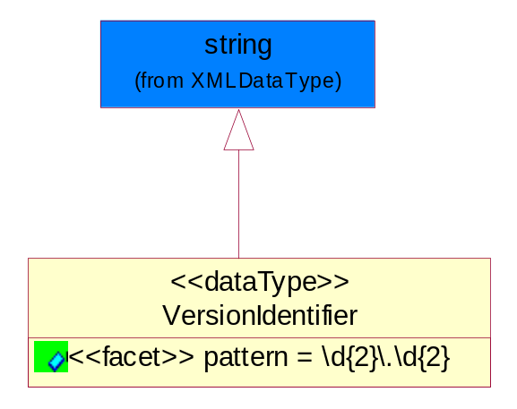
Figure ‎5-55 VersionIdentifier

Attribute | Type | Documentation
pattern |  | \d{2}\.\d{2}

CodeList

TPIRFileType
A code identifying the file type of TPIR form.

Name | Documentation
PDF | Portable Document Format.
XDP | XML Data Package.
XML | eXtensible Markup Language.

XML Data Type

anyURI
Represents a URI as defined by RFC 2396. An anyURI value can be absolute or relative, and may have an optional fragment identifier.

boolean
Represents Boolean values, which are either "true" or "false".

date
For the represents a calendar date.
The pattern for a date is CCYY-MM-DD where CC represents the century, YY the year, MM the month, and DD the day, with an optional time zone indicator as allowed for dateTime.

dateTime
Represents a specific instance of time.
The pattern for dateTime is CCYY-MM-DDThh:mm:ss where CC represents the century, YY the year, MM the month, and DD the day, preceded by an optional leading negative (-) character to indicate a negative number. If the negative character is omitted, positive (+) is assumed. The T is the date/time separator and hh, mm, and ss represent hour, minute, and second respectively. Additional digits can be used to increase the precision of fractional seconds if desired. For example, the format ss.ss... with any number of digits after the decimal point is supported. The fractional seconds part is optional.

This representation may be immediately followed by a "Z" to indicate Coordinated Universal Time (UTC) or to indicate the time zone. For example, the difference between the local time and Coordinated Universal Time, immediately followed by a sign, + or -, followed by the difference from UTC represented as hh:mm (minutes is required). If the time zone is included, both hours and minutes must be present.

float
Represents single-precision 32-bit floating-point numbers.

positiveInteger
Represents an integer that is greater than zero. This data type is derived from nonNegativeInteger.

string
Represents character string.

