

Description of
Partner Interface Process® for 5D10

Validated 11.00.00

Specification Information
Name | Notify of Ship From Stock And Debit Claim Confirmation
Cluster | Marketing Information Management
Segment | Ship from Stock and Debit (EC)
Publication Date | 9 March 2010
Version Identifier | V11.00

Table of Contents
1 Document Management 4
1.1 Legal Disclaimer 4
1.2 Copyright 4
1.3 Trademarks 4
1.4 Acknowledgments 4
1.5 Related Documents 4
1.6 Document Version History 4
1.7 Document Structure 5
2 Business Process 6
2.1 Business Process Definition 6
2.2 PIP Scope Description 6
2.3 PIP Business Document 7
2.4 PIP Business Process Flow Diagram 7
2.5 PIP Start State 8
2.6 PIP End States 8
2.7 Partner Role Description 9
2.8 Business Process Activity Controls 9
3 Network and Implementation Specification 10
3.1 Business Action and Business Signal Specifications 10
3.2 Business Transaction Dialog Specification 10
3.2.1 Message Exchange Controls 11
3.2.2 Communications Specification 11

List of Figures:
Figure 1: Activity Diagram 7
Figure 2: Sequence Diagram 10

List of Tables:
Table 1: PIP Business Document 7
Table 2: PIP Start State 8
Table 3: PIP End State 8
Table 4: PIP Failure State 8
Table 5: Partner Role Description 9
Table 6: Business Activity Description 9
Table 7: Business Activity Performance Control 9
Table 8: Network Component Specification 10
Table 9: Business Action – Business Document Mapping 10
Table 10: Message Exchange Control 11
Table 11: Dialog: Service-Service 11

Document Management

Legal Disclaimer
RosettaNet™, its members, officers, directors, employees, or agents shall not be liable for any injury, loss, damages, financial or otherwise, arising from, related to, or caused by the use of this document or the specifications herein, as well as associated guidelines and schemas. The use of said specifications shall constitute your express consent to the foregoing exculpation.

Copyright
©2010 RosettaNet. All rights reserved. No part of this publication may be reproduced, stored in a retrieval system, or transmitted, in any form or by any means, electronic, mechanical, photocopying, recording, or otherwise, without the prior written permission of the publisher. Printed in the United States of America.

Trademarks
RosettaNet, Partner Interface Process, PIP and the RosettaNet logo are trademarks or registered trademarks of "RosettaNet," a non-profit organization. All other product names and company logos mentioned herein are the trademarks of their respective owners. In the best effort, all terms mentioned in this document that are known to be trademarks or registered trademarks have been appropriately recognized in the first occurrence of the term.

Acknowledgments
This document has been prepared by RosettaNet (http://www.rosettanet.org/) from requirements gathered during the Milestone Program and in conformance with the methodology.

Related Documents
- Associated PIP Message Schemas (included within the PIP Specification package only)
- Description of 5D10 Message
- Messages Structure
- XML instance of ebXML BPSS for PIP 5D10

Document Version History
Version | Date | Description
Validated 11.00.00 | 9 March 2010 | Validated Version: MCC Program

Document Structure
A Partner Interface Process (PIP) Specification is comprised of the following two parts:
- Business Process. Captures the semantics of the business process and the flow of the message exchange between roles as they perform business activities.
- Network and Implementation Specification. Specifies the network protocol message formats and communications requirements between peer-protocols supported by network components in the RosettaNet Implementation Framework.

Business Process

Business Process Definition
The "Notify of Ship From Stock And Debit Claim Confirmation" Partner Interface Process™ (PIP) allows a Product Supplier to response to a claim request, in accordance with a Ship from Stock and Debit Authorization program.
This program is a pricing agreement between a Product Supplier and a Product Distributor that enables the Product Distributor to sell products to a customer at an acceptable profit margin. These pricing arrangements, used in the EC and IT supply chain, allow a Product Distributor to claim credits on products sold to customers.
To use this PIP, a Ship from Stock and Debit Authorization must be in place. Either PIP5D1, "Request Ship from Stock and Debit Authorization," PIP5D2, "Notify of Blanket Ship from Stock and Debit Authorization," or some other acceptable method may be used to initiate a Ship from Stock and Debit Authorization.
The Product Supplier must respond to the initial 5D5 Claim Request. Items that are placed in “Pending” status require additional attention and processing by the Product Supplier prior to providing a final resolution. PIP5D6, "Notify of Ship from Stock and Debit Claim Response," is used to provide this final resolution. It is recommended that trading partners execute PIP5D6 within 48 hours of when the claim item was placed in a “Pending” status in the Ship from Stock and Debit Claim Response.

PIP Scope Description
This PIP is used to provide a claim response. The claim is either accepted, rejected or placed in “Pending” status. A disposition is generated for each line item. If accepted, the Product Supplier's financial system generates a credit to the Product Distributor. Rejected lines are reported with multiple reason codes, allowing the Product Distributor to close out the item or to fix the problem and resubmit the claim.
This PIP is executed when the product fulfillment status is known and the customer has been billed.

PIP Business Document
Business Document are generated and exchanged by roles performing activities in this PIP. Business Document is listed and defined in Table 1.
Table 1: PIP Business Document
Business Document | Description
Ship From Stock And Debit Claim Confirmation Notification | Replies to a claim submission. A confirmation for each claim line is provided. Each claim line can be approved, pended, or rejected. If the claim is accepted, a Credit Reference Identifier is provided, which can contain a credit memo number. If the line is rejected, multiple reason codes can be provided.

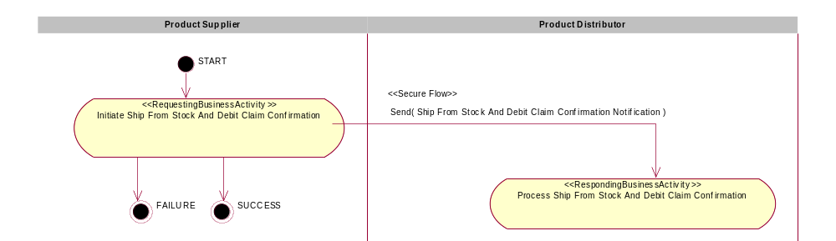
Figure 1: Activity Diagram

PIP Start State
The start state is comprised of the following conditions:
Table 2: PIP Start State
 | Approved | Exist |  | Valid | Non-Repudiated | Retry Count | Authorized
 | Approved | Party | In Backend System
TPA |   |  |  
Sending Partner |  |   |  |  
Receiving Partner |  |  
Business Document |  |  |   |   |   |  |  

PIP End States
The end state is comprised of the following conditions:
Table 3: PIP End State
 | Approved | Exist |  | Valid | Non-Repudiated | Retry Count | Authorized
 | Approved | Party | In Backend system
Acknowledgment of Receipt |  |  |  |  |  
Receiving Partner |  |  |  |  |  |  | 

The PIP failure state is comprised of one or more of the following conditions
Table 4: PIP Failure State
 | NO | Exceeded
Success | 
Retry Count |  | 

Partner Role Description
Table 5 describes the partner roles in this PIP:
Table 5: Partner Role Description
Role Name | Role Description
Product Supplier | This partner role supplies product to customers in the supply chain.
Product Distributor | The party authorized by a Product Supplier to purchase goods and services from the Product Supplier and resell to customers.

Business Process Activity Controls
Table 6 describes the interaction between roles performing business activity in this PIP.
Table 6: Business Activity Description
Role Name |  | Activity Name |  | Activity Description
Product Supplier | Notify of Ship From Stock And Debit Claim Confirmation |  | The Product Supplier process Ship from Stock and Debit Claim Confirmation.

Table 7 details the security, audit and process controls relating to activity performed in the PIP.
Table 7: Business Activity Performance Control
Role  Name | Activity  Name | Acknowledgment of Receipt Non-Repudiation Required? | Acknowledgment of Receipt Time to Acknowledge | Time to Perform | Retry Count | Is Authorization Required? | Non-Repudiation of Origin and Content?
Product Supplier | Notify of Ship From Stock And Debit Claim Confirmation | Y | 2 hrs | 2 hrs | 3 | Y | Y

Network and Implementation Specification
Each network component maps into a role of the PIP model. Table 8 specifies the mapping between roles and network components.
Table 8: Network Component Specification
Network Component | Classification | Maps to Role in Business Process
Product Distributor Service | Business Service | Product Distributor
Product Supplier Service | Business Service | Product Supplier

Business Action and Business Signal Specifications
Each business action maps to a Business Document of the PIP model. Table 9 specifies the mapping between Business Documents and business actions.
Table 9: Business Action – Business Document Mapping
Business Action | Business Document | Document Function
Ship From Stock And Debit Claim Confirmation Notification Action | Ship From Stock And Debit Claim Confirmation Notification | Response

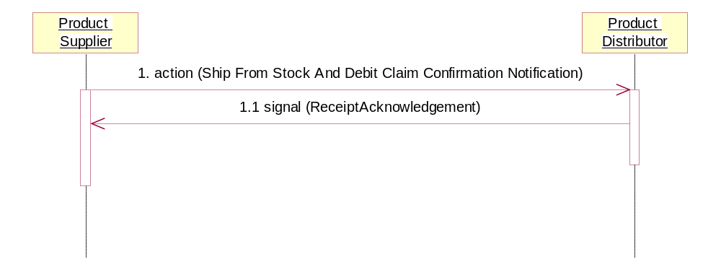

Figure 2: Sequence Diagram

Message Exchange Controls
Table 10: Message Exchange Control
# | Name |  | Time to Acknowledge Receipt Signal |  | Time to Respond to Action |  | Included in Time to Perform | Is Authorization Required? | Is Non-Repudiation Required? | Is Secure Transport Required?
2. |  | Ship From Stock And Debit Claim Confirmation Notification Action |  | 2 hrs |  | 2 hrs | Y | Y | Y | Y
2.2 |  | Receipt Acknowledgment |  | N/A |  | N/A | N | Y | Y | Y

Communications Specification
Table 11: Dialog: Service-Service
# | Business Message | Digital Signature Required? | SSL Required?
1. | Ship From Stock And Debit Claim Confirmation Notification | Y | Y
1.1 | Receipt Acknowledgment | Y | Y

