

Description of
Partner Interface Process® for 5D1

Validated 11.00.00

Specification Information
Name | Request Ship From Stock And Debit Authorization
Cluster | Marketing Information Management
Segment | Ship from Stock and Debit (EC)
Publication Date | 04 July 2008
Version Identifier | V11.00

Table of Contents
1 Document Management 4
1.1 Legal Disclaimer 4
1.2 Copyright 4
1.3 Trademarks 4
1.4 Related Documents 4
1.5 Document Version History 4
1.6 Document Structure 4
2 Business Process 5
2.1 Business Process Definition 5
2.1.1 Executive Summary 5
2.1.2 Business Process Description 5
2.2 PIP Scope Description 6
2.2.1 Business Process Scope Diagram 6
2.3 PIP Business Document 7
2.4 PIP Business Process Flow Diagram 7
2.5 PIP Start State 8
2.6 PIP End States 9
2.7 Partner Role Description 10
2.8 Business Process Activity Controls 10
3 Network and Implementation Specification 11
3.1 Business Action and Business Signal Specifications 11
3.2 Business Transaction Dialog Specification 12
3.2.1 Message Exchange Controls 12
3.2.2 Communications Specification 13

List of Figures:
Figure 1: Business Process Scope Diagram 6
Figure 2: Activity Diagram for Request Ship From Stock And Debit Authorization 7
Figure 3: Sequence Diagram for Request Ship From Stock And Debit Authorization 12

List of Tables:
Table 1: PIP Business Document 7
Table 2: PIP Start State 8
Table 3: PIP End State 9
Table 4: PIP Failure State 9
Table 5: Partner Role Description 10
Table 6: Business Activity Description 10
Table 7: Business Activity Performance Control 10
Table 8: Network Component Specification 11
Table 9: Business Action – Business Document Mapping 11
Table 10: Message Exchange Control 12
Table 11: Dialog: Service-Service 13

Document Management

Legal Disclaimer
RosettaNet™, its members, officers, directors, employees, or agents shall not be liable for any injury, loss, damages, financial or otherwise, arising from, related to, or caused by the use of this document or the specifications herein, as well as associated guidelines and schemas. The use of said specifications shall constitute your express consent to the foregoing exculpation.

Copyright
©2008 RosettaNet. All rights reserved. No part of this publication may be reproduced, stored in a retrieval system, or transmitted, in any form or by any means, electronic, mechanical, photocopying, recording, or otherwise, without the prior written permission of the publisher. Printed in the United States of America.

Trademarks
RosettaNet, Partner Interface Process, PIP and the RosettaNet logo are trademarks or registered trademarks of "RosettaNet," a non-profit organization. All other product names and company logos mentioned herein are the trademarks of their respective owners. In the best effort, all terms mentioned in this document that are known to be trademarks or registered trademarks have been appropriately recognized in the first occurrence of the term.

Related Documents
- Associated PIP Message Schemas (included within the PIP Specification package only)
- Description of 5D1 Message
- Messages Structure
- XML instance of ebXML BPSS for PIP 5D1

Document Version History
Version | Date | Description
Validated 11.00.00 | 04 July 2008 | Validated Version : RosettaNet Schema to Market to Validation 2008

Document Structure
A Partner Interface Process (PIP) Specification is comprised of the following two parts:
- Business Process. Captures the semantics of the business process and the flow of the message exchange between roles as they perform business activities.
- Network and Implementation Specification. Specifies the network protocol message formats and communications requirements between peer-protocols supported by network components in the RosettaNet Implementation Framework.

Business Process

Business Process Definition
The "Request Ship from Stock and Debit Authorization" Partner Interface Process™ (PIP) supports the process used by (1) a distributor to inform a supplier that a customer has been offered a deal involving stock for which the supplier has quoted a new buy price, and (2) for the supplier to authorize the distributor to ship the stock and claim reimbursement. Typically, the process enables a distributor to meet a competitor's price and yet make a profitable sale. The supplier may either authorize the request by providing a debit authorization number or reject the request by providing a rejection reason. A rejection reason must be provided if the authorization request is not accepted.
Prior to requesting a ship from stock and debit authorization, the distributor may use PIP3A1, "Request Quote," to obtain a quote for new buy prices. The ship from stock and debit authorization request may optionally include the quote number, distributor’s branch information and details on the end customer (ship to, sold to and/or used by). If a quote line item does not match the associated ship from stock and debit request line item (i.e., different quantity), the quote must be updated to accurately reflect the authorization request.
If the ship from stock and debit authorization request is authorized, the distributor may use PIP5D5, "Create Ship from Stock and Debit Claim" to submit a claim to the supplier for reimbursement of the difference in cost between the original price and the new price.

Executive Summary
Lets product distributors submit ship from stock and debit authorization requests to product suppliers, and lets product suppliers send debit authorization numbers to product distributors via ship and debit authorization responses

Business Process Description
1. The "Request Ship from Stock and Debit Authorization" Partner Interface Process™ (PIP®) supports the process used by (1) a distributor to inform a supplier that a customer has been offered a deal involving stock for which the supplier has quoted a new buy price, and (2) for the supplier to authorize the distributor to ship the stock and claim reimbursement. Typically, the process enables a distributor to meet a competitor's price and yet make a profitable sale. The supplier may either authorize the request by providing a debit authorization number or reject the request by providing a rejection reason. A rejection reason must be provided if the authorization request is not accepted.
2. Prior to requesting a ship from stock and debit authorization, the distributor may use PIP3A1, "Request Quote," to obtain a quote for new buy prices. The ship from stock and debit authorization request may optionally include the quote number, distributor’s branch information and details on the end customer (ship to, sold to and/or used by). If a quote line item does not match the associated ship from stock and debit request line item (i.e., different quantity), the quote must be updated to accurately reflect the authorization request.
If the ship from stock and debit authorization request is authorized, the distributor may use PIP5D5, "Create Ship from Stock and Debit Claim" to submit a claim to the supplier for reimbursement of the difference in cost between the original price and the new price.

PIP Scope Description
This PIP enables (1) a distributor to request authorization to sell stock at a new buy price and claim reimbursement for the difference between the original price and the new price, and (2) a supplier to respond to the request.

Business Process Scope Diagram
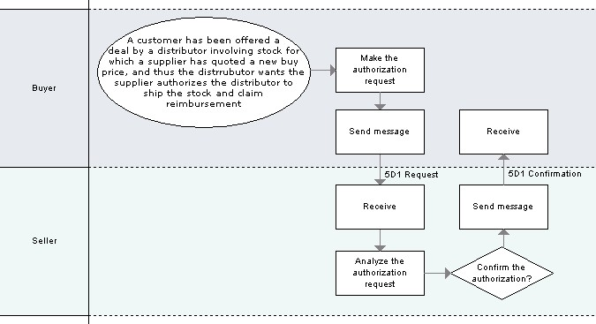

Figure 1: Business Process Scope Diagram

PIP Business Document
Business Document are generated and exchanged by roles performing activities in this PIP. Business Document is listed and defined in Table 1.
Table 1: PIP Business Document
Business Document | Description
Ship From Stock And Debit Authorization Request | References an existing quote and specific line items. This is the only information needed to make the authorization request, as customer or project details are expected to be documented in the actual quote.
Ship From Stock And Debit Authorization Confirmation | Returns an authorization status and details from applicable line items per the quote number provided in the authorization request.

PIP Business Process Flow Diagram
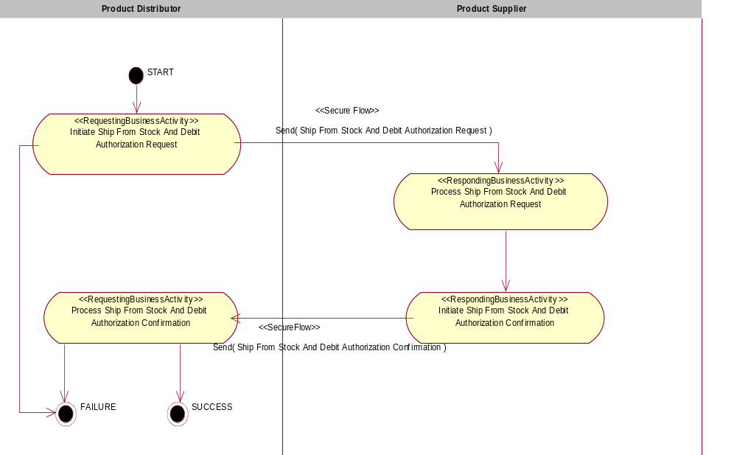
Figure 2: Activity Diagram for Request Ship From Stock And Debit Authorization

PIP Start State
The start state is comprised of the following conditions:
Table 2: PIP Start State
 | Approved | Exist |  | Valid | Non-Repudiated | Retry Count | Authorized
 | Approved | Party | In Backend System
TPA |  |  | 
Sending Partner |  |  |  | 
Receiving Partner |  | 
Business Document |  |  |  |  |  |  |  

PIP End States
The end state is comprised of the following conditions:
Table 3: PIP End State
 | Approved | Exist |  | Valid | Non-Repudiated | Retry Count | Authorized
 | Approved | Party | In Backend system
Acknowledgment of Receipt |  |  |   |   | 
Receiving Partner |  |  |  |  |  |  | 

The PIP failure state is comprised of one or more of the following conditions
Table 4: PIP Failure State
 | NO | Exceeded
Success | 
Retry Count |  |  

Partner Role Description
Table 5 describes the partner roles in this PIP:
Table 5: Partner Role Description
Role Name | Role Description
Product Distributor | The party authorized by a Product Supplier to purchase goods and services from the Product Supplier and resell to customers.
Product Supplier | This partner role supplies product to customers in the supply chain.

Business Process Activity Controls
Table 6 describes the interaction between roles performing business activity in this PIP.
Table 6: Business Activity Description
Role Name |  | Activity Name |  | Activity Description
Product Distributor | Initiate Ship From Stock And Debit Authorization Request |  | This activity allows a Product Distributor to request a Ship from Stock and Debit Authorization for a quote already provided.
Product Supplier | Initiate Ship From Stock And Debit Authorization Confirmation |  | This activity allows a Product Supplier to confirm a Ship from Stock and Debit Authorization request.

Table 7 details the security, audit and process controls relating to activity performed in the PIP.
Table 7: Business Activity Performance Control
Role  Name | Activity  Name | Acknowledgment  of Receipt |  | Time to Perform | Retry Count | Is Authorization Required? | Non-Repudiation of Origin and Content?
Role  Name | Activity  Name | Non-Repudiation Required? | Time to Acknowledge
Product Distributor | Initiate Ship From Stock And Debit Authorization Request | Y | 2 hrs | 24 hrs | 3 | Y | Y
Product Supplier | Initiate Ship From Stock And Debit Authorization Confirmation | Y | 2 hrs | 24 hrs | 3 | Y | Y

Network and Implementation Specification
Each network component maps into a role of the PIP model. Table 8 specifies the mapping between roles and network components.
Table 8: Network Component Specification
Network Component | Classification | Maps to Role in Business Process
Product Distributor Service | Business Service | Product Distributor
Product Supplier Service | Business Service | Product Supplier

Each business action maps to a Business Document of the PIP model. Table 9 specifies the mapping between Business Documents and business actions.
Table 9: Business Action – Business Document Mapping
Business Action | Business Document | Document Function
Ship From Stock And Debit Authorization Request Action | Ship From Stock And Debit Authorization Request | Request
Ship From Stock And Debit Authorization Confirmation Action | Ship From Stock And Debit Authorization Confirmation | Response

Business Transaction Dialog Specification
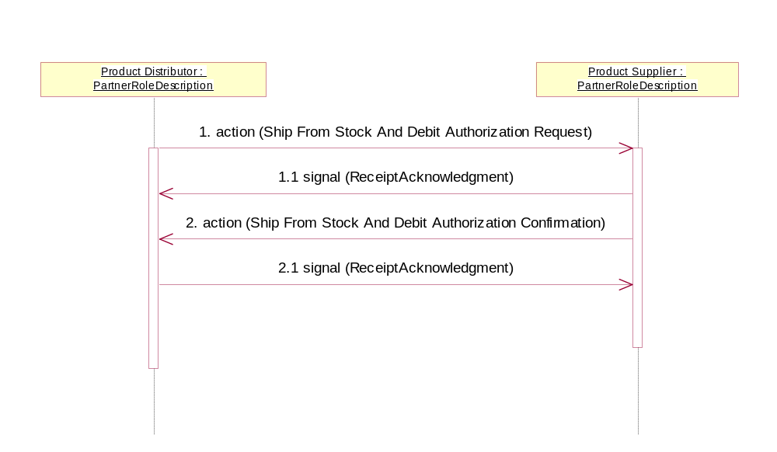

Figure 3: Sequence Diagram for Request Ship From Stock And Debit Authorization

Message Exchange Controls
Table 10: Message Exchange Control
# | Name |  | Time to Acknowledge Receipt Signal |  | Time to Respond to Action |  | Included in Time to Perform | Is Authorization Required? | Is Non-Repudiation Required? | Is Secure Transport Required?
1. |  | Ship From Stock And Debit Authorization Request Action |  | 2 hrs |  | 24 hrs | Y | Y | Y | Y
1.1 |  | Receipt Acknowledgment |  | N/A |  | N/A | Y | Y | Y | Y
2. |  | Ship From Stock And Debit Authorization Confirmation Action |  | 2 hrs |  | N/A | Y | Y | Y | Y
2.1 |  | Receipt Acknowledgment |  | N/A |  | N/A | N/A | Y | Y | Y

Communications Specification
Table 11: Dialog: Service-Service
# | Business Message | Digital Signature Required? | SSL Required?
1. | Ship From Stock And Debit Authorization Request | Y | Y
2. | Ship From Stock And Debit Authorization Confirmation | Y | Y

