

Description of
Partner Interface Process® for 5D3

Validated 11.00.00

Specification Information
Name | Distribute Open Ship From Stock And Debit Authorization Status
Cluster | Marketing Information Management
Segment | Ship from Stock and Debit (EC)
Publication Date | 09 July 2008
Version Identifier | V11.00

Table of Contents
1 Document Management 4
1.1 Legal Disclaimer 4
1.2 Copyright 4
1.3 Trademarks 4
1.4 Acknowledgments 4
1.5 Related Documents 4
1.6 Document Version History 4
1.7 Document Structure 5
2 Business Process 6
2.1 Business Process Definition 6
2.1.1 Business Process Context Diagram 7
2.2 PIP Scope Description 8
2.3 PIP Business Document 8
2.4 PIP Business Process Flow Diagram 8
2.5 PIP Start State 9
2.6 PIP End States 9
2.7 Partner Role Description 10
2.8 Business Process Activity Controls 10
3 Network and Implementation Specification 11
3.1 Business Action and Business Signal Specifications 11
3.2 Business Transaction Dialog Specification 11
3.2.1 Message Exchange Controls 12
3.2.2 Communications Specification 12

List of Figures:
Figure 1: High-level Context Diagram 7
Figure 2: Activity Diagram of Distribute Open Ship From Stock And Debit Authorization Status 8
Figure 3: Sequence Diagram of Distribute Open Ship From Stock And Debit Authorization Status 11

List of Tables:
Table 1: PIP Business Document 8
Table 2: PIP Start State 9
Table 3: PIP End State 9
Table 4: PIP Failure State 9
Table 5: Partner Role Description 10
Table 6: Business Activity Description 10
Table 7: Business Activity Performance Control 10
Table 8: Network Component Specification 11
Table 9: Business Action – Business Document Mapping 11
Table 10: Message Exchange Control 12
Table 11: Dialog: Service-Service 12

Document Management

Legal Disclaimer
RosettaNet™, its members, officers, directors, employees, or agents shall not be liable for any injury, loss, damages, financial or otherwise, arising from, related to, or caused by the use of this document or the specifications herein, as well as associated guidelines and schemas. The use of said specifications shall constitute your express consent to the foregoing exculpation.

Copyright
©2008 RosettaNet. All rights reserved. No part of this publication may be reproduced, stored in a retrieval system, or transmitted, in any form or by any means, electronic, mechanical, photocopying, recording, or otherwise, without the prior written permission of the publisher. Printed in the United States of America.

Trademarks
RosettaNet, Partner Interface Process, PIP and the RosettaNet logo are trademarks or registered trademarks of "RosettaNet," a non-profit organization. All other product names and company logos mentioned herein are the trademarks of their respective owners. In the best effort, all terms mentioned in this document that are known to be trademarks or registered trademarks have been appropriately recognized in the first occurrence of the term.

Acknowledgments
This document has been prepared by RosettaNet (http://www.rosettanet.org/) from requirements gathered during the Milestone Program and in conformance with the methodology. Listed below are the legal entities that contributed to the design and development of this PIP.
Arrow Electronics, Inc. | TTI, Inc.
NEC Electronics Inc.

Related Documents
- Associated PIP Message Schemas (included within the PIP Specification package only)
- Description of 5D3 Message
- Messages Structure
- XML instance of ebXML BPSS for PIP 5D3

Document Version History
Version | Date | Description
Validated 11.00.00 | 09 July 2008 | Validated Version : RosettaNet Schema to Market to Validation 2008

Document Structure
A Partner Interface Process (PIP) Specification is comprised of the following two parts:
- Business Process. Captures the semantics of the business process and the flow of the message exchange between roles as they perform business activities.
- Network and Implementation Specification. Specifies the network protocol message formats and communications requirements between peer-protocols supported by network components in the RosettaNet Implementation Framework.

Business Process

Business Process Definition
The "Distribute Open Ship from Stock and Debit Authorization Status" Partner Interface Process™ (PIP) enables a Product Supplier to send a Product Distributor a detailed report (list) of existing Open Ship from Stock and Debit Authorizations. It includes such details as the remaining authorized quantity and critical dates for specific customers. It can include Ship from Stock and Debit Authorizations initiated by the distributor, the supplier, or both. The Product Supplier distributes the status information based on a frequency determined between partners (i.e., daily, weekly, or monthly). The Product Supplier will only provide information for internally approved and “Open” (neither expired or cancelled) authorizations in the notification.
To use this PIP, a Ship from Stock and Debit Authorization must be in place. Either PIP5D1, "Request Ship from Stock and Debit Authorization", PIP5D2, "Notify of Blanket Ship from Stock and Debit Authorization", or other agreed method may be used to initiate a Ship from Stock and Debit Authorization.
This program is a pricing agreement between a Product Supplier and a Product Distributor that enables the Product Distributor to sell products to a customer at an acceptable profit margin. These pricing arrangements, currently used in the Electronic Components (EC) and Information Technology (IT) supply chains, allow a Product Distributor to claim credits on product sold to customers.

Business Process Context Diagram
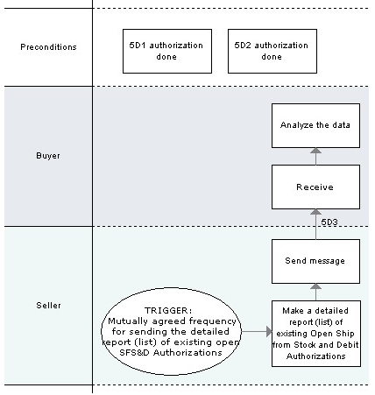
Figure 1: High-level Context Diagram

PIP Scope Description
This PIP allows a Product Supplier to distribute to a Product Distributor a list of Open Ship from Stock and Debit Authorizations.

PIP Business Document
Business Document are generated and exchanged by roles performing activities in this PIP. Business Document is listed and defined in Table 1.
Table 1: PIP Business Document
Business Document | Description
Open Ship From Stock And Debit Authorization Status Distribution | This is a master-status Notification of an existing Ship from Stock and Debit Authorization that contains: single or multiple distributor branch(es), single or multiple end customers, all related debit authorization numbers, rejection reasons, part and pricing information, quoted quantity, remaining quantity, critical dates and authorization status code.

PIP Business Process Flow Diagram
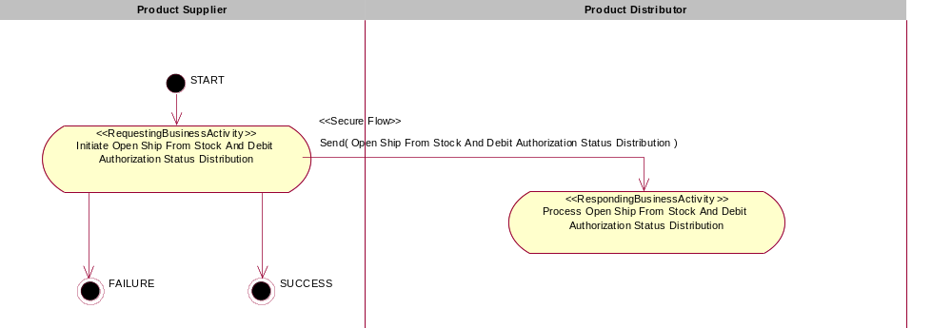

Figure 2: Activity Diagram of Distribute Open Ship From Stock And Debit Authorization Status

PIP Start State
The start state is comprised of the following conditions:
Table 2: PIP Start State
 | Approved | Exist |  | Valid | Non-Repudiated | Retry Count | Authorized
 | Approved | Party | In Backend System
TPA |  |  | 
Sending Partner |  |  |  | 
Receiving Partner |  | 
Business Document |  |  |  | 

PIP End States
The end state is comprised of the following conditions:
Table 3: PIP End State
 | Approved | Exist |  | Valid | Non-Repudiated | Retry Count | Authorized
 | Approved | Party | In Backend system
Acknowledgment of Receipt |  |  |  | 
Receiving Partner |  |  |  |  |  |  | 

The PIP failure state is comprised of one or more of the following conditions
Table 4: PIP Failure State
 | NO | Exceeded
Success | 
Retry Count |  | 

Partner Role Description
Table 5 describes the partner roles in this PIP:
Table 5: Partner Role Description
Role Name | Role Description
Product Supplier | This partner role supplies product to customers in the supply chain.
Product Distributor | The party authorized by a Product Supplier to purchase goods and services from the Product Supplier and resell to customers.

Business Process Activity Controls
Table 6 describes the interaction between roles performing business activity in this PIP.
Table 6: Business Activity Description
Role Name |  | Activity Name |  | Activity Description
Product Supplier | Initiate Open Ship From Stock And Debit Authorization Status Distribution |  | Activity distributes the status of a Ship From Stock And Debit Authorization from a Product Supplier.

Table 7 details the security, audit and process controls relating to activity performed in the PIP.
Table 7: Business Activity Performance Control
Role  Name | Activity  Name | Acknowledgment  of Receipt |  | Time to Perform | Retry Count | Is Authorization Required? | Non-Repudiation of Origin and Content?
Role  Name | Activity  Name | Non-Repudiation Required? | Time to Acknowledge
Product Supplier | Initiate Open Ship From Stock And Debit Authorization Status Distribution | N | 2hrs | N/A | 3 | N | N

Network and Implementation Specification
Each network component maps into a role of the PIP model. Table 8 specifies the mapping between roles and network components.
Table 8: Network Component Specification
Network Component | Classification | Maps to Role in Business Process
Product Supplier Service | Business Service | Product Supplier
Product Distributor Service | Business Service | Product Distributor

Each business action maps to a Business Document of the PIP model. Table 9 specifies the mapping between Business Documents and business actions.
Table 9: Business Action – Business Document Mapping
Business Action | Business Document | Document Function
Open Ship From Stock And Debit Authorization Status Distribution Action | Open Ship From Stock And Debit Authorization Status Distribution | Request

Business Transaction Dialog Specification
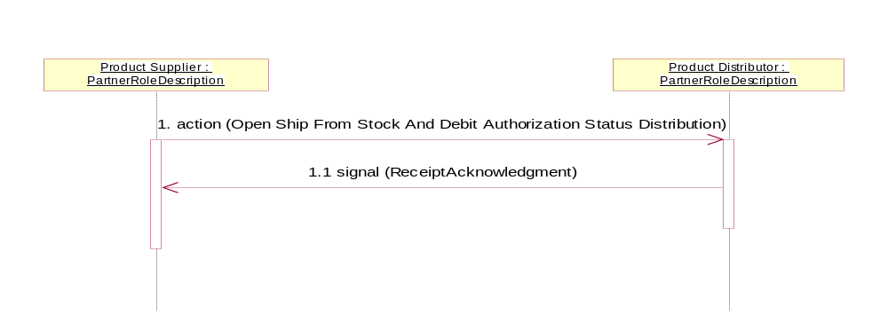

Figure 3: Sequence Diagram of Distribute Open Ship From Stock And Debit Authorization Status

Message Exchange Controls
Table 10: Message Exchange Control
# | Name |  | Time to Acknowledge Receipt Signal |  | Time to Respond to Action |  | Included in Time to Perform | Is Authorization Required? | Is Non-Repudiation Required? | Is Secure Transport Required?
1. |  | Open Ship From Stock And Debit Authorization Status Distribution Action |  | 2hrs |  | N/A | N/A | N | N | Y
1.1. |  | Receipt Acknowledgment |  | N/A |  | N/A | N/A | N | N | Y

Communications Specification
Table 11: Dialog: Service-Service
# | Business Message | Digital Signature Required? | SSL Required?
1. | Open Ship From Stock And Debit Authorization Status Distribution | N | Y
1.1. | Receipt Acknowledgment | N | Y

