

Description of
Partner Interface Process® for 5D5

Validated 11.00.00

Specification Information
Name | Request Ship From Stock And Debit Claim
Cluster | Marketing Information Management
Segment | Ship from Stock and Debit (EC)
Publication Date | 24 February 2010
Version Identifier | V11.00

Table of Contents
1 Document Management 4
1.1 Legal Disclaimer 4
1.2 Copyright 4
1.3 Trademarks 4
1.4 Acknowledgments 4
1.5 Related Documents 4
1.6 Document Version History 4
1.7 Document Structure 5
2 Business Process 6
2.1 Business Process Definition 6
2.1.1 Executive Summary 6
2.1.2 Business Process Description 6
2.2 PIP Scope Description 7
2.2.1 Business Process Scope Diagram 8
2.3 PIP Business Document 9
2.4 PIP Business Process Flow Diagram 9
2.5 PIP Start State 10
2.6 PIP End States 10
2.7 Partner Role Description 11
2.8 Business Process Activity Controls 11
3 Network and Implementation Specification 12
3.1 Business Action and Business Signal Specifications 12
3.2 Business Transaction Dialog Specification 12
3.2.1 Message Exchange Controls 13
3.2.2 Communications Specification 13

List of Figures:
Figure 1: Business Process Scope Diagram 8
Figure 2: Activity Diagram 9
Figure 3: Sequence Diagram 12

List of Tables:
Table 1: PIP Business Document 9
Table 2: PIP Start State 10
Table 3: PIP End State 10
Table 4: PIP Failure State 10
Table 5: Partner Role Description 11
Table 6: Business Activity Description 11
Table 7: Business Activity Performance Control 11
Table 8: Network Component Specification 12
Table 9: Business Action – Business Document Mapping 12
Table 10: Message Exchange Control 13
Table 11: Dialog: Service-Service 13

Document Management

Legal Disclaimer
RosettaNet™, its members, officers, directors, employees, or agents shall not be liable for any injury, loss, damages, financial or otherwise, arising from, related to, or caused by the use of this document or the specifications herein, as well as associated guidelines and schemas. The use of said specifications shall constitute your express consent to the foregoing exculpation.

Copyright
©2010 RosettaNet. All rights reserved. No part of this publication may be reproduced, stored in a retrieval system, or transmitted, in any form or by any means, electronic, mechanical, photocopying, recording, or otherwise, without the prior written permission of the publisher. Printed in the United States of America.

Trademarks
RosettaNet, Partner Interface Process, PIP and the RosettaNet logo are trademarks or registered trademarks of "RosettaNet," a non-profit organization. All other product names and company logos mentioned herein are the trademarks of their respective owners. In the best effort, all terms mentioned in this document that are known to be trademarks or registered trademarks have been appropriately recognized in the first occurrence of the term.

Acknowledgments
This document has been prepared by RosettaNet (http://www.rosettanet.org/) from requirements gathered during the Milestone Program and in conformance with the methodology. Listed below are the legal entities that contributed to the design and development of this PIP.
Arrow Electronics, Inc. | NEC Electronics Inc.
TTI, Inc.

Related Documents
- Associated PIP Message Schemas (included within the PIP Specification package only)
- Description of 5D5 Message
- Messages Structure
- XML instance of ebXML BPSS for PIP 5D5

Document Version History
Version | Date | Description
Validated 11.00.00 | 24 February 2010 | Validated Version

Document Structure
A Partner Interface Process (PIP) Specification is comprised of the following two parts:
- Business Process. Captures the semantics of the business process and the flow of the message exchange between roles as they perform business activities.
- Network and Implementation Specification. Specifies the network protocol message formats and communications requirements between peer-protocols supported by network components in the RosettaNet Implementation Framework.

Business Process

Business Process Definition
The "Request Ship from Stock and Debit Claim" Partner Interface Process™ (PIP) allows a Product Distributor to submit a claim for reimbursement to a Product Supplier, and receive a claim response, in accordance with a Ship from Stock and Debit Authorization program.
This program is a pricing agreement between a Product Supplier and a Product Distributor that enables the Product Distributor to sell products to a customer at an acceptable profit margin. These pricing arrangements, used in the EC and IT supply chain, allow a Product Distributor to claim credits on products sold to customers.
To use this PIP, a Ship from Stock and Debit Authorization must be in place. Either PIP5D1, "Request Ship from Stock and Debit Authorization," PIP5D2, "Notify of Blanket Ship from Stock and Debit Authorization," or some other acceptable method may be used to initiate a Ship from Stock and Debit Authorization.
The Product Supplier must respond to the initial 5D5 Claim Request within 48 hours. Items that are placed in “Pending” status require additional attention and processing by the Product Supplier prior to providing a final resolution. PIP5D6, "Notify of Ship from Stock and Debit Claim Response," is used to provide this final resolution. It is recommended that trading partners execute PIP5D6 within 48 hours of when the claim item was placed in a “Pending” status in the Ship from Stock and Debit Claim Response.
PIP 5D5 may be used to resubmit claim requests for line items that may have previously been rejected and subsequently revised. If the Product Distributor submitted a claim in error, the Product Supplier typically rejects those claims upon editing of the claim request.

Executive Summary
The "Request Ship from Stock and Debit Claim" Partner Interface Process™ (PIP®) allows a Product Distributor to submit a claim for reimbursement to a Product Supplier, and receive a claim response, in accordance with a Ship from Stock and Debit Authorization program.
This program is a pricing agreement between a Product Supplier and a Product Distributor that enables the Product Distributor to sell products to a customer at an acceptable profit margin. These pricing arrangements, used in the EC and IT supply chain, allow a Product Distributor to claim credits on products sold to customers.

Business Process Description
This PIP is used to submit a claim for a debit against an authorization program, and to receive a claim response. The Product Supplier may edit the product quantities, date of sale, and other information in the claim. The claim is then accepted, rejected or placed in “Pending” status. A disposition is generated for each line item. If accepted, the Product Supplier's financial system generates a credit to the Product Distributor. Rejected lines are reported with multiple reason codes, allowing the Product Distributor to close out the item or to fix the problem and resubmit the claim.
This PIP is executed when the product fulfillment status is known and the customer has been billed.

PIP Scope Description
To use this PIP®, a Ship from Stock and Debit Authorization must be in place. Either PIP5D1, "Request Ship from Stock and Debit Authorization," PIP5D2, "Notify of Blanket Ship from Stock and Debit Authorization," or some other acceptable method may be used to initiate a Ship from Stock and Debit Authorization.
The Product Supplier must respond to the initial 5D5 Claim Request within 48 hours. Items that are placed in “Pending” status require additional attention and processing by the Product Supplier prior to providing a final resolution. PIP5D6, "Notify of Ship from Stock and Debit Claim Response," is used to provide this final resolution. It is recommended that trading partners execute PIP5D6 within 48 hours of when the claim item was placed in a “Pending” status in the Ship from Stock and Debit Claim Response.
PIP 5D5 may be used to resubmit claim requests for line items that may have previously been rejected and subsequently revised. If the Product Distributor submitted a claim in error, the Product Supplier typically rejects those claims upon editing of the claim request.

Business Process Scope Diagram
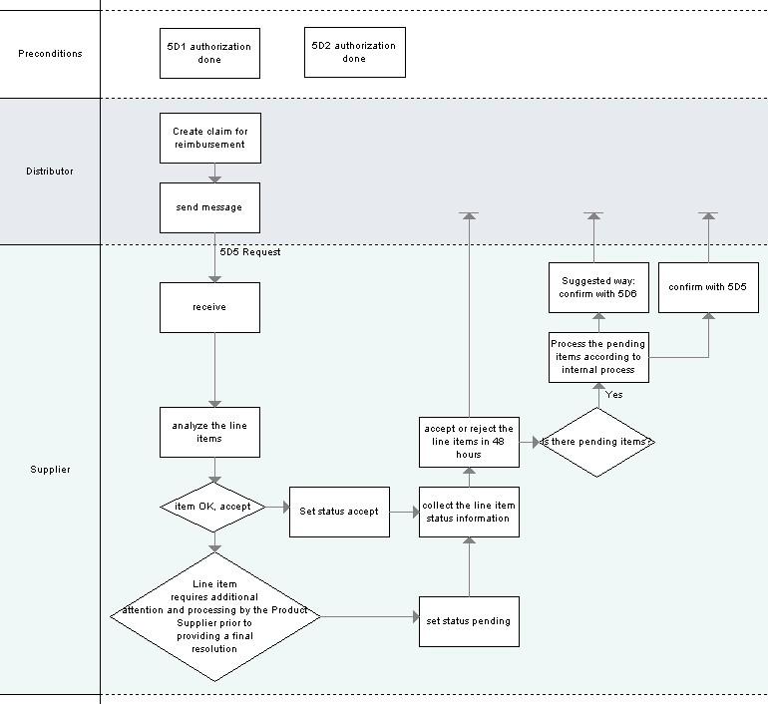
Figure 1: Business Process Scope Diagram

PIP Business Document
Business Document are generated and exchanged by roles performing activities in this PIP. Business Document is listed and defined in Table 1.
Table 1: PIP Business Document
Business Document | Description
Ship From Stock And Debit Claim Request | A claim submission for reimbursement in accordance with a Ship from Stock and Debit Authorization program. The claim request is hierarchically-grouped; at the highest level by Authorization program number, then by invoice identification number from Product Distributor to the customer, then by part sold to the customer. Several "cost groups" provide detail on how the "claimed cost" is calculated by the Product Distributor.
Ship From Stock And Debit Claim Confirmation | Replies to a claim submission. A confirmation for each claim line is provided. Each claim line can be approved, pended, or rejected. If the claim is accepted, a Credit Reference Identifier is provided, which can contain a credit memo number. If the line is rejected, multiple reason codes can be provided.

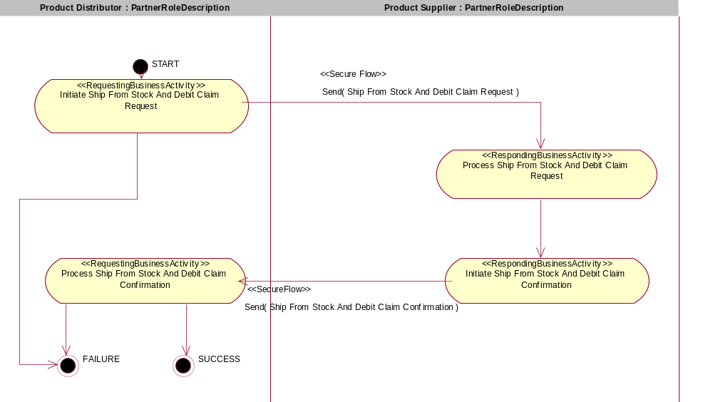
Figure 2: Activity Diagram

PIP Start State
The start state is comprised of the following conditions:
Table 2: PIP Start State
 | Approved | Exist |  | Valid | Non-Repudiated | Retry Count | Authorized
 | Approved | Party | In Backend System
TPA |   |  |  
Sending Partner |  |   |  |  
Receiving Partner |  |  
Business Document |  |  |   |   |   |  |  

PIP End States
The end state is comprised of the following conditions:
Table 3: PIP End State
 | Approved | Exist |  | Valid | Non-Repudiated | Retry Count | Authorized
 | Approved | Party | In Backend system
Acknowledgment of Receipt |  |  |  |  |  
Receiving Partner |  |  |  |  |  |  | 

The PIP failure state is comprised of one or more of the following conditions
Table 4: PIP Failure State
 | NO | Exceeded
Success | 
Retry Count |  | 

Partner Role Description
Table 5 describes the partner roles in this PIP:
Table 5: Partner Role Description
Role Name | Role Description
Product Distributor | The party authorized by a Product Supplier to purchase goods and services from the Product Supplier and resell to customers.
Product Supplier | This partner role supplies product to customers in the supply chain.

Business Process Activity Controls
Table 6 describes the interaction between roles performing business activity in this PIP.
Table 6: Business Activity Description
Role Name |  | Activity Name |  | Activity Description
Product Distributor | Initiate Ship From Stock And Debit Claim Request |  | The Product Distributor prepares and submits the Ship from Stock and Debit Claim Request.
Product Supplier | Initiate Ship From Stock And Debit Claim Confirmation |  | The Product Supplier process Ship from Stock and Debit Claim Confirmation.

Table 7 details the security, audit and process controls relating to activity performed in the PIP.
Table 7: Business Activity Performance Control
Role  Name | Activity  Name | Acknowledgment of Receipt Non-Repudiation Required? | Acknowledgment of Receipt Time to Acknowledge | Time to Perform | Retry Count | Is Authorization Required? | Non-Repudiation of Origin and Content?
Product Distributor | Initiate Ship From Stock And Debit Claim Request | Y | 2 hrs | 48 hrs | 3 | Y | Y
Product Supplier | Initiate Ship From Stock And Debit Claim Confirmation | Y | 2 hrs | 24 hrs | 3 | Y | Y

Network and Implementation Specification
Each network component maps into a role of the PIP model. Table 8 specifies the mapping between roles and network components.
Table 8: Network Component Specification
Network Component | Classification | Maps to Role in Business Process
Product Distributor Service | Business Service | Product Distributor
Product Supplier Service | Business Service | Product Supplier

Business Action and Business Signal Specifications
Each business action maps to a Business Document of the PIP model. Table 9 specifies the mapping between Business Documents and business actions.
Table 9: Business Action – Business Document Mapping
Business Action | Business Document | Document Function
Ship From Stock And Debit Claim Request Action | Ship From Stock And Debit Claim Request | Request
Ship From Stock And Debit Claim Confirmation Action | Ship From Stock And Debit Claim Confirmation | Response

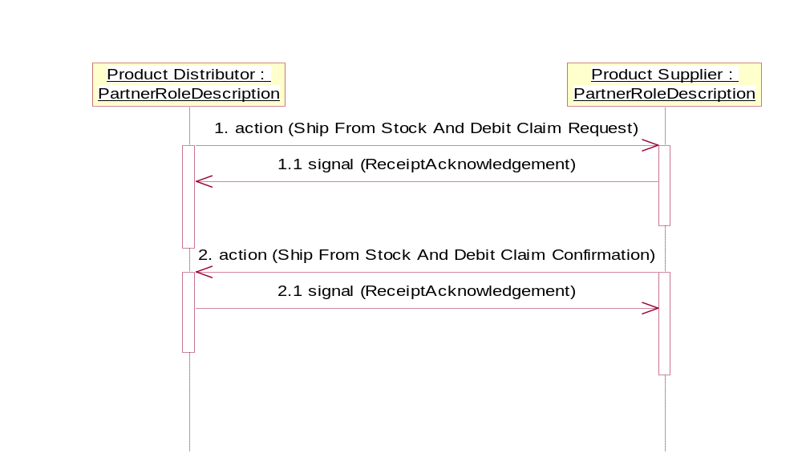

Figure 3: Sequence Diagram

Message Exchange Controls
Table 10: Message Exchange Control
# | Name |  | Time to Acknowledge Receipt Signal |  | Time to Respond to Action |  | Included in Time to Perform | Is Authorization Required? | Is Non-Repudiation Required? | Is Secure Transport Required?
1. |  | Ship From Stock And Debit Claim Request Action |  | 2 hrs |  | 48 hrs | Y | Y | Y | Y
1.1 |  | Receipt Acknowledgment |  | N/A |  | N/A | Y | Y | Y | Y
2. |  | Ship From Stock And Debit Claim Confirmation Action |  | 2 hrs |  | N/A | Y | Y | Y | Y
2.2 |  | Receipt Acknowledgment |  | N/A |  | N/A | N | Y | Y | Y

Communications Specification
Table 11: Dialog: Service-Service
# | Business Message | Digital Signature Required? | SSL Required?
1. | Ship From Stock And Debit Claim Request | Y | Y
2. | Ship From Stock And Debit Claim Confirmation | Y | Y

