

Description of
Partner Interface Process® for 5D8

Validated 11.00.00

Specification Information
Name | Notify of Ship From Stock And Debit Authorization Confirmation
Cluster | Marketing Information Management
Segment | Ship from Stock and Debit (EC)
Publication Date | 8 March 2010
Version Identifier | V11.00

Table of Contents
1 Document Management 4
1.1 Legal Disclaimer 4
1.2 Copyright 4
1.3 Trademarks 4
1.4 Related Documents 4
1.5 Document Version History 4
1.6 Document Structure 4
2 Business Process 5
2.1 Business Process Definition 5
2.2 PIP Scope Description 5
2.3 PIP Business Document 6
2.4 PIP Business Process Flow Diagram 6
2.5 PIP Start State 7
2.6 PIP End States 7
2.7 Partner Role Description 8
2.8 Business Process Activity Controls 8
3 Network and Implementation Specification 9
3.1 Business Action and Business Signal Specifications 9
3.2 Business Transaction Dialog Specification 10
3.2.1 Message Exchange Controls 11
3.2.2 Communications Specification 11

List of Figures:
Figure 1: Activity Diagram 6
Figure 2: Sequence Diagram 10

List of Tables:
Table 1: PIP Business Document 6
Table 2: PIP Start State 7
Table 3: PIP End State 7
Table 4: PIP Failure State 7
Table 5: Partner Role Description 8
Table 6: Business Activity Description 8
Table 7: Business Activity Performance Control 8
Table 8: Network Component Specification 9
Table 9: Business Action – Business Document Mapping 9
Table 10: Message Exchange Control 11
Table 11: Dialog: Service-Service 11

Document Management

Legal Disclaimer
RosettaNet™, its members, officers, directors, employees, or agents shall not be liable for any injury, loss, damages, financial or otherwise, arising from, related to, or caused by the use of this document or the specifications herein, as well as associated guidelines and schemas. The use of said specifications shall constitute your express consent to the foregoing exculpation.

Copyright
©2010 RosettaNet. All rights reserved. No part of this publication may be reproduced, stored in a retrieval system, or transmitted, in any form or by any means, electronic, mechanical, photocopying, recording, or otherwise, without the prior written permission of the publisher. Printed in the United States of America.

Trademarks
RosettaNet, Partner Interface Process, PIP and the RosettaNet logo are trademarks or registered trademarks of "RosettaNet," a non-profit organization. All other product names and company logos mentioned herein are the trademarks of their respective owners. In the best effort, all terms mentioned in this document that are known to be trademarks or registered trademarks have been appropriately recognized in the first occurrence of the term.

Related Documents
- Associated PIP Message Schemas (included within the PIP Specification package only)
- Description of 5D8 Message
- Messages Structure
- XML instance of ebXML BPSS for PIP 5D8

Document Version History
Version | Date | Description
Validated 11.00.00 | 8 March 2010 | Validated Version : MCC Program

Document Structure
A Partner Interface Process (PIP) Specification is comprised of the following two parts:
- Business Process. Captures the semantics of the business process and the flow of the message exchange between roles as they perform business activities.
- Network and Implementation Specification. Specifies the network protocol message formats and communications requirements between peer-protocols supported by network components in the RosettaNet Implementation Framework.

Business Process

Business Process Definition
The "Notify of Ship from Stock and Debit Authorization Confirmation" Partner Interface Process™ (PIP) supports the process used by a supplier to authorize the distributor to ship the stock and claim reimbursement. The supplier may either authorize the request by providing a debit authorization number or reject the request by providing a rejection reason. A rejection reason must be provided if the authorization request is not accepted.
Prior to requesting a ship from stock and debit authorization, the distributor may use PIP3A1, "Request Quote," to obtain a quote for new buy prices. The ship from stock and debit authorization request may optionally include the quote number, distributor’s branch information and details on the end customer (ship to, sold to and/or used by). If a quote line item does not match the associated ship from stock and debit request line item (i.e., different quantity), the quote must be updated to accurately reflect the authorization request.
If the ship from stock and debit authorization request is authorized, the distributor may use PIP5D5, "Create Ship from Stock and Debit Claim" to submit a claim to the supplier for reimbursement of the difference in cost between the original price and the new price.

PIP Scope Description
This PIP enables a supplier to respond to the request of a distributor.

PIP Business Document
Business Document are generated and exchanged by roles performing activities in this PIP. Business Document is listed and defined in Table 1.
Table 1: PIP Business Document
Business Document | Description
Ship From Stock And Debit Authorization Confirmation Notification | Returns an authorization status and details from applicable line items per the quote number provided in the authorization request.

PIP Business Process Flow Diagram
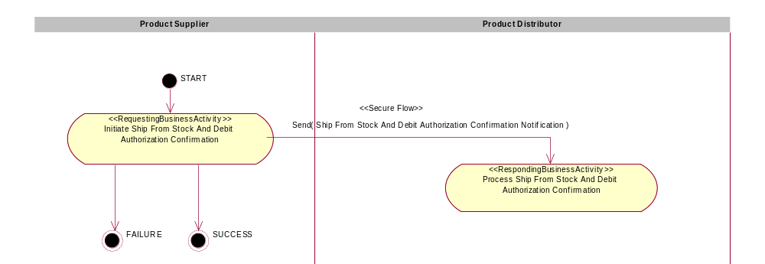
Figure 1: Activity Diagram

PIP Start State
The start state is comprised of the following conditions:
Table 2: PIP Start State
 | Approved | Exist |  | Valid | Non-Repudiated | Retry Count | Authorized
 | Approved | Party | In Backend System
TPA |  |  | 
Sending Partner |  |  |  | 
Receiving Partner |  | 
Business Document |  |  |  |  |  |  |  

PIP End States
The end state is comprised of the following conditions:
Table 3: PIP End State
 | Approved | Exist |  | Valid | Non-Repudiated | Retry Count | Authorized
 | Approved | Party | In Backend system
Acknowledgment of Receipt |  |  |   |   | 
Receiving Partner |  |  |  |  |  |  | 

The PIP failure state is comprised of one or more of the following conditions
Table 4: PIP Failure State
 | NO | Exceeded
Success | 
Retry Count |  |  

Partner Role Description
Table 5 describes the partner roles in this PIP:
Table 5: Partner Role Description
Role Name | Role Description
Product Supplier | This partner role supplies product to customers in the supply chain.
Product Distributor | The party authorized by a Product Supplier to purchase goods and services from the Product Supplier and resell to customers.

Business Process Activity Controls
Table 6 describes the interaction between roles performing business activity in this PIP.
Table 6: Business Activity Description
Role Name |  | Activity Name |  | Activity Description
Product Supplier | Notify of Ship From Stock And Debit Authorization Confirmation |  | This activity allows a Product Supplier to confirm a Ship from Stock and Debit Authorization request.

Table 7 details the security, audit and process controls relating to activity performed in the PIP.
Table 7: Business Activity Performance Control
Role  Name | Activity  Name | Acknowledgment  of Receipt |  | Time to Perform | Retry Count | Is Authorization Required? | Non-Repudiation of Origin and Content?
Role  Name | Activity  Name | Non-Repudiation Required? | Time to Acknowledge
Product Supplier | Notify of Ship From Stock And Debit Authorization Confirmation | Y | 2 hrs | 2 hrs | 3 | Y | Y

Network and Implementation Specification
Each network component maps into a role of the PIP model. Table 8 specifies the mapping between roles and network components.
Table 8: Network Component Specification
Network Component | Classification | Maps to Role in Business Process
Product Supplier Service | Business Service | Product Supplier
Product Distributor Service | Business Service | Product Distributor

Business Action and Business Signal Specifications
Each business action maps to a Business Document of the PIP model. Table 9 specifies the mapping between Business Documents and business actions.
Table 9: Business Action – Business Document Mapping
Business Action | Business Document | Document Function
Ship From Stock And Debit Authorization Confirmation Notification Action | Ship From Stock And Debit Authorization Confirmation Notification | Response

Business Transaction Dialog Specification
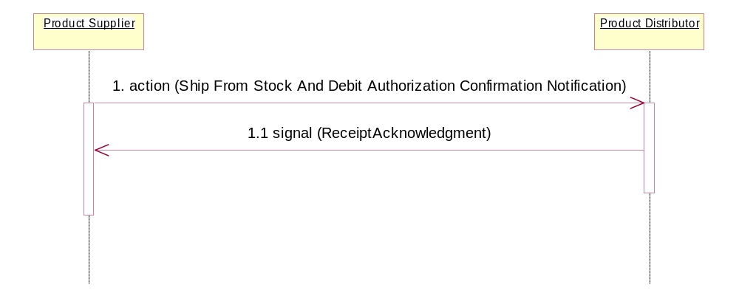

Figure 2: Sequence Diagram

Message Exchange Controls
Table 10: Message Exchange Control
# | Name |  | Time to Acknowledge Receipt Signal |  | Time to Respond to Action |  | Included in Time to Perform | Is Authorization Required? | Is Non-Repudiation Required? | Is Secure Transport Required?
1. |  | Ship From Stock And Debit Authorization Confirmation Notification Action |  | 2 hrs |  | 2 hrs | Y | Y | Y | Y
1.1 |  | Receipt Acknowledgment |  | N/A |  | N/A | N/A | Y | Y | Y

Communications Specification
Table 11: Dialog: Service-Service
# | Business Message | Digital Signature Required? | SSL Required?
1. | Ship From Stock And Debit Authorization Confirmation | Y | Y
1.1 | Receipt Acknowledgment | Y | Y

