

Description of 5D9 Message

PIP® 5D9
Validated 11.00.00

Specification Information
Name | Description Of 5D9 Message
PIP | Notify of Ship From Stock And Debit Claim Request
Cluster | Marketing Information Management
Segment | Ship from Stock and Debit (EC)
Publication Date | 8 March 2010
Version Identifier | V11.00

Table of Content

1. Document Management 6
1.1 Legal Disclaimer 6
1.2 Copyright 6
1.3 Trademarks 6
1.4 Acknowledgments 6
1.5 Related Documents 6
1.6 Document Version History 6
1.7 Document Purpose 6
2. Interchange Model 7
2.1 ShipFromStockAndDebitClaimRequestNotification 7
2.1.1 Interchange Diagram 7
2.1.2 Dependency Diagram 7
2.1.3 AuthorizationInformation 8
2.1.4 InvoiceInformation 9
2.1.5 ProductInformation 10
2.1.6 Resource 11
2.1.7 ShipFromStockAndDebitClaimRequest 11
3. Domain Model 12
3.1 Procurement 12
3.1.1 Dependency Diagram 12
3.1.2 BranchInformation 12
3.1.3 CustomerInformation 13
3.1.4 PricingInformation 13
3.1.5 CodeList 14
3.1.5.1 CustomerType 14
3.2 Shared 15
3.2.1 Dependency Diagram 15
3.2.2 MonetaryAmount 15
3.2.3 ProductPricing 16
3.2.4 CodeList 17
3.2.4.1 InvoiceChargeType 17
3.2.4.2 MonetaryAmountType 17
3.2.4.3 PricingTypeCode 17
3.2.4.4 AmountType 19
4. Universal Structure 20
4.1 ContactInformation 20
4.1.1 ContactInformation 20
4.2 DataType 21
4.2.1 Contact 21
4.2.2 DUNS 21
4.2.3 DUNSPlus4 22
4.2.4 GLN 22
4.2.5 GTIN 23
4.3 Document 24
4.3.1 BusinessDocumentReference 24
4.4 Locations 25
4.4.1 AlternativeIdentifier 25
4.4.2 Location 26
4.4.3 LocationChoice 27
4.4.4 PhysicalAddress 28
4.5 MonetaryExpression 29
4.5.1 FinancialAmount 29
4.6 PartnerIdentification 30
4.6.1 FullPartner 30
4.6.2 IntermittentPartner 30
4.6.3 KnownPartner 31
4.6.4 KnownPartnerContact 32
4.6.5 NewPartner 32
4.6.6 PartnerDescription 33
4.6.7 PartnerDescriptionChoice 34
4.6.8 PartnerIdentification 35
4.6.9 PartnerIdentificationChoice 36
4.6.10 SpecifiedFullPartner 36
4.6.11 SpecifiedIntermittentPartner 37
4.6.12 SpecifiedKnownPartner 38
4.6.13 SpecifiedKnownPartnerContact 38
4.6.14 SpecifiedNewPartner 39
4.6.15 SpecifiedPartnerDescription 40
4.6.16 SpecifiedPartnerDescriptionChoice 40
4.7 ProductIdentification 42
4.7.1 ProductIdentification 42
4.7.2 ProductIdentificationChoice 42
4.8 CodeList 43
4.8.1 Country 43
4.8.2 CountrySubdivision 43
4.8.3 Currency 43
4.8.4 Language 43
4.8.5 DocumentType 44
4.8.6 MimeTypeQualifier 46
4.8.7 UnitOfMeasure 56
4.8.8 ProcessRoleIdentifier 69
5. System Structure 72
5.1 BusinessProcessIdentifier 72
5.2 BusinessServiceInformation 73
5.3 ContractInformation 74
5.4 CorrelationInformation 75
5.5 DocumentHeader 76
5.6 DocumentIdentification 77
5.7 DocumentIdentificationChoice 77
5.8 DocumentInformation 78
5.9 DocumentManifest 79
5.10 DocumentSecurity 80
5.11 ManifestItem 81
5.12 PipIdentifier 82
5.13 PipVersion 82
5.14 Receiver 83
5.15 RequestingDocumentInformation 84
5.16 Sender 85
5.17 StandardDocumentIdentification 86
5.18 TpirPipIdentification 87
5.19 VersionIdentifier 88
5.20 CodeList 88
5.20.1 TPIRFileType 88
6. XML Data Type 89
6.1 anyURI 89
6.2 boolean 89
6.3 date 89
6.4 dateTime 89
6.5 float 89
6.6 positiveInteger 89
6.7 string 89

Table of Figures

Figure ‎2-1 Interchange 7
Figure ‎2-2 Dependency 7
Figure ‎2-3 AuthorizationInformation 8
Figure ‎2-4 InvoiceInformation 9
Figure ‎2-5 ProductInformation 10
Figure ‎2-6 Resource 11
Figure ‎2-7 ShipFromStockAndDebitClaimRequest 11
Figure ‎3-1 Dependency 12
Figure ‎3-2 BranchInformation 12
Figure ‎3-3 CustomerInformation 13
Figure ‎3-4 PricingInformation 13
Figure ‎3-5 Dependency 15
Figure ‎3-6 MonetaryAmount 15
Figure ‎3-7 ProductPricing 16
Figure ‎4-1 ContactInformation 20
Figure ‎4-2 Contact 21
Figure ‎4-3 DUNS 21
Figure ‎4-4 DUNSPlus4 22
Figure ‎4-5 GLN 22
Figure ‎4-6 GTIN 23
Figure ‎4-7 BusinessDocumentReference 24
Figure ‎4-8 AlternativeIdentifier 25
Figure ‎4-9 Location 26
Figure ‎4-10 PhysicalAddress 28
Figure ‎4-11 FinancialAmount 29
Figure ‎4-12 FullPartner 30
Figure ‎4-13 IntermittentPartner 30
Figure ‎4-14 KnownPartner 31
Figure ‎4-15 KnownPartnerContact 32
Figure ‎4-16 NewPartner 32
Figure ‎4-17 PartnerDescription 33
Figure ‎4-18 PartnerIdentification 35
Figure ‎4-19 SpecifiedFullPartner 36
Figure ‎4-20 SpecifiedIntermittentPartner 37
Figure ‎4-21 SpecifiedKnownPartner 38
Figure ‎4-22 SpecifiedKnownPartnerContact 38
Figure ‎4-23 SpecifiedNewPartner 39
Figure ‎4-24 SpecifiedPartnerDescription 40
Figure ‎4-25 ProductIdentification 42
Figure ‎5-1 BusinessProcessIdentifier 72
Figure ‎5-2 BusinessServiceInformation 73
Figure ‎5-3 ContractInformation 74
Figure ‎5-4 CorrelationInformation 75
Figure ‎5-5 DocumentHeader 76
Figure ‎5-6 DocumentIdentification 77
Figure ‎5-7 DocumentInformation 78
Figure ‎5-8 DocumentManifest 79
Figure ‎5-9 DocumentSecurity 80
Figure ‎5-10 ManifestItem 81
Figure ‎5-11 PipIdentifier 82
Figure ‎5-12 PipVersion 82
Figure ‎5-13 Receiver 83
Figure ‎5-14 RequestingDocumentInformation 84
Figure ‎5-15 Sender 85
Figure ‎5-16 StandardDocumentIdentification 86
Figure ‎5-17 TpirPipIdentification 87
Figure ‎5-18 VersionIdentifier 88

Document Management

Legal Disclaimer
RosettaNet, its members, officers, directors, employees, or agents shall not be liable for any injury, loss, damages, financial or otherwise, arising from, related to, or caused by the use of this document or the specifications herein, as well as associated guidelines and schemas. The use of said specifications shall constitute your express consent to the foregoing exculpation.

Copyright
©2010 RosettaNet. All rights reserved. No part of this publication may be reproduced, stored in a retrieval system, or transmitted, in any form or by any means, electronic, mechanical, photocopying, recording, or otherwise, without the inclusion of this copyright notice. Any derivative works must cite the copyright notice. Any public redistribution or sale of this publication or derivative works requires prior written permission of the publisher.

Trademarks
RosettaNet, Partner Interface Process, PIP and the RosettaNet logo are trademarks or registered trademarks of "RosettaNet," a non-profit organization. All other product names and company logos mentioned herein are the trademarks of their respective owners. In the best effort, all terms mentioned in this document that are known to be trademarks or registered trademarks have been appropriately recognized in the first occurrence of the term.

Acknowledgments
This document has been prepared by RosettaNet (http://www.rosettanet.org/) from requirements gathered during the Milestone Program and in conformance with the methodology.

Related Documents
- Associated PIP Message Schemas (included with PIP Specification only)
- Description of Partner Interface Process for 5D9
- Message Structure

Document Version History
Version | Date | Description
Validated 11.01.00 | 8 March 2010 | Validated Version: MCC Program

Document Purpose
The purpose of the document is to explain the structure, the association between objects, the content of objects and the definition for single elements to a non-technical audience.

Interchange Model

ShipFromStockAndDebitClaimRequestNotification

Interchange Diagram
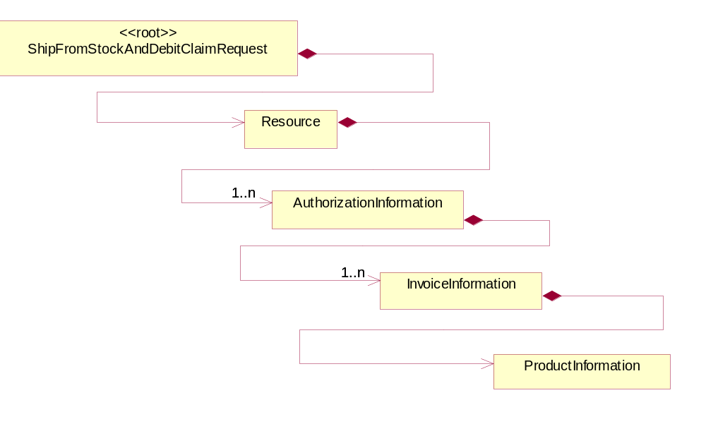
Figure ‎2-1 Interchange

Dependency Diagram
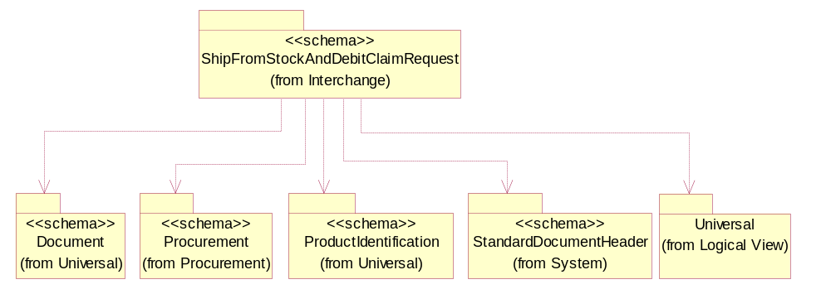
Figure ‎2-2 Dependency

AuthorizationInformation
The collection of business properties that describe information pertaining to authorizations for Ship From Stock and Debit activities.
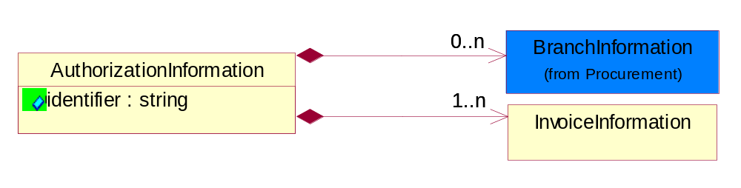
Figure ‎2-3 AuthorizationInformation

Attribute | Type | Documentation
identifier | string | The unique identification number assigned to an approved Ship From Stock and Debit Authorization request.

Composition | Cardinality | Type | Documentation
InvoiceInformation | 1..n | InvoiceInformation | The collection of business properties that describe information pertaining to invoices for ship from stock and debit activities.
BranchInformation | 0..n | BranchInformation | The collection of business properties that describe information pertaining to branch location.

InvoiceInformation
The collection of business properties that describe information pertaining to invoices for ship from stock and debit activities.
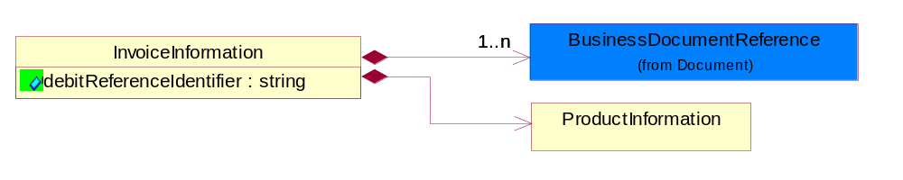
Figure ‎2-4 InvoiceInformation

Attribute | Type | Documentation
debitReferenceIdentifier | string | Identifying number assigned to a debit transaction.

Composition | Cardinality | Type | Documentation
BusinessDocumentReference | 1..n | BusinessDocumentReference | The business document reference object allows for the indirect referencing of a relationship to other business related documents.
ProductInformation | 1 | ProductInformation | The collection of business properties that describe product information pertaining to Ship From Stock and Debit activities.

ProductInformation
The collection of business properties that describe product information pertaining to Ship From Stock and Debit activities.
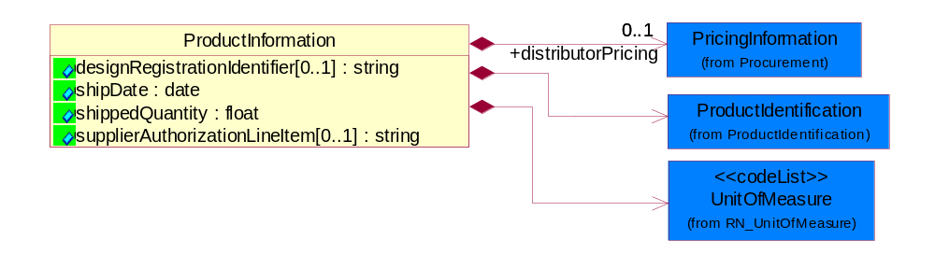
Figure ‎2-5 ProductInformation

Attribute | Type | Documentation
designRegistrationIdentifier[0..1] | string | A proprietary unique identifier for a design registration.
shipDate | date | The (GMT) local date the product is shipped.
shippedQuantity | float | Quantity of product shipped.
supplierAuthorizationLineItem[0..1] | string | The line item assigned by a supplier to specifically identify a line on the approving document.

Composition | Cardinality | Type | Documentation
UnitOfMeasure | 1 | UnitOfMeasure | Code identifying a product unit of measure.
ProductIdentification | 1 | ProductIdentification | The object provides the identifier(s) of a product.
distributorPricing | 0..1 | PricingInformation | The collection of business properties that describe the distributors’ price of the products referenced.

Resource
The collection of business properties that describe information relating to Ship From Stock and Debit activities.
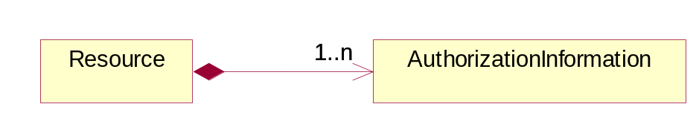
Figure ‎2-6 Resource

Composition | Cardinality | Type | Documentation
AuthorizationInformation | 1..n | AuthorizationInformation | The collection of business properties that describe information pertaining to authorizations for Ship From Stock and Debit activities.

ShipFromStockAndDebitClaimRequest
A wrapper or root element for PIP5D5.
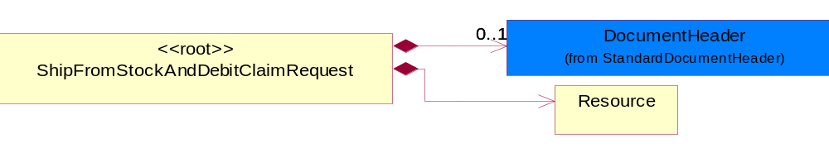
Figure ‎2-7 ShipFromStockAndDebitClaimRequest

Composition | Cardinality | Type | Documentation
DocumentHeader | 0..1 | DocumentHeader | The object allows for the identification of the sender and receiver of the business document.
Resource | 1 | Resource | The collection of business properties that describe information relating to Ship From Stock and Debit activities.

Domain Model

Procurement

Dependency Diagram
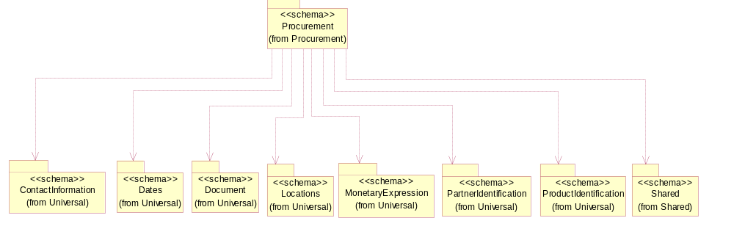
Figure ‎3-8 Dependency

BranchInformation
The collection of business properties that describe information pertaining to branch location.
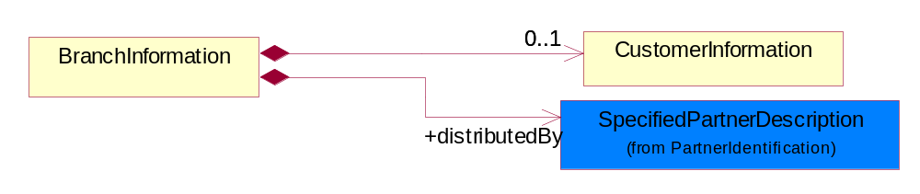
Figure ‎3-9 BranchInformation

Composition | Cardinality | Type | Documentation
distributedBy | 1 | SpecifiedPartnerDescription | The party who supplies products to retailers.
CustomerInformation | 0..1 | CustomerInformation | The collection of business properties that describe an end user.

CustomerInformation
The collection of business properties that describe an end user.
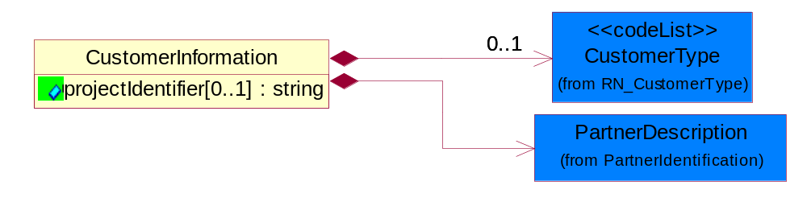
Figure ‎3-10 CustomerInformation

Attribute | Type | Documentation
projectIdentifier[0..1] | string | The unique identification number that identifies a project for a given customer.

Composition | Cardinality | Type | Documentation
CustomerType | 0..1 | CustomerType | Code identifying the type of end user.
PartnerDescription | 1 | PartnerDescription | The collection of business properties that describe a business partners' identity, their contact information, where they are physically located and their function in a supply chain.

PricingInformation
The collection of business properties that describe the price of the products referenced.
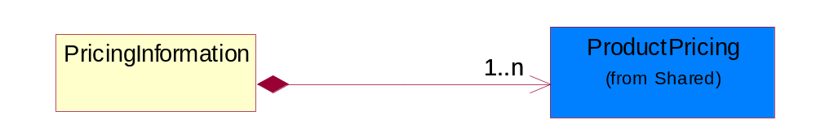
Figure ‎3-11 PricingInformation

Composition | Cardinality | Type | Documentation
ProductPricing | 1..n | ProductPricing | The collection of business properties that describe the type of pricing and financial amount for a product.

CodeList

CustomerType
Code identifying the type of end user.

Name | Documentation
ENC | End customer.
ULC | Ultimate customer.

Shared

Dependency Diagram
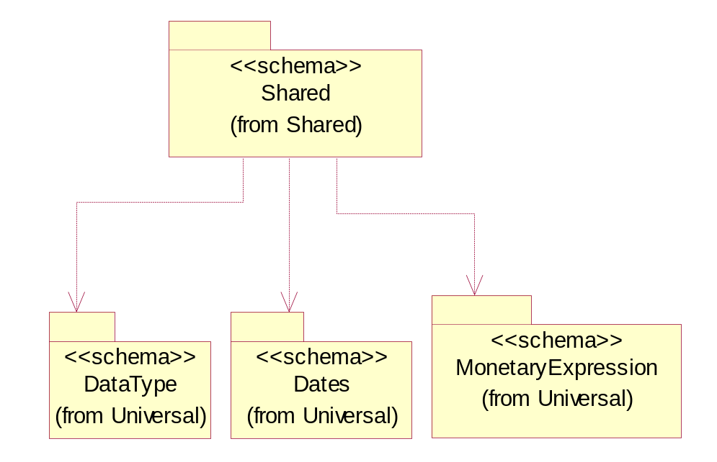
Figure ‎3-12 Dependency

MonetaryAmount
The collection of business properties that describe the monetary amount defined by a specified currency.
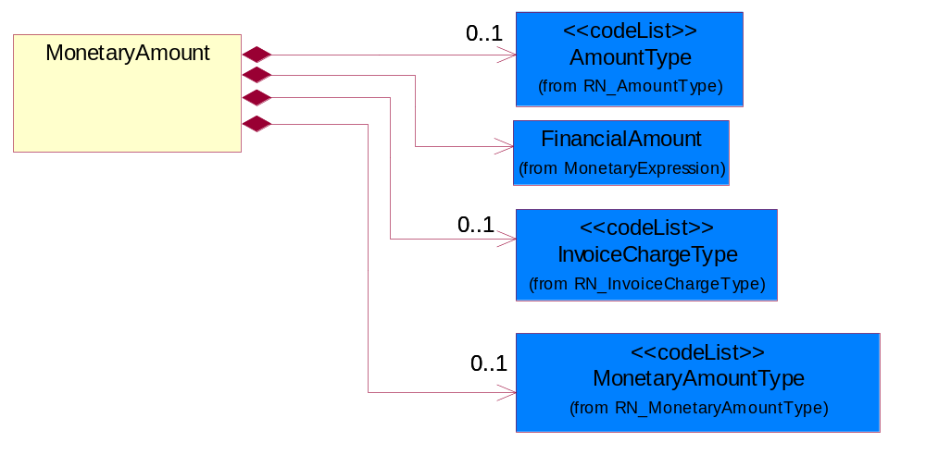
Figure ‎3-13 MonetaryAmount

Composition | Cardinality | Type | Documentation
FinancialAmount | 1 | FinancialAmount | The business document must express financial amounts.
InvoiceChargeType | 0..1 | InvoiceChargeType | Code identifying the values for the types of charges contained in an invoice.
MonetaryAmountType | 0..1 | MonetaryAmountType | Code identifying whether the monetary amount is a debit or credit.
AmountType | 0..1 | AmountType | Code identifying the type of monetary amount.

ProductPricing
The collection of business properties that describe the type of pricing and financial amount for a product.
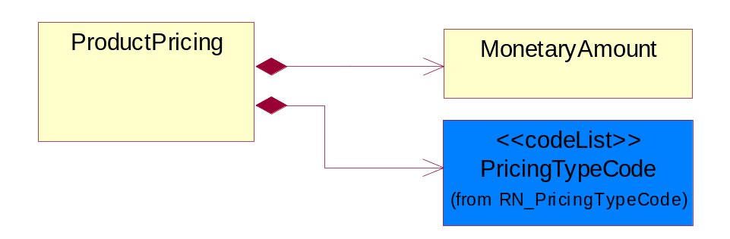
Figure ‎3-14 ProductPricing

Composition | Cardinality | Type | Documentation
MonetaryAmount | 1 | MonetaryAmount | The collection of business properties that describe the monetary amount defined by a specified currency.
PricingTypeCode | 1 | PricingTypeCode | Code identifying the type of pricing available for a product.

CodeList

InvoiceChargeType
Code identifying the values for the types of charges contained in an invoice.

Name | Documentation
ALC | Allowances and Charges.
CUC | Custom Charges.
DEA | Deposit Amount.
ESC | Expedited Shipping Charge - Charge for accelerating the delivery of a product.
FRC | Freight Charges.
HAC | Handling Charges.
LEC | Lease Charge - Charge for the use of a product in which the purchaser assumes certain responsibilities of ownership.
LIC | License Charge - Charge for the use of a product (usually software) in which the manufacturer maintains ownership of the product.
MAC | Maintenance Charge - Charge (usually periodic) for providing maintenance support for a product.
PUC | Purchase Charge - Charge for a product in which the buyer takes all responsibilities of ownership.
QUD | Quantity Discount.
REC | Rental Charge - Charge for the use of a product (usually hardware) in which the manufacturer maintains ownership of the product.

MonetaryAmountType
Code identifying whether the monetary amount is a debit or credit.

Name | Documentation
CRE | Credit.
DEB | Debit.
ZER | Zero remit.

PricingTypeCode
Code identifying the type of pricing available for a product.

Name | Documentation
ACR | Authorized Cost and Resale.
ACS | Authorized Cost - The negotiated cost agreed upon between the supplier and distributor at the time the “debit?is authorized.
ACT | Authorized cost.
ANY | Any available.
ARS | Authorized resale.
ASP | Average Selling Price - Manufacturer's published price.
BPA | Budgetary Price Amount.
BPP | Broken Purchase Price.
BSH | Book-Ship.
CAT | Catalog price - Book (the supplier’s published cost at the time of transaction) or Published Price.
CLM | Claim Amount.
CMC | Commercial.
CMD | Commodity.
CMF | Contract Manufacturing.
CON | Contract.
COS | Cost - Price for which the distributor purchased the parts.
CPL | Country Price List.
DBC | Disti Book Cost.
DFR | Duty free.
DIS | Distribution.
DPD | Duty paid.
DTP | Distribution price.
EDU | Education.
ERT | E-Rate.
EXC | Exception.
FGM | Federal government.
GEN | General.
HIE | Higher Education.
LCL | Local.
LGM | Local government.
LIS | List.
MPR | Market price.
MRP | Manufacturer's recommendation for unit pricing.
MSR | Manufacturer Suggested Retail Price (MSRP).
MUS | Minimum Unit Sale (MUS) - Manufacturer requirement of total dollar value for design opportunity.
NPF | Nonprofit.
OEM | Original Equipment Manufacturing (OEM).
OVP | OEM Volume Pricing - Original equipment manufacturing price per volume ordered.
PED | Primary Education.
QUO | Quote Price
RCS | Requested Cost (RCS) - Reseller requested cost to the manufacturer.
REX | Reseller Expects.
RFB | Refurbished.
RIN | Religious Institution.
RSP | Resale - Price the distributor is authorized to use for sale to their customer (RSP).
SCE | Special Education.
SEC | Security and management reseller.
SED | Secondary Education.
SEV | Service provider.
SGM | State Government.
SPD | Special Discount Price.
SPE | Special Education.
SPL | Samples.
SRP | Suggested Resale Price.
STR | Standard Rebate.
THP | Threshold Price.
TOC | Total Other Charges - Suggested resale price - The sum total of all distributor added charges to the customer for value added services, including but not limited to programming, tape and reel, labeling, date coding, kitting and in-house assembly.

AmountType
Code identifying the type of monetary amount.

Name | Documentation
DIP | Discount Percentage.
DIS | Discount Value - The monetary amount of the discount on the price applied to a customer order.
FRE | Freight Charges - The monetary amount to be paid for freight transportation.
INS | InsuranceCharges - The monetary amount to be paid for freight insurance.
MAT | Material Cost - This object represents the material cost for the product.
MIS | Miscellaneous Charges - The monetary amount to be paid for miscellaneous charges.
NET | Net Amount.
PRC | Processing Charges - The monetary amount to be paid by consignee for consignment manufacturer.
TOD | Total Amount Due - Total amount due upon receipt of statement.
TOT | Total Amount - Total price for an entire business document.
TOV | Total Value Added Amount - The total amount of the shipment including any value added tax.
UNI | Unit Price - Agreed upon sale price for each unit ordered.
VAD | Value Added Unit Price - The price of a unit including any value added tax.

Universal Structure

ContactInformation

ContactInformation
The business document must allow for the identification of the name of the department, service or individual to be contacted regarding the context of the business document.
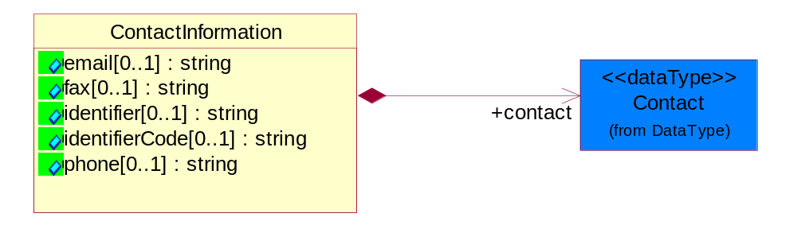
Figure ‎4-15 ContactInformation

Attribute | Type | Documentation
email[0..1] | string | The electronic mail for the specified contact.
fax[0..1] | string | The fax number for the specified contact.
identifier[0..1] | string | Identifies the role of the contact (i.e. Service Technician, Account Manager) in the Business Process.
identifierCode[0..1] | string | IdentifierCode is a unique security authorization code to identify the contact- ie. badge ID.
phone[0..1] | string | The telephone number for the specified contact.

Composition | Cardinality | Type | Documentation
contact | 1 | Contact | The name of the department, service or individual to be contacted within the organization.

DataType

Contact
The name of the department, service or individual to be contacted within the organization.
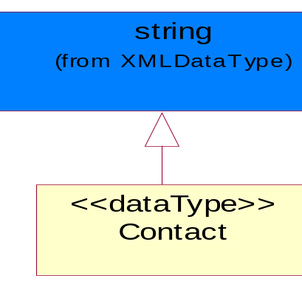
Figure ‎4-16 Contact

DUNS
A number assigned by Dun and Bradstreet to identify a business location.
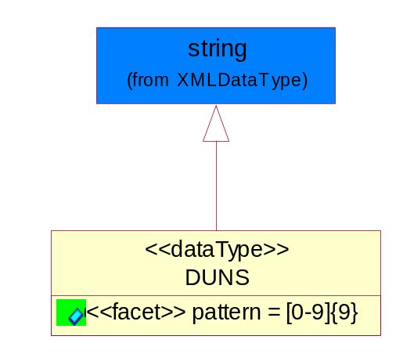
Figure ‎4-17 DUNS

Attribute | Type | Documentation
pattern |  | [0-9]{9}

DUNSPlus4
A identifier to specify a specific location within a business location.
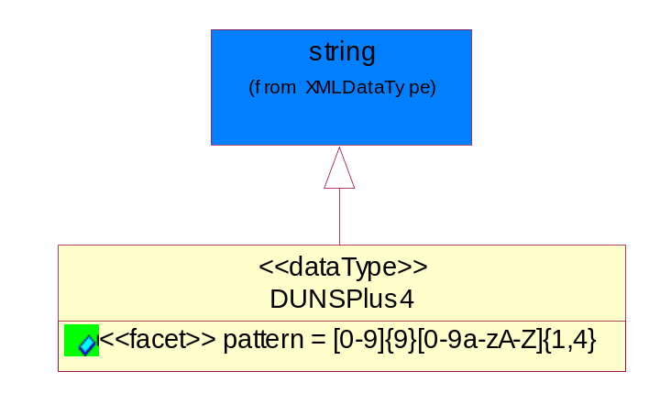
Figure ‎4-18 DUNSPlus4

Attribute | Type | Documentation
pattern |  | Data Universal Numbering System +4 (DUNS+4) number means the DUNS number assigned by Dun and Bradstreet, Inc. (D&B) plus an alphanumeric of length 4 suffix that may be assigned by a business concern.

GLN
Global Location Number (GLN) - A identifier to identify legal entities, trading parties and location.
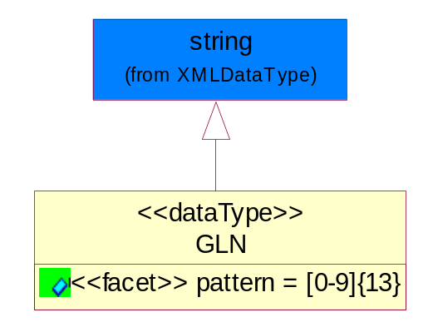
Figure ‎4-19 GLN

Attribute | Type | Documentation
pattern |  | [0-9]{13}

GTIN
Global Trade Identification Number (GTIN).
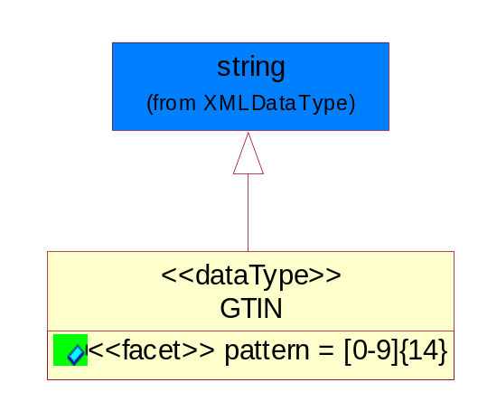
Figure ‎4-20 GTIN

Attribute | Type | Documentation
pattern |  | [0-9]{14}

Document

BusinessDocumentReference
The business document reference object allows for the indirect referencing of a relationship to other business related documents.
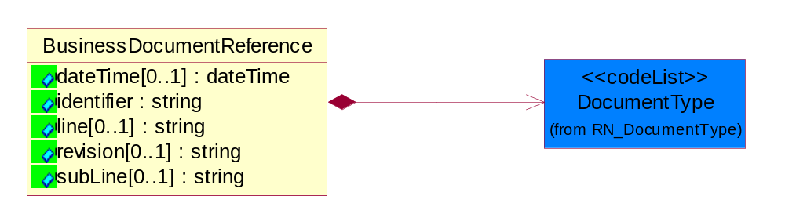
Figure ‎4-21 BusinessDocumentReference

Attribute | Type | Documentation
dateTime[0..1] | dateTime | The date-time stamp indicating on the referenced business document.
identifier | string | Unique identification of the referenced business document.
line[0..1] | string | References the specific line number of the specified business document.
revision[0..1] | string | Referenced the revision of the specified business document.
subLine[0..1] | string | References the specific subline number of the specified business document.

Composition | Cardinality | Type | Documentation
DocumentType | 1 | DocumentType | A code identifying the business context of a document.

Locations

AlternativeIdentifier
Identifies the specified code and the name of the organization that a code is utilized from.
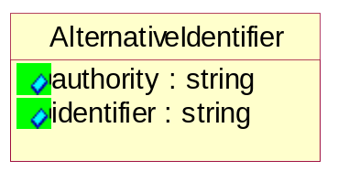
Figure ‎4-22 AlternativeIdentifier

Attribute | Type | Documentation
authority | string | The name of the organization that a code is utilized from.
identifier | string | The specified code to represent an entity (e.g. product, location, partner, etc.).

Location
The business document must specify a location.
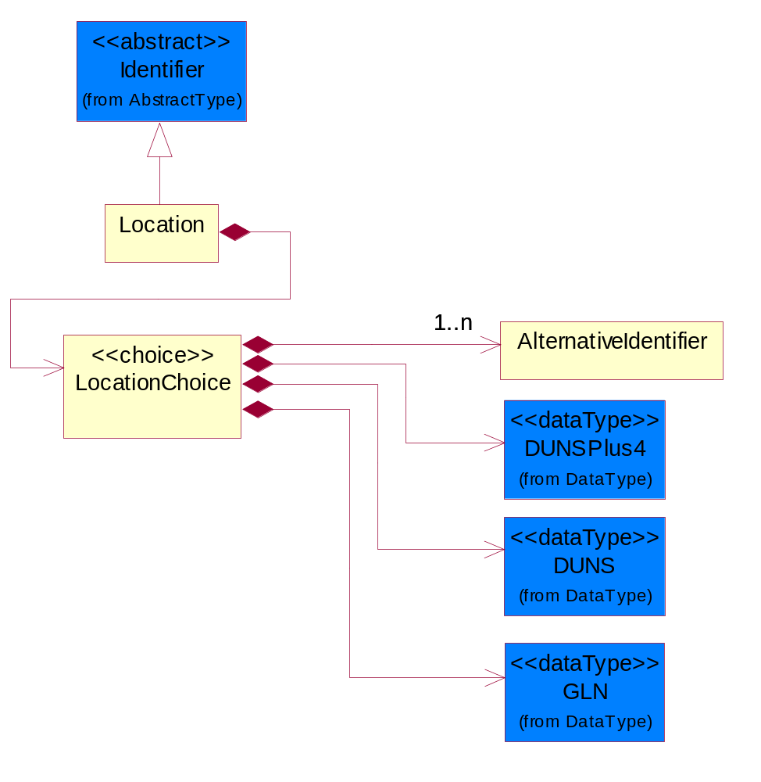
Figure ‎4-23 Location

Composition | Cardinality | Type | Documentation
LocationChoice | 1 | LocationChoice

LocationChoice

Composition | Cardinality | Type | Documentation
DUNSPlus4 | 1 | DUNSPlus4 | A identifier to specify a specific location within a business location.
DUNS | 1 | DUNS | A number assigned by Dun and Bradstreet to identify a business location.
AlternativeIdentifier | 1..n | AlternativeIdentifier | Identifies the specified code and the name of the organization that a code is utilized from.
GLN | 1 | GLN | Global Location Number (GLN) - A identifier to identify legal entities, trading parties and location.

PhysicalAddress
The business document must provide a physical address for a party to the business transaction.
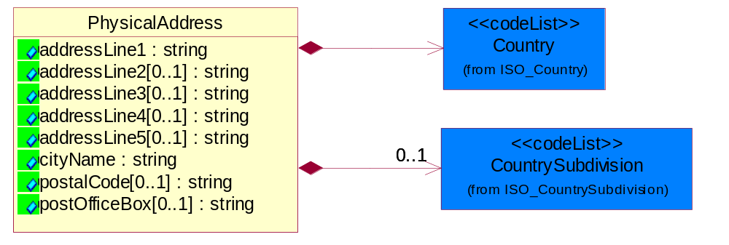
Figure ‎4-24 PhysicalAddress

Attribute | Type | Documentation
addressLine1 | string | The first line of a physical address.
addressLine2[0..1] | string | The second line of a physical address.
addressLine3[0..1] | string | The third line of a physical address.
addressLine4[0..1] | string | The fourth line of a physical address.
addressLine5[0..1] | string | The fifth line of a physical address.
cityName | string | The name of a city.
postalCode[0..1] | string | Identifying geographic location as specified by a national postal code.
postOfficeBox[0..1] | string | The Post Office Box identifier used to identify a party's post office box.

Composition | Cardinality | Type | Documentation
Country | 1 | Country | For representation of Country name RosettaNet has adopted ISO 3166-3; 1999. Refer to the following web page to get the latest version of the standard:  http://www.iso.ch/iso/en/prods-services/iso3166ma/02iso-3166-code-lists/index.html  If you need more information about the ISO standard please contact ISO for more details.
CountrySubdivision | 0..1 | CountrySubdivision | For representation of a Countries subdivisions RosettaNet has adopted ISO 3166-3; 1999. Refer to the following web page to get the latest version of the standard:  http://www.iso.ch/iso/en/prods-services/iso3166ma/02iso-3166-code-lists/index.html  If you need more information about the ISO standard please contact ISO for more details.

MonetaryExpression

FinancialAmount
The business document must express financial amounts.
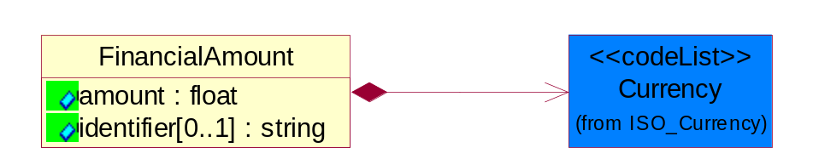
Figure ‎4-25 FinancialAmount

Attribute | Type | Documentation
amount | float | Specifies the monetary amount.
identifier[0..1] | string | Identifier is a unique identifier to which the specific price is tied - ie. promotion name/ program.

Composition | Cardinality | Type | Documentation
Currency | 1 | Currency | For representation of Currency codes RosettaNet has adopted ISO 4217; 1995. The British Standards Institution (BSI) is the ISO 4217 Maintenance Agency. Refer to the following web page to get the latest version of the standard:  http://www.bsi-global.com/Technical+Information/Publications/_Publications/tig90.xalter  If you need more information about the ISO standard please contact ISO for more details.

PartnerIdentification

FullPartner
The business document must describe the trading partners in the business transaction. This data structure provide the flexibility to describe a partner in all possible methods as for new, existing or known partner.
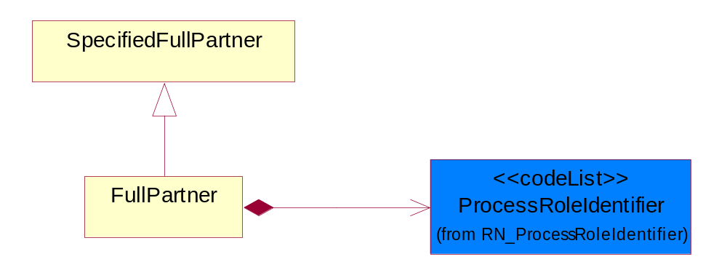
Figure ‎4-26 FullPartner

Composition | Cardinality | Type | Documentation
ProcessRoleIdentifier | 1 | ProcessRoleIdentifier | Describes the role of the partner in the business process. A partner will fulfill at least one or more roles during the business process.

IntermittentPartner
The business document must describe a physical address for a delivery.
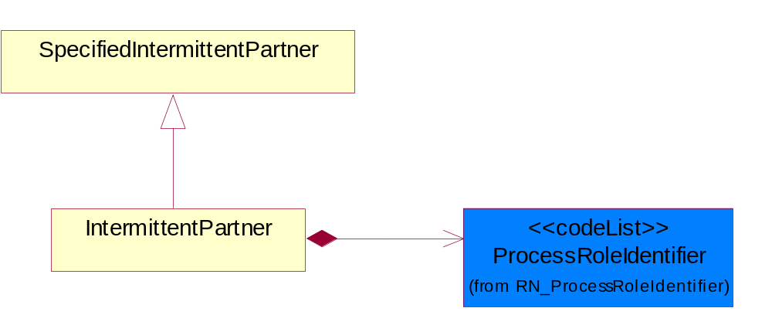
Figure ‎4-27 IntermittentPartner

Composition | Cardinality | Type | Documentation
ProcessRoleIdentifier | 1 | ProcessRoleIdentifier | Describes the role of the partner in the business process. A partner will fulfill at least one or more roles during the business process.

KnownPartner
The business document must describe the trading partners in the business transaction.
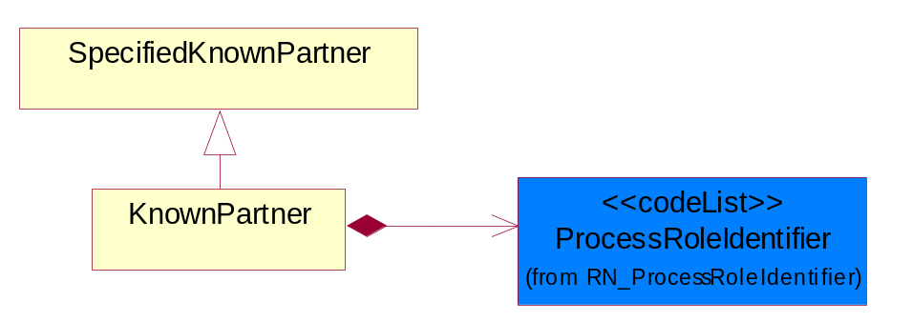
Figure ‎4-28 KnownPartner

Composition | Cardinality | Type | Documentation
ProcessRoleIdentifier | 1 | ProcessRoleIdentifier | Describes the role of the partner in the business process. A partner will fulfill at least one or more roles during the business process.

KnownPartnerContact
The business document must describe the trading partners in the business transaction.
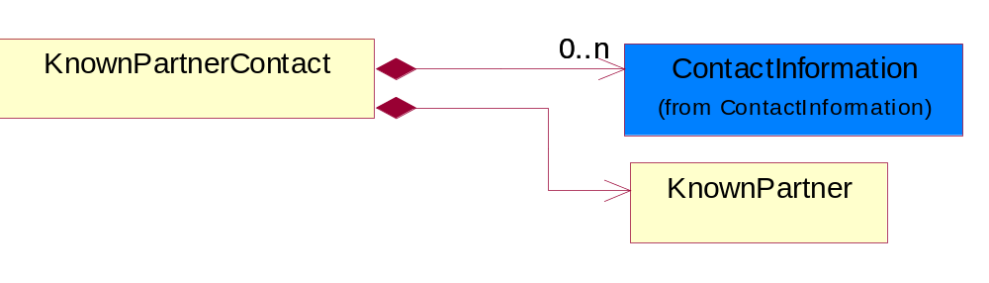
Figure ‎4-29 KnownPartnerContact

Composition | Cardinality | Type | Documentation
KnownPartner | 1 | KnownPartner | The business document must describe the trading partners in the business transaction.
ContactInformation | 0..n | ContactInformation | The business document must allow for the identification of the name of the department, service or individual to be contacted regarding the context of the business document.

NewPartner
The business document must describe a new, existing (but known to only one of the parties to the transaction) or an unknown party to the business transaction.
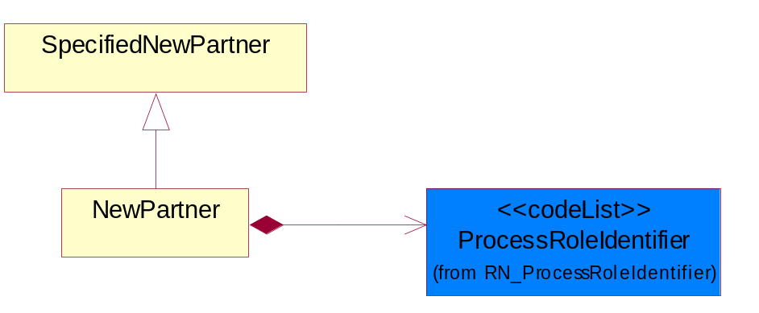
Figure ‎4-30 NewPartner

Composition | Cardinality | Type | Documentation
ProcessRoleIdentifier | 1 | ProcessRoleIdentifier | Describes the role of the partner in the business process. A partner will fulfill at least one or more roles during the business process.

PartnerDescription
The collection of business properties that describe a business partners' identity, their contact information, where they are physically located and their function in a supply chain.
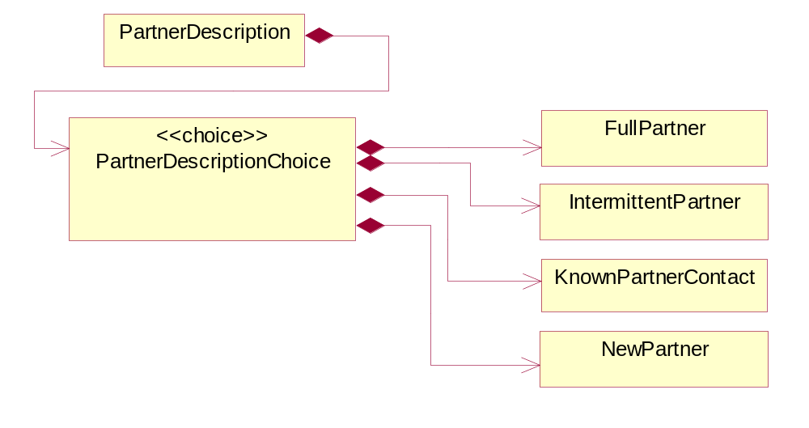
Figure ‎4-31 PartnerDescription

Composition | Cardinality | Type | Documentation
PartnerDescriptionChoice | 1 | PartnerDescriptionChoice

PartnerDescriptionChoice

Composition | Cardinality | Type | Documentation
KnownPartnerContact | 1 | KnownPartnerContact | The business document must describe the trading partners in the business transaction.
IntermittentPartner | 1 | IntermittentPartner | The business document must describe a physical address for a delivery.
NewPartner | 1 | NewPartner | The business document must describe a new, existing (but known to only one of the parties to the transaction) or an unknown party to the business transaction.
FullPartner | 1 | FullPartner | The business document must describe the trading partners in the business transaction. This data structure provide the flexibility to describe a partner in all possible methods as for new, existing or known partner.

PartnerIdentification
The business document must allow for the identity of one or more parties to the transaction.
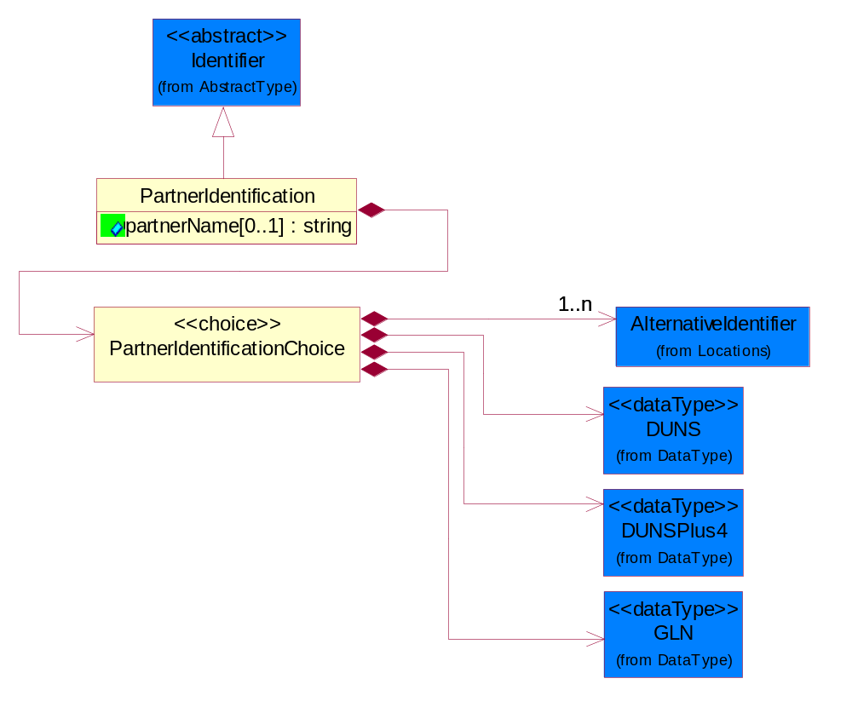
Figure ‎4-32 PartnerIdentification

Attribute | Type | Documentation
partnerName[0..1] | string | The name of the partner’s company/business.

Composition | Cardinality | Type | Documentation
PartnerIdentificationChoice | 1 | PartnerIdentificationChoice

PartnerIdentificationChoice

Composition | Cardinality | Type | Documentation
DUNS | 1 | DUNS | A number assigned by Dun and Bradstreet to identify a business location.
DUNSPlus4 | 1 | DUNSPlus4 | A identifier to specify a specific location within a business location.
AlternativeIdentifier | 1..n | AlternativeIdentifier | Identifies the specified code and the name of the organization that a code is utilized from.
GLN | 1 | GLN | Global Location Number (GLN) - A identifier to identify legal entities, trading parties and location.

SpecifiedFullPartner
The business document must describe the trading partners in the business transaction. This data structure provide the flexibility to describe a partner in all possible methods as for new, existing or known partner. This is specifically for partner who role has been specified.
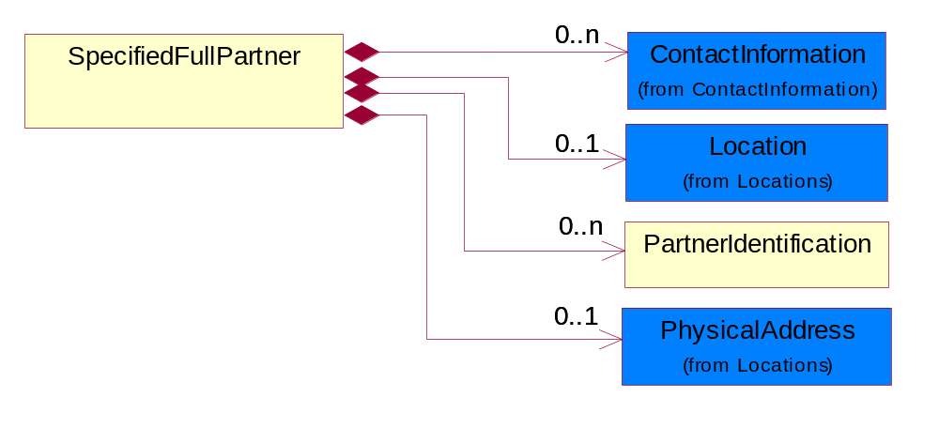
Figure ‎4-33 SpecifiedFullPartner

Composition | Cardinality | Type | Documentation
ContactInformation | 0..n | ContactInformation | The business document must allow for the identification of the name of the department, service or individual to be contacted regarding the context of the business document.
Location | 0..1 | Location | The business document must specify a location.
PartnerIdentification | 0..n | PartnerIdentification | The business document must allow for the identity of one or more parties to the transaction.
PhysicalAddress | 0..1 | PhysicalAddress | The business document must provide a physical address for a party to the business transaction.

SpecifiedIntermittentPartner
The business document must describe a physical address for a delivery.
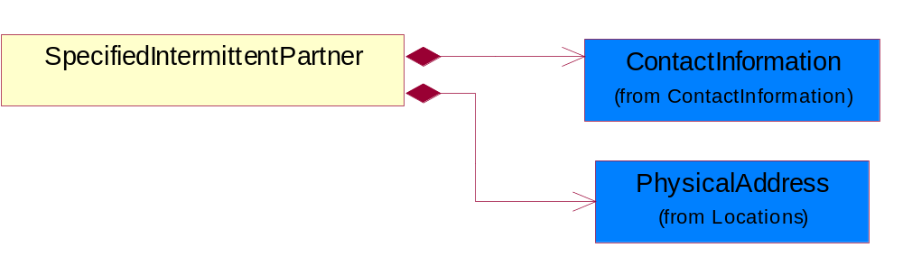
Figure ‎4-34 SpecifiedIntermittentPartner

Composition | Cardinality | Type | Documentation
ContactInformation | 1 | ContactInformation | The business document must allow for the identification of the name of the department, service or individual to be contacted regarding the context of the business document.
PhysicalAddress | 1 | PhysicalAddress | The business document must provide a physical address for a party to the business transaction.

SpecifiedKnownPartner
The business document must describe the trading partners in the business transaction.
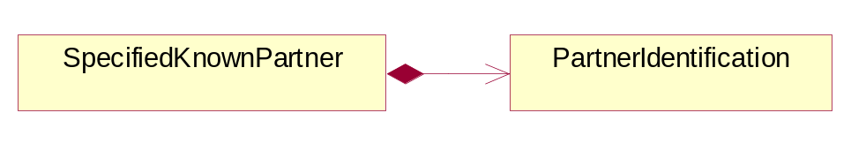
Figure ‎4-35 SpecifiedKnownPartner

Composition | Cardinality | Type | Documentation
PartnerIdentification | 1 | PartnerIdentification | The business document must allow for the identity of one or more parties to the transaction.

SpecifiedKnownPartnerContact
The business document must describe the trading partners in the business transaction and allow for a identification of an individual of the trading partner.
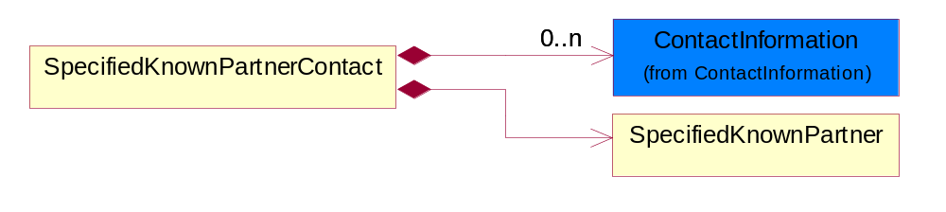
Figure ‎4-36 SpecifiedKnownPartnerContact

Composition | Cardinality | Type | Documentation
SpecifiedKnownPartner | 1 | SpecifiedKnownPartner | The business document must describe the trading partners in the business transaction.
ContactInformation | 0..n | ContactInformation | The business document must allow for the identification of the name of the department, service or individual to be contacted regarding the context of the business document.

SpecifiedNewPartner
The business document must describe a new, existing (but known to only one of the parties to the transaction) or an unknown party to the business transaction.
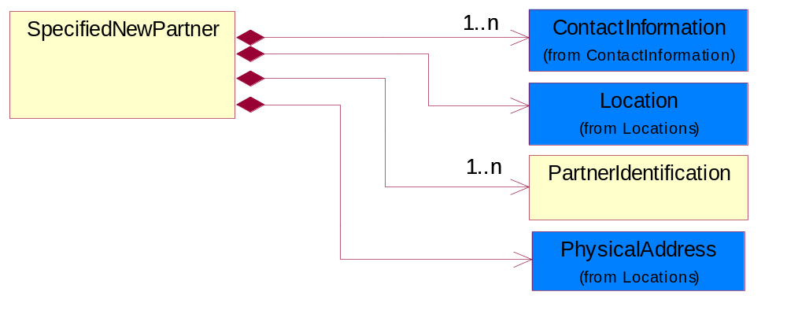
Figure ‎4-37 SpecifiedNewPartner

Composition | Cardinality | Type | Documentation
ContactInformation | 1..n | ContactInformation | The business document must allow for the identification of the name of the department, service or individual to be contacted regarding the context of the business document.
Location | 1 | Location | The business document must specify a location.
PhysicalAddress | 1 | PhysicalAddress | The business document must provide a physical address for a party to the business transaction.
PartnerIdentification | 1..n | PartnerIdentification | The business document must allow for the identity of one or more parties to the transaction.

SpecifiedPartnerDescription
The collection of business properties that describe a business partners' identity, their contact information, where they are physically located and their function in a supply chain.
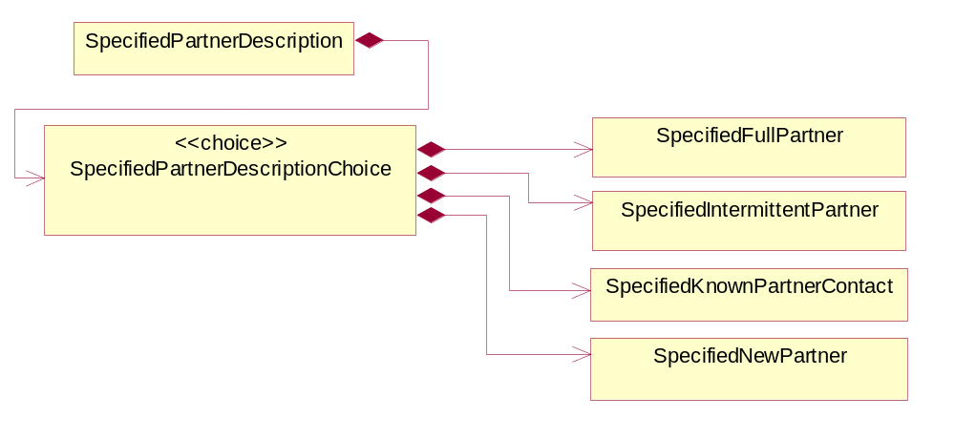
Figure ‎4-38 SpecifiedPartnerDescription

Composition | Cardinality | Type | Documentation
SpecifiedPartnerDescriptionChoice | 1 | SpecifiedPartnerDescriptionChoice

SpecifiedPartnerDescriptionChoice

Composition | Cardinality | Type | Documentation
SpecifiedKnownPartnerContact | 1 | SpecifiedKnownPartnerContact | The business document must describe the trading partners in the business transaction and allow for a identification of an individual of the trading partner.
SpecifiedIntermittentPartner | 1 | SpecifiedIntermittentPartner | The business document must describe a physical address for a delivery.
SpecifiedNewPartner | 1 | SpecifiedNewPartner | The business document must describe a new, existing (but known to only one of the parties to the transaction) or an unknown party to the business transaction.
SpecifiedFullPartner | 1 | SpecifiedFullPartner | The business document must describe the trading partners in the business transaction. This data structure provide the flexibility to describe a partner in all possible methods as for new, existing or known partner. This is specifically for partner who role has been specified.

ProductIdentification

ProductIdentification
The object provides the identifier(s) of a product.
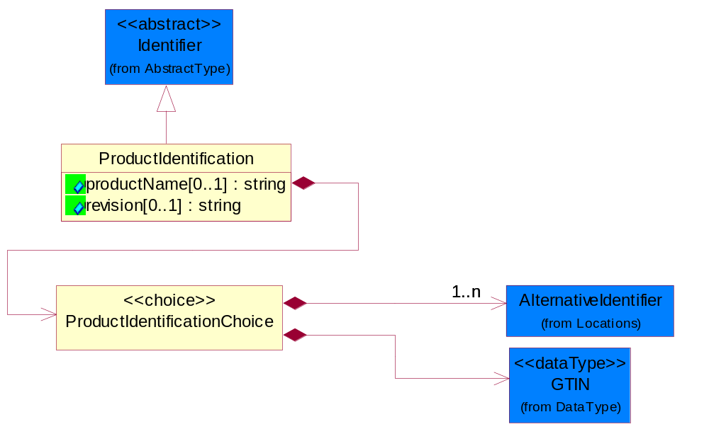
Figure ‎4-39 ProductIdentification

Attribute | Type | Documentation
productName[0..1] | string | The name of the product.
revision[0..1] | string | Referenced the specified product revision.

Composition | Cardinality | Type | Documentation
ProductIdentificationChoice | 1 | ProductIdentificationChoice

ProductIdentificationChoice

Composition | Cardinality | Type | Documentation
AlternativeIdentifier | 1..n | AlternativeIdentifier | Identifies the specified code and the name of the organization that a code is utilized from.
GTIN | 1 | GTIN | Global Trade Identification Number (GTIN).

CodeList

Country
For representation of Country name RosettaNet has adopted ISO 3166-3; 1999. Refer to the following web page to get the latest version of the standard:
http://www.iso.ch/iso/en/prods-services/iso3166ma/02iso-3166-code-lists/index.html

If you need more information about the ISO standard please contact ISO for more details.

CountrySubdivision
For representation of a Countries subdivisions RosettaNet has adopted ISO 3166-3; 1999. Refer to the following web page to get the latest version of the standard:
http://www.iso.ch/iso/en/prods-services/iso3166ma/02iso-3166-code-lists/index.html

If you need more information about the ISO standard please contact ISO for more details.

Currency
For representation of Currency codes RosettaNet has adopted ISO 4217; 1995. The British Standards Institution (BSI) is the ISO 4217 Maintenance Agency. Refer to the following web page to get the latest version of the standard:
http://www.bsi-global.com/Technical+Information/Publications/_Publications/tig90.xalter

If you need more information about the ISO standard please contact ISO for more details.

Language
For representation of Language name RosettaNet has adopted ISO 639-2; 1998. Refer to the following web page to get the latest version of the standard:

http://www.loc.gov/standards/iso639-2/iso639jac.html

If you need more information about the ISO standard please contact ISO for more details.

DocumentType
A code identifying the business context of a document.

Instance | Documentation
APM | Applied Promotions.
ARA | Authorization Request Approval.
CAR | Certificate of Analysis Response.
CBN | Product batch number of customer.
CCN | Customs clearance number.
CFA | Failure Analysis - Request document that will accompany the product providing characteristics of the component failure.
CIN | Commercial Invoice.
CNM | Traditional credit note or memo.
COA | Certificate of Analysis.
CON | In a virtual sourcing relationship, a third party trading partner is supplying a part to a customer on behalf of another company that has taken the order for the customer. In this case a Customer Order Number is associated to the request for material that is sent to the virtual trading partners.
COS | Consumption Notice.
COT | Contract.
CRN | Unique consumption reference number identifying the product consumption issue i.e. one-to-one relationship with physical flow.
DEM | Traditional debit note or memo.
DEN | Delivery Note.
DIN | Discontinuation Notice.
DOR | Delivery Order.
DRN | Drawing Number.
DRR | Design Registration Request.
ECO | Engineering Change Order - The proprietary unique identification number that represents an engineering change order.
EDD | Export Declaration Document.
EIR | Engineering Information Request.
EOL | End of Life.
FUO | Sales order or transfer order fulfilling demand out of a facility (outbound shipment).
IDD | Import Declaration Document.
INV | Invoice.
LID | Location Identifier. Data for on-site work that have to be done on the machine (associated with preventive maintenance order).
MEN | Master Event Number.
MID | Machine Identifier. Data for on-site work that have to be done on the machine (associated with preventive maintenance order).
MON | Model Number.
NTS | Notes.
OCL | The unique identifier assigned by the OEM for a warranty claim.
OGA | Other governmental agency issued document.
OPO | The unique identifier assigned by the OEM for a part order.
OPR | The unique identifier assigned by the OEM for a part return.
PCN | Product/Process Change.
PFA | Failure Analysis - Request document that will accompany the product providing characteristics of the product failure.
PII | Refers to previously issued invoice.
PLS | Unique number that identifies packing form prior to shipment.
POI | Purchase Order IN.
PON | Production order number for material release.
POO | Purchase Order OUT.
PRC | Product Catalog.
PSI | Refers to previously issued self-billing invoice.
PUO | Purchase Order.
QUO | Quote.
REC | Document identifying the receipt of materials or products into a facility against a purchase order or transfer order (inbound shipment).
REN | Release Number.
REO | Purchase order or transfer order replenishing inventory into a facility (inbound shipment).
REQ | Requisition.
RMA | Returned Material Authorization.
RPO | Purchase order for materials or product returned to and reworked by a supplier.
RTA | Remittance Advice - Remittance details.
SAO | Sales Order.
SBC | Credit Memo used in self-billing scenario.
SBD | Debit Memo used in self-billing scenario.
SBI | Invoice in self billing scenario.
SBN | Product batch number of supplier.
SCA | Similar to contracts - Contains the quantity of an article that is to be ordered from a vendor and the price for article or service that is to be procured.
SEN | Serial Number.
SEO | A document that gives a repair provider the necessary authorization to repair or upgrade a product either at the customer site or at the repair provider’s site.
SHD | Shipping Document.
SNC | Shipset Number on Code List.
SPC | The unique identifier assigned by the ASP for a warranty claim.
SPN | Spec Number.
SPO | The unique identifier assigned by the ASP for a part order.
SPR | The unique identifier assigned by the ASP for a part return.
SPW | The unique identifier assigned by the ASP to reference a work order.
SRI | A document that contains the shipping reference number which allows the product to be tracked within the outsourced logistic providers network.
SWT | Switch Authorization.
TCS | Terms and Conditions.
TRO | Order which results in materials or products being moved from one facility to another (outbound shipment and inbound shipment).
WAB | Waybill.
WAC | Denotes a warranty claim.
WOO | Work Order.

MimeTypeQualifier
The MIME type as defined by IANA.

Please refer to http://www.iana.org/assignments/media-types/ for a list of types.

Instance | Documentation
application/activemessage | [Shapiro]
application/andrew-inset | [Borenstein]
application/applefile | [Faltstrom]
application/atomicmail | [Borenstein]
application/batch-SMTP | [RFC2442]
application/beep+xml | [RFC3080]
application/cals-1840 | [RFC1895]
application/cnrp+xml | [RFCCNRP]
application/commonground | [Glazer]
application/cpl+xml
application/cybercash | [Eastlake]
application/dca-rft | [Campbell]
application/dec-dx | [Campbell]
application/dicom | [RFC3240]
application/dvcs | [RFC3029]
application/EDI-Consent | [RFC1767]
application/EDIFACT | [RFC1767]
application/EDI-X12 | [RFC1767]
application/eshop | [Katz]
application/font-tdpfr | [RFC3073]
application/http | [RFC2616]
application/hyperstudio | [Domino]
application/iges | [Parks]
application/index | [RFC2652]
application/index.cmd | [RFC2652]
application/index.obj | [RFC2652]
application/index.response | [RFC2652]
application/index.vnd | [RFC2652]
application/iotp | [RFC2935]
application/ipp | [RFC2910]
application/isup | [RFC3204]
application/mac-binhex40 | [Faltstrom]
application/macwriteii | [Lindner]
application/marc | [RFC2220]
application/mathematica | [Van Nostern]
application/msword | [Lindner]
application/news-message-id | [RFC1036,Spencer]
application/news-transmission | [RFC1036, Spencer]
application/ocsp-request | [RFC2560]
application/ocsp-response | [RFC2560]
application/octet-stream | [RFC2045,RFC2046]
application/oda | [RFC2045,RFC2046]
application/ogg | [RFC-walleij-ogg-mediatype-08.txt]
application/parityfec | [RFC3009]
application/pdf | [Lindner]
application/pgp-encrypted | [RFC3156]
application/pgp-keys | [RFC3156]
application/pgp-signature | [RFC3156]
application/pkcs10 | [RFC2311]
application/pkcs7-mime | [RFC2311]
application/pkcs7-signature | [RFC2311]
application/pkix-cert | [RFC2585]
application/pkixcmp | [RFC2510]
application/pkix-crl | [RFC2585]
application/postscript | [RFC2045,RFC2046]
application/prs.alvestrand.titrax-sheet | [Alvestrand]
application/prs.cww | [Rungchavalnont]
application/prs.nprend | [Doggett]
application/prs.plucker | [Janssen]
application/qsig | [RFC3204]
application/reginfo+xml | [RFC-ietf-sipping-reg-event-00.txt]
application/remote-printing | [RFC1486,Rose]
application/riscos | [Smith]
application/rtf | [Lindner]
application/sdp | [RFC2327]
application/set-payment | [Korver]
application/set-payment-initiation | [Korver]
application/set-registration | [Korver]
application/set-registration-initiation | [Korver]
application/sgml | [RFC1874]
application/sgml-open-catalog | [Grosso]
application/sieve | [RFC3028]
application/slate | [Crowley]
application/timestamp-query | [RFC3161]
application/timestamp-reply | [RFC3161]
application/tve-trigger | [Welsh]
application/vemmi | [RFC2122]
application/vnd.3gpp.pic-bw-large | [Meredith]
application/vnd.3gpp.pic-bw-small | [Meredith]
application/vnd.3gpp.pic-bw-var | [Meredith]
application/vnd.3gpp.sms | [Meredith]
application/vnd.3M.Post-it-Notes | [O'Brien]
application/vnd.accpac.simply.aso | [Leow]
application/vnd.accpac.simply.imp | [Leow]
application/vnd.acucobol | [Lubin]
application/vnd.acucorp | [Lubin]
application/vnd.adobe.xfdf | [Perelman]
application/vnd.aether.imp | [Moskowitz]
application/vnd.amiga.ami | [Blumberg]
application/vnd.anser-web-certificate-issue-initiation | [Mori]
application/vnd.anser-web-funds-transfer-initiation | [Mori]
application/vnd.audiograph | [Slusanschi]
application/vnd.blueice.multipass | [Holmstrom]
application/vnd.bmi | [Gotoh]
application/vnd.businessobjects | [Imoucha]
application/vnd.canon-cpdl | [Muto]
application/vnd.canon-lips | [Muto]
application/vnd.cinderella | [Kortenkamp]
application/vnd.claymore | [Simpson]
application/vnd.commerce-battelle | [Applebaum]
application/vnd.commonspace | [Chandhok]
application/vnd.contact.cmsg | [Patz]
application/vnd.cosmocaller | [Dellutri]
application/vnd.ctc-posml | [Kohlhepp]
application/vnd.cups-postscript | [Sweet]
application/vnd.cups-raster | [Sweet]
application/vnd.cups-raw | [Sweet]
application/vnd.curl | [Byrnes]
application/vnd.cybank | [Helmee]
application/vnd.data-vision.rdz | [Fields]
application/vnd.dna | [Searcy]
application/vnd.dpgraph | [Parker]
application/vnd.dreamfactory | [Appleton]
application/vnd.dxr | [Duffy]
application/vnd.ecdis-update | [Buettgenbach]
application/vnd.ecowin.chart | [Olsson]
application/vnd.ecowin.filerequest | [Olsson]
application/vnd.ecowin.fileupdate | [Olsson]
application/vnd.ecowin.series | [Olsson]
application/vnd.ecowin.seriesrequest | [Olsson]
application/vnd.ecowin.seriesupdate | [Olsson]
application/vnd.enliven | [Santinelli]
application/vnd.epson.esf | [Hoshina]
application/vnd.epson.msf | [Hoshina]
application/vnd.epson.quickanime | [Gu]
application/vnd.epson.salt | [Nagatomo]
application/vnd.epson.ssf | [Hoshina]
application/vnd.ericsson.quickcall | [Tidwell]
application/vnd.eudora.data | [Resnick]
application/vnd.fdf | [Zilles]
application/vnd.ffsns | [Holstage]
application/vnd.FloGraphIt | [Floersch]
application/vnd.framemaker | [Wexler]
application/vnd.fsc.weblaunch | [D.Smith]
application/vnd.fujitsu.oasys | [Togashi]
application/vnd.fujitsu.oasys2 | [Togashi]
application/vnd.fujitsu.oasys3 | [Okudaira]
application/vnd.fujitsu.oasysgp | [Sugimoto]
application/vnd.fujitsu.oasysprs | [Ogita]
application/vnd.fujixerox.ddd | [Onda]
application/vnd.fujixerox.docuworks | [Taguchi]
application/vnd.fujixerox.docuworks.binder | [Matsumoto]
application/vnd.fut-misnet | [Pruulmann]
application/vnd.grafeq | [Tupper]
application/vnd.groove-account | [Joseph]
application/vnd.groove-help | [Joseph]
application/vnd.groove-identity-message | [Joseph]
application/vnd.groove-injector | [Joseph]
application/vnd.groove-tool-message | [Joseph]
application/vnd.groove-tool-template | [Joseph]
application/vnd.groove-vcard | [Joseph]
application/vnd.hbci | [Hammann]
application/vnd.hhe.lesson-player | [Jones]
application/vnd.hp-HPGL | [Pentecost]
application/vnd.hp-hpid | [Gupta]
application/vnd.hp-hps | [Aubrey]
application/vnd.hp-PCL | [Pentecost]
application/vnd.hp-PCLXL | [Pentecost]
application/vnd.httphone | [Lefevre]
application/vnd.hzn-3d-crossword | [Minnis]
application/vnd.ibm.afplinedata | [Buis]
application/vnd.ibm.electronic-media | [Tantlinger]
application/vnd.ibm.MiniPay | [Herzberg]
application/vnd.ibm.modcap | [Hohensee]
application/vnd.ibm.secure-container | [Tantlinger]
application/vnd.informix-visionary | [Gales]
application/vnd.intercon.formnet | [Gurak]
application/vnd.intertrust.digibox | [Tomasello]
application/vnd.intertrust.nncp | [Tomasello]
application/vnd.intu.qbo | [Scratchley]
application/vnd.intu.qfx | [Scratchley]
application/vnd.irepository.package+xml | [Knowles]
application/vnd.is-xpr | [Natarajan]
application/vnd.japannet-directory-service | [Fujii]
application/vnd.japannet-jpnstore-wakeup | [Yoshitake]
application/vnd.japannet-payment-wakeup | [Fujii]
application/vnd.japannet-registration | [Yoshitake]
application/vnd.japannet-registration-wakeup | [Fujii]
application/vnd.japannet-setstore-wakeup | [Yoshitake]
application/vnd.japannet-verification | [Yoshitake]
application/vnd.japannet-verification-wakeup | [Fujii]
application/vnd.jisp | [Deckers]
application/vnd.kde.karbon | [Faure]
application/vnd.kde.kchart | [Faure]
application/vnd.kde.kformula | [Faure]
application/vnd.kde.kivio | [Faure]
application/vnd.kde.kontour | [Faure]
application/vnd.kde.kpresenter | [Faure]
application/vnd.kde.kspread | [Faure]
application/vnd.kde.kword | [Faure]
application/vnd.kenameaapp | [DiGiorgio-Haag]
application/vnd.koan | [Cole]
application/vnd.liberty-request+xml | [McDowell]
application/vnd.llamagraphics.life-balance.desktop | [White]
application/vnd.lotus-1-2-3 | [Wattenberger]
application/vnd.lotus-approach | [Wattenberger]
application/vnd.lotus-freelance | [Wattenberger]
application/vnd.lotus-notes | [Laramie]
application/vnd.lotus-organizer | [Wattenberger]
application/vnd.lotus-screencam | [Wattenberger]
application/vnd.lotus-wordpro | [Wattenberger]
application/vnd.mcd | [Gotoh]
application/vnd.mediastation.cdkey | [Flurry]
application/vnd.meridian-slingshot | [Wedel]
application/vnd.micrografx.flo | [Prevo]
application/vnd.micrografx.igx | [Prevo]
application/vnd.mif | [Wexler]
application/vnd.minisoft-hp3000-save | [Bartram]
application/vnd.mitsubishi.misty-guard.trustweb | [Tanaka]
application/vnd.Mobius.DAF | [Kabayama]
application/vnd.Mobius.DIS | [Kabayama]
application/vnd.Mobius.MBK | [Devasia]
application/vnd.Mobius.MQY | [Devasia]
application/vnd.Mobius.MSL | [Kabayama]
application/vnd.Mobius.PLC | [Kabayama]
application/vnd.Mobius.TXF | [Kabayama]
application/vnd.mophun.application | [Wennerstrom]
application/vnd.mophun.certificate | [Wennerstrom]
application/vnd.motorola.flexsuite | [Patton]
application/vnd.motorola.flexsuite.adsi | [Patton]
application/vnd.motorola.flexsuite.fis | [Patton]
application/vnd.motorola.flexsuite.gotap | [Patton]
application/vnd.motorola.flexsuite.kmr | [Patton]
application/vnd.motorola.flexsuite.ttc | [Patton]
application/vnd.motorola.flexsuite.wem | [Patton]
application/vnd.mozilla.xul+xml | [McDaniel]
application/vnd.ms-artgalry | [Slawson]
application/vnd.ms-asf | [Fleischman]
application/vnd.mseq | [Le Bodic]
application/vnd.ms-excel | [Gill]
application/vnd.msign | [Borcherding]
application/vnd.ms-lrm | [Ledoux]
application/vnd.ms-powerpoint | [Gill]
application/vnd.ms-project | [Gill]
application/vnd.ms-tnef | [Gill]
application/vnd.ms-works | [Gill]
application/vnd.ms-wpl | [Plastina]
application/vnd.musician | [Adams]
application/vnd.music-niff | [Butler]
application/vnd.netfpx | [Mutz]
application/vnd.noblenet-directory | [Solomon]
application/vnd.noblenet-sealer | [Solomon]
application/vnd.noblenet-web | [Solomon]
application/vnd.novadigm.EDM | [Swenson]
application/vnd.novadigm.EDX | [Swenson]
application/vnd.novadigm.EXT | [Swenson]
application/vnd.obn | [Hessling]
application/vnd.osa.netdeploy | [Klos]
application/vnd.palm | [Peacock]
application/vnd.pg.format | [Gandert]
application/vnd.pg.osasli | [Gandert]
application/vnd.powerbuilder6 | [Guy]
application/vnd.powerbuilder6-s | [Guy]
application/vnd.powerbuilder7 | [Shilts]
application/vnd.powerbuilder75 | [Shilts]
application/vnd.powerbuilder75-s | [Shilts]
application/vnd.powerbuilder7-s | [Shilts]
application/vnd.previewsystems.box | [Smolgovsky]
application/vnd.publishare-delta-tree | [Ben-Kiki]
application/vnd.pvi.ptid1 | [Lamb]
application/vnd.pwg-multiplexed | [RFC3391]
application/vnd.pwg-xhtml-print+xml | [Wright]
application/vnd.Quark.QuarkXPress | [Scheidler]
application/vnd.rapid | [Szekely]
application/vnd.s3sms | [Tarkkala]
application/vnd.sealed.net | [Lambert]
application/vnd.seemail | [Webb]
application/vnd.shana.informed.formdata | [Selzler]
application/vnd.shana.informed.formtemplate | [Selzler]
application/vnd.shana.informed.interchange | [Selzler]
application/vnd.shana.informed.package | [Selzler]
application/vnd.smaf | [Takahashi]
application/vnd.sss-cod | [Dani]
application/vnd.sss-dtf | [Bruno]
application/vnd.sss-ntf | [Bruno]
application/vnd.street-stream | [Levitt]
application/vnd.svd | [Becker]
application/vnd.swiftview-ics | [Widener]
application/vnd.triscape.mxs | [Simonoff]
application/vnd.trueapp | [Hepler]
application/vnd.truedoc | [Chase]
application/vnd.ufdl | [Manning]
application/vnd.uplanet.alert | [Martin]
application/vnd.uplanet.alert-wbxml | [Martin]
application/vnd.uplanet.bearer-choice | [Martin]
application/vnd.uplanet.bearer-choice-wbxml | [Martin]
application/vnd.uplanet.cacheop | [Martin]
application/vnd.uplanet.cacheop-wbxml | [Martin]
application/vnd.uplanet.channel | [Martin]
application/vnd.uplanet.channel-wbxml | [Martin]
application/vnd.uplanet.list | [Martin]
application/vnd.uplanet.listcmd | [Martin]
application/vnd.uplanet.listcmd-wbxml | [Martin]
application/vnd.uplanet.list-wbxml | [Martin]
application/vnd.uplanet.signal | [Martin]
application/vnd.vcx | [T.Sugimoto]
application/vnd.vectorworks | [Pharr]
application/vnd.vidsoft.vidconference | [Hess]
application/vnd.visio | [Sandal]
application/vnd.visionary | [Aravindakumar]
application/vnd.vividence.scriptfile | [Risher]
application/vnd.vsf | [Rowe]
application/vnd.wap.sic | [WAP-Forum]
application/vnd.wap.slc | [WAP-Forum]
application/vnd.wap.wbxml | [Stark]
application/vnd.wap.wmlc | [Stark]
application/vnd.wap.wmlscriptc | [Stark]
application/vnd.webturbo | [Rehem]
application/vnd.wrq-hp3000-labelled | [Bartram]
application/vnd.wt.stf | [Wohler]
application/vnd.wv.csp+wbxml | [Salmi]
application/vnd.xara | [Matthewman]
application/vnd.xfdl | [Manning]
application/vnd.yellowriver-custom-menu | [Yellow]
application/whoispp-query | [RFC2957]
application/whoispp-response | [RFC2958]
application/wita | [Campbell]
application/wordperfect5.1 | [Lindner]
application/x400-bp | [RFC1494]
application/xhtml+xml | [RFC3236]
application/xml | [RFC3023]
application/xml-dtd | [RFC3023]
application/xml-external-parsed-entity | [RFC3023]
application/zip | [Lindner]
audio/32kadpcm | [RFC2421,RFC2422]
audio/AMR | [RFC3267]
audio/AMR-WB | [RFC3267]
audio/basic | [RFC2045,RFC2046]
audio/CN | [RFC3389]
audio/DAT12 | [RFC3190]
audio/DVI4
audio/EVRC | [RFC-ietf-avt-evrc-smv-03.txt]
audio/EVRC0 | [RFC-ietf-avt-evrc-smv-03.txt]
audio/G.722.1 | [RFC3047]
audio/G722
audio/G723
audio/G726-16
audio/G726-24
audio/G726-32
audio/G726-40
audio/G728
audio/G729
audio/G729D
audio/G729E
audio/GSM
audio/GSM-EFR
audio/L16 | [RFC2586]
audio/L20 | [RFC3190]
audio/L24 | [RFC3190]
audio/L8
audio/LPC
audio/MP4A-LATM | [RFC3016]
audio/MPA
audio/mpa-robust | [RFC3119]
audio/mpeg | [RFC3003]
audio/parityfec | [RFC3009]
audio/PCMA
audio/PCMU
audio/prs.sid | [Walleij]
audio/QCELP
audio/RED
audio/SMV | [RFC-ietf-avt-evrc-smv-03.txt]
audio/SMV0 | [RFC-ietf-avt-evrc-smv-03.txt]
audio/telephone-event | [RFC2833]
audio/tone | [RFC2833]
audio/VDVI
audio/vnd.3gpp.iufp | [Belling]
audio/vnd.cisco.nse | [Kumar]
audio/vnd.cns.anp1 | [McLaughlin]
audio/vnd.cns.inf1 | [McLaughlin]
audio/vnd.digital-winds | [Strazds]
audio/vnd.everad.plj | [Cicelsky]
audio/vnd.lucent.voice | [Vaudreuil]
audio/vnd.nortel.vbk | [Parsons]
audio/vnd.nuera.ecelp4800 | [Fox]
audio/vnd.nuera.ecelp7470 | [Fox]
audio/vnd.nuera.ecelp9600 | [Fox]
audio/vnd.octel.sbc | [Vaudreuil]
audio/vnd.qcelp | [Lundblade]
audio/vnd.rhetorex.32kadpcm | [Vaudreuil]
audio/vnd.vmx.cvsd | [Vaudreuil]
image/cgm | Computer Graphics Metafile
image/g3fax | [RFC1494]
image/gif | [RFC2045,RFC2046]
image/ief | [RFC1314] Image Exchange Format
image/jpeg | [RFC2045,RFC2046]
image/naplps | [Ferber]
image/png | [Randers-Pehrson]
image/prs.btif | [Simon]
image/prs.pti | [Laun]
image/t38 | [RFC3362]
image/tiff | [RFC3302] Tag Image File Format
image/tiff-fx | [RFC3250] Tag Image File Format Fax eXtended
image/vnd.cns.inf2 | [McLaughlin]
image/vnd.djvu | [Bottou]
image/vnd.dwg | [Moline]
image/vnd.dxf | [Moline]
image/vnd.fastbidsheet | [Becker]
image/vnd.fpx | [Spencer]
image/vnd.fst | [Fuldseth]
image/vnd.fujixerox.edmics-mmr | [Onda]
image/vnd.fujixerox.edmics-rlc | [Onda]
image/vnd.globalgraphics.pgb | [Bailey]
image/vnd.mix | [Reddy]
image/vnd.ms-modi | [Vaughan]
image/vnd.net-fpx | [Spencer]
image/vnd.svf | [Moline]
image/vnd.wap.wbmp | [Stark]
image/vnd.xiff | [S.Martin]
message/delivery-status | [RFC1894]
message/disposition-notification | [RFC2298]
message/external-body | [RFC2045,RFC2046]
message/http | [RFC2616]
message/news | [RFC 1036, H.Spencer]
message/partial | [RFC2045,RFC2046]
message/rfc822 | [RFC2045,RFC2046]
message/s-http | [RFC2660]
message/sip | [RFC3261]
message/sipfrag | [RFC3420]
model/iges | [Parks]
model/mesh | [RFC2077]
model/vnd.dwf | [Pratt]
model/vnd.flatland.3dml | [Powers]
model/vnd.gdl | [Babits]
model/vnd.gs-gdl | [Babits]
model/vnd.gtw | [Ozaki]
model/vnd.mts | [Rabinovitch]
model/vnd.parasolid.transmit.binary | [Parasolid]
model/vnd.parasolid.transmit.text | [Parasolid]
model/vnd.vtu | [Rabinovitch]
model/vrml | [RFC2077]
multipart/alternative | [RFC2045,RFC2046]
multipart/appledouble | [Faltstrom]
multipart/byteranges | [RFC2068]
multipart/digest | [RFC2045,RFC2046]
multipart/encrypted | [RFC1847]
multipart/form-data | [RFC2388]
multipart/header-set | [Crocker]
multipart/mixed | [RFC2045,RFC2046]
multipart/parallel | [RFC2045,RFC2046]
multipart/related | [RFC2387]
multipart/report | [RFC1892]
multipart/signed | [RFC1847]
multipart/voice-message | [RFC2421,RFC2423]
text/calendar | [RFC2445]
text/css | [RFC2318]
text/directory | [RFC2425]
text/enriched | [RFC1896]
text/html | [RFC2854]
text/parityfec | [RFC3009]
text/plain | [RFC2646,RFC2046]
text/prs.lines.tag | [Lines]
text/rfc822-headers | [RFC1892]
text/richtext | [RFC2045,RFC2046]
text/rtf | [Lindner]
text/sgml | [RFC1874]
text/t140 | [RFC2793]
text/tab-separated-values | [Lindner]
text/uri-list | [RFC2483]
text/vnd.abc | [Allen]
text/vnd.curl | [Byrnes]
text/vnd.DMClientScript | [Bradley]
text/vnd.fly | [Gurney]
text/vnd.fmi.flexstor | [Hurtta]
text/vnd.in3d.3dml | [Powers]
text/vnd.in3d.spot | [Powers]
text/vnd.IPTC.NewsML | [IPTC]
text/vnd.IPTC.NITF | [IPTC]
text/vnd.latex-z | [Lubos]
text/vnd.motorola.reflex | [Patton]
text/vnd.ms-mediapackage | [Nelson]
text/vnd.net2phone.commcenter.command | [Xie]
text/vnd.sun.j2me.app-descriptor | [G.Adams]
text/vnd.wap.si | [WAP-Forum]
text/vnd.wap.sl | [WAP-Forum]
text/vnd.wap.wml | [Stark]
text/vnd.wap.wmlscript | [Stark]
text/xml | [RFC3023]
text/xml-external-parsed-entity | [RFC3023]
video/BMPEG
video/BT656
video/CelB
video/DV | [RFC3189]
video/H261
video/H263
video/H263-1998
video/H263-2000
video/JPEG
video/MP1S
video/MP2P
video/MP2T
video/MP4V-ES | [RFC3016]
video/mpeg | [RFC2045,RFC2046]
video/MPV
video/nv
video/parityfec | [RFC3009]
video/pointer | [RFC2862]
video/quicktime | [Lindner]
video/SMPTE292M | [RFC-avt-smpte292-video-08.txt]
video/vnd.fvt | [Fuldseth]
video/vnd.motorola.video | [McGinty]
video/vnd.motorola.videop | [McGinty]
video/vnd.mpegurl | [Recktenwald]
video/vnd.nokia.interleaved-multimedia | [Kangaslampi]
video/vnd.objectvideo | [Clark]
video/vnd.vivo | [Wolfe]

UnitOfMeasure
Code identifying a product unit of measure.

Instance | Documentation
10P | 10-pack.
1BF | 100 Board Feet.
1FC | 20 Foot Container.
1GR | Gram/Cubic Centimeter.
1GT | 10,000 Gallon Tankcar.
1KB | 25 Kilogram Bulk Bag.
1KD | 10 Kilogram Drum.
1KP | 1000-pack.
1M2 | 1/Square Meter (1/M2).
1PA | 20-Pack.
1PB | 50 Pound Bag.
1PD | 100 Pound Drum.
1PM | 1/minute (1/min).
22S | Square Millimeter/Second (mm2/s).
2FC | 40 Foot Container.
2GR | Gram/square meter.
2GT | 20,000 Gallon Tankcar.
2KB | 300 Kilogram Bulk Bag.
2KD | 15 Kilogram Drum.
2PA | 100-Pack.
3GR | Grams Per 100 Centimeters.
3KB | 500 Kilogram Bulk Bag.
3KD | 55 Gallon Drum.
3MH | Cubic Millimeters/Hour (mm3/hour).
4GR | Grams Per 100 Grams.
4KD | 115 Kilogram Drum.
50P | 50-pack.
5GR | Grams Per Cubic Centimeter.
6GR | Grams Per Square Centimeter.
7GR | Grams Per Square Meter.
ABC | Absorbance per centimeter (Absorbance per cm).
ABU | Absorbance per Unit (absorbance per unit).
ACC | Atoms per Cubic Centimeters (atoms per cu cm).
ACR | Acre.
ACS | Acidic strength/concentration.
ACT | Actual Pounds.
ACU | Activity unit (Activ.unit).
ALU | Aluminum Pounds Only.
AM1 | Ampoule.
AMN | Ångstroms/Minute (Ångst/min).
AMP | Ampere.
ANG | Angstrom (A).
APB | Atomic Parts per Billion (atomic ppb).
APG | API Specific Gravity (API Grav).
APM | Atomic Parts per Million (atomic ppm).
APT | Atomic Parts per Trillion (atomic ppt).
APU | APHA Units (apha).
ASC | Atoms per Square Centimeters (atoms per sq cm).
ASM | Angstrom.
ASY | Assembly (ASY).
ATG | Atmospheric gauge.
ATM | Atmosphere absolute.
ATP | Atomic %.
ATY | Activity.
BAB | Base Box.
BAC | Batch.
BAE | Bale.
BAG | Bag.
BAL | Ball.
BAN | Band.
BAP | Batting Pound.
BAR | Bar.
BAS | Basket.
BAT | Batt.
BAW | Base Weight.
BEA | Beam.
BEC | Becquerel/kilogram.
BEL | Belt.
BHP | Brake HP.
BIL | Billet.
BIN | Bin.
BIT | Bit.
BKC | Bulk Car Load.
BLN | Balance.
BLO | Block.
BOA | Board.
BOF | Board Feet.
BOL | Bolt.
BOT | Bottle.
BOX | Box.
BRB | Bar absolute.
BRD | Barrels Per Day.
BRE | Barrel.
BRI | Barrel (Imperial).
BRM | Barrels Per Minute.
BTF | British Thermal Units (BTUs) Per Cubic Foot.
BTP | British Thermal Units (BTUs) Per Pound.
BTU | British Thermal Unit (BTU).
BUB | Bubbler.
BUC | Bucket.
BUD | Bushel, Dry Imperial.
BUK | Bunks.
BUL | Bulk.
BUN | Bundle.
BUP | Bulk Pack.
BUS | Bushel.
BYT | Bytes.
C0W | Counts per Wafer (Counts/wf).
C3M | Cubic centimeter per minute (cm3/minute).
CAA | Carat.
CAB | Carboy.
CAC | Card.
CAD | Candela.
CAG | Cartridge.
CAK | Cask.
CAL | Calorie.
CAN | Can.
CAO | Carload.
CAR | Car.
CAS | Case.
CAT | Canister.
CAW | Catchweight.
CC2 | Centipoises per hour per square centimeters (cps per hr per sq cm).
CCC | Counts per Square Centimeters (Counts/cm2).
CD3 | Cubic decimeter (Cubic dec).
CEL | Cell.
CEM | Centimeter.
CEP | Centipoises (CPS).
CET | Centiliter.
CGM | Centigram.
CHA | Chains (Land Survey).
CHE | Chest.
CM2 | Square centimeter (cm2).
CMH | Centimeter/hour (cm/h).
CML | Colony/Milliliter (col/ml).
CMS | Centimeter/Second (cm/s).
CNN | Connector.
COG | Coil Group.
COI | Coil.
COL | Coulomb.
COM | Composite Product Pounds (Total Weight).
CON | Cone.
COT | Container.
COV | Cover.
CRA | Crate.
CRT | Carton.
CSE | Cassette.
CST | Centistokes.
CUB | Cubic centimeter.
CUC | Cubic centimeter/second.
CUF | Cubic Foot.
CUI | Cubic inch.
CUM | Cubic meter.
CUP | Cup.
CUY | Cubic yard.
CYC | Cycles.
CYL | Cylinder.
DAL | Dalton units (dalton).
DAY | Day.
DCB | Decibels.
DCG | Decagram.
DCL | Deciliter.
DCM | Defects per Square Centimeters (Defects/cm2).
DE1 | Defects.
DE2 | Degrees in Angles.
DE3 | Degree.
DEA | Deal.
DEC | Decimeter.
DEF | Degree Fahrenheit.
DEG | Degree Celsius.
DEP | Dep. Factor.
DFW | Defects per Wafer (Defects/Wafer).
DGM | Decigram.
DIE | Die.
DIL | Display.
DIP | Dispenser.
DNC | Dynes per centimeter (Dynes per cm).
DOZ | Dozen.
DPM | Parts per Million per Day (ppm per day).
DRA | Dram.
DRU | Drum.
DRY | Dry Pounds.
EAC | Each.
ELE | Electrical Capacitance.
EML | Enzyme Units/Milliliter (Enzyme/ml).
ENU | Enzyme Units (Enzy.Units).
EQ2 | Milliequivalent per 30 Kg (mequ/30Kg).
EQG | Milliequivalent per gram (milliequivalent per g).
EQK | Milliequivalent per Kilogram (mequ/Kg).
EQM | Milliequivalent per Millimeter (milliequivalent per mm).
FAR | Farads.
FFA | Femtofarad.
FIN | 1/32 inch.
FLO | Fluid Ounce.
FOI | Fluid Ounce (Imperial).
FOO | Foot.
FOU | Fluid Ounce US.
FPS | Feet per second (Feet/s).
FRH | Sales FT3 at 60°F per hour (FTR/hour).
FRM | Sales FT3 at 60°F per minute (FTR/min).
FTR | Sales FT3 at 60°F, 14.7 psia (SFT3_60F_S).
FTS | Sales FT3 at 70°F, 14.7 psia (SFT3_70F_S).
FTT | 1000 FT3 at 60°F, 14.7 psia (KFT3_60F_S).
FTU | 1000 FT3 at 70°F, 14.7 psia (KFT3_70F_S).
FUU | Fuel Usage (Gallons).
G2S | Gram square per second (g²/s).
GAI | Gram act. ingrd. (g act.ing).
GAL | Gallon.
GAS | Gage Systems.
GAU | Gram Gold.
GCL | Gardner Color.
GEG | Keim/Gramm (keim/g).
GEQ | Gram per Equivalent (g/Eq).
GGM | Gram per gram mole (g/gmole).
GHG | Gram per Hectogram (g/hg).
GIH | Gigahertz.
GIJ | Gigajoules.
GIL | Gill (Imperial).
GM4 | Gram per 100 Milliliters (g/100ml).
GME | Gram per Mole Equivalent (g/mole Eq).
GMO | Gram per Mol (g/mol).
GNL | Gram act.Ingrd per Liter (gai/liter).
GOB | Gross Barrels.
GOG | Gross Gallons.
GOH | Gigaohm (GOhm).
GOK | Gross Kilogram.
GOT | Gross Ton.
GOY | Gross Yard.
GPN | US Gallon per minute (gpm US).
GRA | Gram.
GRG | Great Gross (Dozen Gross).
GRK | Grams Per Kilogram.
GRL | Grams Per Liter.
GRM | Grams Per Milliliter.
GRN | Grain.
GRO | Gross.
GRP | Group.
HAG | Half Gallon.
HAH | Half Hour.
HAL | Half Liter.
HAN | Hank.
HEA | Heat lots.
HEC | Hectare.
HEL | Hectoliter.
HEP | Hectopascal.
HER | Hertz.
HGM | Hegman.
HNY | Henry.
HOS | Hours.
HOU | Hour.
HUA | Hundredth of a Carat.
HUB | Hundred Boxes.
HUC | Hundred Count.
HUS | Hundred Sheets.
HZM | Hertz per Minute (Hertz per min).
IH2 | Inches of Water Gauge (inH2O-g).
IHG | Inches of Mercury Gauge (inHg-g).
ILB | Inch pounds (in.lb).
IMG | Imperial Gallons.
INC | Inch.
IPS | Inch per second (inch / sec).
JAR | Jar.
JKG | Joule/Kilogram (J/kg).
JMO | Joule/Mol (J/mol).
JOI | Joint.
JOU | Joule.
KAI | Kilogram act. Ingrd. (kg ac.ing.).
KAK | kg act.ingrd. / kg (kai/kg).
KBY | Kilobyte.
KCM | Kilogram per cm2 gauge (kg/cm2-g).
KD3 | Kilogram per Cubic Decimeter (kg/dm3).
KEG | Keg.
KEL | Kelvin.
KGE | Container Fill Weight in Kg/Ea.
KGH | Kilogram per Hour (kg/h).
KGL | Kilograms per Liter (kg/L).
KGM | Kilogram/Mol (kg/mol).
KGS | Kilogram per Second (kg/s).
KHO | Kilometer/hour.
KIC | Kilogram per cubic meter.
KIE | Kilometer.
KIG | Kilogram.
KIH | Kilohertz.
KIK | Kilobecquerel/Kilogram.
KIL | Kiloampere.
KIM | Kilogram/square meter.
KIO | Kiloohm.
KIS | Kilogramm pro Sekunde.
KIT | Kit.
KIV | Kilovolt.
KIW | Kilowatt.
KJK | Kilojoule per kilogram (KJ/kg).
KJL | Kilojoule.
KJM | Kilojoule/Mol (KJ/mol).
KKG | Kilogram/Kilogram.
KMK | Cubic meter/Cubic meter (m3/m3).
KMN | Kelvin per Minute (K/min).
KMS | Kelvin per Second (K/s).
KNM | Kilonewton per square meter (kN/m2).
KNT | Kilonewton (ND).
KPA | Kilopascal (kPa).
KRU | Kreb Unit.
KTN | Kilotonne (kt).
KUD | Kubikdezimeter.
KUM | Kubikmeter pro Sekunde.
KVA | Kilovoltampere (kVA).
KWH | Kilowatt-hour.
KWR | Kilovolt ampere reactive hours (KVAH reac.).
LBH | US Pound per Hour (lb/hour).
LBM | US Pound per minute (lb/min).
LG2 | Liter per Gram per Centimeter (l/g/cm).
LGC | Liters per Gram-Centimeters (l/g-cm).
LHK | Liter per 100 km (l/100 km).
LIF | Lifts.
LIM | Link.
LIQ | Liquid Pounds.
LIT | Liter.
LMI | Liter per Minute (l/min).
LMS | Liter per Molsecond (l/mol.s).
LOA | Load.
LOT | Lot.
LPD | Light Point Defects per Wafer (LPD/Wafer).
LPH | Liter per hour (l/hr).
LUG | Lug.
M15 | Micron per 15 Square Millimeters (mu per 15 sq mm).
M20 | Micron per 20 Square Millimeters (mu per 20 sq mm).
M25 | Micron per 25 Square Millimeters (mu per 25 sq mm).
M26 | Micron per 26 by 8 Millimeters (mu per 26 by 8 mm).
M2G | Meters square per gram (m sq per gram).
M3A | Sales m3 at 15 °C, 1 atmos (Sm3_15C_S).
M3B | Sales m3 at 21 °C, 1 atmos (Sm3_21C_S).
M3C | Sales m3 at 10 °C, 1 atmos (Sm3_10C_S).
M3D | Sales m3 at 43 °C, 1 bar (Sm3_43C_D).
M3E | Sales m3 at 9 °C, 1 bar (Sm3_9C_D).
M3F | Sales m3 at 15 °C, 1 bar (Sm3_15C_D).
M3G | Sales m3 at 27 °C, 1 atmos (Sm3_27C_S).
M3H | Cubic Meter per Hour (m3/h).
M3J | Sales m3 at 35 °C, 1 atmos (Sm3_35C_S).
M3K | Cubic Meter/Kilogram (m3/Kg).
M3M | Milliliter per Cubic Meter (ml/m3).
M3N | Mol per Cubic Meter (Mol/m3).
MAM | Milliamps/mm.
MAT | Mat.
MBY | Megabyte.
MBZ | Meterbar per Second (m.bar/s).
MC2 | Millisecond per Centimeter (mS/cm).
MCA | Microampere (µA).
MCG | Microgram.
MCH | Micromhos (µmhos).
MCK | Microcuries per Kilogram (µci/kg).
MCL | Microcuries per Gaseous Liter (µc/l).
MCM | Milligrams Per Cubic Meter.
MCN | Metal Can.
MCP | Manifolded Cylinder Pack.
MCR | Micron.
MEG | Megagram.
MEH | Megahertz.
MEJ | Megajoule (MJ).
MEP | Megapascal.
MET | Meter.
MEW | Megawatt.
MFD | Microfarad (µF).
MGA | Milligram per Amp (mg per amp).
MGF | Milligram per Square Centimeter (mg/cm2).
MGG | Milligram per Gram (mg/g).
MGL | Microgram per Liter (µg/l).
MGM | Milligram.
MGO | Megohm (MOhm).
MGR | Micrograms per Gram (µg/g).
MGS | Milligram per Second (mg per sec).
MH1 | Millimeter per Hour (mm/h).
MHC | Micromhos per Centimeter (µmhos/cm).
MHR | Meter per Hour (m/h).
MHV | Megavolt.
MIB | Million BTU's.
MIC | Mikrogram/cubic meter.
MIG | Micrograms Per Cubic Meter.
MIL | Mile.
MIM | Micrometer.
MIN | Minute.
MIP | Millipascal seconds.
MIS | Microsecond.
MIT | Miter.
MIV | Millivolt.
MIW | Milliwatt.
MJM | Wobbe Number (MJ/m3).
MJO | Millijoule.
MKG | Milligrams of KOH per Gram (mg KOH per g).
MKL | Millimol per Gram (mmol/g).
ML1 | Milliliter per Liter (ml/l).
ML2 | Milliliter per Liter (ml/l).
ML3 | Mol per Liter (Mol/Liter).
ML4 | Millimol per Liter (Millimol/l).
MLA | Milliampere.
MLB | Millibar.
MLC | Milligram/cubic meter.
MLG | Milliliter per Gallon (ml per gal).
MLI | Milliliter.
MLK | Milligram/kilogram.
MLL | Milligram/Liter.
MLM | Mole per Mole (mole/mole).
MLP | Mole Percent (% mole).
MLR | Microliter (µl).
MLS | Miles.
MLW | Milliliter act. Ingr. (ml act.in.).
MM3 | Cubic Millimeter (mm3).
MMA | Millimeter per Year (mm/a).
MME | Millimeter.
MMG | Millimol/gram (mmol/g).
MMH | Millimeter H20.
MMK | Millimol/kilogram.
MMM | 0.000001 meter (1 millionth of a meter). (Micrometer/Micron).
MMN | Meter per Minute (m/min).
MMO | Millimol.
MMS | Millimeter per Second (mm/s).
MNM | Millinewton per meter (mN/m).
MNT | Meganewton (MN).
MOK | Mol/kilogram.
MOL | Mol.
MON | Month.
MPB | Mass parts per billion (ppb(m)).
MPG | Miles per Gallon (US) (Mi/Gal(US)).
MPH | Megagrams Per Hour.
MPM | Mass Parts per Million (ppm(m)).
MPT | Mass Parts per Trillion (ppt(m)).
MPZ | Meterpascal per Second (m.Pa/s).
MQG | Mircoequivalent per Gram (microeq/g).
MRF | Millifarad (mF).
MS1 | MilliSiemen per Centimeter (mS/cm).
MS2 | Meter per Second Squared (m/s2).
MS3 | Microsiemens per Centimeter (µS/cm).
MSC | Millisecond.
MSM | Milligrams Per Square Meter.
MTA | Millitesla.
MTQ | Meter pro Quadratsekunde.
MTR | Meter (m).
MTS | Meters per second.
MUL | Multichip - When 2 or more dies (chips) are merged into one package.
MVA | Megavoltampere (MVA).
MVS | Millivolts.
MVT | Millivolt.
MWH | Megawatt Hours (mwh).
MWR | Megavolt Ampere Reactive Hours (MVAH reac.).
MWT | Molecular Weight (mW).
MYS | Micro Siemens (mic. Siem.).
N2M | Newton/Square millimeter (N/mm2).
NAA | Nanoamps.
NAM | Nanometer.
NAS | Nanosecond.
NEB | Net Barrels.
NEG | Net Gallons.
NEI | Net Imperial Gallons.
NEL | Net Liters.
NEW | Newton.
NM2 | Newton per Square Meter (N/m²).
NM3 | Normal m3 at 0°C, 1 atmos (Normal m3).
NMH | Newton per Hour (N/h).
NMM | Newton per Millimeter (N/mm).
NMR | Normal m3 per Hour (Nm3/h).
NOL | Normality.
NPK | Nowpac Container (Nowpac).
NRG | Bar Gauge.
NRU | Nanofarad (nF).
NTU | Nephelometric Turbidity Units (NTU).
NTY | Equivalents per Liter (equ/l).
NUM | Numbers.
NWM | Newton per Meter (N/m).
NXM | Newton per 25 mm (N/25mm).
O2P | Percent Oxygen (% Oxygen).
OCT | Ohm/ct.
OHC | Ohm-Centimeter (ohm cm).
OHM | Ohm.
OMM | Ohm/mm.
ONE | One.
OPH | Operating hour (Oper. Hour).
OSQ | Ohm/sq.
OTP | One Thousand Pieces.
OUN | Ounce.
OVI | Ohm/via.
OZG | Ounce per Gallon (oz per gal).
PAC | Parcel.
PAD | Pad.
PAG | Package.
PAI | Pail.
PAK | Pack (PAK).
PAL | Pallet.
PAN | Panel.
PAR | Pair.
PAS | Pascal.
PAT | Packet.
PBA | PPBA Silicon (ppba Si).
PBW | Parts Per Billion by Weight (ppbw).
PC2 | Parts per Square Centimeters (part per sq cm).
PCA | Percent Active (% Active).
PCL | Picocuries per Liter (pCi/l).
PEC | Percent.
PEG | Percentage.
PEH | Percent Per 1000 Hours.
PEN | Pennyweight.
PER | Per Hundred Pieces.
PEW | Percent Weight.
PF3 | Per Cubic Foot (per cu ft).
PF4 | Particles per Cubic Feet (particles per cu ft).
PFA | Percent Failed Area (Failed Area %).
PFR | Picofarad.
PH | PH Factor (pH).
PI2 | Parts per Square Inch (part per sq in).
PID | Pint U.S. Dry.
PIE | Piece.
PIL | Pint - US liquid.
PL1 | Parts per Liter (parts per l).
PL2 | Parts per Milliliter (parts per ml).
PL3 | Part per Millilitre (Part/ml).
PLA | Plate.
PLI | Pounds per Linear Inch (lb/Lin. In).
PLL | Pallet (Lift).
PLR | Per Liter.
PLT | Palette.
PLU | Pallet/Unit Load.
PMA | Percent Mass (%(m)).
PMI | Per Mille (%0).
PML | Particles per Milliliter (particles/mL).
PMO | Per Mille mass (%0(mass)).
PMP | Parts Per Million Platinum (ppm Pt).
PMV | Parts Per Million (weight/Vol) (ppm (w/v)).
PMW | Parts Per Million by Weight (ppmw).
PNJ | Particles per Injection (particles per inj).
PNT | Points.
POF | Pounds Per Foot.
POG | Pounds Per Gallon.
PON | Pound.
POP | Pounds Per Piece of Product.
POR | Pores.
POS | Pounds Per 1000 Square Feet.
POT | Pounds Per Thousand.
PP3 | Parts per Million mole (ppm mole).
PP4 | Parts per Billion Mole (ppb mole).
PPB | Parts per billion (US).
PPF | Parts per Ft3 (Parts/Ft3).
PPH | Parts Per Hundred (pph).
PPM | Parts per million.
PPP | Pounds Per Pound of Product.
PPT | Parts per Trillion (ppt).
PRS | Number of Persons.
PSA | Pounds per Square Inch Absolute.
PSC | Picosecond.
PSG | Pound per Square Inch Gauge (psi gauge).
PSI | PSI Unit (PSI).
PSS | Pascal second.
PSV | Poise.
PTL | Particles per Liter (Part/Liter).
PWF | Particles per Wafer (particles/wf).
QML | Kilomol (kmol).
QUA | Quart - US liquid.
RAC | Rack.
REA | Ream of 500 Sheets.
REE | Reel.
RIN | Ring.
RLU | Relative Light Unit (RLU).
ROD | Rod.
ROL | Roll.
RPM | Revolutions per Minute (Revs/min).
SAC | Sack.
SBB | Super Bulk Bag.
SCL | Scales.
SEC | Second.
SET | Set.
SHE | Sheet.
SHI | Shipment.
SHM | Sheet - Metric measure.
SHO | Shot.
SID | Disk (Disc).
SIE | Siemens per Meter (Siemens/m).
SKE | Skein.
SKI | Skid.
SLE | Sleeve.
SLI | Slip Sheet.
SMI | Square mile.
SMM | Square millimeter.
SPO | Spool.
SQF | Square foot.
SQI | Square inch.
SQK | Square kilometer.
SQM | Square meter.
SQS | Square meter/second.
SQU | Square.
SQY | Square Yard.
STI | Stick.
STM | Statute Mile.
STP | Steps.
STR | Strip.
STU | Stabilizer Units (SU).
SVU | Say Bolt Viscosity Units (SVU).
TAB | Tablet.
TAN | Tank.
TAR | Target pieces (target).
TAT | Tank Truck.
TES | Tesla.
THO | Thousand.
TM3 | 1/Cubic Meter (1/m3).
TNN | Tonne.
TOM | Ton per Cubic Meter (t/m3).
TON | Ton.
TOR | Torr.
TOT | Tote.
TPT | Pass Test (Pass).
TRA | Train.
TRF | Track Foot.
TRL | Trailer.
TRO | Troy.
TRU | Truckload.
TRY | Tray.
TRZ | Troy OZ.
TUB | Tube.
ULU | Unitless Unit of Measure.
UNT | Unit.
USG | US gallon.
USP | US pound.
UST | US ton.
VAL | VO mat. (Value).
VAP | Voltampere (VA).
VHN | Vickers Micro-Hardness (VHN10).
VIA | Vial.
VMP | Molar %.
VOL | Volt.
VPB | Volume Parts per Billion (ppb(V)).
VPC | Percent Volume (%(V)).
VPM | Volume Parts per Million (ppm(V)).
VPR | Per Mille Volume (%O(V)).
VPT | Volume parts per Trillion (ppt(V)).
VTA | Volts (Alternating Current).
VTD | Volts (Direct Current).
VTM | Volts Per Meter.
WAF | Wafer.
WAR | Watt.
WEE | Week.
WPT | Parts Per Trillion by Weight (pptw).
WRA | Wrap.
YAR | Yard.
YEA | Year.

ProcessRoleIdentifier
Describes the role of the partner in the business process. A partner will fulfill at least one or more roles during the business process.

Instance | Documentation
ADM | Administered by - The party who is the administrative authority of an account.
ALT | Alternate approval by - The party who has approved a request in the event the approver is not able to respond.
APP | Approval by - The party who has approved a request.
AUT | Authorized By - The party who has authorized a request.
BIF | Bill from - The party that will issue the invoice.
BIT | Bill to - The party that will pay the invoice.
CBK | Customs Broker - CustomsBroker  This object represents the party that declare the shipment on behalf of declarant.
CLF | Collect From - To enable the buyer to specify the location of where products not supplied directly by the seller/installer may be collected.
CLM | Claimed By - This object represents the claimant.
CNC | Cancellation party - The party who is cancelling the shipping order.
COR | Change originated by - The party who originates a proposed change.
COW | Change owned by - The party who owns or who is assigned responsibility for a proposed change.
CRA | Credit applicant - The party who is applying for credit.
CRE | Created by - The party responsible for creating a process or task.
CSP | Contract Service Provider.
CWN | contractOwner - The party who is the owner of the contract. For example, in the direct business, the buyer is the contract owner. In the distribution business, the buyer is the distributor and the contract owner is the reseller.
DCE | DesignCustomerApplicationEngineer. The demand customer's Field Application Engineer.
DCT | Declared To - This object represents the party that the declaration goes to.
DCU | DesignCustomer. The owner of the product for which the design has been created.
DIS | Distributed by - The party who supplies products to retailers.
DLR | Declared By - This object represents the party that declare the shipment.
DST | Distributed To - This object represents the party to send information to.
FCP | Forecast Partner - The collection of business properties that describes the partner types for a forecast.
FIA | From Install At - The collection of sender business properties that describes a business partners' identity, their contact information, where they are physically located and their function in a supply chain.
FIN | Financed by - The party who is the financier.
FNB | Founded by - The party who performs the act, process, or art of casting metals.
FOR | Forwarded to - The party to whom a business document has been forwarded.
IMB | Imported By - The party responsible for importing the product.
INL | Inventory location - The party where the inventory product entry is located.
INO | Inventory owner - The party that owns the inventory product entry.
ITF | In transit from - The party sending the product quantity in a product location transfer.
ITL | installAt - The partner and/or location to which the product must be set up for use or service.
ITT | In transit to - The party receiving the product quantity in a product location transfer.
LGP | Logistics Provided By - The party who handles the details of an operation.
MFG | Manufactured by - The party who creates, processes or produces goods especially in large quantities and by means of industrial machines.
OWN | Owned by - The party who owns a process.
PAE | ProductProviderFieldApplicationEngineer. The product provider Field Application Engineer.
PCW | Primary Contract With - The primary party with whom a contract is formed.
PNB | Planning By - The party who establishes goals, policies or procedures.
PSR | ProductProviderSalesRepresentative. The product provider sales representative.
PUR | Purchased by - The party who is a purchaser of a product.
REA | Requested approval by - The party who has been selected to approve a request.
REC | Received by - The party who has received a product shipment.
REQ | Requested by - The party who has initiated a request.
RES | Respond to - The party to whom a responding business document must be sent when it is not equal to the partner specified in the document header.
RET | Return by - The party responsible for either carrying or forwarding the returned product.
REV | Reviewed by - The party responsible for reviewing a business document.
RFR | receivedFrom - The partner and/or location from where the product was shipped.
RLS | Released By - This object represents the party that releases the goods.
RMT | remitTo - The partner to which payment for a business document is sent.
RPB | Repaired By - The collection of business properties used to identify the business partner responsible for the repair or  rework of a product.
RQT | Refer Quote To - The partner to whom a quote request is being referred.
RSF | Requested Ship From - The party where the product is requested to be shipped from.
RTT | ReturnTo - The partner and/or location to which the returned product must be delivered.
SBF | Self-billing from - The party who initiates the billing in self-billing scenario.
SBT | Self-billing to - The party whom the invoice is addressed to.
SCB | Subcontracted By - The party who is contracted to perform part or all of another party's contract.
SCP | Shipping charges paid by - The party responsible for administering payment of the shipping charges.
SCW | Secondary Contract With - The subsequent party(ies) with whom a contract is formed.
SHF | Ship From - The collection of business properties used to identify the business partner initiating a shipment or transaction.
SHT | Ship To - The partner and/or location to which the product must be delivered.
SLD | Sold to - The party to whom a product has been sold.
SOB | Sold By - The seller involved in a business transaction.
SPL | Supplied by - The party who supplies an item, part or assembly.
SPS | Service Provider Site - Identification for the location of the ASP site that is ordering the replacement parts and/or performing the repair.
SRT | Submit returns to - The party to whom product returns are to be submitted.
STR | Stored By - This object represents the party that stores the goods.
SVA | ShipVia - The partner and/or location through which the product must be shipped, such as the "cross dock" at a shipping hub.  It must not be specified for the last leg, since this would be the same as the final destination specified in the ShipmentInformation/shipTo.
TFR | Transfer From - The party responsible for making the payment (Payer).
TIA | To lnstall At - The collection of receiver business properties that describes business partners' identity, their contact information, where they are physically located and their function in a supply chain.
TMT | Transfer Manufacturing To - The movement of the manufacturing process to another site.
TRA | Transported by - The party responsible for either carrying or forwarding the product.
TSB | Tested By - The collection of business properties used to identify the specific location and resources used to conduct a defined cycle or steps or measurements required to confirm a result or event.
TTR | Transfer To - The party who is receiving the payment (payee).
ULR | Ultimate recipient - The party who ultimately receives the shipment, when an intermediate party takes responsibility for payment and final delivery.
USE | Used by - The party who is the end user of the product.
UST | Unstuffed By - This object represents the party that unstuffs the goods.
WHB | Warehoused By - The party who stocks or stores products.

System Structure

BusinessProcessIdentifier
A Business Process Identifier to uniquely define the TPIR-PIP 'role' within a Business Scenario at a company or MNC level. The identifier MUST be composed of alphanumeric characters only and its length MUST be between one and twelve characters.
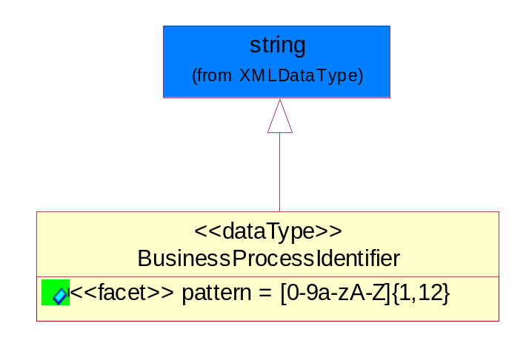
Figure ‎5-40 BusinessProcessIdentifier

Attribute | Type | Documentation
pattern |  | [0-9a-zA-Z]{1,12}

BusinessServiceInformation
The object allows the specification of the business service utilized within the partner company. This may or may not be the same as the information sent by the RNIF.
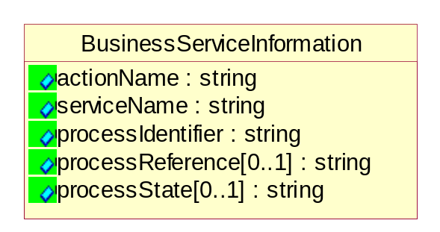
Figure ‎5-41 BusinessServiceInformation

Attribute | Type | Documentation
actionName | string | The name of Action. For RosettaNet usually any of Request/Confirm/Notify/Query/Response.
serviceName | string | The name of the Business Activity with the "Request/Confirm" part removed. E.g., for the Activity "Request Purchase Order"==> "Purchase Order".
processIdentifier | string | The name of the PIP e.g. Notify of Forecast Reply.
processReference[0..1] | string | The URN for the PIP that includes Cluster/Segment/Process pattern used to identify the interface process (such as PIP3A4)
processState[0..1] | string | The business process (or service) state of the sender of a document. When a service receives this document, the receiver may use the state as a precondition.

ContractInformation
A block of information used to correlate a contract in an executing choreography.

Figure ‎5-42 ContractInformation

Attribute | Type | Documentation
contractIdentifier[0..1] | string | Unique identification of a contract between the Sender and the Receiver
contractType[0..1] | string | The type of the contract: an attribute describing the type of the ContractIndentification. Valid values are URI, URN,ebXMLCPA, or other values defined by partners.

CorrelationInformation
A block of information used to correlate a requesting document to a responding document and to the contract in an executing choreography.
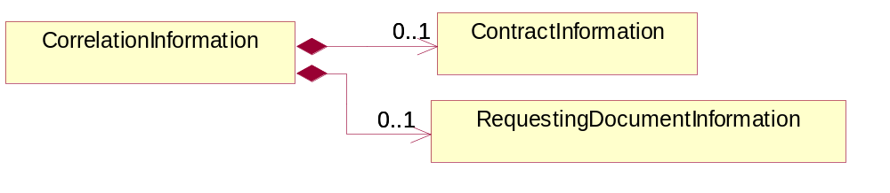
Figure ‎5-43 CorrelationInformation

Composition | Cardinality | Type | Documentation
ContractInformation | 0..1 | ContractInformation | A block of information used to correlate a contract in an executing choreography.
RequestingDocumentInformation | 0..1 | RequestingDocumentInformation | A block of information used to correlate a requesting document to a responding document in an executing choreography.

DocumentHeader
The object allows for the identification of the sender and receiver of the business document.
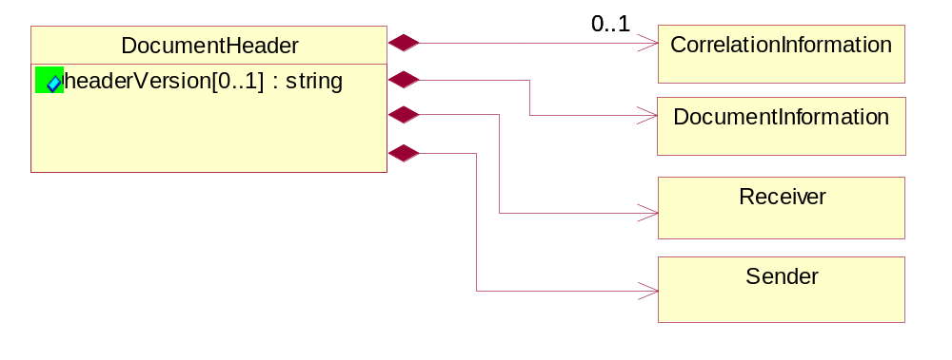
Figure ‎5-44 DocumentHeader

Attribute | Type | Documentation
headerVersion[0..1] | string | The UN/CEFACT version of the document header.

Composition | Cardinality | Type | Documentation
Sender | 1 | Sender | The object allows the identification of the initiating party of the business message.
CorrelationInformation | 0..1 | CorrelationInformation | A block of information used to correlate a requesting document to a responding document and to the contract in an executing choreography.
DocumentInformation | 1 | DocumentInformation | The object specifies information to identify the business document, a summary of attachments, and information about the business document security.
Receiver | 1 | Receiver | The object allows the identification of the receiving party of the business message.

DocumentIdentification
The object specifies all information necessary to identify the business document.
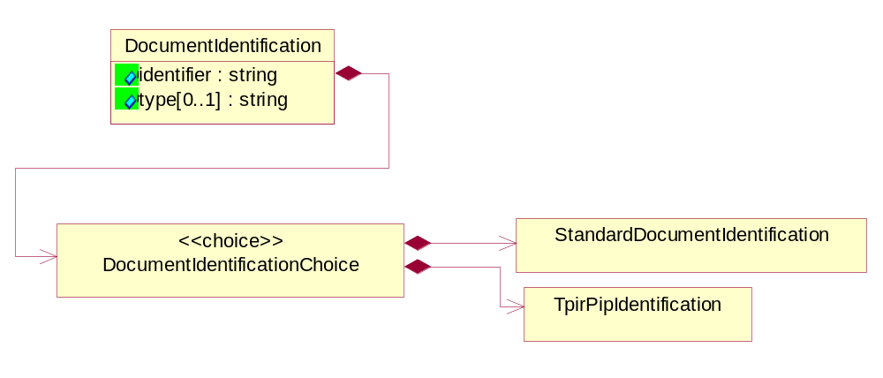
Figure ‎5-45 DocumentIdentification

Attribute | Type | Documentation
identifier | string | The unique identifier for the document being sent.
type[0..1] | string | Name of the Action Message

Composition | Cardinality | Type | Documentation
DocumentIdentificationChoice | 1 | DocumentIdentificationChoice

DocumentIdentificationChoice

Composition | Cardinality | Type | Documentation
StandardDocumentIdentification | 1 | StandardDocumentIdentification | The object specifies additional information necessary to identify the standard business document.
TpirPipIdentification | 1 | TpirPipIdentification | The object specifies all information necessary to uniquely identify a TPIR-PIP within a Registry or trading partner repository.

DocumentInformation
The object specifies information to identify the business document, a summary of attachments, and information about the business document security.
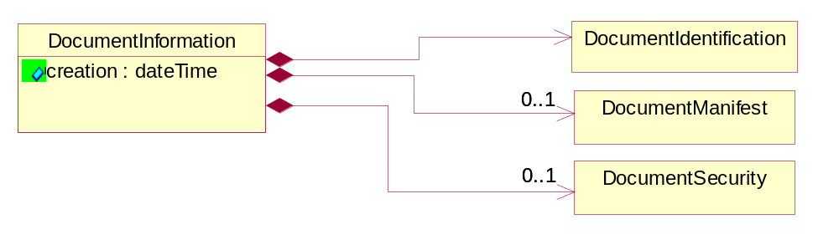
Figure ‎5-46 DocumentInformation

Attribute | Type | Documentation
creation | dateTime | The creation date and time of the specified Business Document (i.e. the Purchase Order date).

Composition | Cardinality | Type | Documentation
DocumentIdentification | 1 | DocumentIdentification | The object specifies all information necessary to identify the business document.
DocumentSecurity | 0..1 | DocumentSecurity | The object provides additional granularity in specifying business document security (this is in addition to the specified PIP security).
DocumentManifest | 0..1 | DocumentManifest | The block provides a brief summary of attachments and Service Content.

DocumentManifest
The block provides a brief summary of attachments and Service Content.
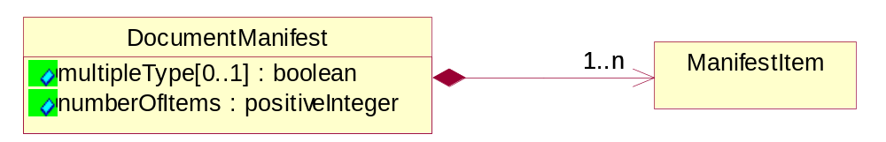
Figure ‎5-47 DocumentManifest

Attribute | Type | Documentation
multipleType[0..1] | boolean | Indicates whether the manifest contains documents of multiple types. True if yes, and False if no.
numberOfItems | positiveInteger | Total number of documents in the message. The physical count of the attachments in the payload plus the RosettaNet Business Message (for Service Content). The value of this field will be at least 1.

Composition | Cardinality | Type | Documentation
ManifestItem | 1..n | ManifestItem | The object provides details about the specific attachment(s).

DocumentSecurity
The object provides additional granularity in specifying business document security (this is in addition to the specified PIP security).

Figure ‎5-48 DocumentSecurity

Attribute | Type | Documentation
nonRepudiableReceipt | boolean | The value "true" will indicate that a signed acknowledgement for the business document is necessary.
persistentEncryption | boolean | The value "true" will indicate that the Business Document (including the header) needs to be encrypted when stored or transported.
persistentSignature | boolean | The value "true" will indicate that a signature is required to be stored with the document while stored or transported.

ManifestItem
The object provides details about the specific attachment(s).

Figure ‎5-49 ManifestItem

Attribute | Type | Documentation
description[0..1] | string | A description of the attachment.
length[0..1] | positiveInteger | The size of the attachment in bytes (i.e. 1 000 000 bytes)
universalResourceIdentifier | string | The generic set of all names/addresses that are short strings that refer to resources.

Composition | Cardinality | Type | Documentation
mimeTypeQualifier | 1 | MimeTypeQualifier | The MIME type as defined by IANA.  Please refer to http://www.iana.org/assignments/media-types/ for a list of types.
language | 0..1 | Language | For representation of Language name RosettaNet has adopted ISO 639-2; 1998. Refer to the following web page to get the latest version of the standard:  http://www.loc.gov/standards/iso639-2/iso639jac.html  If you need more information about the ISO standard please contact ISO for more details.

PipIdentifier
PIP Identification.[ i.e. PIP3A4]
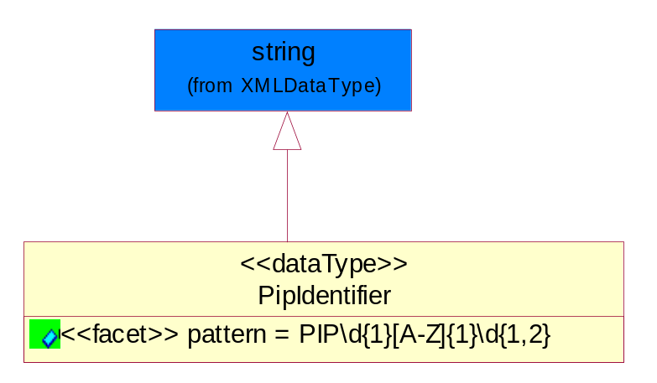
Figure ‎5-50 PipIdentifier

Attribute | Type | Documentation
pattern |  | PIP\d{1}[A-Z]{1}\d{1,2}

PipVersion
PIP version number (i.e. 02.02.00).
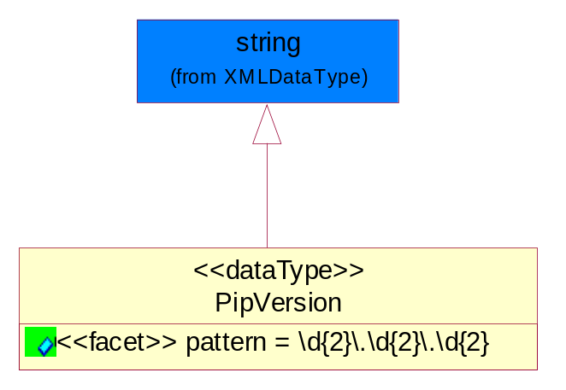
Figure ‎5-51 PipVersion

Attribute | Type | Documentation
pattern |  | \d{2}\.\d{2}\.\d{2}

Receiver
The object allows the identification of the receiving party of the business message.
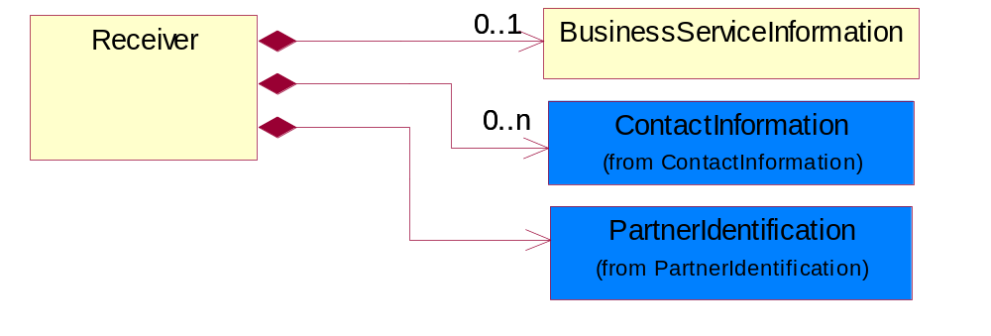
Figure ‎5-52 Receiver

Composition | Cardinality | Type | Documentation
BusinessServiceInformation | 0..1 | BusinessServiceInformation | The object allows the specification of the business service utilized within the partner company. This may or may not be the same as the information sent by the RNIF.
PartnerIdentification | 1 | PartnerIdentification | The business document must allow for the identity of one or more parties to the transaction.
ContactInformation | 0..n | ContactInformation | The business document must allow for the identification of the name of the department, service or individual to be contacted regarding the context of the business document.

RequestingDocumentInformation
A block of information used to correlate a requesting document to a responding document in an executing choreography.

Figure ‎5-53 RequestingDocumentInformation

Attribute | Type | Documentation
businessProcessInstanceIdentifier[0..1] | string | The identifier for the public business process instance being sent that both the sender and receiver can identify.
responseDateTime[0..1] | dateTime | The expected time to receive the response. This can not be greater than the PIP TimeToPerform.
requestingDocumentCreationDateTime[0..1] | dateTime | The date-time of the requesting business document.
requestingDocumentInstanceIdentifier | string | The Business Document identification number that identifies the requesting Business Document.

Sender
The object allows the identification of the initiating party of the business message.
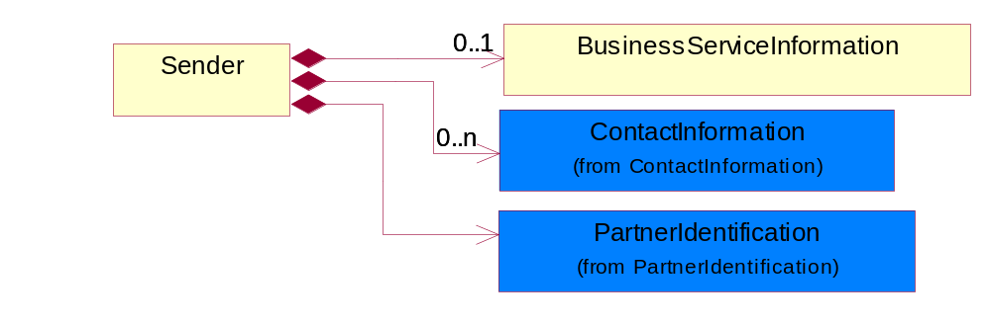
Figure ‎5-54 Sender

Composition | Cardinality | Type | Documentation
PartnerIdentification | 1 | PartnerIdentification | The business document must allow for the identity of one or more parties to the transaction.
BusinessServiceInformation | 0..1 | BusinessServiceInformation | The object allows the specification of the business service utilized within the partner company. This may or may not be the same as the information sent by the RNIF.
ContactInformation | 0..n | ContactInformation | The business document must allow for the identification of the name of the department, service or individual to be contacted regarding the context of the business document.

StandardDocumentIdentification
The object specifies additional information necessary to identify the standard business document.
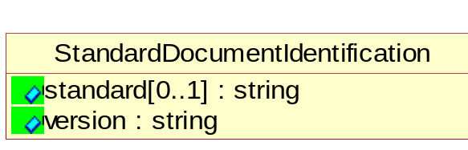
Figure ‎5-55 StandardDocumentIdentification

Attribute | Type | Documentation
standard[0..1] | string | Identifies the standard used to submit the business document. (e.g. RosettaNet).
version | string | PIP3A4v01.00

TpirPipIdentification
The object specifies all information necessary to uniquely identify a TPIR-PIP within a Registry or trading partner repository.

Figure ‎5-56 TpirPipIdentification

Attribute | Type | Documentation
partnerId | DUNSPlus4 | The Trading Partner Identification of MNC that is creating this TPIR PIP.
pipIdentifier | PipIdentifier | A TPIR PIP Identification [i.e., 3A4 ).
pipVersion | PipVersion | A TPIR PIP version number (i.e., 02.02.00)
tpirPipVersion | VersionIdentifier | A TPIR-PIP Version Number (i.e., major and minor version number as XX.XX).
tpirBusinessProcessIdentifier[0..1] | BusinessProcessIdentifier | A Business Process Identifier to uniquely define the TPIR-PIP 'role' within a Business Scenario at a company or MNC level. The identifier MUST be composed of alphanumeric characters only and its length MUST be between one and twelve characters.
uri[0..1] | anyURI | Describes the destination uri for the TPIR form.

Composition | Cardinality | Type | Documentation
fileType | 0..1 | TPIRFileType | Describes the file type of the TPIR form (PDF, XDP or XML).

VersionIdentifier
Version Number (i.e., major and minor version number as XX.XX).
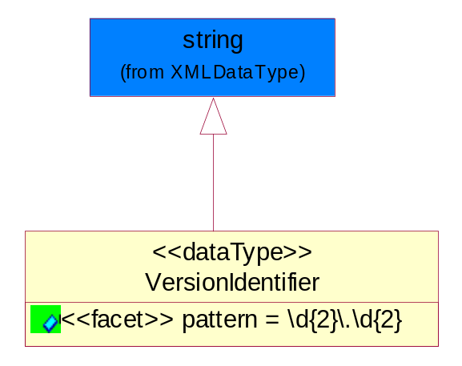
Figure ‎5-57 VersionIdentifier

Attribute | Type | Documentation
pattern |  | \d{2}\.\d{2}

CodeList

TPIRFileType
A code identifying the file type of TPIR form.

Name | Documentation
PDF | Portable Document Format.
XDP | XML Data Package.
XML | eXtensible Markup Language.

XML Data Type

anyURI
Represents a URI as defined by RFC 2396. An anyURI value can be absolute or relative, and may have an optional fragment identifier.

boolean
Represents Boolean values, which are either "true" or "false".

date
For the represents a calendar date.
The pattern for a date is CCYY-MM-DD where CC represents the century, YY the year, MM the month, and DD the day, with an optional time zone indicator as allowed for dateTime.

dateTime
Represents a specific instance of time.
The pattern for dateTime is CCYY-MM-DDThh:mm:ss where CC represents the century, YY the year, MM the month, and DD the day, preceded by an optional leading negative (-) character to indicate a negative number. If the negative character is omitted, positive (+) is assumed. The T is the date/time separator and hh, mm, and ss represent hour, minute, and second respectively. Additional digits can be used to increase the precision of fractional seconds if desired. For example, the format ss.ss... with any number of digits after the decimal point is supported. The fractional seconds part is optional.

This representation may be immediately followed by a "Z" to indicate Coordinated Universal Time (UTC) or to indicate the time zone. For example, the difference between the local time and Coordinated Universal Time, immediately followed by a sign, + or -, followed by the difference from UTC represented as hh:mm (minutes is required). If the time zone is included, both hours and minutes must be present.

float
Represents single-precision 32-bit floating-point numbers.

positiveInteger
Represents an integer that is greater than zero. This data type is derived from nonNegativeInteger.

string
Represents character string.

