

Description of
Partner Interface Process® for 6A2

Validated 11.00.00

Specification Information
Name | Notify Of Service Contract Reply
Cluster | Provide and Administer Warranties, Service Packages, and Contract Services
Segment | Service And Support
Publication Date | 12 January 2006
Version Identifier | V11.00

Table of Contents
1 Document Management 4
1.1 Legal Disclaimer 4
1.2 Copyright 4
1.3 Trademarks 4
1.4 Acknowledgments 4
1.5 Related Documents 5
1.6 Document Version History 5
1.7 Document Structure 5
2 Business Process 6
2.1 Business Process Definition 6
2.1.1 Executive Summary 6
2.1.2 Business Process Description 6
2.2 PIP Scope Description 6
2.3 PIP Business Document 7
2.4 PIP Business Process Flow Diagram 7
2.5 PIP Start State 8
2.6 PIP End States 8
2.7 Partner Role Descriptions 9
2.8 Business Process Activity Controls 9
3 Network and Implementation Specification 10
3.1 Business Action and Business Signal Specifications 10
3.2 Business Transaction Dialog Specification 11
3.2.1 Message Exchange Controls 11
3.2.2 Communications Specification 12

List of Figures:
Figure 1: Activity Diagram of Notify Of Service Contract Reply 8
Figure 2: Sequence Diagram of Notify Of Service Contract Reply 12

List of Tables:
Table 1: PIP Business Document 7
Table 2: PIP Start State 8
Table 3: PIP End State 8
Table 4: PIP Failure State 8
Table 5: Partner Role Description 9
Table 6: Business Activity Description 9
Table 7: Business Activity Performance Control 9
Table 8: Network Component Specification 10
Table 9: Business Action – Business Document Mapping 10
Table 10: Message Exchange Control 11
Table 11: Dialog: Service-Service 12

Document Management

Legal Disclaimer
RosettaNet™, its members, officers, directors, employees, or agents shall not be liable for any injury, loss, damages, financial or otherwise, arising from, related to, or caused by the use of this document or the specifications herein, as well as associated guidelines and schemas. The use of said specifications shall constitute your express consent to the foregoing exculpation.

Copyright
©2006 RosettaNet. All rights reserved. No part of this publication may be reproduced, stored in a retrieval system, or transmitted, in any form or by any means, electronic, mechanical, photocopying, recording, or otherwise, without the prior written permission of the publisher. Printed in the United States of America.

Trademarks
RosettaNet, Partner Interface Process, PIP and the RosettaNet logo are trademarks or registered trademarks of "RosettaNet," a non-profit organization. All other product names and company logos mentioned herein are the trademarks of their respective owners. In the best effort, all terms mentioned in this document that are known to be trademarks or registered trademarks have been appropriately recognized in the first occurrence of the term.

Acknowledgments
This document has been prepared by RosettaNet (http://www.rosettanet.org/) from requirements gathered during the Milestone Program and in conformance with the methodology. Listed below are the legal entities that contributed to the design and development of this PIP.
Bellsouth Communication Systems | Cisco Systems
Intel | SBC Business Marketing
Sterling Commerce | World Wide Technology (WWT)

Related Documents
- Associated PIP Message Schemas (included within the PIP Specification package only)
- Description of 6A2 Message
- Messages Structure
- XML instance of ebXML BPSS for PIP 6A2

Document Version History
Version | Date | Description
Validated 11.00.00 | 12 Jan 2006 | Validated Version

Document Structure
A Partner Interface Process (PIP) Specification is comprised of the following two parts:
- Business Process. Captures the semantics of the business process and the flow of the message exchange between roles as they perform business activities.
- Network and Implementation Specification. Specifies the network protocol message formats and communications requirements between peer-protocols supported by network components in the RosettaNet Implementation Framework.

Business Process

Business Process Definition
Enable the notification of service contract reply from service contract issuer to service contract requester.

Executive Summary
Businesses sell product in various forms such as physical product, services or product with services subscription. Every purchase of service or product with service comes with a service contract that states that agreed service contract period between buyer and seller. During the contract period, the buyer may raise change request to seller to change the service contract.
This process may involve several parties. The first party of the service contract is usually the service contract issuer or seller, who issues the contract of the service. The second party is usually the service contract requester or buyer, who had purchased the service and raises the change request. In direct business model, the service contract requester is usually the contract owner. For distribution business model, the reseller is the contract owner.
When the service contract request has been raised, the service contract issuer would review the service contract request. The service contract issuer reserves the right of accepting or rejecting the service contract request. If the service contract request is accepted, the service contract issuer will bill the service contract requester for any revenue impacting change. If the service contract request is rejected, the service contract issuer will have to state the reason of rejecting the service contract request.

Business Process Description
The “Notify of Service Contract Reply” Partner Interface Process™ (PIP) supports a process in which a service contract issuer notifies the service contract requester the updated content of service contract.
PIP 6A1 Notify of Service Contract is usually transmitted before the receipt of 6A2 Notify of Service Contract Reply.

PIP Scope Description
This PIP is design to notify the changes and reply the query of service contract information raised by a seller to service product buyer.
This PIP allows changes in the following scenarios:-
  - Request or notify service cancellation on a specific product.
  - Request or notify of service contract cancellation.
  - Request or notify change of billing information.
  - Request or notify change of contact name of contract owner on the service request.
  - Request or notify change of service address.
  - Request or notify change of product information
  - Request or notify change to start and/or end date.
  - Request or notify updates to notes on service contract.
  - Request or notify merging/consolidating of contracts.
  - Request or notify product move from one contract to another.
  - Query certain parameters and respond with associated data with the parameters.
  - Request or notify move product from one contract to another and change service location address.
  - Query eligible target contracts.

PIP Business Document
Business Document are generated and exchanged by roles performing activities in this PIP. Business Document is listed and defined in Table 1.
Table 1: PIP Business Document
Business Document | Description
Service Contract Reply Notification | Contains information for a service contract reply notification.

PIP Business Process Flow Diagram
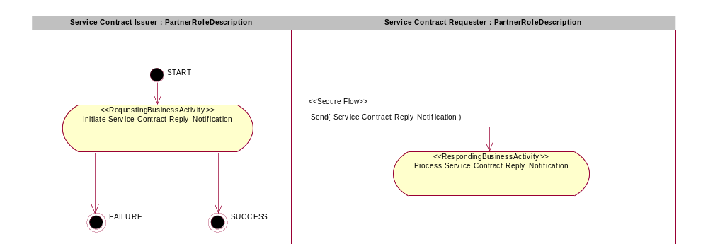
Figure 1: Activity Diagram of Notify Of Service Contract Reply

PIP Start State
The start state is comprised of the following conditions:
Table 2: PIP Start State
 | Approved | Exist |  | Valid | Non-Repudiated | Retry Count | Authorized
 | Approved | Party | In Backend System
TPA |  |  | 
Sending Partner |  |  |  | 
Receiving Partner |  | 
Business Document |  |  |  |  |  |  | 

PIP End States
The end state is comprised of the following conditions:
Table 3: PIP End State
 | Approved | Exist |  | Valid | Non-Repudiated | Retry Count | Authorized
 | Approved | Party | In Backend system
Acknowledgment of Receipt |  |  |  |  | 
Receiving Partner |  |  |  |  |  |  | 
The PIP failure state is comprised of one or more of the following conditions:
Table 4: PIP Failure State
 | NO | Exceeded
Success | 
Retry Count |  | 

Partner Role Descriptions
Table 5 describes the partner roles in this PIP.
Table 5: Partner Role Description
Role Name | Role Description
Service Contract Issuer | The department or organization that issues the service contract update.
Service Contract Requester | The department or organization that raises the service contract request.

Business Process Activity Controls
Table 6 describes the interaction between roles performing business activity in this PIP.
Table 6: Business Activity Description
Role  Name | Activity Name | Activity Description
Service Contract Issuer | Notify Of Service Contract Reply | A Service Contract Issuer sends a Service Contract Reply Notification business document to a Service Contract Requester.

Table 7 details the security, audit and process controls relating to activity performed in the PIP.
Table 7: Business Activity Performance Control
Role  Name | Activity  Name | Acknowledgment  of Receipt |  | Time to Perform | Retry Count | Is Authorization Required? | Non-Repudiation of Origin and Content?
Role  Name | Activity  Name | Non-Repudiation Required? | Time to Acknowledge
Service Contract Issuer | Notify Of Service Contract Reply | Y | 2hrs | N/A | 3 | Y | Y
Note: All time parameters are defined as (hrs or mins), i.e. 2hrs

Network and Implementation Specification
Each network component maps into a role of the PIP model. Table 8 specifies the mapping between roles and network components.
Table 8: Network Component Specification
Network Component | Classification | Maps to Role in Business Process
Service Contract Issuer | Business Service | Service Contract Issuer
Service Contract Requester | Business Service | Service Contract Requester

Business Action and Business Signal Specifications
Each business action maps to a Business Document of the PIP model. Table 9 specifies the mapping between Business Documents and business actions.
Table 9: Business Action – Business Document Mapping
Business Action | Business Document | Document Function
Service Contract Reply Notification Action | Service Contract Reply Notification | Response

Business Transaction Dialog Specification
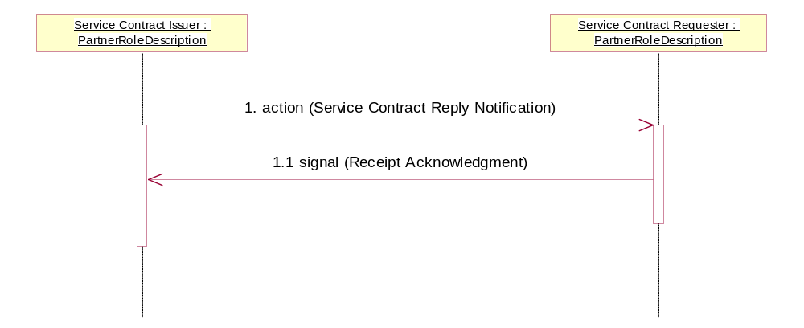
Figure 2: Sequence Diagram of Notify Of Service Contract Reply

Message Exchange Controls
Table 10: Message Exchange Control
# | Name |  | Time to Acknowledge Receipt Signal |  | Time to Respond to Action |  | Included in Time to Perform |  | Is Authorization Required? |  | Is Non-Repudiation Required? |  | Is Secure Transport Required?
1. |  | Service Contract Reply Notification Action |  | 2hrs |  | N/A |  | N/A |  | Y |  | Y |  | Y
1.1. |  | Receipt Acknowledgment |  | N/A |  | N/A |  | N/A |  | Y |  | Y |  | Y

Communications Specification
Table 11: Dialog: Service-Service
# | Business Message | Digital Signature Required? | SSL Required?
1. | Service Contract Reply Notification | N | Y
1.1. | Receipt Acknowledgment | N | Y

