

Description of 6A2 Message

PIP® 6A2
Validated 11.10.00

Specification Information
Name | Description Of 6A2 Message
PIP | Notify Of Service Contract Reply
Cluster | Service And Support
Segment | Provide and Administer Warranties, Service Packages, and Contract Services
Publication Date | 20 July 2006
Version Identifier | V11.10

Table of Content

1. Document Management 6
1.1 Legal Disclaimer 6
1.2 Copyright 6
1.3 Trademarks 6
1.4 Acknowledgments 6
1.5 Related Documents 6
1.6 Document Version History 6
1.7 Document Purpose 7
2. Interchange Model 8
2.1 ServiceContractReplyNotification 8
2.1.1 Interchange Diagram 8
2.1.2 Dependency Diagram 9
2.1.3 Product 9
2.1.4 ServiceContract 10
2.1.5 ServiceContractLineItem 12
2.1.6 ServiceContractReplyNotification 14
2.1.7 Site 15
2.2 CodeList 16
2.2.1 RequestType 16
2.2.2 AcknowledgmentReason 16
3. Domain Model 18
3.1 Procurement 18
3.1.1 Procurement 18
3.1.1.1 Dependency Diagram 18
3.1.2 CodeList 18
3.1.2.1 PurchaseOrderStatus 18
3.1.2.2 PurchaseOrderAcknowledgmentReason 19
3.2 Shared 20
3.2.1 Shared 20
3.2.1.1 Dependency Diagram 20
3.2.1.2 DatePeriodAndDuration 20
3.2.1.3 DatePeriodAndDurationChoice 21
3.2.1.4 Duration 21
3.2.1.5 MonetaryAmount 21
3.2.1.6 ProductPricing 22
3.2.1.7 ProductQuantity 23
3.2.2 CodeList 23
3.2.2.1 InvoiceChargeType 23
3.2.2.2 MonetaryAmountType 24
3.2.2.3 PricingTypeCode 24
3.2.2.4 AmountType 25
4. Universal Structure 26
4.1 ContactInformation 26
4.1.1 ContactInformation 26
4.2 DataType 27
4.2.1 Contact 27
4.2.2 DUNS 27
4.2.3 DUNSPlus4 28
4.2.4 GLN 28
4.2.5 GTIN 29
4.3 Dates 30
4.3.1 DatePeriod 30
4.4 Document 31
4.4.1 BusinessDocumentReference 31
4.5 Locations 32
4.5.1 AlternativeIdentifier 32
4.5.2 Location 32
4.5.3 LocationChoice 33
4.5.4 PhysicalAddress 33
4.6 MonetaryExpression 35
4.6.1 FinancialAmount 35
4.7 PartnerIdentification 36
4.7.1 PartnerIdentification 36
4.7.2 PartnerIdentificationChoice 37
4.7.3 SpecifiedFullPartner 37
4.7.4 SpecifiedIntermittentPartner 38
4.7.5 SpecifiedKnownPartner 39
4.7.6 SpecifiedKnownPartnerContact 39
4.7.7 SpecifiedNewPartner 40
4.7.8 SpecifiedPartnerDescription 41
4.7.9 SpecifiedPartnerDescriptionChoice 41
4.8 ProductIdentification 43
4.8.1 ProductIdentification 43
4.8.2 ProductIdentificationChoice 43
4.9 CodeList 44
4.9.1 Country 44
4.9.2 CountrySubdivision 44
4.9.3 Currency 44
4.9.4 Language 44
4.9.5 DocumentType 45
4.9.6 MimeTypeQualifier 46
5. System Structure 58
5.1 BusinessProcessIdentifier 58
5.2 BusinessServiceInformation 58
5.3 ContractInformation 60
5.4 CorrelationInformation 60
5.5 DocumentHeader 61
5.6 DocumentIdentification 62
5.7 DocumentIdentificationChoice 62
5.8 DocumentInformation 63
5.9 DocumentManifest 64
5.10 DocumentSecurity 64
5.11 ManifestItem 65
5.12 PipIdentifier 66
5.13 PipVersion 66
5.14 Receiver 67
5.15 RequestingDocumentInformation 68
5.16 Sender 68
5.17 StandardDocumentIdentification 69
5.18 TpirPipIdentification 69
5.19 VersionIdentifier 70
5.20 CodeList 71
5.20.1 TPIRFileType 71
6. XML Data Type 72
6.1 anyURI 72
6.2 boolean 72
6.3 date 72
6.4 dateTime 72
6.5 duration 72
6.6 float 72
6.7 positiveInteger 72
6.8 string 72

Table of Figures

Figure ‎2-1 Interchange 8
Figure ‎2-2 Dependency 9
Figure ‎2-3 Product 9
Figure ‎2-4 ServiceContract 10
Figure ‎2-5 ServiceContractLineItem 12
Figure ‎2-6 ServiceContractReplyNotification 14
Figure ‎2-7 Site 15
Figure ‎3-1 Dependency 18
Figure ‎3-2 Dependency 20
Figure ‎3-3 DatePeriodAndDuration 20
Figure ‎3-4 Duration 21
Figure ‎3-5 MonetaryAmount 21
Figure ‎3-6 ProductPricing 22
Figure ‎3-7 ProductQuantity 23
Figure ‎4-1 ContactInformation 26
Figure ‎4-2 Contact 27
Figure ‎4-3 DUNS 27
Figure ‎4-4 DUNSPlus4 28
Figure ‎4-5 GLN 28
Figure ‎4-6 GTIN 29
Figure ‎4-7 DatePeriod 30
Figure ‎4-8 BusinessDocumentReference 31
Figure ‎4-9 AlternativeIdentifier 32
Figure ‎4-10 Location 32
Figure ‎4-11 PhysicalAddress 33
Figure ‎4-12 FinancialAmount 35
Figure ‎4-13 PartnerIdentification 36
Figure ‎4-14 SpecifiedFullPartner 37
Figure ‎4-15 SpecifiedIntermittentPartner 38
Figure ‎4-16 SpecifiedKnownPartner 39
Figure ‎4-17 SpecifiedKnownPartnerContact 39
Figure ‎4-18 SpecifiedNewPartner 40
Figure ‎4-19 SpecifiedPartnerDescription 41
Figure ‎4-20 ProductIdentification 43
Figure ‎5-1 BusinessProcessIdentifier 58
Figure ‎5-2 BusinessServiceInformation 58
Figure ‎5-3 ContractInformation 60
Figure ‎5-4 CorrelationInformation 60
Figure ‎5-5 DocumentHeader 61
Figure ‎5-6 DocumentIdentification 62
Figure ‎5-7 DocumentInformation 63
Figure ‎5-8 DocumentManifest 64
Figure ‎5-9 DocumentSecurity 64
Figure ‎5-10 ManifestItem 65
Figure ‎5-11 PipIdentifier 66
Figure ‎5-12 PipVersion 66
Figure ‎5-13 Receiver 67
Figure ‎5-14 RequestingDocumentInformation 68
Figure ‎5-15 Sender 68
Figure ‎5-16 StandardDocumentIdentification 69
Figure ‎5-17 TpirPipIdentification 69
Figure ‎5-18 VersionIdentifier 70

Document Management

Legal Disclaimer
RosettaNet, its members, officers, directors, employees, or agents shall not be liable for any injury, loss, damages, financial or otherwise, arising from, related to, or caused by the use of this document or the specifications herein, as well as associated guidelines and schemas. The use of said specifications shall constitute your express consent to the foregoing exculpation.

Copyright
©2006 RosettaNet. All rights reserved. No part of this publication may be reproduced, stored in a retrieval system, or transmitted, in any form or by any means, electronic, mechanical, photocopying, recording, or otherwise, without the inclusion of this copyright notice. Any derivative works must cite the copyright notice. Any public redistribution or sale of this publication or derivative works requires prior written permission of the publisher.

Trademarks
RosettaNet, Partner Interface Process, PIP and the RosettaNet logo are trademarks or registered trademarks of "RosettaNet," a non-profit organization. All other product names and company logos mentioned herein are the trademarks of their respective owners. In the best effort, all terms mentioned in this document that are known to be trademarks or registered trademarks have been appropriately recognized in the first occurrence of the term.

Acknowledgments
This document has been prepared by RosettaNet (http://www.rosettanet.org/) from requirements gathered during the Milestone Program and in conformance with the methodology. Listed below are the legal entities that contributed to the design and development of this PIP.
Bellsouth Communication Systems | Cisco Systems
Intel | SBC Business Marketing
Sterling Commerce | World Wide Technology (WWT)

Related Documents
- Associated PIP Message Schemas (included with PIP Specification only)
- Description of Partner Interface Process for 6A2
- Message Structure

Document Version History
Version | Date | Description
Validated 11.00.00 | 12 Jan 2006 | Validated Version
Validated 11.10.00 | 20 July 2006 | Validated Version

Document Purpose
The purpose of the document is to explain the structure, the association between objects, the content of objects and the definition for single elements to a non-technical audience.

Interchange Model

ServiceContractReplyNotification

Interchange Diagram
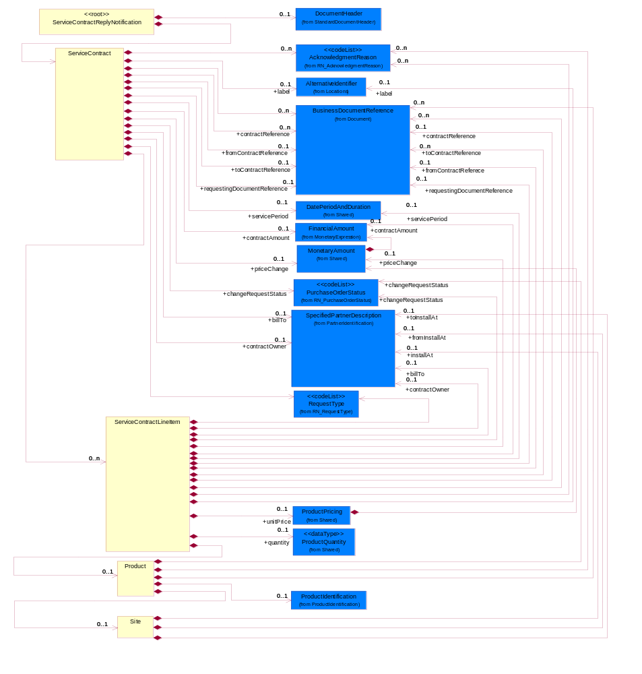
Figure ‎2-1 Interchange

Dependency Diagram
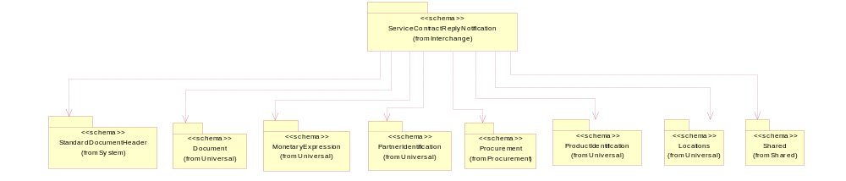
Figure ‎2-2 Dependency

Product
The object provides the information of a product.
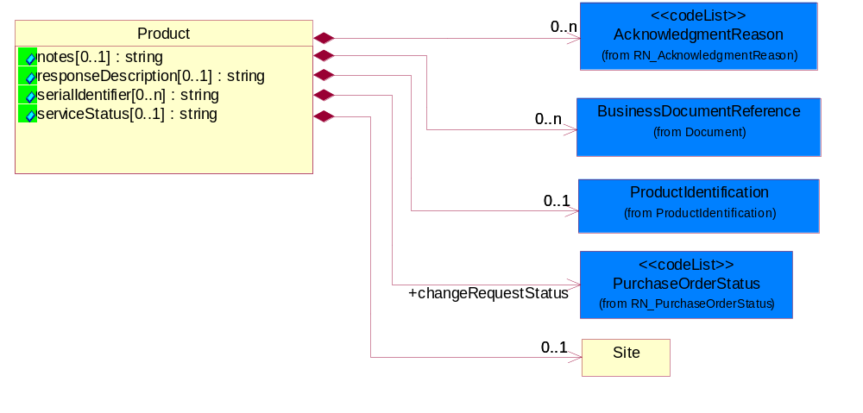
Figure ‎2-3 Product

Attribute | Type | Documentation
notes[0..1] | string | A textual description.
responseDescription[0..1] | string | The object representing the description of response error message.
serialIdentifier[0..n] | string | A unique serial identifier assigned to a product.
serviceStatus[0..1] | string | Code identifying the status of a service.

Composition | Cardinality | Type | Documentation
ProductIdentification | 0..1 | ProductIdentification | The object provides the identifier(s) of a product.
BusinessDocumentReference | 0..n | BusinessDocumentReference | The business document reference object allows for the indirect referencing of a relationship to other business related documents.
Site | 0..1 | Site | The object provides the information of a site.
changeRequestStatus | 1 | PurchaseOrderStatus | Code identifying the status of a contract change request.
AcknowledgmentReason | 0..n | AcknowledgmentReason | Code identifying an type of change request acknowledgment reason.

ServiceContract
This object representing a contract.
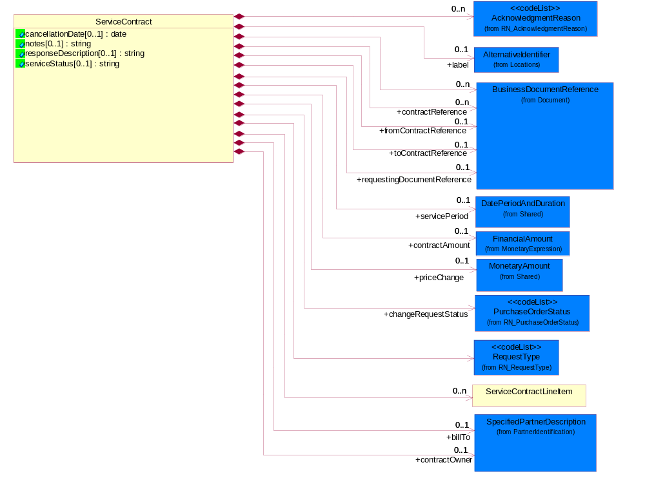
Figure ‎2-4 ServiceContract

Attribute | Type | Documentation
cancellationDate[0..1] | date | The cancellation date of the agreement.
notes[0..1] | string | A textual description.
responseDescription[0..1] | string | The object representing the description of response error message.
serviceStatus[0..1] | string | Code identifying the status of a service.

Composition | Cardinality | Type | Documentation
BusinessDocumentReference | 0..n | BusinessDocumentReference | The business document reference object allows for the indirect referencing of a relationship to other business related documents.
billTo | 0..1 | SpecifiedPartnerDescription | The party that will pay the invoice.
contractOwner | 0..1 | SpecifiedPartnerDescription | The party who is the owner of the contract. For example, In the direct business, the buyer is the contract owner. In the distribution business, the buyer is the distributor and the contract owner is the reseller.
contractReference | 0..n | BusinessDocumentReference | A reference to existing contract.
ServiceContractLineItem | 0..n | ServiceContractLineItem | The collection of business properties that describe a service entry in a quote business documents.
fromContractReference | 0..1 | BusinessDocumentReference | The sender contract reference object allows for the indirect referencing of a relationship to other business related documents.
toContractReference | 0..1 | BusinessDocumentReference | The receiver contract reference object allows for the indirect referencing of a relationship to other business related documents.
label | 0..1 | AlternativeIdentifier | Contract label is another alternative for contract identifier.
changeRequestStatus | 1 | PurchaseOrderStatus | Code identifying the status of a contract change request.
contractAmount | 0..1 | FinancialAmount | The business document must express contract amounts.
RequestType | 1 | RequestType | Code identifying an type of request.
AcknowledgmentReason | 0..n | AcknowledgmentReason | Code identifying an type of change request acknowledgment reason.
requestingDocumentReference | 0..1 | BusinessDocumentReference | The receiver contract reference object allows for the indirect referencing of a relationship to related requesting documents reference.
servicePeriod | 0..1 | DatePeriodAndDuration | The effective period of contract.
priceChange | 0..1 | MonetaryAmount | Different in price.

ServiceContractLineItem
The collection of business properties that describe a service entry in a quote business documents.
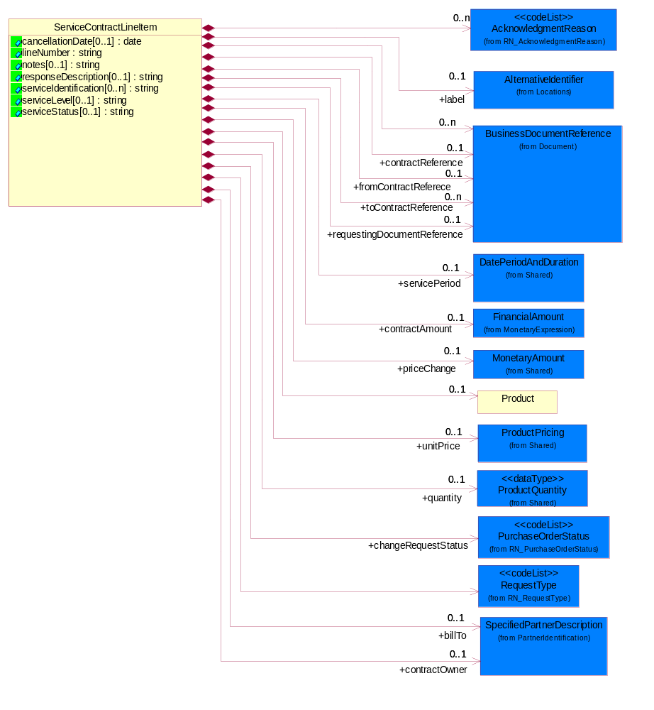
Figure ‎2-5 ServiceContractLineItem

Attribute | Type | Documentation
cancellationDate[0..1] | date | Date of contract cancellation.
lineNumber | string | Number of the line in the document.
notes[0..1] | string | Notes.
responseDescription[0..1] | string | The object representing the description of response error message.
serviceIdentification[0..n] | string | A unique serial identifier assigned to a service.
serviceLevel[0..1] | string | The object that representing the type of service.
serviceStatus[0..1] | string | Code identifying the status of a service.

Composition | Cardinality | Type | Documentation
BusinessDocumentReference | 0..n | BusinessDocumentReference | The business document reference object allows for the indirect referencing of a relationship to other business related documents.
contractReference | 0..1 | BusinessDocumentReference | A reference to existing contract.
Product | 0..1 | Product | The object provides the information of a product.
contractAmount | 0..1 | FinancialAmount | The business document must express contract amounts.
changeRequestStatus | 1 | PurchaseOrderStatus | Code identifying the status of a contract change request.
RequestType | 1 | RequestType | Code identifying an type of request.
AcknowledgmentReason | 0..n | AcknowledgmentReason | Code identifying an type of change request acknowledgment reason.
fromContractReferece | 0..1 | BusinessDocumentReference | The sender contract reference object allows for the indirect referencing of a relationship to other business related documents.
toContractReference | 0..n | BusinessDocumentReference | The receiver contract reference object allows for the indirect referencing of a relationship to other business related documents.
requestingDocumentReference | 0..1 | BusinessDocumentReference | The receiver contract reference object allows for the indirect referencing of a relationship to related requesting documents reference.
servicePeriod | 0..1 | DatePeriodAndDuration | The effective period of contract.
priceChange | 0..1 | MonetaryAmount | Different in price.
unitPrice | 0..1 | ProductPricing | Agreed upon sale price for each unit ordered.
quantity | 0..1 | ProductQuantity | The product quantity received.
billTo | 0..1 | SpecifiedPartnerDescription | The party that will pay the invoice.
contractOwner | 0..1 | SpecifiedPartnerDescription | The party who is the owner of the contract. For example, In the direct business, the buyer is the contract owner. In the distribution business, the buyer is the distributor and the contract owner is the reseller.
label | 0..1 | AlternativeIdentifier | Contract label is another alternative for contract identifier.

ServiceContractReplyNotification
The collection of business properties that describe the confirmation of update made to a service contract.
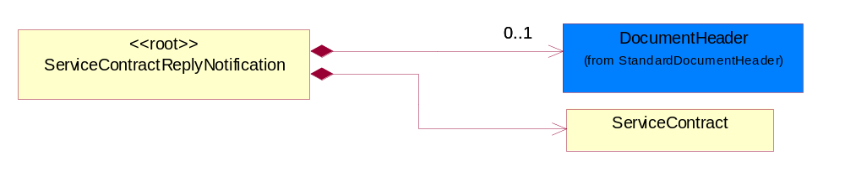
Figure ‎2-6 ServiceContractReplyNotification

Composition | Cardinality | Type | Documentation
DocumentHeader | 0..1 | DocumentHeader | The object allows for the identification of the sender and receiver of the business document.
ServiceContract | 1 | ServiceContract | This object representing a contract.

Site
The object provides the information of a site.
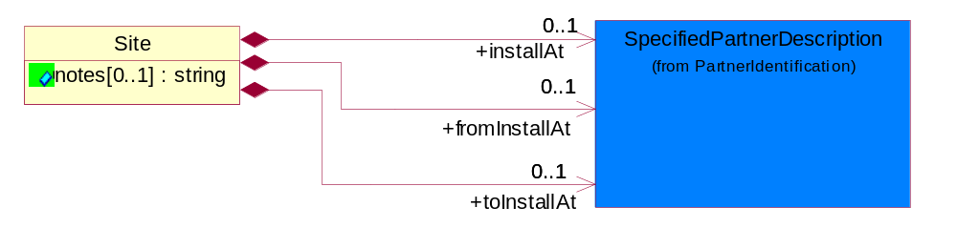
Figure ‎2-7 Site

Attribute | Type | Documentation
notes[0..1] | string | A textual description.

Composition | Cardinality | Type | Documentation
installAt | 0..1 | SpecifiedPartnerDescription | The partner and/or location to which the product must be set up for use or service.
fromInstallAt | 0..1 | SpecifiedPartnerDescription | The collection of sender business properties that describe a business partners' identity, their contact information, where they are physically located and their function in a supply chain.
toInstallAt | 0..1 | SpecifiedPartnerDescription | The collection of receiver business properties that describe a business partners' identity, their contact information, where they are physically located and their function in a supply chain.

CodeList

RequestType
Code identifying an type of request.

Name | Documentation
CHA | Request or notify change of service address.
CHB | Request or notify change of billing information.
CHD | Request or notify change to start and/or end date.
CHN | Request or notify updates to notes on service contract.
CHO | Request or notify change of contact name of contract owner on the service request.
CHP | Request or notify change of product information (replacement part, RMA) 3-way sparing will be part of this scenario.
CNC | Request or notify of service contract cancellation.
CNP | Request or notify service cancellation on a specific product.
MEG | Request or notify merging/consolidating of contracts.
MNC | Request or notify move product from one contract to another and change service location address.
MOV | Request or notify product move from one contract to another.
QST | Query site information.
QTR | Query eligible target contracts.
QUE | Query certain parameters and respond with associated data with the parameters.  - Query contract data by parameters  - Query eligible target contracts  - Query site information

AcknowledgmentReason
Code identifying an type of change request acknowledgment reason.

Name | Documentation
ACC | Accept with Changes.
ALA | Already Acknowledged.
CNA | Contract Not Accessible.
CNO | Contract Number - Invalid or missing contract number
CRH | Credit Hold.
DAT | Date - Invalid or missing date.
DSN | Duplicate serial number.
EXR | Export Restricted.
IBI | Invalid buyer ID.
IBT | Invalid Bill To - Use if Bill To is missing or invalid.
IFC | Invalid Fulfillment Code - Use if unsupported Fulfillment Code or the code is not the same for all the lines in the purchase order.
IGT | Invalid GTIN.
IID | Invalid ID.
INB | Invalid Billing.
INC | Invalid Configuration.
INI | Insufficient Inventory.
INP | Invalid Product.
IPL | Invalid Price List.
IPO | Purchase Order Number - Invalid or missing purchase order number.
IQR | Invalid Quote Reference.
ISL | Invalid or missing service level or service type.
ISN | Invalid or missing serial number.
IST | Invalid Ship To - User if Ship To is missing or invalid.
NAU | Not Authorized to sell.
OGT | Obsolete GTIN.
PAR | Part Replacement.
PAS | Part Substitution.
PEN | Pending.
PPO | Packaged Product Only - no licenses.
PRI | Pricing - Invalid or missing price.
PRS | Product already Shipped.
QTY | Quantity - Invalid or missing quantity
RNC | Reject - Non-Cancel/non-returnable.
RNW | Reject - Nsot within cancellation window.
SCR | See Comments for Reason.
SRL | Service Location - Invalid or missing service location.

Domain Model

Procurement

Procurement

Dependency Diagram
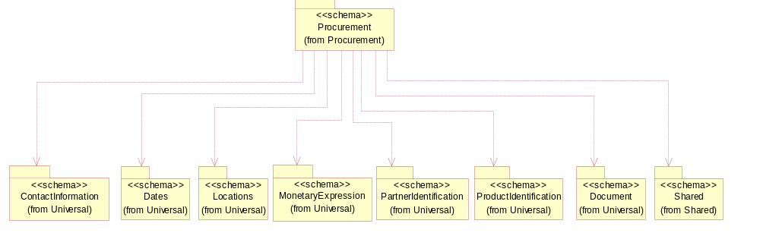
Figure ‎3-8 Dependency

CodeList

PurchaseOrderStatus
Code identifying the status of a purchase order.

Name | Documentation
ACC | Accept.
PAR | Partial.
PEN | Pending.
REJ | Reject.

PurchaseOrderAcknowledgmentReason
The reason for acknowledging a purchase order.

Name | Documentation
ACC | Accept with Changes.
ALA | Already Acknowledged.
CNO | Contract Number - Invalid or missing contract number
CRH | Credit Hold.
DAT | Date - Invalid or missing date.
DSN | Duplicate serial number.
EXR | Export Restricted.
IBI | Invalid buyer ID.
IBT | Invalid Bill To - Use if Bill To is missing or invalid.
IFC | Invalid Fulfillment Code - Use if unsupported Fulfillment Code or the code is not the same for all the lines in the purchase order.
IGT | Invalid GTIN.
IID | Invalid ID.
INB | Invalid Billing.
INC | Invalid Configuration.
INI | Insufficient Inventory.
INP | Invalid Product.
IPL | Invalid Price List.
IPO | Purchase Order Number - Invalid or missing purchase order number.
IQR | Invalid Quote Reference.
ISL | Invalid or missing service level or service type.
ISN | Invalid or missing serial number.
IST | Invalid Ship To - User if Ship To is missing or invalid.
NAU | Not Authorized to sell.
OGT | Obsolete GTIN.
PAR | Part Replacement.
PAS | Part Substitution.
PEN | Pending.
PPO | Packaged Product Only - no licenses.
PRI | Pricing - Invalid or missing price.
PRS | Product already Shipped.
QTY | Quantity - Invalid or missing quantity
RNC | Reject - Non-Cancel/non-returnable.
RNW | Reject - Nsot within cancellation window.
SCR | See Comments for Reason.
SRL | Service Location - Invalid or missing service location.

Shared

Shared

Dependency Diagram
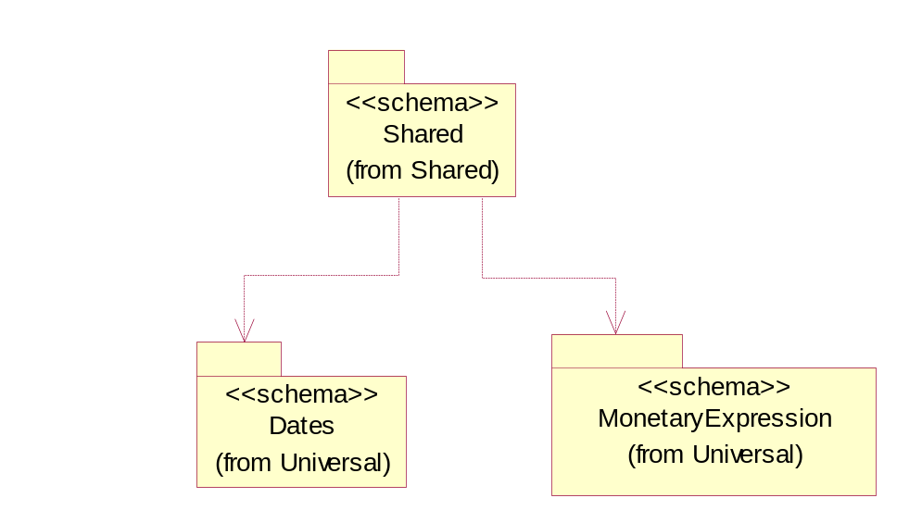
Figure ‎3-9 Dependency

DatePeriodAndDuration
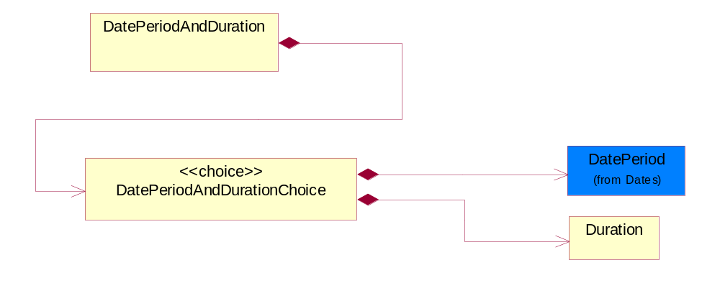
Figure ‎3-10 DatePeriodAndDuration

Composition | Cardinality | Type | Documentation
DatePeriodAndDurationChoice | 1 | DatePeriodAndDurationChoice

DatePeriodAndDurationChoice

Composition | Cardinality | Type | Documentation
DatePeriod | 1 | DatePeriod | The business document must allow for the computation or statement of a duration based upon a beginning and an ending date.
Duration | 1 | Duration | This object allows representation of a duration of time.

Duration
This object allows representation of a duration of time.
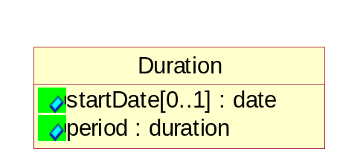
Figure ‎3-11 Duration

Attribute | Type | Documentation
startDate[0..1] | date | The date indicating the beginning of the duration.
period | duration | Represents a duration of time.

MonetaryAmount
The collection of business properties that describe the monetary amount defined by a specified currency.
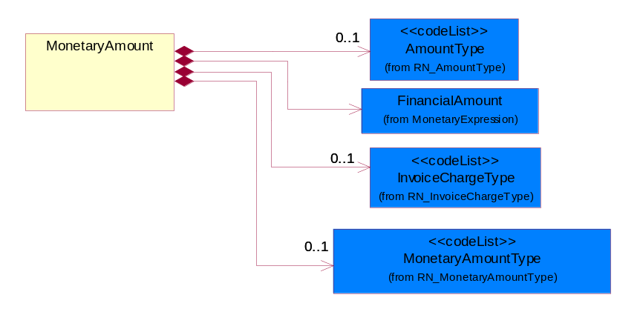
Figure ‎3-12 MonetaryAmount

Composition | Cardinality | Type | Documentation
FinancialAmount | 1 | FinancialAmount | The business document must express financial amounts.
InvoiceChargeType | 0..1 | InvoiceChargeType | Code identifying the values for the types of charges contained in an invoice.
MonetaryAmountType | 0..1 | MonetaryAmountType | Code identifying whether the monetary amount is a debit or credit.
AmountType | 0..1 | AmountType

ProductPricing
The collection of business properties that describe the type of pricing and financial amount for a product.
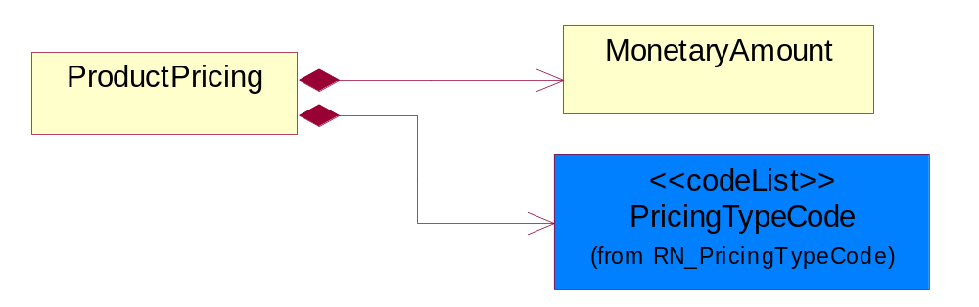
Figure ‎3-13 ProductPricing

Composition | Cardinality | Type | Documentation
MonetaryAmount | 1 | MonetaryAmount | The collection of business properties that describe the monetary amount defined by a specified currency.
PricingTypeCode | 1 | PricingTypeCode | Code identifying the type of pricing available for a product.

ProductQuantity
A quantity specifying the number of product units.
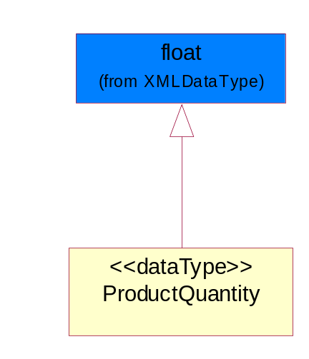
Figure ‎3-14 ProductQuantity

CodeList

InvoiceChargeType
Code identifying the values for the types of charges contained in an invoice.

Name | Documentation
ALC | Allowances and Charges.
CUC | Custom Charges.
DEA | Deposit Amount.
ESC | Expedited Shipping Charge - Charge for accelerating the delivery of a product.
FRC | Freight Charges.
HAC | Handling Charges.
LEC | Lease Charge - Charge for the use of a product in which the purchaser assumes certain responsibilities of ownership.
LIC | License Charge - Charge for the use of a product (usually software) in which the manufacturer maintains ownership of the product.
MAC | Maintenance Charge - Charge (usually periodic) for providing maintenance support for a product.
PUC | Purchase Charge - Charge for a product in which the buyer takes all responsibilities of ownership.
QUD | Quantity Discount.
REC | Rental Charge - Charge for the use of a product (usually hardware) in which the manufacturer maintains ownership of the product.

MonetaryAmountType
Code identifying whether the monetary amount is a debit or credit.

Name | Documentation
CRE | Credit.
DEB | Debit.
ZER | Zero remit.

PricingTypeCode
Code identifying the type of pricing available for a product.

Name | Documentation
ACR | Authorized Cost and Resale.
ACS | Authorized Cost - The negotiated cost agreed upon between the supplier and distributor at the time the “debit?is authorized.
ACT | Authorized cost.
ANY | Any available.
ARS | Authorized resale.
ASP | Average Selling Price - Manufacturer's published price.
BPP | Broken Purchase Price.
BSH | Book-Ship.
CAT | Catalog price - Book (the supplier’s published cost at the time of transaction) or Published Price.
CMC | Commercial.
CMD | Commodity.
CMF | Contract Manufacturing.
CON | Contract.
COS | Cost - Price for which the distributor purchased the parts.
DBC | Disti Book Cost.
DFR | Duty free.
DIS | Distribution.
DPD | Duty paid.
DTP | Distribution price.
EDU | Education.
ERT | E-Rate.
EXC | Exception.
FGM | Federal government.
GEN | General.
HIE | Higher Education.
LCL | Local.
LGM | Local government.
LIS | List.
MPR | Market price.
MRP | Manufacturer's recommendation for unit pricing.
MSR | Manufacturer Suggested Retail Price (MSRP).
MUS | Minimum Unit Sale (MUS) - Manufacturer requirement of total dollar value for design opportunity.
NPF | Nonprofit.
OEM | Original Equipment Manufacturing (OEM).
OVP | OEM Volume Pricing - Original equipment manufacturing price per volume ordered.
PED | Primary Education.
QUO | Quote Price
RCS | Requested Cost (RCS) - Reseller requested cost to the manufacturer.
RFB | Refurbished.
RIN | Religious Institution.
RSP | Resale - Price the distributor is authorized to use for sale to their customer (RSP).
SCE | Special Education.
SEC | Security and management reseller.
SED | Secondary Education.
SEV | Service provider.
SGM | State Government.
SPD | Special Discount Price.
SPE | Special Education.
SPL | Samples.
SRP | Suggested Resale Price.
STR | Standard Rebate.
THP | Threshold Price.
TOC | Total Other Charges - Suggested resale price - The sum total of all distributor added charges to the customer for value added services, including but not limited to programming, tape and reel, labeling, date coding, kitting and in-house assembly.

AmountType

Name | Documentation
DIS | Discount Value - The monetary amount of the discount on the price applied to a customer order.
FRE | Freight Charges - The monetary amount to be paid for freight transportation.
INS | InsuranceCharges - The monetary amount to be paid for freight insurance.
MAT | Material Cost - This object represents the material cost for the product.
MIS | Miscellaneous Charges - The monetary amount to be paid for miscellaneous charges.
PRC | Processing Charges - The monetary amount to be paid by consignee for consignment manufacturer.
TOD | Total Amount Due - Total amount due upon receipt of statement.
TOT | Total Amount - Total price for an entire business document.
TOV | Total Value Added Amount - The total amount of the shipment including any value added tax.
UNI | Unit Price - Agreed upon sale price for each unit ordered.
VAD | Value Added Unit Price - The price of a unit including any value added tax.

Universal Structure

ContactInformation

ContactInformation
The business document must allow for the identification of the name of the department, service or individual to be contacted regarding the context of the business document.
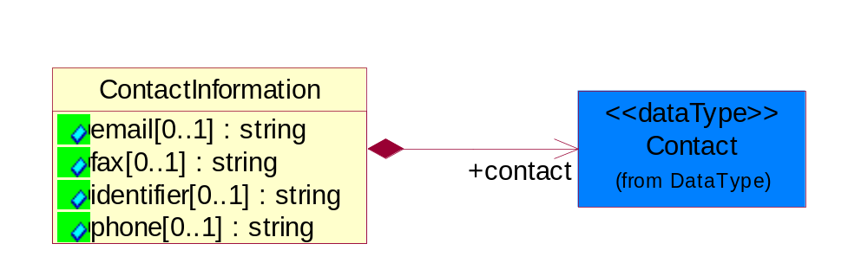
Figure ‎4-15 ContactInformation

Attribute | Type | Documentation
email[0..1] | string | The electronic mail for the specified contact.
fax[0..1] | string | The fax number for the specified contact.
identifier[0..1] | string | Identifies the role of the contact (i.e. Service Technician, Account Manager) in the Business Process.
phone[0..1] | string | The telephone number for the specified contact.

Composition | Cardinality | Type | Documentation
contact | 1 | Contact | The name of the department, service or individual to be contacted within the organization.

DataType

Contact
The name of the department, service or individual to be contacted within the organization.
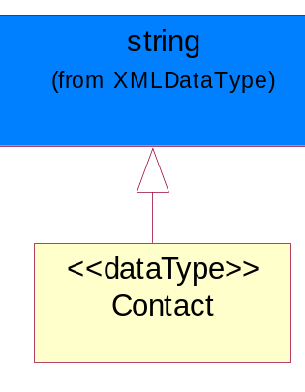
Figure ‎4-16 Contact

DUNS
A number assigned by Dun and Bradstreet to identify a business location.
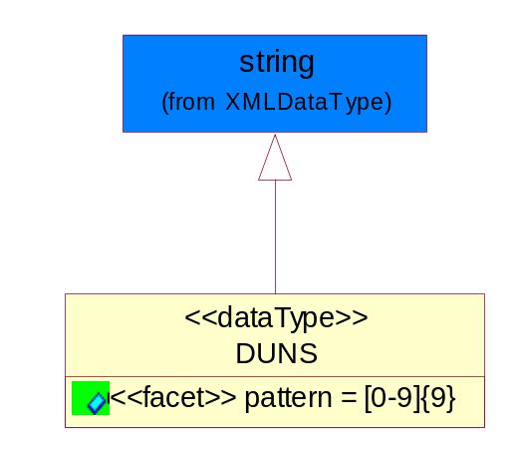
Figure ‎4-17 DUNS

Attribute | Type | Documentation
pattern |  | [0-9]{9}

DUNSPlus4
A identifier to specify a specific location within a business location.
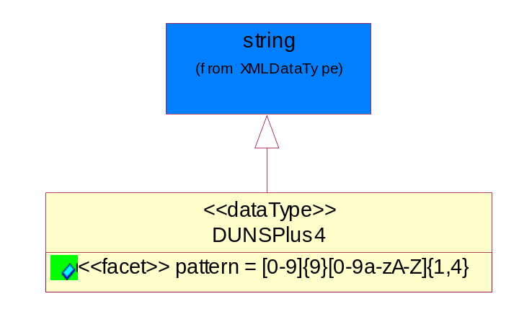
Figure ‎4-18 DUNSPlus4

Attribute | Type | Documentation
pattern |  | Data Universal Numbering System +4 (DUNS+4) number means the DUNS number assigned by Dun and Bradstreet, Inc. (D&B) plus an alphanumeric of length 4 suffix that may be assigned by a business concern.

GLN
Global Location Number (GLN) - A identifier to identify legal entities, trading parties and location.
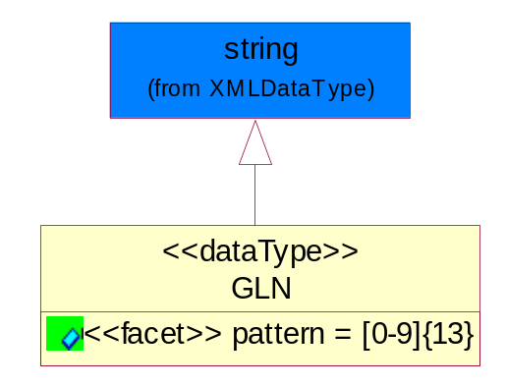
Figure ‎4-19 GLN

Attribute | Type | Documentation
pattern |  | [0-9]{13}

GTIN
Global Trade Identification Number (GTIN).
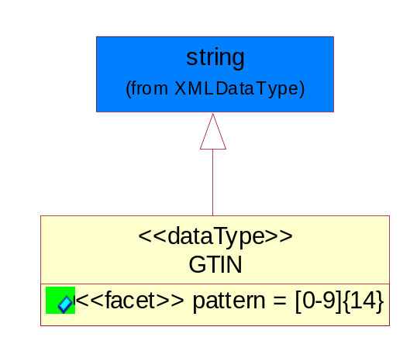
Figure ‎4-20 GTIN

Attribute | Type | Documentation
pattern |  | [0-9]{14}

Dates

DatePeriod
The business document must allow for the computation or statement of a duration based upon a beginning and an ending date.
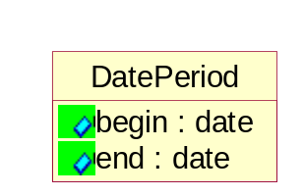
Figure ‎4-21 DatePeriod

Attribute | Type | Documentation
begin | date | The date indicating the beginning of the date period.
end | date | The date indicating the ending of the date period.

Document

BusinessDocumentReference
The business document reference object allows for the indirect referencing of a relationship to other business related documents.
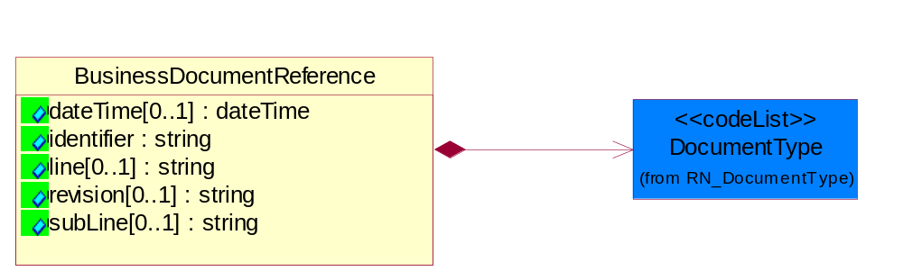
Figure ‎4-22 BusinessDocumentReference

Attribute | Type | Documentation
dateTime[0..1] | dateTime | The date-time stamp indicating on the referenced business document.
identifier | string | Unique identification of the referenced business document.
line[0..1] | string | References the specific line number of the specified business document.
revision[0..1] | string | Referenced the revision of the specified business document.
subLine[0..1] | string | References the specific subline number of the specified business document.

Composition | Cardinality | Type | Documentation
DocumentType | 1 | DocumentType | A code identifying the business context of a document.

Locations

AlternativeIdentifier
Identifies the specified code and the name of the organization that a code is utilized from.
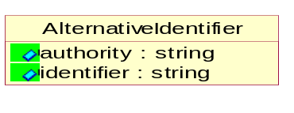
Figure ‎4-23 AlternativeIdentifier

Attribute | Type | Documentation
authority | string | The name of the organization that a code is utilized from.
identifier | string | The specified code to represent an entity (e.g. product, location, partner, etc.)

Location
The business document must specify a location.
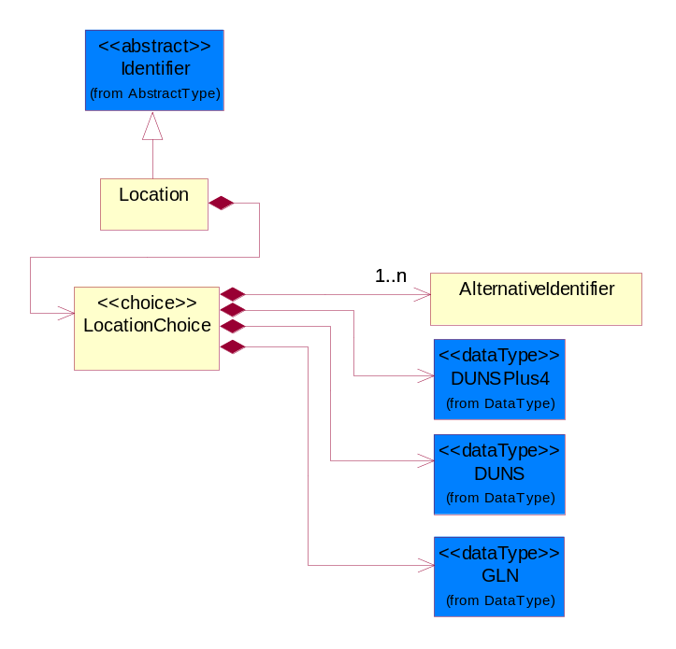
Figure ‎4-24 Location

Composition | Cardinality | Type | Documentation
LocationChoice | 1 | LocationChoice

LocationChoice

Composition | Cardinality | Type | Documentation
DUNSPlus4 | 1 | DUNSPlus4 | A identifier to specify a specific location within a business location.
DUNS | 1 | DUNS | A number assigned by Dun and Bradstreet to identify a business location.
AlternativeIdentifier | 1..n | AlternativeIdentifier | Identifies the specified code and the name of the organization that a code is utilized from.
GLN | 1 | GLN | Global Location Number (GLN) - A identifier to identify legal entities, trading parties and location.

PhysicalAddress
The business document must provide a physical address for a party to the business transaction.
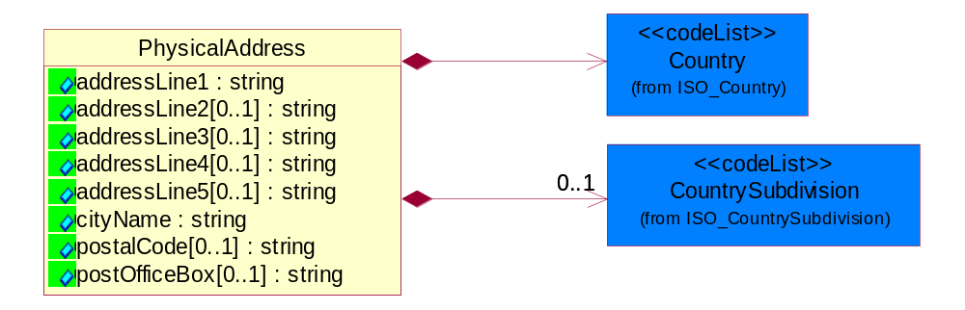
Figure ‎4-25 PhysicalAddress

Attribute | Type | Documentation
addressLine1 | string | The first line of a physical address.
addressLine2[0..1] | string | The second line of a physical address.
addressLine3[0..1] | string | The third line of a physical address.
addressLine4[0..1] | string | The fourth line of a physical address.
addressLine5[0..1] | string | The fifth line of a physical address.
cityName | string | The name of a city.
postalCode[0..1] | string | Identifying geographic location as specified by a national postal code.
postOfficeBox[0..1] | string | The Post Office Box identifier used to identify a party's post office box.

Composition | Cardinality | Type | Documentation
Country | 1 | Country | For representation of Country name RosettaNet has adopted ISO 3166-3; 1999. Refer to the following web page to get the latest version of the standard:  http://www.iso.ch/iso/en/prods-services/iso3166ma/02iso-3166-code-lists/index.html  If you need more information about the ISO standard please contact ISO for more details.
CountrySubdivision | 0..1 | CountrySubdivision | For representation of a Countries subdivisions RosettaNet has adopted ISO 3166-3; 1999. Refer to the following web page to get the latest version of the standard:  http://www.iso.ch/iso/en/prods-services/iso3166ma/02iso-3166-code-lists/index.html  If you need more information about the ISO standard please contact ISO for more details.

MonetaryExpression

FinancialAmount
The business document must express financial amounts.
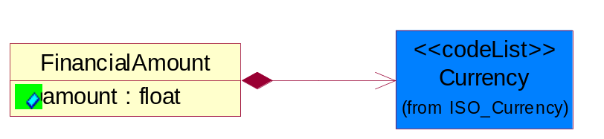
Figure ‎4-26 FinancialAmount

Attribute | Type | Documentation
amount | float | Specifies the monetary amount.

Composition | Cardinality | Type | Documentation
Currency | 1 | Currency | For representation of Currency codes RosettaNet has adopted ISO 4217; 1995. The British Standards Institution (BSI) is the ISO 4217 Maintenance Agency. Refer to the following web page to get the latest version of the standard:  http://www.bsi-global.com/Technical+Information/Publications/_Publications/tig90.xalter  If you need more information about the ISO standard please contact ISO for more details.

PartnerIdentification

PartnerIdentification
The business document must allow for the identity of one or more parties to the transaction.
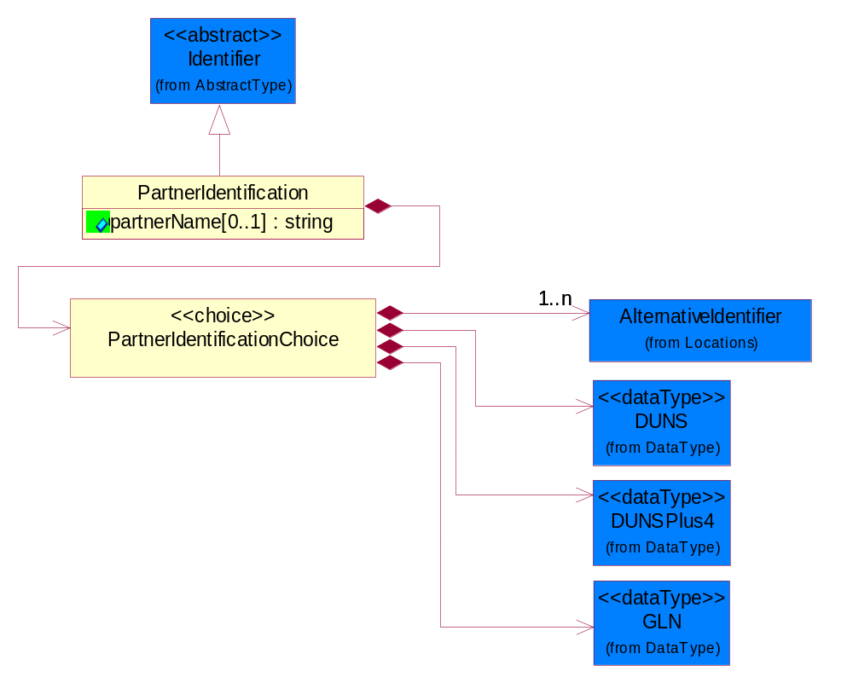
Figure ‎4-27 PartnerIdentification

Attribute | Type | Documentation
partnerName[0..1] | string | The name of the partner’s company/business.

Composition | Cardinality | Type | Documentation
PartnerIdentificationChoice | 1 | PartnerIdentificationChoice

PartnerIdentificationChoice

Composition | Cardinality | Type | Documentation
DUNS | 1 | DUNS | A number assigned by Dun and Bradstreet to identify a business location.
DUNSPlus4 | 1 | DUNSPlus4 | A identifier to specify a specific location within a business location.
AlternativeIdentifier | 1..n | AlternativeIdentifier | Identifies the specified code and the name of the organization that a code is utilized from.
GLN | 1 | GLN | Global Location Number (GLN) - A identifier to identify legal entities, trading parties and location.

SpecifiedFullPartner
The business document must describe the trading partners in the business transaction. This data structure provide the flexibility to describe a partner in all possible methods as for new, existing or known partner. This is specifically for partner who role has been specified.
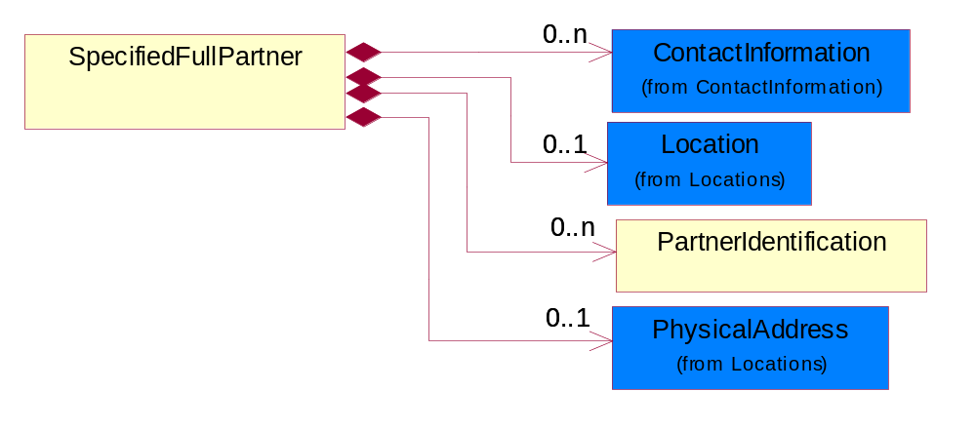
Figure ‎4-28 SpecifiedFullPartner

Composition | Cardinality | Type | Documentation
ContactInformation | 0..n | ContactInformation | The business document must allow for the identification of the name of the department, service or individual to be contacted regarding the context of the business document.
Location | 0..1 | Location | The business document must specify a location.
PartnerIdentification | 0..n | PartnerIdentification | The business document must allow for the identity of one or more parties to the transaction.
PhysicalAddress | 0..1 | PhysicalAddress | The business document must provide a physical address for a party to the business transaction.

SpecifiedIntermittentPartner
The business document must describe a physical address for a delivery.
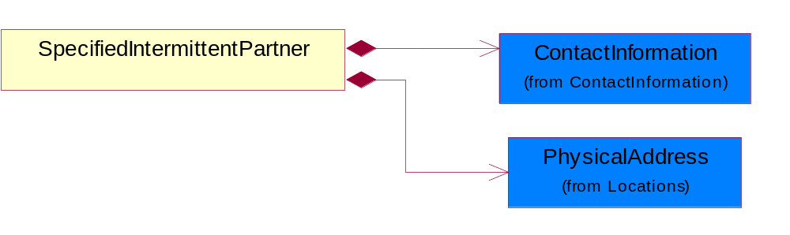
Figure ‎4-29 SpecifiedIntermittentPartner

Composition | Cardinality | Type | Documentation
ContactInformation | 1 | ContactInformation | The business document must allow for the identification of the name of the department, service or individual to be contacted regarding the context of the business document.
PhysicalAddress | 1 | PhysicalAddress | The business document must provide a physical address for a party to the business transaction.

SpecifiedKnownPartner
The business document must describe the trading partners in the business transaction.
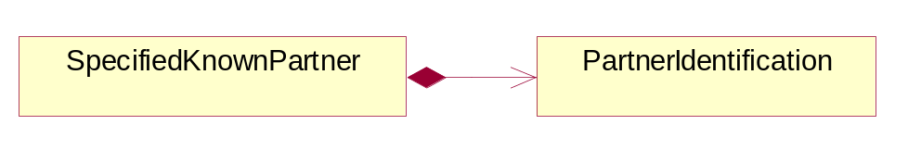
Figure ‎4-30 SpecifiedKnownPartner

Composition | Cardinality | Type | Documentation
PartnerIdentification | 1 | PartnerIdentification | The business document must allow for the identity of one or more parties to the transaction.

SpecifiedKnownPartnerContact
The business document must describe the trading partners in the business transaction and allow for a identification of an individual of the trading partner.
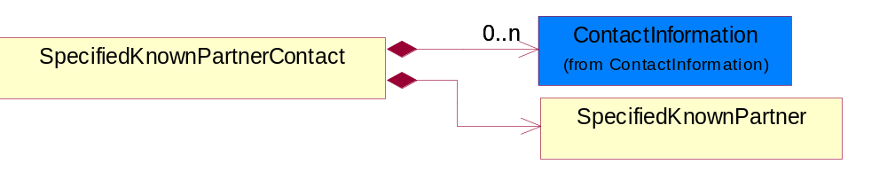
Figure ‎4-31 SpecifiedKnownPartnerContact

Composition | Cardinality | Type | Documentation
SpecifiedKnownPartner | 1 | SpecifiedKnownPartner | The business document must describe the trading partners in the business transaction.
ContactInformation | 0..n | ContactInformation | The business document must allow for the identification of the name of the department, service or individual to be contacted regarding the context of the business document.

SpecifiedNewPartner
The business document must describe a new, existing (but known to only one of the parties to the transaction) or an unknown party to the business transaction.
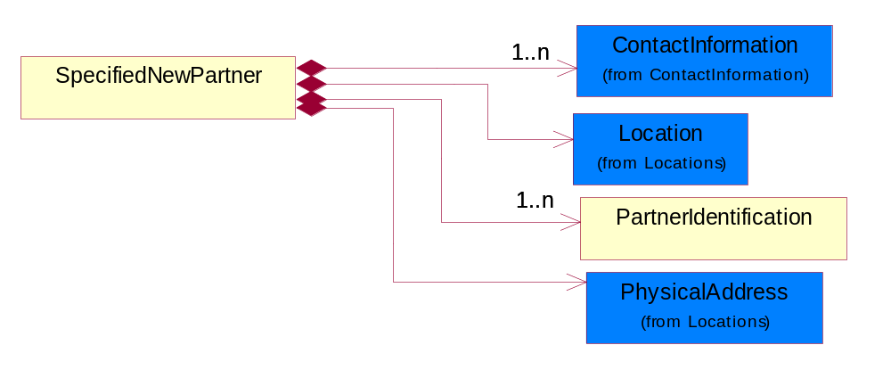
Figure ‎4-32 SpecifiedNewPartner

Composition | Cardinality | Type | Documentation
ContactInformation | 1..n | ContactInformation | The business document must allow for the identification of the name of the department, service or individual to be contacted regarding the context of the business document.
Location | 1 | Location | The business document must specify a location.
PhysicalAddress | 1 | PhysicalAddress | The business document must provide a physical address for a party to the business transaction.
PartnerIdentification | 1..n | PartnerIdentification | The business document must allow for the identity of one or more parties to the transaction.

SpecifiedPartnerDescription
The collection of business properties that describe a business partners' identity, their contact information, where they are physically located and their function in a supply chain.
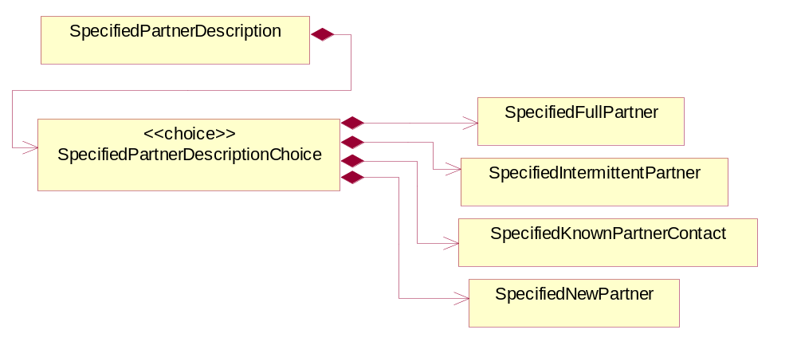
Figure ‎4-33 SpecifiedPartnerDescription

Composition | Cardinality | Type | Documentation
SpecifiedPartnerDescriptionChoice | 1 | SpecifiedPartnerDescriptionChoice

SpecifiedPartnerDescriptionChoice

Composition | Cardinality | Type | Documentation
SpecifiedKnownPartnerContact | 1 | SpecifiedKnownPartnerContact | The business document must describe the trading partners in the business transaction and allow for a identification of an individual of the trading partner.
SpecifiedIntermittentPartner | 1 | SpecifiedIntermittentPartner | The business document must describe a physical address for a delivery.
SpecifiedNewPartner | 1 | SpecifiedNewPartner | The business document must describe a new, existing (but known to only one of the parties to the transaction) or an unknown party to the business transaction.
SpecifiedFullPartner | 1 | SpecifiedFullPartner | The business document must describe the trading partners in the business transaction. This data structure provide the flexibility to describe a partner in all possible methods as for new, existing or known partner. This is specifically for partner who role has been specified.

ProductIdentification

ProductIdentification
The object provides the identifier(s) of a product.
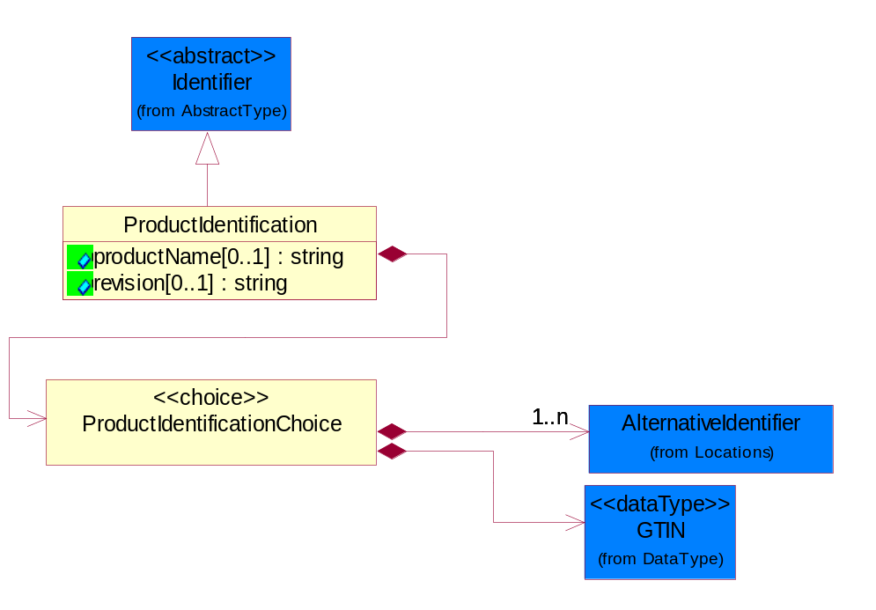
Figure ‎4-34 ProductIdentification

Attribute | Type | Documentation
productName[0..1] | string | The name of the product.
revision[0..1] | string | Referenced the specified product revision.

Composition | Cardinality | Type | Documentation
ProductIdentificationChoice | 1 | ProductIdentificationChoice

ProductIdentificationChoice

Composition | Cardinality | Type | Documentation
AlternativeIdentifier | 1..n | AlternativeIdentifier | Identifies the specified code and the name of the organization that a code is utilized from.
GTIN | 1 | GTIN | Global Trade Identification Number (GTIN).

CodeList

Country
For representation of Country name RosettaNet has adopted ISO 3166-3; 1999. Refer to the following web page to get the latest version of the standard:
http://www.iso.ch/iso/en/prods-services/iso3166ma/02iso-3166-code-lists/index.html

If you need more information about the ISO standard please contact ISO for more details.

CountrySubdivision
For representation of a Countries subdivisions RosettaNet has adopted ISO 3166-3; 1999. Refer to the following web page to get the latest version of the standard:
http://www.iso.ch/iso/en/prods-services/iso3166ma/02iso-3166-code-lists/index.html

If you need more information about the ISO standard please contact ISO for more details.

Currency
For representation of Currency codes RosettaNet has adopted ISO 4217; 1995. The British Standards Institution (BSI) is the ISO 4217 Maintenance Agency. Refer to the following web page to get the latest version of the standard:
http://www.bsi-global.com/Technical+Information/Publications/_Publications/tig90.xalter

If you need more information about the ISO standard please contact ISO for more details.

Language
For representation of Language name RosettaNet has adopted ISO 639-2; 1998. Refer to the following web page to get the latest version of the standard:

http://www.loc.gov/standards/iso639-2/iso639jac.html

If you need more information about the ISO standard please contact ISO for more details.

DocumentType
A code identifying the business context of a document.

Instance | Documentation
CBN | Product batch number of customer.
CCN | Customs clearance number.
CFA | Failure Analysis - Request document that will accompany the product providing characteristics of the component failure.
CIN | Commercial Invoice.
CNM | Traditional credit note or memo.
CON | In a virtual sourcing relationship, a third party trading partner is supplying a part to a customer on behalf of another company that has taken the order for the customer. In this case a Customer Order Number is associated to the request for material that is sent to the virtual trading partners.
COT | Contract.
CRN | Unique consumption reference number identifying the product consumption issue i.e. one-to-one relationship with physical flow.
DEM | Traditional debit note or memo.
DEN | Delivery Note.
DIN | Discontinuation Notice.
DRN | Drawing Number.
FUO | Sales order or transfer order fulfilling demand out of a facility (outbound shipment).
INV | Invoice.
LID | Location Identifier. Data for on-site work that have to be done on the machine (associated with preventive maintenance order)
MEN | Master Event Number.
MID | Machine Identifier. Data for on-site work that have to be done on the machine (associated with preventive maintenance order)
MON | Model Number.
OCL | The unique identifier assigned by the OEM for a warranty claim.
OGA | Other governmental agency issued document.
OPO | The unique identifier assigned by the OEM for a part order.
OPR | The unique identifier assigned by the OEM for a part return.
PFA | Failure Analysis - Request document that will accompany the product providing characteristics of the product failure.
PII | Refers to previously issued invoice.
PLS | Unique number that identifies packing form prior to shipment.
POI | Purchase Order IN.
PON | Production order number for material release.
POO | Purchase Order OUT
PRC | Product Catalog.
PSI | Refers to previously issued self-billing invoice.
PUO | Purchase Order.
QUO | Quote.
REC | Document identifying the receipt of materials or products into a facility against a purchase order or transfer order (inbound shipment).
REO | Purchase order or transfer order replenishing inventory into a facility (inbound shipment).
REQ | Requisition.
RMA | Returned Material Authorization.
RPO | Purchase order for materials or product returned to and reworked by a supplier.
RTA | Remittance Advice - Remittance details.
SAO | Sales Order.
SBC | Credit Memo used in self-billing scenario.
SBD | Debit Memo used in self-billing scenario.
SBI | Invoice in self billing scenario.
SBN | Product batch number of supplier.
SCA | Similar to contracts - Contains the quantity of an article that is to be ordered from a vendor and the price for article or service that is to be procured.
SEN | Serial Number.
SEO | A document that gives a repair provider the necessary authorization to repair or upgrade a product either at the customer site or at the repair provider’s site.
SHD | Shipping Document.
SNC | Shipset Number on Code List.
SPC | The unique identifier assigned by the ASP for a warranty claim.
SPN | Spec Number.
SPO | The unique identifier assigned by the ASP for a part order.
SPR | The unique identifier assigned by the ASP for a part return.
SPW | The unique identifier assigned by the ASP to reference a work order.
SRI | A document that contains the shipping reference number which allows the product to be tracked within the outsourced logistic providers network.
TRO | Order which results in materials or products being moved from one facility to another (outbound shipment and inbound shipment).
WAB | Waybill.
WAC | Denotes a warranty claim.
WOO | Work Order.

MimeTypeQualifier
The MIME type as defined by IANA.

Please refer to http://www.iana.org/assignments/media-types/ for a list of types.

Instance | Documentation
application/activemessage | [Shapiro]
application/andrew-inset | [Borenstein]
application/applefile | [Faltstrom]
application/atomicmail | [Borenstein]
application/batch-SMTP | [RFC2442]
application/beep+xml | [RFC3080]
application/cals-1840 | [RFC1895]
application/cnrp+xml | [RFCCNRP]
application/commonground | [Glazer]
application/cpl+xml
application/cybercash | [Eastlake]
application/dca-rft | [Campbell]
application/dec-dx | [Campbell]
application/dicom | [RFC3240]
application/dvcs | [RFC3029]
application/EDI-Consent | [RFC1767]
application/EDIFACT | [RFC1767]
application/EDI-X12 | [RFC1767]
application/eshop | [Katz]
application/font-tdpfr | [RFC3073]
application/http | [RFC2616]
application/hyperstudio | [Domino]
application/iges | [Parks]
application/index | [RFC2652]
application/index.cmd | [RFC2652]
application/index.obj | [RFC2652]
application/index.response | [RFC2652]
application/index.vnd | [RFC2652]
application/iotp | [RFC2935]
application/ipp | [RFC2910]
application/isup | [RFC3204]
application/mac-binhex40 | [Faltstrom]
application/macwriteii | [Lindner]
application/marc | [RFC2220]
application/mathematica | [Van Nostern]
application/msword | [Lindner]
application/news-message-id | [RFC1036,Spencer]
application/news-transmission | [RFC1036, Spencer]
application/ocsp-request | [RFC2560]
application/ocsp-response | [RFC2560]
application/octet-stream | [RFC2045,RFC2046]
application/oda | [RFC2045,RFC2046]
application/ogg | [RFC-walleij-ogg-mediatype-08.txt]
application/parityfec | [RFC3009]
application/pdf | [Lindner]
application/pgp-encrypted | [RFC3156]
application/pgp-keys | [RFC3156]
application/pgp-signature | [RFC3156]
application/pkcs10 | [RFC2311]
application/pkcs7-mime | [RFC2311]
application/pkcs7-signature | [RFC2311]
application/pkix-cert | [RFC2585]
application/pkixcmp | [RFC2510]
application/pkix-crl | [RFC2585]
application/postscript | [RFC2045,RFC2046]
application/prs.alvestrand.titrax-sheet | [Alvestrand]
application/prs.cww | [Rungchavalnont]
application/prs.nprend | [Doggett]
application/prs.plucker | [Janssen]
application/qsig | [RFC3204]
application/reginfo+xml | [RFC-ietf-sipping-reg-event-00.txt]
application/remote-printing | [RFC1486,Rose]
application/riscos | [Smith]
application/rtf | [Lindner]
application/sdp | [RFC2327]
application/set-payment | [Korver]
application/set-payment-initiation | [Korver]
application/set-registration | [Korver]
application/set-registration-initiation | [Korver]
application/sgml | [RFC1874]
application/sgml-open-catalog | [Grosso]
application/sieve | [RFC3028]
application/slate | [Crowley]
application/timestamp-query | [RFC3161]
application/timestamp-reply | [RFC3161]
application/tve-trigger | [Welsh]
application/vemmi | [RFC2122]
application/vnd.3gpp.pic-bw-large | [Meredith]
application/vnd.3gpp.pic-bw-small | [Meredith]
application/vnd.3gpp.pic-bw-var | [Meredith]
application/vnd.3gpp.sms | [Meredith]
application/vnd.3M.Post-it-Notes | [O'Brien]
application/vnd.accpac.simply.aso | [Leow]
application/vnd.accpac.simply.imp | [Leow]
application/vnd.acucobol | [Lubin]
application/vnd.acucorp | [Lubin]
application/vnd.adobe.xfdf | [Perelman]
application/vnd.aether.imp | [Moskowitz]
application/vnd.amiga.ami | [Blumberg]
application/vnd.anser-web-certificate-issue-initiation | [Mori]
application/vnd.anser-web-funds-transfer-initiation | [Mori]
application/vnd.audiograph | [Slusanschi]
application/vnd.blueice.multipass | [Holmstrom]
application/vnd.bmi | [Gotoh]
application/vnd.businessobjects | [Imoucha]
application/vnd.canon-cpdl | [Muto]
application/vnd.canon-lips | [Muto]
application/vnd.cinderella | [Kortenkamp]
application/vnd.claymore | [Simpson]
application/vnd.commerce-battelle | [Applebaum]
application/vnd.commonspace | [Chandhok]
application/vnd.contact.cmsg | [Patz]
application/vnd.cosmocaller | [Dellutri]
application/vnd.ctc-posml | [Kohlhepp]
application/vnd.cups-postscript | [Sweet]
application/vnd.cups-raster | [Sweet]
application/vnd.cups-raw | [Sweet]
application/vnd.curl | [Byrnes]
application/vnd.cybank | [Helmee]
application/vnd.data-vision.rdz | [Fields]
application/vnd.dna | [Searcy]
application/vnd.dpgraph | [Parker]
application/vnd.dreamfactory | [Appleton]
application/vnd.dxr | [Duffy]
application/vnd.ecdis-update | [Buettgenbach]
application/vnd.ecowin.chart | [Olsson]
application/vnd.ecowin.filerequest | [Olsson]
application/vnd.ecowin.fileupdate | [Olsson]
application/vnd.ecowin.series | [Olsson]
application/vnd.ecowin.seriesrequest | [Olsson]
application/vnd.ecowin.seriesupdate | [Olsson]
application/vnd.enliven | [Santinelli]
application/vnd.epson.esf | [Hoshina]
application/vnd.epson.msf | [Hoshina]
application/vnd.epson.quickanime | [Gu]
application/vnd.epson.salt | [Nagatomo]
application/vnd.epson.ssf | [Hoshina]
application/vnd.ericsson.quickcall | [Tidwell]
application/vnd.eudora.data | [Resnick]
application/vnd.fdf | [Zilles]
application/vnd.ffsns | [Holstage]
application/vnd.FloGraphIt | [Floersch]
application/vnd.framemaker | [Wexler]
application/vnd.fsc.weblaunch | [D.Smith]
application/vnd.fujitsu.oasys | [Togashi]
application/vnd.fujitsu.oasys2 | [Togashi]
application/vnd.fujitsu.oasys3 | [Okudaira]
application/vnd.fujitsu.oasysgp | [Sugimoto]
application/vnd.fujitsu.oasysprs | [Ogita]
application/vnd.fujixerox.ddd | [Onda]
application/vnd.fujixerox.docuworks | [Taguchi]
application/vnd.fujixerox.docuworks.binder | [Matsumoto]
application/vnd.fut-misnet | [Pruulmann]
application/vnd.grafeq | [Tupper]
application/vnd.groove-account | [Joseph]
application/vnd.groove-help | [Joseph]
application/vnd.groove-identity-message | [Joseph]
application/vnd.groove-injector | [Joseph]
application/vnd.groove-tool-message | [Joseph]
application/vnd.groove-tool-template | [Joseph]
application/vnd.groove-vcard | [Joseph]
application/vnd.hbci | [Hammann]
application/vnd.hhe.lesson-player | [Jones]
application/vnd.hp-HPGL | [Pentecost]
application/vnd.hp-hpid | [Gupta]
application/vnd.hp-hps | [Aubrey]
application/vnd.hp-PCL | [Pentecost]
application/vnd.hp-PCLXL | [Pentecost]
application/vnd.httphone | [Lefevre]
application/vnd.hzn-3d-crossword | [Minnis]
application/vnd.ibm.afplinedata | [Buis]
application/vnd.ibm.electronic-media | [Tantlinger]
application/vnd.ibm.MiniPay | [Herzberg]
application/vnd.ibm.modcap | [Hohensee]
application/vnd.ibm.secure-container | [Tantlinger]
application/vnd.informix-visionary | [Gales]
application/vnd.intercon.formnet | [Gurak]
application/vnd.intertrust.digibox | [Tomasello]
application/vnd.intertrust.nncp | [Tomasello]
application/vnd.intu.qbo | [Scratchley]
application/vnd.intu.qfx | [Scratchley]
application/vnd.irepository.package+xml | [Knowles]
application/vnd.is-xpr | [Natarajan]
application/vnd.japannet-directory-service | [Fujii]
application/vnd.japannet-jpnstore-wakeup | [Yoshitake]
application/vnd.japannet-payment-wakeup | [Fujii]
application/vnd.japannet-registration | [Yoshitake]
application/vnd.japannet-registration-wakeup | [Fujii]
application/vnd.japannet-setstore-wakeup | [Yoshitake]
application/vnd.japannet-verification | [Yoshitake]
application/vnd.japannet-verification-wakeup | [Fujii]
application/vnd.jisp | [Deckers]
application/vnd.kde.karbon | [Faure]
application/vnd.kde.kchart | [Faure]
application/vnd.kde.kformula | [Faure]
application/vnd.kde.kivio | [Faure]
application/vnd.kde.kontour | [Faure]
application/vnd.kde.kpresenter | [Faure]
application/vnd.kde.kspread | [Faure]
application/vnd.kde.kword | [Faure]
application/vnd.kenameaapp | [DiGiorgio-Haag]
application/vnd.koan | [Cole]
application/vnd.liberty-request+xml | [McDowell]
application/vnd.llamagraphics.life-balance.desktop | [White]
application/vnd.lotus-1-2-3 | [Wattenberger]
application/vnd.lotus-approach | [Wattenberger]
application/vnd.lotus-freelance | [Wattenberger]
application/vnd.lotus-notes | [Laramie]
application/vnd.lotus-organizer | [Wattenberger]
application/vnd.lotus-screencam | [Wattenberger]
application/vnd.lotus-wordpro | [Wattenberger]
application/vnd.mcd | [Gotoh]
application/vnd.mediastation.cdkey | [Flurry]
application/vnd.meridian-slingshot | [Wedel]
application/vnd.micrografx.flo | [Prevo]
application/vnd.micrografx.igx | [Prevo]
application/vnd.mif | [Wexler]
application/vnd.minisoft-hp3000-save | [Bartram]
application/vnd.mitsubishi.misty-guard.trustweb | [Tanaka]
application/vnd.Mobius.DAF | [Kabayama]
application/vnd.Mobius.DIS | [Kabayama]
application/vnd.Mobius.MBK | [Devasia]
application/vnd.Mobius.MQY | [Devasia]
application/vnd.Mobius.MSL | [Kabayama]
application/vnd.Mobius.PLC | [Kabayama]
application/vnd.Mobius.TXF | [Kabayama]
application/vnd.mophun.application | [Wennerstrom]
application/vnd.mophun.certificate | [Wennerstrom]
application/vnd.motorola.flexsuite | [Patton]
application/vnd.motorola.flexsuite.adsi | [Patton]
application/vnd.motorola.flexsuite.fis | [Patton]
application/vnd.motorola.flexsuite.gotap | [Patton]
application/vnd.motorola.flexsuite.kmr | [Patton]
application/vnd.motorola.flexsuite.ttc | [Patton]
application/vnd.motorola.flexsuite.wem | [Patton]
application/vnd.mozilla.xul+xml | [McDaniel]
application/vnd.ms-artgalry | [Slawson]
application/vnd.ms-asf | [Fleischman]
application/vnd.mseq | [Le Bodic]
application/vnd.ms-excel | [Gill]
application/vnd.msign | [Borcherding]
application/vnd.ms-lrm | [Ledoux]
application/vnd.ms-powerpoint | [Gill]
application/vnd.ms-project | [Gill]
application/vnd.ms-tnef | [Gill]
application/vnd.ms-works | [Gill]
application/vnd.ms-wpl | [Plastina]
application/vnd.musician | [Adams]
application/vnd.music-niff | [Butler]
application/vnd.netfpx | [Mutz]
application/vnd.noblenet-directory | [Solomon]
application/vnd.noblenet-sealer | [Solomon]
application/vnd.noblenet-web | [Solomon]
application/vnd.novadigm.EDM | [Swenson]
application/vnd.novadigm.EDX | [Swenson]
application/vnd.novadigm.EXT | [Swenson]
application/vnd.obn | [Hessling]
application/vnd.osa.netdeploy | [Klos]
application/vnd.palm | [Peacock]
application/vnd.pg.format | [Gandert]
application/vnd.pg.osasli | [Gandert]
application/vnd.powerbuilder6 | [Guy]
application/vnd.powerbuilder6-s | [Guy]
application/vnd.powerbuilder7 | [Shilts]
application/vnd.powerbuilder75 | [Shilts]
application/vnd.powerbuilder75-s | [Shilts]
application/vnd.powerbuilder7-s | [Shilts]
application/vnd.previewsystems.box | [Smolgovsky]
application/vnd.publishare-delta-tree | [Ben-Kiki]
application/vnd.pvi.ptid1 | [Lamb]
application/vnd.pwg-multiplexed | [RFC3391]
application/vnd.pwg-xhtml-print+xml | [Wright]
application/vnd.Quark.QuarkXPress | [Scheidler]
application/vnd.rapid | [Szekely]
application/vnd.s3sms | [Tarkkala]
application/vnd.sealed.net | [Lambert]
application/vnd.seemail | [Webb]
application/vnd.shana.informed.formdata | [Selzler]
application/vnd.shana.informed.formtemplate | [Selzler]
application/vnd.shana.informed.interchange | [Selzler]
application/vnd.shana.informed.package | [Selzler]
application/vnd.smaf | [Takahashi]
application/vnd.sss-cod | [Dani]
application/vnd.sss-dtf | [Bruno]
application/vnd.sss-ntf | [Bruno]
application/vnd.street-stream | [Levitt]
application/vnd.svd | [Becker]
application/vnd.swiftview-ics | [Widener]
application/vnd.triscape.mxs | [Simonoff]
application/vnd.trueapp | [Hepler]
application/vnd.truedoc | [Chase]
application/vnd.ufdl | [Manning]
application/vnd.uplanet.alert | [Martin]
application/vnd.uplanet.alert-wbxml | [Martin]
application/vnd.uplanet.bearer-choice | [Martin]
application/vnd.uplanet.bearer-choice-wbxml | [Martin]
application/vnd.uplanet.cacheop | [Martin]
application/vnd.uplanet.cacheop-wbxml | [Martin]
application/vnd.uplanet.channel | [Martin]
application/vnd.uplanet.channel-wbxml | [Martin]
application/vnd.uplanet.list | [Martin]
application/vnd.uplanet.listcmd | [Martin]
application/vnd.uplanet.listcmd-wbxml | [Martin]
application/vnd.uplanet.list-wbxml | [Martin]
application/vnd.uplanet.signal | [Martin]
application/vnd.vcx | [T.Sugimoto]
application/vnd.vectorworks | [Pharr]
application/vnd.vidsoft.vidconference | [Hess]
application/vnd.visio | [Sandal]
application/vnd.visionary | [Aravindakumar]
application/vnd.vividence.scriptfile | [Risher]
application/vnd.vsf | [Rowe]
application/vnd.wap.sic | [WAP-Forum]
application/vnd.wap.slc | [WAP-Forum]
application/vnd.wap.wbxml | [Stark]
application/vnd.wap.wmlc | [Stark]
application/vnd.wap.wmlscriptc | [Stark]
application/vnd.webturbo | [Rehem]
application/vnd.wrq-hp3000-labelled | [Bartram]
application/vnd.wt.stf | [Wohler]
application/vnd.wv.csp+wbxml | [Salmi]
application/vnd.xara | [Matthewman]
application/vnd.xfdl | [Manning]
application/vnd.yellowriver-custom-menu | [Yellow]
application/whoispp-query | [RFC2957]
application/whoispp-response | [RFC2958]
application/wita | [Campbell]
application/wordperfect5.1 | [Lindner]
application/x400-bp | [RFC1494]
application/xhtml+xml | [RFC3236]
application/xml | [RFC3023]
application/xml-dtd | [RFC3023]
application/xml-external-parsed-entity | [RFC3023]
application/zip | [Lindner]
audio/32kadpcm | [RFC2421,RFC2422]
audio/AMR | [RFC3267]
audio/AMR-WB | [RFC3267]
audio/basic | [RFC2045,RFC2046]
audio/CN | [RFC3389]
audio/DAT12 | [RFC3190]
audio/DVI4
audio/EVRC | [RFC-ietf-avt-evrc-smv-03.txt]
audio/EVRC0 | [RFC-ietf-avt-evrc-smv-03.txt]
audio/G.722.1 | [RFC3047]
audio/G722
audio/G723
audio/G726-16
audio/G726-24
audio/G726-32
audio/G726-40
audio/G728
audio/G729
audio/G729D
audio/G729E
audio/GSM
audio/GSM-EFR
audio/L16 | [RFC2586]
audio/L20 | [RFC3190]
audio/L24 | [RFC3190]
audio/L8
audio/LPC
audio/MP4A-LATM | [RFC3016]
audio/MPA
audio/mpa-robust | [RFC3119]
audio/mpeg | [RFC3003]
audio/parityfec | [RFC3009]
audio/PCMA
audio/PCMU
audio/prs.sid | [Walleij]
audio/QCELP
audio/RED
audio/SMV | [RFC-ietf-avt-evrc-smv-03.txt]
audio/SMV0 | [RFC-ietf-avt-evrc-smv-03.txt]
audio/telephone-event | [RFC2833]
audio/tone | [RFC2833]
audio/VDVI
audio/vnd.3gpp.iufp | [Belling]
audio/vnd.cisco.nse | [Kumar]
audio/vnd.cns.anp1 | [McLaughlin]
audio/vnd.cns.inf1 | [McLaughlin]
audio/vnd.digital-winds | [Strazds]
audio/vnd.everad.plj | [Cicelsky]
audio/vnd.lucent.voice | [Vaudreuil]
audio/vnd.nortel.vbk | [Parsons]
audio/vnd.nuera.ecelp4800 | [Fox]
audio/vnd.nuera.ecelp7470 | [Fox]
audio/vnd.nuera.ecelp9600 | [Fox]
audio/vnd.octel.sbc | [Vaudreuil]
audio/vnd.qcelp | [Lundblade]
audio/vnd.rhetorex.32kadpcm | [Vaudreuil]
audio/vnd.vmx.cvsd | [Vaudreuil]
image/cgm | Computer Graphics Metafile
image/g3fax | [RFC1494]
image/gif | [RFC2045,RFC2046]
image/ief | [RFC1314] Image Exchange Format
image/jpeg | [RFC2045,RFC2046]
image/naplps | [Ferber]
image/png | [Randers-Pehrson]
image/prs.btif | [Simon]
image/prs.pti | [Laun]
image/t38 | [RFC3362]
image/tiff | [RFC3302] Tag Image File Format
image/tiff-fx | [RFC3250] Tag Image File Format Fax eXtended
image/vnd.cns.inf2 | [McLaughlin]
image/vnd.djvu | [Bottou]
image/vnd.dwg | [Moline]
image/vnd.dxf | [Moline]
image/vnd.fastbidsheet | [Becker]
image/vnd.fpx | [Spencer]
image/vnd.fst | [Fuldseth]
image/vnd.fujixerox.edmics-mmr | [Onda]
image/vnd.fujixerox.edmics-rlc | [Onda]
image/vnd.globalgraphics.pgb | [Bailey]
image/vnd.mix | [Reddy]
image/vnd.ms-modi | [Vaughan]
image/vnd.net-fpx | [Spencer]
image/vnd.svf | [Moline]
image/vnd.wap.wbmp | [Stark]
image/vnd.xiff | [S.Martin]
message/delivery-status | [RFC1894]
message/disposition-notification | [RFC2298]
message/external-body | [RFC2045,RFC2046]
message/http | [RFC2616]
message/news | [RFC 1036, H.Spencer]
message/partial | [RFC2045,RFC2046]
message/rfc822 | [RFC2045,RFC2046]
message/s-http | [RFC2660]
message/sip | [RFC3261]
message/sipfrag | [RFC3420]
model/iges | [Parks]
model/mesh | [RFC2077]
model/vnd.dwf | [Pratt]
model/vnd.flatland.3dml | [Powers]
model/vnd.gdl | [Babits]
model/vnd.gs-gdl | [Babits]
model/vnd.gtw | [Ozaki]
model/vnd.mts | [Rabinovitch]
model/vnd.parasolid.transmit.binary | [Parasolid]
model/vnd.parasolid.transmit.text | [Parasolid]
model/vnd.vtu | [Rabinovitch]
model/vrml | [RFC2077]
multipart/alternative | [RFC2045,RFC2046]
multipart/appledouble | [Faltstrom]
multipart/byteranges | [RFC2068]
multipart/digest | [RFC2045,RFC2046]
multipart/encrypted | [RFC1847]
multipart/form-data | [RFC2388]
multipart/header-set | [Crocker]
multipart/mixed | [RFC2045,RFC2046]
multipart/parallel | [RFC2045,RFC2046]
multipart/related | [RFC2387]
multipart/report | [RFC1892]
multipart/signed | [RFC1847]
multipart/voice-message | [RFC2421,RFC2423]
text/calendar | [RFC2445]
text/css | [RFC2318]
text/directory | [RFC2425]
text/enriched | [RFC1896]
text/html | [RFC2854]
text/parityfec | [RFC3009]
text/plain | [RFC2646,RFC2046]
text/prs.lines.tag | [Lines]
text/rfc822-headers | [RFC1892]
text/richtext | [RFC2045,RFC2046]
text/rtf | [Lindner]
text/sgml | [RFC1874]
text/t140 | [RFC2793]
text/tab-separated-values | [Lindner]
text/uri-list | [RFC2483]
text/vnd.abc | [Allen]
text/vnd.curl | [Byrnes]
text/vnd.DMClientScript | [Bradley]
text/vnd.fly | [Gurney]
text/vnd.fmi.flexstor | [Hurtta]
text/vnd.in3d.3dml | [Powers]
text/vnd.in3d.spot | [Powers]
text/vnd.IPTC.NewsML | [IPTC]
text/vnd.IPTC.NITF | [IPTC]
text/vnd.latex-z | [Lubos]
text/vnd.motorola.reflex | [Patton]
text/vnd.ms-mediapackage | [Nelson]
text/vnd.net2phone.commcenter.command | [Xie]
text/vnd.sun.j2me.app-descriptor | [G.Adams]
text/vnd.wap.si | [WAP-Forum]
text/vnd.wap.sl | [WAP-Forum]
text/vnd.wap.wml | [Stark]
text/vnd.wap.wmlscript | [Stark]
text/xml | [RFC3023]
text/xml-external-parsed-entity | [RFC3023]
video/BMPEG
video/BT656
video/CelB
video/DV | [RFC3189]
video/H261
video/H263
video/H263-1998
video/H263-2000
video/JPEG
video/MP1S
video/MP2P
video/MP2T
video/MP4V-ES | [RFC3016]
video/mpeg | [RFC2045,RFC2046]
video/MPV
video/nv
video/parityfec | [RFC3009]
video/pointer | [RFC2862]
video/quicktime | [Lindner]
video/SMPTE292M | [RFC-avt-smpte292-video-08.txt]
video/vnd.fvt | [Fuldseth]
video/vnd.motorola.video | [McGinty]
video/vnd.motorola.videop | [McGinty]
video/vnd.mpegurl | [Recktenwald]
video/vnd.nokia.interleaved-multimedia | [Kangaslampi]
video/vnd.objectvideo | [Clark]
video/vnd.vivo | [Wolfe]

System Structure

BusinessProcessIdentifier
A Business Process Identifier to uniquely define the TPIR-PIP 'role' within a Business Scenario at a company or MNC level. The identifier MUST be composed of alphanumeric characters only and its length MUST be between one and twelve characters.
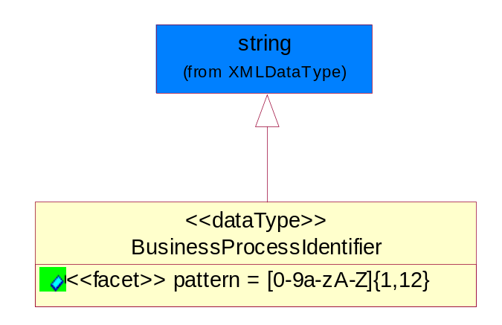
Figure ‎5-35 BusinessProcessIdentifier

Attribute | Type | Documentation
pattern |  | [0-9a-zA-Z]{1,12}

BusinessServiceInformation
The object allows the specification of the business service utilized within the partner company. This may or may not be the same as the information sent by the RNIF.
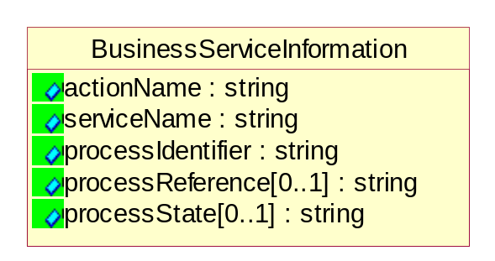
Figure ‎5-36 BusinessServiceInformation

Attribute | Type | Documentation
actionName | string | The name of Action. For RosettaNet usually any of Request/Confirm/Notify/Query/Response.
serviceName | string | The name of the Business Activity with the "Request/Confirm" part removed. E.g., for the Activity "Request Purchase Order"==> "Purchase Order".
processIdentifier | string | The name of the PIP e.g. Notify of Forecast Reply.
processReference[0..1] | string | The URN for the PIP that includes Cluster/Segment/Process pattern used to identify the interface process (such as PIP3A4)
processState[0..1] | string | The business process (or service) state of the sender of a document. When a service receives this document, the receiver may use the state as a precondition.

ContractInformation
A block of information used to correlate a contract in an executing choreography.

Figure ‎5-37 ContractInformation

Attribute | Type | Documentation
contractIdentifier[0..1] | string | Unique identification of a contract between the Sender and the Receiver
contractType[0..1] | string | The type of the contract: an attribute describing the type of the ContractIndentification. Valid values are URI, URN,ebXMLCPA, or other values defined by partners.

CorrelationInformation
A block of information used to correlate a requesting document to a responding document and to the contract in an executing choreography.
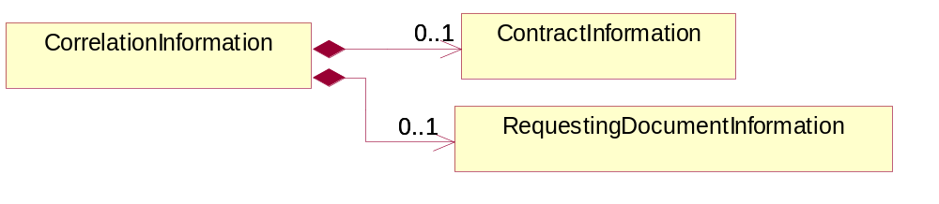
Figure ‎5-38 CorrelationInformation

Composition | Cardinality | Type | Documentation
ContractInformation | 0..1 | ContractInformation | A block of information used to correlate a contract in an executing choreography.
RequestingDocumentInformation | 0..1 | RequestingDocumentInformation | A block of information used to correlate a requesting document to a responding document in an executing choreography.

DocumentHeader
The object allows for the identification of the sender and receiver of the business document.
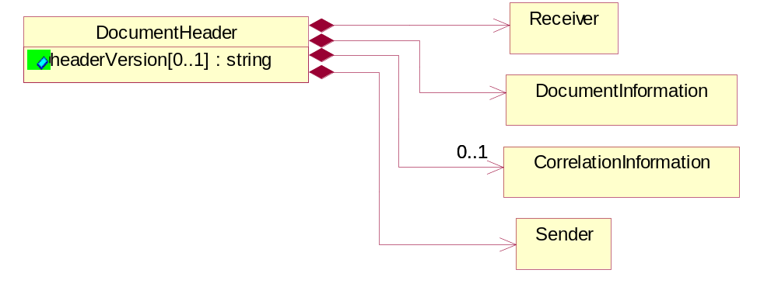
Figure ‎5-39 DocumentHeader

Attribute | Type | Documentation
headerVersion[0..1] | string | The UN/CEFACT version of the document header.

Composition | Cardinality | Type | Documentation
Sender | 1 | Sender | The object allows the identification of the initiating party of the business message.
CorrelationInformation | 0..1 | CorrelationInformation | A block of information used to correlate a requesting document to a responding document and to the contract in an executing choreography.
DocumentInformation | 1 | DocumentInformation | The object specifies information to identify the business document, a summary of attachments, and information about the business document security.
Receiver | 1 | Receiver | The object allows the identification of the receiving party of the business message.

DocumentIdentification
The object specifies all information necessary to identify the business document.
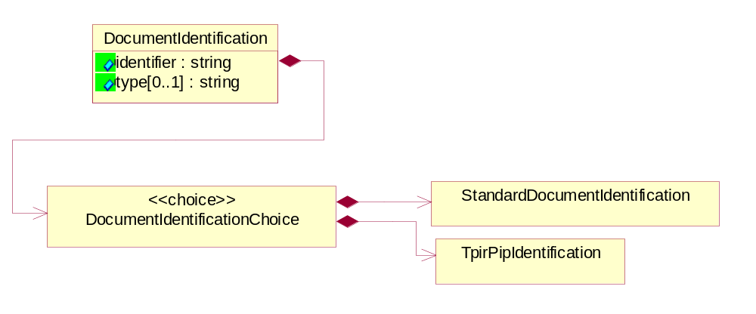
Figure ‎5-40 DocumentIdentification

Attribute | Type | Documentation
identifier | string | The unique identifier for the document being sent.
type[0..1] | string | Name of the Action Message

Composition | Cardinality | Type | Documentation
DocumentIdentificationChoice | 1 | DocumentIdentificationChoice

DocumentIdentificationChoice

Composition | Cardinality | Type | Documentation
StandardDocumentIdentification | 1 | StandardDocumentIdentification | The object specifies additional information necessary to identify the standard business document.
TpirPipIdentification | 1 | TpirPipIdentification | The object specifies all information necessary to uniquely identify a TPIR-PIP within a Registry or trading partner repository.

DocumentInformation
The object specifies information to identify the business document, a summary of attachments, and information about the business document security.
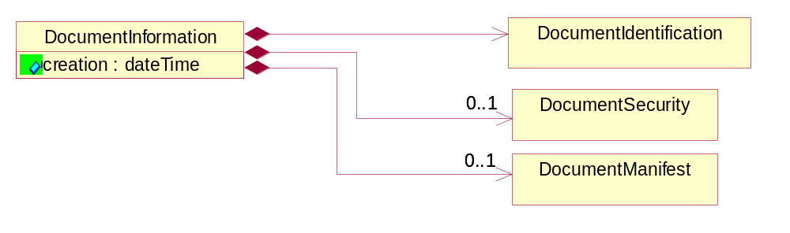
Figure ‎5-41 DocumentInformation

Attribute | Type | Documentation
creation | dateTime | The creation date and time of the specified Business Document (i.e. the Purchase Order date).

Composition | Cardinality | Type | Documentation
DocumentIdentification | 1 | DocumentIdentification | The object specifies all information necessary to identify the business document.
DocumentSecurity | 0..1 | DocumentSecurity | The object provides additional granularity in specifying business document security (this is in addition to the specified PIP security).
DocumentManifest | 0..1 | DocumentManifest | The block provides a brief summary of attachments and Service Content.

DocumentManifest
The block provides a brief summary of attachments and Service Content.
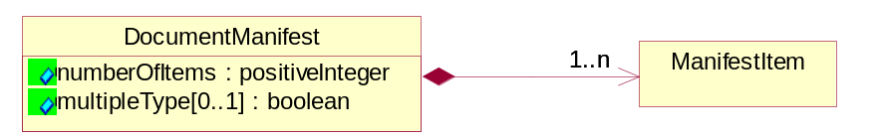
Figure ‎5-42 DocumentManifest

Attribute | Type | Documentation
numberOfItems | positiveInteger | Total number of documents in the message. The physical count of the attachments in the payload plus the RosettaNet Business Message (for Service Content). The value of this field will be at least 1.
multipleType[0..1] | boolean | Indicates whether the manifest contains documents of multiple types. True if yes, and False if no.

Composition | Cardinality | Type | Documentation
ManifestItem | 1..n | ManifestItem | The object provides details about the specific attachment(s).

DocumentSecurity
The object provides additional granularity in specifying business document security (this is in addition to the specified PIP security).
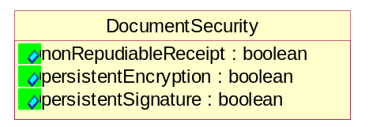
Figure ‎5-43 DocumentSecurity

Attribute | Type | Documentation
nonRepudiableReceipt | boolean | The value "true" will indicate that a signed acknowledgement for the business document is necessary.
persistentEncryption | boolean | The value "true" will indicate that the Business Document (including the header) needs to be encrypted when stored or transported.
persistentSignature | boolean | The value "true" will indicate that a signature is required to be stored with the document while stored or transported.

ManifestItem
The object provides details about the specific attachment(s).
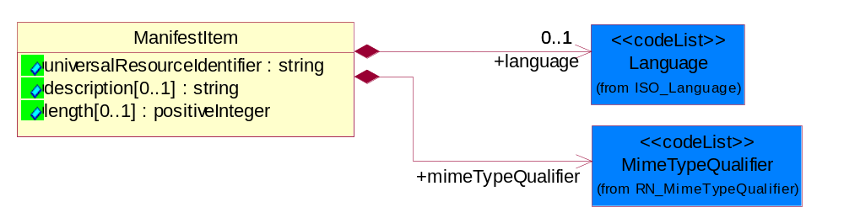
Figure ‎5-44 ManifestItem

Attribute | Type | Documentation
universalResourceIdentifier | string | The generic set of all names/addresses that are short strings that refer to resources.
description[0..1] | string | A description of the attachment.
length[0..1] | positiveInteger | The size of the attachment in bytes (i.e. 1 000 000 bytes)

Composition | Cardinality | Type | Documentation
mimeTypeQualifier | 1 | MimeTypeQualifier | The MIME type as defined by IANA.  Please refer to http://www.iana.org/assignments/media-types/ for a list of types.
language | 0..1 | Language | For representation of Language name RosettaNet has adopted ISO 639-2; 1998. Refer to the following web page to get the latest version of the standard:  http://www.loc.gov/standards/iso639-2/iso639jac.html  If you need more information about the ISO standard please contact ISO for more details.

PipIdentifier
PIP Identification.[ i.e. PIP3A4]
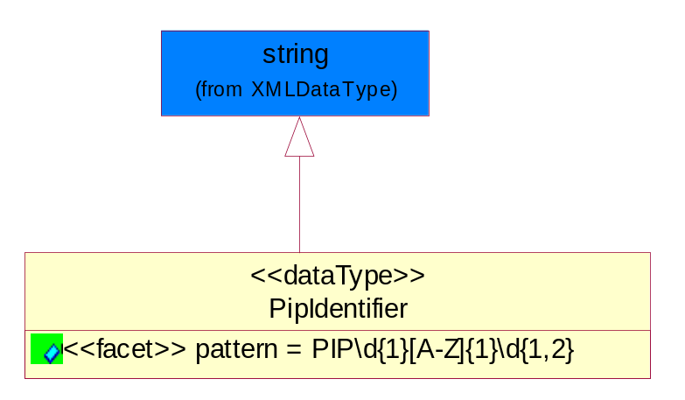
Figure ‎5-45 PipIdentifier

Attribute | Type | Documentation
pattern |  | PIP\d{1}[A-Z]{1}\d{1,2}

PipVersion
PIP version number (i.e. 02.02.00).
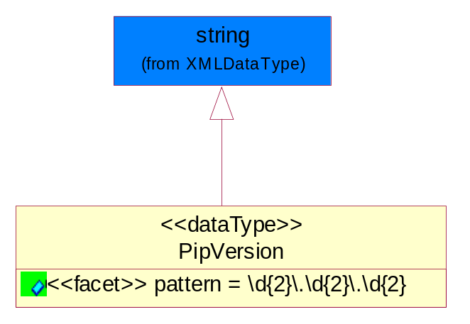
Figure ‎5-46 PipVersion

Attribute | Type | Documentation
pattern |  | \d{2}\.\d{2}\.\d{2}

Receiver
The object allows the identification of the receiving party of the business message.
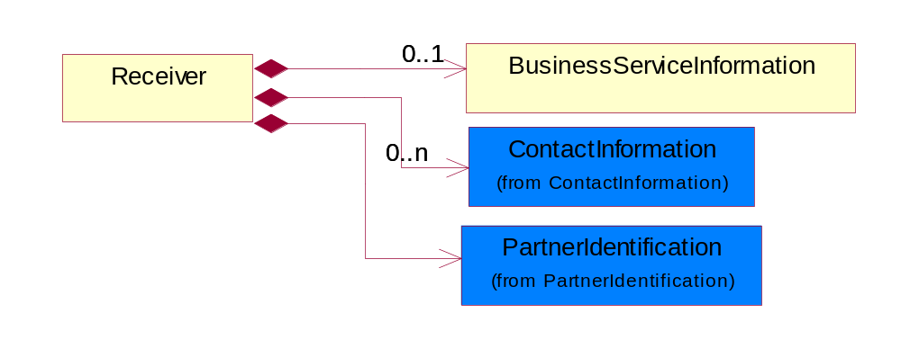
Figure ‎5-47 Receiver

Composition | Cardinality | Type | Documentation
BusinessServiceInformation | 0..1 | BusinessServiceInformation | The object allows the specification of the business service utilized within the partner company. This may or may not be the same as the information sent by the RNIF.
PartnerIdentification | 1 | PartnerIdentification | The business document must allow for the identity of one or more parties to the transaction.
ContactInformation | 0..n | ContactInformation | The business document must allow for the identification of the name of the department, service or individual to be contacted regarding the context of the business document.

RequestingDocumentInformation
A block of information used to correlate a requesting document to a responding document in an executing choreography.

Figure ‎5-48 RequestingDocumentInformation

Attribute | Type | Documentation
businessProcessInstanceIdentifier[0..1] | string | The identifier for the public business process instance being sent that both the sender and receiver can identify.
responseDateTime[0..1] | dateTime | The expected time to receive the response. This can not be greater than the PIP TimeToPerform.
requestingDocumentCreationDateTime[0..1] | dateTime | The date-time of the requesting business document.
requestingDocumentInstanceIdentifier | string | The Business Document identification number that identifies the requesting Business Document.

Sender
The object allows the identification of the initiating party of the business message.
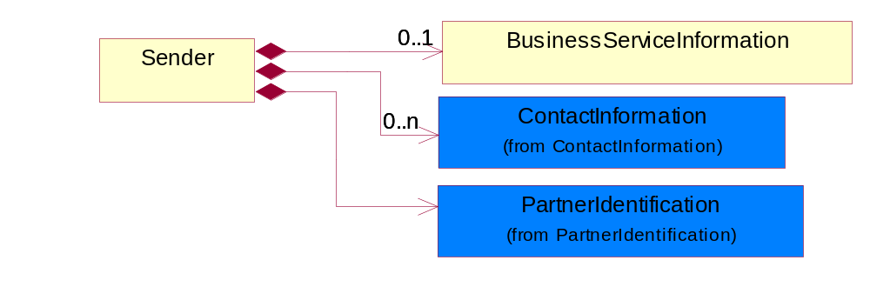
Figure ‎5-49 Sender

Composition | Cardinality | Type | Documentation
PartnerIdentification | 1 | PartnerIdentification | The business document must allow for the identity of one or more parties to the transaction.
BusinessServiceInformation | 0..1 | BusinessServiceInformation | The object allows the specification of the business service utilized within the partner company. This may or may not be the same as the information sent by the RNIF.
ContactInformation | 0..n | ContactInformation | The business document must allow for the identification of the name of the department, service or individual to be contacted regarding the context of the business document.

StandardDocumentIdentification
The object specifies additional information necessary to identify the standard business document.
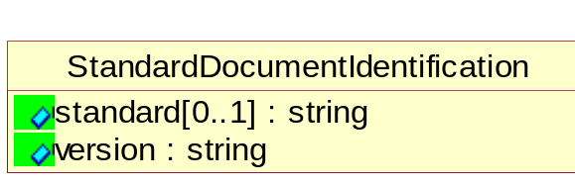
Figure ‎5-50 StandardDocumentIdentification

Attribute | Type | Documentation
standard[0..1] | string | Identifies the standard used to submit the business document. (e.g. RosettaNet).
version | string | PIP3A4v01.00

TpirPipIdentification
The object specifies all information necessary to uniquely identify a TPIR-PIP within a Registry or trading partner repository.

Figure ‎5-51 TpirPipIdentification

Attribute | Type | Documentation
partnerId | DUNSPlus4 | The Trading Partner Identification of MNC that is creating this TPIR PIP.
pipIdentifier | PipIdentifier | A TPIR PIP Identification [i.e., 3A4 ).
pipVersion | PipVersion | A TPIR PIP version number (i.e., 02.02.00)
tpirPipVersion | VersionIdentifier | A TPIR-PIP Version Number (i.e., major and minor version number as XX.XX).
tpirBusinessProcessIdentifier[0..1] | BusinessProcessIdentifier | A Business Process Identifier to uniquely define the TPIR-PIP 'role' within a Business Scenario at a company or MNC level. The identifier MUST be composed of alphanumeric characters only and its length MUST be between one and twelve characters.
uri[0..1] | anyURI | Describes the destination uri for the TPIR form.

Composition | Cardinality | Type | Documentation
fileType | 0..1 | TPIRFileType | Describes the file type of the TPIR form (PDF, XDP or XML).

VersionIdentifier
Version Number (i.e., major and minor version number as XX.XX).
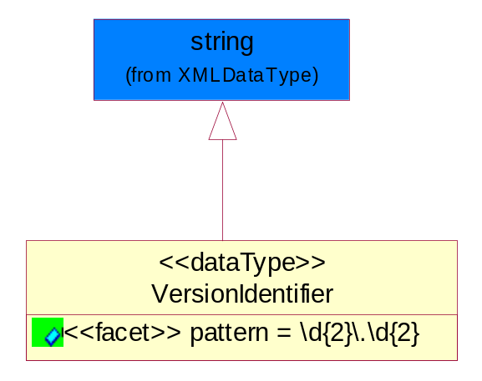
Figure ‎5-52 VersionIdentifier

Attribute | Type | Documentation
pattern |  | \d{2}\.\d{2}

CodeList

TPIRFileType
A code identifying the file type of TPIR form.

Name | Documentation
PDF | Portable Document Format.
XDP | XML Data Package.
XML | eXtensible Markup Language.

XML Data Type

anyURI
Represents a URI as defined by RFC 2396. An anyURI value can be absolute or relative, and may have an optional fragment identifier.

boolean
Represents Boolean values, which are either "true" or "false".

date
For the represents a calendar date.
The pattern for a date is CCYY-MM-DD where CC represents the century, YY the year, MM the month, and DD the day, with an optional time zone indicator as allowed for dateTime.

dateTime
Represents a specific instance of time.
The pattern for dateTime is CCYY-MM-DDThh:mm:ss where CC represents the century, YY the year, MM the month, and DD the day, preceded by an optional leading negative (-) character to indicate a negative number. If the negative character is omitted, positive (+) is assumed. The T is the date/time separator and hh, mm, and ss represent hour, minute, and second respectively. Additional digits can be used to increase the precision of fractional seconds if desired. For example, the format ss.ss... with any number of digits after the decimal point is supported. The fractional seconds part is optional.

This representation may be immediately followed by a "Z" to indicate Coordinated Universal Time (UTC) or to indicate the time zone. For example, the difference between the local time and Coordinated Universal Time, immediately followed by a sign, + or -, followed by the difference from UTC represented as hh:mm (minutes is required). If the time zone is included, both hours and minutes must be present.

duration
Represents a duration of time.
The pattern for duration is PnYnMnDTnHnMnS, where nY represents the number of years, nM the number of months, nD the number of days, T the date/time separator, nH the number of hours, nM the number of minutes, and nS the number of seconds.

float
Represents single-precision 32-bit floating-point numbers.

positiveInteger
Represents an integer that is greater than zero. This data type is derived from nonNegativeInteger.

string
Represents character string.

