

Description of
Partner Interface Process® for 6C1

Validated 11.01.00

Specification Information
Name | Query Service Entitlement
Cluster | Service and Support
Segment | Technical Support and Service Management
Publication Date | 24 February 2010
Version Identifier | V11.01

Table of Contents
1 Document Management 4
1.1 Legal Disclaimer 4
1.2 Copyright 4
1.3 Trademarks 4
1.4 Acknowledgments 4
1.5 Related Documents 5
1.6 Document Version History 5
1.7 Document Structure 5
2 Business Process 6
2.1 Business Process Definition 6
2.1.1 Business Process Description 7
2.1.2 PIP Process Description 7
2.1.3 Business Process Scope Diagram 7
2.2 PIP Business Documents 8
2.3 PIP Business Process Flow Diagram 8
2.4 PIP Start State 9
2.5 PIP End State 9
2.6 Partner Role Descriptions 10
2.7 Business Process Activity Control 10
3 Network and Implementation Specification 11
3.1 Business Action and Business Signal Specification 11
3.2 Business Transaction Dialog Specification 11
3.2.1 Message Exchange Control 12
3.2.2 Communications Specification 12

List of Figures
Figure 1: Reverse Supply Chain 6
Figure 2: Business Process Scope Diagram 7
Figure 3: Activity Diagram 8
Figure 4: Sequence Diagram 11

List of Tables
Table 1: PIP Business Documents 8
Table 2: PIP Start State 9
Table 3: PIP End State 9
Table 4: PIP Failure State 9
Table 5: Partner Role Descriptions 10
Table 6: Business Activity Descriptions 10
Table 7: Business Activity Performance Controls 10
Table 8: Network Component Specification 11
Table 9: Business Action – Business Document Mapping 11
Table 10: Message Exchange Control 12
Table 11: Dialog: Service-Service 12

Document Management

Legal Disclaimer
RosettaNet™, its members, officers, directors, employees, or agents shall not be liable for any injury, loss, damages, financial or otherwise, arising from, related to, or caused by the use of this document or the specifications herein, as well as associated guidelines and schemas. The use of said specifications shall constitute your express consent to the foregoing exculpation.

Copyright
©2010 RosettaNet. All rights reserved. No part of this publication may be reproduced, stored in a retrieval system, or transmitted, in any form or by any means, electronic, mechanical, photocopying, recording, or otherwise, without the prior written permission of the publisher. Printed in the United States of America.

Trademarks
RosettaNet, Partner Interface Process, PIP and the RosettaNet logo are trademarks or registered trademarks of “RosettaNet,” a non-profit organization. All other product names and company logos mentioned herein are the trademarks of their respective owners. In the best effort, all terms mentioned in this document that are known to be trademarks or registered trademarks have been appropriately recognized in the first occurrence of the term.

Acknowledgments
This document has been prepared by RosettaNet (http://www.rosettanet.org/) from requirements gathered during the Milestone Program and in conformance with the methodology. Listed below are the legal entities that contributed to the design and development of this PIP.
BCM Electronics | HP Canada
CompTIA | Intel Corporation
CompuCom Systems | MIMOS Berhad
Globetronics SDH. BHD | NexInnovations
Hewlett Packard | Sterling Commerce
Hewlett-Packard Company | Unisys
HP

Related Documents
- Associated PIP Message Schemas (included within the PIP Specification package only)
- Description of PIP6C1 Message
- Message Structure
- XML instance of ebBPSS for PIP 6C1

Document Version History
Version | Date | Description
Validated 11.00.00 | 04 July 2008 | Validated Version : RosettaNet Schema to Market to Validation 2008
Validated 11.01.00 | 24 February 2010 | Validated Version : MCC Program

Document Structure
A Partner Interface Process (PIP) Specification is comprised of the following two parts:
- Business Process. Captures the semantics of the business process and the flow of the message exchange between roles as they perform business activities.
- Network and Implementation Specification. Specifies the network protocol message formats and communications requirements between peer-protocols supported by network components in the RosettaNet Implementation Framework.

Business Process

Business Process Definition

Reverse Supply Chain Management (RSCM)
RSCM is the automation of business processes and information exchange to manage the complete path of a product from the customer to its final disposition. These RSCM processes include returns, advanced exchanges, fulfillment, real-time inventory management, warranty tracking, repairs, reverse logistics, parts ordering, de-manufacturing, and re-disposition.
The reverse supply chain is considerably different from the forward supply chain. Customer Relationship Management (CRM), Enterprise Resource Planning (ERP), and traditional supply chain management systems were not built to handle the complex processes of the reverse supply chain.
Streamlining reverse supply chain processes and capturing accurate information about inventory and operations is essential to increasing bottom line profitability and reducing costs. To manage their business better, manufacturers require real-time data visibility across the entire reverse supply chain, thereby allowing monitoring of actual inventory, cycle times, returns costs, and supplier operations. Integrating RSCM solutions with CRM, ERP and forward supply chain applications gives OEMs complete visibility and management of the entire product life cycle.
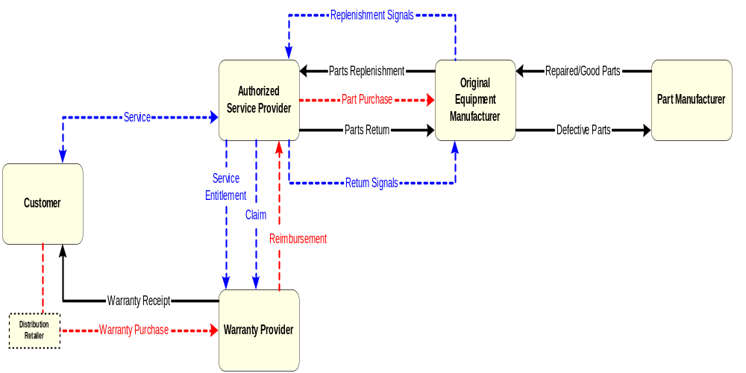
Figure 1: Reverse Supply Chain
The service event business process models the workflow initiated by a customer request for service on a purchased unit. The interactions between the customer and the Authorized Service Provider (ASP) and the ASP to the Warranty Provider (WP) can be complex, taking various courses based on characteristics and decisions made during the course of the service event. A service event begins with the determination of service entitlement, a repair process, and completes with a warranty reimbursement claim submitted to the warranty provider.

Business Process Description
The Request Service Event Entitlement PIP automates the sharing of service entitlement information between the ASP and the WP. Service Event information for a unit must be requested from the WP. The request for service entitlement can be invoked independently for basic warranty entitlement verification for information only or (more commonly) as the initial step of a service event to verify the warranty coverage conditions that apply.

PIP Process Description
This PIP answers an Authorized Service Provider’s query for the determination of warranty service entitlement from a Warranty Provider.

Business Process Scope Diagram
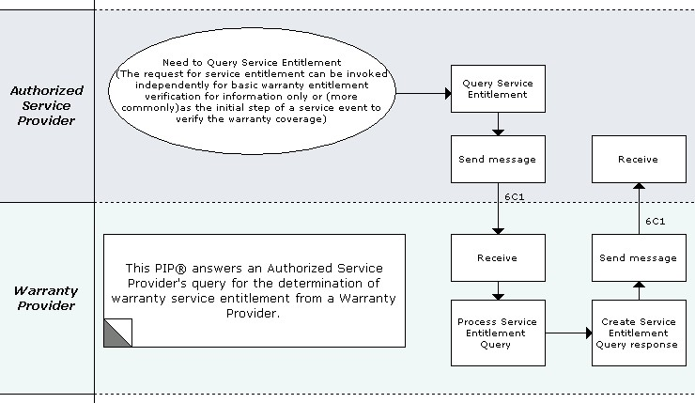
Figure 2: Business Process Scope Diagram

PIP Business Documents
Business Documents are generated and exchanged by roles performing activities in this PIP. Business Documents are listed and defined in Table 1.
Table 1: PIP Business Documents
Business Document | Description
Service Entitlement Query | Queries a Warranty Provider for the warranty status of a defective unit.
Service Entitlement Status Response | A response to a query requesting the warranty status of a defective unit. The status reflects the current state of the service entitlement at the time of the request.

PIP Business Process Flow Diagram
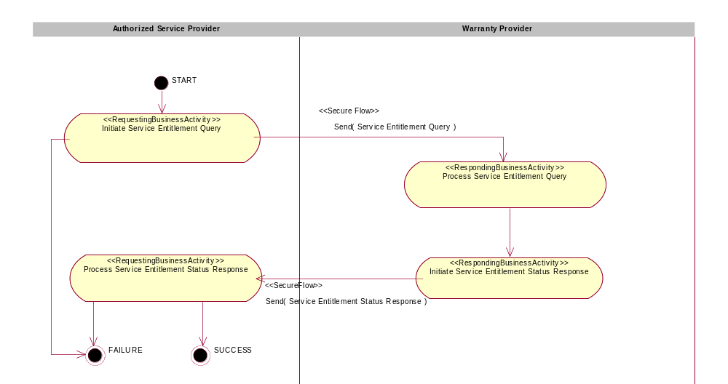
Figure 3: Activity Diagram

PIP Start State
The start state is comprised of the following condition(s):
Table 2: PIP Start State
 | Approved | Exist |  | Valid | Non-Repudiated | Retry Count | Authorized
 | Approved | Party | In Backend system
TPA |  |  | 
Sending Partner |  |  |  | 
Receiving Partner |  | 
Business Document |  |  |  | 

PIP End State
The end state is comprised of the following condition(s):
Table 3: PIP End State
 | Approved | Exist |  | Valid | Non-Repudiated | Retry Count | Authorized
 | Approved | Party | In Backend system
Acknowledgment of Receipt |  |  |  | 
Receiving Partner |  |  |  |  |  |  | 

The PIP failure state is comprised of one or more of the following condition(s):
Table 4: PIP Failure State
 | NO | Exceeded
Success | 
Retry Count |  | 

Partner Role Descriptions
Table 5 describes the partner roles in this PIP.
Table 5: Partner Role Descriptions
Role Name | Role Description
Authorized Service Provider | The provider authorized by the Original Equipment Manufacturer (OEM) to perform service on a unit.
Warranty Provider | The provider who honors the warranty terms and reimburses the Authorized Service Provider for a service event performed within the warranty obligation terms.

Business Process Activity Control
Table 6 describes the interaction between roles performing business activities in this PIP.
Table 6: Business Activity Descriptions
Role Name | Activity Name | Activity Description
Authorized Service Provider | Initiate Service Entitlement Query | This activity queries a Warranty Provider for the status of service entitlement on a unit. Is the requestor and recipient of service entitlement data.
Warranty Provider | Initiate Service Entitlement Status Response | This activity communicates service entitlement status to the Authorized Service Provider per requests received.

Table 7 details the security, audit and process controls relating to activities performed in the PIP.
Table 7: Business Activity Performance Control
Role  Name | Activity  Name | Acknowledgment  of Receipt |  | Time to Perform | Retry Count | Is Authorization Required? | Non-Repudiation of Origin and Content?
Role  Name | Activity  Name | Non-Repudiation Required? | Time to Acknowledge
Authorized Service Provider | Initiate Service Entitlement Query | N | 1 hr | 1 hr | 3 | N | N
Warranty Provider | Initiate Service Entitlement Status Response | N | 1 hr | 1 hr | 3 | N | N

Network and Implementation Specification
Each network component maps into a role of the PIP model. Table 8 specifies the mapping between roles and network components.
Table 8: Network Component Specification
Network Component | Classification | Maps to Role in Business Process
Authorized Service Provider Service | Business Service | Authorized Service Provider
Warranty Provider Service | Business Service | Warranty Provider

Business Action and Business Signal Specification
Each business action maps to a Business Document of the PIP model. Table 9 specifies the mapping between Business Documents and business actions.
Table 9: Business Action – Business Document Mapping
Business Action | Business Document | Document Function
Service Entitlement Query Action | Service Entitlement Query | Request
Service Entitlement Status Response Action | Service Entitlement Status Response | Respond

Business Transaction Dialog Specification
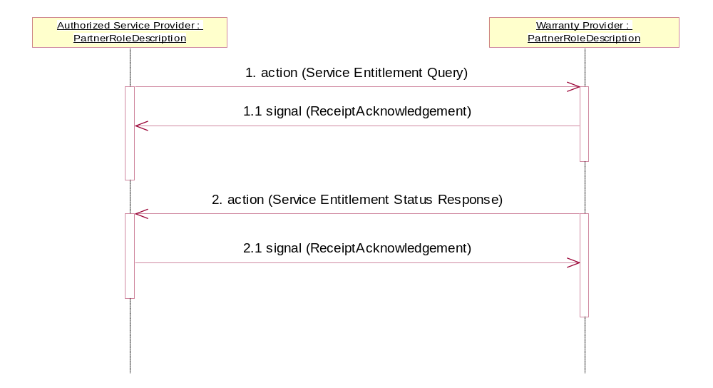
Figure 4: Sequence Diagram

Message Exchange Control
Table 10: Message Exchange Control
# | Name |  | Time to Acknowledge Receipt Signal |  | Time to Respond to Action |  | Included in Time to Perform |  | Is Authorization Required? |  | Is Non-Repudiation Required? |  | Is Secure Transport Required?
1. |  | Service Entitlement Query Action |  | 1 hr |  | 1 hr |  | Y |  | N |  | N |  | Y
1.1. |  | Receipt Acknowledgment |  | N/A |  | N/A |  | N/A |  | N |  | N |  | Y
2. |  | Service Entitlement Status Response Action |  | 1 hr |  | N/A |  | N/A |  | N |  | N |  | Y
2.1. |  | Receipt Acknowledgment |  | N/A |  | N/A |  | N/A |  | N |  | N |  | Y

Communications Specification
Table 11: Dialog: Service-Service
# | Business Message | Digital Signature Required? | SSL Required?
1. | Service Entitlement Query | Y | Y
1.1. | Receipt Acknowledgment | Y | Y
2. | Service Entitlement Status Response | Y | Y
2.1. | Receipt Acknowledgment | Y | Y

