

Description of 6C4 Message

PIP® 6C4
Validated 11.00.00

Specification Information
Name | Description Of 6C4 Message
PIP | Notify Of Case Confirmation
Cluster | Service and Support
Segment | Technical Support and Service Management
Publication Date | 20 April 2009
Version Identifier | V11.00

Table of Content

1. Document Management 6
1.1 Legal Disclaimer 6
1.2 Copyright 6
1.3 Trademarks 6
1.4 Acknowledgments 6
1.5 Related Documents 7
1.6 Document Version History 7
1.7 Document Purpose 7
2. Interchange Model 8
2.1 CaseConfirmationNotification 8
2.1.1 Interchange Diagram 8
2.1.2 Dependency Diagram 9
2.1.3 AcceptanceCase 9
2.1.4 Case 10
2.1.5 CaseConfirmationNotification 10
2.1.6 CaseDetail 11
2.1.7 CloseRejectCase 13
2.1.8 ProblemType 13
2.1.9 Response 14
2.1.10 ResponseChoice 14
2.1.11 ServiceDetail 14
3. Domain Model 16
3.1 Service 16
3.1.1 Service 16
3.1.1.1 Dependency Diagram 16
3.1.1.2 CaseID 16
3.1.1.3 CRContact 17
3.1.1.4 Fault 18
3.1.1.5 Hardware 18
3.1.1.6 MessageInformation 18
3.1.1.7 Notes 19
3.1.1.8 Part 20
3.1.1.9 RejectCase 20
3.1.1.10 ReplacedPart 20
3.1.1.11 ResponsePeriod 21
3.1.1.12 RoutingInformation 21
3.1.1.13 ServiceInformation 22
3.1.1.14 Software 23
3.1.1.15 Update 23
3.1.2 CodeList 24
3.1.2.1 RequestType 24
3.1.2.2 Severity 24
3.1.2.3 Priority 24
3.1.2.4 ContactPreference 25
4. Universal Structure 26
4.1 ContactInformation 26
4.1.1 ContactInformation 26
4.2 DataType 27
4.2.1 Contact 27
4.2.2 DUNS 27
4.2.3 DUNSPlus4 28
4.2.4 GLN 28
4.2.5 GTIN 29
4.3 Locations 29
4.3.1 AlternativeIdentifier 29
4.3.2 Location 30
4.3.3 LocationChoice 30
4.3.4 PhysicalAddress 31
4.4 PartnerIdentification 32
4.4.1 FullPartner 32
4.4.2 PartnerIdentification 33
4.4.3 PartnerIdentificationChoice 33
4.4.4 SpecifiedFullPartner 34
4.5 ProductIdentification 35
4.5.1 ProductIdentification 35
4.5.2 ProductIdentificationChoice 35
4.6 CodeList 36
4.6.1 Country 36
4.6.2 CountrySubdivision 36
4.6.3 Language 36
4.6.4 MimeTypeQualifier 36
4.6.5 ProcessRoleIdentifier 47
5. System Structure 50
5.1 BusinessProcessIdentifier 50
5.2 BusinessServiceInformation 50
5.3 ContractInformation 51
5.4 CorrelationInformation 51
5.5 DocumentHeader 52
5.6 DocumentIdentification 53
5.7 DocumentIdentificationChoice 53
5.8 DocumentInformation 54
5.9 DocumentManifest 54
5.10 DocumentSecurity 55
5.11 ManifestItem 55
5.12 PipIdentifier 56
5.13 PipVersion 57
5.14 Receiver 57
5.15 RequestingDocumentInformation 58
5.16 Sender 58
5.17 StandardDocumentIdentification 59
5.18 TpirPipIdentification 59
5.19 VersionIdentifier 60
5.20 CodeList 61
5.20.1 TPIRFileType 61
6. XML Data Type 62
6.1 anyURI 62
6.2 boolean 62
6.3 date 62
6.4 dateTime 62
6.5 duration 62
6.6 positiveInteger 62
6.7 string 62

Table of Figures

Figure ‎2-1 Interchange 8
Figure ‎2-2 Dependency 9
Figure ‎2-3 AcceptanceCase 9
Figure ‎2-4 Case 10
Figure ‎2-5 CaseConfirmationNotification 10
Figure ‎2-6 CaseDetail 11
Figure ‎2-7 CloseRejectCase 13
Figure ‎2-8 ProblemType 13
Figure ‎2-9 Response 14
Figure ‎2-10 ServiceDetail 14
Figure ‎3-1 Dependency 16
Figure ‎3-2 CaseID 16
Figure ‎3-3 CRContact 17
Figure ‎3-4 Fault 18
Figure ‎3-5 Hardware 18
Figure ‎3-6 MessageInformation 18
Figure ‎3-7 Notes 19
Figure ‎3-8 Part 20
Figure ‎3-9 RejectCase 20
Figure ‎3-10 ReplacedPart 20
Figure ‎3-11 ResponsePeriod 21
Figure ‎3-12 RoutingInformation 21
Figure ‎3-13 ServiceInformation 22
Figure ‎3-14 Software 23
Figure ‎3-15 Update 23
Figure ‎4-1 ContactInformation 26
Figure ‎4-2 Contact 27
Figure ‎4-3 DUNS 27
Figure ‎4-4 DUNSPlus4 28
Figure ‎4-5 GLN 28
Figure ‎4-6 GTIN 29
Figure ‎4-7 AlternativeIdentifier 29
Figure ‎4-8 Location 30
Figure ‎4-9 PhysicalAddress 31
Figure ‎4-10 FullPartner 32
Figure ‎4-11 PartnerIdentification 33
Figure ‎4-12 SpecifiedFullPartner 34
Figure ‎4-13 ProductIdentification 35
Figure ‎5-1 BusinessProcessIdentifier 50
Figure ‎5-2 BusinessServiceInformation 50
Figure ‎5-3 ContractInformation 51
Figure ‎5-4 CorrelationInformation 51
Figure ‎5-5 DocumentHeader 52
Figure ‎5-6 DocumentIdentification 53
Figure ‎5-7 DocumentInformation 54
Figure ‎5-8 DocumentManifest 54
Figure ‎5-9 DocumentSecurity 55
Figure ‎5-10 ManifestItem 55
Figure ‎5-11 PipIdentifier 56
Figure ‎5-12 PipVersion 57
Figure ‎5-13 Receiver 57
Figure ‎5-14 RequestingDocumentInformation 58
Figure ‎5-15 Sender 58
Figure ‎5-16 StandardDocumentIdentification 59
Figure ‎5-17 TpirPipIdentification 59
Figure ‎5-18 VersionIdentifier 60

Document Management

Legal Disclaimer
RosettaNet, its members, officers, directors, employees, or agents shall not be liable for any injury, loss, damages, financial or otherwise, arising from, related to, or caused by the use of this document or the specifications herein, as well as associated guidelines and schemas. The use of said specifications shall constitute your express consent to the foregoing exculpation.

Copyright
©2009 RosettaNet. All rights reserved. No part of this publication may be reproduced, stored in a retrieval system, or transmitted, in any form or by any means, electronic, mechanical, photocopying, recording, or otherwise, without the inclusion of this copyright notice. Any derivative works must cite the copyright notice. Any public redistribution or sale of this publication or derivative works requires prior written permission of the publisher.

Trademarks
RosettaNet, Partner Interface Process, PIP and the RosettaNet logo are trademarks or registered trademarks of "RosettaNet," a non-profit organization. All other product names and company logos mentioned herein are the trademarks of their respective owners. In the best effort, all terms mentioned in this document that are known to be trademarks or registered trademarks have been appropriately recognized in the first occurrence of the term.

Acknowledgments
This document has been prepared by RosettaNet (http://www.rosettanet.org/) from requirements gathered during the Milestone Program and in conformance with the methodology. Listed below are the legal entities that contributed to the design and development of this PIP.
BT | Cisco Systems
Ericsson | HP
IBM | Motorola
Nokia | TeliaSonera

Related Documents
- Associated PIP Message Schemas (included with PIP Specification only)
- Description of Partner Interface Process for 6C4
- Message Structure

Document Version History
Version |  | Date |  | Description
Validated 11.00.00 | 20 April 2009 |  | Validated Version - Q12009 Maintenance Process

Document Purpose
The purpose of the document is to explain the structure, the association between objects, the content of objects and the definition for single elements to a non-technical audience.

Interchange Model

CaseConfirmationNotification

Interchange Diagram
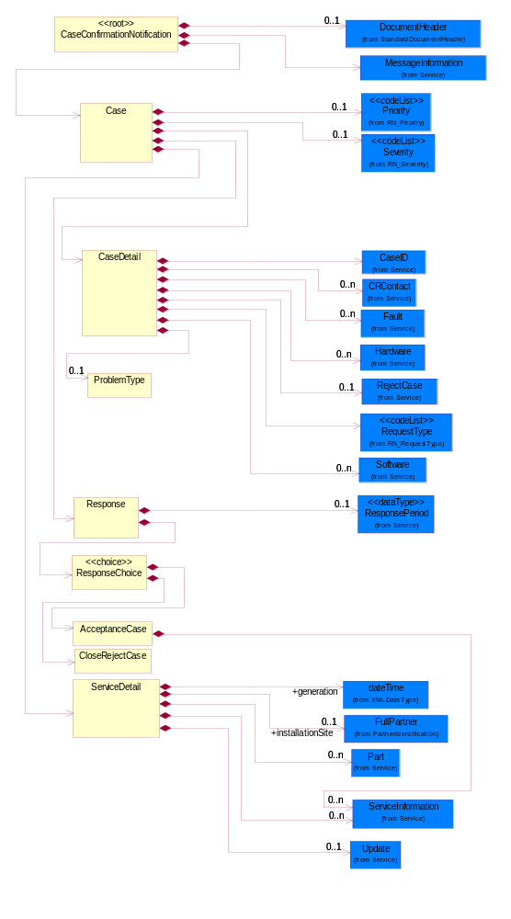
Figure ‎2-1 Interchange

Dependency Diagram
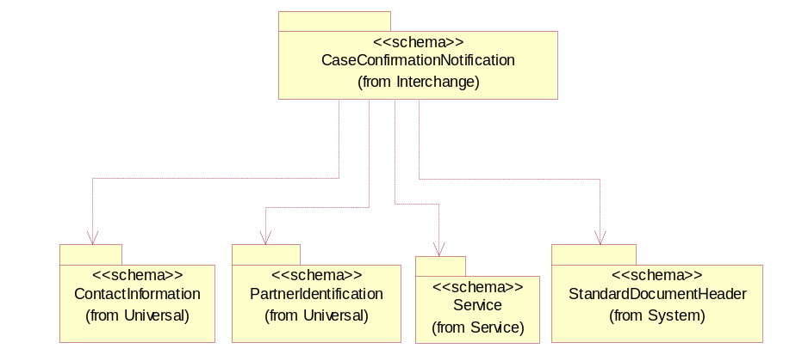
Figure ‎2-2 Dependency

AcceptanceCase
An acceptance message replied by the case receiver.
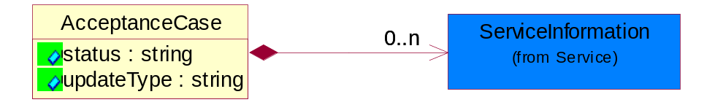
Figure ‎2-3 AcceptanceCase

Attribute | Type | Documentation
status | string | Status of this case.
updateType | string | The type of update for this acceptance message.

Composition | Cardinality | Type | Documentation
ServiceInformation | 0..n | ServiceInformation | Details of service done by the service requestor/case sender.

Case
A placeholder for ticketing each case.
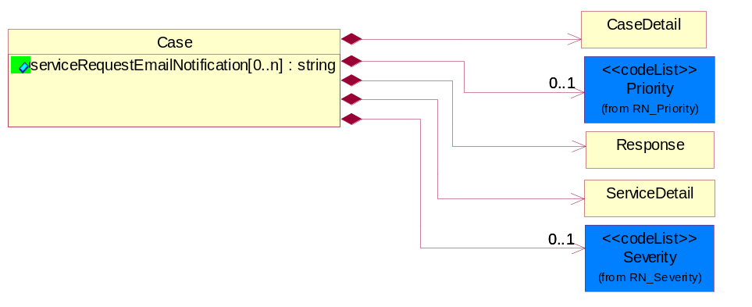
Figure ‎2-4 Case

Attribute | Type | Documentation
serviceRequestEmailNotification[0..n] | string | Email address(es) of recipient who would like to receive email notification of this case.

Composition | Cardinality | Type | Documentation
CaseDetail | 1 | CaseDetail | The details of the case.
Priority | 0..1 | Priority | A collection of urgency type of the case.
Response | 1 | Response | Response given by case receiver after receiving the case request.
ServiceDetail | 1 | ServiceDetail | The details of the service.
Severity | 0..1 | Severity | A collection of importance of impact of the case to other cases.

CaseConfirmationNotification
Message wrapper for 6C4.
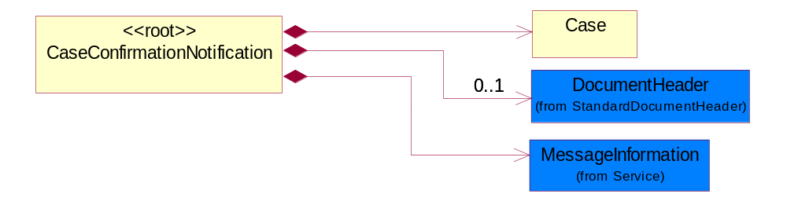
Figure ‎2-5 CaseConfirmationNotification

Composition | Cardinality | Type | Documentation
Case | 1 | Case | A placeholder for ticketing each case.
DocumentHeader | 0..1 | DocumentHeader | The object allows for the identification of the sender and receiver of the business document.
MessageInformation | 1 | MessageInformation | Details of the way the message is packaged and sent.

CaseDetail
The details of the case.
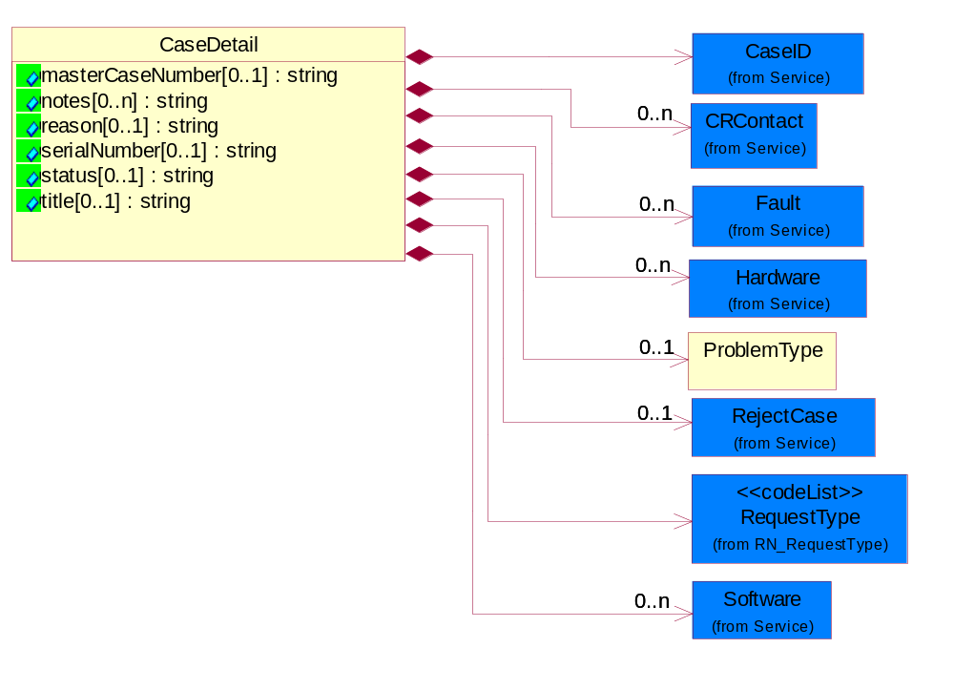
Figure ‎2-6 CaseDetail

Attribute | Type | Documentation
masterCaseNumber[0..1] | string | The case sender may provide an original case number when opening a case (as a reference).
notes[0..n] | string | Text field to be appended to the ongoing text portion of the case.
reason[0..1] | string | Description indicating the reason for reopening of a case or the reason for closure or the reason for rejecting the closing of the case.
serialNumber[0..1] | string | The product serial number when creating the initial request.
status[0..1] | string | Provide the current case status.
title[0..1] | string | Brief description of the case.

Composition | Cardinality | Type | Documentation
CaseID | 1 | CaseID | The collection of business properties that require the identification of a case to ensure uniqueness in the Case Receiver's bandend case management system.
CRContact | 0..n | CRContact | Case point of contact provided by the case receiver.
Fault | 0..n | Fault | The service requestor/case sender may need to provide additional minor details for a number of faults which appear to be related or which are showing the same symptoms. This section may subsequently be updated by either party.
Hardware | 0..n | Hardware | Product/ Hardware details.
ProblemType | 0..1 | ProblemType | The ProblemType group is used to define a case problem to a detail level that can be automatically to the correct support team for immediate resolution. By providing a hierarchy of problem details, it eliminates manual touches to refine the problem definition and route, allowing direct routing to the appropriate resource to resolve the problem.
RejectCase | 0..1 | RejectCase | Case that has been rejected from acceptance.
RequestType | 1 | RequestType | The classification of each requests indicated by the service requestor/case sender.
Software | 0..n | Software | Software details.

CloseRejectCase
To indicate the reason for rejecting the closing of the case.
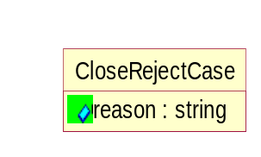
Figure ‎2-7 CloseRejectCase

Attribute | Type | Documentation
reason | string | The reason to reject the case.

ProblemType
The ProblemType group is used to define a case problem to a detail level that can be automatically to the correct support team for immediate resolution. By providing a hierarchy of problem details, it eliminates manual touches to refine the problem definition and route, allowing direct routing to the appropriate resource to resolve the problem.
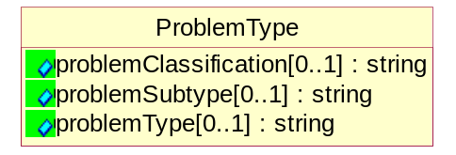
Figure ‎2-8 ProblemType

Attribute | Type | Documentation
problemClassification[0..1] | string | Identifies the high level classification of problem as defined by the customer. Example: password reset, configuration help, error messages, network slow etc.
problemSubtype[0..1] | string | Identifies the sub-area within the problem type of the problem. Example: specific hardware or software within the problem type.
problemType[0..1] | string | Identifies the area within the classification of the problem. Example: LAN, WAN, wireless, security, etc.

Response
Response given by case receiver after receiving the case request.
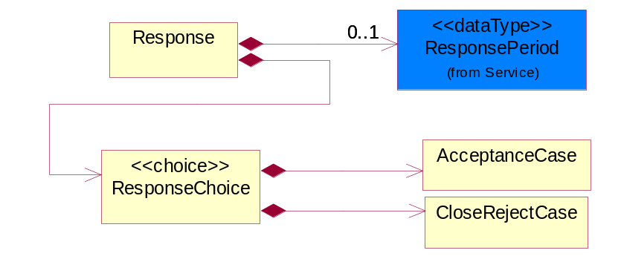
Figure ‎2-9 Response

Composition | Cardinality | Type | Documentation
ResponseChoice | 1 | ResponseChoice
ResponsePeriod | 0..1 | ResponsePeriod | The needed time of response for a servicing a case.

ResponseChoice

Composition | Cardinality | Type | Documentation
AcceptanceCase | 1 | AcceptanceCase | An acceptance message replied by the case receiver.
CloseRejectCase | 1 | CloseRejectCase | To indicate the reason for rejecting the closing of the case.

ServiceDetail
The details of the service.
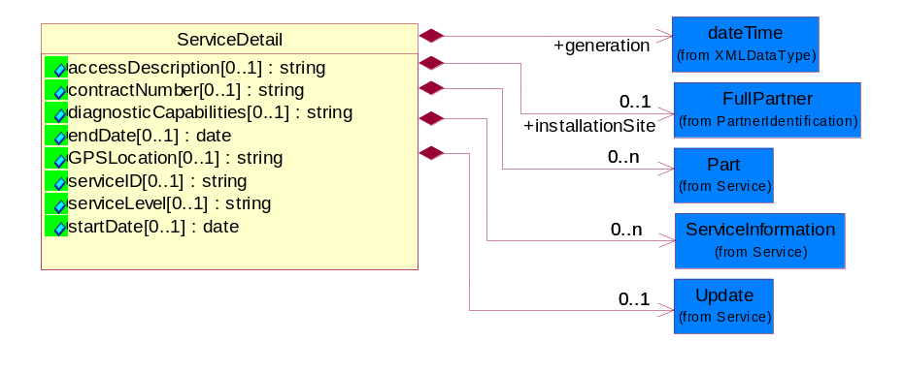
Figure ‎2-10 ServiceDetail

Attribute | Type | Documentation
accessDescription[0..1] | string | The textual description with access information to the product location (access codes).
contractNumber[0..1] | string | The service contract number which applies to the case when creating an initial request.
diagnosticCapabilities[0..1] | string | Details of the point in the network where remote diagnostic testing capabilities end.
endDate[0..1] | date | Service coverage end date.
GPSLocation[0..1] | string | The map coordinates of the product location.
serviceID[0..1] | string | The Telecom directory number or IP address for the case.
serviceLevel[0..1] | string | Service level purchased for the product on this contract.
startDate[0..1] | date | Service coverage start date.

Composition | Cardinality | Type | Documentation
generation | 1 | dateTime | Date and time that case was created in the back-end system.
installationSite | 0..1 | FullPartner | The site of installation for this case.
Part | 0..n | Part | The list of spare parts that could fix the issue.
ServiceInformation | 0..n | ServiceInformation | Details of service done by the service requestor/case sender.
Update | 0..1 | Update | The provider or requestor may include the update details that the case was updated within their internal system.

Domain Model

Service

Service

Dependency Diagram
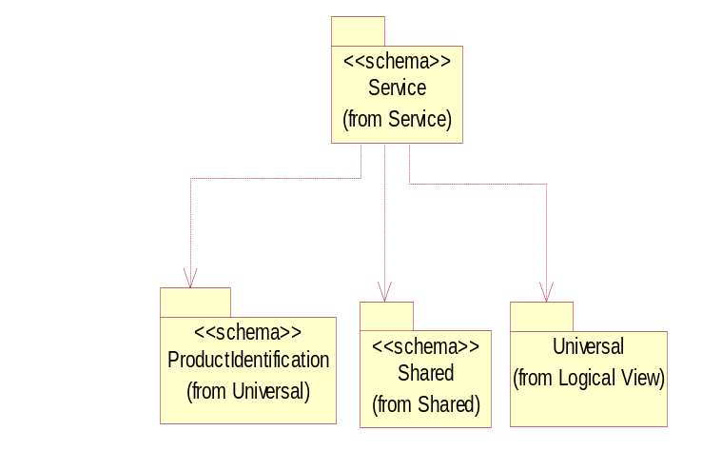
Figure ‎3-11 Dependency

CaseID
The collection of business properties that require the identification of a case to ensure uniqueness in the Case Receiver's bandend case management system.
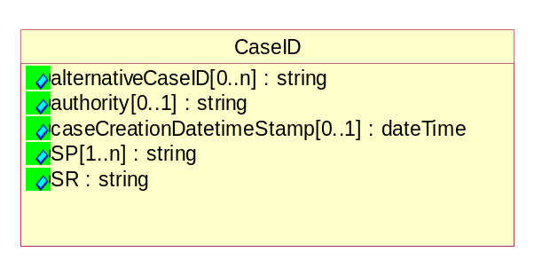
Figure ‎3-12 CaseID

Attribute | Type | Documentation
alternativeCaseID[0..n] | string | An alternate alphanumeric case ID when more than one Case ID is needed.
authority[0..1] | string | Organization which created this alternative Case Id.
caseCreationDatetimeStamp[0..1] | dateTime | Case creation datetime stamp.
SP[1..n] | string | Alphanumeric case ID generated by the Service Provider (generally, the Case Receiver).
SR | string | Alphanumeric case ID generated by the Service Requester (generally, the Case Sender).

CRContact
Case point of contact provided by the case receiver.
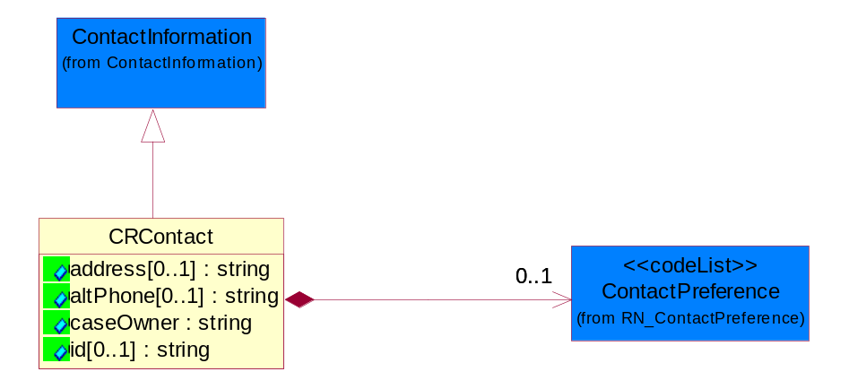
Figure ‎3-13 CRContact

Attribute | Type | Documentation
address[0..1] | string | Address information provided by the Case Receiver.
altPhone[0..1] | string | The alternative telephone number for the specified contact.
caseOwner | string | The name of the owner who is responsible for this case.
id[0..1] | string | Contact identification.

Composition | Cardinality | Type | Documentation
ContactPreference | 0..1 | ContactPreference | Code identifying the preference of using which contact mode.

Fault
The service requestor/case sender may need to provide additional minor details for a number of faults which appear to be related or which are showing the same symptoms. This section may subsequently be updated by either party.
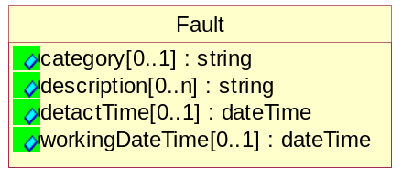
Figure ‎3-14 Fault

Attribute | Type | Documentation
category[0..1] | string | Fault category assigned to the case.
description[0..n] | string | Details of the case.
detactTime[0..1] | dateTime | Date and time the fault was first noticed.
workingDateTime[0..1] | dateTime | Date and time when the service was last known to be working.

Hardware
Product/ Hardware details.
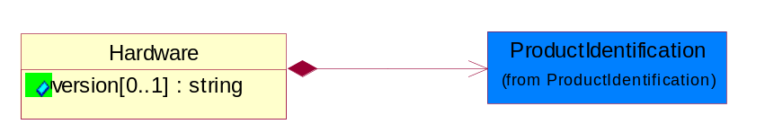
Figure ‎3-15 Hardware

Attribute | Type | Documentation
version[0..1] | string | Version number of hardware which is defective.

Composition | Cardinality | Type | Documentation
ProductIdentification | 1 | ProductIdentification | The object provides the identifier(s) of a product.

MessageInformation
Details of the way the message is packaged and sent.
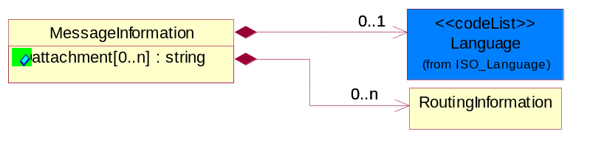
Figure ‎3-16 MessageInformation

Attribute | Type | Documentation
attachment[0..n] | string | Attachment description refers to describing the attachment is being sent. For example: "System Configuration Download" or "System Trouble Shooting Results".

Composition | Cardinality | Type | Documentation
Language | 0..1 | Language | For representation of Language name RosettaNet has adopted ISO 639-2; 1998. Refer to the following web page to get the latest version of the standard:  http://www.loc.gov/standards/iso639-2/iso639jac.html  If you need more information about the ISO standard please contact ISO for more details.
RoutingInformation | 0..n | RoutingInformation | Generic routing feature to may be required to identify routing attributes.

Notes
Extra service information notes.
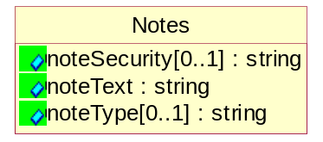
Figure ‎3-17 Notes

Attribute | Type | Documentation
noteSecurity[0..1] | string | Security level of notes.
noteText | string | Note Text.
noteType[0..1] | string | Type of notes.

Part
The list of spare parts that could fix the issue.
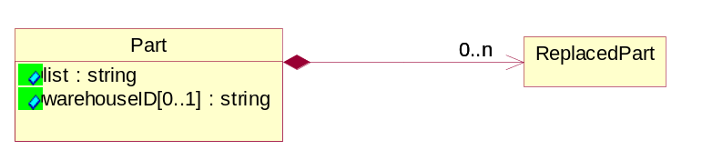
Figure ‎3-18 Part

Attribute | Type | Documentation
list | string | A list of spare parts which could be used to fix the issue.
warehouseID[0..1] | string | An identifier which indicates which warehouse the parts will be taken from.

Composition | Cardinality | Type | Documentation
ReplacedPart | 0..n | ReplacedPart | The list of replacement parts that could fix the issue.

RejectCase
Case that has been rejected from acceptance.
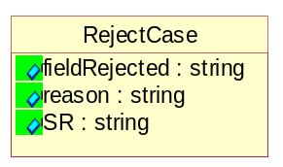
Figure ‎3-19 RejectCase

Attribute | Type | Documentation
fieldRejected | string | Points to the field that is incomplete or wrong information inputted that made this case rejected.
reason | string | Reason for the reject.
SR | string | The Case ID of the service requestor/case sender.

ReplacedPart
The list of replacement parts that could fix the issue.
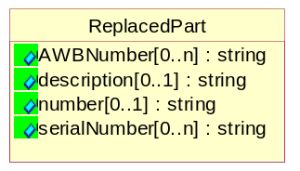
Figure ‎3-20 ReplacedPart

Attribute | Type | Documentation
AWBNumber[0..n] | string | The AWB number used to send back the item(s) from site to repair facility.
description[0..1] | string | A detailed description of the replaced part.
number[0..1] | string | The part number of the replaced part.
serialNumber[0..n] | string | The serial number(s) of the replaced part.

ResponsePeriod
The needed time of response for a servicing a case.
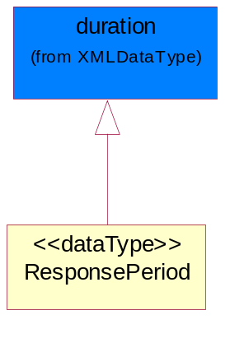
Figure ‎3-21 ResponsePeriod

RoutingInformation
Generic routing feature to may be required to identify routing attributes.
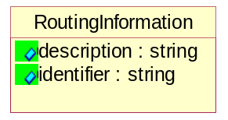
Figure ‎3-22 RoutingInformation

Attribute | Type | Documentation
description | string | The placeholder to explain the type of information use to create the identifier.(e.g.Product,Location,CustomerType)  This will add the semantic to the identifier.
identifier | string | Routing Identifier for the routing information.

ServiceInformation
Details of service done by the service requestor/case sender.
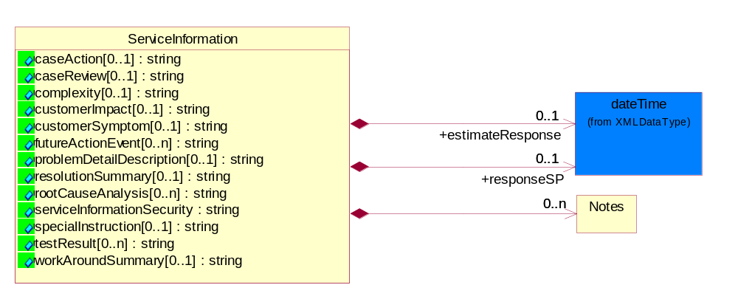
Figure ‎3-23 ServiceInformation

Attribute | Type | Documentation
caseAction[0..1] | string | In response to the original case being accepted, the service provider/case receiver may provide a description of what action will be taken.
caseReview[0..1] | string | Notes provided by the Case Reviewer, other Service Engineer.
complexity[0..1] | string | Complexity level of issue.
customerImpact[0..1] | string | Problem impact to the customer.
customerSymptom[0..1] | string | Problem symptom reported by End Customer.
futureActionEvent[0..n] | string | Future Action Event - In progress reporting, the service provider/case receiver may have the ability to report any planned appointments, using a wide definition of appointment as meaning 'any resource which must be booked on a time basis to report actions which may impact case (outages, appts).
problemDetailDescription[0..1] | string | Detail description provided by Service Engineer.
resolutionSummary[0..1] | string | Service Request resolution summary.
rootCauseAnalysis[0..n] | string | Text description of the root cause recorded for the final resolution.
serviceInformationSecurity | string | Service information security. E.g.  - Internal: for sharing within organization & its subsidiary.  - External: for sharing amongest Service Provider and Service Requestor  - Public: for sharing with all users, including end customers.
specialInstruction[0..1] | string | Special instruction to or by the Field Engineer.
testResult[0..n] | string | Detailed results of tests which have been carried out. Provided by service provider/case receiver to the service requestor/case sender.
workAroundSummary[0..1] | string | Workaround suggested by Service Engineer.

Composition | Cardinality | Type | Documentation
estimateResponse | 0..1 | dateTime | The expected response time by the service requestor/case sender.
responseSP | 0..1 | dateTime | A response time reply may be sent by the service provider/case receiver (indicates how soon they will provide a response).
Notes | 0..n | Notes | Extra service information notes.

Software
Software details.
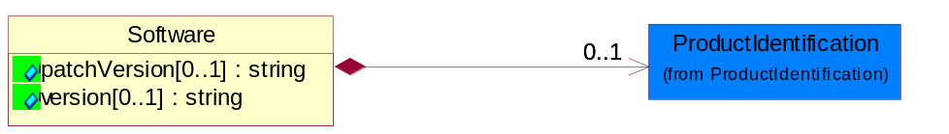
Figure ‎3-24 Software

Attribute | Type | Documentation
patchVersion[0..1] | string | Version of the software patch.
version[0..1] | string | Version number of software.

Composition | Cardinality | Type | Documentation
ProductIdentification | 0..1 | ProductIdentification | The object provides the identifier(s) of a product.

Update
The provider or requestor may include the update details that the case was updated within their internal system.
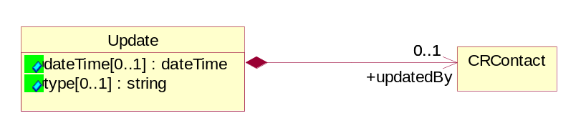
Figure ‎3-25 Update

Attribute | Type | Documentation
dateTime[0..1] | dateTime | Date and time the provider or requestor updates the case to their internal system.
type[0..1] | string | Update type updated by provider or requestor.

Composition | Cardinality | Type | Documentation
updatedBy | 0..1 | CRContact | Information of user who updated the service information.

CodeList

RequestType
The classification of each requests indicated by the service requestor/case sender.

Name | Documentation
CLO | Close- Close/Cancel the referenced request without further action.
OPN | Open- Open a new request.
ROP | Reopen- Referenced request that has been closed is reopened by this message.
UPD | Update- Referenced request made information is updated by this message.

Severity
A collection of importance of impact of the case to other cases.

Name | Documentation
CRI | Critical - Highest level of severity.
MAJ | Major - Second highest level of severity.
MED | Medium - Moderate level of severity.
MIN | Minor - Minimal level of severity.
NOI | No Impact to other cases.

Priority
A collection of urgency type of the case.

Name | Documentation
HIG | High - A level lower than urgent to solve case.
LOW | Low importance of priority to solve case.
MED | Medium level of urgency to solve case.
URG | Urgent to solve case.

ContactPreference
Code identifying the preference of using which contact mode.

Name | Documentation
B2B | Business to Business.
EMA | By EMail.
PHO | By Phone.

Universal Structure

ContactInformation

ContactInformation
The business document must allow for the identification of the name of the department, service or individual to be contacted regarding the context of the business document.
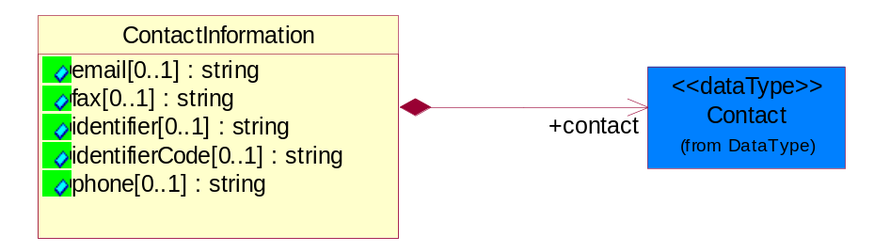
Figure ‎4-26 ContactInformation

Attribute | Type | Documentation
email[0..1] | string | The electronic mail for the specified contact.
fax[0..1] | string | The fax number for the specified contact.
identifier[0..1] | string | Identifies the role of the contact (i.e. Service Technician, Account Manager) in the Business Process.
identifierCode[0..1] | string | IdentifierCode is a unique security authorization code to identify the contact- ie. badge ID.
phone[0..1] | string | The telephone number for the specified contact.

Composition | Cardinality | Type | Documentation
contact | 1 | Contact | The name of the department, service or individual to be contacted within the organization.

DataType

Contact
The name of the department, service or individual to be contacted within the organization.
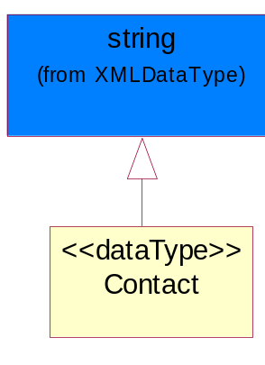
Figure ‎4-27 Contact

DUNS
A number assigned by Dun and Bradstreet to identify a business location.
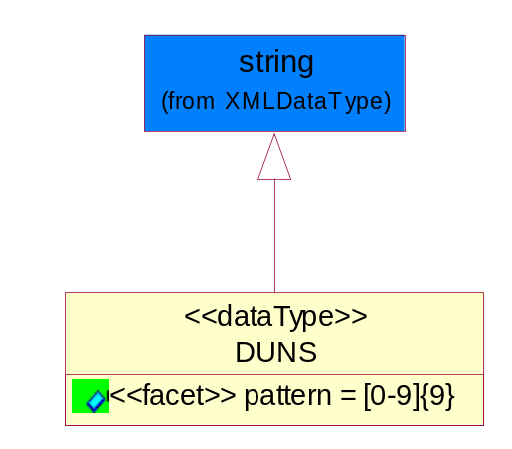
Figure ‎4-28 DUNS

Attribute | Type | Documentation
pattern |  | [0-9]{9}

DUNSPlus4
A identifier to specify a specific location within a business location.
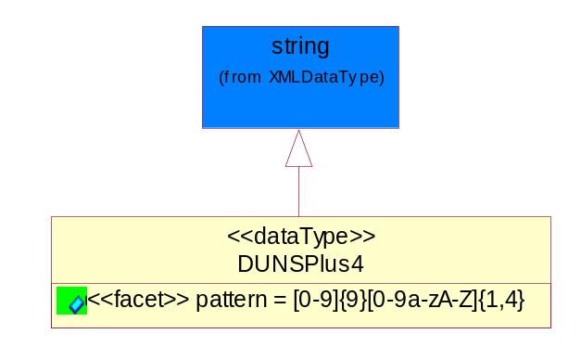
Figure ‎4-29 DUNSPlus4

Attribute | Type | Documentation
pattern |  | Data Universal Numbering System +4 (DUNS+4) number means the DUNS number assigned by Dun and Bradstreet, Inc. (D&B) plus an alphanumeric of length 4 suffix that may be assigned by a business concern.

GLN
Global Location Number (GLN) - A identifier to identify legal entities, trading parties and location.
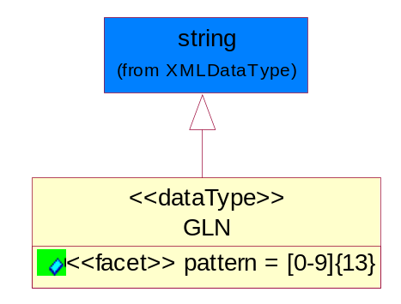
Figure ‎4-30 GLN

Attribute | Type | Documentation
pattern |  | [0-9]{13}

GTIN
Global Trade Identification Number (GTIN).
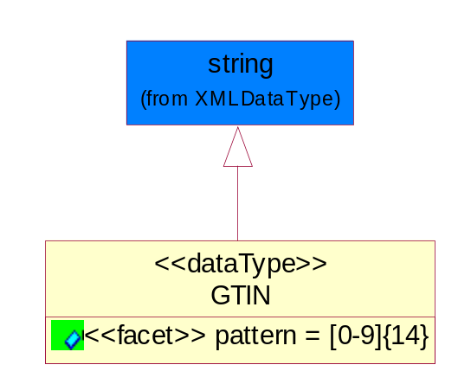
Figure ‎4-31 GTIN

Attribute | Type | Documentation
pattern |  | [0-9]{14}

Locations

AlternativeIdentifier
Identifies the specified code and the name of the organization that a code is utilized from.
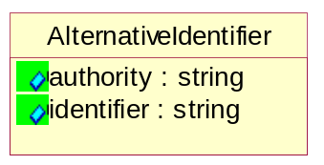
Figure ‎4-32 AlternativeIdentifier

Attribute | Type | Documentation
authority | string | The name of the organization that a code is utilized from.
identifier | string | The specified code to represent an entity (e.g. product, location, partner, etc.).

Location
The business document must specify a location.
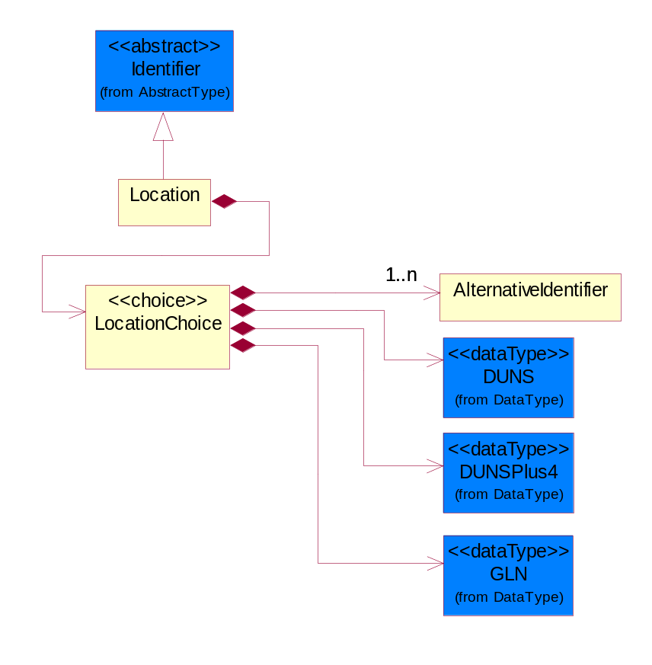
Figure ‎4-33 Location

Composition | Cardinality | Type | Documentation
LocationChoice | 1 | LocationChoice

LocationChoice

Composition | Cardinality | Type | Documentation
AlternativeIdentifier | 1..n | AlternativeIdentifier | Identifies the specified code and the name of the organization that a code is utilized from.
DUNS | 1 | DUNS | A number assigned by Dun and Bradstreet to identify a business location.
DUNSPlus4 | 1 | DUNSPlus4 | A identifier to specify a specific location within a business location.
GLN | 1 | GLN | Global Location Number (GLN) - A identifier to identify legal entities, trading parties and location.

PhysicalAddress
The business document must provide a physical address for a party to the business transaction.
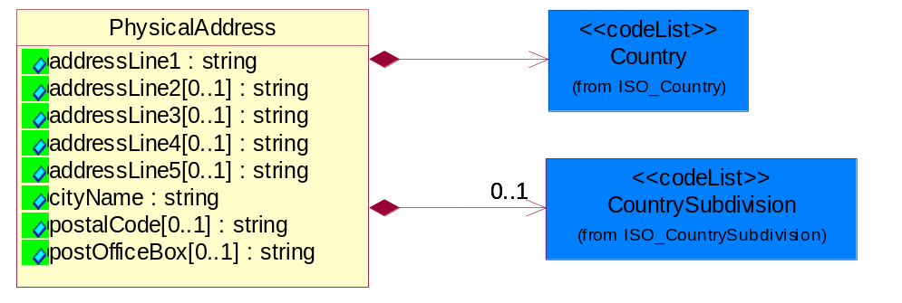
Figure ‎4-34 PhysicalAddress

Attribute | Type | Documentation
addressLine1 | string | The first line of a physical address.
addressLine2[0..1] | string | The second line of a physical address.
addressLine3[0..1] | string | The third line of a physical address.
addressLine4[0..1] | string | The fourth line of a physical address.
addressLine5[0..1] | string | The fifth line of a physical address.
cityName | string | The name of a city.
postalCode[0..1] | string | Identifying geographic location as specified by a national postal code.
postOfficeBox[0..1] | string | The Post Office Box identifier used to identify a party's post office box.

Composition | Cardinality | Type | Documentation
Country | 1 | Country | For representation of Country name RosettaNet has adopted ISO 3166-3; 1999. Refer to the following web page to get the latest version of the standard:  http://www.iso.ch/iso/en/prods-services/iso3166ma/02iso-3166-code-lists/index.html  If you need more information about the ISO standard please contact ISO for more details.
CountrySubdivision | 0..1 | CountrySubdivision | For representation of a Countries subdivisions RosettaNet has adopted ISO 3166-3; 1999. Refer to the following web page to get the latest version of the standard:  http://www.iso.ch/iso/en/prods-services/iso3166ma/02iso-3166-code-lists/index.html  If you need more information about the ISO standard please contact ISO for more details.

PartnerIdentification

FullPartner
The business document must describe the trading partners in the business transaction. This data structure provide the flexibility to describe a partner in all possible methods as for new, existing or known partner.
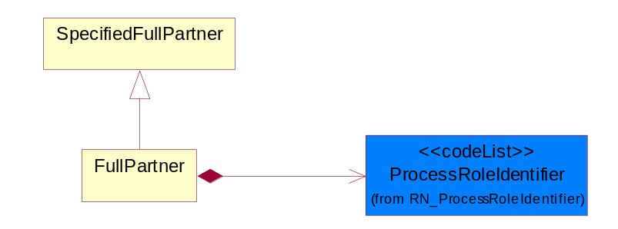
Figure ‎4-35 FullPartner

Composition | Cardinality | Type | Documentation
ProcessRoleIdentifier | 1 | ProcessRoleIdentifier | Describes the role of the partner in the business process. A partner will fulfill at least one or more roles during the business process.

PartnerIdentification
The business document must allow for the identity of one or more parties to the transaction.
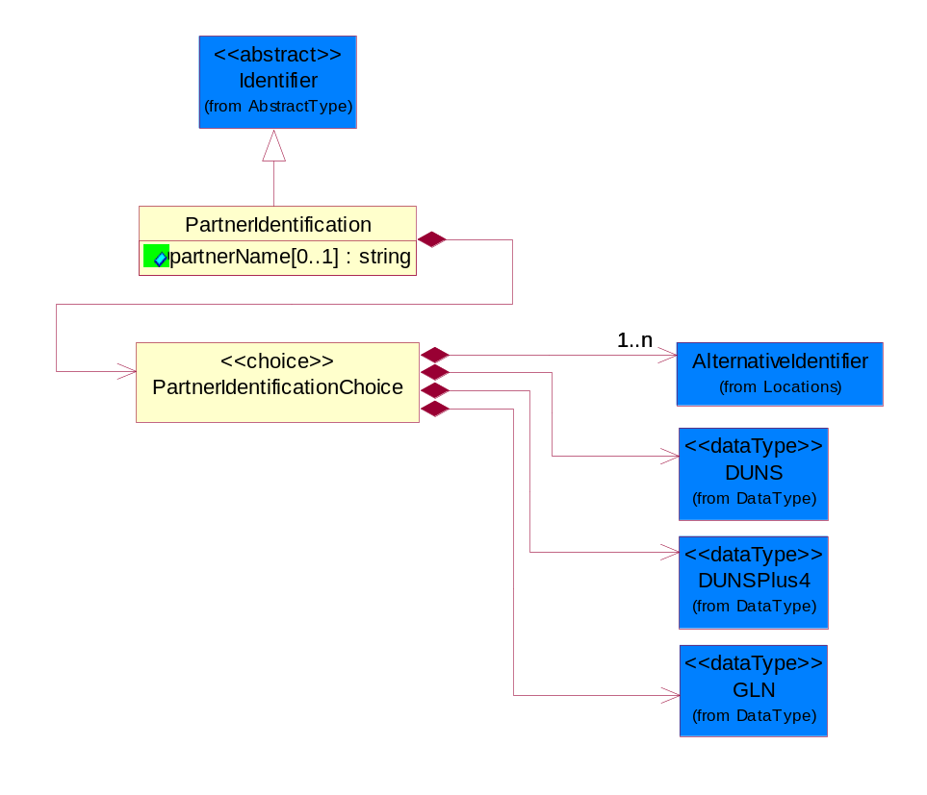
Figure ‎4-36 PartnerIdentification

Attribute | Type | Documentation
partnerName[0..1] | string | The name of the partner’s company/business.

Composition | Cardinality | Type | Documentation
PartnerIdentificationChoice | 1 | PartnerIdentificationChoice

PartnerIdentificationChoice

Composition | Cardinality | Type | Documentation
AlternativeIdentifier | 1..n | AlternativeIdentifier | Identifies the specified code and the name of the organization that a code is utilized from.
DUNS | 1 | DUNS | A number assigned by Dun and Bradstreet to identify a business location.
DUNSPlus4 | 1 | DUNSPlus4 | A identifier to specify a specific location within a business location.
GLN | 1 | GLN | Global Location Number (GLN) - A identifier to identify legal entities, trading parties and location.

SpecifiedFullPartner
The business document must describe the trading partners in the business transaction. This data structure provide the flexibility to describe a partner in all possible methods as for new, existing or known partner. This is specifically for partner who role has been specified.
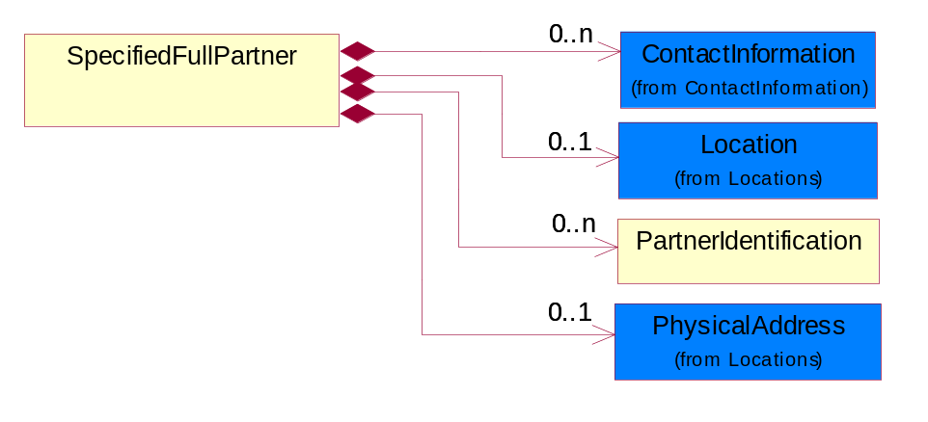
Figure ‎4-37 SpecifiedFullPartner

Composition | Cardinality | Type | Documentation
ContactInformation | 0..n | ContactInformation | The business document must allow for the identification of the name of the department, service or individual to be contacted regarding the context of the business document.
Location | 0..1 | Location | The business document must specify a location.
PartnerIdentification | 0..n | PartnerIdentification | The business document must allow for the identity of one or more parties to the transaction.
PhysicalAddress | 0..1 | PhysicalAddress | The business document must provide a physical address for a party to the business transaction.

ProductIdentification

ProductIdentification
The object provides the identifier(s) of a product.
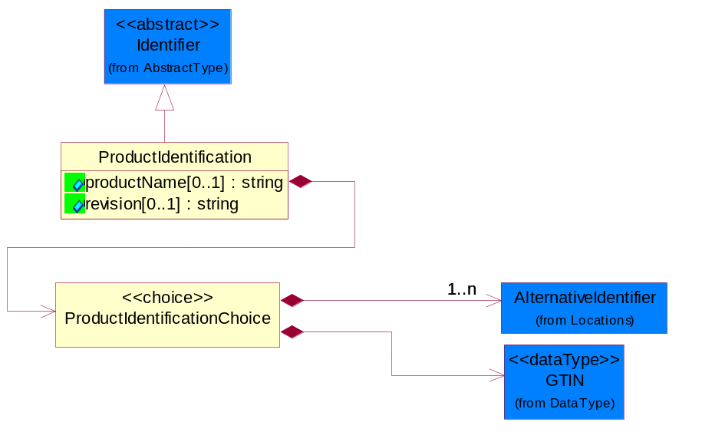
Figure ‎4-38 ProductIdentification

Attribute | Type | Documentation
productName[0..1] | string | The name of the product.
revision[0..1] | string | Referenced the specified product revision.

Composition | Cardinality | Type | Documentation
ProductIdentificationChoice | 1 | ProductIdentificationChoice

ProductIdentificationChoice

Composition | Cardinality | Type | Documentation
AlternativeIdentifier | 1..n | AlternativeIdentifier | Identifies the specified code and the name of the organization that a code is utilized from.
GTIN | 1 | GTIN | Global Trade Identification Number (GTIN).

CodeList

Country
For representation of Country name RosettaNet has adopted ISO 3166-3; 1999. Refer to the following web page to get the latest version of the standard:
http://www.iso.ch/iso/en/prods-services/iso3166ma/02iso-3166-code-lists/index.html

If you need more information about the ISO standard please contact ISO for more details.

CountrySubdivision
For representation of a Countries subdivisions RosettaNet has adopted ISO 3166-3; 1999. Refer to the following web page to get the latest version of the standard:
http://www.iso.ch/iso/en/prods-services/iso3166ma/02iso-3166-code-lists/index.html

If you need more information about the ISO standard please contact ISO for more details.

Language
For representation of Language name RosettaNet has adopted ISO 639-2; 1998. Refer to the following web page to get the latest version of the standard:

http://www.loc.gov/standards/iso639-2/iso639jac.html

If you need more information about the ISO standard please contact ISO for more details.

MimeTypeQualifier
The MIME type as defined by IANA.

Please refer to http://www.iana.org/assignments/media-types/ for a list of types.

Instance | Documentation
application/activemessage | [Shapiro]
application/andrew-inset | [Borenstein]
application/applefile | [Faltstrom]
application/atomicmail | [Borenstein]
application/batch-SMTP | [RFC2442]
application/beep+xml | [RFC3080]
application/cals-1840 | [RFC1895]
application/cnrp+xml | [RFCCNRP]
application/commonground | [Glazer]
application/cpl+xml
application/cybercash | [Eastlake]
application/dca-rft | [Campbell]
application/dec-dx | [Campbell]
application/dicom | [RFC3240]
application/dvcs | [RFC3029]
application/EDI-Consent | [RFC1767]
application/EDIFACT | [RFC1767]
application/EDI-X12 | [RFC1767]
application/eshop | [Katz]
application/font-tdpfr | [RFC3073]
application/http | [RFC2616]
application/hyperstudio | [Domino]
application/iges | [Parks]
application/index | [RFC2652]
application/index.cmd | [RFC2652]
application/index.obj | [RFC2652]
application/index.response | [RFC2652]
application/index.vnd | [RFC2652]
application/iotp | [RFC2935]
application/ipp | [RFC2910]
application/isup | [RFC3204]
application/mac-binhex40 | [Faltstrom]
application/macwriteii | [Lindner]
application/marc | [RFC2220]
application/mathematica | [Van Nostern]
application/msword | [Lindner]
application/news-message-id | [RFC1036,Spencer]
application/news-transmission | [RFC1036, Spencer]
application/ocsp-request | [RFC2560]
application/ocsp-response | [RFC2560]
application/octet-stream | [RFC2045,RFC2046]
application/oda | [RFC2045,RFC2046]
application/ogg | [RFC-walleij-ogg-mediatype-08.txt]
application/parityfec | [RFC3009]
application/pdf | [Lindner]
application/pgp-encrypted | [RFC3156]
application/pgp-keys | [RFC3156]
application/pgp-signature | [RFC3156]
application/pkcs10 | [RFC2311]
application/pkcs7-mime | [RFC2311]
application/pkcs7-signature | [RFC2311]
application/pkix-cert | [RFC2585]
application/pkixcmp | [RFC2510]
application/pkix-crl | [RFC2585]
application/postscript | [RFC2045,RFC2046]
application/prs.alvestrand.titrax-sheet | [Alvestrand]
application/prs.cww | [Rungchavalnont]
application/prs.nprend | [Doggett]
application/prs.plucker | [Janssen]
application/qsig | [RFC3204]
application/reginfo+xml | [RFC-ietf-sipping-reg-event-00.txt]
application/remote-printing | [RFC1486,Rose]
application/riscos | [Smith]
application/rtf | [Lindner]
application/sdp | [RFC2327]
application/set-payment | [Korver]
application/set-payment-initiation | [Korver]
application/set-registration | [Korver]
application/set-registration-initiation | [Korver]
application/sgml | [RFC1874]
application/sgml-open-catalog | [Grosso]
application/sieve | [RFC3028]
application/slate | [Crowley]
application/timestamp-query | [RFC3161]
application/timestamp-reply | [RFC3161]
application/tve-trigger | [Welsh]
application/vemmi | [RFC2122]
application/vnd.3gpp.pic-bw-large | [Meredith]
application/vnd.3gpp.pic-bw-small | [Meredith]
application/vnd.3gpp.pic-bw-var | [Meredith]
application/vnd.3gpp.sms | [Meredith]
application/vnd.3M.Post-it-Notes | [O'Brien]
application/vnd.accpac.simply.aso | [Leow]
application/vnd.accpac.simply.imp | [Leow]
application/vnd.acucobol | [Lubin]
application/vnd.acucorp | [Lubin]
application/vnd.adobe.xfdf | [Perelman]
application/vnd.aether.imp | [Moskowitz]
application/vnd.amiga.ami | [Blumberg]
application/vnd.anser-web-certificate-issue-initiation | [Mori]
application/vnd.anser-web-funds-transfer-initiation | [Mori]
application/vnd.audiograph | [Slusanschi]
application/vnd.blueice.multipass | [Holmstrom]
application/vnd.bmi | [Gotoh]
application/vnd.businessobjects | [Imoucha]
application/vnd.canon-cpdl | [Muto]
application/vnd.canon-lips | [Muto]
application/vnd.cinderella | [Kortenkamp]
application/vnd.claymore | [Simpson]
application/vnd.commerce-battelle | [Applebaum]
application/vnd.commonspace | [Chandhok]
application/vnd.contact.cmsg | [Patz]
application/vnd.cosmocaller | [Dellutri]
application/vnd.ctc-posml | [Kohlhepp]
application/vnd.cups-postscript | [Sweet]
application/vnd.cups-raster | [Sweet]
application/vnd.cups-raw | [Sweet]
application/vnd.curl | [Byrnes]
application/vnd.cybank | [Helmee]
application/vnd.data-vision.rdz | [Fields]
application/vnd.dna | [Searcy]
application/vnd.dpgraph | [Parker]
application/vnd.dreamfactory | [Appleton]
application/vnd.dxr | [Duffy]
application/vnd.ecdis-update | [Buettgenbach]
application/vnd.ecowin.chart | [Olsson]
application/vnd.ecowin.filerequest | [Olsson]
application/vnd.ecowin.fileupdate | [Olsson]
application/vnd.ecowin.series | [Olsson]
application/vnd.ecowin.seriesrequest | [Olsson]
application/vnd.ecowin.seriesupdate | [Olsson]
application/vnd.enliven | [Santinelli]
application/vnd.epson.esf | [Hoshina]
application/vnd.epson.msf | [Hoshina]
application/vnd.epson.quickanime | [Gu]
application/vnd.epson.salt | [Nagatomo]
application/vnd.epson.ssf | [Hoshina]
application/vnd.ericsson.quickcall | [Tidwell]
application/vnd.eudora.data | [Resnick]
application/vnd.fdf | [Zilles]
application/vnd.ffsns | [Holstage]
application/vnd.FloGraphIt | [Floersch]
application/vnd.framemaker | [Wexler]
application/vnd.fsc.weblaunch | [D.Smith]
application/vnd.fujitsu.oasys | [Togashi]
application/vnd.fujitsu.oasys2 | [Togashi]
application/vnd.fujitsu.oasys3 | [Okudaira]
application/vnd.fujitsu.oasysgp | [Sugimoto]
application/vnd.fujitsu.oasysprs | [Ogita]
application/vnd.fujixerox.ddd | [Onda]
application/vnd.fujixerox.docuworks | [Taguchi]
application/vnd.fujixerox.docuworks.binder | [Matsumoto]
application/vnd.fut-misnet | [Pruulmann]
application/vnd.grafeq | [Tupper]
application/vnd.groove-account | [Joseph]
application/vnd.groove-help | [Joseph]
application/vnd.groove-identity-message | [Joseph]
application/vnd.groove-injector | [Joseph]
application/vnd.groove-tool-message | [Joseph]
application/vnd.groove-tool-template | [Joseph]
application/vnd.groove-vcard | [Joseph]
application/vnd.hbci | [Hammann]
application/vnd.hhe.lesson-player | [Jones]
application/vnd.hp-HPGL | [Pentecost]
application/vnd.hp-hpid | [Gupta]
application/vnd.hp-hps | [Aubrey]
application/vnd.hp-PCL | [Pentecost]
application/vnd.hp-PCLXL | [Pentecost]
application/vnd.httphone | [Lefevre]
application/vnd.hzn-3d-crossword | [Minnis]
application/vnd.ibm.afplinedata | [Buis]
application/vnd.ibm.electronic-media | [Tantlinger]
application/vnd.ibm.MiniPay | [Herzberg]
application/vnd.ibm.modcap | [Hohensee]
application/vnd.ibm.secure-container | [Tantlinger]
application/vnd.informix-visionary | [Gales]
application/vnd.intercon.formnet | [Gurak]
application/vnd.intertrust.digibox | [Tomasello]
application/vnd.intertrust.nncp | [Tomasello]
application/vnd.intu.qbo | [Scratchley]
application/vnd.intu.qfx | [Scratchley]
application/vnd.irepository.package+xml | [Knowles]
application/vnd.is-xpr | [Natarajan]
application/vnd.japannet-directory-service | [Fujii]
application/vnd.japannet-jpnstore-wakeup | [Yoshitake]
application/vnd.japannet-payment-wakeup | [Fujii]
application/vnd.japannet-registration | [Yoshitake]
application/vnd.japannet-registration-wakeup | [Fujii]
application/vnd.japannet-setstore-wakeup | [Yoshitake]
application/vnd.japannet-verification | [Yoshitake]
application/vnd.japannet-verification-wakeup | [Fujii]
application/vnd.jisp | [Deckers]
application/vnd.kde.karbon | [Faure]
application/vnd.kde.kchart | [Faure]
application/vnd.kde.kformula | [Faure]
application/vnd.kde.kivio | [Faure]
application/vnd.kde.kontour | [Faure]
application/vnd.kde.kpresenter | [Faure]
application/vnd.kde.kspread | [Faure]
application/vnd.kde.kword | [Faure]
application/vnd.kenameaapp | [DiGiorgio-Haag]
application/vnd.koan | [Cole]
application/vnd.liberty-request+xml | [McDowell]
application/vnd.llamagraphics.life-balance.desktop | [White]
application/vnd.lotus-1-2-3 | [Wattenberger]
application/vnd.lotus-approach | [Wattenberger]
application/vnd.lotus-freelance | [Wattenberger]
application/vnd.lotus-notes | [Laramie]
application/vnd.lotus-organizer | [Wattenberger]
application/vnd.lotus-screencam | [Wattenberger]
application/vnd.lotus-wordpro | [Wattenberger]
application/vnd.mcd | [Gotoh]
application/vnd.mediastation.cdkey | [Flurry]
application/vnd.meridian-slingshot | [Wedel]
application/vnd.micrografx.flo | [Prevo]
application/vnd.micrografx.igx | [Prevo]
application/vnd.mif | [Wexler]
application/vnd.minisoft-hp3000-save | [Bartram]
application/vnd.mitsubishi.misty-guard.trustweb | [Tanaka]
application/vnd.Mobius.DAF | [Kabayama]
application/vnd.Mobius.DIS | [Kabayama]
application/vnd.Mobius.MBK | [Devasia]
application/vnd.Mobius.MQY | [Devasia]
application/vnd.Mobius.MSL | [Kabayama]
application/vnd.Mobius.PLC | [Kabayama]
application/vnd.Mobius.TXF | [Kabayama]
application/vnd.mophun.application | [Wennerstrom]
application/vnd.mophun.certificate | [Wennerstrom]
application/vnd.motorola.flexsuite | [Patton]
application/vnd.motorola.flexsuite.adsi | [Patton]
application/vnd.motorola.flexsuite.fis | [Patton]
application/vnd.motorola.flexsuite.gotap | [Patton]
application/vnd.motorola.flexsuite.kmr | [Patton]
application/vnd.motorola.flexsuite.ttc | [Patton]
application/vnd.motorola.flexsuite.wem | [Patton]
application/vnd.mozilla.xul+xml | [McDaniel]
application/vnd.ms-artgalry | [Slawson]
application/vnd.ms-asf | [Fleischman]
application/vnd.mseq | [Le Bodic]
application/vnd.ms-excel | [Gill]
application/vnd.msign | [Borcherding]
application/vnd.ms-lrm | [Ledoux]
application/vnd.ms-powerpoint | [Gill]
application/vnd.ms-project | [Gill]
application/vnd.ms-tnef | [Gill]
application/vnd.ms-works | [Gill]
application/vnd.ms-wpl | [Plastina]
application/vnd.musician | [Adams]
application/vnd.music-niff | [Butler]
application/vnd.netfpx | [Mutz]
application/vnd.noblenet-directory | [Solomon]
application/vnd.noblenet-sealer | [Solomon]
application/vnd.noblenet-web | [Solomon]
application/vnd.novadigm.EDM | [Swenson]
application/vnd.novadigm.EDX | [Swenson]
application/vnd.novadigm.EXT | [Swenson]
application/vnd.obn | [Hessling]
application/vnd.osa.netdeploy | [Klos]
application/vnd.palm | [Peacock]
application/vnd.pg.format | [Gandert]
application/vnd.pg.osasli | [Gandert]
application/vnd.powerbuilder6 | [Guy]
application/vnd.powerbuilder6-s | [Guy]
application/vnd.powerbuilder7 | [Shilts]
application/vnd.powerbuilder75 | [Shilts]
application/vnd.powerbuilder75-s | [Shilts]
application/vnd.powerbuilder7-s | [Shilts]
application/vnd.previewsystems.box | [Smolgovsky]
application/vnd.publishare-delta-tree | [Ben-Kiki]
application/vnd.pvi.ptid1 | [Lamb]
application/vnd.pwg-multiplexed | [RFC3391]
application/vnd.pwg-xhtml-print+xml | [Wright]
application/vnd.Quark.QuarkXPress | [Scheidler]
application/vnd.rapid | [Szekely]
application/vnd.s3sms | [Tarkkala]
application/vnd.sealed.net | [Lambert]
application/vnd.seemail | [Webb]
application/vnd.shana.informed.formdata | [Selzler]
application/vnd.shana.informed.formtemplate | [Selzler]
application/vnd.shana.informed.interchange | [Selzler]
application/vnd.shana.informed.package | [Selzler]
application/vnd.smaf | [Takahashi]
application/vnd.sss-cod | [Dani]
application/vnd.sss-dtf | [Bruno]
application/vnd.sss-ntf | [Bruno]
application/vnd.street-stream | [Levitt]
application/vnd.svd | [Becker]
application/vnd.swiftview-ics | [Widener]
application/vnd.triscape.mxs | [Simonoff]
application/vnd.trueapp | [Hepler]
application/vnd.truedoc | [Chase]
application/vnd.ufdl | [Manning]
application/vnd.uplanet.alert | [Martin]
application/vnd.uplanet.alert-wbxml | [Martin]
application/vnd.uplanet.bearer-choice | [Martin]
application/vnd.uplanet.bearer-choice-wbxml | [Martin]
application/vnd.uplanet.cacheop | [Martin]
application/vnd.uplanet.cacheop-wbxml | [Martin]
application/vnd.uplanet.channel | [Martin]
application/vnd.uplanet.channel-wbxml | [Martin]
application/vnd.uplanet.list | [Martin]
application/vnd.uplanet.listcmd | [Martin]
application/vnd.uplanet.listcmd-wbxml | [Martin]
application/vnd.uplanet.list-wbxml | [Martin]
application/vnd.uplanet.signal | [Martin]
application/vnd.vcx | [T.Sugimoto]
application/vnd.vectorworks | [Pharr]
application/vnd.vidsoft.vidconference | [Hess]
application/vnd.visio | [Sandal]
application/vnd.visionary | [Aravindakumar]
application/vnd.vividence.scriptfile | [Risher]
application/vnd.vsf | [Rowe]
application/vnd.wap.sic | [WAP-Forum]
application/vnd.wap.slc | [WAP-Forum]
application/vnd.wap.wbxml | [Stark]
application/vnd.wap.wmlc | [Stark]
application/vnd.wap.wmlscriptc | [Stark]
application/vnd.webturbo | [Rehem]
application/vnd.wrq-hp3000-labelled | [Bartram]
application/vnd.wt.stf | [Wohler]
application/vnd.wv.csp+wbxml | [Salmi]
application/vnd.xara | [Matthewman]
application/vnd.xfdl | [Manning]
application/vnd.yellowriver-custom-menu | [Yellow]
application/whoispp-query | [RFC2957]
application/whoispp-response | [RFC2958]
application/wita | [Campbell]
application/wordperfect5.1 | [Lindner]
application/x400-bp | [RFC1494]
application/xhtml+xml | [RFC3236]
application/xml | [RFC3023]
application/xml-dtd | [RFC3023]
application/xml-external-parsed-entity | [RFC3023]
application/zip | [Lindner]
audio/32kadpcm | [RFC2421,RFC2422]
audio/AMR | [RFC3267]
audio/AMR-WB | [RFC3267]
audio/basic | [RFC2045,RFC2046]
audio/CN | [RFC3389]
audio/DAT12 | [RFC3190]
audio/DVI4
audio/EVRC | [RFC-ietf-avt-evrc-smv-03.txt]
audio/EVRC0 | [RFC-ietf-avt-evrc-smv-03.txt]
audio/G.722.1 | [RFC3047]
audio/G722
audio/G723
audio/G726-16
audio/G726-24
audio/G726-32
audio/G726-40
audio/G728
audio/G729
audio/G729D
audio/G729E
audio/GSM
audio/GSM-EFR
audio/L16 | [RFC2586]
audio/L20 | [RFC3190]
audio/L24 | [RFC3190]
audio/L8
audio/LPC
audio/MP4A-LATM | [RFC3016]
audio/MPA
audio/mpa-robust | [RFC3119]
audio/mpeg | [RFC3003]
audio/parityfec | [RFC3009]
audio/PCMA
audio/PCMU
audio/prs.sid | [Walleij]
audio/QCELP
audio/RED
audio/SMV | [RFC-ietf-avt-evrc-smv-03.txt]
audio/SMV0 | [RFC-ietf-avt-evrc-smv-03.txt]
audio/telephone-event | [RFC2833]
audio/tone | [RFC2833]
audio/VDVI
audio/vnd.3gpp.iufp | [Belling]
audio/vnd.cisco.nse | [Kumar]
audio/vnd.cns.anp1 | [McLaughlin]
audio/vnd.cns.inf1 | [McLaughlin]
audio/vnd.digital-winds | [Strazds]
audio/vnd.everad.plj | [Cicelsky]
audio/vnd.lucent.voice | [Vaudreuil]
audio/vnd.nortel.vbk | [Parsons]
audio/vnd.nuera.ecelp4800 | [Fox]
audio/vnd.nuera.ecelp7470 | [Fox]
audio/vnd.nuera.ecelp9600 | [Fox]
audio/vnd.octel.sbc | [Vaudreuil]
audio/vnd.qcelp | [Lundblade]
audio/vnd.rhetorex.32kadpcm | [Vaudreuil]
audio/vnd.vmx.cvsd | [Vaudreuil]
image/cgm | Computer Graphics Metafile
image/g3fax | [RFC1494]
image/gif | [RFC2045,RFC2046]
image/ief | [RFC1314] Image Exchange Format
image/jpeg | [RFC2045,RFC2046]
image/naplps | [Ferber]
image/png | [Randers-Pehrson]
image/prs.btif | [Simon]
image/prs.pti | [Laun]
image/t38 | [RFC3362]
image/tiff | [RFC3302] Tag Image File Format
image/tiff-fx | [RFC3250] Tag Image File Format Fax eXtended
image/vnd.cns.inf2 | [McLaughlin]
image/vnd.djvu | [Bottou]
image/vnd.dwg | [Moline]
image/vnd.dxf | [Moline]
image/vnd.fastbidsheet | [Becker]
image/vnd.fpx | [Spencer]
image/vnd.fst | [Fuldseth]
image/vnd.fujixerox.edmics-mmr | [Onda]
image/vnd.fujixerox.edmics-rlc | [Onda]
image/vnd.globalgraphics.pgb | [Bailey]
image/vnd.mix | [Reddy]
image/vnd.ms-modi | [Vaughan]
image/vnd.net-fpx | [Spencer]
image/vnd.svf | [Moline]
image/vnd.wap.wbmp | [Stark]
image/vnd.xiff | [S.Martin]
message/delivery-status | [RFC1894]
message/disposition-notification | [RFC2298]
message/external-body | [RFC2045,RFC2046]
message/http | [RFC2616]
message/news | [RFC 1036, H.Spencer]
message/partial | [RFC2045,RFC2046]
message/rfc822 | [RFC2045,RFC2046]
message/s-http | [RFC2660]
message/sip | [RFC3261]
message/sipfrag | [RFC3420]
model/iges | [Parks]
model/mesh | [RFC2077]
model/vnd.dwf | [Pratt]
model/vnd.flatland.3dml | [Powers]
model/vnd.gdl | [Babits]
model/vnd.gs-gdl | [Babits]
model/vnd.gtw | [Ozaki]
model/vnd.mts | [Rabinovitch]
model/vnd.parasolid.transmit.binary | [Parasolid]
model/vnd.parasolid.transmit.text | [Parasolid]
model/vnd.vtu | [Rabinovitch]
model/vrml | [RFC2077]
multipart/alternative | [RFC2045,RFC2046]
multipart/appledouble | [Faltstrom]
multipart/byteranges | [RFC2068]
multipart/digest | [RFC2045,RFC2046]
multipart/encrypted | [RFC1847]
multipart/form-data | [RFC2388]
multipart/header-set | [Crocker]
multipart/mixed | [RFC2045,RFC2046]
multipart/parallel | [RFC2045,RFC2046]
multipart/related | [RFC2387]
multipart/report | [RFC1892]
multipart/signed | [RFC1847]
multipart/voice-message | [RFC2421,RFC2423]
text/calendar | [RFC2445]
text/css | [RFC2318]
text/directory | [RFC2425]
text/enriched | [RFC1896]
text/html | [RFC2854]
text/parityfec | [RFC3009]
text/plain | [RFC2646,RFC2046]
text/prs.lines.tag | [Lines]
text/rfc822-headers | [RFC1892]
text/richtext | [RFC2045,RFC2046]
text/rtf | [Lindner]
text/sgml | [RFC1874]
text/t140 | [RFC2793]
text/tab-separated-values | [Lindner]
text/uri-list | [RFC2483]
text/vnd.abc | [Allen]
text/vnd.curl | [Byrnes]
text/vnd.DMClientScript | [Bradley]
text/vnd.fly | [Gurney]
text/vnd.fmi.flexstor | [Hurtta]
text/vnd.in3d.3dml | [Powers]
text/vnd.in3d.spot | [Powers]
text/vnd.IPTC.NewsML | [IPTC]
text/vnd.IPTC.NITF | [IPTC]
text/vnd.latex-z | [Lubos]
text/vnd.motorola.reflex | [Patton]
text/vnd.ms-mediapackage | [Nelson]
text/vnd.net2phone.commcenter.command | [Xie]
text/vnd.sun.j2me.app-descriptor | [G.Adams]
text/vnd.wap.si | [WAP-Forum]
text/vnd.wap.sl | [WAP-Forum]
text/vnd.wap.wml | [Stark]
text/vnd.wap.wmlscript | [Stark]
text/xml | [RFC3023]
text/xml-external-parsed-entity | [RFC3023]
video/BMPEG
video/BT656
video/CelB
video/DV | [RFC3189]
video/H261
video/H263
video/H263-1998
video/H263-2000
video/JPEG
video/MP1S
video/MP2P
video/MP2T
video/MP4V-ES | [RFC3016]
video/mpeg | [RFC2045,RFC2046]
video/MPV
video/nv
video/parityfec | [RFC3009]
video/pointer | [RFC2862]
video/quicktime | [Lindner]
video/SMPTE292M | [RFC-avt-smpte292-video-08.txt]
video/vnd.fvt | [Fuldseth]
video/vnd.motorola.video | [McGinty]
video/vnd.motorola.videop | [McGinty]
video/vnd.mpegurl | [Recktenwald]
video/vnd.nokia.interleaved-multimedia | [Kangaslampi]
video/vnd.objectvideo | [Clark]
video/vnd.vivo | [Wolfe]

ProcessRoleIdentifier
Describes the role of the partner in the business process. A partner will fulfill at least one or more roles during the business process.

Instance | Documentation
ADM | Administered by - The party who is the administrative authority of an account.
ALT | Alternate approval by - The party who has approved a request in the event the approver is not able to respond.
APP | Approval by - The party who has approved a request.
AUT | Authorized By - The party who has authorized a request.
BIF | Bill from - The party that will issue the invoice.
BIT | Bill to - The party that will pay the invoice.
CBK | Customs Broker - CustomsBroker  This object represents the party that declare the shipment on behalf of declarant.
CLF | Collect From - To enable the buyer to specify the location of where products not supplied directly by the seller/installer may be collected.
CLM | Claimed By - This object represents the claimant.
CNC | Cancellation party - The party who is cancelling the shipping order.
COR | Change originated by - The party who originates a proposed change.
COW | Change owned by - The party who owns or who is assigned responsibility for a proposed change.
CRA | Credit applicant - The party who is applying for credit.
CRE | Created by - The party responsible for creating a process or task.
CSP | Contract Service Provider.
CWN | contractOwner - The party who is the owner of the contract. For example, in the direct business, the buyer is the contract owner. In the distribution business, the buyer is the distributor and the contract owner is the reseller.
DCE | DesignCustomerApplicationEngineer. The demand customer's Field Application Engineer.
DCT | Declared To - This object represents the party that the declaration goes to.
DCU | DesignCustomer. The owner of the product for which the design has been created.
DIS | Distributed by - The party who supplies products to retailers.
DLR | Declared By - This object represents the party that declare the shipment.
DST | Distributed To - This object represents the party to send information to.
FCP | Forecast Partner - The collection of business properties that describes the partner types for a forecast.
FIA | From Install At - The collection of sender business properties that describes a business partners' identity, their contact information, where they are physically located and their function in a supply chain.
FIN | Financed by - The party who is the financier.
FNB | Founded by - The party who performs the act, process, or art of casting metals.
FOR | Forwarded to - The party to whom a business document has been forwarded.
IMB | Imported By - The party responsible for importing the product.
INL | Inventory location - The party where the inventory product entry is located.
INO | Inventory owner - The party that owns the inventory product entry.
ITF | In transit from - The party sending the product quantity in a product location transfer.
ITL | installAt - The partner and/or location to which the product must be set up for use or service.
ITT | In transit to - The party receiving the product quantity in a product location transfer.
LGP | Logistics Provided By - The party who handles the details of an operation.
MFG | Manufactured by - The party who creates, processes or produces goods especially in large quantities and by means of industrial machines.
OWN | Owned by - The party who owns a process.
PAE | ProductProviderFieldApplicationEngineer. The product provider Field Application Engineer.
PCW | Primary Contract With - The primary party with whom a contract is formed.
PNB | Planning By - The party who establishes goals, policies or procedures.
PSR | ProductProviderSalesRepresentative. The product provider sales representative.
PUR | Purchased by - The party who is a purchaser of a product.
REA | Requested approval by - The party who has been selected to approve a request.
REC | Received by - The party who has received a product shipment.
REQ | Requested by - The party who has initiated a request.
RES | Respond to - The party to whom a responding business document must be sent when it is not equal to the partner specified in the document header.
RET | Return by - The party responsible for either carrying or forwarding the returned product.
REV | Reviewed by - The party responsible for reviewing a business document.
RFR | receivedFrom - The partner and/or location from where the product was shipped.
RLS | Released By - This object represents the party that releases the goods.
RMT | remitTo - The partner to which payment for a business document is sent.
RPB | Repaired By - The collection of business properties used to identify the business partner responsible for the repair or  rework of a product.
RQT | Refer Quote To - The partner to whom a quote request is being referred.
RSF | Requested Ship From - The party where the product is requested to be shipped from.
RTT | ReturnTo - The partner and/or location to which the returned product must be delivered.
SBF | Self-billing from - The party who initiates the billing in self-billing scenario.
SBT | Self-billing to - The party whom the invoice is addressed to.
SCB | Subcontracted By - The party who is contracted to perform part or all of another party's contract.
SCP | Shipping charges paid by - The party responsible for administering payment of the shipping charges.
SCW | Secondary Contract With - The subsequent party(ies) with whom a contract is formed.
SHF | Ship From - The collection of business properties used to identify the business partner initiating a shipment or transaction.
SHT | Ship To - The partner and/or location to which the product must be delivered.
SLD | Sold to - The party to whom a product has been sold.
SOB | Sold By - The seller involved in a business transaction.
SPL | Supplied by - The party who supplies an item, part or assembly.
SPS | Service Provider Site - Identification for the location of the ASP site that is ordering the replacement parts and/or performing the repair.
SRT | Submit returns to - The party to whom product returns are to be submitted.
STR | Stored By - This object represents the party that stores the goods.
SVA | ShipVia - The partner and/or location through which the product must be shipped, such as the "cross dock" at a shipping hub.  It must not be specified for the last leg, since this would be the same as the final destination specified in the ShipmentInformation/shipTo.
TFR | Transfer From - The party responsible for making the payment (Payer).
TIA | To lnstall At - The collection of receiver business properties that describes business partners' identity, their contact information, where they are physically located and their function in a supply chain.
TMT | Transfer Manufacturing To - The movement of the manufacturing process to another site.
TRA | Transported by - The party responsible for either carrying or forwarding the product.
TSB | Tested By - The collection of business properties used to identify the specific location and resources used to conduct a defined cycle or steps or measurements required to confirm a result or event.
TTR | Transfer To - The party who is receiving the payment (payee).
ULR | Ultimate recipient - The party who ultimately receives the shipment, when an intermediate party takes responsibility for payment and final delivery.
USE | Used by - The party who is the end user of the product.
UST | Unstuffed By - This object represents the party that unstuffs the goods.
WHB | Warehoused By - The party who stocks or stores products.

System Structure

BusinessProcessIdentifier
A Business Process Identifier to uniquely define the TPIR-PIP 'role' within a Business Scenario at a company or MNC level. The identifier MUST be composed of alphanumeric characters only and its length MUST be between one and twelve characters.
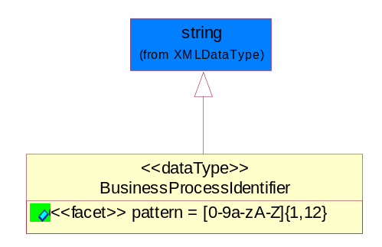
Figure ‎5-39 BusinessProcessIdentifier

Attribute | Type | Documentation
pattern |  | [0-9a-zA-Z]{1,12}

BusinessServiceInformation
The object allows the specification of the business service utilized within the partner company. This may or may not be the same as the information sent by the RNIF.
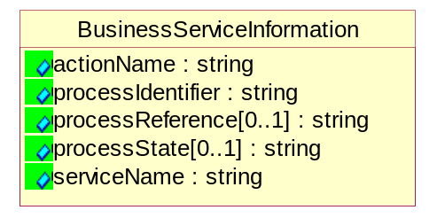
Figure ‎5-40 BusinessServiceInformation

Attribute | Type | Documentation
actionName | string | The name of Action. For RosettaNet usually any of Request/Confirm/Notify/Query/Response.
processIdentifier | string | The name of the PIP e.g. Notify of Forecast Reply.
processReference[0..1] | string | The URN for the PIP that includes Cluster/Segment/Process pattern used to identify the interface process (such as PIP3A4)
processState[0..1] | string | The business process (or service) state of the sender of a document. When a service receives this document, the receiver may use the state as a precondition.
serviceName | string | The name of the Business Activity with the "Request/Confirm" part removed. E.g., for the Activity "Request Purchase Order"==> "Purchase Order".

ContractInformation
A block of information used to correlate a contract in an executing choreography.
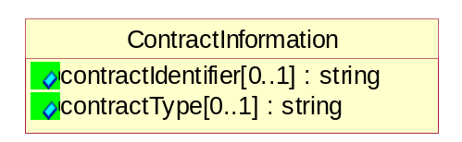
Figure ‎5-41 ContractInformation

Attribute | Type | Documentation
contractIdentifier[0..1] | string | Unique identification of a contract between the Sender and the Receiver
contractType[0..1] | string | The type of the contract: an attribute describing the type of the ContractIndentification. Valid values are URI, URN,ebXMLCPA, or other values defined by partners.

CorrelationInformation
A block of information used to correlate a requesting document to a responding document and to the contract in an executing choreography.
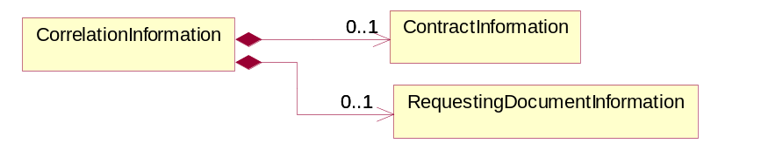
Figure ‎5-42 CorrelationInformation

Composition | Cardinality | Type | Documentation
ContractInformation | 0..1 | ContractInformation | A block of information used to correlate a contract in an executing choreography.
RequestingDocumentInformation | 0..1 | RequestingDocumentInformation | A block of information used to correlate a requesting document to a responding document in an executing choreography.

DocumentHeader
The object allows for the identification of the sender and receiver of the business document.
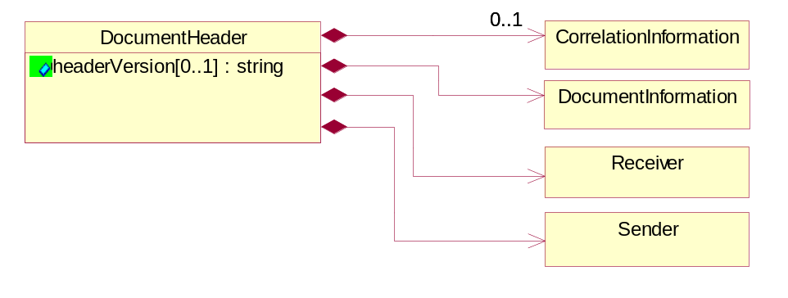
Figure ‎5-43 DocumentHeader

Attribute | Type | Documentation
headerVersion[0..1] | string | The UN/CEFACT version of the document header.

Composition | Cardinality | Type | Documentation
CorrelationInformation | 0..1 | CorrelationInformation | A block of information used to correlate a requesting document to a responding document and to the contract in an executing choreography.
DocumentInformation | 1 | DocumentInformation | The object specifies information to identify the business document, a summary of attachments, and information about the business document security.
Receiver | 1 | Receiver | The object allows the identification of the receiving party of the business message.
Sender | 1 | Sender | The object allows the identification of the initiating party of the business message.

DocumentIdentification
The object specifies all information necessary to identify the business document.
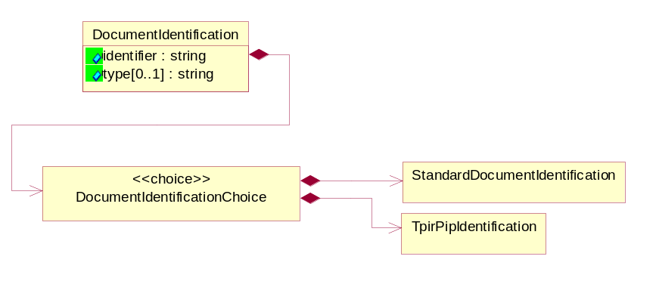
Figure ‎5-44 DocumentIdentification

Attribute | Type | Documentation
identifier | string | The unique identifier for the document being sent.
type[0..1] | string | Name of the Action Message

Composition | Cardinality | Type | Documentation
DocumentIdentificationChoice | 1 | DocumentIdentificationChoice

DocumentIdentificationChoice

Composition | Cardinality | Type | Documentation
StandardDocumentIdentification | 1 | StandardDocumentIdentification | The object specifies additional information necessary to identify the standard business document.
TpirPipIdentification | 1 | TpirPipIdentification | The object specifies all information necessary to uniquely identify a TPIR-PIP within a Registry or trading partner repository.

DocumentInformation
The object specifies information to identify the business document, a summary of attachments, and information about the business document security.
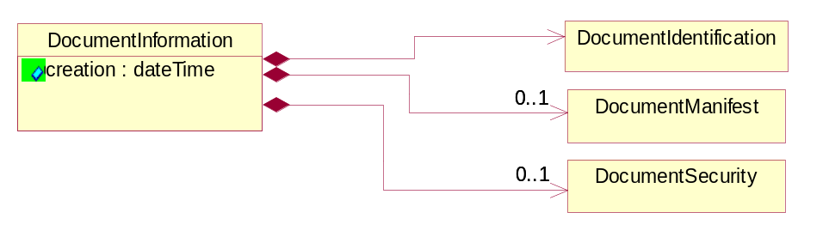
Figure ‎5-45 DocumentInformation

Attribute | Type | Documentation
creation | dateTime | The creation date and time of the specified Business Document (i.e. the Purchase Order date).

Composition | Cardinality | Type | Documentation
DocumentIdentification | 1 | DocumentIdentification | The object specifies all information necessary to identify the business document.
DocumentManifest | 0..1 | DocumentManifest | The block provides a brief summary of attachments and Service Content.
DocumentSecurity | 0..1 | DocumentSecurity | The object provides additional granularity in specifying business document security (this is in addition to the specified PIP security).

DocumentManifest
The block provides a brief summary of attachments and Service Content.
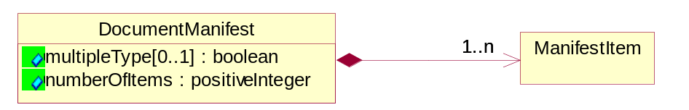
Figure ‎5-46 DocumentManifest

Attribute | Type | Documentation
multipleType[0..1] | boolean | Indicates whether the manifest contains documents of multiple types. True if yes, and False if no.
numberOfItems | positiveInteger | Total number of documents in the message. The physical count of the attachments in the payload plus the RosettaNet Business Message (for Service Content). The value of this field will be at least 1.

Composition | Cardinality | Type | Documentation
ManifestItem | 1..n | ManifestItem | The object provides details about the specific attachment(s).

DocumentSecurity
The object provides additional granularity in specifying business document security (this is in addition to the specified PIP security).
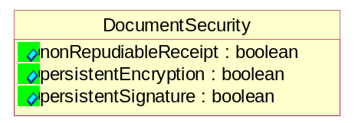
Figure ‎5-47 DocumentSecurity

Attribute | Type | Documentation
nonRepudiableReceipt | boolean | The value "true" will indicate that a signed acknowledgement for the business document is necessary.
persistentEncryption | boolean | The value "true" will indicate that the Business Document (including the header) needs to be encrypted when stored or transported.
persistentSignature | boolean | The value "true" will indicate that a signature is required to be stored with the document while stored or transported.

ManifestItem
The object provides details about the specific attachment(s).
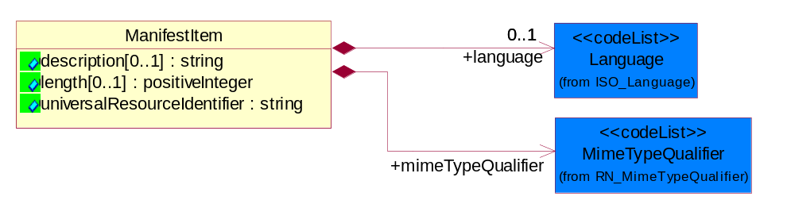
Figure ‎5-48 ManifestItem

Attribute | Type | Documentation
description[0..1] | string | A description of the attachment.
length[0..1] | positiveInteger | The size of the attachment in bytes (i.e. 1 000 000 bytes)
universalResourceIdentifier | string | The generic set of all names/addresses that are short strings that refer to resources.

Composition | Cardinality | Type | Documentation
language | 0..1 | Language | For representation of Language name RosettaNet has adopted ISO 639-2; 1998. Refer to the following web page to get the latest version of the standard:  http://www.loc.gov/standards/iso639-2/iso639jac.html  If you need more information about the ISO standard please contact ISO for more details.
mimeTypeQualifier | 1 | MimeTypeQualifier | The MIME type as defined by IANA.  Please refer to http://www.iana.org/assignments/media-types/ for a list of types.

PipIdentifier
PIP Identification.[ i.e. PIP3A4]
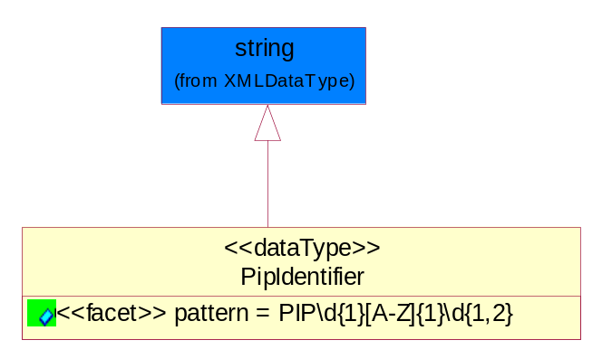
Figure ‎5-49 PipIdentifier

Attribute | Type | Documentation
pattern |  | PIP\d{1}[A-Z]{1}\d{1,2}

PipVersion
PIP version number (i.e. 02.02.00).
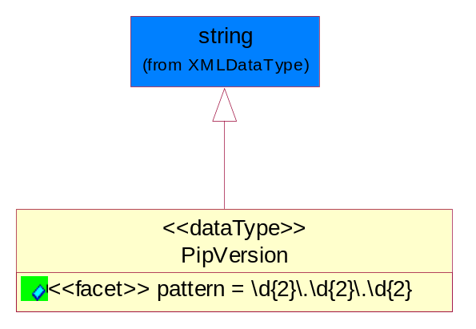
Figure ‎5-50 PipVersion

Attribute | Type | Documentation
pattern |  | \d{2}\.\d{2}\.\d{2}

Receiver
The object allows the identification of the receiving party of the business message.
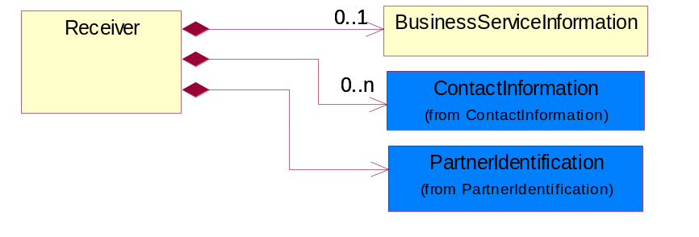
Figure ‎5-51 Receiver

Composition | Cardinality | Type | Documentation
BusinessServiceInformation | 0..1 | BusinessServiceInformation | The object allows the specification of the business service utilized within the partner company. This may or may not be the same as the information sent by the RNIF.
ContactInformation | 0..n | ContactInformation | The business document must allow for the identification of the name of the department, service or individual to be contacted regarding the context of the business document.
PartnerIdentification | 1 | PartnerIdentification | The business document must allow for the identity of one or more parties to the transaction.

RequestingDocumentInformation
A block of information used to correlate a requesting document to a responding document in an executing choreography.
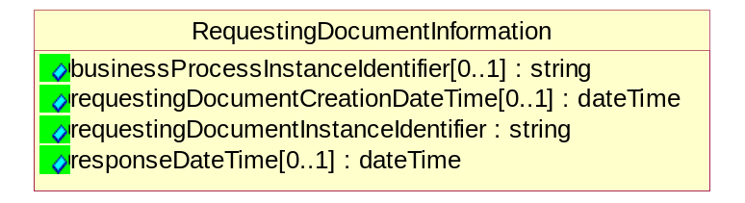
Figure ‎5-52 RequestingDocumentInformation

Attribute | Type | Documentation
businessProcessInstanceIdentifier[0..1] | string | The identifier for the public business process instance being sent that both the sender and receiver can identify.
requestingDocumentCreationDateTime[0..1] | dateTime | The date-time of the requesting business document.
requestingDocumentInstanceIdentifier | string | The Business Document identification number that identifies the requesting Business Document.
responseDateTime[0..1] | dateTime | The expected time to receive the response. This can not be greater than the PIP TimeToPerform.

Sender
The object allows the identification of the initiating party of the business message.
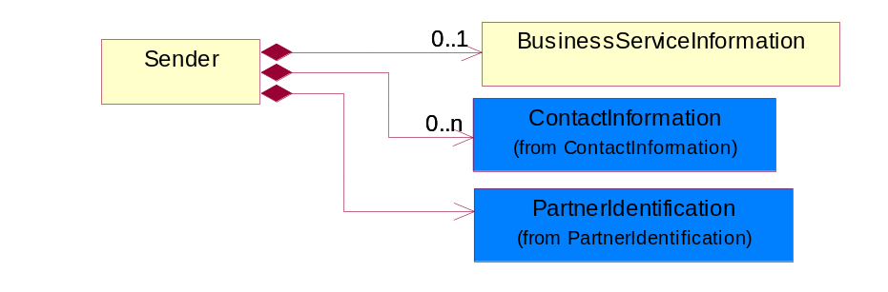
Figure ‎5-53 Sender

Composition | Cardinality | Type | Documentation
BusinessServiceInformation | 0..1 | BusinessServiceInformation | The object allows the specification of the business service utilized within the partner company. This may or may not be the same as the information sent by the RNIF.
ContactInformation | 0..n | ContactInformation | The business document must allow for the identification of the name of the department, service or individual to be contacted regarding the context of the business document.
PartnerIdentification | 1 | PartnerIdentification | The business document must allow for the identity of one or more parties to the transaction.

StandardDocumentIdentification
The object specifies additional information necessary to identify the standard business document.
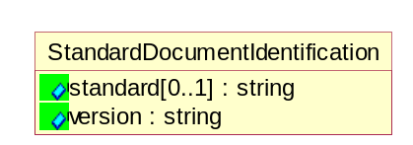
Figure ‎5-54 StandardDocumentIdentification

Attribute | Type | Documentation
standard[0..1] | string | Identifies the standard used to submit the business document. (e.g. RosettaNet).
version | string | PIP3A4v01.00

TpirPipIdentification
The object specifies all information necessary to uniquely identify a TPIR-PIP within a Registry or trading partner repository.
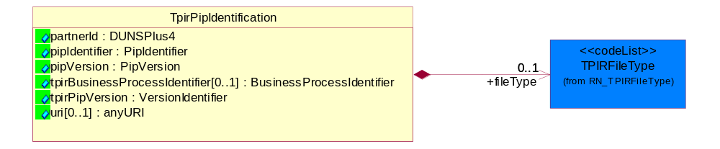
Figure ‎5-55 TpirPipIdentification

Attribute | Type | Documentation
partnerId | DUNSPlus4 | The Trading Partner Identification of MNC that is creating this TPIR PIP.
pipIdentifier | PipIdentifier | A TPIR PIP Identification [i.e., 3A4 ).
pipVersion | PipVersion | A TPIR PIP version number (i.e., 02.02.00)
tpirBusinessProcessIdentifier[0..1] | BusinessProcessIdentifier | A Business Process Identifier to uniquely define the TPIR-PIP 'role' within a Business Scenario at a company or MNC level. The identifier MUST be composed of alphanumeric characters only and its length MUST be between one and twelve characters.
tpirPipVersion | VersionIdentifier | A TPIR-PIP Version Number (i.e., major and minor version number as XX.XX).
uri[0..1] | anyURI | Describes the destination uri for the TPIR form.

Composition | Cardinality | Type | Documentation
fileType | 0..1 | TPIRFileType | Describes the file type of the TPIR form (PDF, XDP or XML).

VersionIdentifier
Version Number (i.e., major and minor version number as XX.XX).
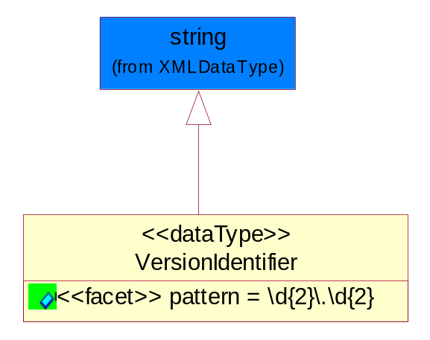
Figure ‎5-56 VersionIdentifier

Attribute | Type | Documentation
pattern |  | \d{2}\.\d{2}

CodeList

TPIRFileType
A code identifying the file type of TPIR form.

Name | Documentation
PDF | Portable Document Format.
XDP | XML Data Package.
XML | eXtensible Markup Language.

XML Data Type

anyURI
Represents a URI as defined by RFC 2396. An anyURI value can be absolute or relative, and may have an optional fragment identifier.

boolean
Represents Boolean values, which are either "true" or "false".

date
For the represents a calendar date.
The pattern for a date is CCYY-MM-DD where CC represents the century, YY the year, MM the month, and DD the day, with an optional time zone indicator as allowed for dateTime.

dateTime
Represents a specific instance of time.
The pattern for dateTime is CCYY-MM-DDThh:mm:ss where CC represents the century, YY the year, MM the month, and DD the day, preceded by an optional leading negative (-) character to indicate a negative number. If the negative character is omitted, positive (+) is assumed. The T is the date/time separator and hh, mm, and ss represent hour, minute, and second respectively. Additional digits can be used to increase the precision of fractional seconds if desired. For example, the format ss.ss... with any number of digits after the decimal point is supported. The fractional seconds part is optional.
This representation may be immediately followed by a "Z" to indicate Coordinated Universal Time (UTC) or to indicate the time zone. For example, the difference between the local time and Coordinated Universal Time, immediately followed by a sign, + or -, followed by the difference from UTC represented as hh:mm (minutes is required). If the time zone is included, both hours and minutes must be present.

duration
Represents a duration of time.
The pattern for duration is PnYnMnDTnHnMnS, where nY represents the number of years, nM the number of months, nD the number of days, T the date/time separator, nH the number of hours, nM the number of minutes, and nS the number of seconds.

positiveInteger
Represents an integer that is greater than zero. This data type is derived from nonNegativeInteger.

string
Represents character string.

